VPC TASKS – 02

- Create one VPC, with 1 public subnet and 1 private subnet.

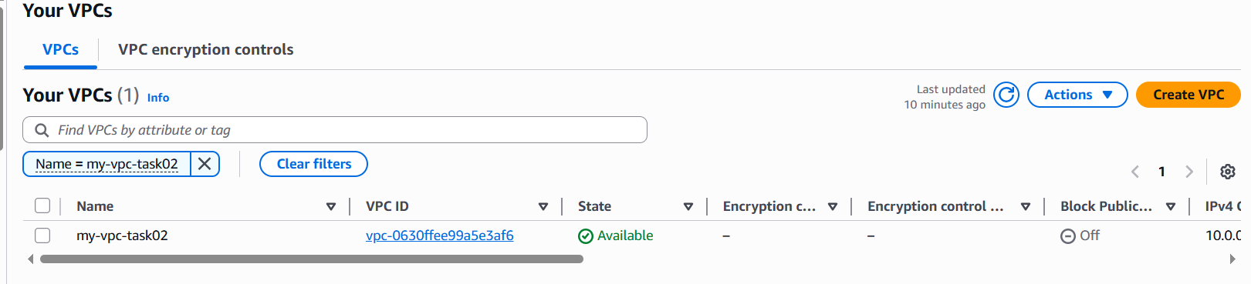
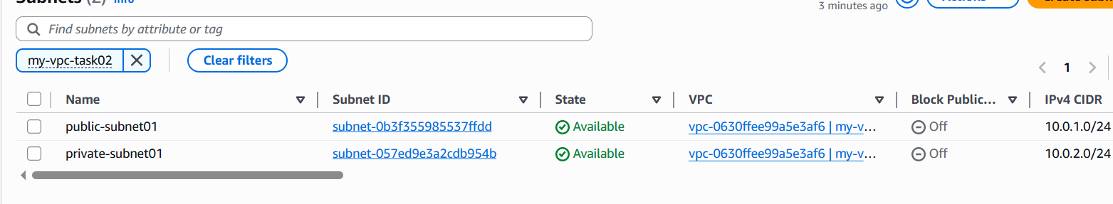
- Enable VPC peering for cross-region.

- Change AWS region to N. Virginia / us-east-1.
- Go to VPC > Your VPCs.
- Click Create VPC.
- Select VPC only.
- Enter name: virginia-vpc-new.
- Enter IPv4 CIDR: 10.0.0.0/16.
- Click Create VPC.
- Go to VPC > Subnets.
- Click Create subnet.
- Select VPC: virginia-vpc-new.
- Enter subnet name: virginia-public-subnet.
- Select AZ: us-east-1a.
- Enter subnet CIDR: 10.0.1.0/24.
- Click Create subnet.
- Select virginia-public-subnet.
- Click Actions > Edit subnet settings.
- Enable Auto-assign public IPv4 address.
- Click Save.
- Go to VPC > Internet Gateways.
- Click Create internet gateway.
- Enter name: virginia-igw-new.
- Click Create internet gateway.
- Select virginia-igw-new.
- Click Actions > Attach to VPC.
- Select virginia-vpc-new.
- Click Attach internet gateway.
- Go to VPC > Route Tables.
- Click Create route table.
- Enter name: virginia-public-rt.
- Select VPC: virginia-vpc-new.
- Click Create route table.
- Select virginia-public-rt.
- Open Routes tab.
- Click Edit routes.
- Click Add route.
- Destination: 0.0.0.0/0.
- Target: Internet Gateway > virginia-igw-new.
- Click Save changes.
- Open Subnet associations tab.
- Click Edit subnet associations.
- Select virginia-public-subnet.
- Click Save associations.
Create fresh Ohio VPC
- Change AWS region to Ohio / us-east-2.
- Go to VPC > Your VPCs.
- Click Create VPC.
- Select VPC only.
- Enter name: ohio-vpc-new.
- Enter IPv4 CIDR: 20.0.0.0/16.
- Click Create VPC.
- Go to VPC > Subnets.
- Click Create subnet.
- Select VPC: ohio-vpc-new.
- Enter subnet name: ohio-public-subnet.
- Select AZ: us-east-2a.
- Enter subnet CIDR: 20.0.1.0/24.
- Click Create subnet.
- Select ohio-public-subnet.
- Click Actions > Edit subnet settings.
- Enable Auto-assign public IPv4 address.
- Click Save.
- Go to VPC > Internet Gateways.
- Click Create internet gateway.
- Enter name: ohio-igw-new.
- Click Create internet gateway.
- Select ohio-igw-new.
- Click Actions > Attach to VPC.
- Select ohio-vpc-new.
- Click Attach internet gateway.
- Go to VPC > Route Tables.
- Click Create route table.
- Enter name: ohio-public-rt.
- Select VPC: ohio-vpc-new.
- Click Create route table.
- Select ohio-public-rt.
- Open Routes tab.
- Click Edit routes.
- Click Add route.
- Destination: 0.0.0.0/0.
- Target: Internet Gateway > ohio-igw-new.
- Click Save changes.
- Open Subnet associations tab.
- Click Edit subnet associations.
- Select ohio-public-subnet.
- Click Save associations.
Launch Virginia EC2
- Change region to N. Virginia / us-east-1.
- Go to EC2 > Instances.
- Click Launch instance.
- Name: virginia-ec2-new.
- Select AMI: Amazon Linux 2023.
- Select instance type: t2.micro or t3.micro.
- Select key pair: bashscript.
- In Network settings, select VPC: virginia-vpc-new.
- Select subnet: virginia-public-subnet.
- Set Auto-assign public IP: Enable.
- Create security group: virginia-sg-new.
- Add inbound rule: SSH | TCP | 22 | 0.0.0.0/0.
- Add inbound rule: All ICMP - IPv4 | ICMP | All | 20.0.0.0/16.
- Click Launch instance.
- Copy the Public IPv4 and Private IPv4 of Virginia EC2.
Launch Ohio EC2
- Change region to Ohio / us-east-2.
- Go to EC2 > Instances.
- Click Launch instance.
- Name: ohio-ec2-new.
- Select AMI: Amazon Linux 2023.
- Select instance type: t2.micro or t3.micro.
- Select key pair: bashscript.
- In Network settings, select VPC: ohio-vpc-new.
- Select subnet: ohio-public-subnet.
- Set Auto-assign public IP: Enable.
- Create security group: ohio-sg-new.
- Add inbound rule: SSH | TCP | 22 | 0.0.0.0/0.
- Add inbound rule: All ICMP - IPv4 | ICMP | All | 10.0.0.0/16.
- Click Launch instance.
- Copy the Public IPv4 and Private IPv4 of Ohio EC2.
Create VPC peering
- Change region to N. Virginia / us-east-1.
- Go to VPC > Peering Connections.
- Click Create peering connection.
- Name: virginia-ohio-peer-new.
- Requester VPC: virginia-vpc-new.
- Account: My account.
- Region: Another region.
- Accepter region: Ohio / us-east-2.
- Accepter VPC: ohio-vpc-new.
- Click Create peering connection.
- Change region to Ohio / us-east-2.
- Go to VPC > Peering Connections.
- Select pending peering request.
- Click Actions > Accept request.
- Confirm status becomes Active.
Add peering routes
- Change region to N. Virginia / us-east-1.
- Go to VPC > Route Tables.
- Select virginia-public-rt.
- Open Routes tab.
- Click Edit routes.
- Click Add route.
- Destination: 20.0.0.0/16.
- Target: Peering Connection > virginia-ohio-peer-new / pcx-xxxx.
- Click Save changes.
- Change region to Ohio / us-east-2.
- Go to VPC > Route Tables.
- Select ohio-public-rt.
- Open Routes tab.
- Click Edit routes.
- Click Add route.
- Destination: 10.0.0.0/16.
- Target: Peering Connection > virginia-ohio-peer-new / pcx-xxxx.
- Click Save changes.
Connect and test
- Open Git Bash.
- Run: cd ~/Downloads.
- Run: chmod 400 bashscript.
- SSH to Virginia EC2: ssh -i bashscript ec2-user@<virginia-public-ip>.
- From inside Virginia EC2, ping Ohio private IP: ping <ohio-private-ip>.
- Example: ping 20.0.1.25.
- If replies come, Virginia to Ohio peering is working.
- Open another Git Bash.
- Run: cd ~/Downloads.
- SSH to Ohio EC2: ssh -i bashscript ec2-user@<ohio-public-ip>.
- From inside Ohio EC2, ping Virginia private IP: ping <virginia-private-ip>.
- Example: ping 10.0.1.20.
- If replies come, Ohio to Virginia peering is working.

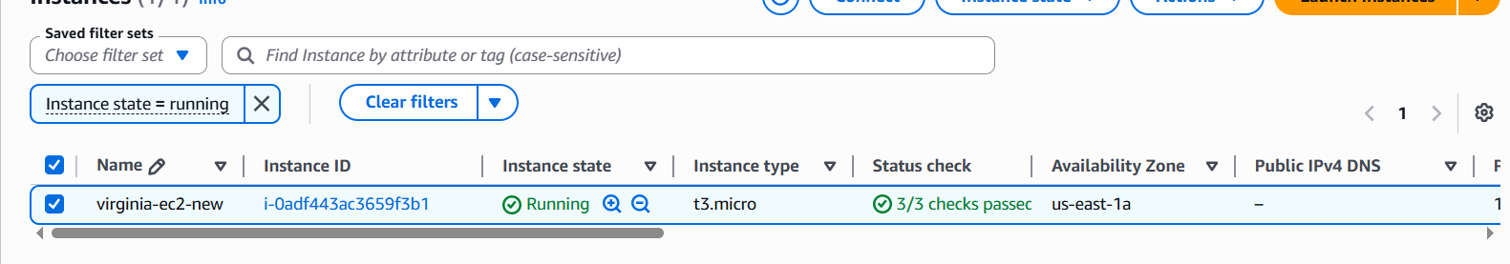
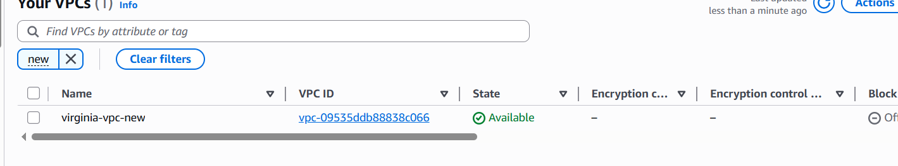
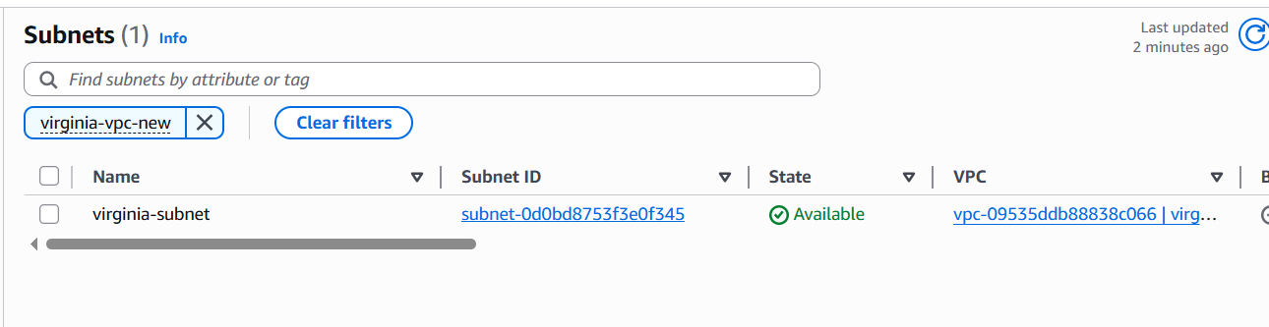
Ohio-
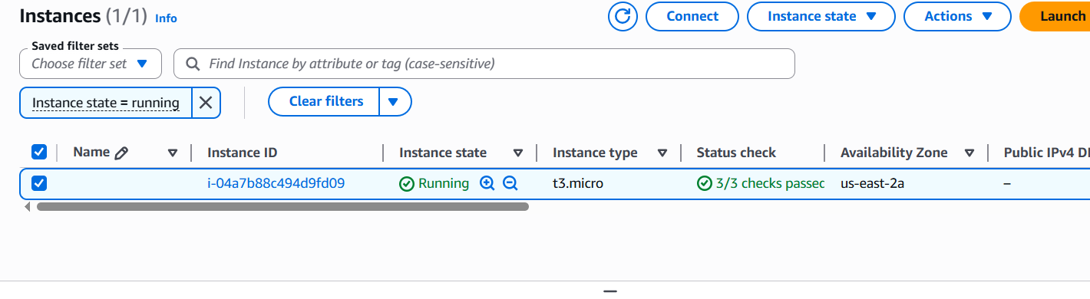
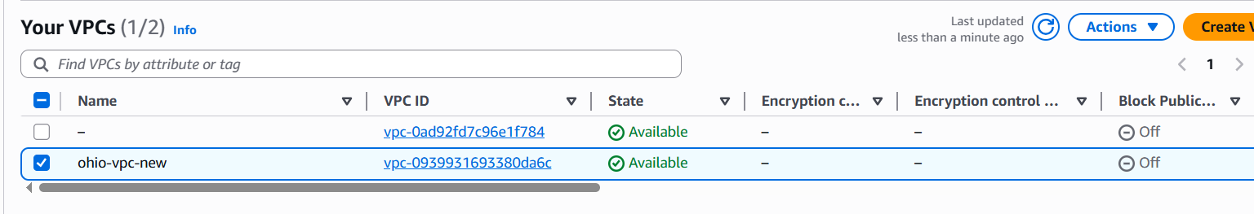
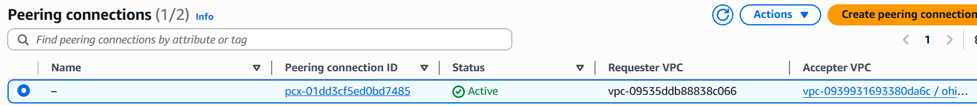

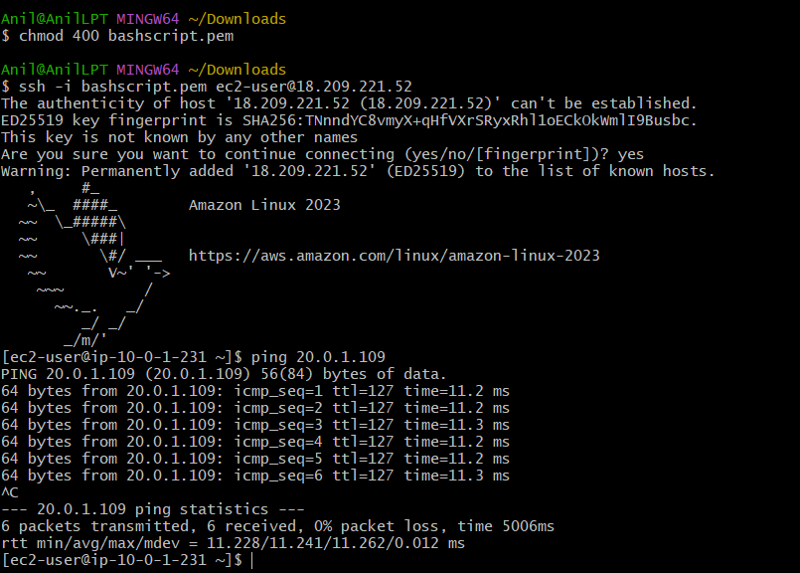

- Enable VPC peering for cross-account (you can collaborate with your friend to do this task).

- Login to your AWS Console.
- Change region to Ohio / us-east-2.
- Go to VPC > Your VPCs.
- Confirm your VPC exists.
- Your VPC can be:
Name: ohio-vpc
CIDR: 20.0.0.0/16
- Go to Subnets.
- Confirm your subnet exists.
Subnet name: ohio-subnet
CIDR: 20.0.1.0/24
- Go to Internet Gateways.
- Confirm Internet Gateway is attached to your Ohio VPC.
- Go to Route Tables.
- Confirm your Ohio route table has:
0.0.0.0/0 -> Internet Gateway
This is for SSH access to your EC2.
Create cross-account peering request
- Stay in Ohio / us-east-2.
- Go to VPC > Peering Connections.
- Click Create peering connection.
- Enter name:
cross-account-peer
- Under Select a local VPC to peer with, select your VPC:
ohio-vpc
- Under Select another VPC to peer with, choose:
Another account
- Enter your friend’s AWS Account ID.
- For region, select friend’s VPC region.
If friend’s VPC is also in Ohio:
This region / us-east-2
If friend’s VPC is in another region:
Another region
- Enter friend’s VPC ID:
vpc-xxxxxxxx
- Click Create peering connection.
- Status will show:
Pending acceptance
Friend accepts peering request
Your friend should do these steps:
- Login to their AWS account.
- Go to the region where their VPC is created.
- Go to VPC > Peering Connections.
- Select the pending peering request.
- Click Actions.
- Click Accept request.
- Confirm accept.
- Status should become:
Active
Add route in your Ohio route table
- In your AWS account, go to Ohio / us-east-2.
- Go to VPC > Route Tables.
- Select your Ohio route table.
- Open Routes tab.
- Click Edit routes.
- Click Add route.
- Add:
Destination: Friend VPC CIDR
Target: Peering Connection
Example:
Destination: 30.0.0.0/16
Target: pcx-xxxxxxxx
- Click Save changes.
Important: For friend’s CIDR, target should be Peering Connection, not Internet Gateway.
Friend adds route in their route table
Your friend must add return route.
In friend’s AWS account:
- Go to VPC > Route Tables.
- Select their VPC route table.
- Open Routes tab.
- Click Edit routes.
- Click Add route.
- Add:
Destination: Your Ohio VPC CIDR
Target: Peering Connection
Example:
Destination: 20.0.0.0/16
Target: pcx-xxxxxxxx
- Click Save changes.
This is mandatory. If your side has route but friend’s side does not, ping will fail.
Security group changes on your side
- Go to EC2 > Instances.
- Select your Ohio EC2 instance.
- Open Security tab.
- Click your Security Group.
- Go to Inbound rules.
- Click Edit inbound rules.
- Add SSH rule for your laptop:
SSH | TCP | 22 | 0.0.0.0/0
- Add ICMP rule from friend’s VPC:
All ICMP - IPv4 | ICMP | All | Friend VPC CIDR
Example:
All ICMP - IPv4 | ICMP | All | 30.0.0.0/16
- Click Save rules.
- Security group changes on friend’s side
Your friend should add this inbound rule in their EC2 security group:
All ICMP - IPv4 | ICMP | All | Your Ohio VPC CIDR
Example:
All ICMP - IPv4 | ICMP | All | 20.0.0.0/16
If friend needs SSH access to their EC2, they should also allow:
SSH | TCP | 22 | Friend's public IP
Launch EC2 instances if not already created

Your EC2 in Ohio
Use:
VPC: ohio-vpc
Subnet: ohio-subnet
Auto-assign public IP: Enable
Security group: SSH 22 and ICMP

Friend EC2
Friend should use:
VPC: friend-vpc
Subnet: friend-subnet
Auto-assign public IP: Enable
Security group: SSH 22 and ICMP

Test cross-account peering
- Open Git Bash.
- Go to your key location:
cd ~/Downloads
- Give permission to key:
chmod 400 bashscript
- SSH into your Ohio EC2:
ssh -i bashscript ec2-user@<your-ohio-ec2-public-ip>
- From your Ohio EC2, ping your friend’s EC2 private IP:
ping <friend-ec2-private-ip>
- If replies come, your side to friend side is working.
- Friend should also test from their EC2:
ping <your-ohio-ec2-private-ip>
Example:
ping 20.0.1.20

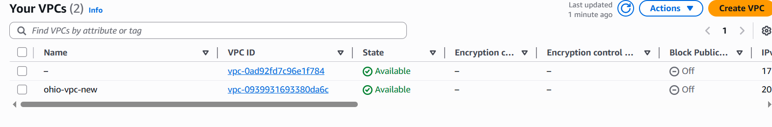

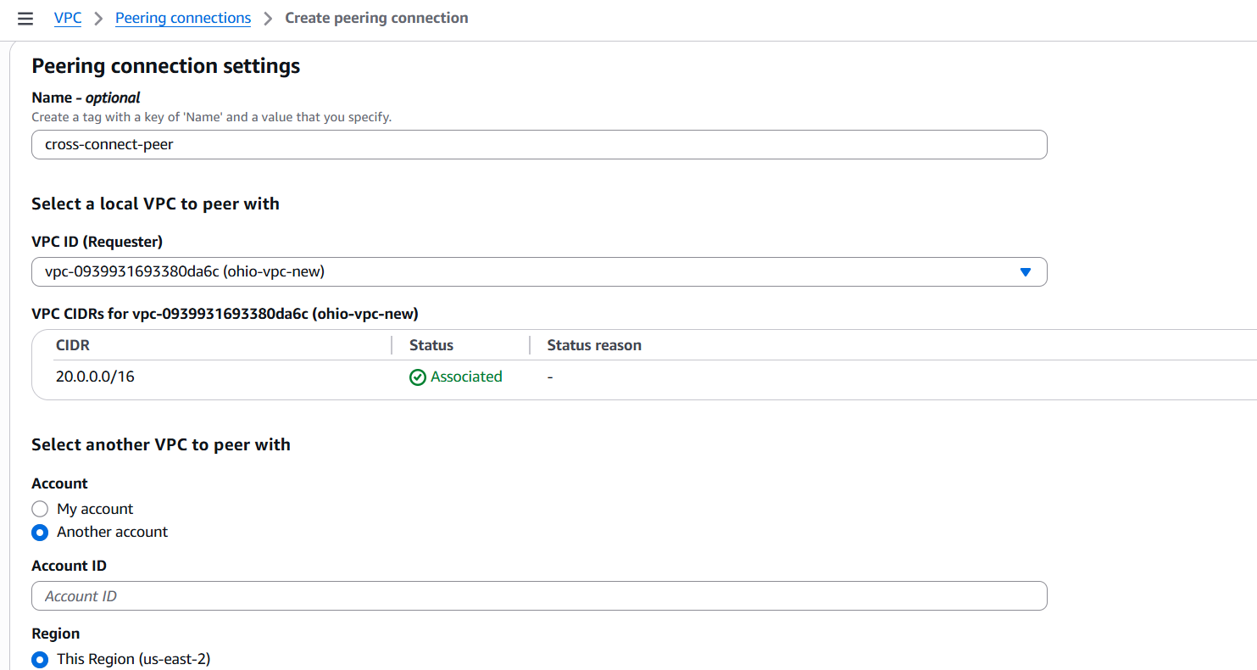

- Set up a VPC Transit Gateway.

Login to AWS Console.
- Change region to N. Virginia / us-east-1.
- Go to VPC > Your VPCs.
- Click Create VPC.
- Select VPC only.
- Enter name: vpc-1.
- Enter IPv4 CIDR: 10.0.0.0/16.
- Click Create VPC.
- Go to VPC > Subnets.
- Click Create subnet.
- Select VPC: vpc-1.
- Enter subnet name: subnet-1.
- Select Availability Zone: us-east-1a.
- Enter subnet CIDR: 10.0.1.0/24.
- Click Create subnet.
- Select subnet-1.
- Click Actions > Edit subnet settings.
- Enable Auto-assign public IPv4 address.
- Click Save.
- Go to VPC > Internet Gateways.
- Click Create internet gateway.
- Enter name: igw-vpc1.
- Click Create internet gateway.
- Select igw-vpc1.
- Click Actions > Attach to VPC.
- Select vpc-1.
- Click Attach internet gateway.
- Go to VPC > Route Tables.
- Click Create route table.
- Enter name: rt-vpc1.
- Select VPC: vpc-1.
- Click Create route table.
- Select rt-vpc1.
- Open Routes tab.
- Click Edit routes.
- Click Add route.
- Destination: 0.0.0.0/0.
- Target: Internet Gateway > igw-vpc1.
- Click Save changes.
- Open Subnet associations tab.
- Click Edit subnet associations.
- Select subnet-1.
- Click Save associations.

- Go to VPC > Your VPCs.
- Click Create VPC.
- Select VPC only.
- Enter name: vpc-2.
- Enter IPv4 CIDR: 20.0.0.0/16.
- Click Create VPC.
- Go to VPC > Subnets.
- Click Create subnet.
- Select VPC: vpc-2.
- Enter subnet name: subnet-2.
- Select Availability Zone: us-east-1b.
- Enter subnet CIDR: 20.0.1.0/24.
- Click Create subnet.
- Select subnet-2.
- Click Actions > Edit subnet settings.
- Enable Auto-assign public IPv4 address.
- Click Save.
- Go to VPC > Internet Gateways.
- Click Create internet gateway.
- Enter name: igw-vpc2.
- Click Create internet gateway.
- Select igw-vpc2.
- Click Actions > Attach to VPC.
- Select vpc-2.
- Click Attach internet gateway.
- Go to VPC > Route Tables.
- Click Create route table.
- Enter name: rt-vpc2.
- Select VPC: vpc-2.
- Click Create route table.
- Select rt-vpc2.
- Open Routes tab.
- Click Edit routes.
- Click Add route.
- Destination: 0.0.0.0/0.
- Target: Internet Gateway > igw-vpc2.
- Click Save changes.
- Open Subnet associations tab.
- Click Edit subnet associations.
- Select subnet-2.
- Click Save associations.

- Go to EC2 > Instances.
- Click Launch instance.
- Enter name: vpc1-ec2.
- Select AMI: Amazon Linux 2023.
- Select instance type: t2.micro or t3.micro.
- Select key pair: bashscript.
- In Network settings, select VPC: vpc-1.
- Select subnet: subnet-1.
- Set Auto-assign public IP to Enable.
- Create security group name: vpc1-sg.
- Add inbound rule: SSH | TCP | 22 | 0.0.0.0/0.
- Add inbound rule: All ICMP - IPv4 | ICMP | All | 20.0.0.0/16.
- Click Launch instance.
- Copy Public IPv4 and Private IPv4 of vpc1-ec2.
- Go to EC2 > Instances.
- Click Launch instance.
- Enter name: vpc2-ec2.
- Select AMI: Amazon Linux 2023.
- Select instance type: t2.micro or t3.micro.
- Select key pair: bashscript.
- In Network settings, select VPC: vpc-2.
- Select subnet: subnet-2.
- Set Auto-assign public IP to Enable.
- Create security group name: vpc2-sg.
- Add inbound rule: SSH | TCP | 22 | 0.0.0.0/0.
- Add inbound rule: All ICMP - IPv4 | ICMP | All | 10.0.0.0/16.
- Click Launch instance.
- Copy Public IPv4 and Private IPv4 of vpc2-ec2.
- Go to VPC Dashboard.
- Click Transit Gateways.
- Click Create transit gateway.
- Enter name: main-tgw.
- Keep default settings.
- Click Create transit gateway.
- Wait until Transit Gateway state becomes Available.
- Go to Transit Gateway Attachments.
- Click Create transit gateway attachment.
- Select Transit Gateway: main-tgw.
- Select attachment type: VPC.
- Select VPC ID: vpc-1.
- Select subnet: subnet-1.
- Click Create transit gateway attachment.
- Wait until attachment state becomes Available.
- Go to Transit Gateway Attachments.
- Click Create transit gateway attachment.
- Select Transit Gateway: main-tgw.
- Select attachment type: VPC.
- Select VPC ID: vpc-2.
- Select subnet: subnet-2.
- Click Create transit gateway attachment.
- Wait until attachment state becomes Available.
- Go to VPC > Route Tables.
- Select rt-vpc1.
- Open Routes tab.
- Click Edit routes.
- Click Add route.
- Destination: 20.0.0.0/16.
- Target: Transit Gateway > main-tgw.
- Click Save changes.
- Go to VPC > Route Tables.
- Select rt-vpc2.
- Open Routes tab.
- Click Edit routes.
- Click Add route.
- Destination: 10.0.0.0/16.
- Target: Transit Gateway > main-tgw.
- Click Save changes
Open Git Bash.
- Run: cd ~/Downloads.
- Run: chmod 400 bashscript.
- Connect to VPC 1 EC2: ssh -i bashscript ec2-user@<vpc1-public-ip>.
- From VPC 1 EC2, ping VPC 2 private IP: ping <vpc2-private-ip>.
- Example: ping 20.0.1.25.
- If replies come, VPC 1 to VPC 2 through Transit Gateway is working.
- Open another Git Bash.
- Connect to VPC 2 EC2: ssh -i bashscript ec2-user@<vpc2-public-ip>.
- From VPC 2 EC2, ping VPC 1 private IP: ping <vpc1-private-ip>.
- Example: ping 10.0.1.20.
- If replies come, VPC 2 to VPC 1 through Transit Gateway is working.

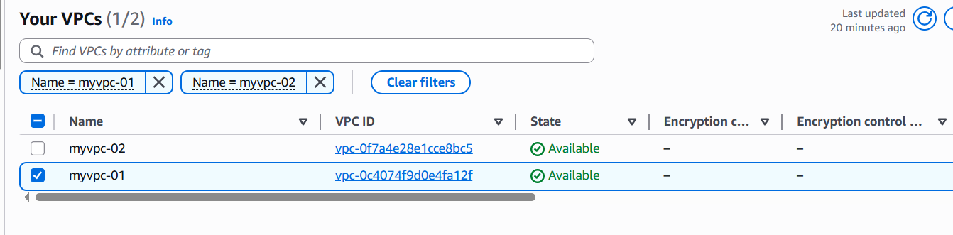
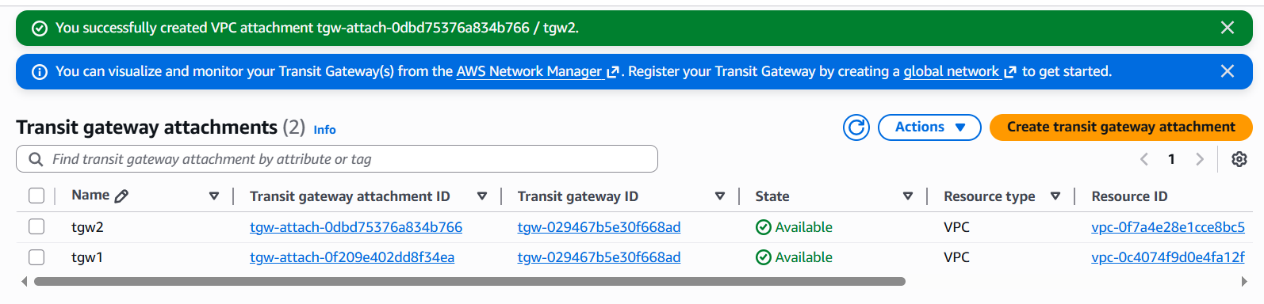

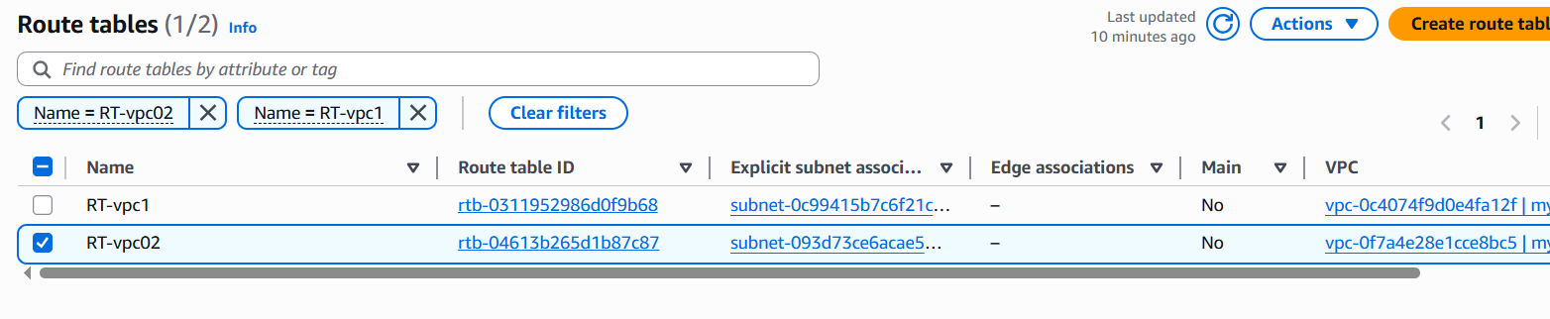
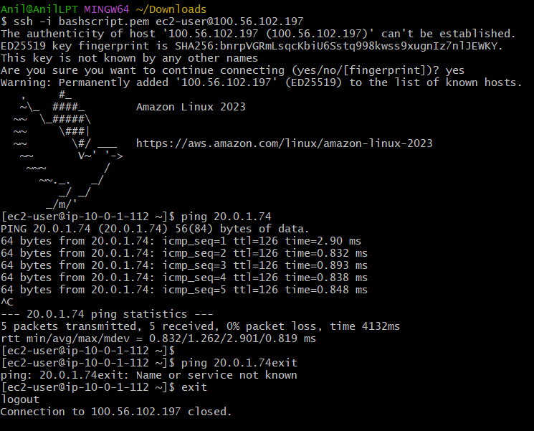
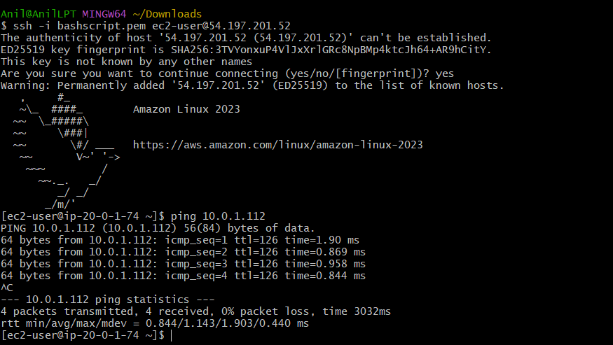

- Set up a VPC Endpoint

- Login to AWS Console.
- Change region to N. Virginia / us-east-1.
- Go to VPC.
- Click Your VPCs.
- Click Create VPC.
- Select VPC only.
- Enter VPC name: endpoint-vpc.
- Enter IPv4 CIDR block: 10.0.0.0/16.
- Click Create VPC.

Create subnet
- Go to VPC > Subnets.
- Click Create subnet.
- Select VPC: endpoint-vpc.
- Enter subnet name: endpoint-subnet.
- Select Availability Zone: us-east-1a.
- Enter subnet CIDR block: 10.0.1.0/24.
- Click Create subnet.
- Select endpoint-subnet.
- Click Actions > Edit subnet settings.
- Enable Auto-assign public IPv4 address.
- Click Save.

Create Internet Gateway
- Go to VPC > Internet Gateways.
- Click Create internet gateway.
- Enter name: endpoint-igw.
- Click Create internet gateway.
- Select endpoint-igw.
- Click Actions > Attach to VPC.
- Select endpoint-vpc.
- Click Attach internet gateway.

Create route table
- Go to VPC > Route Tables.
- Click Create route table.
- Enter name: endpoint-rt.
- Select VPC: endpoint-vpc.
- Click Create route table.
- Select endpoint-rt.
- Open Routes tab.
- Click Edit routes.
- Click Add route.
- Destination: 0.0.0.0/0.
- Target: Internet Gateway > endpoint-igw.
- Click Save changes.
- Open Subnet associations tab.
- Click Edit subnet associations.
- Select endpoint-subnet.
- Click Save associations.

Launch EC2 instance
- Go to EC2 > Instances.
- Click Launch instance.
- Enter name: endpoint-ec2.
- Select AMI: Amazon Linux 2023 or Amazon Linux 2.
- Select instance type: t2.micro or t3.micro.
- Select key pair: bashscript.
- In Network settings, select VPC: endpoint-vpc.
- Select subnet: endpoint-subnet.
- Set Auto-assign public IP to Enable.
- Create security group name: endpoint-sg.
- Add inbound rule: SSH | TCP | 22 | 0.0.0.0/0.
- Click Launch instance.
- Copy the EC2 Public IPv4 address.

Create IAM role for EC2
- Go to IAM.
- Click Roles.
- Click Create role.
- Select AWS service.
- Select use case: EC2.
- Click Next.
- Search for policy: AmazonS3ReadOnlyAccess.
- Select AmazonS3ReadOnlyAccess.
- Click Next.
- Enter role name: EC2-S3-Role.
- Click Create role.

Attach IAM role to EC2
- Go to EC2 > Instances.
- Select endpoint-ec2.
- Click Actions.
- Click Security > Modify IAM role.
- Select IAM role: EC2-S3-Role.
- Click Update IAM role.

Create S3 VPC Endpoint
- Go to VPC Dashboard.
- Click Endpoints.
- Click Create endpoint.
- Enter endpoint name: s3-endpoint.
- Under Service category, select AWS services.
- Search for s3.
- Select service: com.amazonaws.us-east-1.s3.
- Make sure Type is Gateway.
- Do not select Interface.
- Scroll down to Network settings.
- Select VPC: endpoint-vpc.
- Under Route tables, select endpoint-rt.
- Under Policy, select Full access.
- Click Create endpoint.
- Wait until endpoint status becomes Available.

Verify route table
- Go to VPC > Route Tables.
- Select endpoint-rt.
- Open Routes tab.
- Check for an automatically added S3 route.
- It will look similar to: pl-xxxxxxxx -> vpce-xxxxxxxx.
- This confirms S3 traffic will go through the VPC Endpoint.

Test from EC2
- Open Git Bash.
- Run: cd ~/Downloads.
- Run: chmod 400 bashscript.
- Connect to EC2:
ssh -i bashscript ec2-user@<endpoint-ec2-public-ip>
- After login, check AWS identity:
aws sts get-caller-identity
- Test S3 access:
aws s3 ls
- If S3 buckets are listed, the VPC Endpoint is working.
- If you get permission error, check IAM role is attached correctly.
- If endpoint is not working, check endpoint-rt is selected in the VPC Endpoint.
- Final result: EC2 can access S3 privately through the S3 Gateway Endpoint

