ASG TASKS
- Create one VPC in N. Virginia region.
Purpose: A VPC is your private network inside AWS.
All your AWS resources like subnets, EC2, NAT Gateway, Load Balancer, route tables, and security groups will be created inside this VPC.
Without a VPC, we cannot control networking, IP ranges, routing, public/private access, or security properly.

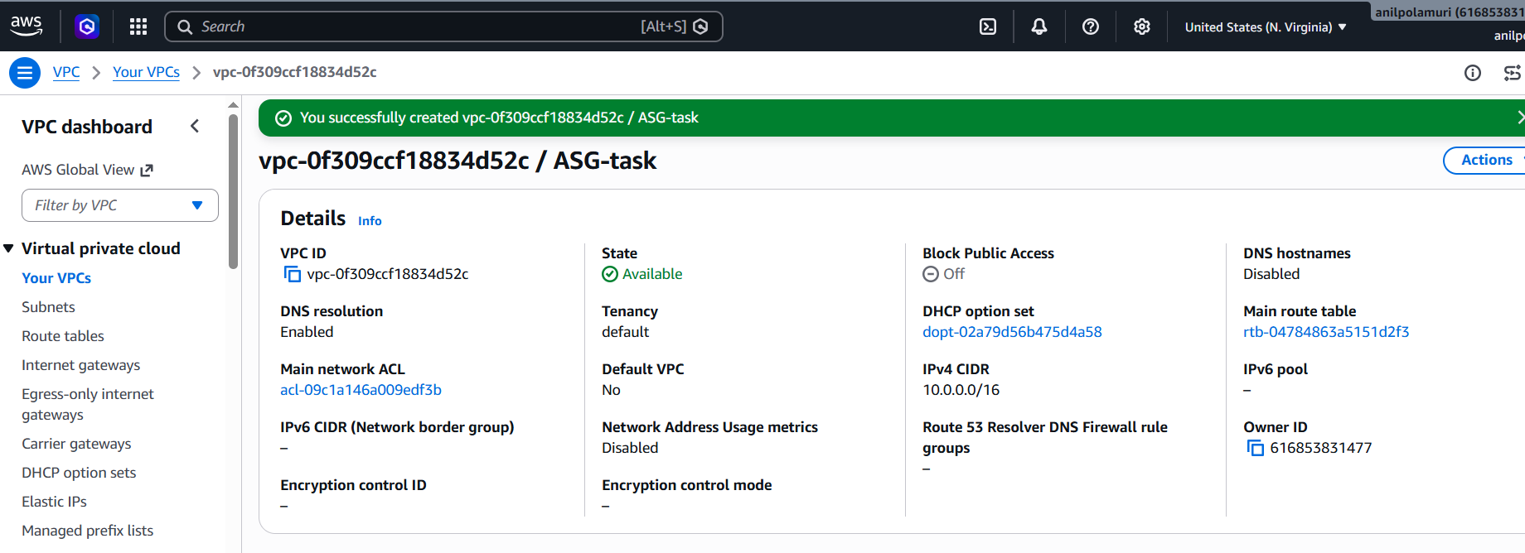

- Create two subnets: one public subnet and one private subnet.

Purpose: Subnets divide the VPC into smaller networks.
We need:
Public subnet → for resources that need internet access directly
Private subnet → for backend resources that should not be directly exposed to internet
Example:
Public subnet → Load Balancer, NAT Gateway, public EC2
Private subnet → private EC2/application server

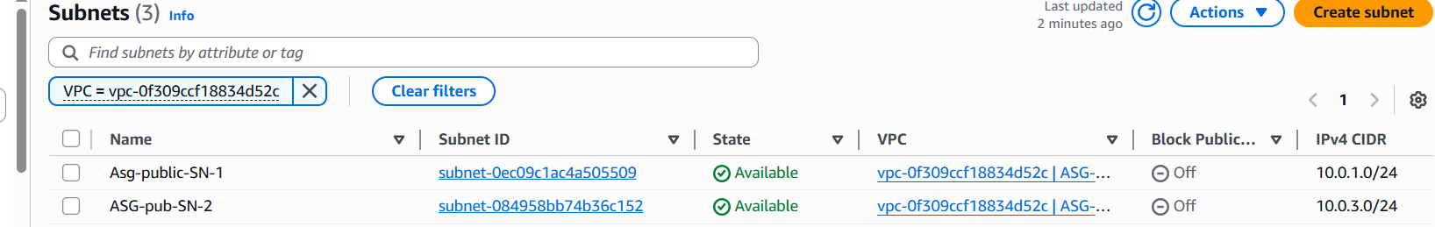

- Attach an IGW to the VPC.
Purpose: An Internet Gateway, or IGW, allows resources in public subnets to communicate with the internet.

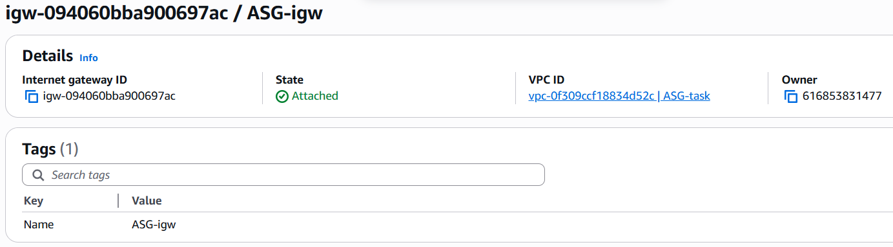

- Create one public route table (RT) and one private route table.

Purpose: A route table decides where network traffic should go.

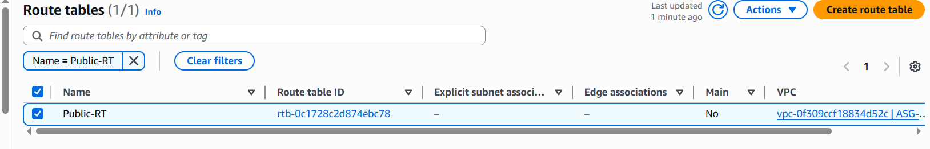

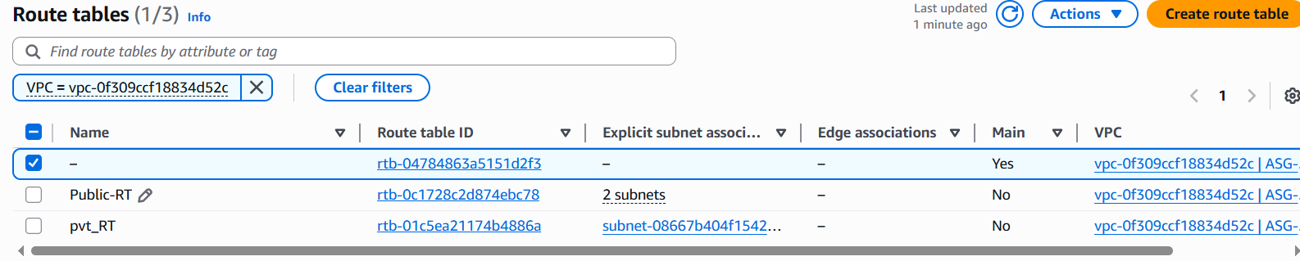

- Deploy a NAT gateway in the public subnet and attach the NAT gateway to the private subnet.
Purpose: Private subnet instances should not be directly exposed to the internet.
But they may still need outbound internet access to:
Install packages
Update OS
Download Apache
Send CloudWatch metrics
Access external services
A NAT Gateway allows private EC2 to go out to internet, but outside users cannot directly come in.

We create NAT Gateway inside a public subnet and attach an Elastic IP to it.
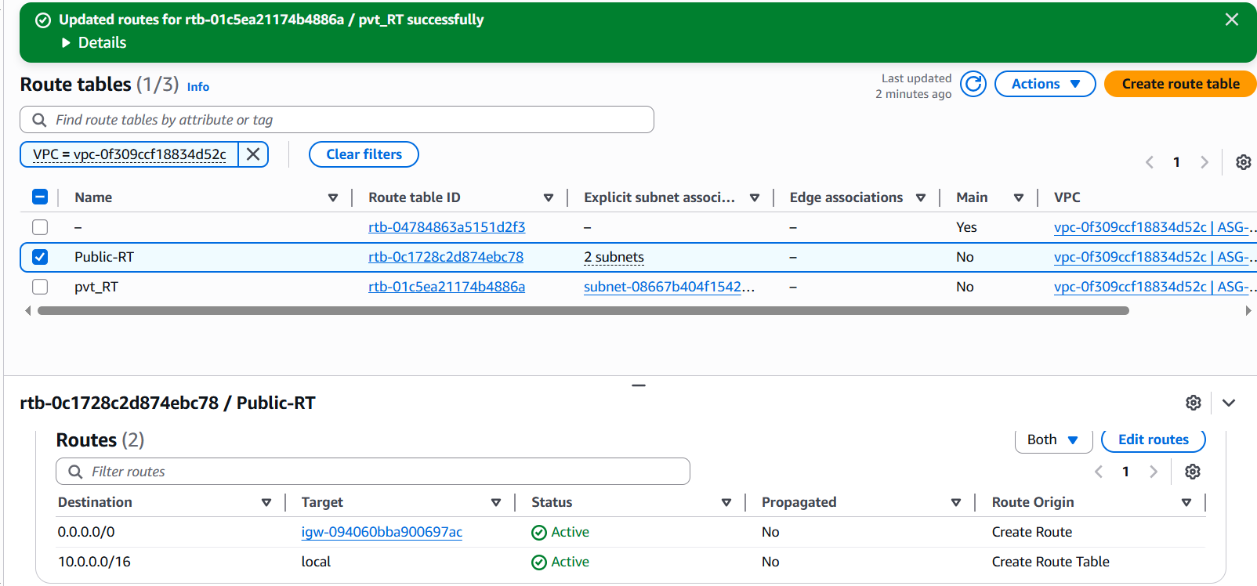

- Create two instances, one in the public subnet and one in the private subnet.

What are we doing?
We are creating two Linux servers:
Public EC2 → placed in public subnet
Private EC2 → placed in private subnet
Both will run Apache web server.

Why are we doing this?
Because later we will attach both servers to the Application Load Balancer.
The ALB will send traffic to these two Apache servers.

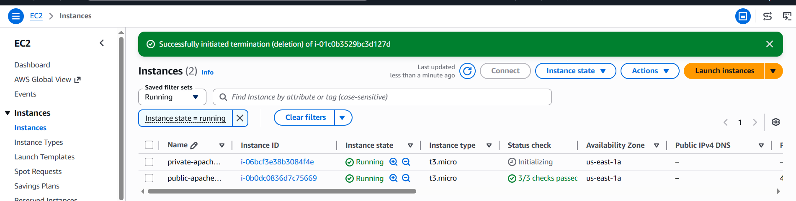

- Deploy Apache server on both EC2 instances with a sample index.html file.

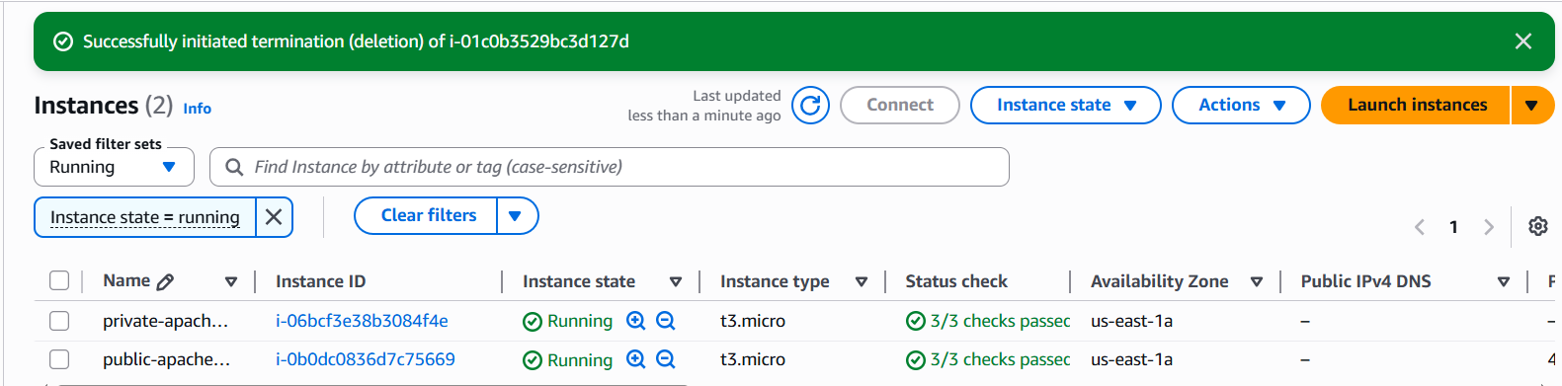
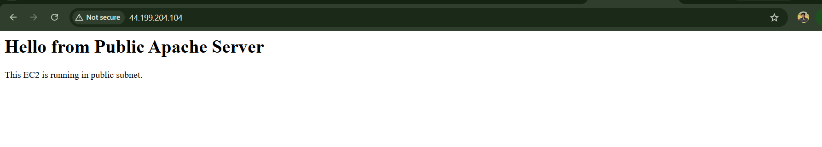

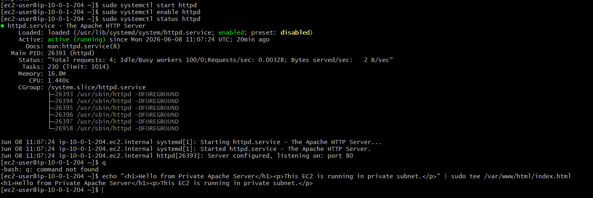

- Create one application load balancer and attach it to both EC2 instances.
Purpose: We are creating an Application Load Balancer, also called ALB.
The ALB will receive browser traffic and forward that traffic to both EC2 instances:

Instead of users directly accessing each EC2 separately, users will access only one ALB DNS name.
Example:
http://apache-alb-xxxx.us-east-1.elb.amazonaws.com
The ALB will distribute traffic between:
Public EC2
Private EC2

Step 1: Create ALB Security Group

Why are we doing this?
The Load Balancer needs a security group to allow users from the internet to access the website.
Traffic flow:
User browser → ALB → EC2 instances
So first, ALB must allow HTTP traffic on port 80.

How to do it
Go to:
EC2 → Security Groups → Create security group
Enter:
Security group name: alb-sg
Description: Security group for Apache Application Load Balancer
VPC: ASG-task
Add inbound rule:
Type: HTTP
Port: 80
Source: 0.0.0.0/0
Keep outbound rule:
All traffic → 0.0.0.0/0
Click:
Create security group

Step 2: Update EC2 Security Group

Why are we doing this?
Your EC2 instances should allow Apache traffic from the ALB.
The ALB receives traffic from users, then forwards it to EC2 on port 80.
So EC2 security group must allow:
HTTP 80 from ALB security group

How to do it
Go to:
EC2 → Security Groups
Open the security group attached to your EC2 instances.
Example:
web-ec2-sg
Go to:
Inbound rules → Edit inbound rules
Add this rule:
Type: HTTP
Port: 80
Source: alb-sg
Keep your SSH rule if needed:
Type: SSH
Port: 22
Source: My IP
For private EC2 SSH through public EC2, keep:
Type: SSH
Port: 22
Source: 10.0.1.0/24
Click:
Save rules
Final EC2 inbound rules should look like:
HTTP 80 Source: alb-sg
SSH 22 Source: My IP / public subnet CIDR

Step 3: Create Target Group

Why are we doing this?
Target group is where we register backend EC2 instances.
The ALB does not directly send traffic to EC2.
It sends traffic to the target group, and the target group contains both EC2 instances.
Flow:
ALB → Target Group → Public EC2 + Private EC2

How to do it
Go to:
EC2 → Target Groups → Create target group
Select:
Target type: Instances
Enter:
Target group name: Apache-tg
Protocol: HTTP
Port: 80
VPC: ASG-task
IP address type: IPv4
Health check:
Protocol: HTTP
Path: /
Click:
Next
Now select both instances:
public-apache-server
private-apache-server
Keep port:
80
Click:
Include as pending below
Then click:
Create target group

Step 4: Create Application Load Balancer

Why are we doing this?
The ALB gives one public DNS name for users.
Instead of accessing each EC2 separately, users access:
http://ALB-DNS-NAME
Then ALB distributes traffic to both EC2 instances.

How to do it
Go to:
EC2 → Load Balancers → Create load balancer
Select:
Application Load Balancer
Enter:
Load balancer name: apache-alb
Scheme: Internet-facing
IP address type: IPv4

Step 5: Network Mapping

Why are we doing this?
An internet-facing ALB must be placed in public subnets so users can reach it from the browser.

How to do it
In Network mapping, select:
VPC: ASG-task
Select two public subnets:
us-east-1a → Asg-public-SN-1 → 10.0.1.0/24
us-east-1b → ASG-pub-SN-2 → 10.0.3.0/24
Both should show:
Route table: IGW
That means they are public subnets.

Step 6: Select ALB Security Group

Why are we doing this?
The ALB security group controls who can access the Load Balancer.

How to do it
In Security groups, select:
alb-sg
Remove default security group if not needed.

Step 7: Listener and Routing

Why are we doing this?
Listener tells the ALB:
When traffic comes on port 80, forward it to Apache target group.

How to do it
In Listeners and routing, keep:
Protocol: HTTP
Port: 80
For default action, select:
Forward to target group
Choose:
Apache-tg

Step 8: Create Load Balancer
Review:
Load balancer name: apache-alb
Scheme: Internet-facing
VPC: ASG-task
Subnets: 2 public subnets
Security group: alb-sg
Listener: HTTP 80
Target group: Apache-tg
Click:
Create load balancer
Wait until state becomes:
Active

Step 9: Check Target Health

Why are we doing this?
This confirms ALB can reach both Apache servers.
Go to:
EC2 → Target Groups → Apache-tg → Targets
Wait 2–3 minutes.
Expected status:
public-apache-server → Healthy
private-apache-server → Healthy
Status may first show:
Initial
Then it should become:
Healthy

Step 10: Test ALB in Browser
Go to:
EC2 → Load Balancers → apache-alb
Copy:
DNS name
Open in browser:
http://ALB-DNS-NAME
Expected output:
Hello from Public Apache Server

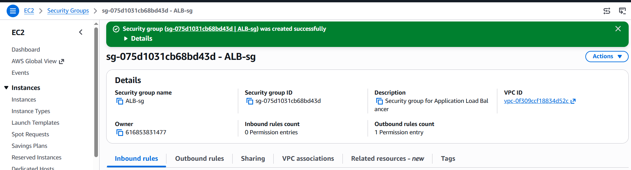

.
.

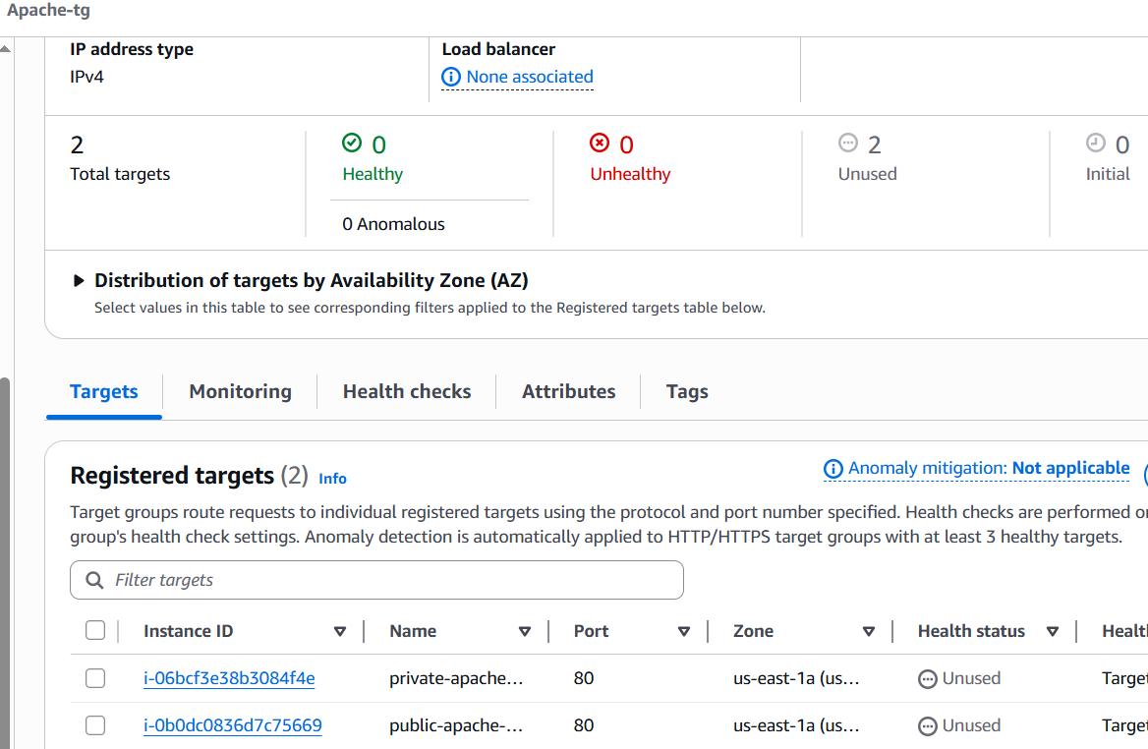

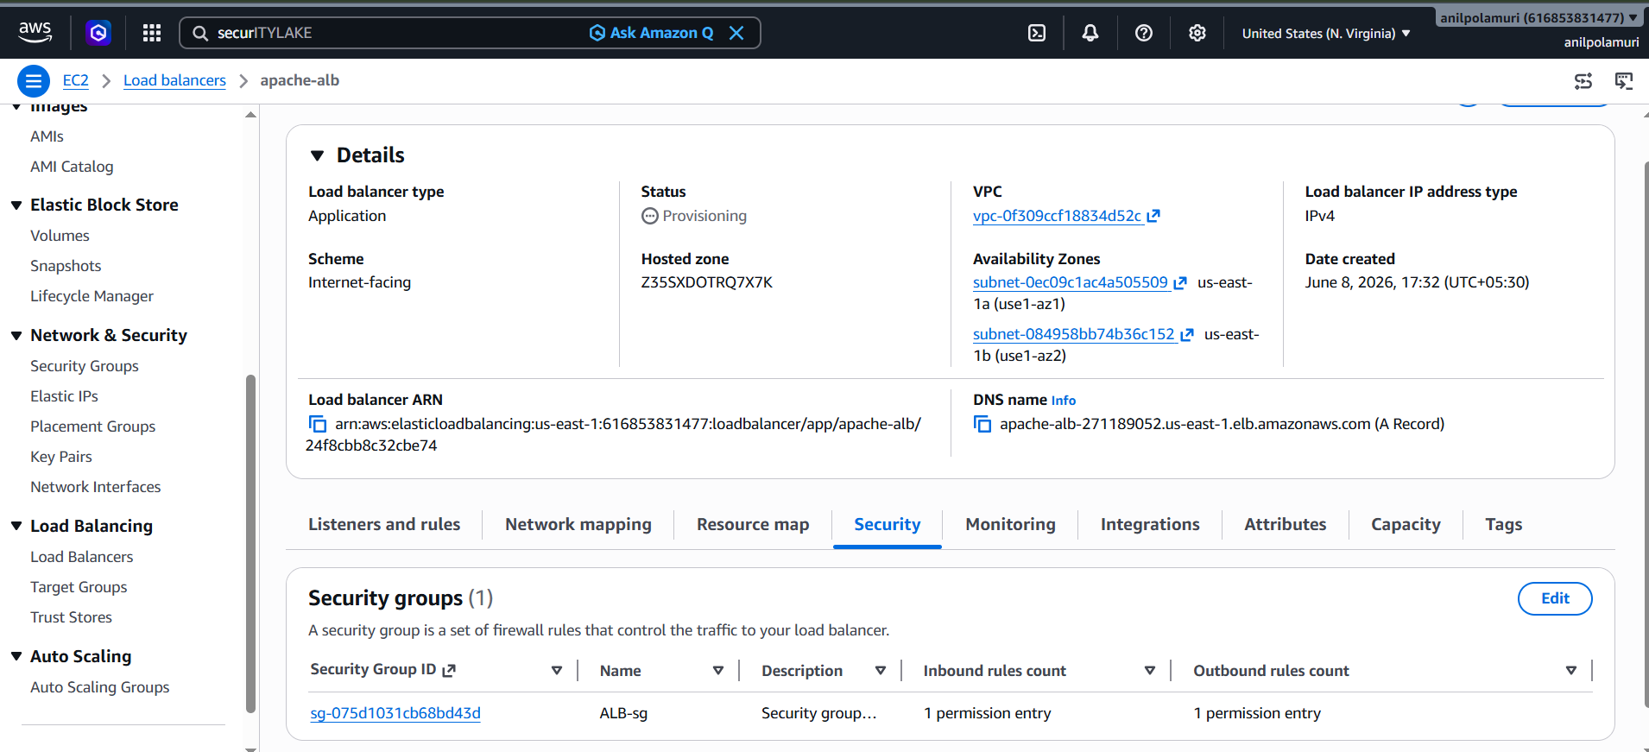

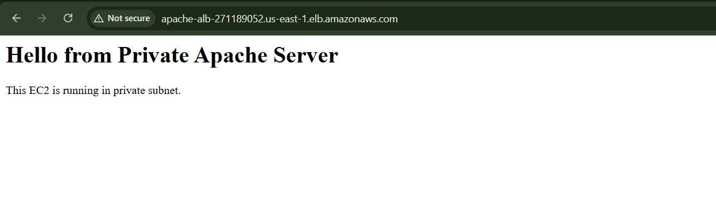

- Store application load balancer logs in S3.

Step 1: Create S3 bucket for ALB logs
Go to:
AWS Console → S3 → Buckets → Create bucket
Enter bucket name:
asg-alb-logs-yourname
Example:
asg-alb-logs-sravya-2026
Important: S3 bucket name must be globally unique.
Select region:
US East (N. Virginia) us-east-1
Keep:
Block all public access: ON
Keep other settings as default.
Click:
Create bucket

Step 2: Open the S3 bucket permissions
Go to:
S3 → Buckets → your ALB logs bucket
Open:
Permissions
Scroll to:
Bucket policy
Click:
Edit

Step 3: Add bucket policy for ALB logs
Paste this policy.
Replace these two values:
YOUR-BUCKET-NAME
YOUR-AWS-ACCOUNT-ID
Bucket policy:
{
"Version": "2012-10-17",
"Statement": [
{
"Sid": "AWSLogDeliveryWrite",
"Effect": "Allow",
"Principal": {
"Service": "logdelivery.elasticloadbalancing.amazonaws.com"
},
"Action": "s3:PutObject",
"Resource": "arn:aws:s3:::YOUR-BUCKET-NAME/AWSLogs/YOUR-AWS-ACCOUNT-ID/*"
},
{
"Sid": "AWSLogDeliveryAclCheck",
"Effect": "Allow",
"Principal": {
"Service": "logdelivery.elasticloadbalancing.amazonaws.com"
},
"Action": "s3:GetBucketAcl",
"Resource": "arn:aws:s3:::YOUR-BUCKET-NAME"
}
]
}

Enable access logs in ALB
Go to:
EC2 → Load Balancers
Select your ALB:
apache-alb
Open:
Attributes
Click:
Edit
Find:
Monitoring
Enable:
Access logs
For S3 URI, enter:
s3://YOUR-BUCKET-NAME
Example:
s3://asg-alb-logs-sravya-2026
Leave prefix empty for now.
Click:
Save changes

Step 6: Generate traffic to ALB
Open your ALB DNS name in browser:
http://ALB-DNS-NAME
Refresh the page multiple times.
Example:
http://apache-alb-123456789.us-east-1.elb.amazonaws.com

Why?
ALB logs are generated only when traffic hits the Load Balancer.

Step 7: Verify logs in S3
Wait around 5–10 minutes.
Then go to:
S3 → your ALB logs bucket → Objects
You should see a folder path like:
AWSLogs/
Open it:
AWSLogs → your-account-id → elasticloadbalancing → us-east-1
Inside, you should see log files ending with:
.log.gz
The log path usually looks like:
AWSLogs/ACCOUNT-ID/elasticloadbalancing/us-east-1/yyyy/mm/dd/

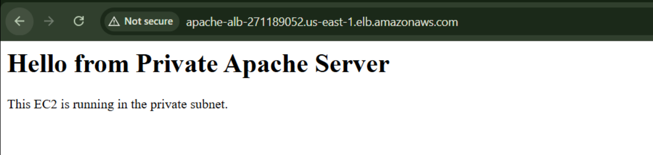
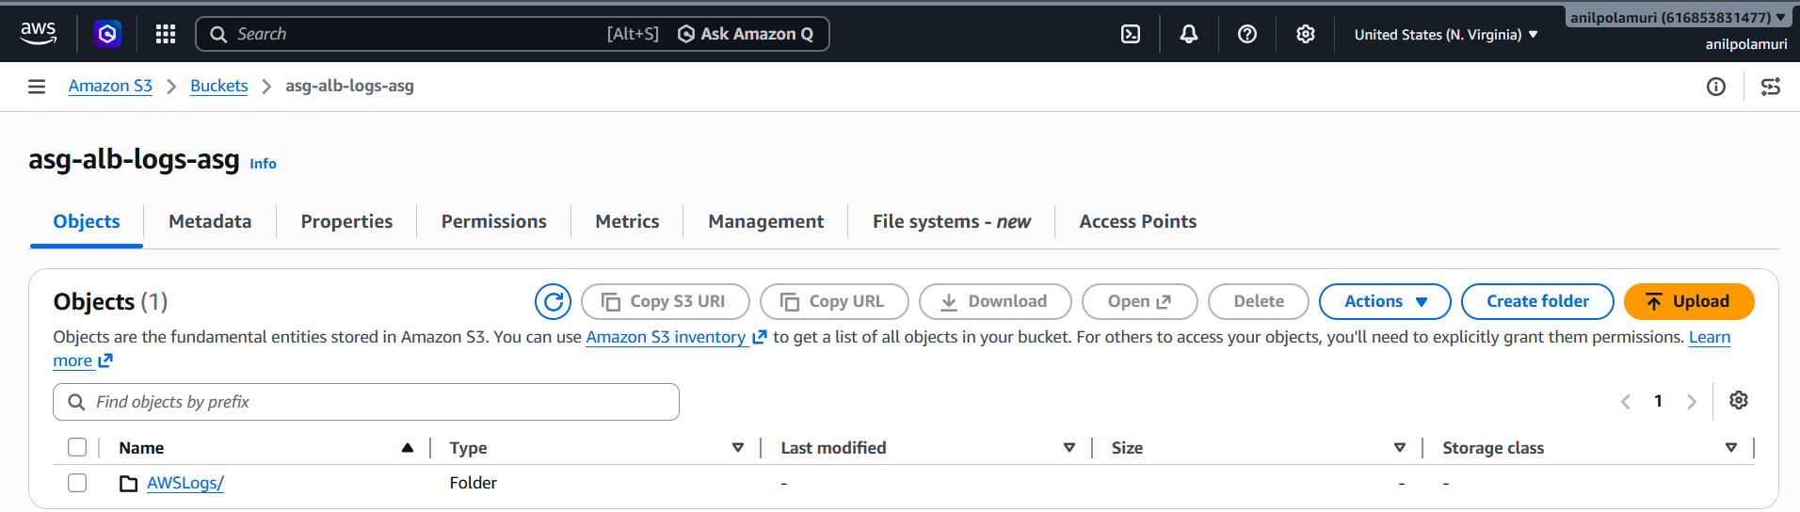
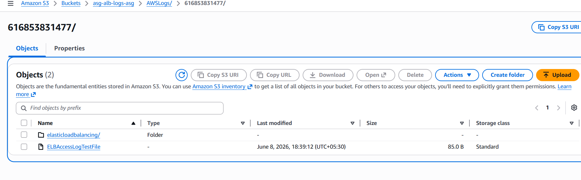

- Store the VPC flow logs in a CloudWatch log group.

Purpose of this task
VPC Flow Logs capture network traffic going in and out of your VPC resources.

Part 1: Create CloudWatch Log Group

Step 1: Go to CloudWatch
Go to:
AWS Console → CloudWatch

Purpose
CloudWatch is the AWS monitoring and logging service. We are using it to store VPC Flow Logs.

Step 2: Open Log Groups
Go to:
Logs → Log groups

Purpose
A log group is like a folder where AWS stores logs.

Step 3: Create Log Group
Click:
Create log group
Enter name:
/aws/vpc/asg-vpc-flowlogs
Click:
Create

Purpose
This log group will store your VPC network traffic logs.
Flow:
VPC traffic → VPC Flow Logs → CloudWatch Log Group

Part 2: Create IAM Role for VPC Flow Logs

Step 4: Go to IAM
Go to:
AWS Console → IAM

Purpose
IAM is used to create permissions. VPC Flow Logs needs permission to write logs into CloudWatch.

Step 5: Create Role
Go to:
IAM → Roles → Create role

Purpose
We are creating a role that the VPC Flow Logs service can use.

Step 6: Select Trusted Entity
Select:
Custom trust policy

Purpose
This role is not for EC2.
It is for the AWS service called:
vpc-flow-logs.amazonaws.com
So we use custom trust policy.

Step 7: Paste Trust Policy
Paste this:
{
"Version": "2012-10-17",
"Statement": [
{
"Effect": "Allow",
"Principal": {
"Service": "vpc-flow-logs.amazonaws.com"
},
"Action": "sts:AssumeRole"
}
]
}
Click:
Next

Purpose
This trust policy allows the VPC Flow Logs service to use this IAM role.
Simple meaning:
VPC Flow Logs service is allowed to assume this role.

Step 8: Add Permissions Page
On the Add permissions page, do not select anything.
Click:
Next

Purpose
We are skipping managed policies because we will create a simple inline policy manually after the role is created.

Step 9: Role Name
Enter role name:
vpc-flowlogs-role
Click:
Create role

Purpose
This creates the IAM role, but it still needs permission to write logs to CloudWatch. We will add that next.

Part 3: Add Inline Policy to IAM Role

Step 10: Open the Role
Go to:
IAM → Roles
Search:
vpc-flowlogs-role
Open it.

Purpose
We need to attach CloudWatch Logs write permissions to this role.

Step 11: Create Inline Policy
Go to:
Permissions → Add permissions → Create inline policy

Purpose
Inline policy is directly attached to this role. It gives this role permission to write logs.

Step 12: Choose JSON
Select:
JSON

Purpose
JSON lets us paste exact permissions instead of searching manually.

Step 13: Paste Permission Policy
Paste this:
{
"Version": "2012-10-17",
"Statement": [
{
"Effect": "Allow",
"Action": [
"logs:CreateLogGroup",
"logs:CreateLogStream",
"logs:PutLogEvents",
"logs:DescribeLogGroups",
"logs:DescribeLogStreams"
],
"Resource": "*"
}
]
}
Click:
Next

Purpose
This policy allows the role to:
Create log streams
Put log events
Describe log groups
Describe log streams
Without this permission, VPC Flow Logs cannot send logs to CloudWatch.

Step 14: Name the Inline Policy
Enter policy name:
vpc-flowlogs-cloudwatch-inline-policy
Click:
Create policy

Purpose
This saves the CloudWatch write permissions inside the IAM role.
Now the role is ready.

Part 4: Create VPC Flow Log

Step 15: Go to VPC
Go to:
AWS Console → VPC

Purpose
VPC Flow Logs are created from the VPC service.

Step 16: Open Your VPC
Go to:
Your VPCs
Select your VPC:
ASG-task

Purpose
We need to capture traffic for this specific VPC.

Step 17: Open Flow Logs Tab
At the bottom, click:
Flow logs
Click:
Create flow log

Purpose
This starts the setup to capture VPC network traffic.

Step 18: Enter Flow Log Name
Enter:
asg-vpc-flowlog

Purpose
This name helps identify the flow log later.

Step 19: Select Filter
Select:
All

Purpose
This captures both:
ACCEPT traffic
REJECT traffic
ACCEPT means traffic was allowed.
REJECT means traffic was blocked.
For troubleshooting, All is best.

Step 20: Select Maximum Aggregation Interval
Select:
1 minute

Purpose
This sends logs faster to CloudWatch. It is useful for testing because you do not have to wait long.

Step 21: Select Destination
Select:
Send to CloudWatch Logs

Purpose
This means VPC Flow Logs will be stored in the CloudWatch log group you created.

Step 22: Select Destination Log Group
Choose:
/aws/vpc/asg-vpc-flowlogs

Purpose
This is where the VPC Flow Logs will be saved.

Step 23: Select IAM Role
Choose:
vpc-flowlogs-role

Purpose
This role gives VPC Flow Logs permission to write into CloudWatch Logs.

Step 24: Select Log Record Format
Choose:
AWS default format

Purpose
Default format is enough for this task. It includes source IP, destination IP, ports, protocol, action, and status.

Step 25: Create Flow Log
Click:
Create flow log

Purpose
This enables VPC Flow Logs for your VPC.
Now AWS will start capturing traffic and sending it to CloudWatch.

Part 5: Generate Traffic

Step 26: Open ALB DNS in Browser
Open your ALB URL:
http://apache-alb-271189052.us-east-1.elb.amazonaws.com
Refresh it 4–5 times.

Purpose
Flow logs are generated only when traffic happens. Opening the ALB creates traffic inside your VPC.

Step 27: Wait 3–5 Minutes
Wait for a few minutes.

Purpose
CloudWatch needs some time to receive and show the flow logs.

Part 6: Verify Logs in CloudWatch

Step 28: Go to CloudWatch Log Group
Go to:
CloudWatch → Logs → Log groups
Open:
/aws/vpc/asg-vpc-flowlogs

Purpose
This is where your VPC Flow Logs should appear.

Step 29: Open Log Stream
Click any log stream.

Purpose
Each log stream contains network traffic records for network interfaces in your VPC.

Step 30: Check Log Records
You should see records with values like:
ACCEPT
REJECT
OK

Purpose
This proves your VPC Flow Logs are successfully stored in CloudWatch.

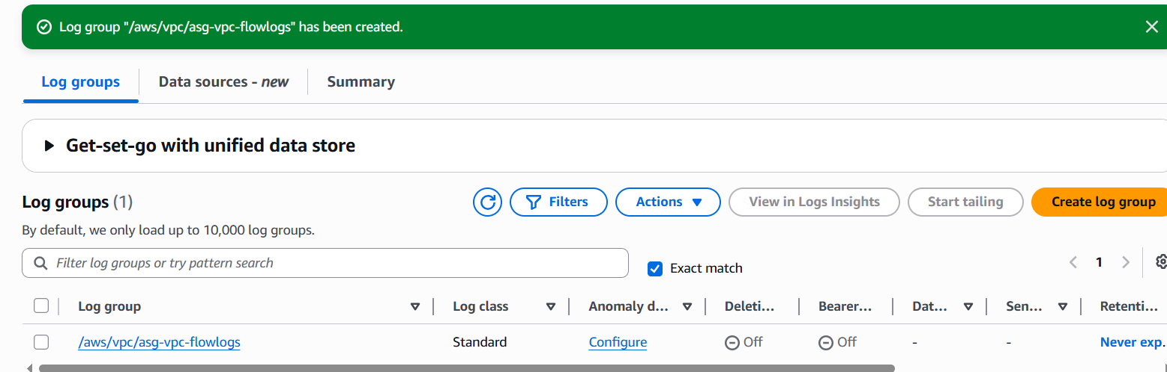

This is where AWS will store your VPC Flow Logs.

Why are we creating IAM Role?
VPC Flow Logs service needs permission to write logs into CloudWatch.
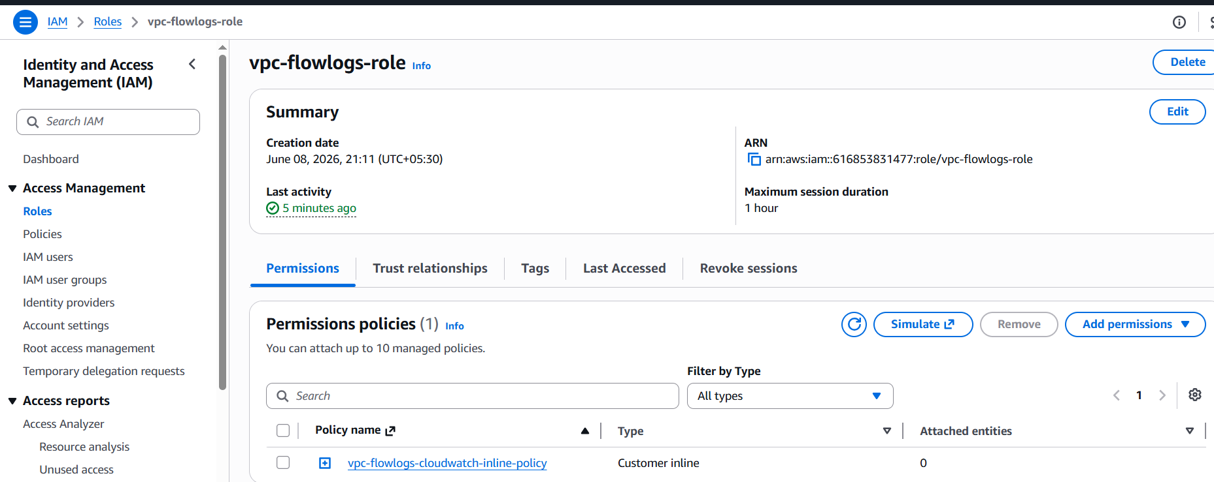
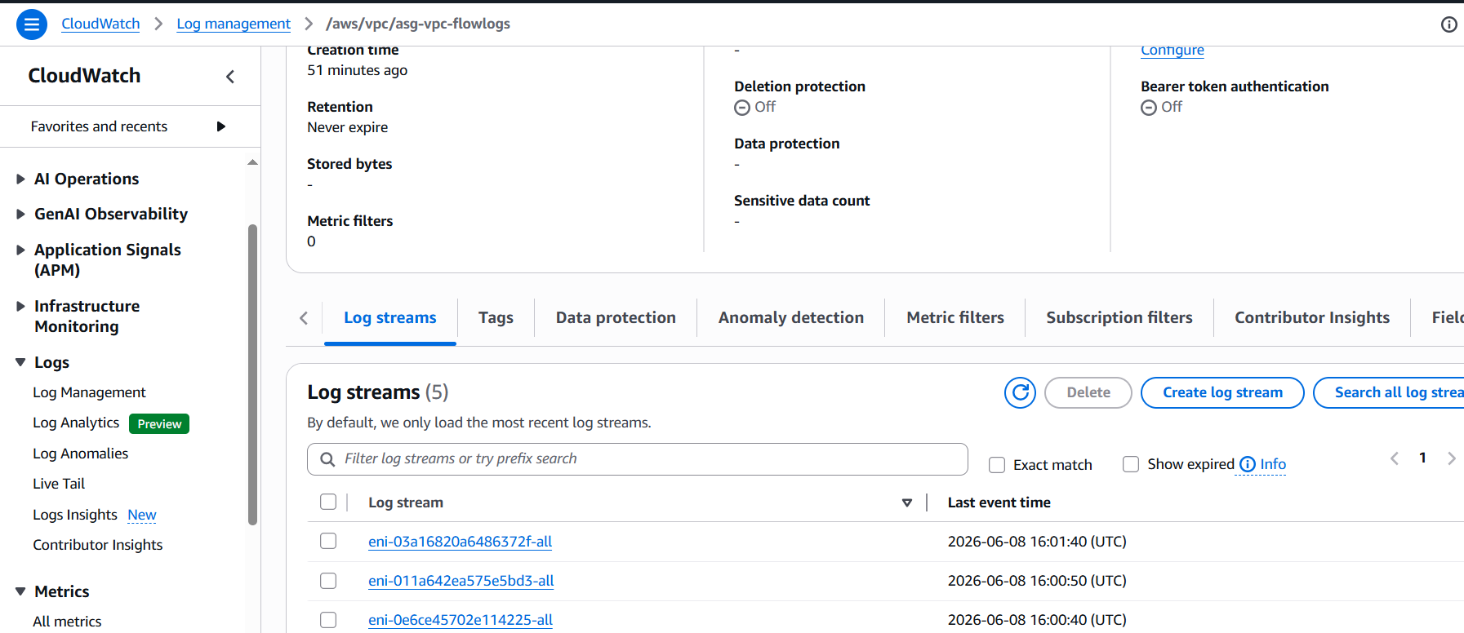

12.If CPU utilization is more than 70%, then it should trigger auto scaling and launch new instance.

Part 1: Create Launch Template

What is Launch Template?
Launch Template is a blueprint for new EC2 instances.
It contains:
AMI
Instance type
Key pair
Security group
User data
IAM role if needed

Why are we creating it?
Auto Scaling needs a template to know how to launch a new instance when CPU crosses 70%.

Step 1: Go to Launch Templates
Go to:
AWS Console → EC2 → Launch Templates
Click:
Create launch template

Step 2: Enter launch template name
Enter:
Launch template name: apache-asg-template

Purpose
This name helps us identify the launch template used by Auto Scaling.

Step 3: Select AMI
Choose:
Amazon Linux 2023 AMI

Purpose
This is the operating system for new Auto Scaling instances.

Step 4: Select instance type
Choose:
t2.micro
or:
t3.micro

Purpose
This decides the CPU and memory size of the new instance. For lab practice, micro instance is enough.

Step 5: Select key pair
Choose the same key pair you used before.
Example:
bashscript
Do not type .pem; select the key pair name from dropdown.

Purpose
This allows you to connect to the new instance later if needed.

Step 6: Select security group
In Network settings, choose:
Select existing security group
Select your EC2 security group.
Example:
web-ec2-sg
or your existing Apache EC2 security group.

Purpose
The new instance must allow traffic from the Load Balancer on port 80.
Your EC2 security group should allow:
HTTP 80 from ALB security group
or if you used VPC CIDR for lab:
HTTP 80 from 10.0.0.0/16

Step 7: Add user data
Scroll down to:
Advanced details → User data
Paste this:
#!/bin/bash
dnf update -y
dnf install -y httpd stress-ng
systemctl enable httpd
systemctl start httpd
INSTANCE_ID=$(curl -s http://169.254.169.254/latest/meta-data/instance-id)
cat > /var/www/html/index.html <<EOF
<html>
<body>
<h1>Hello from Auto Scaling Apache Server</h1>
<p>This instance was launched by Auto Scaling.</p>
<p>Instance ID: $INSTANCE_ID</p>
</body>
</html>
EOF

Purpose
This script runs automatically when the new EC2 is launched.
It will:
Update packages
Install Apache
Install stress-ng for testing
Start Apache
Enable Apache after reboot
Create sample index.html file
So every new instance launched by Auto Scaling is ready to serve traffic.

Step 8: Create launch template
Click:
Create launch template

Verification
Go to:
EC2 → Launch Templates
You should see:
apache-asg-template

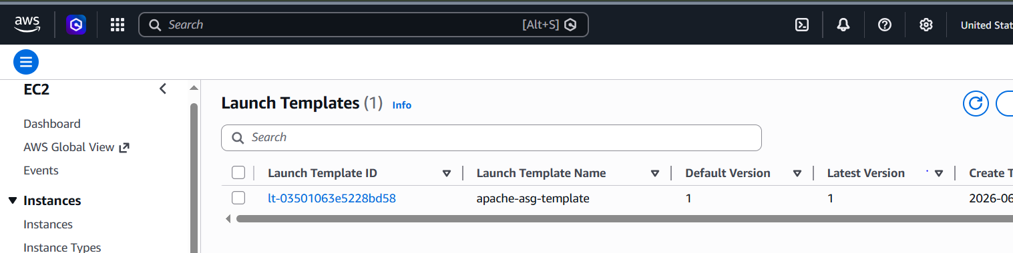

Part 2: Create Auto Scaling Group

What is Auto Scaling Group?
Auto Scaling Group manages EC2 instances automatically.
It can:
Launch new instances
Terminate extra instances
Replace unhealthy instances
Maintain desired capacity

Why are we creating it?
Because CPU-based scaling works only when instances are inside an Auto Scaling Group.

Step 9: Go to Auto Scaling Groups
Go to:
EC2 → Auto Scaling Groups
Click:
Create Auto Scaling group

Step 10: Enter Auto Scaling Group name
Enter:
Auto Scaling group name: apache-asg
Select launch template:
apache-asg-template
Click:
Next

Purpose
This connects the Auto Scaling Group with the launch template.

Step 11: Select VPC
Select your VPC:
VPC: ASG-task

Purpose
New Auto Scaling instances should be launched in the same VPC as your ALB and target group.

Step 12: Select subnet
Select your private subnet.
Example:
private subnet → 10.0.2.0/24

Purpose
In real projects, application servers are usually placed in private subnets. Users do not directly access them. Users access the ALB, and ALB forwards traffic to private instances.
Flow:
User
↓
ALB in public subnet
↓
ASG EC2 in private subnet
Click:
Next

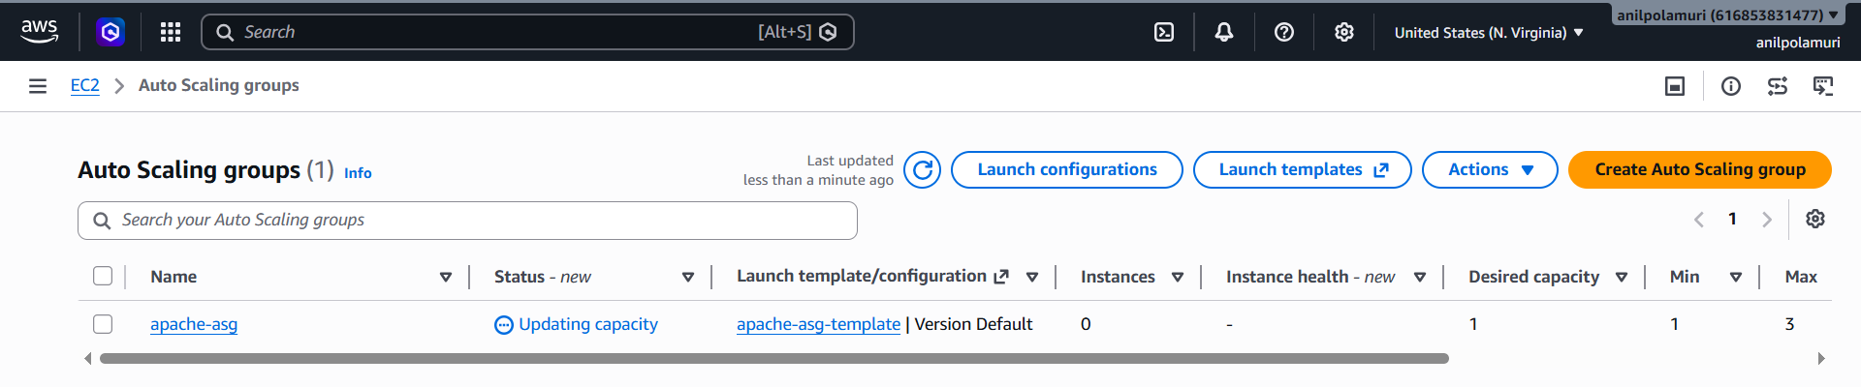

Create CPU Scaling Policy

Purpose
This is the main condition of the task:
If CPU utilization is more than 70%, launch a new instance.
A scaling policy tells Auto Scaling when to increase or decrease capacity.

Steps
Go to:
EC2 → Auto Scaling Groups → apache-asg
Open:
Automatic scaling
Click:
Create dynamic scaling policy
Select:
Target tracking scaling policy
Enter:
Policy name: cpu-70-scaling-policy
Metric type: Average CPU utilization
Target value: 70
Click:
Create
Purpose:
When average CPU goes above 70%, Auto Scaling launches another EC2 instance.

6. Verify CloudWatch Alarms

Purpose
When you create a target tracking policy, AWS automatically creates CloudWatch alarms.
There are usually two alarms:
AlarmHigh → scale out / launch new instance
AlarmLow → scale in / reduce instance

Steps
Go to:
CloudWatch → Alarms
You should see alarms like:
TargetTracking-apache-asg-AlarmHigh
TargetTracking-apache-asg-AlarmLow
Purpose:
AlarmHigh triggers when CPU is high.
AlarmLow triggers when CPU is low.

7. Connect to Auto Scaling Instance

Purpose
To test scaling, we need to increase CPU on the instance that belongs to the Auto Scaling Group.

Steps
Go to:
EC2 → Instances
Find the instance launched by Auto Scaling.
Check:
Auto Scaling group: apache-asg
If it is in the private subnet, connect through public EC2:
Your laptop → Public EC2 → ASG private EC2
From public EC2:
ssh -i bashscript.pem ec2-user@ASG_PRIVATE_IP
Example:
ssh -i bashscript.pem ec2-user@10.0.2.48

8. Verify Apache on ASG Instance

Purpose
This confirms the launch template user data worked and Apache is running on the Auto Scaling instance.

Steps
Inside ASG instance, run:
sudo systemctl status httpd
Expected:
Active: active (running)
Press:
q
Test webpage locally:
curl localhost
Expected:
Hello from Auto Scaling Apache Server

9. Generate High CPU Load

Purpose
We need to make CPU go above 70% to trigger Auto Scaling.
Since stress-ng was not available, we used the yes command to generate CPU load.

Steps
Inside ASG instance, run:
yes > /dev/null &
yes > /dev/null &
yes > /dev/null &
yes > /dev/null &
yes > /dev/null &
Check CPU:
top
You should see multiple yes processes using CPU.
Example:
yes → 20% CPU
yes → 20% CPU
yes → 20% CPU
yes → 20% CPU
yes → 20% CPU
Together, CPU goes above 70%.
Press:
q
to exit top.

10. Check AlarmHigh

Purpose
This confirms CloudWatch detected high CPU.

Steps
Go to:
CloudWatch → Alarms
Watch:
TargetTracking-apache-asg-AlarmHigh
Expected:
In alarm
Purpose:
AlarmHigh means CPU crossed the configured threshold and Auto Scaling action should trigger.

11. Check Auto Scaling Activity

Purpose
This proves Auto Scaling reacted to high CPU and launched a new instance.

Steps
Go to:
EC2 → Auto Scaling Groups → apache-asg → Activity
Check for activity like:
Launching a new EC2 instance
or:
Successfully launched instance

12. Verify New Instance Launched

Purpose
This confirms the scaling action worked.

Steps
Go to:
EC2 → Instances
You should see a new instance launched by Auto Scaling.
Check:
Auto Scaling group: apache-asg
Now you may have more than one ASG instance.

13. Verify Target Group Health

Purpose
The new instance should automatically attach to the ALB Target Group and become healthy.

Steps
Go to:
EC2 → Target Groups → Apache-tg → Targets
Wait a few minutes.
Expected:
New ASG instance → Healthy
Purpose:
This proves the new instance joined the ALB target group and can receive traffic.

14. Stop CPU Load

Purpose
After testing, stop the CPU load so the instance does not stay overloaded.

Steps
Go back to ASG instance terminal and run:
pkill yes
Check:
top
The yes processes should be gone.

