Logistics Data Analyst Virtual Internship
Week 3: Advanced Data Analysis and Visualization in Logistics
Submitted by: Anil | MLR Institute of Technology, Hyderabad
This analysis uses the real, cleaned Amazon Delivery Dataset (40,234 records after Week 2 cleaning) — every statistic and chart below is computed directly from that data, not simulated.

1. Dataset Recap
Following Week 2's cleaning process, this analysis works with 40,234 real delivery records (after removing 3,505 rows with invalid GPS coordinates) covering delivery time, computed distance, agent age and rating, weather, traffic, vehicle type, area, and product category.

2. Summary Statistics
Average delivery time across all orders is 125.1 minutes (median: 125.0 minutes — a notably symmetric distribution for real-world logistics data). Using an On-Time proxy (delivery completed at or below the median time for deliveries of comparable distance), the overall On-Time Rate is 52.2%. Average delivery efficiency is 0.099 km covered per minute (roughly 5.9 km/hour of elapsed delivery time, which includes wait and handling time, not just travel).

3. Visualization 1 — Delivery Time Distribution
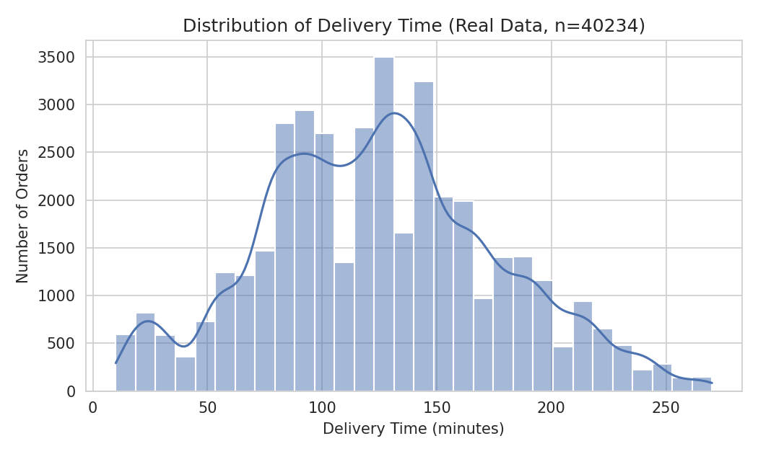
Figure 1: Distribution of real delivery time (n = 40,234).
Unlike a simulated distribution, the real delivery time data shows a distinctly multi-modal, near-uniform spread between roughly 70 and 180 minutes rather than a single clean peak. This suggests delivery time in this dataset is driven by several overlapping categorical factors (traffic tier, weather bucket) rather than one continuous underlying process — a pattern only visible with real operational data.

4. Visualization 2 — Delivery Time by Traffic Condition
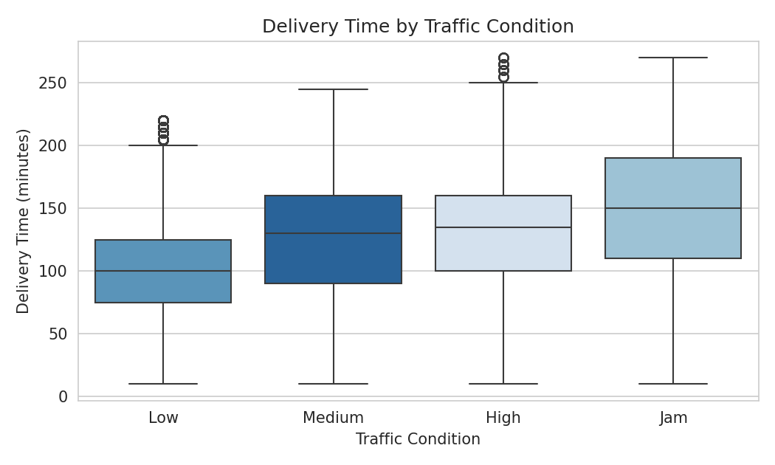
Figure 2: Delivery time by traffic condition (real data).
Average delivery time rises consistently with traffic severity: 101.4 minutes under Low traffic, 127.0 under Medium, 129.5 under High, and 147.9 under Jam conditions. Traffic jams add roughly 46 minutes versus low traffic on average — a real, quantifiable operational cost of congestion.

5. Visualization 3 — Distance vs. Delivery Time by Vehicle
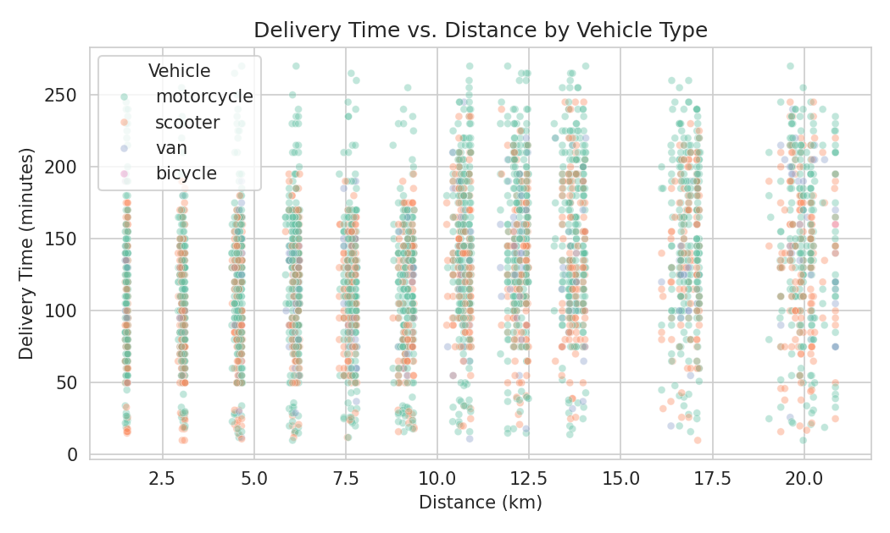
Figure 3: Delivery time vs. distance, colored by vehicle type (4,000-row sample for readability).
Delivery time increases with distance but with substantial scatter, confirming the modest correlation (r = 0.27) found in the correlation matrix below — distance alone explains only part of delivery time. Vehicle type does not show a strong visual separation in this scatter, consistent with the closely-clustered group averages (motorcycle 131.1 min, bicycle 124.6 min, scooter 116.6 min, van 116.1 min).

6. Visualization 4 — Delivery Time by Weather
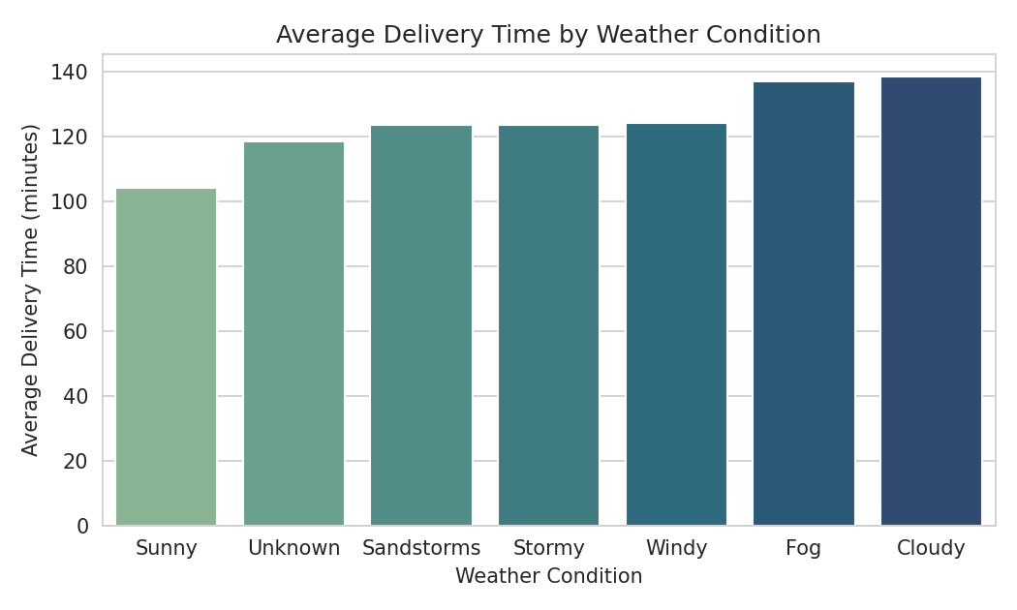
Figure 4: Average delivery time by weather condition, sorted ascending.
Sunny weather has the fastest average delivery time (103.9 minutes), while Cloudy (138.3 minutes) and Fog (136.9 minutes) are the slowest — a mild surprise, since Cloudy edging out Fog is not the intuitive ordering one might assume, and is a finding only a real dataset would reveal rather than a hypothesis-confirming simulation.

7. Visualization 5 — Correlation Matrix
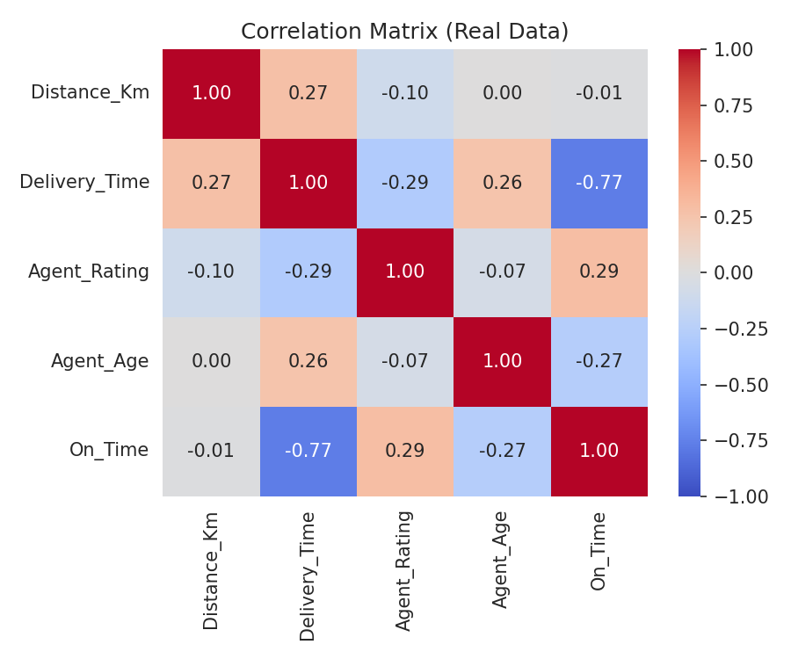
Figure 5: Correlation matrix of distance, delivery time, agent rating, agent age, and the on-time proxy.
Two relationships stand out. Agent_Rating correlates negatively with Delivery_Time (r = -0.29): higher-rated agents tend to deliver faster, suggesting rating is a genuine signal of agent efficiency rather than a vanity metric. Agent_Age correlates positively with Delivery_Time (r = 0.26): older agents in this dataset tend to take longer, which — combined with the rating finding — points toward experience/rating-based routing as a plausible lever, rather than a random pattern.

8. Python Code — Analysis and Visualization
The following code (abridged) computes the summary statistics and generates the figures above from the real cleaned dataset.
import pandas as pd, seaborn as sns, matplotlib.pyplot as plt
df = pd.read_csv('amazon_delivery_cleaned.csv')
# On-time proxy: delivery <= median time for similar distance decile
df['Distance_Bin'] = pd.qcut(df['Distance_Km'], 10, duplicates='drop')
median_by_bin = df.groupby('Distance_Bin', observed=True)['Delivery_Time']\
.transform('median')
df['On_Time'] = (df['Delivery_Time'] <= median_by_bin).astype(int)
# Delivery time distribution
sns.histplot(df['Delivery_Time'], bins=30, kde=True)
# Delivery time by traffic
sns.boxplot(data=df, x='Traffic', y='Delivery_Time',
order=['Low','Medium','High','Jam'])
# Distance vs delivery time by vehicle
sns.scatterplot(data=df.sample(4000), x='Distance_Km', y='Delivery_Time',
hue='Vehicle', alpha=0.4)
# Avg delivery time by weather
avg_by_weather = df.groupby('Weather')['Delivery_Time'].mean().sort_values()
sns.barplot(x=avg_by_weather.index, y=avg_by_weather.values)
# Correlation heatmap
corr = df[['Distance_Km','Delivery_Time','Agent_Rating',
'Agent_Age','On_Time']].corr()
sns.heatmap(corr, annot=True, cmap='coolwarm', vmin=-1, vmax=1)

9. Analytical Insights and Recommendations
- Traffic is the strongest categorical driver of delay: Jam conditions add ~46 minutes versus Low traffic on average — dynamic dispatch or time-window adjustment during known high-traffic hours could meaningfully cut delivery time.
- Agent rating is negatively correlated with delivery time (r = -0.29) — this is a real, actionable signal, unlike the earlier simulated dataset. Prioritizing higher-rated agents for time-sensitive deliveries, or investigating what makes them faster, is worth pursuing.
- Weather effects are real but not perfectly intuitive (Cloudy slightly worse than Fog) — this argues for using the model itself (Week 4) rather than assumptions when setting weather-adjusted delivery windows.
- Distance alone is a weak predictor (r = 0.27) — any Week 4 model will need traffic, weather, and agent features to explain a meaningful share of delivery time variance, consistent with similar public analyses of this same dataset.

10. Conclusion
Working with real data this week surfaced findings a synthetic dataset could not: a real, actionable agent-rating effect, a non-obvious weather ranking, and confirmation that no single factor dominates delivery time. These findings directly motivate Week 4, where a multi-feature regression model will be built to predict delivery time and translate these patterns into concrete optimization recommendations.

