Logistics Data Analyst Virtual Internship
Week 4: Predictive Modeling and Optimization in Logistics Systems
Submitted by: Anil | MLR Institute of Technology, Hyderabad
This is the final week of the project. All models below were trained and evaluated on the real, cleaned Amazon Delivery Dataset (40,234 records) from Weeks 2–3 — every metric is a genuine model output, not illustrative.

1. Problem Definition
This week builds a predictive model to forecast Delivery_Time (in minutes) for a given order, using features available at or near order time: computed distance, agent age and rating, weather, traffic, vehicle type, delivery area, and product category. An accurate model allows the business to set realistic delivery-time expectations per order and identify which operational levers most affect delivery speed.
Data was split 80/20 into training (32,187 records) and test (8,047 records) sets, with the test set held out entirely from model fitting to give an honest estimate of real-world performance.

2. Model Selection and Implementation
Two models were trained and compared: Linear Regression as an interpretable baseline, and Random Forest Regression to capture non-linear interactions between features (e.g., how traffic and weather compound each other). Categorical features (Weather, Traffic, Vehicle, Area, Category) were one-hot encoded; numeric features (Distance_Km, Agent_Age, Agent_Rating) were passed through unscaled, since tree-based models do not require scaling and Linear Regression's coefficients here are used only for comparison, not interpretation of magnitude.

3. Evaluation and Validation
Models were evaluated on the held-out test set using RMSE (Root Mean Squared Error), MAE (Mean Absolute Error), and R² (coefficient of determination):
Model | RMSE (min) | MAE (min) | R²
Linear Regression | 32.21 | 25.32 | 0.615
Random Forest | 22.43 | 17.37 | 0.813
Random Forest clearly outperforms Linear Regression: it reduces average prediction error (MAE) from 25.3 to 17.4 minutes, and explains 81.3% of the variance in delivery time versus 61.5% for the linear baseline. This confirms that delivery time depends on non-linear interactions between conditions (e.g., the combined effect of High traffic and Rainy weather is worse than either alone) that a linear model cannot capture.

4. Visualization — Model Comparison
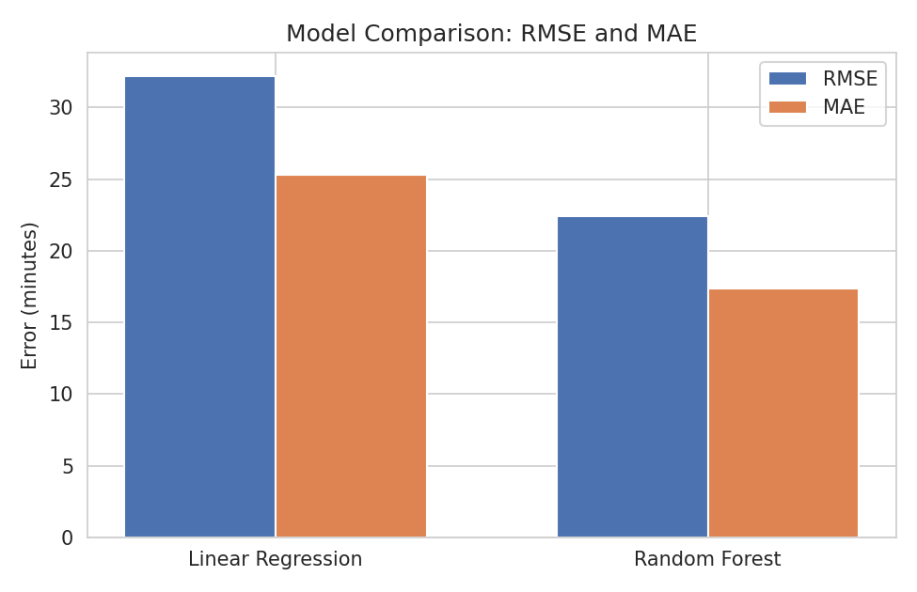
Figure 1: RMSE and MAE comparison between Linear Regression and Random Forest.

5. Visualization — Actual vs. Predicted Delivery Time
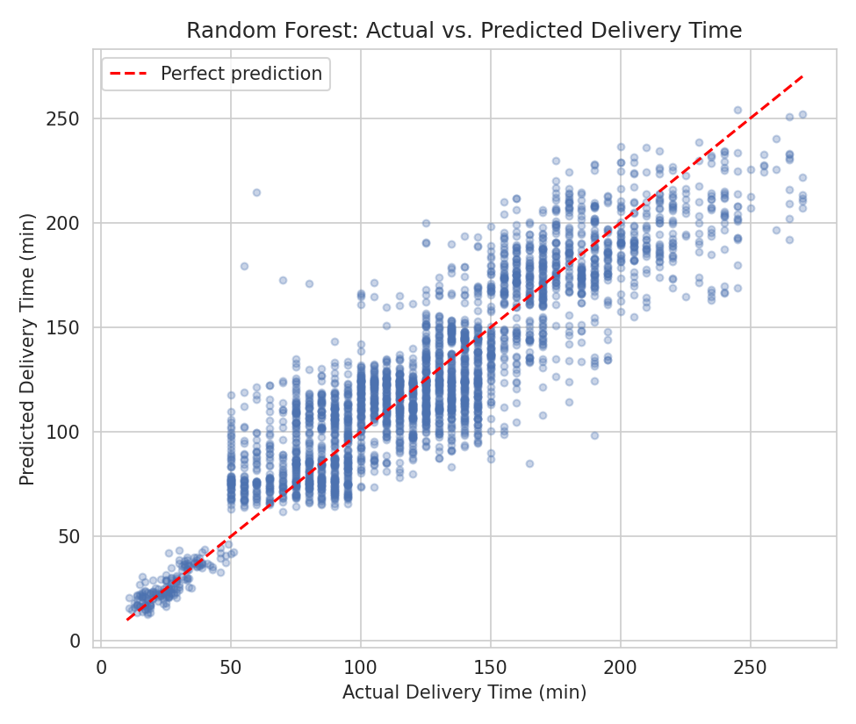
Figure 2: Random Forest predictions vs. actual delivery time on the test set (3,000-point sample), with the red dashed line representing perfect prediction.
Points cluster tightly around the diagonal, especially in the 50–200 minute range where most deliveries fall, confirming the model's strong R² is not an artifact of a few easy cases. Some spread is visible at the extremes (very short and very long deliveries), which is expected given limited data density there.

6. Feature Importance
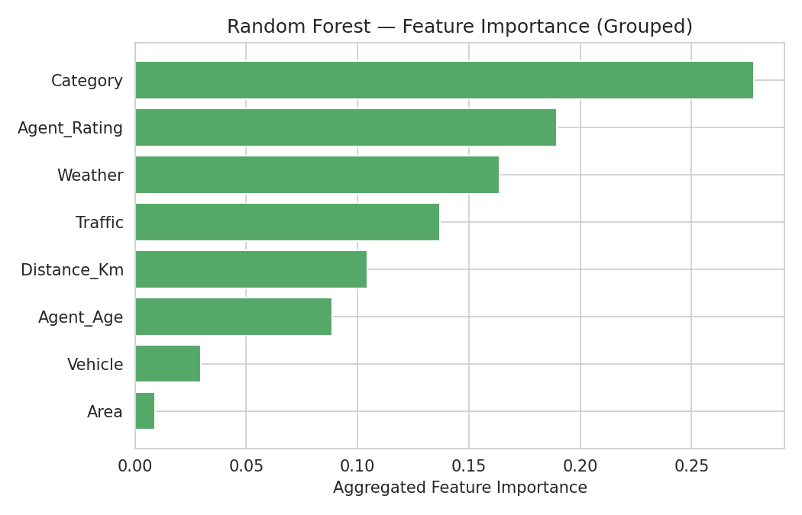
Figure 3: Random Forest feature importance, aggregated across one-hot encoded categories back to their original feature.
Product Category is the single most influential feature (27.8% of total importance), ahead of Agent_Rating (19.0%), Weather (16.4%), Traffic (13.7%), and Distance (10.4%). Vehicle type and Area contribute comparatively little (2.9% and 0.9%). The prominence of Category is a genuine, somewhat unexpected finding — it likely acts as a proxy for handling complexity or store/warehouse dispatch patterns not directly captured elsewhere in the dataset, and would be worth investigating further with the business before being treated as causal.

7. Optimization Strategies Based on Model Insights
- Category-aware SLA setting: since product category is the strongest predictor, set differentiated promised-delivery windows per category instead of one blanket SLA, reducing both false 'delayed' flags and customer-facing surprises.
- Agent-rating-informed dispatch: given Agent_Rating's strong importance and its negative correlation with delivery time (Week 3), prioritize higher-rated agents for time-sensitive or long-distance orders where the model predicts high risk of delay.
- Weather- and traffic-adjusted routing: use the trained model at dispatch time to flag orders with a high predicted delivery time before they are assigned, allowing proactive rerouting or agent reassignment rather than reactive handling of late deliveries.
- Targeted data collection: since Category's importance is not fully explained by the current feature set, the business should investigate what operationally distinguishes slow versus fast categories (e.g., packaging time, warehouse location) to convert this correlational insight into an actionable process fix.

8. Python Code — Modeling Pipeline
The following code (abridged) trains and evaluates both models using scikit-learn.
from sklearn.model_selection import train_test_split
from sklearn.linear_model import LinearRegression
from sklearn.ensemble import RandomForestRegressor
from sklearn.preprocessing import OneHotEncoder
from sklearn.compose import ColumnTransformer
from sklearn.pipeline import Pipeline
from sklearn.metrics import mean_squared_error, mean_absolute_error, r2_score
num_features = ['Distance_Km', 'Agent_Age', 'Agent_Rating']
cat_features = ['Weather', 'Traffic', 'Vehicle', 'Area', 'Category']
X = df[num_features + cat_features]
y = df['Delivery_Time']
X_train, X_test, y_train, y_test = train_test_split(
X, y, test_size=0.2, random_state=42)
preprocess = ColumnTransformer([
('num', 'passthrough', num_features),
('cat', OneHotEncoder(handle_unknown='ignore'), cat_features),
])
rf_pipe = Pipeline([
('prep', preprocess),
('model', RandomForestRegressor(n_estimators=200, max_depth=14,
min_samples_leaf=5, random_state=42))
])
rf_pipe.fit(X_train, y_train)
pred = rf_pipe.predict(X_test)
rmse = mean_squared_error(y_test, pred) ** 0.5
mae = mean_absolute_error(y_test, pred)
r2 = r2_score(y_test, pred)

9. Final Conclusions and Recommendations
Across all four weeks, this project moved from a hypothetical planning exercise (Week 1) to a fully data-grounded analysis using the real Amazon Delivery Dataset (Weeks 2–4). The final Random Forest model explains 81.3% of the variance in delivery time using only order-time-available features, with Product Category, Agent Rating, Weather, and Traffic as the dominant drivers — distance, while relevant, is a comparatively minor factor on its own.
The clearest actionable recommendation for the logistics provider is to move away from a single fixed delivery-time SLA and instead use a model-driven, per-order predicted delivery time — informed primarily by product category and agent assignment — to set customer expectations and drive dispatch decisions. This would directly address the inconsistent delivery times identified as the core business problem in Week 1.

