

**IBM CAREER EDUCATION**

**MAIN PROJECT**

**DOMAIN NAME: JAVA**

**AIRLINE MANAGEMENT SYSTEM**

**Submitted By,**

PRAJAPATI ANIL GANESHBHAI CBA(18082271004)

GOSWAMI RAHUL CBA(18162101028)

II Year – (CBA) ‘A’ Section Ganpat University, Ahmedabad.

**Submitted To,**

A.Saai Sanjeev Achaarya

IBM Software Technical Trainer

**COLLEGE MANAGEMENT SYSTEM**

**FLOW CHART**

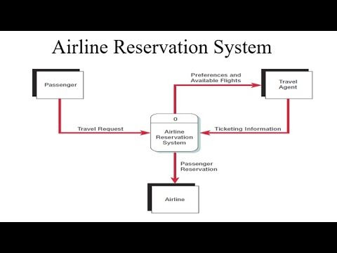

**COLLEGE MANAGEMENT SYSTEM**

**SOFTWARE SPECIFICATIONS**

➢ OPERATING SYSTEM : PARROT OS(LINUX)

➢ ENVIRONMENT : IBM RAD Software

**HARDWARE SPECIFICATIONS**

➢PROCESSOR : INTEL(R)CORE™i3-7020U CPU @ 2.30GHz

➢RAM : 8GB RAM

➢MONITOR : 15” COLOR

➢HARD DISK : 1 TB

**AIRLINE MANAGEMENT SYSTEM**

**DESCRIPTION**

**INTRODUCTION:**

Air travel has become less and less cheaper over the years, as a result the no: of passengers has increased considerably. Unlike a train or bus ticket where we have to stand in a queue besides a counter, air tickets are usually booked online. The proposed system is a web portal where the user can book their air travel tickets between two cities online on a particular date. There will be a provision for searching the flights for a travel destination on an input date, the search result will comprise of the full details such as flight no, flight name, cost, arrival and departure time etc. A cancellation option is also given in case user wishes to abandon his travel for various reasons.

**ADVANTAGES:-**

* Easy to book tickets.
* Saves time and money.
* Provides every information about **flight**.
* 24/7 customer support through chat and calls.
* Mobile Availability.
* Send automated tickets to the customer by mail.
* Easy Refund Policies.
* Available for both Domestic and International **Airlines**.

**DISADVANTAGES:-**

WE DON’T HAVE A DATABASE .