TapFin Website — Page Content
Page 01: Landing Page (Home)
Source: Website_structure_Sept2026.docx

How to read this document
- Black text is the website copy. It is taken word for word from the source document. Do not edit it.
- GREY CAPITAL LABELS (HEADING, SUBHEADING, BUTTON, etc.) name each element. They are not shown on the website.
- Builder notes in grey italics are layout instructions from the source document. They are not shown on the website.
- [Square brackets] mark a button or a form field, as written in the source.
- Red text marks content that is missing from the source and still needs to be provided.
- Sample design images are layout references only. Where an image's text differs from the copy, use the copy in this document.
- Open questions about the content are listed at the end of the document under "Items to confirm".

Page outline
# | Section | Contents
— | Header / Navigation | Menu: Finance | Data Analytics | Why TapFin | Insights | Login | Request a Demo
1 | Hero (What TapFin is) | Headline, subheadline, [Request a demo] button
2 | Why TapFin? (What we do?) | Heading, 3 stats, 3 cards
3 | Who we are? | About Us, Our Vision, Our Mission, Why now?, The People Behind TapFin (Founders), The Team
4 | CTA | Get a callback form, Contact us

Header / Navigation
MENU ITEMS (CATEGORIES)
Finance | Data Analytics | Why TapFin | Insights | Login | Request a Demo
Builder note: Dropdown items and click actions below are taken from the Website Navigation Structure image in the source document.
Menu item | Dropdown items | Action
Finance | GoGreen Capital  Tap Fintech  • Apply for Loans  • Partner with TapFin for Lending | GoGreen Capital: Redirects to gogreencapital.in  Apply for Loans: Leads to loan application flow  Partner with TapFin for Lending: Leads to lender partnership form
Data Analytics | TRUST  FleetForce  TapFin Xchange | Each opens its Product page
Why TapFin | — | Scrolls to the Why TapFin section on the home page (Section 2 of this page)
Insights | Blogs  Life at TapFin  TapFin in News | Blogs: Blog section  Life at TapFin: Careers / culture  TapFin in News: Press / media
Login | — | Redirects to TapFin.ai
Request a Demo | — | Redirects to Contact us form (Section 4 of this page)

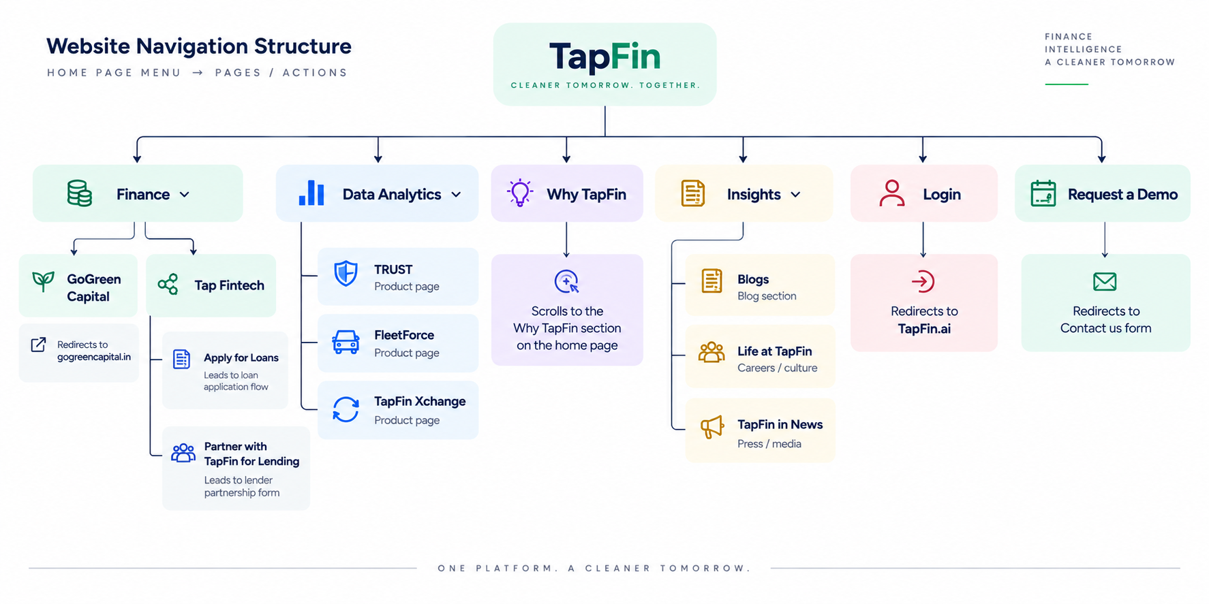
Sample design / IA reference: Website Navigation Structure (from source document)

Section 1: Hero (What TapFin is)
HEADLINE
Finance. Analyse. Resale.
SUBHEADLINE
One ecosystem for the entire asset lifecycle - every OEM, IoT, form factor, fuel technology and geography.
BUTTON
[Request a demo]

Section 2: Why TapFin? (What we do?)
Builder note: This is the section the "Why TapFin" menu item scrolls to.
SECTION HEADING
Deep asset intelligence. Smarter decisions at every stage
STATS INTRO
Built on
Builder note: Source: "Built on (with three buttons, placed side-by-side):". Show the three stats below side by side.
Stat 1 | Stat 2 | Stat 3
1.91B+  Data points processed | 42.2M+  Kilometres analysed | 10+  Lender partners

CARDS
Builder note: Source: "Below which, will be 3 cards which will read:"

Card 1
CARD TITLE
Finance:
CARD DESCRIPTION
Smarter financing, powered by asset intelligence.
CARD POINTS
- GoGreen Capital: Data-backed in-house NBFC
- Tap Fintech: End-to-end loan application processing with 10+ Lending Partners

Card 2
CARD TITLE
Intelligence:
CARD DESCRIPTION
Usage-based intelligence for performance and risk decisions.
CARD POINTS
- TRUST: Data-based decisions across underwriting, monitoring, collections & resale
- FleetForce: Operational intelligence across behaviour, utilisation, profitability & lifecycle

Card 3
CARD TITLE
Resale Marketplace:
CARD DESCRIPTION
Unlock the Right value of every asset.
CARD POINTS
- TapFin Xchange: Usage-backed resale valuation for pre-owned EVs

Section 3: Who we are?

3.1 About Us
HEADING
About Us:
BODY
TapFin is building what we believe the sustainability ecosystem has been missing - a unified layer that sits at the intersection of financing, asset intelligence and resale across the entire lifecycle. Built by people who understand assets from the ground up, we combine real-world operations, data and AI to turn asset data into informed decisions.

3.2 Our Vision
HEADING
Our Vision:
BODY
[Content not provided]

3.3 Our Mission
HEADING
Our Mission:
BODY
[Content not provided]

3.4 Why now?
EYEBROW / SECTION LABEL
Why now?
HEADING
EVs are not just vehicles. They are connected, data-rich assets.
GRAPHIC TEXT
Builder note: Source: "Image that says:". Use this text inside the graphic.
Modern EV journey generates millions of data points:
GPS, Mileage, Battery health, utilisation, charging pattern, driving behaviour, trip completion, revenue.
SILOS INTRO
Yet decisions across the asset lifecycle are still often made in silos:
SILO POINTS
- FINANCING: Buruea and borrower creditworthiness
- INTELLIGENCE: Mileage, GPS and trip completion
- RESALE: No. of ownerships and asset age
TAPFIN STATEMENT
TapFin's AI algorithms turn continuously generated asset data into AI-enabled actionable intelligence across the lifecycle.
OUTCOMES (3 ITEMS)
Outcome 1 | Outcome 2 | Outcome 3
Finance with confidence | Monitor with early risk signals | Usage-based resale
Informed underwriting, risk and collections intelligence for lenders | Mitigate operational loopholes and optimise performance. | Transparent and utilisation-based pricing

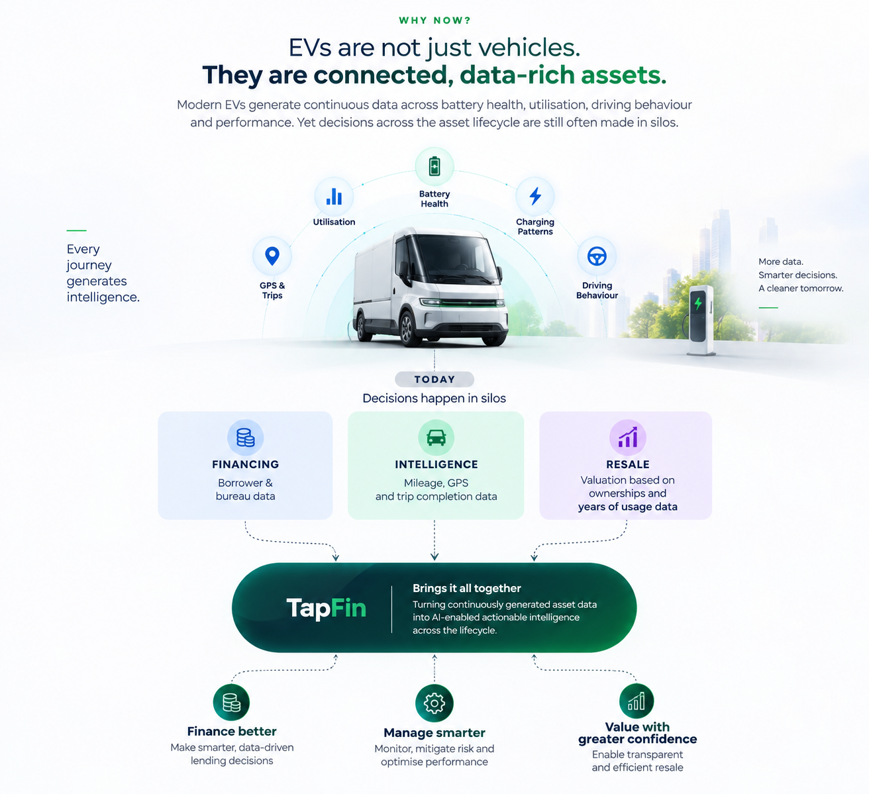
Sample design: Why now? (layout reference only; use the copy above)

3.5 The People Behind TapFin (Founders)
HEADING
The People Behind TapFin:
SUBHEADING
Founders:
Builder note: (2 cards with the photo and a short description of the CoFounder's profile)

Founder card 1
NAME
Aditya Singh
TITLE
Co-Founder & CEO, TapFin
BIO
A fintech and mobility technology entrepreneur with 20+ years across EVs, financing, technology and financial services, Aditya co-founded and scaled CreditMate for 5 years, before its acquisition by Paytm.
EDUCATION
Education: MBA, XLRI Jamshedpur | IT, Delhi University
PHOTO
[Photo to be provided]

Founder card 2
NAME
Terniza Berry
TITLE
CoFounder and COO, TapFin
BIO
A banking and fintech leader with 20+ years across SME and retail banking, supply chain financing, and regulatory compliance, Terniza spent 16+ years at HSBC, including as Interim COO of Wholesale Banking, before moving into electric mobility as COO of MoEVing Fintech.
EDUCATION
MBA, XLRI Jamshedpur | CBS Delhi
PHOTO
[Photo to be provided]
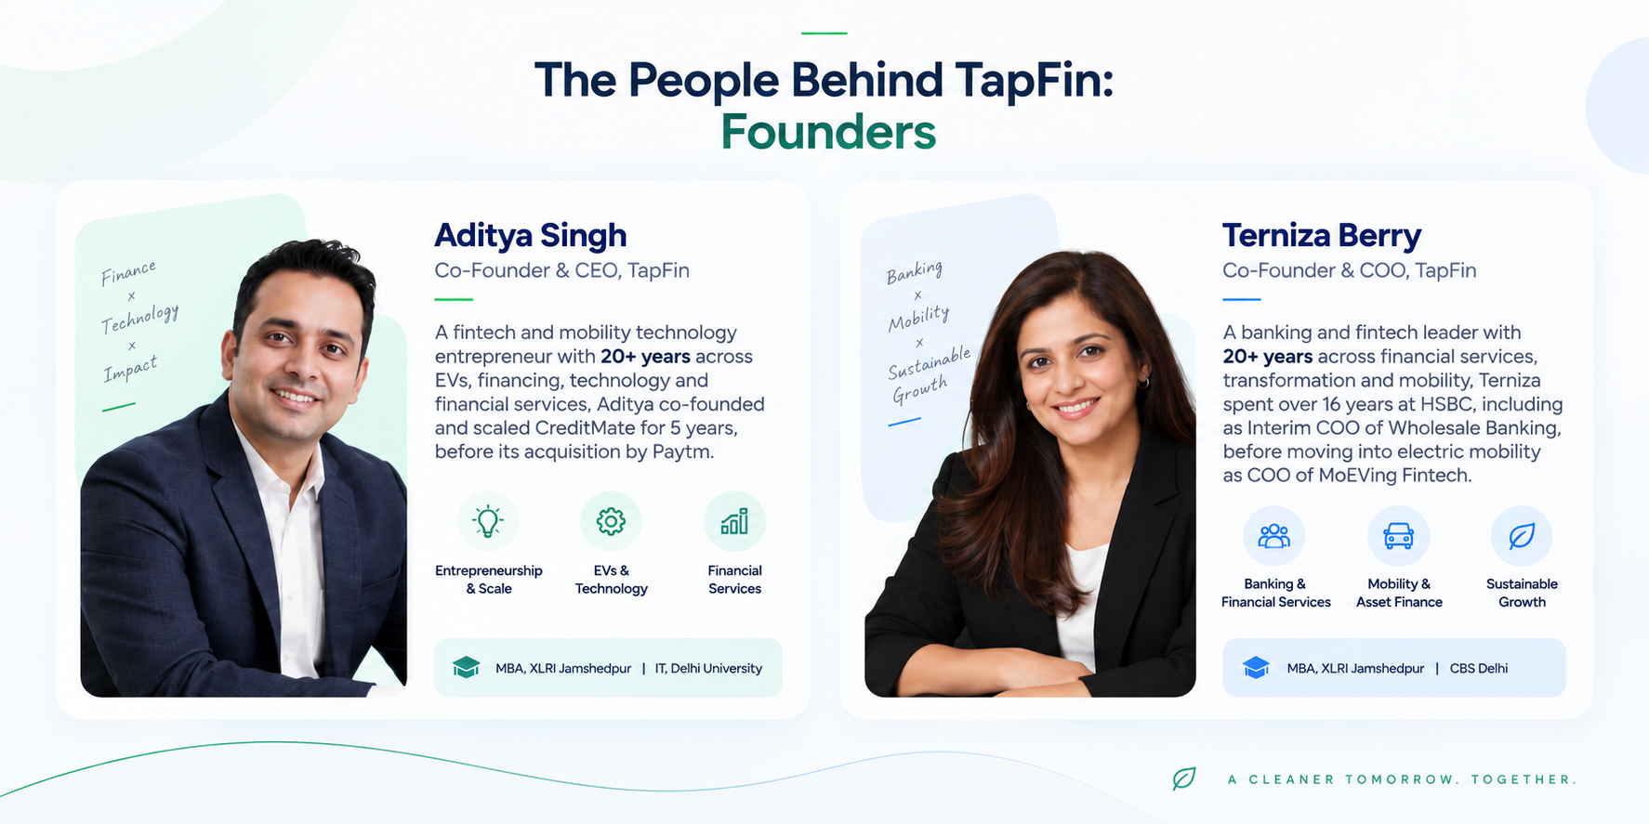
Sample design: The People Behind TapFin – Founders (layout reference only; use the copy above)

3.6 The Team
HEADING
The Team:

Team card 1
NAME
Nikhil Saigal
TITLE
Chief Business Officer
BIO
Nikhil Saigal is a business leader with nearly two decades of experience across payments, fintech, partnerships and commercial growth. He spent close to nine years at Paytm, rising to Vice President, Business and also Flipkart.
EXPERTISE
Expertise: Fintech & Payments | Business Growth | Strategic Partnerships | EV Financing | Mobility & Asset Intelligence
EDUCATION
Education: International Management Institute (IMI)
PHOTO
[Photo to be provided]

Team card 2
NAME
Samir Sahu:
TITLE
Chief Technology Officer
BIO
Samir Sahu is a technology leader with 15+ years of experience across lending technology, data analytics and software engineering. He has held technology leadership roles at Arthimpact Finserve and ADH Deutschland, along with experience building scalable software products across sectors.
EXPERTISE
His expertise spans AI & Data, OEM/IoT integrations, asset intelligence, risk monitoring and scalable lending technology.
PHOTO
[Photo to be provided]

Team card 3
NAME
Charu Kapur
TITLE
Chief Financial Officer
BIO
Charu Kapur is a finance leader with 20+ years of experience across financial services, capital raising and business strategy. She has held senior finance roles at Netafim Agricultural Financing Agency, Samunnati Financial Services and National Bulk Handling Corporation, with deep experience across fundraising, treasury and corporate finance.
EXPERTISE
Her expertise spans NBFC Finance & Capital Raising | Treasury & Lender Relationships | Corporate Finance | Portfolio Risk | Financial Planning | EV & Sustainable Finance.
PHOTO
[Photo to be provided]
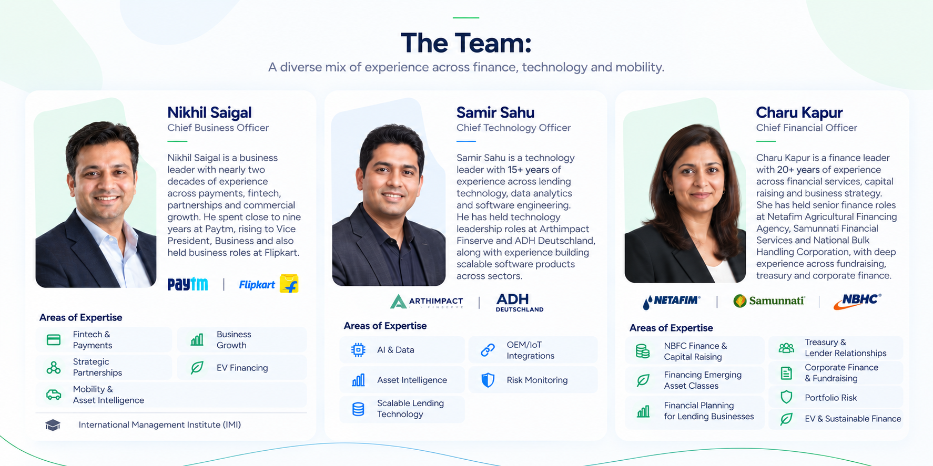
Sample design: The Team (layout reference only; use the copy above)

Section 4: CTA
Builder note: This is the Contact us form that the "Request a Demo" menu item leads to.

4.1 Get a callback
HEADING
Get a callback:
FORM ITEMS (IN SOURCE ORDER)
- [Full name]
- [Work email]
- [Company]
- [Phone number]
- [Select a solution]
- [Speak with our team]
- contact@tapfin.in

4.2 Contact us
HEADING
Contact us:
DETAILS
Mobile: +91 80696 45301, Email: contact@tapfin.in

Items to confirm (not website copy)
The copy above has not been changed. These are points in the source that need your decision before the build.

Missing content
- Our Vision and Our Mission: headings exist, but there is no text.
- Founder and team photos: needed for all 5 cards (the sample images show placeholder people).
- [Select a solution]: the dropdown options are not listed.
- Footer: no footer content is given in the source.

Possible typos or inconsistencies (left unchanged)
- Section 3.4, Financing point: "Buruea" (probably "Bureau").
- Founder titles: card 1 says "Co-Founder & CEO, TapFin" but card 2 says "CoFounder and COO, TapFin". The sample design uses "Co-Founder & COO, TapFin".
- Terniza Berry's education line has no "Education:" prefix, unlike Aditya Singh's.
- Team card 2: the name is written "Samir Sahu:" with a colon. The other names have none.
- Nikhil Saigal's bio ends "...rising to Vice President, Business and also Flipkart." Some words may be missing; the sample design reads "...and also held business roles at Flipkart."
- Samir Sahu and Charu Kapur have no Education line. Nikhil Saigal has one.
- Expertise format differs: Nikhil uses an "Expertise:" label with | separators; Samir uses a sentence; Charu uses a sentence with | separators.
- Button text: the hero has "[Request a demo]" but the menu has "Request a Demo".
- Headings end with a colon in the source (e.g. "About Us:", "Finance:", "The Team:"). Confirm whether the colons should show on the website.

Unclear instructions
- Section 2: "Built on (with three buttons, placed side-by-side)". Is "Built on" shown as text above the stats? Are the stats clickable buttons or plain stat blocks?
- Section 4: "[Speak with our team]" is likely the form's submit button. "contact@tapfin.in" appears inside the form list. Confirm whether it is a field or a line of text under the form.

Text in sample images but not in the copy (not added)
- The Team subheading: "A diverse mix of experience across finance, technology and mobility."
- Why now? image text, e.g. "Every journey generates intelligence.", "More data. Smarter decisions. A cleaner tomorrow.", "TODAY Decisions happen in silos", "Brings it all together", "Finance better", "Manage smarter", "Value with greater confidence".
- Founder image: icon labels ("Entrepreneurship & Scale", "EVs & Technology", "Financial Services", "Banking & Financial Services", "Mobility & Asset Finance", "Sustainable Growth") and a different version of Terniza Berry's bio.
- Navigation image taglines: "CLEANER TOMORROW. TOGETHER.", "FINANCE INTELLIGENCE A CLEANER TOMORROW", "ONE PLATFORM. A CLEANER TOMORROW."
- If you want any of these on the website, add them to the copy and they will be included.

