**Ansible Setup & Configuration**

**PreReq's**

* Ansible control server has to be linux
* In this case node is also linux
* The above linux machines should be reachable (by network)

**Setup**

* Admin user for ansible

# become root user

sudo -i

adduser ansible

* Changing key based authentication to also support password based authenticaion

nano /etc/ssh/sshd_config

# change passwordAuthentication from no to yes & save the file

service sshd restart

* Make ansible user admin

visudo

# scroll to the line where you see %sudo or wheel

# and add the below line

ansible ALL=(ALL:ALL) NOPASSWD:ALL

* Install Python & Ansible
  + Follow instructions [from here](https://docs.ansible.com/ansible/latest/installation_guide/intro_installation.html#latest-releases-via-apt-ubuntu)
* Inventory
  + System Level Inventory:
    - /etc/ansible created during ansible installation
    - /etc/ansible/hosts => default inventory
* Configure nodes for ansible access
  + Give no password access
  + Create a key pair
  + ssh-keygen
  + copy public to nodes
* ssh-copy-id ansible@<node-ip>
  + then use ansible ping command to check

**Ansible Basics**

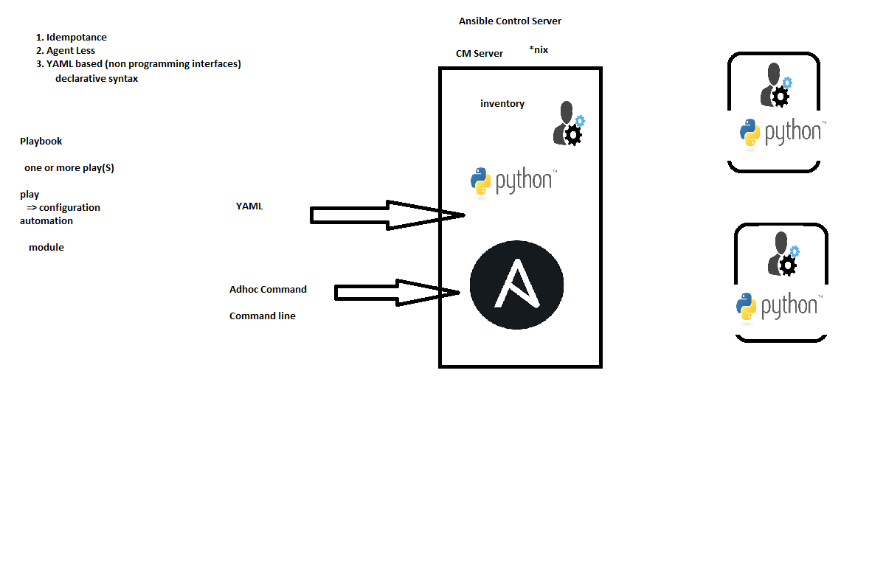

**Modules**

* Modules are unit of work in ansible
* These are actual workers
* Rest of all are supporting modules
* Ansible supports way too many modules
* How to find the right one? If i'm automating
  + Linux Commands:
    - easiest: search in ansible. eg 'service start httpd' query will be service in ansible
* Module:
  + type
  + Different arguments/parameters
  + state
  + Module always tries to maintain state whenever executed
* ansible -m ping all
* ansible -m apt -a 'name=tree,state=present' all
  + Module for automation should be represented in YAML