**KPI GRAFANA DOCUMENT**

**DEPLOYMENT VOLUME**

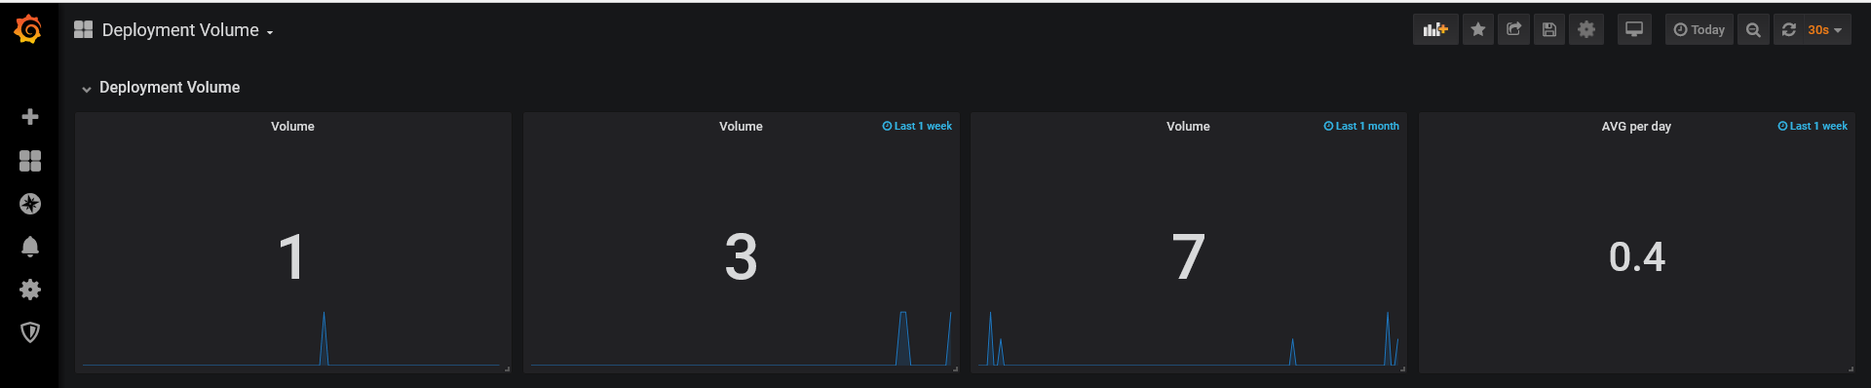

**Queries & Setup:**

SELECT count("build_time") FROM "autogen"."jenkins_data" WHERE ("build_result" = 'SUCCESS') AND $timeFilter GROUP BY time($__interval) fill(null)

**Volume**

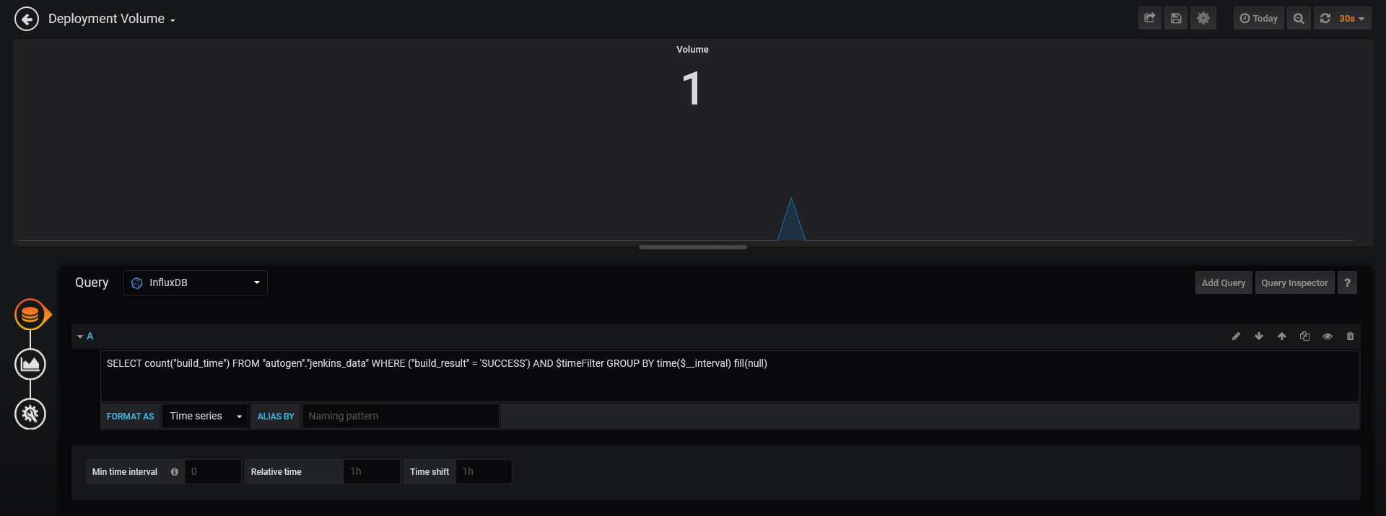

**Volume for last 1 week**

SELECT count("build_time") FROM "autogen"."jenkins_data" WHERE ("build_result" = 'SUCCESS') AND $timeFilter GROUP BY time($__interval) fill(null)

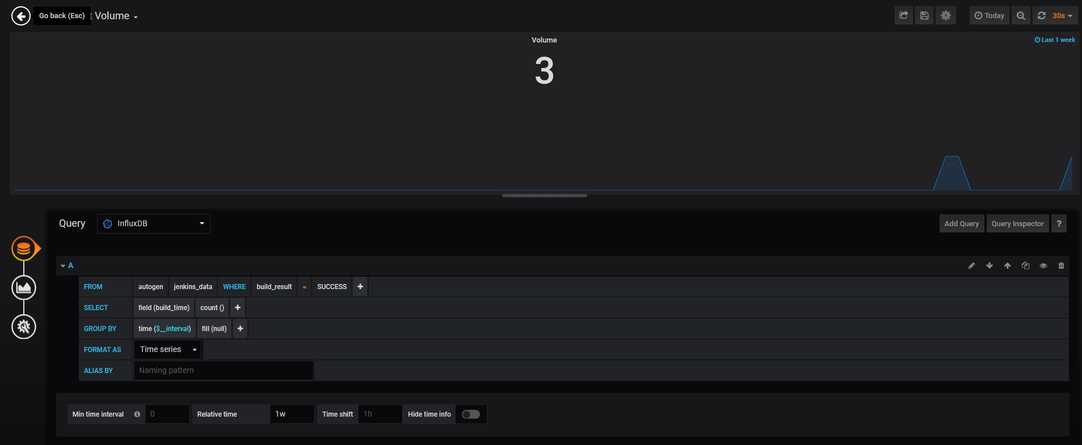

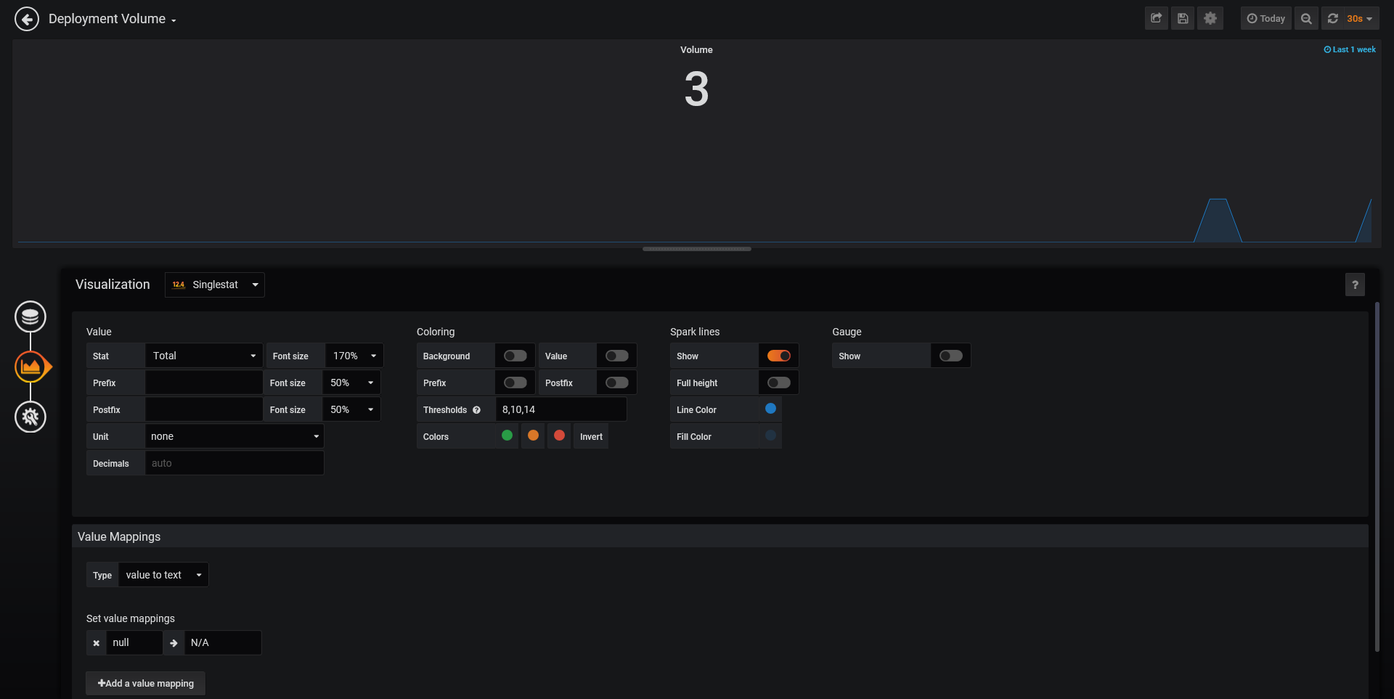

Volume For last 1 Month

SELECT count("build_time") FROM "autogen"."jenkins_data" WHERE ("build_result" = 'SUCCESS') AND $timeFilter GROUP BY time($__interval) fill(null)

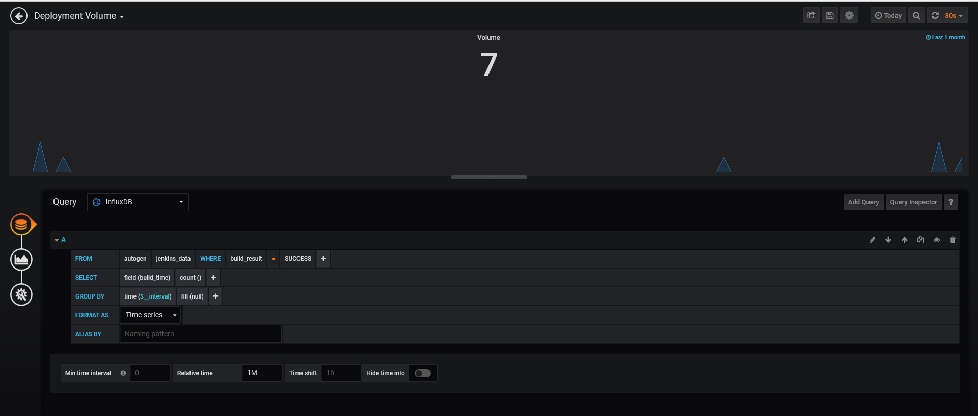

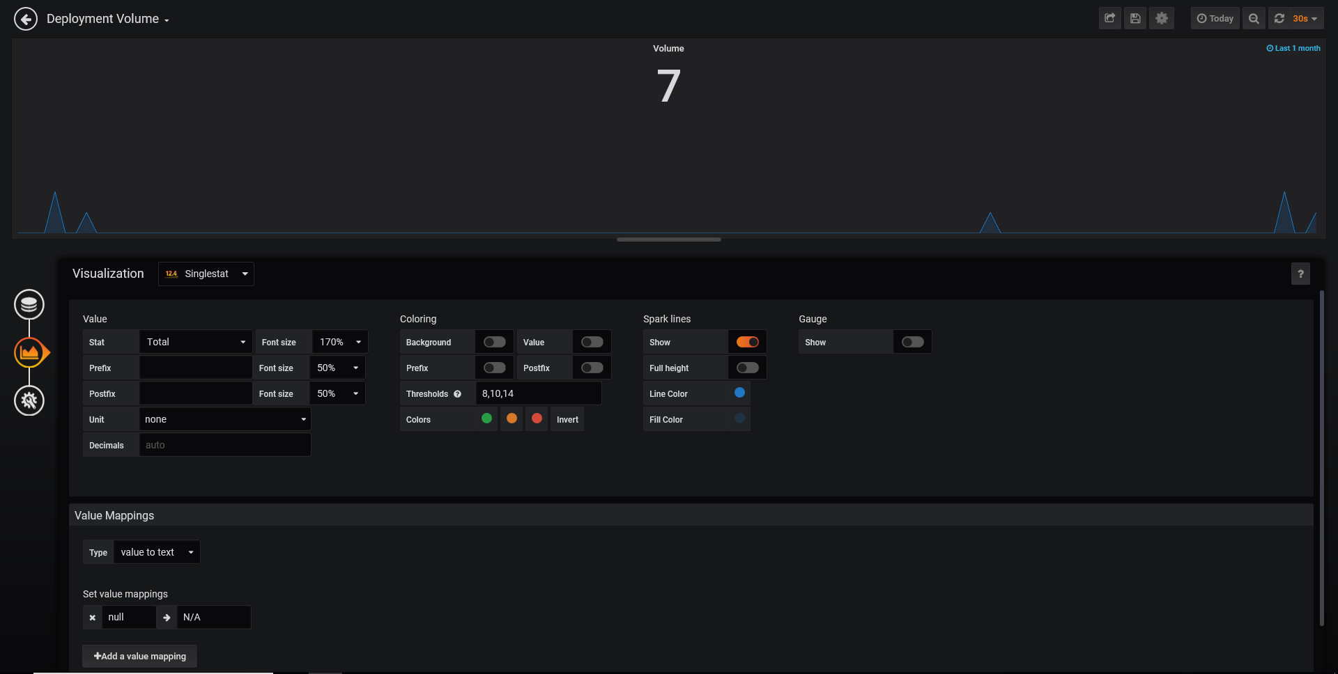

Average Volume per day for 1 week

SELECT count("build_time") FROM "jenkins_data" WHERE ("build_result" = 'SUCCESS') AND $timeFilter GROUP BY time($__interval) fill(null)

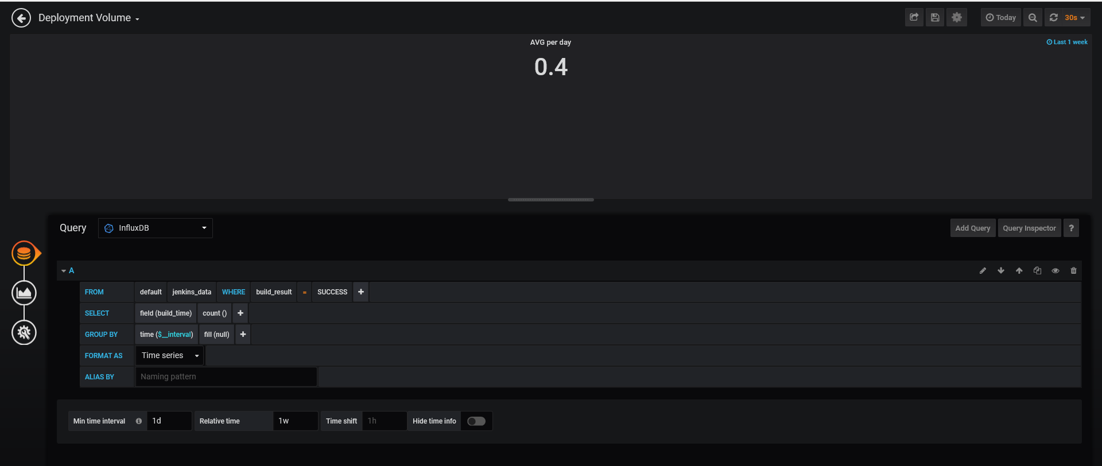

**Deployment Speed**

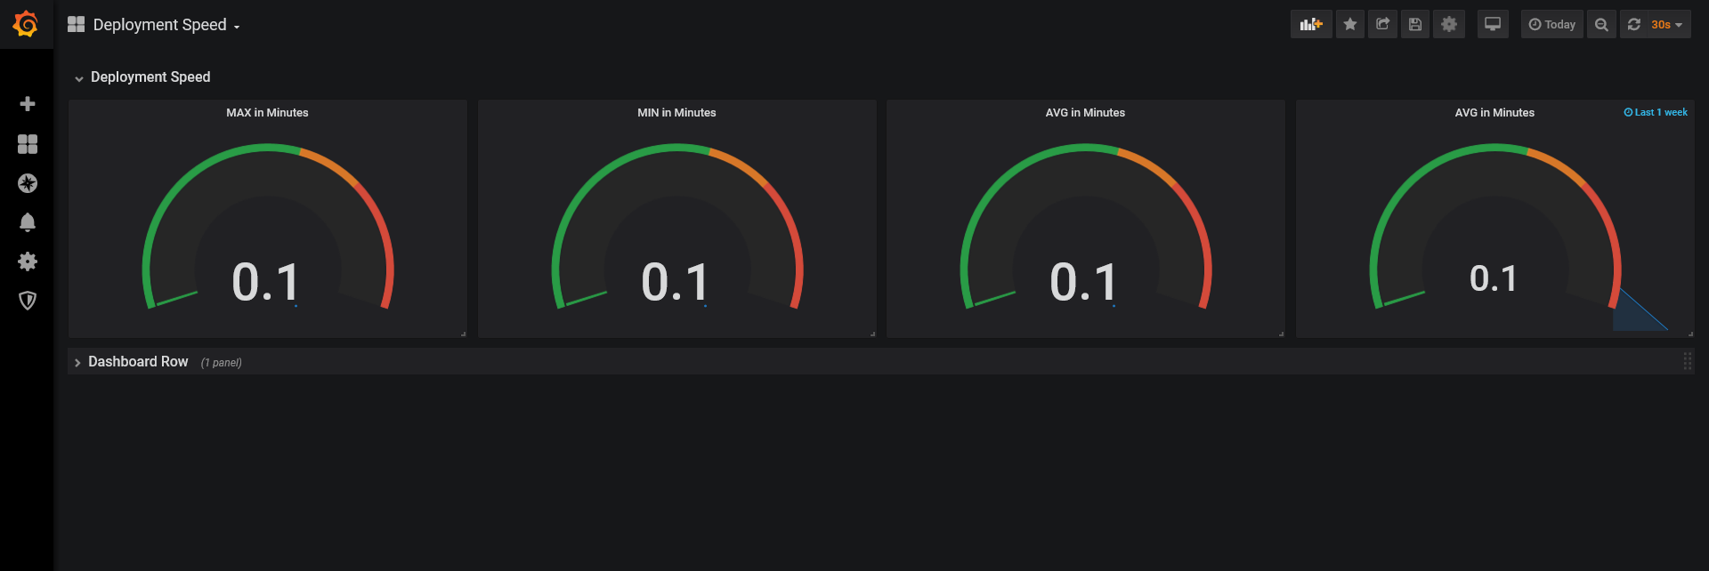

**Query & Setup:**

**Maximum speed in Minutes**

SELECT max("build_time") / 60000 FROM "autogen"."jenkins_data" WHERE ("build_result" = 'SUCCESS') AND $timeFilter GROUP BY time($__interval) fill(null)

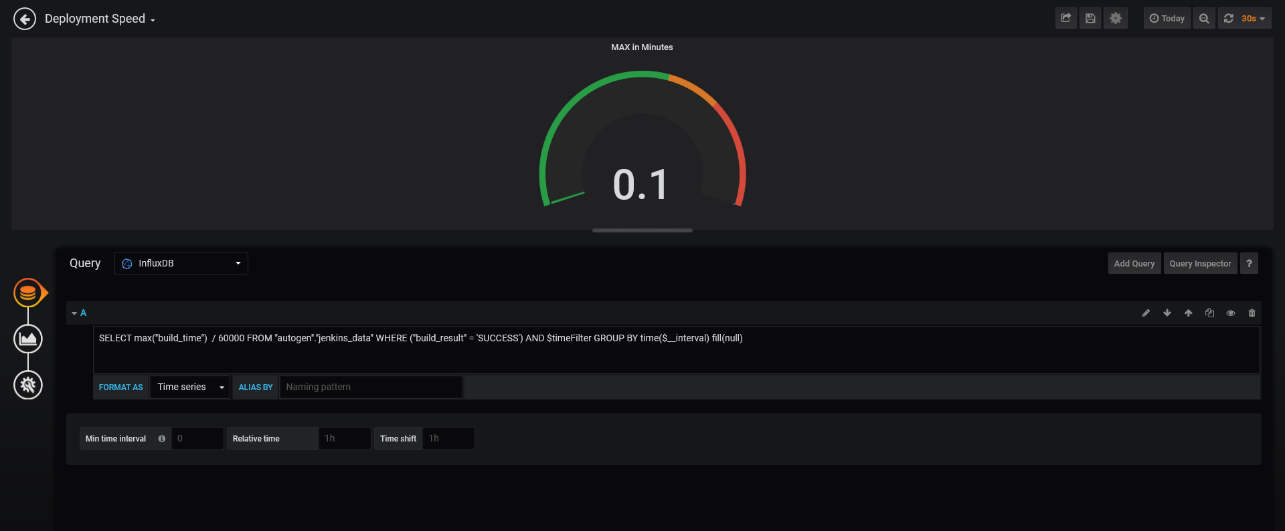

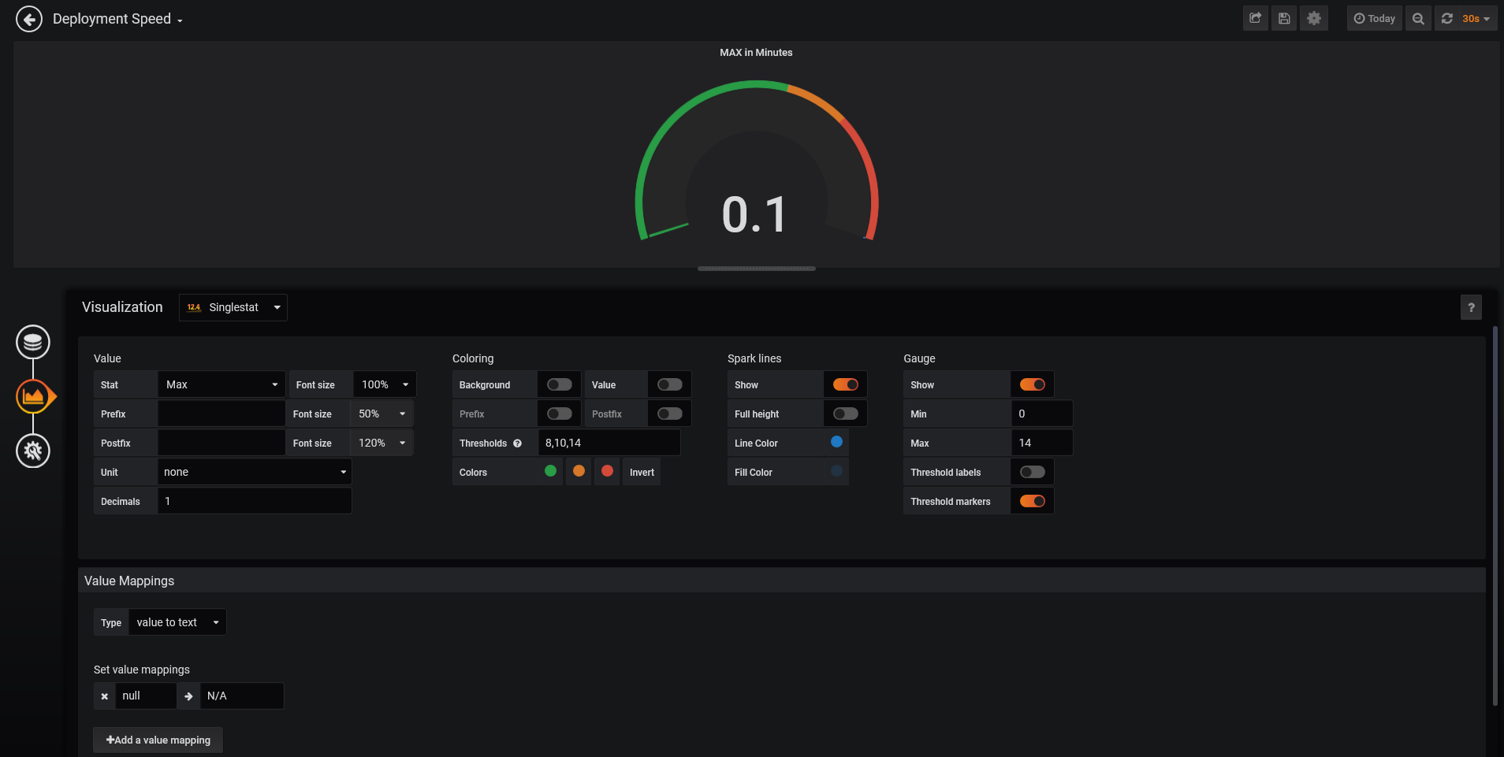

**Minimum Speed in Minutes**

SELECT mean("build_time") / 60000 FROM "autogen"."jenkins_data" WHERE ("build_result" = 'SUCCESS') AND $timeFilter GROUP BY time($__interval) fill(null)

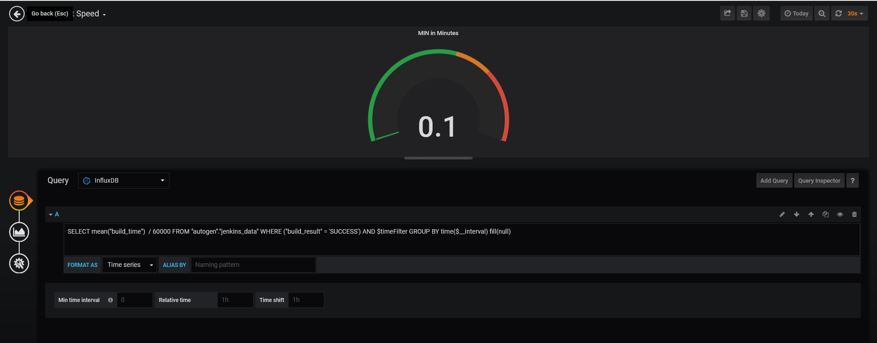

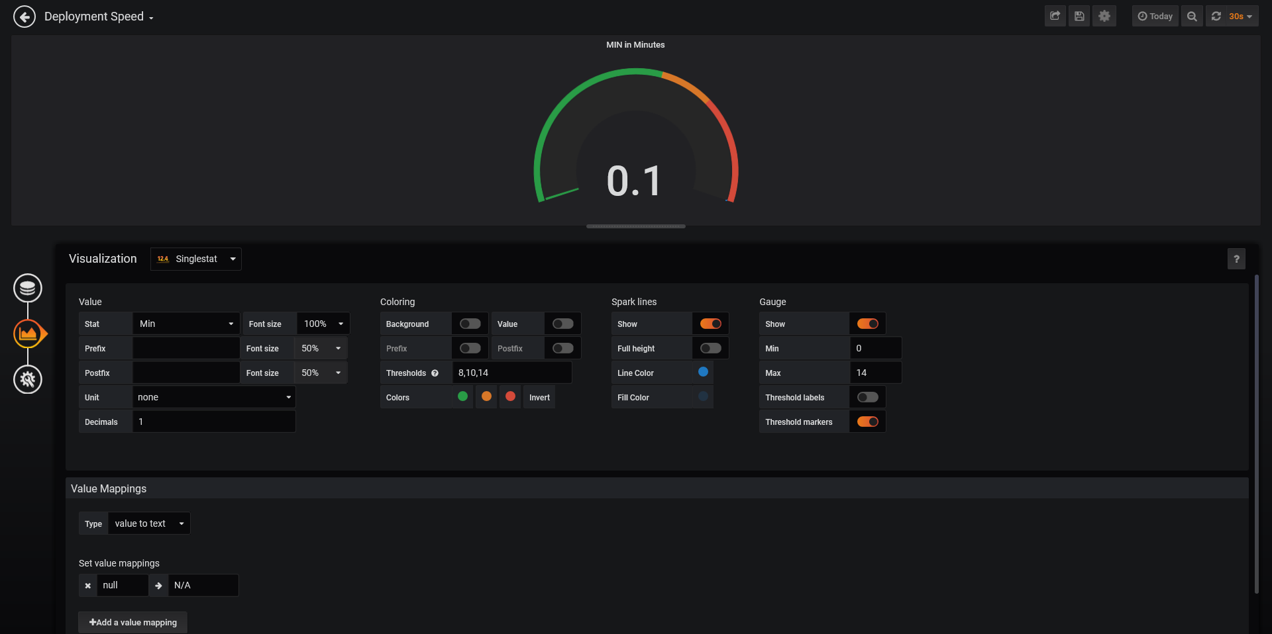

**Average speed in Minutes**

SELECT mean("build_time") / 60000 FROM "autogen"."jenkins_data" WHERE ("build_result" = 'SUCCESS') AND $timeFilter GROUP BY time($__interval) fill(null)

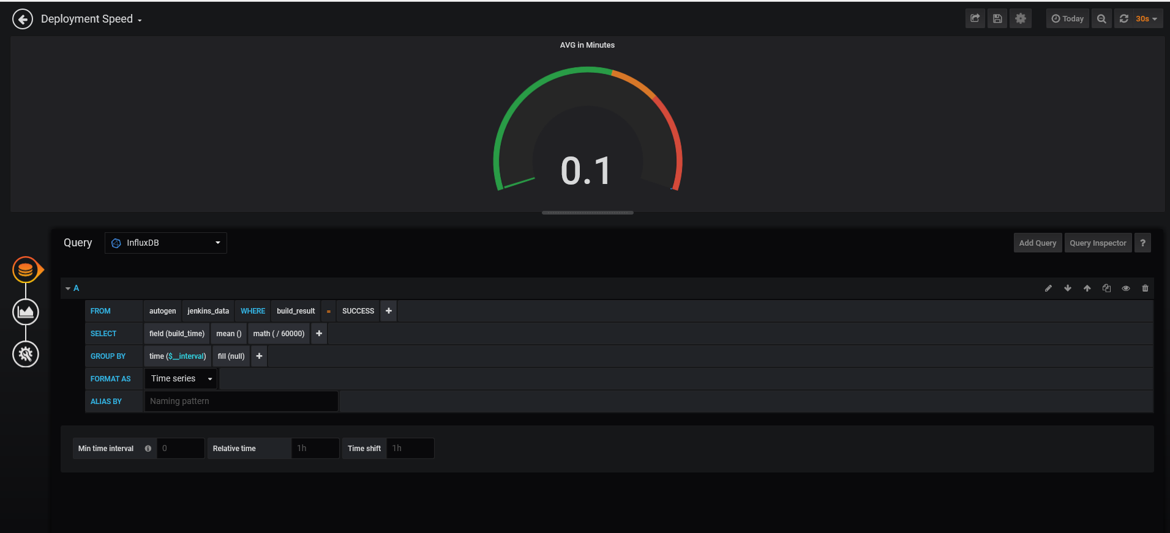

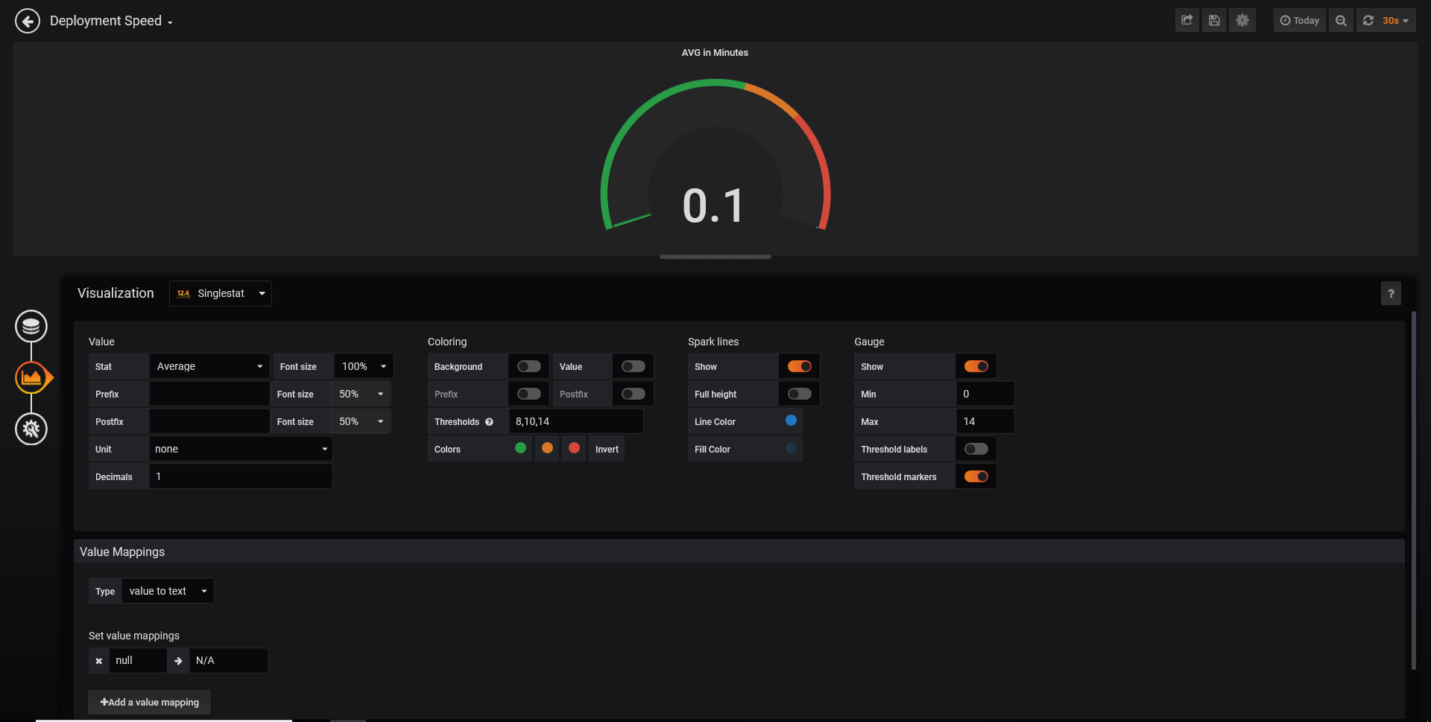

Average Speed in Minutes For 1 Week

SELECT mean("build_time") / 60000 FROM "autogen"."jenkins_data" WHERE ("build_result" = 'SUCCESS') AND $timeFilter GROUP BY time($__interval) fill(null)

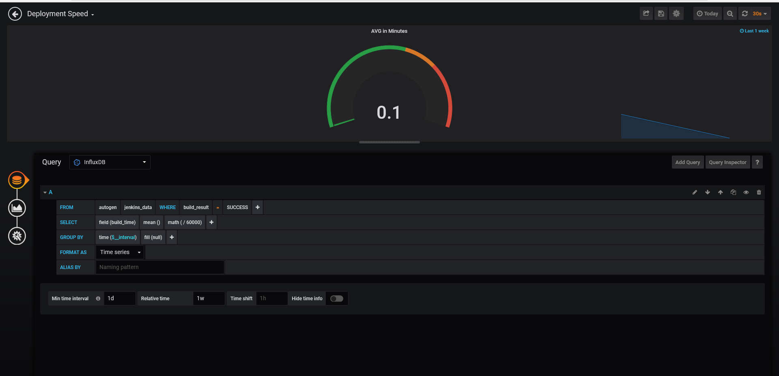

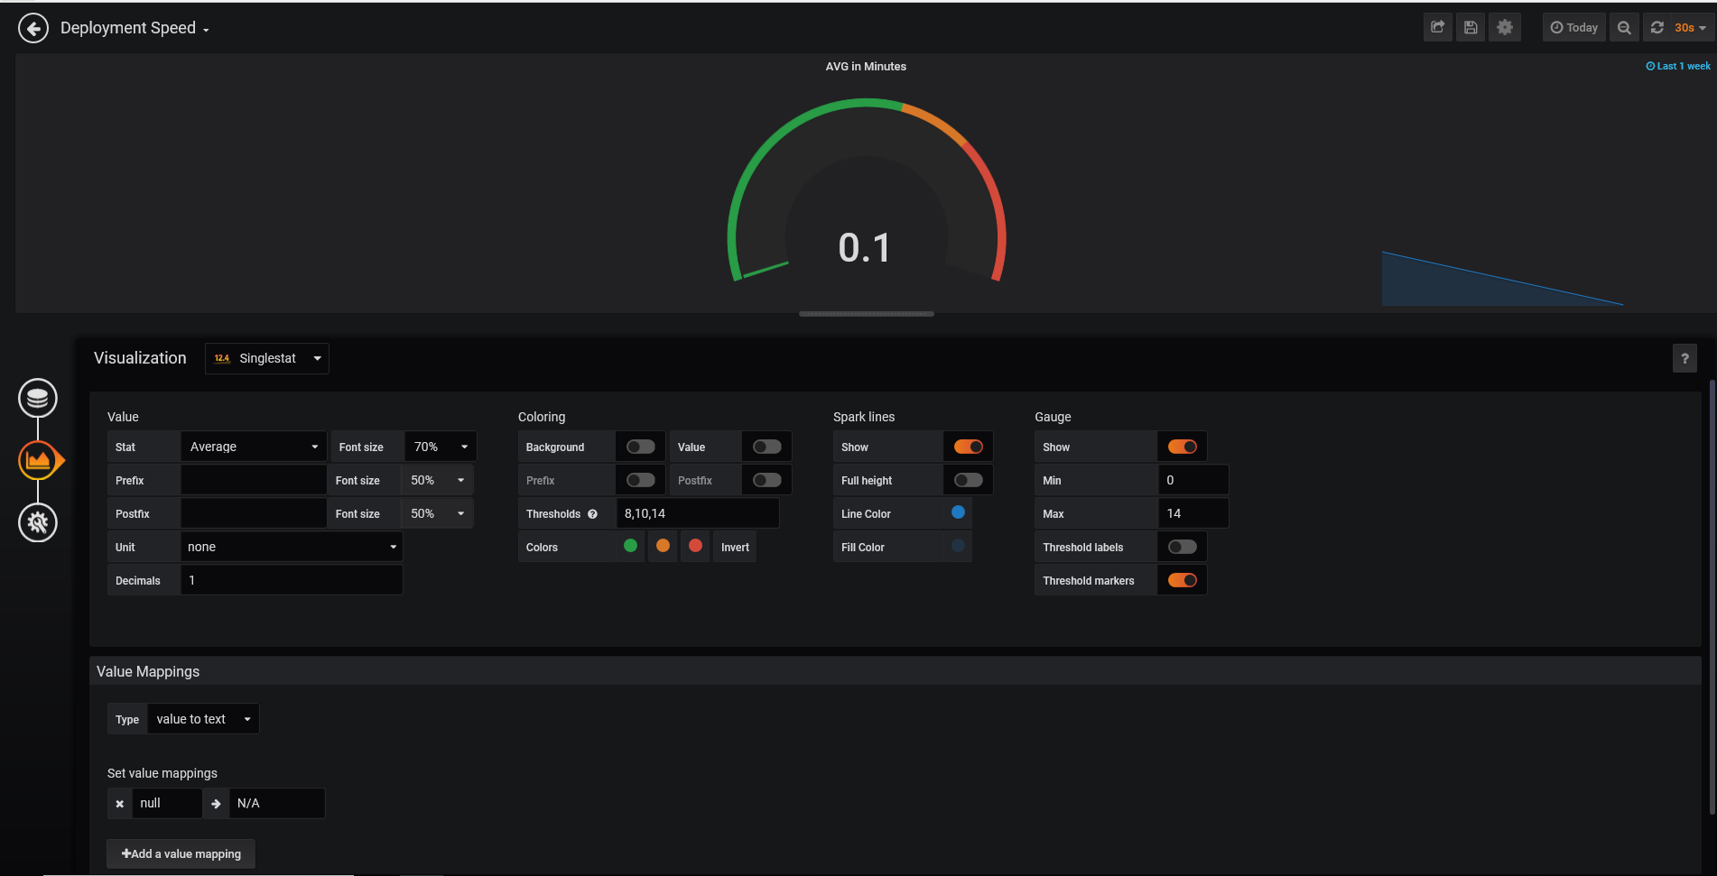

**Deployment Failure**

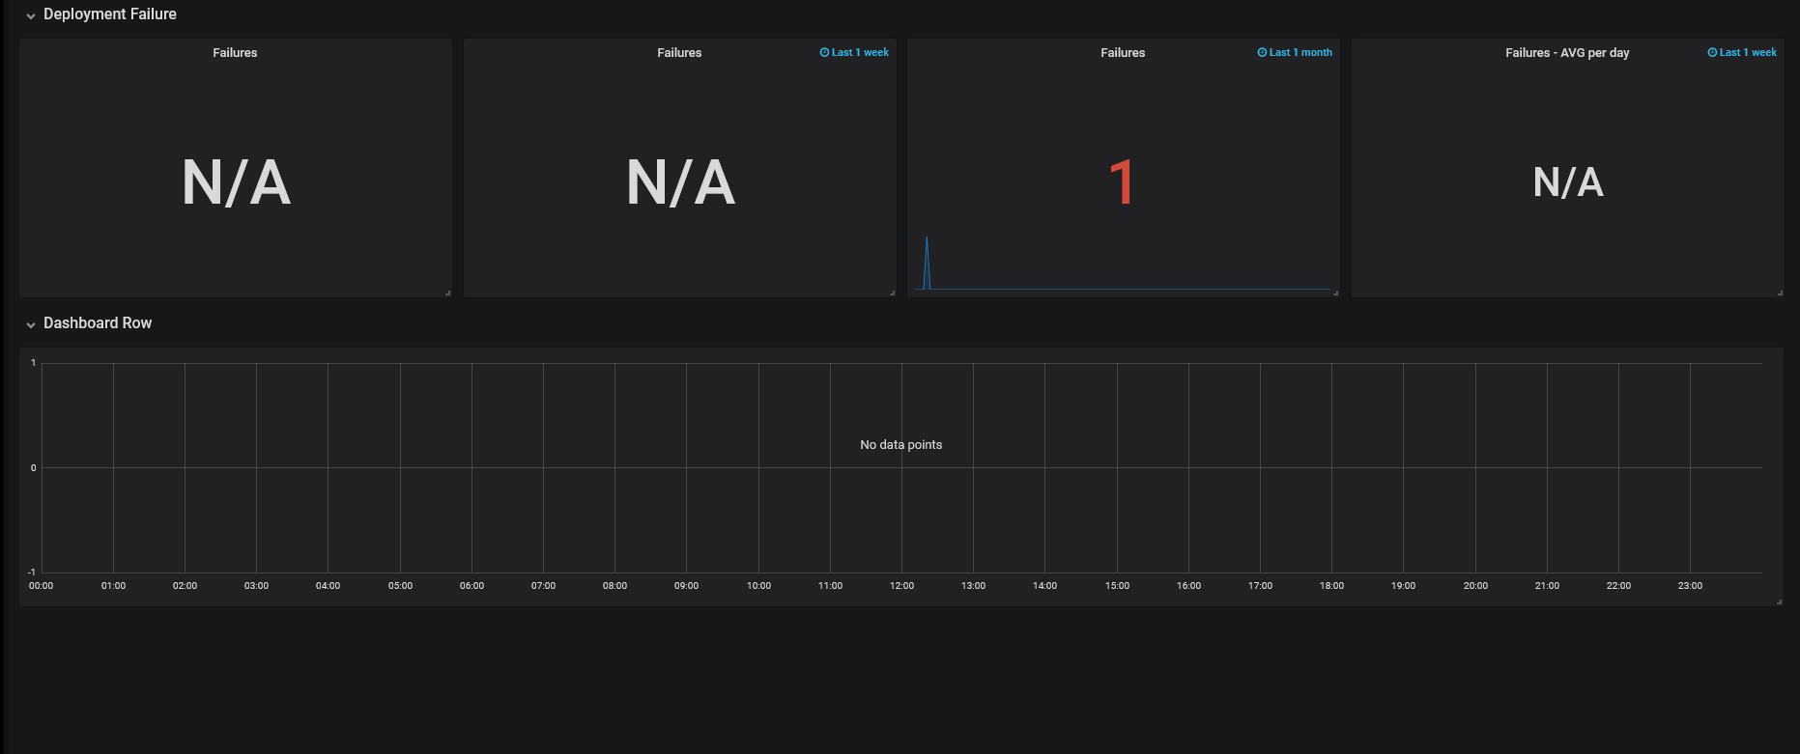

Query and setup:

**Failures**

SELECT count("build_time") FROM "autogen"."jenkins_data" WHERE ("build_result" = 'FAILURE') AND $timeFilter GROUP BY time($__interval) fill(null)

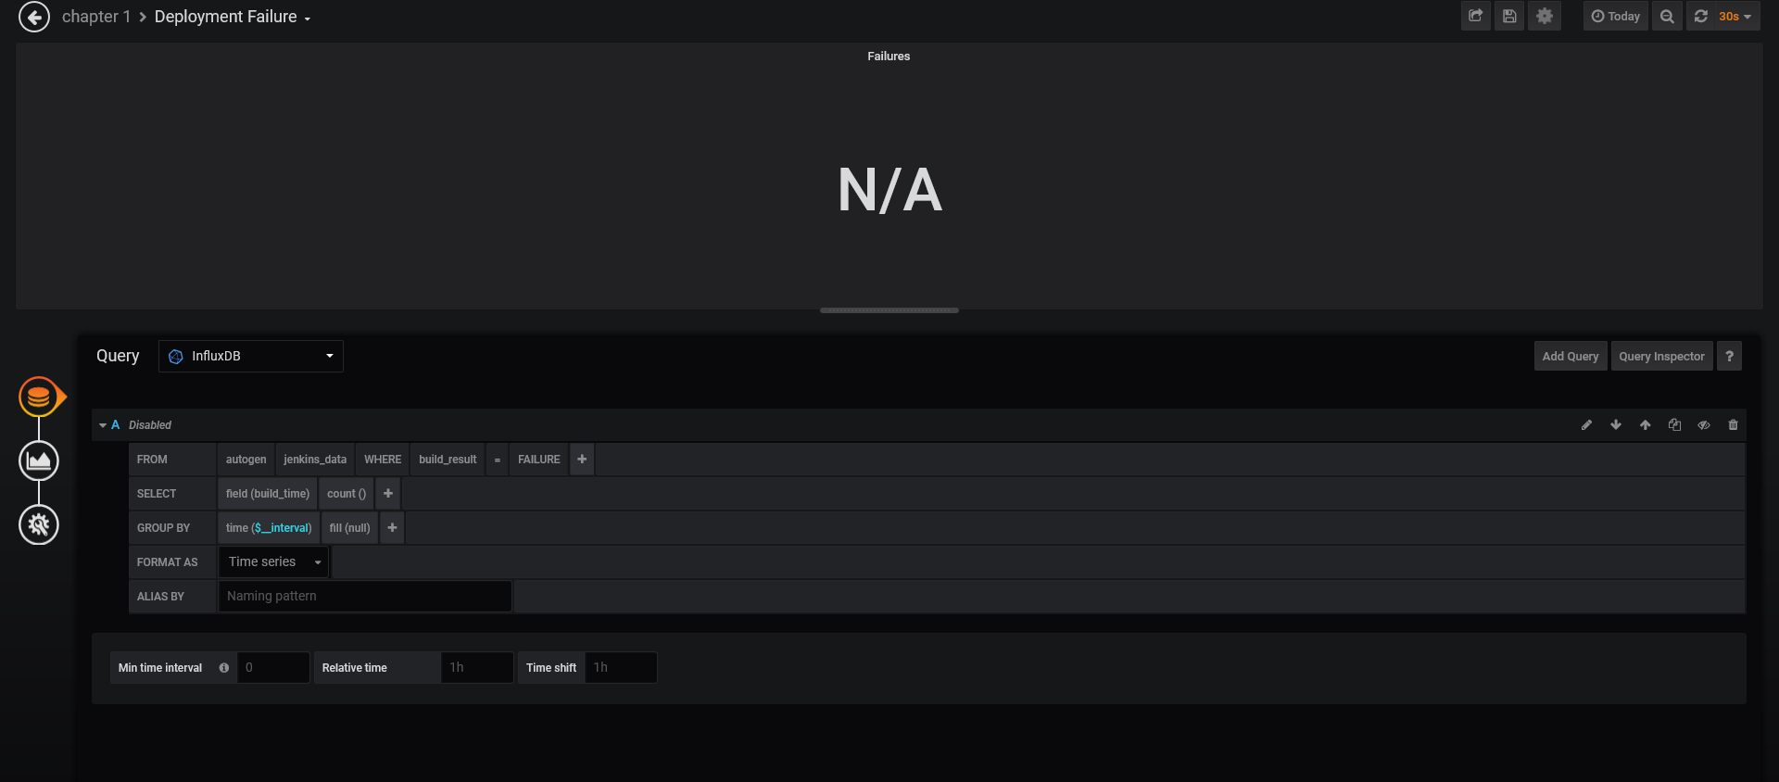

**Failure in 1 Week**

SELECT count("build_time") FROM "autogen"."jenkins_data" WHERE ("build_result" = 'FAILURE') AND $timeFilter GROUP BY time($__interval) fill(null)

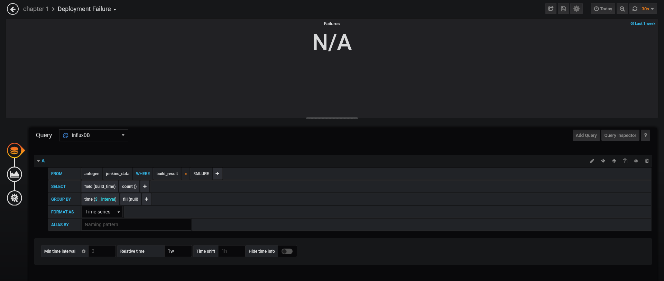

**Failures on last 1 Month**

SELECT count("build_time") FROM "autogen"."jenkins_data" WHERE ("build_result" = 'FAILURE') AND $timeFilter GROUP BY time($__interval) fill(null)

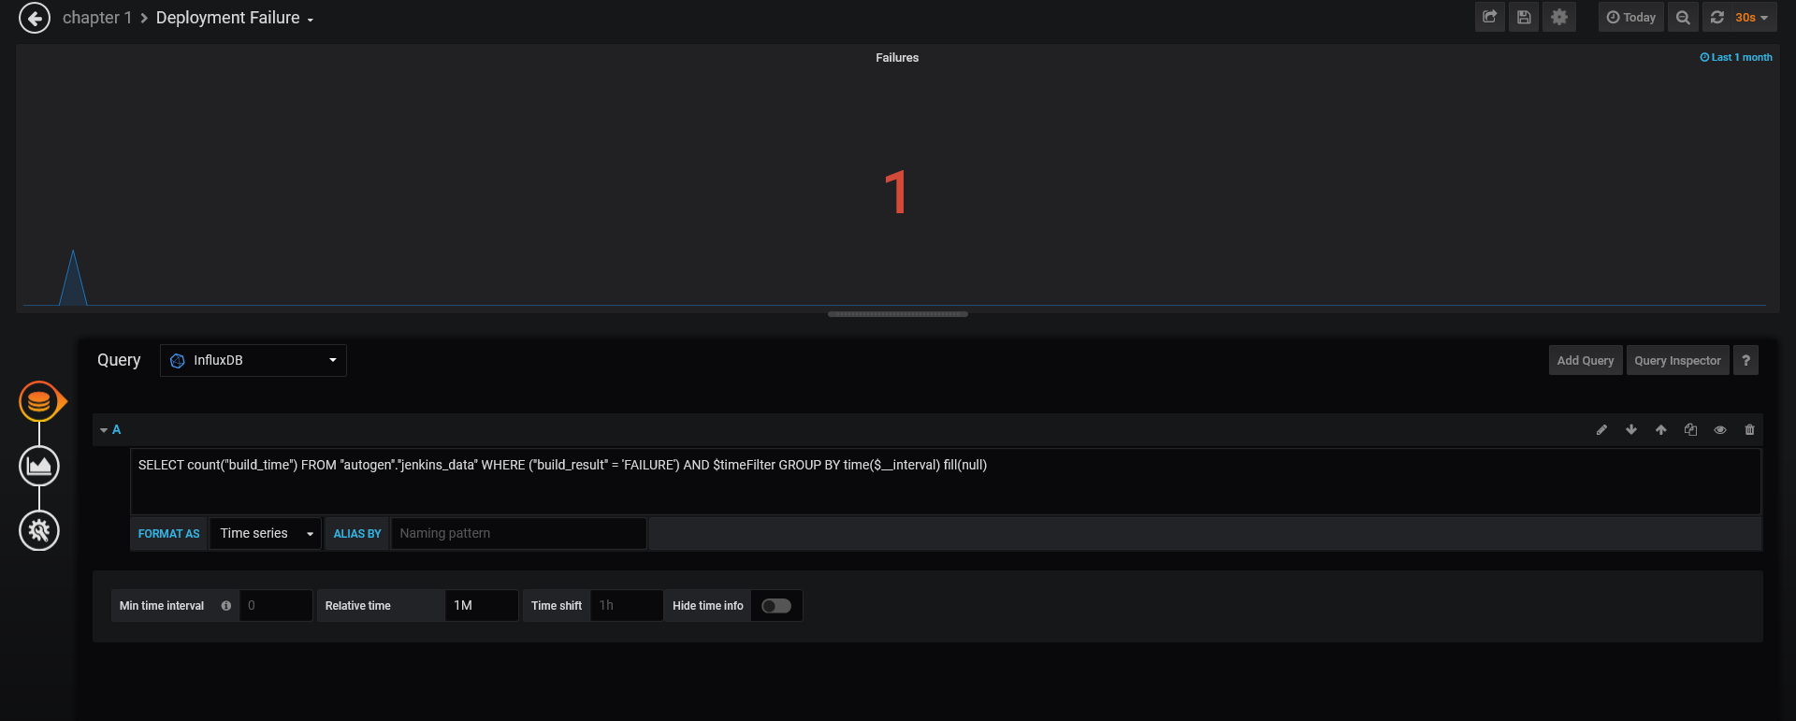

**Average failures in 1 week**

SELECT count("build_time") FROM "autogen"."jenkins_data" WHERE ("build_result" = 'FAILURE') AND $timeFilter GROUP BY time($__interval) fill(null)

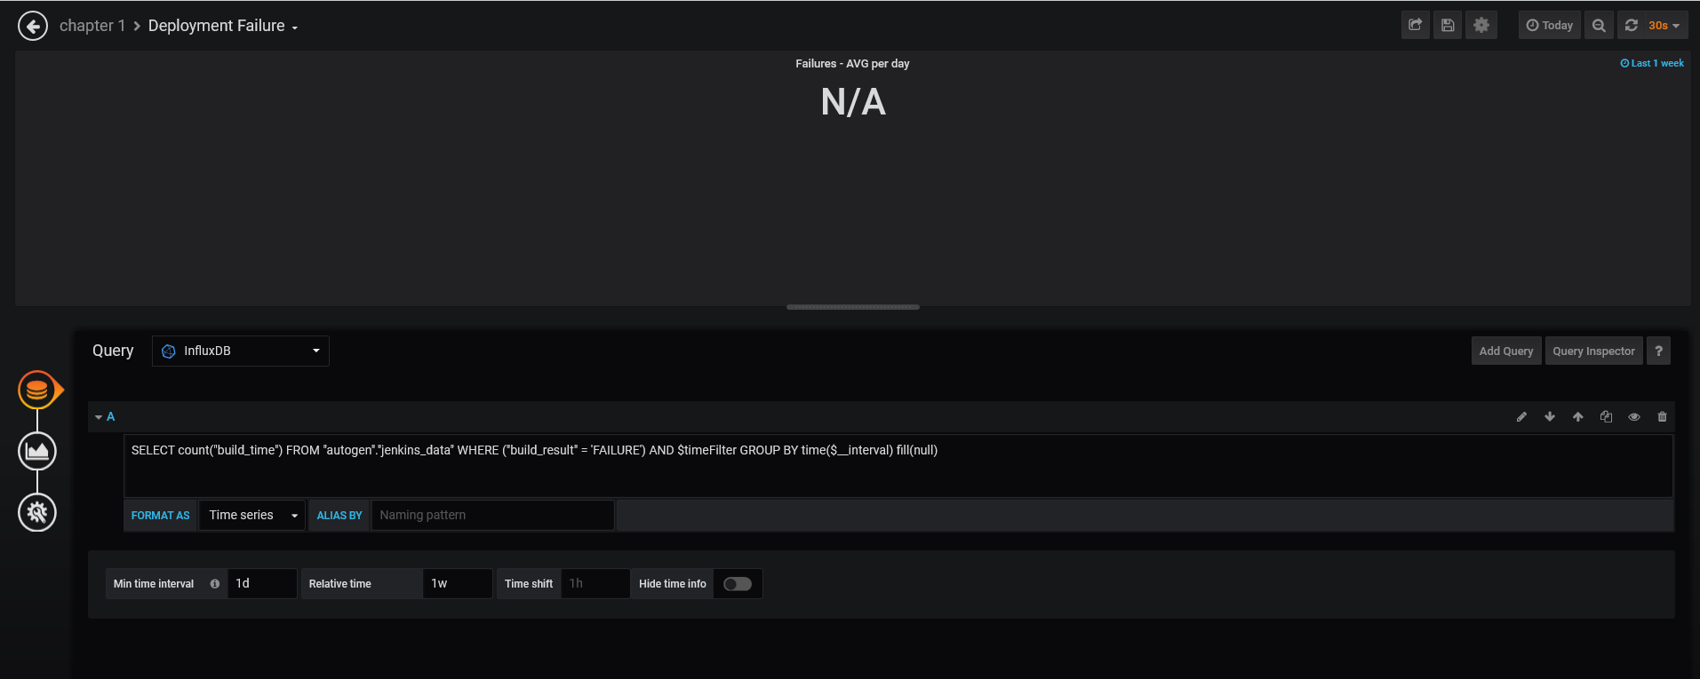

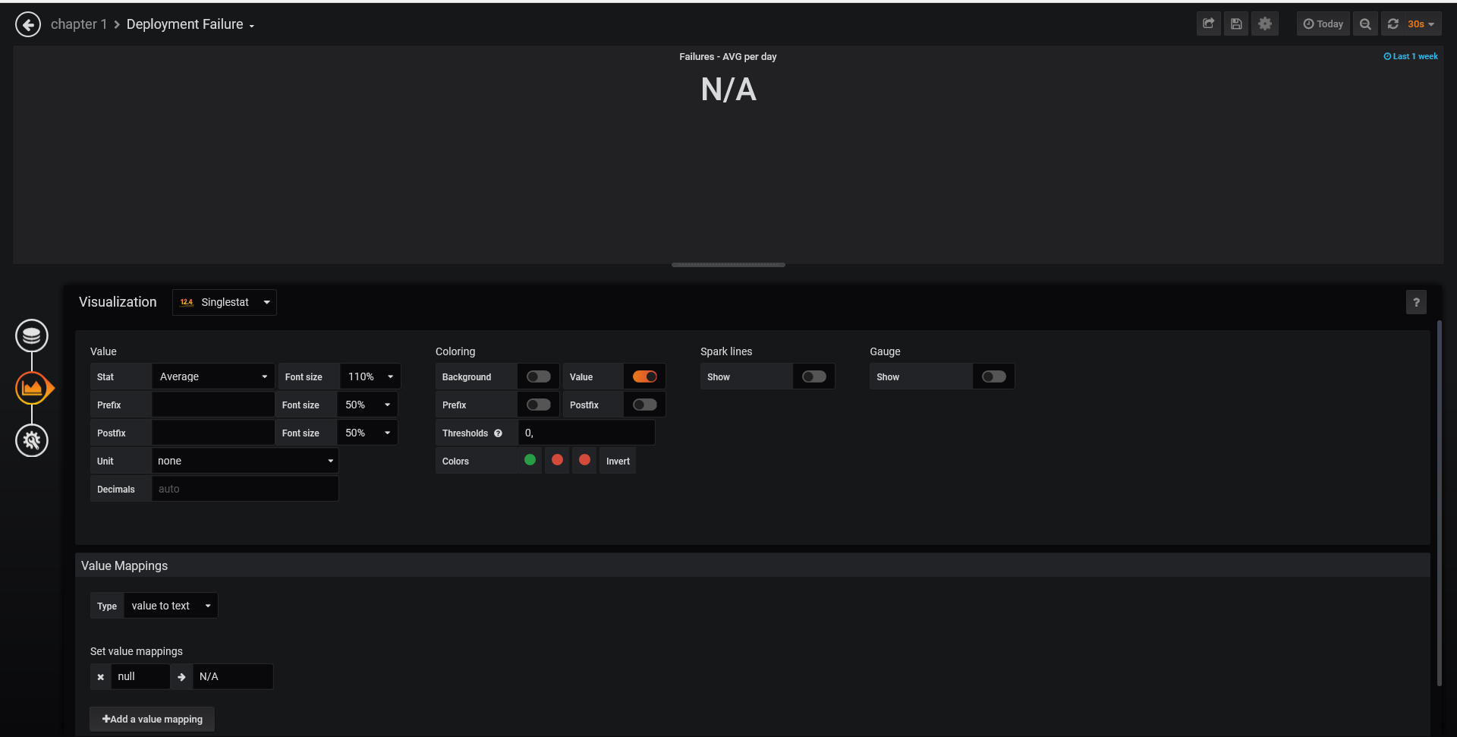

**Mean Time To Detection**:

SELECT mean("value") FROM "mttd" WHERE ("app_name" = 'app-ex') AND $timeFilter GROUP BY time($__interval)

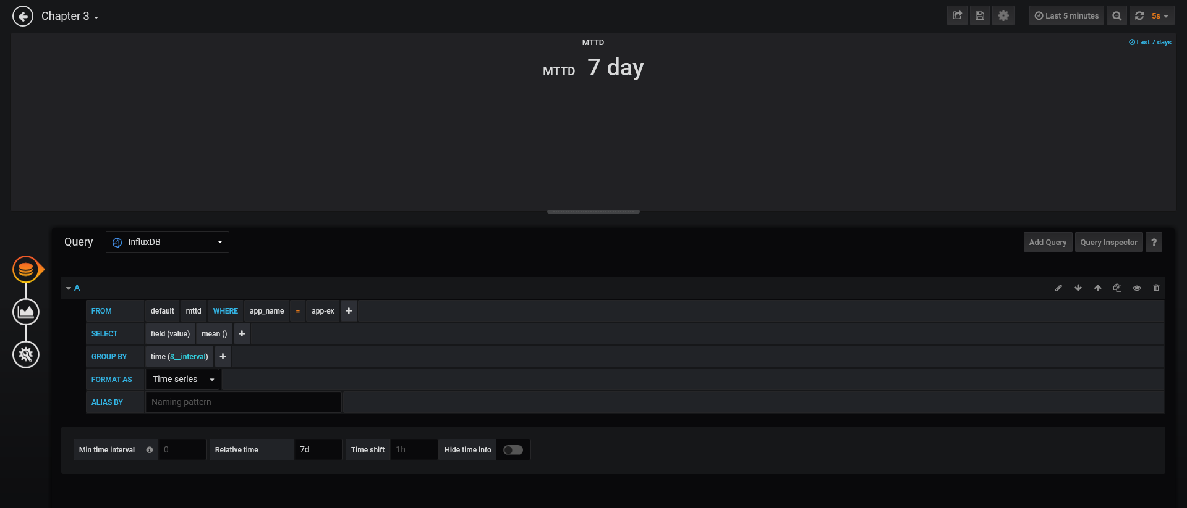

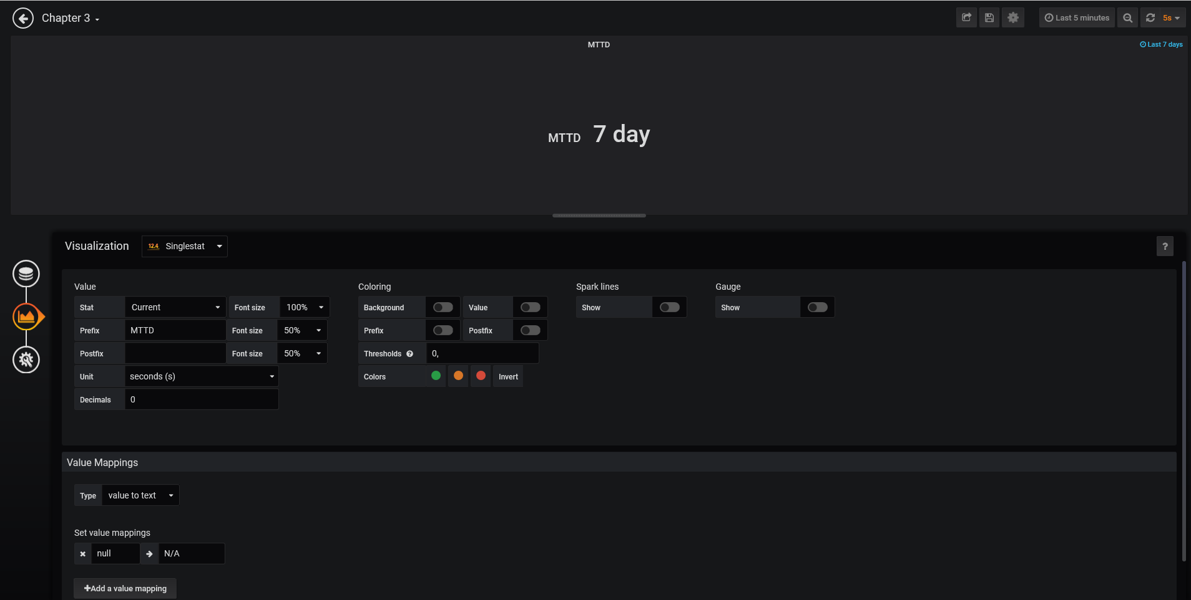

**MEAN TIME BETWEEN FAILURE**

SELECT ((2 * 24 * 60 * 60) - sum("value")) / count("value") FROM "mtbf" WHERE ("app_name" = 'app-ex') AND $timeFilter

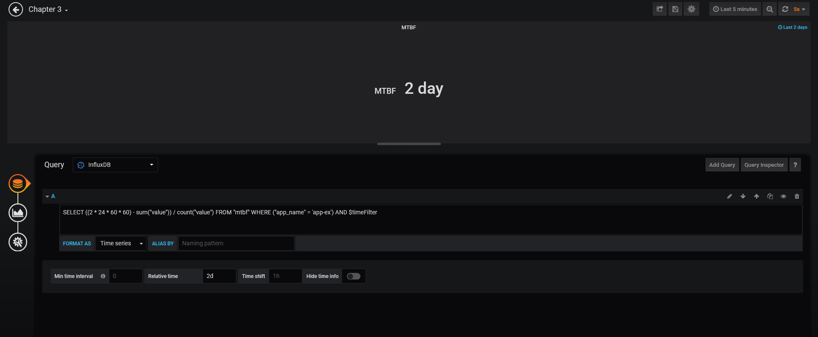

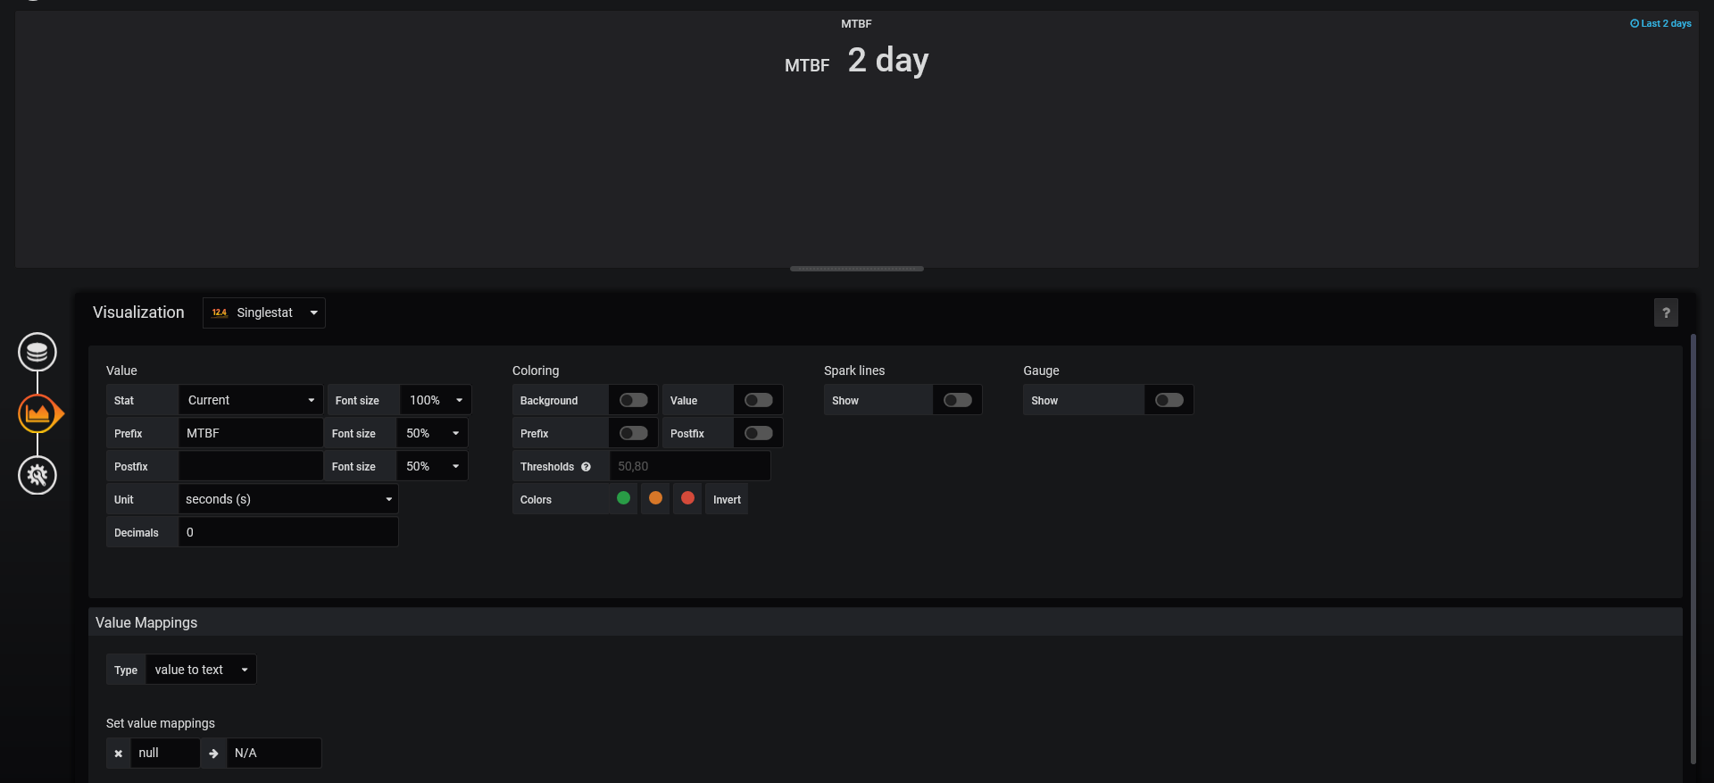

Graph of UP and Downtime

probe_success{instance="http://app-ex:3000/healthcheck",job="blackbox"} > 0

probe_success{instance="http://app-ex:3000/healthcheck",job="blackbox"} <= 0

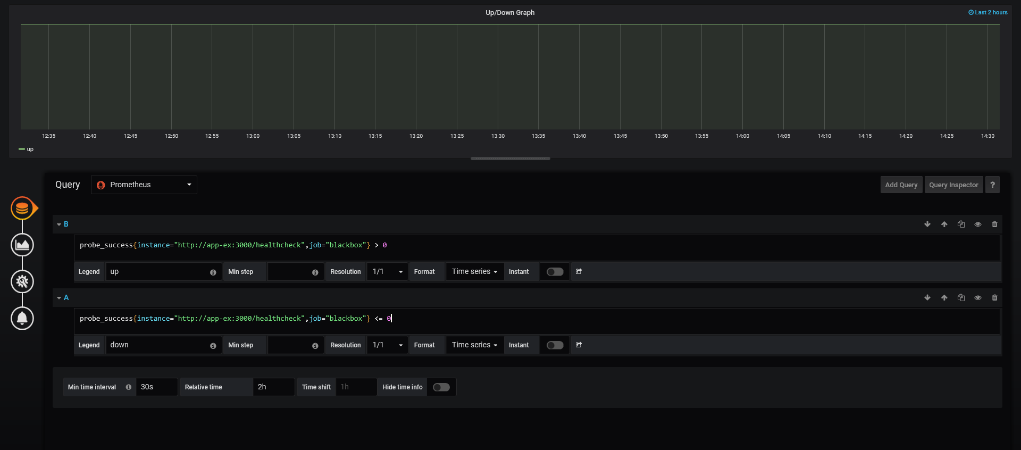

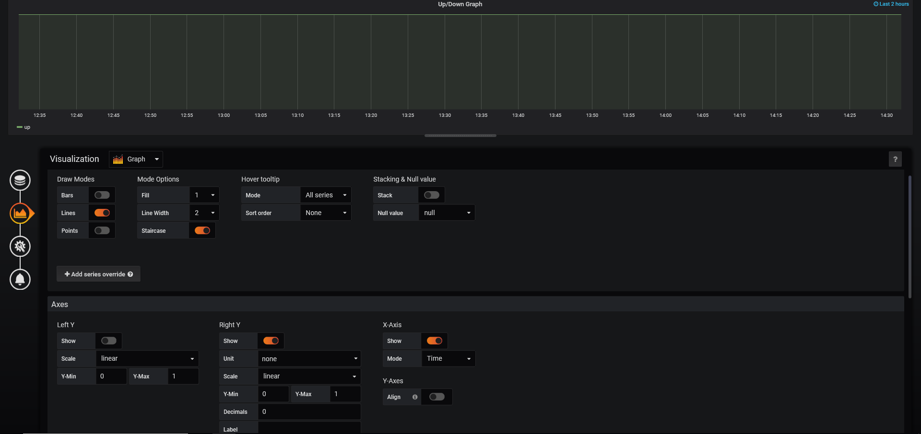

**DownTime:**

SELECT count("value") FROM "mtbf" WHERE ("app_name" = 'app-ex') AND $timeFilter

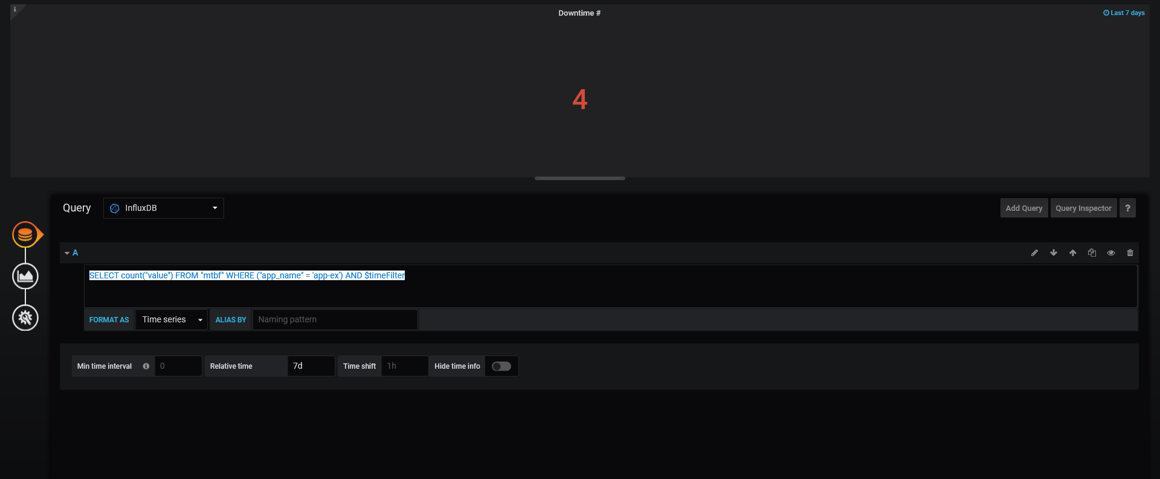

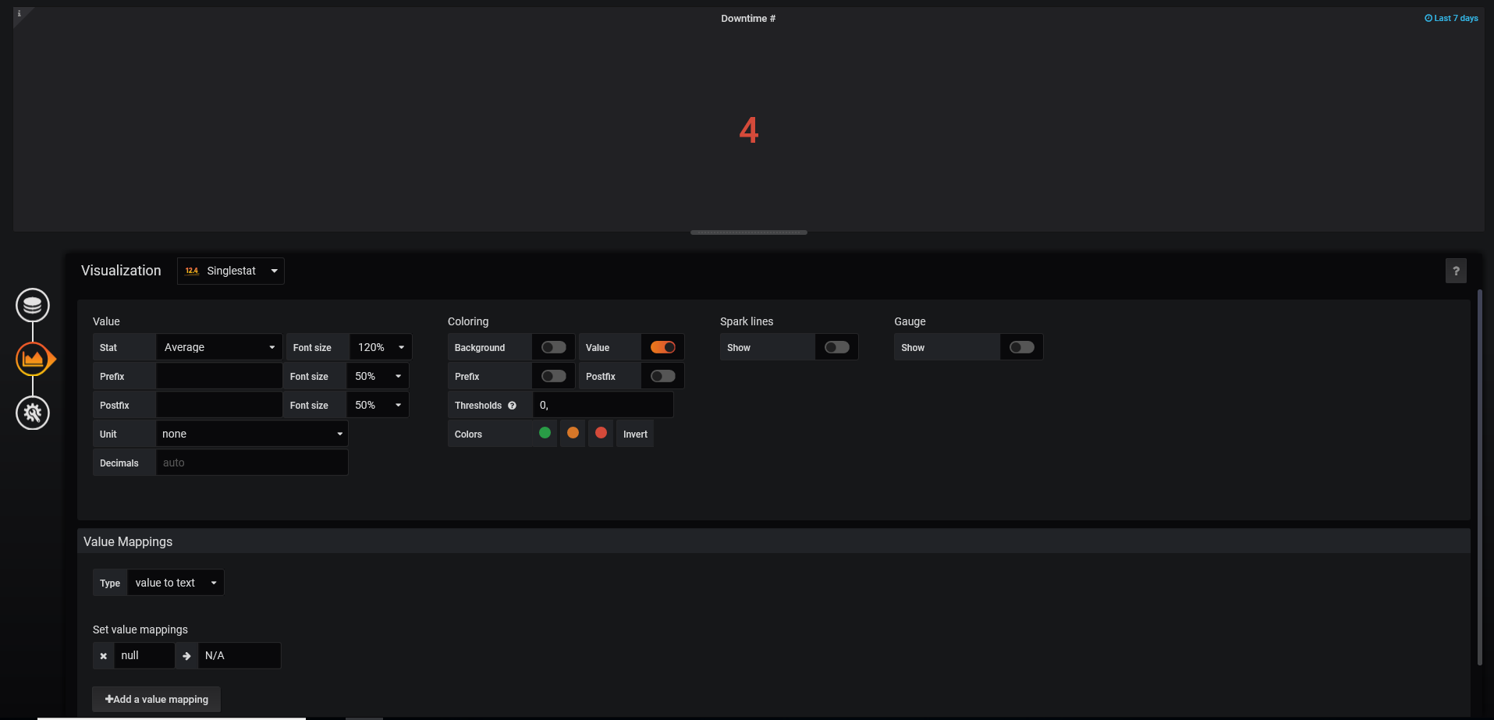

**UPTime**

SELECT ((24 * 60 * 60) - sum("value")) * 100 / (24 * 60 * 60) FROM "mtbf" WHERE ("app_name" = 'app-ex') AND $timeFilter

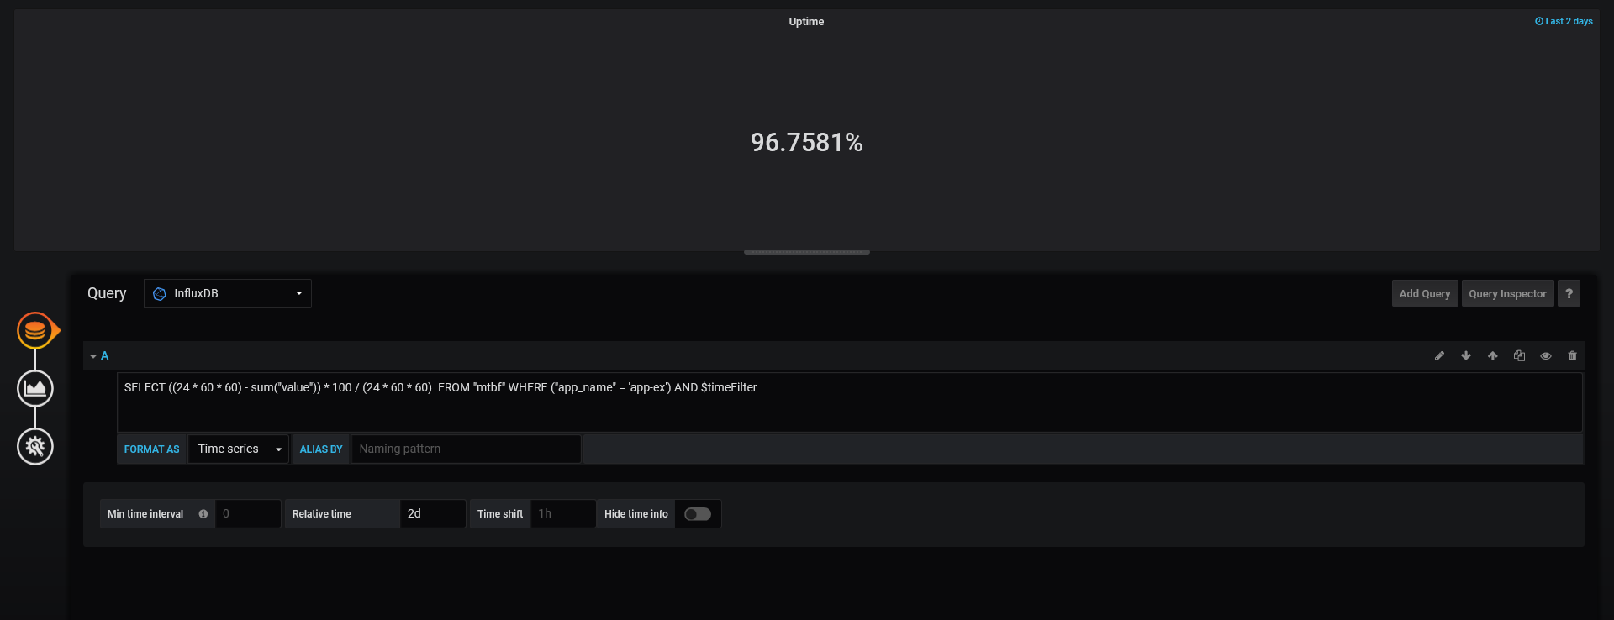

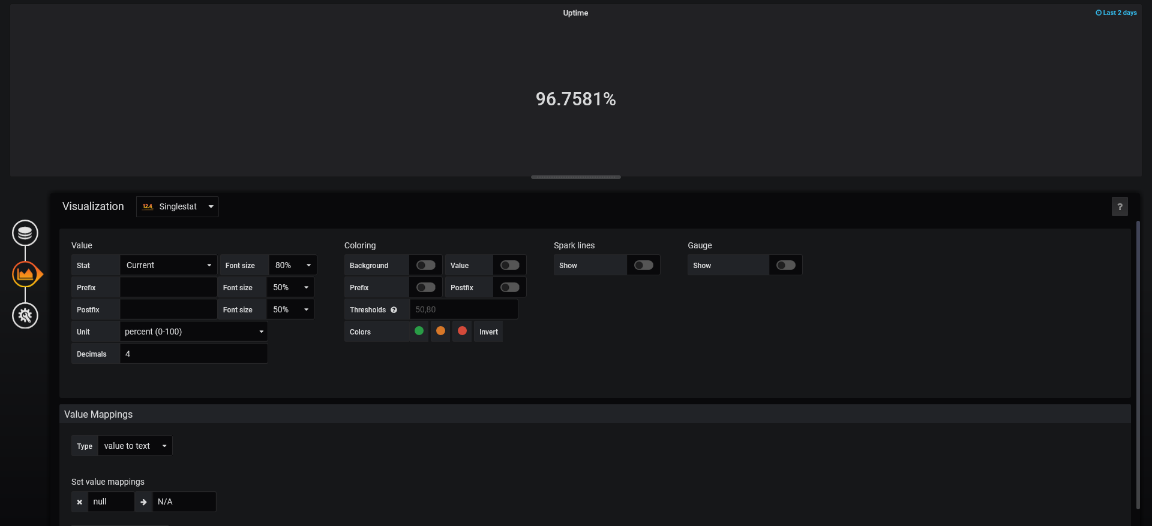

**Application Status:**

probe_success{instance="http://app-ex:3000/healthcheck",job="blackbox"}

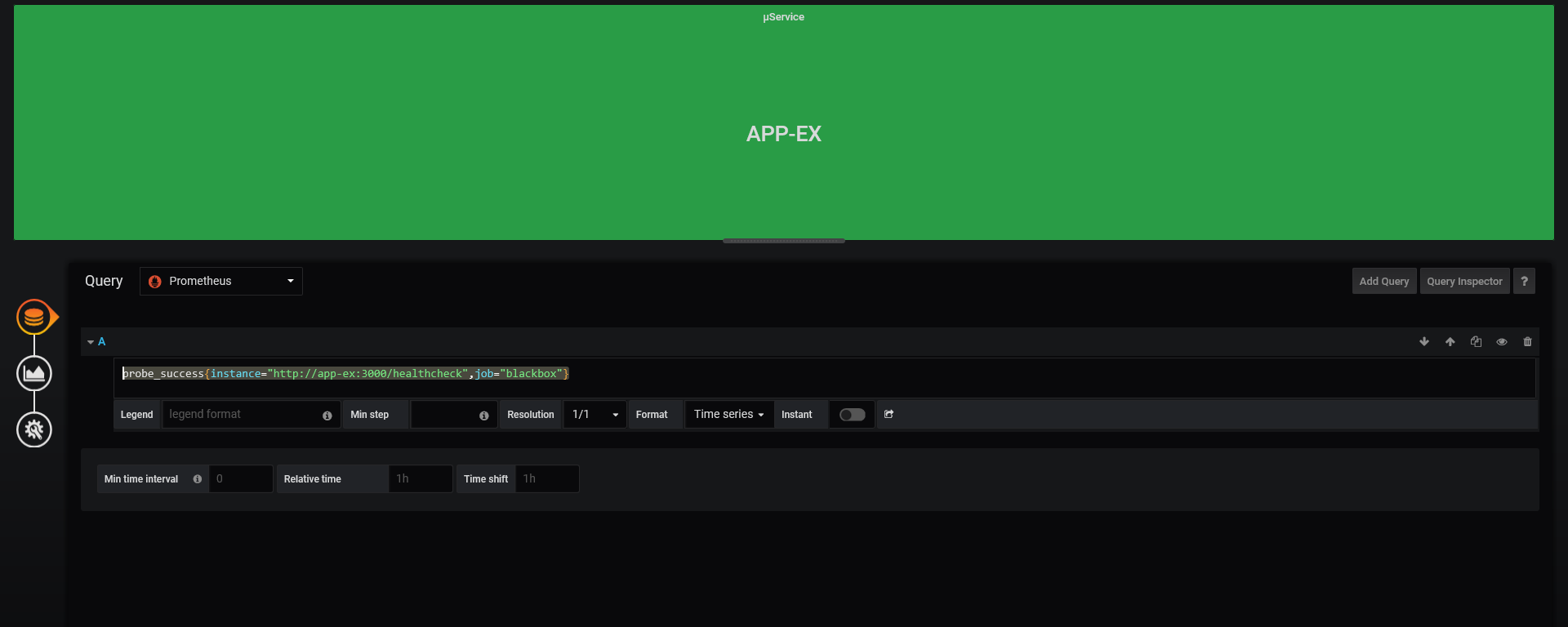

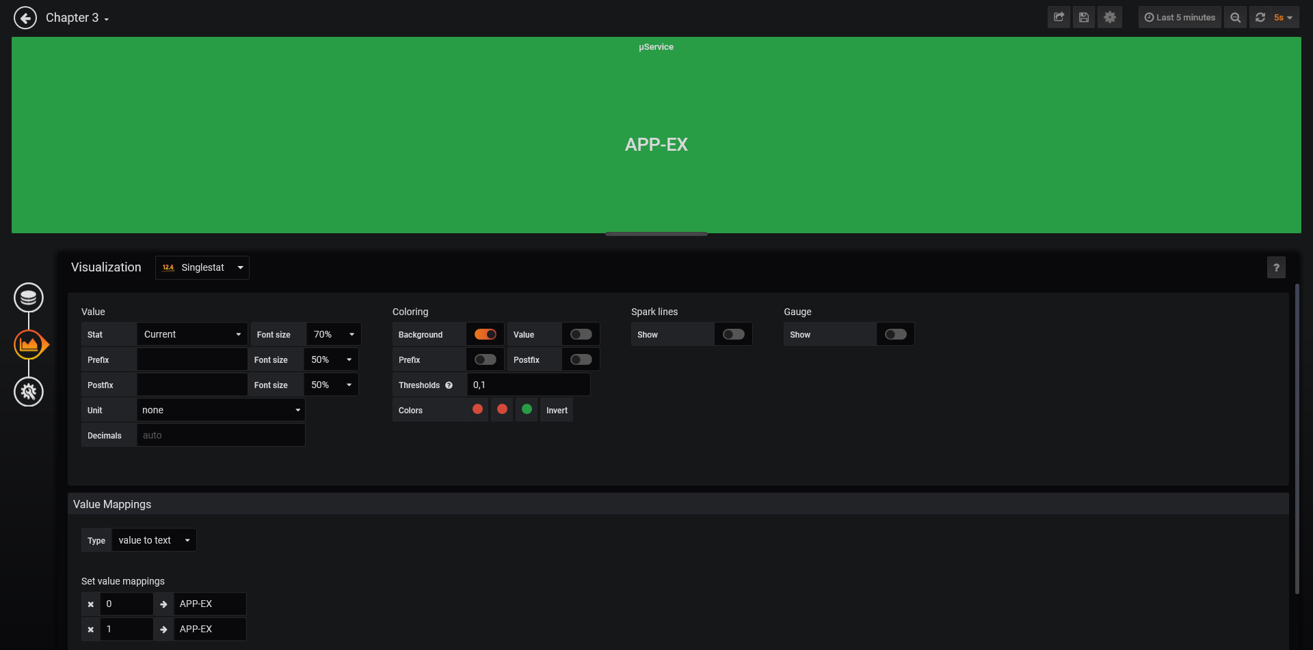

**Mean Time To Recover:**

SELECT sum("value") / count("value") FROM "mtbf" WHERE ("app_name" = 'app-ex') AND $timeFilter

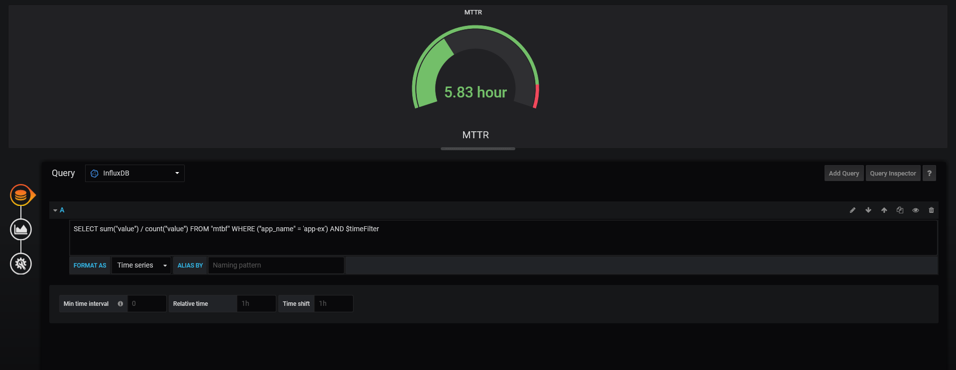

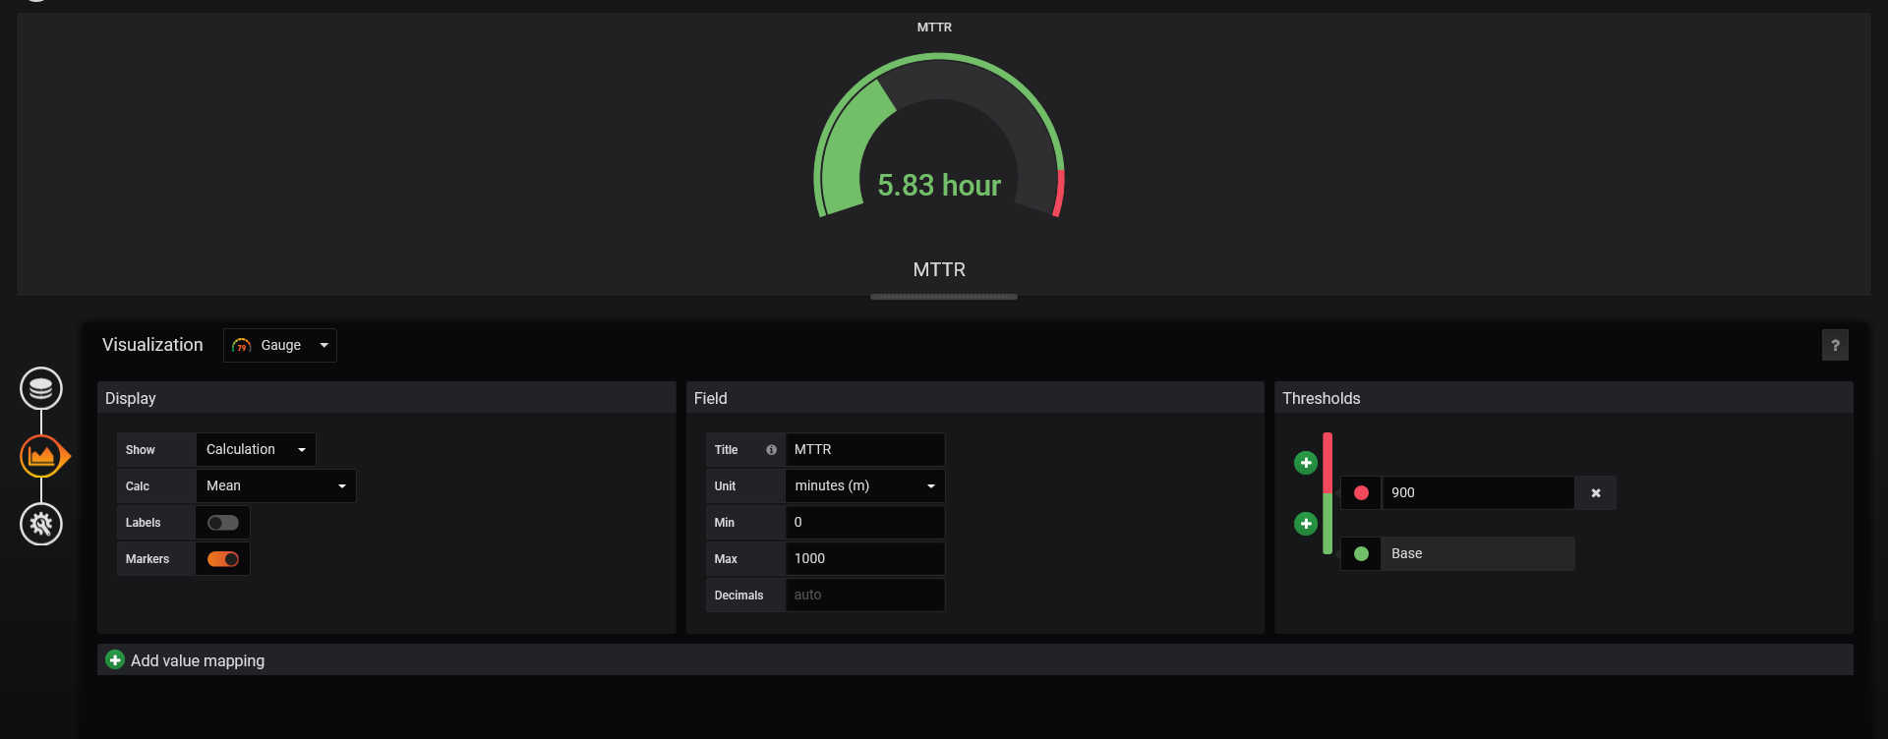

**Application Performance:**

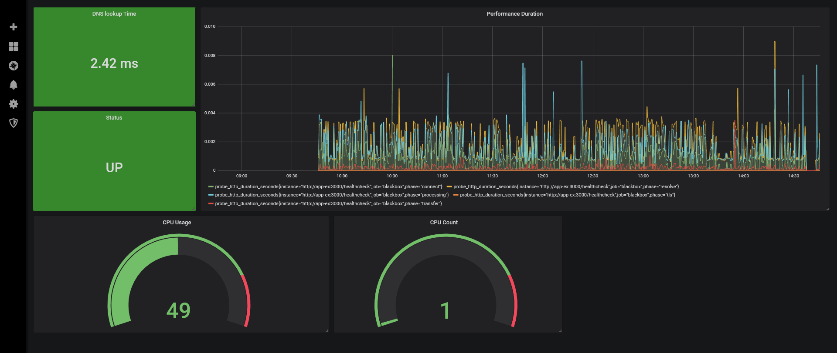

**DNS LookUP Time:**

probe_dns_lookup_time_seconds{instance="http://app-ex:3000/healthcheck",job="blackbox"}

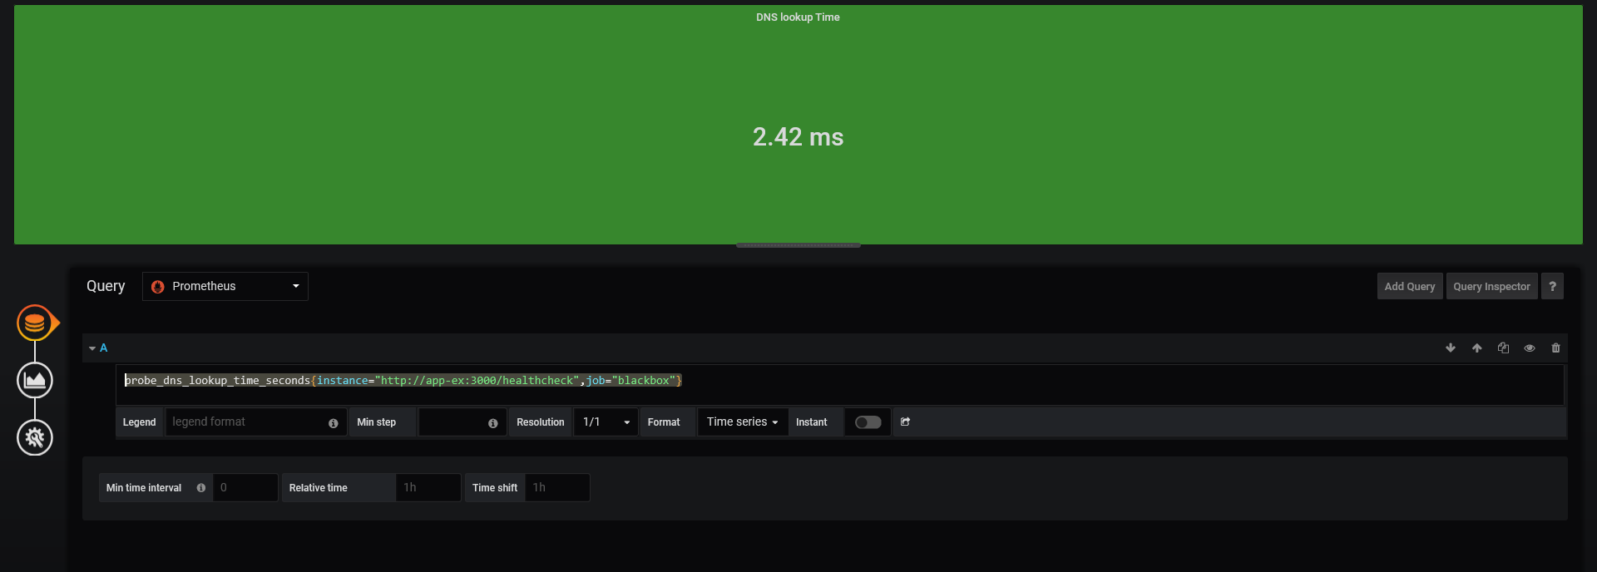

**Performance durartion:**

probe_http_duration_seconds{instance="http://app-ex:3000/healthcheck",job="blackbox",phase="connect"}

probe_http_duration_seconds{instance="http://app-ex:3000/healthcheck",job="blackbox",phase="processing"}

probe_http_duration_seconds{instance="http://app-ex:3000/healthcheck",job="blackbox",phase="resolve"}

probe_http_duration_seconds{instance="http://app-ex:3000/healthcheck",job="blackbox",phase="tls"}

probe_http_duration_seconds{instance="http://app-ex:3000/healthcheck",job="blackbox",phase="transfer"}

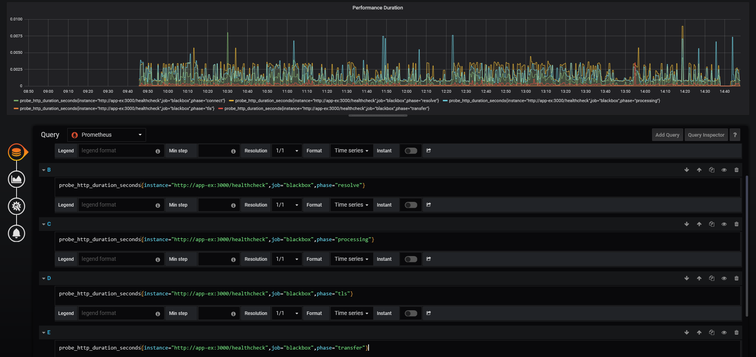

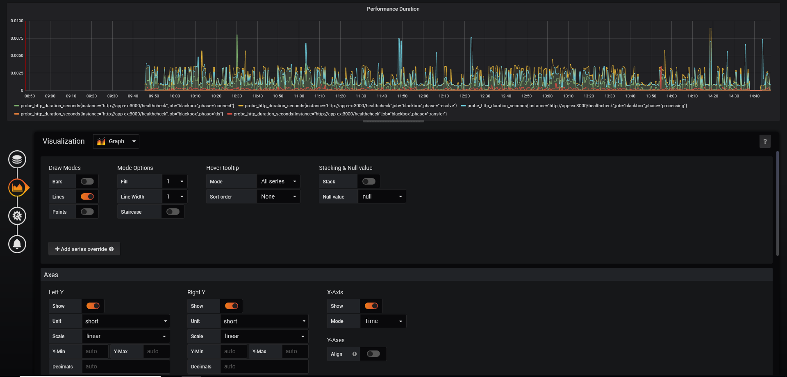

**CPU Process Seconds in Total**

process_cpu_seconds_total{instance="localhost:9090",job="prometheus"}

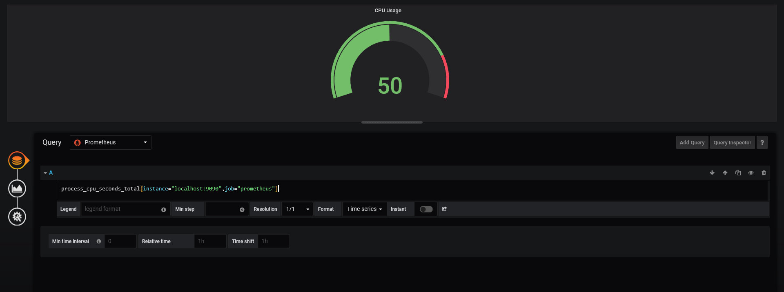

**Number of CPUs**

count(process_cpu_seconds_total)

