**CAT Project Report – Sprint 2**

**Group Members:**

|  |  |
| --- | --- |
| Anıl SEZGİN  Ali AYTEKİN  Ceren TOĞAY  Mevlüt Hulusi GÖNEN  Nergis ÇELEN  Veysel Emirhan OĞUZ |  |

**Description:**

CAT stands for Checklist Automation Tool, it is a software tool which helps testing Android phone. CAT needs a checklist provided as an excel file, parses it and shows it on its GUI. The tool gives its users to change the status of a testcase on its GUI. Whenever user wants the result of the provided checklist, CAT prints an output file. Furthermore, the tool works parallel with Calaba.sh, which is used to parse testcase and run it on the device-under-test, and gives user a chance to automate any of the testcases.

**Product Backlog:**

|  |  |  |  |  |
| --- | --- | --- | --- | --- |
| **ID** | **Story** | **Priority** | **Time Estimation** | **Status** |
| 1 | User can import excel file which includes checklist | 2 | 15 hours | Not started |
| 2 | User can display details of each checklist item | 3 | 10 hours | Not started |
| 3 | Setting up environment | 1 | 6 hours | İn progress |
| 4 | User can modify status of test case | 4 | 4 hours | Not Started |
| 5 | User can modify if test case is automated or not. | 6 | 16 hours | Not Started |
| 6 | User can display results of test case | 5 | 4 hours | Not started |

The marked items are selected to be completed for this Sprint.

**Sprint Backlog:**

|  |  |  |  |  |
| --- | --- | --- | --- | --- |
| **ID** | **Task** | **Responsible** | **Time Estimation** | **Progress** |
| 2.1 | Show parsed excel file on a new window | Veysel Emirhan Oğuz | 7 hours |  |
| 4.1 | Add textview to change status | Mevlüt Gönen | 6 hours |  |
| 1.1 | Complete parser implementation | Nergis Çelen | 6 hours |  |
| 1.2 | Deliver a complete checklist excel model | Ceren Toğay | 1 hour |  |
| 1.3 | Complete unit tests for parser function | Anıl Sezgin | 1 hour |  |
| 1.4 | Complete remaining unit tests | Ali Aytekin | 2 hours |  |

**Burn-down Chart:**

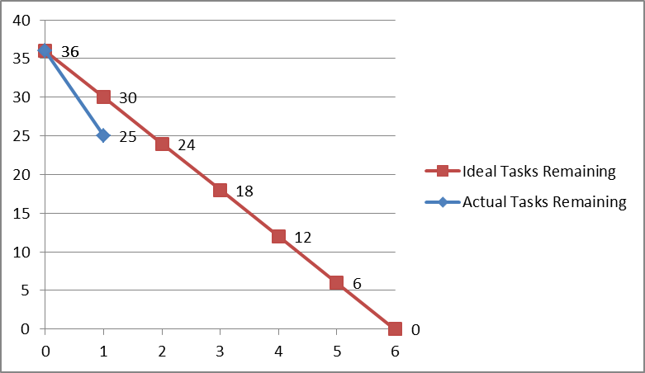

**Accuracy of Time Estimations:**

|  |  |  |
| --- | --- | --- |
| **Product Backlog Item** | **Estimated Completion Time** | **Actual Time Spent** |
| 2 | 6 hrs | 8 hrs |
| 4 | 8 hrs | 4 hrs |

**Note:** You should keep track of the time spent for tasks and compare them with your actual estimations, so that you can make a better estimation and update the product backlog before the next Sprint.