Assignment #3 – Template
Software Requirements Specification

Revision History

Date | Revision | Description | Author
04/20/23 | 1.0 | Initial Version | Anilsha T
04/21/23 | 1.1 | Overall Description | Anilsha T
04/21/23 | 1.2 | Specific Requirements | Anilsha T
04/21/23 | 1.3 | Non-functional Requirements | Anilsha T

Table of Contents
1. Purpose 4
1.1. Scope 4
1.2. Definitions, Acronyms, Abbreviations 4
1.3. References 4
1.4. Overview 4
2. Overall Description 5
2.1. Product Perspective 5
2.2. Product Architecture 5
2.3. Product Functionality/Features 5
2.4. Constraints 5
2.5. Assumptions and Dependencies 5
3. Specific Requirements 6
3.1. Functional Requirements 6
3.2. External Interface Requirements 6
3.3. Internal Interface Requirements 7
4. Non-Functional Requirements 8
4.1. Security and Privacy Requirements 8
4.2. Environmental Requirements 8
4.3. Performance Requirements 8

Purpose
This document outlines the requirements for the Mine Pump Control System (MPC).

Scope
This document will catalog the user, system, and hardware requirements for the MPC system. It will not, however, document how these requirements will be implemented.

Definitions, Acronyms, Abbreviations
List any acronyms, terms etc. that need to be defined.

References
Use Case Specification Document – Step 2 in assignment description
Use Case Specification Document .docx
UML Use Case Diagrams Document – Step 3 in assignment description
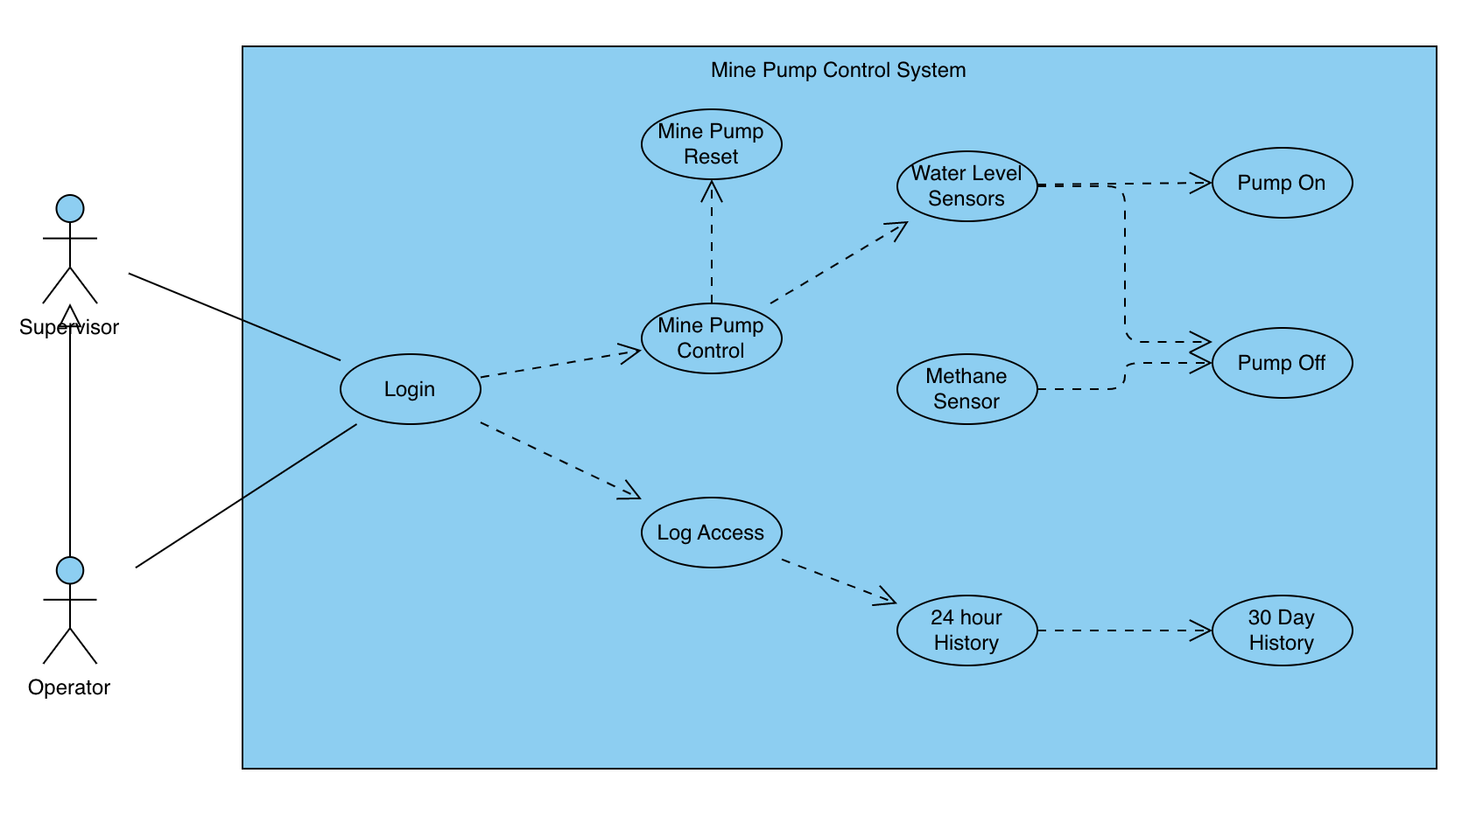

Class Diagrams – Step 5 in assignment description
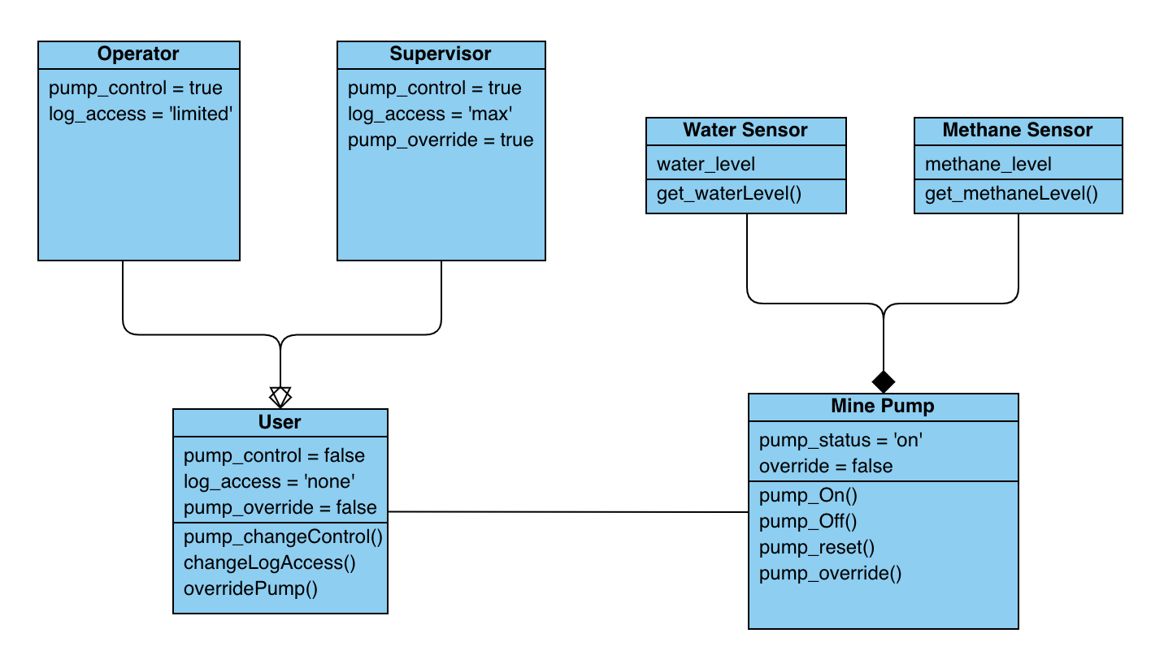
Sequence Diagrams – Step 6 in assignment description

Overview
The Mine Pump Control System (MPC), is designed to monitor and pump flood water out of mine shafts. As underground mining operations take place far below the water table, flooding into mine galleries and shafts is an ever-present danger.

Overall Description

Product Perspective

Product Architecture
The system will be organized into three major modules: the login module, the log access module, and the mine pump control module.
Note: System architecture should follow standard OO design practices.

Product Functionality/Features
The high-level features of the system are as follows (see section 3 of this document for more detailed requirements that address these features):
2.3.1 A log in system that allows operators and supervisors to access the system.
2.3.2 A section for log access, where users are able to access logs created by the system.
2.3.3 A pump reset feature used after a supervisor manually turns on or off the pump.
2.3.4 Water level sensors that detect the water levels in the mine and automatically turn on and off the pump.
2.3.5 A methane sensor that detects unsafe levels of methane in the mine, which can trigger an evacuation alarm.
2.3.6 A manual pump status change feature where operators and supervisors can manually turn the pump on and off.

Constraints
List appropriate constraints.
    - Users are constrained to only Linux systems.
    - Users cannot use mobile devices to access the system.
    - Users must use the environment created to access the system. Browser access will not work.

Assumptions and Dependencies
List appropriate assumptions
Assumption Example: It is assumed that the maximum number of users at a given time is 15,000.
    - It is assumed that users that have access to the system will be only operators or supervisors.
    - It is assumed that all sensors are operational and require no maintenance.
    - It is assumed that the system will run continuously- it must be available 24 hours a day.

Specific Requirements

Functional Requirements

Common Requirements:
Provide requirements that apply to all components as appropriate.
3.1.1.1 System should be able to keep track of the credentials of a user.
3.1.1.2 The system may not change a user’s access at any point.

Login Module Requirements:
Provide module specific requirements as appropriate.
Example:
3.1.2.1 Users should be allowed to log in using their issued id and pin, both of which are alphanumeric strings between 6 and 20 characters in length.
3.1.2.2 System should be able to determine if user has valid credentials.
3.1.2.3 System should be able to give user access to certain functions of the system dependent of their credentials.

Log Access Module Requirements:
Provide module specific requirements as appropriate.
3.1.3.1 System should be able to validate user credentials, between operator, supervisor, or none.
3.1.3.2 System should be able to provide access to logs to operators for 24 hours, and supervisors for 30 days.
3.1.3.3 System should be able to allow supervisors to add notes to logs within the past 24 hours.

Mine Pump Control Module Requirements:
Provide module specific requirements as appropriate.
3.1.4.1 The water sensors should detect when the water levels reach the minimum or maximum levels set by the sensor.
3.1.4.2 The methane sensor should detect when there is an unsafe concentration of methane in the mine.
3.1.4.3 The water sensors should be able to turn on and off the pump when the water levels are detected.

External Interface Requirements
Provide module specific requirements as appropriate.
3.2.1 The system provides an interface where the users are able to see the water and methane levels read by the sensors if they have valid credentials. The system provides the user the option to turn the pump on or off, or to look at the system logs.

Internal Interface Requirements
Provide module specific requirements as appropriate.
3.3.1 The system must process system logs which contain the time, status of the system, and function executed in the form of a text file. The system will decipher the permission level of the user and provide a 24 hour history for operators, and a 30 day history for supervisors.

Non-Functional Requirements

Security and Privacy Requirements
Example:
4.1.1 The System must encrypt data being transmitted over the Internet.
4.1.2 The system must disallow users without credentials from entering the system.
4.1.3 The system must not allow information to be transferred out into third-party applications or web services.

Environmental Requirements
Example:
4.2.1 System cannot require that any software other than a web browser be installed on user computers.
4.2.2 System must make use of the existing Oracle 9i implementation for its database.
4.2.3 System must be deployed on existing Linux-based server infrastructure.
4.2.4 System only allows input from the system’s GUI therefore no commands are processed from the terminal.
4.2.5 System must not be terminated or killed in any form. Users cannot terminate the system.

Performance Requirements
Example:
4.3.1 System must render all UI pages in no more than 9 seconds for dynamic pages. Static pages (HTML-only) must be rendered in less than 3 seconds.
4.3.2 The system times the user out after 30 minutes of inactivity and logs the user out.
4.3.3 The system must be able to process system commands such as pump control and reset within 30 seconds of the user executing the command. Once the system processes the command, the pump must be activated and fully functioning within 5 minutes of the action being queued.

