**Niroj Maharjan**

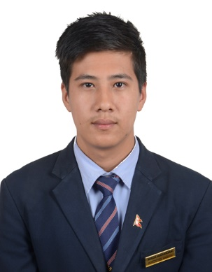**Personal Details**

Date of Birth : July 28, 1998

Nationality : Nepalese

Marital Status : Single

Current Address : Bafal, Kathmandu, Nepal

Home Address : Same as the current Address.

**Application Detail**

Applying for: F & B practical training

Available from:

Desired program length: 1 year

Education Status: Enroll Student

Visa Application in:

**Education**

|  |  |  |  |  |
| --- | --- | --- | --- | --- |
| Level | Board | Institution | Passed Year | Division |
| Bachelor | Tribhuwan University | NCCS | Running |  |
| +2 Level | HSEB | Sirius College | 2014 – 2016 | Second |
| SLC | Government of Nepal | Sirius Higher Secondary School | 2014 | First |

**Professional Experience**

* ODC (Hotel Yak and Yeti, Hotel Radisson)
* Training in food production regarding various cuisines
* Fine dining etiquettes in college restaurant

**Skills**

* Teamwork
* Ability to handle the wide variety of tasks
* Good problem solving skills
* Microsoft Office(Word, Power Point, Excel)
* Good Communication and Negotiation Skills
* Experience in managing large quantities of data.

**Languages Skills**

* Nepali
* English
* Chinese

**Computer Skills**

* Microsoft Office (Word, Excel, Power Point)
* Webpage Designing (HTML,CSS, JavaScript, Adobe Photoshop, Web Hosting, Adobe Dreamweaver)

**Award and Certificate**

July, 2014 : Webpage Designing

December, 2018 : Barista Certification from NCCS

**References**

“Available upon Request”