**As a User ‘Cyrus’**

**As an authenticated User**

CSR and other departments – no create button/edit button

* User can post comments.
* 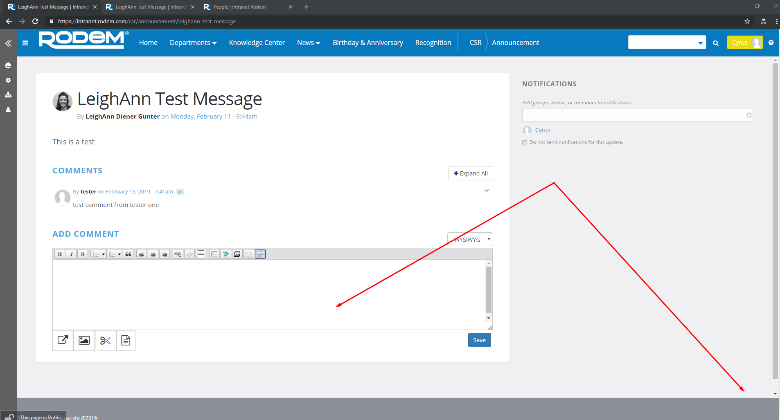

**As an editor**

CSR and other departments – inside Announcement content- no create/edit button but a ‘revision’ button

-user can post comments

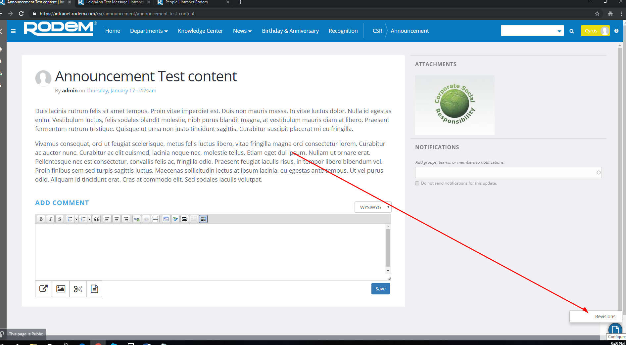

**As an Administrator**

-Csr and other departments – Can customize/change layout/clone/archive the page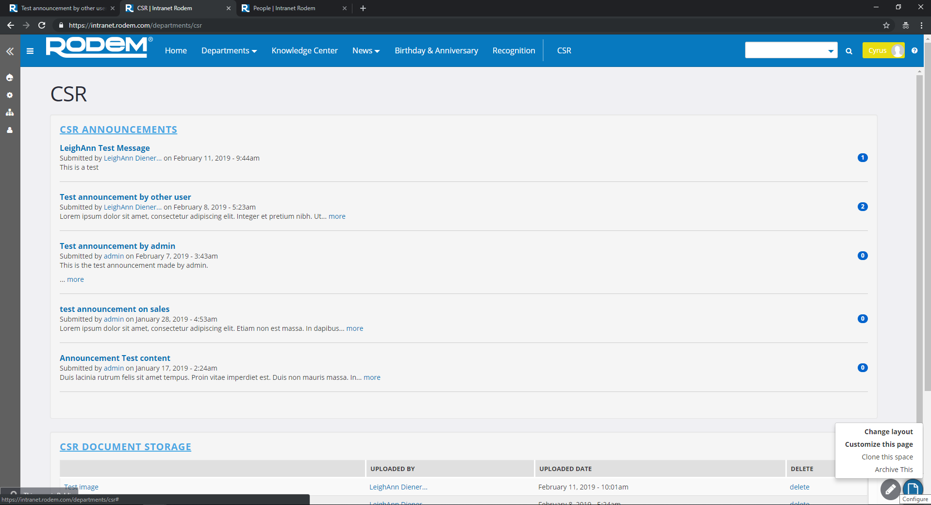

-Announcement Section – Can clone/archive the document.

- User can post comments.

