Settings
Path: Three Line >> Settings
Steps to reach Settings:
Step 1 : Three Line in Steps to reach Settings : Click on the three-line (☰) menu icon located at the top-left corner of your dashboard.
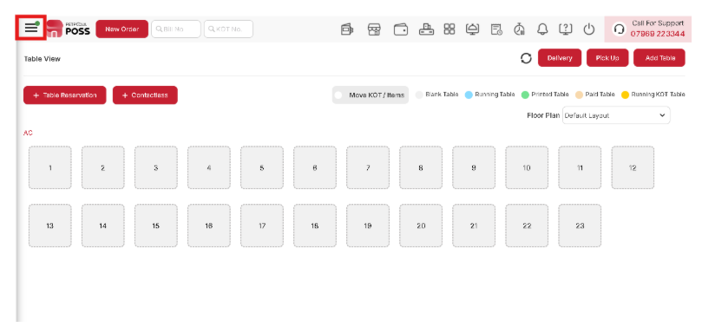
{Image Name: Three Line,
Description: The red box highlights a menu icon on the POS interface. It appears to be a navigation button used to access different sections or settings within the platform.Here is an image of Step 1 Three Line in Steps to Reach Settings.}
Step 2 : Settings in Steps to reach Settings : From the dropdown menu, select Settings to view or modify your application preferences.
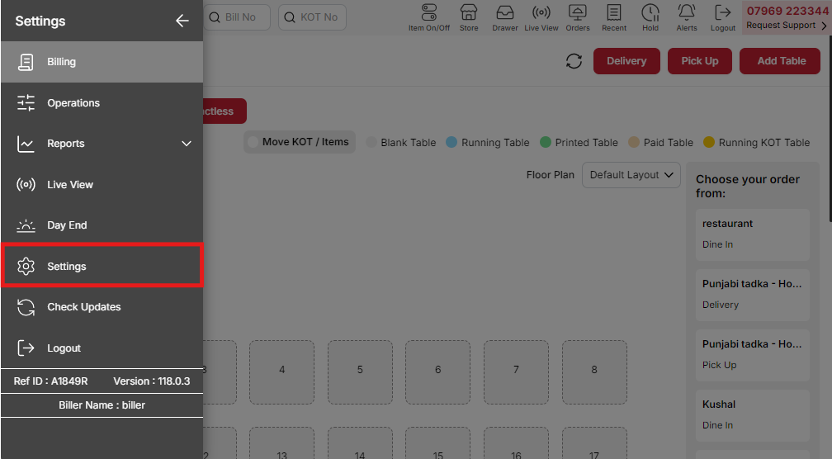
{Image Name: Settings,
Description: The red box highlights the “Settings” option in the side menu of the POS. This section is used to configure system preferences and operational settings.Here is an image of Step 2 Settings in Steps to Reach Settings.}

Billing Screen

Display

Path : Three Line >> Settings >> Display.

Steps to reach Display:
Step 1 : Three Line in Steps to reach Display : Click on the three-line menu icon located at the top-left corner of your dashboard.

{Image Name: Menu Icon,
Description: The red box highlights a menu icon on the POS interface. It appears to be a navigation button used to access different sections or settings within the platform.Here is an image of Step 1 Three Line in Steps to Reach Display.}
Step 2 : Settings in Steps to reach Display : From the dropdown menu, select Settings.

{Image Name: Settings,
Description: The red box highlights the “Settings” option in the side menu of the POS. This section is used to configure system preferences and operational settings.Here is an image of Step 2 Settings in Steps to Reach Display.}
Step 3 : Display in Steps to reach Display : Click on Display to adjust and manage screen display settings.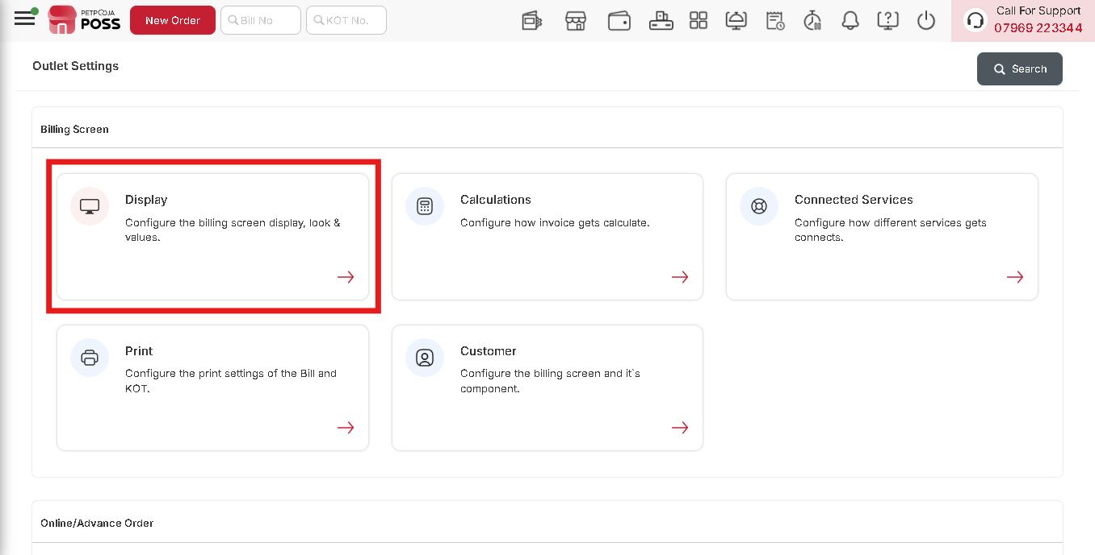
{Image Name: Display,
Description: The red box highlights the “Display” option under the Billing Screen settings. It allows users to configure the billing screen’s display, layout, and visual appearance.Here is an image of Step 3 Display in Steps to Reach Display.}

Key Features :
Defines default values for the billing screen components.

1. Layout for Billing Screen
- Keyboard – Use a keyboard-based interface.
- Touch Screen – Use a touch-based interface.

2. Display Preference for the Menu (Only for Touch Screen)
- On the Left – Menu appears on the left side .
- On the Right – Menu appears on the right side.

3. Default Screen to Display
- Billing – Opens the billing screen by default.
- Table Management – Opens the table management screen by default.

4. Order Live View
- ASC (Ascending Order) – Orders appear from oldest to newest.
- DESC (Descending Order) – Orders appear from newest to oldest.

5. KOT Live View
- ASC (Ascending Order) – KOT orders appear from oldest to newest.
- DESC (Descending Order) – KOT orders appear from newest to oldest.

1. KPT Order Handling
- KPT breached order should remain on top of the screen in live view – Ensures urgent orders stay visible.
- Display alerts for prep time exceeding or order handover on the live view card – Alerts for delayed or ready orders.

2. Add New Item in Cart (Available only in cloud login)
- In Bottom – Adds items at the bottom of the cart.
- On Top – Adds items at the top of the cart.

3. Virtual Keyboard Settings
- Enable virtual keyboard in touch – Allows virtual keyboard use in touch mode.
- Open virtual keyboard while entering order number in online order food ready text box – Enables keyboard for online order numbers.
- Open virtual keyboard for short code search on billing screen – Enables keyboard for quick item searches. (Works only if the virtual keyboard is enabled for touch view.)

4. Billing Screen Preferences
- Display item images on the billing screen – Shows product images during billing.
- Auto add items to billing screen on select – Automatically adds selected items to the bill.
- Open virtual keyboard for short code search on billing screen – Enables keyboard for quick searches. (Only applicable when the virtual keyboard is enabled for touch view.)
- Auto add items to billing screen from variation/addon popup – Automatically adds selected variations or add-ons to the bill.
- Display Search Item option on billing screen – Allows searching for items in touch view. (Only for Touch View.)
- Addon Min-Max Validation – Ensures add-ons follow minimum and maximum limits.
- Display item price – Shows item prices on the billing screen.
- Display settle amount textbox – Displays a textbox for settling amounts during billing.
- Allow user to settle an order with a lower amount – Enables settling an order for a lower amount. (Only available in cloud login.)
- Display Settle and Save button for delivery and pickup orders on live view card – Adds a "Settle and Save" button for delivery and pickup orders.

2. Tip Configuration
- Show Tip – Enables tipping option during billing.
- Set Tip Selection As – Choose how the tip amount is selected.
  - None – No tip option.
  - Percentage – Tip calculated as a percentage of the total.
  - Fixed – Tip set to a fixed amount. (Selected)
- Set Tip Value – Enter tip values in a comma-separated format for customer selection in Kiosk.
- Show CWT (Category Wise Taxes) Bifurcation On Billing Screen – Displays tax breakdown by category.
- By default make tax area open – Keep the tax section expanded on the billing screen for easier visibility.
- Show KOT details (KOT ID and Time) while View/Merge KOT – Displays KOT ID and timestamp when viewing or merging KOT.
- Merge e-bill and print bill – Sends an e-bill when the bill is printed. (E-bill settings enabled.)
- No. of Persons Mandatory – Requires entering the number of persons before proceeding with billing.
- Show Addon Quantity with the total item quantity (multiplication) to prepare in Bill – Displays add-on quantity multiplied by item quantity in bills and KOT Live View/KDS.
- Display errors while checking printer status – Shows error messages if issues occur with the printer
- Custom Payment Information Mandatory – Requires custom payment details to complete the transaction.
- Do not allow the biller to punch item quantity in decimal – Restricts item quantity input to whole numbers only.
Set option for quick links for items in table view screen – Choose how items are managed in table view:
- Save & Print – Saves and prints the bill.
- View KOT – Displays KOT details.
- Both – Enables both Save & Print and View KOT options.
Display Menu – Choose how the menu is displayed:
- None – No menu display.
- Group Wise – Displays menu items grouped by category.
- Default Group Wise Menu – Sets the default menu category (e.g., Dessert).
- Consider category scheduling for offline billing – Enables category-based billing schedules for offline use.
- Show suggested items against the item selected on billing – Displays item suggestions based on selected items.
Assign to validation on billing screen – Requires assigning bills/KOTs to specific order types before processing:
(Note: Assigning is mandatory for selected order types.)
- Delivery
- Pick Up
- Dine In

Mark Order and KOT as completed once the bill is settled – Marks order/KOT as completed after billing for selected order types:
- Delivery
- Pick Up
- Dine In

1. Item Sorting
- Item Sorting – Defines the sorting order of items in the billing system:
  - A - Z – Sorts items alphabetically from A to Z.
  - Price Low to High (Selected) – Displays items in ascending order based on price.
  - Item Rank – Sorts items based on their predefined ranking.
- Show table start by / bill created by information on billing screen (Touch Screen) – Displays details of who started the table or created the bill on the billing screen.

Default Values

1. Default Order Type
- Sets the default order method (e.g., Pick Up, Delivery, Dine-in) for transactions.

2. Default Payment Type
- Defines the standard payment method, such as Cash, Card, or Other.

3. Default Custom Payment Type
- Specifies a custom payment method like UPI for digital transactions.

4. Default Table No.
- Sets a default table number, primarily used for dine-in services.

5. Default Petty Cash Amount
- Defines the preset petty cash amount available unless changed manually.

6. Item Quantity
- Specifies predefined numeric values (comma-separated) for selecting item quantities.

7. Item Price
- Defines predefined numeric values (comma-separated) for selecting item prices.

8. Default Quantity
- Sets the default quantity for items added to the cart unless entered manually.

9. Finalize Order
- An option to finalize the order, available only in cloud login.

10. Font Configuration
- Allows selecting the default font style for the system interface.

11. Default Login Screen
- Defines the login method: Username/Password, Passcode, or Swipe Card.

Section Configuration Remain

Table Settlement

15. Lock Active Table
- Defines when the table should be locked during billing (Save & Print, Settle & Save, or None).

16. Release Table On
- Specifies when a table is released, either on "Print Bill" or "Settle & Save."

17. Release Recent Section On
- Determines when the recent section is released (Print Bill or Settle & Save).

18. Release Recent Section On Order Delivered (For Online Orders)
- Enables automatic release of the recent section once an online order is delivered.

19. Discount Label
- Defines the name displayed for the discount field (e.g., "Coupon Code").

20. Discount Calculate Button Text
- Specifies the text for the discount application button (e.g., "Apply").

21. Display "Leave as it is. {No Discount}" on Discount Screen?
- Allows the option to show a "No Discount" selection on the discount screen.

22. By Default Make Discount Area Open
- Ensures the discount section is visible by default on the billing screen.

Order wise Information
- Enable Order Wise Information – Checkbox to activate order-wise details for better order tracking.
- Order Wise Information Label – Mandatory field to define a custom label for the order-wise details.

Negative Quantity Settings
- Negative Quantity Reason – Displays a reason, but currently shows "undefined" with an error icon.
- Cloud Login Restriction – The setting is only available when logged in via the cloud.
- Allow Negative Quantity – Checkbox is checked, meaning negative quantities are permitted.

Order Cancel Reason Settings

1. Order Cancel Reason Settings
The following settings pertain to configuring the order cancellation settings in the billing screen.
- Order Cancel Reason 1 - 4:
  - Input fields to specify predefined reasons for canceling an order.
- Show Biller an Option to Release Used KOTs While Cancelling a Bill (Enabled)
  - Allows the biller to release used KOTs when canceling a bill (only for same-day KOTs), enabling the creation of a new bill using the older KOTs.
- Order Cancel OTP:
  - Email ID input field to receive an OTP while canceling an order. Multiple email IDs can be added, separated by commas.

Order Edit Reason Settings

1. Order Edit Reason Settings
The following settings pertain to configuring the order edit settings in the billing screen.
- Order Edit Reason 1 - 4:
  - Input fields to specify predefined reasons for editing an order.
- Order Edit OTP:
  - Email ID input field to receive an OTP while editing an order after print. Multiple email IDs can be added, separated by commas.

Order Complimentary Reason Settings
The following settings pertain to configuring the order complimentary settings in the billing screen.
- Order Complimentary Reason 1 - 4:
  - Input fields to specify predefined reasons for marking an order as complimentary.
- Order Complimentary OTP:
  - Email ID input field to receive an OTP while processing a complimentary order. Multiple email IDs can be added, separated by commas.

Order Sales Return Reason Settings
The following settings pertain to configuring the order sales return settings in the billing screen.
- Order Sales Return Reason 1 - 4:
  - Input fields to specify predefined reasons for processing an order sales return.
- Order Sales Return OTP:
  - Email ID input field to receive an OTP while processing a sales return order. Multiple email IDs can be added, separated by commas.

Lower / Higher Order Settlement Amount Reason Settings
The following settings pertain to configuring the order settlement settings in the billing screen.
- Reason for Settling Order Amount Other Than the Invoice Total:
  - Checkbox option to enable or disable providing a reason when settling an order amount that differs from the invoice total.

Special Order Discount Settings
The following settings pertain to configuring the special order discount settings in the billing screen.
- Special Discount OTP:
  - Enter an email ID through which you will receive an OTP while applying a special order discount.
  - Multiple email IDs can be added, separated by commas.

The following settings pertain to configuring the item price change (NC) settings in the billing screen.
- Item Price Change (NC) Reasons:
  - Reason 1: (Input field)
  - Reason 2: (Input field)
  - Reason 3: (Input field)
  - Reason 4: (Input field)

Calculations
Steps to reach Calculations:
Step 1 : Three Line in Steps to reach Calculations : Click on the three-line (☰) menu icon located at the top-left corner of your dashboard.

{Image Name: Menu Icon,
Description: The red box highlights a menu icon on the POS interface. It appears to be a navigation button used to access different sections or settings within the platform.Here is an image of Step 1 Three Line in Steps to Reach Calculations.}
Step 2 : Settings in Steps to reach Calculations : From the dropdown menu, select Settings.

{Image Name: Settings,
Description: The red box highlights the “Settings” option in the side menu of the POS. This section is used to configure system preferences and operational settings.Here is an image of Step 2 Settings in Steps to Reach Calculations.}
Step 3 : Calculations in Steps to reach Calculations : Click on Calculations to configure and manage billing or pricing calculation settings.
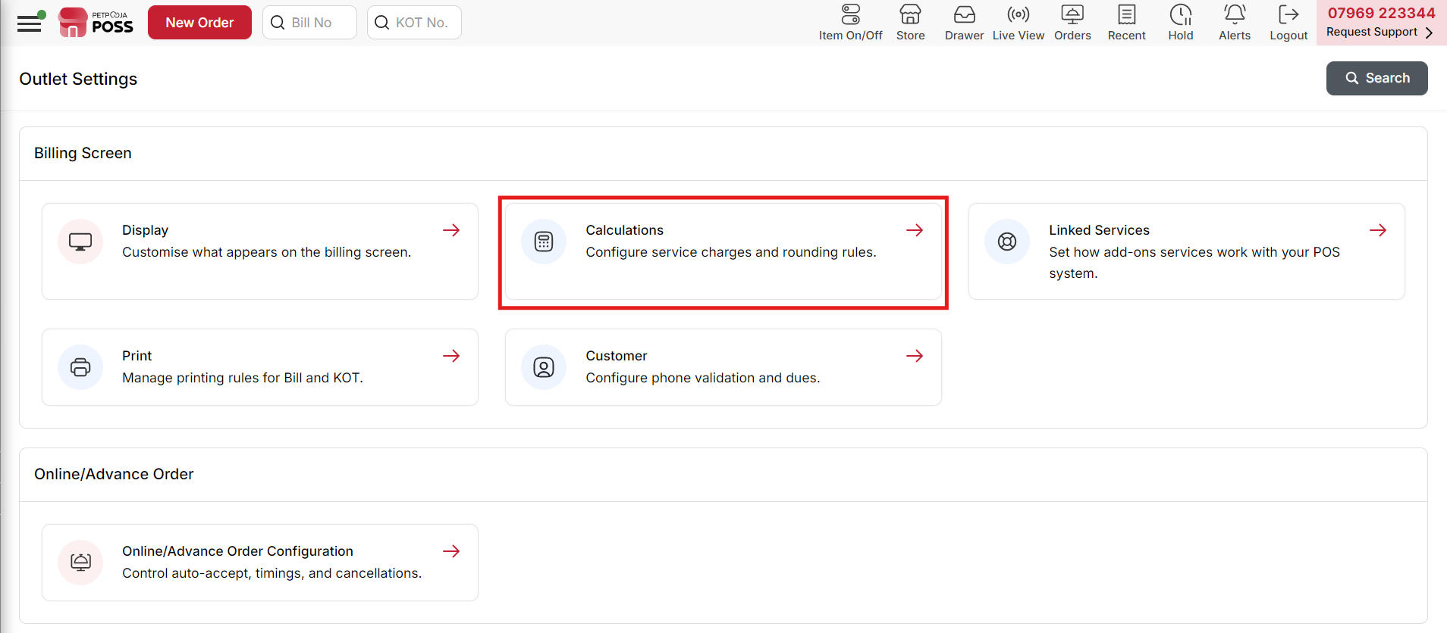
{Image Name: Calculations,
Description: The red box highlights the “Calculations” option in the Billing Screen settings. It is used to configure service charges, rounding rules, and billing-related calculations.Here is an image of Step 3 Calculations in Steps to Reach Calculations.}

Key Features :

- Round-Off Options :

Description: Briefly explains that the selected option will affect billing calculations.

Round off options for billing :

- Normal (Selected) – Uses standard rounding rules:
      - If the decimal value is ≥ 0.5, it rounds up.
      - If the decimal value is < 0.5, it rounds down.
- Round off up – Always rounds the amount upward. (Ex. Example: 12.45 → 13.00).
- Round off down – Always rounds the amount downward. (Ex. Example: 12.75 → 12.00)
- None: No rounding is applied, and the exact amount is retained.(Ex. 12.67 Remains 12.67)

Round the number to the increments of *:

1 (Default)

Explanation: The number will be rounded to the selected increment. For example, if round-up is chosen and the increment is 0.25, then 2.20 would be rounded to 2.25.

2. Select decimal points for invoice calculation and Menu price input :

Description: Allows users to set the precision of numerical values in invoices and menu prices.

Example: If "1" is chosen, a value like 0.9277 will be rounded to 1.0.

Service Charge
Description: The settings define how the service charge is displayed, calculated, and applied for different order types (Delivery, Pickup, Dine-in). It also includes tax settings and conditions for service charge application.

Key Features :
Service Charge Display & Calculation:

- Display & Calculate Service Charge: The system allows service charge calculation and display.
- Service Charge Label: The label is set as "service charges", which will appear on invoices/bills (Its label is Editable).
- Service Charge Type:
      - Fix : This means the service charge will be a fixed amount of the total bill (Ex. 20 RS fixed )
      - Percentage : This means the service charge will be a Percentage amount of the total bill (Ex. 5% Percentage). Calculate Service Charge
      - Calculation On :
- Core
- Total
Service Charge Value *:
- 10
- Calculate Service Charge Automatically : Enabled for Delivery, Pickup, and Dine-in, meaning service charges will be calculated automatically for these order types.

- Calculate Tax on Service Charge : This option is enabled, meaning tax will be calculated on the service charge amount.

- Apply service charge on online orders : This option is enabled, meaning the service charge will also be applied to online orders.

- Set a specific amount to calculate :
      - Greater Than : Example: If the order total is ₹120, the service charge will be applied. If it's ₹80, it won’t be applied.
      - Less Than : Example: If the order total is ₹90, the service charge will be applied. If it's ₹150, it won’t be applied.
      - None : This means no condition is set based on the amount.

Container Charge

Key Features :

- Show Container Charge On Billing Screen :
Description: If enabled, the container charge will be displayed on the billing screen.

- Container Charge Label * : The label is set as "Container Charge Label", which will appear on invoices/bills (Its label is Editable).

- Container Charge : There are two options are there :

      - Item Wise : If “Item Wise” is selected, the charges apply to the individual items.
      - Order wise : If "Order Wise" is selected, the charge applies to the entire order

- Container Charge Type : There are two options are there :

      - Fixed : If "Fixed" is selected the container charge will be applied as a fixed amount of the total order value.
      - Percentage : If set to "Percentage," the container charge is calculated as a percentage of the total amount.

- Calculate Container Charge Calculation On : There are two options are there :

      - Core : → Core means the charge is calculated on the core amount before taxes and discounts.
      - Total : → The container charge is applied on the final bill amount after taxes and discounts.

- Container Charge Value : When setting a Container Charge Value, you have two options.

      - Fixed Charge:A specific amount is applied as the charge, regardless of the container’s value or quantity. (Ex.If the fixed charge is 20).
      - Percentage Charge: The charge is calculated as a percentage of the total value of the container(Ex.If the Percentage charge is 20%).

- Calculate Container Charge Automatically :

If selected, the container charge will be applied automatically to the chosen order type (Delivery, Pick Up, or Dine In).

Calculate tax on Container Charge. :
This option enables or disables the application of tax on the container charge in the billing screen.

- Set a specific amount to calculate :

      - Greater Than : If the order total is ₹120, the service charge will be applied. If it's ₹80, it won’t be applied.
      - Less Than : If the order total is ₹90, the service charge will be applied. If it's ₹150, it won’t be applied.
      - None : This means no condition is set based on the amount.

Delivery Charge

Key Features :

- Show Delivery Charge On Billing Screen : This ensures that the delivery charge is displayed on the billing screen for transparency.

- Default Delivery Charge (Only for Delivery) * : This field lets you set a default charge for deliveries.

- Calculate tax on Delivery Charge : If checked, tax will be applied to the delivery charge.

- Set a specific amount to calculate :
      - Greater Than: Tax will be applied if the delivery charge is above the specified amount.
      - Less Than: Tax will be applied if the delivery charge is below the specified amount.
      - None: No specific condition will be applied for tax calculation.

Discount

Key Features :

- Calculate Tax Before Discount Calculation – Determines if tax is applied before discount.

- Calculate Backward Tax After Discount – Adjusts tax calculation after discount is applied.

- Special Discount Calculation On : – Defines whether the discount applies to the total amount or core value.
      - Total : This discount is applied to the entire order, reducing both the subtotal and the taxable amount.
      - Core : This discount is applied before tax but does not reduce the taxable amount.

- Item/ Category Discount Auto-Applied – Enables automatic discount application without manual selection.

- Show Item/Category wise discount box while adding an item – Displays discount input boxes for each item/category.

- Apply Bogo Automatically – Enables automatic Buy One Get One (BOGO) discount.

- Common Coupon Discount – Allows configured coupons from HO/Chain outlets to be used.

- Ignore add-on price while calculating discount (works for all types for discount) – Excludes add-on costs from discount calculations.

- Special Discount Reason Mandatory – Requires a reason to apply special discounts.

KOT/Bill

Key Features :

- Assign Bill sales to KOT punched user – Assign bill sales to the user who punched the KOT in reports.

- Save KOT On Save Bill (Only first time not in edit) – Saves the KOT automatically when the bill is saved for the first time.

- Consider Non Prepared KOT in Bill – Includes unprepared KOT items in the printed bill.

- Merge duplicate items – Combines identical items on the billing screen.

- Split a bill when multiple groups are present – Allows bill splitting based on multiple groups in an order.
- Auto Finalize Order –
- Everyday Reset KOT Number from * – Resets KOT numbers daily from a specified value, ensuring sequential numbering within the day for better organization.

Complimentary Bill

Key Features :
Description : The Complimentary Bill setting disables taxes and additional charges (Packing, Delivery, Service charges) to ensure free-of-cost billing.

Disable Taxes and other Charges(Packing Charge, Delivery charge, Service charge) on Complimentary Bill : No Taxes are Applied – Any applicable taxes such as VAT, GST, or sales tax are automatically disabled for complimentary bills.

Special Notes

Save special note into special notes master while saving Kot / Orders : This setting helps businesses store and manage special notes for orders, making it easier for staff to add common instructions without retyping them every time.

Surcharge

Key Features :
- Display & Calculate Surcharge: Indicates that the surcharge will be displayed and calculated in the billing system.
  - Surcharge Label* : The text entered here will be displayed as the surcharge label in the billing screen.
- Surcharge Type: Defines whether the surcharge is a fixed amount or a percentage.
- Surcharge Value : A required field where the actual surcharge percentage or fixed amount is entered.
- Calculate Surcharge Automatically : The surcharge is set to be calculated as a percentage and applies automatically to Cash, Card, Due, and Other payment methods

Linked Services

Steps to reach Linked Services:
Step 1 : Three Line in Steps to reach Linked Services : Click on the three-line (☰) menu icon located at the top-left corner of your dashboard.

{Image Name: Menu Icon,
Description: The red box highlights a menu icon on the POS interface. It appears to be a navigation button used to access different sections or settings within the platform.Here is an image of Step 1 Three Line in Steps to Reach Linked Services.}
Step 2 : Settings in Steps to reach Linked Services : From the dropdown menu, select Settings.

{Image Name: Settings,
Description: The red box highlights the “Settings” option in the side menu of the POS. This section is used to configure system preferences and operational settings.Here is an image of Step 2 Settings in Steps to Reach Linked Services.}
Step 3 : Linked Services in Steps to reach Linked Services : Click on Linked Services to view or manage connected third-party integrations and linked applications.
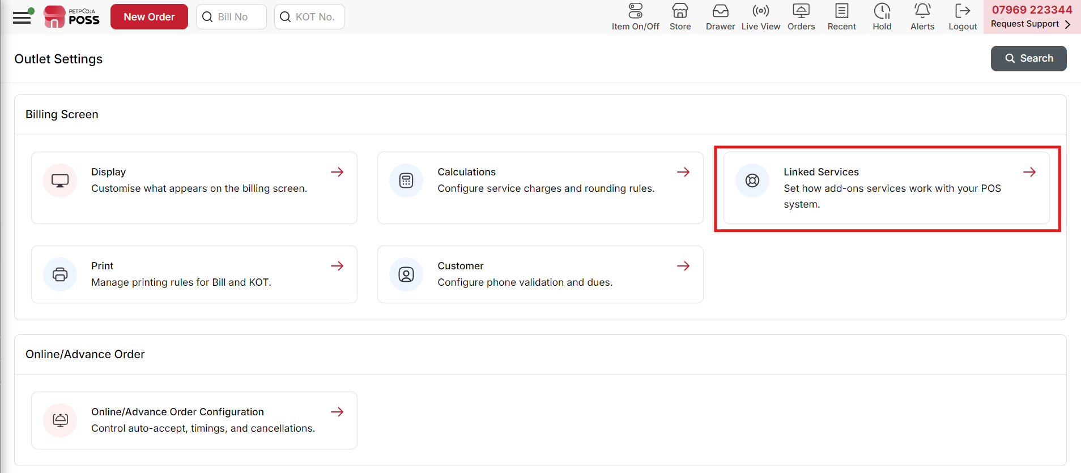
{Image Name: Linked Services,
Description: The red box highlights the “Linked Services” option in the Billing Screen settings. It allows users to manage how add-on services integrate and interact with the POS system.Here is an image of Step 3 Linked Services in Steps to Reach Linked Services.}

Inventory Settings :

Key Features :
The Inventory Settings section configures how inventory is managed within the billing screen.
- Enable Auto Consumption for Inventory: This option allows automatic inventory consumption but is only available for cloud login.
- Reset Your Stock on a Day Start: Enabling this will reset the stock levels at the beginning of each day.
- Action When Items Goes Out of Stock:
  - Hide Items (Selected): Items will be hidden from the billing screen when out of stock.
  - Disable Items: Items will be shown but cannot be selected for billing.
- Use Real-Time Stock Management: When enabled, stock levels will update instantly based on transactions.

Day End Settings

Key Features
The Day End Settings module helps configure the process of closing daily transactions in the billing screen.
- Enable Manual Day End : Allows manually ending the day’s operations, but this feature is only available in cloud login.
- Don't allow Day End if there is any active table on Table View Screen : Prevents closing the day if there are active tables in the Table View Screen, ensuring all orders are completed.
- Don't allow Day End if there is any un-sync orders data : Restricts day-end closure if there are any unsynced order records, preventing data loss.
- Restrict editing the order once the manual day end operation has been completed : Once the manual day-end process is completed, orders cannot be edited, maintaining data accuracy.

Loyalty Settings

Key Features
The Loyalty Settings module configures how loyalty points are applied in the billing screen.
- Make "Send Loyalty" option set as default on Billing screen : Ensures the "Send Loyalty" option is pre-selected on the billing screen for all transactions.
- Apply Loyalty points when order punched as : Loyalty points can be applied to Delivery, Pick Up, and Dine-In orders, depending on the selected options.
(This feature is only available in cloud login.)
- Send Loyalty Data (Only for Table Order) :
  - Print Bill : Loyalty data is sent when the bill is printed.
  - Settle & Save : Loyalty data is sent when the order is settled and saved.

Cash Drawer Settings

Key Features
The Cash Drawer Settings module configures when the cash drawer should open during billing operations.
- Open Cash Drawer On : Options include Save & Print, Settle & Save, Both, or None (None is selected, meaning the cash drawer won't open automatically).
- Open Cashdrawer for Cash Payment only : When enabled, the drawer will open only for transactions made using cash.

KDS Settings

Key Features
The KDS (Kitchen Display System) Settings help configure how kitchen order updates sync with the order screen.
- From KDS/KOT live screen send update to order screen : Any updates made in the KDS or KOT live view, such as marking an item or order as ready, will automatically reflect in the order screen.
- On marking done all items on KDS, Mark KOT as done : When all items in the KDS are marked as done, the full KOT (Kitchen Order Ticket) will be considered completed across all platforms, including online aggregators.

Captain App settings

Key Features
The Captain App settings help configure printing and notification preferences for the Captain App.
- Print KOT from Captain App: Allows printing Kitchen Order Tickets (KOT) directly from the Captain App.
- Allow Discount from Captain APP (Applicable for Dine-In orders only) : Enables applying discounts via the Captain App for Dine-In orders
(only available in cloud login).
- Notify captain users once the food ready is marked : Options to notify captains when items are ready, KOT is ready, or disable notifications.

Barcode settings

Key Features
The Barcode Settings allow configuring barcode-related parameters for the POS system.
- Prefix for Barcode: A mandatory field required to activate barcode settings.
- No. of Characters to Calculate Weight: Defines the number of characters used to extract the weight from the barcode.
- Weight Denominator: Determines the conversion factor for weight calculations in grams or kilograms.

Example:
If the Barcode Prefix is 900, No. of Characters to Calculate Weight is 5, and Weight Denominator is 1000:
- A barcode 9002200048 will be interpreted as:
  - 900 → Prefix
  - 22 → Product Code
  - 00048 → Weight
- The weight value 00048 is divided by 1000, resulting in 48 grams.
- The system will bill Product Code 22 with 48 grams of weight.

Expense Settings

Key Features
The Expense Settings allow configuring expense and withdrawal restrictions in the POS system.
- Restrict Users to Add Expense and Withdrawal for Current Date Only:
  - users can only record expenses and withdrawals for the current date.
  - Historical or future entries will be restricted.
  - Ensures accurate and real-time expense tracking.

Invoice Structure

Key Features
The Invoice Structure settings allow configuring how invoices are generated in the POS system.
- Invoice Structure Fields:
  - Prefix: Customizable text before the invoice number.
  - Number Length: Defines the length of the invoice number.
  - Suffix: Customizable text after the invoice number.
- Configurable Date Formats:
  - {yy} – Two-digit year (e.g., 18 for 2018).
  - {yyyy} – Four-digit year (e.g., 2018).
  - {mm} – Numeric month (e.g., 01 for January).
  - {mnm} – Short month name (e.g., Jan for January).
  - {dd} – Numeric day (e.g., 01 for the first day).
  - Example:
If the structure is set as {yy}/ABC, number length as 2, and no suffix, the invoice will be generated as:
18/ABC02

Print
Steps to reach Print:
Step 1 : Three Line in Steps to reach Print : Click on the three-line (☰) menu icon located at the top-left corner of your dashboard.

{Image Name: Menu Icon,
Description: The red box highlights a menu icon on the POS interface. It appears to be a navigation button used to access different sections or settings within the platform.Here is an image of Step 1 Three Line in Steps to Reach Print.}
Step 2 : Settings in Steps to reach Print : From the dropdown menu, select Settings.

{Image Name: Settings,
Description: The red box highlights the “Settings” option in the side menu of the POS. This section is used to configure system preferences and operational settings.Here is an image of Step 2 Settings in Steps to Reach Print.}
Step 3 : Print in Steps to reach Print : Click on Print to configure printer preferences and printing options for bills, receipts, or reports.
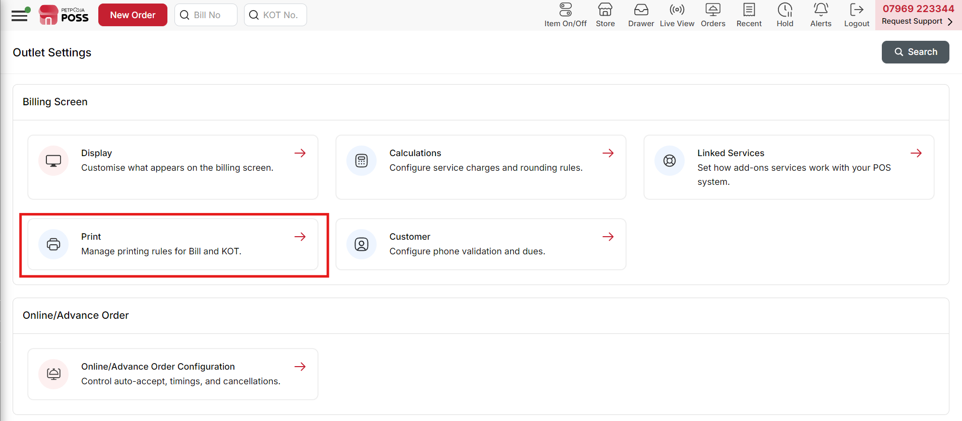
{Image Name: Print,
Description: The red box highlights the “Print” option in the Billing Screen settings. It allows users to manage printing rules and configurations for bills and KOT (Kitchen Order Tickets).Here is an image of Step 3 Print in Steps to Reach print.}

Key features of Print :

- Show order barcode on both bill and KoT print : The "Show order barcode on both Bill and KOT print" option lets you choose how the order barcode appears:

      - Full Order ID – Prints the complete order ID as a barcode.
      - Last 4 Digits – Prints only the last four digits of the order ID as a barcode.

- Print KOT on Print Bill : KOT prints when the bill is first printed.
- Print Only Modified KOT : Only prints modified items with a “Modified” label.
- Print Only Modified Items in KOT : only the modified items are printed on the KOT instead of the entire order.
- Print Cancelled KOT: Prints Cancelled KOT separately.
- Print add-ons and special notes below item row in KOT: This setting prints add-ons and special notes below the item name in the KOT, ensuring kitchen staff see customizations easily.
- Show Duplicate in KOT in case of multiple prints : This setting prints "Duplicate" on the KOT when it is reprinted, helping to distinguish reprints from the original.
- Print Deleted Items In KOT : This setting prints deleted items on a separate KOT, making it clear which items have been removed from the order.
- Print Deleted Items in separate KOT : This setting ensures that deleted items are printed on a separate KOT, helping the kitchen track order modifications easily.
- Show order barcode on KoT print : This setting prints the order barcode on the KOT, allowing easy order tracking and food readiness marking via barcode scanning.
- While moving KOT items from one table to another table print KOT : This setting prints a new KOT when items are moved from one table to another, ensuring the kitchen is updated on table transfers.

Bill Print Settings :

- Print Category wise Tax(CWT) bifurcation on bill : This option ensures that the tax is categorized based on different product categories in the bill. It helps in better understanding the tax distribution

- Print Brand Wise bifurcation on bill : The bill will show tax bifurcation based on brand instead of category. This is useful for businesses managing multiple brands.

- Show Duplicate on a bill in case of multiple prints : When a bill is reprinted, it will display "Duplicate" at the top to indicate it is not the original copy.

- Show Customer paid and return to customer in bill print : Displays the amount paid by the customer and any balance amount that needs to be returned. Useful for transparency in transactions.

- Print KOT no on bill as Token no : The Kitchen Order Ticket (KOT) number will be shown as a token number in bills where KOTs exist in the desktop application.

- Show addons in bill print : Ensures that any additional items (such as extra toppings, add-ons, or modifications) are listed in the bill.

- Show order barcode on bill print : Allows scanning the barcode on the bill to track order status.

- Merge Duplicate Item : The "Merge Duplicate Item" setting combines identical items on the bill into a single entry with the total quantity, making the bill neat and easy to read.

- Merge ebill and print bill. : When enabled, an e-bill is automatically generated along with the printed bill, ensuring digital records are maintained.

Customer
Steps to reach Customer:
Step 1 : Three Line in Steps to reach Customer : Click on the three-line (☰) menu icon located at the top-left corner of your dashboard.

{Image Name: Menu Icon,
Description: The red box highlights a menu icon on the POS interface. It appears to be a navigation button used to access different sections or settings within the platform.Here is an image of Step 1 Three Line in Steps to Reach Customer.}
Step 2 : Settings in Steps to reach Customer : From the dropdown menu, select Settings.

{Image Name: Settings,
Description: The red box highlights the “Settings” option in the side menu of the POS. This section is used to configure system preferences and operational settings.Here is an image of Step 2 Settings in Steps to Reach Customer.}
Step 3 : Customer in Steps to reach Customer : Click on Customer to manage and configure customer-related settings and preferences.
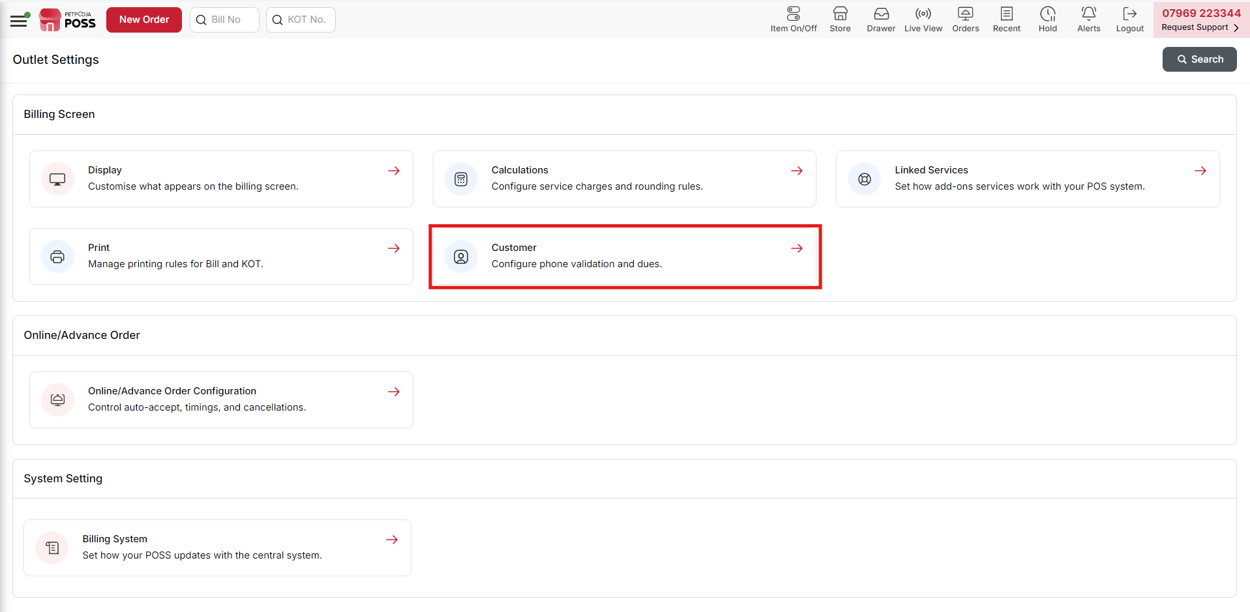
{Image Name: Customer,
Description: The red box highlights the “Customer” option under Billing Screen settings. It allows configuration of customer-related features such as phone number validation and management of customer dues.Here is an image of Step 3 Customer in Steps to Reach Customer.}

Customer Settings

Billing Screen Configuration
The following settings help configure customer entry on the billing screen.

1. Customer Phone Validation on Billing Screen
This setting enables the validation of customer phone numbers before proceeding with billing. It is available only in cloud login.
- Delivery → Phone number validation is enabled for delivery orders.
- Pick Up → Not enabled for pickup orders.
- Dine In → Not enabled for dine-in orders.

2. Phone Number Length Settings (Available only in cloud login)
- Minimum Length for Phone Number (in digits) → The minimum required digits for a phone number. (Default: 10)
- Maximum Length for Phone Number (in digits) → The maximum allowed digits for a phone number. (Default: 10)

3. Show Customer Email on Billing Screen
- Show customer email on billing screen (Disabled in this setup)
- This setting is also available only in cloud login.
4. Due Payment settings
The following settings configure the Due Payment module in the billing screen.
Customer Phone number mandatory when the due payment is selected
This setting is only available in cloud login.

Online Order Auto Acceptance
Overview : If Auto acceptance of an online order is enabled, then choose the next step after acceptance of an order. To enable autoaccept, visit settings of swiggy, zomato, online ordering widget, Menu QR under the Marketplace section.

Steps to reach Online Order Auto Acceptance:
Step 1 : Three Line in Steps to reach Online Order Auto Acceptance : Click on the three-line menu icon located at the top-left corner of your dashboard.

{Image Name: Menu Icon,
Description: The red box highlights a menu icon on the POS interface. It appears to be a navigation button used to access different sections or settings within the platform.Here is an image of Step 1 Three Line in Steps to Reach Online Order Auto Acceptance.}
Step 2 : Settings in Steps to reach Online Order Auto Acceptance : From the dropdown menu, select Settings.

{Image Name: Settings,
Description: The red box highlights the “Settings” option in the side menu of the POS. This section is used to configure system preferences and operational settings.Here is an image of Step 2 Settings in Steps to Reach Online Order Auto Acceptance.}
Step 3 : Online Order Auto Acceptance in Steps to reach Online Order Auto Acceptance : Click on Online Order Auto Acceptance to enable or configure automatic acceptance settings for incoming online orders.

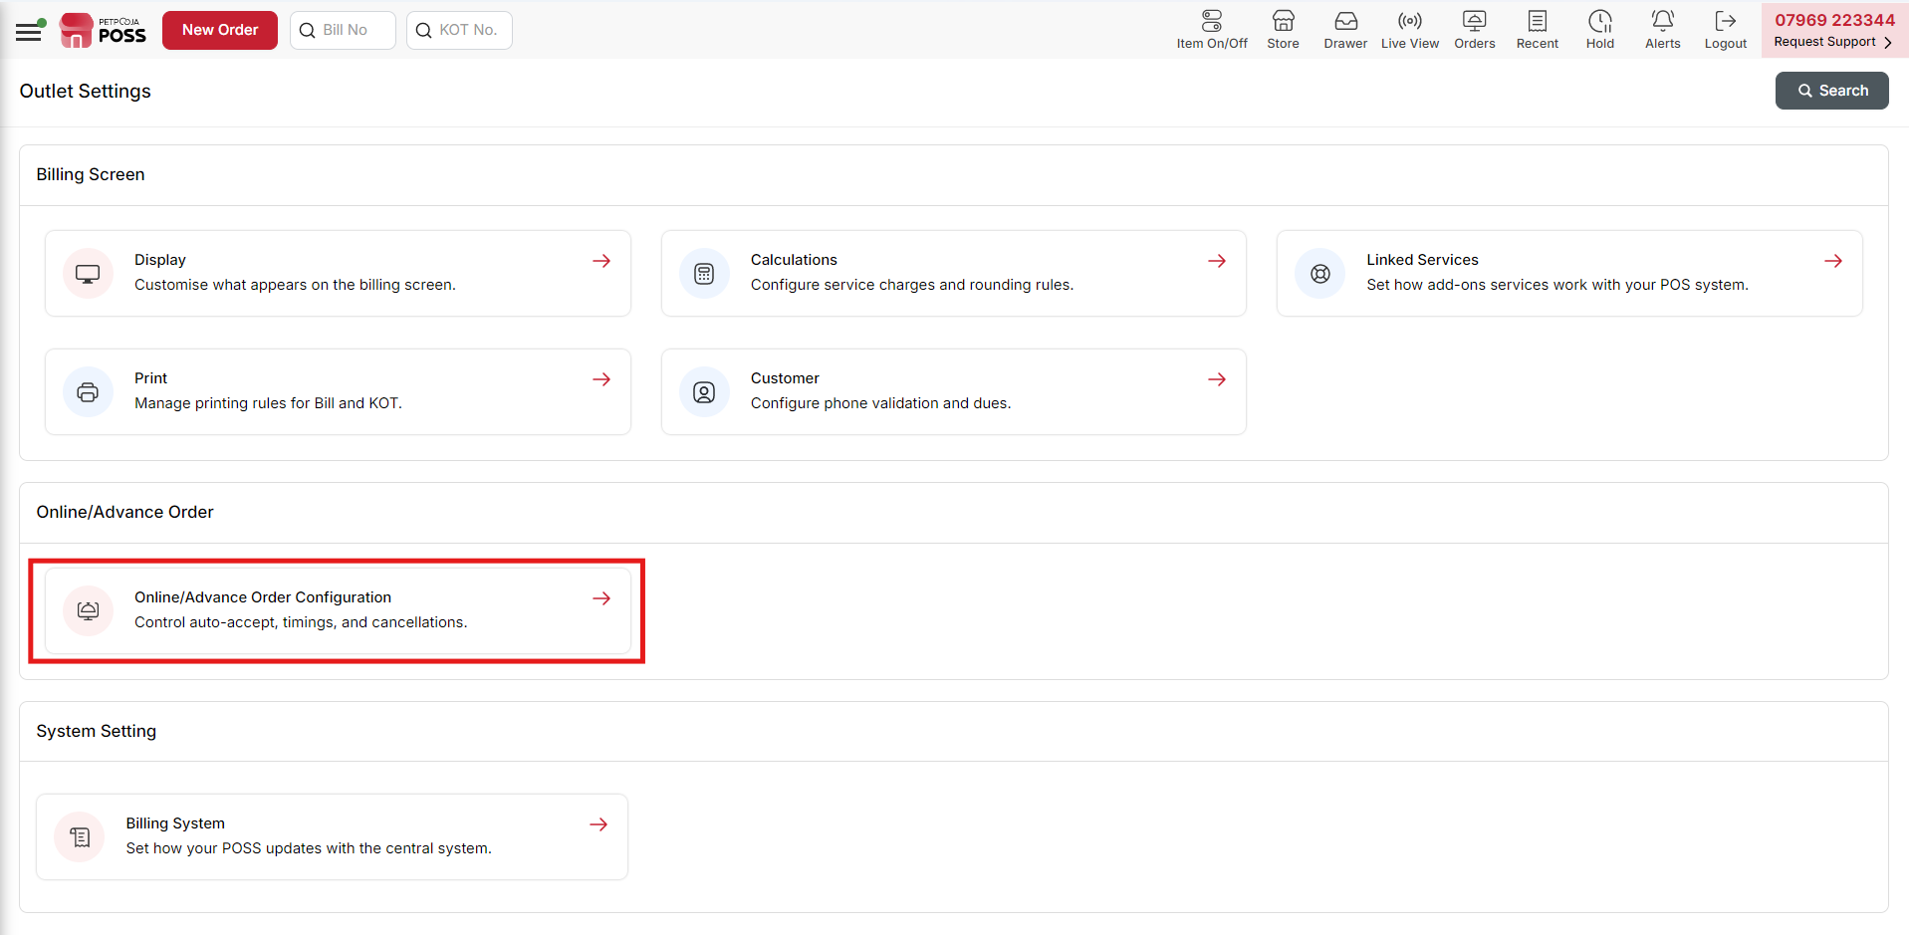
{Image Name: Online/Advance Order Configuration,
Description: The red box highlights the “Online/Advance Order Configuration” option. It helps manage order settings like auto-accept, timing control, and order cancellation rules.Here is an image of Step 3 Online Order Auto Acceptance in Steps to Reach Online Order Auto Acceptance.}
Key features of Online Order Auto Acceptance :
- KOT print after autoaccept
Click here if you want KOT to be Printed once an online order gets auto accepted.
- KOT in Advance order
Click here if you want to create KOT in case of an advance order.
- Bill print after autoaccept
Click here if you want Bill to be Printed once an online order gets auto accepted.
Default action while pressing (Ctrl+A) Online order accept
○ Save
○ Save & Print
○ Save & eBill
○ KOT
○ KOT & Print
Online Orders System Configuration
The following settings pertain to configuring the Online Orders System Configuration.
Ignore Online Order Delivery Charge
Click here to ignore online order delivery charges sent by Zomato, Swiggy, etc., in the invoice total.
Delivery Charges (₹):
Enter default delivery charge to enable across all online ordering channels to set.
Minimum Order Amount (₹) :
Enter minimum order amount. This field is not being used by all providers.
Auto Cancel Duration :
If the order is not accepted within the time set above, the order will get rejected.
Accept Online Payment
Click here if you are accepting online payments. This info is not synced with every third party.
Generate invoices when orders are accepted using the acceptance app or web dashboard?
Orders accepted using the Acceptance app or web dashboard will have a unique series of invoice IDs (Ex: O1, O2, O3….) and these orders will not be visible on the Petpooja desktop/android.
Set Sound : Example : Sound -1 and Sound -2
Upload Your Custom Sound
Set Volume : Test Sound
Do you want to show Online order delivery notification section?
Show Online order delivery notification section

Online Orders System Configuration
Ignore Online Order Delivery Charge
Click here to ignore online order delivery charges sent by Zomato, Swiggy, etc., in the invoice total.
Delivery Charges (₹):
Enter default delivery charge to enable across all online ordering channels to set.
Minimum Order Amount (₹):
Enter minimum order amount. This field is not being used by all providers.
Auto Cancel Duration :
If the order is not accepted within the time set above, the order will get rejected.
Accept Online Payment
Click here if you are accepting online payments. This info is not synced with every third party.

Generate invoices when orders accepted using the acceptance app or web dashboard?
Description: Orders accepted using the Acceptance app or web dashboard will have unique invoice IDs (e.g., O1, O2, O3…). These orders won’t be visible on the Petpooja desktop or Android.

Set Sound
- Option: Choose a predefined sound (e.g., Sound-1).
- Custom Upload: Option to upload a custom notification sound.
- Set Volume: Adjustable volume slider with a Test Sound button.
Do you want to show Online order delivery notification section? – Displays notifications for online order deliveries.
Hide orders after mark foodready/dispatched in live view screen – Option to remove orders from the live view after marking them as dispatched.
Print rider temperature/mask details in bill – Includes rider temperature and mask details on printed bills.
Notify about the item(s) going in stock – Alerts when stock is replenished.

Save customer information for orders
- Home Website – Saves customer order details from the home website.

Notification On
- Fixed Prep Time – Uses a predefined preparation time.
Order Prep Time – Uses the preparation time based on the order details.

Notify markfood ready after
- Time: 15 Min (Configurable: Minimum 1 – Maximum 150 minutes)
- Description: Sets the time to mark food as ready after an online order is accepted.

Remind me after every
- Time: 5 Min (Dropdown selection available)
- Description: Sets the time interval for reminders until food is marked as ready.

- Minimum Preparation Time : 30 Min (Configurable)
- Minimum Delivery Time : 30 Min (Configurable)
- Prior reminder for advance order : 60 Min (Configurable via dropdown)
Do not create memo for advance orders (Offline Orders Only) – Prevents automatic memo creation for offline advance orders.
Create kot on creating memo for advance orders (Offline Orders Only) – Enables KOT generation when creating memos for advance orders.
Create invoice from memo manually after settlement – When enabled, invoices for settled orders won’t be created automatically. The biller must manually create the invoice from the advance order grid.

Billing System
Steps to reach Billing System:
Step 1 : Three Line in Steps to reach Billing System : Click on the three-line (☰) menu icon located at the top-left corner of your dashboard.

{Image Name: Menu Icon,
Description: The red box highlights a menu icon on the POS interface. It appears to be a navigation button used to access different sections or settings within the platform.Here is an image of Step 1 Three Line in Steps to Reach Billing System.}
Step 2 : Settings in Steps to reach Billing System : From the dropdown menu, select Settings.

{Image Name: Settings,
Description: The red box highlights the “Settings” option in the side menu of the POS. This section is used to configure system preferences and operational settings.Here is an image of Step 2 Settings in Steps to Reach Billing System.}
Step 3 : Billing System in Steps to reach Billing System : Click on Billing System to access and configure billing-related settings and preferences.

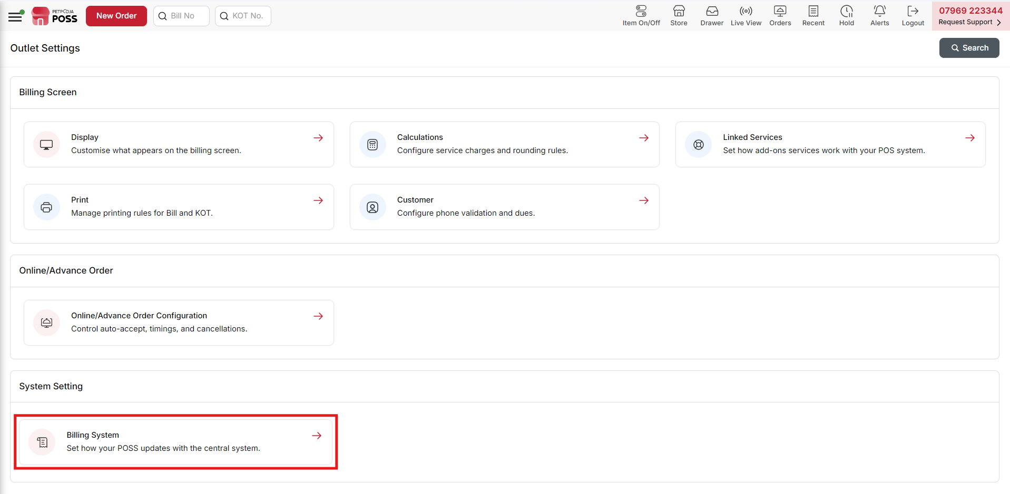
{Image Name: Billing System,
Description: The red box highlights the “Billing System” option under System Setting. It is used to control how the POS system syncs and updates data with the central system.Here is an image of Step 3 Billing System in Steps to Reach Billing System.}
Key features of Billing System :

Restaurant Closing Hours
- Current day will be closed on: 2025-03-24 00:00
- Change Closing Hours: Button to modify the closing time.

Notification & Availability
Display the notification (toaster) for temporary Extend Closing Hours – Enables notifications for temporary extension of closing hours.
Is the outlet open round-the-clock (24*7)? – Indicates if the restaurant operates 24/7.
- Restaurant Running Hours : 24 (Indicates how long tables remain open in hours)
- Sync Batch Packet Size : 100 (Defines the number of orders synced in one packet)
- Default Order Limit : 500 (Specifies the maximum allowed orders)

Auto Sync Settings
- Default Auto Sync Time: 10 Min (Time taken to sync orders with the dashboard automatically. Requires internet connection.)
- Default Pending Order Sync Time : 5 Sec (Time taken for pending orders to sync with the dashboard. Requires internet connection.)
- Default Captain Order Intranet Sync Time : 5 Sec (Time taken for captain orders to sync within the intranet.)

Order Editing & Auto Settlement
- No. of Minutes to Edit Orders : 9999999 (Defines how long an order can be modified after creation.)
- No. of Minutes to Auto Settle After Print : (Configurable)
- Note: Once an order is auto-settled, it cannot be modified, even if modification rights are granted.

Payment Sync Settings
- Payment request sync time : 5 Sec (Defines the interval for syncing payment requests.)
- Check payment request sync time : 5 Sec (Defines the interval for verifying payment request sync status.)

Display Settings
- Billing Screen Refresh After No. Of Bill Print : 0 (Specifies how many bill prints trigger a screen refresh.)
- Note: This setting determines when the screen refreshes based on the number of bill prints.

Security Setting
The following settings help determine the security configurations of the application:
- Default Manager Password for Desktop Use : (Field to set or update the manager password for desktop access.)
- User Idle Time for Logout : 10 Min (Specifies the duration of inactivity before automatic logout.)

