Internal Testing 2 – 23/08/2021

1. Email notifications to client: all the email notifications start with “loho”, which is not visible in the body of the email. Can you help to remove this?



1. Client view: when the audit is created:
   1. Change the button “SING AGREEMENT” to “SIGN AGREEMENT”
   2. The button does not seem to work

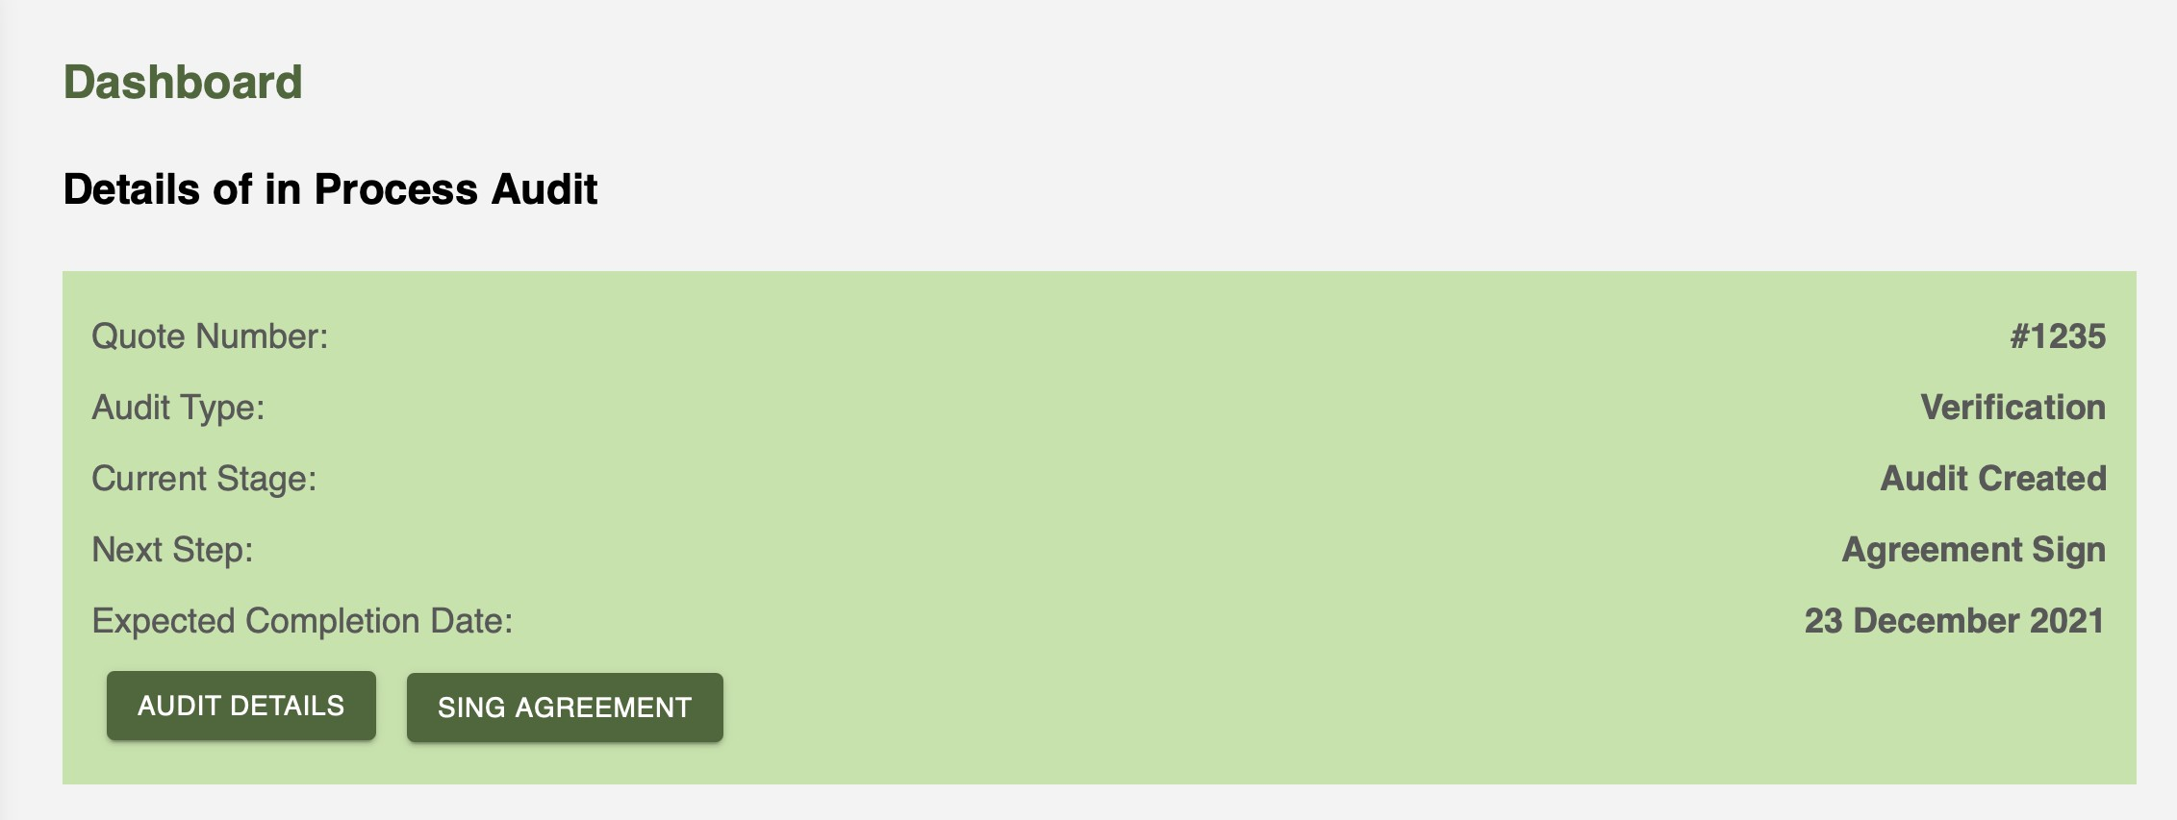

1. Client view: document uploads:
   1. Reduce the size of the description box, in order to be sure the whole window is visible on the screen
   2. Change wording to: “Upload file (you can only choose the following extensions: ###)“

Add a large “+”, as per the picture below

The point above is valid for all document uploads throughout the portal, whether it is from the Admin, Client or Auditor.

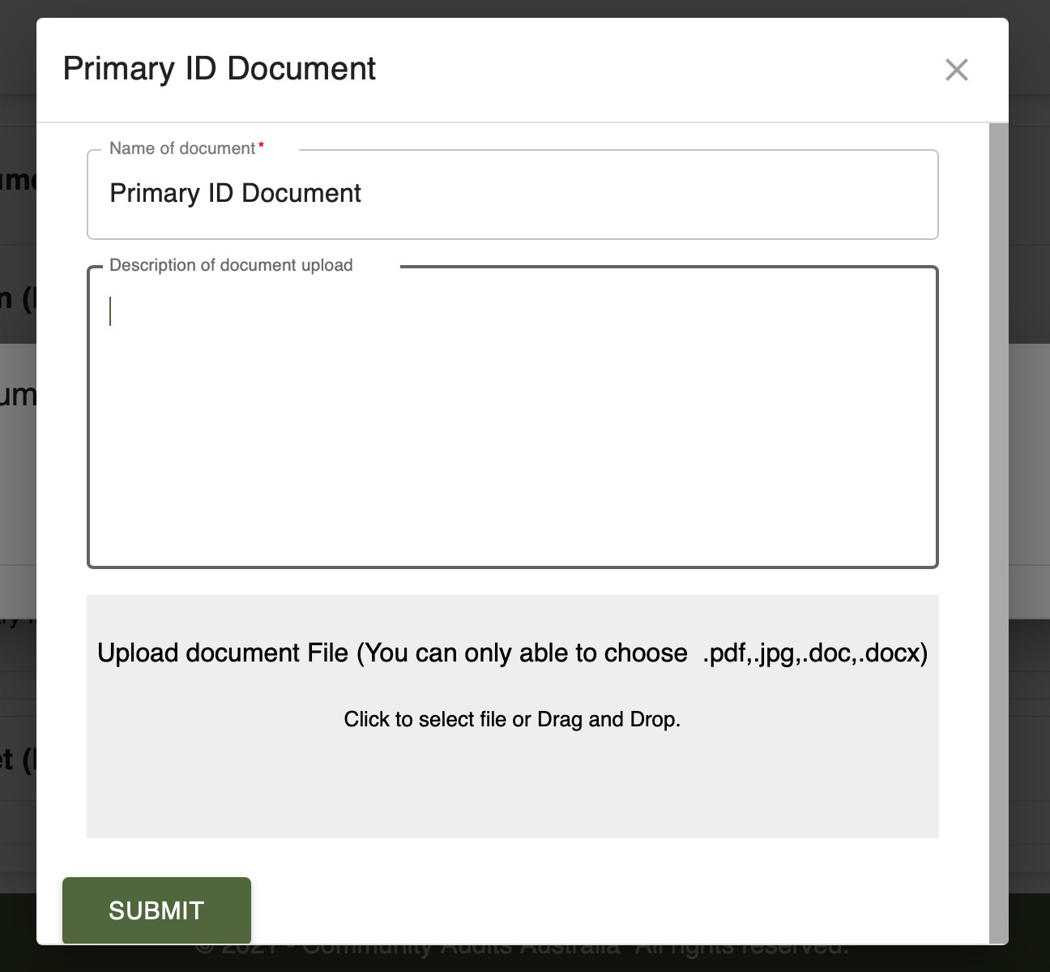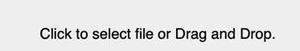

1. Client view: documents upload general page:
   1. Change header to “Documents upload for audit reference 1235”
   2. Change the 3 buttons at the top with the same as the ones used in the sections:

i.

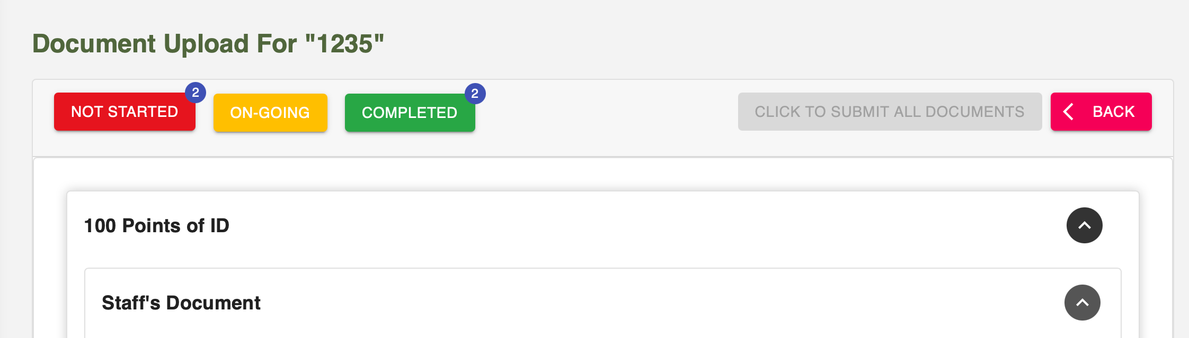

1. Client view: document upload sections and sub-sections:
   1. Change “InProgress” with “In Progress”
   2. Each section should have a status visible, depending on the status of the documents:
      1. If no document is submitted, section shows Pending (red button)
      2. If some but not all the documents are submitted, section shows In Progress (black)
      3. If all the documents are submitted, section shows Submitted (green)

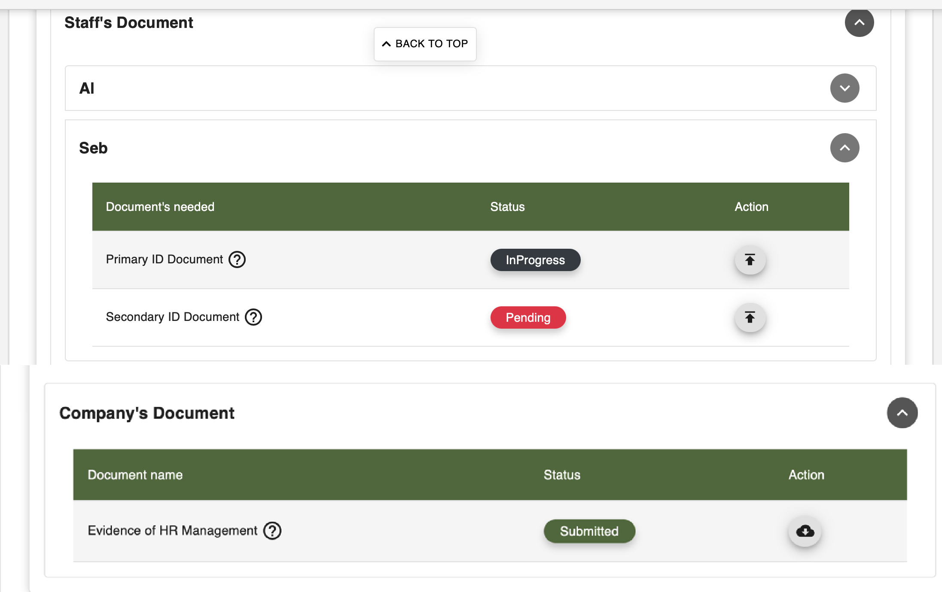

1. Client view: document upload page, 2 action buttons:
   1. One button ”Upload”, which brings directly to the upload page, not the option to click N/A
   2. One button “Not applicable” next to it, which brings to the page to give the justifications

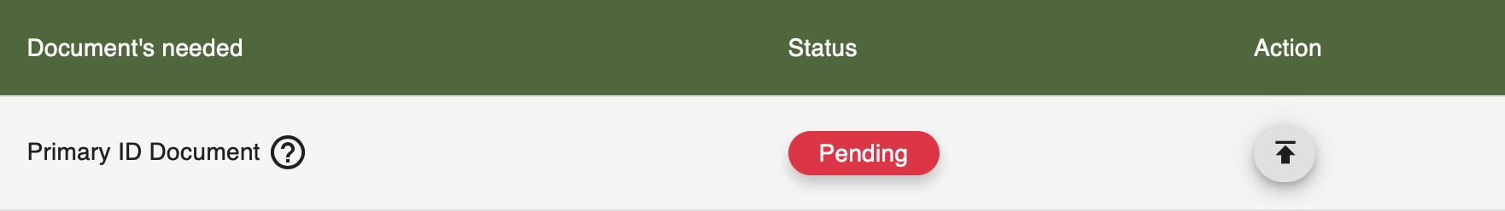

1. Client view: document upload page? Change “SAVE LATER” to “SAVE FOR LATER”

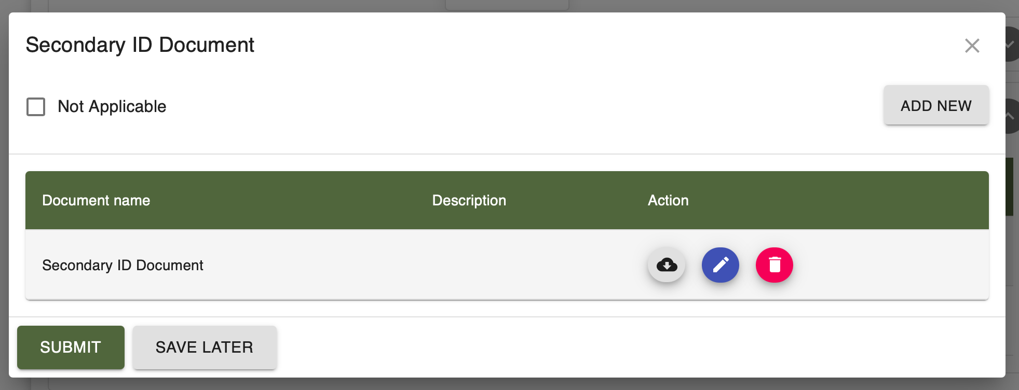

1. Client view: audit date booking. This page needs to be clearer:
   1. Title should be: “Submit the documents and book your audit”
   2. Above the date selection: “Please select your preferred date for the audit to take place:”
   3. Remarks box should be smaller

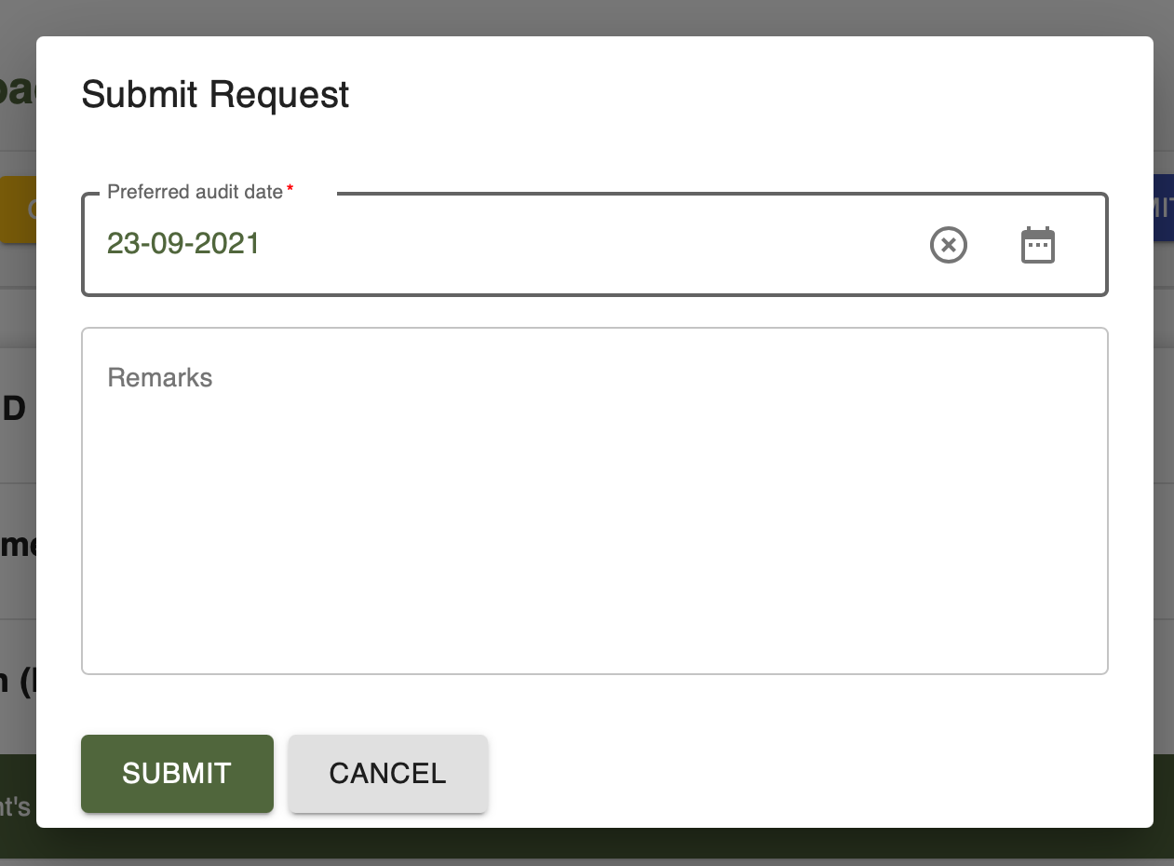

* 1. After clicking submit. Change the wording to:
     1. Title: “Submit the documents and book your audit”
     2. Text should be: “Are you sure you want to submit all the documents, and book the audit for the following date: [insert date]”
     3. At the moment, the Cancel button is not working
     4. Confirmation buttons should be the same as above:

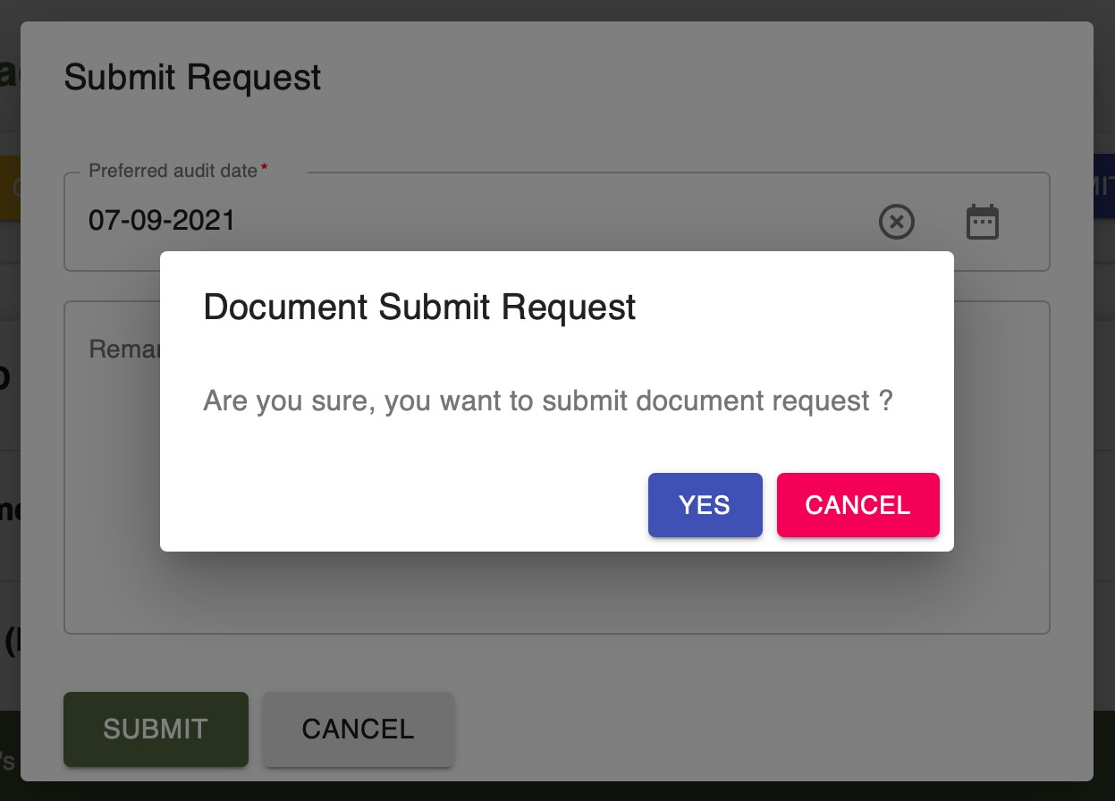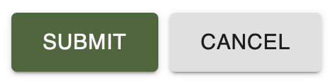

1. Admin view: Assign auditors
   1. Title should be: “Assign auditors for audit reference 1235”
   2. We need to be able to choose the same date for start and end date (which was denied in the example below)

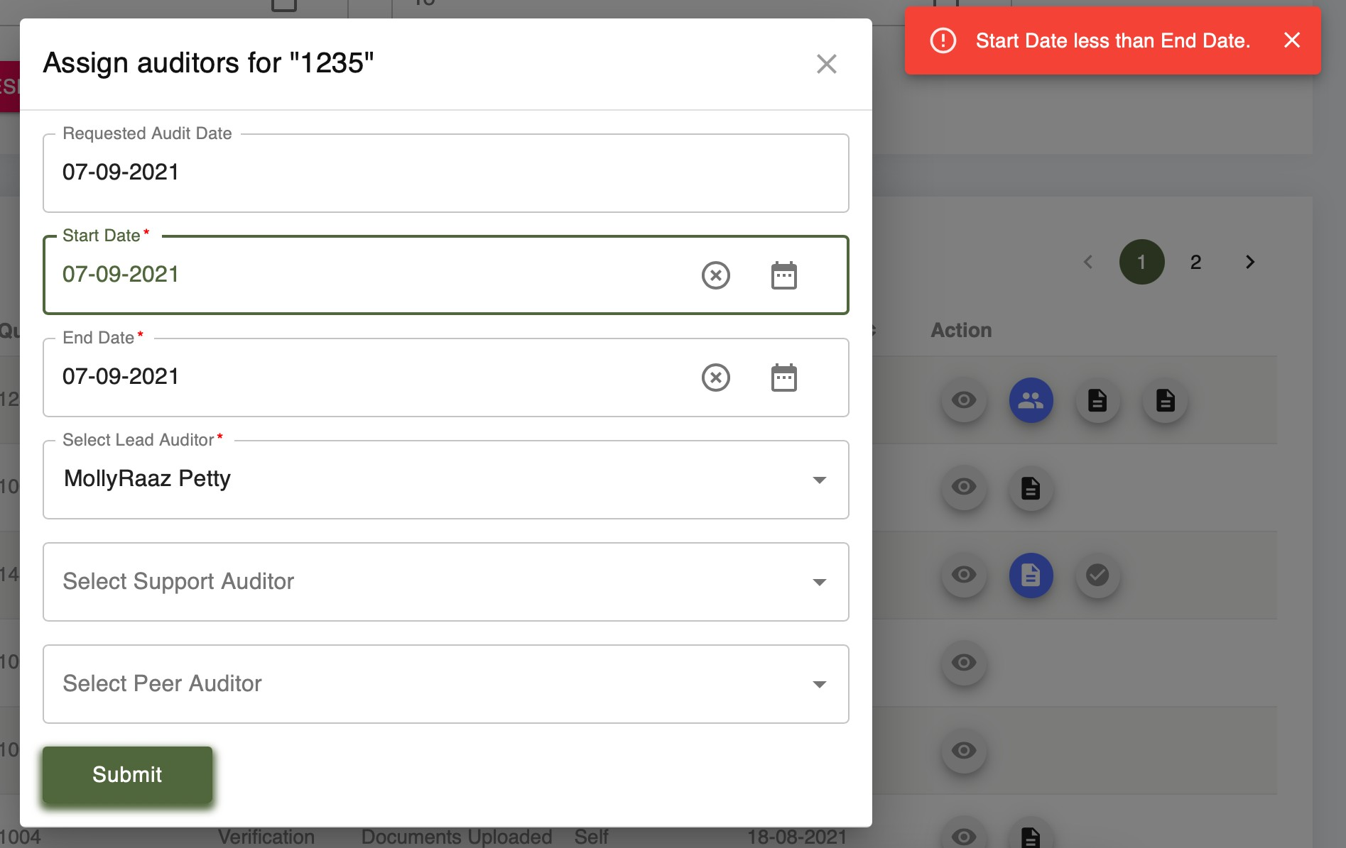

1. Auditor view: Audit requests: there is an issue with one of the icons in the window below:

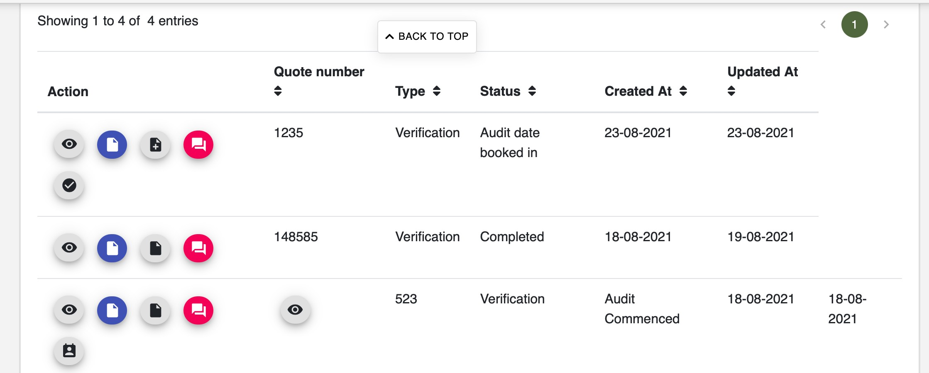

1. Auditor view: in the window below, the audit has not started yet, so the auditor cannot ask the client to add additional documents yet.

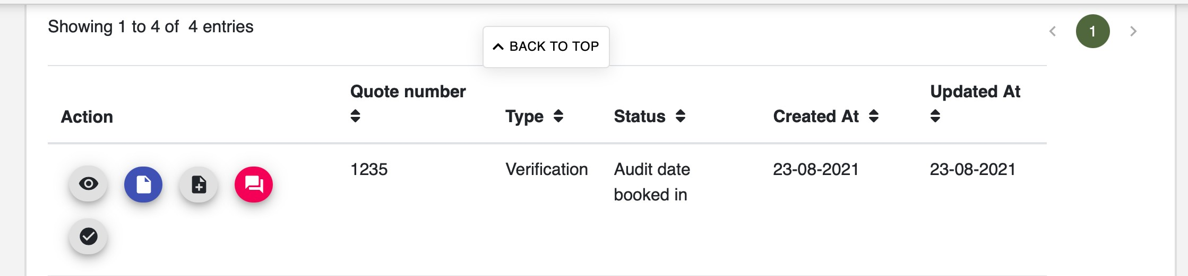

1. All views (auditor, client and admin):
   1. Replace “Created At” with “Creation date”
   2. Replace “Updated At” with “Latest update”
   3. The filter needs to be on the same line as the text (example of Quote number below)



1. Auditor view: documents download
   1. The download button below does not work
   2. When downloading (via the other button), in some cases the file name has completely changed. It needs to remain the same as originally.
   3. In case there is a N/A document, the icon description should be “View the explanation”, instead or “Download document”

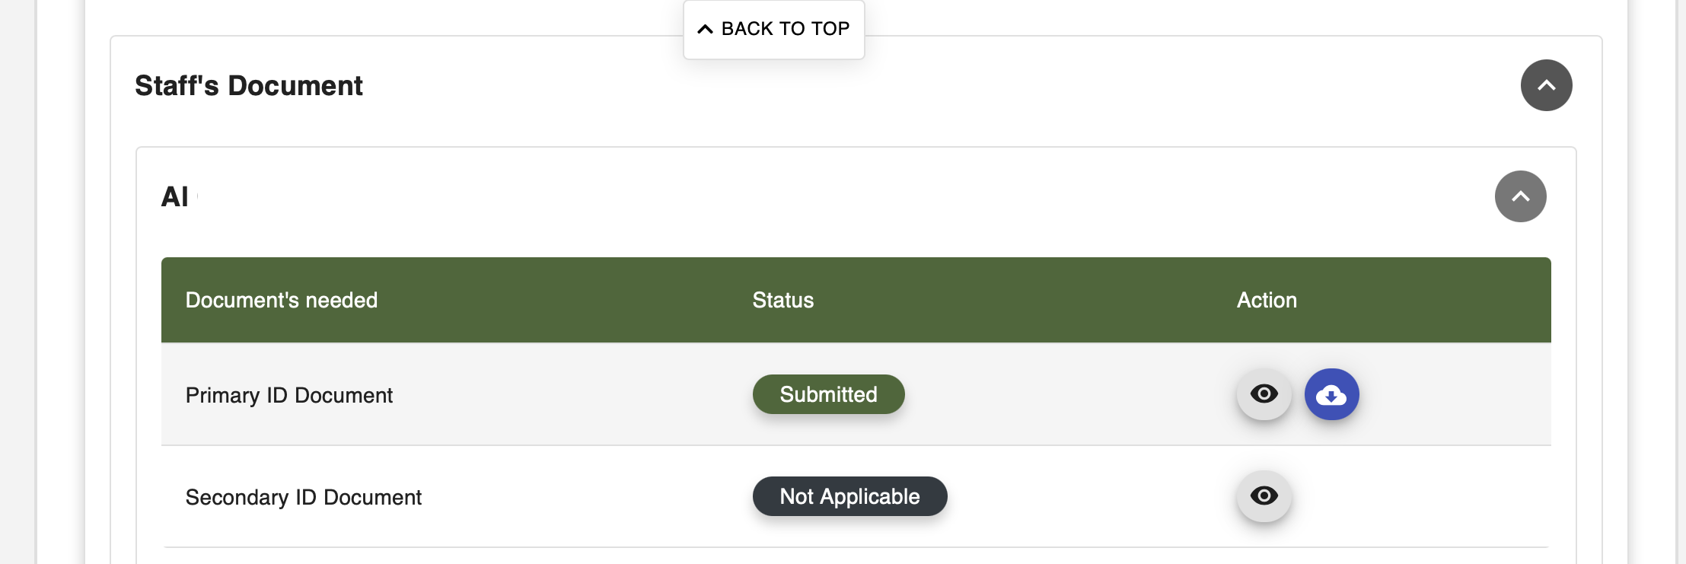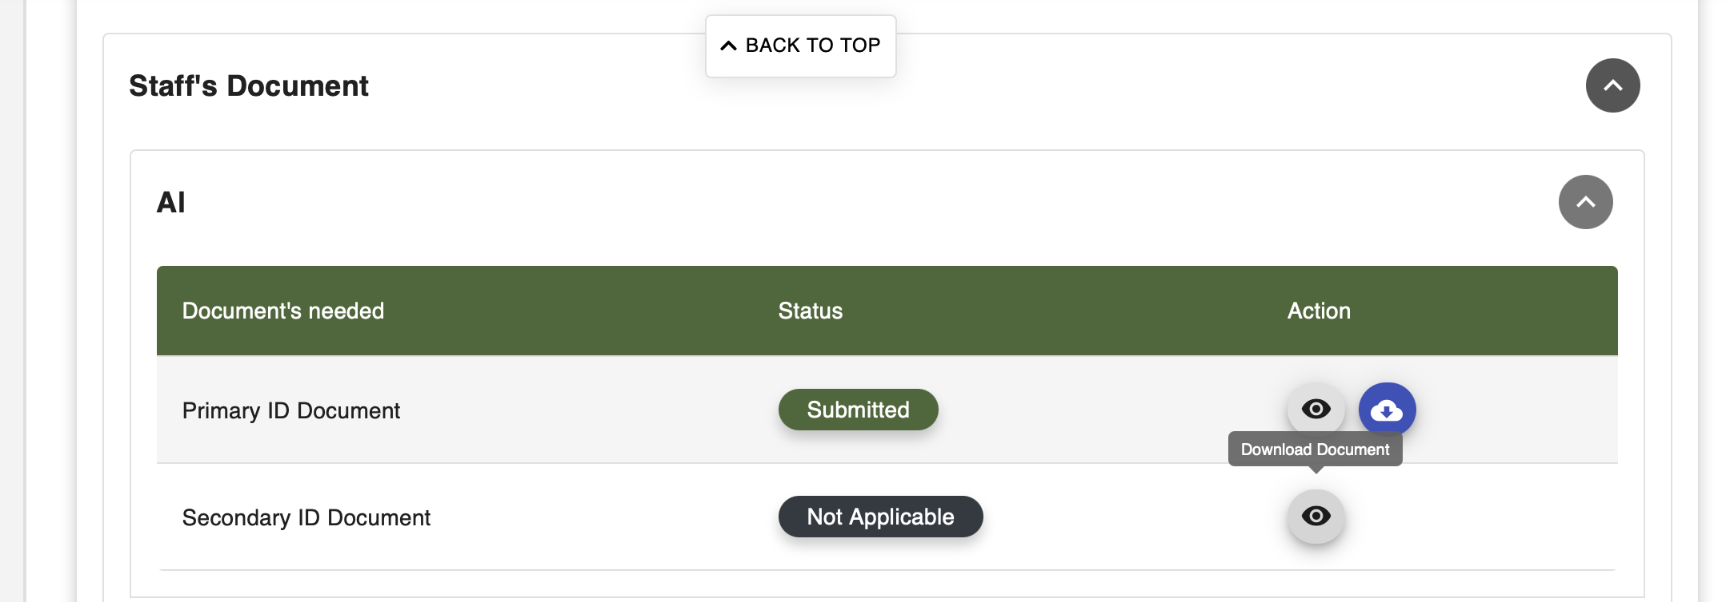

1. Client view: Key personnel
   1. Issue in the display:
      1. Phone number appears instead of Email
      2. Position appears instead of the phone number
      3. Type of staff appears instead of Position
      4. etc
   2. Please bring the icons to the left so they are visible at all times

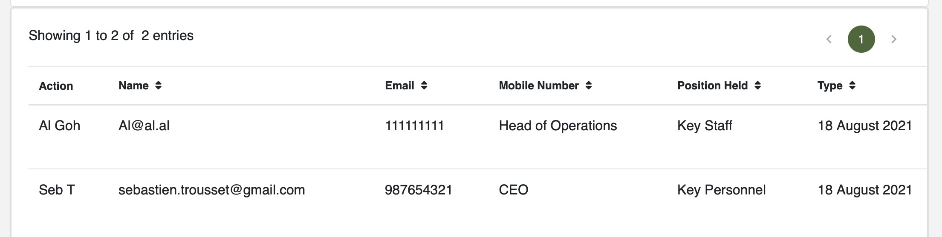

1. Client view: chat button at the top. The number is confusing, we don’t know what is it. Since there can be only one ongoing chat for the client, a simple click on the first chat icon needs to bring to the chat directly.



1. Client view: chat window:
   1. The title needs to be: “Chat with the auditor”
   2. 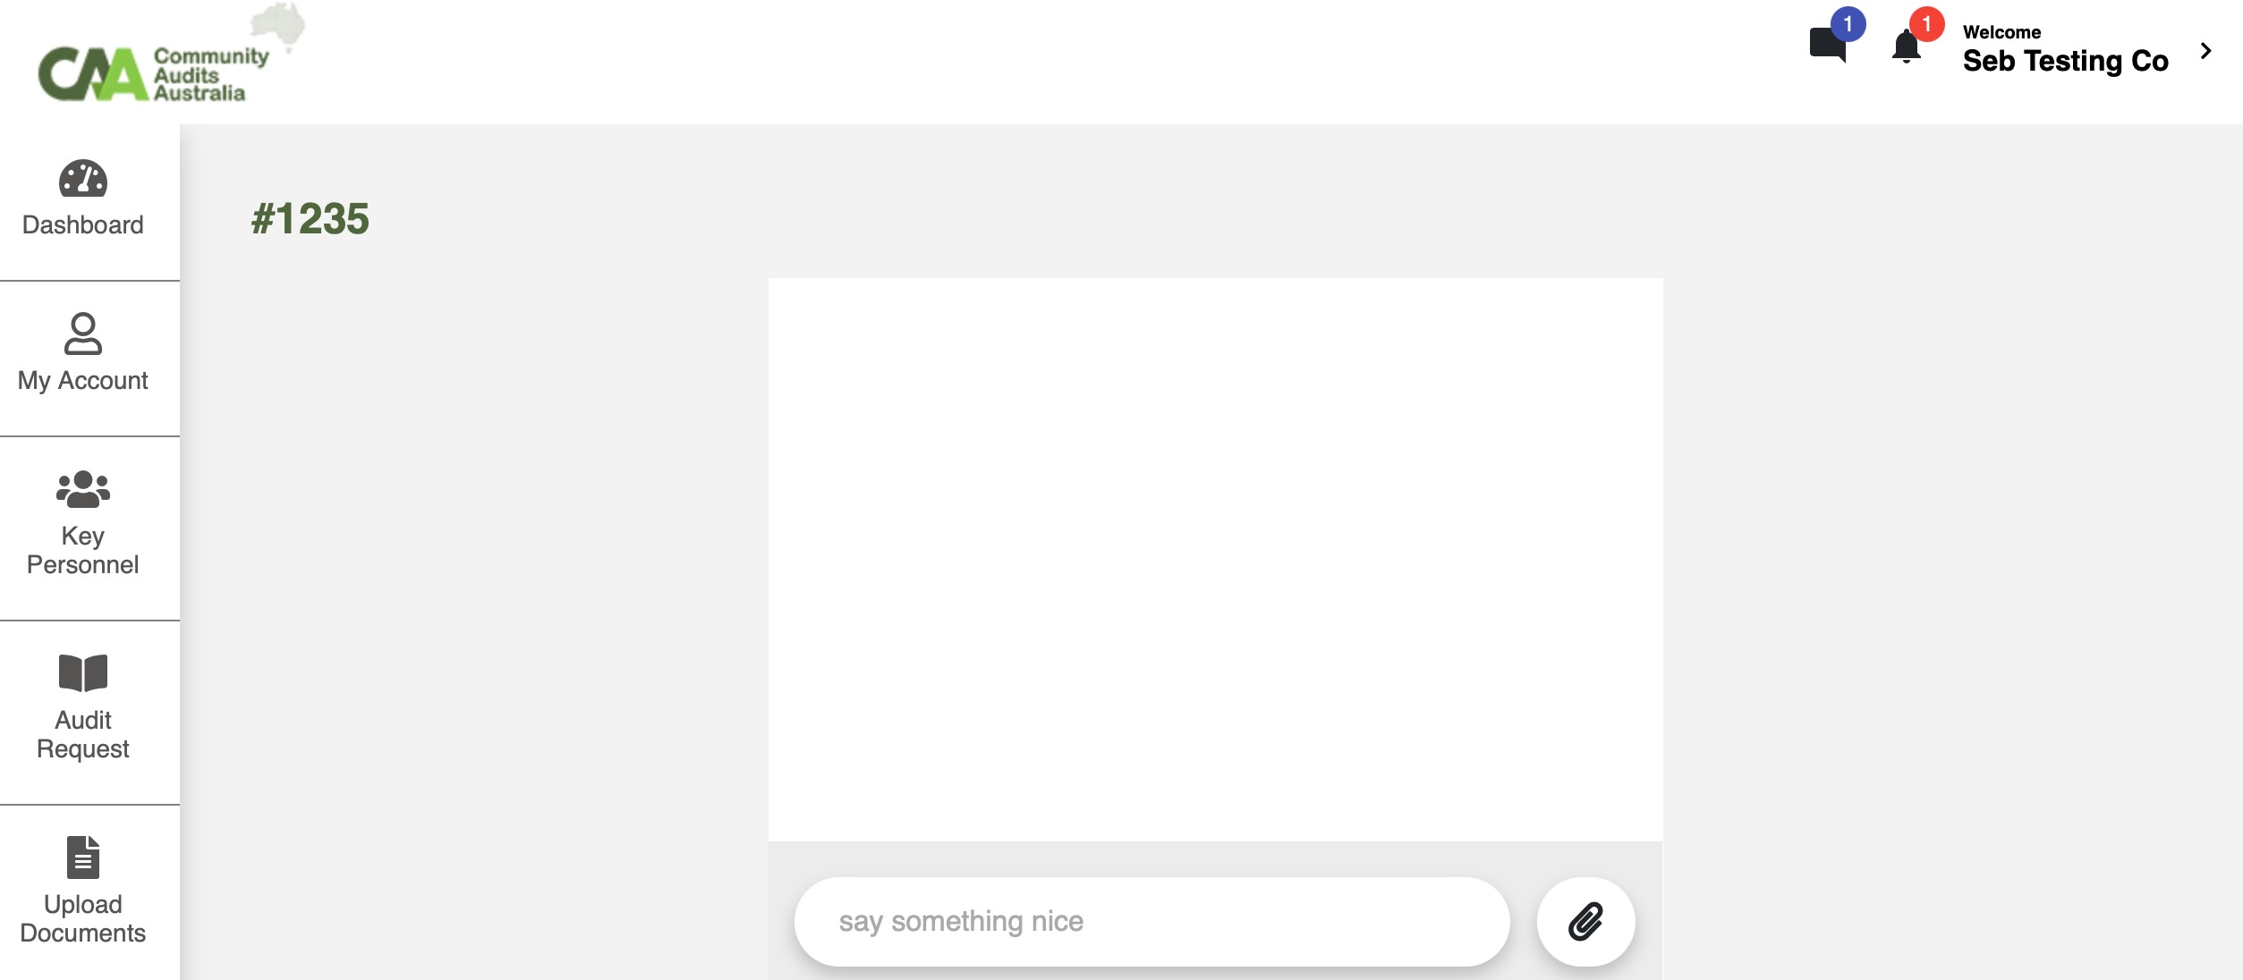The chat appears empty while the icon at the top shows one message
2. Client view: add additional documents: the current view makes it look like an error message and is not clear
   1. Instead of “Other documents”, change to “Additional documents”
   2. Take out the picture and “Sorry we couldn’t find any data”
   3. Just display a button “Add documents”

Note: the option to upload additional documents can only be visible whenever the auditor requests additional documents

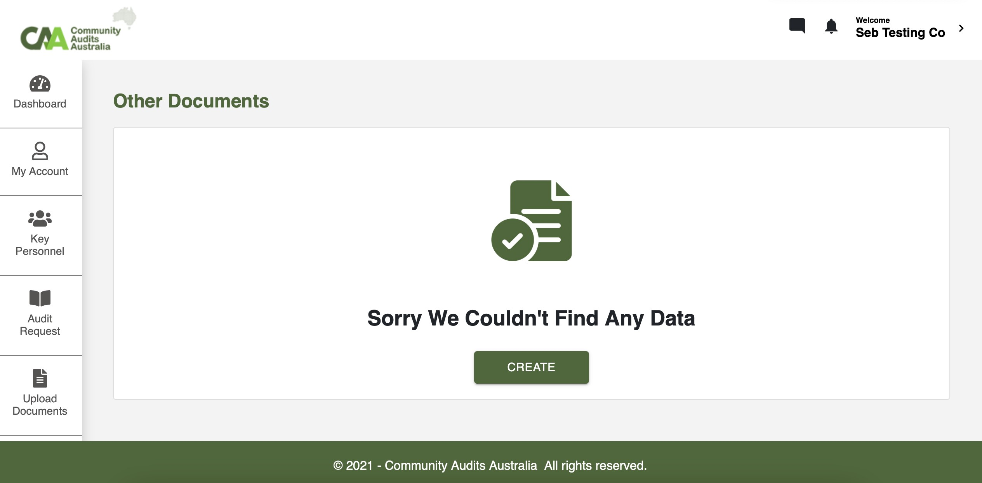

Once the documents are attached:

* 1. There is a display issue (action on the left vs icons on the right)
  2. Replace Updated At with “Latest update”
  3. Send to Auditor button in dark green (same as template color)

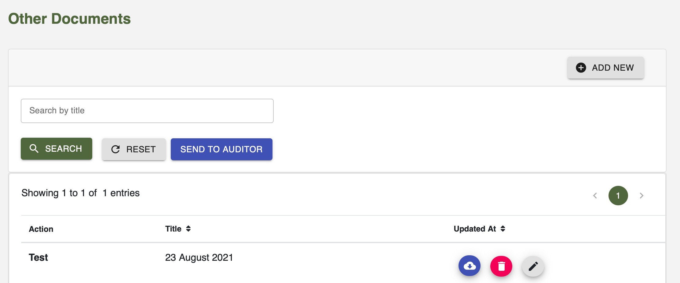

1. Auditor view: Upload report window
   1. Grey area: same comments as point 3
   2. Remove the “Report Remarks” wording

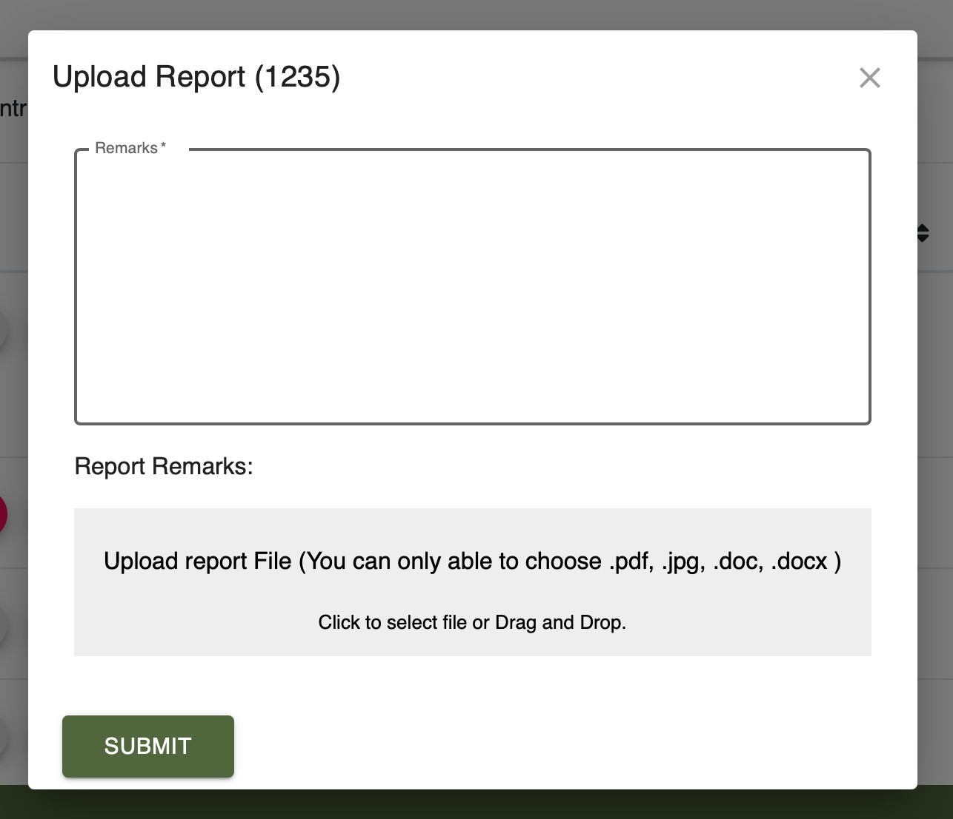

1. Auditor view: When the report is rejected by the client:
   1. One additional icon is needed for “Rejection reasons”. It will aggregate all the rejection reasons that the client will key in the system (in case the client rejects more than one time)

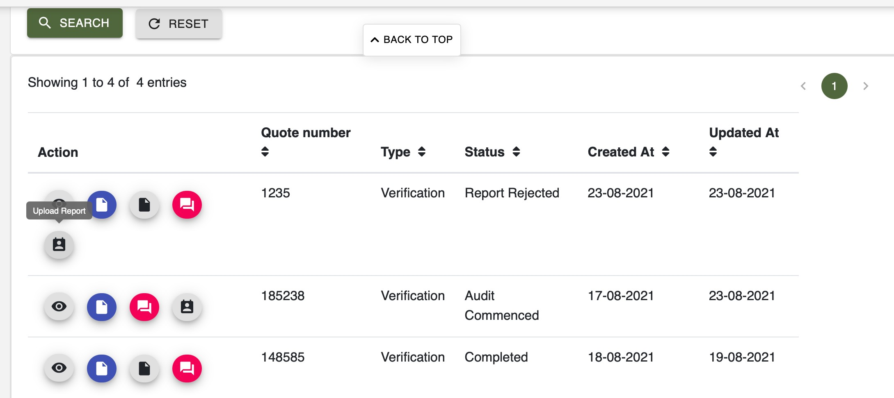

Additional button

1. Client view: Report acceptance / rejection
   1. First window “View report”
      1. 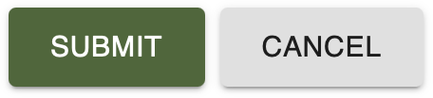Download button in grey
      2. Accept button in dark green
      3. Reject button in red
   2. Second window “Accept Report”
      1. Wording to be changed to: “Are you sure you want to accept the audit report for the audit ref 1235?”
      2. Yes in dark green
      3. Cancel in grey

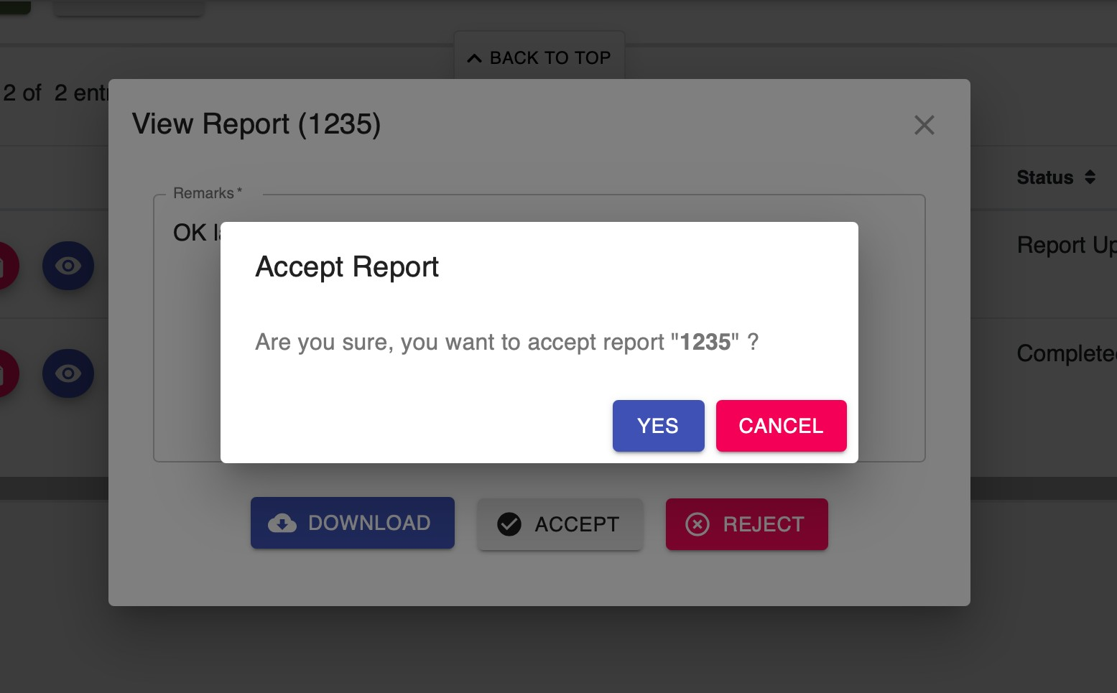

1. Admin view: Once the report is accepted by the client:
   1. Unless I missed something, the two actions “Mark as completed” and “Submit report” are the same. They should be only one action called: “Submit report to NDIA” (Not AU Gov)

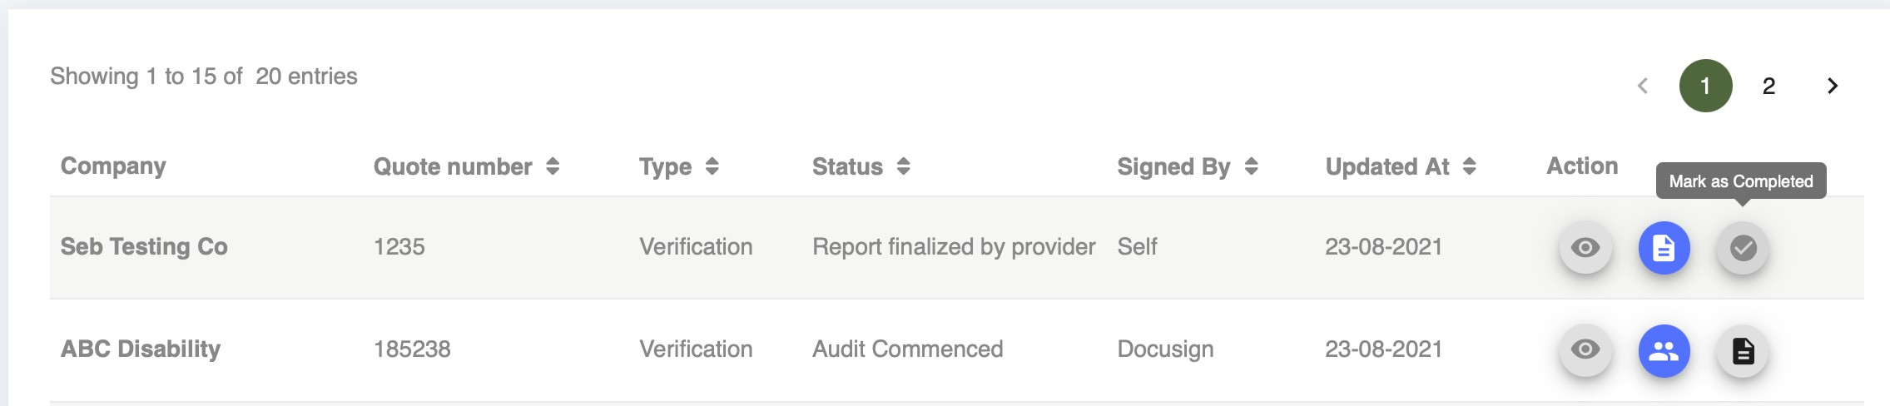

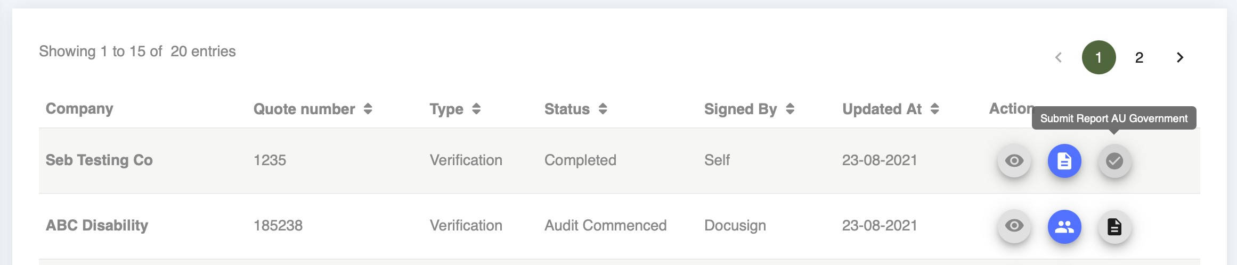

1. All views: Notification pages:
   1. Title should be “Notifications”
   2. Window should read “Clear all notifications”
   3. Text should be “Are you sure you want to clear all the notifications?”
   4. Clear all button should be dark green
   5. Yes and Cancel buttons should be green and grey

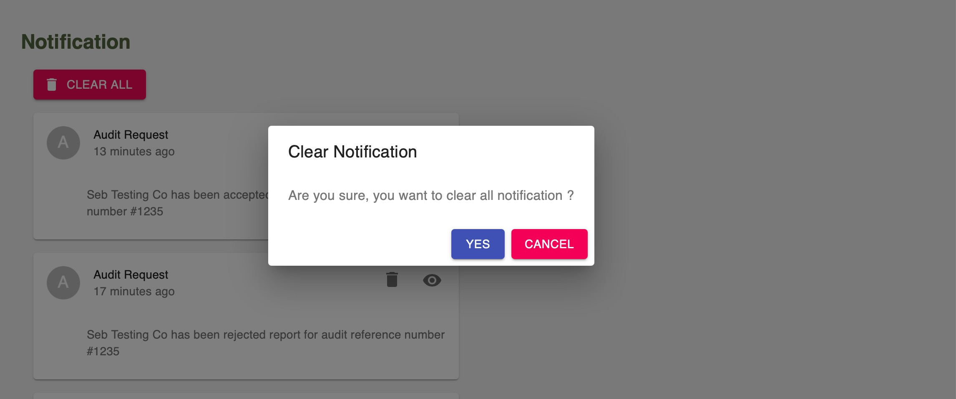

1. Client view: audit request page icons
   1. Remove Chat icon there
   2. Make all icons grey, except immediate call to action in dark green. Immediate call to actions are:
      1. Sign the agreement
      2. Pay the invoice
      3. Upload the documents
      4. Upload additional documents
      5. View the report

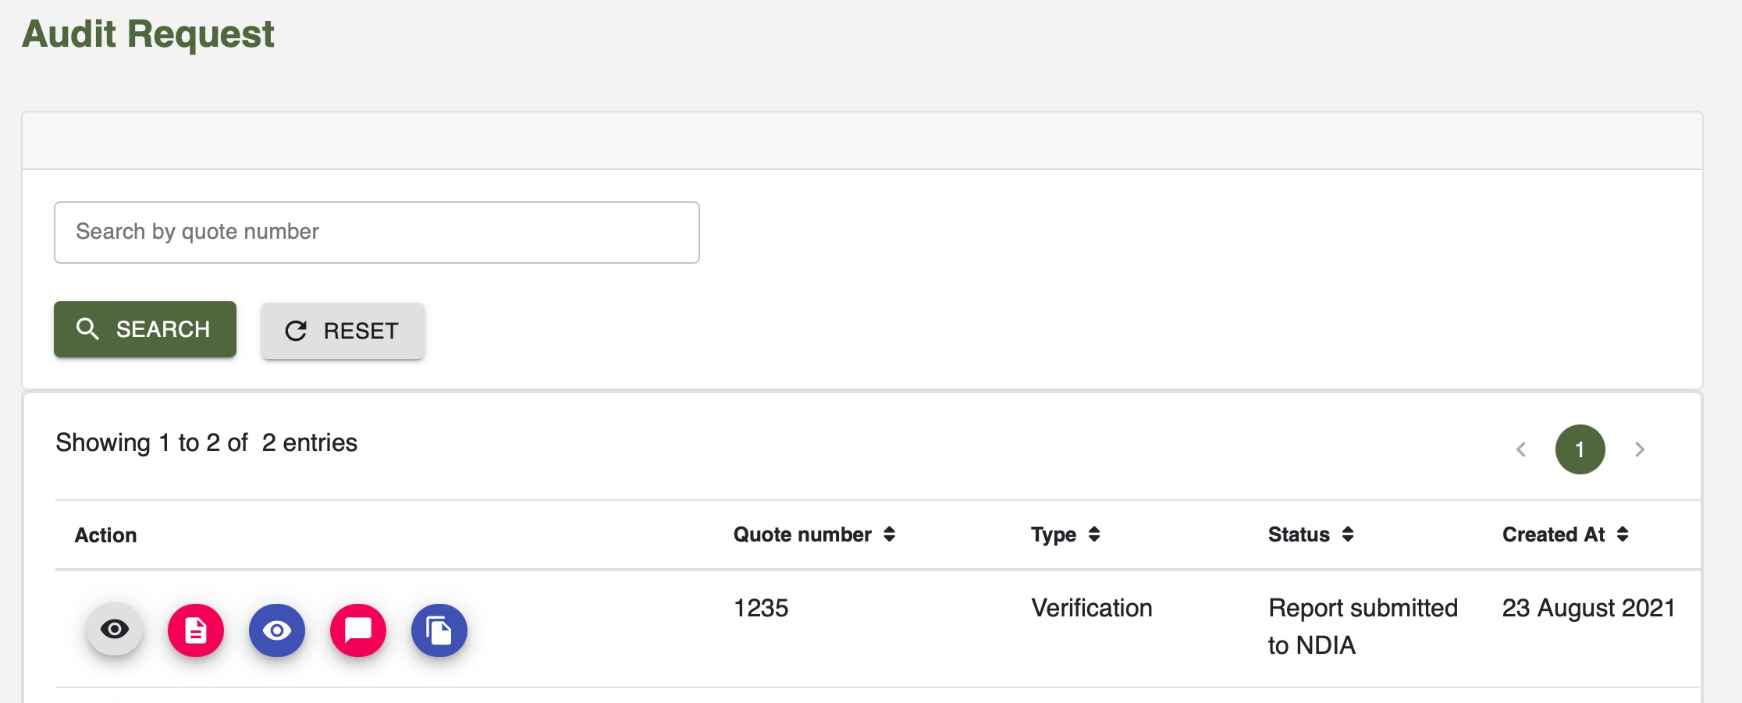

1. Client view: submit additional documents
   1. Icon should read: “Upload additional documents”
   2. The icon can only be visible once the auditor has asked for additional documents

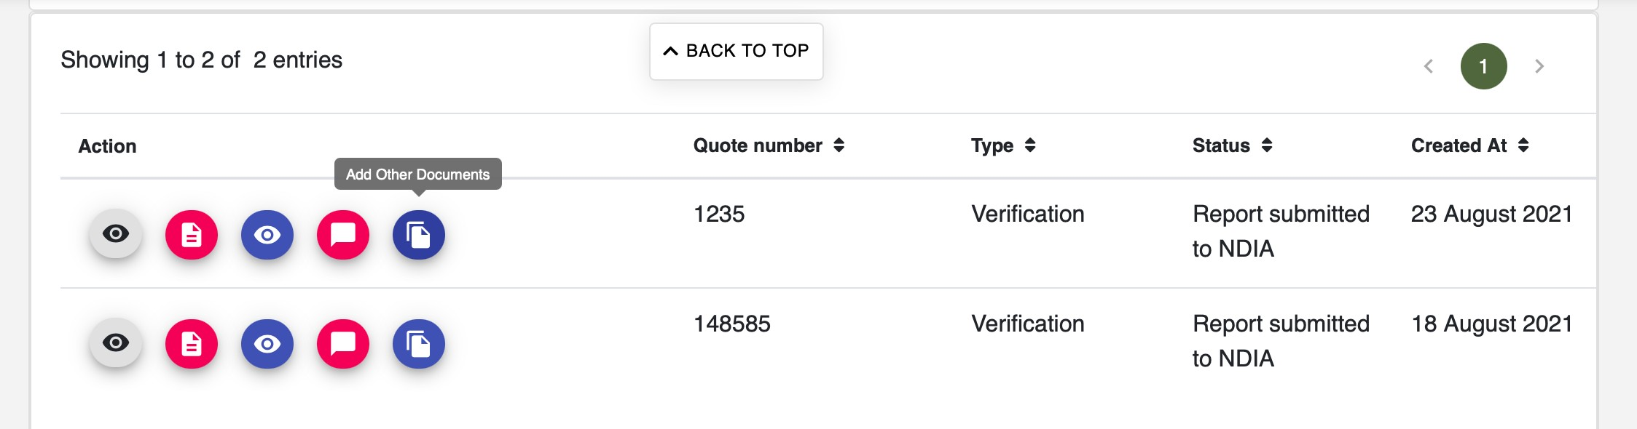

1. Client dashboard timeline
   1. Remove “Created Date :”
   2. Add the date of the last stage (Report submitted to NDIA) once it is completed
   3. Change the arrows to a plain large arrow as below

