Wireshark Network Packet Analysis Report

1. Objective
The objective of this experiment is to use the Wireshark tool to capture and analyze network packets generated while accessing the Wikipedia API. The analysis includes observation of the TCP and TLS handshake process, DNS resolution and latency measurement, and the comparison of API call patterns to identify potential caching effects.

2. Tools Used
• Wireshark v4.2
• Web browser (Google Chrome)
• Wikipedia API (https://en.wikipedia.org)
• Windows 10 operating system

3. Procedure
a. Opened Wireshark and selected the active network interface for capturing live traffic.
b. Applied the filter 'tcp port 443' to capture HTTPS traffic.
c. Accessed the Wikipedia website to generate HTTPS requests.
d. Stopped the capture and filtered the packets using 'tls.handshake' and 'dns' filters.
e. Observed TCP 3-way handshake packets (SYN, SYN-ACK, ACK) and TLS handshake messages (Client Hello, Server Hello, etc.).
f. Measured DNS resolution time and latency by analyzing query and response packets.
g. Compared multiple API calls to check for caching or repeated request behavior.

4. Observations
Figure 1 below shows the DNS resolution packets for Wikipedia.org domain:
Figure 1: DNS Query and Response for Wikipedia.org
Figure 2 below shows the TCP 3-way handshake packets followed by TLS handshake packets on port 443:
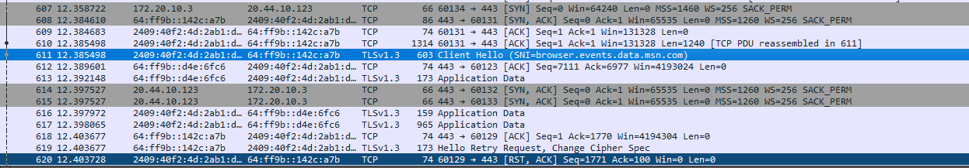
Figure 2: TCP and TLS Handshake Capture
Figure 3 below shows the detailed TLSv1.3 Client Hello message indicating the start of the secure session:
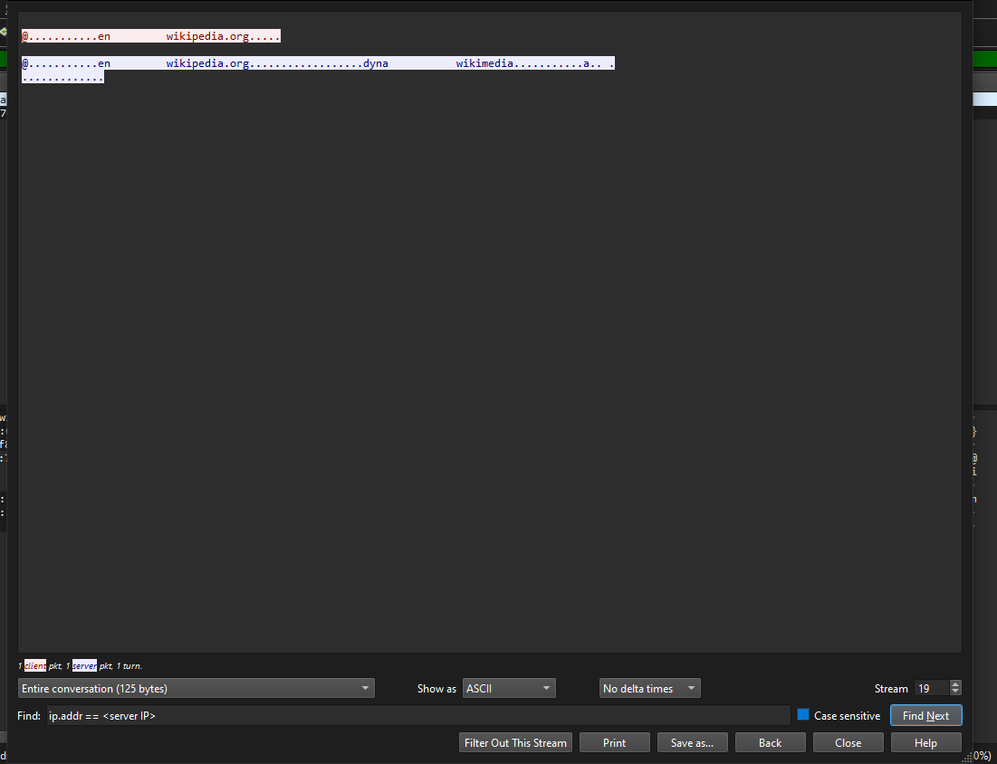
Figure 3: TLS Client Hello Message

4.1 Summary of Observations
Parameter | Observation
TCP Handshake | SYN, SYN-ACK, and ACK packets captured successfully between client and server.
TLS Handshake | TLSv1.3 Client Hello and Server Hello messages exchanged; encryption established.
DNS Resolution | Query and response captured for wikipedia.org with a resolution delay of ~2.8 ms.
Latency | Average round-trip delay measured around 120–150 ms.
Caching | Subsequent API requests showed reduced delay, indicating caching or connection reuse.

5. Conclusion
The Wireshark analysis successfully demonstrated the network behavior of HTTPS communication with the Wikipedia API. The captured packets clearly show the TCP 3-way handshake and the TLSv1.3 handshake establishing a secure session. DNS resolution time and latency were measured effectively, and repeated API requests exhibited caching characteristics. Overall, this experiment provided valuable insights into the working of secure web protocols and API communication patterns.

