ApexPlanet Software Pvt. Ltd.
Cybersecurity & Ethical Hacking Internship Program
TASK 1
Foundations of Cybersecurity
Foundation & Environment Setup
Lab Setup Report
Detail | Information
Intern Name | Talluri Anil Babu
Offer Letter ID | APSPL2649190
Program | Cybersecurity & Ethical Hacking
Internship Period | 21 October 2026 - 19 December 2026
Task Timeline | Days 1-12
Submission Date | ____ / ____ / 2026

1. Objective
The objective of Task 1 is to build strong fundamentals in cybersecurity, networking and cryptography, and to set up a professional, isolated hacking lab. The lab consists of an attacker machine (Kali Linux) and intentionally vulnerable target machines (Metasploitable2 and DVWA) connected through a private Host-Only network. All later internship tasks (scanning, web application testing, exploitation and the capstone) are performed in this lab.

2. Lab Architecture
Machine | Role | Network Adapter | IP Address
Kali Linux | Attacker / testing workstation | eth0: NAT (updates) / eth1: Host-Only | 10.0.2.15 (NAT) / 192.168.56.101
Metasploitable2 | Vulnerable target (network services) | Host-Only only | 192.168.56.103
DVWA v1.0.7 | Vulnerable web application (on Metasploitable2) | Host-Only only | 192.168.56.103/dvwa

Host-Only network: 192.168.56.0/24 (gateway 192.168.56.1, DHCP enabled). The intentionally vulnerable machine is connected to the Host-Only adapter only and is never exposed to NAT, bridged networks or the internet.

2.1 Hardware and Software Used
Item | Details
Host machine | Windows laptop, Intel Core i7-13620H (10 cores / 16 threads), 16 GB DDR5 RAM (4800 MT/s), NVMe SSD
Hypervisor | Oracle VirtualBox 7.2.14 (r174565)
Attacker VM | Kali Linux (kali-rolling), 4 vCPUs, 6048 MB RAM, 80 GB disk; adapters: NAT + Host-Only
Target OS | Metasploitable2 (Ubuntu 8.04 based) with DVWA v1.0.7
Analysis tools | Wireshark, Nmap 7.99, Burp Suite Community v2026.7.2, Netcat, OpenSSL 3.6.3

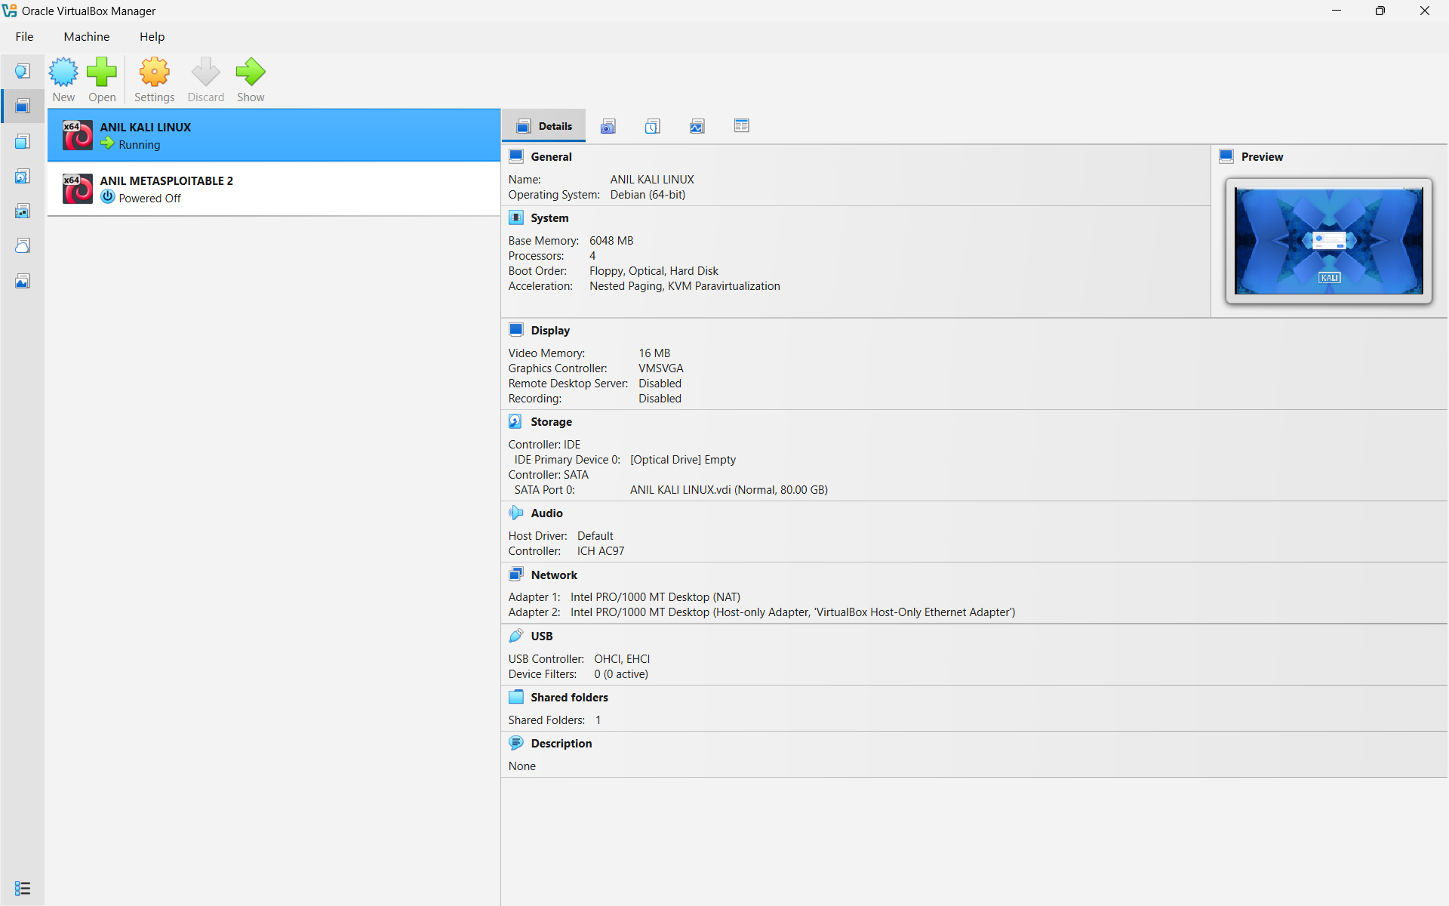
Figure 1: VirtualBox Manager: Kali VM details and the two lab VMs

3. Lab Setup Procedure

3.1 Installing the Hypervisor
Oracle VirtualBox 7.2.14 was installed on the Windows host with default options. Hardware virtualization was enabled in the BIOS/UEFI before installation.
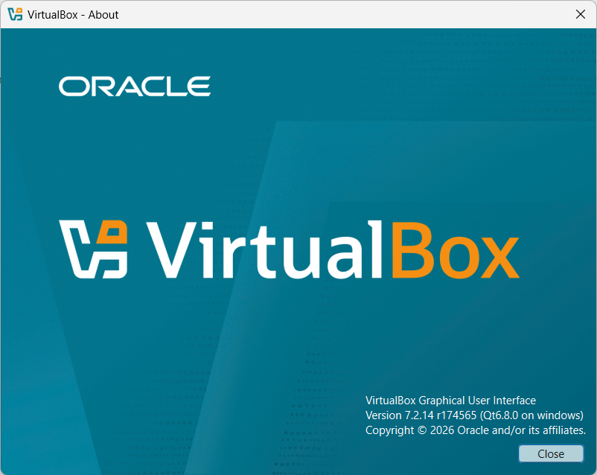
Figure 2: VirtualBox 7.2.14 installed (Help > About)

3.2 Configuring the Private Host-Only Network
A Host-Only network was created in the VirtualBox Network Manager with IPv4 address 192.168.56.1, mask 255.255.255.0 and the DHCP server enabled. This keeps the vulnerable machines isolated from the internet and from the home/college network.
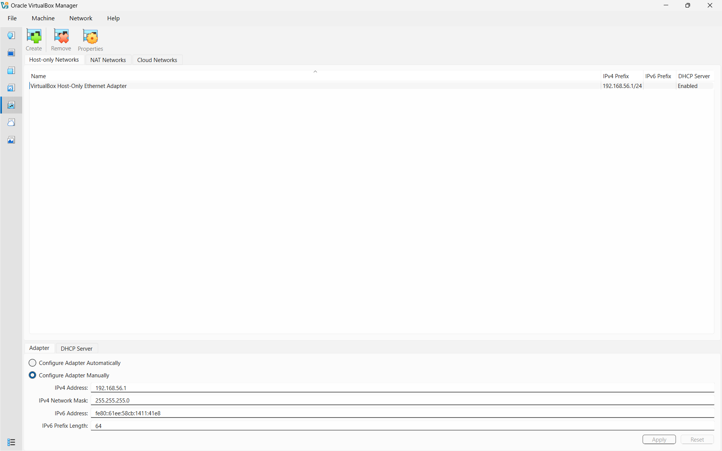
Figure 3: Host-Only network configuration (192.168.56.1/24, DHCP enabled)

3.3 Kali Linux (Attacker Machine)
Kali Linux was configured with two adapters: Adapter 1 (NAT) for updates and internet, and Adapter 2 (Host-Only) for lab traffic. The system was updated with:
sudo apt update && sudo apt full-upgrade -y

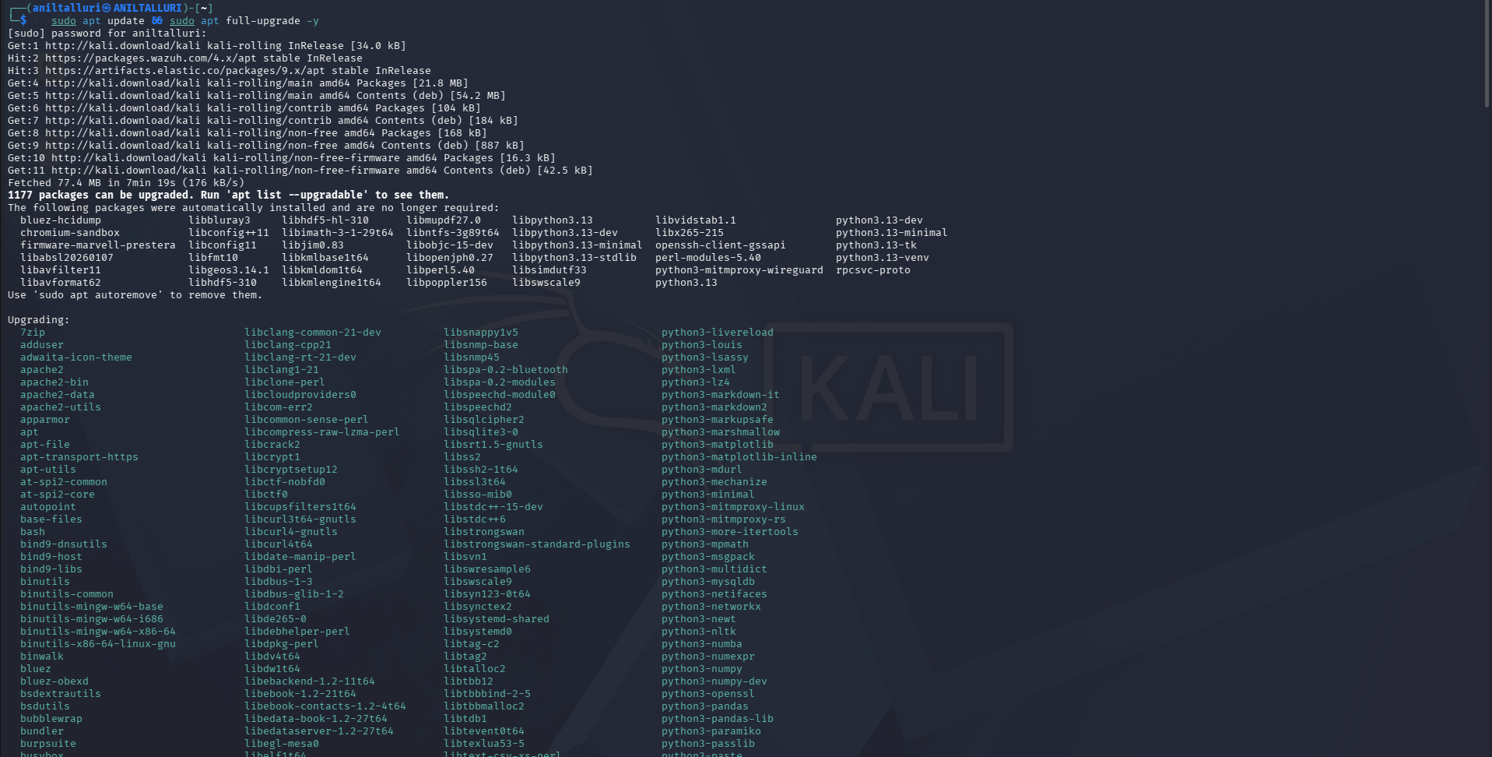
Figure 4: Kali Linux updated with apt update and full-upgrade
The network interfaces were checked with ip -br a. eth0 (NAT) has 10.0.2.15 and eth1 (Host-Only) has 192.168.56.101.
Figure 5: Kali network interfaces: NAT (eth0) and Host-Only (eth1)

3.4 Metasploitable2 (Target Machine)
Metasploitable2 was added as a VM using the provided virtual disk, with only the Host-Only adapter attached. After booting, the address was read with ifconfig: 192.168.56.103 on eth0 with mask 255.255.255.0.
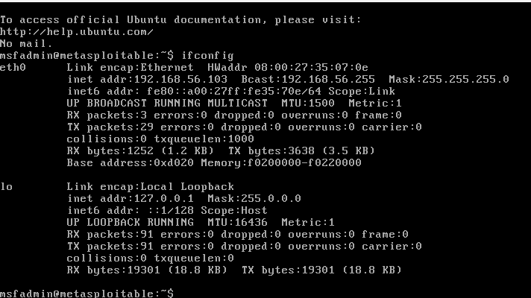
Figure 6: Metasploitable2 on the Host-Only network (192.168.56.103)

3.5 DVWA (Damn Vulnerable Web Application)
DVWA v1.0.7, included with Metasploitable2, was opened from Kali at http://192.168.56.103/dvwa/ and logged in as admin. The security level was set to Low for practice.
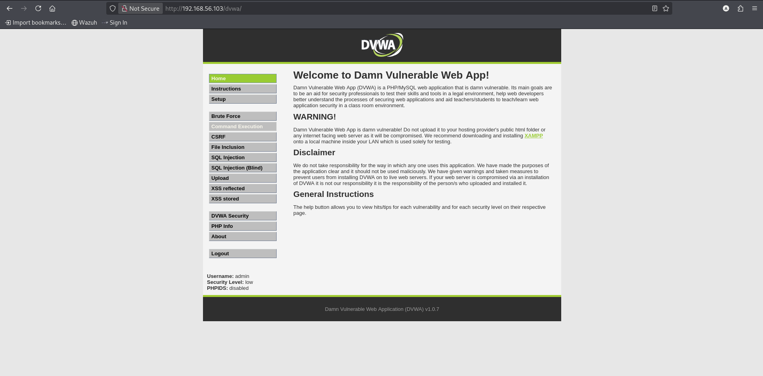
Figure 7: DVWA home page, accessed from Kali, security level: low

3.6 Connectivity Verification
Connectivity from the attacker to the target was verified with ping (4 packets sent, 4 received, 0% loss) and a service scan with Nmap.
ping -c 4 192.168.56.103
nmap -sV 192.168.56.103

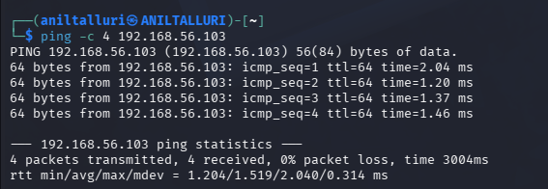
Figure 8: Ping from Kali to Metasploitable2: 0% packet loss
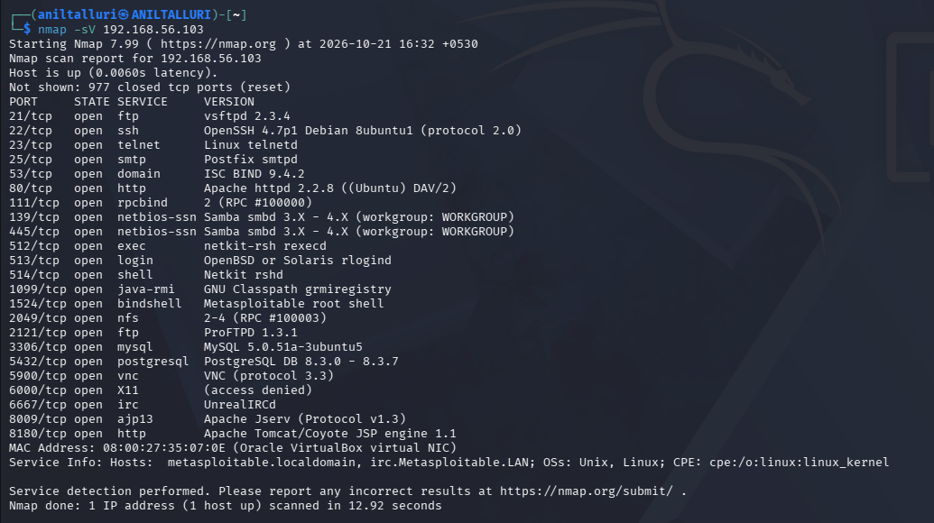
Figure 9: Nmap service scan: 23 open ports on the target
Selected services found by the scan (all intentionally vulnerable and used in later tasks):
Port | Service | Version detected
21/tcp | ftp | vsftpd 2.3.4
22/tcp | ssh | OpenSSH 4.7p1 Debian 8ubuntu1
23/tcp | telnet | Linux telnetd
80/tcp | http | Apache httpd 2.2.8 (Ubuntu) DAV/2
445/tcp | netbios-ssn | Samba smbd 3.X - 4.X
1524/tcp | bindshell | Metasploitable root shell
3306/tcp | mysql | MySQL 5.0.51a-3ubuntu5
5432/tcp | postgresql | PostgreSQL DB 8.3.0 - 8.3.7
6667/tcp | irc | UnrealIRCd

3.7 Wireshark Test Capture
Wireshark was started on the Host-Only interface (eth1). Test traffic was generated by pinging the target and loading the DVWA page. With the display filter icmp || http, the four ICMP echo requests and replies and the HTTP request/response are visible. The capture was saved as test-capture.pcapng in the repository.
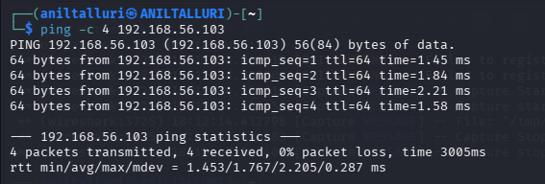
Figure 10: Ping used to generate ICMP traffic during the capture
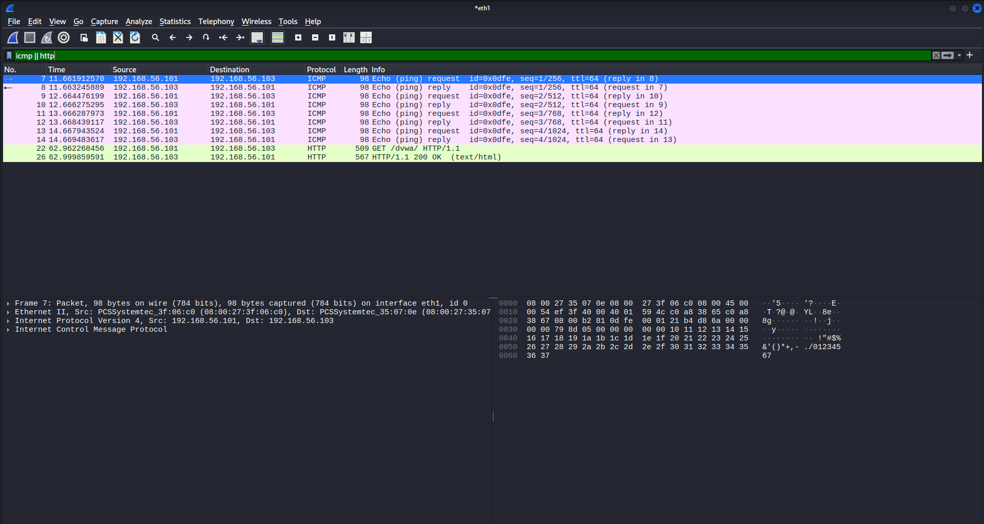
Figure 11: Wireshark with filter "icmp || http": ICMP echo request/reply and HTTP

A longer capture without a filter shows the full conversation: ARP resolving 192.168.56.103, the TCP three-way handshake (SYN, SYN/ACK, ACK), GET /dvwa/, a 302 redirect and the POST /dvwa/login.php login request.
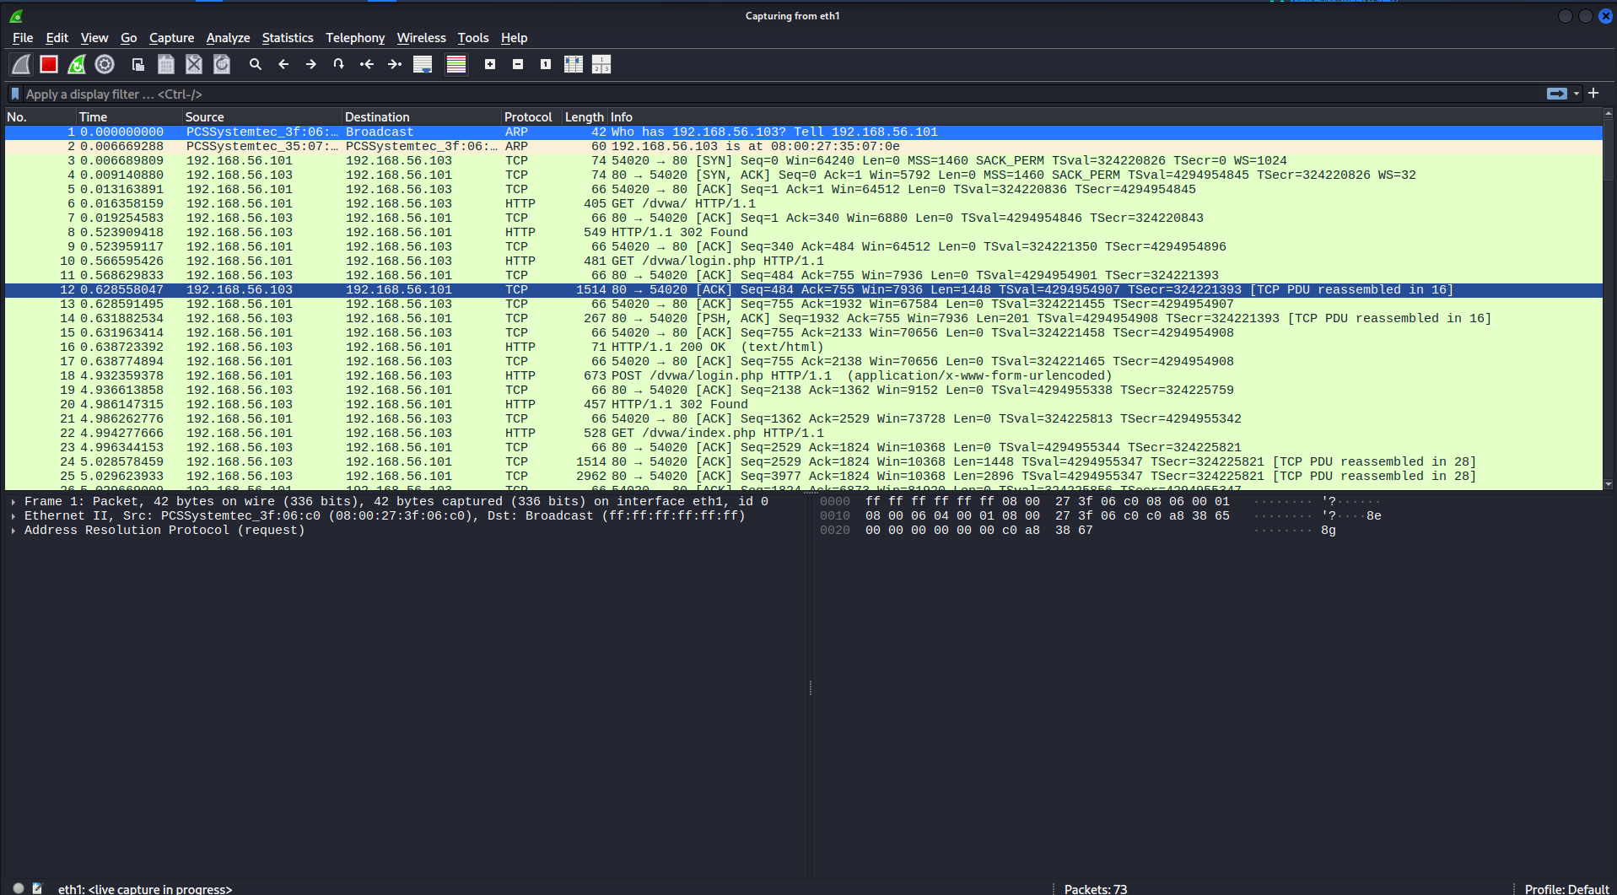
Figure 12: Unfiltered capture: ARP, TCP handshake and HTTP login
Observation: because DVWA uses plain HTTP, the login form data travels unencrypted and can be read by anyone capturing traffic on the network. This is why HTTPS (TLS) is required for real applications.

4. Linux Fundamentals Practised
Area | Commands | Purpose
Navigation | pwd, ls -la, cd, mkdir, cp, mv, find, grep | Move around and search the file system
Permissions | chmod 755, chmod 600, chown user:group | Control who can read, write, execute
Package management | apt update/full-upgrade/install, dpkg -i, dpkg -l | Install and manage software
Networking | ip a / ip -br a, ifconfig, ping, netstat -tulnp, traceroute, nmcli | Inspect and test network connectivity

A complete Linux cheat-sheet is available in the GitHub repository (linux-cheatsheet.md).

5. Networking Basics Summary
- OSI model: 7 layers from Physical to Application; the TCP/IP model maps these into 4 layers.
- TCP uses a three-way handshake (SYN, SYN/ACK, ACK), seen in the Wireshark capture; UDP is connectionless.
- DNS resolves names to IP addresses; HTTPS is HTTP protected by TLS (port 443).
- Lab subnet 192.168.56.0/24 gives 254 usable host addresses. NAT (eth0, 10.0.2.15) lets the VM reach the internet through the host.

6. Cryptography Hands-on (OpenSSL)
The following exercises were run on Kali Linux with OpenSSL 3.6.3 (9 Jun 2026) using the script openssl-demo.sh from the repository (crypto-demo folder).
Exercise | Result
AES-256-CBC encryption | Message encrypted to a salted ciphertext (starts with U2FsdGVkX1, base64) and decrypted correctly with the same password (symmetric).
SHA-256 / MD5 hashing | SHA-256("hello") = 2cf24dba...938b9824. Changing one character ("hellO") gave a completely different hash (avalanche effect).
RSA-2048 key pair | Message encrypted with the public key (256-byte ciphertext) and decrypted with the private key (asymmetric).
Digital signature | File signed with the private key; verified with the public key: "Verified OK".
Self-signed certificate | X.509 certificate for CN=lab.local created and inspected (subject, issuer, validity, SHA-256 fingerprint).

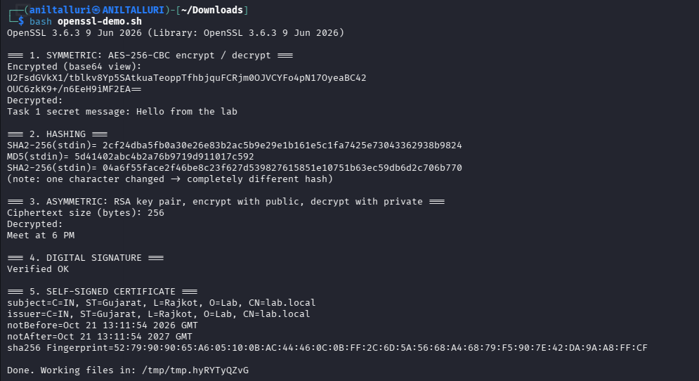
Figure 13: OpenSSL demo on Kali: AES, hashing, RSA, signature and certificate

7. Tool Familiarization
Tool | What was practised | Example
Wireshark | Packet capture, display filters, reading TCP/HTTP/ICMP | Filter: icmp || http
Nmap | Service and version detection on the target | nmap -sV 192.168.56.103
Burp Suite | Intercepting a browser request to DVWA through the proxy | Proxy > Intercept on
Netcat | Port checks, banner grabbing, listener, file transfer | nc -zv 192.168.56.103 21-25

Burp Suite Community (v2026.7.2) was started with a temporary project. With Intercept on, the request from Burp's browser to http://192.168.56.103/dvwa/login.php was held for inspection before being forwarded: the request line, Host header, cookies and other headers are visible and can be edited or sent to Repeater.
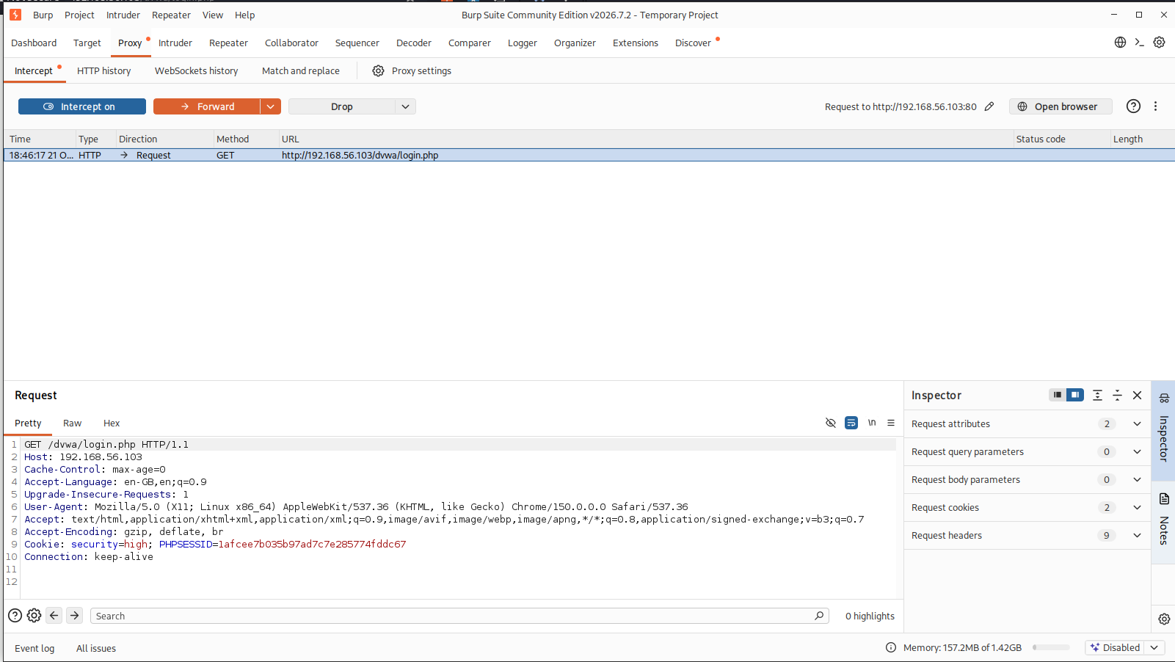
Figure 14: Burp Suite Proxy with Intercept on, holding GET /dvwa/login.php

8. Safety and Ethical Considerations
- All activity was limited to my own isolated lab network.
- The vulnerable machine is attached to the Host-Only adapter only. An early check showed it on a normal network address, so its adapter was corrected to Host-Only and re-verified before any testing.
- No real-world systems or networks were scanned or tested.

9. Key Learnings
- Built and configured a safe, isolated penetration testing lab and fixed adapter/IP problems using ip, ifconfig and nmcli.
- Understood the CIA triad, common threats and attack vectors.
- Practised Linux commands for permissions, packages and networking.
- Saw the TCP handshake and plain-text HTTP login in Wireshark, and used Nmap to enumerate services.
- Practised symmetric and asymmetric encryption, hashing, signatures and certificates with OpenSSL.

10. Conclusion
The foundation lab is ready. Kali Linux (192.168.56.101) reaches Metasploitable2 and DVWA (192.168.56.103) over a private Host-Only network, and the essential tools (Wireshark, Nmap, Burp Suite, Netcat, OpenSSL) have been tested. This environment will be used for Task 2 (Network Security & Scanning) onwards.

11. Submission Links
Item | Link
GitHub repository | https://github.com/aniltalluri000-sys/apexplanet-cybersecurity-internship
Task 1 folder | https://github.com/aniltalluri000-sys/apexplanet-cybersecurity-internship/tree/main/task-01-foundation-lab
LinkedIn video (5 min) | <paste LinkedIn Featured video link>

