-select "ID","Adi","Kodu","Aciklama","Birim_ID" from "Reyon"
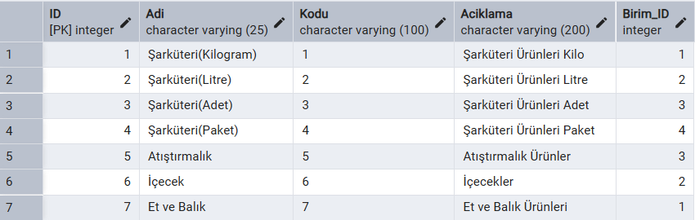

select u."Adi",u."Aciklama",u."Fiyat",u."Miktar",u."Kategori_ID",u."Birim_ID"
from "Urun" u
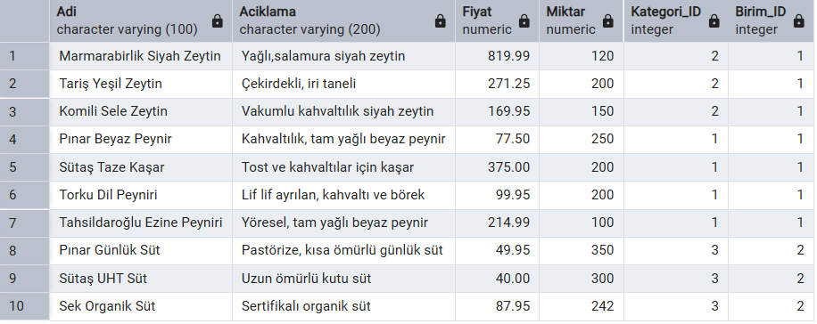

select k."Adi",k."Kodu",k."Aciklama",k."Reyon_ID",r."Adi",k."Birim_ID",b."Adi"
from "Kategori" k
inner join "Reyon" r on k."Reyon_ID"=r."ID"
inner join "Birim" b on k."Birim_ID"=b."ID"
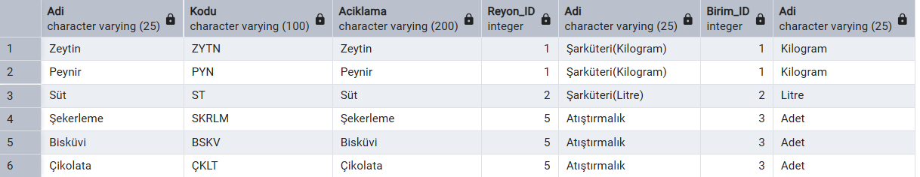

select u."Adi",u."Aciklama",u."Fiyat",u."Miktar",u."Kategori_ID",k."Adi" KategoriAdi,k."Reyon_ID",
r."Adi" ReyonAdi,u."Birim_ID",b."Adi" BirimAdi from "Urun" u

inner join "Kategori" k on u."Kategori_ID"=k."ID"

inner join "Birim" b on u."Birim_ID"=b."ID"

INNER JOIN "Reyon" r ON k."Reyon_ID" = r."ID"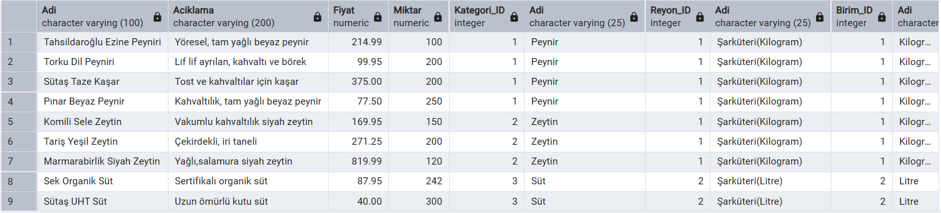

select k."Adi",u."Adi" urun_adi from "Kategori" k left join "Urun" u on k."ID"=u."ID"
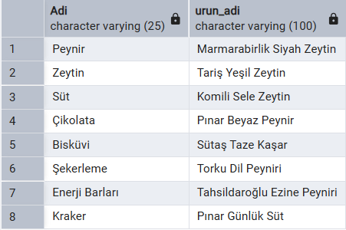

select u."Adi" urun_adi,r."Adi" reyon_adi from "Urun" u right join "Reyon" r on u."ID"=r."ID"
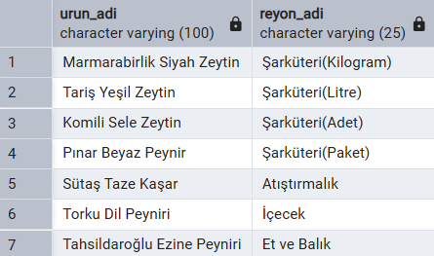

select k."Adi",count(u."ID") as urun_sayisi from "Kategori" k left join "Urun" u on k."ID"=u."Kategori_ID"
group by k."Adi"
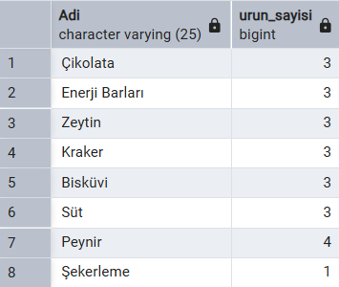

select k."Adi",max(u."Fiyat") as en_pahali from "Kategori" k join "Urun" u on
k."ID"=u."Kategori_ID" group by k."Adi"
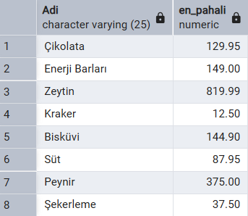

select "Adi","Fiyat" from "Urun" where "Fiyat">(select avg ("Fiyat") from "Urun")
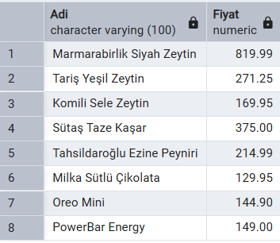
select distinct "Adi" from "Reyon"
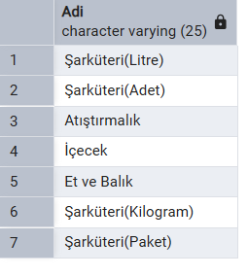

select "Adi" urun_adi,"Fiyat" urun_fiyati from "Urun" order by "Fiyat" desc limit 3
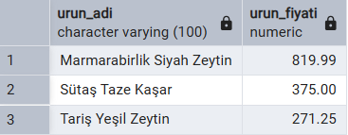

select "Adi","Fiyat",
Case
When "Fiyat"<100 then 'Ucuz'
When "Fiyat" between 100 and 200 then 'Orta'
Else 'Pahali'
end as fiyat_durumu
from "Urun"

