Lab Cycle 1
Aim: Calculator Application:
- Using with and without R objects on console.

Program:
With R Objects:
print("Welcome to Calculator (With R Objects)")
operator <- readline("Enter operator (+, -, *, /): ")
num1 <- as.numeric(readline("Enter first number: "))
num2 <- as.numeric(readline("Enter second number: "))
if (operator == "+") {
result <- num1 + num2
print(paste("Result =", result))
} else if (operator == "-") {
result <- num1 - num2
print(paste("Result =", result))
} else if (operator == "*") {
result <- num1 * num2
print(paste("Result =", result))
} else if (operator == "/") {
if (num2 != 0) {
result <- num1 / num2
print(paste("Result =", result))
} else {
print("Error: Division by zero")
}
} else {
print("Invalid operator")
}
Output:
Welcome to Calculator
Enter operator(+,-,*,/): +
Enter first number:3
Enter second number:8
Result=11

Without R Objects:
cat("Simple Calculator 501(without object)\n")
cat("Enter first number: ")
num1 <- as.numeric(readline())
cat("Enter operator (+, -, *, /): ")
op <- readline()
cat("Enter second number: ")
num2 <- as.numeric(readline())
if (op == "+") {
cat("Result:", num1 + num2, "\n")
} else if (op == "-") {
cat("Result:", num1 - num2, "\n")
} else if (op == "*") {
cat("Result:", num1 * num2, "\n")
} else if (op == "/") {
if (num2 == 0) {
cat("Error: Division by zero!\n")
} else {
cat("Result:", num1 / num2, "\n")
}
} else {
cat("Invalid operator\n")
}

Output:
Simple Calculator
Enter operator(+,-,*,/): +
Enter first number:3
Enter second number:8
Result=11

Aim: Calculator Application:
b)Using mathematical functions on console.

Program:
num1<-as.numeric(readline("Enter first number: "))
num2<-as.numeric(readline("Enter Second number: "))
abs(num1)
sqrt(num2)
round(num1,3)
ceiling(num1)
floor(num1)
sin(num2)
cos(num2)
tan(num2)
log(num2)
exp(num2)
factorial(num2)
choose(5,2)
sign(num1)

Output:
> num1<-as.numeric(readline("Enter first number: "))
Enter first number:
> num2<-as.numeric(readline("Enter Second number: "))
Enter Second number:
> abs(num1)
[1] NA
> sqrt(num2)
[1] NA
> round(num1,3)
[1] NA
> ceiling(num1)
[1] NA
> floor(num1)
[1] NA
> sin(num2)
[1] NA
> cos(num2)
[1] NA
> tan(num2)
[1] NA
> log(num2)
[1] NA
> exp(num2)
[1] NA
> factorial(num2)
[1] NA
> choose(5,2)
[1] 10
> sign(num1)
[1] NA
>
Aim: : Calculator Application:
c) Write an R script, to create R objects for calculator application and save
in a specified location in disk.

Program:
operator <- readline("Enter operator (+, -, *, /): ")
num1 <- as.numeric(readline("Enter first number: "))
num2 <- as.numeric(readline("Enter second number: "))
if(op=="+"){
res<-num1+num2
}else if(op=="-"){
res<-num1-num2
}else if(op=="*"){
res<-num1*num2
}else if(op=="/"){
res<-num1/num2
}else{
res<-NA
cat("Invalid Operator")
}
Calculator_data<-list(
number1=num1,
number2=num2,
operation=op,
result=res
)
save_path<-"C:\Users\admin\Desktop\503\503\data.RData"
save(calculator_data,file=sava_path)
cat("data save successfully to",save_path,"\n")

Output:
Enter num1:45
Enter num2:20
Enter operator(+,-,*,/): -
Result:25

Aim: : Calculator Application:
d) RPackages: tidyr, ggplot2, ggraph, glue. Shiny

Program:

#tidyr
library(tidyr)
# Example dataset
df <- data.frame(
Name = c("A", "B"),
Math = c(90, 85),
Science = c(80, 88)
)

# Convert wide data to long format
long_df <- gather(df, Subject, Marks, Math:Science)

print(long_df)

#glue
library(glue)
a <- 10
b <- 20
glue("The sum of {a} and {b} is {a+b}")

Output:

Name Subject Marks
1 A Math 90
2 B Math 85
3 A Science 80
4 B Science 88

The sum of 10 and 20 is 30

Program:
#ggplot2

library(ggplot2)

ggplot(mtcars, aes(x = wt, y = mpg)) +
geom_point(color = "blue") +
labs(title = "Scatter Plot of MPG vs Weight")

#ggraph

library(igraph)
library(ggraph)

# Create graph object
g <- graph(c("A","B", "A","C", "B","D"))

# Plot graph
ggraph(g, layout = "circle") +
geom_edge_link() +
geom_node_point(size = 5, color = "red") +
geom_node_text(aes(label = name), vjust = 1.5)

Output:

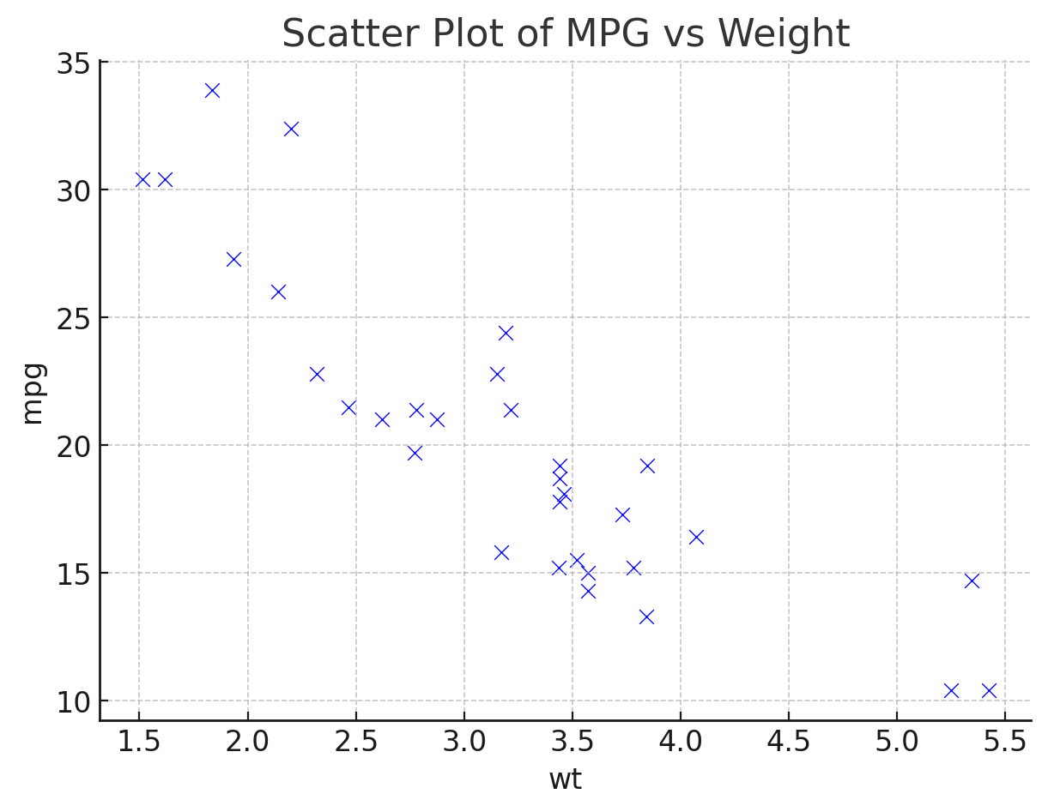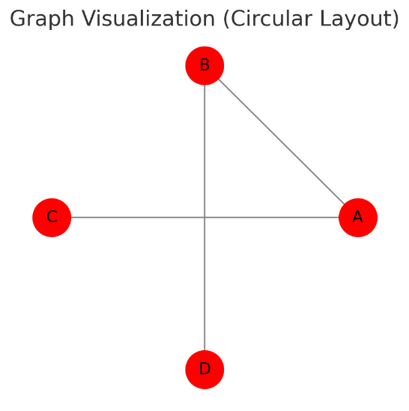

Program:
#Shiny

library(shiny)

# UI
ui <- fluidPage(
titlePanel("Simple Calculator"),

numericInput("num1", "Enter first number:", 0),
numericInput("num2", "Enter second number:", 0),
textInput("op", "Enter operator (+, -, *, /):", "+"),

actionButton("calc", "Calculate"),
br(),
textOutput("result")
)

# Server
server <- function(input, output) {
observeEvent(input$calc, {
result <- switch(input$op,
"+" = input$num1 + input$num2,
"-" = input$num1 - input$num2,
"*" = input$num1 * input$num2,
"/" = ifelse(input$num2 != 0, input$num1 / input$num2, "Error: Division by zero!"),
"Invalid operator!")

output$result <- renderText({ paste("Result:", result) })
})
}

# Run app
shinyApp(ui = ui, server = server)

Output:

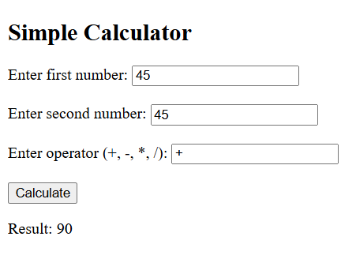
Aim: : Descriptive Statistics:
a) Write an R script to find basic descriptive statistics using summary.

Program:
myData <- read.csv("fitness_exercises.csv", stringsAsFactors = FALSE)
print(head(myData))
print(summary(myData))

Output:
> # Import the data using read.csv()
> myData <- read.csv("fitness_exercises.csv", stringsAsFactors = FALSE)

> # Print the first 6 rows
> print(head(myData))
bodyPart equipment gifUrl id
1 waist body weight http://d205bpvrqc9yn1.cloudfront.net/0001.gif 1
2 waist body weight http://d205bpvrqc9yn1.cloudfront.net/0002.gif 2
3 waist body weight http://d205bpvrqc9yn1.cloudfront.net/0003.gif 3
4 upper legs body weight http://d205bpvrqc9yn1.cloudfront.net/1512.gif 1512
5 waist body weight http://d205bpvrqc9yn1.cloudfront.net/0006.gif 6
6 back cable http://d205bpvrqc9yn1.cloudfront.net/0007.gif 7
name target
1 3/4 sit-up abs
2 45° side bend abs
3 air bike abs
4 all fours squad stretch quads
5 alternate heel touchers abs
6 alternate lateral pulldown lats

> # Use summary() to get descriptive statistics
> print(summary(myData))
bodyPart equipment gifUrl id
Length:1327 Length:1327 Length:1327 Min. : 1.0
Class :character Class :character Class :character 1st Qu.: 378.5
Mode :character Mode :character Mode :character Median : 862.0
Mean :1189.5
3rd Qu.:1661.5
Max. :5201.0
name target
Length:1327 Length:1327
Class :character Class :character
Mode :character Mode :character

Aim: : Descriptive Statistics:
b) Write an R script to find subset of dataset by using subset

Program:
df <- data.frame(
age = 1:10,
category=rep(c("A","B"),each=5),
value=rnorm(10)
)

# Print the original data frame
print("Original Data Frame:")
print(df)

# 1. Subset based on a condition (e.g., age > 27)
subset_age <- subset(df, age>2)
print("Subset (age > 2):")
print(subset_age)

# 2. Subset based on multiple conditions (e.g., age > 27 and city is 'London')
subset_age_value <- subset(df, age > 2 & value>1)
print("Subset (age > 2 & value > 1):")
print(subset_age_value)

Output:
# Print the original data frame
> print("Original Data Frame:")
[1] "Original Data Frame:"

> print(df)
age category value
1 1 A 0.75824488
2 2 A -0.89647431
3 3 A -0.60503366
4 4 A 0.18010395
5 5 A 0.01542015
6 6 B -0.29360162
7 7 B 0.28459992
8 8 B -1.02765601
9 9 B -0.18700653
10 10 B 0.67524209

> # 1. Subset based on a condition (e.g., age > 27)
> subset_age <- subset(df, age>2)

> print("Subset (age > 2):")
[1] "Subset (age > 2):"

> print(subset_age)
age category value
3 3 A -0.60503366
4 4 A 0.18010395
5 5 A 0.01542015
6 6 B -0.29360162
7 7 B 0.28459992
8 8 B -1.02765601
9 9 B -0.18700653
10 10 B 0.67524209

> # 2. Subset based on multiple conditions (e.g., age > 27 and city is 'London')
> subset_age_value <- subset(df, age > 2 & value>1)

> print("Subset (age > 2 & value > 1):")
[1] "Subset (age > 2 & value > 1):"

> print(subset_age_value)
[1] age category value
<0 rows> (or 0-length row.names)

Aim: Reading and Writing Different Types of Datasets:
a) Reading different types of data sets (.txt, .csv) from web and disk and writing in file in specific disk location

Program:
csv_data <- read.csv("C:/Users/admin/Desktop/503/503/industry.csv")
head(csv_data)
new_row <- data.frame(Industry="Healthcare")
csv_data<-rbind(csv_data,new_row)
head(csv_data)
txt_data <- readLines("C:/Users/admin/Desktop/503/503/text.txt")
cat(txt_data)
writeLines("Computer Engineering", file="C:/Users/admin/Desktop/503/503/text.txt",append=TRUE)
cat(txt_data)
Output:
> csv_data <- read.csv("C:/Users/admin/Desktop/503/503/industry.csv")
> head(csv_data)
Industry
1 Technology
2 Finance
3 Retail
4 Manufacturing
> new_row <- data.frame(Industry="Healthcare")
> csv_data<-rbind(csv_data,new_row)
> head(csv_data)
Industry
1 Technology
2 Finance
3 Retail
4 Manufacturing
5 Healthcare
> txt_data <- readLines("C:/Users/admin/Desktop/503/503/text.txt")
> cat(txt_data)
Electrical Engineering
Mechanical Engineering
> writeLines("Computer Engineering", file="C:/Users/admin/Desktop/503/503/text.txt",append=TRUE)
> cat(txt_data)
Electrical Engineering
Mechanical Engineering
Aim: Reading and Writing Different Types of Datasets:
b)Reading Excel data sheet in R.

Program:

library(readxl)
file_path <- "C:/Users/admin/Desktop/503/503/excel.xls"
data <- read_excel(file_path)
print(head(data))

Output:

> print(results)
name age email title author
1 John Doe 30 john.doe@example.com <NA> <NA>
2 Jane Smith 25 jane.smith@example.com <NA> <NA>
3 <NA> <NA> <NA> The Adventure Begins Robert Johnson
year
1 <NA>
2 <NA>
3 2022

Aim: Reading and Writing Different Types of Datasets:
c)Reading XML dataset in R

Program:

library("XML")
library("methods")
results <- xmlToDataFrame("file:///C:/Users/admin/Desktop/503/503/xmlFile.xml")
print(results)

Output:
`0` `First Name` `Last Name` Gender Country Age Date Id
<dbl> <chr> <chr> <chr> <chr> <dbl> <chr> <dbl>
1 1 Dulce Abril Female United States 32 15/10/2017 1562
2 2 Mara Hashimoto Female Great Britain 25 16/08/2016 1582
3 3 Philip Gent Male France 36 21/05/2015 2587
4 4 Kathleen Hanner Female United States 25 15/10/2017 3549
5 5 Nereida Magwood Female United States 58 16/08/2016 2468
6 6 Gaston Brumm Male United States 24 21/05/2015 2554

Aim: Visualizations:
- Find the data distributions using box and scatter plot

Program:

# Load library
library(ggplot2)

# Boxplot of mpg (miles per gallon) by number of cylinders
ggplot(mtcars, aes(x = factor(cyl), y = mpg, fill = factor(cyl))) +
geom_boxplot() +
labs(title = "Boxplot of MPG by Number of Cylinders",
x = "Cylinders",
y = "Miles per Gallon") +
theme_minimal()

# Scatter plot of weight vs mpg
ggplot(mtcars, aes(x = wt, y = mpg, color = factor(cyl))) +
geom_point(size = 3) +
labs(title = "Scatter Plot of MPG vs Weight",
x = "Weight (1000 lbs)",
y = "Miles per Gallon",
color = "Cylinders") +
theme_minimal()

Output:
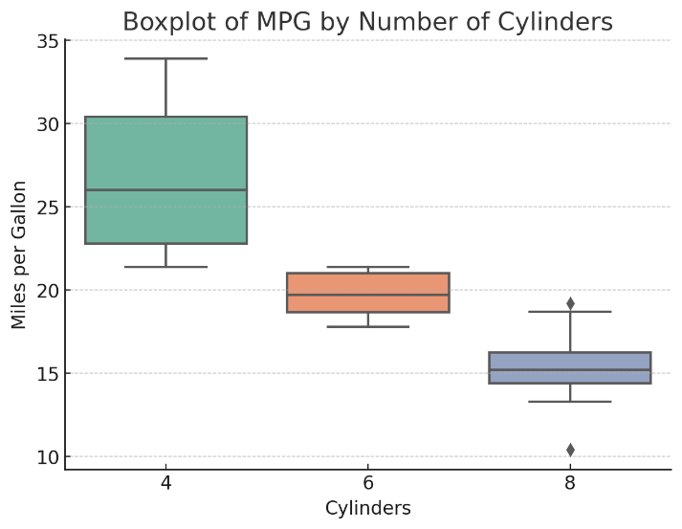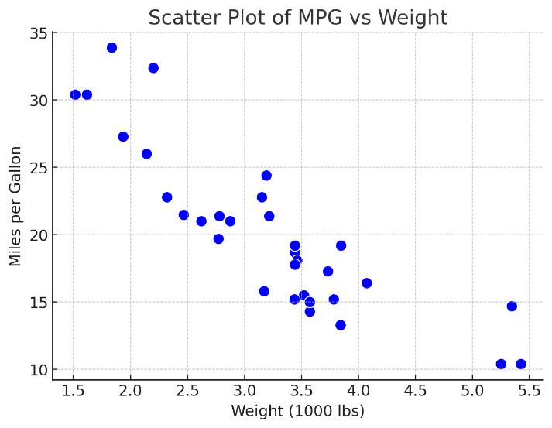

Aim: Visualizations:
- Find the outliers using plot.

Program:

# Sample data with an outlier
df <- data.frame(
Category = c("A", "B", "C", "D", "E", "F"),
Values = c(23, 45, 12, 36, 29, 120) # 120 is a potential outlier
)
library(ggplot2)
# Boxplot
ggplot(df, aes(y = Values)) +
geom_boxplot(fill = "lightblue", outlier.color = "red", outlier.shape = 16, outlier.size = 3) +
labs(title = "Boxplot to Detect Outliers", y = "Values") +
theme_minimal()

Output:

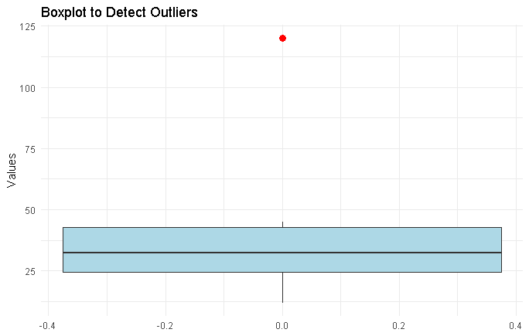
Aim: Visualizations:
- Plot the histogram, bar chart and pie chart on sample data.

Program:

install.packages("ggplot2") # Run this once
library(ggplot2)
# Sample data
df <- data.frame(
Category = c("A", "B", "C", "D", "E"),
Values = c(23, 45, 12, 36, 29)
)
ggplot(df, aes(x = Values)) +
geom_histogram(binwidth = 5, fill = "skyblue", color = "black") +
labs(title = "Histogram", x = "Value Ranges", y = "Frequency")
ggplot(df, aes(x = Category, y = Values, fill = Category)) +
geom_bar(stat = "identity") +
labs(title = "Bar Chart", x = "Category", y = "Values") +
theme_minimal()
# Compute percentages
df$Percentage <- df$Values / sum(df$Values) * 100
df$Label <- paste0(df$Category, " (", round(df$Percentage, 1), "%)")
# Create pie chart
ggplot(df, aes(x = "", y = Values, fill = Category)) +
geom_bar(stat = "identity", width = 1) +
coord_polar("y", start = 0) +
labs(title = "Pie Chart") +
theme_void() +
geom_text(aes(label = Label), position = position_stack(vjust = 0.5))

Output:
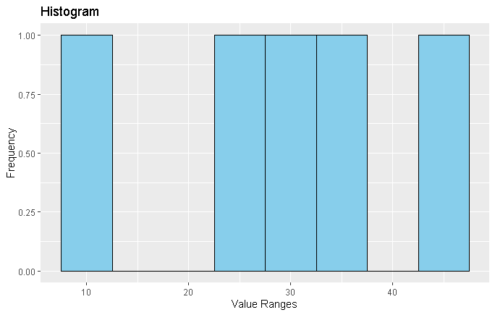
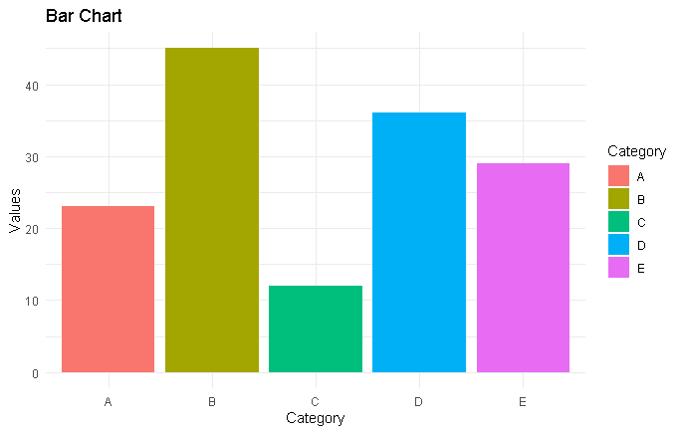

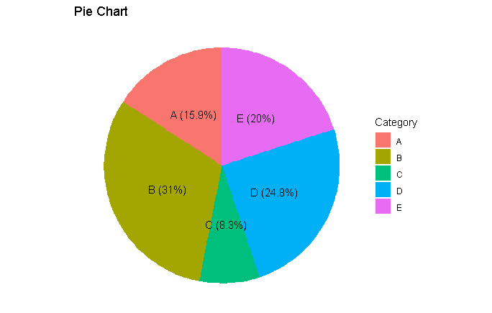

Aim: Write the R script that detect file types and reads it accordingly.

Program:

# Required libraries
if (!require("readxl")) install.packages("readxl", dependencies = TRUE)
library(readxl)
# Function to detect file type and read accordingly
read_data_file <- function(file_path) {
# Extract file extension
file_ext <- tools::file_ext(file_path)
# Read file based on extension
if (file_ext == "csv") {
data <- read.csv(file_path, stringsAsFactors = FALSE)
print("CSV file")
} else if (file_ext %in% c("xls", "xlsx")) {
data <- read_excel(file_path)
print("Excel file")
} else if (file_ext == "txt") {
data <- read.table(file_path, header = TRUE, sep = "\t", stringsAsFactors = FALSE)
print("Text")
} else {
stop("Unsupported file type: ", file_ext)
}
return(data)
}
file_path <- "Book1.xlsx"
df <- read_data_file(file_path)
head(df)

Output:
df <- read_data_file(file_path)
[1] "Excel file"
> head(df)
# A tibble: 4 × 2
Name Marks
<chr> <dbl>
1 Neha 150
2 Riya 190
3 Varun 120
4 Kiarn 155

