Objective:
● Generate a dataset using the provided MATLAB file which simulates the
physics of the photovoltaic system.
● Developed an advanced neural network model that accurately predicts the
AC power output (Pac) of a photovoltaic system based on the provided
photovoltaic physics model.
● Extend the model to detect and diagnose faults in the solar plant
equipment.

Methodology:
- To know about Inputs:
From given physics model we can know that our desired output
(PAC) depends on which inputs,Here it depends on Gir &
Ta.
- Dataset Generation:
To make a NN model , we need Data to train and test the model,so from given matlab , I ran two .m files for variable identification and ran a simulink file.

Problem:
Since in simulation there were two inputs box ,I need to rerun simulation multiple times to get multiple combination of data , so i wrote matlab script .due to limitation of time , i could only took
1271 datas.(File name : data_set.csv).

In the fig. Given below to reach saturation state and from hit and trial , I saw that all graphs are reaching saturation in more or less 0.2 sec.
So for each data i need to run simulation for at least 0.2 sec which is also limitation for data generation.

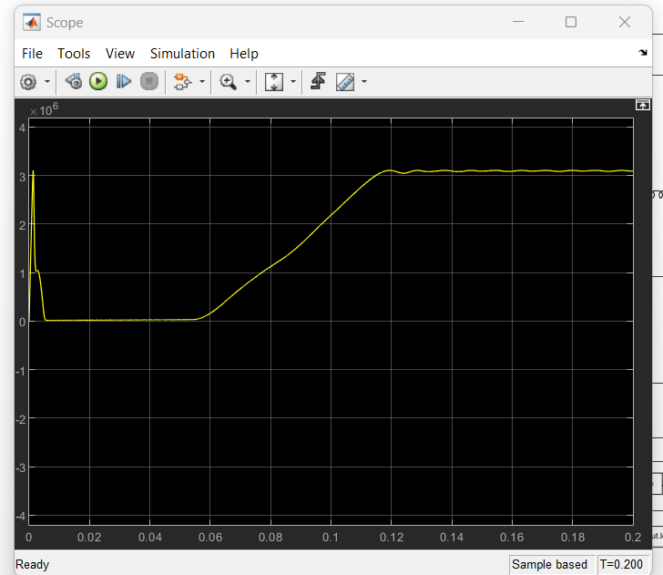
P out for Gir :1000, T=20 deg c

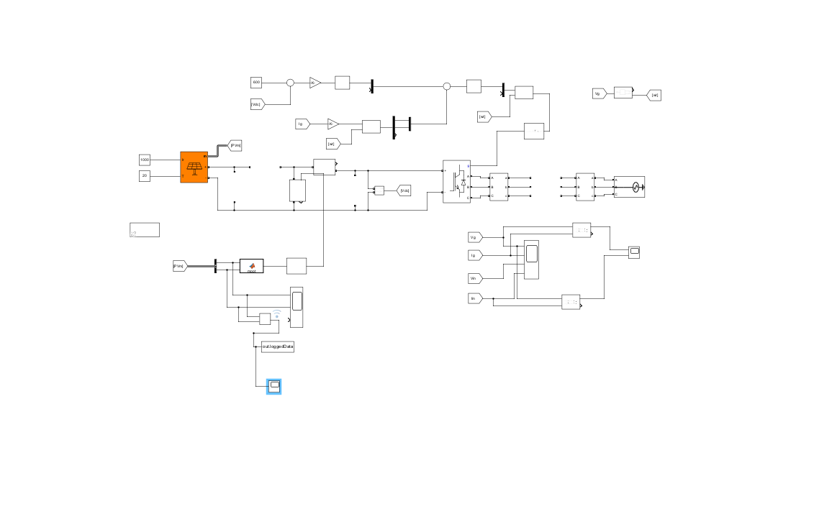
Updated Simulink Block pic

Matlab script : Final name : untitled.m

% Load your Simulink model
model_name = 'test1';
load_system(model_name)
% Define the number of data points
num_data_points = 1000;

ir_min = 100; // ir = iridance
// t = ambient temp
ir_max = 1500;
t_min = 15;
t_max = 35;

output_csv_file = 'data_set.csv';

if ~isfile(output_csv_file)
header = {'Ir', 'T', 'Power'};
writetable(cell2table(cell(0,3), 'VariableNames', header), output_csv_file);
end
% Loop over data points
for i = 1:num_data_points
ir = ir_min + rand() * (ir_max - ir_min); % Generate a random value within the range
t = t_min + rand() * (t_max - t_min); % Generate a random value within the range
% Set the parameter values
set_param([model_name '/Constant'], 'Value', num2str(ir));
set_param([model_name '/Constant1'], 'Value', num2str(t));
% Start the simulation
simOut = sim(model_name);
% Access the logged signal data loggedData = simOut.get('loggedData').signals.values;
% Append the input, t, and last output to the CSV file
data = [ir, t, loggedData(end)];
dlmwrite(output_csv_file, data, '-append');
end
% Close the Simulink model
close_system(model_name, 0);

Since for photovoltaic systems optimal Ir is between 100 and 1500 so we took according to that and same for temp also.

Ir : Sun Irradiance T = Ta and Power=power
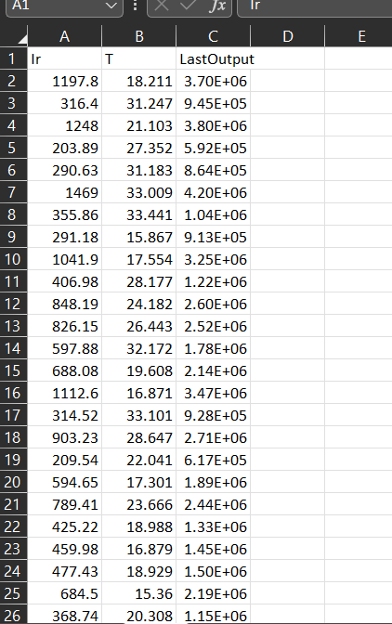

Successfully Generated Data!

- Neural network code in python (Google Colab):

import pandas as pd
import numpy as np
import tensorflow as tf
from tensorflow import keras
from sklearn.model_selection import train_test_split
from sklearn.metrics import mean_squared_error, mean_absolute_error, r2_score
import matplotlib.pyplot as plt

data = pd.read_csv('data_set.csv')

X = data[['Ir', 'T']].values
y = data['Power'].values

X_train, X_test, y_train, y_test = train_test_split(X, y, test_size=0.2, random_state=42)

# L2 regularization

model = keras.Sequential([
keras.layers.Dense(512, activation='relu', input_shape=(X.shape[1],),
5kernel_regularizer=keras.regularizers.l2(0.01)),
keras.layers.Dense(1024, activation='relu', kernel_regularizer=keras.regularizers.l2(0.01)),
keras.layers.Dense(512, activation='relu', kernel_regularizer=keras.regularizers.l2(0.01)),
keras.layers.Dense(256, activation='relu', kernel_regularizer=keras.regularizers.l2(0.01)),
keras.layers.Dense(1, activation='linear')
])

# mean squared error loss
model.compile(optimizer='adam', loss='mean_squared_error')

# Train the model
history = model.fit(X_train, y_train, epochs=200, batch_size=64, verbose=0, validation_data=(X_test, y_test))

# Make predictions on the test set
y_pred = model.predict(X_test)

# metrics
mse = mean_squared_error(y_test, y_pred)
rmse = np.sqrt(mse)
mae = mean_absolute_error(y_test, y_pred)
r2 = r2_score(y_test, y_pred)

# Print the metrics
print(f"Mean Squared Error (MSE): {mse}")
print(f"Root Mean Squared Error (RMSE): {rmse}")
print(f"Mean Absolute Error (MAE): {mae}")
print(f"R-squared (R^2) Score: {r2}")

# Plot Predicted vs. Actual Output
plt.figure(figsize=(8, 6))
plt.scatter(y_test, y_pred, alpha=0.5)
plt.xlabel("Actual Output")
plt.ylabel("Predicted Output")
plt.title("Predicted vs. Actual Output")
plt.grid()
plt.show()

# Plot Loss History
plt.figure(figsize=(8, 6))
plt.plot(history.history['loss'], label='Training Loss')
plt.plot(history.history['val_loss'], label='Validation Loss')
plt.xlabel('Epoch')
plt.ylabel('Loss')
plt.legend()
plt.title('Loss History')
plt.grid()
plt.show()

RESULTS
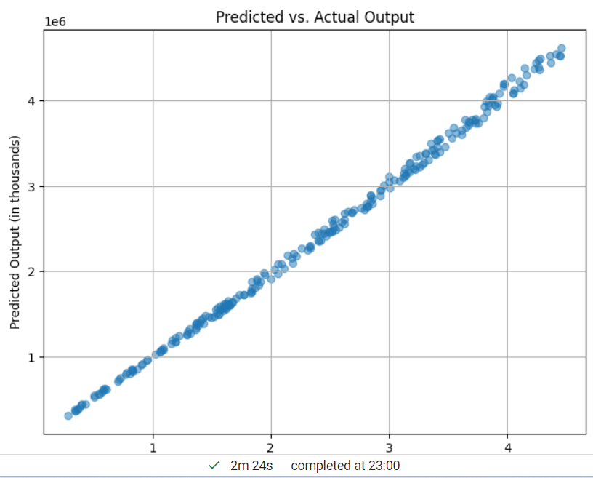

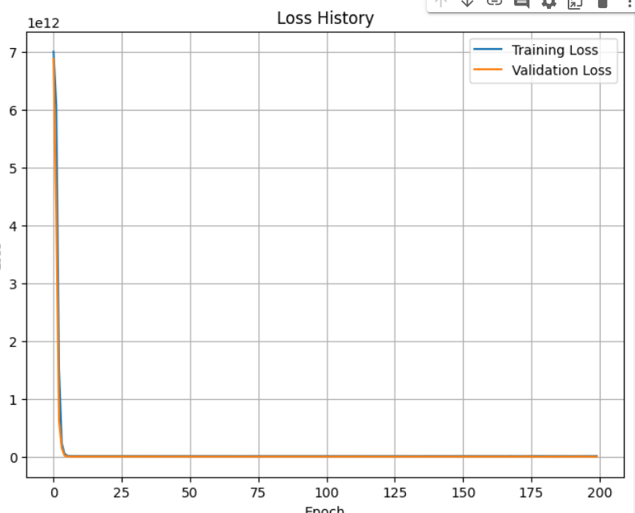

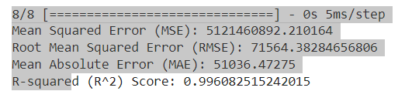

Since Predicted vs output graph is approx is like y=x , i think regression is good enough also R - squared score is also good. Since power is order 10 power 6 so i think mean absolute error is reasonable, i trained the model many times but cannot able to reduce error than this.

Optimizing Neural Network Performance:

1. Hyperparameter Tuning:- We can tune the number of layers, the number of neurons in each layer, activation functions, learning rate, batch size, and the number of training epochs.

2. Regularization: To prevent overfitting and improve the model's generalization.

3. Data Quality: We can Check that the data used for training and evaluation aligns with the physics model. Any discrepancies may lead to inaccurate predictions.

Anomaly Detection : we can define threshold value according to our needs,means how much deviation is acceptable.
Code :
reconstructed_data = model.predict(X_test)
reconstruction_error = np.mean(np.square(X_test - reconstructed_data), axis=1)

threshold to classify anomalies
threshold = 0.1

anomalies = X_test[reconstruction_error > threshold]
# Plot Anomalies
if len(anomalies) > 0:
plt.figure(figsize=(8, 6))
plt.scatter(anomalies[:, 0], anomalies[:, 1], alpha=0.5, color='red', label='Anomalies')
plt.scatter(X_test[:, 0], X_test[:, 1], alpha=0.5, color='blue', label='Normal')
plt.xlabel("Feature 1")
plt.ylabel("Feature 2")
plt.title("Anomaly Detection")
plt.legend()
plt.grid()
plt.show()
// we can adjust threshold value according to our need.

Result:
