JS Events and Methods Document

JavaScript's interaction with HTML is handled through events that occur when the user or the browser manipulates a page.

Common Events in JavaScript with Examples -

- Onkeyup Event
- Onkeydown Event
- Onchange Event
- Onfocus Event
- Onblur Event
- Onsubmit Event
- Onselect Event
- Onkeypress Event
- Onclick Event
- Ondblclick Event
- Onload Event

Common String & Array Methods in JS with Example -

- charAt()
- concat()
- indexOf()
- replace()
- slice()
- split()
- substring()
- tostring()
- trim()
- include()

- filter()
- find()
- map()
- push()
- pop()
- reduce()
- reverse()
- sort()
- shift()
- unshift()

1- Onkeyup Event

This is a keyboard event and event is triggered whenever a key is released after pressing.

Code:-

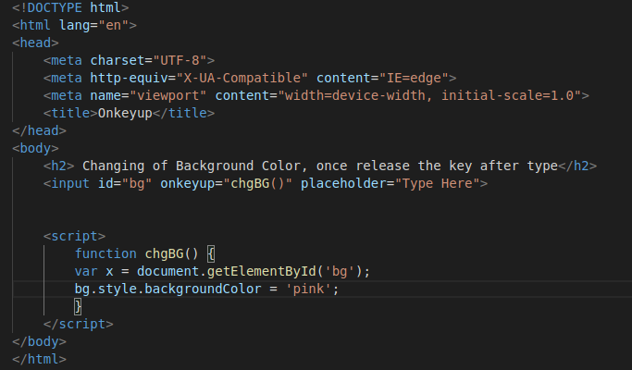

output:-

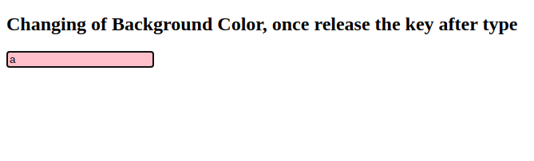

2- Onkeydown Event

A function is triggered when the user is pressing a key in the input field.

Code:-

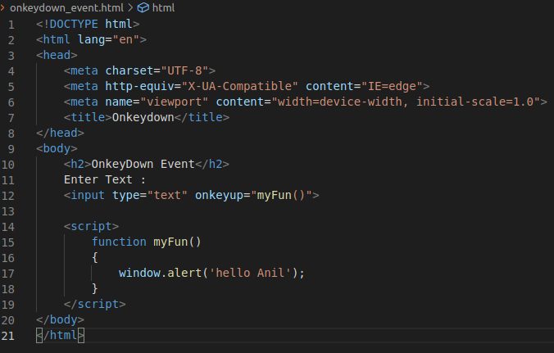

output:-

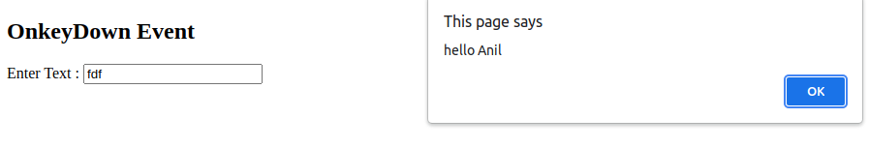

3- Onchange Event

The onchange event occurs when a user changes the value of a form element. Here we are choosing an name from the list.

Code:-

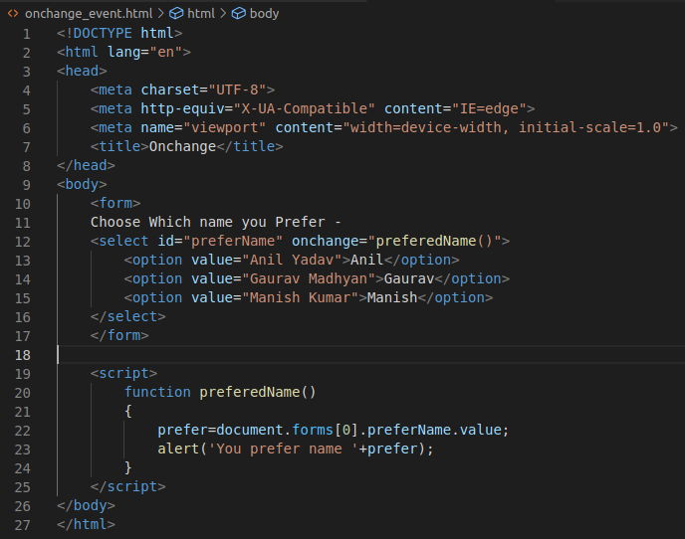

Output:-
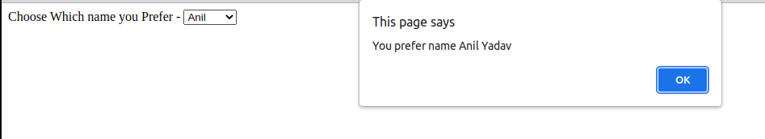

4- Onfocus Event

whenever, the focus is received by the element specified, this event executes.

Code:-

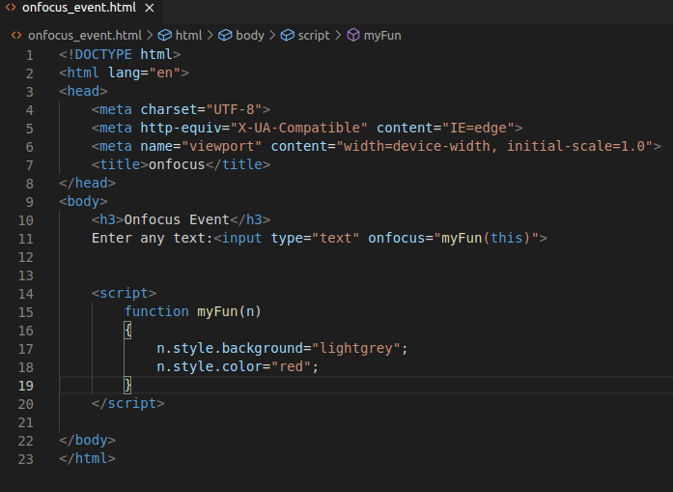

output:-

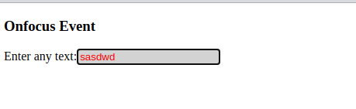

5- onblur Events

When you leave the input field, a function is triggered.

Code:-

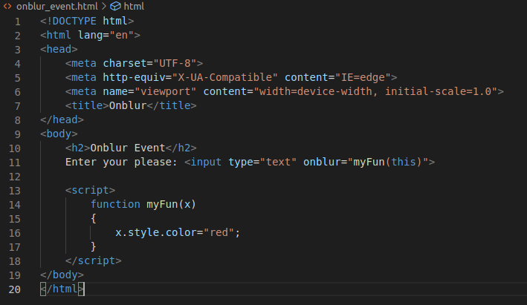

output:-

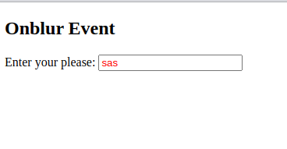

6- onsubmit Event

code:-

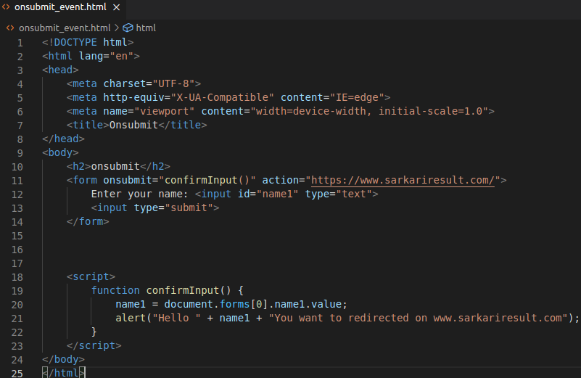

output:

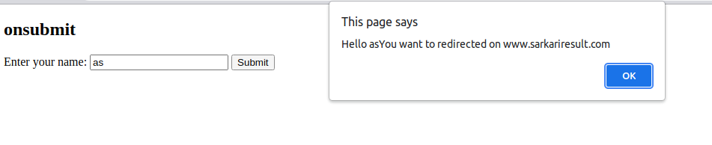

7- Onselect Event

It works , when input text selected.

Code:-

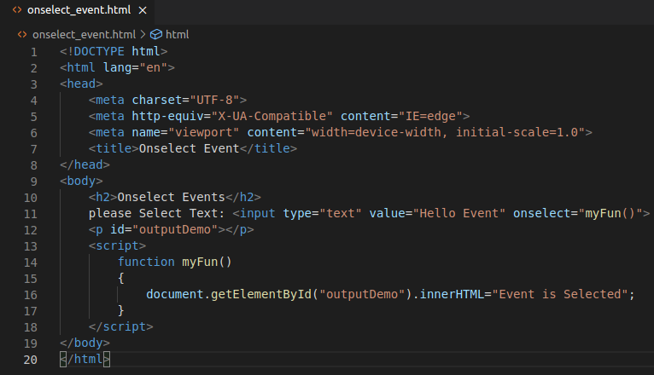

output:

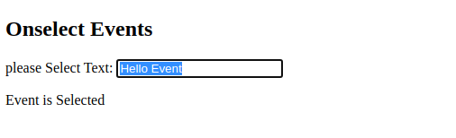

8- Onkeypress Event

When a user pressing / holding down a key.

Code:

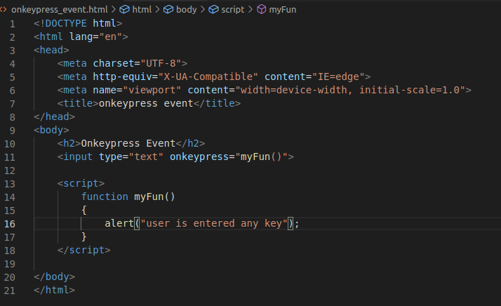

output:

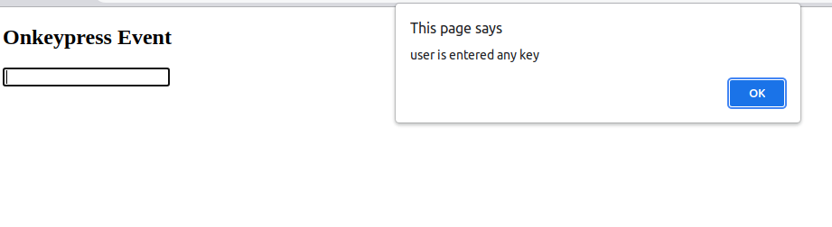

9- Onclick Event

When button is click , trigger function.

Code:

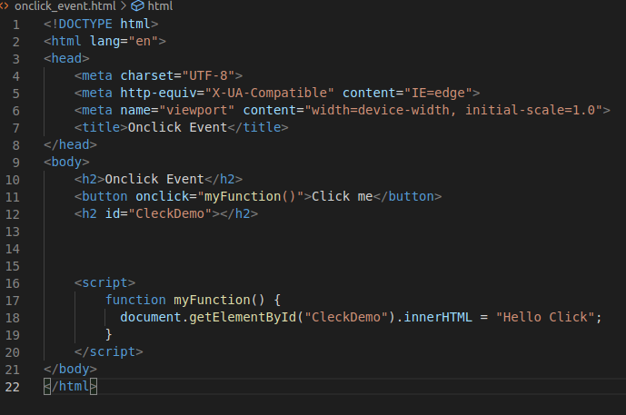

Output:

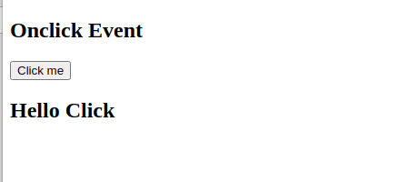

10- Ondblclick event

When we click to times , function trigger.

Code:

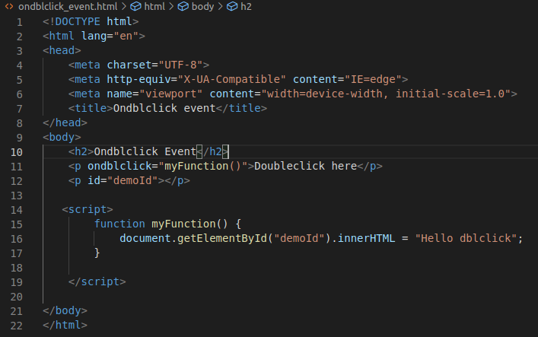

output:

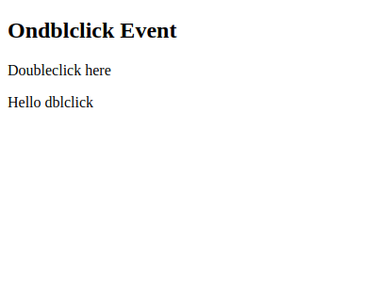

11- Onload Event

When the page has been loaded.

code:

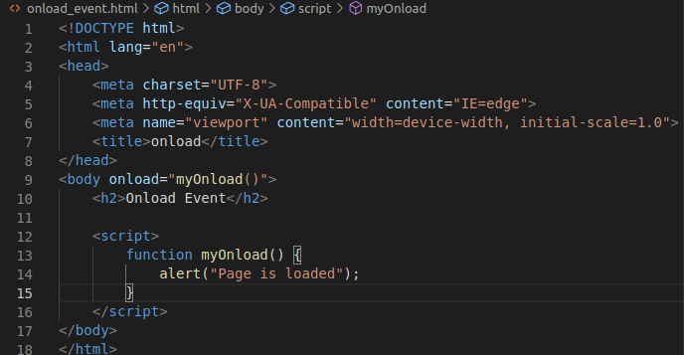

output:

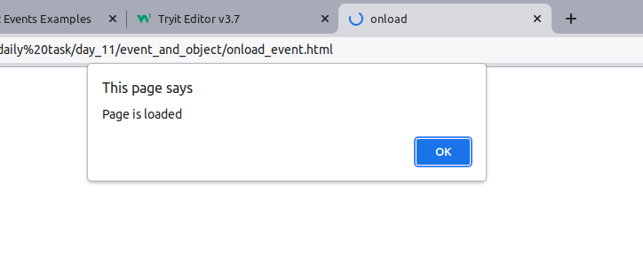

String & Array Methods in JS with Example

toString():-toString() returns the content of a string.

SubString():-substring() extracts a part of a string.

Replace():-replace() searches a string for a value,and returns a new string with the specified value(s) replaced.

CharAt():-charAt() returns the character at a specified position in a string.

Concat():-The concat() method joins two or more strings.

IndexOf():-indexOf() returns the position of the first occurrence of a value in a string.

Slice():-slice() extracts a part of a string and returns the extracted part.

Trim():-trim() removes whitespace from both sides of a string.

Includes():-includes() returns true if a string contains a specified string.

Pop():-The pop() method returns the value that was "popped out".

Push():-The push() method appends a new element to an array.

Reverse():-The Array.reverse() method reverses the order of the elements in an array.

Map():-The Array.map() method creates a new array from the results of calling a function for every element.

Sort():-The Array.sort() method sorts the elements of an array.

Filter():-The filter() method creates a new array filled with elements that pass a test provided by a function.

String Methods Code:

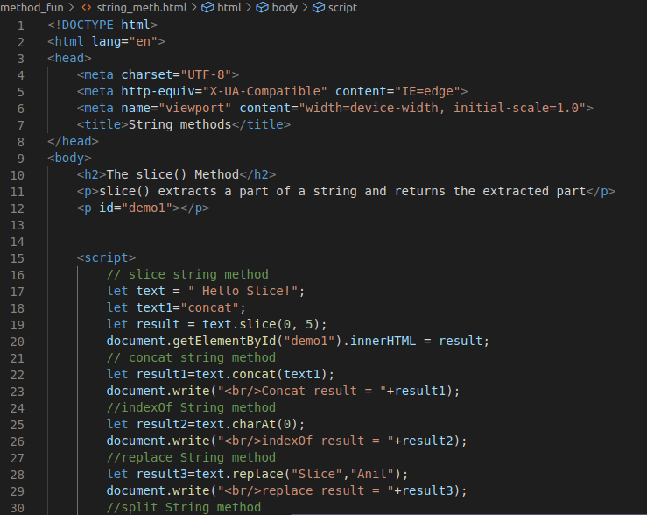
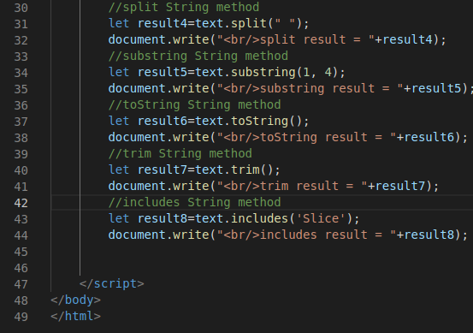

Output:-

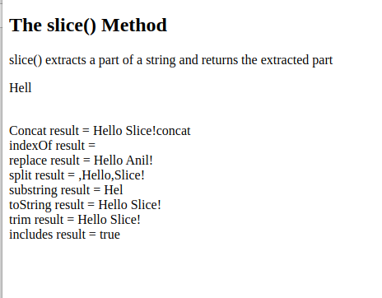

Array Methods Code:

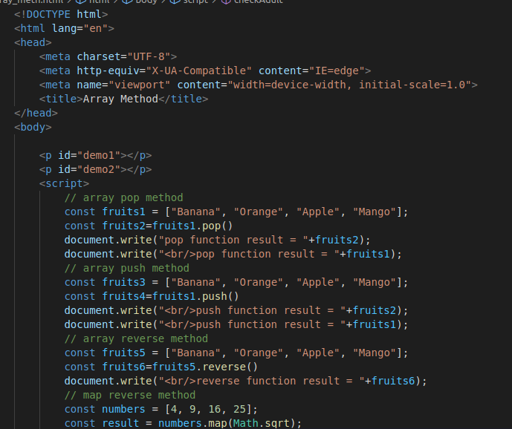
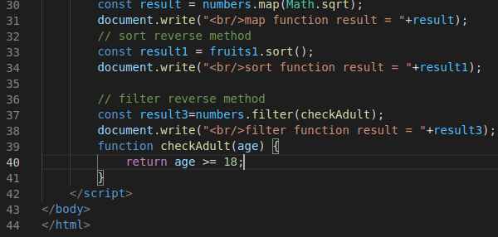

output:-

