CSS CONTENT

CSS Selectors

CSS selectors are used to "find" (or select) the HTML elements you want to style.
We can divide CSS selectors into five categories:

- Simple selectors

- Combinator selectors

- Pseudo-class selectors

- Pseudo-elements selectors

- Attribute selectors

1 - Simple selectors

Simple Selectors select elements based on name, id, class.
code

<!DOCTYPE html>
<html>
<head>
<style>
#a1 {
text-align: center;
color: red;
}
.a2 {
text-align: center;
color: green;
}
</style>
</head>
<body>

<p id="a1">id selecter</p>
<p class="a2">class selecter</p>

</body>
</html>

output

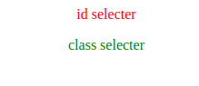

2 - Combinator selectors

Combinator selectors select elements based on a specific relationship between them.
There are four different combinators in CSS:
- descendant selector (space)
- child selector (>)
- adjacent sibling selector (+)
- general sibling selector (~)

Code

a) Descendant Selector & Adjacent Sibling Selector :-

<html>
<head>
<style>
div p {
background-color: yellow;
}
div + p {
background-color: yellow;
}
</style>
</head>
<body>

<h2>Descendant Selector</h2>

<p>The descendant selector</p>

<div>
<p>Paragraph 2 in the div.</p>
<section><p>Paragraph 3 in the div.</p></section>
</div>

<h2>Adjacent Sibling Selector</h2>

<p>The + selector</p>
<p>hiii</p>

<div>
<p>Paragraph 1 in the div.</p>
</div>

<p>Paragraph 3. After a div.</p>
<p>Paragraph 4. After a div.</p>

</body>
</html>

output

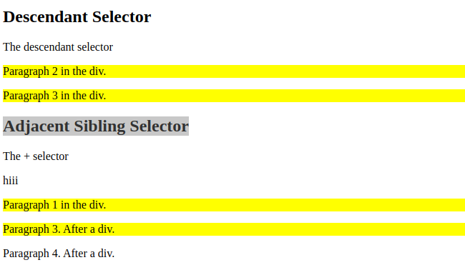

b) Child Selector

code

<html>
<head>
<style>
div > p {
background-color: yellow;
}
</style>
</head>
<body>

<h2>Child Selector</h2>

<p>The child selector (>) selects all elements that are the children of a specified element.</p>

<div>
<p>Paragraph 1 in the div.</p>
<p>Paragraph 2 in the div.</p>
<section>
<p>Paragraph 3 .</p>
</section>

</div>

<p>Paragraph 5. Not in a div.</p>

</body>
</html>

output
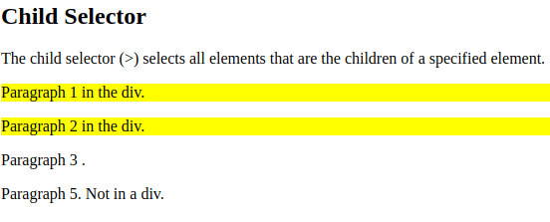
c) General Sibling Selector

code :-

<html>
<head>
<style>
div ~ p {
background-color: yellow;
}
</style>
</head>
<body>

<h2>General Sibling Selector</h2>

<p>Paragraph 1.</p>

<div>
<p>Paragraph 2.</p>
</div>

<p>Paragraph 3.</p>

</body>
</html>

output :

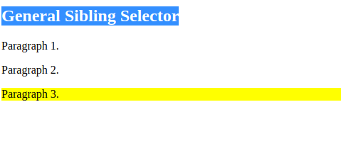

3-Pseudo-class selectors

A pseudo-class is used to define a special state of an element.

<html>
<head>
<style>
a:link {
color: red;
}
a:hover {
color: hotpink;
}

</style>
</head>
<body>

<h2>Styling a link depending on state</h2>

<p><b><a href="default.asp" target="_blank">This is a link</a></b></p>

</body>
</html>

output :-

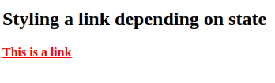

4) Pseudo-Elements

A CSS pseudo-element is used to style specified parts of an element.

Code:-

<html>
<head>
<style>
p::first-line {
color: #ff0000;
}
</style>
</head>
<body>

<p>You can use the ::first-line pseudo-element to add a special effect to the first line of a text. Some more text. And even more, and more, and more, and more, and more, and more, and more, and more, and more, and more, and more, and more.</p>

</body>
</html>

output:-

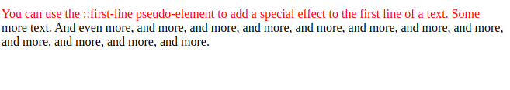

5) Attribute Selector

It is possible to style HTML elements that have specific attributes or attribute values.

Code:-
<html>
<head>
<style>
a[target] {
background-color: yellow;
}
</style>
</head>
<body>
<h2>attribute Selector</h2>
<p> background </p>
<a href="http://https://www.w3schools.com/" target="_blank">disney.com</a>

</body>
</html>
output:-

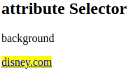

Pseudo-Class

Pseudo-Class:- A pseudo-class is used to define a special state of an element. There are some important pseudo classes.
1. :first-child:- The :first-child pseudo-class matches a specified element that is the first child of another element.

Syntax= :first-child { css_declarations; }

2. :last-child:- The:last-child selector matches every element that is the last child of its parent.
Syntax=:first-child { css_declarations; }

3. :nth-child(n):- The :nth-child(n) selector matches every element that is the nth child, regardless of type, of its parent.

Syntax=:nth-child(number) {css_declarations; }

4. :nth-last-child(n):- The :nth-last-child(n) selector matches every element that is the nth child, regardless of type, of its parent, counting from the last child.
Syntax=:nth-last-child(number) { css_declarations; }

5. :nth-of-type(n):- The :nth-of-type(n) selector matches every element that is the nth child, of a particular type, of its parent.

Syntax=:nth-of-type(number) { css_declarations; }

6. :nth-last-of-type(n):-The :nth-last-of-type(n) selector matches every element that is the nth child, of a particular type, of its parent, counting from the last child.
Syntax=:nth-last-of-type(number) { css_declarations; }

7. :only-child:- The :only-child selector matches every element that is the only child of its parent.

Syntax=:only-child { css_declarations; }

8. :only-of-type:- The :only-of-type selector matches every element that is the only child of its type, of its parent.

Syntax=:only-of-type { css_declarations; }

9. :first-of-type:- The :first-of-type selector matches every element that is the first child, of a particular type, of its parent.
Syntax=:first-of-type { css_declarations; }

10. :last-of-type:-The :last-of-type selector matches every element that is the last child, of a particular type, of its parent.

Syntax=:last-of-type {css_declarations; }

Attribute Selectors

Attribute Selectors:- The CSS Attribute Selector is used to select an element with some specific attribute or attribute value. It is an excellent way to style the HTML elements by grouping them based on some specific attributes and the attribute selector will select those elements with similar attributes.

1. A[attr]- Element With specific Attribute.

2. A[attr=val]:- Attribute whose value is 4exactly value.

3. A[attr^=val]:-Attribute begains with value.

4. A[attr|=val]:-Attribute begains with value OR is first in a dash separated list.

5. A[attr$=val]:-Attribute end with Value.

6. A[attr*=val]:- Value occurs anywhere in attribute.

7. A[attr~=val]:-Value matches attribute in space separated.

