Mysql task1

step-1

i)- create database eight_db
ii)- CREATE TABLE tweets (
id int NOT NULL AUTO_INCREMENT,
username varchar(15),
content varchar(140),
favourite int,
PRIMARY KEY (id)
);

step-2

i)- create table pastries (
id int not null AUTO_INCREMENT,
name varchar(50),
quantity int,
PRIMARY KEY(id)
);

ii)- select * from pastries
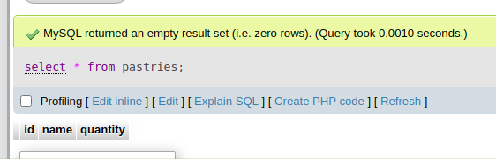
iii)- drop table pastries

step-3

i)- create table people(
id int NOT null AUTO_INCREMENT,
first_name varchar(20),
last_name varchar(20),
age int(2),
PRIMARY KEY(id)
);

ii)- insert into people(first_name,last_name,age) values('anil','yadav','21');
insert into people(first_name,last_name,age) values('Manish','Kumar','24');

iii)- insert into people(first_name,last_name,age) values('Juhi','yadav','18'),
('himanshu','Sharma','20'),('Gaurav','Madhyan','30');

iv)- drop table people

v)- SHOW TABLES FROM eight_db;
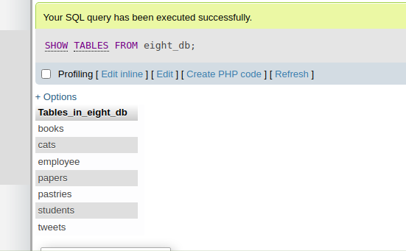
step-4

i)- CREATE TABLE employee (
id int NOT NULL AUTO_INCREMENT,
last_name varchar(15) NOT null,
first_name varchar(15) NOT null,
middle_name varchar(15),
age int(2) NOT null,
current_status varchar(20) NOT null DEFAULT 'employed',
PRIMARY KEY (id)
);

step-5

i)- Execute the below query :
CREATE TABLE cats (
cat_id INT NOT NULL AUTO_INCREMENT,
name VARCHAR(100),
breed VARCHAR(100),
age INT,
PRIMARY KEY (cat_id)
);

ii)- Now insert data into this table using below query :
INSERT INTO cats(name,breed,age) values('Ringo', 'Tabby', 4),('Cindy', 'Maine Coon', 10),
('Dumbledore', 'Maine Coon', 11),('Egg', 'Persian', 4),('Misty',
'Tabby', 13),('George Michael', 'Ragdoll', 9), ('Jackson', 'Sphynx',
7);

iii)- SELECT cat_id from cats;
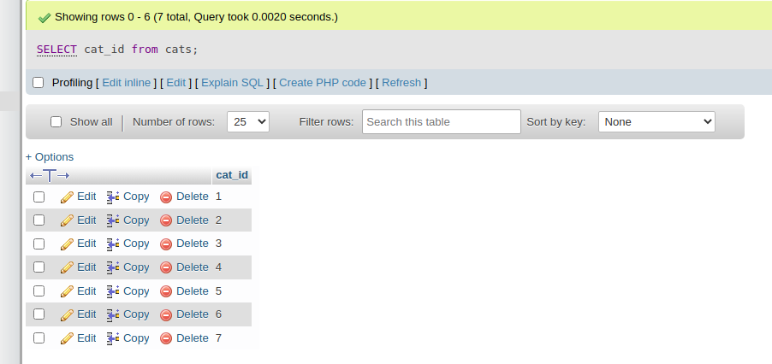
iv)- SELECT name,breed from cats;
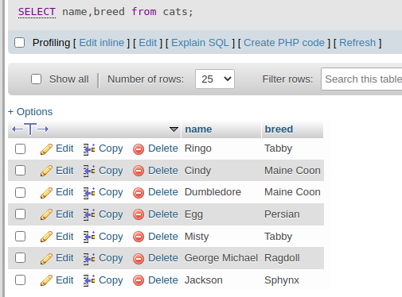

v) - SELECT name,age from cats where breed="Tabby";
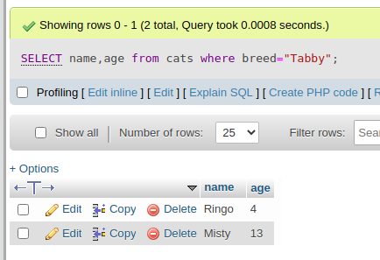

vi)- SELECT cat_id,age from cats where cat_id=age;
