Digital Demand vs. Career Opportunities:
An Analysis of Google Trends and LinkedIn Job Postings in IT Roles
Anıl Yolcu

1. Introduction & Motivation
Understanding the job market is important for both job seekers and employers. However, traditional labor market statistics are often published with delays and may not reflect current trends. Because of this, alternative and more real-time data sources can be useful for observing changes in the job market.
This project explores whether digital interest can provide meaningful signals about career opportunities. Google Trends data is used as a proxy for public interest in specific job roles, while LinkedIn job postings are used to represent actual job availability. By comparing these two sources, the project aims to investigate whether what people search for online aligns with what companies are offering.
The analysis focuses only on IT-related roles. IT jobs are closely connected to online platforms and digital tools, making them more suitable for a study based on search behavior and online job postings. The main motivation is to examine whether digital demand signals can help explain or anticipate job market patterns in the IT domain.

2. Data Sources
This project uses two main data sources to represent different sides of the job market: job supply and job demand.

2.1 LinkedIn Job Postings
LinkedIn job postings are used to represent the supply side of the job market. The dataset was obtained from Kaggle (“LinkedIn Job Postings”) and contains over 120,000 job postings, including features such as job_title, location, posted_date, and job_description. In this project, only the job_title information is used.
The dataset was downloaded directly from Kaggle as a CSV file. Due to GitHub file size limitations, the original raw dataset (postings.csv) is not included in the project repository. Instead, the repository provides instructions on how to download the file from Kaggle and place it in the same directory as the notebook before running the analysis.
During preprocessing, raw job titles from this dataset are later grouped into standardized IT role categories. The number of job postings in each role group is used as an indicator of job availability in the market.
The dataset is publicly available on Kaggle and can be accessed at:
https://www.kaggle.com/datasets/arshkon/linkedin-job-postings

2.2 Google Trends
Google Trends data is used to represent the demand side, measured as public interest in specific IT job roles. For each IT role group, relevant search keywords were defined and used to collect Google Trends data.
The data covers the period between January 2023 and April 2024. Google Trends provides normalized interest values rather than absolute search counts, so the results reflect relative interest levels instead of exact numbers. For each role group, search interest values over time are aggregated into a single measure called search_volume.

3. Data Preprocessing and Feature Construction
The raw data obtained from LinkedIn and Google Trends is not directly suitable for analysis, so several preprocessing steps were applied.
First, job titles from the LinkedIn dataset were cleaned by converting all text to lowercase and removing unnecessary symbols and variations. Since many job titles refer to the same role using different wording, a keyword-based mapping was used to group raw titles into approximately 20 standardized IT role groups (for example, different variations of “data scientist” were mapped to a single group). The initial mapping rules were drafted with the help of an LLM and then manually reviewed and adjusted to ensure consistency. Job titles that could not be clearly associated with an IT role were removed from the analysis.
After grouping, the number of job postings in each IT role group was counted. This value is referred to as job_count and is used as a measure of job availability.
For the same IT role groups, Google Trends data was collected using consistent search terms. The data covers the period from January 2023 to April 2024. Since Google Trends provides normalized interest values over time, the interest scores for each role were aggregated to obtain a single value called search_volume.
Finally, the LinkedIn and Google Trends datasets were merged using the IT role group name as a common key. The resulting dataset contains one row per IT role group, with job_count representing job supply and search_volume representing digital interest.

4. Exploratory Data Analysis (EDA)
Exploratory data analysis was used to better understand the structure of the data and to compare job supply and digital interest across different IT roles.
First, the distribution of LinkedIn job postings across IT role groups was visualized.
Figure 2 shows that job postings are not evenly distributed across roles. Some roles, such as software-related positions, dominate the job market, while others appear much less frequently. This indicates a clear imbalance in job availability across IT roles.
Next, Google Trends search interest was examined.
Figure 1 presents the aggregated search interest for each IT role group. The distribution of search interest also varies across roles, and the ordering of roles differs from the job posting distribution. This suggests that high public interest in a role does not always correspond to a high number of job postings.
Overall, the EDA highlights noticeable differences between job supply and digital interest. These initial observations motivate a deeper analysis of the relationship between the two variables in the following sections.

Figure1: Aggregated Google Trends search interest by IT role group.
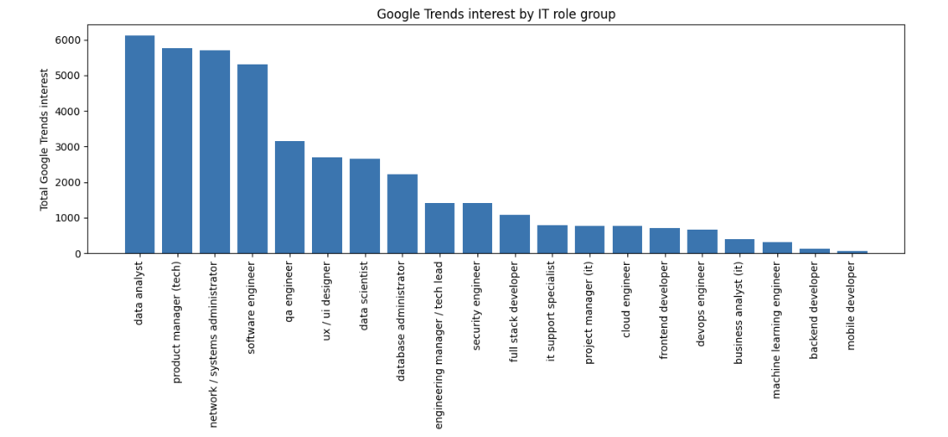
Figure2: Number of LinkedIn job postings by IT role group.
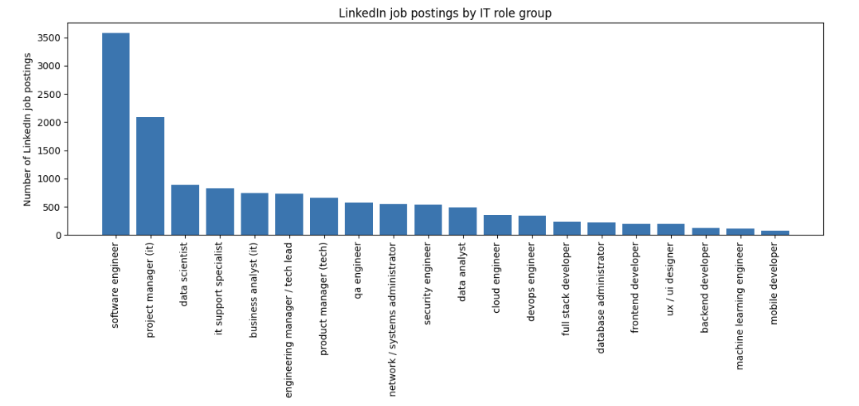

5. Relationship Between Digital Interest and Job Market Supply
After examining job supply and digital interest separately, the next step is to directly compare these two measures across IT roles.
To do this, both LinkedIn job postings and Google Trends search interest were converted into rankings.
Each IT role group was ranked based on its number of job postings and its level of search interest.
Figure 3 shows a scatter plot comparing LinkedIn ranks with Google Trends ranks for each role.
Using ranks instead of raw values helps reduce the impact of extreme values and large differences between roles. The plot suggests a general positive relationship: roles that rank higher in job postings also tend to rank higher in search interest. However, the points do not lie perfectly on the diagonal, indicating that this relationship is not exact and varies across roles.
In addition, the distribution of job counts was examined to better understand the data structure.
Figure 4 compares the raw job count distribution with its log-transformed version. The raw distribution is highly skewed, while the log-transformed distribution is more balanced. This observation supports the use of rank-based and non-parametric methods in later analysis.
Overall, this section provides visual evidence that digital interest and job market supply are related, while also highlighting the limitations of assuming a simple linear relationship.

Figure3: Rank comparison between LinkedIn job postings and Google Trends interest.
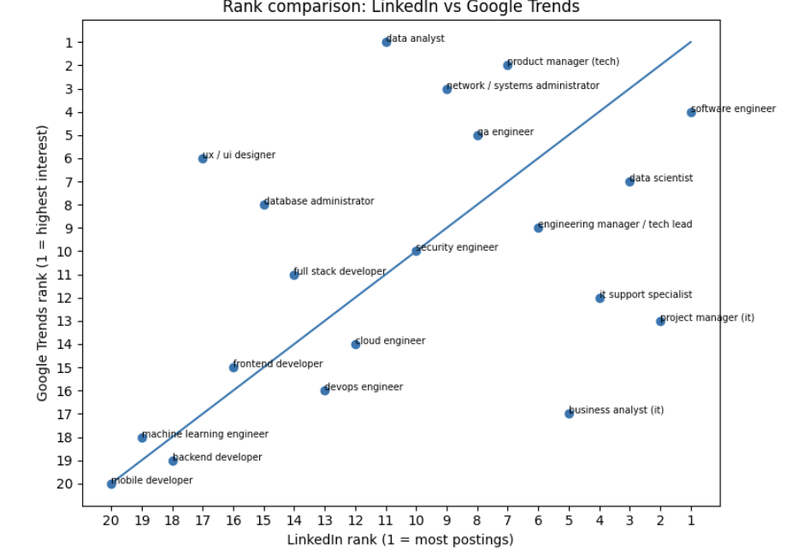

Figure4: Distribution of LinkedIn job posting counts across IT role groups, shown for both raw values and log-transformed values.

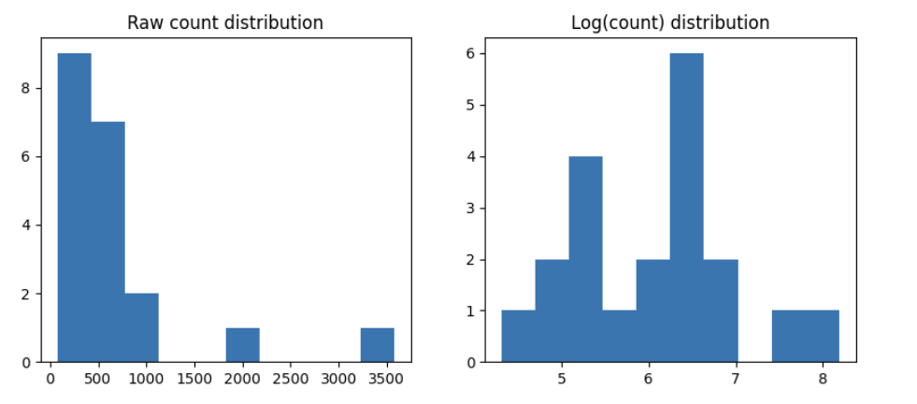

6. Hypothesis Testing
Based on the exploratory analysis, a formal hypothesis test was conducted to examine the relationship between digital interest and job market supply.
The null hypothesis (H₀) states that there is no relationship between Google Trends search interest and the number of LinkedIn job postings across IT role groups. The alternative hypothesis (H₁) states that a statistically significant relationship exists between the two.
Because the data is not normally distributed and the analysis is based on rankings rather than raw values, Spearman rank correlation was selected. This method does not assume normality and is more suitable for small datasets with skewed distributions.
The Spearman correlation results indicate a positive and statistically significant relationship between Google Trends interest and LinkedIn job postings. This means that IT roles with higher search interest tend to have higher job posting ranks, although the relationship is not perfect.
These results support the alternative hypothesis and suggest that digital search interest is meaningfully related to job market supply. However, the strength of the relationship also indicates that search interest alone cannot fully explain job availability.

7. From Statistical Relationship to Machine Learning
The hypothesis testing results show that there is a statistically significant relationship between Google Trends interest and LinkedIn job postings. However, correlation alone does not indicate whether this relationship can be used in practice.
For this reason, the analysis moves from a purely statistical perspective to a simple machine learning approach. The goal is no longer to measure the strength of the relationship, but to test whether digital interest can help distinguish between different types of IT roles.
Instead of predicting exact job posting counts, the problem is reformulated to answer a simpler question:
whether an IT role belongs to a high-interest or low-interest category. This shift makes the problem more suitable for the limited size and structure of the dataset.
This transition allows the project to explore the practical usefulness of digital interest signals, while avoiding overly complex models that would not be reliable given the available data.

8. Machine Learning Methodology
8.1 Problem Reformulation
To apply machine learning, the problem was reformulated as a binary classification task.
Each IT role group was labeled as either High Interest or Low Interest based on its Google Trends search volume. Roles above a chosen threshold were labeled as high interest, while the remaining roles were labeled as low interest.
This approach simplifies the prediction task and makes the results easier to interpret. Given the small number of IT role groups, predicting exact values would not be reliable, whereas a binary distinction provides a more stable and meaningful outcome.

8.2 Model Choice
A simple and interpretable classification model was used. The focus was not on achieving high performance, but on understanding whether digital interest contains any predictive signal. More complex models were intentionally avoided, as they would likely overfit the limited data and reduce interpretability.

8.3 Evaluation Strategy
Because the dataset contains a small number of observations, Leave-One-Out Cross-Validation (LOOCV) was used for evaluation. This method allows each IT role group to be tested individually while training the model on all remaining roles.
LOOCV provides a more reliable performance estimate in small datasets, even though it can be computationally expensive. In this case, the dataset size is small enough for LOOCV to be practical.

9. Machine Learning Results
The performance of the classification model was evaluated using Leave-One-Out Cross-Validation.
Figure 5 presents the confusion matrix of the model. The results show that the model is able to correctly classify some IT role groups into high and low interest categories. However, there are also several misclassifications, indicating that the model’s performance is limited.
To better understand the model’s behavior, predicted probabilities were analyzed.
Figure 6 shows the distribution of predicted probabilities for high- and low-interest roles. The overlap between the two distributions suggests that the model is often uncertain, especially for roles that lie near the decision boundary.
Overall, the results indicate that while digital interest contains some useful information, it is not sufficient on its own to reliably classify all IT roles. The model demonstrates partial predictive ability, but its performance remains constrained by the simplicity of the features and the small size of the dataset.

Figure5: Confusion matrix showing the classification performance of the binary model evaluated using Leave-One-Out Cross-Validation.
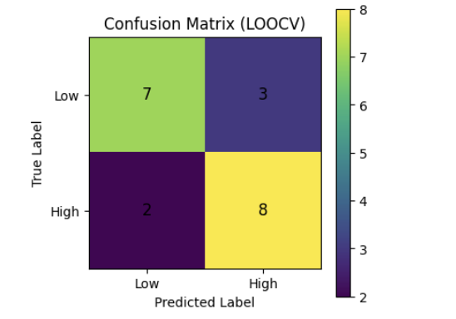
Figure6: Distribution of predicted probabilities for high-interest and low-interest IT roles produced by the classification model.

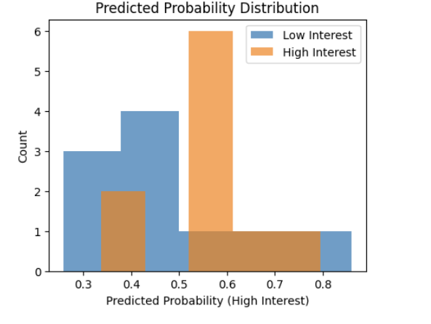

10. Discussion of Results
The results of this study suggest that digital interest, measured using Google Trends, is related to job market supply in the IT domain, but the relationship is not strong enough to fully explain job availability.
The statistical analysis shows a meaningful association between search interest and job postings, which indicates that online search behavior can reflect real-world job market trends to some extent. However, the machine learning results demonstrate that this relationship is imperfect and varies across different IT roles.
Some roles receive high search interest but have relatively fewer job postings, while others show the opposite pattern. This highlights the fact that factors such as industry demand, skill requirements, and hiring practices also play an important role and are not captured by search data alone.
Overall, the findings support the idea that Google Trends can provide useful but limited signals about the job market. Digital interest should be viewed as a complementary indicator rather than a standalone predictor of career opportunities.

11. Limitations
This project has several important limitations that affect both the analysis and the model performance.
First, the dataset is small. The analysis is conducted on a limited number of IT role groups, which restricts the complexity of both statistical tests and machine learning models. This makes it difficult to achieve strong predictive performance.
Second, the definition of IT role groups is partly subjective. Although job titles were carefully mapped using keyword rules and manual review, some roles may still overlap or be imperfectly categorized.
Third, Google Trends data is normalized and does not represent absolute search volumes. As a result, search interest values reflect relative popularity rather than exact demand levels. This limits how precisely digital interest can be compared with job posting counts.
In addition, LinkedIn job postings represent only one platform and may not fully capture the entire job market. Some roles may be underrepresented or overrepresented depending on company hiring practices.
Finally, the binary labeling used in the machine learning stage simplifies a complex reality. While this approach improves stability, it also removes finer distinctions between roles and contributes to classification errors.

12. Future Work
There are several ways this project could be extended in the future.
First, the analysis could be improved by including additional job platforms such as Indeed or Glassdoor. Using multiple sources would provide a more complete view of job market supply.
Second, a time-based analysis could be performed instead of aggregating data over a long period. This would allow changes in search interest and job postings to be studied over time and could help identify leading or lagging signals.
Third, the definition of IT role groups could be refined further. More detailed or hierarchical role categories may capture differences that are lost in the current grouping.
Finally, with a larger and richer dataset, more advanced machine learning models could be explored. This would allow a better evaluation of whether digital interest can meaningfully predict job market trends under less restrictive data conditions.

13. Conclusion
This project examined the relationship between digital interest and job market supply for IT roles using Google Trends and LinkedIn job postings data.
The results show that there is a meaningful but limited relationship between what people search for online and the availability of jobs in the market. While statistical analysis indicates a positive association, the machine learning results demonstrate that digital interest alone is not sufficient for strong or reliable prediction.
Overall, the findings suggest that Google Trends can provide useful signals about job market dynamics, but these signals should be interpreted with caution. Digital interest works best as a supporting indicator rather than a standalone measure. This study highlights both the potential and the limitations of using digital data sources to understand real-world labor markets.

Use of AI Tools
AI-based tools were used during this project to assist with code drafting, debugging, and language refinement. All analytical decisions, data processing steps, model choices, and interpretations were made by the author. The outputs produced with AI assistance were reviewed, modified, and validated throughout the project.

