<https://msaine.s3.amazonaws.com/SDEV+153/CH12/store.html>

store.html

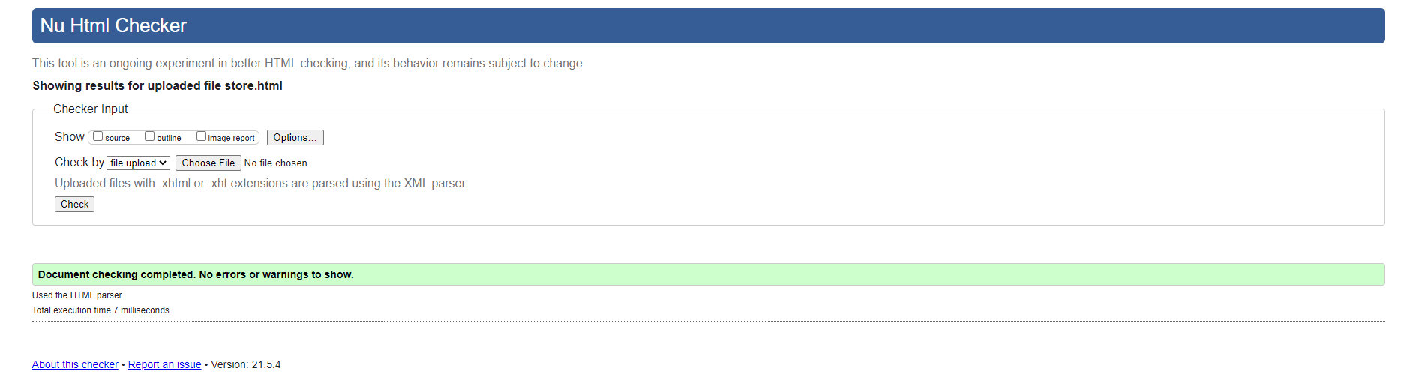

Yoga.css

