https://msaine.s3.amazonaws.com/SDEV+153/CH13/Yoga/index.html

index.html

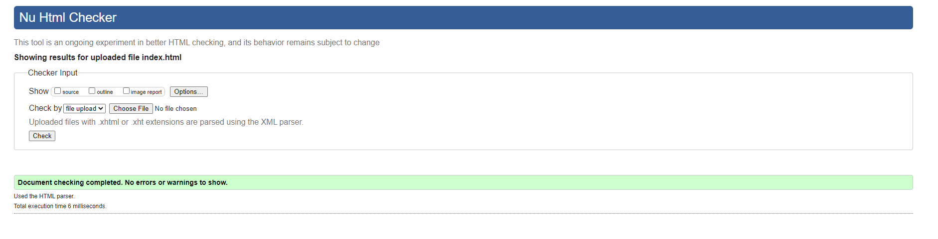

schedule.html

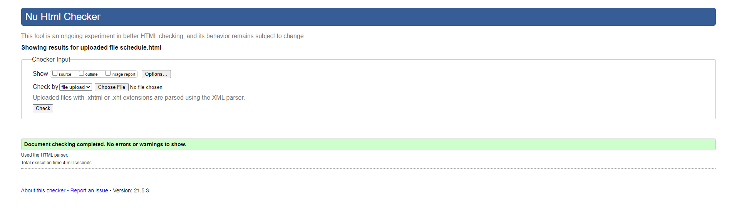

classes.html

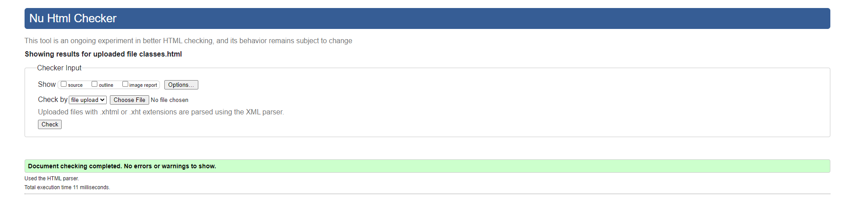

contact.html

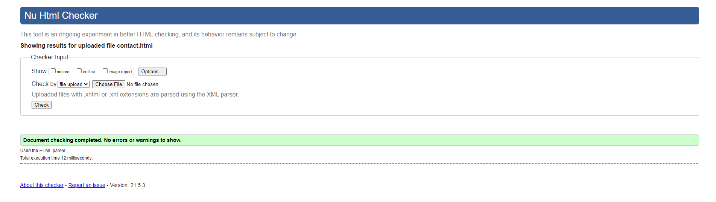

store.html

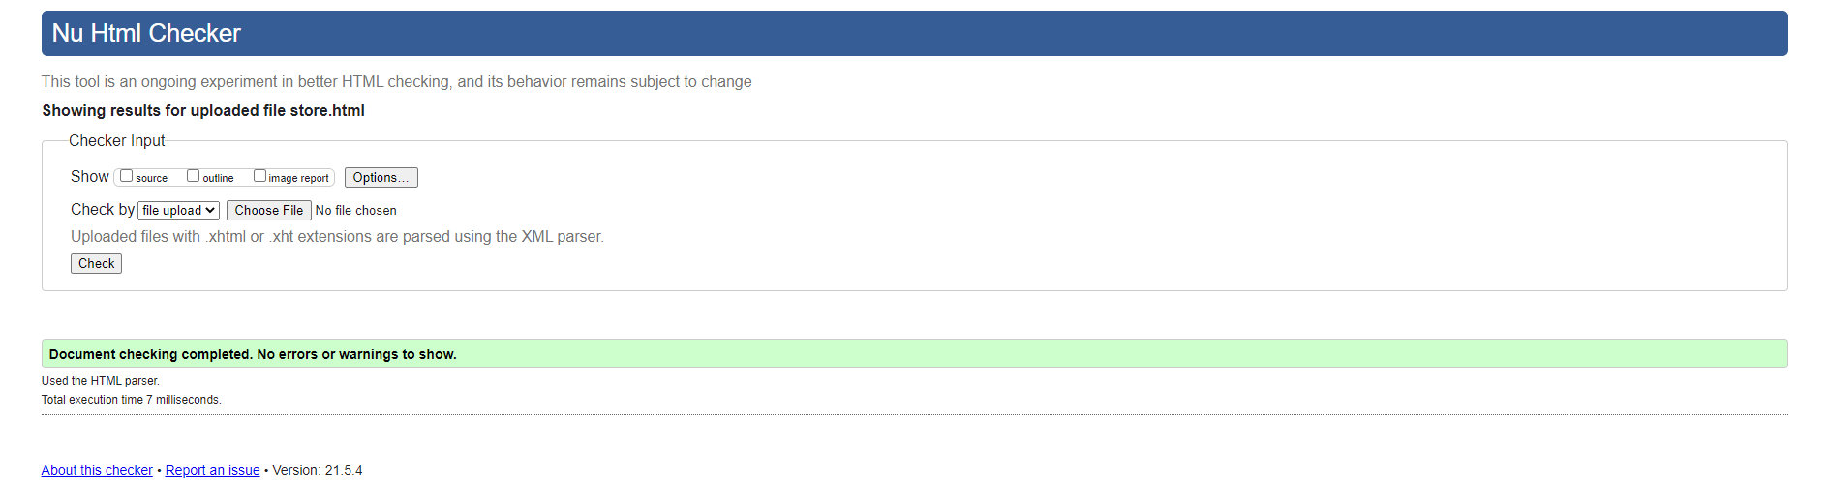

Yoga.css

