<https://msaine.s3.amazonaws.com/SDEV+153/CH2/Yoga/index.html>

<https://msaine.s3.amazonaws.com/SDEV+153/CH2/Yoga/classes.html>

NU HTML Checker – index.html

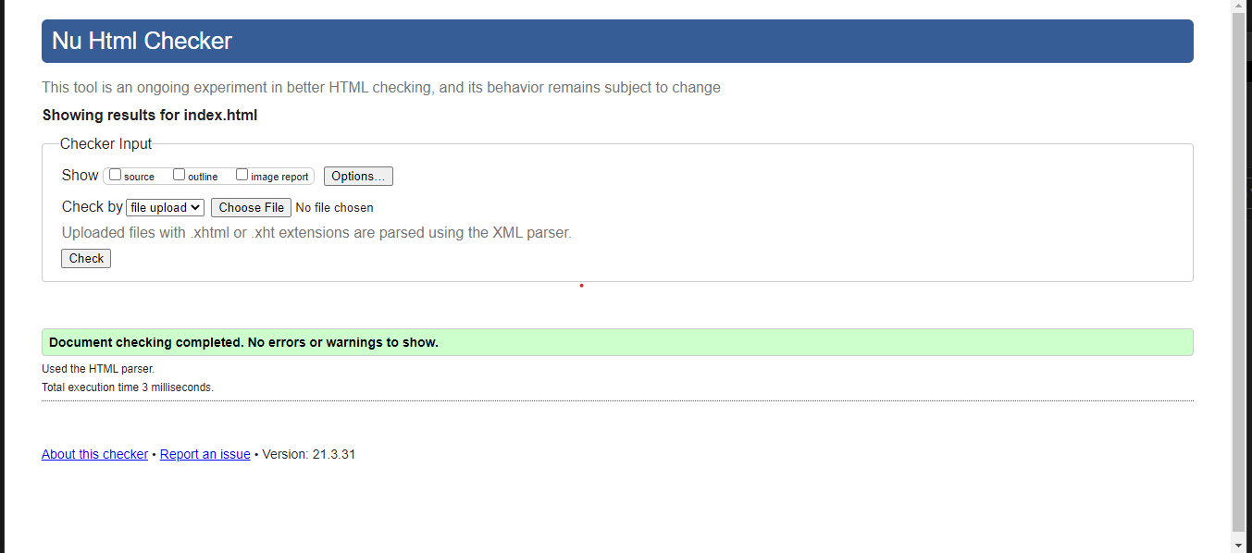

NU HTML Checker – classes.html

