<https://msaine.s3.amazonaws.com/SDEV+153/CH6/Yoga/index.html>

<https://msaine.s3.amazonaws.com/SDEV+153/CH6/Yoga/classes.html>

<https://msaine.s3.amazonaws.com/SDEV+153/CH6/Yoga/schedule.html>

NU HTML Checker – yoga.css

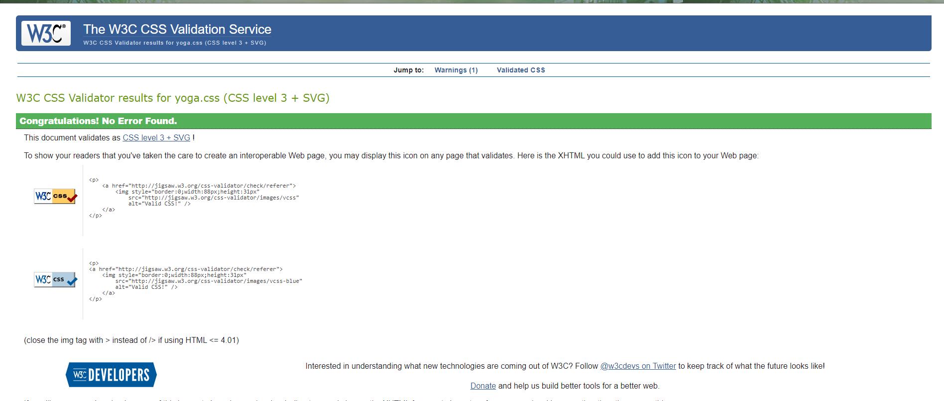

Revised Index.html

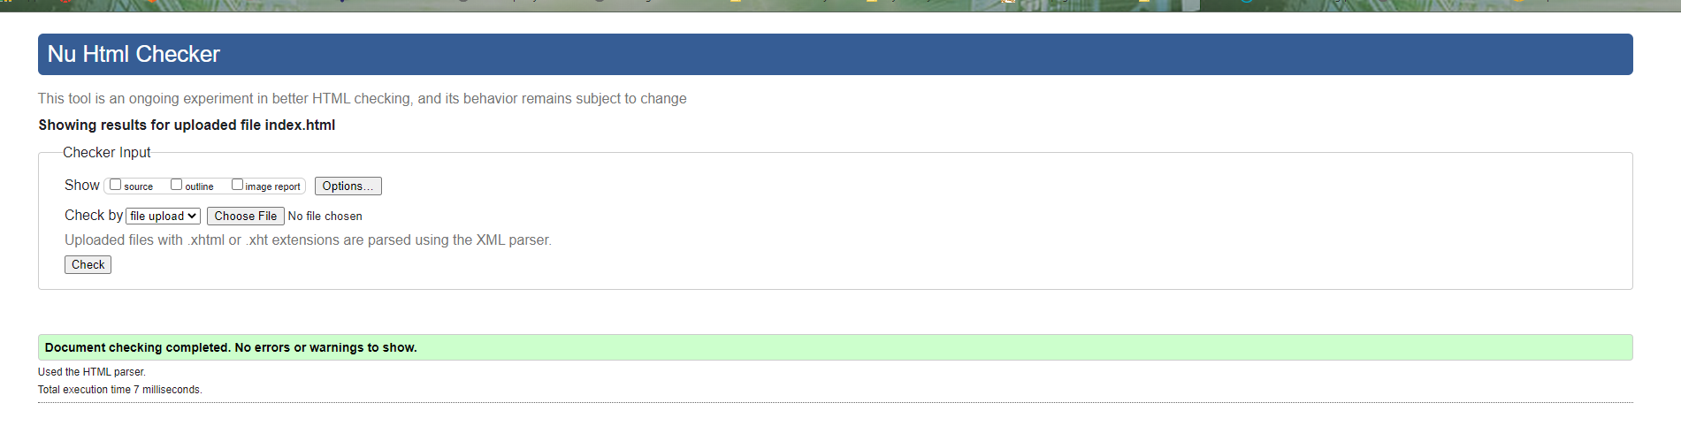

Revised classes.html

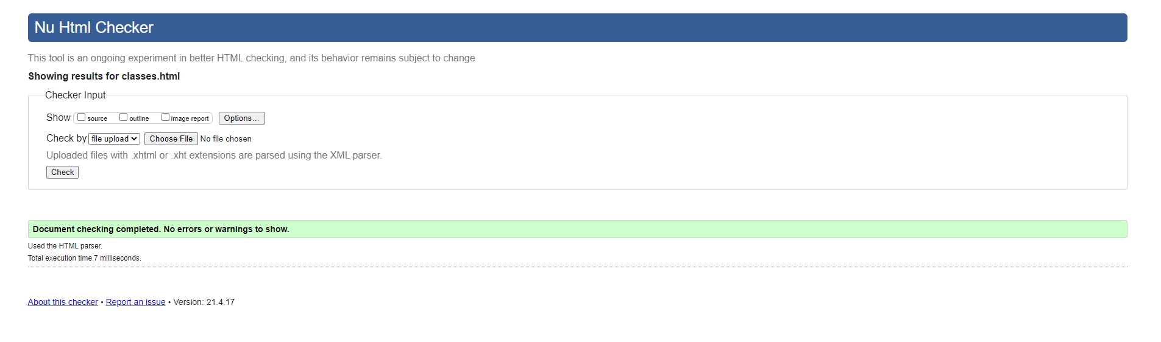

Revised Schedule

