<https://msaine.s3.amazonaws.com/SDEV+153/CH8/Yoga/schedule.html>

NU HTML Checker – yoga.css

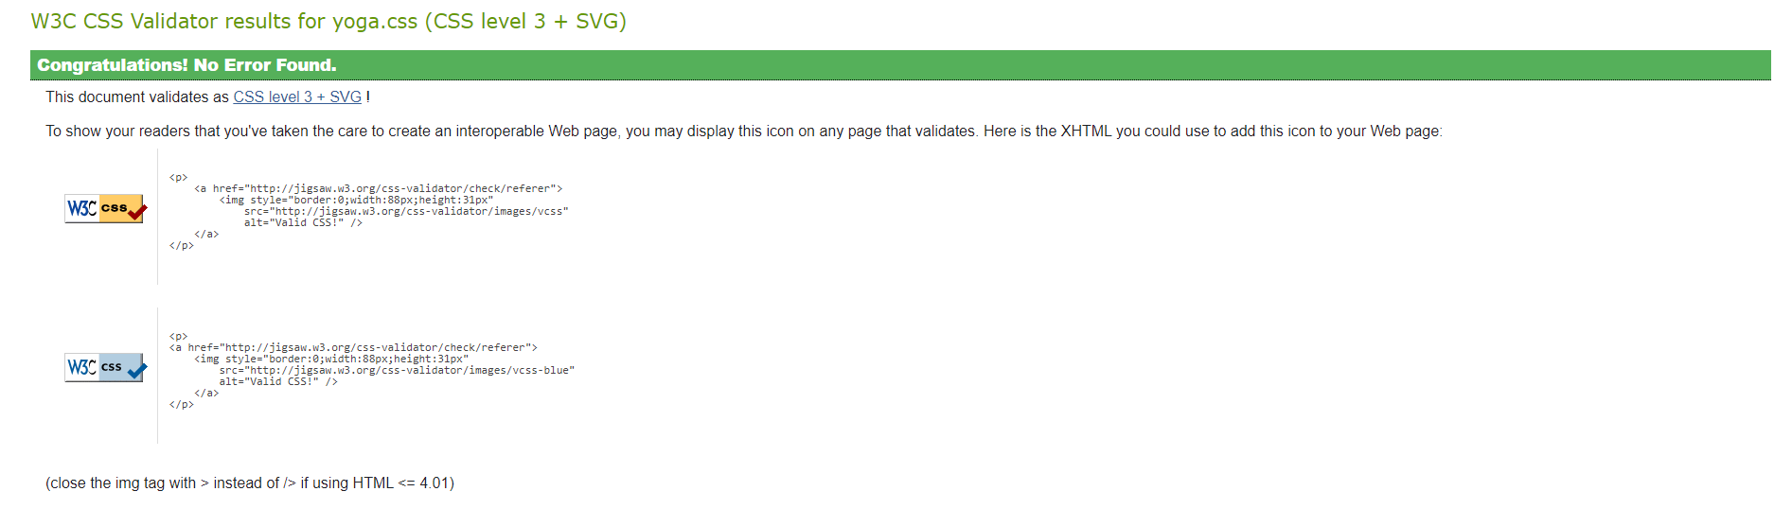

Revised Schedule

