https://msaine.s3.amazonaws.com/SDEV+153/CH9/index.html

https://msaine.s3.amazonaws.com/SDEV+153/CH9/contact.html

NU HTML Checker – yoga.css

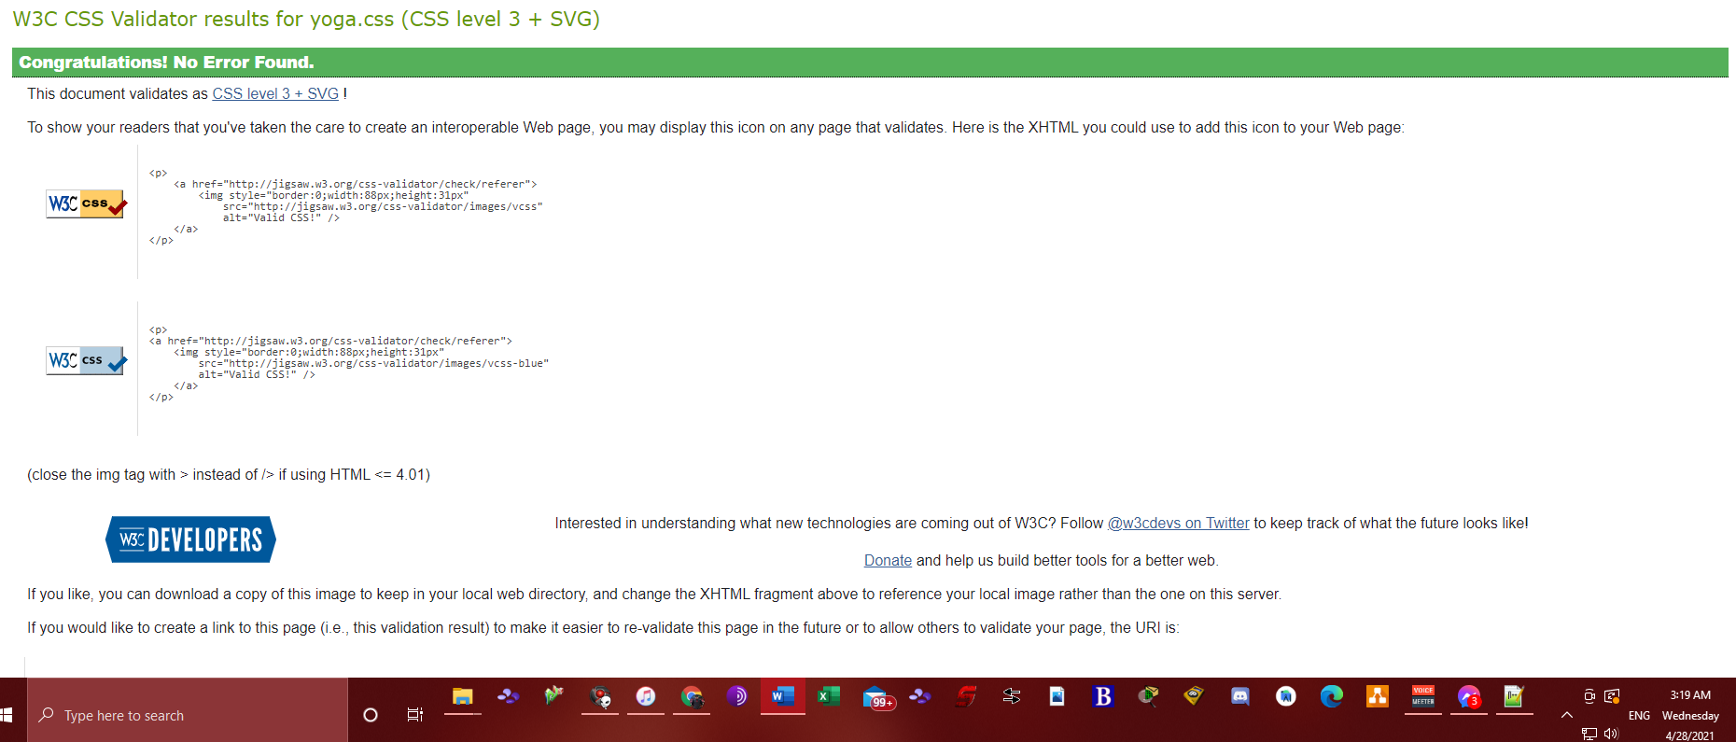

New Page contact.html

