https://msaine.s3.amazonaws.com/SDEV+153/FinalProject/index.htm

Index.htm

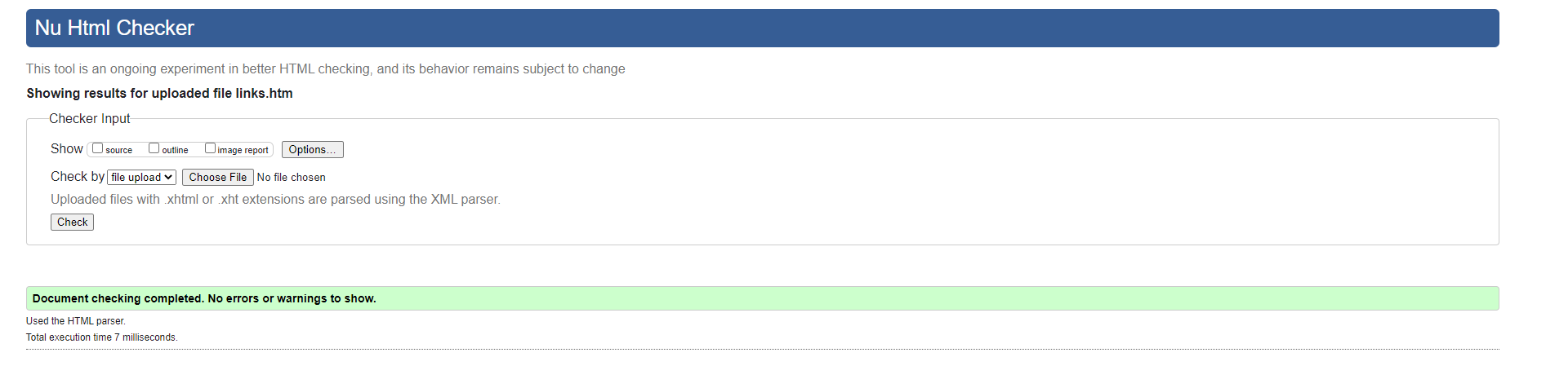

Aboutus.htm

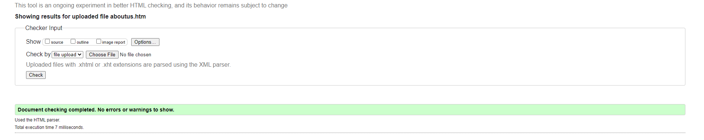

Contactus.htm

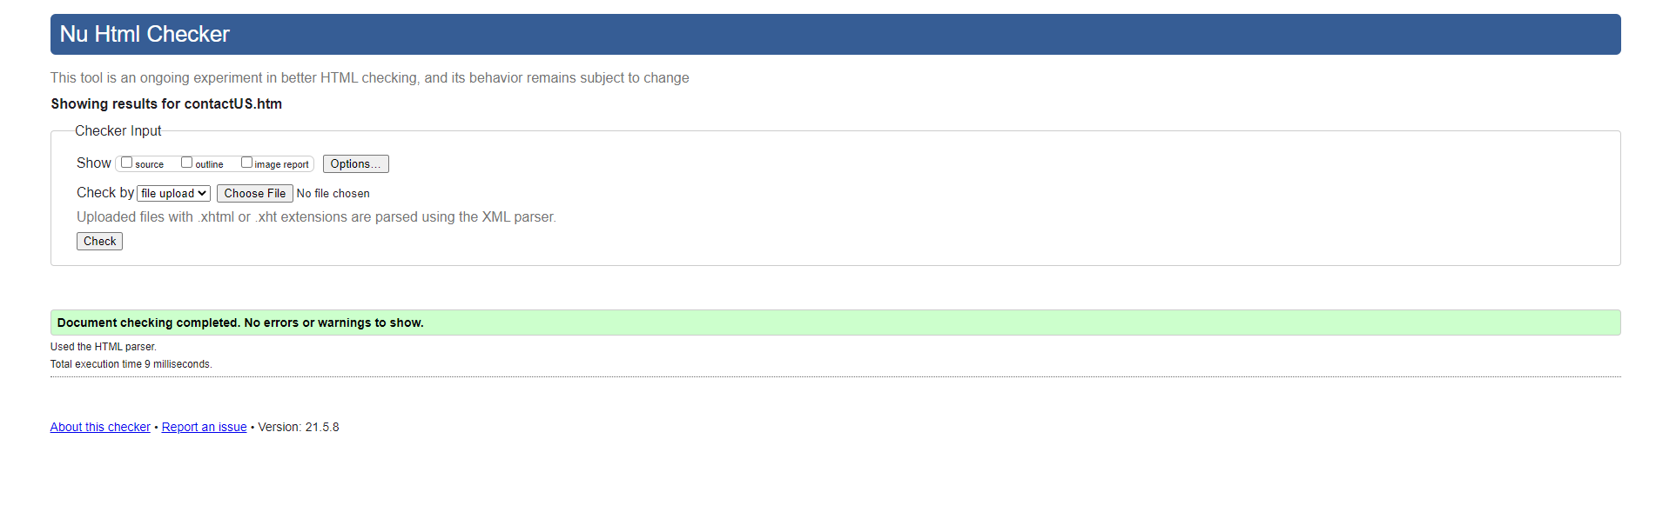

Getaquote.htm

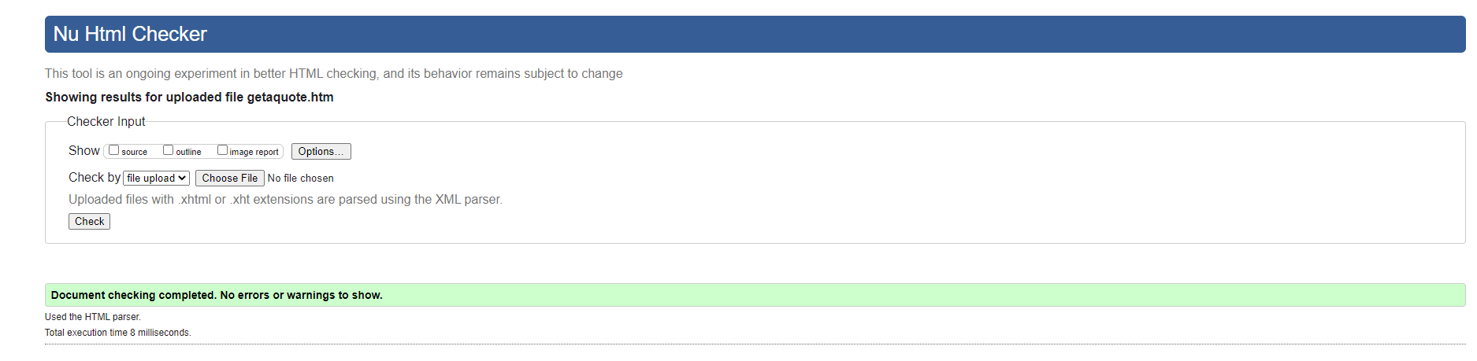

Links.htm

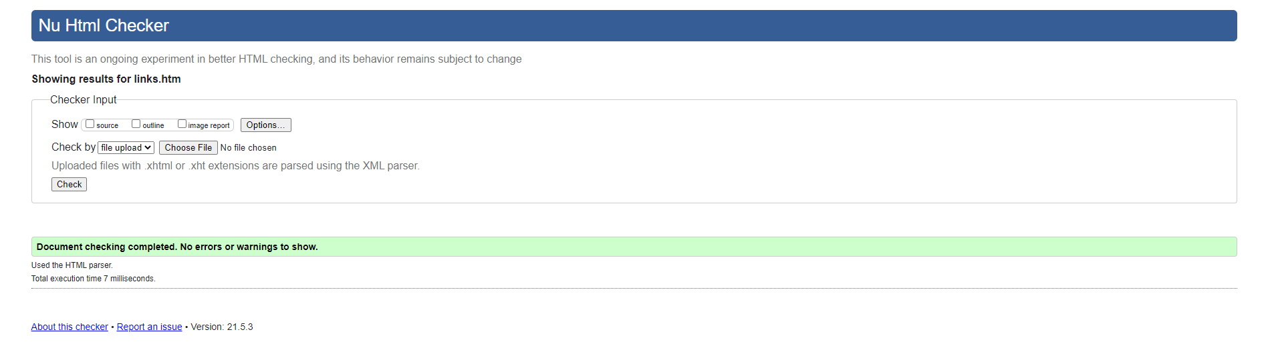

Style-sheet.csss

