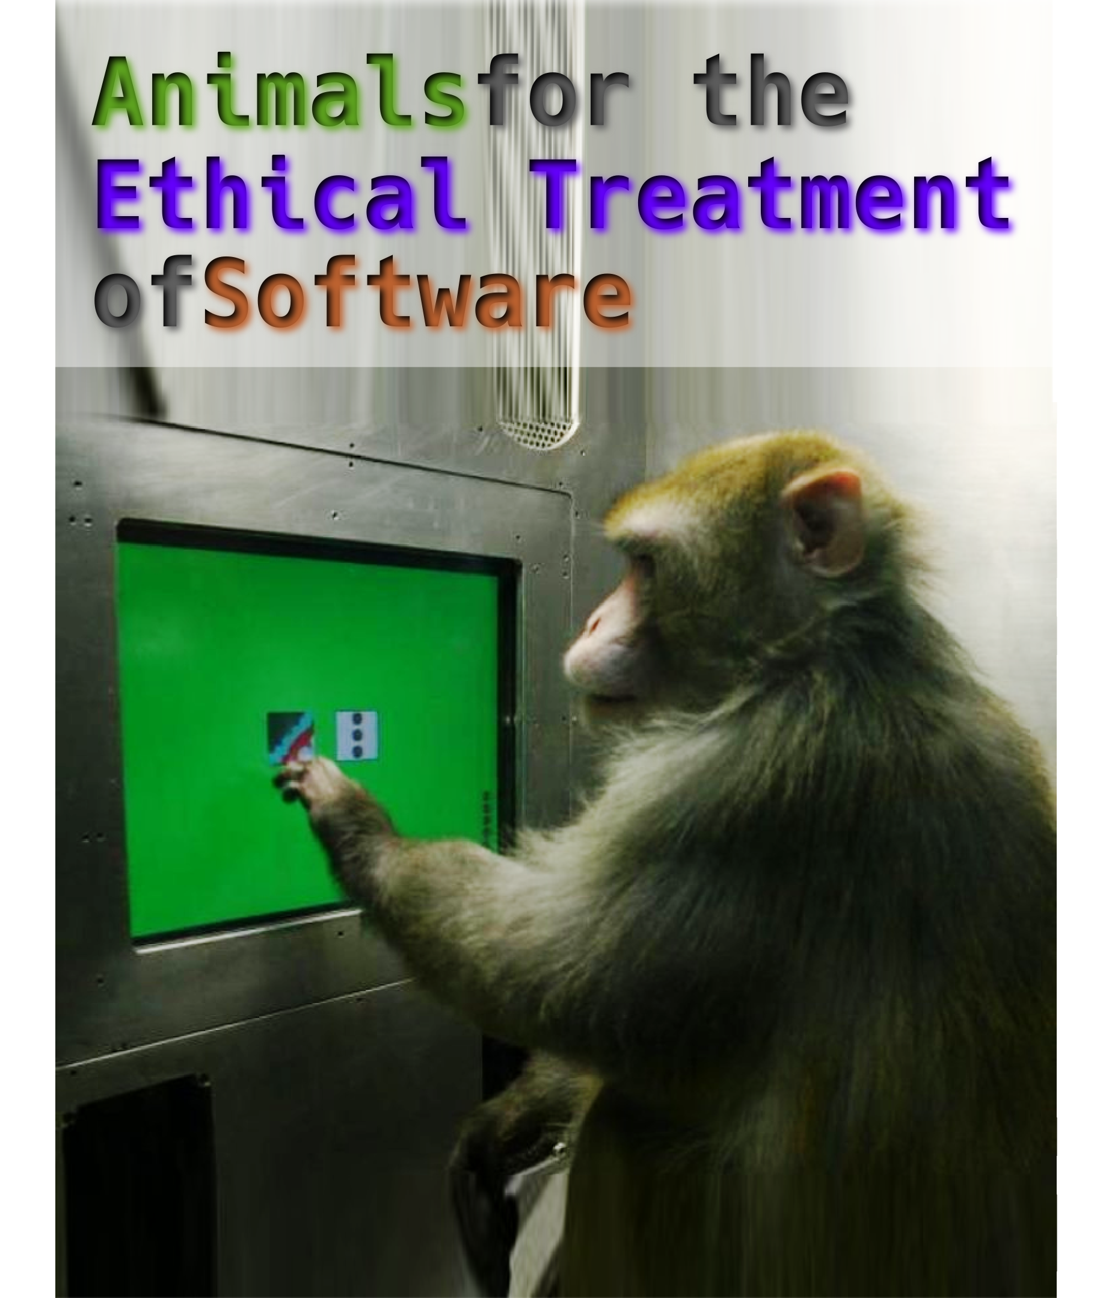
1
The Human Animal

2
The Freedom of Free Software

3
The Slavery of Propriety

4
Nature vs. Nurture in the Automatic General Intellect

5
The Illusion of Artificiality

6
DNA Language HOWTO

7
Errorism

