ANDROID APP DEVELOPMENT USING KOTLIN

MENTOR SELECTOR

PROJECT REPORT

12/18/2021



BY
- M.MANOJKUMAR III CSE A
- M.Joshua Dayalan III CSE A

OBJECTIVE:
The main objective of our project is to develop an app for choosing mentors for students based on their CGPA. This reduces the wastage of time of officials to sort the mentors for students.
PROJECT DESCRIPTION:
In our project we designed two types of logins
- Admin (HOD) login
- Staff Advisor login
ADMIN LOGIN:
Admin login consists of staff details and staff advisor for each class is selected by the admin.
STAFF ADVISOR LOGIN:
Staff advisor login includes the student details of the respective staff advisors.
PROCEDURE:
- The student’s detail like name, department, section, year, CGPA are given under staff advisor login.
- The staff advisor should select the gender of mentor in the login and the mentor chosen randomly.
- After choosing the mentor the staff advisor should click Generate button to match the randomly chosen mentor to a student according to their CGPA.

CODE:

MAIN ACTIVITY

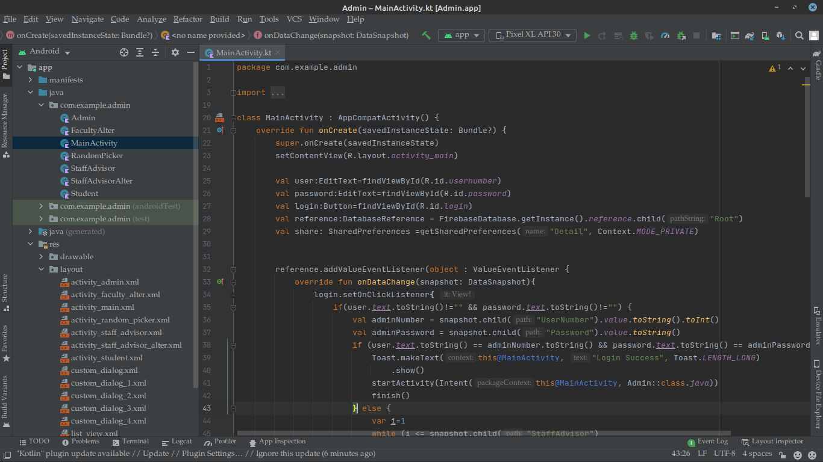

Staff Advisor Code:

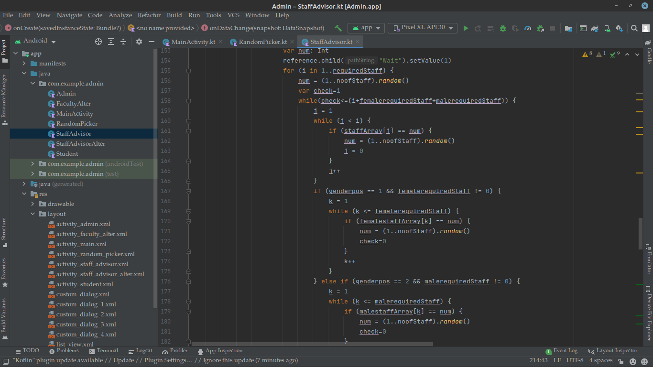

Random Picker Code:
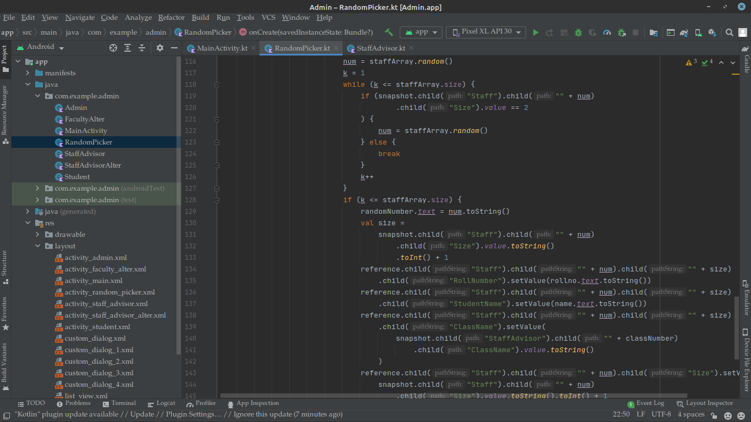
Firebase contents:
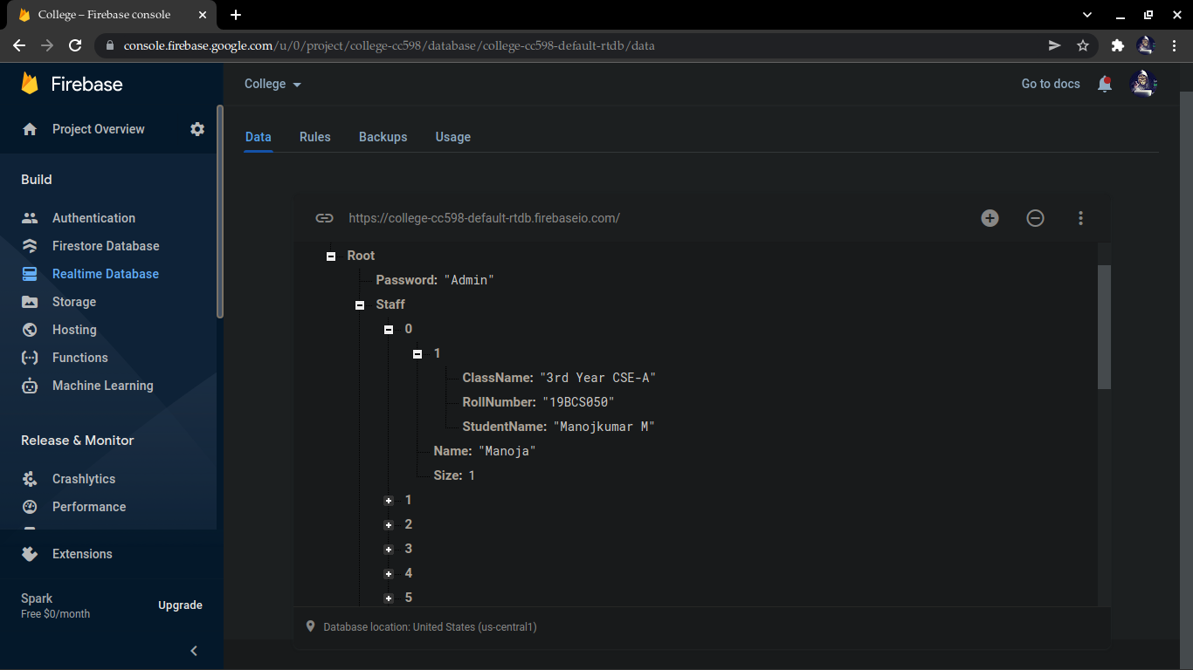

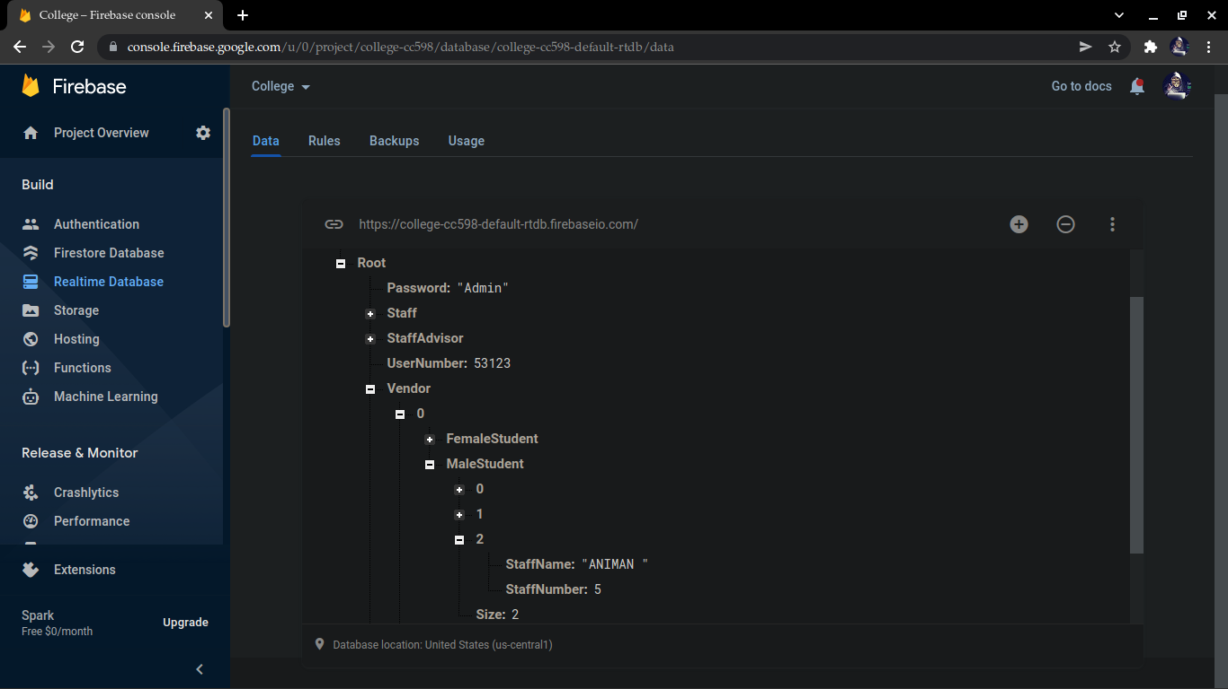

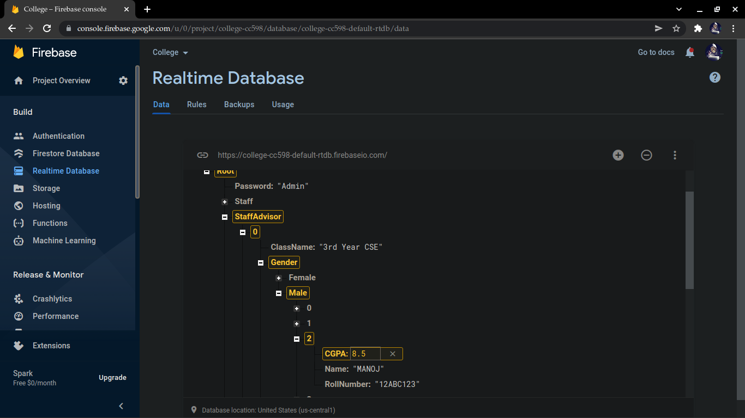

Activity_XML:

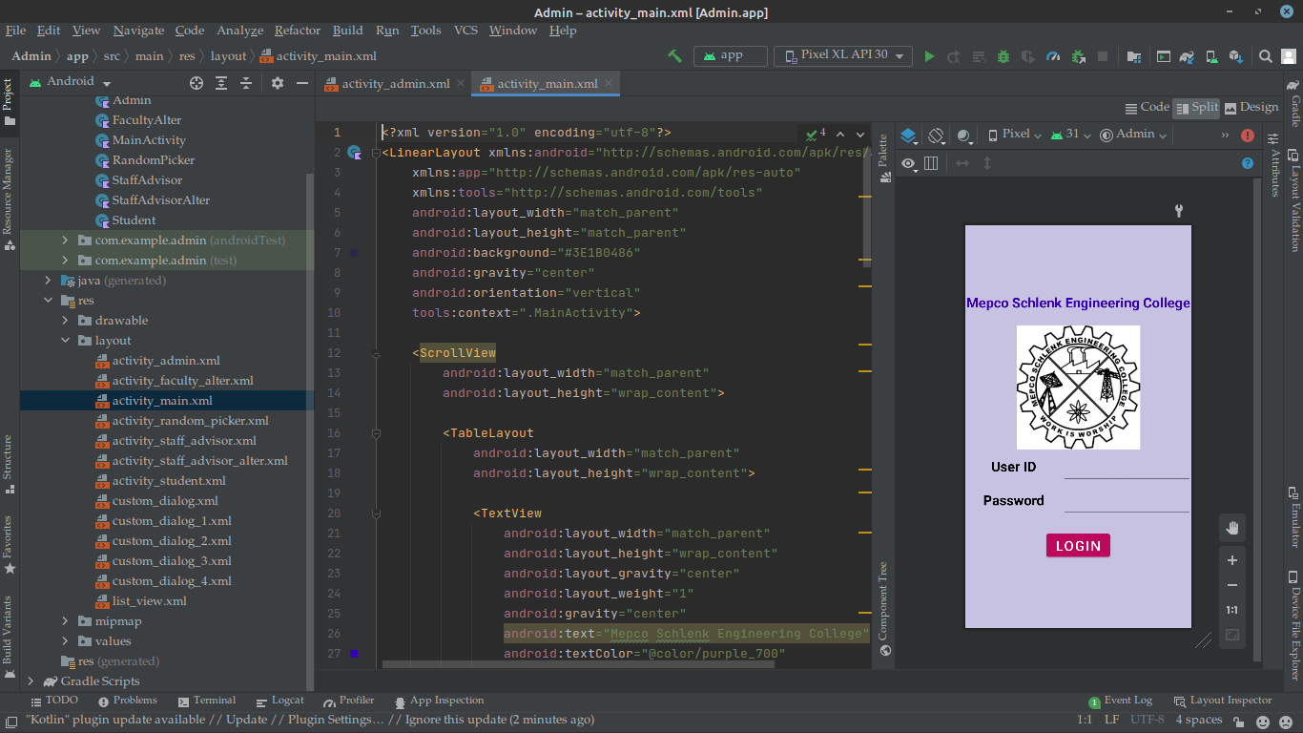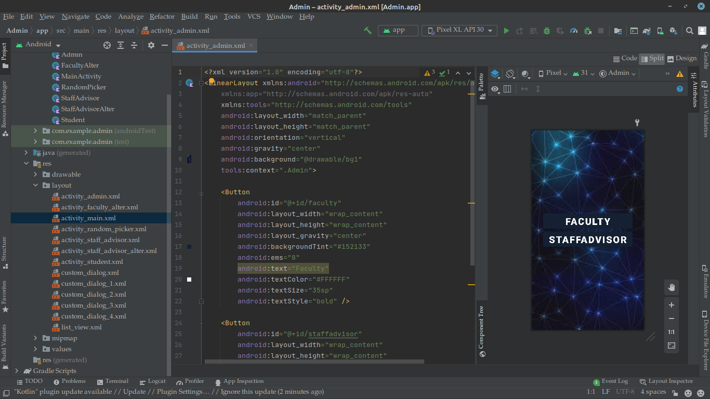

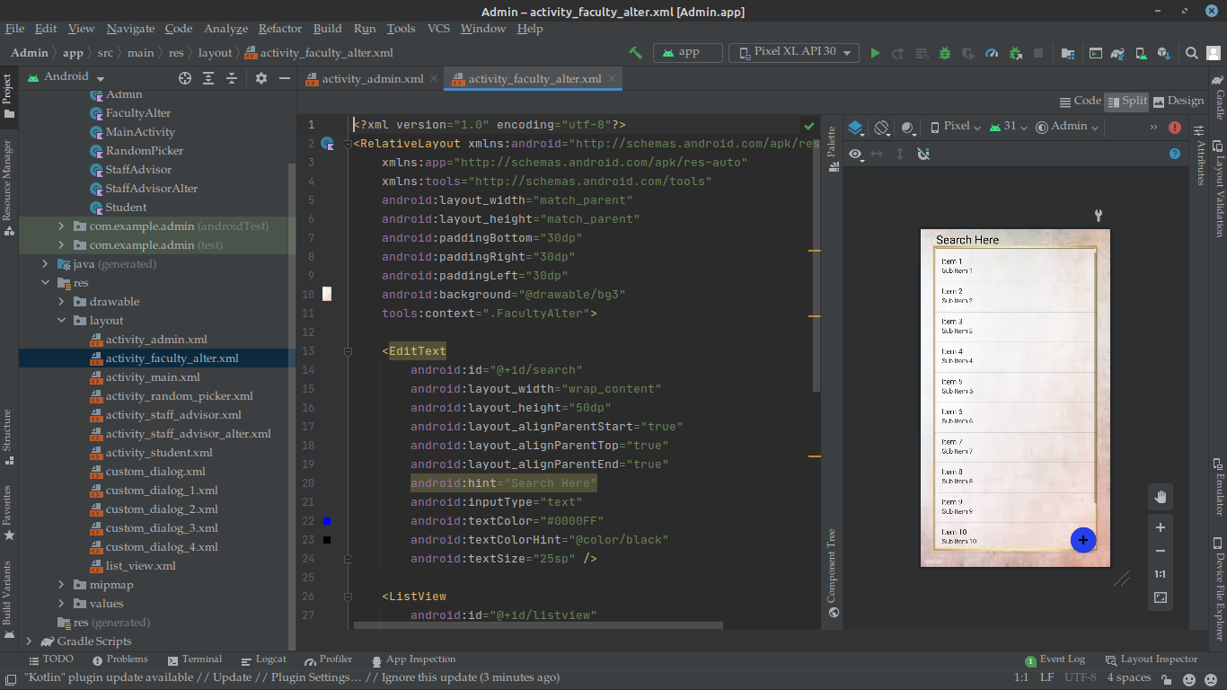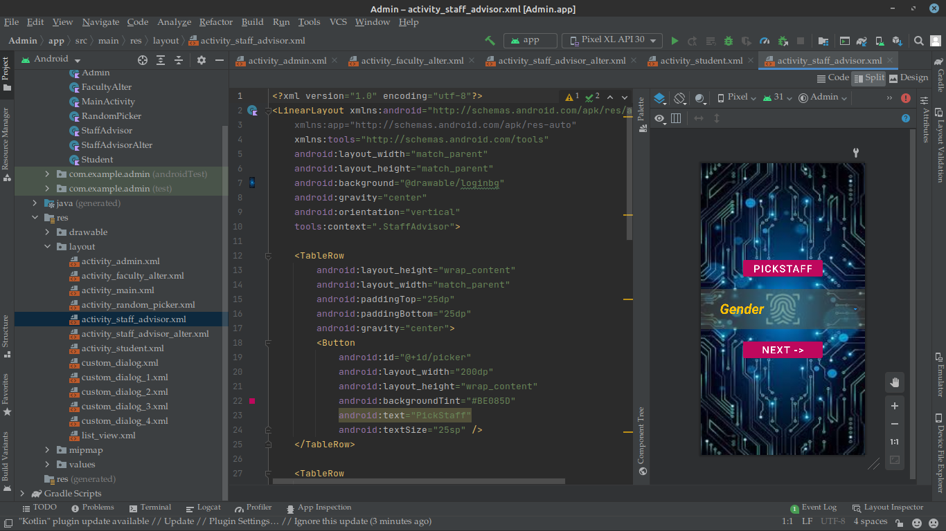

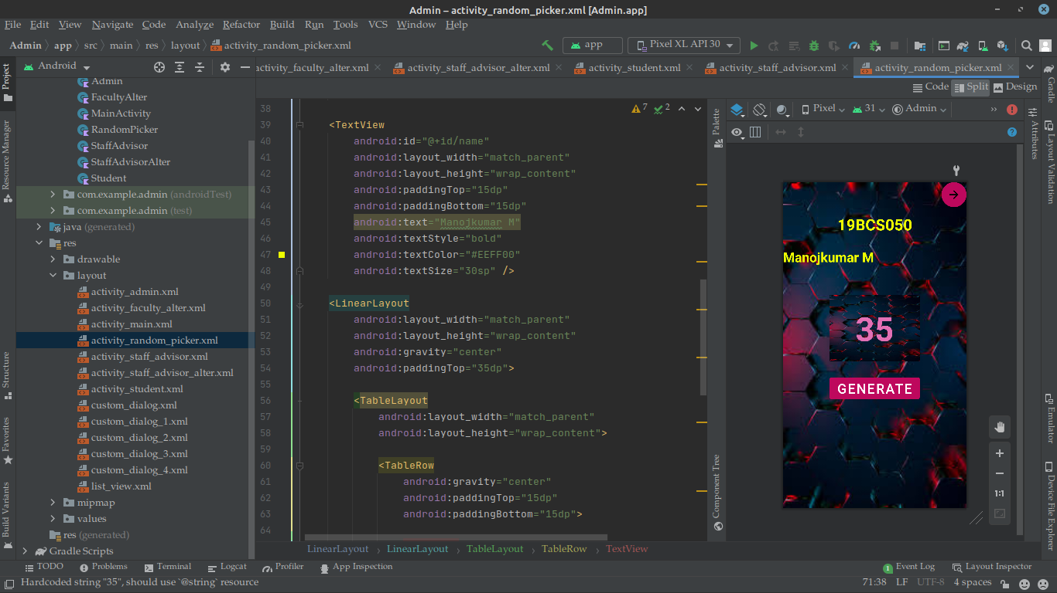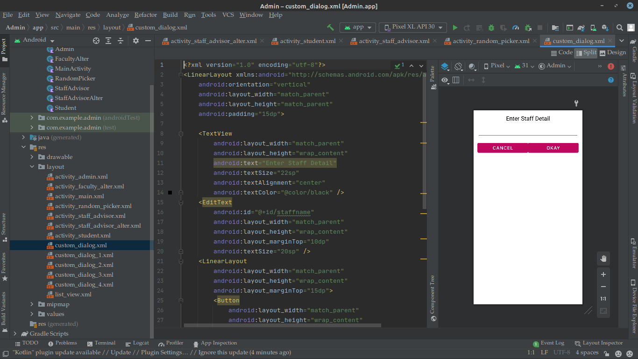

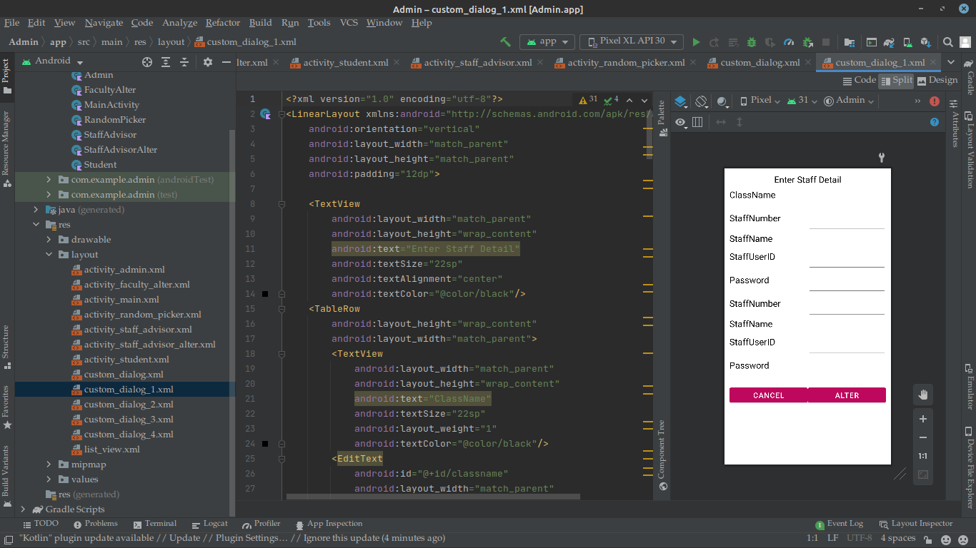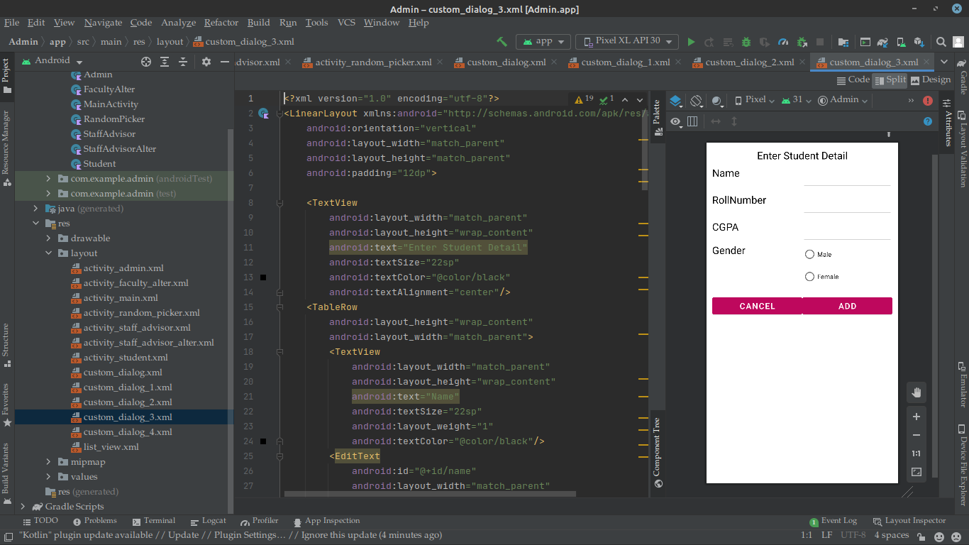

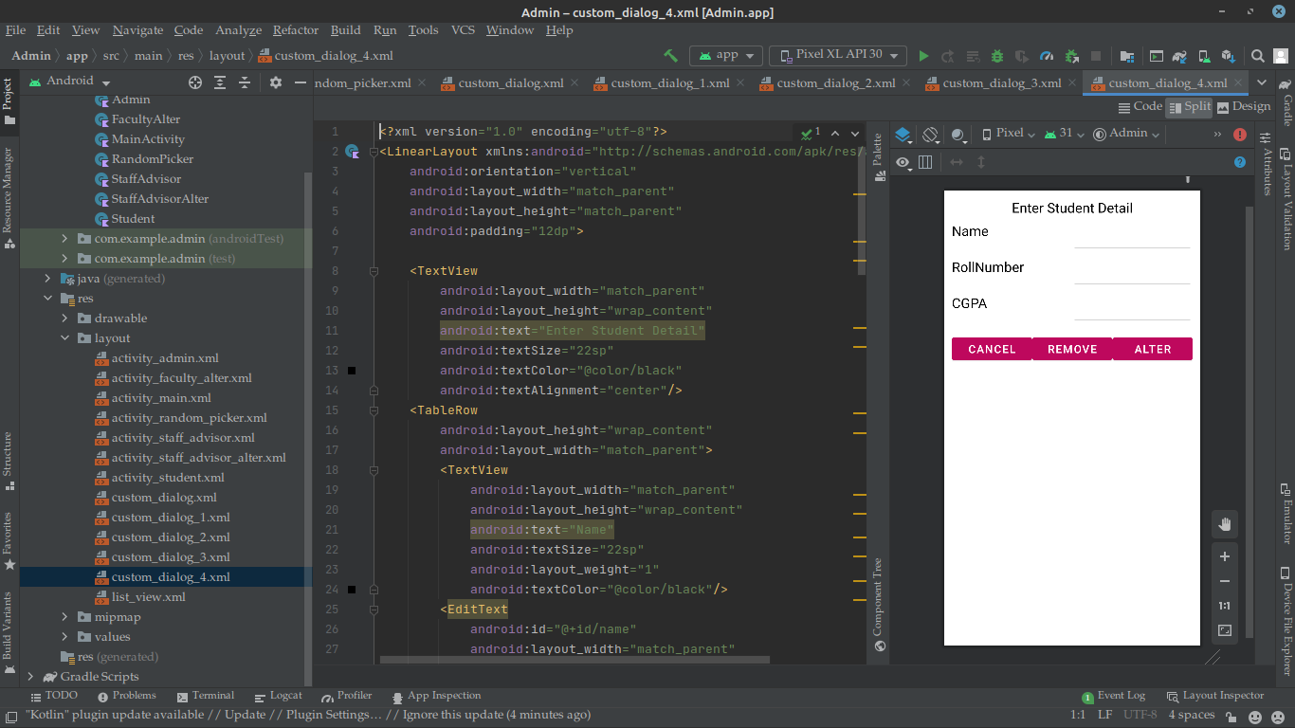

CONCLUSION:
Mentor selector app is very useful to assign mentor for a student to guide their project and this application reduces the time required to assign mentor for students.

