**ASTRONOMY-EVENTS**

**Star Hunt**

Points:30

**General rules and Regulations**

1. This is a **team event**. There is no limitation on the number of teams from each pool. The teams must register for it before 11:59 pm 28 aug,2012.

2. Each team can have AT MOST 3 members. All the members must be from the same pool of hostels.

3. For Every round, the teams will be given a particular time slot and teams will have to be present during that time at the Venue.

**Format**

The event will be held in three parts:

**1st round-NAKED EYE OBSERVATION (15% weightage):**

1. Each team will get:

a. A list of 10 Night Sky Objects from which a team has to point at any 8 objects.

b. Beginners and/or Intermediate Star Charts.

c. MAXIMUM 6 minutes of time to point those objects.

d. A laser pointer

e. One official from Astro-Club.

2. What you are supposed to Show to the official: The Teams are supposed to show by Laser Pointer, the objects in the list, in any order. Whether you have got the correct object or not will be decided by the official assigned to your team.

3. You will be given two chances to point at an object correctly.

4. No hint will be given to the teams.

5.Important :

a. Make sure you show each and every object that you point to, to the official assigned to your team.

b. MAXIMUM TIME GIVEN TO EACH TEAM IS 6 MINS.

6. Judging Criteria:

A. Point Structure for each object:

a. 10 points will be awarded to the team if it points to object correctly in the 1st attempt.

b. 5 points will be awarded to the team if it points to object correctly in the 2nd attempt.

b. NO points will be awarded to the team if it fail to points to object in both the attempts.

B. The top 16 teams will qualify for the 2nd and 3rd round.

C. Criteria for deciding the top 16 teams:

Priority will be given according to:

a. Number of objects pointed: The team which will point to more number of objects (**maximum objects**=8) will get higher position.

b. Score awarded: If two teams point to same number of objects then the team with higher score get higher position.

c. Time taken: If two teams point to same number of objects and they also have same score then the team that takes less time in pointing the objects gets higher position.

D. The judging will be done by Astronomy Club Coordinators

**Second stage-POINTING THROUGH TELESCOPE(50% weightage):**

1. Each team will get:

a. A list of 6 Night Sky Objects, the team has to point to all of them.

b. Beginners and/or Intermediate Star Charts.

c. MAXIMUM 12 minutes of time.

d. A Telescope

e. One official from Astro-Club.

2. Time: Each Team will get a total of (2 mins + 10 mins) = 12 minutes of time. You are expected to make yourself comfortable with the telescope in the initial 2 minutes and do the star hunt in the **remaining 10 minutes**. The Official will keep record of time and points during those 10 minutes.

3. What you are supposed to Show to the official: The Teams are supposed to show through their telescope the objects in the list, in any order. Whether you have got the correct object or not will be decided by the official assigned to your team.

4. Important:

a. Make sure you show each and every object that you point to, to the official assigned to your team.

b. MAXIMUM TIME GIVEN TO EACH TEAM TO POINT THE OBJECTS IS 10 MINS.

5. Judging Criteria:

Point System for Each Object :

a. +20 will be given to the Team that points the object in night sky points in the telescope successfully on first attempt.

b. +15 will be given to the Team that points the object in night sky points in the telescope successfully on second attempt.

c. +10 will be given to the Team that points the object in night sky points in the telescope successfully on third attempt.

d. The team will not get any point if they fail to point the object in the night sky in the telescope on third attempt.

6. The team will also get a hint (if they ask) for an object but 5 points will be deducted for it. Only one hint will be given per object.

**7.** Minimum eligibility criteria: Each team will have to point to 2 objects for the final scores.

8. The judging will be done by Astronomy Club Coordinators

**Third Stage-OBSERVATION IN PLANETARIUM(35% weightage)**

1. This round will be conducted inside the planetarium.

2. In each slot, 4 or less teams will be allowed to go inside the planetarium. Only 1 team from each pool can go inside the planetarium in one slot.

2. The problem statement for this round will be given on the spot and will be based on the planetary motions of planets in our Solar system. The teams are expected to have the knowledge of basic laws of gravitation and planetary motion.

3. The Teams will be shown 15 minute long virtual sky during which they will have to record the required data. For analyzing the data and thereby tackling the problem statement, 30 minutes will be given to each team.

4. What you are supposed to Show to the official: In both the parts, the Teams are supposed to show the answers with the solution. The solution must consist of sufficient mathematical reasoning and justification for your assumptions to support your answer.

5. Important : Make sure you that your method is right, irrespective of what your final answer is and whether that answer is correct or not.

6. Judging: The team with the best solution and JUSTIFICATION will get more credit. The best solution need not be the one with accurate answer but the one with straightforward and reasonable approach. The judging regarding the solutions will be done by the club’s **FACULTY ADVISER** and **SENIOR CLUB MEMBERS.**

7. Scoring for this round:

Method and Reasoning: 85%

Answer: 15%

**DECIDING THE WINNER**

The winner will be decided according to the aggregate score earned by a team in each round.

Score Earning Criteria:

Suppose a team gets ‘x’ points in Round 1, ‘y’ points in Round 2 and ‘z’ points in Round 3. Then aggregate score will be:

(x/80)*15 + (y/120)*50 + (z/100)* 35

In case of a tie after the above calculation the team which took **less time in the 2nd round** will get higher position.

In case if one stage of the event gets scrapped due to unfavourable sky conditions, judging would be done solely on the basis of the other stages.

A typical star chart:

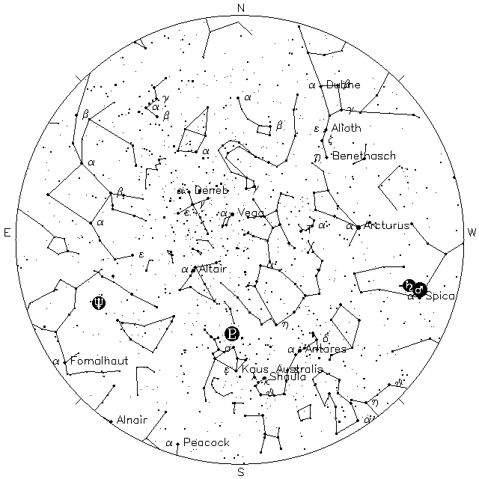

**Astro-Quiz**

Points: 15

General Rules

1. The Event will be conducted in two rounds Prelims and finals.

2. Teams of three or less can participate in the Prelims, and there is no limit on the number of teams from each pool. **Registration is on the spot.**

3. After the prelims, 6 teams will qualify for the finals.

4. The points of prelims will NOT be carried forward to the finals

5. **The event will be a 'Team Event'** i.e. the points will be awarded to teams irrespective of the pool to which the team belong. There is no restriction on the number of teams per pool.

For example: Suppose the first and second winners are from the same pool, a total of (15+9) will be awarded to the pool.

6. Cheating in any form will not be tolerated and the team will be disqualified in such cases. Especially use of mobile phones will not be allowed in the room.

7. The Quizmaster's decision will be final in deciding the right answers.

**Prelims:**

Prelims will consist of a total of 20 questions. Starred questions will be used in case of tie-breakers.

**Finals:**

The final will have four rounds. The details of the rounds will be revealed during the event.

JUDGING CRITERIA : The final decision on answer of any question will be taken by the Faculty Adviser and the Quiz Master.

**Messier Hunt**

Points: 10

General Rules and Regulations

1. It is pool event (only 1 team(of maximum 3 people) from each pool can take part in it). **The team must register for it before 11:59 pm, 28 aug, 2012.**

2. Each team will be given 20 mins. They have to point the telescope to as many messier objects as they can.

3. Each Messier object will count only when they show its position in the eyepiece to the official and tell which messier they have pointed.

4. The team will be provided with a messier chart.

5. Minimum eligibility criteria: the team should point at least 2 messier objects.

6. The teams will be given a particular time slot and teams will have to be present during that time at the Venue.

Judging Criteria:

1. The Team that points to the maximum number of messier objects will get more credits.

2. In case if two teams points to same number of messier objects the team that had pointed them in less time will get higher position.

**Judging will be done by the Astronomy Club Coordinators**

**Virtual Observatory**

Points: 15

General Rules and Regulations:

1**. It is a team event** with each team consisting of upto three members

2. Only three teams are allowed per pool. **The team must register for this event before 11: 59 pm, 28 aug 2012.**

3. This event is divided into two parts.

4. The **first part** will consist of a set of theoretical problems on astrophysics which will be given on the spot. **(60% weightage)**

5. The second part would consist of another astrophysics problem which would have to be solved using software. Solving this problem would require basic knowledge about star systems and conventional methods used in finding the distances of astronomical objects.**(40% weightage)**

6. A total of 3 hours will be provided for completing both the parts.

7. **What you are supposed to Show to the official:** In both the parts, the Teams are supposed to show the answers with the solution. The solution must consist of sufficient mathematical reasoning and justification for your assumptions to support your answer.

8. **Important :** Make sure you that your method is right, irrespective of what your final answer is and whether that answer is correct or not.

9. Judging: The team with the best solution and JUSTIFICATION will be declared the winner. The best solution need not be the one with accurate answer but the one with straightforward and reasonable approach.

9. The judging regarding the solutions will be done by the club’s **FACULTY ADVISER** and **SENIOR CLUB MEMBERS.**

**Score Criteria for both rounds:**

Method and Reasoning: 85 %

Answer: 15%

**Astrophotography:**

Points: 20

General Rules and Regulations

1. **This is a team event**. Each team can have AT MOST 3 members. All the members must be from the same pool of hostels. Only **two teams per pool** would be allowed. Teams can come and practice in the given slots.

2. The teams would be provided with a digital camera and a telescope with a camera mount and a solar filter attached to it for the round 1.

3. Teams have to point the telescope towards the sun on their own and take a photograph.

WARNING: you have to point the telescope towards the sun WITHOUT looking through the viewfinder as it causes serious damage to your eyes.

Get some idea about

ISO

Exposure time, and

Focal number

You may need to adjust these to take a good image.

4. EVENT STRUCTURE:

There will be two rounds:

(a) DAY ROUND(50% weightage)

Each team would be given a **slot of 30 mins** for using the camera and the telescope and participants will have to take an image of the sun showing the sunspots.

Judging criterion

1. The picture would be judged on the basis of the clarity of sunspots.

2. The decision regarding the winner would be taken by the faculty advisor of the club and would be final.

3. In case of any dispute, the decision taken by the Astro-Team will be FINAL and BINDING

4.**Minimum Eligibility Criteria:** In case no sunspot is visible in the photograph, no credits will be awarded.

(b) NIGHT ROUND (50% weightage)

Each team would be given a **slot of 30 mins** for using the camera and the telescope and participants will have to take an image of the moon showing the craters.

The club would be releasing a list of craters which should be clearly visible and distinguishable in the image.

Judging criterion:

1. The picture would be judged on the basis of the clarity, sharpness and contrast of craters.

2. The decision regarding the winner would taken by the faculty advisor of the club and would be final.

3. In case of any dispute, the decision taken by the Astro-Team will be FINAL and BINDING

4. **Minimum Eligibility Criteria:** The minimum criteria for credit is the distinguishability of all the craters in the above mentioned list.

5. In case if one stage of the event gets scrapped due to unfavourable sky conditions, judging would be done solely on the basis of the other stage.

**Judging for this event will be done by the faculty advisor of the club.**

**Treasure Hunt**

Points: 20

1. **This is a pool event**. Each pool must have only 1 team. There no limitation on the number of participants in a team.

2. Each team should have a team captain and he will be that should report the code to the official.

3. Each team will be provided with a map of the campus in which different places will be associated with some objects in the sky as well as some numbers.

3. The hints will point towards either the original locations or objects or numbers mentioned above.

4. On solving the clue, you will have to find out the Code that is placed in the location pointed by the clue and on reporting the Code to the officials in Person, you will be provided with the next clue.

5. In case if any member of a pool is found tampering the clue, the whole pool will be disqualified.

6. The entire event will be finished in 5 hours and in case some teams are not able to reach and solve the last clue within the time mentioned, the judging will be done on the current position of the teams. In case if two team are on same clue then the team which reached that clue first shall get a higher position.

7. Minimum Eligibility Criteria: A team should solve at least 30% of total clues to get the points of this event.