**HOVERUGBY**

Ever fascinated by the wrestling giants competing against each another for honour, pride and glory! And the speed of a rugby player to achieve his aim. If so, then this is the event for you. Here it will be your hovercraft that will do the talking. So get up, design the most efficient quick wrestling hovercraft that you have ever imagined!!!

* **Problem Statement**:

Each pool has to design and fabricate 2 hovercrafts that are light-weight, easily maneuverable, quick and strong. They must out-throw their opponent in a match of hovercraft rugby. Also they must enter the goal area to score points.

* **Rules and Regulations**:
* A hovercraft is a vehicle which floats on a cushion of high pressurized air and propels itself on this air-cushion using a thrust producing mechanism.
* Control is generally achieved by the use of rudders, though it is not the only solution.
* The overall hovercraft dimensions must not exceed 50cmX50cmX50cm.
* The model can be fabricated using foam, wood, coroplast or any other material with permission from the coordinators.
* Participants must make all parts of the craft themselves.
* Usage of readymade kits is strictly prohibited. Use of readymade actuators/motors, remote controls and propellers is allowed.
* The use of IC engines is prohibited. Only electrical motors are allowed.
* A team has to use 2 models at a time throughout the competition. However, spare models can be fabricated, if material permits. In case of any damage to the craft, small modifications are allowed.
* The potential difference between any two points on the hovercraft must not exceed 12V.

If anyone is found not following above rules, they will be disqualified.

* **Arena**:

The overall arena is a flat surface, with 2 goal posts.

The perimeter of the arena will be made using wooden wall of height 10 cm.

The “pitch” for the event will be as given below in 2 views:

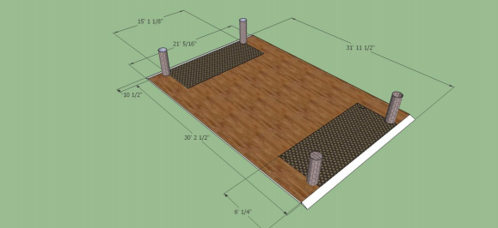

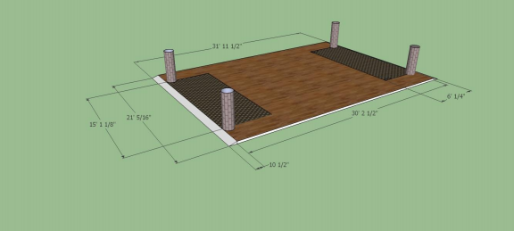

The black shaded areas are the “Goal Areas.” The overall brown board is the pitch.

* **Event Structure:**
* Each match between two opponents will contain three sets of 3 min time duration each.
* Each team will play matches against every other team, thereby producing the overall result.
* Your craft has to enter the opponent’s goal area and slide down the incline to the OAT stage surface to score 1 goal.
* Both the crafts can also attack at the same time.
* A maximum of 1 craft of the defending team can remain in the goal area at any time.
* Score for each craft will be summarized separately, then added with its partner to give the total score for a team in that set.
* The scores of each set will be independent, the team winning more number of sets will be the winner of the match.
* In case of tie after 3 sets, there will be 1 extra set of 1 minute. In case of tie after the extra set, there will be golden goal, i.e. the team scoring the first goal will win.
* **Match Rules:**
* Each successful goal will lead to a +5 for that particular craft.

There are no negative points if hovercraft touches the boundary.

Human intervention will lead to -2 points.

* A set will not stop until the 3 min duration, irrespective of how many goals are scored or how many times the crafts fall.
* Once the attacking craft scores a goal and lands on the OAT surface, it has to restart from its home goal area.
* If the defender falls from the incline and can come up without any manual interference (touching, etc.) no points will be deducted. If manually it is put onto the arena, 1 point will be deducted for that hovercraft.
* If a craft falls from the edge, it has to be manually put back onto the pitch from that boundary position.
* Each team is allowed to take 2 timeouts of 45 seconds each in each set.

**Activities allowed:**

* Hitting the other craft
* Dragging the other craft to the edge
* Any other thing you may imagine!!!
* Using any kind of fire, spray, liquid or any other activity that may cause serious damage to the arena or the electronics (as per coordinators discretion) is not allowed.
* **Components:**

Below are the components that will be provided to each pool. Apart from these, each pool is authorized to purchase any other materials required at the expense of their respective pool budgets, on proper verification of bills by us.

**The materials provided to you include:**

* 4 electric motors
* Two 9gm servos
* 4 propellers
* 4 ESC
* One 2mm coroplast sheet
* Batteries, receiver & transmitter will be provided during practice slots only.

**Note: In case of any disputes, the decision of the coordinators would be final and binding to all.**

* **Contacts:**

Arpit Khunteta arpitr@iitk.ac.in +91 8960467870

Deepak Pawar deepaksp@iitk.ac.in +91 8960484303

Suraj Bhamare surajab@iitk.ac.in +91 9793972266

In case of any doubt, contact the secretary of your hall or any of us.