# Host a Website on Amazon S3

Abhinav Singh

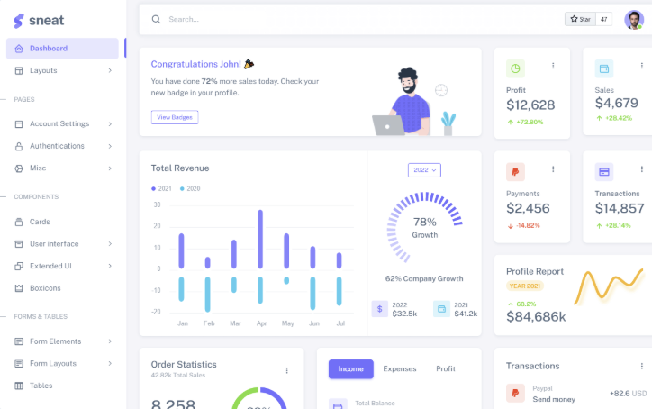

## Introducing Today's Project!

In this project, I will demonstrate... I'm doing this project to learn s3 and how to host a website on s3 bucket

Tools and concepts

Services I used were...S3 bucket Key concepts I learnt is ACL and website hosting option in AWS S3 bucket

Project reflection

This project took me approximately 20 mins

## How I Set Up an S3 Bucket

Creating an S3 bucket took me less then 3 mins

The Region I picked for my S3 bucket was ap-soth-1 ... because i am from india this is the best region for me

S3 bucket names are globally unique! This means...every bucket name on aws like aws it name shoudl be unique

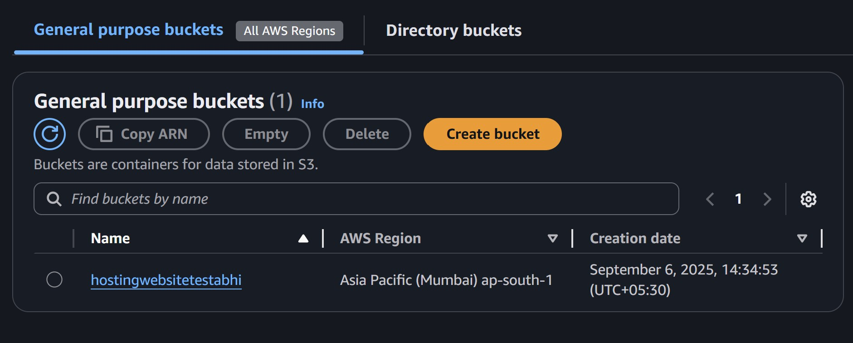

## Upload Website Files to S3

index.html and image assets

I uploaded two files to my S3 bucket - they were... index.html and all of the other files in which we have css and images

Both files are necessary for this project as...one is index.html and other files are images css

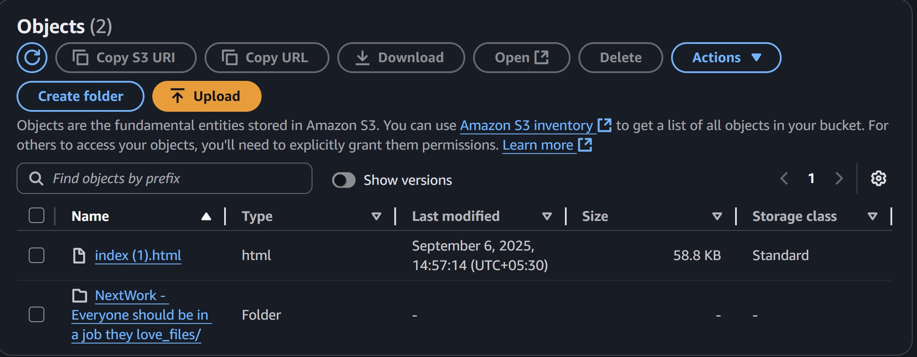

## Static Website Hosting on S3

Website hosting means we host our files on web server so everyone can see that

To enable website hosting with my S3 bucket, go to properties and in last option you can see static website hosting

An ACL is... access control list which kind of provide security and access control , so who can access objects in bucket and who can't

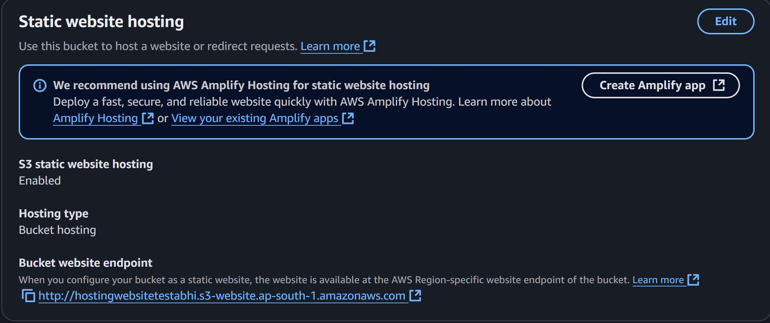

## Bucket Endpoints

Once static website is enabled, S3 produces a bucket endpoint URL, which is...[http://hostingwebsitetestabhi.s3-website.ap-south-1.amazonaws.com](http://hostingwebsitetestabhi.s3-website.ap-south-1.amazonaws.com/)

When I first visited the bucket endpoint URL, I saw... The reason for this error was...and forbidden error

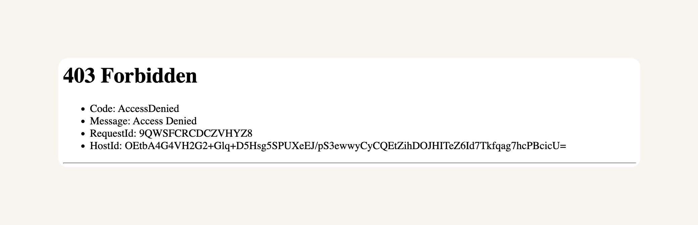

## Success!

To resolve this 403 Forbidden error, by allow object

