2.12 Computer assignment.

u1 = [1, 1]';

u2 = [1.5 1.5]';

% Generate 100 feature vectors form each class.

for i=1:100

rnd1(i,:,:)=u1+0.2*randn(2,1);

rnd2(i,:,:)=u2+0.2*randn(2,1);

end

class1=sum(rnd1,2);

class2=sum(rnd2,2);

% Calcaluate the percentage of error

fprintf('\nFor minimizing the error probablity\n\n');

val1 = class1>2.5;

val2 = class2>2.5;

fprintf('Percentage error for case of minimum probability error: %f\n', sum(val)/100);

fprintf('Percentage error for case of minimum probability error: %f\n', sum(val2)/100);

% Now, for minimizing the risk %

class1_1=sum(rnd1.^2,2)-(sum(rnd1,2))-0.5;

class2_1=sum(rnd2.^2,2)-(sum(rnd2,2))-0.5;

val1_1 = class1_1>0;

val2_1 = class2_1>0;

fprintf('\nFor minimizing the risk\n\n');

fprintf('Percentage error for case of minimum probability error: %f\n', sum(val1_1)/100);

fprintf('Percentage error for case of minimum probability error: %f\n', sum(val2_1)/100);

_____________________________________________________________________________________

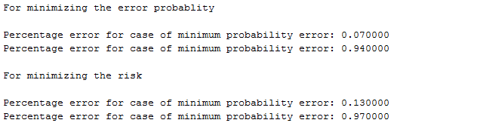

­­­­­­­­­­­­­­_____________________________________________________________________________________

*Note:* The decision surface was derived for both cases in the handwritten solution. That was used here to perform the classification.