STUDENT PERFORMANCE ANALYSIS &
ACADEMIC SUCCESS PREDICTION
A Data Analytics & Machine Learning Project Report

Table of Contents
Table of Contents 2
1. Abstract 3
2. Introduction 3
3. Problem Statement 4
4. Objectives 4
5. Dataset Description 4
Table 1: Description of Major Variables 4
6. Data Preprocessing 5
7. Exploratory Data Analysis 5
7.1 Dataset Overview 5
7.2 Missing Values 5
7.3 Duplicate Records 6
7.4 Final Grade Distribution 6
7.5 Final Grade Boxplot 6
7.6 Study Time vs Final Grade 6
7.7 Absences vs Final Grade 7
7.8 Previous Failures vs Final Grade 7
7.9 Sex vs Final Grade 8
7.10 Age vs Final Grade 9
7.11 Mother's Education vs Final Grade 9
7.12 Father's Education vs Final Grade 10
7.13 School Support vs Final Grade 10
7.14 Correlation Analysis 11
8. Machine Learning 12
8.1 Machine Learning Objective 12
8.2 Target Variable 12
8.3 Feature Selection 12
8.4 Train-Test Split 12
8.5 Data Preprocessing 13
8.6 Linear Regression 13
8.7 Random Forest Regression 13
8.8 Evaluation Metrics 13
8.9 Model Results 13
8.10 Actual vs Predicted Analysis 14
9. Power BI Dashboard 14
9.1 Purpose 14
9.2 KPI Cards 14
9.3 Visualizations 15
10. Key Findings 15
11. Limitations 15
12. Conclusion 16

1. Abstract
This project applies data analytics and machine learning techniques to the Student Performance dataset (student-mat.csv), which records demographic, family, social, school-related and academic information for 395 secondary-school students, along with their mathematics grades across three grading periods (G1, G2 and G3). The objective of the study is to explore the structure of the dataset, examine patterns between student characteristics and final academic performance, and build predictive models for the final grade (G3).
Exploratory Data Analysis (EDA) was carried out to understand the distribution of final grades and to examine how variables such as weekly study time, number of absences, previous class failures, sex, age, parental education and school support relate to final grades. A correlation analysis was also performed across the numerical variables in the dataset.
For the machine-learning component, G3 was used as the target variable, while G1 and G2 (the earlier-period grades) were deliberately excluded from the primary model so that prediction relies on student characteristics rather than prior grades. The dataset was split into training (80%) and testing (20%) subsets, and two regression models — Linear Regression and Random Forest Regression — were trained and compared. On the test set, Linear Regression achieved an MAE of 3.395, an RMSE of 4.196 and an R² of 0.141, while Random Forest achieved an MAE of 3.010, an RMSE of 3.765 and an R² of 0.309. Random Forest therefore produced lower error and a higher R² than Linear Regression on this particular test split, indicating a comparatively better, though still limited, fit.
A Power BI dashboard was also created using the same dataset to present key indicators and visual summaries — including total students, average final grade, average absences and average study time — in an interactive format. The findings of the project, along with their limitations, are discussed in the sections that follow.

2. Introduction
Understanding the factors associated with student academic performance is an area of ongoing interest in education, as it can help schools, teachers and policymakers identify patterns that may be relevant to student support. Data analytics offers a structured way to examine large amounts of student-related information — demographic, social and academic — and to summarise it into interpretable patterns rather than relying only on individual observation.
Machine learning extends this by allowing a model to learn a mapping between student characteristics and academic outcomes, which can then be used to generate predictions for new or unseen students. While such models cannot capture every factor that influences a student's performance, they can highlight which measured characteristics show the strongest statistical association with final grades within a given dataset.
The purpose of this project is to apply these techniques — exploratory data analysis, regression modelling and dashboard visualisation — to a real student performance dataset, in order to practise the end-to-end workflow of a data analytics and machine learning project: from data cleaning, through analysis and modelling, to communicating results visually.

3. Problem Statement
Educational institutions collect a wide range of information about their students, but this information is not always analysed in a structured way to understand its relationship with academic outcomes. There is a need to explore student performance data systematically — to identify which recorded characteristics show a meaningful association with final grades — and to assess whether such characteristics can be used to build a reasonably informative predictive model for final academic performance (G3), independent of a student's grades in earlier grading periods.

4. Objectives
- Understand the structure and characteristics of the student performance dataset.
- Clean and prepare the dataset for analysis.
- Examine the distribution of students' final mathematics grades.
- Analyze relationships between student characteristics and final grades.
- Investigate factors such as study time, absences and previous failures.
- Develop machine learning models for predicting final mathematics grades.
- Compare Linear Regression and Random Forest Regression.
- Evaluate the models using MAE, RMSE and R².
- Create a Power BI dashboard to present the major findings visually.

5. Dataset Description
The dataset used in this project is the Student Performance dataset (student-mat.csv), which contains information on students enrolled in a mathematics course, including demographic details, family background, school-related attributes, social habits and academic grades across three grading periods.
The dataset, as loaded for analysis, contains 395 records (students) and 33 variables (columns). There are no missing values and no duplicate rows in the dataset.

Table 1: Description of Major Variables
Variable | Description | Type
school | School identifier (GP or MS) | Categorical
sex | Recorded sex category (F / M) | Categorical
age | Student age in years | Numerical
address | Home address type (Urban / Rural) | Categorical
Medu / Fedu | Mother's / Father's education level (0–4) | Numerical/Ordinal
studytime | Weekly study-time category (1–4) | Numerical/Ordinal
failures | Number of past class failures | Numerical
schoolsup | Extra educational school support (yes/no) | Categorical
absences | Number of school absences | Numerical
G1 | First-period grade | Numerical
G2 | Second-period grade | Numerical
G3 | Final grade (target variable) | Numerical
Note: only variables directly referenced in the analysis are listed above; the full dataset contains additional demographic, family and social variables (e.g. famsize, Pstatus, Mjob, Fjob, reason, guardian, internet, romantic, goout, health) that were retained in the feature set used for modelling.

6. Data Preprocessing
Before analysis, the dataset was checked for data-quality issues. A missing-value check across all 33 columns confirmed that there are no missing values in the dataset (total missing values = 0). A duplicate-row check also confirmed that there are no duplicate records (duplicate rows = 0). As a result, no rows needed to be removed or imputed prior to analysis.
For the machine-learning stage, the dataset's columns were separated into numerical features (e.g. age, Medu, Fedu, traveltime, studytime, failures, famrel, freetime, goout, Dalc, Walc, health, absences) and categorical features (e.g. school, sex, address, famsize, Pstatus, Mjob, Fjob, reason, guardian, schoolsup, famsup, paid, activities, nursery, higher, internet, romantic). Numerical features were processed using median imputation followed by standard scaling, while categorical features were processed using most-frequent imputation followed by one-hot encoding, implemented through a scikit-learn ColumnTransformer / Pipeline.
The dataset was then split into a training set and a testing set using an 80/20 split (test_size = 0.20), with a fixed random state for reproducibility. G1 and G2 were excluded from the input feature set for the primary model, so that the model predicts G3 using student characteristics rather than earlier-period grades.

7. Exploratory Data Analysis
This section presents the exploratory analysis performed on the dataset. Each subsection describes what was examined and the pattern observed in the actual data. Where relationships are described, this refers to an observed association in the dataset and does not imply causation.

7.1 Dataset Overview
The dataset contains 395 student records and 33 variables, combining demographic, family, school-related, social and academic information. All columns are complete, with 16 numerical columns and 17 categorical (object-type) columns.

7.2 Missing Values
A column-by-column missing-value check was performed using isnull().sum(). No missing values were found in any of the 33 columns; the total number of missing values across the dataset is 0.

7.3 Duplicate Records
A duplicate-row check using duplicated().sum() found 0 duplicate rows in the dataset, so the full 395 records were retained for analysis.

7.4 Final Grade Distribution
The final grade (G3) ranges from 0 to 20, with a mean of approximately 10.42 and a median of 11. The distribution and its spread are illustrated in the boxplot in Figure 1 below, which also indicates the presence of a number of students with a final grade of 0.
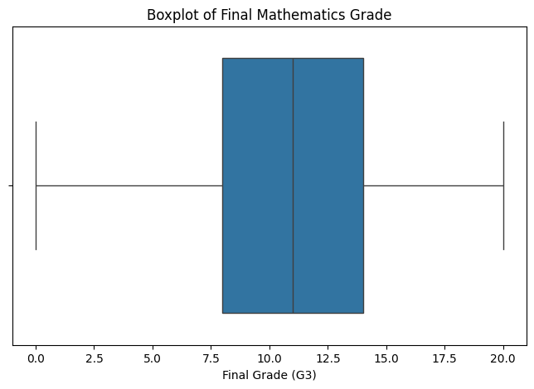
Figure 1: Boxplot of Final Mathematics Grade (G3)

7.5 Final Grade Boxplot
The boxplot in Figure 1 (above) summarises the spread of final grades. The interquartile range of G3 spans from 8 to 14, with the median at 11, indicating that most students obtained final grades in the middle range, while a smaller number of students scored 0 or scored close to the maximum of 20.

7.6 Study Time vs Final Grade
Students were grouped by their weekly study-time category (1 = less than 2 hours, up to 4 = more than 10 hours). The group means were: category 1 (n=105, mean G3 ≈ 10.05), category 2 (n=198, mean G3 ≈ 10.17), category 3 (n=65, mean G3 ≈ 11.40) and category 4 (n=27, mean G3 ≈ 11.26). This suggests a mild positive association between higher study-time categories and average final grade, though the overall correlation between studytime and G3 across the dataset is weak (r ≈ 0.10).
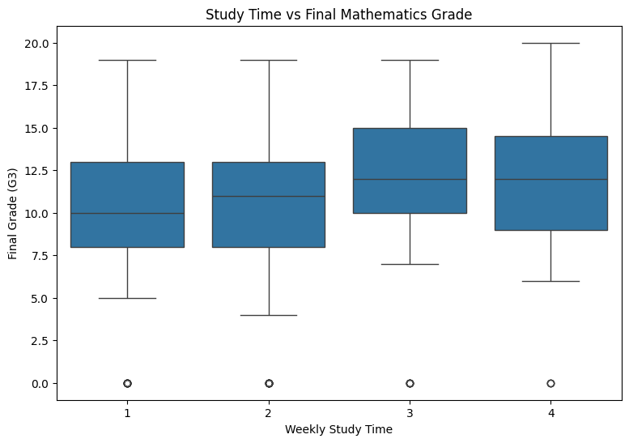
Figure 2: Weekly Study Time vs Final Mathematics Grade

7.7 Absences vs Final Grade
A scatter plot of absences against G3 (Figure 3) shows a wide spread of final grades across different absence counts, including students with very high absence counts (up to 75) as well as students with 0 absences. The linear correlation between absences and G3 across the dataset is very weak (r ≈ 0.03), indicating no clear linear relationship between the number of absences and final grade in this dataset.
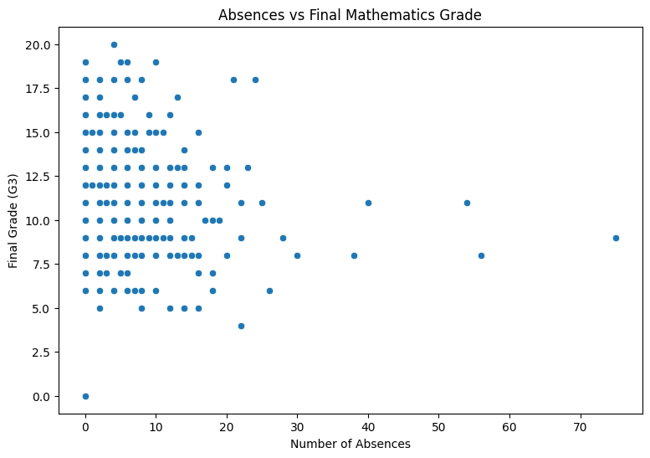
Figure 3: Number of Absences vs Final Mathematics Grade

7.8 Previous Failures vs Final Grade
Students were grouped by number of previous failures. Average G3 declines as prior failures increase: 0 failures (n=312, mean G3 ≈ 11.25), 1 failure (n=50, mean G3 ≈ 8.12), 2 failures (n=17, mean G3 ≈ 6.24), and 3 failures (n=16, mean G3 ≈ 5.69). This is the clearest pattern observed among the categorical/count comparisons in this dataset, consistent with the moderate negative correlation between failures and G3 (r ≈ −0.36).
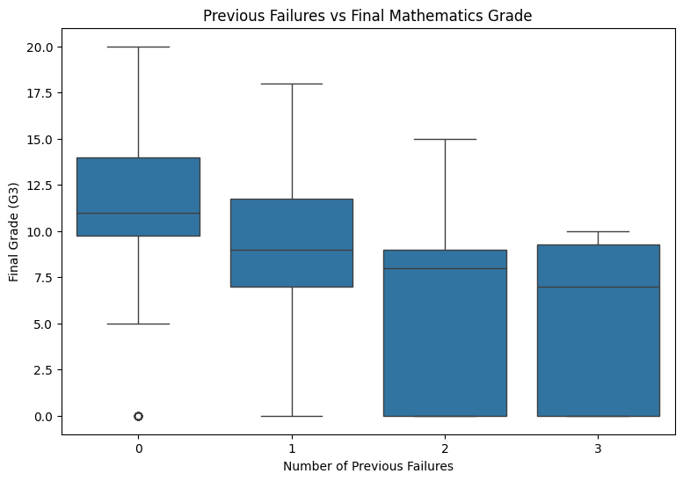
Figure 4: Previous Failures vs Final Mathematics Grade

7.9 Sex vs Final Grade
Grouping by sex shows a mean final grade of approximately 9.97 for female students (n=208) and approximately 10.91 for male students (n=187) in this dataset, with medians of 10 and 11 respectively. The boxplot in Figure 5 shows overlapping distributions between the two groups.
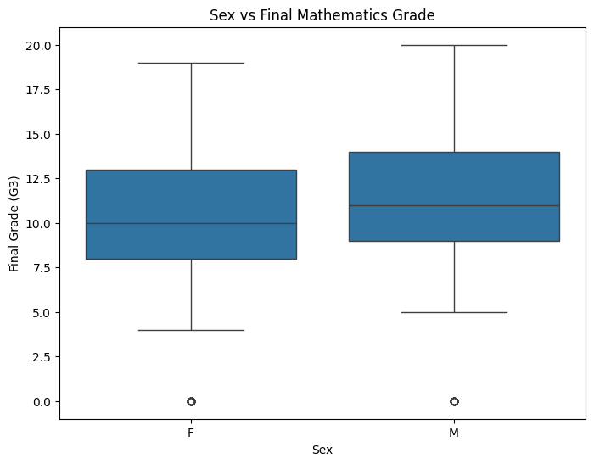
Figure 5: Sex vs Final Mathematics Grade

7.10 Age vs Final Grade
Mean final grade by age generally shows a declining pattern from the younger to the older age groups within the bulk of the sample: age 15 (n=82, mean ≈ 11.26), age 16 (n=104, mean ≈ 11.03), age 17 (n=98, mean ≈ 10.28), age 18 (n=82, mean ≈ 9.55) and age 19 (n=24, mean ≈ 8.21). The very small groups at ages 20–22 (four students combined) are not considered reliable due to their small sample size. The overall correlation between age and G3 is weak-to-moderate and negative (r ≈ −0.16).
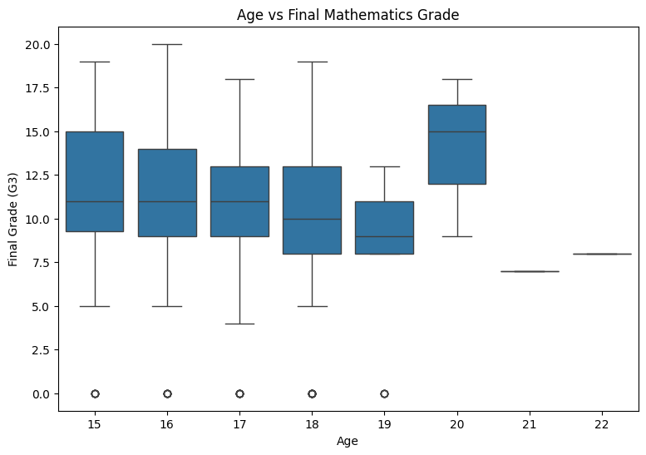
Figure 6: Age vs Final Mathematics Grade

7.11 Mother's Education vs Final Grade
Mean G3 generally increases with mother's education level (Medu, coded 0–4): Medu 1 (n=59, mean ≈ 8.68), Medu 2 (n=103, mean ≈ 9.73), Medu 3 (n=99, mean ≈ 10.30) and Medu 4 (n=131, mean ≈ 11.76). (The Medu = 0 group has only 3 students and is not considered reliable.) This corresponds to a weak positive correlation between Medu and G3 (r ≈ 0.22).
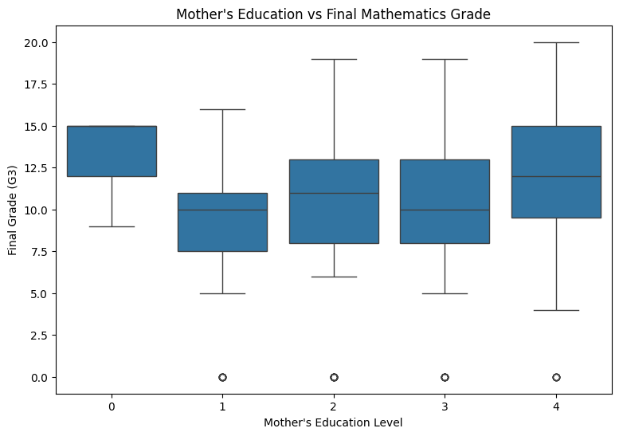
Figure 7: Mother's Education Level vs Final Mathematics Grade

7.12 Father's Education vs Final Grade
A similar, slightly weaker pattern is observed for father's education level (Fedu): Fedu 1 (n=82, mean ≈ 9.16), Fedu 2 (n=115, mean ≈ 10.26), Fedu 3 (n=100, mean ≈ 10.66) and Fedu 4 (n=96, mean ≈ 11.36). The correlation between Fedu and G3 is weak and positive (r ≈ 0.15).
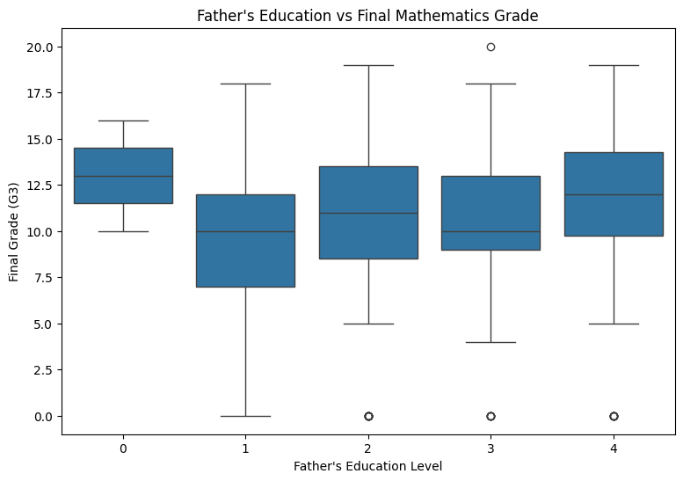
Figure 8: Father's Education Level vs Final Mathematics Grade

7.13 School Support vs Final Grade
Students receiving extra educational school support (schoolsup = yes, n=51) had a lower mean final grade (≈ 9.43) than students without such support (schoolsup = no, n=344, mean ≈ 10.56) in this dataset. This observed difference should not be interpreted causally — school support is typically provided to students who are already struggling academically, so the direction of this association is expected and does not imply that the support itself lowers performance.
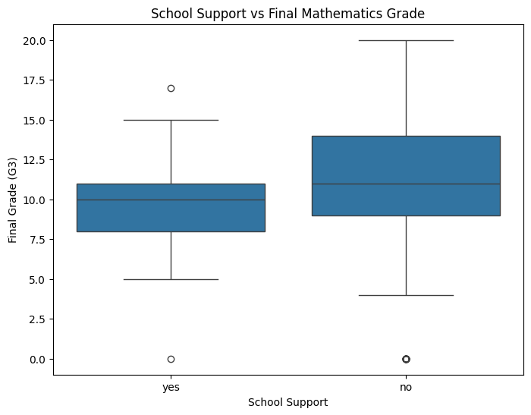
Figure 9: School Support vs Final Mathematics Grade

7.14 Correlation Analysis
A correlation heatmap (Figure 10) was generated across all numerical variables in the dataset. As expected, G1 and G2 show a strong positive correlation with G3 (r ≈ 0.80 and r ≈ 0.91 respectively), since these are earlier grades for the same students. Among the other numerical variables, failures shows the strongest association with G3 (r ≈ −0.36), followed by Medu (r ≈ 0.22) and age (r ≈ −0.16); studytime and absences show very weak linear correlations with G3 (r ≈ 0.10 and r ≈ 0.03 respectively). This supports excluding G1/G2 from the primary predictive model, since their strong correlation with G3 would otherwise dominate the model and reduce the influence of the other student characteristics.
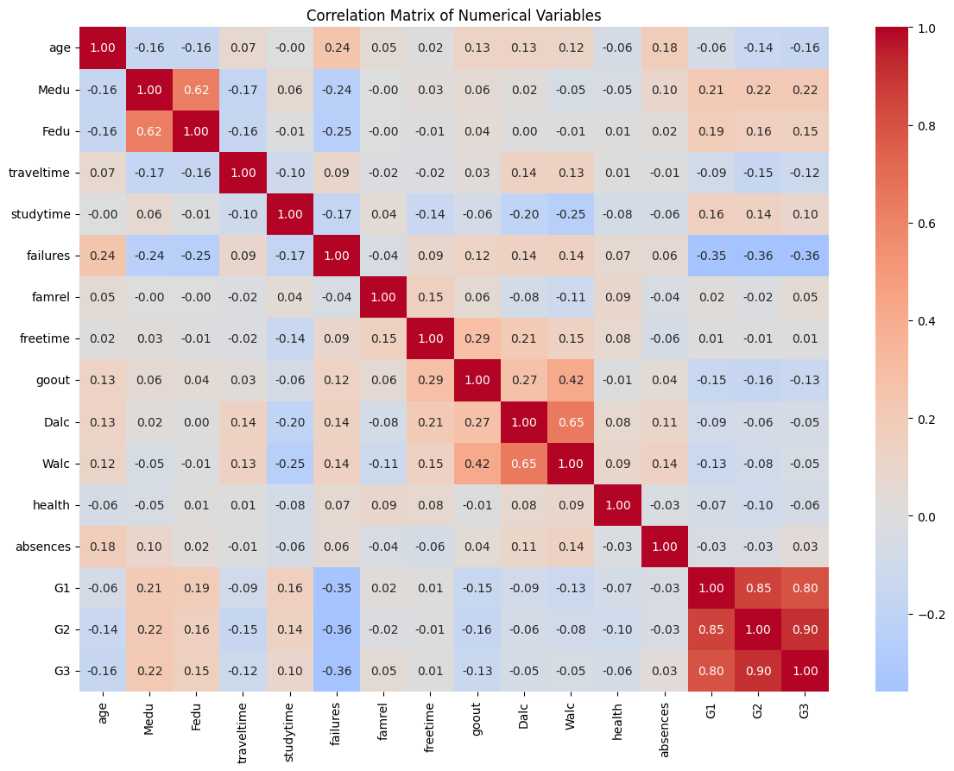
Figure 10: Correlation Heatmap of Numerical Variables

8. Machine Learning

8.1 Machine Learning Objective
The objective of the machine-learning component is to build a regression model that predicts a student's final mathematics grade (G3) using student characteristics available in the dataset, and to compare two different regression approaches on this task.

8.2 Target Variable
The target variable is G3 (final mathematics grade), a numerical variable ranging from 0 to 20 in this dataset.

8.3 Feature Selection
For the primary model, all columns except G3, G1 and G2 were used as input features. G1 and G2 were deliberately excluded so that the model is evaluated on its ability to predict final performance from student characteristics, rather than simply relying on the strong correlation between consecutive-period grades.

8.4 Train-Test Split
The dataset (395 students) was split into a training set and a testing set using an 80/20 split (test_size = 0.20), giving 316 students in the training set and 79 students in the testing set.

8.5 Data Preprocessing
Numerical features were imputed (median) and standardised (StandardScaler); categorical features were imputed (most frequent) and one-hot encoded (OneHotEncoder). Both transformations were combined using a scikit-learn ColumnTransformer and applied consistently within a Pipeline for both models.

8.6 Linear Regression
A Linear Regression model was trained on the preprocessed training data using scikit-learn's LinearRegression estimator, within the same preprocessing pipeline described above.

8.7 Random Forest Regression
A Random Forest Regression model (RandomForestRegressor, n_estimators = 300, fixed random state) was trained on the same training data and preprocessing pipeline, as an ensemble alternative to Linear Regression.

8.8 Evaluation Metrics
- MAE (Mean Absolute Error): the average absolute difference between predicted and actual final grades; lower values indicate smaller average prediction errors.
- RMSE (Root Mean Squared Error): the square root of the average squared prediction error; lower values indicate smaller prediction errors, with larger errors receiving proportionally greater weight.
- R² (Coefficient of Determination): the proportion of variation in G3 that is explained by the model's predictions on the test data; higher values indicate that the model explains more of the variation in the target within the evaluated data. This is a regression metric and should not be referred to as "accuracy", which applies to classification tasks.

8.9 Model Results
The two models were evaluated on the same held-out test set (79 students). The results obtained were as follows:

Model | MAE | RMSE | R²
Linear Regression | 3.395 | 4.196 | 0.141
Random Forest | 3.010 | 3.765 | 0.309
Table 2: Model evaluation results on the test set.
Random Forest produced a lower MAE and a lower RMSE, and a higher R², than Linear Regression on this particular test split. This indicates that, for this dataset and this train/test split, Random Forest achieved a comparatively better fit than Linear Regression, though neither model explains a large proportion of the variation in final grades. An R² of 0.309 for Random Forest means that roughly 31% of the variation in G3 on the test set is explained by the model, leaving the majority of the variation unexplained — student performance is influenced by many factors that are not necessarily captured in this dataset (e.g. individual motivation, teaching quality, or events outside school).

8.10 Actual vs Predicted Analysis
Figure 11 plots the actual final grades (G3) on the test set against the grades predicted by the Random Forest model. Points closer to a diagonal line would indicate more accurate predictions. The plot shows that predictions are broadly clustered around the middle of the grade range (roughly 8–13), with the model tending to under-predict for students with very high actual grades and over-predict for students with very low actual grades — consistent with the moderate R² value reported above.
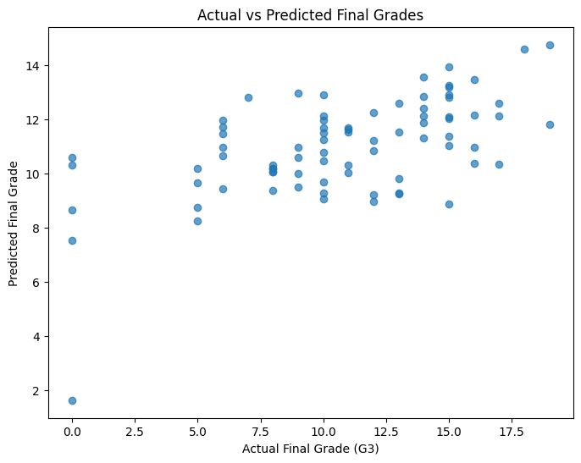
Figure 11: Actual vs Predicted Final Grades (Random Forest)

9. Power BI Dashboard
A Power BI dashboard was created using student-mat.csv to present the dataset's key patterns in an interactive, visual format, complementing the statistical analysis performed in Python.

9.1 Purpose
The dashboard is intended to give a quick, visual overview of the student population and their academic performance, allowing a reader to explore relationships between student characteristics and final grades without needing to read code or statistical output.

9.2 KPI Cards
- Total Students
- Average Final Grade
- Average Absences
- Average Study Time

9.3 Visualizations
- Final Grade Distribution
- Study Time vs Average Final Grade
- Absences vs Final Grade
- Previous Failures vs Average Final Grade
- Average Final Grade by Sex
- School Support vs Average Final Grade
[TO BE FILLED — insert dashboard screenshot here once exported as an image, e.g. Figure 12: Power BI Dashboard Overview]
Note: the dashboard file (Student_Performance_Dashboard.pbix) was provided, but a static screenshot/export of the dashboard was not included, so it could not be embedded as an image in this report. The dashboard structure described above reflects the intended components of the .pbix file.

10. Key Findings
- The dataset (395 students, 33 variables) contains no missing values and no duplicate records.
- The final grade (G3) has a mean of approximately 10.42 and a median of 11, on a 0–20 scale.
- Previous failures show the clearest observed association with final grade among the categorical comparisons: average G3 declines from about 11.25 (0 failures) to about 5.69 (3 failures).
- Weekly study time shows only a weak positive correlation with final grade (r ≈ 0.10) despite higher study-time categories having slightly higher group averages.
- Absences show almost no linear correlation with final grade (r ≈ 0.03) in this dataset.
- Mother's and father's education levels show weak positive correlations with final grade (r ≈ 0.22 and r ≈ 0.15 respectively), with higher parental education associated with somewhat higher average final grades.
- G1 and G2 (earlier-period grades) are strongly correlated with G3 (r ≈ 0.80 and r ≈ 0.91), which is why they were excluded from the primary predictive model.
- Random Forest Regression outperformed Linear Regression on the test set: MAE = 3.010, RMSE = 3.765, R² = 0.309, compared with MAE = 3.395, RMSE = 4.196, R² = 0.141 for Linear Regression.
- Even the better-performing model (Random Forest) explains only around 31% of the variation in final grades when G1 and G2 are excluded, indicating that student characteristics alone are a limited predictor of final academic performance in this dataset.

11. Limitations
- The dataset is limited to 395 students from a specific mathematics course context and may not generalise to other subjects, schools, or student populations.
- The set of available variables, while broad, does not capture every factor that could influence academic performance, such as classroom-level teaching quality, specific curriculum content, or individual psychological factors.
- The evaluation results (MAE, RMSE, R²) are based on a single train/test split; results could vary somewhat with a different split or with cross-validation.
- The relationships described in the EDA section are observed associations in the dataset and do not establish causation — for example, the negative association between school support and final grade almost certainly reflects that support is targeted at struggling students, not that support reduces performance.
- Both regression models leave a substantial share of the variation in final grades unexplained (R² of 0.141 and 0.309 respectively), indicating that factors outside the dataset likely play an important role in determining student performance.
- The primary model deliberately excludes G1 and G2; a model that includes these earlier grades would likely show substantially higher predictive performance, as these variables are strongly correlated with G3, but this was outside the scope of the primary analysis.

12. Conclusion
This project applied exploratory data analysis and machine learning to the Student Performance dataset in order to examine patterns associated with final mathematics grades and to build predictive models for academic performance. The EDA stage confirmed that the dataset is clean (no missing values or duplicates) and revealed that previous class failures, and to a lesser extent parental education, show the clearest associations with final grade among the variables examined, while study time and absences show weak linear associations in this dataset.
For the machine-learning stage, Random Forest Regression outperformed Linear Regression on the held-out test set across all three evaluation metrics (MAE, RMSE and R²), when G1 and G2 were excluded from the feature set. However, with an R² of 0.309, the Random Forest model explains only a moderate share of the variation in final grades, indicating that student characteristics alone provide limited, though non-trivial, predictive power for final academic performance. This is consistent with the understanding that academic outcomes are shaped by a wide range of factors, many of which are not captured in this dataset.
The accompanying Power BI dashboard complements this analysis by presenting the same dataset's key indicators and relationships in an interactive visual format, making the findings more accessible to a non-technical audience. Overall, the project demonstrates a complete data analytics and machine learning workflow — from data cleaning and exploration, through model building and evaluation, to visual communication of results — while acknowledging the limitations inherent in the dataset and the modelling approach used.

