Bookstore Sales and Ratings Analysis Using SQL
(1). Top-Selling Books by Gross Sales?
Input:
Output: 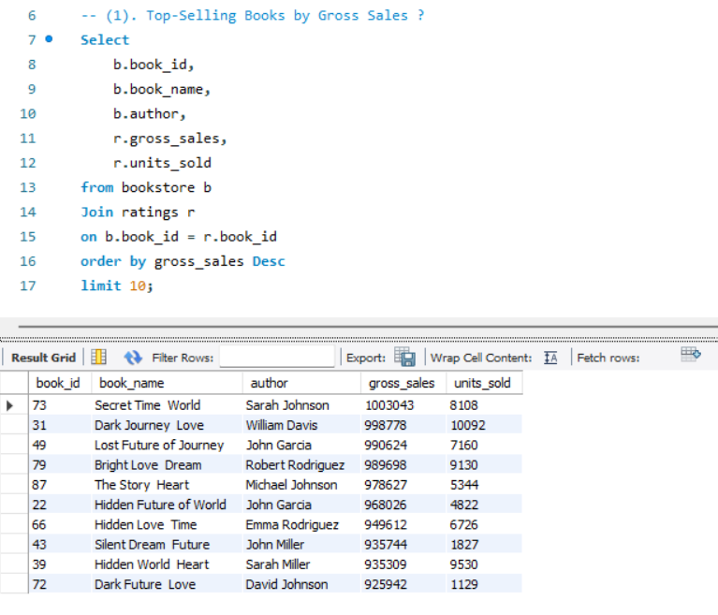
Insight: These books achieved outstanding commercial success.
(2). Average Rating by Genre?
Input:
Output: 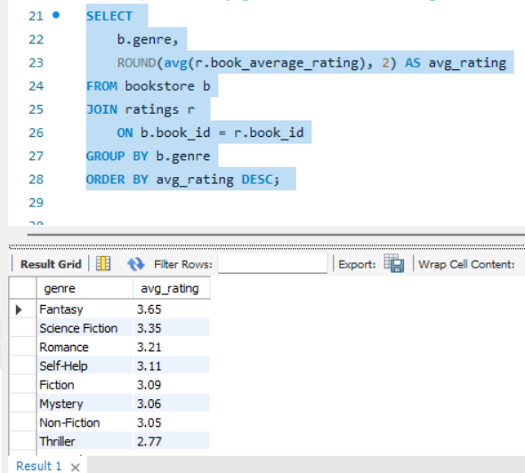
Insight: Some genres consistently perform better in terms of reader satisfaction.
(3). Publishers with Highest Revenue?
Input:
Output: 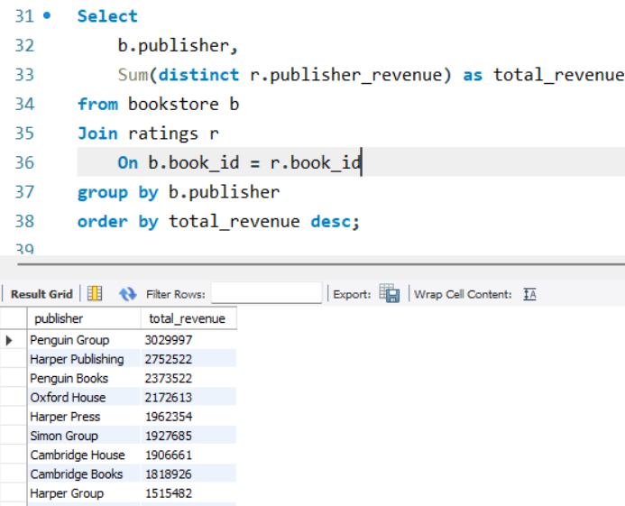
Insight: A few key publishers dominate total earnings.
(4). High-Rated Books Published in 2012, Selected books from 2012 with average rating > 4.0
Input:
Output: 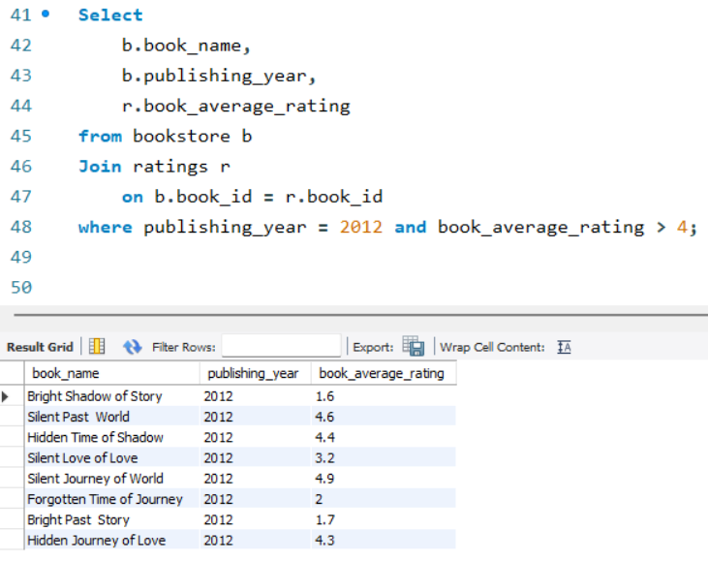
Insight: Identifies high-performing books released that year.

(5). Prolific Authors and Their Ratings –“"Used a CTE to find authors with more than one book and their average author rating"?
Input:
Output: 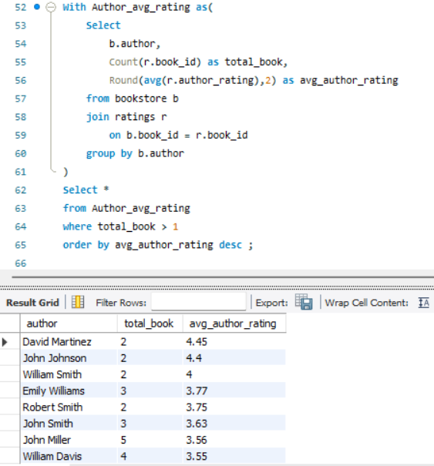
Insight: Some authors consistently deliver high-rated content across multiple books.
(6). Hidden Gems: High Rating, Low Sales- "Identified books with high ratings but low sales (< 1000 units)"?
Input:
Output: 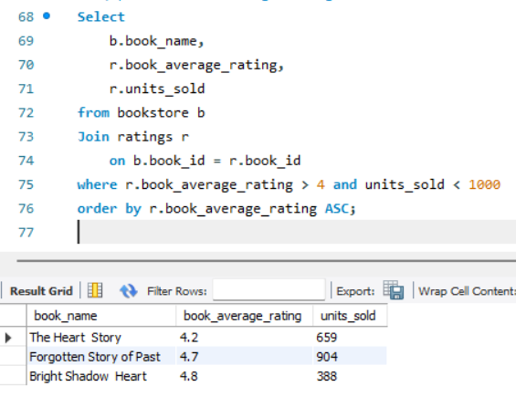
Insight: These books may be underrated or under-marketed.

(7). Profit Margin per Book - “Calculated as Gross Sales - Publisher Revenue” ?
Input:
Output: 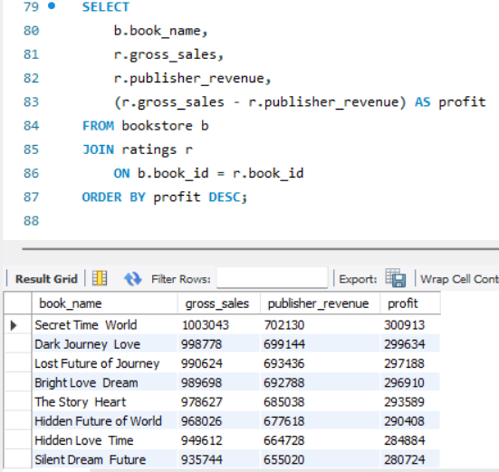
Insight: Books with higher margins are more profitable regardless of units sold.
(8). Most Rated English Books – (“Fetched top 5 most-rated books where the language was English”)
Input:
Output: 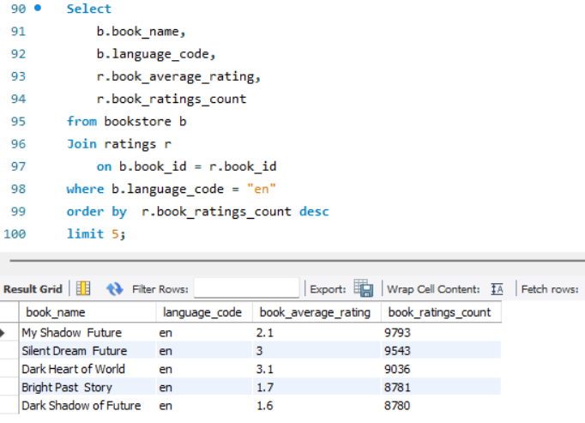
Insight: Indicates popularity and reader engagement in English titles.

(9). Sales by Publishing Year - ("Aggregated total units sold and gross sales year-wise")

Input:
Output: 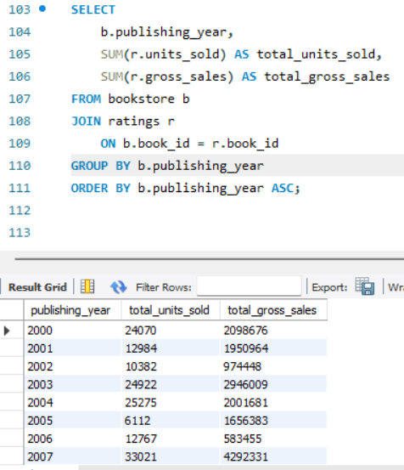

(10). Author Rating > Book Rating – (“Found cases where the author's rating exceeds the book’s average rating”)
Input:
Output: 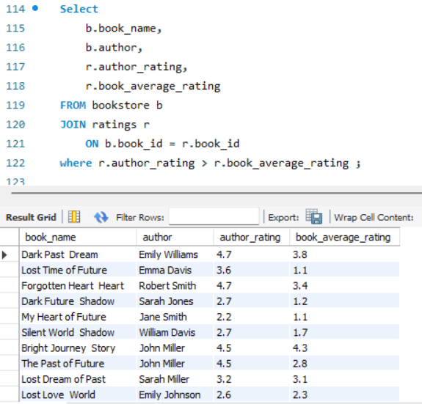
Insight: Possibly reflects author hype or book underperformance.

