AI-Assisted Development: Duraserv BC Integration
Oct 28, 2026 · @Abc

Summary
On the Duraserv development project I used Claude Code (Anthropic's AI coding assistant) as a pair-programmer for research, initial design, code and test cases. It produced first drafts quickly; I reviewed, decided, deployed and tested everything against the real systems.
The result was a noticeably shorter path from requirement to tested build, faster turnaround on change requests, and documentation that stayed current as the work progressed.

Tools used
Tool | Role
Claude Code (Anthropic) | AI assistant for research, design, code, test cases and documentation
Azure (Functions, SQL, Event Hub, Key Vault) | Project platform, unchanged
Postman, SQL client, BC Sandbox | My own verification of everything the AI produced

How Claude Code was used
Area | How it helped
Research | Explained platform APIs, limits and options before building, so decisions were made earlier and with fewer surprises
Initial design | Drafted architecture and data-flow options with trade-offs for me to choose from
Code | Generated first drafts of functions, SQL scripts and configuration from requirements and field mappings
Test cases | Wrote unit tests with mocked services alongside the code, covering normal, error and retry scenarios
Troubleshooting | Diagnosed failures from real error messages and proposed targeted fixes
Documentation | Produced README, runbook and handover (KT) material as the code changed

Implementation approach
Every change went through the same short loop. I brought the requirement and context; Claude Code drafted; I reviewed, deployed and tested against the real systems.
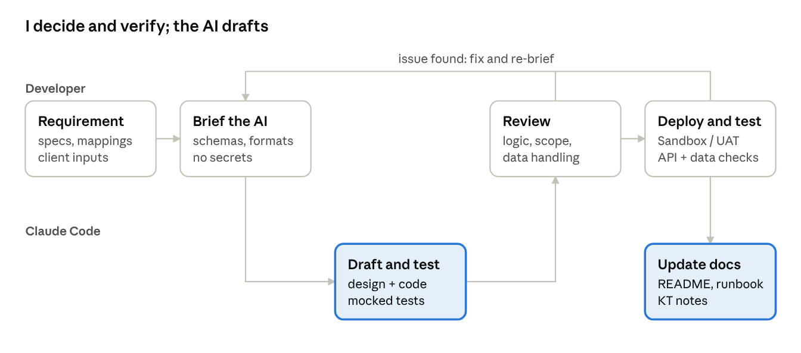
working loop · developer and AI assistant
When a review or a Sandbox/UAT test found a problem, I fed the actual error or real schema back to the assistant and repeated the loop. Nothing was deployed without passing my review and a real-system test.

Key steps
- Set up: started using Claude Code on the project with company-appropriate rules: no credentials, no production data, technical context only.
- Research first: for each new area, asked Claude Code to explain the relevant platform APIs and constraints before any build.
- Initial design: had it propose the design and options; agreed the approach with the team and client.
- Build in small increments: generated code one feature at a time, with unit tests in the same step.
- Review and verify: reviewed each change myself, then deployed and tested it in Sandbox/UAT.
- Feed back real results: gave errors and actual API/schema formats back to Claude Code for precise fixes.
- Document as you go: updated technical docs and handover notes with each change.

Time saved and speed
Figures below are my estimates against doing the same work without AI assistance.
Activity | Without AI | With Claude Code | Gain
Research (APIs, platform limits) | [x] days | [x] hours | [x]%
Initial design | [x] days | [x] hours | [x]%
Coding (first working version) | [x] days | [x] days | [x]%
Unit test cases | [x] days | [x] hours | [x]%
Change requests (typical) | [x] days | same day | [x]%
Documentation / KT | [x] days | [x] hours | [x]%
Overall |  |  | ~[x]% faster
Where the speed came from:
- First drafts in minutes: design options, code and tests no longer started from a blank page.
- Less time searching documentation: API behaviour and limits explained on request, with the reasoning.
- Tests written with the code: edge cases and failure paths covered from the start, so fewer issues reached UAT.
- Quick change turnaround: new requirements from the client or partner team were usually implemented and unit-tested the same day.
- Faster debugging: real error messages turned into targeted fixes quickly.

Guardrails and policy alignment
- No system access: Claude Code had no access to client systems, databases or environments; all execution was by me.
- No sensitive data: no credentials, keys, tokens or production data were shared. Only technical context (structures, formats, error messages) was used.
- Human in control: every output was reviewed by me; design and business decisions were made with the team and client.
- Standard release process: AI-generated code went through the same testing and deployment steps as any other code. The deployed solution does not depend on the AI tool.

Lessons learned and next steps
- Verify assumptions early: giving the AI real schemas and API responses up front avoids rework.
- Mocked tests are a start, not the finish: real-environment testing is still essential.
- Ask for the simplest solution: it keeps code easy to review and maintain.
- Next: share this way of working with the wider team as a lightweight guideline for AI-assisted development.

