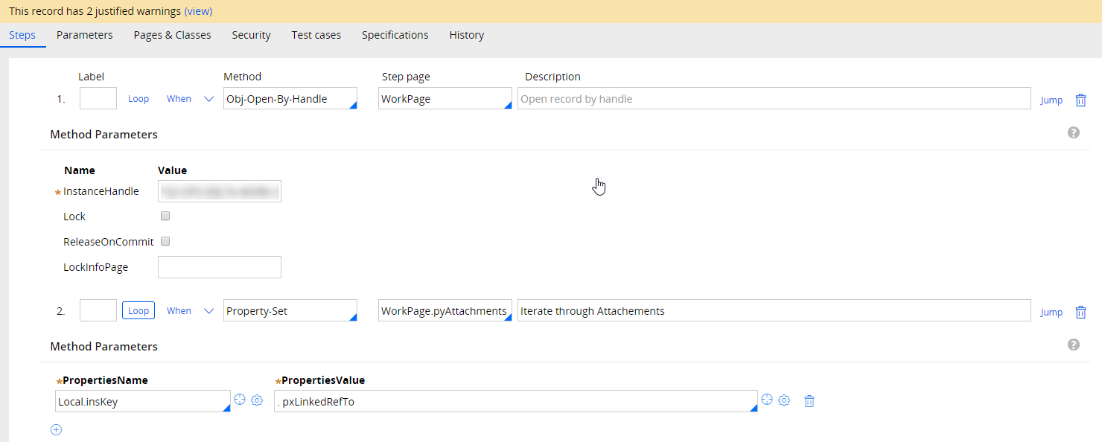

Get Attachment Stream from work objects By populating pyAttachmentPage

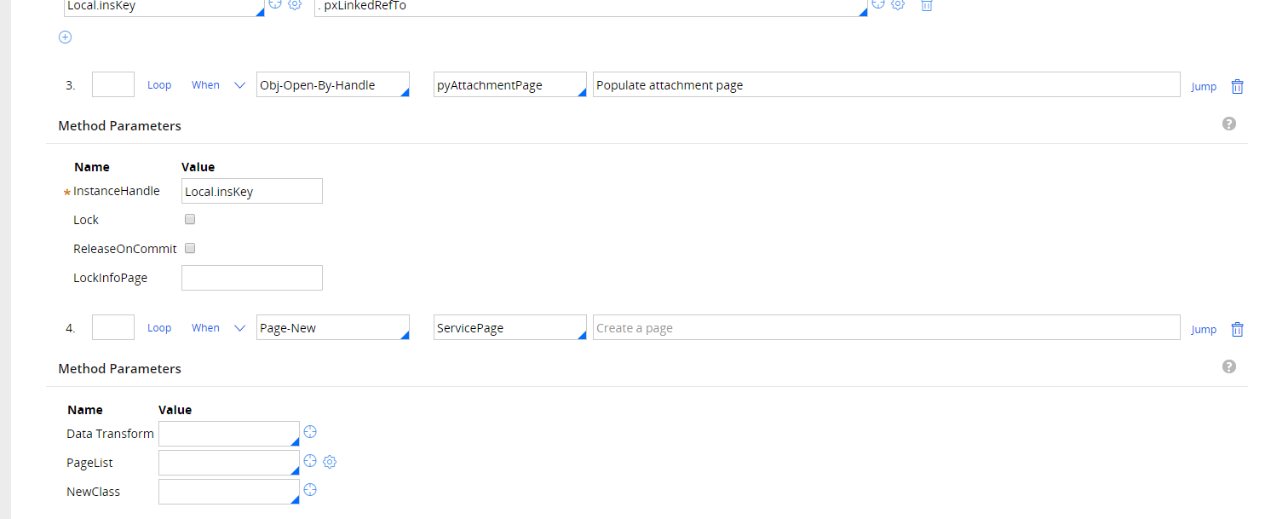

Populate pyRequestAttachmentPage with Request information, wither text or documents

