PhD CREDIT SEMINAR · STUDY GUIDE
Remote Sensing for Quantifying Aerosol Impact on Terrestrial Ecosystem Productivity
Slide-by-slide explanation of every concept, table and figure, from simple to scientific, with likely questions and answers
Animesh Panda · Roll No. 13098 · Ph.D. 2nd Year
Chairman: Rabi N. Sahoo · Seminar Leader: Subash Nataraja Pillai

How to use this guide
This guide follows your 60-slide presentation exactly. Part A defines the core terms once, from simple to scientific. Part B explains every slide in the same order: a picture of the slide, the message in simple words, each concept from simple to scientific, what the table and figure show, key numbers to remember, and likely questions with model answers. Part C collects the key equations, Part D gives a 20-point quick revision, and Part E gives general viva questions.
Suggested way to study: first read Part A until every term is clear; then read Part B one section at a time, saying the 'simple words' paragraph aloud as if presenting; then practise the questions without looking at the answers. Notes in shaded boxes point out places where the slide needs care (a duplicated slide, a missing title, or a reference that does not support a row).
To update the table of contents after opening the file in Word, right-click it and choose 'Update field'.

Part A · Core concepts and glossary
These are the terms used throughout the seminar. If you understand these 26 terms, you can follow every slide.
Aerosol
Simple: Tiny solid or liquid particles floating in the air, such as smoke, dust, soot and haze droplets.
Scientific: A suspension of particles (about 0.001–100 µm) in air. Classified by source (natural, anthropogenic), formation (primary, secondary), size (fine ≤ 1 µm radius, coarse ≥ 1 µm) and composition (sulfate, nitrate, black carbon, organic carbon, dust, sea salt).
Aerosol optical depth (AOD, τ)
Simple: A number that says how much the haze dims the sun. 0.1 is clean, 0.5 hazy, above 1 very polluted.
Scientific: The vertical integral of the aerosol extinction coefficient at a wavelength (usually 550 nm); direct-beam transmission is e^{−τ/cosθ}. Dimensionless.
Ångström exponent (α)
Simple: Tells whether particles are small (smoke, pollution) or large (dust).
Scientific: τ(λ) = βλ^{−α}; α > 1 fine particles, α < 0.5 coarse particles. Calculated from AOD at two wavelengths.
Single-scattering albedo (SSA, ω₀)
Simple: Tells whether particles mainly bounce light (scatter) or soak it up (absorb).
Scientific: Ratio of scattering to total extinction; 1 = pure scattering. Sulfate ≈ 0.98, dust 0.92–0.95, smoke 0.84–0.94.
Asymmetry parameter (g)
Simple: Tells whether scattered light mostly continues forward (downward) or goes back.
Scientific: Mean cosine of the scattering angle, −1 to +1; aerosols ≈ 0.6–0.75 (mostly forward).
Black carbon
Simple: Soot from burning; it darkens and heats the air.
Scientific: Strongly absorbing carbonaceous aerosol from incomplete combustion; low SSA; positive (warming) atmospheric forcing; reduces global GPP (≈ −0.28 Pg C yr⁻¹, Zhou et al., 2022).
Secondary organic aerosol (SOA)
Simple: Particles formed in the air from gases released by plants or pollution.
Scientific: Formed by oxidation of volatile organic compounds (isoprene, terpenes, aromatics) and gas-to-particle conversion; mostly scattering.
Radiative forcing
Simple: A change in the Earth's energy balance caused by something like greenhouse gases or aerosols.
Scientific: Change in net radiative flux (W m⁻²) at the top of the atmosphere or surface; effective radiative forcing includes rapid adjustments. Aerosol total ≈ −1.3 W m⁻² (IPCC AR6).
Direct, semi-direct and indirect effects
Simple: Haze dims sunlight directly; soot heats air and burns off clouds; particles seed brighter, longer-lived clouds.
Scientific: Aerosol–radiation interaction (scattering and absorption), adjustments due to absorption-induced heating, and aerosol–cloud interaction (CCN effects on droplet number, albedo, lifetime and precipitation).
PAR
Simple: The part of sunlight that plants use for photosynthesis.
Scientific: Photosynthetically active radiation, 400–700 nm; ≈ 45–50% of shortwave energy; in W m⁻² or µmol photons m⁻² s⁻¹.
Direct and diffuse radiation
Simple: Direct light comes straight from the sun and casts sharp shadows; diffuse light comes from the whole sky after scattering.
Scientific: Direct-beam irradiance from the solar disc and diffuse irradiance scattered by molecules, aerosols and clouds; diffuse fraction f_{dif} = diffuse/global.
Dimming
Simple: Less sunlight reaching the ground.
Scientific: Reduction in surface irradiance due to aerosol (and cloud) extinction; 'global dimming' refers to the observed decline in surface solar radiation from the 1950s to 1980s.
Diffuse fertilization effect (DFE)
Simple: Hazy, soft light helps plants photosynthesise more efficiently.
Scientific: Increase in canopy light-use efficiency and GPP when the diffuse fraction increases, because diffuse light reaches light-limited shaded leaves while sunlit leaves are saturated.
Sunlit and shaded leaves
Simple: Leaves in direct sun versus leaves in shade inside the canopy.
Scientific: Sunlit leaves receive direct plus diffuse light and are often light-saturated; shaded leaves receive only diffuse light and are light-limited. Two-leaf models treat them separately.
FAPAR and APAR
Simple: The fraction of PAR absorbed by leaves, and the amount absorbed.
Scientific: FAPAR from satellite (MOD15) or NDVI; APAR = FAPAR × PAR.
Light-use efficiency (LUE, ε)
Simple: How much carbon plants fix per unit of light absorbed.
Scientific: GPP/APAR, in g C MJ⁻¹; higher under diffuse light (1.12–1.80×; Kanniah et al., 2012). Shu et al. (2022) fitted LUE_{dif} = 3.61 and LUE_{dir} = 1.68 g C MJ⁻¹.
GPP
Simple: All the carbon plants take in by photosynthesis.
Scientific: Gross primary productivity, g C m⁻² per time; GPP = APAR × ε in LUE models; from flux towers by partitioning NEE.
NPP
Simple: The carbon plants keep for growth after their own breathing.
Scientific: Net primary productivity = GPP − autotrophic respiration.
NEE and NEP
Simple: The net carbon the whole ecosystem gains or loses.
Scientific: NEP = NPP − heterotrophic respiration; NEE is the net CO₂ flux measured by eddy covariance, NEE ≈ −NEP (negative = uptake).
Eddy covariance
Simple: A tower method that measures how much CO₂ the ecosystem breathes in or out.
Scientific: NEE = ρ_{a}·cov(w′, c′) from 10–20 Hz measurements of vertical wind and CO₂; 30-minute fluxes; footprint ≈ 1 km².
Vegetation indices (NDVI, EVI, NIRv)
Simple: Satellite 'greenness' numbers.
Scientific: Combinations of red, NIR and blue reflectance: NDVI = (NIR − R)/(NIR + R); EVI adds blue and soil terms; NIRv = NDVI × NIR. Indicate canopy structure, not instantaneous photosynthesis.
SIF
Simple: A faint glow emitted by leaves during photosynthesis, measured by satellites.
Scientific: Solar-induced chlorophyll fluorescence, 650–800 nm, retrieved from Fraunhofer-line infilling; SIF ≈ APAR × fluorescence yield × escape; closely related to GPP.
MAIAC, Dark Target, Deep Blue
Simple: Methods for calculating haze from satellite images.
Scientific: MODIS AOD algorithms: Dark Target (dark vegetation, 2.1 µm surface relation, 10/3 km), Deep Blue (blue bands over bright land, 6–10 km), MAIAC (time-series, 1 km).
AERONET
Simple: A worldwide network of ground instruments that measure haze very accurately.
Scientific: Federated network of CIMEL sun–sky photometers; AOD at 340–1020 nm, SSA, size distribution; Level 2.0 is the reference for satellite validation.
Inverted-U (optimum) response
Simple: A little haze helps plants, too much hurts; the curve rises then falls.
Scientific: Non-linear response of productivity to AOD with a maximum at an optimum AOD (≈ 0.4–0.9 in different studies), because the diffuse gain saturates while dimming continues.
Natural experiment
Simple: A real event that changes haze suddenly while other things stay similar.
Scientific: Exogenous variation in aerosol (lockdowns, weekly emission cycle, volcanic eruptions) used to infer causal effects in observational data.

Part B · Slide-by-slide explanation

Slide 1: Title slide
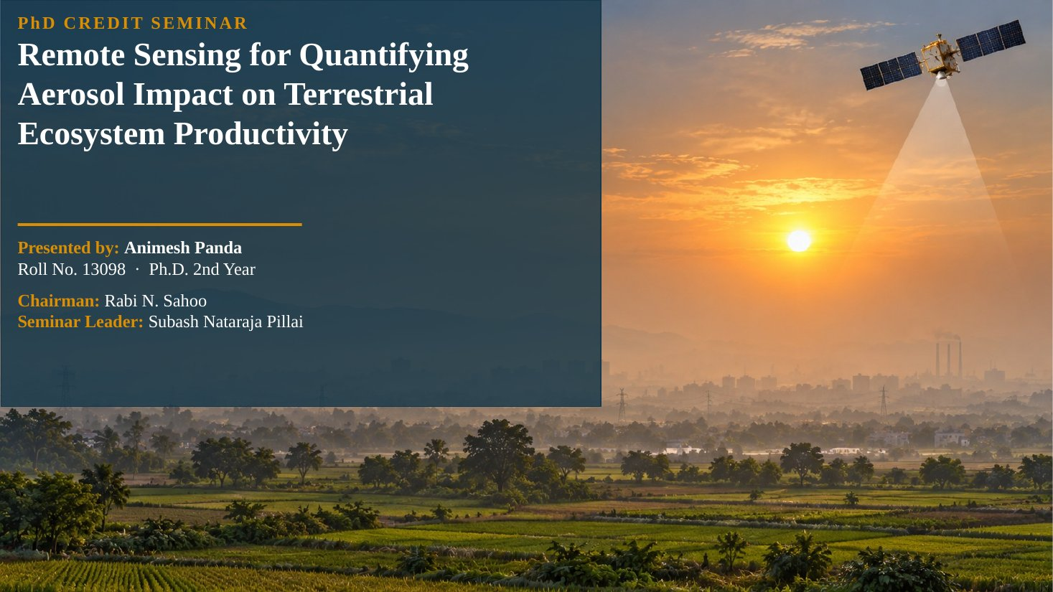
Slide 1
What this slide says, in simple words
The title tells the audience three things at once: the problem (aerosols, the tiny particles that make the sky hazy), the thing affected (terrestrial ecosystem productivity, meaning how much carbon land plants fix by photosynthesis) and the tool (remote sensing, meaning measurement from satellites and other instruments at a distance).
In one sentence, the seminar asks: how do satellites and related instruments help us measure how much haze changes the growth of forests and crops?
Concepts explained: from simple to scientific
Remote sensing. Simply, it means measuring something without touching it. Scientifically, it is the acquisition of information about the Earth's surface and atmosphere from the electromagnetic radiation that is reflected, emitted or scattered, recorded by sensors on satellites, aircraft or the ground. In this seminar, remote sensing gives aerosol optical depth (AOD), the amount of light reaching the ground, and indicators of plant photosynthesis such as vegetation indices and solar-induced fluorescence (SIF).
Quantifying. Not just saying aerosols 'affect' plants, but putting a number on the effect, for example 'GPP increased by 16.5% when AOD fell by 23.8%' or 'aerosol reduced rice yield by 7.9%'. Quantification needs good measurements of both sides (aerosol and productivity) and a method to separate the aerosol effect from weather and other drivers.
Terrestrial ecosystem productivity. The rate at which land vegetation captures carbon dioxide and converts it into organic matter. It is expressed as GPP (gross primary productivity), NPP (net primary productivity), NEE or NEP (net ecosystem exchange or production) and, for crops, yield. These terms are explained in detail at Slide 16.
The figure explained
The background photograph shows a hazy sunrise over cropland with a satellite above, which summarises the topic: sunlight passing through a polluted layer before reaching the crops, and a satellite observing both the haze and the vegetation.
Likely questions and model answers
Q1. Why did you choose this topic?
Because aerosol loading over India, especially over the Indo-Gangetic Plain, is among the highest in the world and is still rising, while this region produces a large share of India's food grains. Aerosols change both the amount and the quality (direct versus diffuse) of sunlight that drives photosynthesis, and yet very few studies have quantified this for India. Remote sensing is the only practical way to observe aerosol, light and vegetation together over such a large area.
Q2. What is the difference between 'impact' and 'effect' in your title?
They are used in the same sense: the change in productivity caused by aerosols. The important scientific point is that the impact can be positive (more diffuse light helps shaded leaves) or negative (less total light, less rain, ozone damage), so the net impact must be quantified case by case.

Slide 2: Seminar outline

Slide 2
What this slide says, in simple words
This slide is the road map. The seminar moves logically from the problem, to how each side is measured, to how the two are linked, to the mechanisms, the evidence, two detailed case studies, the challenges and the conclusions.
Remember the story: aerosol is the cause; light and climate are the pathways; the canopy is the receiver; productivity is the outcome; remote sensing measures each step.
Concepts explained: from simple to scientific
Why this order. The order follows the causal chain of the conceptual framework (Slide 4). You cannot discuss mechanisms without first defining aerosols and productivity, and you cannot judge evidence without knowing the measurement methods and their limitations. Case studies come after the general evidence so that the audience can see how one study applies all the earlier concepts.
The ten parts. (1) Introduction: why the topic matters and the framework. (2) Atmospheric aerosols: types, distribution, trends, optical and radiative properties. (3) Remote sensing of aerosols and radiation: ground networks, satellites, lidar, reanalysis, direct and diffuse PAR. (4) Remote sensing of productivity: concepts, flux towers, vegetation indices, SIF and products. (5) Linking methods: statistics, natural experiments, process models.
(6) Mechanisms: light route, climate route, ozone and aerosol type, optimum load, modulating factors. (7) Evidence: ecosystems, crops, India. (8) Case studies: Wang et al., 2021 and Shu et al., 2022. (9) Challenges. (10) Conclusions.
Likely questions and model answers
Q1. How are your two case studies connected to the rest of the seminar?
Case study 1 (Wang et al., 2021) applies field measurements, a leaf-to-canopy photosynthesis model and satellite SIF to test the optimum aerosol load in a cropland. Case study 2 (Shu et al., 2022) applies the light-use-efficiency modelling idea at global scale, building an aerosol-aware LUE model and mapping the aerosol effect on GPP. One is field-to-region, the other ecosystem-to-globe, so together they cover both scales of the seminar.

Section 1 · Introduction

Slide 3: Why aerosol–productivity interactions matter
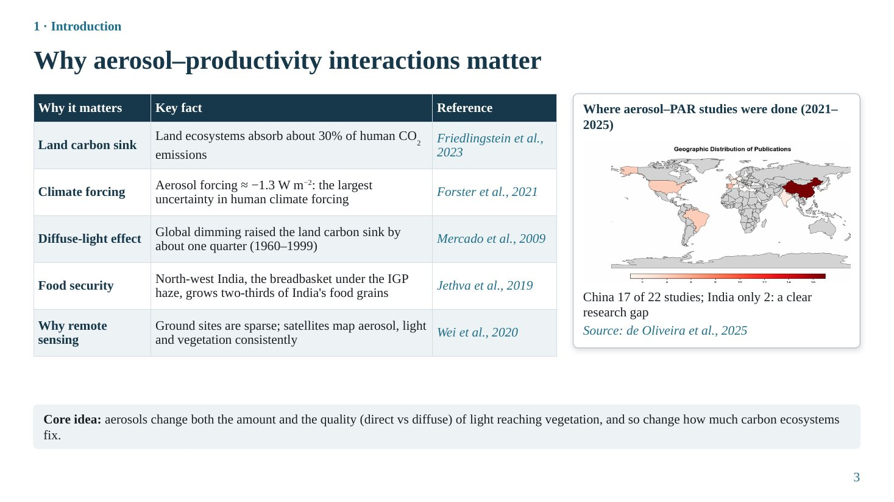
Slide 3
What this slide says, in simple words
This slide answers 'why should anyone care?'. Land plants remove a large part of the carbon dioxide we emit; aerosols are a big unknown in climate change; haze can actually help plants by making light diffuse; India's food basket sits under one of the haziest skies in the world; and only satellites can watch all of this at once. Yet almost no aerosol–light–plant studies come from India.
Concepts explained: from simple to scientific
Land carbon sink (about 30%). Of the CO₂ humans emit each year, roughly 30% is taken up by land ecosystems (Friedlingstein et al., 2023, Global Carbon Budget), about a quarter by the oceans, and the rest stays in the atmosphere. So a small percentage change in photosynthesis over large areas changes the global carbon balance noticeably.
Aerosol radiative forcing (−1.3 W m⁻²). Radiative forcing is the change in the Earth's energy balance caused by a factor, in watts per square metre. Greenhouse gases give positive forcing (warming); aerosols give negative forcing (cooling) by reflecting sunlight and by making clouds brighter. The IPCC Sixth Assessment Report (Forster et al., 2021) estimates total aerosol effective radiative forcing at about −1.3 W m⁻², with a wide uncertainty range, which makes aerosols the largest single source of uncertainty in human climate forcing.
Diffuse-light effect (one quarter of the sink). Aerosols scatter sunlight, so more of it arrives from all parts of the sky (diffuse light) instead of straight from the sun (direct beam). Plant canopies use diffuse light more efficiently. Mercado et al., 2009 estimated that the increase in diffuse light during the 'global dimming' period raised the land carbon sink by about one quarter between 1960 and 1999. This is the reason aerosols are not simply 'bad' for plants.
Food security. North-west India (Punjab, Haryana, western Uttar Pradesh) is India's breadbasket, producing about two-thirds of its food grains (Jethva et al., 2019). It lies under the Indo-Gangetic Plain (IGP) aerosol plume, so the question 'does haze help or harm crops' is directly a food-security question.
Why remote sensing. Ground stations measuring aerosol, radiation and carbon flux are few and represent only small areas. Satellites give consistent, repeated, large-area observations of aerosol, light and vegetation (Wei et al., 2020).
The table explained
The table has three columns: the reason, the key fact, and the reference. Read it row by row as five arguments for the topic: carbon cycle, climate, mechanism, food security and method.
The figure explained
The map is from the systematic review by de Oliveira et al., 2025, which screened studies on aerosol–photosynthetically active radiation (PAR) interactions published in 2021–2025. Darker colours mean more studies. China dominates with 17 of the 22 studies, followed by Spain (5) and the USA and Brazil (4 each); India has only 2. The message is a research gap: the most aerosol-loaded cropland region of the world is among the least studied.
Key numbers to remember
• Land sink ≈ 30% of human CO₂ emissions
• Aerosol ERF ≈ −1.3 W m⁻² (IPCC AR6)
• Diffuse effect raised the land sink by ≈ ¼ (1960–1999)
• North-west India ≈ ⅔ of India's food grains
• Aerosol–PAR studies 2021–2025: China 17 of 22, India 2
Likely questions and model answers
Q1. If aerosols reduce sunlight, how can they increase the carbon sink?
Because plants do not respond only to the amount of light but also to its distribution. Under clear skies the top, sunlit leaves are often light-saturated, so extra direct light is wasted, while shaded leaves inside the canopy are light-limited. Aerosol scattering converts part of the direct beam into diffuse light that reaches shaded leaves. If the gain in the shaded leaves is larger than the loss in the sunlit leaves, canopy photosynthesis increases even though total light decreased. This is called diffuse fertilization.
Q2. What is meant by 'effective radiative forcing'?
It is the change in net energy flux at the top of the atmosphere caused by an agent, after allowing fast adjustments of the atmosphere (temperature, clouds) but keeping sea-surface temperature fixed. For aerosols it includes both the aerosol–radiation interaction (direct effect plus adjustments) and the aerosol–cloud interaction.
Q3. Why is India under-represented in such studies?
Mainly because of data limitations: very few eddy-covariance flux towers over Indian croplands, few stations measuring diffuse radiation, and only a handful of AERONET sites. Satellite AOD is also less accurate over bright, heterogeneous Indian land surfaces, which makes attribution harder.

Slide 4: Conceptual framework: from emissions to ecosystem productivity
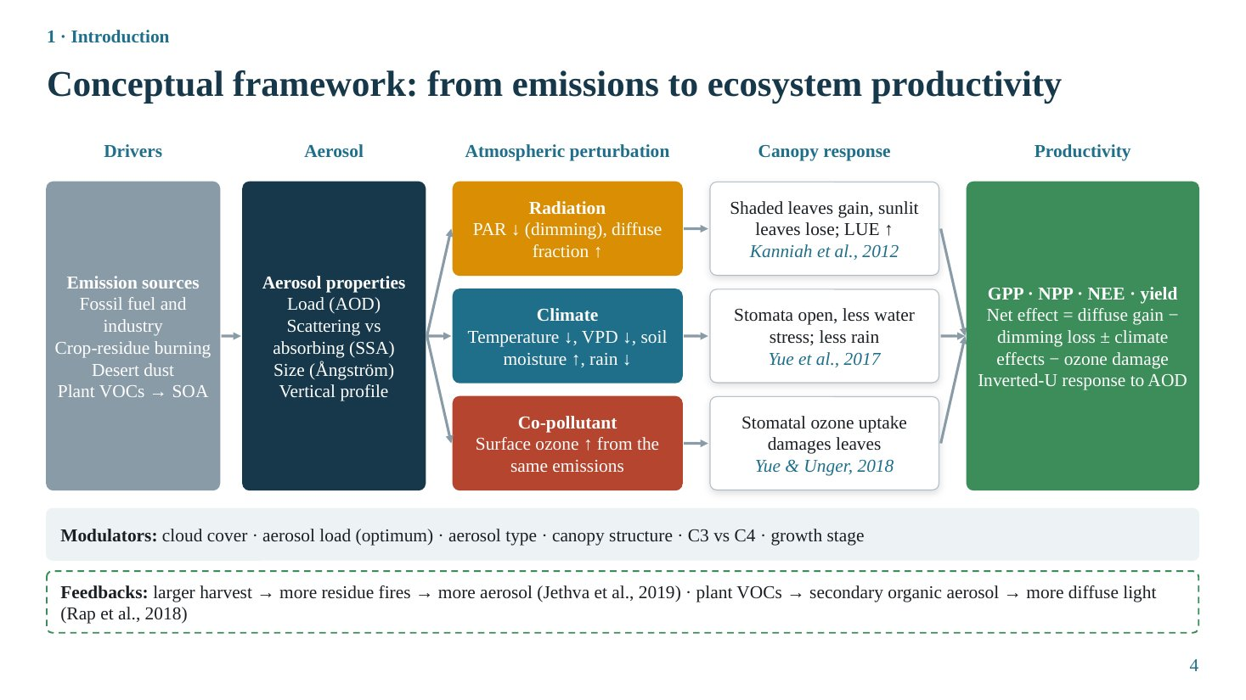
Slide 4
What this slide says, in simple words
This slide is the backbone of the seminar. It shows a chain: emissions create aerosols; aerosols change the atmosphere in three ways (light, climate, ozone); the canopy reacts to each change; and the sum of these reactions is the change in productivity. Some factors make the effect stronger or weaker (modulators), and some loops feed back (feedbacks).
Concepts explained: from simple to scientific
Drivers (emission sources). Aerosols come from fossil fuel and industry (sulfate, nitrate, black carbon), crop-residue burning (smoke: organic and black carbon), desert dust, and plant volatile organic compounds (VOCs) that oxidise into secondary organic aerosol (SOA).
Aerosol properties. Four properties decide the effect: (1) load, measured as aerosol optical depth (AOD); (2) whether particles scatter or absorb light, measured by single-scattering albedo (SSA); (3) size, indicated by the Ångström exponent; (4) vertical profile, i.e. at what height the layer lies. These are explained at Slide 9.
Route 1, radiation. Aerosol reduces photosynthetically active radiation (PAR, 400–700 nm), called dimming, but increases the diffuse fraction. The canopy responds because shaded leaves gain light while sunlit leaves lose some, so canopy light-use efficiency (LUE) increases (Kanniah et al., 2012).
Route 2, climate. Less sunlight cools the surface; lower temperature lowers the vapour pressure deficit (VPD, the drying power of air); less evaporation keeps soil wetter; but aerosol can also suppress rain. Plants respond with more open stomata and less water stress, but suffer when rain decreases (Yue et al., 2017).
Route 3, co-pollutant ozone. The same emissions (NO_{x} and VOCs) create surface ozone, which enters leaves through stomata and damages photosynthetic tissue (Yue & Unger, 2018). Ozone is not an aerosol, but it travels together with aerosol, so it must be separated in any attribution.
Net effect and inverted-U. Productivity change = diffuse-light gain − dimming loss ± climate effects − ozone damage. At low AOD the diffuse gain dominates, at high AOD the dimming loss dominates, so productivity first rises and then falls with AOD: an inverted-U curve (Slide 27).
Modulators. Cloud cover (cloudy light is already diffuse), aerosol load relative to the optimum, aerosol type, canopy structure (multi-layer canopies gain more), C3 versus C4 photosynthesis, and crop growth stage.
Feedbacks. Two loops: (1) in north-west India a bigger harvest leaves more residue, more burning and more aerosol (Jethva et al., 2019); (2) plants emit VOCs that form SOA, which increases diffuse light and so helps plants (Rap et al., 2018).
The figure explained
Read the diagram left to right. Grey box: drivers. Dark box: aerosol properties. Three coloured lanes: radiation (orange), climate (blue), ozone (red), each with its canopy response in a white box and a reference. Green box: productivity and the net-effect equation. The strip below lists modulators; the dashed box lists feedbacks.
Likely questions and model answers
Q1. Why do you include ozone in a seminar on aerosols?
Because ozone is produced from the same emissions and peaks in similar seasons, so in observations the two are confounded. If a study relates productivity to 'pollution' without separating ozone, part of the ozone damage may be wrongly attributed to aerosol. Globally, Yue & Unger (2018) estimated ozone damage of about −4.0 Pg C yr⁻¹ against an aerosol gain of about +1.0 Pg C yr⁻¹, so ignoring ozone would change the conclusion completely.
Q2. What does 'vertical profile' add to AOD?
AOD is a column total. The same AOD can come from a layer near the ground or from an elevated layer. Elevated absorbing layers heat the air aloft and stabilise the atmosphere (semi-direct effect) and change cloud formation, while near-surface aerosol affects air quality and humidity near the canopy. Lidar (CALIOP, EarthCARE) measures the profile.
Q3. Explain the reverse feedback in north-west India.
Jethva et al. (2019) found that from 2002 to 2016 the vegetation index rose by about 21% and post-harvest fire counts by about 60%. A bigger rice crop leaves more straw, which is burnt in October–November, raising aerosol. So in statistics, high productivity can cause high AOD, not only the reverse. This is called reverse causation and must be considered when interpreting correlations.

Section 2 · Atmospheric aerosols

Slide 5: Aerosol types and sources
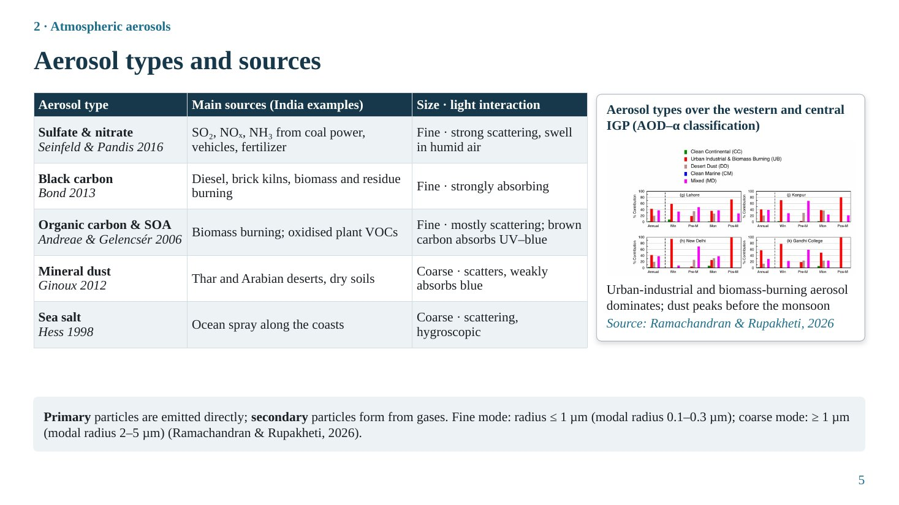
Slide 5
What this slide says, in simple words
Aerosols are tiny solid or liquid particles floating in air. Different kinds come from different sources, and they treat sunlight differently: some mostly bounce light around (scatter), some soak it up (absorb). Over the Indo-Gangetic Plain, pollution and smoke particles dominate most of the year, and dust is important before the monsoon.
Concepts explained: from simple to scientific
Definition. An aerosol is a suspension of fine solid or liquid particles in a gas. In atmospheric science the word usually refers to the particles themselves, with diameters from a few nanometres to tens of micrometres.
Sulfate and nitrate. Formed from gases (SO₂ from coal power, NO_{x} from vehicles, NH₃ from fertilizer) by chemical reactions in the air, so they are secondary aerosols. Fine, strongly scattering, and hygroscopic: they absorb water and grow in humid air, which increases AOD (Seinfeld & Pandis, 2016).
Black carbon (BC). Soot from incomplete combustion: diesel engines, brick kilns, biomass and crop-residue burning. Fine and strongly absorbing; it heats the air and darkens the sky without adding much diffuse light (Bond et al., 2013).
Organic carbon and secondary organic aerosol (SOA). From biomass burning and from oxidation of plant VOCs (isoprene, terpenes). Mostly scattering, although 'brown carbon' absorbs ultraviolet and blue light (Andreae & Gelencsér, 2006).
Mineral dust and sea salt. Dust from the Thar and Arabian deserts and dry soils is coarse, scatters, and weakly absorbs blue light (Ginoux et al., 2012). Sea salt from ocean spray is coarse, scattering and hygroscopic (Hess et al., 1998).
Primary versus secondary. Primary aerosols are emitted directly as particles (dust, sea salt, black carbon). Secondary aerosols form in the air from gases (sulfate, nitrate, SOA).
Fine versus coarse mode. Ramachandran & Rupakheti (2026) define fine mode as radius ≤ 1 µm (modal radius 0.1–0.3 µm) and coarse mode as ≥ 1 µm (modal radius 2–5 µm). Fine particles scatter far more visible light per unit mass, because their size is close to the wavelength of visible light.
The table explained
Each row is an aerosol type with its typical Indian sources and its size and light behaviour; the reference under the name is the standard source for that type. The most important column for productivity is the last one: scattering aerosols can add useful diffuse light, absorbing aerosols mainly remove light.
The figure explained
The figure (Ramachandran & Rupakheti, 2026) classifies aerosol at AERONET sites in the western and central IGP by combining AOD (amount) and Ångström exponent (size). Each bar shows the share of aerosol types by season: urban-industrial and biomass-burning aerosol (red) dominates in most seasons; desert dust (grey) peaks in the pre-monsoon; clean continental and mixed types make up the rest.
Key numbers to remember
• Fine mode: radius ≤ 1 µm (modal 0.1–0.3 µm)
• Coarse mode: radius ≥ 1 µm (modal 2–5 µm)
Likely questions and model answers
Q1. Why do fine particles scatter more light than coarse particles of the same mass?
Scattering efficiency per particle is highest when particle size is comparable to the wavelength (Mie regime, roughly 0.1–1 µm for visible light). For a given mass there are vastly more fine particles than coarse ones, and each is near the optimal size, so the mass scattering efficiency of fine particles is several times larger.
Q2. Which aerosol types are 'good' for plants?
Scattering types with high single-scattering albedo, such as sulfate, nitrate and most organic aerosol, can increase diffuse light at moderate loads. Black carbon mainly absorbs. Zhou et al. (2022) found that sulfate and nitrate give the largest global GPP gain, whereas black carbon reduces global GPP by about 0.28 Pg C yr⁻¹. But even scattering aerosol becomes harmful at high loads.
Q3. What is the AOD–Ångström classification?
A method to infer aerosol type from AERONET data: high AOD with high Ångström exponent (fine particles) indicates urban-industrial or biomass-burning aerosol; high AOD with low Ångström exponent (coarse) indicates dust; low AOD indicates clean continental or marine aerosol; intermediate combinations are 'mixed'.

Slide 6: AOD trends: global
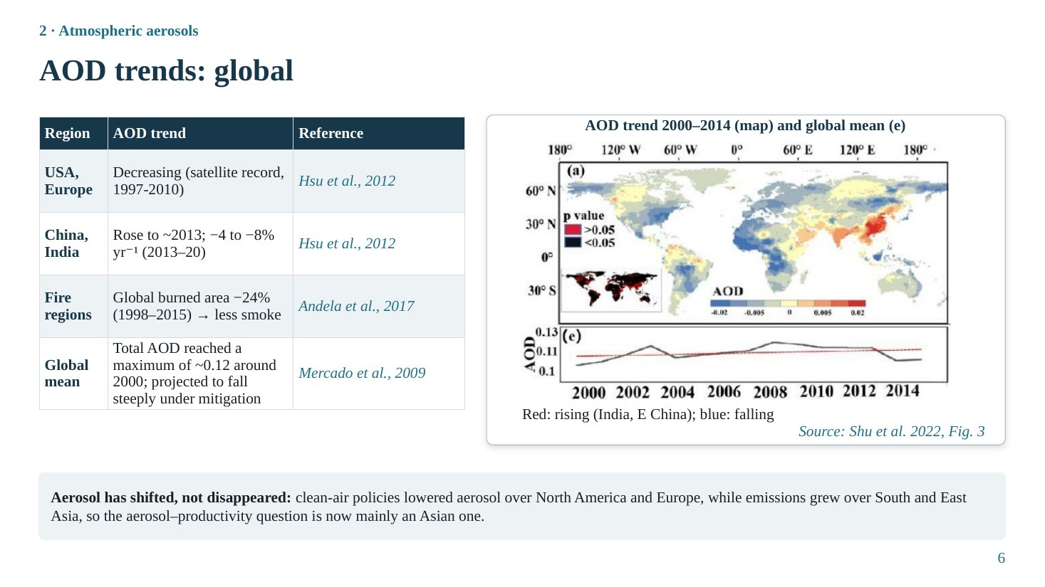
Slide 6
What this slide says, in simple words
Haze is not increasing everywhere. Over the USA and Europe it decreased because of clean-air laws; over China and India it increased with industrial growth. Fires in savannas decreased, so smoke there decreased too. The global average rose up to about the year 2000. The overall lesson: aerosol has moved from the West to Asia.
Concepts explained: from simple to scientific
Aerosol optical depth (AOD). A dimensionless number describing how much the whole column of aerosol attenuates light at a given wavelength (usually 550 nm). AOD 0.1 is clean; 0.5 is hazy; above 1.0 is very polluted. Defined fully at Slide 9.
Regional trends. Hsu et al. (2012), using the SeaWiFS Deep Blue record summarised in Wei et al. (2020), found decreasing AOD over the USA and Europe and increasing AOD over China and India in 1997–2010. Andela et al. (2017) found global burned area fell about 24% (1998–2015), mostly in savannas due to agricultural expansion, reducing smoke.
Long-term global picture. Mercado et al. (2009) used a reconstruction in which global mean AOD reaches about 0.12 around 2000 and declines steeply in a mitigation scenario.
The table explained
Read each row as region, direction of AOD change and source. Caution for questions: the row for China and India also states a decline of −4 to −8% per year after 2013. That decline applies to China (after its 2013 clean-air action plan), not India, and it does not come from Hsu et al. (2012), whose record ends in 2010. If asked, say that Indian AOD has continued to rise (Slide 8).
The figure explained
The figure is Fig. 3 of Shu et al. (2022). The map shows the per-pixel AOD trend for 2000–2014: red means increasing, blue decreasing. India and eastern China are red; parts of North America, Europe and the Amazon are blue. Black dots or hatching mark statistically significant trends (p < 0.05). Panel (e) below the map is the global mean AOD time series, which rises slightly over 2000–2014.
Key numbers to remember
• Burned area −24% (1998–2015)
• Global mean AOD maximum ≈ 0.12 around 2000
Likely questions and model answers
Q1. Why has AOD decreased in Europe and the USA?
Because of air-quality regulations since the 1970s–1990s (for example desulphurisation of power plants and vehicle emission standards) that cut SO₂ and particulate emissions, so sulfate aerosol decreased. This 'brightening' is the opposite of the earlier global dimming.
Q2. Does a falling global AOD mean the aerosol–productivity problem is disappearing?
No. Aerosol has shifted regionally. Over South Asia AOD is still rising and lies over intensive cropland. Also, where AOD falls, the diffuse-light benefit falls too; Mercado et al. projected the diffuse fertilization effect to decline to near zero by 2100 under mitigation.

Slide 7: Spatial and seasonal distribution of aerosols over South Asia
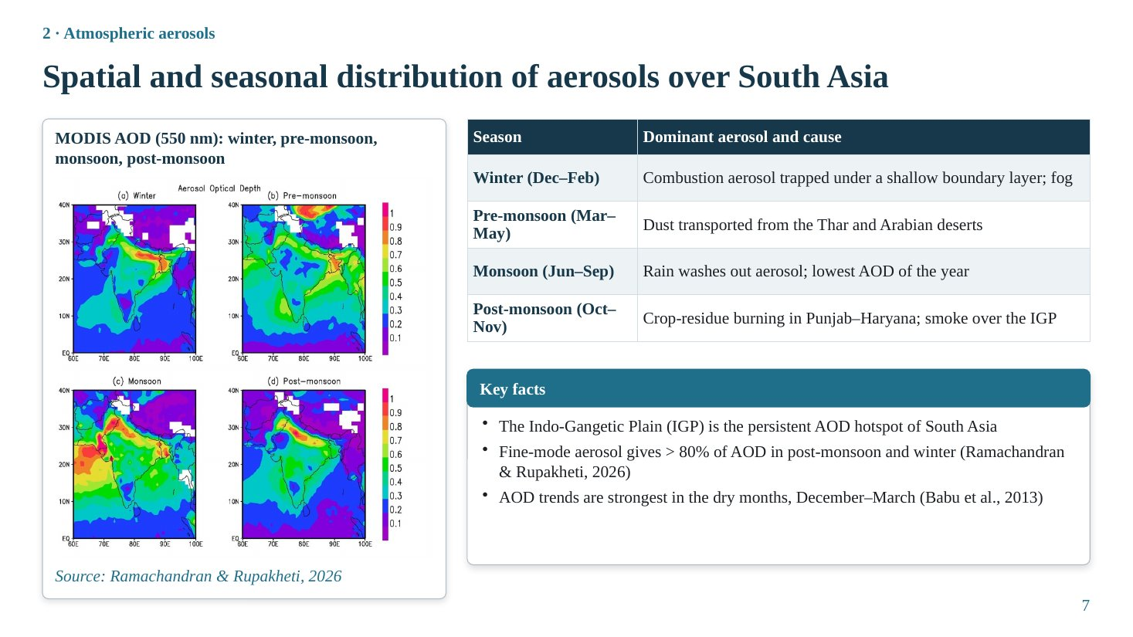
Slide 7
What this slide says, in simple words
Over South Asia, the Indo-Gangetic Plain (Punjab to West Bengal) is always the haziest place. Why the haze happens changes with season: winter smog trapped near the ground, pre-monsoon dust, monsoon rain washing the air, and post-monsoon smoke from burning crop residue.
Concepts explained: from simple to scientific
Why the IGP is a hotspot. It has very high population, industry, vehicles, thermal power plants and agricultural burning, and it is bounded by the Himalaya to the north, which blocks dispersion, so particles accumulate.
Boundary layer. The atmospheric boundary layer is the lowest part of the atmosphere, mixed by surface heating. In winter it is shallow (a few hundred metres) and stable, often with temperature inversions and fog, so emissions are trapped near the ground.
Seasonal cycle. Winter (Dec–Feb): combustion aerosol under a shallow boundary layer. Pre-monsoon (Mar–May): dust from the Thar and Arabian deserts carried by westerly winds. Monsoon (Jun–Sep): rain scavenging gives low AOD in many areas, although humid growth and dust can keep AOD high in places. Post-monsoon (Oct–Nov): rice-residue burning in Punjab and Haryana.
Fine-mode dominance. More than 80% of AOD in post-monsoon and winter comes from fine-mode particles at almost all sites (Ramachandran & Rupakheti, 2026), i.e. combustion and smoke. AOD trends are strongest in December–March (Babu et al., 2013), which coincides with the rabi wheat season.
The table explained
The table is a seasonal calendar: each season, the dominant aerosol and the reason. Link it to crops: post-monsoon smoke falls at kharif harvest and rabi sowing; winter haze covers the wheat crop; pre-monsoon dust coincides with wheat ripening and harvest.
The figure explained
Four MODIS AOD (550 nm) maps for winter, pre-monsoon, monsoon and post-monsoon (Ramachandran & Rupakheti, 2026). Colour scale from purple (≈ 0.1) to red/magenta (≥ 0.9). In every season a band of high AOD lies along the IGP. In the pre-monsoon, high AOD also appears over the Arabian Sea and north-west (dust). White patches are missing data (clouds, snow or bright surfaces).
Key numbers to remember
• Fine mode > 80% of AOD in post-monsoon and winter
• Strongest AOD trends: December–March
Likely questions and model answers
Q1. Why is AOD sometimes high even in the monsoon?
Two reasons: hygroscopic growth (very humid air makes sulfate and other particles swell, increasing their scattering) and dust transport into the western IGP and Arabian Sea before and during early monsoon. Cloud contamination of satellite retrievals can also bias monsoon AOD high.
Q2. Which crop is most exposed to haze in the IGP?
Rabi wheat, because the strongest AOD and its strongest increasing trend occur in December–March, the main wheat growing season. Rice is exposed to post-monsoon smoke near harvest.

Slide 8: AOD trends: South Asia
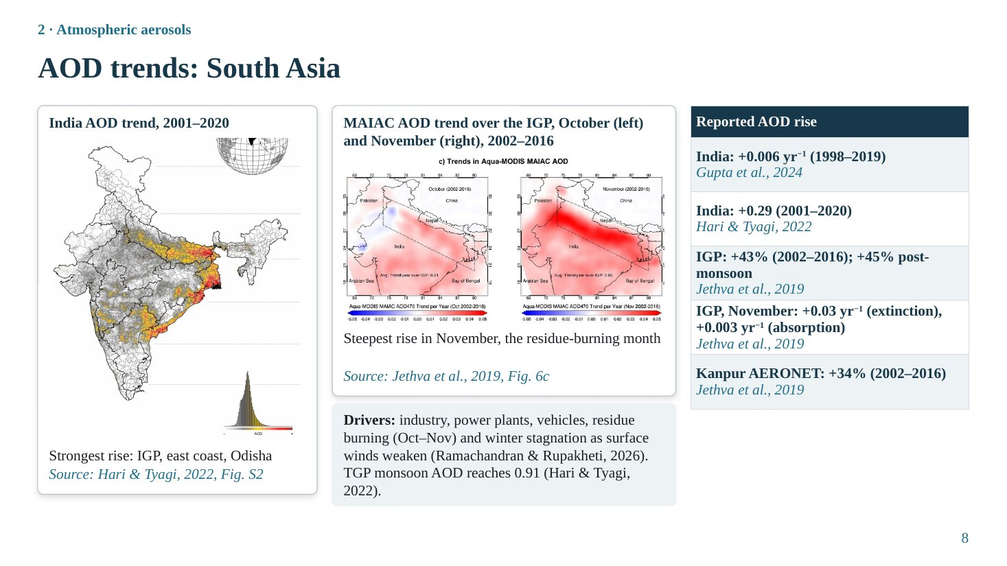
Slide 8
What this slide says, in simple words
Haze over India has been increasing for two decades, and the strongest rise is over the Indo-Gangetic Plain, the east coast and Odisha. The jump is biggest in November, the month of stubble burning. A ground station at Kanpur confirms what the satellites show.
Concepts explained: from simple to scientific
MAIAC. Multi-Angle Implementation of Atmospheric Correction: a MODIS algorithm that retrieves AOD at 1 km resolution using a time series of images to separate the slowly changing surface from the fast-changing aerosol (Slide 13).
Extinction vs absorption AOD. Extinction AOD includes both scattering and absorption. Absorption AOD (from OMI ultraviolet measurements) counts only the absorbing part. Jethva et al. found both increasing in November over the IGP, meaning both scattering and absorbing smoke increased.
Drivers. Industry, thermal power, vehicles, residue burning in October–November, and winter stagnation intensified by weakening surface winds (Ramachandran & Rupakheti, 2026).
The table explained
Each row is one quantitative estimate of the rise, with its source: India +0.006 per year (Gupta et al., 2024, 1998–2019); India +0.29 (Hari & Tyagi, 2022, 2001–2020); IGP +43% overall and +45% post-monsoon (Jethva et al., 2019, 2002–2016); IGP November trends +0.03 per year in extinction AOD and +0.003 per year in absorption AOD; and Kanpur AERONET +34%.
The figure explained
Left map (Hari & Tyagi, 2022, Fig. S2): MODIS AOD trend over India for 2001–2020; warm colours (strongest increase) along the IGP, east coast and Odisha.
Right maps (Jethva et al., 2019, Fig. 6c): MAIAC AOD trend for October (left) and November (right), 2002–2016. October shows weak trends; November shows a strong positive trend over the whole IGP, matching the timing of rice-residue burning.
Key numbers to remember
• India AOD +0.006 yr⁻¹ (1998–2019)
• India AOD +0.29 (2001–2020)
• IGP aerosol +43% (2002–2016); +45% post-monsoon
• IGP November: +0.03 yr⁻¹ extinction, +0.003 yr⁻¹ absorption
• Kanpur AERONET +34% (2002–2016)
• TGP monsoon AOD up to 0.91
Likely questions and model answers
Q1. How do you know the satellite trend is real and not an instrument artefact?
Because the independent ground-based AERONET sun photometer at Kanpur, in the centre of the IGP, shows a similar increase (about 34%, roughly 0.03 per year) over 2002–2016. Agreement between a ground instrument and satellite products makes an artefact unlikely.
Q2. Why is the November trend stronger than October?
Rice harvest with combine harvesters in Punjab and Haryana leaves loose straw, and the short window before wheat sowing encourages burning, which peaks in late October and November. Jethva et al. linked the rise in fire counts (≈ 60%) and vegetation index (≈ 21%) to the rise in November AOD.

Slide 9: Aerosol optical properties that control light at the canopy
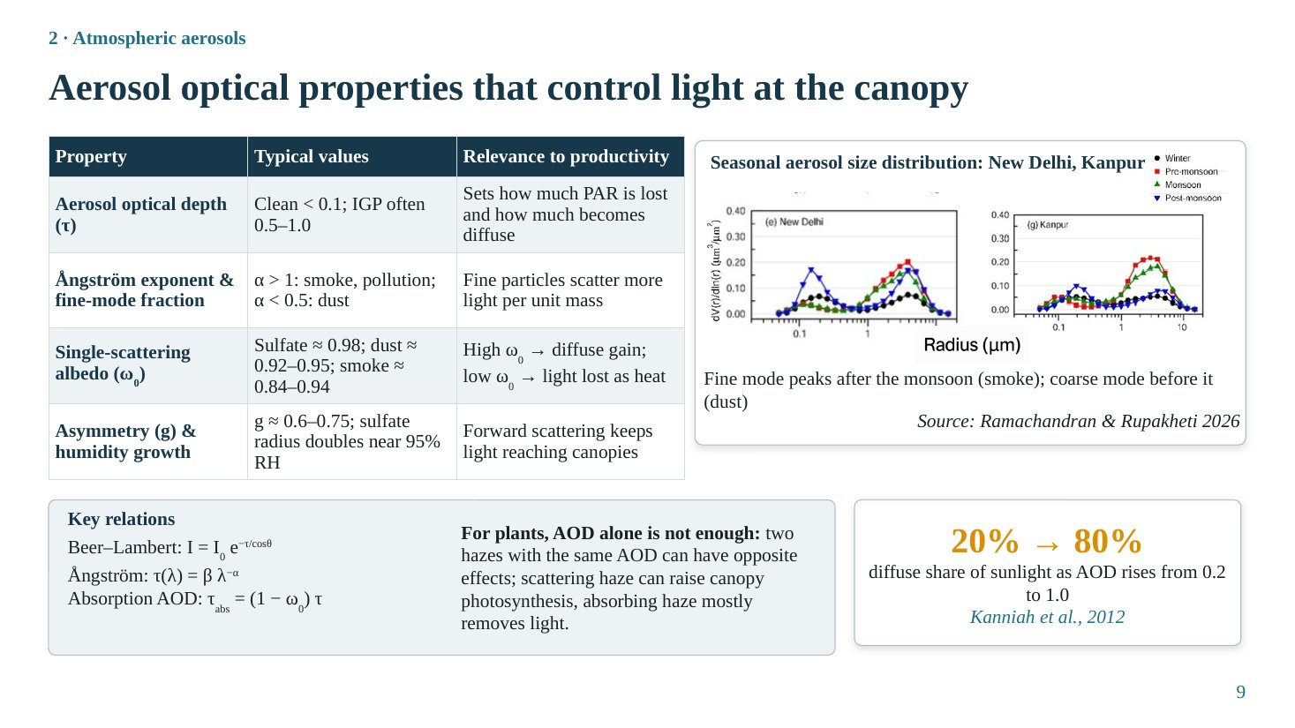
Slide 9
What this slide says, in simple words
Not all haze is the same. Four properties tell us what haze does to light: how thick it is (AOD), how big the particles are (Ångström exponent), whether particles scatter or absorb (single-scattering albedo), and in which direction they scatter (asymmetry). For plants, the scatter-or-absorb property is crucial: scattering haze can help, absorbing haze mostly harms.
Concepts explained: from simple to scientific
Aerosol optical depth (τ). Simple: a measure of how much the haze dims the sun. Scientific: τ is the integral of the aerosol extinction coefficient over the vertical column; direct-beam irradiance decreases as I = I₀ e^{−τ/cosθ} (Beer–Lambert law), where θ is the solar zenith angle (so 1/cosθ is the air mass).
Example: with τ = 0.5 and the sun overhead, e^{−0.5} ≈ 0.61, so only about 61% of the direct beam (ignoring other gases) reaches the ground; the rest is scattered (partly reaching the ground as diffuse light) or absorbed.
Ångström exponent (α) and fine-mode fraction. τ(λ) = β λ^{−α}. α describes how fast AOD decreases with wavelength. Small particles scatter blue light much more than red, giving α > 1 (smoke, pollution). Large particles scatter all wavelengths similarly, giving α < 0.5 (dust). The fine-mode fraction is the share of AOD from fine particles.
Single-scattering albedo (ω₀, SSA). The ratio of scattering to total extinction (scattering + absorption). ω₀ = 1 means pure scattering; lower values mean more absorption. Typical values (Dubovik et al., 2002): sulfate ≈ 0.98, dust ≈ 0.92–0.95, smoke ≈ 0.84–0.94. Absorption AOD is τ_{abs} = (1 − ω₀) τ.
Asymmetry parameter (g) and humidity growth. g ranges from −1 (all backward) to +1 (all forward); aerosols have g ≈ 0.6–0.75, so most scattered light continues downward and reaches the canopy as diffuse light. Hygroscopic particles such as sulfate roughly double their radius near 95% relative humidity (Hess et al., 1998), which increases AOD.
Diffuse share and AOD. The review by Kanniah et al. (2012) notes that the diffuse share of sunlight is about 20% at AOD 0.2 and about 80% at AOD 1.0. AOD therefore strongly controls light quality.
The table explained
Four rows, one per property: typical values and why it matters for productivity. The key practical lesson is in the last column of the SSA row: high ω₀ converts direct light into usable diffuse light; low ω₀ removes light as heat.
The figure explained
Seasonal aerosol volume size distributions at New Delhi and Kanpur (Ramachandran & Rupakheti, 2026). The x-axis is particle radius (µm, log scale), the y-axis is volume concentration. Two humps: the fine mode (left, about 0.1–0.3 µm) is highest after the monsoon (smoke); the coarse mode (right, about 2–5 µm) is highest before the monsoon (dust). Different coloured lines are seasons.
Key numbers to remember
• Clean AOD < 0.1; IGP 0.5–1.0
• α > 1 smoke/pollution; α < 0.5 dust
• SSA: sulfate 0.98, dust 0.92–0.95, smoke 0.84–0.94
• g ≈ 0.6–0.75
• Diffuse share 20% (AOD 0.2) → 80% (AOD 1.0)
Likely questions and model answers
Q1. Two hazes have the same AOD of 0.6. Why can their effects on crops differ?
Because their single-scattering albedo can differ. A sulfate-rich haze (ω₀ ≈ 0.98) scatters almost all intercepted light, so much of it still reaches the canopy as diffuse light. A smoke- or black-carbon-rich haze (ω₀ ≈ 0.85) absorbs about 15% of intercepted light, which is lost as heat, reduces total PAR more and adds less diffuse light. It also heats the atmosphere and can reduce clouds and rain.
Q2. What is the physical meaning of the Beer–Lambert law here?
Each thin layer of the atmosphere removes a fixed fraction of the direct beam passing through it, so the direct beam decreases exponentially with optical path (τ multiplied by air mass). Sun photometers use this law in reverse: by measuring the direct beam at the ground and knowing the top-of-atmosphere value, they calculate τ.
Q3. How is the Ångström exponent calculated in practice?
From AOD at two wavelengths: α = −ln(τ₁/τ₂) / ln(λ₁/λ₂), commonly using 440 and 870 nm in AERONET.

Slide 10: Conceptual framework (repeated) and aerosol radiative effects
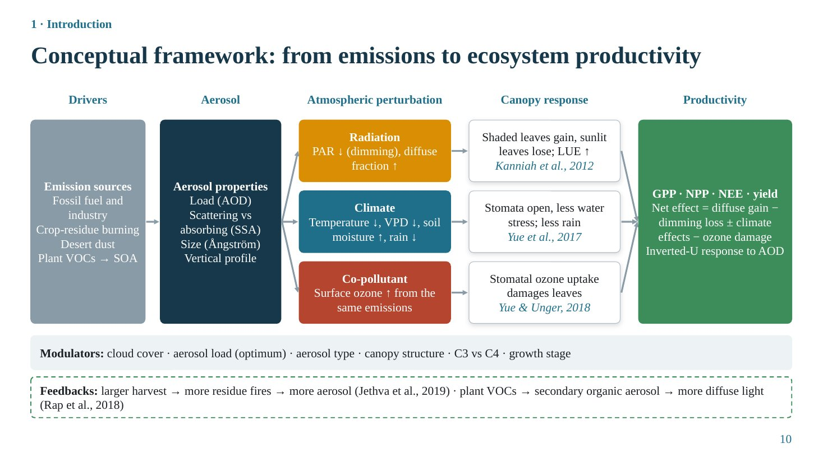
Slide 10
Note on this slide: In your deck, Slide 10 is an exact copy of Slide 4 (the conceptual framework), although it sits inside Section 2 where the 'Aerosol radiative effects' slide belongs. It looks as if the radiative-effects slide was replaced by mistake. If you keep the duplicate, simply say 'let us return to the framework before moving to measurement'. Because examiners often ask about radiative effects, the concept is explained fully below so that you can answer even if the slide is not shown.

What this slide says, in simple words
Aerosols change the energy reaching the ground in three ways. Directly, by scattering and absorbing sunlight. Semi-directly, when absorbing particles heat the air and evaporate clouds. Indirectly, by acting as seeds for cloud droplets, making clouds brighter and changing rain. Together these give less total light, more diffuse light, cooler days and changed rainfall at the surface.
Concepts explained: from simple to scientific
Direct effect (aerosol–radiation interaction, ARI). Scattering and absorption of solar radiation by particles. It reduces surface irradiance (dimming) and increases the diffuse fraction. Scattering also returns some light to space (cooling); absorption heats the aerosol layer.
Semi-direct effect. Absorbing aerosol, mainly black carbon, heats the layer, increases atmospheric stability and lowers relative humidity, which can evaporate clouds or suppress their formation. In IPCC AR6 this is treated as a rapid adjustment within the ARI forcing (Forster et al., 2021).
Indirect effect (aerosol–cloud interaction, ACI). Aerosols act as cloud condensation nuclei (CCN). More CCN with the same water gives more, smaller droplets (Twomey effect): brighter clouds that reflect more sunlight. Smaller droplets coalesce less efficiently, delaying rain and possibly lengthening cloud lifetime.
Rain invigoration and suppression. Rosenfeld et al. (2008) showed that in deep convective clouds, delayed rain lets droplets rise above the freezing level, release latent heat and invigorate the cloud. This works up to an AOD of about 0.25; heavier aerosol reduces surface heating and suppresses convection and rain.
Aerosol radiative forcing (ARF). ARF = F_{with aerosol} − F_{clean} (net flux difference). At the surface ARF is strongly negative; at the top of the atmosphere it is smaller; the difference (ARF_{TOA} − ARF_{surface}) is absorbed in the atmosphere. Over north-east India, Latha et al. (2018) found MERRA reanalysis gave ARF = −8 − 35.8·AOD, about half the forcing efficiency estimated from ground observations, so reanalysis underestimates dimming. Globally, IPCC AR6 gives about −0.3 W m⁻² for ARI and about −1.0 W m⁻² for ACI.
Monsoon. Bollasina et al. (2011) attributed part of the weakening of the South Asian summer monsoon in the second half of the 20th century to anthropogenic aerosol. Less monsoon rain matters greatly for rainfed crops.
The figure explained
The visible slide is the framework of Slide 4; see Slide 4 for its explanation.
Key numbers to remember
• IPCC AR6 ERF: ARI ≈ −0.3, ACI ≈ −1.0, total ≈ −1.3 W m⁻²
• Rain invigoration up to AOD ≈ 0.25 (Rosenfeld et al., 2008)
• NE India reanalysis: ARF = −8 − 35.8·AOD (Latha et al., 2018)
Likely questions and model answers
Q1. What is the difference between radiative forcing at the surface and at the top of the atmosphere?
Top-of-atmosphere forcing measures the change in energy leaving or entering the Earth system and determines global warming or cooling. Surface forcing measures the change in energy reaching the ground and determines effects on evaporation, temperature and photosynthesis. For absorbing aerosol, surface forcing is much more negative than TOA forcing because the energy is absorbed in the atmosphere instead of reaching the ground.
Q2. What is the Twomey effect?
For a fixed amount of cloud liquid water, increasing the number of cloud condensation nuclei produces more and smaller droplets, which have a larger total surface area and reflect more sunlight. So polluted clouds are brighter, producing a negative radiative forcing.
Q3. Why do absorbing aerosols weaken the monsoon?
They heat the atmosphere and cool the surface, reducing the land–sea temperature contrast and stabilising the lower atmosphere, which weakens monsoon circulation and convection. Reduced surface evaporation also lowers the moisture supply.

Section 3 · Remote sensing of aerosols and radiation

Slide 11: Ground-based aerosol measurement
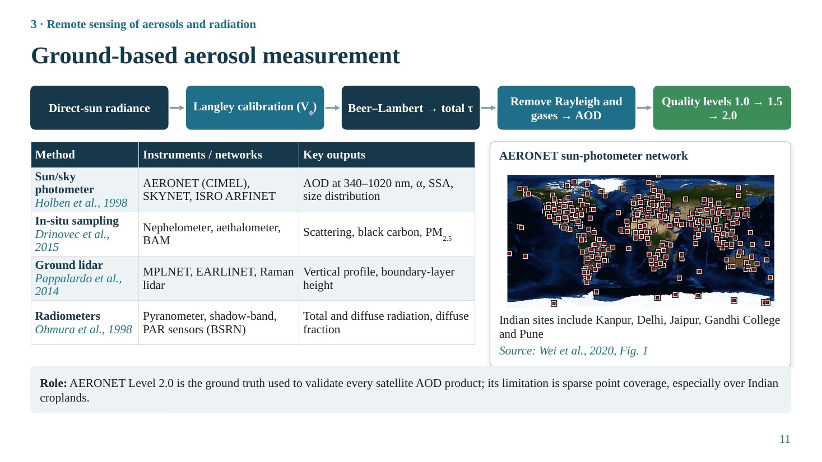
Slide 11
What this slide says, in simple words
Before trusting satellites we need accurate measurements on the ground. The main instrument is a sun photometer, which looks straight at the sun and measures how much the sunlight is dimmed. Other instruments measure particles in the air, the height of haze layers, and the amount of direct and diffuse sunlight.
Concepts explained: from simple to scientific
Sun photometer principle. The instrument points at the sun and measures the direct-sun signal V at several narrow wavelengths. From Beer–Lambert: V = V₀ · d⁻² · exp(−m·τ_{total}), where V₀ is the signal that would be measured at the top of the atmosphere, d the Earth–sun distance in astronomical units and m the air mass. So τ_{total} = [ln(V₀/d²) − ln V] / m.
τ_{total} includes Rayleigh scattering by air molecules and absorption by gases (ozone, NO₂, water vapour). These are computed and subtracted, leaving aerosol optical depth.
Langley calibration. To know V₀, measurements are made at a clean, stable high-altitude site over a morning as the air mass changes. Plotting ln V against m gives a straight line whose intercept at m = 0 is ln V₀. This is the Langley plot.
AERONET quality levels. Level 1.0: unscreened. Level 1.5: cloud-screened and quality-controlled. Level 2.0: quality-assured with pre- and post-deployment calibration. Level 2.0 is the reference for validating satellite AOD (Holben et al., 1998). Sky radiance scans (almucantar) are inverted to give single-scattering albedo and size distribution.
Other ground methods. In-situ instruments: nephelometer (scattering coefficient), aethalometer (black carbon from light absorption on a filter), beta-attenuation monitor (PM_{2.5} mass) (Drinovec et al., 2015). Ground lidar: laser pulses give vertical profiles and boundary-layer height (MPLNET, EARLINET; Pappalardo et al., 2014). Radiometers: pyranometer (global radiation), shadow-band or shaded pyranometer (diffuse radiation), PAR quantum sensors; the Baseline Surface Radiation Network sets standards (Ohmura et al., 1998).
Indian networks. AERONET sites (Kanpur, Delhi, Jaipur, Gandhi College, Pune and a few others), ISRO's ARFINET network of multi-wavelength radiometers, and SKYNET sky radiometers.
The table explained
Four families: sun/sky photometers give column optical properties; in-situ samplers give surface concentrations; ground lidar gives vertical structure; radiometers give the radiation that plants actually receive. For productivity studies the radiometer row is essential, because measured diffuse radiation is needed to test the diffuse-fertilization mechanism.
The figure explained
Global map of AERONET stations (Wei et al., 2020, Fig. 1). Each square is a station. The network is dense in North America and Europe and sparse in South Asia and Africa, which is why AERONET is an excellent reference but cannot map aerosol over Indian croplands.
Key numbers to remember
• AERONET wavelengths: 340–1020 nm
• Quality levels: 1.0 → 1.5 → 2.0 (Level 2.0 for validation)
Likely questions and model answers
Q1. Why are ground measurements called 'ground truth'?
Because sun photometers measure the direct beam with a simple, well-understood physical law and careful calibration, giving AOD with an uncertainty of about 0.01–0.02, much better than satellite retrievals, which must estimate surface reflectance and assume aerosol models.
Q2. What is the main limitation of AERONET for agricultural studies?
It gives point measurements at a few locations, so it cannot describe spatial variation over large cropland areas. In India only a handful of sites exist, and only two met the criteria used by Hari & Tyagi (2022) for validation.

Slide 12: Satellite aerosol retrieval principle
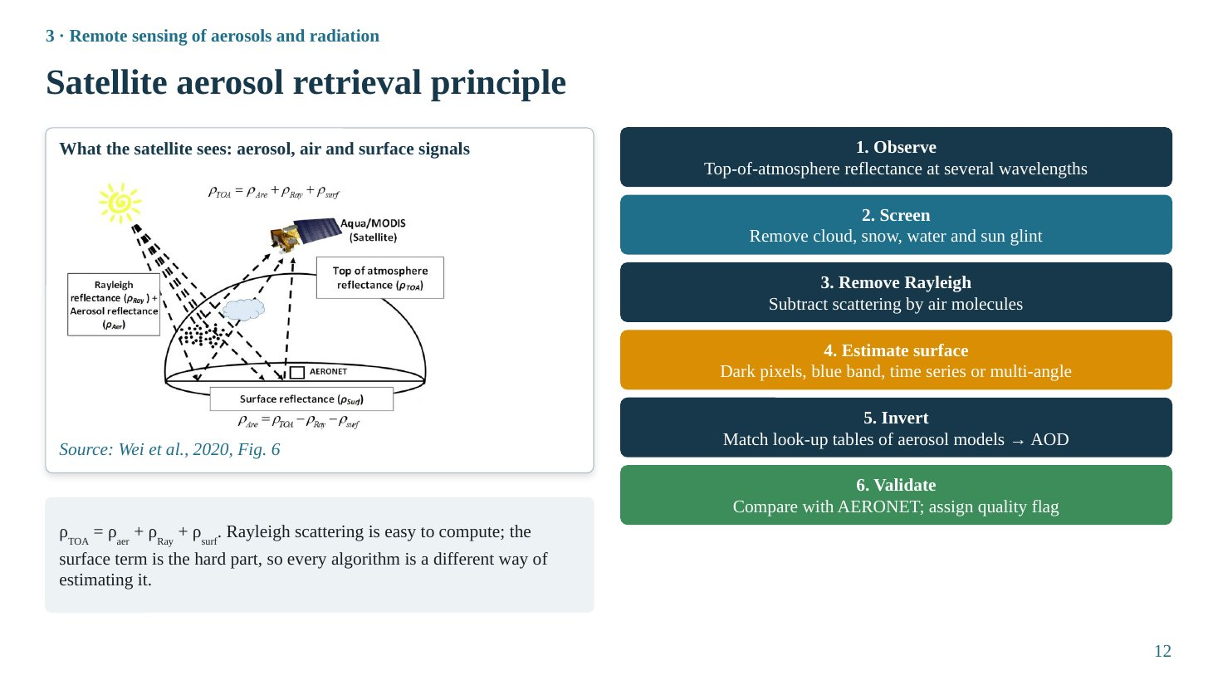
Slide 12
What this slide says, in simple words
A satellite sees light coming back from three places: the haze, the air molecules, and the ground. To find out how much haze there is, the algorithm must subtract the air part (easy) and the ground part (hard). Every satellite algorithm is basically a different trick for estimating the ground part.
Concepts explained: from simple to scientific
Top-of-atmosphere reflectance. ρ_{TOA} = ρ_{aer} + ρ_{Ray} + ρ_{surf}, where ρ_{aer} is light scattered back by aerosol (the signal we want), ρ_{Ray} by air molecules (Rayleigh scattering), and ρ_{surf} by the surface after passing through the atmosphere twice.
Six steps. (1) Observe TOA reflectance at several wavelengths. (2) Screen clouds, snow, water and sun glint. (3) Remove the Rayleigh term, calculated from surface pressure and viewing and solar geometry. (4) Estimate surface reflectance, the hardest step. (5) Invert: compare the remaining signal with pre-computed look-up tables (LUTs) from radiative-transfer models for different aerosol types and AODs, and pick the best match. (6) Validate against AERONET and assign quality flags.
Why the surface is hard. Over dark surfaces (oceans, dense vegetation) the surface contributes little in visible bands, so aerosol stands out. Over bright surfaces (deserts, cities, dry cropland) the surface signal can be several times the aerosol signal, so a small error in surface reflectance gives a large AOD error.
The figure explained
Wei et al. (2020), Fig. 6: sunlight enters the atmosphere; some is scattered by air molecules and aerosols back to the satellite (MODIS on Aqua), and some reaches the surface and is reflected back. The satellite receives the sum. The equation on the figure, ρ_{aer} = ρ_{TOA} − ρ_{Ray} − ρ_{surf}, shows the logic of every retrieval.
Likely questions and model answers
Q1. Why can't satellites retrieve AOD under clouds?
Clouds are much brighter than aerosol and completely dominate the reflected signal, so the aerosol contribution cannot be separated. Cloudy pixels are masked, which means satellite AOD represents clear-sky conditions only.
Q2. What is a look-up table?
A pre-computed table of simulated TOA reflectances for many combinations of aerosol type, AOD, surface reflectance and sun–satellite geometry, produced with a radiative-transfer model. The algorithm searches the table for the combination that best reproduces the observed reflectance.

Slide 13: Satellite aerosol algorithms and sensors
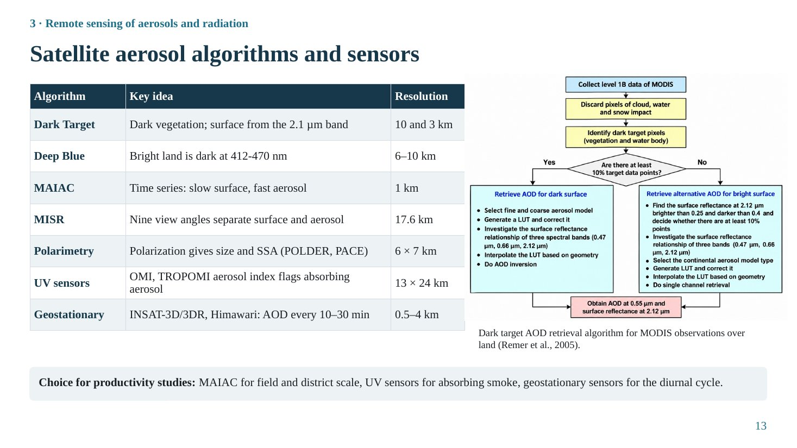
Slide 13
What this slide says, in simple words
Different algorithms solve the 'ground problem' in different ways: by using dark green vegetation, by using the blue colour where bright land looks dark, by watching the same place over many days, by viewing from many angles, or by using polarisation. MODIS Dark Target, merged with Deep Blue, is the most widely used product; MAIAC is best for field-scale crop studies.
Concepts explained: from simple to scientific
Dark Target (DT). Over vegetated land the visible surface reflectance is closely related to the 2.1 µm reflectance, where aerosol is almost transparent; the algorithm estimates visible surface reflectance from it and retrieves AOD at 10 km and 3 km (Levy et al., 2013). Expected error over land ±(0.05 + 0.15τ). Fails over bright surfaces.
Deep Blue (DB). Bright surfaces such as deserts and cities are dark at 412–470 nm, so the algorithm uses blue bands and a surface reflectance database; it works over bright land at 6–10 km (Hsu et al., 2013). In Collection 6, DT and DB are merged using NDVI: DT where NDVI > 0.3, DB where NDVI < 0.2, and an average in between (Sayer et al., 2014).
MAIAC. Multi-Angle Implementation of Atmospheric Correction uses a time series: the surface changes slowly while aerosol changes quickly, so the surface can be characterised from many days of observations (including its directional reflectance). AOD at 1 km (Lyapustin et al., 2018), ideal for districts and fields.
MISR. Nine cameras view the same scene from different angles within minutes; the angular pattern separates surface and aerosol and gives particle shape and size. Narrow swath, so global coverage takes about 9 days (standard product 17.6 km; Kahn et al., 2010).
Polarimetry. Polarisation of reflected light is sensitive to particle size, shape and refractive index, and therefore SSA. POLDER flew until 2013; the PACE mission (2024) carries polarimeters (Dubovik et al., 2011).
UV sensors. OMI and TROPOMI measure at ultraviolet wavelengths, where absorbing aerosol (smoke, dust) gives a distinctive aerosol index even over clouds (Torres et al., 2007); coarse pixels (OMI 13 × 24 km).
Geostationary. INSAT-3D/3DR over India and Himawari over East Asia observe the same region every 10–30 minutes, capturing the diurnal cycle; surface estimation is harder at large view angles.
The table explained
Three columns: algorithm, key idea (how it handles the surface) and resolution. Use it to justify data choices: MAIAC for crop-scale studies; DT+DB for long, global records; UV for absorbing smoke; geostationary for diurnal variation.
The figure explained
The flowchart (Remer et al., 2005, reproduced in Wei et al., 2020) shows the MODIS Dark Target land algorithm: collect Level 1B data; discard cloud, water and snow pixels; identify dark-target pixels; if at least 10% of pixels are dark, retrieve AOD with fine and coarse aerosol models using the 0.47, 0.66 and 2.12 µm surface relationship; otherwise use an alternative bright-surface retrieval with a continental model; output AOD at 0.55 µm and surface reflectance at 2.12 µm.
Key numbers to remember
• DT: 10 and 3 km; EE ±(0.05 + 0.15τ)
• DB: 6–10 km
• MAIAC: 1 km
• MISR: 17.6 km; 9 view angles
• OMI: 13 × 24 km
• Geostationary: AOD every 10–30 min
Likely questions and model answers
Q1. Which algorithm is most widely used, and which would you choose for a district-level crop study in Punjab?
MODIS Dark Target merged with Deep Blue is the most widely used, because it gives a continuous global record since 2000 (Terra) and 2002 (Aqua); Wei et al. (2020) report MODIS as the most used sensor in AOD research. For district-level crop studies MAIAC is preferable because of its 1 km resolution and better performance over heterogeneous, seasonally bright croplands; Jethva et al. (2019) used MAIAC for the IGP.
Q2. Why does Dark Target fail over bright surfaces?
It relies on the empirical relation between visible and 2.1 µm surface reflectance, which holds for dark vegetation. Over bright surfaces the surface signal dominates the TOA reflectance and the relation breaks down, so small errors in estimated surface reflectance produce large AOD errors.
Q3. What does 'expected error ±(0.05 + 0.15τ)' mean?
About two-thirds of retrievals are expected to lie within this envelope of the AERONET value. At τ = 0.2 the envelope is ±0.08; at τ = 1.0 it is ±0.20. The error grows with aerosol load, so in hazy regions absolute uncertainty is large.

Slide 14: Lidar, reanalysis and validation of aerosol products
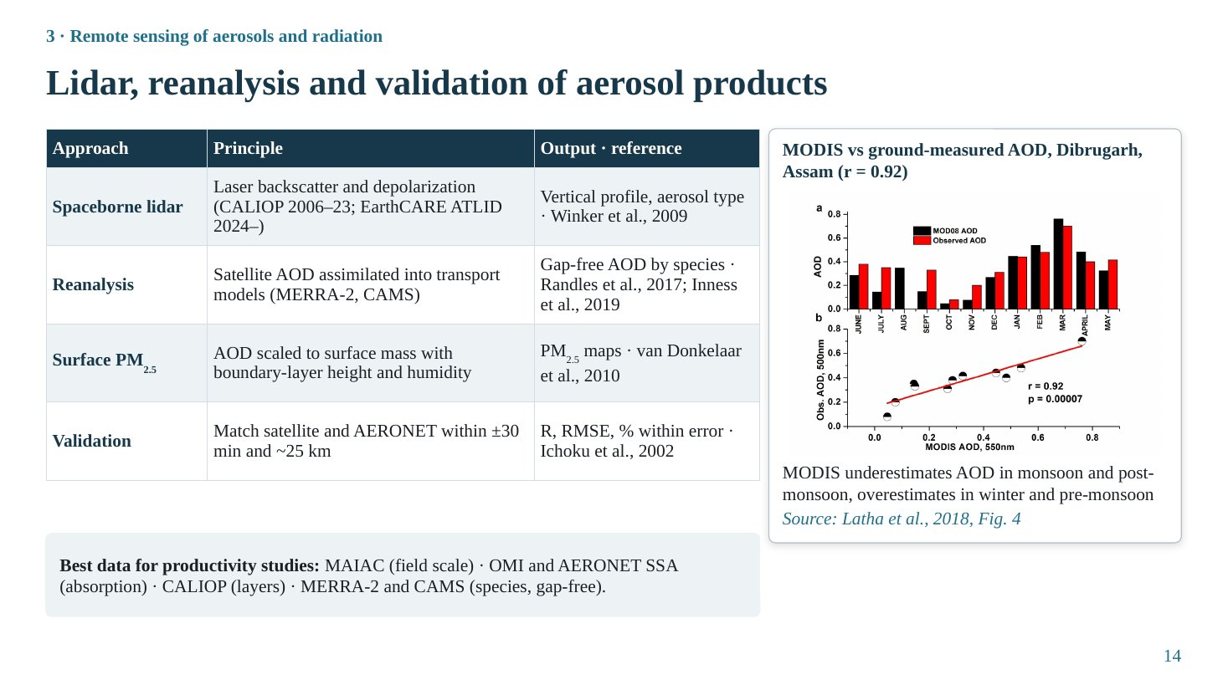
Slide 14
What this slide says, in simple words
Satellites like MODIS give one number for the whole column. Lidar adds the height of haze layers. Reanalysis combines satellite data with computer models to give complete maps even under clouds, separated by aerosol type. Every product must be checked against ground measurements.
Concepts explained: from simple to scientific
Spaceborne lidar. A laser sends pulses downward and measures backscatter from different heights. Depolarisation distinguishes non-spherical dust from spherical pollution droplets. CALIOP (on CALIPSO, 2006–2023) and ATLID (on EarthCARE, launched 2024) (Winker et al., 2009). Limitation: very narrow track.
Reanalysis. Chemical transport models (simulating emission, transport, chemistry and removal of aerosol) are combined with assimilated satellite AOD to give gap-free AOD split into species (dust, sulfate, black carbon, organic carbon, sea salt): MERRA-2 (Randles et al., 2017) and CAMS (Inness et al., 2019), at about 0.5° resolution.
Surface PM_{2.5} from AOD. PM_{2.5} ≈ η × AOD, where η depends on boundary-layer height, humidity and aerosol type, often from a model (van Donkelaar et al., 2010).
Validation method. Average satellite pixels within about 25 km of an AERONET site and AERONET measurements within ±30 minutes of the overpass (Ichoku et al., 2002). Statistics: correlation (R), root-mean-square error (RMSE), bias, and the percentage within the expected error.
The table explained
Four rows: lidar (vertical), reanalysis (gap-free species), surface PM_{2.5} (air quality) and validation (accuracy). The strip below the table gives the practical recommendation for productivity studies.
The figure explained
Latha et al. (2018), Fig. 4, for Dibrugarh, Assam. Top: monthly MODIS AOD (black bars) and ground-observed AOD (red bars) through the year. Bottom: scatter plot of MODIS against observed AOD with a regression line, r ≈ 0.92. MODIS underestimates AOD in the monsoon and post-monsoon and overestimates it in winter and pre-monsoon, so seasonal bias must be checked.
Key numbers to remember
• Validation window: ±30 min, ~25 km
• Dibrugarh MODIS vs ground r ≈ 0.92
Likely questions and model answers
Q1. Why would you use reanalysis AOD instead of satellite AOD?
Reanalysis has no gaps under clouds and provides aerosol species, which matters because scattering and absorbing species affect plants differently. Shu et al. (2022) used MERRA-2 AOD for this reason. Its disadvantages are coarse resolution and dependence on model emission inventories.
Q2. What does a correlation of 0.92 not tell you?
It does not tell you about bias. Satellite AOD can be systematically high or low while still correlated. Latha et al. found season-dependent under- and over-estimation, so both correlation and bias (or RMSE) should be reported.

Slide 15: Estimating direct and diffuse PAR from aerosol data
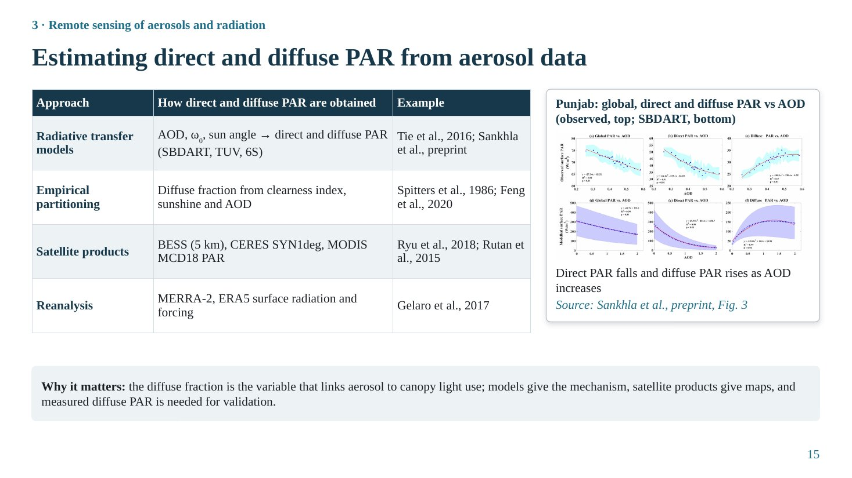
Slide 15
What this slide says, in simple words
Plants care less about AOD itself than about how much light arrives directly from the sun and how much arrives as soft, scattered light from the whole sky. There are four ways to get these numbers: physical models, simple empirical formulas, satellite products and reanalysis.
Concepts explained: from simple to scientific
PAR. Photosynthetically active radiation, 400–700 nm, the part of sunlight used in photosynthesis (about 45–50% of shortwave energy). Units: W m⁻² or µmol photons m⁻² s⁻¹.
Diffuse fraction. f_{dif} = diffuse PAR / total PAR. Clear, clean sky: about 0.1–0.2; hazy: 0.3–0.6; overcast: close to 1.
Radiative-transfer models. SBDART, TUV and 6S solve the radiative-transfer equation through a layered atmosphere using AOD, SSA, asymmetry, gas profiles and sun angle, and output direct and diffuse irradiance. Tie et al. (2016) used TUV for China; Sankhla et al. (preprint) used SBDART for Punjab.
Empirical partitioning. The diffuse fraction is estimated from the clearness index k_{t} = global radiation / top-of-atmosphere radiation, or from sunshine duration or AOD (for example Spitters et al., 1986). Low k_{t} means cloudy, diffuse conditions. Feng et al. (2020) used this approach to drive the BEPS model.
Satellite and reanalysis products. BESS (Breathing Earth System Simulator, 5 km; Ryu et al., 2018), CERES SYN1deg (1°, hourly; Rutan et al., 2015), MODIS MCD18 PAR; MERRA-2 and ERA5 surface radiation (Gelaro et al., 2017).
The table explained
Four approaches with how they obtain direct and diffuse PAR and an example study. Models explain the mechanism; satellite products give maps; measured diffuse PAR is needed to validate both.
The figure explained
Sankhla et al. (preprint), Fig. 3, Punjab wheat season. Top row: observed global, direct and diffuse PAR against AOD; bottom row: SBDART simulations. Direct PAR falls steeply, diffuse PAR rises, and global PAR falls moderately as AOD increases. The agreement between observation and model supports the radiative-transfer approach.
Likely questions and model answers
Q1. Why is it not enough to know AOD to predict the effect on photosynthesis?
Because the effect depends on the split between direct and diffuse light, which also depends on SSA, sun angle and especially clouds. Under overcast skies light is already diffuse and extra aerosol only removes light. So AOD must be converted into direct and diffuse PAR for the actual sky conditions.
Q2. What is the problem of using satellite diffuse PAR to study the AOD effect?
Products such as BESS and CERES compute diffuse PAR partly from MODIS aerosol data, so finding that their diffuse PAR increases with AOD is partly circular. Independent, measured diffuse PAR is needed (Slide 33).

Section 4 · Remote sensing of productivity

Slide 16: Ecosystem productivity: key concepts
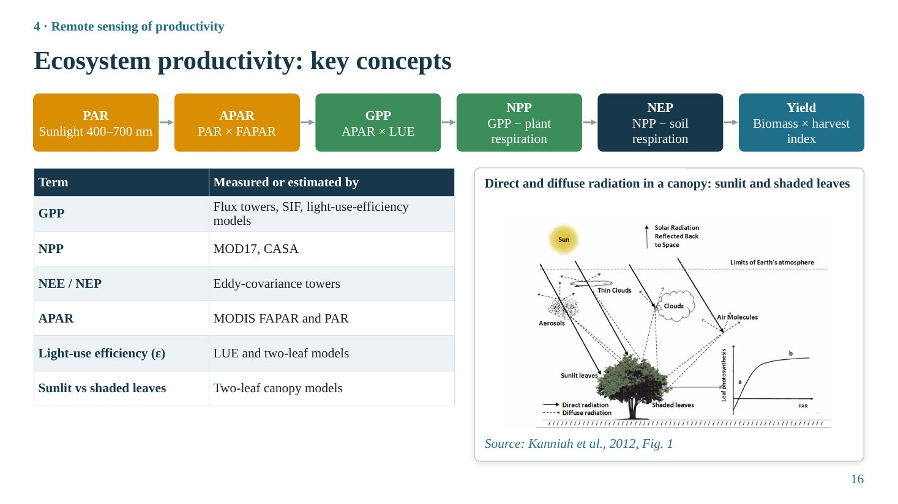
Slide 16
What this slide says, in simple words
Plants absorb part of the sunlight falling on them. They use it to turn CO₂ into sugar (GPP). They burn some of that sugar to live (plant respiration); what remains is growth (NPP). Soil microbes also release CO₂; what the whole ecosystem finally keeps is NEP. For crops, part of the growth becomes grain: yield.
Concepts explained: from simple to scientific
APAR and FAPAR. APAR = PAR × FAPAR, where FAPAR is the fraction of incoming PAR absorbed by green leaves (0 to about 0.95). FAPAR is estimated from satellites (MODIS MOD15) or from NDVI.
GPP. Gross primary productivity: total carbon fixed by photosynthesis per unit area and time (g C m⁻² d⁻¹ or yr⁻¹). Light-use-efficiency models write GPP = APAR × ε, where ε (LUE) is grams of carbon fixed per MJ of absorbed PAR, reduced by temperature and water stress.
NPP. Net primary productivity = GPP − autotrophic (plant) respiration, typically about half of GPP. It represents biomass production.
NEP and NEE. Net ecosystem production = NPP − heterotrophic (soil microbial) respiration. Net ecosystem exchange is the net CO₂ flux measured by towers, with the sign convention that negative NEE means uptake by the ecosystem: NEE ≈ −NEP.
Yield. Grain yield = total above-ground biomass × harvest index (about 0.4–0.5 for modern wheat and rice).
Sunlit and shaded leaves. Direct sunlight reaches only leaves facing the sun at the top and edges of the canopy (sunlit leaves); deeper leaves receive only diffuse and scattered light (shaded leaves). Sunlit leaves are often light-saturated, shaded leaves light-limited. Two-leaf models compute their photosynthesis separately.
The table explained
The table maps each term to how it is measured or estimated: GPP from towers, SIF and LUE models; NPP from MOD17 or CASA; NEE/NEP from eddy-covariance towers; APAR from MODIS FAPAR and PAR; LUE and the sunlit/shaded split from LUE and two-leaf models.
The figure explained
Kanniah et al. (2012), Fig. 1: solar radiation passes through the atmosphere where aerosols, clouds and air molecules scatter it. The solid line (direct beam) reaches only sunlit leaves; dashed lines (diffuse) reach the canopy from all directions, including shaded leaves. The inset graph shows that leaf photosynthesis saturates at high light (curve b) while it rises steeply at low light, which is why redistributing light to shaded leaves raises canopy photosynthesis.
Likely questions and model answers
Q1. What is the difference between GPP, NPP and NEE?
GPP is total photosynthetic carbon uptake. NPP subtracts the plants' own respiration and represents growth. NEE is the net exchange of the whole ecosystem with the atmosphere, including soil respiration; it is what a flux tower measures directly.
Q2. Why does a light-saturation curve explain diffuse fertilization?
Leaf photosynthesis increases almost linearly with light at low irradiance and levels off at high irradiance. Moving some light from saturated sunlit leaves (where it gives little extra photosynthesis) to light-limited shaded leaves (where it gives a lot) increases total canopy photosynthesis, even if total light decreases slightly.

Slide 17: Measuring productivity on the ground
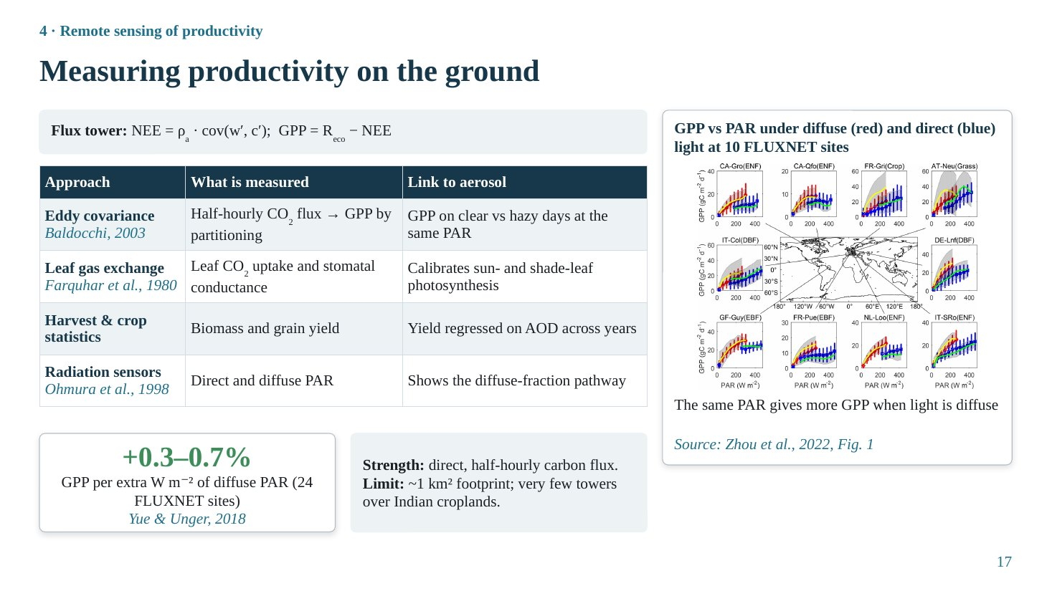
Slide 17
What this slide says, in simple words
Flux towers are tall masts with fast instruments that measure the up-and-down movement of air and its CO₂ content many times a second. From this they calculate how much CO₂ the ecosystem takes up every half hour. Tower data show clearly that the same amount of light produces more photosynthesis when the light is diffuse.
Concepts explained: from simple to scientific
Eddy covariance. NEE = ρ_{a} · cov(w′, c′): the covariance between fluctuations of vertical wind speed (w′) and CO₂ concentration (c′), multiplied by air density, measured with a sonic anemometer and a fast gas analyser at 10–20 Hz and averaged over 30 minutes (Baldocchi, 2003).
Flux partitioning. At night there is no photosynthesis, so NEE equals ecosystem respiration (R_{eco}). A respiration–temperature relation fitted at night is extrapolated to daytime; then GPP = R_{eco} − NEE.
Leaf gas exchange. Portable systems (e.g. LI-6400) measure CO₂ uptake and stomatal conductance of single leaves; interpreted with the Farquhar photosynthesis model (Farquhar et al., 1980). Used in case study 1.
Crop statistics and radiation sensors. Harvest statistics give yield, which can be regressed on AOD across years. Radiation sensors measuring direct and diffuse PAR demonstrate the diffuse-fraction pathway.
Diffuse sensitivity. Across 24 FLUXNET sites, GPP increases by 0.3–0.7% for each 1 W m⁻² increase in diffuse PAR (Yue & Unger, 2018).
The table explained
Four approaches: what is measured and how it links to aerosol. The key comparison for aerosol studies is GPP on clear versus hazy days at the same PAR.
The figure explained
Zhou et al. (2022), Fig. 1: GPP against PAR at 10 FLUXNET sites (forests, crop, grass). Red: observed under diffuse conditions; blue: direct conditions; yellow and green: model simulations; grey shading: spread. At the same PAR, the red (diffuse) curves lie above the blue (direct) curves at almost all sites.
Key numbers to remember
• Eddy covariance sampling: 10–20 Hz, 30-min fluxes
• GPP +0.3–0.7% per 1 W m⁻² diffuse PAR (24 sites)
• Tower footprint ≈ 1 km²
Likely questions and model answers
Q1. Why can't flux towers alone answer the question for India?
Each tower represents about a square kilometre, and there are very few towers over Indian croplands, so they cannot represent regional variation. Satellites are needed to scale up, with towers used for calibration and validation.
Q2. How do you separate the diffuse-light effect from the total-light effect using tower data?
By comparing GPP at the same PAR level under different diffuse fractions (binning by PAR and by diffuse fraction), or by fitting separate light-response curves for diffuse and direct conditions, as in Zhou et al. (2022), Fig. 1.

Slide 18: Satellite productivity proxies I: vegetation indices and canopy structure
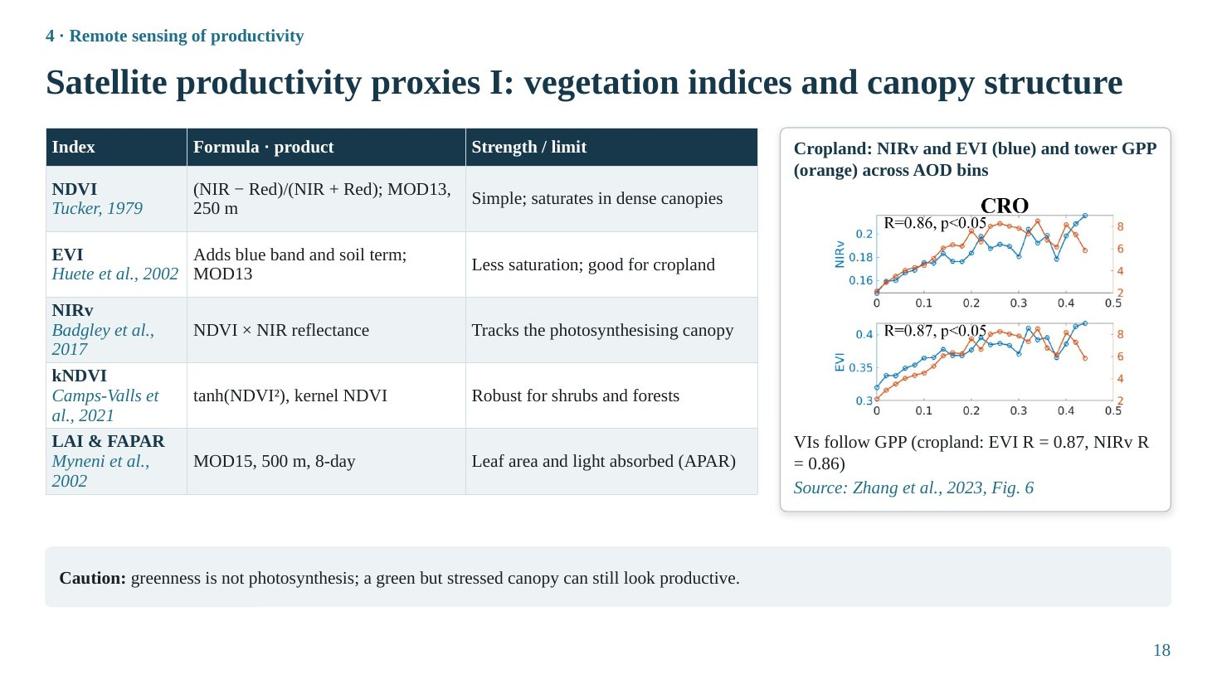
Slide 18
What this slide says, in simple words
Healthy green leaves reflect a lot of near-infrared light and absorb red light. Vegetation indices combine these colours into a single 'greenness' number. Greenness is a good indicator of how much leaf area can capture light, but it is not the same as photosynthesis.
Concepts explained: from simple to scientific
NDVI. NDVI = (NIR − Red)/(NIR + Red), from −1 to +1; dense vegetation 0.6–0.9 (Tucker, 1979). Simple and long record (MOD13, 250 m), but saturates in dense canopies and is affected by soil background.
EVI. EVI = 2.5 (NIR − Red)/(NIR + 6 Red − 7.5 Blue + 1) (Huete et al., 2002). The blue band corrects for aerosol and the soil term for background, so EVI saturates less and works well over cropland.
NIRv. NIRv = NDVI × NIR reflectance (Badgley et al., 2017): reflectance from vegetation only, closely related to photosynthetic capacity and SIF.
kNDVI. kNDVI = tanh(NDVI²) (Camps-Valls et al., 2021), a kernel version that reduces saturation and is robust across biomes.
LAI and FAPAR. Leaf area index (one-sided leaf area per ground area) and FAPAR from MODIS MOD15 at 500 m, 8-day (Myneni et al., 2002). FAPAR gives APAR for LUE models.
The table explained
Each index with its formula or product and its strength or limitation. For aerosol studies over cropland, EVI and NIRv are the best choices.
The figure explained
Zhang et al. (2023), Fig. 6 (cropland, CRO): mean NIRv (top, blue) and EVI (bottom, blue) and tower GPP (orange) in AOD bins of 0.02. The indices follow GPP across the AOD range (R = 0.86 for NIRv and 0.87 for EVI, p < 0.05), showing that satellite indices capture aerosol-related variation in cropland GPP.
Key numbers to remember
• Cropland: EVI R = 0.87, NIRv R = 0.86, kNDVI 0.86, NDVI 0.73 (Zhang et al., 2023)
Likely questions and model answers
Q1. Why does NDVI saturate?
In dense canopies red reflectance is already near zero, so further increases in leaf area raise NIR only slightly and NDVI approaches a ceiling around 0.9. EVI and NIRv remain more sensitive at high biomass.
Q2. Can vegetation indices detect an aerosol effect on photosynthesis within a day?
Not well. Greenness reflects canopy structure and chlorophyll, which change over days to weeks. A sudden change in light (haze) changes photosynthesis within minutes without changing greenness. SIF is better for short-term physiological responses.

Slide 19: Satellite productivity proxies II: SIF and productivity products
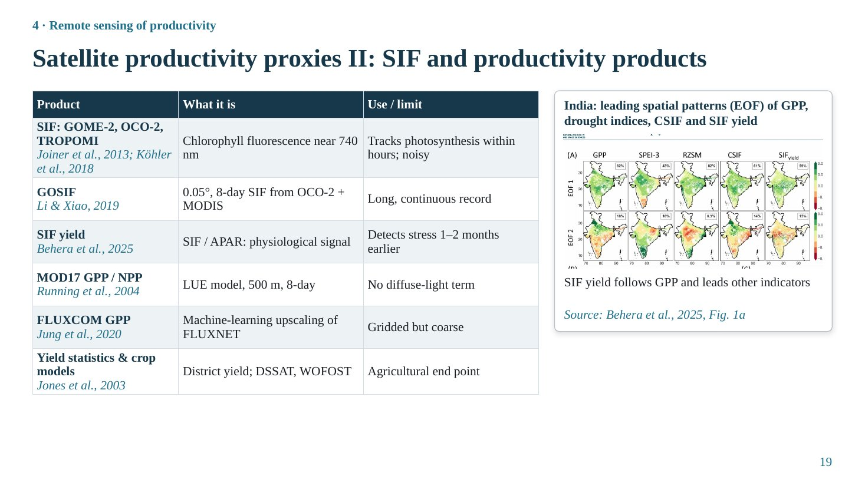
Slide 19
What this slide says, in simple words
When leaves photosynthesise, they glow very faintly in red and far-red light. Satellites can detect this glow, called solar-induced fluorescence (SIF). It changes within hours when photosynthesis changes, so it is a more direct signal than greenness. Several ready-made GPP products are also available, each with strengths and weaknesses.
Concepts explained: from simple to scientific
SIF. About 1–2% of light absorbed by chlorophyll is re-emitted as fluorescence at 650–800 nm, peaking near 685 and 740 nm. SIF is retrieved by measuring the infilling of solar Fraunhofer lines, dark absorption lines in the solar spectrum (GOME-2, OCO-2, TROPOMI; Joiner et al., 2013; Köhler et al., 2018). SIF ≈ APAR × SIF yield × escape probability, and it correlates strongly with GPP.
GOSIF. A gridded SIF product (0.05°, 8-day) that combines sparse OCO-2 SIF soundings with MODIS reflectance and meteorology using machine learning (Li & Xiao, 2019).
SIF yield. SIF divided by APAR, removing the effect of light amount and isolating physiological status. Behera et al. (2025) found that over India SIF yield detects emerging drought stress 1–2 months earlier than other indicators.
MOD17. MODIS GPP/NPP from an LUE model (500 m, 8-day; Running et al., 2004). Important limitation: no diffuse-light term, so it cannot represent the diffuse fertilization effect.
FLUXCOM and crop data. FLUXCOM upscales FLUXNET towers globally with machine learning (Jung et al., 2020), coarse resolution. District yield statistics and crop models (DSSAT, WOFOST) give the agricultural end point (Jones et al., 2003).
The table explained
Each product: what it is and its use or limitation. Remember the MOD17 limitation, because it explains why case study 2 (Shu et al., 2022) built a diffuse-aware LUE model.
The figure explained
Behera et al. (2025), Fig. 1a: the first two EOF (empirical orthogonal function) spatial patterns of GPP, the SPEI-3 drought index, root-zone soil moisture, continuous SIF (CSIF) and SIF yield over India, with the percentage of variance explained in each panel. EOF analysis finds the dominant patterns of variation. SIF yield shows the strongest positive relationship with GPP and leads the other indicators by 1–2 months.
Likely questions and model answers
Q1. Why is SIF a better proxy than NDVI for photosynthesis?
Because fluorescence is emitted by the photosynthetic apparatus itself and responds within hours to changes in light, temperature and water stress, whereas NDVI responds to changes in leaf area and chlorophyll over days to weeks. SIF also does not saturate in dense canopies like NDVI.
Q2. What is the main weakness of SIF data?
Low signal (a tiny fraction of reflected light), so retrievals are noisy and require averaging in space and time; native footprints are coarse (GOME-2 about 80 × 40 km, later 40 × 40 km) or sparse (OCO-2). Clouds also limit retrievals.

Section 5 · Linking aerosols to productivity

Slide 20: Statistical designs for linking aerosols to productivity
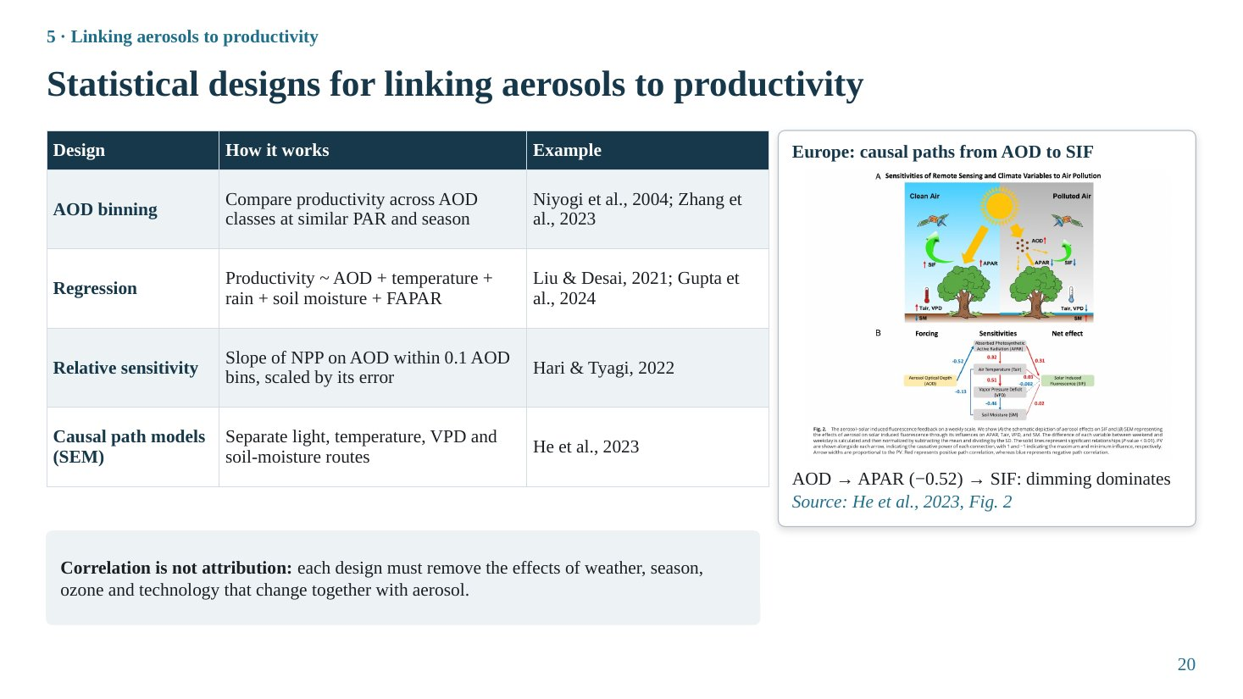
Slide 20
What this slide says, in simple words
Once we have aerosol data and productivity data, how do we connect them? We can group days by haze level and compare; fit equations that also include weather; look at how the response changes across haze levels; or draw a cause-and-effect diagram and estimate the strength of each arrow.
Concepts explained: from simple to scientific
AOD binning. Group observations into AOD classes (for example 0–0.2, 0.2–0.4, 0.4–0.6) at similar PAR, season and time of day, and compare mean productivity across classes (Niyogi et al., 2004; Zhang et al., 2023).
Regression. Productivity = f(AOD, temperature, rainfall, soil moisture, FAPAR, ...). The AOD coefficient estimates the aerosol effect holding other factors constant (Liu & Desai, 2021; Gupta et al., 2024). Problems: collinearity (AOD correlated with humidity and temperature) and omitted variables (e.g. ozone).
Relative sensitivity. Hari & Tyagi (2022) regressed NPP on AOD within AOD bins of 0.1 (from 0 to 3) and divided the slope by its standard error (S = (dNPP/dAOD)/ε), showing where the response changes sign.
Structural equation modelling (SEM). A path diagram of hypothesised causal links (AOD → APAR → SIF, AOD → temperature → SIF, etc.) is fitted to data, giving standardised path coefficients for each route (He et al., 2023).
The table explained
Four designs with how they work and examples. All are observational, so they demonstrate association; to argue for causation, confounding must be controlled.
The figure explained
He et al. (2023), Fig. 2: (A) concept: polluted air reduces total light but increases diffuse light; (B) path diagram from aerosol forcing to SIF via APAR, temperature, VPD and soil moisture. The strongest path is AOD → APAR (standardised coefficient −0.52), then APAR → SIF (positive); the temperature, VPD and soil-moisture paths are weak. Conclusion for Europe: dimming dominates, so aerosol reduces photosynthesis.
Key numbers to remember
• SEM Europe: AOD → APAR = −0.52
Likely questions and model answers
Q1. What does 'correlation is not attribution' mean in this context?
AOD changes together with season, weather (humidity, temperature, cloud), ozone and farming practices. A correlation between AOD and productivity may reflect any of these. Attribution requires a design that controls or excludes these confounders, such as natural experiments, careful regression with covariates, or process models.
Q2. What is a standardised path coefficient of −0.52?
It means that a one-standard-deviation increase in AOD is associated with a 0.52 standard-deviation decrease in APAR, holding other paths constant. Standardisation makes paths comparable across variables with different units.

Slide 21: Natural experiments: when aerosol switches on or off
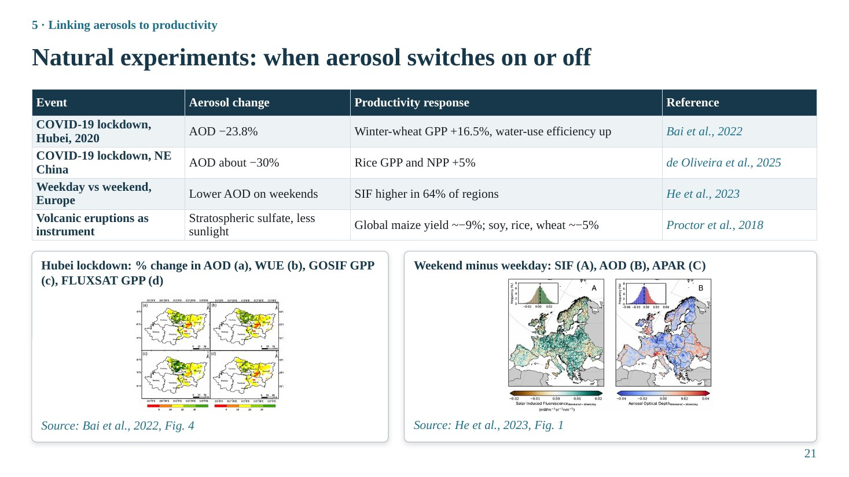
Slide 21
What this slide says, in simple words
Sometimes the world runs an experiment for us: haze suddenly drops or rises while everything else stays roughly the same. The COVID-19 lockdown cleaned the air; weekends have less traffic than weekdays; volcanic eruptions fill the sky with particles. Comparing productivity before and after such events isolates the aerosol effect better than ordinary correlations.
Concepts explained: from simple to scientific
Why natural experiments are powerful. In an ordinary correlation, many factors change together. In a natural experiment, aerosol changes abruptly for an external reason, while crop variety, management and land use stay the same, so the response is more confidently attributed to aerosol.
COVID-19 lockdown, Hubei. Bai et al. (2022): during the 2020 lockdown, AOD over winter-wheat areas of Xiangyang fell by 23.8% (± 10.1%) compared with the previous three years; GPP rose by 16.5% (± 5.8%) and water-use efficiency by 17.0%. GPP was estimated with two independent satellite products (GOSIF and FLUXSAT).
COVID-19 lockdown, NE China. Reported in the review by de Oliveira et al. (2025): a reduction of about 30% in AOD increased rice GPP and NPP by about 5%.
Weekly cycle. He et al. (2023): human emissions are lower at weekends, so AOD is lower. Comparing weekend and weekday satellite SIF across Europe (2018, 2019, 2021), 64% of regions showed higher SIF at weekends.
Volcanic eruptions as an instrument. Proctor et al. (2018) used the sunlight reduction caused by major eruptions (El Chichón 1982, Pinatubo 1991) as a statistical instrument: scattering stratospheric aerosol reduced global maize yield by about 9% and soy, rice and wheat by about 5%. The loss of total light outweighed any diffuse benefit for crops.
Caveats. Other factors also change: lockdowns reduced ozone and NO₂; 2020 rainfall in Xiangyang was 1.83 times the previous years; eruptions cooled the climate. So even natural experiments need careful control.
The table explained
Each row is an event, the aerosol change, the productivity response and the source. All four suggest that, in polluted regions or for crops, less aerosol means more productivity, i.e. these systems are above the optimum aerosol load.
The figure explained
Left (Bai et al., 2022, Fig. 4): maps of Xiangyang, Hubei, showing percentage change during the lockdown relative to the previous three years in (a) AOD (mostly negative), (b) WUE, (c) GOSIF GPP and (d) FLUXSAT GPP (mostly positive).
Right (He et al., 2023, Fig. 1): weekend-minus-weekday difference across Europe in (A) SIF (green, higher at weekends), (B) AOD (blue, lower at weekends) and (C) APAR. The histograms show the distribution of differences.
Key numbers to remember
• Hubei: AOD −23.8%, GPP +16.5%, WUE +17.0%
• NE China rice: AOD −30%, GPP/NPP +5%
• Europe: SIF higher at weekends in 64% of regions
• Volcanic dimming: maize −9%, soy, rice, wheat −5%
Likely questions and model answers
Q1. Pinatubo increased forest photosynthesis, yet Proctor et al. found it reduced crop yields. How do you reconcile these?
The two studies examine different systems and quantities. Gu et al. (2003) measured noon photosynthesis of a dense, multi-layer deciduous forest under cloudless skies, where diffuse light greatly benefits shaded leaves. Proctor et al. examined global crop yields over whole seasons under real (often cloudy) skies; crops have simpler canopies and C4 maize benefits little from diffuse light, so the loss of total light dominated. This illustrates that canopy structure, photosynthetic pathway and cloud cover decide the sign.
Q2. How can you be sure the Hubei GPP increase was due to lower aerosol and not rain?
You cannot be fully sure. Bai et al. found rainfall was also much higher, and their GeoDetector analysis showed PAR explained the largest share (42.1%) of WUE variation, followed by rainfall (about 30%). So the increase likely had contributions from both more light and more water. This is exactly the caveat of natural experiments.

Slide 22: Process models that link aerosols to productivity
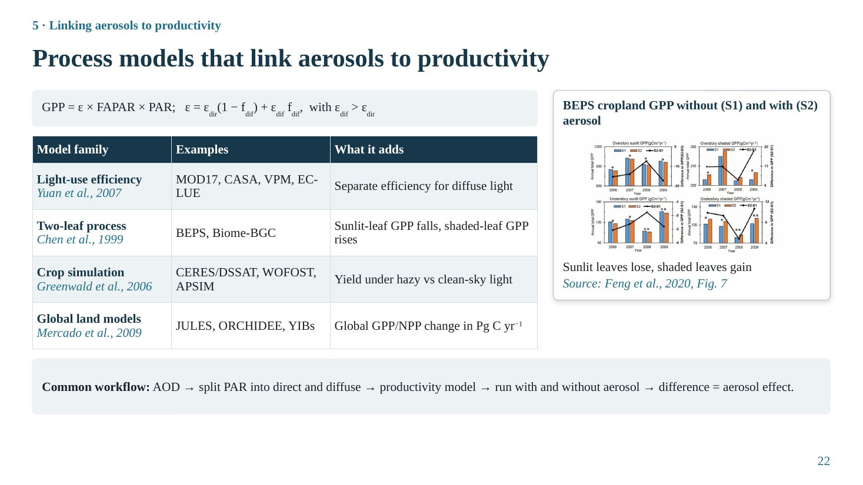
Slide 22
What this slide says, in simple words
Process models are computer models that calculate photosynthesis from light, temperature and water. If we run them once with aerosol and once without, the difference is the aerosol effect. Simple models just give diffuse light a higher efficiency; more detailed models calculate sunlit and shaded leaves separately.
Concepts explained: from simple to scientific
Light-use-efficiency (LUE) models with diffuse term. GPP = ε × FAPAR × PAR, with ε = ε_{dir}(1 − f_{dif}) + ε_{dif} f_{dif} and ε_{dif} > ε_{dir}. Examples: MOD17, CASA, VPM, EC-LUE (Yuan et al., 2007); standard MOD17 and CASA have no diffuse term, while modified versions (such as AOD-LUE in case study 2) do.
Two-leaf models. Canopy split into sunlit and shaded fractions, each with its own absorbed light and photosynthesis (Farquhar model). BEPS (Chen et al., 1999) and Biome-BGC. The diffuse effect emerges from the physics.
Crop simulation models. CERES (in DSSAT), WOFOST and APSIM simulate daily crop growth and yield from radiation, temperature, water and nitrogen. Greenwald et al. (2006) modified radiation-use efficiency for diffuse light to test aerosol effects on maize, wheat and rice.
Global land models. JULES, ORCHIDEE and YIBs simulate global GPP/NPP. Mercado et al. (2009) used JULES; Yue & Unger (2018) and Zhou et al. (2022) used YIBs.
Common workflow. AOD (and SSA) → radiative transfer → direct and diffuse PAR → productivity model → run with aerosol and without aerosol → difference = aerosol effect.
The table explained
Model family, examples and what each adds. Remember: the result is only as good as the model's diffuse-light response, which must be calibrated against towers.
The figure explained
Feng et al. (2020), Fig. 7: annual GPP from the improved BEPS model averaged over seven cropland sites in North China, for scenario S1 (no aerosol) and S2 (with aerosol), split into overstory sunlit, overstory shaded, understory sunlit and understory shaded leaves. Bars show GPP; lines show the change (ΔGPP). Sunlit-leaf GPP decreases with aerosol, shaded-leaf GPP increases.
Likely questions and model answers
Q1. Why do two-leaf models capture the diffuse effect better than big-leaf models?
A big-leaf model treats the canopy as one leaf receiving the average light, so it cannot represent the non-linear saturation of sunlit leaves versus light limitation of shaded leaves. A two-leaf model computes each separately; when aerosol shifts light from direct to diffuse, sunlit-leaf photosynthesis falls slightly (they were saturated) while shaded-leaf photosynthesis rises strongly.
Q2. What is the main weakness of the model approach?
Results depend on parameterisation, especially how much more efficiently diffuse light is used, which is uncertain for crops. Models also need accurate inputs (AOD, SSA, clouds) and may omit processes such as ozone damage or aerosol–cloud–rain interactions.

Section 6 · Mechanisms of aerosol impact

Slide 23: Light route: dimming vs diffuse fertilization
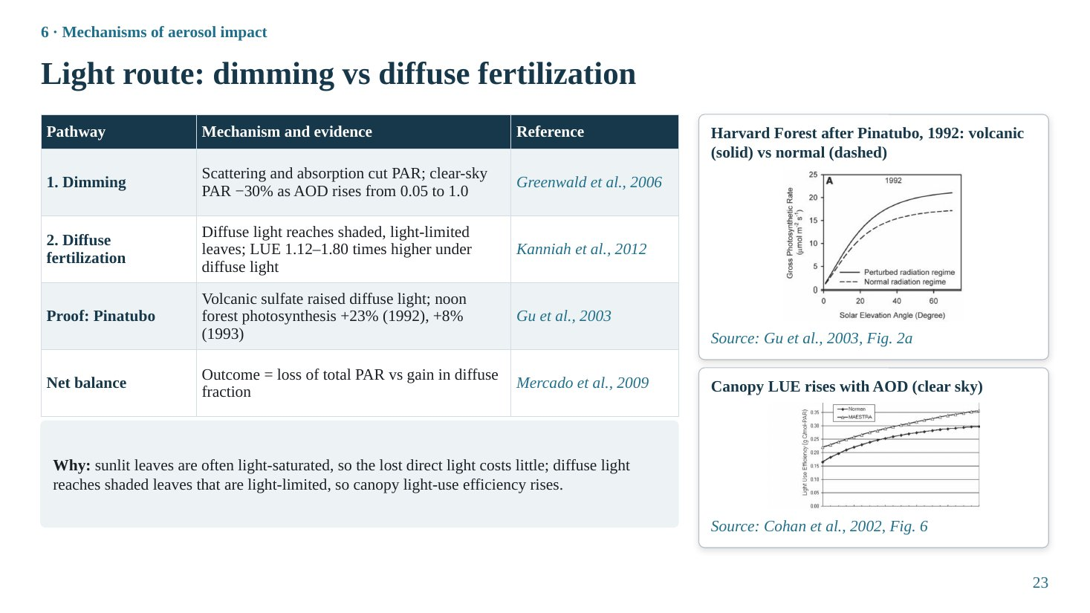
Slide 23
What this slide says, in simple words
Haze does two opposite things to light. It reduces the total light reaching plants (dimming, bad), and it spreads the remaining light more evenly through the canopy (diffuse fertilization, good). Which one wins decides whether plants grow more or less.
Concepts explained: from simple to scientific
Dimming. Scattering (some back to space) and absorption reduce total PAR at the surface. Greenwald et al. (2006): under clear skies, PAR decreases by about 30% as AOD rises from 0.05 to 1.0, while the diffuse fraction increases by more than 200%.
Diffuse fertilization. Diffuse light comes from all directions, so it penetrates deeper and reaches shaded leaves. Kanniah et al. (2012) report canopy LUE 1.12–1.80 times higher under diffuse light than under direct light.
Proof: Mount Pinatubo. The 1991 eruption injected sulfate into the stratosphere, increasing diffuse radiation worldwide for about two years. At Harvard Forest, noon canopy photosynthesis under cloudless skies increased by 23% in 1992 and 8% in 1993 (Gu et al., 2003). This contributed to the temporary slowdown of the atmospheric CO₂ growth rate after the eruption.
Net balance. Mercado et al. (2009): the net effect depends on the balance between the reduction in total PAR and the increase in the diffuse fraction. The net is positive when the canopy has many shaded, light-limited leaves and the diffuse gain is large; negative when total light becomes limiting.
Why it works. Sunlit leaves are often light-saturated, so the lost direct light costs little. Shaded leaves are light-limited, so the extra diffuse light is used efficiently. Canopy light-use efficiency rises.
The table explained
Four rows: dimming (the loss), diffuse fertilization (the gain), Pinatubo (the proof) and net balance (the outcome).
The figure explained
Top (Gu et al., 2003, Fig. 2a): canopy gross photosynthetic rate against solar elevation angle at Harvard Forest in 1992. Solid line: perturbed (volcanic) radiation regime; dashed line: normal regime. The solid line is higher at all solar elevations, especially at high sun.
Bottom (Cohan et al., 2002, Fig. 6): modelled canopy light-use efficiency against AOD from 0 to 1 under cloudless skies, in two canopy models (Norman and MAESTRA). LUE increases steadily with AOD.
Key numbers to remember
• Clear-sky PAR −30% as AOD 0.05 → 1.0
• LUE 1.12–1.80× higher under diffuse light
• Pinatubo: noon forest photosynthesis +23% (1992), +8% (1993)
Likely questions and model answers
Q1. If LUE keeps rising with AOD, why doesn't photosynthesis keep rising?
Because GPP = LUE × APAR. LUE increases with AOD, but APAR decreases as total light falls. At low AOD the LUE increase outweighs the APAR loss; at high AOD the APAR loss dominates. Hence the inverted-U response.
Q2. Why was Harvard Forest's response so large after Pinatubo?
It is a dense, multi-layer deciduous forest with high leaf area, so many shaded leaves could use the extra diffuse light; the comparison was under cloudless skies, where diffuse light was previously scarce, and stratospheric sulfate is strongly scattering with little absorption.

Slide 24: Climate route: temperature, humidity, water and rain
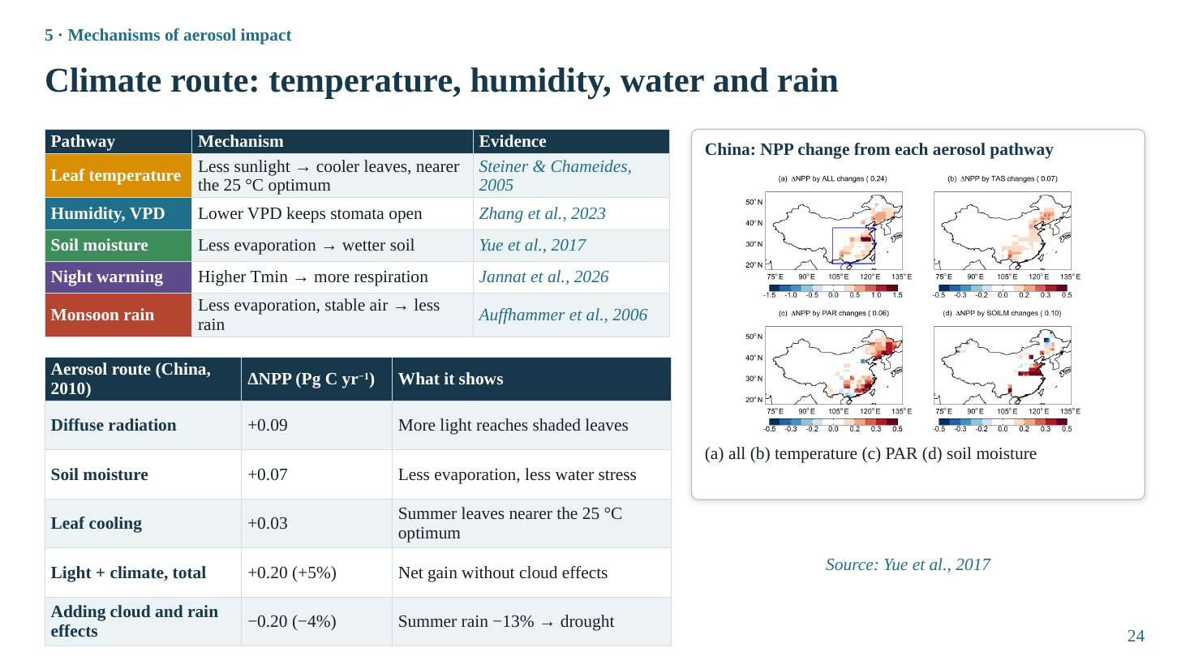
Slide 24
What this slide says, in simple words
Haze also changes the weather around plants. Less sunlight means cooler leaves and moister air, which can help plants keep their pores open. Less evaporation leaves wetter soil. But haze can also warm nights and reduce rain, which hurts. Calculations for China show that the rain effect can turn a small gain into a loss.
Concepts explained: from simple to scientific
Leaf temperature. Less radiation cools leaves; in hot conditions this brings them closer to the photosynthetic optimum (about 25 °C for many C3 plants) (Steiner & Chameides, 2005).
Vapour pressure deficit (VPD). VPD is the difference between saturation and actual vapour pressure, i.e. the drying power of air. High VPD makes stomata close to save water, reducing CO₂ uptake. Haze lowers VPD, keeping stomata open (Zhang et al., 2023).
Soil moisture. Less radiation reduces evaporation, so soil stays wetter and plants suffer less water stress (Yue et al., 2017).
Night warming. Aerosol can raise night-time minimum temperature (Tmin) by trapping longwave radiation and humidity, increasing plant respiration and lowering net carbon gain. Jannat et al. (2026) found rice yield responses in Bangladesh linked more strongly to Tmin than Tmax.
Monsoon rain. Aerosol cools the surface and stabilises the atmosphere, reducing evaporation and convection, so monsoon rain can decrease. Auffhammer et al. (2006) found Indian rice harvests closely follow monsoon rainfall (r = +0.61).
Quantification for China (Yue et al., 2017). In a coupled climate–vegetation model for 2010: diffuse radiation +0.09, soil moisture +0.07, leaf cooling +0.03 Pg C yr⁻¹; light plus climate total +0.20 Pg C yr⁻¹ (+5% of China's NPP). Adding aerosol–cloud effects reduced summer rain by 13% and the total became −0.20 Pg C yr⁻¹ (−4%).
The table explained
Upper table: five climate pathways, their mechanism and evidence.
Lower table: the Yue et al. (2017) decomposition of aerosol effects on China's NPP in 2010. Note that the individual terms (0.09 + 0.07 + 0.03 = 0.19) are close to the total of 0.20; interactions explain the small difference.
The figure explained
Yue et al. (2017), Fig. 8: maps of aerosol-induced change in summer NPP over China: (a) total, (b) from temperature change, (c) from PAR change (diffuse effect), (d) from soil moisture change. Red: increase; blue: decrease. The PAR and soil-moisture effects are mostly positive over eastern China.
Key numbers to remember
• China NPP (2010): diffuse +0.09, soil moisture +0.07, cooling +0.03 Pg C yr⁻¹
• Light + climate +0.20 (+5%); with cloud effects −0.20 (−4%)
• Summer rain −13% with aerosol–cloud effects
• Indian rice harvest vs monsoon rain r = +0.61
Likely questions and model answers
Q1. Why does including aerosol–cloud interactions change the sign of the effect?
Because aerosol–cloud interactions make clouds brighter and longer-lived and suppress precipitation. In Yue et al. (2017) summer rainfall decreased by 13%, soil moisture decreased and cloud cover increased, reducing available radiation further. The resulting drought and light loss outweighed the diffuse and cooling benefits.
Q2. Is the climate route more or less important than the light route?
It depends on region and season. In China the direct diffuse-light term (+0.09) and the soil moisture term (+0.07) were comparable, and the rain term dominated when cloud effects were included. For rainfed Indian agriculture, the rain pathway can outweigh the light pathway.

Slide 25: Water-cycle route: evapotranspiration and water-use efficiency
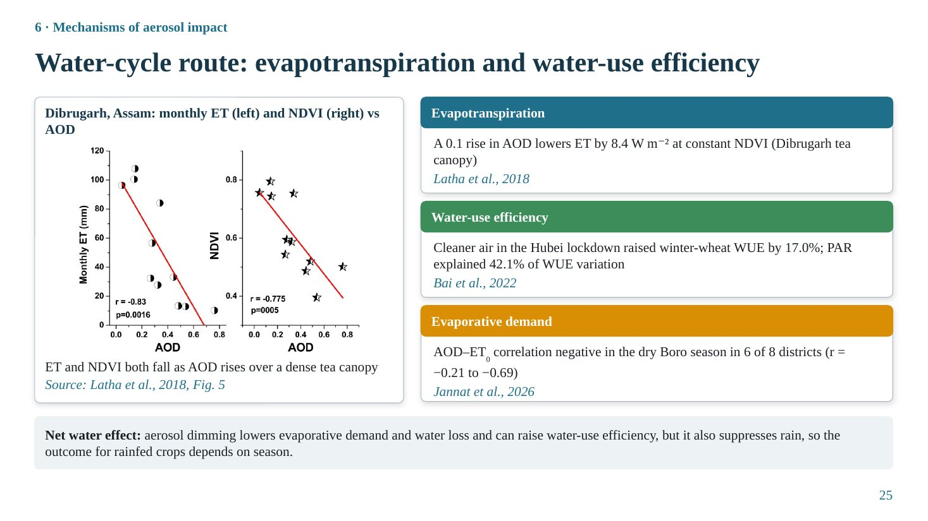
Slide 25
What this slide says, in simple words
Haze affects how much water plants and soil lose. Less sunlight means less energy for evaporation, so evapotranspiration falls. In polluted regions, cleaner air increased both photosynthesis and water-use efficiency. The overall water effect is mixed because haze can also reduce rain.
Concepts explained: from simple to scientific
Evapotranspiration (ET). Water lost by soil evaporation plus plant transpiration. It is driven mainly by available energy (net radiation), VPD and soil water. Aerosol reduces net radiation, so ET decreases.
Latha et al. (2018), Dibrugarh tea canopy. Monthly ET and NDVI both decreased with AOD. A regression ET = 0.25 + 84.27·AOD + 131.51·NDVI (fitted in their units) implies that, at constant NDVI, an AOD increase of 0.1 reduces ET by about 8.4 W m⁻². Valid for moderately vegetated (NDVI 0.4–0.8), humid (RH > 70%) and moderately polluted (AOD 0.1–0.8) conditions.
Water-use efficiency (WUE). Carbon gained per unit water lost (GPP/ET). Bai et al. (2022): during the Hubei lockdown, winter-wheat WUE increased by 17.0%; PAR explained 42.1% of WUE variation, more than rainfall.
Reference evapotranspiration (ET₀). The atmospheric demand for water from a reference grass surface (FAO Penman–Monteith). Jannat et al. (2026): the AOD–ET₀ correlation was negative in the dry Boro season in 6 of 8 Bangladeshi districts (r = −0.21 to −0.69).
The figure explained
Latha et al. (2018), Fig. 5: left, monthly ET (mm) against AOD (r = −0.83, p = 0.0016); right, NDVI against AOD (r = −0.775). Both decrease with increasing AOD over the dense tea canopy of Dibrugarh, Assam.
Key numbers to remember
• Dibrugarh: ET vs AOD r = −0.83; ΔAOD +0.1 → ET −8.4 W m⁻²
• Hubei lockdown: WUE +17.0%; PAR explains 42.1% of WUE variation
• Bangladesh Boro: AOD–ET₀ r = −0.21 to −0.69 (6 of 8 districts)
Likely questions and model answers
Q1. Why is the NDVI–AOD correlation also negative in Dibrugarh, and does that mean aerosol reduces greenness?
Not necessarily. Both may follow the seasonal cycle (dry season: higher AOD and lower vegetation activity). That is why Latha et al. fitted ET against both AOD and NDVI, to estimate the aerosol effect at constant NDVI. Correlation between NDVI and AOD alone cannot prove causation.
Q2. Can aerosol be beneficial for crops through the water cycle?
Yes, in water-limited conditions: lower radiation and VPD reduce evaporative demand and water loss, which can raise WUE and delay water stress. But if aerosol suppresses rain, the water benefit is lost. So the net outcome depends on season and irrigation.

Slide 26: Co-pollutant ozone and aerosol type
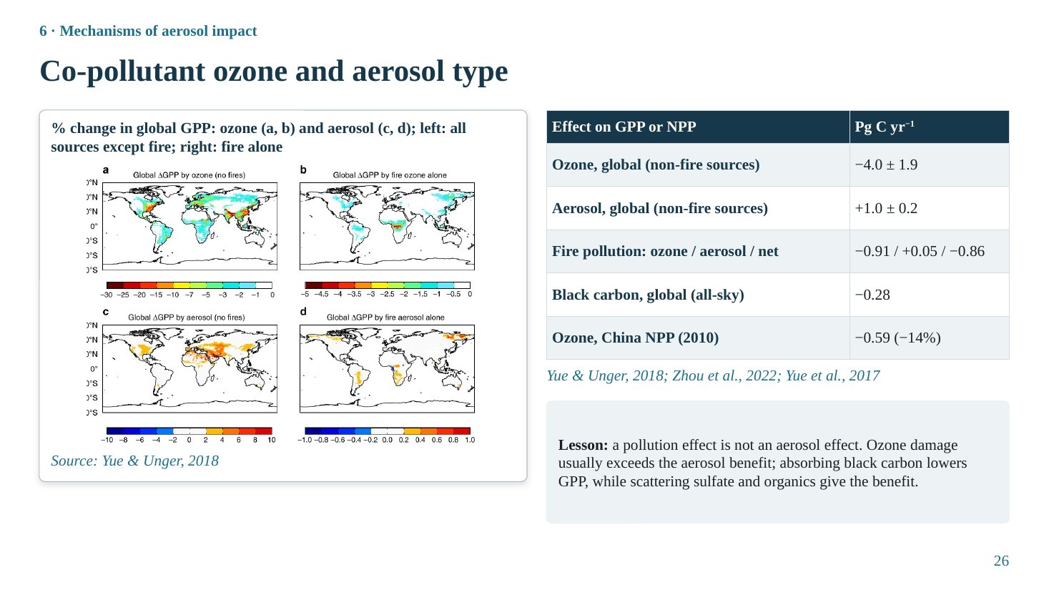
Slide 26
What this slide says, in simple words
Air pollution is not only haze. The same emissions create ozone near the ground, which damages leaves. Globally, ozone damage is about four times larger than the benefit from aerosols. Among aerosols, black carbon (soot) reduces productivity, while scattering particles like sulfate give the benefit.
Concepts explained: from simple to scientific
Surface ozone. Formed from NO_{x} and VOCs in sunlight. Ozone enters leaves through stomata, oxidises cell components, reduces photosynthetic capacity and accelerates senescence. Damage depends on stomatal ozone uptake (flux).
Global numbers (Yue & Unger, 2018). For 2002–2011, with all emissions except fire: ozone reduces global GPP by 4.0 ± 1.9 Pg C yr⁻¹; aerosol increases it by 1.0 ± 0.2 Pg C yr⁻¹. Fire pollution alone: ozone −0.91, aerosol +0.05, net −0.86 Pg C yr⁻¹.
Black carbon. Zhou et al. (2022): black carbon reduces global GPP by 0.28 Pg C yr⁻¹ under all-sky conditions, because it absorbs light and adds little diffuse light.
China (Yue et al., 2017). Ozone reduced China's NPP by 0.59 Pg C yr⁻¹ (about 14%), larger than any aerosol term.
Lesson. A 'pollution effect' is not an 'aerosol effect'. Studies that relate productivity to pollution without separating ozone and aerosol type cannot attribute the result to the diffuse-light mechanism.
The table explained
Five numbers in Pg C per year that put aerosol in perspective. Compare −4.0 for ozone with +1.0 for aerosol.
The figure explained
Yue & Unger (2018): global maps of percentage change in GPP: (a) by ozone from non-fire sources, (b) by ozone from fire, (c) by aerosol from non-fire sources, (d) by aerosol from fire. Ozone losses (blue, up to −10% or more) are widespread over eastern USA, Europe, India and eastern China; aerosol gains (orange) are moderate, mostly over the same polluted regions and the tropics.
Key numbers to remember
• Global: ozone −4.0 ± 1.9, aerosol +1.0 ± 0.2 Pg C yr⁻¹
• Fire: ozone −0.91, aerosol +0.05, net −0.86 Pg C yr⁻¹
• Black carbon −0.28 Pg C yr⁻¹
• China ozone −0.59 Pg C yr⁻¹ (−14%)
Likely questions and model answers
Q1. What is 1 Pg C?
One petagram of carbon = 10¹⁵ g = 1 billion tonnes of carbon. For comparison, global terrestrial GPP is roughly 120–130 Pg C yr⁻¹, so 1 Pg C yr⁻¹ is about 1% of global GPP.
Q2. If cleaner air reduces aerosol benefit, could air-quality policy harm vegetation?
Partly, in regions where scattering aerosol currently adds diffuse light. But the same policies usually reduce ozone (whose damage is larger) and black carbon, so the net effect is usually beneficial. Yue et al. (2017) projected that maximum feasible emission reductions in China would relieve about 70% of the current pollution damage to NPP by 2030.

Slide 27: The optimum aerosol load: an inverted-U response
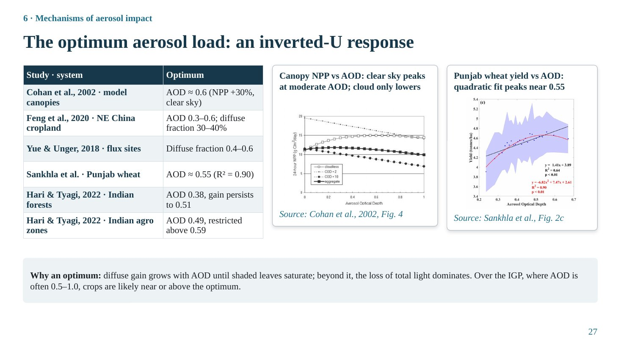
Slide 27
What this slide says, in simple words
A little haze helps plants, too much haze hurts them. Plotting productivity against haze gives a hill-shaped curve: it rises, peaks at an optimum, then falls. Different studies find optimum AOD values mostly between about 0.4 and 0.6 for crops and ecosystems. Much of the Indo-Gangetic Plain is already at or above that level.
Concepts explained: from simple to scientific
Why a peak exists. At low AOD, extra aerosol mainly redistributes light to shaded leaves (gain > loss). As AOD increases, the diffuse fraction saturates (it cannot exceed about 0.6–0.8 under aerosol alone) while total light keeps falling, and eventually even shaded leaves become light-limited by the total loss. Beyond the optimum, dimming dominates.
Reported optima. Cohan et al. (2002), model canopies: maximum NPP enhancement about 30% near AOD 0.6 under clear skies. Feng et al. (2020), NE China cropland: AOD 0.3–0.6 with diffuse fraction 30–40%. Yue & Unger (2018), flux sites: maximum photosynthesis at diffuse fraction 0.4–0.6. Sankhla et al. (preprint), Punjab wheat: yield peaks near AOD 0.55 (R² = 0.90). Hari & Tyagi (2022), India: forest NPP peaks at AOD 0.38 and benefits up to 0.51; agro zones peak at 0.49 and are restricted above 0.59. Case study 1 (Wang et al., 2021): canopy optimum AOD 0.93.
Mathematical form. Usually a quadratic fit, P = a + b·AOD + c·AOD² with c < 0. The optimum is at AOD* = −b/(2c).
The table explained
Each study and its optimum. Note that optima differ by crop, canopy, cloud conditions and background humidity, so there is no single universal optimum.
The figure explained
Left (Cohan et al., 2002, Fig. 4): modelled 24-hour canopy NPP against AOD for clear sky (COD = 0) and increasing cloud optical depth. Under clear sky NPP rises then levels off; under cloudy conditions it only decreases.
Right (Sankhla et al., Fig. 2c): Punjab wheat yield against seasonal AOD with a quadratic fit (shaded band = confidence interval); yield increases up to about AOD 0.55.
Key numbers to remember
• Cohan: AOD ≈ 0.6 (NPP +30%, clear sky)
• Feng: AOD 0.3–0.6
• Yue & Unger: diffuse fraction 0.4–0.6
• Sankhla: AOD ≈ 0.55, R² = 0.90
• Hari & Tyagi: forest 0.38 (to 0.51); agro 0.49 (restricted > 0.59)
Likely questions and model answers
Q1. If the Punjab optimum is about 0.55, is the IGP above or below the optimum?
Seasonal AOD over the IGP frequently exceeds 0.5–1.0, especially in post-monsoon and winter, so much of the region and season is near or above the optimum. Further increases are expected to reduce productivity. Sankhla et al. found mean seasonal AOD in Punjab rising from 0.33 (2001) to 0.41 (2018), reaching 0.55 in 2015–16.
Q2. Why might the optimum differ between Wang et al. (0.93) and Hari & Tyagi (0.49)?
Different crops and canopies (soybean field plots versus whole agroecological zones), methods (leaf model versus CASA NPP and sensitivity analysis), background humidity and aerosol type (North China Plain haze is humid and scattering), and the definition of AOD (500 nm sun photometer versus 550 nm MODIS). Wang et al. also showed the optimum falls when air becomes drier and cleaner.

Slide 28: Factors that decide the aerosol impact
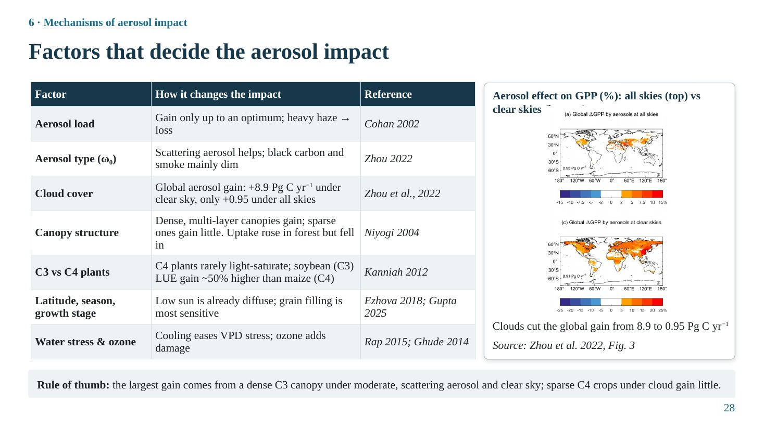
Slide 28
What this slide says, in simple words
Whether haze helps or harms depends on conditions: how much haze, what kind, how cloudy the sky is, how the canopy is built, which type of photosynthesis the plant uses, the season and growth stage, and water stress and ozone. The biggest gain occurs for a dense C3 canopy under moderate, scattering haze and a clear sky.
Concepts explained: from simple to scientific
Aerosol load. Gain only up to the optimum; heavy haze gives a loss (Cohan et al., 2002).
Aerosol type. Scattering aerosol helps; black carbon and smoke mainly dim (Zhou et al., 2022).
Cloud cover. The most important modulator: Zhou et al. (2022) found aerosol raises global GPP by 8.9 Pg C yr⁻¹ under clear skies but only 0.95 Pg C yr⁻¹ under all-sky conditions, because cloudy light is already diffuse and extra aerosol only dims.
Canopy structure. Dense, multi-layer canopies with many shaded leaves gain most. Niyogi et al. (2004) found CO₂ uptake increased with aerosol over forest and cropland but decreased over grassland.
C3 vs C4. C4 plants (maize, sugarcane, sorghum) rarely light-saturate because their CO₂-concentrating mechanism supports high photosynthesis at high light; redistributing light benefits them less. Kanniah et al. (2012) cite a theoretical result that the LUE increase under more diffuse light was about 50% higher for soybean (C3) than maize (C4).
Latitude, season, growth stage. At low sun angles (high latitudes, winter, morning) light is already more diffuse, so the marginal benefit is smaller (Ezhova et al., 2018). Growth stage matters because light during grain filling directly determines yield. Caution: the slide cites Gupta et al. (2025) for 'grain filling is most sensitive', but that statement is not in the paper; present it as general crop physiology.
Water stress and ozone. Cooling and lower VPD ease water stress; ozone adds damage. Caution: the slide cites Rap et al. (2015) and Ghude et al. (2014) for this row; Rap et al. (2015) is about Amazon fire smoke and diffuse light, so for water stress cite He et al. (2023) or Yue et al. (2017) instead.
The table explained
Seven factors, how each changes the impact, and references. Use it to answer any 'why do studies disagree?' question.
The figure explained
Zhou et al. (2022), Fig. 3: percentage change in annual GPP caused by the aerosol diffuse fertilization effect under (top) all-sky and (bottom) clear-sky conditions. All-sky changes are small (mostly < 2%), whereas clear-sky increases exceed 4% over most land, showing that clouds cut the global gain from 8.9 to 0.95 Pg C yr⁻¹.
Key numbers to remember
• Aerosol GPP gain: +8.9 (clear sky) vs +0.95 Pg C yr⁻¹ (all sky)
• Soybean (C3) LUE gain ≈ 50% higher than maize (C4)
Likely questions and model answers
Q1. Why are clouds the strongest modulator?
Clouds scatter light much more strongly than aerosol and are present over large areas. Under cloudy skies the diffuse fraction is already high, so aerosol cannot add much diffuse light but still reduces total light. Thus most of the potential aerosol benefit is realised only under clear skies.
Q2. Why would rice and wheat respond differently from maize?
Rice and wheat are C3 plants that light-saturate at moderate irradiance, so diffuse light redistributed to shaded leaves increases canopy photosynthesis. Maize is C4 and does not saturate easily, so it benefits less from redistribution and loses more from total light reduction, consistent with Proctor et al. (2018) finding larger losses for maize (≈ 9%) than for other crops (≈ 5%).

Section 7 · Evidence

Slide 29: Evidence from natural ecosystems across the globe
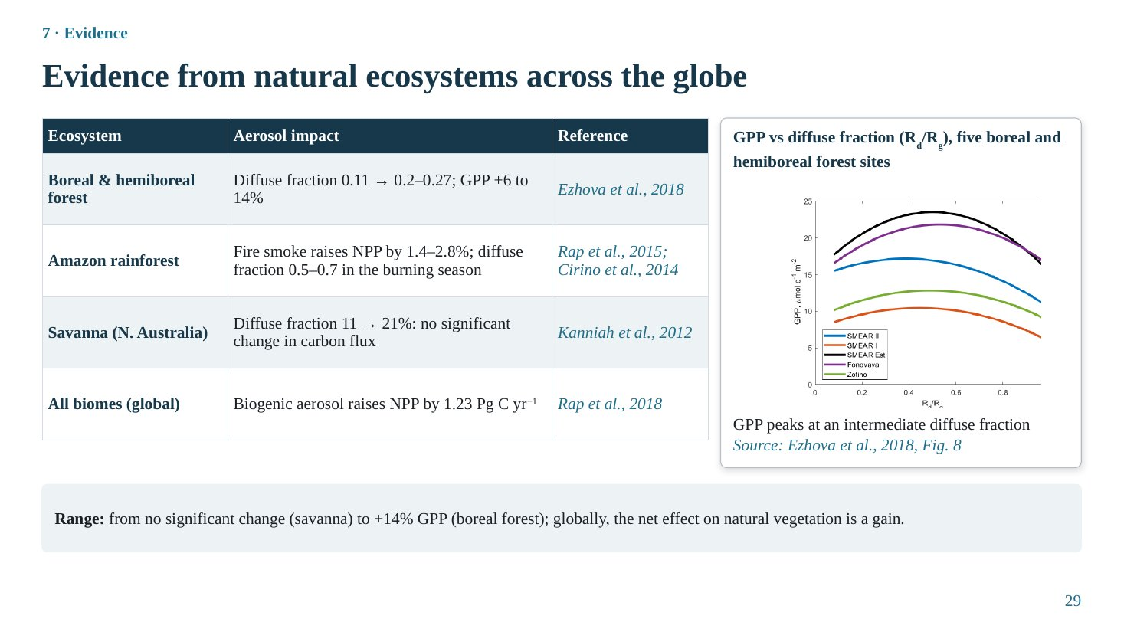
Slide 29
What this slide says, in simple words
In natural ecosystems, aerosols usually help. Boreal forests photosynthesise more on moderately hazy days, Amazon forests gain from fire smoke, a savanna showed no change, and aerosols produced by plants themselves add a lot of productivity globally.
Concepts explained: from simple to scientific
Boreal and hemiboreal forests. Ezhova et al. (2018), sites in Finland, Estonia and Siberia: the diffuse fraction rose from about 0.11 on clean days to 0.2–0.27 on days with relatively high aerosol loading, raising GPP by 6–14%.
Amazon rainforest. Rap et al. (2015): smoke from fires increased forest NPP by 1.4–2.8% through diffuse radiation. Cirino et al. (2014) measured diffuse fractions of 0.5–0.7 in the burning season, with uptake falling again under very heavy smoke.
Savanna. Northern Australia: an increase in diffuse fraction from 11% to 21% did not significantly change the carbon flux (reported in Kanniah et al., 2012). Open canopies with few shaded leaves and C4 grasses gain little.
Biogenic aerosol. Rap et al. (2018): secondary organic aerosol formed from plant VOCs raises global NPP by 1.23 Pg C yr⁻¹ (range 0.76–1.61), about 30 times larger than the carbon in the SOA itself, a positive feedback.
The table explained
Ecosystem, aerosol impact and source. The range runs from no significant change to +14%.
The figure explained
Ezhova et al. (2018), Fig. 8: estimated GPP (GPP = LUE × PAR) against diffuse fraction R_{d}/R_{g} for five sites (SMEAR I, SMEAR II, SMEAR Estonia, Fonovaya, Zotino). Each curve rises, peaks at an intermediate diffuse fraction and then declines: the inverted-U at ecosystem scale.
Key numbers to remember
• Boreal: diffuse fraction 0.11 → 0.2–0.27; GPP +6–14%
• Amazon smoke: NPP +1.4–2.8%; diffuse fraction 0.5–0.7
• Savanna: diffuse fraction 11 → 21%, no significant change
• Biogenic SOA: +1.23 Pg C yr⁻¹
Likely questions and model answers
Q1. Why do natural ecosystems usually gain while crops in polluted regions lose?
Natural forests are dense, multi-layer canopies of mostly C3 species, and they are usually exposed to moderate aerosol loads (often below the optimum). Croplands in the IGP or North China Plain have simpler canopies, sometimes C4 crops, and very high aerosol loads above the optimum, often with ozone.
Q2. What is the significance of the Rap et al. (2018) result?
It shows a natural feedback: vegetation emits VOCs, these form scattering aerosol, which increases diffuse light and plant productivity. It also means that changes in vegetation (deforestation) or temperature (which controls VOC emission) can change aerosol and productivity together.

Slide 30: Evidence from crops outside South Asia
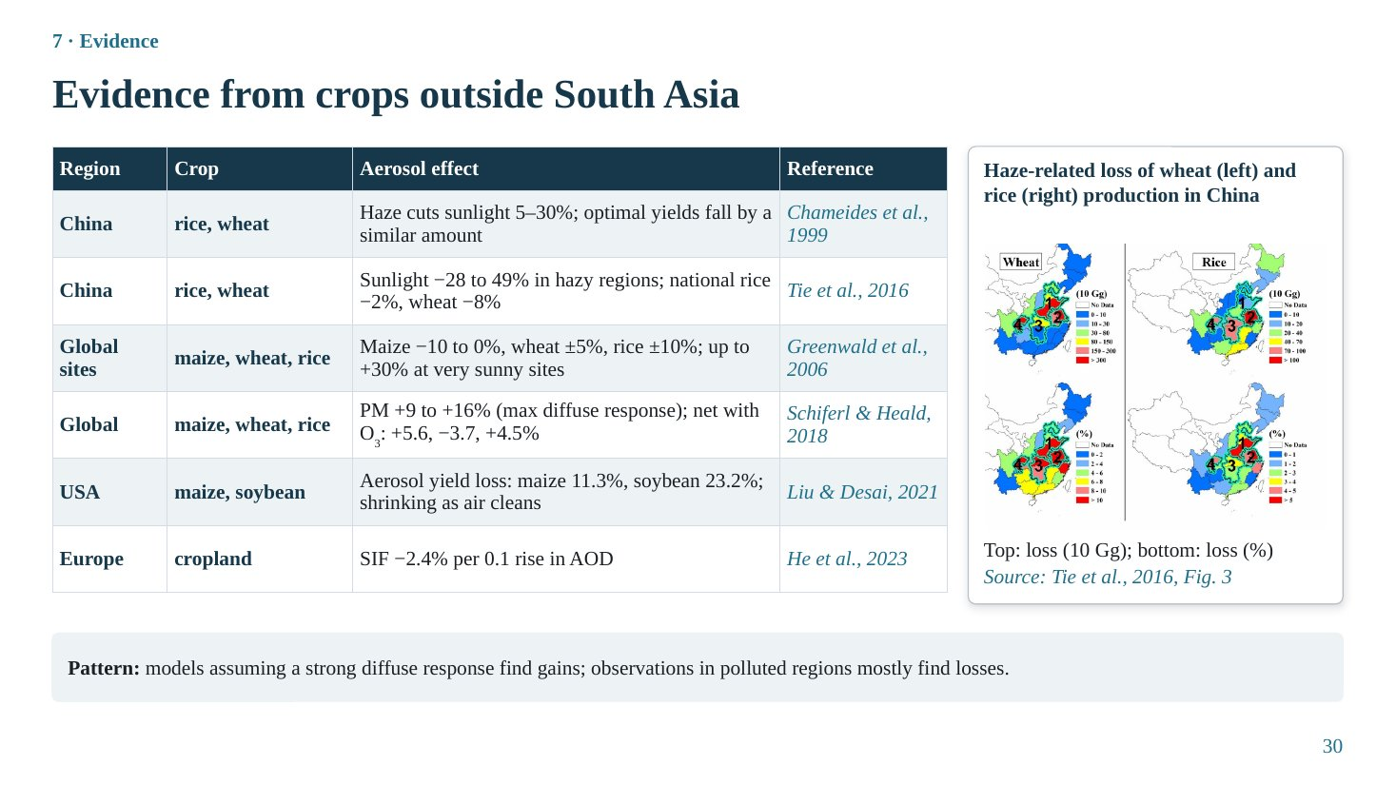
Slide 30
What this slide says, in simple words
For crops, models that assume crops love diffuse light predict gains, while real-world observations in polluted regions mostly show losses. Haze in China cuts sunlight and reduces wheat and rice production; in the USA, aerosol losses in maize and soybean shrank as air became cleaner; in Europe, crop photosynthesis falls as haze increases.
Concepts explained: from simple to scientific
China. Chameides et al. (1999): regional haze in eastern China reduces sunlight by 5–30% and optimal yields by a similar amount. Tie et al. (2016): solar irradiance reduced by 28–49% in China's polluted regions (using MODIS AOD and the TUV model); national production losses about 2% for rice and 8% for wheat.
Crop models. Greenwald et al. (2006), CERES: maize −10 to 0%, wheat ±5%, rice ±10%; up to +30% only under exceptionally sunny conditions (California Central Valley). Schiferl & Heald (2018): with maximum diffuse sensitivity, particulate matter could raise production by 9–16%; including ozone, net +5.6% maize, −3.7% wheat, +4.5% rice (2010).
Observations. Liu & Desai (2021), US county statistics 1980–2019: aerosol yield losses 11.3% (maize) and 23.2% (soybean), decreasing as air quality improved. He et al. (2023), Europe: cropland SIF −2.4% per 0.1 increase in AOD.
The table explained
Region, crop, aerosol effect and reference. Read the pattern in the strip: method matters.
The figure explained
Tie et al. (2016), Fig. 3: estimated reduction of wheat (left) and rice (right) production in China due to haze. Top maps: loss in units of 10 Gg; bottom maps: percentage loss. Losses concentrate in the North China Plain, Yangtze River Delta and Sichuan Basin.
Key numbers to remember
• China haze: sunlight −5–30% (Chameides), −28–49% (Tie)
• China production: rice −2%, wheat −8%
• US aerosol losses: maize 11.3%, soybean 23.2%
• Europe: cropland SIF −2.4% per 0.1 AOD
Likely questions and model answers
Q1. Why do model studies like Schiferl & Heald find gains while observational studies find losses?
Because the models assume crops respond strongly to diffuse light (maximum diffuse sensitivity); this parameter is uncertain and probably too high for many crops. Observational studies include real clouds, ozone, heat and the actual high aerosol loads of polluted regions, which push crops beyond the optimum.
Q2. Why are US soybean losses larger than maize losses?
Liu & Desai found soybean more sensitive to aerosol and maize more sensitive to ozone. One possible explanation: aerosol and humidity effects differ between C3 soybean and C4 maize, and timing of exposure differs; the statistical result does not itself identify the mechanism.

Slide 31: Evidence from India and South Asia
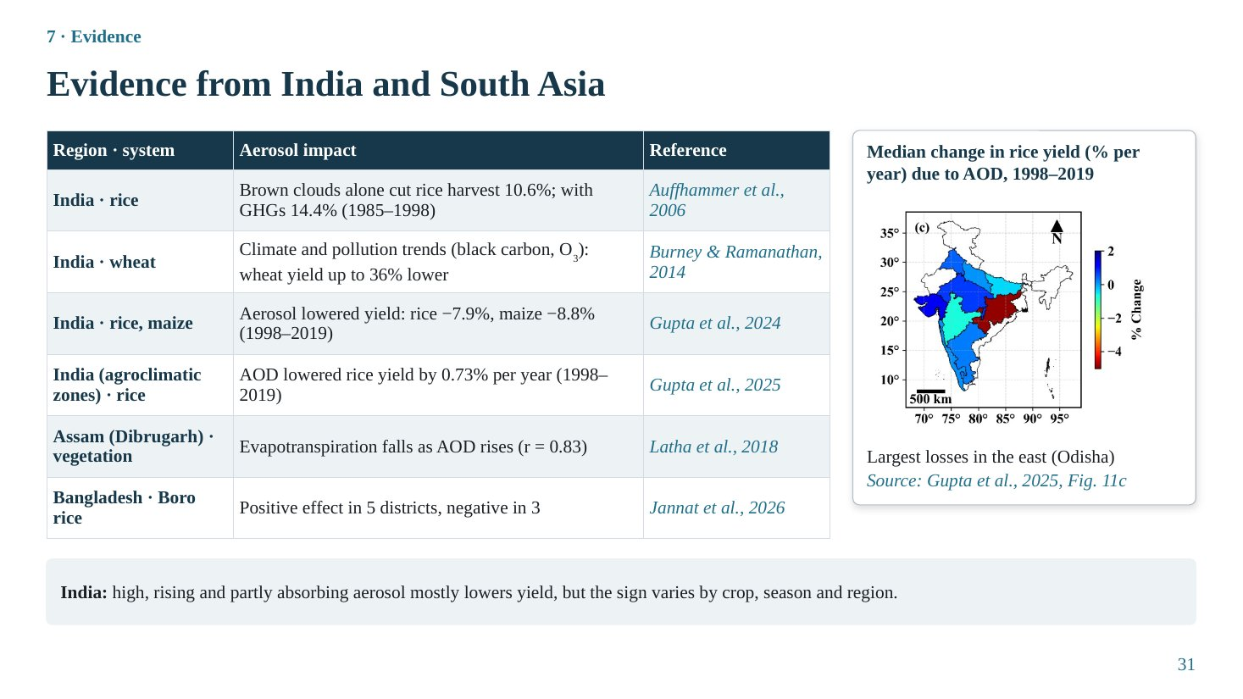
Slide 31
What this slide says, in simple words
In India most studies find that haze lowers crop yields: rice and maize yields are several percent lower than they would be with cleaner air, and the losses are largest in the east. But the effect is not the same everywhere: in Bangladesh some districts even showed a positive effect.
Concepts explained: from simple to scientific
Auffhammer et al. (2006). A statistical model of historical Indian rice harvests combined with regional climate scenarios. Atmospheric brown clouds (ABCs) alone reduced the rice harvest by 10.6% in 1985–1998 (3.94% in 1966–1984); reducing ABCs and greenhouse gases together would have increased harvests by 14.4% in 1985–1998, mainly through rainfall and night temperature.
Burney & Ramanathan (2014). Attributed a wheat yield gap of up to 36% (relative to a counterfactual) to recent climate and short-lived pollutant trends (black carbon and ozone). It is a model counterfactual and has been debated.
Gupta et al. (2024). Earth-observation data for 1998–2019: rising aerosol reduced rice yield by 7.9% and maize by 8.8% over India.
Gupta et al. (2025). Across agroclimatic zones, AOD reduced rice yield by about 0.73% per year (1998–2019), with the largest losses in eastern India, especially Odisha.
Latha et al. (2018). Over Dibrugarh, Assam, ET decreases with AOD (r = −0.83), because aerosol forcing reduces energy for evaporation.
Jannat et al. (2026). Boro rice in eight Bangladeshi districts (2007–2023): net positive aerosol effects in five districts (Khulna, Barisal, Rangpur, Mymensingh, Sylhet) and negative in three (Chattogram, Dhaka, Rajshahi).
The table explained
Region and crop, aerosol impact, reference. Note the different methods: statistical models (Auffhammer, Gupta), model counterfactual (Burney & Ramanathan), regional correlation (Latha) and regression with indirect pathways (Jannat).
The figure explained
Gupta et al. (2025), Fig. 11c: median annual percentage change in rice yield due to AOD over India, 1998–2019. Blue: positive or small change; red: negative. The largest negative changes (red) are in the east, especially Odisha.
Key numbers to remember
• Brown clouds: rice −10.6% (1985–1998); with GHGs −14.4%
• Wheat gap up to 36% (black carbon + ozone trends)
• Rice −7.9%, maize −8.8% (1998–2019)
• Rice −0.73% per year due to AOD
• Bangladesh: positive in 5, negative in 3 districts
Likely questions and model answers
Q1. How did Auffhammer et al. separate the aerosol effect on rice?
They estimated the sensitivity of rice harvest to rainfall and temperature from historical data, then used climate model scenarios with and without brown clouds (and greenhouse gases) to compute the climate each scenario would produce, and fed those into the statistical model. The difference in predicted harvest is the attributed effect. So the effect acts through climate (rain, temperature), not only through light.
Q2. Why might Bangladesh show positive effects while India mostly shows losses?
Bangladesh Boro rice is irrigated and grown in the dry season, where lower evaporative demand under haze may help, and coastal districts (Khulna) have different aerosol and humidity regimes. The sign depends on aerosol load relative to the optimum, cloudiness, water status and crop.

Slide 32: Ecosystem-wise productivity trends in India
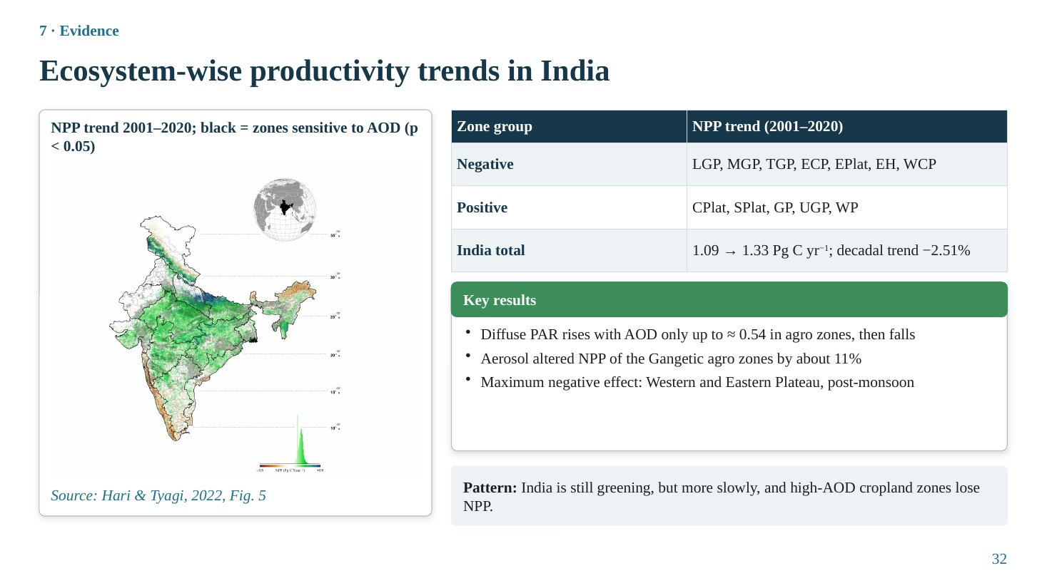
Slide 32
What this slide says, in simple words
Looking inside India by ecological zones: India is still getting greener overall, but the rate of greening has slowed, and productivity is falling in several high-haze zones, especially the Gangetic plains.
Concepts explained: from simple to scientific
Data and method (Hari & Tyagi, 2022). NPP was modelled with the CASA light-use-efficiency model (NDVI, temperature, rainfall, solar radiation) for India's agroecological zones, 2001–2020, and related to MODIS AOD. Trends were tested with Innovative Trend Analysis (ITA), which compares the two halves of the series, and Mann–Kendall/Sen's slope.
Zone abbreviations. LGP, MGP, TGP, UGP: Lower, Middle, Trans- and Upper Gangetic Plains; ECP: East Coast Plain; EPlat, CPlat, SPlat, WPlat: Eastern, Central, Southern, Western Plateau; EH: Eastern Himalaya; WCP: West Coast Plain; GP: Gujarat Plain; WP: Western Plain (Thar).
Key results. NPP trend negative in LGP, MGP, TGP, ECP, EPlat, EH and WCP; positive in CPlat, SPlat, GP, UGP and WP. India's total NPP rose from about 1.09 to 1.33 Pg C yr⁻¹, but the decadal trend weakened by 2.51%. Diffuse PAR (SBDART) rises with AOD only up to about 0.54 in agro zones, then falls. Aerosol altered agro-zone NPP by about 11%. Maximum negative effect over the Western and Eastern Plateau in post-monsoon.
The table explained
Three rows: zones with negative and positive NPP trends, and the all-India total.
The figure explained
Hari & Tyagi (2022), Fig. 5: map of the NPP trend 2001–2020 (green: increasing; brown: decreasing), with black stippling where NPP is significantly sensitive to AOD (p < 0.05). The inset histogram shows the distribution of trend values.
Key numbers to remember
• India NPP 1.09 → 1.33 Pg C yr⁻¹ (2001–2020)
• Decadal trend −2.51%
• Agro zones: diffuse PAR rises only up to AOD ≈ 0.54
• Aerosol altered agro NPP by ≈ 11%
Likely questions and model answers
Q1. Is CASA NPP a measurement?
No, it is a model estimate driven by satellite NDVI and meteorology. Hari & Tyagi validated it against MODIS NPP (R² about 0.78). Importantly, standard CASA has no diffuse-light term, so the AOD–NPP link in that study is statistical, not mechanistic.
Q2. Why would diffuse PAR stop increasing above AOD 0.54?
At high AOD multiple scattering and absorption reduce the total light so much that the diffuse component itself begins to decrease, even though the diffuse fraction remains high. The canopy then loses both direct and diffuse light.

Section 9 · Challenges

Slide 33: Uncertainties and challenges
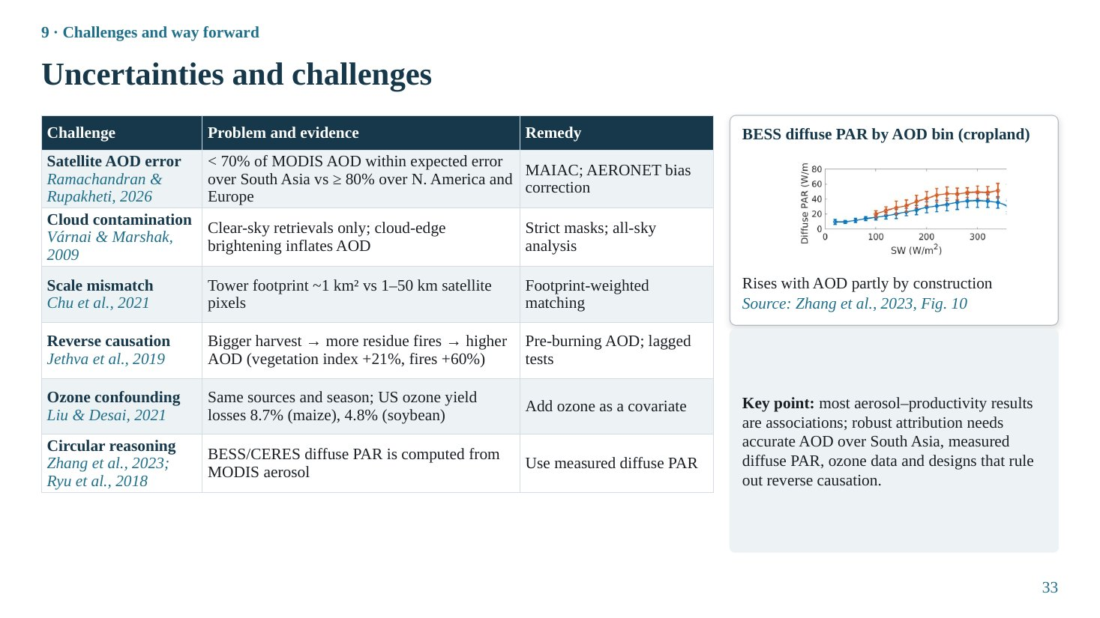
Slide 33
What this slide says, in simple words
Six problems can mislead us: satellite AOD is less accurate over South Asia; satellites can't see through clouds and cloud edges inflate AOD; a tower and a satellite pixel see different areas; productivity can cause haze (burning residue); ozone travels with aerosol; and some satellite light products are calculated from aerosol data, so they can't independently test it.
Concepts explained: from simple to scientific
Satellite AOD error. Fewer than 70% of MODIS AOD values fall within the expected error over South Asia, versus at least 80% over North America and Europe (Ramachandran & Rupakheti, 2026, citing Ansari & Ramachandran, 2024). Remedy: MAIAC and AERONET-based bias correction.
Cloud contamination. Only clear-sky retrievals are possible, and near cloud edges light scattered by clouds brightens neighbouring pixels (the 3-D cloud adjacency effect) and inflates AOD (Várnai & Marshak, 2009). Remedy: strict cloud masks, all-sky analyses.
Scale mismatch. Flux-tower footprints are about 1 km², satellite pixels 1–50 km (Chu et al., 2021). Remedy: footprint-weighted matching, homogeneous sites.
Reverse causation. In north-west India, vegetation index rose by about 21% and fires by about 60% (2002–2016): bigger harvest → more residue fires → higher AOD (Jethva et al., 2019). Remedy: use pre-burning AOD, lagged analyses.
Ozone confounding. Same sources and season. US ozone yield losses were 8.7% for maize and 4.8% for soybean (Liu & Desai, 2021). Remedy: include ozone as a covariate.
Circular reasoning. BESS and CERES diffuse PAR are computed using MODIS aerosol, so showing that their diffuse PAR rises with AOD is partly built in (Zhang et al., 2023; Ryu et al., 2018). Remedy: use measured diffuse PAR.
The table explained
Each challenge, its evidence and its remedy. Prepare one example for each, because examiners often ask 'what are the limitations of your evidence?'.
The figure explained
Zhang et al. (2023), Fig. 10: mean BESS diffuse PAR in each AOD bin (low 0–0.2, medium 0.2–0.4, high 0.4–0.6) against shortwave radiation for cropland. Diffuse PAR is higher in higher AOD bins, partly because BESS uses aerosol inputs to compute it.
Key numbers to remember
• MODIS within EE: < 70% (South Asia) vs ≥ 80% (N. America, Europe)
• NW India 2002–2016: vegetation index +21%, fires +60%
• US ozone losses: maize 8.7%, soybean 4.8%
Likely questions and model answers
Q1. Which of these challenges is most serious for Indian studies, in your view?
Probably the combination of satellite AOD error over bright, heterogeneous surfaces and the lack of measured diffuse radiation and flux towers, because together they mean neither side of the relationship is well constrained. Reverse causation is also specific and important in the residue-burning belt.
Q2. How would you design a better study for the IGP?
Install flux towers and diffuse-radiation sensors over rice–wheat systems; use MAIAC AOD corrected against AERONET; include ozone and meteorology as covariates; exploit natural experiments (lockdown, burning bans, weekday cycles); use SIF and two-leaf models; and analyse pre-burning periods to avoid reverse causation.

Section 10 · Conclusions

Slide 34: Conclusions and take-home messages
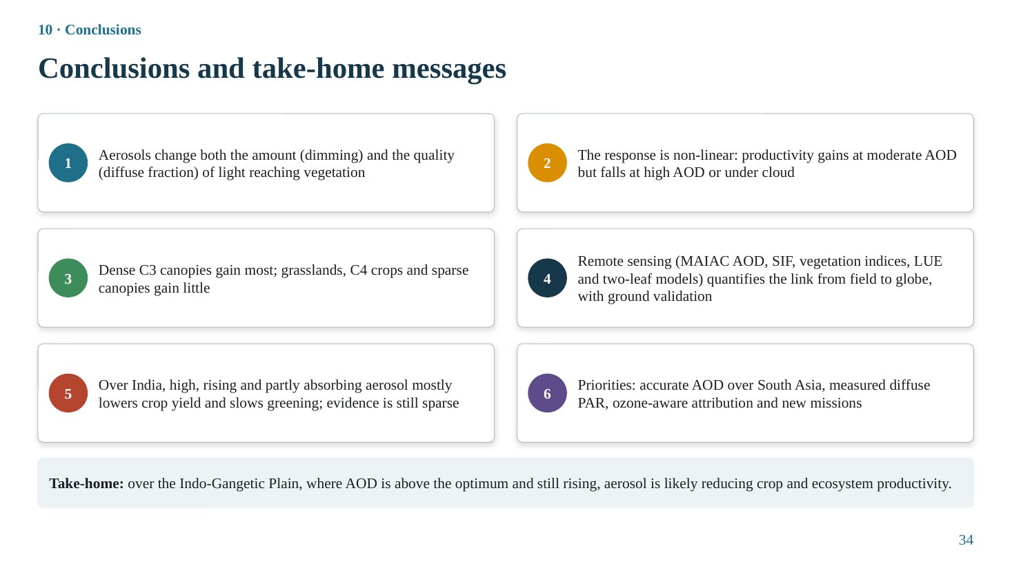
Slide 34
What this slide says, in simple words
Six messages: haze changes both how much light and what kind of light reaches plants; the response is hill-shaped; dense C3 canopies gain most; remote sensing can measure the link from field to globe; in India haze mostly lowers yields and slows greening; and better data are needed.
Concepts explained: from simple to scientific
Message 1. Aerosols change both the amount (dimming) and quality (diffuse fraction) of light.
Message 2. The response is non-linear (inverted-U): gains at moderate AOD, losses at high AOD or under cloud.
Message 3. Dense C3 canopies gain most; grasslands, C4 crops and sparse canopies gain little.
Message 4. Remote sensing (MAIAC AOD, SIF, vegetation indices, LUE and two-leaf models) quantifies the link from field to globe, with ground validation.
Message 5. Over India, high, rising and partly absorbing aerosol mostly lowers crop yield and slows greening; evidence is still sparse.
Message 6. Priorities: accurate AOD over South Asia, measured diffuse PAR, ozone-aware attribution and new missions. (Note: this card still mentions 'new missions'; if you prefer to avoid that topic, say 'and better observations'.)
Likely questions and model answers
Q1. Give your main conclusion in one sentence.
Over the Indo-Gangetic Plain, where aerosol optical depth is already above the optimum for crops and still rising, aerosol is likely reducing crop and ecosystem productivity, although moderate scattering aerosol can enhance productivity of dense canopies elsewhere.
Q2. What is the policy relevance?
Reducing emissions, especially black carbon, residue burning and ozone precursors, would likely raise crop productivity in the IGP, in addition to health benefits. Wang et al. (2021) concluded similarly for the North China Plain, where 76–90% of cropland exceeded the optimum AOD.

Case study 1 · Wang et al., 2021

Slide 35: Case Study 1: title and overview
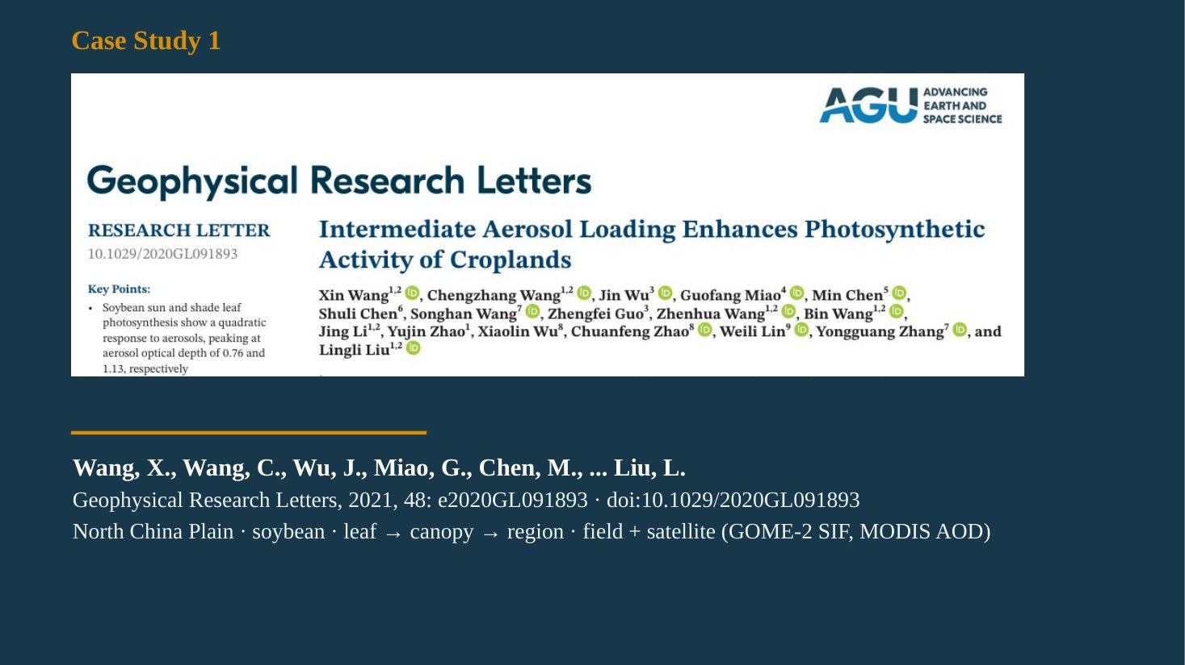
Slide 35
What this slide says, in simple words
The first case study asks a simple but difficult question: does a moderate amount of haze help crops photosynthesise, and does too much haze harm them? It answers it at three scales, single leaves, whole canopy and the entire North China Plain, using field instruments, a photosynthesis model and satellite fluorescence.
Concepts explained: from simple to scientific
Citation. Wang, X., Wang, C., Wu, J., Miao, G., Chen, M., et al., Liu, L. (2021). Intermediate aerosol loading enhances photosynthetic activity of croplands. Geophysical Research Letters 48: e2020GL091893.
Key points of the paper. Soybean sun- and shade-leaf photosynthesis show a quadratic (inverted-U) response to aerosols, peaking at AOD 0.76 and 1.13 respectively; canopy photosynthesis peaks at 0.93. Aerosol effects on sun leaves were driven mainly by humidity and on shade leaves by diffuse light. Satellite SIF shows the same pattern regionally, and 76–90% of the North China Plain exceeded the optimum.
The figure explained
The slide shows the paper's header from Geophysical Research Letters with title, authors and key points.
Likely questions and model answers
Q1. Why did you choose this paper as a case study?
Because it directly tests the optimum-aerosol hypothesis in a cropland, at leaf, canopy and regional scales, combines field measurements with satellite SIF (remote sensing), and separates the effects of light, temperature and humidity, a gap in earlier studies. Its policy conclusion is directly relevant to the IGP.

Slide 36: Background: competing effects of aerosols on crops
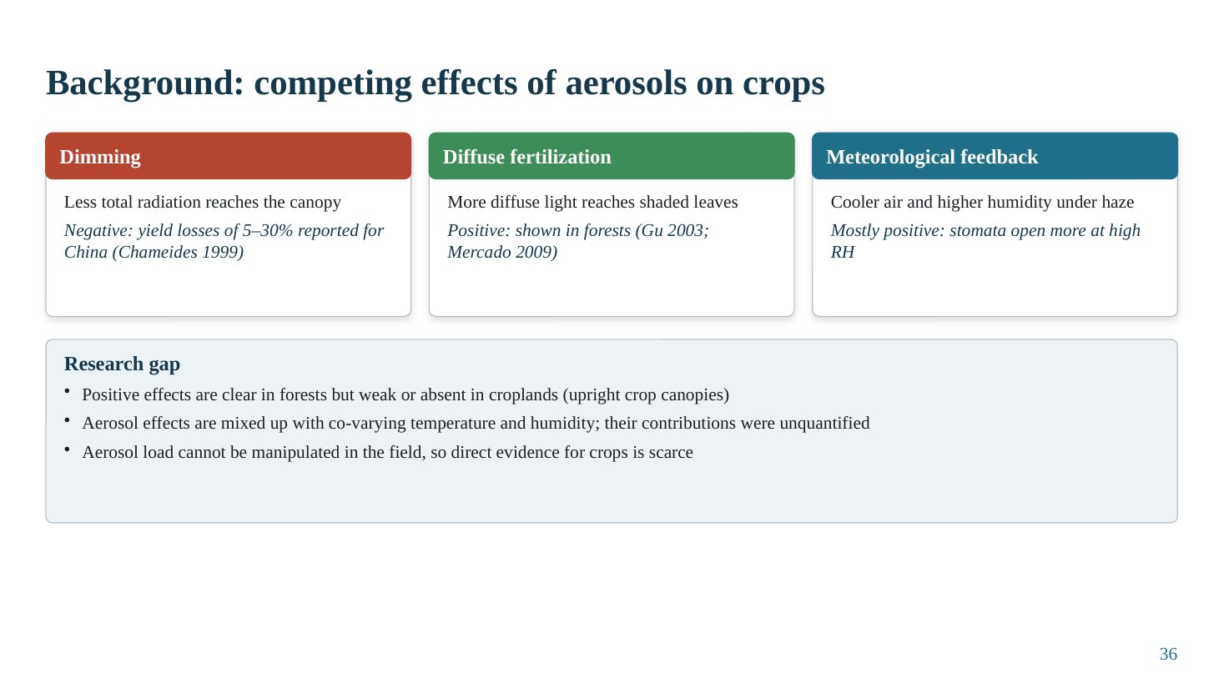
Slide 36
What this slide says, in simple words
Haze affects crops in three ways at once: less light (bad), more diffuse light (good) and cooler, more humid air (mostly good). Forests clearly benefit, but for crops the evidence was unclear, and nobody had separated the light effect from the humidity and temperature effects.
Concepts explained: from simple to scientific
Dimming. Less total radiation; yield losses of 5–30% were reported for China (Chameides et al., 1999).
Diffuse fertilization. More diffuse light reaches shaded leaves; shown in forests (Gu et al., 2003; Mercado et al., 2009).
Meteorological feedback. Haze lowers air temperature and raises relative humidity; stomata open more at high RH, so mostly positive.
Research gaps. (1) Positive effects clear in forests but weak or absent in croplands, possibly because crop canopies are upright and simple. (2) Aerosol effects are confounded with co-varying temperature and humidity, whose contributions had not been quantified. (3) Aerosol load cannot be manipulated in the field, so direct evidence is scarce.
Likely questions and model answers
Q1. Why might upright crop canopies benefit less from diffuse light?
Upright (erectophile) leaves allow direct light to penetrate deeper, so fewer leaves are fully shaded and the canopy is less light-saturated at the top; also crops like soybean are light-demanding and saturate at higher irradiance. So redistributing light gives a smaller gain than in a dense, multi-layer forest.

Slide 37: Study region, hypotheses and objectives
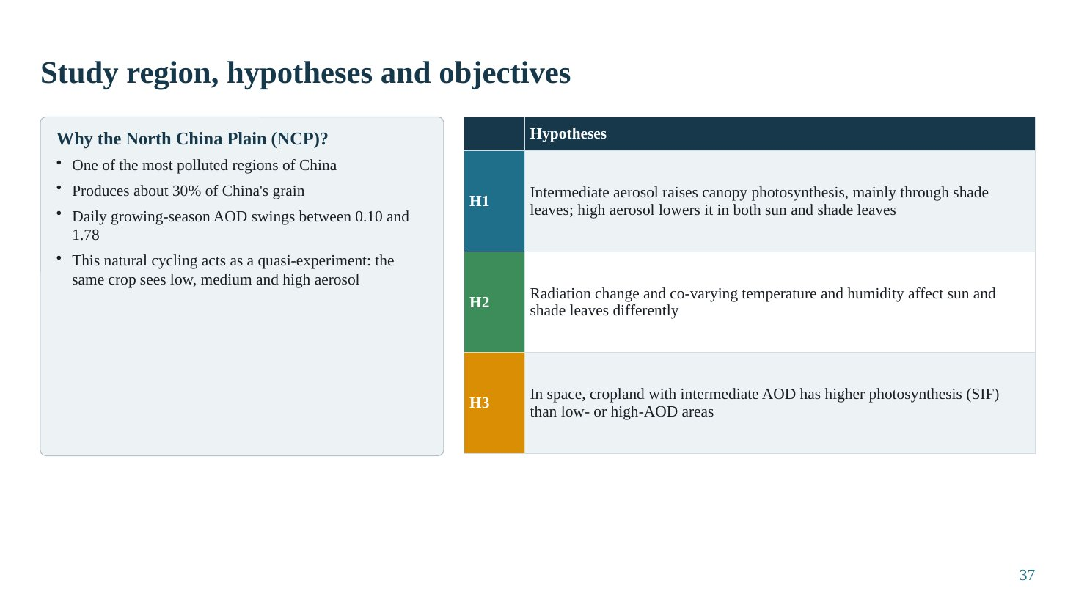
Slide 37
What this slide says, in simple words
The North China Plain is very polluted and grows a large share of China's grain. Because the haze there swings from almost clean to very dense within days, the same crop experiences low, medium and high haze: a natural experiment. The authors tested three hypotheses.
Concepts explained: from simple to scientific
Why the NCP. One of the most polluted regions of China; produces about 30% of China's grain; daily growing-season AOD varies between 0.10 and 1.78.
H1. Intermediate aerosol raises canopy photosynthesis, mainly through shade leaves; high aerosol lowers photosynthesis of both sun and shade leaves.
H2. Radiation change and co-varying temperature and humidity affect sun and shade leaves differently.
H3. In space, cropland with intermediate AOD has higher photosynthesis (SIF) than low- or high-AOD areas.
Quasi-experiment. A situation in which the variable of interest varies naturally over a wide range while other conditions (crop, management) are similar, allowing near-experimental inference.
The table explained
Three hypotheses: H1 (optimum and its leaf basis), H2 (mechanisms differ for sun and shade leaves), H3 (regional spatial pattern).
Key numbers to remember
• NCP ≈ 30% of China's grain
• Growing-season AOD range 0.10–1.78
Likely questions and model answers
Q1. What is the difference between H1 and H3?
H1 is tested at one field site over time (temporal variation of AOD at leaf and canopy scale). H3 is tested across space over the whole region with satellite data (spatial variation of AOD and SIF). Finding the same inverted-U at both gives stronger evidence.

Slide 38: Study design: two scales, two observing systems
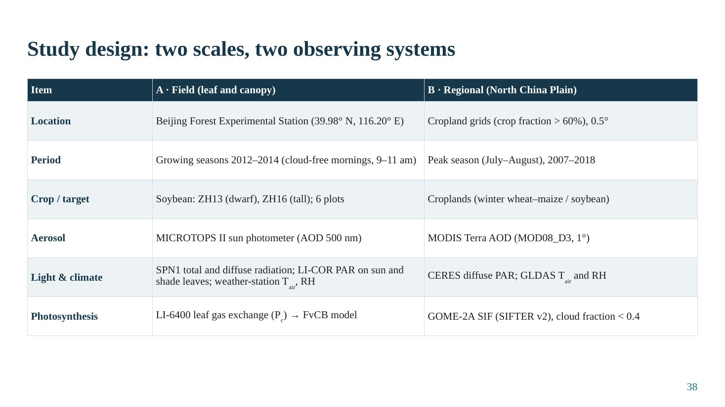
Slide 38
What this slide says, in simple words
At a field station in Beijing, the team measured haze, light on sun and shade leaves, temperature, humidity and leaf photosynthesis of two soybean varieties for three seasons. Across the North China Plain, they used satellite haze, diffuse light, weather and fluorescence data for twelve years.
Concepts explained: from simple to scientific
Field scale. Beijing Forest Experimental Station (39.98° N, 116.20° E); growing seasons 2012–2014; cloud-free mornings 9–11 am; soybean varieties ZH13 (dwarf) and ZH16 (tall); 6 plots.
Field instruments. MICROTOPS II hand-held sun photometer (AOD at 500 nm); SPN1 sunshine pyranometer (total and diffuse radiation); LI-COR quantum sensors for PAR on sun and shade leaves; weather station (air temperature, RH); LI-6400 portable photosynthesis system for leaf gas exchange (photosynthesis capacity, Pc).
Regional scale. Cropland grid cells with crop fraction > 60% at 0.5°; peak season July–August, 2007–2018. MODIS Terra AOD (MOD08_D3, 1°); CERES diffuse PAR; GLDAS air temperature and RH; GOME-2A SIF (SIFTER v2) with cloud fraction < 0.4; MCD12C1 land cover.
The table explained
Two columns compare field and regional designs row by row: location, period, crop, aerosol measurement, light and climate data, photosynthesis measurement.
Likely questions and model answers
Q1. Why were measurements restricted to cloud-free mornings?
To isolate the aerosol effect from cloud effects (clouds also create diffuse light), and to keep sun angle and temperature conditions comparable across days.
Q2. What does the SPN1 sensor measure?
Total (global) and diffuse shortwave radiation simultaneously, using an array of thermopiles under a patterned shade; direct radiation is the difference. This allows calculation of the diffuse fraction.

Slide 39: Methodology flowchart
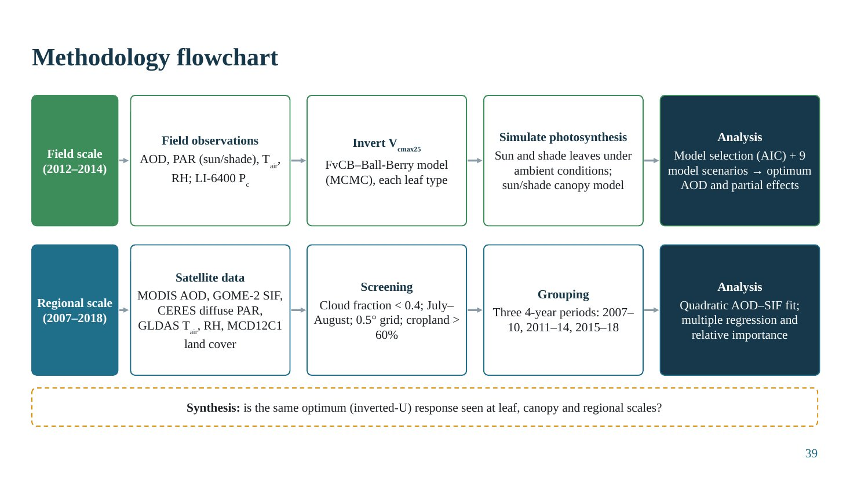
Slide 39
What this slide says, in simple words
The flowchart has two parallel paths. In the field path, leaf measurements are used to tune a photosynthesis model, which then calculates photosynthesis of sun and shade leaves under real conditions; statistics find the optimum haze level and the contribution of each factor. In the regional path, satellite data are cleaned, grouped into three time periods and analysed. Finally, the two scales are compared.
Concepts explained: from simple to scientific
Inverting Vcmax25. Vcmax25 is the maximum carboxylation rate of the enzyme Rubisco at 25 °C, the main photosynthetic capacity parameter. It is estimated (inverted) from measured leaf photosynthesis using the FvCB–Ball-Berry model and a Markov Chain Monte Carlo (MCMC) method, separately for each leaf type.
Simulation. Photosynthesis of sun and shade leaves is simulated with measured PAR, temperature and humidity, then scaled to the canopy with a sun/shade canopy model.
Analysis. Model selection by AIC chooses the best functional form (linear, quadratic, exponential, logarithmic); nine model scenarios isolate the partial effects of PAR, temperature, RH and Vcmax25.
Regional path. Screening (cloud fraction < 0.4, July–August, cropland > 60%); grouping into 2007–2010, 2011–2014, 2015–2018; quadratic AOD–SIF fit; multiple regression with relative importance.
The figure explained
The flowchart itself: two vertical columns (field scale left, regional scale right) of boxes connected by arrows, converging on the synthesis box at the bottom.
Likely questions and model answers
Q1. Why use a model instead of directly measuring photosynthesis on every day?
Continuous leaf measurements on many leaves under all conditions are impractical. The model, once calibrated with measured capacity (Vcmax25) and validated, can compute photosynthesis for every observation of light, temperature and humidity, and can be run in scenarios to separate causes, which measurements alone cannot do.

Slide 40: Leaf-to-canopy photosynthesis model and its validation
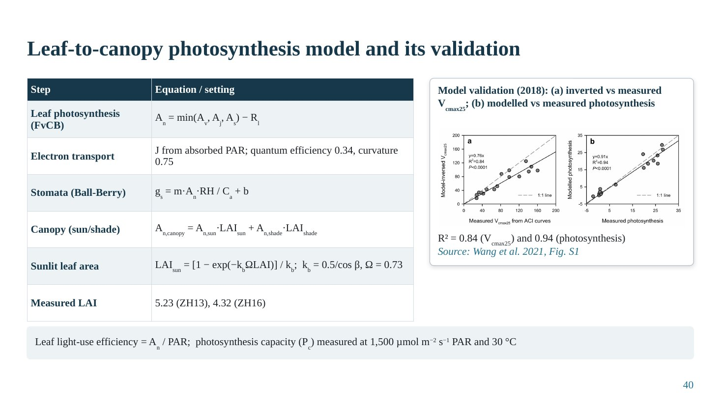
Slide 40
What this slide says, in simple words
The authors used a standard biochemical model of leaf photosynthesis, combined with a model of how leaf pores respond to humidity, and added up sun and shade leaves to get the canopy. They tested it with an independent experiment and it matched measurements very well.
Concepts explained: from simple to scientific
FvCB model. Farquhar–von Caemmerer–Berry: net photosynthesis A_{n} = min(A_{v}, A_{j}, A_{s}) − R_{l}, the minimum of three limitations: Rubisco carboxylation (A_{v}), electron transport driven by light (A_{j}) and triose-phosphate utilisation or sink (A_{s}), minus leaf respiration R_{l}.
Electron transport. J from absorbed PAR using quantum efficiency 0.34 and curvature 0.75 of a non-rectangular hyperbola: light response saturates at high PAR.
Ball-Berry stomatal model. g_{s} = m·A_{n}·RH/C_{a} + b: stomatal conductance increases with photosynthesis and relative humidity at the leaf surface and decreases with CO₂ concentration. This is how humidity enters the model.
Canopy scaling. A_{n,canopy} = A_{n,sun}·LAI_{sun} + A_{n,shade}·LAI_{shade}; LAI_{sun} = [1 − exp(−k_{b}ΩLAI)]/k_{b}, with k_{b} = 0.5/cos β (extinction coefficient for direct beam, β is the solar zenith angle in their notation) and clumping index Ω = 0.73. Measured LAI: 5.23 (ZH13), 4.32 (ZH16).
Validation. Independent 2018 experiment: inverted versus measured Vcmax25 R² = 0.84; modelled versus measured photosynthesis R² = 0.94.
Leaf LUE. A_{n}/PAR. Photosynthesis capacity Pc measured at 1,500 µmol m⁻² s⁻¹ PAR and 30 °C.
The table explained
Each modelling step and its equation or setting, from leaf biochemistry to canopy scaling.
The figure explained
Wang et al. (2021), Fig. S1: (a) inverted Vcmax25 against measured Vcmax25 (R² = 0.84) and (b) modelled against measured photosynthesis (R² = 0.94), both close to the 1:1 line.
Key numbers to remember
• Quantum efficiency 0.34; curvature 0.75
• Ω = 0.73; LAI 5.23 (ZH13), 4.32 (ZH16)
• Validation R² 0.84 (Vcmax25), 0.94 (photosynthesis)
Likely questions and model answers
Q1. Explain the three limitations in the FvCB model in simple words.
Photosynthesis is limited by the slowest of three steps: how fast the enzyme Rubisco can fix CO₂ (important at high light), how fast light-driven electron transport can supply energy (important at low light, e.g. shaded leaves), and how fast the leaf can use the sugars produced. The leaf's actual rate is the minimum of the three.
Q2. How does humidity affect photosynthesis in this model?
Through the Ball-Berry equation: higher relative humidity increases stomatal conductance, which allows more CO₂ into the leaf and raises the intercellular CO₂ concentration, increasing the Rubisco-limited rate. This is why sun leaves, which are Rubisco-limited, benefit from humidity.

Slide 41: Statistical analysis and model experiments
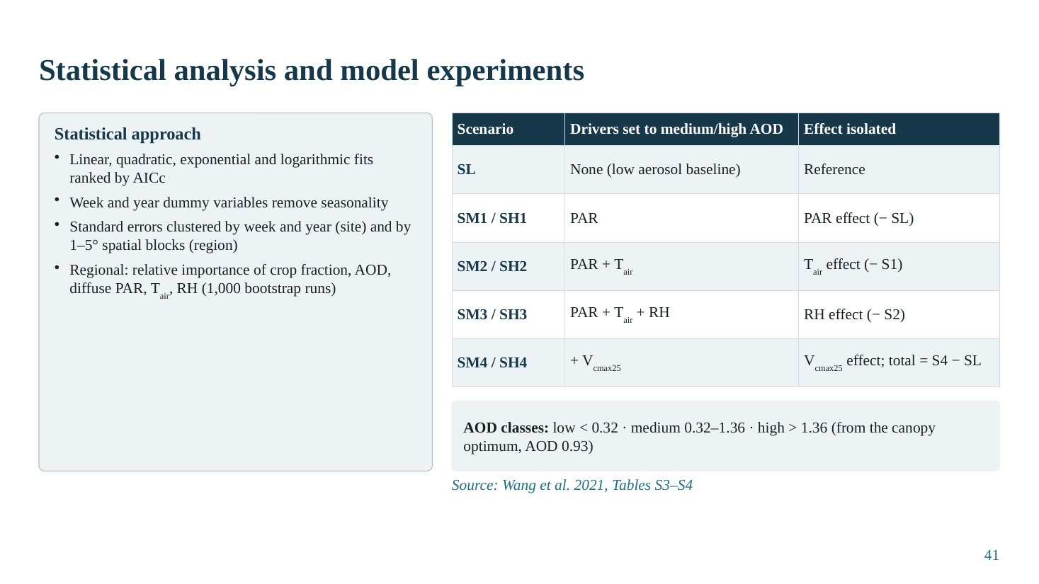
Slide 41
What this slide says, in simple words
To find the shape of the response, the authors tried four curve types and picked the best by a standard criterion. To find why the response happens, they ran the model nine times, changing one factor at a time from low-haze to medium- or high-haze values. Each difference shows the contribution of one factor.
Concepts explained: from simple to scientific
Model selection by AICc. The corrected Akaike Information Criterion balances goodness of fit against number of parameters; the model with the lowest AICc is preferred. Linear, quadratic, exponential and logarithmic forms were compared; quadratic was best for photosynthesis.
Controlling seasonality and false significance. Week and year dummy variables remove seasonal and interannual effects. Standard errors were clustered by week and year (site scale) and by 1–5° spatial blocks (regional scale), so that correlated observations do not exaggerate significance.
Factorial scenario design. SL: all drivers at low-aerosol values (baseline). SM1/SH1: PAR set to medium/high-aerosol values → PAR effect = S1 − SL. SM2/SH2: PAR + air temperature → temperature effect = S2 − S1. SM3/SH3: + RH → RH effect = S3 − S2. SM4/SH4: + Vcmax25 → Vcmax25 effect = S4 − S3; total effect = S4 − SL.
AOD classes. Low < 0.32; medium 0.32–1.36; high > 1.36, defined around the canopy optimum AOD of 0.93.
Regional relative importance. Crop fraction, AOD, diffuse PAR, air temperature and RH; relative importance with 1,000 bootstrap runs.
The table explained
Each scenario, which drivers are set to medium or high aerosol values, and which effect is isolated by the difference. This sequential design adds one driver at a time.
Key numbers to remember
• AOD classes: low < 0.32, medium 0.32–1.36, high > 1.36
• Bootstrap: 1,000 runs
Likely questions and model answers
Q1. Why does the order of adding drivers matter?
Because effects can interact non-linearly. Adding RH after PAR and temperature gives the RH effect under medium- or high-aerosol light and temperature. A different order could give slightly different partial effects; the total effect (S4 − SL) is unaffected.
Q2. What is the purpose of clustering standard errors?
Observations within the same week, year or spatial block are not independent. Treating them as independent underestimates standard errors and gives false significance. Clustering corrects for this correlation.

Slide 42: Results I: aerosols change the canopy microclimate
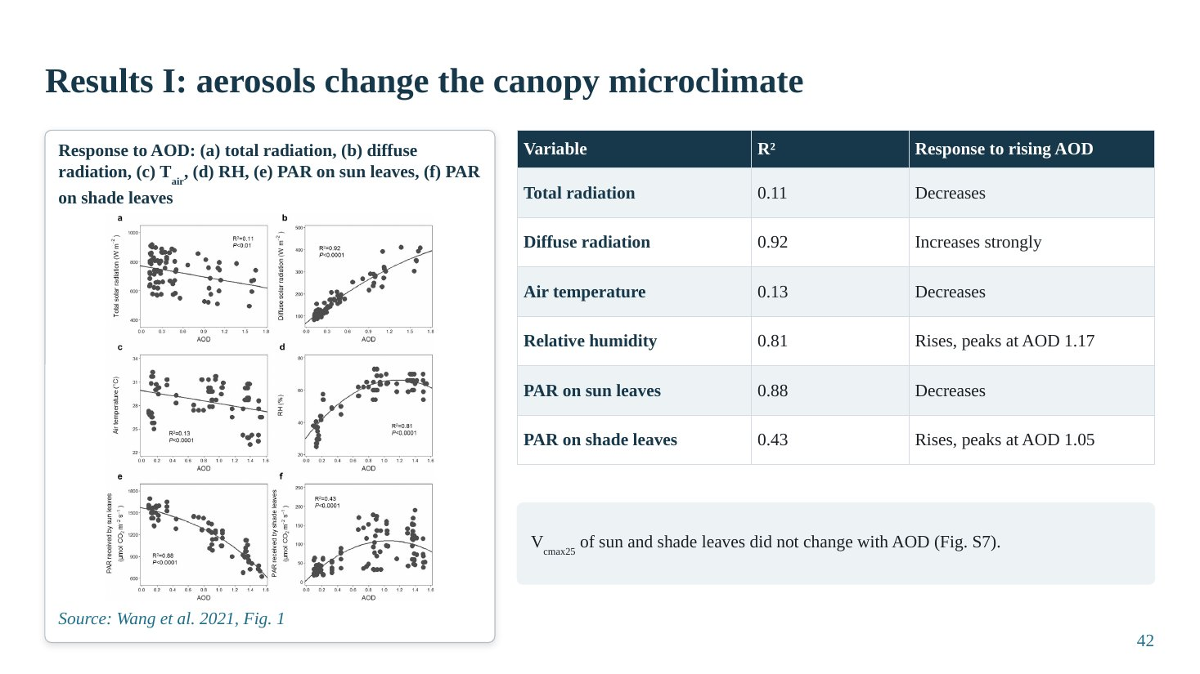
Slide 42
What this slide says, in simple words
As haze increased at the field site, total radiation and air temperature fell slightly, diffuse radiation rose strongly, and humidity rose. Sun leaves got less light; shade leaves got more light up to a point. The leaves' own photosynthetic capacity didn't change, so any change in photosynthesis comes from the environment.
Concepts explained: from simple to scientific
Total vs diffuse radiation. Total radiation decreased weakly with AOD (R² = 0.11), but diffuse radiation increased strongly (R² = 0.92).
Temperature and humidity. Air temperature decreased weakly (R² = 0.13). RH increased and peaked at AOD 1.17 (R² = 0.81); humidity and aerosol co-vary because humid air favours aerosol formation and hygroscopic growth.
Light on leaves. PAR on sun leaves decreased (R² = 0.88). PAR on shade leaves increased, peaking at AOD 1.05 (R² = 0.43), then decreased.
No biochemical change. Vcmax25 of sun and shade leaves did not change with AOD (Fig. S7).
The table explained
Each microclimate variable, the R² of its relationship with AOD and the direction of the response.
The figure explained
Wang et al. (2021), Fig. 1: scatter plots against AOD of (a) total radiation, (b) diffuse radiation, (c) air temperature, (d) RH, (e) PAR on sun leaves, (f) PAR on shade leaves, with fitted curves.
Key numbers to remember
• Diffuse radiation R² = 0.92 (increase)
• RH peaks at AOD 1.17 (R² = 0.81)
• Shade-leaf PAR peaks at AOD 1.05 (R² = 0.43)
• Sun-leaf PAR decreases (R² = 0.88)
Likely questions and model answers
Q1. Why does shade-leaf PAR decrease at very high AOD?
Because at very high AOD total radiation becomes so low that even the increased diffuse fraction cannot compensate; the absolute diffuse light reaching inner leaves begins to fall.
Q2. Why is it important that Vcmax25 did not change?
It rules out an alternative explanation that aerosol (or associated pollutants) changed the leaves' biochemical capacity. So the photosynthesis response is caused by changes in light, temperature and humidity.

Slide 43: Results II: quadratic response of photosynthesis to AOD
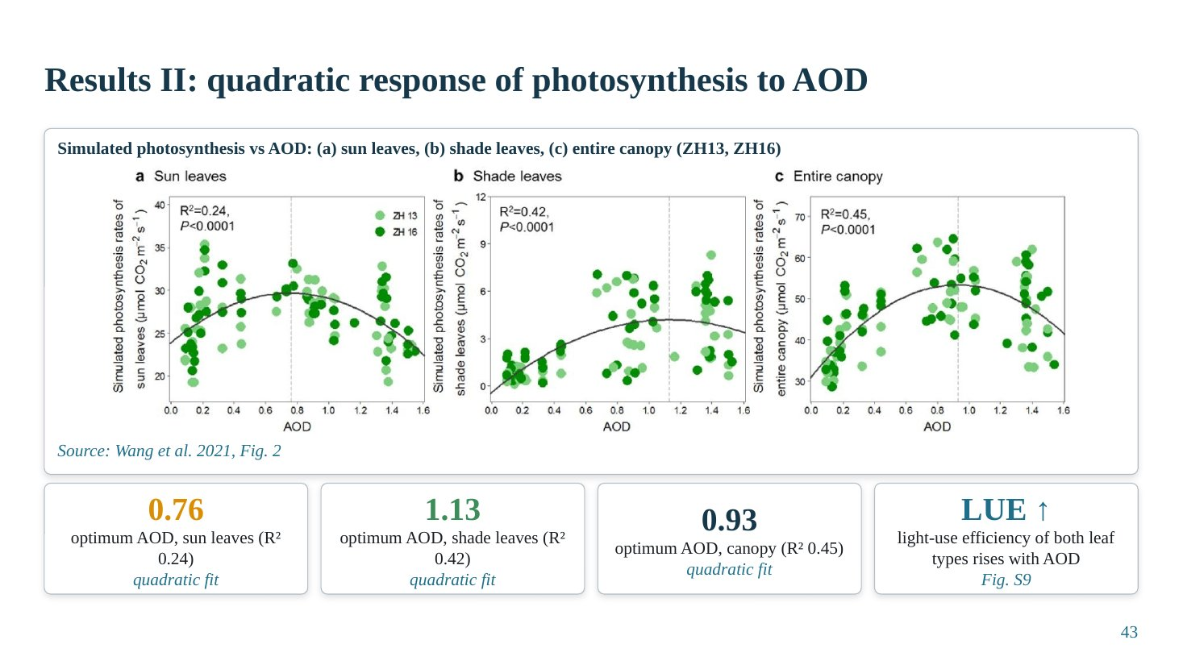
Slide 43
What this slide says, in simple words
Photosynthesis of sun leaves, shade leaves and the whole canopy all follow a hill-shaped curve with haze. Sun leaves peak at a lower haze level, shade leaves at a higher one, and the whole canopy in between. Light-use efficiency keeps rising with haze.
Concepts explained: from simple to scientific
Optima. Sun leaves: AOD 0.76 (R² 0.24). Shade leaves: AOD 1.13 (R² 0.42). Entire canopy: AOD 0.93 (R² 0.45). Found for both varieties (ZH13, ZH16).
Why shade leaves peak later. Shade leaves are light-limited; they keep gaining from extra diffuse light until total radiation falls too low. Sun leaves are saturated but lose direct light sooner.
Light-use efficiency. LUE of both leaf types increases with AOD (Fig. S9), because diffuse light is distributed more evenly and used more efficiently.
R² values. The R² values (0.24–0.45) are modest because many other factors cause day-to-day variation; the significance and consistency of the quadratic shape matter more than R² alone.
The figure explained
Wang et al. (2021), Fig. 2: simulated photosynthesis against AOD for (a) sun leaves, (b) shade leaves, (c) entire canopy, for ZH13 and ZH16, with quadratic fits; vertical lines mark the optima.
Key numbers to remember
• Optimum AOD: sun 0.76, shade 1.13, canopy 0.93
Likely questions and model answers
Q1. How do you calculate the optimum from a quadratic fit?
For P = a + b·AOD + c·AOD² (c < 0), dP/dAOD = b + 2c·AOD = 0, so AOD* = −b/(2c).
Q2. If LUE increases continuously, why does canopy photosynthesis decrease above 0.93?
Because photosynthesis = LUE × absorbed light. Above the optimum, the decrease in absorbed light outweighs the increase in LUE.

Slide 44: Results III: what drives the response? Partial effects
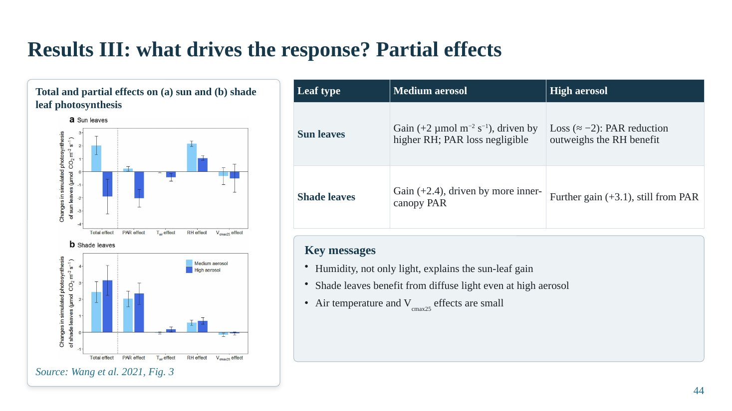
Slide 44
What this slide says, in simple words
The scenario experiments show that sun leaves and shade leaves gain for different reasons. Sun leaves gain at medium haze mainly because humidity rises (their pores open), and lose at high haze because light falls too much. Shade leaves gain at both medium and high haze because they receive more diffuse light.
Concepts explained: from simple to scientific
Sun leaves. Medium aerosol: gain of about +2 µmol m⁻² s⁻¹, driven by higher RH; PAR loss negligible because they are light-saturated. High aerosol: loss of about −2 µmol m⁻² s⁻¹ because PAR reduction outweighs the RH benefit.
Shade leaves. Medium aerosol: gain of about +2.4; high aerosol: further gain of about +3.1, both from more inner-canopy PAR.
Minor factors. Air temperature and Vcmax25 effects were small.
Key insight. Humidity, not only light, explains part of the aerosol effect. Earlier studies attributing everything to diffuse light may have overestimated the light mechanism.
The table explained
Leaf type versus medium and high aerosol: the sign and size of the photosynthesis change and its driver.
The figure explained
Wang et al. (2021), Fig. 3: bars of total and partial effects (PAR, Tair, RH, Vcmax25) on (a) sun-leaf and (b) shade-leaf photosynthesis, under medium and high aerosol.
Key numbers to remember
• Sun leaves: +2 (medium, RH-driven), ≈ −2 (high, PAR-driven) µmol m⁻² s⁻¹
• Shade leaves: +2.4 (medium), +3.1 (high), PAR-driven
Likely questions and model answers
Q1. Why does a small loss of PAR not affect sun leaves at medium aerosol?
Because sun leaves operate on the saturated part of the light-response curve, where photosynthesis barely changes with light. A modest reduction in PAR keeps them near saturation.
Q2. Does this mean aerosol itself increases humidity?
Partly the reverse: high humidity also increases AOD through hygroscopic growth and secondary aerosol formation. So humidity and AOD co-vary. The study separates their contributions to photosynthesis but notes that RH contributes a large part of the 'aerosol effect' observed in nature.

Slide 45: Results IV: regional evidence from satellite SIF (2007–2010)
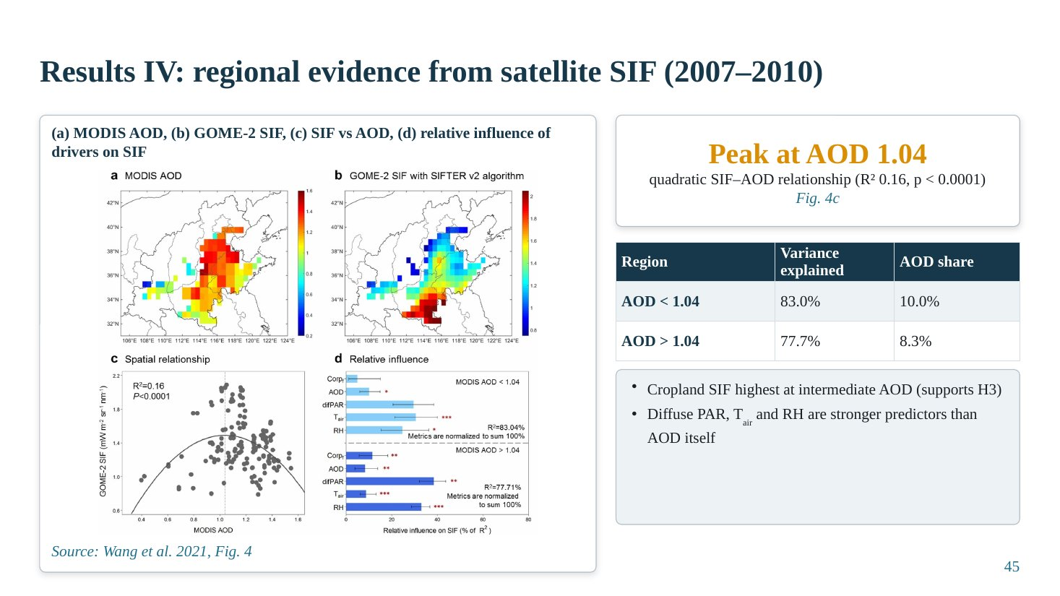
Slide 45
What this slide says, in simple words
The same hill-shaped pattern appears across the whole North China Plain: cropland fluorescence is highest at intermediate haze, peaking at AOD 1.04 in 2007–2010. But haze itself explains only about a tenth of the variation; diffuse light, temperature and humidity matter more.
Concepts explained: from simple to scientific
Quadratic SIF–AOD relation. Peak at AOD 1.04, R² = 0.16, p < 0.0001: weak but highly significant because of the large sample.
Relative importance. Crop fraction, AOD, diffuse PAR, Tair and RH together explain 83.0% of SIF variation where AOD < 1.04 and 77.7% where AOD > 1.04. AOD's own share is 10.0% and 8.3%.
Interpretation. Supports H3 (regional optimum). But AOD is only one part; background diffuse light, temperature and humidity are stronger predictors.
The table explained
Region below and above the optimum: total variance explained and AOD's share.
The figure explained
Wang et al. (2021), Fig. 4: (a) MODIS AOD map, (b) GOME-2 SIF map over the NCP, (c) SIF against AOD with a quadratic fit peaking at 1.04, (d) relative influence of drivers on SIF.
Key numbers to remember
• Regional SIF optimum (2007–2010): AOD 1.04, R² 0.16
• Variance explained: 83.0% (AOD < 1.04), 77.7% (> 1.04)
• AOD share: 10.0% and 8.3%
Likely questions and model answers
Q1. An R² of 0.16 is low. Is the result meaningful?
Yes in the sense that the quadratic shape is statistically significant (p < 0.0001) and consistent with field results. The low R² shows that AOD explains only a small part of spatial SIF variation; other drivers (crop fraction, climate) explain most of it, which is why the multivariate analysis is also reported.

Slide 46: Results V: the optimum AOD fell as air got cleaner and drier
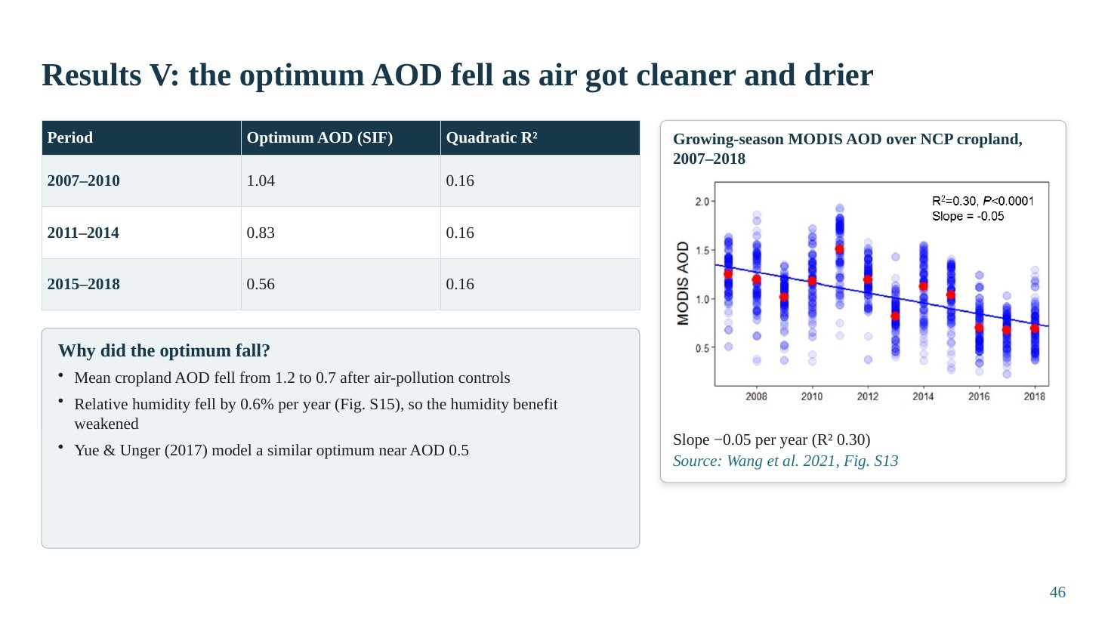
Slide 46
What this slide says, in simple words
Over twelve years the optimum haze level for crops dropped from 1.04 to 0.83 to 0.56. Meanwhile pollution controls reduced haze and the air became drier. Because part of the haze benefit came through humidity, drier air lowered the optimum. Still, most of the region remained above the optimum.
Concepts explained: from simple to scientific
Optimum by period. 2007–2010: 1.04; 2011–2014: 0.83; 2015–2018: 0.56 (each R² 0.16).
Drivers. Mean cropland AOD fell from about 1.2 to 0.7 after air-pollution controls (slope −0.05 per year, R² 0.30). RH fell by 0.6% per year (Fig. S15), weakening the humidity benefit.
Comparison. Yue & Unger (2017) modelled a similar optimum near AOD 0.5.
Policy. Even with the lower optimum, 76–90% of the NCP remained above the optimum AOD.
The table explained
Period, optimum AOD from SIF and quadratic R².
The figure explained
Wang et al. (2021), Fig. S13: time series of growing-season MODIS AOD over NCP cropland, 2007–2018, with a declining linear trend (slope −0.05 per year, R² 0.30).
Key numbers to remember
• Optimum: 1.04 → 0.83 → 0.56
• Cropland AOD ≈ 1.2 → 0.7; slope −0.05 yr⁻¹
• RH −0.6% per year
• 76–90% of NCP above optimum
Likely questions and model answers
Q1. Why would drier air lower the optimum AOD?
At the optimum, the diffuse and humidity benefits balance the light loss. If part of the benefit comes from humidity (opening stomata), drier conditions reduce that benefit, so the light loss becomes dominant at a lower AOD.
Q2. What does this imply for the IGP?
The optimum is not fixed; it depends on background humidity and aerosol properties. In drier conditions (pre-monsoon, winter in north-west India) the optimum may be lower, so crops may be further above it.

Slide 47: Discussion: mechanisms and comparison with forests
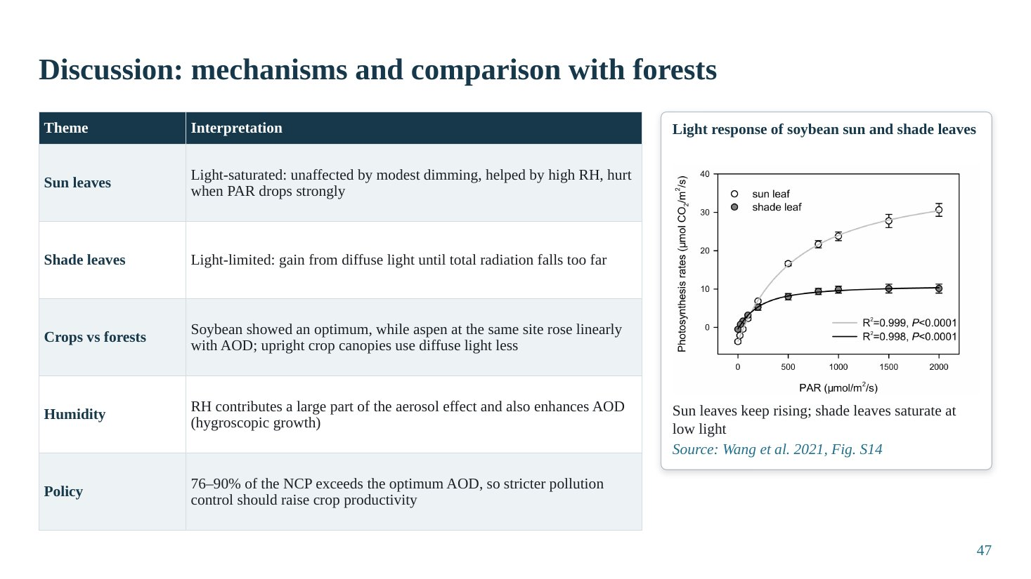
Slide 47
What this slide says, in simple words
The hill-shaped response arises because sun and shade leaves react differently. Soybean differs from forest trees: aspen at the same site kept increasing with haze, while soybean peaked. Humidity is a large, often ignored part of the haze effect. Because most of the region is above the optimum, cleaner air should raise crop photosynthesis.
Concepts explained: from simple to scientific
Sun leaves. Light-saturated: unaffected by modest dimming, helped by high RH, hurt when PAR drops strongly.
Shade leaves. Light-limited: gain from diffuse light until total radiation falls too far.
Crops vs forests. Soybean showed an optimum, while aspen at the same site increased linearly with AOD; upright crop canopies use diffuse light less, and soybean is light-demanding.
Humidity. RH contributes a large part of the aerosol effect and also enhances AOD through hygroscopic growth.
Policy. 76–90% of the NCP exceeds the optimum AOD, so stricter pollution control should raise crop productivity.
The table explained
Five themes and their interpretation.
The figure explained
Wang et al. (2021), Fig. S14: light-response curves of soybean sun and shade leaves: sun-leaf photosynthesis keeps rising with PAR, while shade leaves saturate at low light.
Likely questions and model answers
Q1. Why did aspen respond linearly but soybean quadratically?
Aspen forms a taller, more complex canopy with more shaded leaves and lower light saturation, so it keeps benefiting from diffuse light over the observed AOD range. Soybean is more light-demanding with an upright canopy, so the light loss at high AOD outweighs the diffuse gain sooner.

Slide 48: Conclusions of case study 1
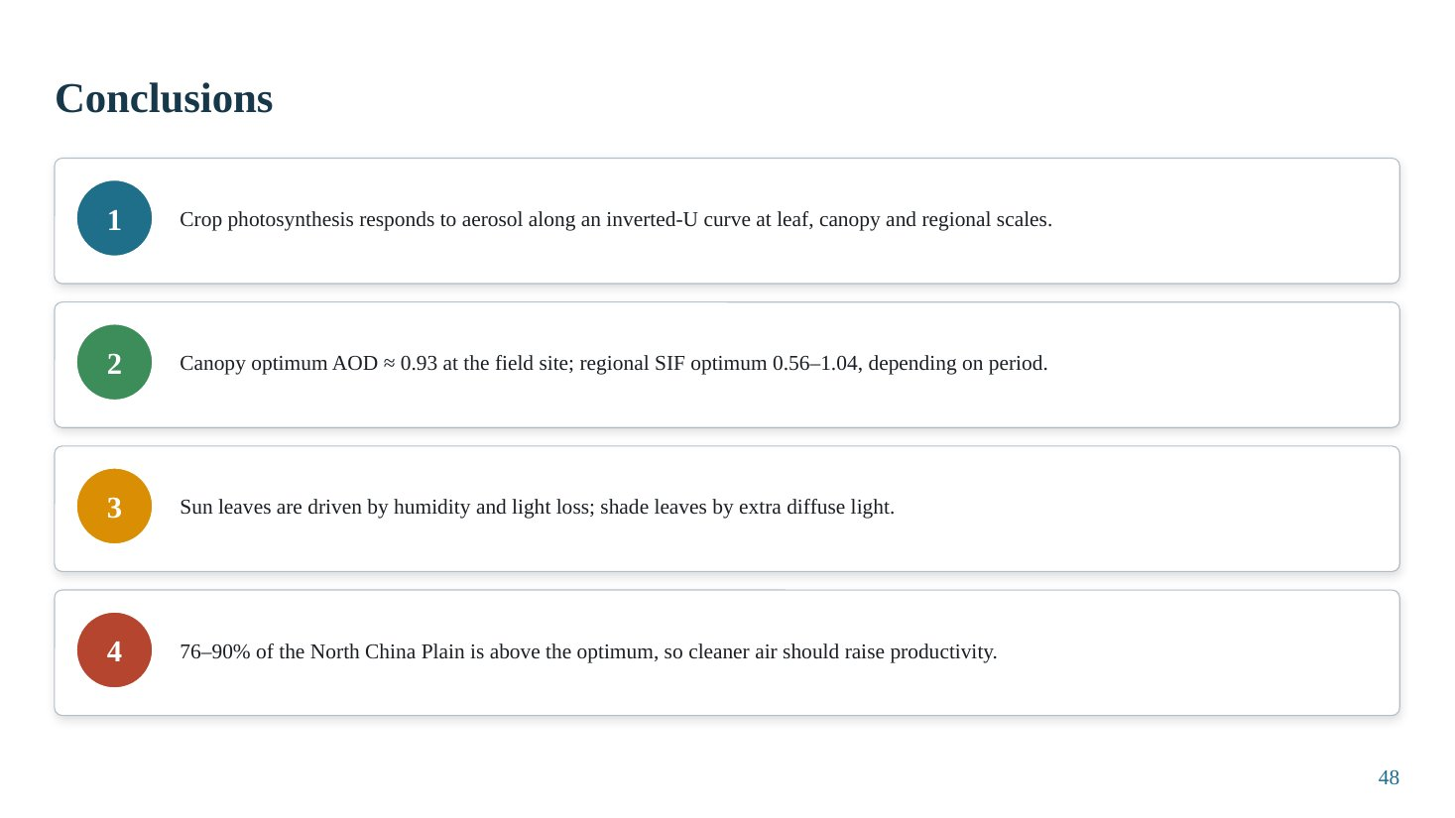
Slide 48
What this slide says, in simple words
Four conclusions: crop photosynthesis follows a hill-shaped curve with haze at leaf, canopy and regional scales; the optimum is near AOD 0.9 at the site and 0.56–1.04 regionally; sun leaves respond mainly to humidity and light loss, shade leaves to diffuse light; and most of the North China Plain is above the optimum, so cleaner air should help.
Concepts explained: from simple to scientific
Relevance to your seminar. This study confirms the inverted-U concept for a crop, shows how to separate light, temperature and humidity effects, and demonstrates the use of satellite SIF to scale up. Its policy conclusion likely applies to the IGP, where AOD is similarly high.
Limitations to mention. One crop (soybean) at one field site; regional SIF at coarse resolution (0.5°); MODIS AOD at 1°; co-variation of humidity and AOD; ozone not explicitly separated.
Key numbers to remember
• Canopy optimum ≈ 0.93
• Regional optimum 0.56–1.04
• 76–90% of NCP above optimum
Likely questions and model answers
Q1. What are the limitations of Wang et al. (2021)?
Single crop and field site; morning clear-sky measurements only; regional analysis uses coarse satellite products and a weak R²; humidity and AOD are correlated so their effects are not fully independent; ozone and other pollutants were not separated; GOME-2 SIF has a coarse footprint.
Q2. Would the same optimum apply to rice or wheat in India?
Not necessarily. The optimum depends on crop canopy, photosynthetic pathway, humidity and aerosol type. For Punjab wheat, Sankhla et al. found about 0.55; Hari & Tyagi found agro-zone NPP peaking near 0.49. So Indian crop optima appear lower than the NCP soybean canopy optimum.

Case study 2 · Shu et al., 2022

Slide 49: Case Study 2: title and overview
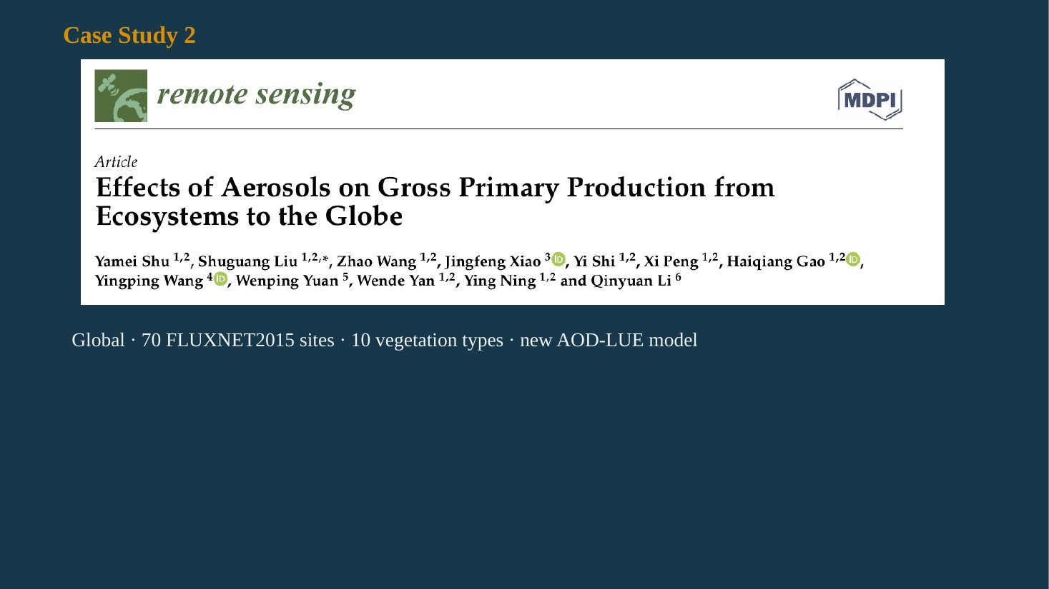
Slide 49
What this slide says, in simple words
The second case study builds a new global productivity model that knows about haze. It splits sunlight into direct and diffuse parts, gives each its own efficiency, tests the model at 70 flux towers worldwide, and then maps where aerosols increase or decrease productivity across the globe.
Concepts explained: from simple to scientific
Citation. Shu, Y., Liu, S., Wang, Z., Xiao, J., Shi, Y., Peng, X., Gao, H., Wang, Y., Yuan, W., Yan, W., Ning, Y., Li, Q. (2022). Effects of aerosols on gross primary production from ecosystems to the globe. Remote Sensing (MDPI).
Scope. Global; 70 FLUXNET2015 sites; 10 vegetation types; new AOD-LUE model; global simulation 2000–2019.
The figure explained
The slide shows the article header from Remote Sensing with title and authors.
Likely questions and model answers
Q1. How does case study 2 complement case study 1?
Case study 1 explains mechanisms at leaf and canopy scale in one crop and region. Case study 2 scales up the diffuse-light mechanism into a global model and quantifies how the aerosol effect varies across biomes and latitudes.

Slide 50: Background, research gap and objectives
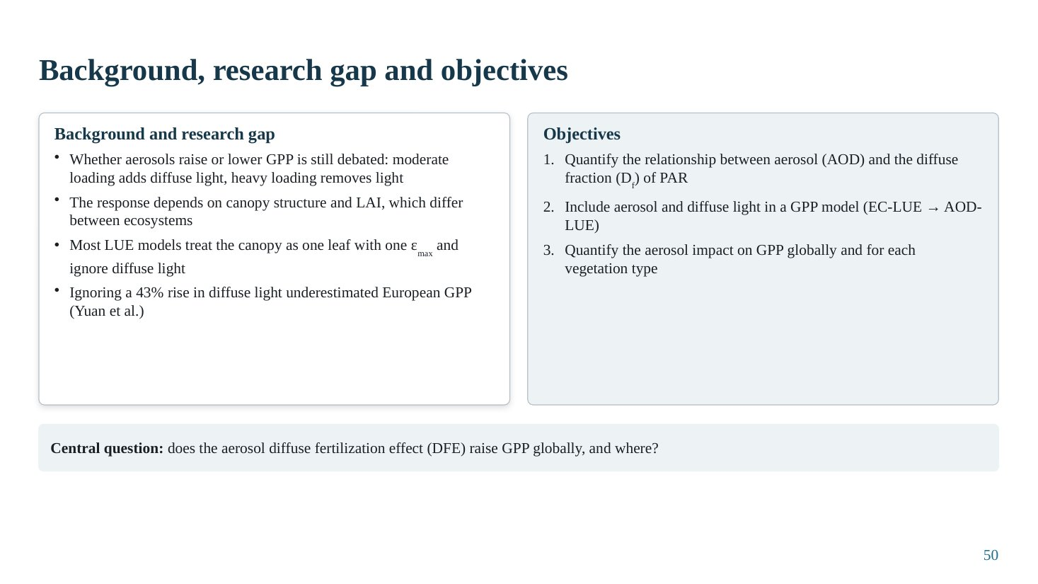
Slide 50
What this slide says, in simple words
Whether aerosols raise or lower GPP is still debated. Most global models treat the whole canopy as one big leaf with one efficiency, so they cannot see the benefit of diffuse light. The study aims to link haze to diffuse light, put that into a GPP model, and map the effect globally.
Concepts explained: from simple to scientific
Big-leaf LUE models. Treat the canopy as a single leaf with one maximum efficiency ε_{max}; they ignore that diffuse light is used more efficiently than direct light.
Evidence of the gap. Ignoring a 43% increase in diffuse light underestimated European GPP (cited from Yuan et al.).
Objectives. (1) Quantify the AOD–diffuse fraction (D_{f}) relationship. (2) Include aerosol and diffuse light in a GPP model (EC-LUE → AOD-LUE). (3) Quantify the aerosol impact on GPP globally and by vegetation type.
Central question. Does the aerosol diffuse fertilization effect (DFE) raise GPP globally, and where?
Likely questions and model answers
Q1. Why is a big-leaf model unable to capture diffuse fertilization?
Because it uses a single efficiency for all absorbed light, so redistributing light between sunlit and shaded leaves does not change its predicted GPP; only total absorbed light matters. Diffuse fertilization depends precisely on that redistribution.

Slide 51: Study design and data
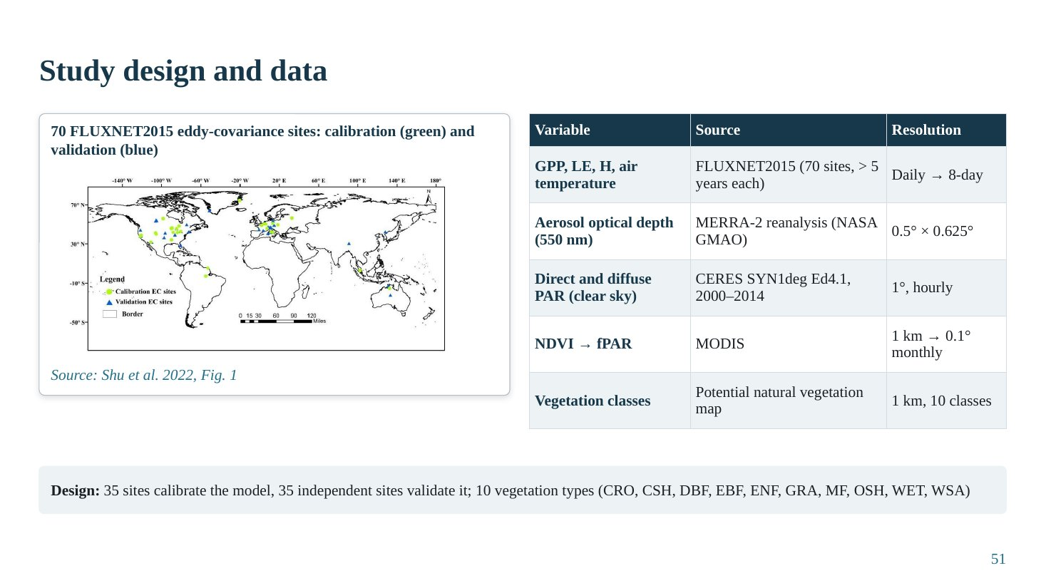
Slide 51
What this slide says, in simple words
The model was built and tested with data from 70 flux towers around the world, each with more than five years of data. Haze came from a reanalysis product, direct and diffuse light from a satellite radiation product, and leaf greenness from MODIS. Half the towers were used to tune the model and the other half to test it.
Concepts explained: from simple to scientific
FLUXNET2015. A global database of standardised eddy-covariance data. Variables used: GPP, latent heat (LE), sensible heat (H) and air temperature, daily aggregated to 8-day.
MERRA-2 AOD. NASA GMAO reanalysis, 550 nm, 0.5° × 0.625°: gap-free, which matters because flux towers measure under all skies.
CERES SYN1deg. Edition 4.1, 2000–2014, 1° hourly direct and diffuse PAR for clear sky.
MODIS NDVI and fPAR. NDVI (1 km aggregated to 0.1° monthly) converted to fPAR by fPAR = 1.24·NDVI − 0.168.
Calibration and validation. 35 sites calibrate the model; 35 independent sites validate it. Ten vegetation types: CRO (cropland), CSH (closed shrubland), DBF (deciduous broadleaf forest), EBF (evergreen broadleaf forest), ENF (evergreen needleleaf forest), GRA (grassland), MF (mixed forest), OSH (open shrubland), WET (wetland), WSA (woody savanna).
The table explained
Each variable, its source and its resolution. Note the scale gap between point towers and 0.5–1° gridded inputs.
The figure explained
Shu et al. (2022), Fig. 1: global map of the 70 FLUXNET2015 sites, calibration sites in green and validation sites in blue, distributed mainly over North America and Europe, with fewer in Asia, Africa and South America.
Key numbers to remember
• 70 sites (35 calibration, 35 validation), > 5 years each
• MERRA-2 AOD 0.5° × 0.625°; CERES 1° hourly
• fPAR = 1.24·NDVI − 0.168
Likely questions and model answers
Q1. Why split the sites into calibration and validation?
To test the model on independent data not used for fitting its parameters. If calibrated and tested on the same sites, performance would be overestimated (overfitting).
Q2. What is a limitation of the site distribution?
Most sites are in North America and Europe; very few are in South Asia or the tropics, so the model's diffuse efficiencies may not represent Indian croplands well.

Slide 52: Methodology flowchart
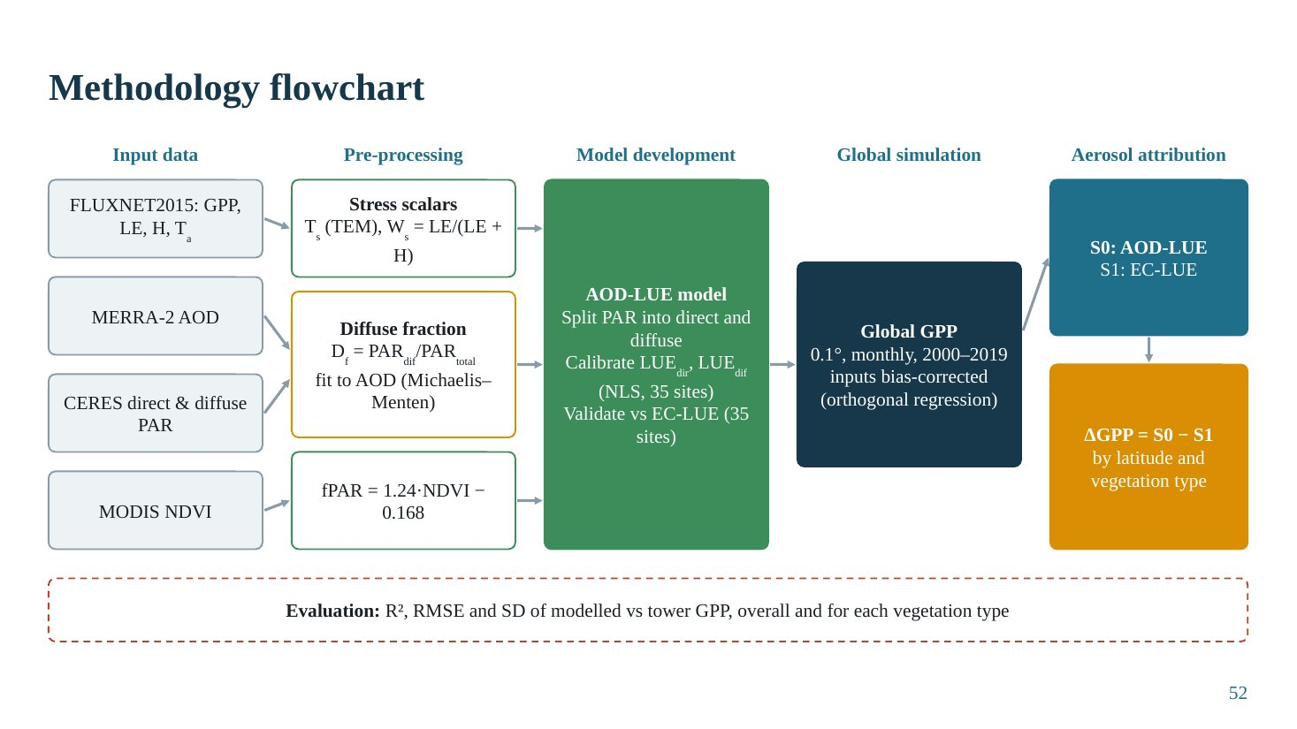
Slide 52
What this slide says, in simple words
Inputs (tower, reanalysis and satellite data) are processed into stress factors, the diffuse fraction linked to haze, and absorbed-light fraction. These feed the new AOD-LUE model, which is calibrated and validated against the original EC-LUE model. Then it is run globally, and comparing the new model with the old gives the aerosol effect.
Concepts explained: from simple to scientific
Stress scalars. Temperature stress T_{s} from the TEM model function; water stress W_{s} = LE/(LE + H), the evaporative fraction.
Diffuse fraction. D_{f} = PAR_{dif}/PAR_{total}, fitted to AOD with a Michaelis–Menten curve.
Calibration. LUE_{dir} and LUE_{dif} fitted by nonlinear least squares (NLS) at 35 sites; validated against EC-LUE at 35 sites.
Global simulation. 0.1°, monthly, 2000–2019; inputs bias-corrected by orthogonal regression.
Aerosol attribution. S0: AOD-LUE (includes aerosol diffuse effect); S1: EC-LUE (no diffuse effect). ΔGPP = S0 − S1, summarised by latitude and vegetation type.
Evaluation metrics. R², RMSE and standard deviation of modelled versus tower GPP, overall and by vegetation type.
The figure explained
The flowchart reads left to right: input data → pre-processing → model development → global simulation → aerosol attribution.
Likely questions and model answers
Q1. Is ΔGPP = S0 − S1 the pure aerosol effect?
It is the effect of representing diffuse light (driven by aerosol) with a separate efficiency, compared with a model that has a single efficiency. It mainly captures the diffuse-fraction effect; it does not include aerosol effects on temperature, humidity, rain or ozone, and it depends on the calibrated efficiencies.

Slide 53: From EC-LUE to AOD-LUE: model equations
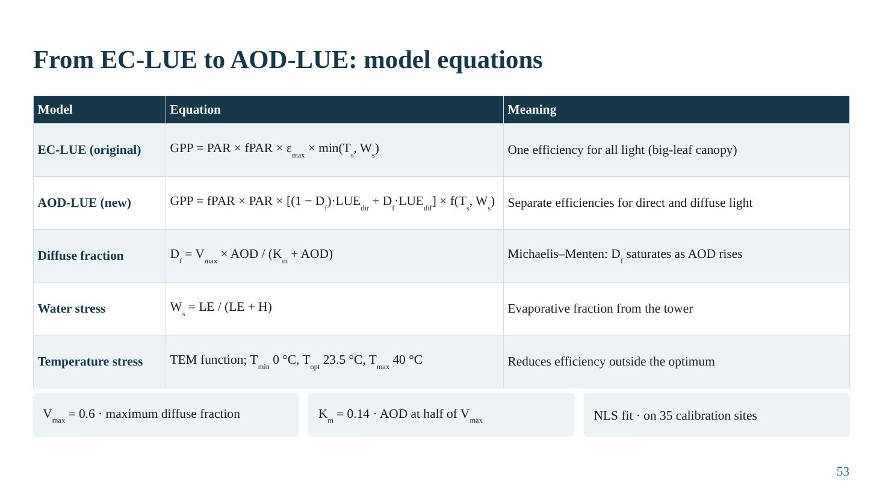
Slide 53
What this slide says, in simple words
The old model multiplies absorbed light by one efficiency. The new model splits light into direct and diffuse parts and gives the diffuse part a higher efficiency. The diffuse share is calculated from haze using a curve that rises quickly at low haze and then levels off.
Concepts explained: from simple to scientific
EC-LUE. GPP = PAR × fPAR × ε_{max} × min(T_{s}, W_{s}): one efficiency for all light (big-leaf canopy), reduced by the most limiting stress.
AOD-LUE. GPP = fPAR × PAR × [(1 − D_{f})·LUE_{dir} + D_{f}·LUE_{dif}] × f(T_{s}, W_{s}): separate efficiencies for direct and diffuse light.
Michaelis–Menten diffuse fraction. D_{f} = V_{max} × AOD/(K_{m} + AOD), with V_{max} = 0.6 (maximum diffuse fraction) and K_{m} = 0.14 (AOD at which D_{f} reaches half of V_{max}). The form is borrowed from enzyme kinetics: rapid rise, then saturation.
Temperature stress. TEM function with T_{min} 0 °C, T_{opt} 23.5 °C, T_{max} 40 °C.
Water stress. W_{s} = LE/(LE + H), the evaporative fraction from tower energy fluxes.
The table explained
Model, equation and meaning for the original and new model and their components.
Key numbers to remember
• V_{max} = 0.6; K_{m} = 0.14
• T_{min} 0 °C, T_{opt} 23.5 °C, T_{max} 40 °C
Likely questions and model answers
Q1. Calculate D_{f} at AOD 0.14 and 0.5.
At AOD 0.14: D_{f} = 0.6 × 0.14/(0.14 + 0.14) = 0.30. At AOD 0.5: D_{f} = 0.6 × 0.5/0.64 ≈ 0.47. At AOD 1.0: 0.6/1.14 ≈ 0.53. So the diffuse fraction grows slowly at high AOD.
Q2. Why is a Michaelis–Menten form physically reasonable?
As aerosol increases, more of the direct beam is scattered, but the diffuse fraction cannot exceed a ceiling, because at very high AOD extra aerosol scatters and absorbs light that is already diffuse. So the diffuse fraction saturates.

Slide 54: Results I: global patterns and trends of AOD and PAR (2000–2014)
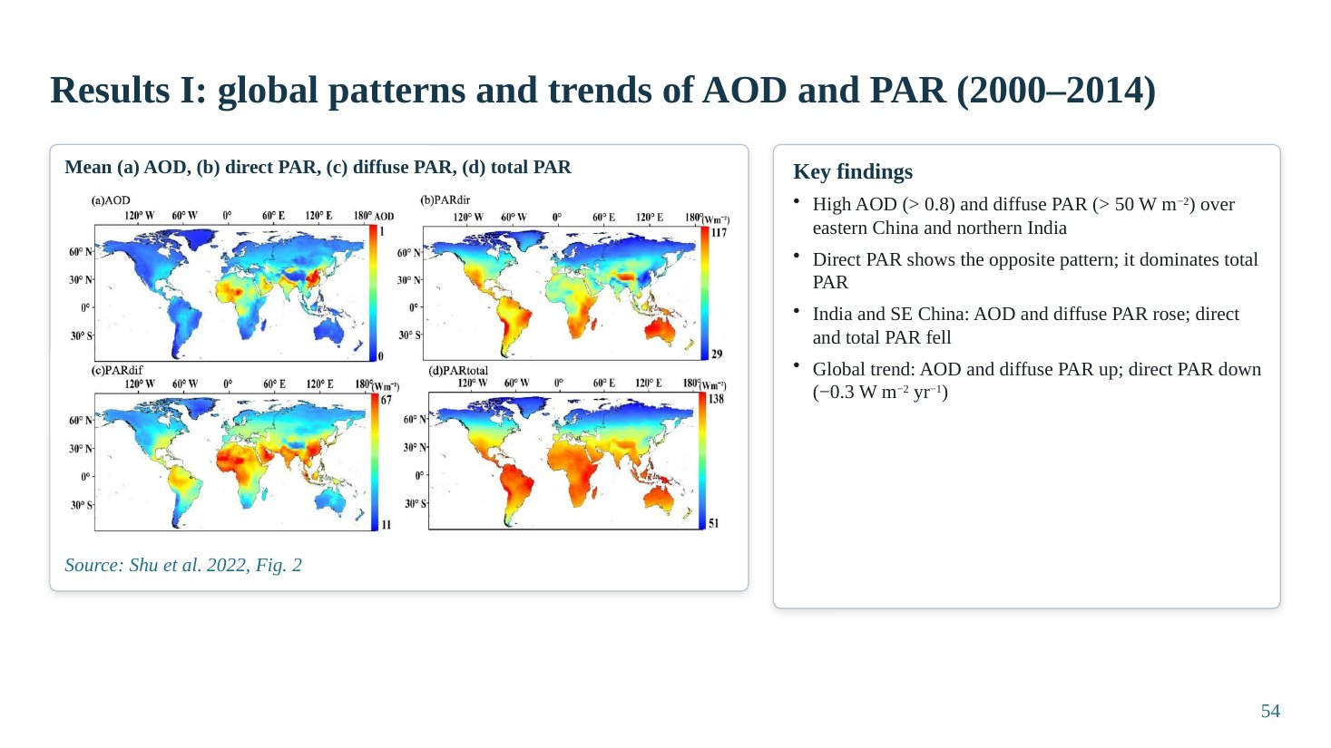
Slide 54
What this slide says, in simple words
Globally, haze and diffuse light are highest over eastern China and northern India, and direct light is lowest there. Over India and south-east China, haze and diffuse light increased while direct and total light decreased.
Concepts explained: from simple to scientific
Spatial pattern. High AOD (> 0.8) and diffuse PAR (> 50 W m⁻²) over eastern China and northern India; direct PAR shows the opposite pattern and dominates total PAR.
Trends. India and south-east China: AOD and diffuse PAR increased; direct and total PAR decreased. Global: AOD and diffuse PAR increased, direct PAR decreased (about −0.3 W m⁻² per year).
The figure explained
Shu et al. (2022), Fig. 2: global maps of mean (a) AOD, (b) direct PAR, (c) diffuse PAR and (d) total PAR for 2000–2014.
Key numbers to remember
• AOD > 0.8 and diffuse PAR > 50 W m⁻² over E China and N India
• Global direct PAR trend ≈ −0.3 W m⁻² yr⁻¹
Likely questions and model answers
Q1. Why is total PAR dominated by direct PAR?
Under clear skies (CERES clear-sky PAR is used here) most PAR arrives as the direct beam; diffuse PAR is typically 10–40% of the total depending on aerosol.

Slide 55: Trend maps and time series (Shu et al., 2022, Fig. 3)
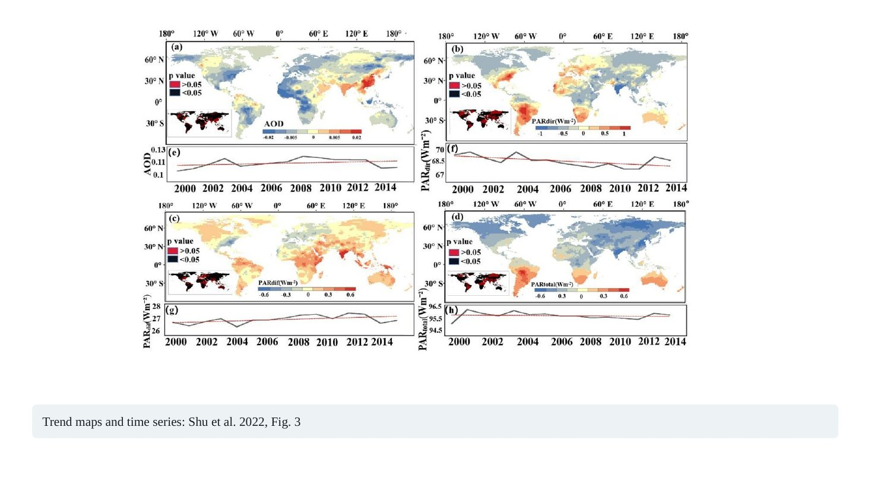
Slide 55
Note on this slide: This slide has only the figure and a caption, without a title. Consider adding a title such as 'Results I (continued): trends of AOD and PAR, 2000–2014'. The same figure also appears on Slide 6.

What this slide says, in simple words
These maps show where haze and light changed between 2000 and 2014, and the global average over time.
The figure explained
Shu et al. (2022), Fig. 3: per-pixel linear trends for 2000–2014 of (a) AOD, (b) direct PAR, (c) diffuse PAR, (d) total PAR; the small black-and-red inset maps show where trends are significant (p < 0.05). Below each map, panels (e)–(h) show global mean annual time series.
AOD increased over India, eastern China and the Middle East and decreased over parts of North America, Europe and the Amazon. Direct PAR decreased where AOD increased; diffuse PAR increased in the same regions.
Likely questions and model answers
Q1. Do the trend maps prove that aerosol caused the PAR changes?
They are consistent with it, because PAR changes mirror AOD changes in space, but clear-sky CERES PAR is itself computed using aerosol information, so the correspondence is partly expected. Independent surface measurements are needed for proof.

Slide 56: Results II: aerosol controls the diffuse fraction
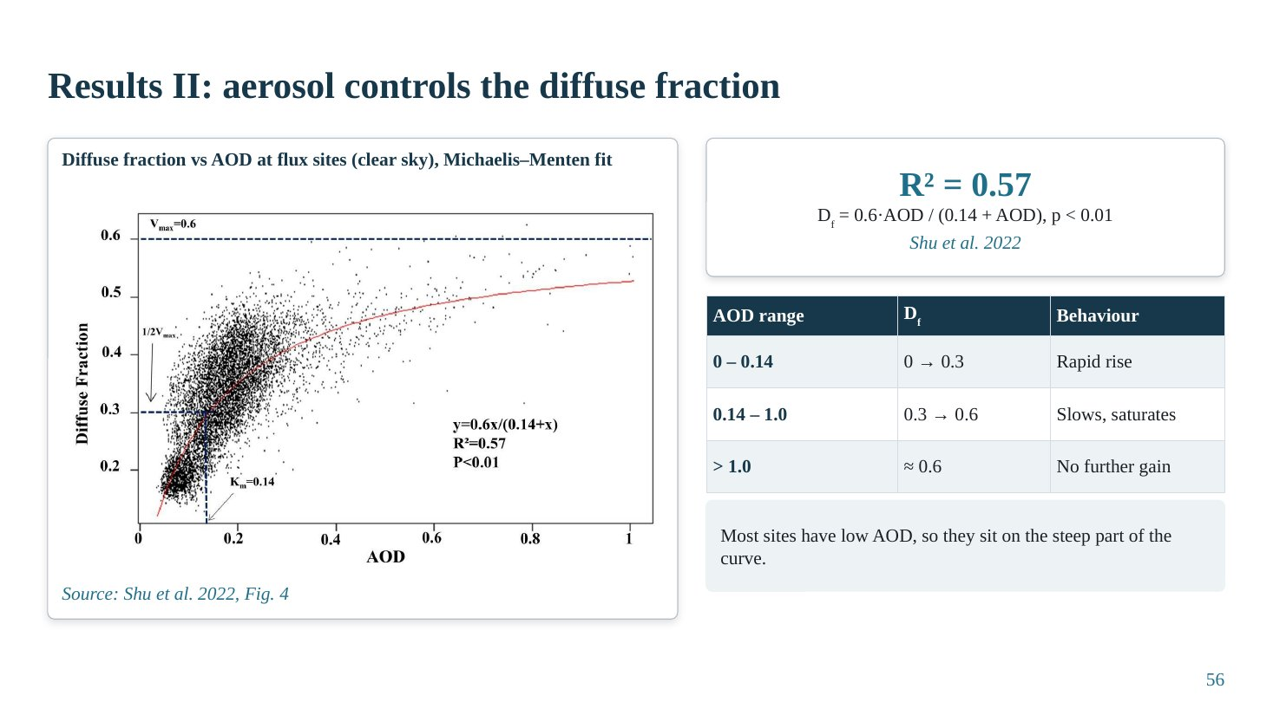
Slide 56
What this slide says, in simple words
At the flux towers, the diffuse share of light rises quickly as haze increases from very low levels, then slows down and levels off at about 60%. So adding haze beyond a certain level gives little extra diffuse light while still removing direct light.
Concepts explained: from simple to scientific
Fit. D_{f} = 0.6·AOD/(0.14 + AOD), R² = 0.57, p < 0.01.
Three regimes. AOD 0–0.14: D_{f} rises rapidly from 0 to 0.3. AOD 0.14–1.0: D_{f} rises slowly from 0.3 to about 0.6. AOD > 1.0: D_{f} ≈ 0.6, no further gain.
Implication. Most flux sites have low AOD, on the steep part of the curve, so they are sensitive to aerosol changes. Heavily polluted regions are on the flat part, where extra aerosol gives little diffuse benefit.
The table explained
AOD range, diffuse fraction and behaviour: rapid rise, slowing and saturation.
The figure explained
Shu et al. (2022), Fig. 4: diffuse fraction against AOD at flux sites under clear sky, with the fitted Michaelis–Menten curve.
Key numbers to remember
• D_{f} = 0.6·AOD/(0.14 + AOD), R² = 0.57
• Saturation D_{f} ≈ 0.6
Likely questions and model answers
Q1. Why does this saturation explain why heavy haze is harmful?
Because once D_{f} saturates, more aerosol cannot increase the diffuse share, but it continues to reduce total light (and direct light). The benefit stops growing while the cost keeps growing, so productivity declines: the mechanism behind the inverted-U.

Slide 57: Results III: AOD-LUE improves GPP simulation
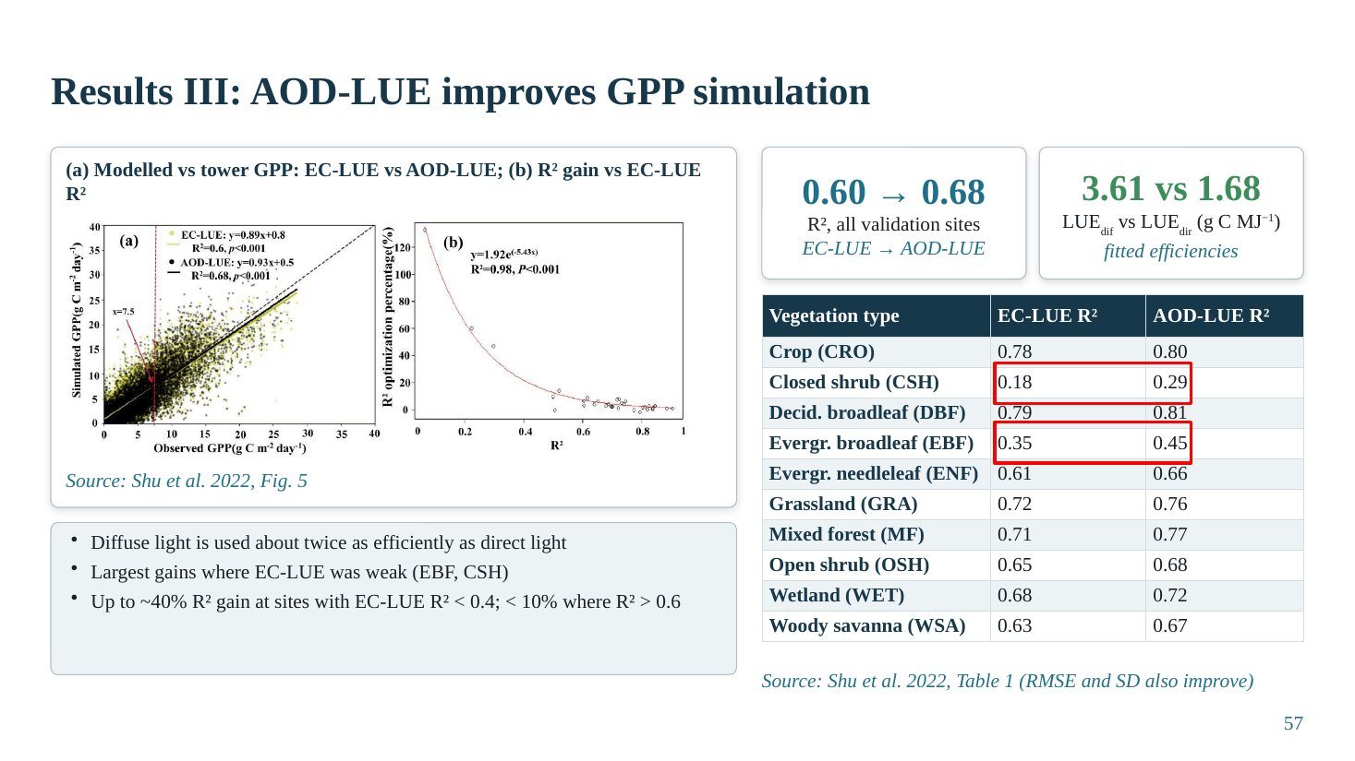
Slide 57
What this slide says, in simple words
The new model reproduces tower GPP better than the old one at independent sites, and its fitted efficiency for diffuse light is more than twice that for direct light. Improvements are largest where the old model performed worst.
Concepts explained: from simple to scientific
Overall improvement. R² at validation sites increased from 0.60 (EC-LUE) to 0.68 (AOD-LUE); RMSE and SD also improved.
Efficiencies. LUE_{dif} = 3.61 g C MJ⁻¹ versus LUE_{dir} = 1.68 g C MJ⁻¹: diffuse light is used about twice as efficiently, direct evidence of diffuse fertilization.
By vegetation type. R² increased for every type: CRO 0.78 → 0.80, CSH 0.18 → 0.29, DBF 0.79 → 0.81, EBF 0.35 → 0.45, ENF 0.61 → 0.66, GRA 0.72 → 0.76, MF 0.71 → 0.77, OSH 0.65 → 0.68, WET 0.68 → 0.72, WSA 0.63 → 0.67. Largest gains where EC-LUE was weak (EBF, CSH): up to about 40% R² gain where EC-LUE R² < 0.4, less than 10% where R² > 0.6.
The table explained
Vegetation type with EC-LUE and AOD-LUE R²: every type improves.
The figure explained
Shu et al. (2022), Fig. 5: (a) modelled against tower GPP for EC-LUE and AOD-LUE; (b) R² gain of AOD-LUE against the EC-LUE R² at each site, showing larger gains where EC-LUE performed poorly.
Key numbers to remember
• R² 0.60 → 0.68
• LUE_{dif} 3.61 vs LUE_{dir} 1.68 g C MJ⁻¹
• Cropland R² 0.78 → 0.80
Likely questions and model answers
Q1. Why is the improvement small for cropland (0.78 → 0.80)?
EC-LUE already performed well for crops, and crops benefit less from diffuse light than complex canopies; their GPP is controlled strongly by management, phenology and fPAR, which both models share.
Q2. Does LUE_{dif} > LUE_{dir} prove diffuse fertilization?
It is strong evidence that, per unit absorbed PAR, diffuse light produces more GPP. But the efficiencies are fitted statistically and could partly absorb other effects correlated with diffuse conditions (lower VPD and temperature on hazy or cloudy days).

Slide 58: Results IV: global impact of aerosols on GPP
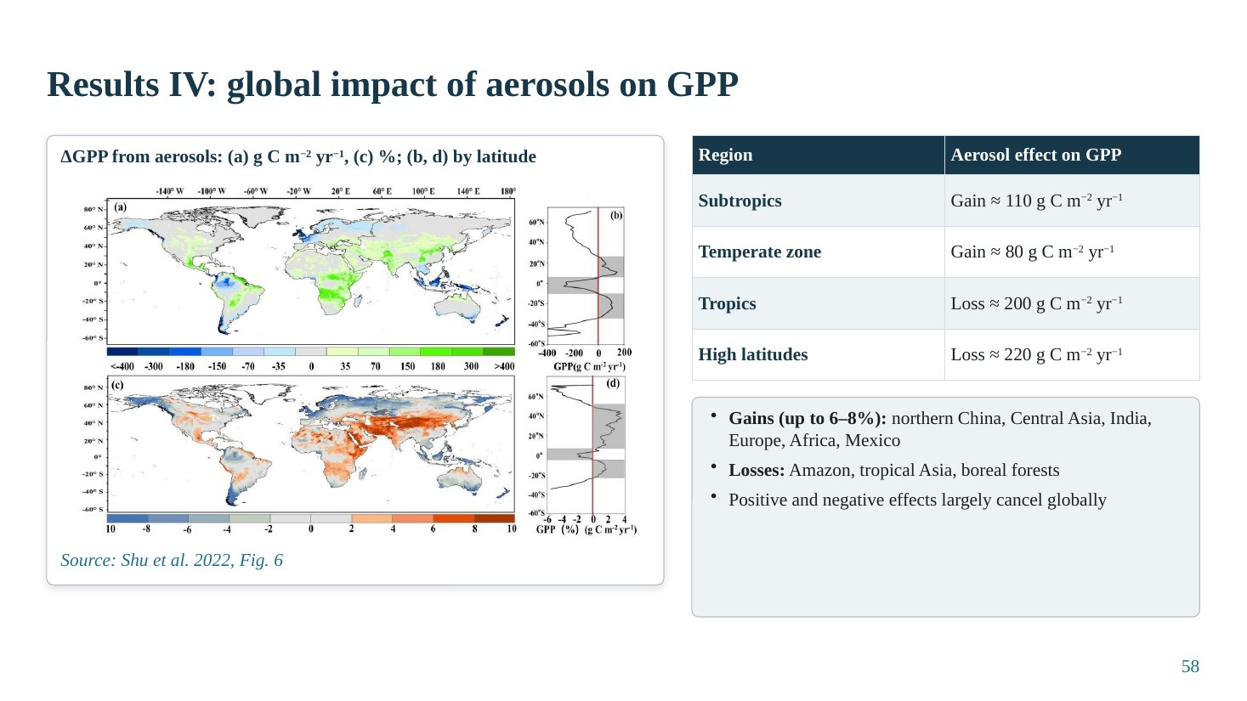
Slide 58
What this slide says, in simple words
Globally the aerosol effect is patchy: some regions gain up to 6–8% GPP, such as northern China, Central Asia, India, Europe, Africa and Mexico, while the Amazon, tropical Asia and boreal forests lose. Gains and losses largely cancel, so the global net effect is small even though regional effects are large.
Concepts explained: from simple to scientific
By latitude. Subtropics: gain about 110 g C m⁻² yr⁻¹; temperate zone: gain about 80; tropics: loss about 200; high latitudes: loss about 220.
By region. Gains up to 6–8% over northern China, Central Asia, India, Europe, parts of Africa and Mexico; losses over the Amazon, tropical Asia and boreal forests; magnitude up to about ±400 g C m⁻² yr⁻¹.
Why tropics and boreal lose. Frequent thick cloud already saturates the diffuse fraction, so aerosol only removes light; boreal sun angles are low, and needleleaf canopies are sparse.
The table explained
Latitude zone and aerosol effect on GPP.
The figure explained
Shu et al. (2022), Fig. 6: global maps of ΔGPP from aerosols in (a) g C m⁻² yr⁻¹ and (c) percent, with (b, d) latitudinal profiles. Warm colours: gain; cool colours: loss.
Key numbers to remember
• Subtropics +110, temperate +80, tropics −200, high latitudes −220 g C m⁻² yr⁻¹
• Regional gains up to 6–8%
Likely questions and model answers
Q1. Shu et al. find gains over India, but your evidence slides show losses in Indian crops. How do you reconcile them?
Shu et al. model only the diffuse-fraction effect with globally calibrated efficiencies and clear-sky PAR; they do not include the reduction of rain, ozone damage or crop-specific responses, and few calibration sites are in India. Indian crop studies (Gupta et al., Auffhammer et al.) are statistical and include climate pathways and real yields. Also, much of the IGP is above the optimum in the haze season, which a coarse model may not resolve.

Slide 59: Results V: aerosol impact differs by vegetation type
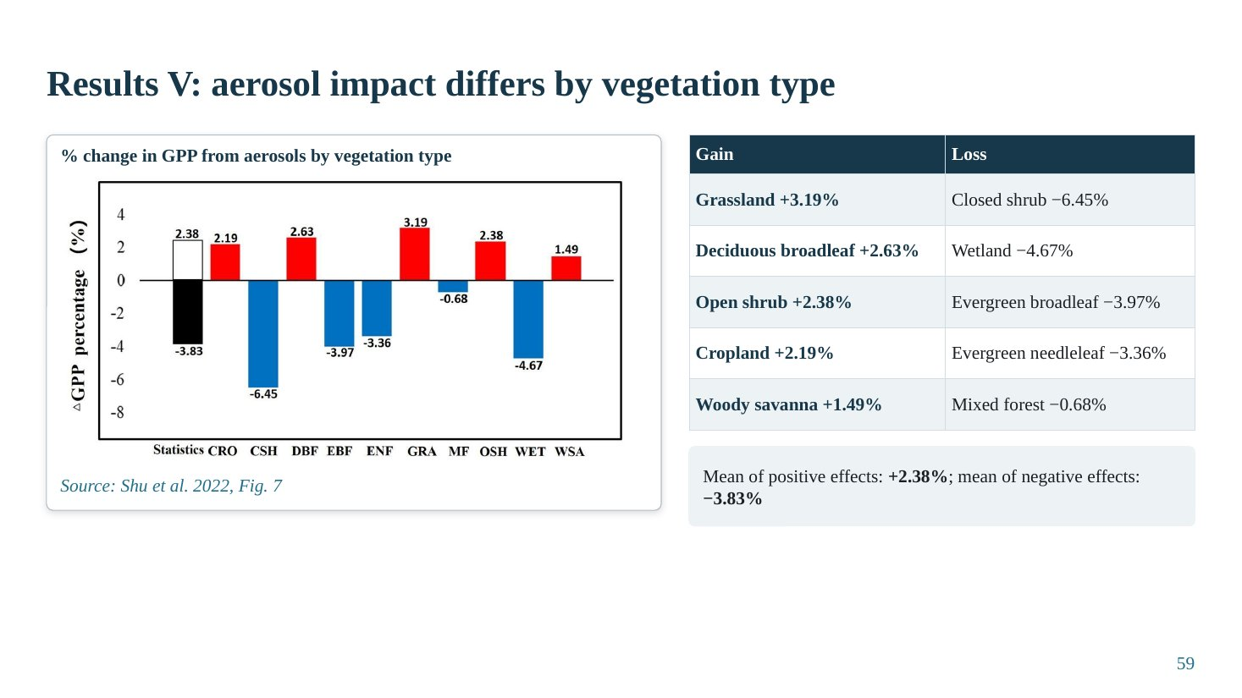
Slide 59
What this slide says, in simple words
Aerosols raised GPP in grassland, deciduous broadleaf forest, open shrubland, cropland and woody savanna, mostly in dry, low-cloud regions. They lowered GPP in closed shrubland, wetlands and evergreen forests, mostly in cloudy tropical and boreal regions.
Concepts explained: from simple to scientific
Gains. Grassland +3.19%, deciduous broadleaf +2.63%, open shrub +2.38%, cropland +2.19%, woody savanna +1.49%; mean of positive effects +2.38%.
Losses. Closed shrub −6.45%, wetland −4.67%, evergreen broadleaf −3.97%, evergreen needleleaf −3.36%, mixed forest −0.68%; mean of negative effects −3.83%.
Labelling note. The paper's text attributes −6.45% inconsistently; the abstract and Fig. 7 assign it to closed shrubland.
The table explained
Two columns: vegetation types with gains and with losses.
The figure explained
Shu et al. (2022), Fig. 7: bar chart of percentage change in GPP from aerosols by vegetation type.
Key numbers to remember
• Grassland +3.19%, DBF +2.63%, cropland +2.19%
• CSH −6.45%, WET −4.67%, EBF −3.97%, ENF −3.36%
• Means: +2.38% (gains), −3.83% (losses)
Likely questions and model answers
Q1. Grassland gains in Shu et al., but Niyogi et al. found grassland uptake decreased. Why?
Different methods and conditions. Shu et al.'s gain reflects grasslands in dry, low-cloud subtropical regions where diffuse light is otherwise scarce, under a model with globally fitted efficiencies. Niyogi et al. measured flux-tower uptake at specific US sites. The sign depends on location, cloudiness and the representation of canopy structure.

Slide 60: Discussion: why the aerosol effect varies
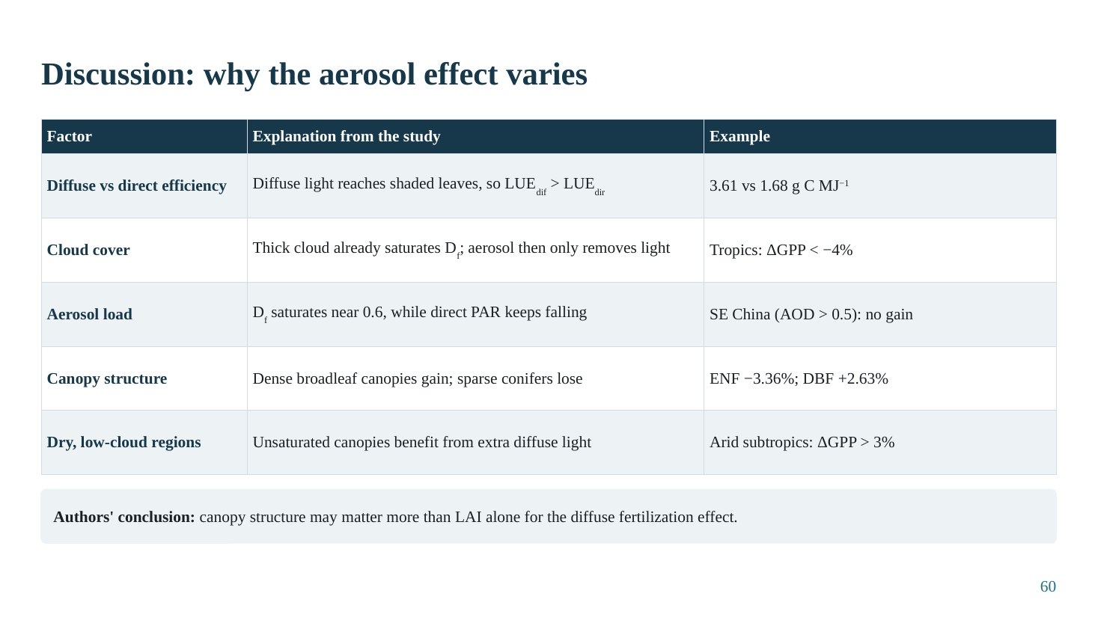
Slide 60
What this slide says, in simple words
Five reasons explain the pattern: diffuse light is used more efficiently; in cloudy regions the light is already diffuse, so haze only removes light; under heavy haze the diffuse gain saturates while direct light keeps falling; dense broadleaf canopies benefit more than sparse conifers; and dry, low-cloud regions gain most.
Concepts explained: from simple to scientific
Diffuse vs direct efficiency. LUE_{dif} (3.61) > LUE_{dir} (1.68) g C MJ⁻¹ because diffuse light reaches shaded leaves.
Cloud cover. Thick cloud already saturates D_{f}; aerosol then only removes light. Tropics: ΔGPP < −4%.
Aerosol load. D_{f} saturates near 0.6 while direct PAR keeps falling. South-east China (AOD > 0.5): no gain.
Canopy structure. Dense broadleaf canopies gain; sparse conifers lose (ENF −3.36%, DBF +2.63%).
Dry, low-cloud regions. Unsaturated canopies benefit from extra diffuse light; arid subtropics ΔGPP > 3%.
Authors' conclusion. Canopy structure may matter more than LAI alone for the diffuse fertilization effect.
The table explained
Factor, explanation and example. These five factors match the general 'factors' slide (Slide 28), which shows the consistency between the case study and the wider literature.
Likely questions and model answers
Q1. What are the main limitations of Shu et al. (2022)?
Coarse reanalysis AOD and 1° CERES radiation; clear-sky PAR partitioning; efficiencies calibrated on mostly North American and European towers; ΔGPP captures only the diffuse-fraction pathway (no temperature, humidity, rain or ozone effects); MOD17-type fPAR from NDVI; and the global net is a small difference of large positive and negative regional terms, so it is sensitive to model assumptions.
Q2. What is the most important lesson from case study 2 for India?
That diffuse light is used about twice as efficiently as direct light, but the benefit saturates at high AOD; so in the heavily polluted IGP, where AOD often exceeds 0.5–1.0, the diffuse benefit is near its maximum while light loss continues, consistent with losses found in Indian crop studies.

Part C · Key equations at a glance
Equation | Meaning | Where used
I = I₀ e^{−τ/cosθ} | Beer–Lambert: direct beam reduced exponentially by optical depth τ and air mass 1/cosθ | Sun photometers, AOD (Slides 9, 11)
τ(λ) = β λ^{−α} | Ångström law: AOD depends on wavelength; α indicates particle size | Aerosol size (Slide 9)
τ_{abs} = (1 − ω₀) τ | Absorption AOD from SSA | Absorbing aerosol (Slide 9)
ARF = F_{with aerosol} − F_{clean} | Aerosol radiative forcing at TOA or surface | Radiative effects (Slide 10)
ρ_{TOA} = ρ_{aer} + ρ_{Ray} + ρ_{surf} | Satellite signal = aerosol + Rayleigh + surface | Retrieval principle (Slide 12)
EE = ±(0.05 + 0.15τ) | Expected error of MODIS Dark Target AOD over land | Algorithms (Slide 13)
f_{dif} = PAR_{dif}/PAR_{total} | Diffuse fraction | PAR partitioning (Slide 15)
APAR = FAPAR × PAR; GPP = APAR × ε | Light-use-efficiency logic | Productivity (Slide 16)
NPP = GPP − R_{a}; NEP = NPP − R_{h} | Carbon flux chain | Productivity (Slide 16)
NEE = ρ_{a}·cov(w′, c′); GPP = R_{eco} − NEE | Eddy covariance and flux partitioning | Flux towers (Slide 17)
NDVI = (NIR − R)/(NIR + R) | Normalised difference vegetation index | Vegetation indices (Slide 18)
ε = ε_{dir}(1 − f_{dif}) + ε_{dif} f_{dif} | Diffuse-aware light-use efficiency | Process models (Slide 22)
P = a + b·AOD + c·AOD²; AOD* = −b/(2c) | Quadratic (inverted-U) fit and optimum | Optimum load (Slides 27, 43)
A_{n} = min(A_{v}, A_{j}, A_{s}) − R_{l} | FvCB leaf photosynthesis | Case study 1 (Slide 40)
g_{s} = m·A_{n}·RH/C_{a} + b | Ball-Berry stomatal conductance | Case study 1 (Slide 40)
LAI_{sun} = [1 − exp(−k_{b}ΩLAI)]/k_{b} | Sunlit leaf area | Case study 1 (Slide 40)
D_{f} = 0.6·AOD/(0.14 + AOD) | Michaelis–Menten diffuse fraction | Case study 2 (Slides 53, 56)
GPP = fPAR·PAR·[(1 − D_{f})LUE_{dir} + D_{f}LUE_{dif}]·f(T_{s}, W_{s}) | AOD-LUE model | Case study 2 (Slide 53)
W_{s} = LE/(LE + H) | Evaporative fraction (water stress) | Case study 2 (Slide 53)

Part D · Quick revision: the whole seminar in 20 points
- Land ecosystems absorb about 30% of human CO₂; aerosols are the largest uncertainty in climate forcing (≈ −1.3 W m⁻²).
- Aerosols change both the amount (dimming) and the quality (diffuse fraction) of light.
- Main aerosol types: sulfate/nitrate (scattering), black carbon (absorbing), organic carbon/SOA (mostly scattering), dust and sea salt (coarse).
- The IGP is South Asia's persistent aerosol hotspot; fine-mode aerosol gives > 80% of AOD in post-monsoon and winter.
- Indian AOD is rising (+0.29 over 2001–2020; IGP +43% over 2002–2016), strongest in November (residue burning).
- Single-scattering albedo decides whether haze can help (scattering) or mainly harms (absorbing).
- Aerosols act through direct, semi-direct and indirect (cloud) effects; heavy pollution suppresses rain beyond AOD ≈ 0.25.
- AERONET is ground truth; satellite algorithms differ in how they estimate surface reflectance (DT, DB, MAIAC, MISR, UV, geostationary).
- MODIS DT+DB is most widely used; MAIAC (1 km) is best for field and district crop studies.
- Direct and diffuse PAR come from radiative-transfer models, empirical partitioning, satellite products or reanalysis.
- GPP = APAR × LUE; NPP = GPP − plant respiration; flux towers measure NEE.
- SIF tracks photosynthesis within hours; vegetation indices track greenness; MOD17 has no diffuse-light term.
- Linking methods: binning, regression, relative sensitivity, SEM, natural experiments and process models.
- Natural experiments: Hubei lockdown AOD −23.8% → wheat GPP +16.5%; weekends SIF higher in 64% of European regions; volcanic dimming maize −9%.
- Light route: LUE 1.12–1.80× higher under diffuse light; Pinatubo raised forest photosynthesis 23%.
- Climate route can reverse the sign: China NPP +0.20 Pg C yr⁻¹ becomes −0.20 when cloud and rain effects are added.
- Ozone damage (−4.0 Pg C yr⁻¹) exceeds aerosol gain (+1.0); clouds cut the global aerosol gain from 8.9 to 0.95 Pg C yr⁻¹.
- Inverted-U: optima ≈ 0.4–0.6 for most crops and ecosystems (0.93 for NCP soybean canopy); IGP is near or above the optimum.
- Case study 1: soybean optimum AOD 0.76 (sun), 1.13 (shade), 0.93 (canopy); humidity drives sun-leaf gain; 76–90% of NCP above optimum.
- Case study 2: D_{f} saturates at 0.6; LUE_{dif} 3.61 vs LUE_{dir} 1.68 g C MJ⁻¹; R² 0.60 → 0.68; gains in dry subtropics, losses in cloudy tropics and boreal forests.

Part E · General viva questions and model answers
Q1. What exactly do you mean by 'quantifying aerosol impact'?
Estimating, with numbers and uncertainty, how much productivity (GPP, NPP, yield) changes because of aerosol, separated from other drivers. Examples: +16.5% GPP when AOD fell 23.8%; −7.9% rice yield due to aerosol; +0.95 Pg C yr⁻¹ global GPP gain under all-sky conditions.
Q2. Is aerosol good or bad for crops?
It depends on load, type, clouds and crop. Moderate scattering aerosol under clear skies can raise photosynthesis of C3 canopies; high, absorbing aerosol, cloudy skies, C4 crops and co-occurring ozone make it harmful. In the IGP most evidence indicates net losses because AOD is near or above the optimum.
Q3. What is the single most important property of aerosol for plants besides AOD?
Single-scattering albedo, because it decides whether intercepted light is redirected as useful diffuse light or absorbed and lost.
Q4. Why can't you simply correlate MODIS AOD with NDVI to get the aerosol effect?
Because both follow seasons and weather, AOD retrievals are cloud-screened and biased over bright surfaces, NDVI responds slowly to light changes, ozone and humidity co-vary, and reverse causation exists (more crop, more burning). A design controlling these factors is needed.
Q5. Why is SIF preferred over NDVI for aerosol studies?
SIF responds within hours to changes in light and physiology and is directly linked to photosynthesis, while NDVI reflects canopy greenness and structure that change slowly.
Q6. How would you measure diffuse PAR in a field experiment?
With a shaded pyranometer or shadow-band, or an SPN1 sunshine pyranometer that measures global and diffuse radiation simultaneously, plus PAR quantum sensors above and inside the canopy for sunlit and shaded leaves, as in Wang et al. (2021).
Q7. What would happen to crop productivity in the IGP if residue burning stopped?
Post-monsoon and winter AOD would fall. Since the region is near or above the optimum, crops would likely gain light and productivity, as in the Hubei lockdown; ozone and black carbon would also fall. The diffuse benefit would shrink only where AOD drops below the optimum.
Q8. Why do model and observation studies disagree on crops?
Models often assume strong diffuse sensitivity and exclude ozone, rain suppression and heat; observations include all real-world factors and very high loads. Different crops (C3 vs C4), canopy structure and cloudiness also differ.
Q9. What is the role of clouds?
Clouds already produce diffuse light, so aerosol adds little diffuse benefit under cloud but still dims. Zhou et al. (2022): global aerosol GPP gain 8.9 Pg C yr⁻¹ under clear skies versus 0.95 under all skies.
Q10. What is reverse causation in this topic?
Higher crop productivity producing more residue that is burnt, raising AOD (Jethva et al., 2019), so a positive correlation between AOD and productivity may not mean aerosol helps crops.
Q11. What is the difference between AOD and PM_{2.5}?
AOD is a column-integrated optical quantity (dimensionless) from remote sensing; PM_{2.5} is the surface mass concentration of particles below 2.5 µm (µg m⁻³). They are related through boundary-layer height, humidity and aerosol type.
Q12. Why is the North China Plain a good analogue for the IGP?
Both are intensively cropped, densely populated plains with very high and seasonally varying aerosol loads, humid summers and cereal–legume rotations. Results from the NCP (optimum AOD, policy conclusion) are therefore relevant, though crops and climate differ.
Q13. What research would you propose for India?
Combine MAIAC AOD (bias-corrected with AERONET), measured direct and diffuse PAR, flux towers over rice–wheat, SIF from TROPOMI, ozone data, and two-leaf or diffuse-aware LUE models; exploit natural experiments (burning bans, lockdown) to separate aerosol effects from weather and reverse causation.
Q14. Which aerosol species should policy target to benefit crops most?
Black carbon and residue-burning smoke (absorbing, little diffuse benefit) and ozone precursors (NO_{x}, VOCs), because they cause losses without the diffuse gain. Reducing them benefits health and productivity.
Q15. What are the units Pg C yr⁻¹ and g C m⁻² yr⁻¹?
1 Pg C = 10¹⁵ g of carbon (one billion tonnes); used for regional or global totals. g C m⁻² yr⁻¹ is carbon fixed per square metre per year, used for maps; 100 g C m⁻² yr⁻¹ equals 1 tonne C per hectare per year.

