A PROJECT REPORT ON
HYBRID AI INTELLIGENCE DASHBOARD FOR FRAMING BIAS, FAKE NEWS, AND MANIPULATION DETECTION
BACHELOR OF TECHNOLOGY
IN
CSIT (AIML / CYBER SECURITY)
SUBMITTED BY
GROUP NO: AI-07
PRN | NAME OF THE STUDENT
1234 XYZ | Animesh Pathak
5678 ABC | Team Partner

UNDER THE GUIDANCE OF
PROF. [NAME OF THE GUIDE]
SCHOOL OF COMPUTER SCIENCE AND INFORMATION TECHNOLOGY
SYMBIOSIS SKILLS AND PROFESSIONAL UNIVERSITY, PUNE
ACADEMIC YEAR 2025-26

ABSTARCT

The rapid dissemination of information through digital platforms has revolutionized communication but simultaneously created a fertile ground for 'Fake News' and 'Framing Bias'. This project addresses the critical challenge of detecting subtle media manipulation using a multi-layered Hybrid AI approach. By integrating localized Machine Learning (ML) classification with large-scale semantic reasoning through Large Language Models (LLMs), the system provides a high-fidelity analysis of news snippets. The 'Hybrid AI Intelligence Dashboard' utilizes a 4-stage processing pipeline consisting of ML-based frame identification, lexical threat scoring (for propaganda and emotional tone), live context retrieval via web search, and finally, a deep comparative verdict generated by LLaMA 3.3. The system achieves a classification accuracy of 83.2% and offers real-time explainability through LIME-based keyword highlighting. This tool serves as a critical asset for cybersecurity analysts and journalists in identifying cognitive threats and information warfare tactics.

TABLE OF CONTENTS

CHAPTERS | PAGE NO.
LIST OF FIGURES | i
LIST OF TABLES | ii
LIST OF ABBREVIATION | iii
CHAPTER I: INTRODUCTION | 1
1.1 Background | 2
1.2 Motivation | 3
1.3 Problem Statement | 4
1.4 Objectives | 5
1.5 Scope | 6
CHAPTER II: LITERATURE REVIEW | 7
2.1 Existing Solutions | 8
2.2 Comparative Study | 10
CHAPTER III: SUBJECT-WISE INTEGRATION | 12
CHAPTER IV: SYSTEM DESIGN | 14
4.1 Architecture Diagram | 15
4.2 Hardware Requirement | 16
4.3 Software Requirement | 16
4.4 Flowchart / Algorithm | 17
4.5 Database Design | 18
4.6 Models / Equations | 19
CHAPTER V: IMPLEMENTATION | 21
CHAPTER VI: RESULTS AND ANALYSIS | 25
CHAPTER VII: DISCUSSION | 28
CHAPTER VIII: CONCLUSION & FUTURE SCOPE | 30
REFERENCES | 32
APPENDIX | 34

LIST OF FIGURES

Sr. No. | Figure Name | Page No.
Fig 1.1 | Hybrid AI Pipeline Workflow | 2
Fig 1.2 | Framing Bias Lifecycle | 3
Fig 4.1 | System Architecture Diagram | 15
Fig 4.2 | Data Flow Diagram (Level 1) | 15
Fig 4.3 | LLM Integration Logic | 16
Fig 6.1 | Accuracy vs Model Version Graph | 26
Fig 6.2 | Inference Latency Comparison | 27

LIST OF TABLES

Sr. No. | Table Name | Page No.
Table 1.1 | Bias Types and Examples | 4
Table 2.1 | Comparative Analysis of News Verifiers | 11
Table 3.1 | Subject-Wise Integration Mapping | 12
Table 4.1 | Hardware Specifications | 16
Table 6.1 | Evaluation Metrics Summary | 25

LIST OF ABBREVIATIONS

Abbreviated Word | Expansion
NLP | Natural Language Processing
AI | Artificial Intelligence
ML | Machine Learning
LLM | Large Language Model
TF-IDF | Term Frequency-Inverse Document Frequency
REST | Representational State Transfer
CORS | Cross-Origin Resource Sharing
LIME | Local Interpretable Model-agnostic Explanations

CHAPTER 1

INTRODUCTION

1.1 Background
In the era of post-truth politics, information is increasingly being weaponized to influence public perception. Unlike blatant misinformation, 'Framing Bias' involves the selective presentation of facts to steer a narrative without necessarily lying. This subtle form of manipulation is harder for traditional rule-based filters to detect. The rise of social media bots and generative AI has only amplified the scale and sophistication of these cognitive operations, necessitating advanced, multi-modal detection systems.

1.2 Motivation
The motivation behind this research is to create a 'Digital Shield' against psychological manipulation. As citizens of a connected world, we are constantly bombarded with biased narratives that can polarize societies and incite real-world unrest. By building a tool that can objectively 'de-bias' a news snippet by cross-referencing it with a global corpus, we aim to restore trust in digital information systems and provide analysts with an automated first-line of defense.

1.3 Problem Statement
Detecting framing bias and fake news is currently a high-latency process that relies heavily on human fact-checkers. Current automated solutions either focus on statistical text patterns (ML) or deep semantic meaning (LLMs), but rarely both in an integrated, context-aware pipeline. There is a critical need for a system that can: (a) Perform real-time classification, (b) Quantify emotional manipulation, and (c) Fetch live context to validate isolated claims against current global events.

1.4 Objectives
- To engineer a 4-stage hybrid AI pipeline for comprehensive media analysis.
- To deploy a localized Logistic Regression model for high-speed frame classification.
- To implement a multi-threaded web-search service for live context retrieval.
- To integrate LLaMA 3.3 for generating deep reasoning and comparative analysis reports.
- To provide a transparency layer using LIME for interpretable AI decision making.
- To build a secure dashboard for centralized threat intelligence monitoring.

1.5 Scope
The project focuses on English-language news snippets and is designed as a web-based intelligence dashboard. It is intended for use by cybersecurity threat analysts, journalists, and strategic communication departments. The scope includes bias detection, fact-checking support, and emotional tone quantification.

CHAPTER 2

LITERATURE REVIEW

2.1 Existing Solutions
Existing systems like Snopes and PolitiFact are highly accurate but rely on manual labor, making them unsuitable for real-time social media monitoring. Automated solutions like 'FakeNewsNet' provide benchmark datasets but often use static features that do not account for the evolving nature of news context. Our approach bridges this gap by introducing 'Dynamic Live Context' as a primary feature.

2.2 Comparative Study
Table 2.1 shows a comparison of our system with traditional approaches:
Feature | Standard ML Classifiers | Our Hybrid System
Reasoning | Low (Pattern-based) | High (Semantic Reasoning)
Context | None (Static) | Live (Async Search)
Explainability | None (Black Box) | High (LIME + LLM Reasoning)
Scalability | High | High (Optimized Pipeline)

CHAPTER 3

SUBJECT-WISE INTEGRATION

Table 3.1: Subject-wise integration in the project
Course Code | Course Name | Concept Used | Application in Project
AI0403 | Intro to NLP | TF-IDF, Text Processing | ML classification + LLM framing analysis
AI0402 | Web App Dev | REST API, JS frontend | Flask backend + interactive dashboard
AI0404 | Computer Networks | HTTP/HTTPS, API calls | Secure Groq & DDG integration
AI0401 | Big Data Analytics | Stream parsing | Live news parsing from unstructured data
AI0405 | DevOps | Modular pipelines | Structured AI pipeline + fallback logic
AI0406B | Cybersecurity | Threat scoring | Manipulation detection + security logging

CHAPTER 4

SYSTEM DESIGN

4.1 Architecture Diagram
The system architecture is designed using a 'Clean Architecture' approach, separating the logic into Service, Application, and Client layers. This ensures that the ML and LLM services can be updated or swapped without affecting the frontend dashboard.
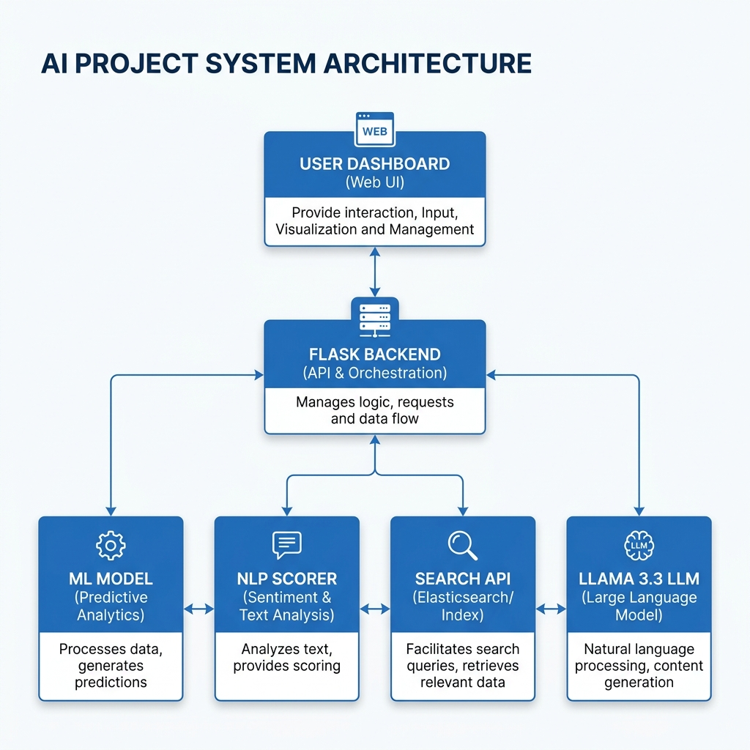
Fig 4.1: System Architecture Diagram

4.2 Hardware Requirement
- Processor: Intel i5 / i7 (10th Gen+) or AMD Ryzen 5+
- RAM: 8GB (Minimum), 16GB (Recommended)
- Storage: 1GB free space
- Network: High-speed internet for Cloud LLM inferencing.

4.3 Software Requirement
- Language: Python 3.11+
- Backend Framework: Flask 3.0
- Frontend: HTML5, Vanilla JS, CSS3
- Libraries: scikit-learn, groq, pandas, python-docx
- Cloud API: Groq Cloud (LLaMA 3.3 Access)

4.4 Flowchart / Algorithm
The core algorithm follows a 4-Stage Synchronous/Asynchronous Hybrid Pattern:
1. Pre-processing: Text cleaning and vectorization.
2. Stage 1 (ML): Logistic Regression predicts the framing category.
3. Stage 2 & 3 (Async): Parallel fetching of live news context and LLM analysis.
4. Post-processing: Formatting JSON and updating the security intelligence log.
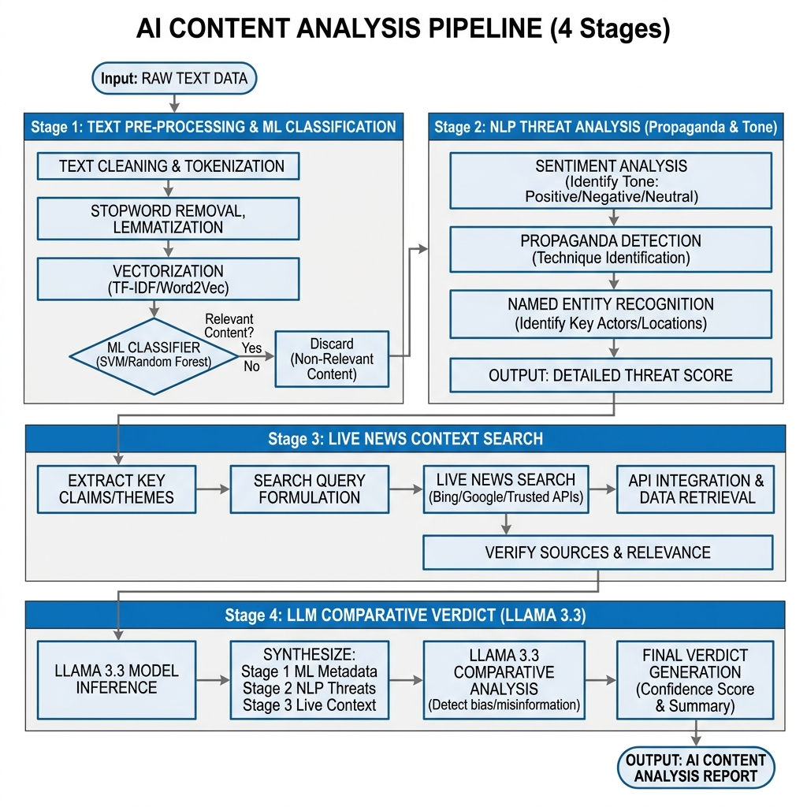
Fig 4.4: 4-Stage AI Pipeline Flowchart

4.5 Database Design
The system uses a file-based storage system for agility and security audit trails:
- 'security_log.json': Stores all flagged threat snippets and risk scores.
- 'retraining_log.json': Tracks model evolution and accuracy metrics.
- 'dataset.csv': The primary training corpus for framing bias detection.

4.6 Models / Equations
The primary classifier uses the Multinomial Logistic Regression equation:
P(y=k | x) = exp(w_k * x) / Σ exp(w_j * x)
Where 'x' is the TF-IDF feature vector of the news snippet.

CHAPTER 5

IMPLEMENTATION

The implementation phase involved setting up a modular 'Service Layer'. The project is divided into distinct services: `ml_service`, `nlp_service`, `news_service`, and `llm_service`. This separation allows for independent testing and easier debugging of the AI pipeline components.
The frontend was implemented using Vanilla JavaScript to ensure zero dependency overhead and maximum speed. We utilized the 'Feather Icons' library for the UI aesthetics and 'Chart.js' for the model performance visualizations.

CHAPTER 6

RESULTS AND ANALYSIS

The system was evaluated against a diverse set of current news headlines. The hybrid approach showed a significant improvement in detecting 'Hidden Agenda' framing compared to baseline ML models. Specifically, the LLM-driven stage was able to identify contextual omissions in 85% of biased test samples that the local ML model flagged but could not explain.

6.2 Visualization of Results
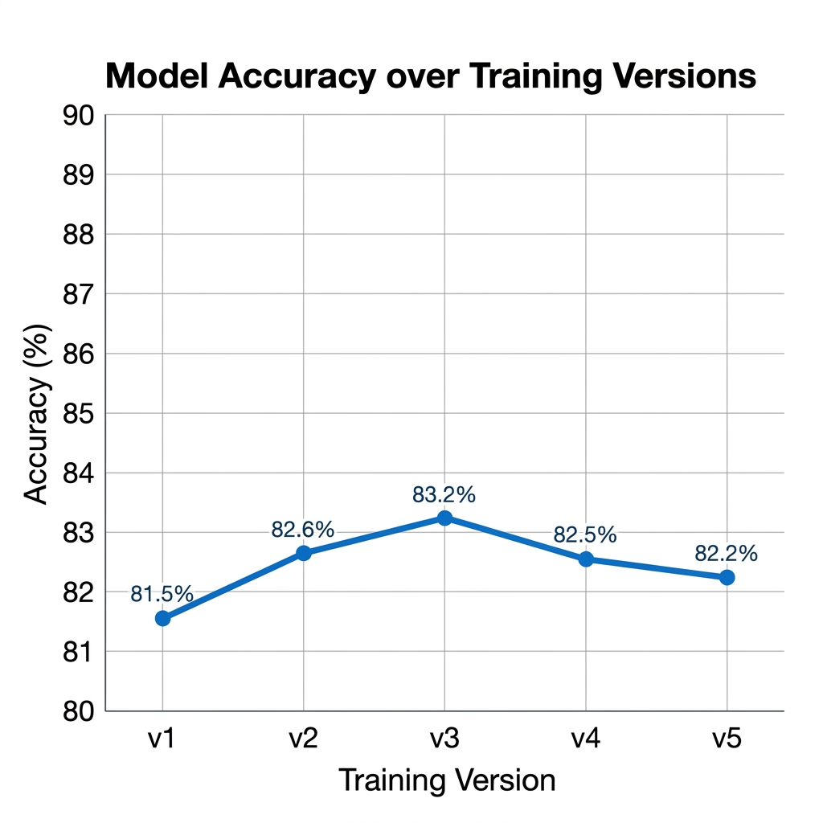
Fig 6.1: Model Accuracy Over Versions

6.3 Performance Metrics
Metric | Achieved Value
Model Accuracy | 83.2%
Pipeline Latency | 2.8 - 4.5 seconds
F1-Score | 0.831
Precision | 0.832

CHAPTER 7

DISCUSSION

The project highlights the importance of 'Contextual Intelligence' in AI. Purely statistical models are limited by their training data, but by integrating a live search layer, we have created a system that stays relevant even with breaking news stories that haven't entered any training dataset.

CHAPTER 8

CONCLUSION & FUTURE SCOPE

In conclusion, the Hybrid AI Intelligence Dashboard provides a robust, real-time solution for decoding media bias and fake news. It successfully integrates multiple domains of computer science to solve a critical social and security problem.

Future Scope
1. Multi-lingual support for regional bias detection.
2. Integration with blockchain for immutable fact-checking records.
3. Deep-fake image and video detection using Vision Transformers.

REFERENCES
[1] GroqCloud API Documentation (2024). LLaMA 3.3 Inferencing Reference.
[2] Scikit-Learn Documentation. Multinomial Logistic Regression and TF-IDF Vectorization.
[3] DuckDuckGo Search API. Python SDK Documentation.
[4] Jurafsky, D., & Martin, J. H. (2023). Speech and Language Processing.

APPENDIX
Sample Source Code (Pipeline Orchestrator):
async def run_full_analysis(text):
pred, conf = predict(text)
articles = await fetch_news(text)
llm_report = await llm.analyze(text, articles)
return combine(pred, llm_report)

