Selection of stable and informative disease-specific spectral features for white rust detection in mustard leaves
A systematic comparison of filter, wrapper and embedded feature-selection methods on the combined K1–K4 feature pool
2264 leaf spectra (378 healthy, 1886 white-rust diseased) · ASD FieldSpec contact probe, 1-nm interval · four dates, three growth stages, three varieties pooled · 4150 spectral features
Animesh Panda · Division of Agricultural Physics, ICAR-Indian Agricultural Research Institute, New Delhi
Methodology, results and interpretation for thesis use · companion to the feature-selection Excel workbook and presentation

Contents

(Right-click → Update field in Word to show page numbers.)

Summary
Twenty-three feature-selection methods (11 filter, 6 wrapper, 6 embedded and a consensus) were applied to the same 4150-feature K1–K4 pool. Each method selected features only inside the training leaves of 20 units (10 plot-grouped folds and 10 hold-outs of 30 % of plots); the selected features were then tested on the leaves of plots that the selection never saw.
Most accurate with 10 features (QDA, equal priors): SFFS with a QDA criterion 87.9 ± 2.8 %, SVM-RFE 87.1 ± 3.6 % and CARS 86.8 ± 2.6 %. These three are statistically tied (Holm-corrected Wilcoxon p = 0.55) and significantly better than all other methods (Friedman χ² = 333, p < 10⁻⁵⁷). All three beat the four-tier RF-17 set of Part C (84.5 %) in 15 of the 20 held-out sets.
Best overall, balancing accuracy (QDA and RF), stability and J–M separability: SVM-RFE (rank 1). It is followed by LASSO, CARS, the Borda consensus and ReliefF. ReliefF is the most stable selector (Jaccard 0.84) at 84.9 % accuracy. The wrappers SFFS, the genetic algorithm and CARS are accurate but unstable (Jaccard 0.22–0.34): many different feature combinations work almost equally well.
Stable and disease-specific features chosen by most methods: the width of the 970-nm water absorption feature (CR3; 17 of 21 methods), the position and symmetry of the 1940-nm water feature (CR6), first-derivative bands on the 1940-nm water band wing (1915–1934 nm), first-derivative bands across the NIR plateau (848–911 nm), the 1724 and 2223–2306 nm C–H / dry-matter regions, and the anthocyanin index ARI.
The best method overall was SVM-RFE. The most stable method was ReliefF. The most universal disease-specific feature was the width of the 970-nm water absorption feature, chosen by 17 of 21 methods.

Key findings
- SFFS (QDA criterion), SVM-RFE and CARS give the most accurate 10-feature sets on new plots (86.8–87.9 % balanced accuracy), 2.3–3.4 points above the four-tier RF-17 set and 8.5–9.6 points above the four-tier CART-13 set.
- SVM-RFE is the best all-round method for this dataset (composite rank 1): accurate with QDA (87.1 %) and RF (87.2 %), moderately stable (Jaccard 0.65). ReliefF is the most stable (0.84) and still accurate (84.9 %).
- Univariate filters (r = ANOVA F = Fisher score, χ², MI) need redundancy control: skipping near-duplicate bands raises their accuracy by 3.6–6.1 points.
- J–M is a poor criterion for choosing features here: the J–M-optimised sets have the highest J–M (1.75–1.80) but only 70–73 % accuracy on new plots.
- Water features dominate the disease signature: 970-nm band width and 1940-nm band position/symmetry, plus derivative bands at 1915–1934 nm and 848–911 nm. CARS, LASSO and SVM-RFE partly rely on bands next to the detector joins, which needs caution.

1. Introduction
Hyperspectral leaf reflectance contains thousands of narrow, strongly correlated bands. When the bands are converted into disease-sensitive features — reflectance (K1), continuum-removed absorption parameters (K2), vegetation indices (K3), first-derivative bands and red-edge parameters (K4) — the number of candidate features (4150 here) far exceeds what a classifier needs. Too many features cause over-fitting, unstable covariance estimates in discriminant analysis, poor interpretability and expensive sensors (Guyon & Elisseeff 2003; Thomas et al. 2018).
Feature selection keeps a small subset of the ORIGINAL features, so the result can be interpreted physiologically and used to design a multispectral sensor (Wei et al. 2021). Feature-selection methods fall into three families (Kohavi & John 1997; Saeys et al. 2007):
- Filter methods score every feature with a statistic computed from the data alone, independent of any classifier (e.g. Pearson correlation, ANOVA F, chi-square, ReliefF, SPA, UVE). They are fast but judge features individually (or by simple redundancy rules).
- Wrapper methods search over feature subsets and score each subset with a classifier or a separability criterion (e.g. RFE, CARS, sequential floating forward selection, genetic algorithms). They find complementary features but are slower and can over-fit.
- Embedded methods select features as part of fitting a model (e.g. Random Forest and CART importance, Boruta, PLS-VIP, LASSO, gradient boosting). They are a compromise between the two.
Crop-disease studies have used many of these methods — chi-square and ANOVA-F (Abdulridha et al. 2023), RFE (Wei et al. 2021; Liu et al. 2024), RELIEF-F (Mahlein et al. 2013), SPA and CARS (Zhu et al. 2017; Li et al. 2009), continuous-wavelet separability scalograms (Cheng et al. 2010), Boruta with SFFS (Mustafa et al. 2022, 2023), genetic algorithms (Nagasubramanian et al. 2018) and the J–M-based four-tier approach (Das et al. 2020) — but usually one or two at a time, on different data and with different validation. Which method works best for a given dataset therefore remains an open question.

1.1 Objectives
- Apply filter, wrapper and embedded feature-selection methods used in crop-disease research to the same K1–K4 feature pool of healthy and white-rust-diseased mustard leaves.
- Evaluate every method under one honest protocol: selection inside training plots only, accuracy on new plots, stability across training sets and separability (J–M).
- Identify which feature-selection method works best for this dataset, with statistical tests.
- Identify stable and informative disease-specific features on which the methods agree, and interpret them physiologically.

2. Materials and methods

2.1 Spectral data
Leaf reflectance was measured with an ASD FieldSpec spectroradiometer and contact probe at 1-nm intervals (350–2500 nm) on four dates (11-02, 24-02, 03-03 and 13-03-2026), covering vegetative, flowering and pod-formation stages and three varieties. After removing exact duplicate spectra, 2264 unique leaf spectra remained (378 healthy from 12 control plots, 1886 diseased from 36 inoculated plots). The 400–2500 nm range (2101 bands at 1 nm) was analysed; the detector-edge noise below 400 nm was removed. The ASD's native resolution (≈ 3 nm VNIR, ≈ 8–10 nm SWIR) is interpolated to 1 nm, so adjacent 1-nm bands are strongly correlated.

2.2 The K1–K4 feature pool
The pool was identical to the combined pool of the four-tier analysis (Part C): K1 band reflectance (2039 bands, Savitzky–Golay smoothed (11 points = 11 nm, 2nd order) after additive splice correction at the 1000/1001 and 1800/1801 nm detector joins, with guard zones 990–1010 and 1795–1835 nm removed); K2 continuum-removed absorption parameters (30: depth, position, area, width and symmetry of six absorption features: blue, red, 970, 1200, 1450 and 1940 nm); K3 vegetation indices (30 after removing MTVI1, which equals mCARI1); K4 first-derivative bands (2031, Savitzky–Golay 15 points, guard zones 988–1012 and 1793–1837 nm removed) and 20 red-edge and derivative edge parameters. Total 4150 features. For the wavelet method an additional feature space of 3368 continuous-wavelet coefficients was derived from the K1 spectrum (Section 2.5.11).

2.3 Study design and validation
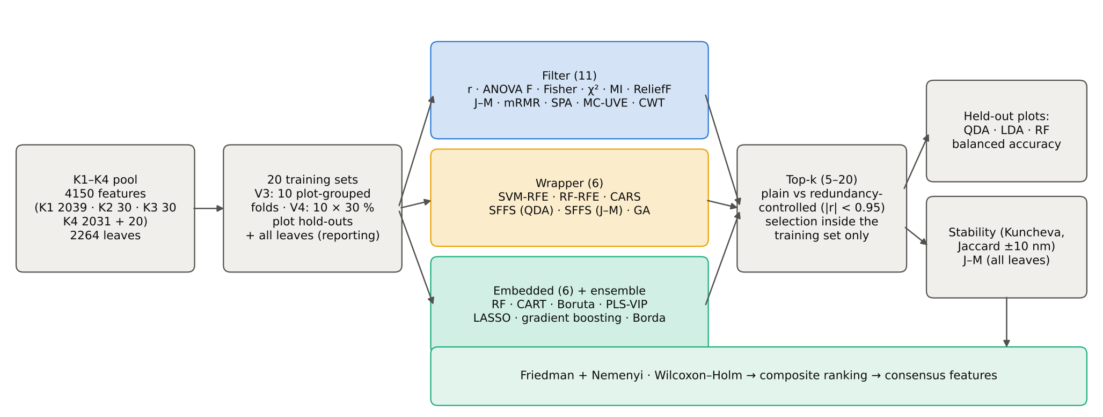
Figure 1. Workflow of the feature-selection comparison.
- Training/test units. 20 units: the 10 plot-grouped folds of the first repeat of the nested cross-validation used throughout the thesis (StratifiedGroupKFold, seed 101) and 10 hold-out splits in which 30 % of the plots (4 healthy + 11 diseased) form the test set. No plot ever contributes leaves to both training and test sets.
- Selection inside the training set only. Every method was run on the training leaves of each unit; the test leaves were used only to measure accuracy. This avoids the selection bias that arises when features are chosen on all samples and then cross-validated (Ambroise & McLachlan 2002). Each method was also run once on all leaves to report the selected features.
- Feature budget. From each method's ranking the top k = 5, 10, 15 and 20 features were taken; k = 10 is used for the headline comparison. SFFS returns its own best set for each size.
- Redundancy control. Two variants were evaluated: the plain top-k (as most methods are published) and a redundancy-controlled top-k in which a candidate correlated |r| ≥ 0.95 (on the training leaves) with an already chosen feature is skipped — the correlation analogue of the minimum spectral distance of Wei et al. (2021).
- Classifiers. QDA with equal priors (Tier 4 of Das et al. 2020), LDA with equal priors and a Balanced Random Forest (300 trees; k = 10) were trained on the training leaves using the selected features and applied to the test leaves.
- Class imbalance (1 : 5). Equal priors (QDA, LDA), balanced class weights (CART, SVM, LASSO, gradient boosting), class-balanced bootstrap samples (Balanced RF, RF-RFE, Boruta), class-balanced Monte-Carlo sub-samples (CARS, MC-UVE) and class-balanced instance sampling (ReliefF); all accuracies are balanced accuracies.
- Inner validation. Methods that tune themselves (SPA chain length, CARS subset, PLS components, CART pruning, LASSO penalty, SFFS and GA criterion) used plot-grouped 3- or 5-fold cross-validation inside the training set.

2.4 Notation
n = number of training leaves, n₀/n₁ = healthy/diseased leaves, x̄_c and σ_c² = class mean and variance of a feature, p = number of features, S = selected subset, k = |S|.

2.5 Filter methods
Filter methods score features from the data alone. Eleven filters were applied; for each the principle, equation, settings, the way the ranking was formed and its use in crop-disease research are given.

2.5.1 F1 · Pearson r
Principle: The point-biserial correlation r measures the linear association between each feature and the disease status coded 0 (healthy) / 1 (diseased). Features are ranked by |r|.
r = (x̄₁ − x̄₀)/s · √(n₀n₁/n²)
Settings: All leaves of the training set; no tuning.
Output used: Features sorted by |r|.
Use in crop-disease studies: Correlation analysis is the most common first screen in hyperspectral disease studies (Mahlein et al. 2013; Thomas et al. 2018).

2.5.2 F2 · ANOVA F
Principle: One-way analysis of variance compares the between-class and within-class variance of each feature; a large F means that the class means differ strongly relative to the scatter within classes.
F = [Σ_c n_c (x̄_c − x̄)² / (C − 1)] / [Σ_c Σ_i (x_ic − x̄_c)² / (n − C)]
Settings: C = 2 classes, df = (1, n − 2); computed on the training leaves.
Output used: Features sorted by F.
Use in crop-disease studies: Abdulridha et al. (2023) used ANOVA-F (with chi-square) to pick wavelengths for wheat stem rust.

2.5.3 F3 · Fisher score
Principle: The Fisher score is the ratio of between-class scatter to within-class scatter of a feature, the univariate form of Fisher's discriminant criterion.
FS = Σ_c n_c (x̄_c − x̄)² / Σ_c n_c σ_c²
Settings: Computed on the training leaves.
Output used: Features sorted by FS.
Use in crop-disease studies: Widely used in band-selection reviews (Duda et al. 2001; Saeys et al. 2007).

2.5.4 F4 · Chi-square
Principle: Each feature is divided into 10 quantile bins and the χ² statistic of the 2 (class) × 10 (bin) contingency table tests whether the bin frequencies differ between healthy and diseased leaves. Unlike F, χ² also responds to differences in the shape of the distributions.
χ² = Σ_c Σ_b (O_cb − E_cb)² / E_cb, E_cb = n_c · n_b / n
Settings: 10 equal-frequency bins defined on the training leaves.
Output used: Features sorted by χ².
Use in crop-disease studies: Abdulridha et al. (2023); Wei et al. (2021) compared chi-square with RFE for peanut stem rot.

2.5.5 F5 · Mutual information
Principle: Mutual information I(X;Y) measures how much knowing the feature reduces the uncertainty about the class, including non-linear dependence. It was estimated with the k-nearest-neighbour estimator of Kraskov et al. (2004).
I(X;Y) = Σ_y ∫ p(x,y) log[p(x,y) / (p(x) p(y))] dx
Settings: k = 3 neighbours, standardised features, fixed random seed.
Output used: Features sorted by I.
Use in crop-disease studies: Used in hyperspectral stress studies together with RFE (e.g. Navrozidis et al. 2023, olive).

2.5.6 F6 · ReliefF
Principle: ReliefF (Kira & Rendell 1992; Kononenko 1994) is a multivariate filter: for each sampled leaf it finds the k nearest leaves of the same class (hits) and of the other class (misses). A feature gains weight when it differs between the leaf and its misses and loses weight when it differs between the leaf and its hits, so ReliefF rewards features that separate the classes locally, including in interaction with other features.
W_j ← W_j − Σ_h |x_j − H_j| / (m k) + Σ_m |x_j − M_j| / (m k)
Settings: k = 10 hits and 10 misses, Manhattan distance on min–max-scaled features; sampled instances = all healthy training leaves and the same number of randomly drawn diseased leaves; the final weight is the mean of the two class-wise updates (equal priors).
Output used: Features sorted by W.
Use in crop-disease studies: Mahlein et al. (2013) used RELIEF-F to select the bands of their disease-specific spectral indices for sugar-beet diseases.

2.5.7 F7 · J–M (univariate)
Principle: The Jeffries–Matusita distance (Tier 3 of Das et al. 2020) of each single feature, assuming Gaussian classes. It combines the difference of the means and the difference of the variances.
B = (μ₀ − μ₁)² / [4(σ₀² + σ₁²)] + ½ ln[(σ₀² + σ₁²) / (2σ₀σ₁)], J–M = 2(1 − e^(−B))
Settings: Computed on the training leaves.
Output used: Features sorted by J–M.
Use in crop-disease studies: Das et al. (2020) used J–M to judge separability of CART-selected bands.

2.5.8 F8 · mRMR
Principle: Minimum-redundancy maximum-relevance (Peng et al. 2005) selects features one at a time, maximising relevance to the class while penalising redundancy with features already chosen. The F-test correlation quotient form (Ding & Peng 2005) was used.
next feature = argmax_j F_j / [ (1/|S|) Σ_{s∈S} |r_js| ]
Settings: Relevance = ANOVA F, redundancy = mean |r| with the selected set; 30 features selected.
Output used: Order of selection.
Use in crop-disease studies: Common in hyperspectral band selection where adjacent bands are collinear.

2.5.9 F9 · SPA
Principle: The successive projections algorithm (Araújo et al. 2001) builds a chain of variables with minimal collinearity: starting from one variable, each step projects all remaining variables onto the subspace orthogonal to the last chosen one and picks the variable with the largest projection. SPA is unsupervised except for the choice of the start variable and the chain length.
x_j ← x_j − (x_kᵀ x_j)(x_kᵀ x_k)⁻¹ x_k; next = argmax_j ‖x_j‖
Settings: Chains of up to 20 variables started from each of the 10 most significant features (ANOVA F); chain and length chosen by plot-grouped 5-fold inner cross-validation of LDA (the MLR validation of the original algorithm).
Output used: Order in the chosen chain.
Use in crop-disease studies: Zhu et al. (2017) used SPA to choose effective wavelengths for presymptomatic tobacco mosaic virus detection.

2.5.10 F10 · MC-UVE
Principle: Monte-Carlo uninformative variable elimination (Centner et al. 1996; Cai et al. 2008) fits PLS models on many random subsets and computes, for each variable, the reliability c = mean(b)/sd(b) of its regression coefficient. Artificial random noise variables are added; real variables that are not more reliable than the noise are uninformative.
c_j = mean(b_j) / sd(b_j); keep j if |c_j| > max |c_noise|
Settings: 100 class-balanced Monte-Carlo sub-samples (80 % of the minority class plus as many majority leaves), PLS-DA with 10 components, 4150 noise variables of amplitude 10⁻¹⁰.
Output used: Features sorted by |c|; native subset = |c| above the noise cut-off.
Use in crop-disease studies: Standard chemometric pre-selection for NIR and hyperspectral calibration.

2.5.11 F11 · CWT scalogram
Principle: Continuous wavelet analysis (Cheng et al. 2010) decomposes each spectrum with the Mexican-hat wavelet at several scales. Small scales describe narrow absorption shapes (like derivatives), large scales describe broad features (like continuum-removed band depths). The separability (here J–M) of every wavelet coefficient forms a scale × wavelength 'separability scalogram'; its local maxima are the candidate features.
W(a, b) = ∫ R(λ) a^(−½) ψ((λ − b)/a) dλ, ψ(t) = (1 − t²) e^(−t²/2)
Settings: Mexican-hat CWT of the K0-processed 1-nm spectrum at scales 2, 4, …, 256 nm; coefficients kept every 5 nm; coefficients inside the cone of influence or within one scale of a detector join excluded (2505 valid of 3368).
Output used: Local maxima of the scalogram sorted by J–M.
Use in crop-disease studies: Cheng et al. (2010) detected green-attack damage of pine with a few wavelet features; widely used for wheat rust and powdery mildew since.

2.6 Wrapper methods
Wrapper methods evaluate feature subsets with a learning algorithm or a separability criterion and search the subset space. Six wrappers were applied. To keep the floating search and the genetic algorithm tractable, they searched a candidate pool of the 100 most significant, mutually non-redundant features of each training set (filter–wrapper hybrid).

2.6.1 W1 · SVM-RFE
Principle: Support-vector-machine recursive feature elimination (Guyon et al. 2002) fits a linear SVM, removes the features with the smallest |weight|, refits on the remaining features and repeats. Because the weights are re-estimated after each removal, a feature's importance is judged in the context of the others.
rank by w_j², remove the lowest, refit
Settings: Linear SVM, C = 0.01, balanced class weights, standardised features; 10 % of the remaining features removed per step down to 100, then one at a time.
Output used: Reverse order of elimination (last survivor = rank 1).
Use in crop-disease studies: Wei et al. (2021) found RFE better than chi-square and SelectFromModel for peanut stem rot; RFE is the method cited from Liu et al. (2024).

2.6.2 W2 · RF-RFE
Principle: Recursive feature elimination with a Random Forest: the forest is refitted after each elimination step and the least important features (mean decrease in Gini) are removed.
rank by MDI, remove the lowest, refit
Settings: Balanced Random Forest with 150 trees; 20 % removed per step down to 100 features, 5 at a time down to 30, then one at a time.
Output used: Reverse order of elimination.
Use in crop-disease studies: Wei et al. (2021); RF-RFE is common in UAV disease studies.

2.6.3 W3 · CARS
Principle: Competitive adaptive reweighted sampling (Li et al. 2009) imitates 'survival of the fittest': in each of N Monte-Carlo runs a PLS model is fitted, variables with small |coefficients| are removed by an exponentially decreasing function, and the survivors are re-sampled with probability proportional to their weight. The subset with the best cross-validated performance is kept.
r_i = a e^(−k i), a = (p/2)^(1/(N−1)), k = ln(p/2)/(N − 1)
Settings: N = 50 runs, class-balanced 80 % sub-samples, PLS-DA with 10 components, plot-grouped 5-fold inner CV on balanced accuracy.
Output used: Sampling run in which the variable was last retained (descending), then final |coefficient|.
Use in crop-disease studies: CARS (often with SPA) is the most used wavelength selector in Chinese crop-disease imaging studies, e.g. Liu et al. (2024, Frontiers in Plant Science) for maize/soybean leaf diseases.

2.6.4 W4 · SFFS (QDA)
Principle: Sequential floating forward selection (Pudil et al. 1994) adds the single feature that most improves the criterion and then removes features ('floating' backward steps) as long as this improves the best set of that size. The criterion here was the plot-grouped inner-CV balanced accuracy of QDA with equal priors — i.e. the Tier-4 classifier of Das et al. (2020) — so SFFS searches directly for the set that QDA classifies best.
J(S) = mean balanced accuracy of QDA in 3-fold plot-grouped inner CV
Settings: Candidates: the 100 most significant features (ANOVA F) that are mutually non-redundant (|r| < 0.95); subset sizes 1–20; best set per size kept.
Output used: Best set for each size k (sets are not nested).
Use in crop-disease studies: Mustafa et al. (2023) used SFFS after Boruta to find the best fusarium-head-blight feature combination.

2.6.5 W5 · SFFS (J–M)
Principle: The same floating search with the multivariate Jeffries–Matusita distance as criterion, i.e. selection of the feature set with the largest class separability (Tier 3 of Das et al. 2020).
J(S) = J–M distance of the multivariate Gaussian classes on the training leaves
Settings: Same 100 candidates; sizes 1–20.
Output used: Best set for each size k.
Use in crop-disease studies: J–M-based band selection is common in multispectral/hyperspectral classification (Das et al. 2020).

2.6.6 W6 · Genetic algorithm
Principle: A genetic algorithm (Leardi et al. 1992) evolves a population of binary chromosomes (feature on/off). Chromosomes with high fitness are selected (tournament), combined (crossover) and mutated; the best ones are kept (elitism).
fitness = inner-CV QDA balanced accuracy − 0.002 × number of features
Settings: Same 100 candidates; 50 chromosomes × 40 generations; tournament size 3; uniform crossover (0.8); bit-flip mutation 1/100; elitism 2; subsets limited to 2–25 features.
Output used: Frequency of each feature in the final population; native subset = best chromosome.
Use in crop-disease studies: Nagasubramanian et al. (2018) used GA-SVM band selection for charcoal rot in soybean.

2.7 Embedded methods
Embedded methods obtain feature importance as a by-product of fitting a model. Six embedded methods were applied.

2.7.1 E1 · RF importance
Principle: The mean decrease in Gini impurity of a Random Forest (Breiman 2001) sums, over all trees and nodes, the impurity reduction achieved by splits on each feature. A Balanced Random Forest (Chen et al. 2004) draws class-balanced bootstrap samples so that the importance is not dominated by the majority class.
MDI_j = (1/T) Σ_trees Σ_{nodes split on j} p(node) ΔGini(node)
Settings: Balanced RF, 500 trees, √p features per split.
Output used: Features sorted by MDI.
Use in crop-disease studies: RF importance is the most widely used embedded selector in hyperspectral disease studies; SelectFromModel with RF (SFM-RF) uses the same scores.

2.7.2 E2 · CART importance
Principle: The Gini importance of a single pruned classification tree (Breiman et al. 1984), the mechanism behind Tier 2 of Das et al. (2020). Only variables used in splits receive importance.
importance_j = Σ_{nodes split on j} p(node) ΔGini(node)
Settings: Gini criterion, balanced class weights (equal priors), minimum 20 leaves to split and 7 per terminal node (as rpart); cost-complexity pruning parameter chosen from 10 candidates by plot-grouped 3-fold inner CV.
Output used: Features used in the tree sorted by importance; native subset = all features used.
Use in crop-disease studies: Das et al. (2020) used CART to select rice-genotype bands.

2.7.3 E3 · Boruta
Principle: Boruta (Kursa & Rudnicki 2010) is an all-relevant method: every feature competes with a randomly shuffled copy of itself (a 'shadow'). In each run a Random Forest is fitted on real and shadow features; a real feature scores a 'hit' when its importance exceeds the best shadow. After each run a binomial test decides whether a feature is significantly more (confirmed) or less (rejected) important than chance.
hits_j ~ Binomial(runs, 0.5); confirm if P(X ≥ hits_j) < α/m
Settings: Balanced RF, 200 trees per run, 60 runs per training set (100 on all leaves), two-sided test with Bonferroni correction, α = 0.01; rejected features dropped from later runs.
Output used: Confirmed features by mean importance, then tentative, then rejected (later rejection = higher rank).
Use in crop-disease studies: Mustafa et al. (2022, 2023) used Boruta to identify fusarium-head-blight-sensitive features in wheat.

2.7.4 E4 · PLS-VIP
Principle: Variable importance in projection (Wold et al. 2001) summarises how much each variable contributes to the PLS components, weighted by the variance of the response explained by each component. VIP > 1 is the usual relevance threshold (Chong & Jun 2005).
VIP_j = √[ p Σ_a SS_a (w_ja/‖w_a‖)² / Σ_a SS_a ], SS_a = q_a² t_aᵀt_a
Settings: PLS-DA on standardised features; 1–15 components chosen by plot-grouped 5-fold inner CV (balanced accuracy).
Output used: Features sorted by VIP; native subset = VIP > 1.
Use in crop-disease studies: PLS-VIP is standard in chemometric and hyperspectral disease studies.

2.7.5 E5 · LASSO
Principle: L1-penalised logistic regression (Tibshirani 1996) shrinks coefficients and sets many exactly to zero, so variable selection happens during model fitting. Features that enter the model at a strong penalty are the most important.
min_β −log L(β) + (1/C) ‖β‖₁
Settings: Balanced class weights, standardised features, C on a 9-point grid from 10⁻³ to 10⁻⁰·⁵ chosen by plot-grouped 3-fold inner CV.
Output used: Order of entry along the regularisation path (strong to weak penalty); native subset = non-zero coefficients at the chosen C.
Use in crop-disease studies: LASSO and SelectFromModel with L1-SVM (SFM-SVM) are standard embedded selectors.

2.7.6 E6 · Gradient boosting
Principle: Gradient-boosted decision trees (Friedman 2001), the algorithm family of XGBoost (Chen & Guestrin 2016), add shallow trees sequentially to correct the errors of the previous ones; the split-gain importance measures each feature's contribution.
F_m(x) = F_{m−1}(x) + ν h_m(x)
Settings: 150 trees, depth 3, learning rate 0.1, sub-sample 0.8, √p features per split, balanced sample weights.
Output used: Features sorted by importance.
Use in crop-disease studies: XGBoost importance is increasingly used for UAV disease mapping.

2.8 Ensemble: consensus feature selection
Ensemble selection aggregates the rankings of several methods to obtain a more robust selection.

2.8.1 C1 · Consensus (Borda)
Principle: Ensemble feature selection (Saeys et al. 2008): the redundancy-controlled top-20 of every distinct method gets Borda points (20 for rank 1 … 1 for rank 20), the points are summed over methods, and features are ranked by their total. Repeating this inside every training set makes the consensus itself an honestly validated method.
Borda_j = Σ_methods (21 − rank_jm) for rank_jm ≤ 20
Settings: 21 distinct methods (Pearson r and Fisher score counted once, as ANOVA F; the CWT scalogram excluded because it works on wavelet features).
Output used: Features sorted by Borda total.
Use in crop-disease studies: Rank aggregation is recommended to stabilise selections in high-dimensional data.

2.9 Evaluation criteria

2.9.1 Accuracy on new plots
Balanced accuracy (BA) — the mean of the recall of healthy and of diseased leaves — is insensitive to the 1 : 5 class imbalance. The area under the ROC curve of QDA's posterior probability was also recorded. Each value is the mean over the 20 test sets.
BA = ½ [ TP/(TP + FN) + TN/(TN + FP) ]

2.9.2 Stability
The 20 top-10 lists of a method were compared pair-wise (190 pairs). The Kuncheva (2007) consistency index corrects the overlap for chance; the Jaccard index is the share of shared features. Because neighbouring 1-nm bands carry the same information, a tolerant Jaccard index counted a feature of the same spectral series within ±10 nm as the same feature (headline stability measure).
KI(A, B) = (r p − k²) / [k (p − k)], Jaccard(A, B) = |A ∩ B| / |A ∪ B|

2.9.3 Separability
The multivariate Jeffries–Matusita distance (0–2) of the top-10 set chosen on all leaves (Tier 3 of Das et al. 2020) was computed with the Gaussian Bhattacharyya distance; J–M ≥ 1.90 is the usual separability threshold. The QDA balanced accuracy of the same set in leaf-level 10-fold cross-validation (the protocol of Das et al.; optimistic because the set was chosen on all leaves) is also reported.
B = ⅛ (μ₀ − μ₁)ᵀ Σ⁻¹ (μ₀ − μ₁) + ½ ln[ |Σ| / √(|Σ₀||Σ₁|) ], Σ = (Σ₀ + Σ₁)/2, J–M = 2(1 − e^(−B))

2.9.4 Statistical comparison of methods
The QDA balanced accuracies of the 22 distinct methods (k = 10, redundancy-controlled) in the 20 units were compared with the Friedman test, followed by the Nemenyi critical difference of mean ranks (Demšar 2006). The best method was compared with every other method by paired Wilcoxon signed-rank tests with Holm correction.
CD = q_α √[ K(K + 1) / (6N) ], K = 22 methods, N = 20 units

2.9.5 Composite ranking
Methods were ranked by four criteria — QDA balanced accuracy and RF balanced accuracy (k = 10, redundancy-controlled), stability (tolerant Jaccard) and J–M of the all-leaf set — and the mean of the four ranks gave the overall rank.

2.9.6 Consensus disease-specific features
For each distinct method and each feature, the share of the 20 training sets in which the feature (±10 nm) was in the method's redundancy-controlled top-10 was computed. The consensus score is the mean of these shares over the 21 distinct methods (CWT excluded, as it uses another feature space); one representative was kept per ±10-nm region. A feature selected in ≥ 50 % of the training sets by many methods is both stable and informative.

2.9.7 Detector-join check
The ASD detectors join at 1000/1001 and 1800/1801 nm. For each method, the share of top-10 selections within 10 nm of a guard zone was counted, and the accuracy was recomputed after excluding such bands from the ranking, to test whether a method exploits residual splice effects.

2.10 Software and quality control
Python 3.13 with NumPy, SciPy, pandas, scikit-learn 1.9 (Pedregosa et al. 2011) and imbalanced-learn (Lemaître et al. 2017); ReliefF, SPA, MC-UVE, CARS, SFFS, the genetic algorithm, Boruta, PLS-VIP, the CWT and all evaluation statistics were implemented in a reusable module (sp/fs_methods.py). Implementation checks are listed in Section 6.

3. Results

3.1 Overview of all methods
Table 1. QDA balanced accuracy on new plots for 5–20 redundancy-controlled features, RF accuracy (k = 10), stability, J–M and overall rank of every method (mean of 20 held-out sets).
Method | Family | QDA k=5 | k=10 | k=15 | k=20 | RF k=10 | Stability | J–M | Overall rank
Pearson r | Filter | 77.8 % | 81.2 % | 83.1 % | 82.8 % | 80.8 % | 0.66 | 1.27 | = ANOVA F
ANOVA F | Filter | 77.8 % | 81.2 % | 83.1 % | 82.8 % | 80.8 % | 0.66 | 1.27 | 14
Fisher score | Filter | 77.8 % | 81.2 % | 83.1 % | 82.8 % | 80.8 % | 0.66 | 1.27 | = ANOVA F
Chi-square | Filter | 70.9 % | 79.6 % | 82.1 % | 85.0 % | 82.2 % | 0.69 | 1.45 | 8
Mutual information | Filter | 70.7 % | 77.8 % | 80.8 % | 82.0 % | 81.8 % | 0.60 | 1.45 | 16
ReliefF | Filter | 75.5 % | 84.9 % | 85.5 % | 85.5 % | 83.6 % | 0.84 | 1.21 | 5
J–M (univariate) | Filter | 69.1 % | 69.7 % | 72.1 % | 73.5 % | 79.6 % | 0.76 | 1.75 | 10
mRMR | Filter | 72.8 % | 75.5 % | 75.5 % | 75.5 % | 81.3 % | 0.58 | 0.92 | 21
SPA | Filter | 68.0 % | 67.1 % | 68.8 % | 72.1 % | 75.7 % | 0.38 | 1.73 | 18
MC-UVE | Filter | 71.7 % | 80.5 % | 82.7 % | 84.2 % | 82.6 % | 0.59 | 1.28 | 12
CWT scalogram | Filter | 61.3 % | 66.7 % | 72.0 % | 79.2 % | 76.9 % | 0.62 | 1.17 | 22
SVM-RFE | Wrapper | 84.3 % | 87.1 % | 88.1 % | 88.3 % | 87.2 % | 0.65 | 1.56 | 1
RF-RFE | Wrapper | 76.4 % | 78.9 % | 81.7 % | 82.9 % | 86.4 % | 0.52 | 1.50 | 6
CARS | Wrapper | 77.3 % | 86.8 % | 88.3 % | 88.9 % | 84.5 % | 0.34 | 1.58 | 3
SFFS (QDA) | Wrapper | 85.0 % | 87.9 % | 88.3 % | 88.3 % | 83.2 % | 0.24 | 1.43 | 11
SFFS (J–M) | Wrapper | 69.0 % | 72.7 % | 73.3 % | 74.5 % | 81.9 % | 0.42 | 1.80 | 13
Genetic algorithm | Wrapper | 73.4 % | 84.1 % | 88.2 % | 88.0 % | 81.5 % | 0.22 | 1.23 | 18
RF importance | Embedded | 71.0 % | 78.0 % | 83.2 % | 85.0 % | 82.6 % | 0.73 | 1.43 | 9
CART importance | Embedded | 76.1 % | 77.8 % | 78.9 % | 79.5 % | 84.9 % | 0.27 | 1.43 | 17
Boruta | Embedded | 71.2 % | 78.5 % | 82.6 % | 83.4 % | 83.7 % | 0.65 | 1.51 | 6
PLS-VIP | Embedded | 64.1 % | 71.6 % | 77.0 % | 79.3 % | 74.8 % | 0.73 | 0.97 | 20
LASSO | Embedded | 78.9 % | 85.4 % | 87.2 % | 86.5 % | 85.5 % | 0.69 | 1.38 | 2
Gradient boosting | Embedded | 72.5 % | 77.4 % | 80.6 % | 82.1 % | 84.7 % | 0.32 | 1.47 | 14
Consensus (Borda) | Ensemble | 79.2 % | 82.7 % | 82.7 % | 81.6 % | 85.1 % | 0.55 | 1.49 | 4

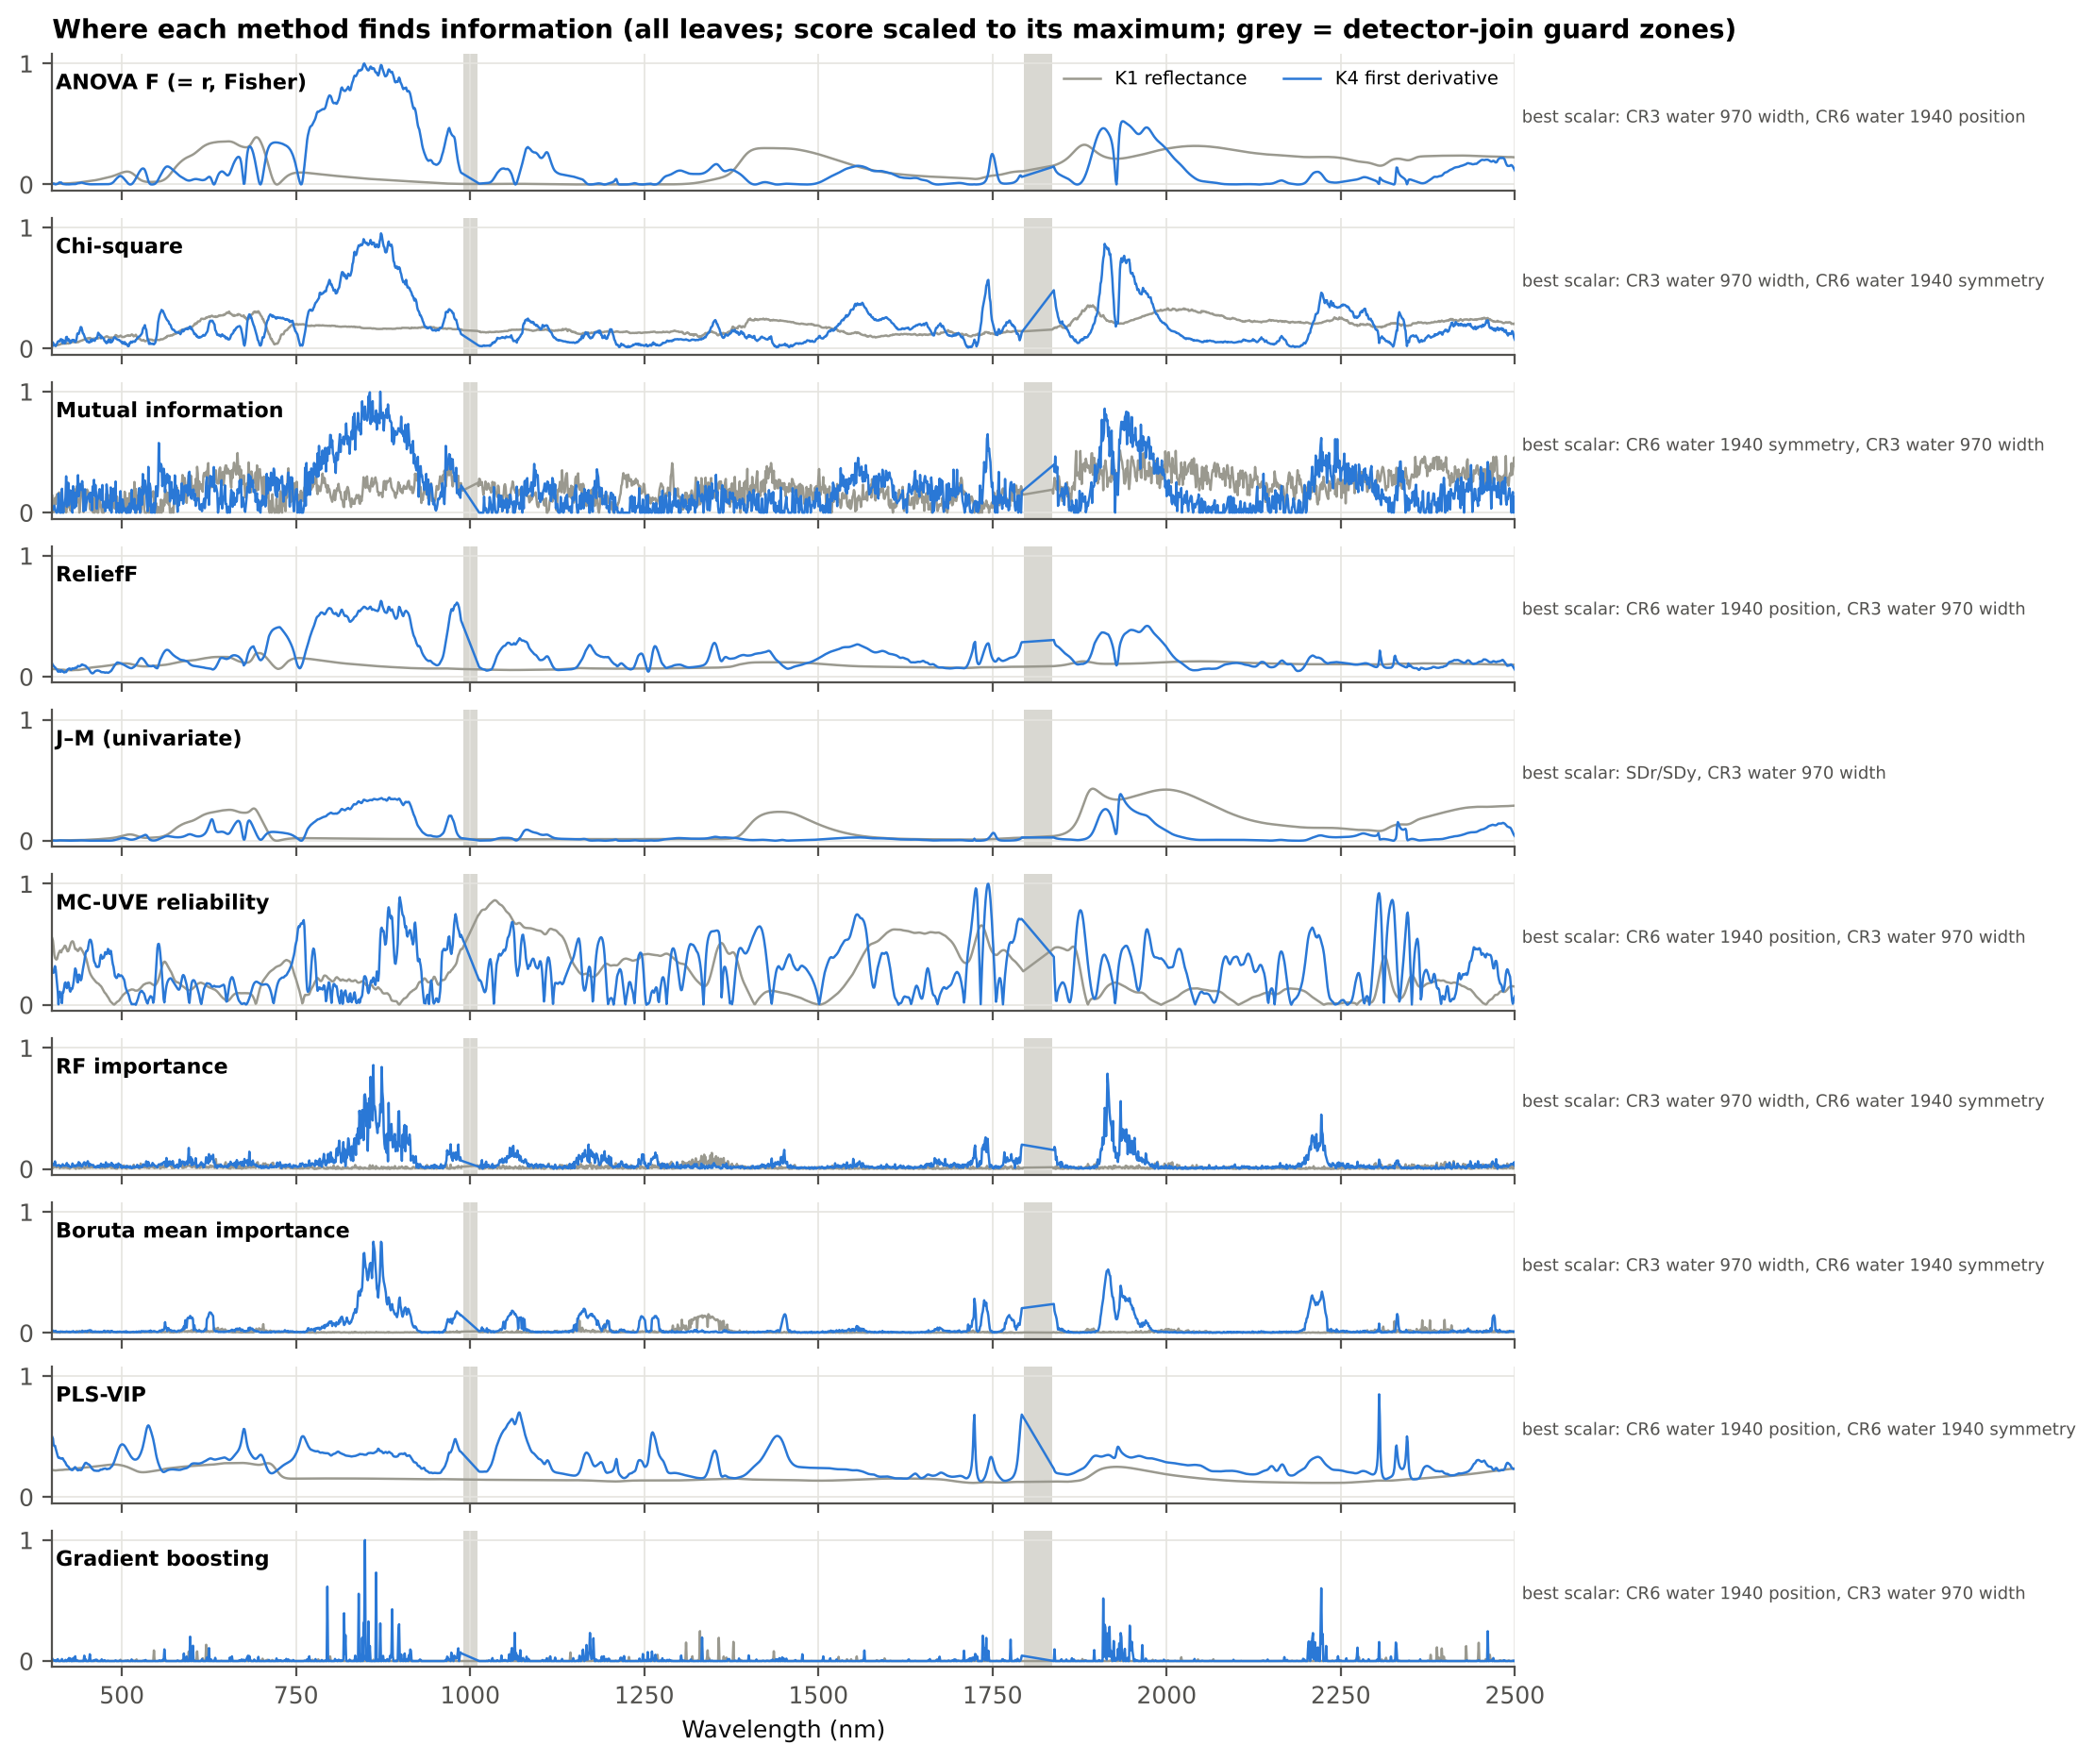
Figure 2. Feature scores of the ranking methods along the wavelength (all leaves, scaled to each method's maximum). Grey bars: detector-join guard zones.
All univariate and importance-based scores peak in the same three regions: first-derivative bands across the NIR plateau (≈ 800–920 nm), first-derivative bands on the 1940-nm water band (≈ 1900–1950 nm) and, for the trees, 2200–2230 nm; among the scalar features the 970-nm water-band width and the 1940-nm water-band position and symmetry score highest. MC-UVE and PLS-VIP spread their weight more evenly and highlight the 1725–1750 and 2300 nm regions.
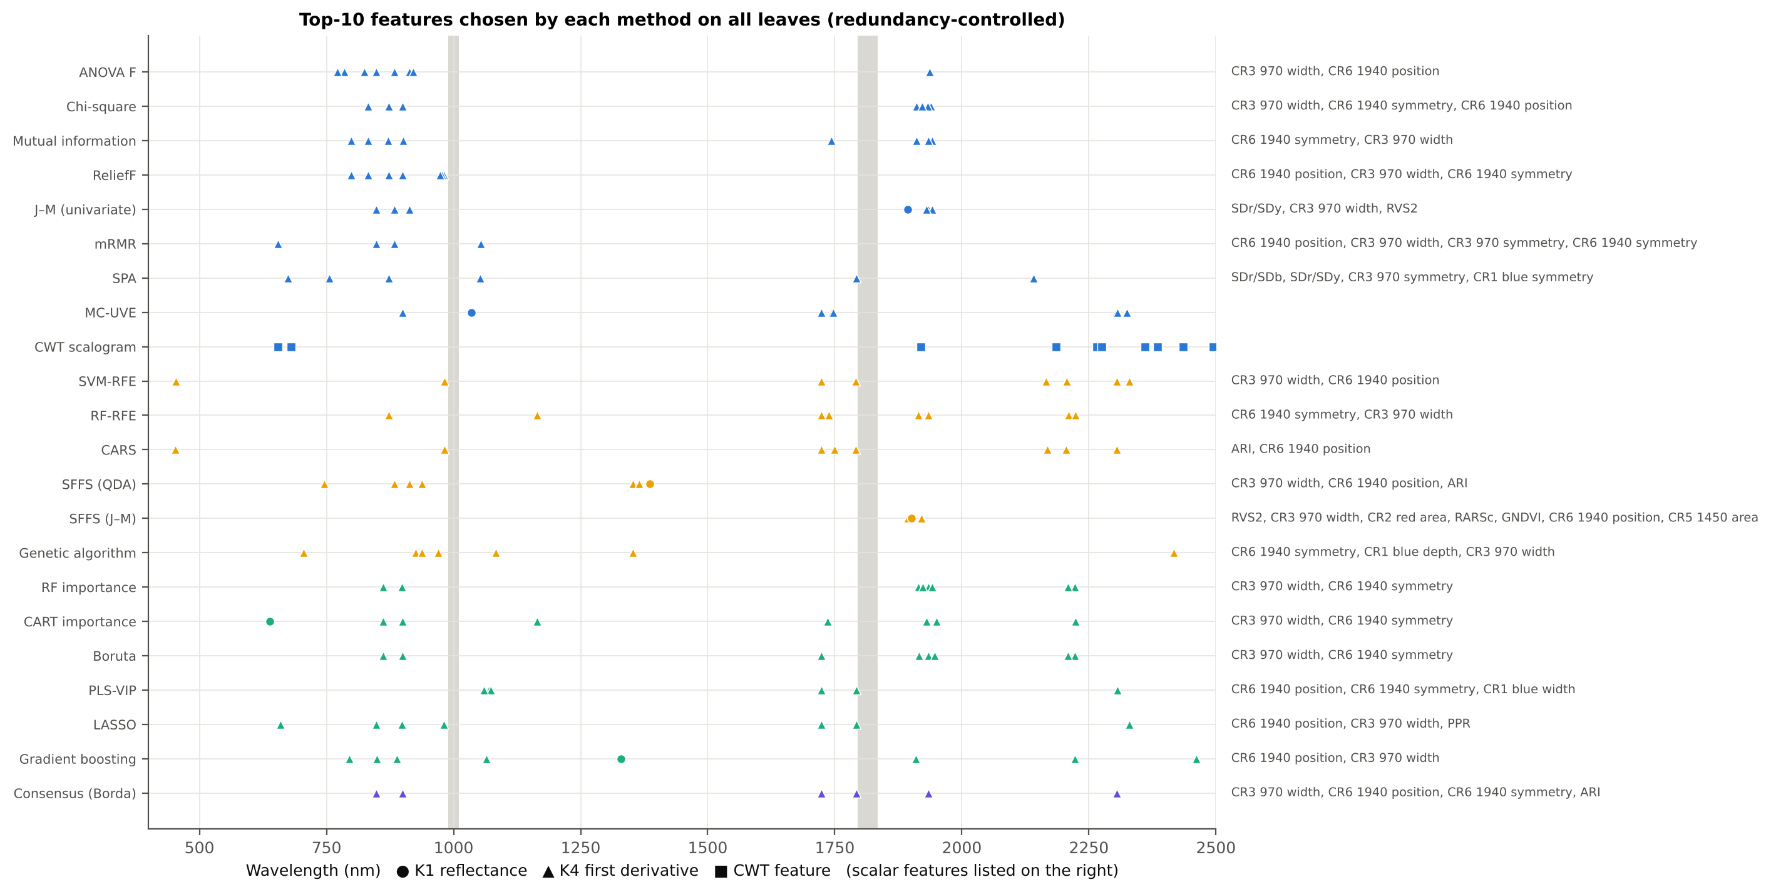
Figure 3. Top-10 features selected by each method on all leaves (redundancy-controlled). Circles: K1 reflectance; triangles: K4 first derivative; squares: CWT features; scalar features (K2, K3, K4 edge) are listed on the right.

3.2 Results of the filter methods

3.2.1 F1 · Pearson r
Pearson r, ANOVA F and the Fisher score gave exactly the same ranking (Spearman ρ = 1): for two classes r² = F/(F + n − 2) and the Fisher score is F times a constant. Their results are therefore reported together under ANOVA F.

3.2.2 F2 · ANOVA F
Top-10 on all leaves (redundancy-controlled): D1_848, D1_884, CR3 water 970 width, D1_825, CR6 water 1940 position, D1_913, D1_920, D1_785, D1_1937, D1_772 — eight of ten are first-derivative bands of the NIR plateau (772–920 nm).
QDA balanced accuracy on new plots rose from 77.8 % (5 features) to 81.2 % (10) and 83.1 % (15); RF 80.8 %, LDA 79.2 % at k = 10. Stability was moderate (Jaccard 0.66) and J–M of the set was low (1.27).
The set is highly redundant (mean |r| within the set 0.65): even after removing near-duplicates, the strongest univariate features all describe the same NIR-slope signal. Redundancy control added 3.7 points (plain top-10: 77.5 %).
- J–M of the all-leaf top-10: 1.267
- QDA (Das protocol, leaf 10-fold): 82.0 %
- RF on top-10 (new plots): 80.8 %
- stability (Jaccard ±10 nm): 0.66; Kuncheva 0.41
- selections within 10 nm of a detector join: 0.0 % (accuracy without them 81.2 %)
- overall rank: 14 of 22
Table 2. ANOVA F: accuracy on new plots for k = 5–20 redundancy-controlled features (mean of 20 held-out sets).
k (features) | QDA BA | SD | LDA BA | AUC (QDA)
5 | 77.8 % | 4.1 % | 73.8 % | 0.864
10 | 81.2 % | 3.5 % | 79.2 % | 0.907
15 | 83.1 % | 3.1 % | 80.6 % | 0.918
20 | 82.8 % | 4.0 % | 81.3 % | 0.917

Table 3. ANOVA F: top-ranked features on all leaves (before redundancy control).
Rank | Feature | Type | Score
1 | D1_848 | K4 first-derivative band | 257
2 | D1_847 | K4 first-derivative band | 256
3 | D1_849 | K4 first-derivative band | 254
4 | D1_872 | K4 first-derivative band | 254
5 | D1_873 | K4 first-derivative band | 253
6 | D1_850 | K4 first-derivative band | 251
7 | D1_857 | K4 first-derivative band | 251
8 | D1_846 | K4 first-derivative band | 250
9 | D1_858 | K4 first-derivative band | 250
10 | D1_871 | K4 first-derivative band | 249
11 | D1_856 | K4 first-derivative band | 248
12 | D1_851 | K4 first-derivative band | 248
13 | D1_861 | K4 first-derivative band | 247
14 | D1_874 | K4 first-derivative band | 247
15 | D1_862 | K4 first-derivative band | 246

3.2.3 F3 · Fisher score
Identical ranking to ANOVA F (see F2).

3.2.4 F4 · Chi-square
Top-10: CR3 water 970 width, D1_872, CR6 water 1940 symmetry, D1_1911, D1_1939, D1_832, CR6 water 1940 position, D1_899, D1_1933, D1_1922 — χ² puts more weight than F on the 1940-nm water features.
QDA 70.9 % (k = 5), 79.6 % (10), 82.1 % (15), 85.0 % (20); RF 82.2 %; stability 0.69; J–M 1.45. Composite rank 8.
χ² benefited most from redundancy control (+6.1 points), because its plain top-10 consists of neighbouring bands.
- J–M of the all-leaf top-10: 1.452
- QDA (Das protocol, leaf 10-fold): 77.6 %
- RF on top-10 (new plots): 82.2 %
- stability (Jaccard ±10 nm): 0.69; Kuncheva 0.48
- selections within 10 nm of a detector join: 0.0 % (accuracy without them 79.6 %)
- computing time: 1.0 s per training set
- overall rank: 8 of 22
Table 4. Chi-square: accuracy on new plots for k = 5–20 redundancy-controlled features (mean of 20 held-out sets).
k (features) | QDA BA | SD | LDA BA | AUC (QDA)
5 | 70.9 % | 5.8 % | 71.3 % | 0.807
10 | 79.6 % | 4.1 % | 75.3 % | 0.896
15 | 82.1 % | 3.7 % | 77.7 % | 0.912
20 | 85.0 % | 2.7 % | 81.4 % | 0.926

Table 5. Chi-square: top-ranked features on all leaves (before redundancy control).
Rank | Feature | Type | Score
1 | CR3 water 970 width | K2 continuum removal | 405
2 | D1_872 | K4 first-derivative band | 385
3 | CR6 water 1940 symmetry | K2 continuum removal | 383
4 | D1_873 | K4 first-derivative band | 381
5 | D1_871 | K4 first-derivative band | 367
6 | D1_874 | K4 first-derivative band | 367
7 | D1_847 | K4 first-derivative band | 366
8 | D1_857 | K4 first-derivative band | 363
9 | D1_848 | K4 first-derivative band | 361
10 | D1_883 | K4 first-derivative band | 358
11 | D1_870 | K4 first-derivative band | 358
12 | D1_849 | K4 first-derivative band | 356
13 | D1_858 | K4 first-derivative band | 356
14 | D1_861 | K4 first-derivative band | 354
15 | D1_862 | K4 first-derivative band | 354

3.2.5 F5 · Mutual information
Top-10: D1_871, D1_1911, D1_1942, D1_901, D1_832, D1_1934, CR6 water 1940 symmetry, D1_1743, D1_799, CR3 water 970 width.
QDA 77.8 % at k = 10 (82.0 % at 20), RF 81.8 %; stability 0.60. MI selected the same regions as F and χ² — no non-linear signal was found that the linear statistics missed — but its k-NN estimate is noisier, making it less stable and 28 s per training set slower.
- J–M of the all-leaf top-10: 1.445
- QDA (Das protocol, leaf 10-fold): 80.4 %
- RF on top-10 (new plots): 81.8 %
- stability (Jaccard ±10 nm): 0.60; Kuncheva 0.33
- selections within 10 nm of a detector join: 0.0 % (accuracy without them 77.8 %)
- computing time: 28.4 s per training set
- overall rank: 16 of 22
Table 6. Mutual information: accuracy on new plots for k = 5–20 redundancy-controlled features (mean of 20 held-out sets).
k (features) | QDA BA | SD | LDA BA | AUC (QDA)
5 | 70.7 % | 5.0 % | 72.7 % | 0.793
10 | 77.8 % | 4.0 % | 76.5 % | 0.888
15 | 80.8 % | 3.9 % | 81.0 % | 0.915
20 | 82.0 % | 3.4 % | 82.8 % | 0.915

Table 7. Mutual information: top-ranked features on all leaves (before redundancy control).
Rank | Feature | Type | Score
1 | D1_871 | K4 first-derivative band | 0.0966
2 | D1_856 | K4 first-derivative band | 0.0961
3 | D1_854 | K4 first-derivative band | 0.0929
4 | D1_855 | K4 first-derivative band | 0.0895
5 | D1_860 | K4 first-derivative band | 0.089
6 | D1_845 | K4 first-derivative band | 0.0889
7 | D1_882 | K4 first-derivative band | 0.0864
8 | D1_849 | K4 first-derivative band | 0.0847
9 | D1_1911 | K4 first-derivative band | 0.0831
10 | D1_880 | K4 first-derivative band | 0.0826
11 | D1_865 | K4 first-derivative band | 0.0816
12 | D1_1942 | K4 first-derivative band | 0.0806
13 | D1_1944 | K4 first-derivative band | 0.0801
14 | D1_847 | K4 first-derivative band | 0.0799
15 | D1_875 | K4 first-derivative band | 0.0798

3.2.6 F6 · ReliefF
Top-10: CR6 water 1940 position, CR3 water 970 width, CR6 water 1940 symmetry, D1_872, D1_981, D1_977, D1_899, D1_798, D1_973, D1_832.
QDA 84.9 % at k = 10 with the smallest variation across the 20 test sets (SD 2.1 points), RF 83.6 %; 85.5 % at k = 15–20. ReliefF was the MOST STABLE method (Jaccard 0.84, Kuncheva 0.64) and is the best filter (composite rank 5).
Because it looks at nearest neighbours in the full feature space, ReliefF rewards features that work together — it picked the three water-band continuum features first. 11 % of its selections (D1_973–981) lie within 10 nm of the 1000-nm detector join, on the shoulder of the 970-nm water band; excluding them cost only 0.9 points.
- J–M of the all-leaf top-10: 1.205
- QDA (Das protocol, leaf 10-fold): 87.4 %
- RF on top-10 (new plots): 83.6 %
- stability (Jaccard ±10 nm): 0.84; Kuncheva 0.64
- selections within 10 nm of a detector join: 11.0 % (accuracy without them 83.9 %)
- computing time: 3.1 s per training set
- overall rank: 5 of 22
Table 8. ReliefF: accuracy on new plots for k = 5–20 redundancy-controlled features (mean of 20 held-out sets).
k (features) | QDA BA | SD | LDA BA | AUC (QDA)
5 | 75.5 % | 3.9 % | 75.5 % | 0.853
10 | 84.9 % | 2.1 % | 81.5 % | 0.926
15 | 85.5 % | 2.5 % | 81.2 % | 0.931
20 | 85.5 % | 2.7 % | 81.7 % | 0.928

Table 9. ReliefF: top-ranked features on all leaves (before redundancy control).
Rank | Feature | Type | Score
1 | CR6 water 1940 position | K2 continuum removal | 0.0491
2 | CR3 water 970 width | K2 continuum removal | 0.0478
3 | CR6 water 1940 symmetry | K2 continuum removal | 0.0392
4 | D1_872 | K4 first-derivative band | 0.0307
5 | D1_873 | K4 first-derivative band | 0.0303
6 | D1_981 | K4 first-derivative band | 0.03
7 | D1_871 | K4 first-derivative band | 0.0299
8 | D1_982 | K4 first-derivative band | 0.0297
9 | D1_980 | K4 first-derivative band | 0.0296
10 | D1_983 | K4 first-derivative band | 0.0291
11 | D1_979 | K4 first-derivative band | 0.0291
12 | D1_978 | K4 first-derivative band | 0.029
13 | D1_874 | K4 first-derivative band | 0.0289
14 | D1_870 | K4 first-derivative band | 0.0285
15 | D1_977 | K4 first-derivative band | 0.0284

3.2.7 F7 · J–M (univariate)
Top-10: SDr/SDy, CR3 water 970 width, R1894, D1_1934, RVS2, D1_884, D1_848, D1_1941, D1_913, D1_1931.
Highest-but-one J–M of all sets (1.75), but only 69.7 % QDA balanced accuracy on new plots (73.5 % at k = 20). Univariate J–M rewards features whose class VARIANCES differ (e.g. SDr/SDy, RVS2), and these variance differences do not transfer to new plots. Stable (0.76) but not informative.
- J–M of the all-leaf top-10: 1.754
- QDA (Das protocol, leaf 10-fold): 71.7 %
- RF on top-10 (new plots): 79.6 %
- stability (Jaccard ±10 nm): 0.76; Kuncheva 0.59
- selections within 10 nm of a detector join: 0.0 % (accuracy without them 69.7 %)
- overall rank: 10 of 22
Table 10. J–M (univariate): accuracy on new plots for k = 5–20 redundancy-controlled features (mean of 20 held-out sets).
k (features) | QDA BA | SD | LDA BA | AUC (QDA)
5 | 69.1 % | 2.5 % | 71.1 % | 0.773
10 | 69.7 % | 2.5 % | 74.1 % | 0.840
15 | 72.1 % | 3.3 % | 79.9 % | 0.883
20 | 73.5 % | 4.0 % | 82.0 % | 0.891

Table 11. J–M (univariate): top-ranked features on all leaves (before redundancy control).
Rank | Feature | Type | Score
1 | SDr/SDy | K4 edge parameter | 1.11
2 | CR3 water 970 width | K2 continuum removal | 0.557
3 | R1894 | K1 band reflectance | 0.479
4 | R1895 | K1 band reflectance | 0.479
5 | R1893 | K1 band reflectance | 0.478
6 | R1896 | K1 band reflectance | 0.477
7 | R1892 | K1 band reflectance | 0.476
8 | R1897 | K1 band reflectance | 0.474
9 | R1891 | K1 band reflectance | 0.472
10 | R1999 | K1 band reflectance | 0.471
11 | R1998 | K1 band reflectance | 0.471
12 | R2000 | K1 band reflectance | 0.471
13 | R1997 | K1 band reflectance | 0.471
14 | R2001 | K1 band reflectance | 0.471
15 | R1996 | K1 band reflectance | 0.471

3.2.8 F8 · mRMR
Top-10 (8 non-redundant): D1_848, D1_1053, CR6 water 1940 position, CR3 water 970 width, D1_655, CR3 water 970 symmetry, CR6 water 1940 symmetry, D1_884.
QDA 75.5 % (no gain beyond 10 because only 8 of its 30 ranked features survive the redundancy rule), RF 81.3 %, lowest J–M (0.92). The quotient criterion over-penalises redundancy here: it replaces strong correlated features by weak uncorrelated ones (D1_1053, D1_655).
- J–M of the all-leaf top-10: 0.917
- QDA (Das protocol, leaf 10-fold): 75.5 %
- RF on top-10 (new plots): 81.3 %
- stability (Jaccard ±10 nm): 0.58; Kuncheva 0.53
- selections within 10 nm of a detector join: 1.8 % (accuracy without them 74.9 %)
- computing time: 0.3 s per training set
- overall rank: 21 of 22
Table 12. mRMR: accuracy on new plots for k = 5–20 redundancy-controlled features (mean of 20 held-out sets).
k (features) | QDA BA | SD | LDA BA | AUC (QDA)
5 | 72.8 % | 3.4 % | 74.1 % | 0.829
10 | 75.5 % | 2.5 % | 76.6 % | 0.849
15 | 75.5 % | 2.5 % | 76.6 % | 0.849
20 | 75.5 % | 2.5 % | 76.6 % | 0.849

Table 13. mRMR: top-ranked features on all leaves (before redundancy control).
Rank | Feature | Type | Score
1 | D1_848 | K4 first-derivative band | –
2 | D1_1053 | K4 first-derivative band | –
3 | D1_847 | K4 first-derivative band | –
4 | CR6 water 1940 position | K2 continuum removal | –
5 | CR3 water 970 width | K2 continuum removal | –
6 | D1_849 | K4 first-derivative band | –
7 | D1_655 | K4 first-derivative band | –
8 | D1_872 | K4 first-derivative band | –
9 | CR3 water 970 symmetry | K2 continuum removal | –
10 | D1_873 | K4 first-derivative band | –
11 | D1_850 | K4 first-derivative band | –
12 | D1_857 | K4 first-derivative band | –
13 | D1_846 | K4 first-derivative band | –
14 | D1_858 | K4 first-derivative band | –
15 | CR6 water 1940 symmetry | K2 continuum removal | –

3.2.9 F9 · SPA
Chain (all leaves, start D1_873): D1_873, D1_2141, D1_674, SDr/SDb, D1_1052, SDr/SDy, D1_756, D1_1792, CR3 water 970 symmetry, CR1 blue symmetry.
Lowest redundancy of all sets (mean |r| 0.10) but low accuracy: QDA 67.1 % at k = 10, 72.1 % for its own subset (≈ 20 variables); RF 75.7 %. Composite rank 18.
SPA minimises collinearity without looking at the class; with 4150 heterogeneous features it picks mutually orthogonal but weakly informative features. It suits continuous calibration with few, similar variables (its original use) better than this two-class pool.
- J–M of the all-leaf top-10: 1.728
- QDA (Das protocol, leaf 10-fold): 68.3 %
- RF on top-10 (new plots): 75.7 %
- stability (Jaccard ±10 nm): 0.38; Kuncheva 0.42
- own subset: 20 features (18–20); RF 79.6 %; QDA 72.1 %
- selections within 10 nm of a detector join: 4.5 % (accuracy without them 67.0 %)
- computing time: 17.0 s per training set
- overall rank: 18 of 22
Table 14. SPA: accuracy on new plots for k = 5–20 redundancy-controlled features (mean of 20 held-out sets).
k (features) | QDA BA | SD | LDA BA | AUC (QDA)
5 | 68.0 % | 3.2 % | 70.1 % | 0.768
10 | 67.1 % | 4.0 % | 72.7 % | 0.788
15 | 68.8 % | 5.0 % | 73.5 % | 0.819
20 | 72.1 % | 5.2 % | 79.5 % | 0.869

Table 15. SPA: top-ranked features on all leaves (before redundancy control).
Rank | Feature | Type | Score
1 | D1_873 | K4 first-derivative band | –
2 | D1_2141 | K4 first-derivative band | –
3 | D1_674 | K4 first-derivative band | –
4 | SDr/SDb | K4 edge parameter | –
5 | D1_1052 | K4 first-derivative band | –
6 | SDr/SDy | K4 edge parameter | –
7 | D1_756 | K4 first-derivative band | –
8 | D1_1792 | K4 first-derivative band | –
9 | CR3 water 970 symmetry | K2 continuum removal | –
10 | CR1 blue symmetry | K2 continuum removal | –
11 | D1_2500 | K4 first-derivative band | –
12 | CR1 blue width | K2 continuum removal | –
13 | D1_538 | K4 first-derivative band | –
14 | λy (yellow-edge position, nm) | K4 edge parameter | –
15 | D1_1071 | K4 first-derivative band | –

3.2.10 F10 · MC-UVE
Top-10 by reliability: D1_1744, D1_1725, D1_2305, D1_2304, D1_2306, D1_1724, D1_899, D1_1747, D1_2324, R1035 — MC-UVE emphasises the 1725–1750 nm and 2305–2325 nm C–H absorption regions.
QDA 80.5 % (k = 10) to 84.2 % (k = 20); RF 82.6 %. Its own subset is huge (on average 1435 of 4150 features more reliable than noise; RF 86.4 %): MC-UVE removes uninformative variables but does not produce a compact set. Redundancy control +4.5 points.
- J–M of the all-leaf top-10: 1.281
- QDA (Das protocol, leaf 10-fold): 83.0 %
- RF on top-10 (new plots): 82.6 %
- stability (Jaccard ±10 nm): 0.59; Kuncheva 0.47
- own subset: 1435 features (1021–1841); RF 86.4 %
- selections within 10 nm of a detector join: 4.0 % (accuracy without them 80.8 %)
- computing time: 23.3 s per training set
- overall rank: 12 of 22
Table 16. MC-UVE: accuracy on new plots for k = 5–20 redundancy-controlled features (mean of 20 held-out sets).
k (features) | QDA BA | SD | LDA BA | AUC (QDA)
5 | 71.7 % | 7.0 % | 73.7 % | 0.812
10 | 80.5 % | 3.9 % | 82.4 % | 0.902
15 | 82.7 % | 3.5 % | 84.7 % | 0.918
20 | 84.2 % | 3.1 % | 85.0 % | 0.930

Table 17. MC-UVE: top-ranked features on all leaves (before redundancy control).
Rank | Feature | Type | Score
1 | D1_1744 | K4 first-derivative band | 11.7
2 | D1_1743 | K4 first-derivative band | 11.7
3 | D1_1745 | K4 first-derivative band | 11.5
4 | D1_1742 | K4 first-derivative band | 11.4
5 | D1_1726 | K4 first-derivative band | 11.3
6 | D1_1727 | K4 first-derivative band | 11.1
7 | D1_1725 | K4 first-derivative band | 11
8 | D1_1746 | K4 first-derivative band | 11
9 | D1_1741 | K4 first-derivative band | 10.9
10 | D1_2305 | K4 first-derivative band | 10.8
11 | D1_2304 | K4 first-derivative band | 10.8
12 | D1_2306 | K4 first-derivative band | 10.5
13 | D1_1724 | K4 first-derivative band | 10.4
14 | D1_899 | K4 first-derivative band | 10.4
15 | D1_2303 | K4 first-derivative band | 10.3

3.2.11 F11 · CWT scalogram
Top-10 wavelet features: s8 2385, s8 2265, s2 1920, s32 2435, s16 2360, s4 655, s2 2495, s16 2275, s2 680, s8 2185 nm — mainly small and medium scales in the 2185–2495 nm SWIR region and the red (655–680 nm).
Lowest accuracy at k = 10 (QDA 66.7 %, RF 76.9 %) but the steepest gain with more features (79.2 % at k = 20). The univariate J–M of each wavelet coefficient has the same weakness as F7; wavelet features from the continuum-removed and derivative domains are already represented in K2/K4, so the CWT adds little here.
- J–M of the all-leaf top-10: 1.168
- QDA (Das protocol, leaf 10-fold): 65.7 %
- RF on top-10 (new plots): 76.9 %
- stability (Jaccard ±10 nm): 0.62; Kuncheva 0.75
- computing time: 0.3 s per training set
- overall rank: 22 of 22
Table 18. CWT scalogram: accuracy on new plots for k = 5–20 redundancy-controlled features (mean of 20 held-out sets).
k (features) | QDA BA | SD | LDA BA | AUC (QDA)
5 | 61.3 % | 4.5 % | 63.5 % | 0.670
10 | 66.7 % | 5.5 % | 68.1 % | 0.748
15 | 72.0 % | 5.6 % | 70.7 % | 0.831
20 | 79.2 % | 4.8 % | 77.2 % | 0.885

Table 19. CWT scalogram: top-ranked features on all leaves (before redundancy control).
Rank | Feature | Type | Score
1 | CWT s8 2385 | CWT wavelet coefficient | 0.497
2 | CWT s8 2265 | CWT wavelet coefficient | 0.394
3 | CWT s2 1920 | CWT wavelet coefficient | 0.369
4 | CWT s32 2435 | CWT wavelet coefficient | 0.337
5 | CWT s16 2360 | CWT wavelet coefficient | 0.326
6 | CWT s4 655 | CWT wavelet coefficient | 0.311
7 | CWT s2 2495 | CWT wavelet coefficient | 0.309
8 | CWT s16 2275 | CWT wavelet coefficient | 0.306
9 | CWT s8 2480 | CWT wavelet coefficient | 0.293
10 | CWT s16 2465 | CWT wavelet coefficient | 0.269
11 | CWT s2 680 | CWT wavelet coefficient | 0.254
12 | CWT s8 2185 | CWT wavelet coefficient | 0.251
13 | CWT s16 640 | CWT wavelet coefficient | 0.246
14 | CWT s4 2040 | CWT wavelet coefficient | 0.234
15 | CWT s2 1355 | CWT wavelet coefficient | 0.232

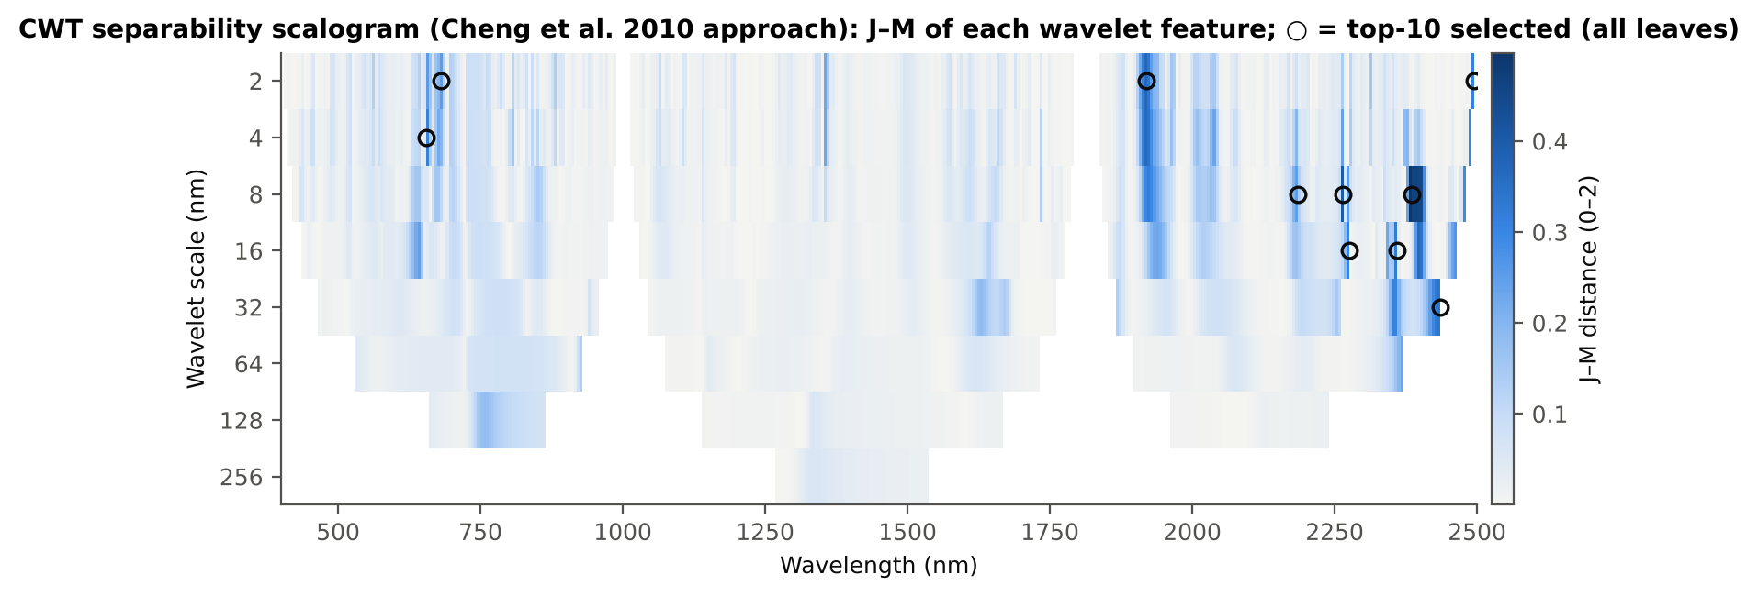
Figure 4. Separability scalogram: J–M of every Mexican-hat wavelet coefficient (scale × wavelength); circles = top-10 selected on all leaves.

3.3 Results of the wrapper methods

3.3.1 W1 · SVM-RFE
Top-10: CR3 water 970 width, CR6 water 1940 position, D1_454, D1_2329, D1_2305, D1_982, D1_1791, D1_1724, D1_2166, D1_2206.
QDA 84.3 % with only 5 features, 87.1 % (10), 88.1 % (15), 88.3 % (20); the best RF (87.2 %) and LDA (89.0 %) results of all methods at k = 10; AUC 0.948. Stability 0.65. Composite rank 1 (best overall).
SVM-RFE combines the two water-band continuum features with complementary weakly-correlated bands (blue 454 nm, C–H 1724 and 2305–2329 nm) — features that are weak alone but add information in a linear model. 18 % of its selections are within 10 nm of a detector join (D1_982, D1_1791); excluding them lowered accuracy by 1.5 points to 85.6 %, still among the best.
- J–M of the all-leaf top-10: 1.558
- QDA (Das protocol, leaf 10-fold): 87.5 %
- RF on top-10 (new plots): 87.2 %
- stability (Jaccard ±10 nm): 0.65; Kuncheva 0.56
- selections within 10 nm of a detector join: 18.0 % (accuracy without them 85.6 %)
- computing time: 26.4 s per training set
- overall rank: 1 of 22
Table 20. SVM-RFE: accuracy on new plots for k = 5–20 redundancy-controlled features (mean of 20 held-out sets).
k (features) | QDA BA | SD | LDA BA | AUC (QDA)
5 | 84.3 % | 3.4 % | 84.5 % | 0.929
10 | 87.1 % | 3.6 % | 89.0 % | 0.948
15 | 88.1 % | 2.9 % | 90.3 % | 0.953
20 | 88.3 % | 2.6 % | 90.6 % | 0.949

Table 21. SVM-RFE: top-ranked features on all leaves (before redundancy control).
Rank | Feature | Type | Score
1 | CR3 water 970 width | K2 continuum removal | –
2 | CR6 water 1940 position | K2 continuum removal | –
3 | D1_454 | K4 first-derivative band | –
4 | D1_2329 | K4 first-derivative band | –
5 | D1_2305 | K4 first-derivative band | –
6 | D1_982 | K4 first-derivative band | –
7 | D1_1791 | K4 first-derivative band | –
8 | D1_1724 | K4 first-derivative band | –
9 | D1_2166 | K4 first-derivative band | –
10 | D1_2206 | K4 first-derivative band | –
11 | ARI | K3 vegetation index | –
12 | SIPI | K3 vegetation index | –
13 | D1_2167 | K4 first-derivative band | –
14 | D1_404 | K4 first-derivative band | –
15 | D1_981 | K4 first-derivative band | –

3.3.2 W2 · RF-RFE
Top-10: D1_872, CR6 water 1940 symmetry, D1_1164, CR3 water 970 width, D1_1914, D1_2210, D1_1934, D1_2224, D1_1738, D1_1724.
Good with RF (86.4 %, 2nd best) but only 78.9 % with QDA at k = 10; stability 0.52; 67 s per training set. Features chosen for trees are not necessarily good for a Gaussian classifier: RF-RFE should be paired with an RF classifier.
- J–M of the all-leaf top-10: 1.500
- QDA (Das protocol, leaf 10-fold): 78.4 %
- RF on top-10 (new plots): 86.4 %
- stability (Jaccard ±10 nm): 0.52; Kuncheva 0.37
- selections within 10 nm of a detector join: 4.5 % (accuracy without them 78.4 %)
- computing time: 67.1 s per training set
- overall rank: 6 of 22
Table 22. RF-RFE: accuracy on new plots for k = 5–20 redundancy-controlled features (mean of 20 held-out sets).
k (features) | QDA BA | SD | LDA BA | AUC (QDA)
5 | 76.4 % | 5.0 % | 78.6 % | 0.884
10 | 78.9 % | 3.5 % | 83.9 % | 0.908
15 | 81.7 % | 4.1 % | 84.6 % | 0.922
20 | 82.9 % | 4.2 % | 85.7 % | 0.929

Table 23. RF-RFE: top-ranked features on all leaves (before redundancy control).
Rank | Feature | Type | Score
1 | D1_872 | K4 first-derivative band | –
2 | CR6 water 1940 symmetry | K2 continuum removal | –
3 | D1_1164 | K4 first-derivative band | –
4 | CR3 water 970 width | K2 continuum removal | –
5 | D1_862 | K4 first-derivative band | –
6 | D1_1914 | K4 first-derivative band | –
7 | D1_873 | K4 first-derivative band | –
8 | D1_2210 | K4 first-derivative band | –
9 | D1_1163 | K4 first-derivative band | –
10 | D1_856 | K4 first-derivative band | –
11 | D1_1934 | K4 first-derivative band | –
12 | D1_861 | K4 first-derivative band | –
13 | D1_1916 | K4 first-derivative band | –
14 | D1_2224 | K4 first-derivative band | –
15 | D1_1738 | K4 first-derivative band | –

3.3.3 W3 · CARS
Top-10: D1_2205, ARI, D1_1723, D1_1749, D1_453, D1_982, D1_2305, D1_2168, CR6 water 1940 position, D1_1791. On all leaves the best of 50 sampling runs was run 25 (31 variables; inner PLS-DA BA 91.6 %).
QDA 86.8 % (k = 10) and the best value at k = 20 (88.9 %); RF 84.5 %, LDA 87.2 %. Its own subsets (on average 57 variables) give RF 87.9 %. Composite rank 3.
CARS is unstable (Jaccard 0.34): the Monte-Carlo sampling ends in different subsets in each training set. It also relies most on join-adjacent bands (13.5 % of selections; excluding them cost 4.6 points, to 82.2 %, p < 0.001).
- J–M of the all-leaf top-10: 1.576
- QDA (Das protocol, leaf 10-fold): 89.3 %
- RF on top-10 (new plots): 84.5 %
- stability (Jaccard ±10 nm): 0.34; Kuncheva 0.18
- own subset: 57 features (25–111); RF 87.9 %
- selections within 10 nm of a detector join: 13.5 % (accuracy without them 82.2 %)
- computing time: 5.6 s per training set
- overall rank: 3 of 22
Table 24. CARS: accuracy on new plots for k = 5–20 redundancy-controlled features (mean of 20 held-out sets).
k (features) | QDA BA | SD | LDA BA | AUC (QDA)
5 | 77.3 % | 3.7 % | 78.7 % | 0.873
10 | 86.8 % | 2.6 % | 87.2 % | 0.946
15 | 88.3 % | 3.1 % | 89.2 % | 0.957
20 | 88.9 % | 3.4 % | 90.0 % | 0.955

Table 25. CARS: top-ranked features on all leaves (before redundancy control).
Rank | Feature | Type | Score
1 | D1_2205 | K4 first-derivative band | –
2 | ARI | K3 vegetation index | –
3 | D1_1723 | K4 first-derivative band | –
4 | D1_1749 | K4 first-derivative band | –
5 | D1_453 | K4 first-derivative band | –
6 | D1_982 | K4 first-derivative band | –
7 | D1_2305 | K4 first-derivative band | –
8 | D1_2168 | K4 first-derivative band | –
9 | D1_435 | K4 first-derivative band | –
10 | CR6 water 1940 position | K2 continuum removal | –
11 | D1_979 | K4 first-derivative band | –
12 | D1_1791 | K4 first-derivative band | –
13 | D1_2135 | K4 first-derivative band | –
14 | D1_473 | K4 first-derivative band | –
15 | D1_477 | K4 first-derivative band | –

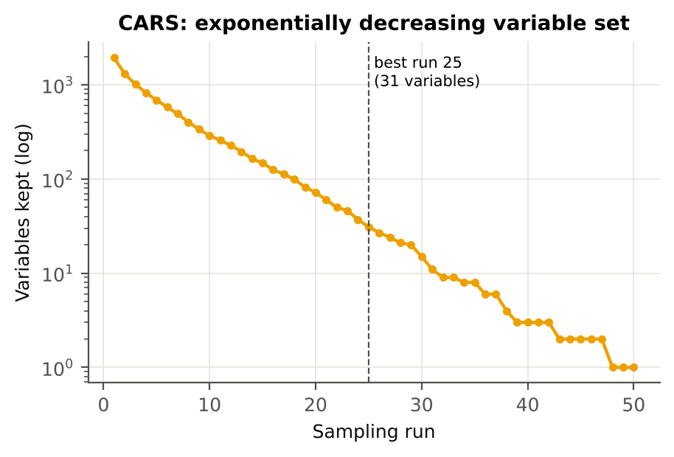
Figure 5. CARS: number of variables retained in the 50 sampling runs (all leaves); dashed line = selected run.

3.3.4 W4 · SFFS (QDA)
Top-10 (all leaves): CR3 water 970 width, D1_938, CR6 water 1940 position, R1386, ARI, D1_884, D1_913, D1_745, D1_1353, D1_1365.
The most accurate method: QDA 85.0 % with 5 features, 87.9 ± 2.8 % with 10, 88.3 % with 15–20; AUC 0.950; best mean rank in the Friedman test (2.52). Because the criterion is QDA itself, the gain is largest for QDA (RF 83.2 %).
But SFFS is unstable (Jaccard 0.24): many different 10-feature combinations reach almost the same inner-CV accuracy, and the search picks a different one in each training set. It is the least affected by the detector joins (3.5 % of selections; −1.1 points, not significant). Its rank in the composite is 11 only because of this instability.
- J–M of the all-leaf top-10: 1.434
- QDA (Das protocol, leaf 10-fold): 91.0 %
- RF on top-10 (new plots): 83.2 %
- stability (Jaccard ±10 nm): 0.24; Kuncheva 0.28
- own subset: 16 features (10–20); RF 83.1 %; QDA 88.0 %
- selections within 10 nm of a detector join: 3.5 % (accuracy without them 86.9 %)
- computing time: 10.0 s per training set
- overall rank: 11 of 22
Table 26. SFFS (QDA): accuracy on new plots for k = 5–20 redundancy-controlled features (mean of 20 held-out sets).
k (features) | QDA BA | SD | LDA BA | AUC (QDA)
5 | 85.0 % | 4.3 % | 78.7 % | 0.922
10 | 87.9 % | 2.8 % | 80.4 % | 0.950
15 | 88.3 % | 3.2 % | 81.9 % | 0.955
20 | 88.3 % | 2.9 % | 82.6 % | 0.955

Table 27. SFFS (QDA): top-ranked features on all leaves (before redundancy control).
Rank | Feature | Type | Score
1 | CR3 water 970 width | K2 continuum removal | –
2 | D1_938 | K4 first-derivative band | –
3 | CR6 water 1940 position | K2 continuum removal | –
4 | R1386 | K1 band reflectance | –
5 | ARI | K3 vegetation index | –
6 | D1_913 | K4 first-derivative band | –
7 | D1_745 | K4 first-derivative band | –
8 | D1_1353 | K4 first-derivative band | –
9 | D1_1365 | K4 first-derivative band | –
10 | D1_1057 | K4 first-derivative band | –
11 | CR1 blue position | K2 continuum removal | –
12 | D1_848 | K4 first-derivative band | –
13 | D1_1747 | K4 first-derivative band | –
14 | D1_762 | K4 first-derivative band | –
15 | D1_1048 | K4 first-derivative band | –

3.3.5 W5 · SFFS (J–M)
Top-10: RVS2, CR3 water 970 width, CR2 red area, RARSc, GNDVI, CR6 water 1940 position, D1_1921, CR5 water 1450 area, D1_1894, R1901.
Highest J–M of all sets (1.80; J–M exceeds 1.90 only with 14 or more features) but only 72.7 % QDA balanced accuracy on new plots. Maximising J–M on the training leaves selects features whose class covariances differ (indices and areas), which does not generalise across plots — J–M is not a good selection criterion for this dataset.
- J–M of the all-leaf top-10: 1.802
- QDA (Das protocol, leaf 10-fold): 73.0 %
- RF on top-10 (new plots): 81.9 %
- stability (Jaccard ±10 nm): 0.42; Kuncheva 0.46
- own subset: 20 features (20–20); RF 82.9 %; QDA 74.5 %
- selections within 10 nm of a detector join: 0.0 % (accuracy without them 71.9 %)
- computing time: 2.7 s per training set
- overall rank: 13 of 22
Table 28. SFFS (J–M): accuracy on new plots for k = 5–20 redundancy-controlled features (mean of 20 held-out sets).
k (features) | QDA BA | SD | LDA BA | AUC (QDA)
5 | 69.0 % | 2.3 % | 71.5 % | 0.768
10 | 72.7 % | 3.4 % | 77.6 % | 0.874
15 | 73.3 % | 6.0 % | 80.5 % | 0.883
20 | 74.5 % | 6.1 % | 82.8 % | 0.888

Table 29. SFFS (J–M): top-ranked features on all leaves (before redundancy control).
Rank | Feature | Type | Score
1 | RVS2 | K3 vegetation index | –
2 | CR3 water 970 width | K2 continuum removal | –
3 | GNDVI | K3 vegetation index | –
4 | CR6 water 1940 position | K2 continuum removal | –
5 | D1_1921 | K4 first-derivative band | –
6 | R1901 | K1 band reflectance | –
7 | CR2 red depth | K2 continuum removal | –
8 | D1_667 | K4 first-derivative band | –
9 | D1_1894 | K4 first-derivative band | –
10 | SR761 | K3 vegetation index | –
11 | REP, linear 4-point (nm) | K4 edge parameter | –
12 | D1_690 | K4 first-derivative band | –
13 | CR2 red area | K2 continuum removal | –
14 | D1_644 | K4 first-derivative band | –
15 | RARSc | K3 vegetation index | –

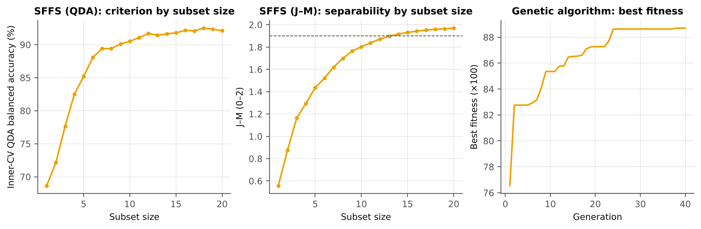
Figure 6. Wrapper searches on all leaves: SFFS criterion by subset size (QDA balanced accuracy; J–M) and best fitness of the genetic algorithm by generation.

3.3.6 W6 · Genetic algorithm
Best chromosome on all leaves (14 features; fitness 0.887, plateau from generation 24): CR3 water 970 width, CR6 water 1940 position, CR6 water 1940 symmetry, CR1 blue depth, D1_678, D1_705, D1_926, D1_938, D1_970, D1_1083, D1_1353, D1_1365, D1_2417, D1_2460.
QDA 84.1 % at k = 10 and 88.2 % at k = 15; its own subsets (about 16 features) give QDA 88.5 %, the highest native-subset accuracy. Least stable method (Jaccard 0.22).
- J–M of the all-leaf top-10: 1.233
- QDA (Das protocol, leaf 10-fold): 86.1 %
- RF on top-10 (new plots): 81.5 %
- stability (Jaccard ±10 nm): 0.22; Kuncheva 0.20
- own subset: 16 features (13–20); RF 83.5 %; QDA 88.5 %
- selections within 10 nm of a detector join: 2.5 % (accuracy without them 83.7 %)
- computing time: 4.9 s per training set
- overall rank: 18 of 22
Table 30. Genetic algorithm: accuracy on new plots for k = 5–20 redundancy-controlled features (mean of 20 held-out sets).
k (features) | QDA BA | SD | LDA BA | AUC (QDA)
5 | 73.4 % | 5.7 % | 71.9 % | 0.827
10 | 84.1 % | 3.3 % | 79.7 % | 0.923
15 | 88.2 % | 3.6 % | 82.9 % | 0.955
20 | 88.0 % | 2.9 % | 83.0 % | 0.952

Table 31. Genetic algorithm: top-ranked features on all leaves (before redundancy control).
Rank | Feature | Type | Score
1 | CR6 water 1940 symmetry | K2 continuum removal | –
2 | D1_1353 | K4 first-derivative band | –
3 | CR1 blue depth | K2 continuum removal | –
4 | D1_2417 | K4 first-derivative band | –
5 | CR3 water 970 width | K2 continuum removal | –
6 | D1_926 | K4 first-derivative band | –
7 | D1_1083 | K4 first-derivative band | –
8 | D1_938 | K4 first-derivative band | –
9 | D1_970 | K4 first-derivative band | –
10 | D1_705 | K4 first-derivative band | –
11 | D1_1365 | K4 first-derivative band | –
12 | D1_678 | K4 first-derivative band | –
13 | CR6 water 1940 position | K2 continuum removal | –
14 | D1_2460 | K4 first-derivative band | –
15 | D1_974 | K4 first-derivative band | –

3.4 Results of the embedded methods

3.4.1 E1 · RF importance
Top-10: CR3 water 970 width, D1_861, D1_1915, D1_1934, CR6 water 1940 symmetry, D1_898, D1_2222, D1_1923, D1_1942, D1_2209.
QDA 78.0 % (k = 10) to 85.0 % (k = 20); RF 82.6 %; stable (0.73). RF importance spreads credit over correlated neighbours and therefore needs redundancy control (+2.9 points). Same regions as the four-tier RF-17 set of Part C.
- J–M of the all-leaf top-10: 1.434
- QDA (Das protocol, leaf 10-fold): 75.0 %
- RF on top-10 (new plots): 82.6 %
- stability (Jaccard ±10 nm): 0.73; Kuncheva 0.53
- selections within 10 nm of a detector join: 2.5 % (accuracy without them 77.9 %)
- computing time: 13.8 s per training set
- overall rank: 9 of 22
Table 32. RF importance: accuracy on new plots for k = 5–20 redundancy-controlled features (mean of 20 held-out sets).
k (features) | QDA BA | SD | LDA BA | AUC (QDA)
5 | 71.0 % | 3.4 % | 71.8 % | 0.809
10 | 78.0 % | 3.4 % | 76.1 % | 0.888
15 | 83.2 % | 2.6 % | 82.9 % | 0.928
20 | 85.0 % | 3.3 % | 84.6 % | 0.939

Table 33. RF importance: top-ranked features on all leaves (before redundancy control).
Rank | Feature | Type | Score
1 | CR3 water 970 width | K2 continuum removal | 0.00708
2 | D1_861 | K4 first-derivative band | 0.00607
3 | D1_873 | K4 first-derivative band | 0.00596
4 | D1_1915 | K4 first-derivative band | 0.00557
5 | D1_857 | K4 first-derivative band | 0.00539
6 | D1_1916 | K4 first-derivative band | 0.00493
7 | D1_874 | K4 first-derivative band | 0.00451
8 | D1_849 | K4 first-derivative band | 0.00436
9 | D1_848 | K4 first-derivative band | 0.00429
10 | D1_855 | K4 first-derivative band | 0.00413
11 | D1_858 | K4 first-derivative band | 0.00407
12 | D1_1917 | K4 first-derivative band | 0.00406
13 | D1_850 | K4 first-derivative band | 0.00404
14 | D1_875 | K4 first-derivative band | 0.00399
15 | D1_1934 | K4 first-derivative band | 0.00396

3.4.2 E2 · CART importance
Top-10: D1_861, CR3 water 970 width, CR6 water 1940 symmetry, D1_1164, D1_1950, D1_900, D1_1736, D1_1931, R639, D1_2224 — on all leaves the pruned tree had 13 terminal nodes.
QDA 77.8 %, RF 84.9 % at k = 10; unstable (0.27) because a single tree changes its splits when the data change — the same weakness found for Tier 2 of the four-tier method. Slow (112 s) because of the pruning search.
- J–M of the all-leaf top-10: 1.426
- QDA (Das protocol, leaf 10-fold): 78.2 %
- RF on top-10 (new plots): 84.9 %
- stability (Jaccard ±10 nm): 0.27; Kuncheva 0.21
- own subset: 17 features (4–57); RF 85.7 %
- selections within 10 nm of a detector join: 3.8 % (accuracy without them 77.6 %)
- computing time: 112.0 s per training set
- overall rank: 17 of 22
Table 34. CART importance: accuracy on new plots for k = 5–20 redundancy-controlled features (mean of 20 held-out sets).
k (features) | QDA BA | SD | LDA BA | AUC (QDA)
5 | 76.1 % | 3.2 % | 77.8 % | 0.864
10 | 77.8 % | 4.0 % | 79.1 % | 0.888
15 | 78.9 % | 4.4 % | 79.9 % | 0.897
20 | 79.5 % | 4.5 % | 80.4 % | 0.901

Table 35. CART importance: top-ranked features on all leaves (before redundancy control).
Rank | Feature | Type | Score
1 | D1_861 | K4 first-derivative band | 0.314
2 | CR3 water 970 width | K2 continuum removal | 0.171
3 | CR6 water 1940 symmetry | K2 continuum removal | 0.104
4 | D1_1164 | K4 first-derivative band | 0.0863
5 | D1_1163 | K4 first-derivative band | 0.084
6 | D1_1950 | K4 first-derivative band | 0.0541
7 | D1_900 | K4 first-derivative band | 0.0499
8 | D1_1736 | K4 first-derivative band | 0.0412
9 | D1_1931 | K4 first-derivative band | 0.0403
10 | R639 | K1 band reflectance | 0.0325
11 | D1_2224 | K4 first-derivative band | 0.0224

3.4.3 E3 · Boruta
On all leaves after 100 runs: 192 features confirmed, 201 tentative, 3757 rejected; per training set 88–155 confirmed (mean 122). Top-10 by importance: CR3 water 970 width, D1_861, CR6 water 1940 symmetry, D1_1916, D1_1934, D1_2223, D1_2209, D1_899, D1_1946, D1_1724.
QDA 78.5 % at k = 10 (83.4 % at 20); RF on the confirmed set 84.4 %; stability 0.65; composite rank 6. Boruta is a screening tool: it tells which features carry disease information (all-relevant) rather than which compact set classifies best; it was also the slowest method (304 s per training set).
- J–M of the all-leaf top-10: 1.508
- QDA (Das protocol, leaf 10-fold): 78.5 %
- RF on top-10 (new plots): 83.7 %
- stability (Jaccard ±10 nm): 0.65; Kuncheva 0.47
- own subset: 122 features (88–155); RF 84.4 %
- selections within 10 nm of a detector join: 3.0 % (accuracy without them 77.7 %)
- computing time: 304.0 s per training set
- overall rank: 6 of 22
Table 36. Boruta: accuracy on new plots for k = 5–20 redundancy-controlled features (mean of 20 held-out sets).
k (features) | QDA BA | SD | LDA BA | AUC (QDA)
5 | 71.2 % | 3.9 % | 71.7 % | 0.821
10 | 78.5 % | 3.9 % | 80.9 % | 0.897
15 | 82.6 % | 3.8 % | 85.7 % | 0.929
20 | 83.4 % | 4.2 % | 86.6 % | 0.935

Table 37. Boruta: top-ranked features on all leaves (before redundancy control).
Rank | Feature | Type | Score
1 | CR3 water 970 width | K2 continuum removal | 0.00821
2 | D1_861 | K4 first-derivative band | 0.00618
3 | D1_872 | K4 first-derivative band | 0.00618
4 | D1_873 | K4 first-derivative band | 0.00611
5 | CR6 water 1940 symmetry | K2 continuum removal | 0.00598
6 | D1_862 | K4 first-derivative band | 0.00583
7 | D1_863 | K4 first-derivative band | 0.00549
8 | D1_848 | K4 first-derivative band | 0.00542
9 | D1_847 | K4 first-derivative band | 0.00536
10 | D1_849 | K4 first-derivative band | 0.00485
11 | D1_857 | K4 first-derivative band | 0.00475
12 | D1_871 | K4 first-derivative band | 0.00472
13 | D1_874 | K4 first-derivative band | 0.00472
14 | D1_860 | K4 first-derivative band | 0.0047
15 | D1_856 | K4 first-derivative band | 0.00468

3.4.4 E4 · PLS-VIP
Top-10: CR6 water 1940 position, D1_2305, CR6 water 1940 symmetry, D1_1070, CR1 blue width, D1_1792, D1_1724, D1_2306, D1_1073, D1_1060. On all leaves 15 components were chosen (the upper limit of the grid) and 1349 features had VIP > 1.
Poor with 10 features (QDA 71.6 %, RF 74.8 %) and low J–M (0.97), although stable (0.73). The VIP > 1 subset (about 1320 features) gives RF 86.3 %, so VIP is useful for screening, not for a compact set.
- J–M of the all-leaf top-10: 0.973
- QDA (Das protocol, leaf 10-fold): 75.9 %
- RF on top-10 (new plots): 74.8 %
- stability (Jaccard ±10 nm): 0.73; Kuncheva 0.65
- own subset: 1320 features (1214–1385); RF 86.3 %
- selections within 10 nm of a detector join: 10.5 % (accuracy without them 71.0 %)
- computing time: 29.6 s per training set
- overall rank: 20 of 22
Table 38. PLS-VIP: accuracy on new plots for k = 5–20 redundancy-controlled features (mean of 20 held-out sets).
k (features) | QDA BA | SD | LDA BA | AUC (QDA)
5 | 64.1 % | 6.1 % | 66.9 % | 0.748
10 | 71.6 % | 5.9 % | 74.0 % | 0.821
15 | 77.0 % | 4.3 % | 78.5 % | 0.866
20 | 79.3 % | 3.9 % | 81.4 % | 0.885

Table 39. PLS-VIP: top-ranked features on all leaves (before redundancy control).
Rank | Feature | Type | Score
1 | CR6 water 1940 position | K2 continuum removal | 4.15
2 | D1_2305 | K4 first-derivative band | 3.52
3 | CR6 water 1940 symmetry | K2 continuum removal | 3.11
4 | D1_1070 | K4 first-derivative band | 2.89
5 | D1_1071 | K4 first-derivative band | 2.89
6 | D1_1069 | K4 first-derivative band | 2.84
7 | CR1 blue width | K2 continuum removal | 2.83
8 | D1_1792 | K4 first-derivative band | 2.82
9 | D1_1072 | K4 first-derivative band | 2.82
10 | D1_1724 | K4 first-derivative band | 2.82
11 | D1_1068 | K4 first-derivative band | 2.78
12 | D1_2306 | K4 first-derivative band | 2.77
13 | D1_1073 | K4 first-derivative band | 2.72
14 | D1_1060 | K4 first-derivative band | 2.67
15 | D1_1067 | K4 first-derivative band | 2.67

3.4.5 E5 · LASSO
Top-10 (order of entry): CR6 water 1940 position, CR3 water 970 width, D1_848, D1_1724, D1_2330, D1_1792, D1_898, PPR, D1_981, D1_660. On all leaves the cross-validated C was the largest value of the grid (0.316) with 127 non-zero coefficients.
QDA 85.4 % (k = 10) and 87.2 % (k = 15); RF 85.5 %; stable (Jaccard 0.70, Kuncheva 0.73). Composite rank 2. Like SVM-RFE it combines the water features with complementary bands, but 15 % of its selections are join-adjacent and excluding them cost 3.2 points (82.2 %).
- J–M of the all-leaf top-10: 1.375
- QDA (Das protocol, leaf 10-fold): 87.1 %
- RF on top-10 (new plots): 85.5 %
- stability (Jaccard ±10 nm): 0.69; Kuncheva 0.73
- own subset: 98 features (42–130); RF 87.0 %
- selections within 10 nm of a detector join: 15.0 % (accuracy without them 82.2 %)
- computing time: 16.7 s per training set
- overall rank: 2 of 22
Table 40. LASSO: accuracy on new plots for k = 5–20 redundancy-controlled features (mean of 20 held-out sets).
k (features) | QDA BA | SD | LDA BA | AUC (QDA)
5 | 78.9 % | 3.6 % | 80.6 % | 0.896
10 | 85.4 % | 3.1 % | 85.8 % | 0.934
15 | 87.2 % | 3.1 % | 88.4 % | 0.945
20 | 86.5 % | 3.8 % | 89.7 % | 0.945

Table 41. LASSO: top-ranked features on all leaves (before redundancy control).
Rank | Feature | Type | Score
1 | CR6 water 1940 position | K2 continuum removal | –
2 | CR3 water 970 width | K2 continuum removal | –
3 | D1_848 | K4 first-derivative band | –
4 | D1_1724 | K4 first-derivative band | –
5 | D1_2330 | K4 first-derivative band | –
6 | D1_1792 | K4 first-derivative band | –
7 | D1_849 | K4 first-derivative band | –
8 | D1_898 | K4 first-derivative band | –
9 | D1_899 | K4 first-derivative band | –
10 | PPR | K3 vegetation index | –
11 | D1_1791 | K4 first-derivative band | –
12 | D1_981 | K4 first-derivative band | –
13 | D1_980 | K4 first-derivative band | –
14 | D1_660 | K4 first-derivative band | –
15 | D1_684 | K4 first-derivative band | –

3.4.6 E6 · Gradient boosting
Top-10: D1_849, D1_795, D1_2222, D1_1909, D1_888, CR6 water 1940 position, CR3 water 970 width, R1330, D1_2461, D1_1064.
QDA 77.4 %, RF 84.7 % at k = 10; unstable (0.32, Kuncheva 0.10) because boosting uses only a few features per tree and the choice among correlated neighbours is arbitrary.
- J–M of the all-leaf top-10: 1.470
- QDA (Das protocol, leaf 10-fold): 83.1 %
- RF on top-10 (new plots): 84.7 %
- stability (Jaccard ±10 nm): 0.32; Kuncheva 0.10
- selections within 10 nm of a detector join: 2.5 % (accuracy without them 77.7 %)
- computing time: 4.0 s per training set
- overall rank: 14 of 22
Table 42. Gradient boosting: accuracy on new plots for k = 5–20 redundancy-controlled features (mean of 20 held-out sets).
k (features) | QDA BA | SD | LDA BA | AUC (QDA)
5 | 72.5 % | 4.2 % | 74.2 % | 0.815
10 | 77.4 % | 4.1 % | 78.0 % | 0.887
15 | 80.6 % | 4.4 % | 81.0 % | 0.912
20 | 82.1 % | 4.4 % | 81.6 % | 0.921

Table 43. Gradient boosting: top-ranked features on all leaves (before redundancy control).
Rank | Feature | Type | Score
1 | D1_849 | K4 first-derivative band | 0.0354
2 | D1_865 | K4 first-derivative band | 0.0259
3 | D1_795 | K4 first-derivative band | 0.0218
4 | D1_2222 | K4 first-derivative band | 0.0213
5 | D1_840 | K4 first-derivative band | 0.0197
6 | D1_1909 | K4 first-derivative band | 0.0183
7 | D1_888 | K4 first-derivative band | 0.0152
8 | D1_819 | K4 first-derivative band | 0.014
9 | CR6 water 1940 position | K2 continuum removal | 0.0117
10 | D1_854 | K4 first-derivative band | 0.0116
11 | D1_848 | K4 first-derivative band | 0.0115
12 | D1_847 | K4 first-derivative band | 0.0112
13 | D1_871 | K4 first-derivative band | 0.011
14 | D1_898 | K4 first-derivative band | 0.0108
15 | D1_1911 | K4 first-derivative band | 0.0107

3.5 Result of the consensus (ensemble) method

3.5.1 C1 · Consensus (Borda)
Consensus top-10 on all leaves: CR3 water 970 width, CR6 water 1940 position, CR6 water 1940 symmetry, D1_1934, D1_848, D1_1724, D1_2305, D1_1792, ARI, D1_899.
QDA 82.7 %, RF 85.1 % at k = 10; stability 0.55; composite rank 4. Aggregating 21 methods gives an interpretable, moderately stable signature but not the highest accuracy: the consensus averages strong and weak methods.
- J–M of the all-leaf top-10: 1.494
- QDA (Das protocol, leaf 10-fold): 85.9 %
- RF on top-10 (new plots): 85.1 %
- stability (Jaccard ±10 nm): 0.55; Kuncheva 0.65
- selections within 10 nm of a detector join: 7.5 % (accuracy without them 80.2 %)
- overall rank: 4 of 22
Table 44. Consensus (Borda): accuracy on new plots for k = 5–20 redundancy-controlled features (mean of 20 held-out sets).
k (features) | QDA BA | SD | LDA BA | AUC (QDA)
5 | 79.2 % | 4.8 % | 79.1 % | 0.885
10 | 82.7 % | 4.2 % | 84.1 % | 0.923
15 | 82.7 % | 4.6 % | 86.4 % | 0.930
20 | 81.6 % | 5.1 % | 87.6 % | 0.936

Table 45. Consensus (Borda): top-ranked features on all leaves (before redundancy control).
Rank | Feature | Type | Score
1 | CR3 water 970 width | K2 continuum removal | 293
2 | CR6 water 1940 position | K2 continuum removal | 211
3 | CR6 water 1940 symmetry | K2 continuum removal | 175
4 | D1_1934 | K4 first-derivative band | 88
5 | D1_848 | K4 first-derivative band | 81
6 | D1_1724 | K4 first-derivative band | 81
7 | D1_2305 | K4 first-derivative band | 77
8 | D1_1792 | K4 first-derivative band | 60
9 | ARI | K3 vegetation index | 58
10 | D1_861 | K4 first-derivative band | 58
11 | D1_899 | K4 first-derivative band | 57
12 | D1_872 | K4 first-derivative band | 56
13 | D1_884 | K4 first-derivative band | 52
14 | D1_2222 | K4 first-derivative band | 48
15 | D1_913 | K4 first-derivative band | 42

3.6 Comparison of accuracy
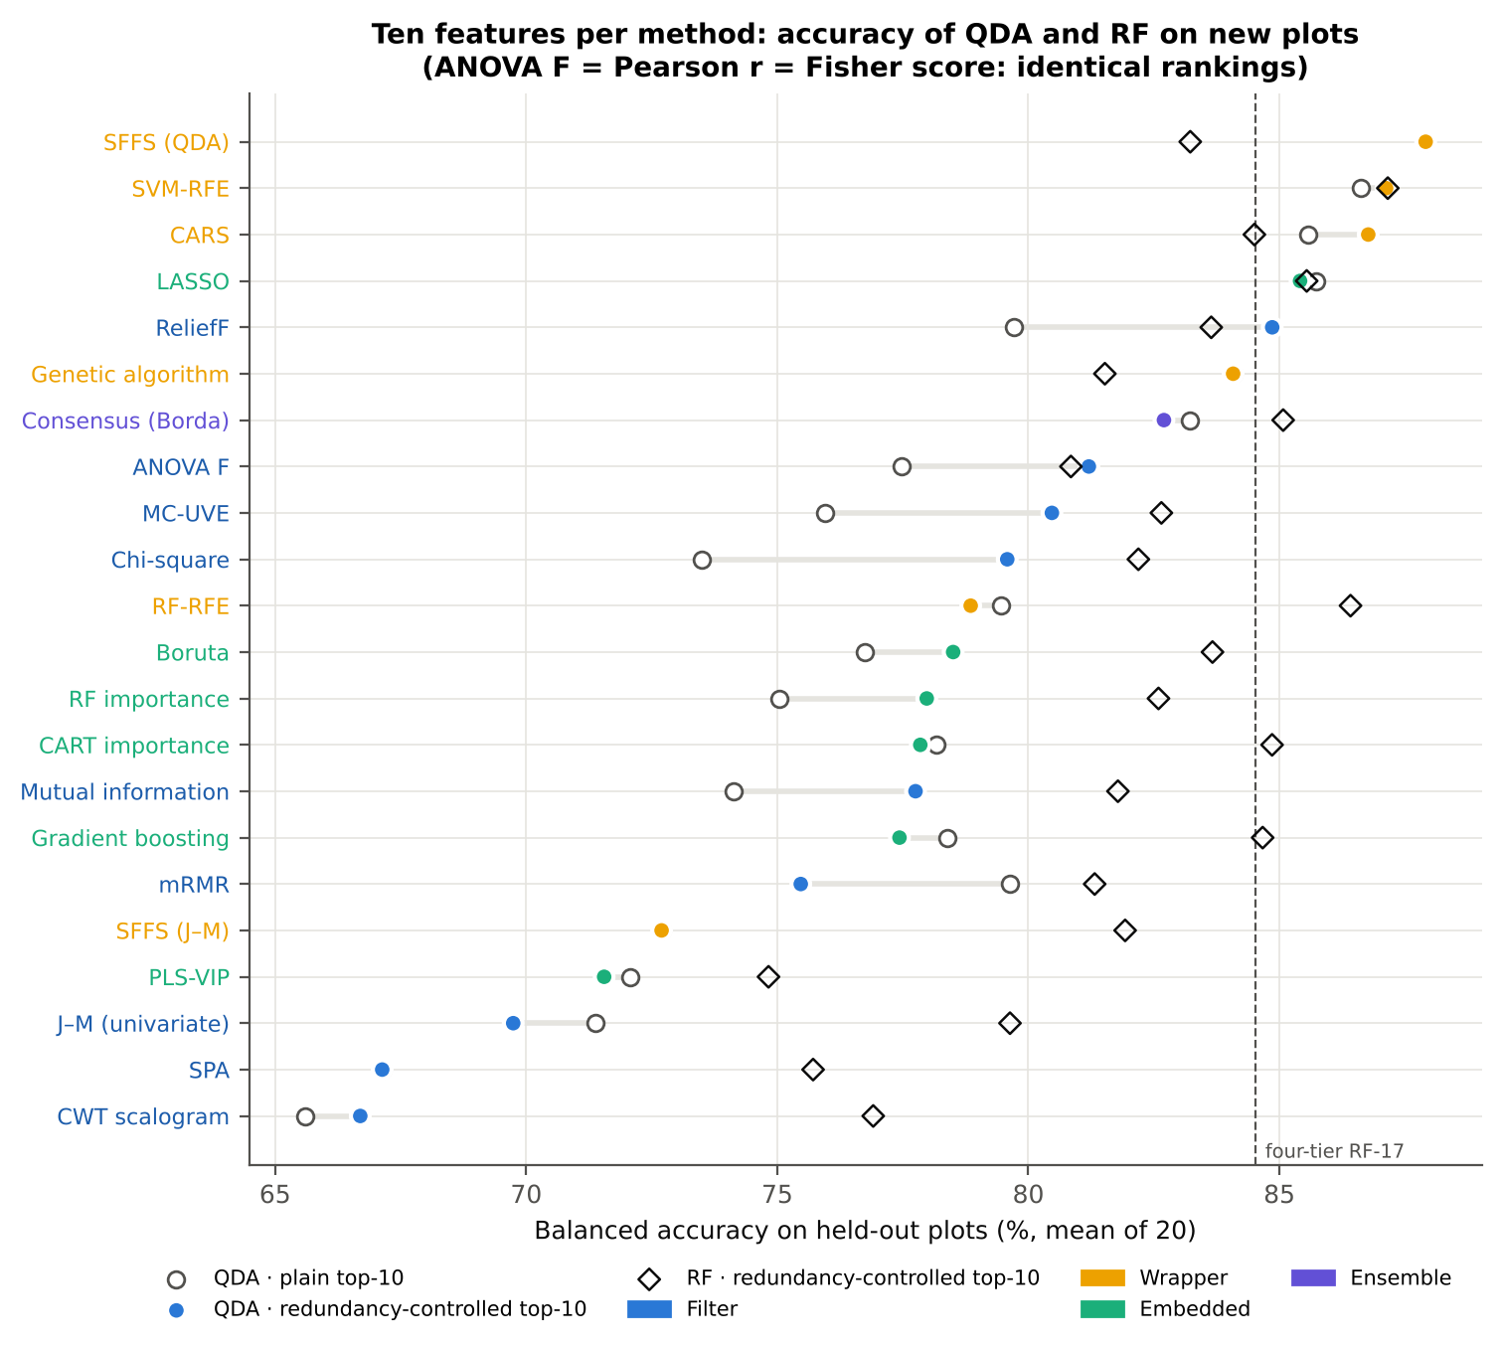
Figure 7. Balanced accuracy on new plots with 10 features per method: QDA with redundancy-controlled (coloured) and plain (open) top-10, and RF (diamonds). Dashed line: four-tier RF-17 set of Part C.
- With 10 features, SFFS (QDA) reaches 87.9 %, SVM-RFE 87.1 %, CARS 86.8 %, LASSO 85.4 %, ReliefF 84.9 % and the genetic algorithm 84.1 % (QDA balanced accuracy, mean of 20 held-out sets).
- Univariate filters stay at 78–81 % (ANOVA F 81.2 %, χ² 79.6 %, MI 77.8 %), as do the tree importances (RF 78.0 %, CART 77.8 %, gradient boosting 77.4 %) and Boruta (78.5 %). PLS-VIP, univariate J–M, SPA and the CWT scalogram fall to 67–72 %.
- With a Random Forest instead of QDA the differences shrink (75–87 %). The best RF results are on the SVM-RFE (87.2 %), RF-RFE (86.4 %) and LASSO (85.5 %) features.

3.7 Number of features
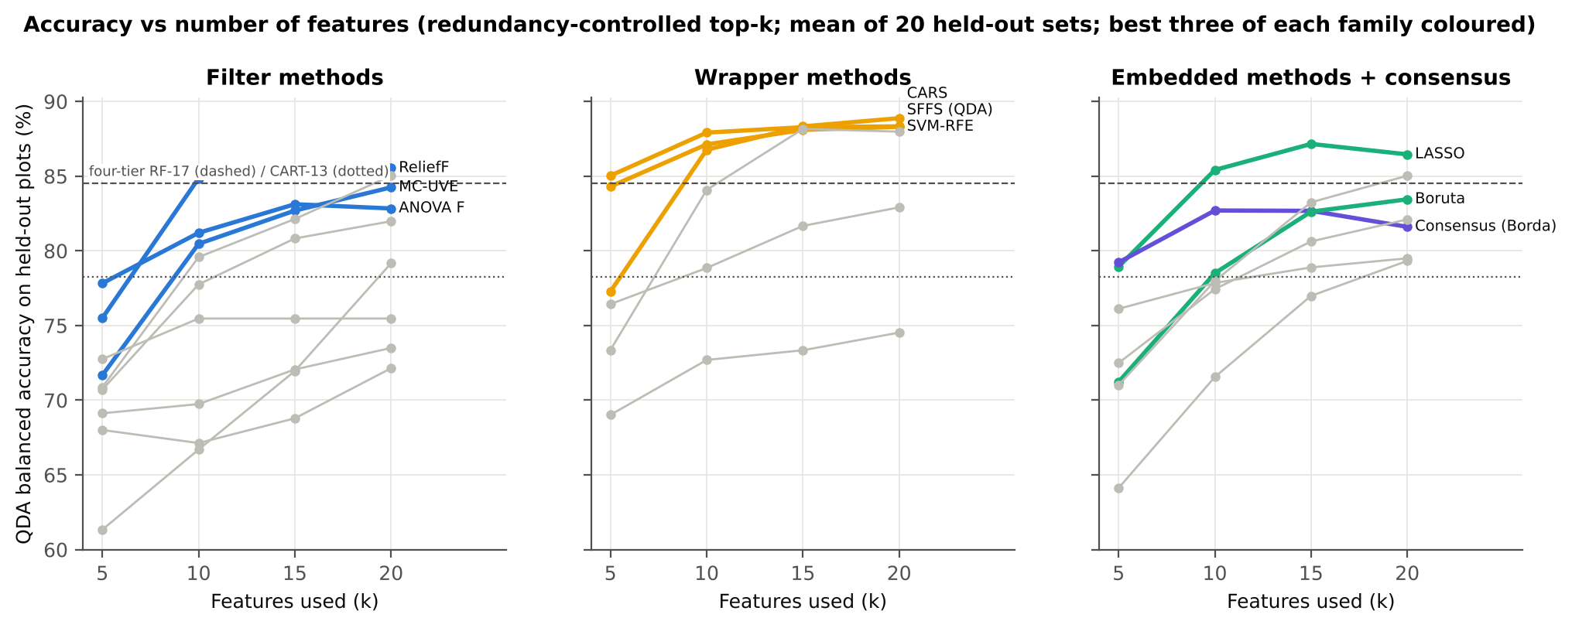
Figure 8. QDA balanced accuracy against the number of features (redundancy-controlled); the three best methods of each family are coloured.
- Accuracy rises from 5 to 15 features and then levels off (SFFS 85.0 → 87.9 → 88.3 → 88.3 %; CARS 77.3 → 86.8 → 88.3 → 88.9 %). SFFS and SVM-RFE already exceed 84 % with five features; 10–15 features are enough.

3.8 Effect of redundancy control
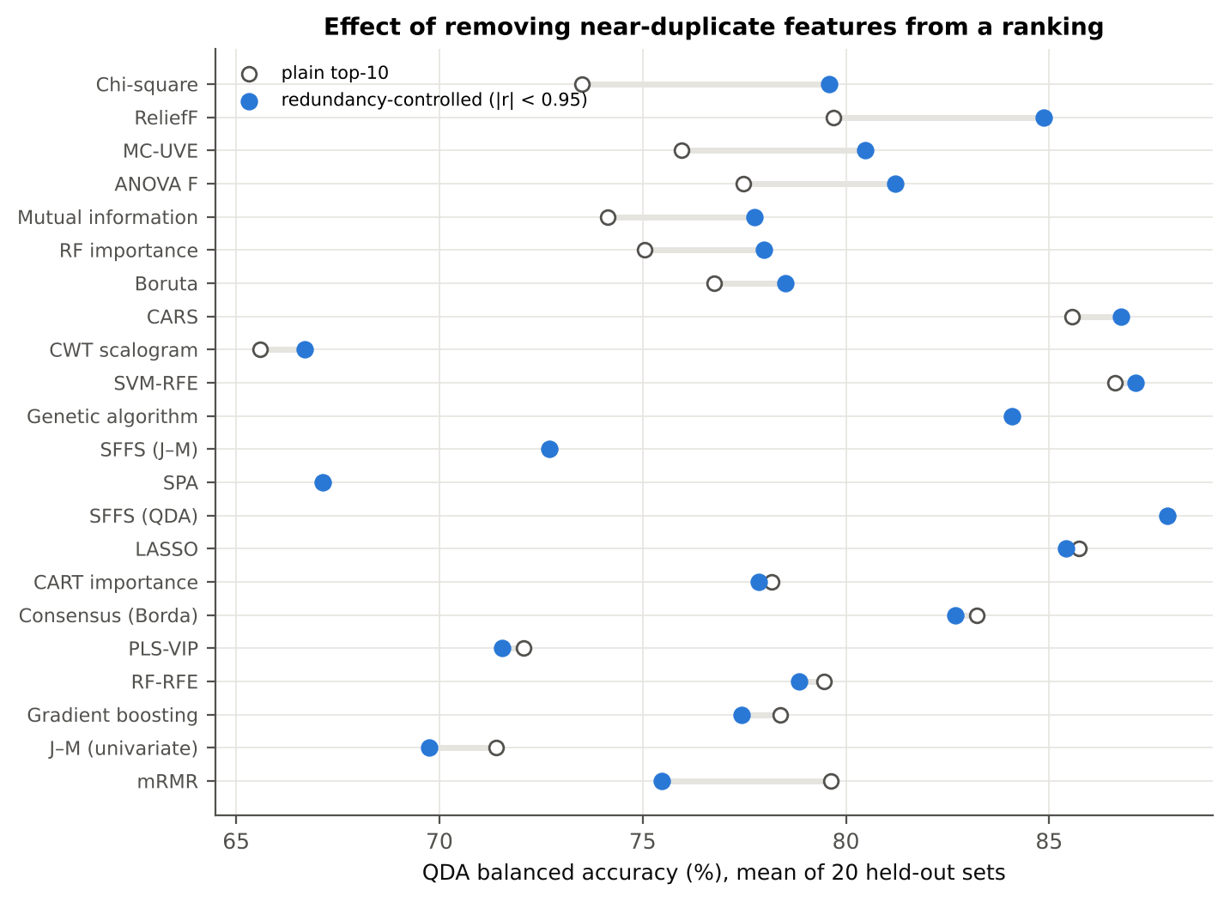
Figure 9. QDA balanced accuracy of the plain and the redundancy-controlled top-10 of each method.
Table 46. Plain vs redundancy-controlled top-10 (QDA balanced accuracy, mean of 20 held-out sets).
Method | Plain top-10 | Redundancy-controlled | Difference
Chi-square | 73.5 % | 79.6 % | +6.1 pts
ReliefF | 79.7 % | 84.9 % | +5.2 pts
MC-UVE | 75.9 % | 80.5 % | +4.5 pts
ANOVA F | 77.5 % | 81.2 % | +3.7 pts
Mutual information | 74.1 % | 77.8 % | +3.6 pts
RF importance | 75.0 % | 78.0 % | +2.9 pts
Boruta | 76.7 % | 78.5 % | +1.8 pts
CARS | 85.6 % | 86.8 % | +1.2 pts
CWT scalogram | 65.6 % | 66.7 % | +1.1 pts
SVM-RFE | 86.6 % | 87.1 % | +0.5 pts
SPA | 67.1 % | 67.1 % | +0.0 pts
SFFS (QDA) | 87.9 % | 87.9 % | +0.0 pts
SFFS (J–M) | 72.7 % | 72.7 % | +0.0 pts
Genetic algorithm | 84.1 % | 84.1 % | +0.0 pts
LASSO | 85.7 % | 85.4 % | -0.3 pts
CART importance | 78.2 % | 77.8 % | -0.3 pts
Consensus (Borda) | 83.2 % | 82.7 % | -0.5 pts
PLS-VIP | 72.1 % | 71.6 % | -0.5 pts
RF-RFE | 79.5 % | 78.9 % | -0.6 pts
Gradient boosting | 78.4 % | 77.4 % | -0.9 pts
J–M (univariate) | 71.4 % | 69.7 % | -1.6 pts
mRMR | 79.6 % | 75.5 % | -4.2 pts

- Top-ranked features of a univariate ranking are neighbouring bands of the same region (e.g. D1_848–D1_920) and carry almost the same information.
- Skipping a feature correlated |r| ≥ 0.95 with one already chosen raised accuracy for χ² (+6.1 points), ReliefF (+5.2), MC-UVE (+4.5), ANOVA F (+3.7), mutual information (+3.6) and RF importance (+2.9).
- Methods that already handle redundancy (SFFS, GA, SPA, CARS, LASSO) gain nothing. This agrees with Wei et al. (2021), where a minimum distance between selected wavelengths improved disease classification.

3.9 Stability of the selections
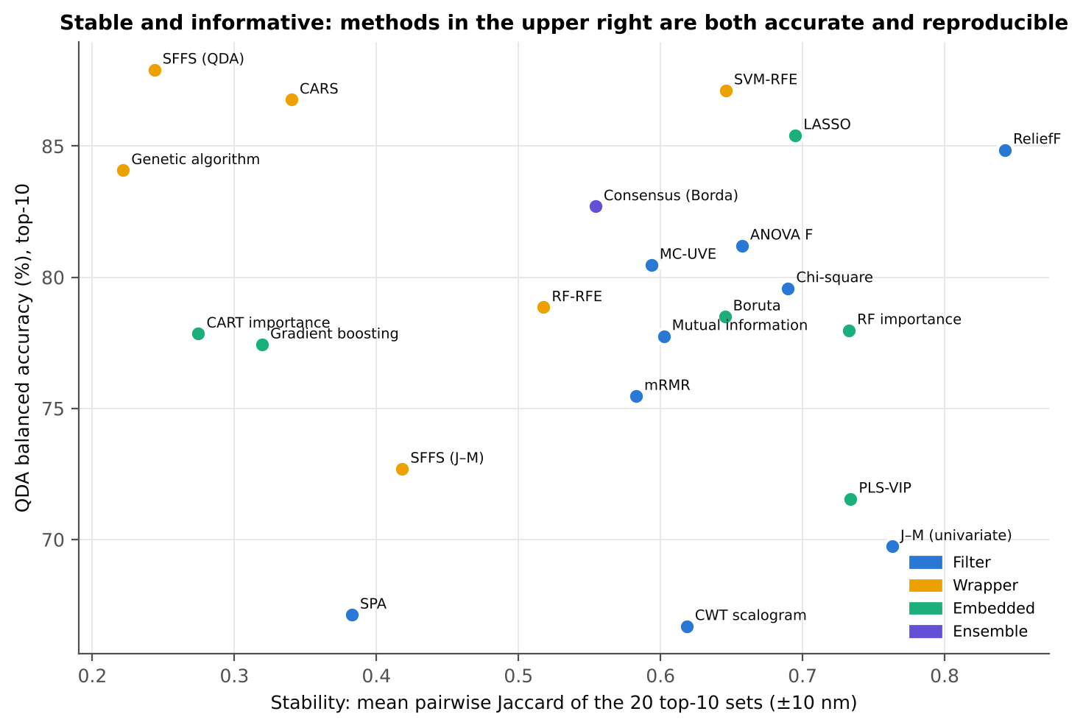
Figure 10. Stability (tolerant Jaccard of the 20 top-10 lists) against QDA balanced accuracy.
Table 47. Stability of the top-10 selections over the 20 training sets.
Method | Kuncheva | Jaccard exact | Jaccard ±10 nm
ReliefF | 0.64 | 0.49 | 0.84
J–M (univariate) | 0.59 | 0.44 | 0.76
PLS-VIP | 0.65 | 0.49 | 0.73
RF importance | 0.53 | 0.38 | 0.73
LASSO | 0.73 | 0.58 | 0.69
Chi-square | 0.48 | 0.33 | 0.69
ANOVA F | 0.41 | 0.27 | 0.66
SVM-RFE | 0.56 | 0.41 | 0.65
Boruta | 0.47 | 0.32 | 0.65
CWT scalogram | 0.75 | 0.62 | 0.62
Mutual information | 0.33 | 0.21 | 0.60
MC-UVE | 0.47 | 0.32 | 0.59
mRMR | 0.53 | 0.39 | 0.58
Consensus (Borda) | 0.65 | 0.50 | 0.55
RF-RFE | 0.37 | 0.24 | 0.52
SFFS (J–M) | 0.46 | 0.31 | 0.42
SPA | 0.42 | 0.27 | 0.38
CARS | 0.18 | 0.11 | 0.34
Gradient boosting | 0.10 | 0.06 | 0.32
CART importance | 0.21 | 0.12 | 0.27
SFFS (QDA) | 0.28 | 0.17 | 0.24
Genetic algorithm | 0.20 | 0.12 | 0.22

- Accuracy and stability trade off. Filters and penalised or importance-based methods are stable (ReliefF 0.84, univariate J–M 0.76, RF importance 0.73, LASSO 0.70, χ² 0.69, SVM-RFE 0.65); search-based wrappers are not (CARS 0.34, SFFS 0.24, GA 0.22) because many equally good feature combinations exist in collinear spectra.

3.10 Statistical comparison
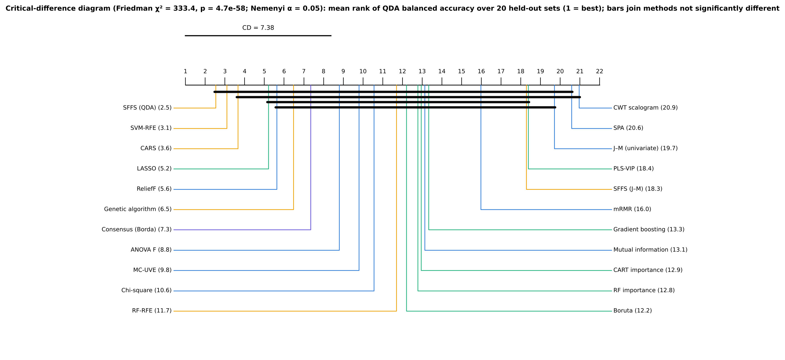
Figure 11. Critical-difference diagram: mean rank of the QDA balanced accuracy over the 20 held-out sets (1 = best); horizontal bars join methods whose difference is smaller than the Nemenyi critical difference.
Table 48. Mean Friedman rank of the 22 distinct methods (QDA, k = 10, redundancy-controlled).
Method | Mean rank
SFFS (QDA) | 2.52
SVM-RFE | 3.10
CARS | 3.65
LASSO | 5.20
ReliefF | 5.62
Genetic algorithm | 6.47
Consensus (Borda) | 7.35
ANOVA F | 8.80
MC-UVE | 9.80
Chi-square | 10.55
RF-RFE | 11.70
Boruta | 12.20
RF importance | 12.78
CART importance | 12.95
Mutual information | 13.12
Gradient boosting | 13.32
mRMR | 15.97
SFFS (J–M) | 18.27
PLS-VIP | 18.38
J–M (univariate) | 19.70
SPA | 20.57
CWT scalogram | 20.95

Table 49. Paired Wilcoxon tests of the best method (SFFS (QDA)) against every other method, Holm-corrected.
Other method | Δ BA (best − other) | Best better | Holm p | Sig.
Chi-square | +8.3 pts | 20/20 | 4.0e-05 | yes
Mutual information | +10.2 pts | 20/20 | 4.0e-05 | yes
mRMR | +12.4 pts | 20/20 | 4.0e-05 | yes
J–M (univariate) | +18.2 pts | 20/20 | 4.0e-05 | yes
SPA | +20.8 pts | 20/20 | 4.0e-05 | yes
RF importance | +9.9 pts | 20/20 | 4.0e-05 | yes
RF-RFE | +9.1 pts | 20/20 | 4.0e-05 | yes
CWT scalogram | +21.2 pts | 20/20 | 4.0e-05 | yes
CART importance | +10.1 pts | 20/20 | 4.0e-05 | yes
SFFS (J–M) | +15.2 pts | 20/20 | 4.0e-05 | yes
Gradient boosting | +10.5 pts | 20/20 | 4.0e-05 | yes
PLS-VIP | +16.4 pts | 20/20 | 4.0e-05 | yes
ANOVA F | +6.7 pts | 19/20 | 4.0e-05 | yes
Boruta | +9.4 pts | 19/20 | 4.0e-05 | yes
Consensus (Borda) | +5.2 pts | 19/20 | 1.9e-04 | yes
MC-UVE | +7.4 pts | 19/19 | 7.9e-04 | yes
LASSO | +2.5 pts | 17/20 | 0.002 | yes
Genetic algorithm | +3.8 pts | 18/20 | 0.002 | yes
ReliefF | +3.1 pts | 16/20 | 0.003 | yes
SVM-RFE | +0.8 pts | 11/20 | 0.555 | no
CARS | +1.1 pts | 11/20 | 0.555 | no

- Friedman test across the 22 distinct methods and 20 units: χ² = 333.4, p = 4.7 × 10⁻⁵⁸; Nemenyi critical difference 7.4 ranks.
- SFFS (QDA), SVM-RFE and CARS are not significantly different (Holm p = 0.55). Every other method is significantly less accurate than SFFS (Holm p ≤ 0.003).

3.11 Composite ranking: which method works best?
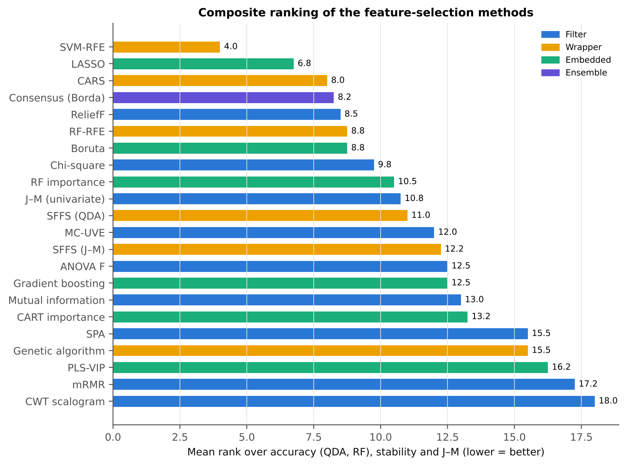
Figure 12. Composite ranking: mean of the ranks for QDA accuracy, RF accuracy, stability and J–M (lower = better).
Table 50. Composite ranking of the 22 distinct methods.
# | Method | Family | QDA BA | RF BA | Stability | J–M | Mean rank
1 | SVM-RFE | Wrapper | 87.1 % | 87.2 % | 0.65 | 1.56 | 4.0
2 | LASSO | Embedded | 85.4 % | 85.5 % | 0.69 | 1.38 | 6.8
3 | CARS | Wrapper | 86.8 % | 84.5 % | 0.34 | 1.58 | 8.0
4 | Consensus (Borda) | Ensemble | 82.7 % | 85.1 % | 0.55 | 1.49 | 8.2
5 | ReliefF | Filter | 84.9 % | 83.6 % | 0.84 | 1.21 | 8.5
6 | Boruta | Embedded | 78.5 % | 83.7 % | 0.65 | 1.51 | 8.8
6 | RF-RFE | Wrapper | 78.9 % | 86.4 % | 0.52 | 1.50 | 8.8
8 | Chi-square | Filter | 79.6 % | 82.2 % | 0.69 | 1.45 | 9.8
9 | RF importance | Embedded | 78.0 % | 82.6 % | 0.73 | 1.43 | 10.5
10 | J–M (univariate) | Filter | 69.7 % | 79.6 % | 0.76 | 1.75 | 10.8
11 | SFFS (QDA) | Wrapper | 87.9 % | 83.2 % | 0.24 | 1.43 | 11.0
12 | MC-UVE | Filter | 80.5 % | 82.6 % | 0.59 | 1.28 | 12.0
13 | SFFS (J–M) | Wrapper | 72.7 % | 81.9 % | 0.42 | 1.80 | 12.2
14 | Gradient boosting | Embedded | 77.4 % | 84.7 % | 0.32 | 1.47 | 12.5
14 | ANOVA F | Filter | 81.2 % | 80.8 % | 0.66 | 1.27 | 12.5
16 | Mutual information | Filter | 77.8 % | 81.8 % | 0.60 | 1.45 | 13.0
17 | CART importance | Embedded | 77.8 % | 84.9 % | 0.27 | 1.43 | 13.2
18 | Genetic algorithm | Wrapper | 84.1 % | 81.5 % | 0.22 | 1.23 | 15.5
18 | SPA | Filter | 67.1 % | 75.7 % | 0.38 | 1.73 | 15.5
20 | PLS-VIP | Embedded | 71.6 % | 74.8 % | 0.73 | 0.97 | 16.2
21 | mRMR | Filter | 75.5 % | 81.3 % | 0.58 | 0.92 | 17.2
22 | CWT scalogram | Filter | 66.7 % | 76.9 % | 0.62 | 1.17 | 18.0

SVM-RFE ranks first because it is among the three most accurate methods with QDA, the most accurate with RF and LDA, and moderately stable. SFFS (QDA) is the most accurate single method but ranks 11th because its selections change from one training set to the next (Jaccard 0.24).

3.12 Comparison with the four-tier feature sets
Table 51. Best feature-selection methods (top-10, QDA) against the four-tier CART-13 and RF-17 sets of Part C on the same 20 held-out sets (paired Wilcoxon tests).
Method | vs | Method BA | Four-tier BA | Δ | Wins | p
SFFS (QDA) | Four-tier CART-13 | 87.9 % | 78.3 % | +9.6 pts | 19/20 | 0.000
SFFS (QDA) | Four-tier RF-17 | 87.9 % | 84.5 % | +3.4 pts | 15/20 | 0.001
SVM-RFE | Four-tier CART-13 | 87.1 % | 78.3 % | +8.9 pts | 20/20 | 0.000
SVM-RFE | Four-tier RF-17 | 87.1 % | 84.5 % | +2.6 pts | 15/20 | 0.004
CARS | Four-tier CART-13 | 86.8 % | 78.3 % | +8.5 pts | 20/20 | 0.000
CARS | Four-tier RF-17 | 86.8 % | 84.5 % | +2.3 pts | 15/20 | 0.019
LASSO | Four-tier CART-13 | 85.4 % | 78.3 % | +7.1 pts | 19/20 | 0.000
LASSO | Four-tier RF-17 | 85.4 % | 84.5 % | +0.9 pts | 13/20 | 0.165
Consensus (Borda) | Four-tier CART-13 | 82.7 % | 78.3 % | +4.4 pts | 16/20 | 0.003
Consensus (Borda) | Four-tier RF-17 | 82.7 % | 84.5 % | -1.8 pts | 8/20 | 0.105
ReliefF | Four-tier CART-13 | 84.9 % | 78.3 % | +6.6 pts | 18/20 | 0.000
ReliefF | Four-tier RF-17 | 84.9 % | 84.5 % | +0.3 pts | 8/20 | 0.956
Boruta | Four-tier CART-13 | 78.5 % | 78.3 % | +0.2 pts | 12/20 | 0.701
Boruta | Four-tier RF-17 | 78.5 % | 84.5 % | -6.0 pts | 0/20 | 0.000

- The four-tier analysis of Part C (CART-13: 78.3 %; RF-17: 84.5 % on the same 20 held-out sets) is beaten by SFFS (QDA) (+3.4 points vs RF-17, 15/20 sets, p = 0.001), SVM-RFE (+2.6, p = 0.004) and CARS (+2.3, p = 0.019).
- LASSO and ReliefF are equivalent to RF-17 (p = 0.17 and 0.96); Boruta's top-10 is 6.0 points worse (0/20, p < 0.001). Against CART-13 every method in this table except Boruta gains 4–10 points.

3.13 Detector-join check
Table 52. Share of top-10 selections within 10 nm of an ASD detector join and QDA accuracy without such bands (methods with at least one such selection).
Method | Near-join share | QDA BA | Join bands excluded | Δ | p
SVM-RFE | 18.0 % | 87.1 % | 85.6 % | -1.5 pts | 0.001
LASSO | 15.0 % | 85.4 % | 82.2 % | -3.2 pts | 0.001
CARS | 13.5 % | 86.8 % | 82.2 % | -4.6 pts | 0.000
ReliefF | 11.0 % | 84.9 % | 83.9 % | -0.9 pts | 0.027
PLS-VIP | 10.5 % | 71.6 % | 71.0 % | -0.5 pts | 0.679
Consensus (Borda) | 7.5 % | 82.7 % | 80.2 % | -2.5 pts | 0.002
RF-RFE | 4.5 % | 78.9 % | 78.4 % | -0.5 pts | 0.208
SPA | 4.5 % | 67.1 % | 67.0 % | -0.2 pts | 0.441
MC-UVE | 4.0 % | 80.5 % | 80.8 % | +0.3 pts | 0.063
CART importance | 3.8 % | 77.8 % | 77.6 % | -0.3 pts | 0.310
SFFS (QDA) | 3.5 % | 87.9 % | 86.9 % | -1.1 pts | 0.121
Boruta | 3.0 % | 78.5 % | 77.7 % | -0.8 pts | 0.028
RF importance | 2.5 % | 78.0 % | 77.9 % | -0.1 pts | 0.345
Genetic algorithm | 2.5 % | 84.1 % | 83.7 % | -0.4 pts | 0.465
Gradient boosting | 2.5 % | 77.4 % | 77.7 % | +0.2 pts | 0.225
mRMR | 1.8 % | 75.5 % | 74.9 % | -0.5 pts | 0.109

- Linear-model selectors pick bands next to the ASD detector joins (≈ 1000 and 1800 nm) more often: SVM-RFE 18 % of its top-10 selections within 10 nm of a join, LASSO 15 %, CARS 13.5 %, ReliefF 11 % (univariate filters 0 %).
- Excluding such bands lowers CARS by 4.6 points (to 82.2 %), LASSO by 3.2 (to 82.2 %), the consensus by 2.5 and SVM-RFE by 1.5 (to 85.6 %). SFFS (QDA) loses only 1.1 points (not significant; 86.9 %).
- Part of the advantage of CARS and LASSO may therefore come from residual splice effects (or from the 970-nm water-band shoulder at 981 nm). SFFS (QDA) and SVM-RFE remain the best methods after this correction.

3.14 Subsets chosen by the methods' own rules
Table 53. Size and accuracy of the subsets chosen by each method's own stopping rule (mean over 20 training sets; QDA only when every subset has ≤ 30 features).
Method | Mean size | Range | QDA BA | RF BA
Boruta | 122.1 | 88–155 | – (> 30 features) | 84.4 %
CARS | 57.1 | 25–111 | – (> 30 features) | 87.9 %
CART importance | 16.8 | 4–57 | – (> 30 features) | 85.7 %
Genetic algorithm | 15.5 | 13–20 | 88.5 % | 83.5 %
LASSO | 98.0 | 42–130 | – (> 30 features) | 87.0 %
MC-UVE | 1434.8 | 1021–1841 | – (> 30 features) | 86.4 %
PLS-VIP | 1319.6 | 1214–1385 | – (> 30 features) | 86.3 %
SFFS (J–M) | 20.0 | 20–20 | 74.5 % | 82.9 %
SFFS (QDA) | 15.9 | 10–20 | 88.0 % | 83.1 %
SPA | 19.8 | 18–20 | 72.1 % | 79.6 %

Boruta, MC-UVE, PLS-VIP (VIP > 1) and LASSO keep about 100–1400 features: they identify relevant features but do not reduce the pool to a compact, interpretable set. SFFS and the GA end at about 16 features with 88.0 % and 88.5 % QDA balanced accuracy.

3.15 Computing cost
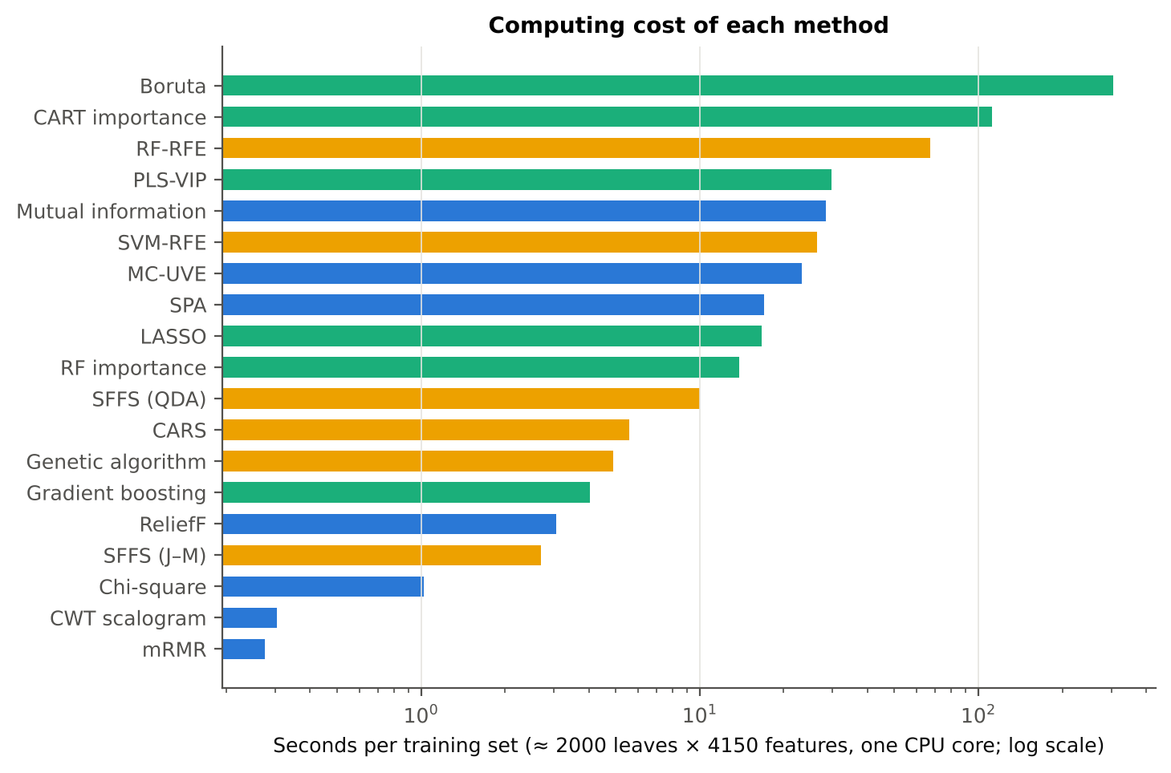
Figure 13. Computing time per training set (≈ 2000 leaves × 4150 features, one CPU core; log scale).
Table 54. Computing time of each method.
Method | Family | Seconds per training set | All leaves (s)
Pearson r | Filter | < 0.1 | < 0.1
ANOVA F | Filter | < 0.1 | < 0.1
Fisher score | Filter | < 0.1 | < 0.1
Chi-square | Filter | 1.0 | 1.6
Mutual information | Filter | 28.4 | 33.2
ReliefF | Filter | 3.1 | 6.5
J–M (univariate) | Filter | < 0.1 | < 0.1
mRMR | Filter | 0.3 | 0.3
SPA | Filter | 17.0 | 21.7
MC-UVE | Filter | 23.3 | 34.9
CWT scalogram | Filter | 0.3 | 0.3
SVM-RFE | Wrapper | 26.4 | 39.2
RF-RFE | Wrapper | 67.1 | 82.6
CARS | Wrapper | 5.6 | 6.9
SFFS (QDA) | Wrapper | 10.0 | 7.6
SFFS (J–M) | Wrapper | 2.7 | 3.5
Genetic algorithm | Wrapper | 4.9 | 5.5
RF importance | Embedded | 13.8 | 17.4
CART importance | Embedded | 112.0 | 119.9
Boruta | Embedded | 304.0 | 516.3
PLS-VIP | Embedded | 29.6 | 37.6
LASSO | Embedded | 16.7 | 21.1
Gradient boosting | Embedded | 4.0 | 5.2

- Per training set (≈ 2000 leaves × 4150 features, one CPU core): univariate filters, χ², mRMR and the CWT scalogram ≤ 1 s; ReliefF 3 s; gradient boosting 4 s; GA 5 s; CARS 6 s; SFFS 10 s; RF importance 14 s; LASSO 17 s; SPA 17 s; MC-UVE 23 s; SVM-RFE 26 s; mutual information 28 s; PLS-VIP 30 s; RF-RFE 67 s; CART (with pruning by inner CV) 112 s; Boruta 304 s.
- SFFS and the GA are fast here only because they search a pre-filtered pool of 100 non-redundant candidates.

3.16 Stable and informative disease-specific features
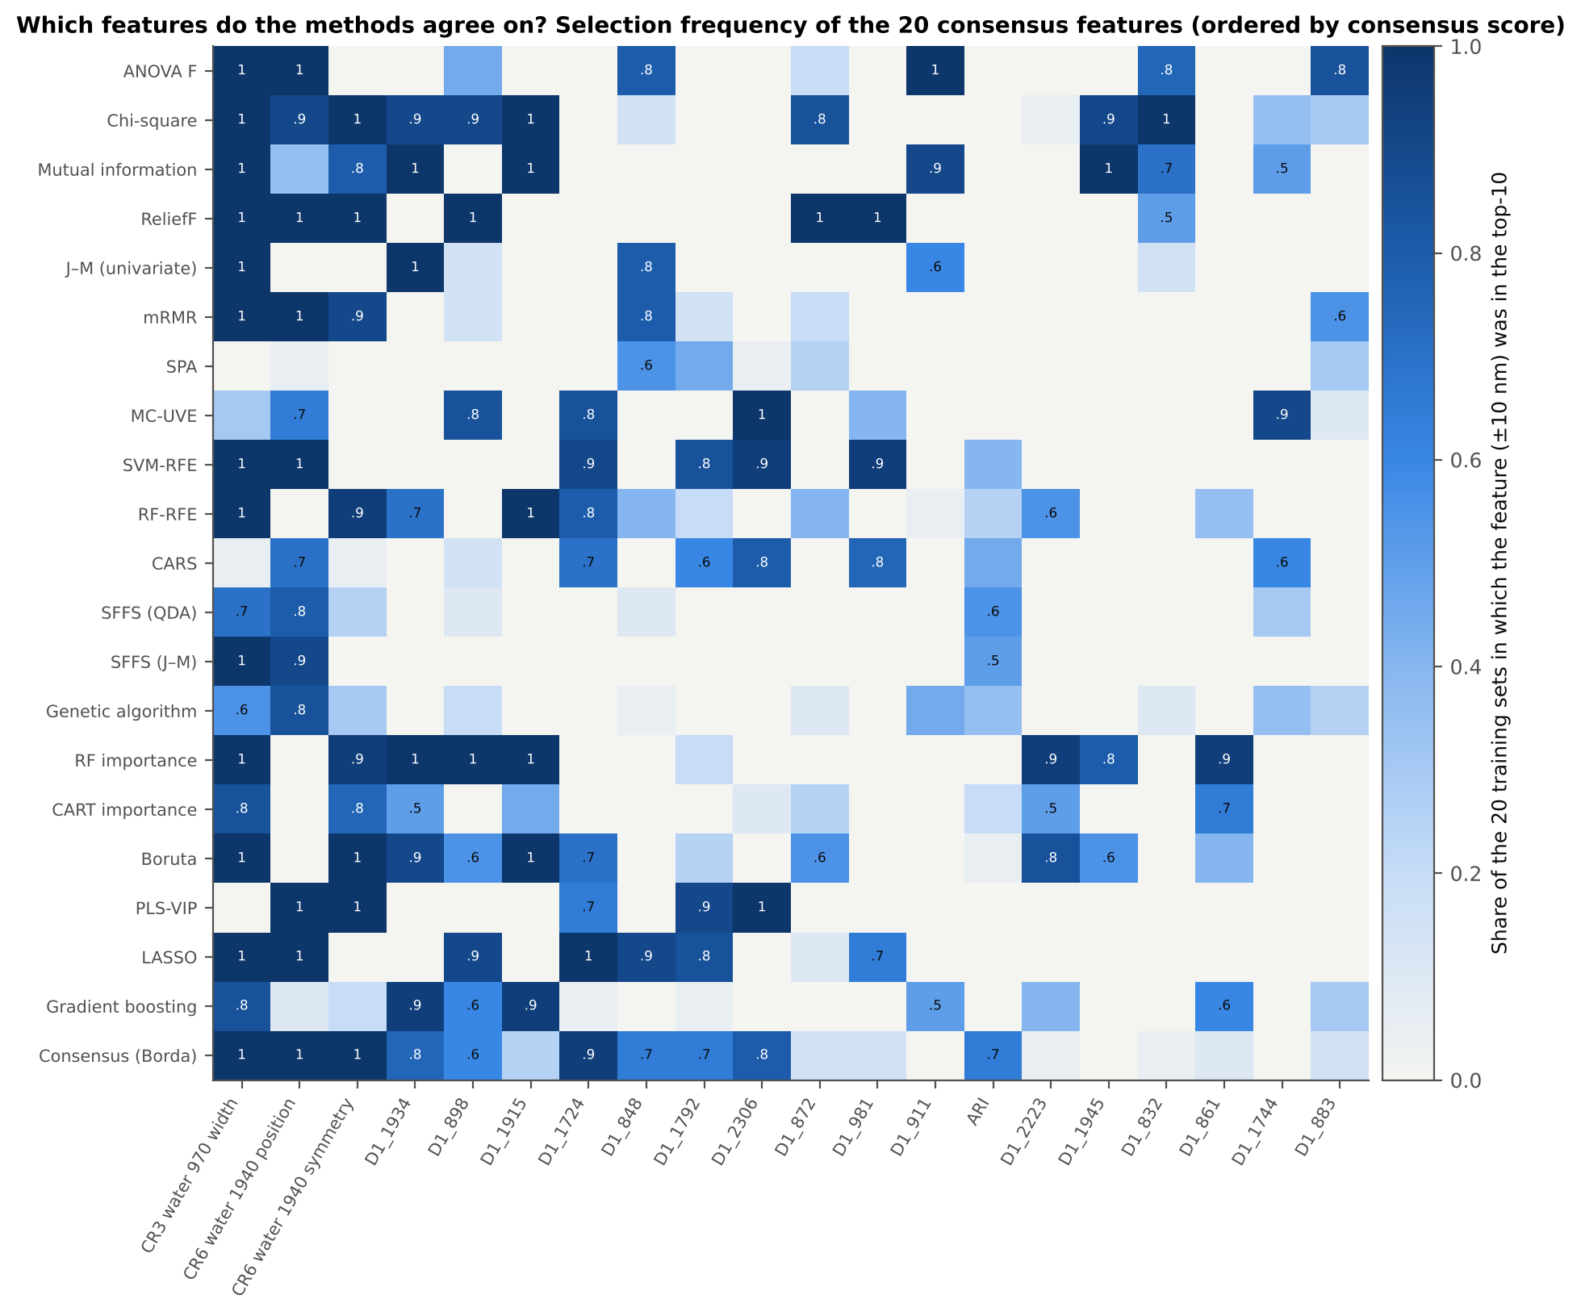
Figure 14. Selection frequency of the 20 consensus features by method: share of the 20 training sets in which the feature (±10 nm) was in the method's top-10.
Table 55. Consensus disease-specific features (one per ±10-nm region), with their univariate AUC, effect size (Hedges g) and direction in diseased leaves.
Feature | Type | Consensus | Methods ≥ 50 % | AUC | Hedges g | Diseased | Note
CR3 water 970 width | K2 continuum removal | 0.78 | 17 | 0.765 | -0.82 | lower
CR6 water 1940 position | K2 continuum removal | 0.59 | 13 | 0.686 | 0.79 | higher
CR6 water 1940 symmetry | K2 continuum removal | 0.48 | 10 | 0.669 | 0.57 | higher
D1_1934 | K4 first-derivative band | 0.37 | 9 | 0.754 | 0.64 | higher
D1_898 | K4 first-derivative band | 0.36 | 8 | 0.758 | 0.85 | higher
D1_1915 | K4 first-derivative band | 0.32 | 6 | 0.701 | -0.60 | lower
D1_1724 | K4 first-derivative band | 0.31 | 8 | 0.516 | -0.03 | lower | weak on its own (AUC < 0.60): complementary in multivariate sets
D1_848 | K4 first-derivative band | 0.25 | 6 | 0.785 | 0.90 | higher
D1_1792 | K4 first-derivative band | 0.25 | 5 | 0.591 | 0.23 | higher | within 10 nm of a detector join — interpret with caution; weak on its own (AUC < 0.60): complementary in multivariate sets
D1_2306 | K4 first-derivative band | 0.22 | 5 | 0.563 | -0.21 | lower | weak on its own (AUC < 0.60): complementary in multivariate sets
D1_872 | K4 first-derivative band | 0.19 | 3 | 0.786 | 0.90 | higher
D1_981 | K4 first-derivative band | 0.19 | 4 | 0.618 | 0.45 | higher | within 10 nm of a detector join — interpret with caution
D1_911 | K4 first-derivative band | 0.17 | 4 | 0.733 | 0.79 | higher
ARI | K3 vegetation index | 0.16 | 3 | 0.646 | 0.47 | higher
D1_2223 | K4 first-derivative band | 0.16 | 4 | 0.639 | 0.26 | higher
D1_1945 | K4 first-derivative band | 0.15 | 4 | 0.715 | 0.63 | higher
D1_832 | K4 first-derivative band | 0.15 | 4 | 0.759 | 0.84 | higher
D1_861 | K4 first-derivative band | 0.15 | 3 | 0.784 | 0.89 | higher
D1_1744 | K4 first-derivative band | 0.14 | 3 | 0.646 | 0.28 | higher
D1_883 | K4 first-derivative band | 0.13 | 2 | 0.778 | 0.88 | higher

- Consensus score = mean, over the 21 distinct methods, of how often the feature (±10 nm) was in the method's top-10 across the 20 training sets.
- The width of the 970-nm water feature (CR3) is the most universal disease feature: 17 of 21 methods choose it in at least half of the training sets (consensus 0.78; AUC 0.77; narrower in diseased leaves). Next come the 1940-nm water feature position (0.59; 13 methods; shifted to longer wavelengths in diseased leaves) and symmetry (0.48; 10 methods).
- Derivative bands follow: D1_1934 (0.37) and D1_1915 (0.32) on the 1940-nm water band wing, and D1_898 (0.36), D1_848 (0.25), D1_872 and D1_911 across the NIR plateau.
- D1_1724, D1_2306 and D1_1792 are weak on their own (AUC < 0.60) but complementary in multivariate sets. D1_1792 and D1_981 lie within 10 nm of a detector join and need caution.
- A 10-feature consensus set gives J–M 1.60 and 82.2 % (Das protocol). The honest in-fold Borda consensus reaches 82.7 % on new plots — a consensus is stable and interpretable, but not more accurate than the best single method.
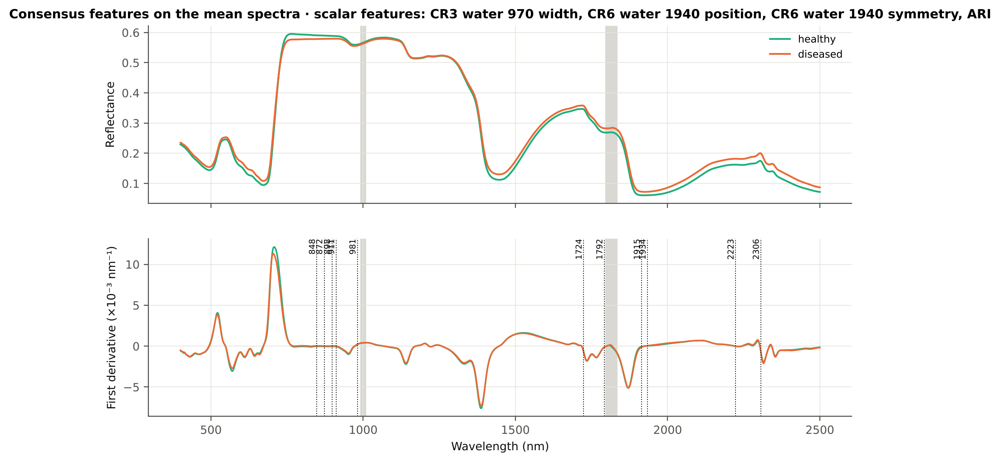
Figure 15. Consensus features on the mean reflectance and first-derivative spectra of healthy and diseased leaves.

Physiological interpretation
- 970 and 1940 nm: liquid-water absorption. White rust pustules rupture the epidermis and disturb leaf water status, changing the depth, width and shape of the water bands.
- 848–911 nm (first derivative): slope of the NIR plateau, set by mesophyll scattering. Hyphae and pustules alter the internal leaf structure.
- 1724 and 2223–2306 nm: C–H, lignin, cellulose and protein (dry-matter) absorption. These are complementary rather than strong on their own.
- ARI: anthocyanins accumulate in stressed, infected leaves.

4. Discussion

4.1 Why wrapper methods performed best
The white-rust signal is spread over several complementary regions — leaf water (970 and 1940 nm), internal leaf structure (NIR-plateau slope) and dry matter (C–H bands near 1730 and 2300 nm) — and within each region over many collinear 1-nm features. Univariate filters and importance rankings repeatedly pick the single strongest region (the NIR-plateau derivative), so even after redundancy control their ten features carry overlapping information (78–81 %). Wrappers (SFFS, SVM-RFE, CARS) and LASSO judge a feature by what it adds to the features already chosen, and therefore combine the water features with weakly discriminating but complementary bands (e.g. D1_1724, D1_2305, D1_454). This is why they reached 85–88 % with the same number of features, in line with Wei et al. (2021), who found RFE superior to chi-square for peanut stem rot.

4.2 Accuracy versus stability
Accuracy and stability did not coincide. The search-based wrappers (SFFS, GA, CARS) produced different subsets in different training sets (Jaccard 0.22–0.34), whereas ReliefF, LASSO, RF importance and the univariate filters were more reproducible (0.60–0.84). In collinear spectra many subsets are almost equally good, so a wrapper's exact choice is partly arbitrary. For a thesis, the accurate wrapper sets should therefore be reported together with selection frequencies, and the physiological interpretation should rest on features that are both stable and informative (the consensus features), following the recommendation to report stability alongside accuracy (Kuncheva 2007; Nogueira et al. 2018).

4.3 J–M is a description, not a selection criterion
The sets with the highest J–M distance — SFFS with a J–M criterion (1.80) and the univariate J–M filter (1.75) — were among the least accurate on new plots (70–73 %). The Bhattacharyya distance contains a covariance term that rewards differences in class spread; in pooled field data such differences arise partly from plots, dates and growth stages and do not transfer to new plots. J–M remains useful to describe the separability of a chosen set (Tier 3 of Das et al. 2020), but it should not be the objective of the selection for this dataset.

4.4 Redundancy in 1-nm data
The ASD records 1-nm values interpolated from a native resolution of about 3–10 nm, so adjacent bands are nearly identical. Without a redundancy rule the top-10 of a univariate ranking contains several copies of the same signal; skipping features correlated |r| ≥ 0.95 raised the accuracy of chi-square, ReliefF, MC-UVE, ANOVA F, mutual information and RF importance by 2.9–6.1 points. Methods with built-in redundancy handling (SFFS, GA, SPA, CARS, LASSO) did not need it, while mRMR's quotient criterion over-penalised redundancy and replaced strong features by weak ones.

4.5 Screening versus selection
Boruta, MC-UVE and PLS-VIP answer a different question from the other methods: which features carry ANY disease information (all-relevant). They confirmed 120–1400 features, and a Random Forest on these large subsets reached 84–86 %, but their top-10 lists were weak. They are best used as a first screening step followed by a wrapper for the final compact set — the two-stage Boruta → SFFS strategy of Mustafa et al. (2023).

4.6 Detector-join artefacts
Linear selectors (SVM-RFE, LASSO, CARS) and ReliefF often selected first-derivative bands just outside the guard zones of the ASD detector joins (≈ 981 and 1791 nm). Removing them cost CARS 4.6 and LASSO 3.2 points but SVM-RFE only 1.5 and SFFS 1.1 points (not significant). Some of this information may be real — 981 nm lies on the shoulder of the 970-nm water band, which is the strongest disease feature — but residual splice effects cannot be excluded. Bands within 10 nm of a join should therefore be flagged or excluded when a sensor is designed.

4.7 Comparison with the four-tier method
The best feature-selection methods improved on the CART-13 set of the four-tier analysis by 8.5–9.6 points and on its RF-17 set by 2.3–3.4 points on the same held-out plots (15 of 20 sets, p ≤ 0.019). The four-tier approach remains useful as an interpretable baseline, but the choice of Tier-2 selector matters: a wrapper that selects complementary features (SVM-RFE or SFFS) is a better Tier-2 than CART for this disease.

4.8 Limitations
- One disease, one crop and one season; the ranking of methods may differ for other datasets — the pipeline can be rerun unchanged.
- Twenty training/test units (10 plot-grouped folds and 10 plot hold-outs); transfer to an unseen date, which was poor in the main analysis, was not repeated for every selector.
- SFFS and the GA searched a pre-filtered pool of 100 candidates; the LASSO penalty and the number of PLS components on all leaves ended at the limits of their search grids.
- XGBoost was represented by scikit-learn gradient boosting, and Boruta by an implementation with Balanced Random Forest importance; the CWT used a 5-nm grid of wavelet coefficients computed from the 1-nm spectrum.
- The reference cited as Liu et al. (2024) for RFE could not be verified and must be completed by the author.

5. Summary and conclusions

5.1 Summary
Twenty-three feature-selection methods (11 filter, 6 wrapper, 6 embedded and a consensus) were applied to the same 4150-feature K1–K4 pool. Each method selected features only inside the training leaves of 20 units (10 plot-grouped folds and 10 hold-outs of 30 % of plots); the selected features were then tested on the leaves of plots that the selection never saw.
Most accurate with 10 features (QDA, equal priors): SFFS with a QDA criterion 87.9 ± 2.8 %, SVM-RFE 87.1 ± 3.6 % and CARS 86.8 ± 2.6 %. These three are statistically tied (Holm-corrected Wilcoxon p = 0.55) and significantly better than all other methods (Friedman χ² = 333, p < 10⁻⁵⁷). All three beat the four-tier RF-17 set of Part C (84.5 %) in 15 of the 20 held-out sets.
Best overall, balancing accuracy (QDA and RF), stability and J–M separability: SVM-RFE (rank 1). It is followed by LASSO, CARS, the Borda consensus and ReliefF. ReliefF is the most stable selector (Jaccard 0.84) at 84.9 % accuracy. The wrappers SFFS, the genetic algorithm and CARS are accurate but unstable (Jaccard 0.22–0.34): many different feature combinations work almost equally well.
Stable and disease-specific features chosen by most methods: the width of the 970-nm water absorption feature (CR3; 17 of 21 methods), the position and symmetry of the 1940-nm water feature (CR6), first-derivative bands on the 1940-nm water band wing (1915–1934 nm), first-derivative bands across the NIR plateau (848–911 nm), the 1724 and 2223–2306 nm C–H / dry-matter regions, and the anthocyanin index ARI.

5.2 Conclusions
1. For discriminating healthy and white-rust leaves from the K1–K4 feature pool, wrapper methods that search for complementary features — SFFS with a QDA criterion, SVM-RFE and CARS — give the most accurate compact feature sets (≈ 87–88 % with 10 features on new plots), significantly better than univariate filters (78–81 %) and tree importances (77–79 %).
2. SVM-RFE is the best all-round method (composite rank 1): it is as accurate as SFFS, accurate with both QDA and RF, more stable than the other wrappers, and robust to the detector-join check (85.6 % after excluding join-adjacent bands).
3. ReliefF, LASSO and RF importance are the most stable selectors; ReliefF combines high stability (0.84) with good accuracy (84.9 %) and is the best filter.
4. Univariate rankings (Pearson r = ANOVA F = Fisher score for two classes, χ², MI) must be combined with redundancy control; J–M-driven selection, SPA, PLS-VIP top-k and the CWT scalogram are not suitable for this dataset.
5. Boruta, MC-UVE and PLS-VIP (VIP > 1) are screening tools: they keep about 120 (Boruta) to 1300–1400 (PLS-VIP, MC-UVE) relevant features rather than a compact set.
6. The stable disease-specific signature of white rust is the leaf-water signal — 970-nm band width and 1940-nm band position and symmetry, with derivative bands at 1915–1934 nm — together with the NIR-plateau slope at 848–911 nm. Dry-matter bands (1724, 2223–2306 nm) and ARI add complementary information.

5.3 Recommendations
- Use SVM-RFE (linear SVM, balanced weights) with redundancy control as the main selector for this dataset. Report SFFS (QDA) and CARS as equally accurate alternatives, and give their selection frequencies because their exact feature sets are unstable.
- For interpretation and sensor design, use the consensus features (CR3 970-nm width, CR6 1940-nm position and symmetry, D1 1915–1934 nm, D1 848–911 nm) or ReliefF, which are reproducible across training sets.
- Always select features inside the training data only, evaluate on new plots, and report accuracy together with stability (Jaccard or Kuncheva) and a Friedman–Nemenyi comparison.
- Apply a redundancy rule (|r| < 0.95, or a minimum spectral distance) to any ranking-based method, and exclude or flag bands within 10 nm of the detector joins.
- Use Boruta or MC-UVE as a first screening step and a wrapper (SFFS or RFE) for the final compact set, as Mustafa et al. (2023) did with Boruta followed by SFFS.

5.4 Recommended feature-selection workflow for new datasets
- Build the disease-sensitive feature pool (K1–K4) from 1-nm spectra with splice correction and guard zones.
- Use plot-grouped training/test splits; select features only inside training data.
- Screen with a stable filter or Boruta/MC-UVE (optional), then select a compact set with SVM-RFE (main method) and SFFS (QDA) or CARS (alternatives), always with redundancy control (|r| < 0.95) and join-adjacent bands flagged.
- Report balanced accuracy on new plots, stability (Jaccard ±10 nm or Kuncheva), J–M as a descriptor, and a Friedman–Nemenyi comparison.
- Interpret only features that are stable across training sets and agreed by several methods (consensus features).

6. Quality control
Table 56. Implementation checks.
Check | Result | Status
Pearson |r|, ANOVA F and Fisher score rank features identically (two classes: r² = F/(F+n−2), Fisher ∝ F) | min ρ = 1.000000 | PASS
ANOVA F implementation | max relative Δ = 5.5e-07 (floating-point level) | PASS
Chi-square implementation | 361.3849 vs 361.3849 | PASS
J–M used by SFFS (J–M) and the evaluation | |Δ| = 3.5e-14 | PASS
Fast QDA used inside SFFS / GA | 100.00 % identical predictions | PASS
PLS-VIP normalisation | 1.000000 | PASS
SPA chain | identical | PASS
No plot in both training and test leaves | 0 shared plots | PASS
CWT implementation | best scale 16 nm | PASS
Boruta convergence | 192 / 201 / 3757 after 100 runs | PASS

References
Abdulridha J, Min A, Rouse MN, Kianian S, Isler V, Yang C. 2023. Evaluation of stem rust disease in wheat fields by drone hyperspectral imaging. Sensors 23(8):4154. doi:10.3390/s23084154
Ambroise C, McLachlan GJ. 2002. Selection bias in gene extraction on the basis of microarray gene-expression data. Proceedings of the National Academy of Sciences 99:6562–6566.
Araújo MCU, Saldanha TCB, Galvão RKH, Yoneyama T, Chame HC, Visani V. 2001. The successive projections algorithm for variable selection in spectroscopic multicomponent analysis. Chemometrics and Intelligent Laboratory Systems 57(2):65–73.
Breiman L, Friedman JH, Olshen RA, Stone CJ. 1984. Classification and regression trees. Belmont (CA): Wadsworth.
Breiman L. 2001. Random forests. Machine Learning 45:5–32.
Cai W, Li Y, Shao X. 2008. A variable selection method based on uninformative variable elimination for multivariate calibration of near-infrared spectra. Chemometrics and Intelligent Laboratory Systems 90(2):188–194.
Centner V, Massart D-L, de Noord OE, de Jong S, Vandeginste BM, Sterna C. 1996. Elimination of uninformative variables for multivariate calibration. Analytical Chemistry 68(21):3851–3858.
Chen C, Liaw A, Breiman L. 2004. Using random forest to learn imbalanced data. Technical Report 666, Department of Statistics, University of California, Berkeley.
Chen T, Guestrin C. 2016. XGBoost: a scalable tree boosting system. Proceedings of the 22nd ACM SIGKDD International Conference on Knowledge Discovery and Data Mining, 785–794.
Cheng T, Rivard B, Sánchez-Azofeifa GA, Feng J, Calvo-Polanco M. 2010. Continuous wavelet analysis for the detection of green attack damage due to mountain pine beetle infestation. Remote Sensing of Environment 114(4):899–910. doi:10.1016/j.rse.2009.12.005
Chong I-G, Jun C-H. 2005. Performance of some variable selection methods when multicollinearity is present. Chemometrics and Intelligent Laboratory Systems 78(1–2):103–112.
Das B, Sahoo RN, Biswas A, Pargal S, Krishna G, Verma R, Chinnusamy V, Sehgal VK, Gupta VK. 2020. Discrimination of rice genotypes using field spectroradiometry. Geocarto International 35(1):64–77. doi:10.1080/10106049.2018.1506507
Demšar J. 2006. Statistical comparisons of classifiers over multiple data sets. Journal of Machine Learning Research 7:1–30.
Duda RO, Hart PE, Stork DG. 2001. Pattern classification, 2nd edn. New York: Wiley.
Friedman JH. 2001. Greedy function approximation: a gradient boosting machine. Annals of Statistics 29(5):1189–1232.
Guyon I, Elisseeff A. 2003. An introduction to variable and feature selection. Journal of Machine Learning Research 3:1157–1182.
Guyon I, Weston J, Barnhill S, Vapnik V. 2002. Gene selection for cancer classification using support vector machines. Machine Learning 46:389–422.
Kira K, Rendell LA. 1992. A practical approach to feature selection. Proceedings of the 9th International Workshop on Machine Learning, 249–256.
Kohavi R, John GH. 1997. Wrappers for feature subset selection. Artificial Intelligence 97:273–324.
Kononenko I. 1994. Estimating attributes: analysis and extensions of RELIEF. In: Machine Learning: ECML-94. Lecture Notes in Computer Science 784. Berlin: Springer, 171–182.
Kraskov A, Stögbauer H, Grassberger P. 2004. Estimating mutual information. Physical Review E 69:066138.
Kuncheva LI. 2007. A stability index for feature selection. Proceedings of the 25th IASTED International Multi-Conference: Artificial Intelligence and Applications, 390–395.
Kursa MB, Rudnicki WR. 2010. Feature selection with the Boruta package. Journal of Statistical Software 36(11):1–13.
Leardi R, Boggia R, Terrile M. 1992. Genetic algorithms as a strategy for feature selection. Journal of Chemometrics 6(5):267–281.
Lemaître G, Nogueira F, Aridas CK. 2017. Imbalanced-learn: a Python toolbox to tackle the curse of imbalanced datasets in machine learning. Journal of Machine Learning Research 18(17):1–5.
Li H, Liang Y, Xu Q, Cao D. 2009. Key wavelengths screening using competitive adaptive reweighted sampling method for multivariate calibration. Analytica Chimica Acta 648(1):77–84.
Liu et al. 2024. [Recursive feature elimination (RFE) for crop-disease spectral features — cited as given in the request; full bibliographic details could not be verified and must be completed by the author.]
Mahlein A-K, Rumpf T, Welke P, Dehne H-W, Plümer L, Steiner U, Oerke E-C. 2013. Development of spectral indices for detecting and identifying plant diseases. Remote Sensing of Environment 128:21–30.
Mustafa G, Zheng H, et al. 2023. Fusarium head blight monitoring in wheat ears using machine learning and multimodal data from asymptomatic to symptomatic periods. Frontiers in Plant Science 13:1102341. doi:10.3389/fpls.2022.1102341
Mustafa G, Zheng H, Khan IH, Tian L, Jia H, Li G, Cheng T, Tian Y, Cao W, Zhu Y, Yao X. 2022. Hyperspectral reflectance proxies to diagnose in-field fusarium head blight in wheat with machine learning. Remote Sensing 14(12):2784.
Nagasubramanian K, Jones S, Sarkar S, Singh AK, Singh A, Ganapathysubramanian B. 2018. Hyperspectral band selection using genetic algorithm and support vector machines for early identification of charcoal rot disease in soybean stems. Plant Methods 14:86.
Nogueira S, Sechidis K, Brown G. 2018. On the stability of feature selection algorithms. Journal of Machine Learning Research 18(174):1–54.
Pearson K. 1895. Note on regression and inheritance in the case of two parents. Proceedings of the Royal Society of London 58:240–242.
Pedregosa F, Varoquaux G, Gramfort A, et al. 2011. Scikit-learn: machine learning in Python. Journal of Machine Learning Research 12:2825–2830.
Peng H, Long F, Ding C. 2005. Feature selection based on mutual information: criteria of max-dependency, max-relevance, and min-redundancy. IEEE Transactions on Pattern Analysis and Machine Intelligence 27(8):1226–1238.
Pudil P, Novovičová J, Kittler J. 1994. Floating search methods in feature selection. Pattern Recognition Letters 15(11):1119–1125.
Rumpf T, Mahlein A-K, Steiner U, Oerke E-C, Dehne H-W, Plümer L. 2010. Early detection and classification of plant diseases with support vector machines based on hyperspectral reflectance. Computers and Electronics in Agriculture 74(1):91–99.
Saeys Y, Abeel T, Van de Peer Y. 2008. Robust feature selection using ensemble feature selection techniques. In: Machine Learning and Knowledge Discovery in Databases (ECML PKDD 2008). Lecture Notes in Artificial Intelligence 5212. Berlin: Springer, 313–325.
Saeys Y, Inza I, Larrañaga P. 2007. A review of feature selection techniques in bioinformatics. Bioinformatics 23(19):2507–2517.
Thomas S, Kuska MT, Bohnenkamp D, Brugger A, Alisaac E, Wahabzada M, Behmann J, Mahlein A-K. 2018. Benefits of hyperspectral imaging for plant disease detection and plant protection: a technical perspective. Journal of Plant Diseases and Protection 125:5–20.
Tibshirani R. 1996. Regression shrinkage and selection via the lasso. Journal of the Royal Statistical Society Series B 58(1):267–288.
Wei X, Johnson MA, Langston DB, Mehl HL, Li S. 2021. Identifying optimal wavelengths as disease signatures using hyperspectral sensor and machine learning. Remote Sensing 13(14):2833. doi:10.3390/rs13142833
Wold S, Sjöström M, Eriksson L. 2001. PLS-regression: a basic tool of chemometrics. Chemometrics and Intelligent Laboratory Systems 58(2):109–130.
Zhu H, Chu B, Zhang C, Liu F, Jiang L, He Y. 2017. Hyperspectral imaging for presymptomatic detection of tobacco disease with successive projections algorithm and machine-learning classifiers. Scientific Reports 7:4125. doi:10.1038/s41598-017-04501-2

