Discrimination of healthy and white-rust-diseased mustard from plot-average leaf spectra
Four-tier hierarchical analysis (Das et al., 2020) with imbalance correction on raw reflectance and on the combined pool of disease-sensitive features derived from raw reflectance; CART versus Random Forest; validation on new plots and new dates — all dates, growth stages and varieties combined
192 plot-average spectra (48 healthy, 144 diseased) = 48 plots × 4 dates · 2264 leaf spectra · ASD FieldSpec contact probe, 400–2500 nm
Animesh Panda · Division of Agricultural Physics, ICAR-Indian Agricultural Research Institute, New Delhi
Methods, results and interpretation · companion to the Excel workbook and the presentation (WhiteRust_PlotAverage_AllDates)

Contents

(Right-click → Update field in Word to refresh the page numbers.)

Abstract
White rust (Albugo candida) is a major disease of Indian mustard. To identify the wavelengths and spectral features that separate healthy from white-rust-diseased plants, leaf reflectance spectra (350–2500 nm, ASD FieldSpec contact probe) measured on four dates (11-02, 24-02, 03-03 and 13-03-2026) were averaged per plot and date, giving 192 plot-average spectra (48 healthy, 144 diseased; 48 plots × 4 dates). The four-tier hierarchical method of Das et al. (2020) — statistical screening, CART band selection, Jeffries–Matusita (J–M) separability and quadratic discriminant analysis (QDA) — was applied first to the raw reflectance (2101 bands) and repeated with a Balanced Random Forest as the band selector. The 1 : 3 imbalance between healthy and diseased spectra was corrected throughout (equal priors in CART and QDA, balanced bootstrap samples, balanced subsets, balanced accuracy). Disease-sensitive features were then derived from the raw reflectance — continuum-removal parameters, 87 vegetation indices, first-, second- and third-derivative spectra and red-edge parameters — and the four tiers were applied to the combined pool of 8264 features.
On raw reflectance, 1039 of 2101 bands differed significantly (Welch's t-test with false-discovery-rate control); the strongest differences were in the red (600–679 nm), at the red edge and in the short-wave infrared beyond 1350 nm. CART selected 9 bands (root 699 nm) with J–M = 1.521, whereas the 17 Random Forest importance peaks reached J–M = 1.960, above the separability threshold of 1.94. QDA with equal priors classified new plots (nested plot-grouped cross-validation) with a balanced accuracy of 77.6 % on the CART bands and 86.8 % on the Random Forest bands. The combined feature pool was dominated by derivative features: the first derivative at 871 nm was the single most discriminating feature (AUC 0.916), and a Random Forest on the pool reached 93.1 % on new plots (92.3 % on a 30 % plot hold-out). Transfer to an unseen date was weak (58.4 %). The disease-specific features of white rust at plot level are the slope of the near-infrared shoulder (first derivative 820–895 nm), the curvature of the red edge (second and third derivative at 682 and 737–741 nm) and derivative features of the water-absorption regions (around 1240 and 1918 nm).
Keywords: white rust; Albugo candida; Indian mustard; hyperspectral reflectance; plot average; CART; Random Forest; Jeffries–Matusita distance; quadratic discriminant analysis; class imbalance; derivative spectra; continuum removal; red-edge position.

1. Introduction
White rust, caused by the oomycete Albugo candida, infects leaves, stems and inflorescences of rapeseed-mustard. On leaves it produces chlorotic spots on the upper surface and white to cream pustules (sori) on the lower surface; systemic infection deforms the inflorescence ('stag head'). Yield losses of 20–60 % have been reported in India (Saharan et al., 2014). Early, objective detection of infected plants is therefore of practical value for disease forecasting and plant protection.
Leaf reflectance is shaped by pigments in the visible region (chlorophylls absorb near 430–450 and 640–680 nm, carotenoids near 450–500 nm), by leaf internal structure in the near infrared (multiple scattering at cell wall–air interfaces of the mesophyll gives the high NIR plateau) and by leaf water and dry matter in the short-wave infrared (absorption near 970, 1200, 1450 and 1940 nm). White rust alters all three: chlorosis lowers chlorophyll absorption and raises visible reflectance, pustules disrupt the epidermis and mesophyll and change NIR scattering, and infected tissue loses water. Hyperspectral reflectance should therefore contain a disease signal at several wavelengths (Mahlein et al., 2013; Mahlein, 2016).
Das et al. (2020) proposed a four-tier hierarchical procedure to identify the most informative wavelengths for discriminating classes from field spectra: (1) statistical screening of every band, (2) band selection with classification and regression trees (CART), (3) separability of the classes on the selected bands with the Jeffries–Matusita distance and (4) classification with quadratic discriminant analysis. This study applies that procedure to healthy versus white-rust-diseased mustard with the following extensions:
- The analysis unit is the plot-average spectrum: the leaf spectra of a plot on a date are averaged, so each plot contributes one spectrum per date. All four dates, three growth stages and three varieties are combined.
- The 1 : 3 class imbalance (48 healthy vs 144 diseased spectra) is corrected at every tier, following the correction used in the flowering-stage workbook.
- Random Forest is used as an alternative band selector and classifier in Tier 2 and compared with CART.
- Accuracy is validated on new plots (plot-grouped and nested cross-validation, plot hold-out) and on a new date, in addition to the leaf/spectrum-level cross-validation of the original protocol.
- Disease-sensitive features derived from the raw reflectance (continuum removal, vegetation indices, first- to third-order derivatives, red-edge parameters) are added, and the four tiers are applied to the combined pool to find the disease-specific features.
The objectives were (i) to identify the wavelengths that separate healthy and diseased plots, (ii) to quantify their separability and classification accuracy on new plots and dates, (iii) to compare CART and Random Forest, and (iv) to identify the disease-specific spectral features of white rust at plot level.

2. Materials and methods

2.1 Experiment and spectral measurements
Mustard was grown in 48 plots: plots 1–12 healthy (protected) and plots 13–48 infected with white rust, three varieties (V1, V2, V3). Leaf reflectance was measured with an ASD FieldSpec spectroradiometer and contact probe (350–2500 nm, 1-nm output) on 11-02-2026 and 24-02-2026 (plots at the vegetative and flowering stages) and on 03-03-2026 and 13-03-2026 (plots at the flowering and pod-formation stages); on each date several leaves of each plot (leaf levels L3, L5 and the lowest leaf) were measured. The data were exported to four labelled workbooks, one per date, with one column per leaf spectrum and the plot number, variety, growth stage and healthy/diseased label in the header rows.

2.2 Data cleaning and plot averaging
Exact duplicate spectra were removed before averaging: a second data block on 13-03-2026 (75 columns) repeats spectra of plots 13, 34, 38, 41 and 42, and four unnamed columns of plot 27 on 11-02-2026 are copies of Mustard00215–00218. This left 2264 unique leaf spectra. The spectra of each plot on each date were then averaged band by band:
R̄_plot,date(λ) = (1/n) Σᵢ Rᵢ(λ), i = 1 … n leaf spectra of the plot on that date
This gives 192 plot-average spectra (48 plots × 4 dates; 48 healthy, 144 diseased). Averaging reduces leaf-to-leaf variation and random instrument noise (by about √n) and makes the plot — the experimental unit to which the disease treatment applies — the unit of analysis. As a cross-check, the labelled workbooks contain their own plot-average (=AVERAGE) columns; 197 of 197 of them are identical to the averages computed here at all 2151 bands (Table 1).
Table 1. Leaf spectra averaged into each plot-average spectrum, by date and class.
Date | Class | Plot averages | Leaf spectra | Min leaves per plot | Max leaves per plot
11-02-2026 | Healthy | 12 | 72 | 3 | 9
11-02-2026 | Diseased | 36 | 356 | 5 | 15
24-02-2026 | Healthy | 12 | 90 | 6 | 9
24-02-2026 | Diseased | 36 | 450 | 10 | 15
03-03-2026 | Healthy | 12 | 108 | 9 | 9
03-03-2026 | Diseased | 36 | 540 | 15 | 15
13-03-2026 | Healthy | 12 | 108 | 9 | 9
13-03-2026 | Diseased | 36 | 540 | 15 | 15

2.3 Spectral range and pre-processing
The 350–399 nm detector edge was removed because its noise is about 100 times that of the 500–699 nm region; 2101 bands (400–2500 nm) were analysed. The water-absorption bands were kept: the contact probe illuminates the leaf with its own lamp at a few millimetres, so there is no atmospheric water vapour in the light path, and these bands carry leaf-water information (Das et al. removed them because they worked with canopy field spectra). As requested, all analyses use the raw plot-average reflectance — no smoothing and no detector-join (splice) correction. The ASD records with three detectors (350–1000, 1001–1800, 1801–2500 nm); the small steps at the detector joins are instrument artefacts, so the bands beside the joins (990–1010 and 1795–1835 nm, the 'guard zones') were excluded from the reflectance and derivative feature sets of the disease-sensitive feature step.

2.4 The four-tier method (Das et al., 2020) with corrections

Tier 1 — statistical screening
With two classes the one-way ANOVA used by Das et al. reduces to a two-sample comparison. Because the class variances differed at many bands (Levene's test), Welch's unequal-variance t-test was used at every band:
t = (x̄_D − x̄_H) / √(s²_D/n_D + s²_H/n_H)
The 2101 p-values were adjusted with the Benjamini–Hochberg false-discovery rate (q < 0.05); without adjustment about 105 bands would be significant by chance. The one-way ANOVA of Das et al. is reported for comparison. Two corrections were added: (a) pseudo-replication — the same plot is measured on four dates, so a linear mixed model with a random plot intercept (R nlme) was fitted at every band; (b) class imbalance — the test was repeated on 1000 balanced random subsets of 48 healthy and 48 diseased spectra. The −log₁₀(p) of every band was plotted against wavelength.

Tier 2 — band selection by CART and by Random Forest
CART (R rpart; Gini splitting, minsplit 20, minbucket 7, complexity parameter 0.01) was grown on the Tier-1 bands with prior = (0.5, 0.5), so that the 48 healthy spectra weigh as much as the 144 diseased spectra. The bands used as split variables form the CART band set. The 1-SE tree (complexity parameter by plot-grouped cross-validation) is reported as a smaller alternative.
Random Forest (Breiman, 2001) was used as the alternative selector: a Balanced Random Forest (Chen et al., 2004) in which every tree is grown on a bootstrap sample with equal numbers of healthy and diseased spectra (1000 trees, √p candidate bands per split). Band importance is the mean decrease in Gini impurity; the 17 highest importance peaks at least 10 nm apart form the Random Forest band set (RF-17).

Tier 3 — Jeffries–Matusita distance
The separability of the classes on a band set is measured by the Jeffries–Matusita distance (Swain and Davis, 1978; Richards, 2013), computed from the class mean vectors μ and covariance matrices Σ of all selected bands together (one value per band set, not per band):
α = ⅛ (μ_H − μ_D)ᵀ [(Σ_H + Σ_D)/2]⁻¹ (μ_H − μ_D) + ½ ln{ |(Σ_H + Σ_D)/2| / √(|Σ_H| |Σ_D|) }, J–M = 2 (1 − e^(−α))
J–M ranges from 0 (identical distributions) to 2 (complete separation). Classes are considered separable at J–M ≥ 1.90; Das et al. used 1.94.

Tier 4 — quadratic discriminant analysis
QDA assigns a spectrum to the class with the larger discriminant score δ_k(x) = −½ ln|Σ_k| − ½ (x − μ_k)ᵀ Σ_k⁻¹ (x − μ_k) + ln π_k. Equal prior probabilities (π_H = π_D = 0.5) were used, because the sample priors (0.25 / 0.75) push the decision towards 'diseased'. Results are reported as error matrices (rows = classified, columns = reference, as Table 2 of Das et al.) with producer's and user's accuracy, overall accuracy (OA), Cohen's κ and the balanced accuracy:
BA = ½ (recall_healthy + recall_diseased)
Balanced accuracy is the headline metric: with 75 % diseased spectra, a classifier that calls everything diseased has OA = 75 % but BA = 50 %.

2.5 Validation
- Spectrum-level 10-fold cross-validation — features chosen once on all 192 spectra; spectra split at random into 10 folds (the protocol of Das et al.). Optimistic, because the same plot on other dates is in training and test, and features are chosen on the test spectra.
- Plot-grouped cross-validation — features fixed, folds formed from whole plots (all four dates of a plot in the same fold).
- Nested plot-grouped cross-validation — Tier 1, feature selection and classifier refitted inside every training set; 10 plot-grouped folds × 5 repeats = 50 training sets, every test fold containing both classes. The honest estimate of the accuracy on new plots (Varma and Simon, 2006).
- 30 % plot hold-out validation — 4 healthy and 11 diseased plots (all their dates) held out, everything refitted on the remaining plots; 10 random splits.
- Leave-one-date-out validation on new plots — train on three dates (training plots of a hold-out split), test on the fourth date (test plots); 10 splits × 4 dates = 40 units. Nothing of the test set — spectrum, plot or date — is seen in training.
- Random under-sampling — as nested cross-validation, but the diseased spectra are randomly under-sampled to the number of healthy spectra in every training set, as an alternative imbalance correction.
Pipelines were compared on identical folds with paired Wilcoxon signed-rank tests. The stability of the selected bands across the 50 training sets was measured with the Jaccard index (bands within ± 10 nm counted as the same).

2.6 Disease-sensitive features derived from raw reflectance
- Band reflectance — raw reflectance at each band (guard zones excluded): Welch t + FDR, Hedges' g, AUC and a threshold classifier validated on plots.
- Continuum removal (Clark and Roush, 1984; Kokaly and Clark, 1999) — in six absorption windows (blue 400–548, red 548–765, water 914–1069, 1069–1258, 1258–1721 and 1721–2304 nm) the reflectance is divided by its upper convex hull; from the band depth BD = 1 − R/R_hull eight parameters are taken: maximum depth, position, area, width (full width at half depth), symmetry, left area, right area and depth/area.
- Vegetation indices — 87 indices: the 31 indices of the Activity 1.4 table (flowering-stage workbook) and further pigment, red-edge, water, dry-matter and disease indices (e.g. the Healthy Index, Cercospora, rust and powdery-mildew indices of Mahlein et al., 2013; the Disease–Water Stress Index of Apan et al., 2004), each with its reference (Appendix B). An optimised two-band index NDSI = (R_λ1 − R_λ2)/(R_λ1 + R_λ2) was searched over all band pairs (Thenkabail et al., 2000), with the search repeated inside training plots to measure its optimism.
- Derivative spectra (Tsai and Philpot, 1998) — first, second and third derivatives of the raw reflectance by central finite differences on the 1-nm grid: D1(λ) = [R(λ+1) − R(λ−1)]/2; D2(λ) = R(λ+1) − 2R(λ) + R(λ−1); D3(λ) = [R(λ+2) − 2R(λ+1) + 2R(λ−1) − R(λ−2)]/2. Derivatives remove additive brightness offsets (D1) and linear trends (D2) and sharpen overlapping absorption features.
- Red-edge parameters — the red-edge inflection point (REIP) by four methods (maximum first derivative, Horler et al., 1983; linear four-point interpolation, Guyot and Baret, 1988; Lagrangian interpolation, Dawson and Curran, 1998; linear extrapolation, Cho and Skidmore, 2006), amplitudes, positions and areas of the blue, yellow and red edges, green peak and red well (Gong et al., 2002) and the red-edge slope (Filella and Peñuelas, 1994).
- Correlation spectra — point-biserial correlation of every band with disease status, on all spectra and on each date; and CART versus Random Forest on each feature group with identical plot-grouped folds.

2.7 Four tiers on the combined feature pool
All band-reflectance, continuum-removal, vegetation-index, derivative (first, second, third) and red-edge features were pooled (8266 features; 8264 after removing exact duplicates), and the same four tiers, settings and validation folds were applied. The features chosen by CART and by Random Forest from this pool, with their statistics and re-selection rates, are the disease-specific features.

2.8 Cross-checks and software
Every step was verified by an independent route (51 checks passed, 8 flagged as limitations, 0 failed): Welch t vs SciPy; FDR vs statsmodels; ANOVA F = t²; mixed model R nlme vs Python statsmodels; rpart vs scikit-learn trees; QDA vs manual discriminant functions and R MASS::qda; J–M by Cholesky vs explicit inverse; Random Forest importance vs a second seed, R randomForest and permutation importance; indices, red-edge position and plot averages recomputed by Excel formulas; assertions that no plot, and in leave-one-date-out no date, is in training and test. Software: Python 3.13 (NumPy, SciPy, pandas, statsmodels, scikit-learn, imbalanced-learn, matplotlib, openpyxl) and R 4.3.3 (rpart, MASS, nlme, randomForest).
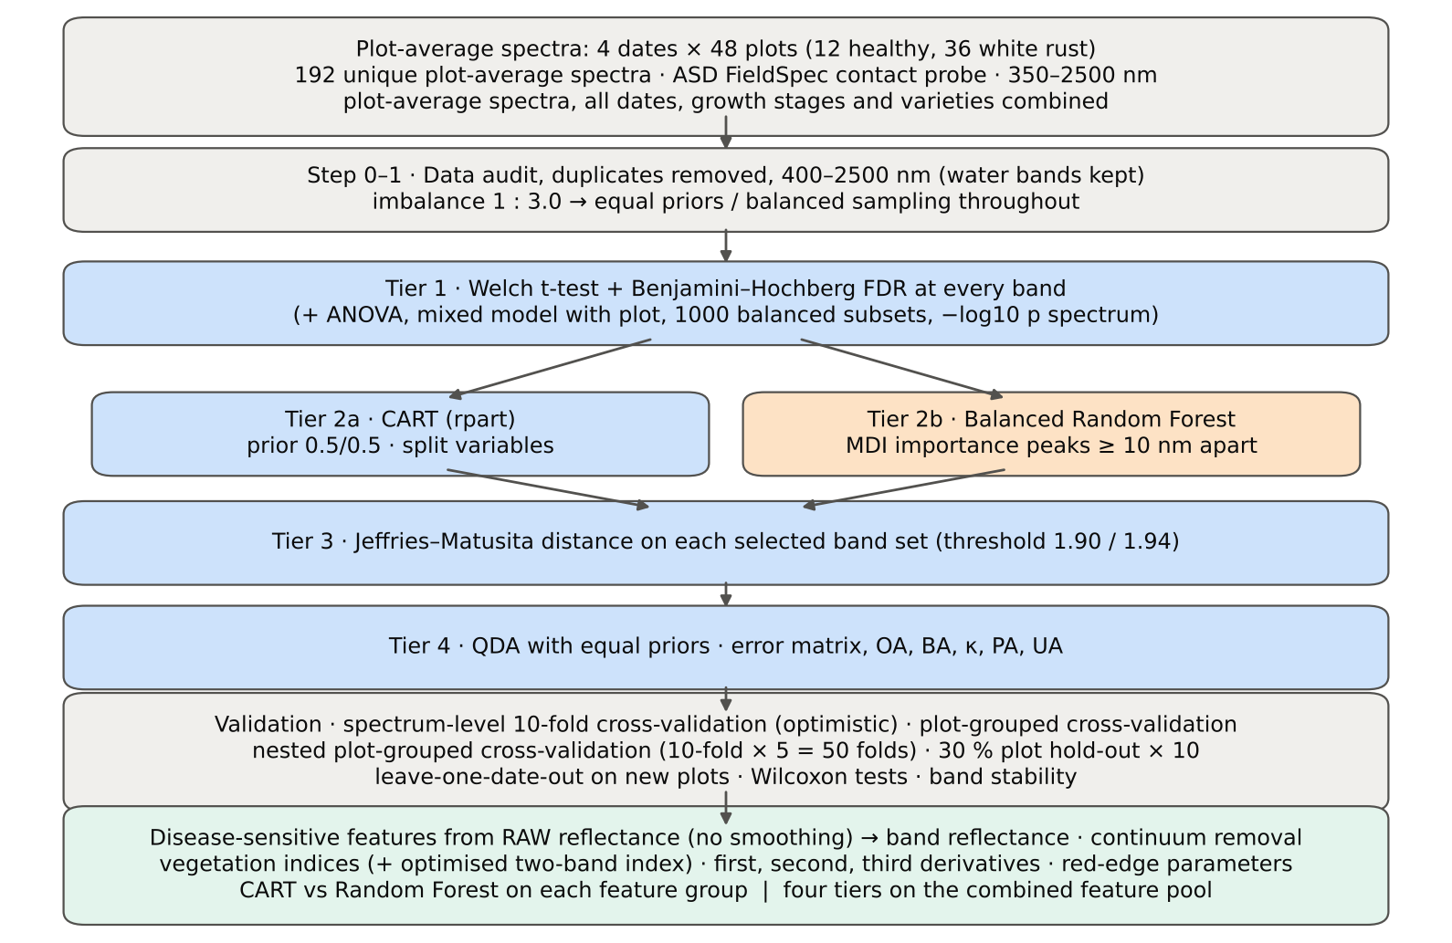
Figure 1. Workflow of the analysis.

3. Results — four tiers on raw reflectance

3.1 Plot-average spectra
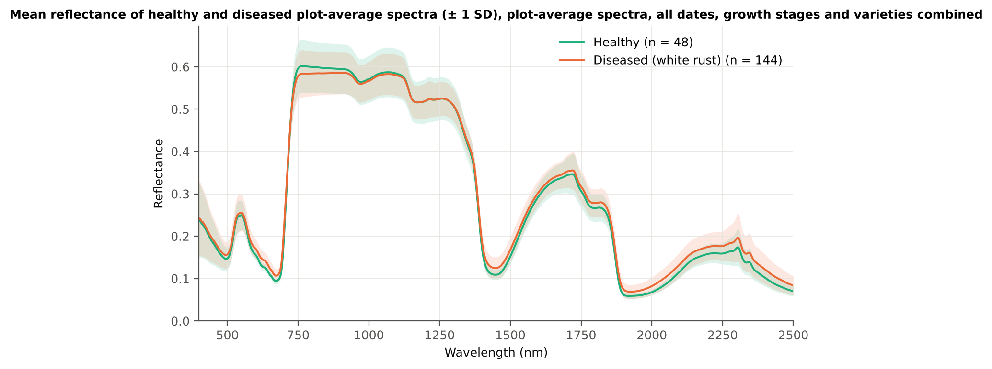
Figure 2. Mean plot-average reflectance of healthy and diseased plots (± 1 SD), all dates combined.
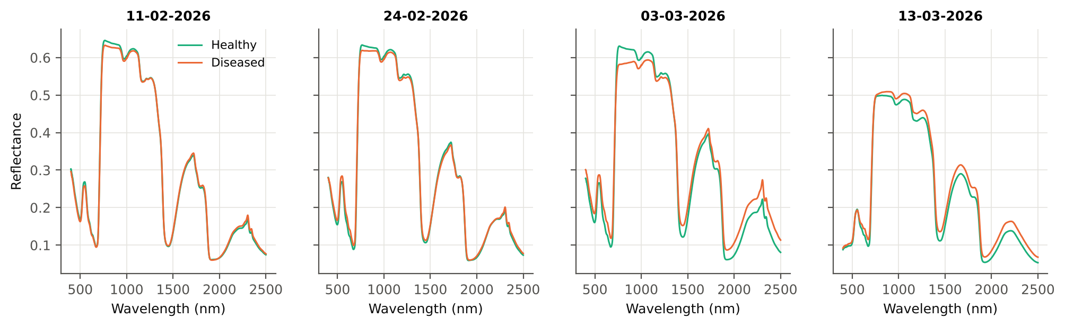
Figure 3. Mean plot-average spectra of healthy and diseased plots on each date.
Diseased plots reflect more in the visible — most clearly in the red (600–680 nm), where chlorophyll absorbs — and in the short-wave infrared beyond 1350 nm, and slightly less on the near-infrared plateau. Higher visible reflectance indicates chlorosis (less chlorophyll), and higher SWIR reflectance indicates lower leaf water content. The difference changes with the date (Figure 3): on 11-02-2026 the classes hardly differ in the red (mean difference −0.3 % reflectance), whereas the red difference is +1.6 % on 24-02, +3.1 % on 03-03 and +1.7 % on 13-03-2026; in SWIR-2 (2000–2300 nm) it grows from +0.3–0.5 % on the first two dates to +3.7 % and +2.4 % on the last two. The NIR plateau (780–1000 nm) is lower in diseased plots on the first three dates (−0.9 to −3.3 %) but higher on 13-03-2026 (+1.2 %), which is why the NIR level is not significant when all dates are pooled.

3.2 Tier 1 — statistical screening
Table 2. Tier 1: number of significant bands (of 2101) by test.
Test | Significant bands
Welch t-test + BH-FDR q < 0.05 (used for Tier 2) | 1039
One-way ANOVA p < 0.05, uncorrected (rule of Das et al.) | 1111
One-way ANOVA + BH-FDR q < 0.05 | 1023
Welch t-test p < 0.05, uncorrected | 1120
Mixed model (random plot effect) + BH-FDR q < 0.05 | 1014
Balanced subsets (48 vs 48): significant in ≥ 95 % of 1000 subsets | 515
Levene test p < 0.05 (unequal variances → Welch) | 704

Welch's t-test with FDR control found 1039 significant bands; 1014 remain significant with a random plot effect, so the differences are not an artefact of repeated measurements of the same plots. In balanced subsets (48 vs 48) a median of 944 bands were significant and 515 bands in at least 95 % of the 1000 subsets — the imbalance does not create the result. The significant bands form contiguous ranges (Table 3, Figure 4): all 80 red bands (600–679 nm), most of the red edge, the water bands and the whole SWIR-2 region, but no band of the NIR plateau (760–1349 nm) and none in the blue.
Table 3. Tier 1 by spectral region: significant bands (Welch + FDR and mixed model) and the band of maximum |t|.
Region | Bands | Welch+FDR significant | Mixed-model significant | Band of max |t| | Max t
Blue (400–499) | 100 | 0 | 0 | 499 | 2.1
Green (500–599) | 100 | 38 | 28 | 599 | 5.7
Red (600–679) | 80 | 80 | 80 | 643 | 8.0
Red edge (680–759) | 80 | 35 | 34 | 695 | 7.8
NIR (760–1349) | 590 | 0 | 0 | 760 | -1.8
Water band I (1350–1430) | 81 | 51 | 52 | 1430 | 5.7
SWIR-1 (1431–1799) | 369 | 151 | 139 | 1432 | 5.7
Water band II (1800–1950) | 151 | 134 | 131 | 1892 | 7.4
SWIR-2 (1951–2349) | 399 | 399 | 399 | 2003 | 7.2
SWIR-2 end (2350–2500) | 151 | 151 | 151 | 2498 | 5.3

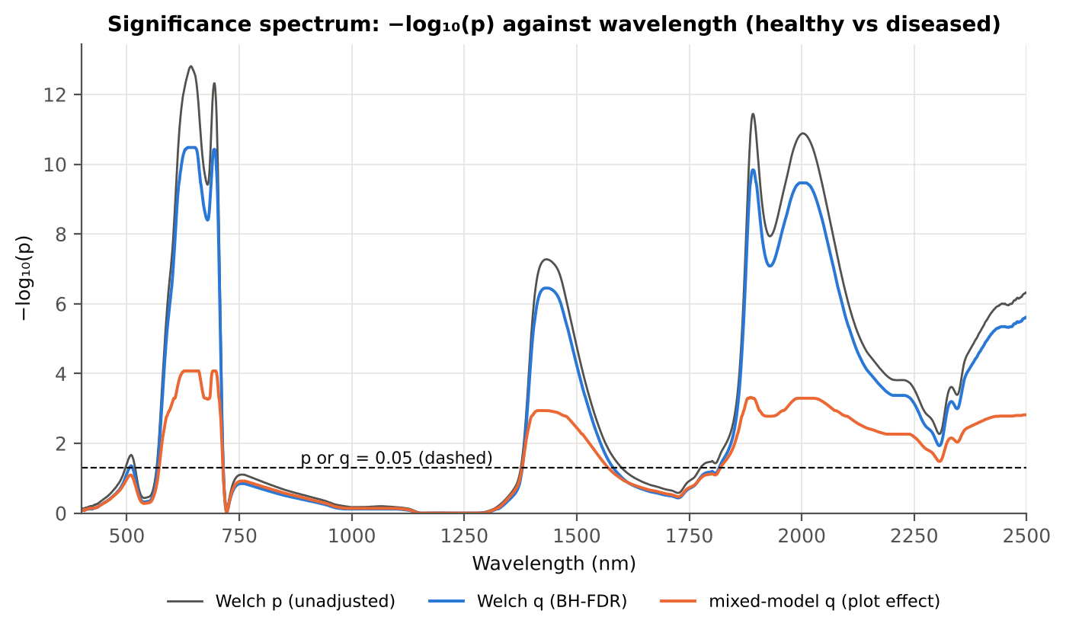
Figure 4. −log₁₀(p) of every band against wavelength (Welch p, FDR-adjusted q and mixed-model q). Dashed line: p or q = 0.05.
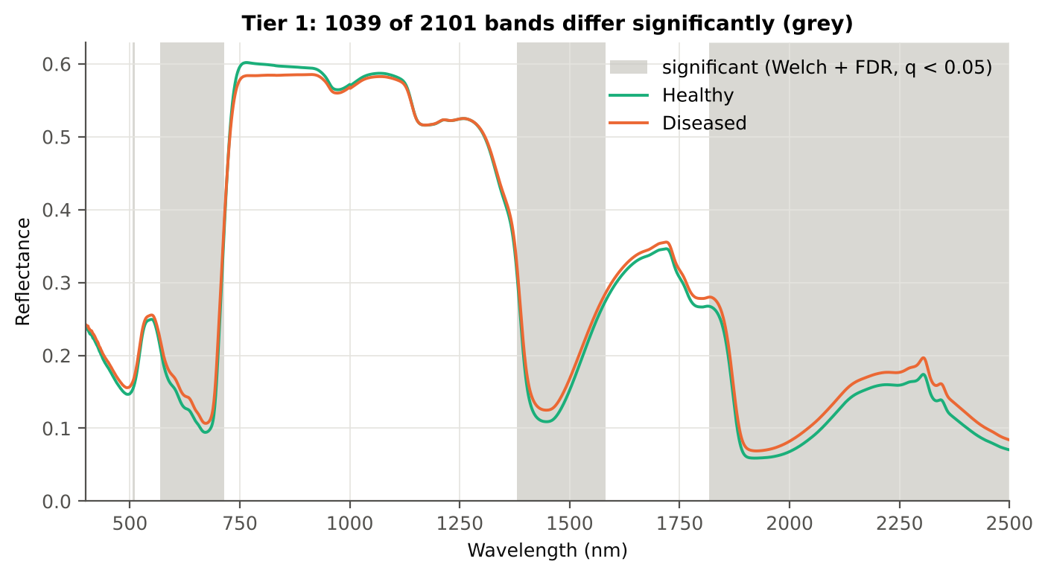
Figure 5. Mean spectra with the Tier-1 significant bands shaded.

3.3 Tier 2 — band selection by CART and Random Forest
CART (equal priors) selected 9 bands, in order of use: 699, 700, 1884, 655, 669, 510, 1384, 1578, 689 nm (Figure 6). The root split is at 699 nm (red edge), followed by red (655, 669 nm), green (510 nm), water-band (1384, 1884 nm) and SWIR-1 (1578 nm) bands. The bands at 699 and 700 nm were re-selected (± 10 nm) in 86 % of 200 plot-level bootstrap trees and in all 50 nested training sets (Table 4). The 1-SE tree uses a single band.
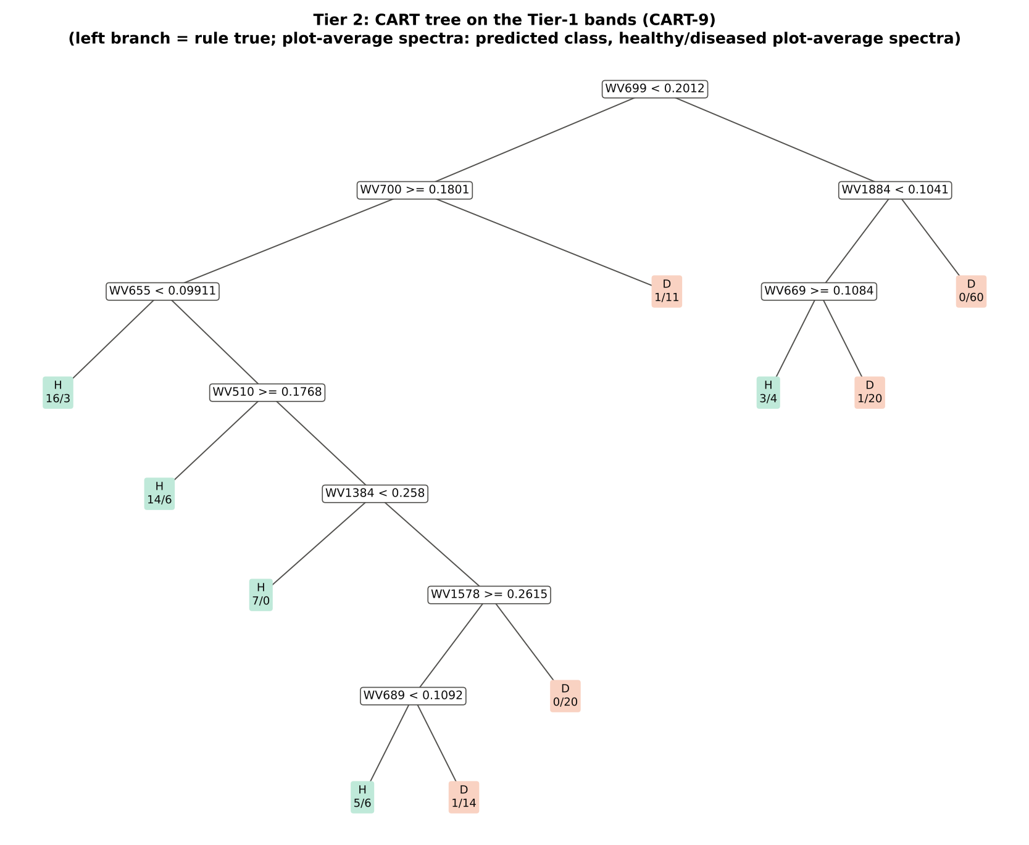
Figure 6. CART tree on the Tier-1 bands (CART-9), rpart with prior 0.5/0.5.
Table 4. The CART-9 bands and how often a band within ± 10 nm is re-selected.
Band (nm) | Region | First used at node | Welch t | Bootstrap re-selection (±10 nm) | Nested cross-validation re-selection (±10 nm) | Mixed model significant
510 | Green | 9 | 2.3 | 37.5 % | 20.0 % | no
655 | Red | 4 | 7.8 | 26.0 % | 48.0 % | yes
669 | Red | 6 | 7.0 | 20.5 % | 34.0 % | yes
689 | Red edge | 78 | 7.5 | 73.0 % | 98.0 % | yes
699 | Red edge | 1 | 7.5 | 86.0 % | 100.0 % | yes
700 | Red edge | 2 | 7.4 | 86.0 % | 100.0 % | yes
1384 | Water band I | 19 | 2.8 | 18.5 % | 18.0 % | yes
1578 | SWIR-1 | 39 | 2.3 | 7.0 % | 4.0 % | no
1884 | Water band II | 3 | 7.0 | 37.5 % | 58.0 % | yes

The Balanced Random Forest importance spectrum (Figure 7) has its highest peaks in the red (602–688 nm) and at the red edge (699 nm) and further peaks in the 1887–1928 nm water band and at 1992–2031 nm: RF-17 = 699, 632, 653, 643, 1887, 614, 2018, 688, 512, 1898, 671, 1992, 602, 2031, 592, 2005, 1928 nm. Ten of the 17 bands lie in the visible and red edge.
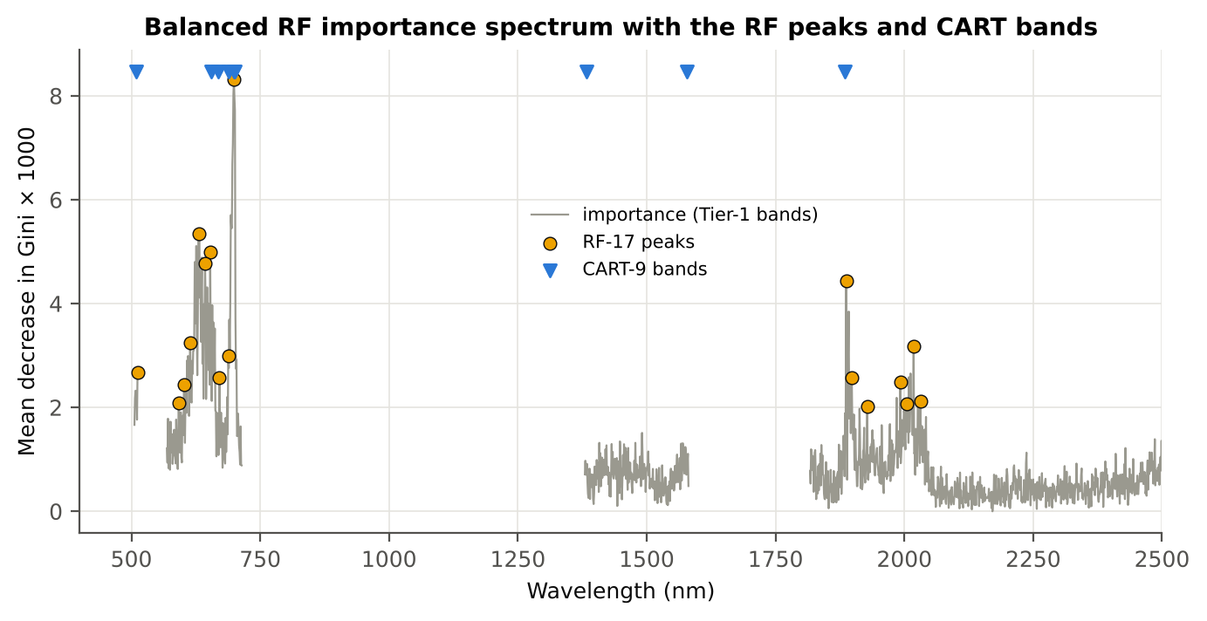
Figure 7. Balanced Random Forest importance spectrum with the RF-17 peaks and the CART bands.

3.4 Tier 3 — Jeffries–Matusita separability
Table 5. Tier 3: Jeffries–Matusita distance (0–2) between healthy and diseased plot-average spectra on each band set.
Set | Features | JM
CART-9 | 9 | 1.521
CART-1 (1-SE) | 1 | 0.462
RF-17 | 17 | 1.960
RF-10 | 10 | 1.669
RF-9 (size-matched) | 9 | 1.624

J–M on the CART bands is 1.521, below the separability threshold; the RF-17 bands reach 1.960, above 1.90 and the 1.94 of Das et al. With the same number of bands as CART (size-matched set) the Random Forest bands give 1.624: slightly better than CART at equal size, so most of the higher separability of RF-17 comes from its larger number of bands. J–M rises steadily as bands are added (Figure 8).
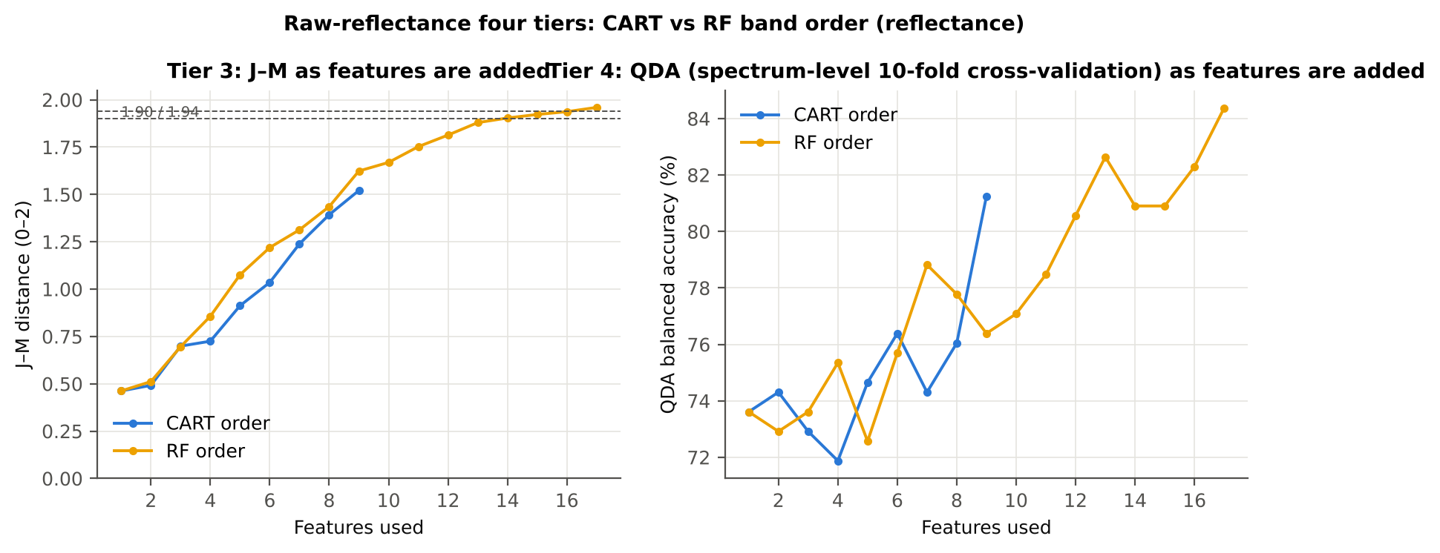
Figure 8. J–M distance and QDA balanced accuracy as the CART and Random Forest bands are added one by one.

3.5 Tier 4 — QDA classification
Table 6. Error matrix of QDA (equal priors) on the CART-9 bands, spectrum-level 10-fold cross-validation (layout of Das et al., Table 2).
Classified \ Reference | Healthy | Diseased | Row total | User's accuracy
Healthy | 41 | 33 | 74 | 55.4 %
Diseased | 7 | 111 | 118 | 94.1 %
Column total | 48 | 144 | 192
Producer's accuracy | 85.4 % | 77.1 %
Overall accuracy | 79.2 % | Balanced accuracy | 81.3 % | κ = 0.529

Table 7. Error matrix of QDA (equal priors) on the RF-17 bands, spectrum-level 10-fold cross-validation.
Classified \ Reference | Healthy | Diseased | Row total | User's accuracy
Healthy | 37 | 12 | 49 | 75.5 %
Diseased | 11 | 132 | 143 | 92.3 %
Column total | 48 | 144 | 192
Producer's accuracy | 77.1 % | 91.7 %
Overall accuracy | 88.0 % | Balanced accuracy | 84.4 % | κ = 0.683

Table 8. Tier 4 on all band sets: QDA with equal and sample priors and LDA (spectrum-level 10-fold cross-validation).
Set | Classifier | OA | BA | PA_H | PA_D | kappa | AUC
CART-9 | QDA equal priors | 79.2 % | 81.2 % | 85.4 % | 77.1 % | 0.529 | 0.878
CART-9 | QDA sample priors | 79.7 % | 78.1 % | 75.0 % | 81.2 % | 0.509 | 0.877
CART-9 | LDA equal priors | 77.6 % | 75.3 % | 70.8 % | 79.9 % | 0.459 | 0.850
CART-1 (1-SE) | QDA equal priors | 66.7 % | 73.6 % | 87.5 % | 59.7 % | 0.347 | 0.767
CART-1 (1-SE) | QDA sample priors | 73.4 % | 62.2 % | 39.6 % | 84.7 % | 0.255 | 0.766
CART-1 (1-SE) | LDA equal priors | 68.2 % | 71.2 % | 77.1 % | 65.3 % | 0.333 | 0.758
RF-17 | QDA equal priors | 88.0 % | 84.4 % | 77.1 % | 91.7 % | 0.683 | 0.939
RF-17 | QDA sample priors | 88.5 % | 83.3 % | 72.9 % | 93.8 % | 0.686 | 0.939
RF-17 | LDA equal priors | 86.5 % | 87.5 % | 89.6 % | 85.4 % | 0.675 | 0.951
RF-10 | QDA equal priors | 75.0 % | 77.1 % | 81.2 % | 72.9 % | 0.448 | 0.867
RF-10 | QDA sample priors | 76.6 % | 76.7 % | 77.1 % | 76.4 % | 0.461 | 0.867
RF-10 | LDA equal priors | 68.2 % | 72.6 % | 81.2 % | 63.9 % | 0.348 | 0.833
RF-9 (size-matched) | QDA equal priors | 72.9 % | 76.4 % | 83.3 % | 69.4 % | 0.422 | 0.863
RF-9 (size-matched) | QDA sample priors | 77.6 % | 78.8 % | 81.2 % | 76.4 % | 0.491 | 0.863
RF-9 (size-matched) | LDA equal priors | 70.3 % | 76.0 % | 87.5 % | 64.6 % | 0.397 | 0.833

With the protocol of Das et al., QDA on the CART bands reaches a balanced accuracy of 81.3 % (OA 79.2 %, κ = 0.529) and on the RF-17 bands 84.4 % (OA 88.0 %, κ = 0.683). With equal priors the healthy recall (producer's accuracy) of the CART bands is 85.4 %; with sample priors it would fall to 75.0 %.

3.6 Validation on new plots and new dates
Table 9. Balanced accuracy of the four pipelines on raw reflectance under each validation scheme (± SD over repeats or splits).
Pipeline | Spectrum-level 10-fold cross-validation | Nested plot-grouped cross-validation | 30 % plot hold-out validation | Leave-one-date-out validation on new plots
CART classifier | 63.9 % | 64.6 % ± 2.6 | 64.0 % ± 6.7 | 53.6 %
Random Forest classifier | 76.0 % | 75.6 % ± 2.0 | 73.0 % ± 5.0 | 55.5 %
QDA on CART-selected features | 81.3 % | 77.6 % ± 2.2 | 72.0 % ± 8.2 | 59.5 %
QDA on Random Forest-selected features | 84.4 % | 86.8 % ± 1.2 | 79.7 % ± 8.1 | 51.8 %

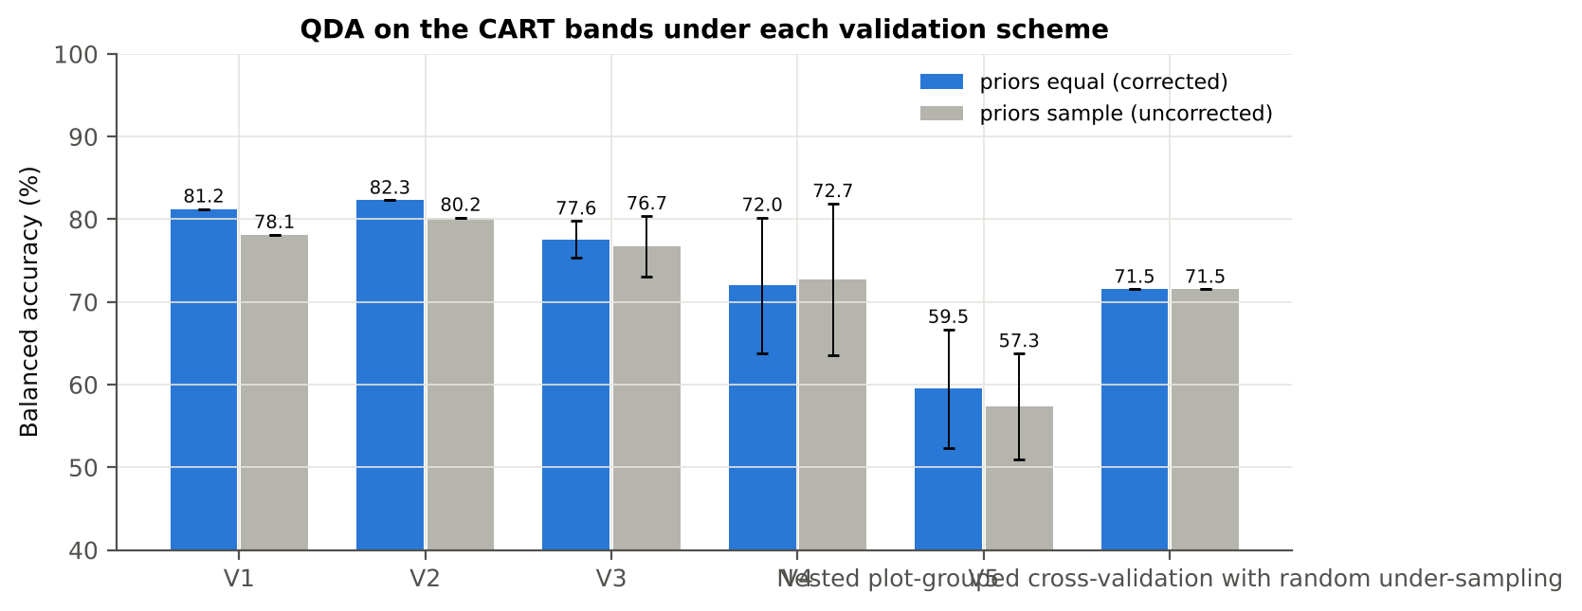
Figure 9. QDA on the CART bands under each validation scheme, equal (corrected) vs sample (uncorrected) priors.
On new plots (nested plot-grouped cross-validation) QDA on the CART bands reaches 77.6 % and QDA on the Random Forest bands 86.8 %; the spectrum-level estimate of the paper's protocol is 3.7 points optimistic for the CART bands. The 30 % plot hold-out gives lower values (72.0 % and 79.7 %) with a large spread between splits, because each split holds out only 4 healthy plots. On an unseen date accuracy drops to 59.5 % (CART bands).
Imbalance correction. In nested cross-validation equal priors give a healthy recall of 80.4 % against 72.1 % with sample priors, at a similar balanced accuracy (77.6 % vs 76.7 %). Random under-sampling of the diseased spectra gave 71.5 % because it discards two thirds of the diseased spectra.

3.7 CART versus Random Forest
Table 10. Paired comparisons on identical folds (positive = first pipeline better).
Comparison | Units | Mean difference | First better | Second better | Wilcoxon p
RF classifier − CART classifier | Nested plot-grouped cross-validation (folds) | +11.6 pts | 40 | 9 | 6.9e-07
RF classifier − CART classifier | 30 % plot hold-out validation (splits) | +9.0 pts | 9 | 0 | 0.004
QDA on RF features − QDA on CART features | Nested plot-grouped cross-validation (folds) | +9.8 pts | 42 | 6 | 7.5e-06
QDA on RF features − QDA on CART features | 30 % plot hold-out validation (splits) | +7.6 pts | 6 | 4 | 0.186
QDA on CART features − CART classifier | Nested plot-grouped cross-validation (folds) | +13.7 pts | 42 | 6 | 3.5e-07
QDA on CART features − CART classifier | 30 % plot hold-out validation (splits) | +8.0 pts | 9 | 1 | 0.004
QDA on RF features − RF classifier | Nested plot-grouped cross-validation (folds) | +11.8 pts | 43 | 4 | 1.2e-07
QDA on RF features − RF classifier | 30 % plot hold-out validation (splits) | +6.7 pts | 7 | 3 | 0.084

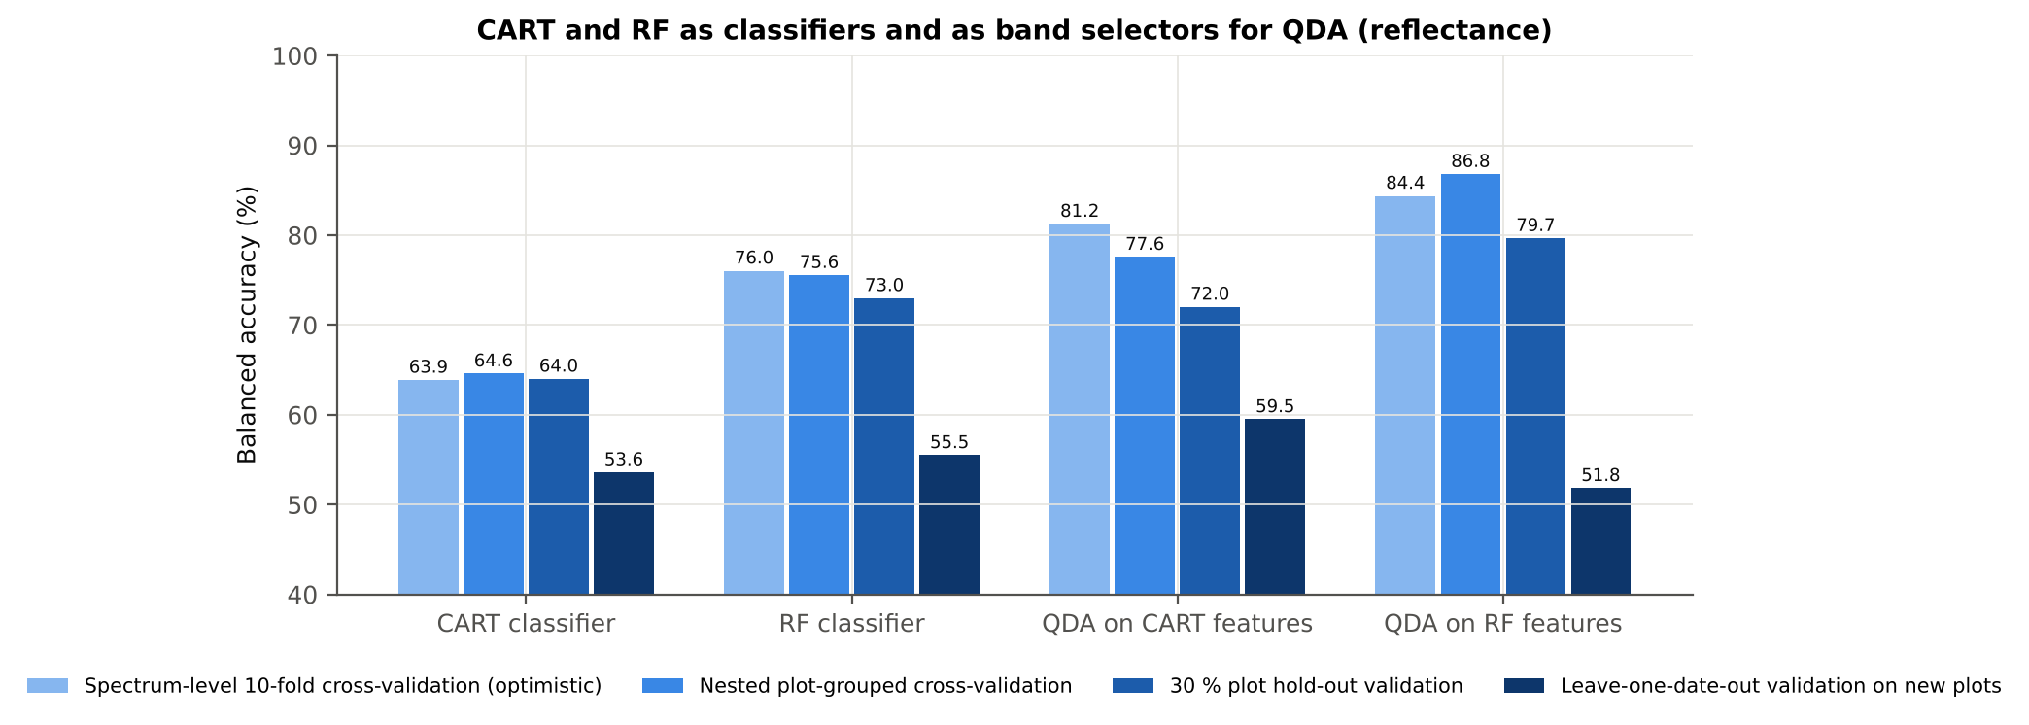
Figure 10. CART and Random Forest as classifiers and as band selectors for QDA (raw reflectance).
Table 11. Stability of the selected bands over the 50 nested training sets.
Method | Mean features | Unique features (union) | Stability index (±10 nm) | Mean pairwise Jaccard (±10 nm)
CART | 7.3 | 145 | 0.048 | 0.268
RF | 17.0 | 327 | 0.193 | 0.670

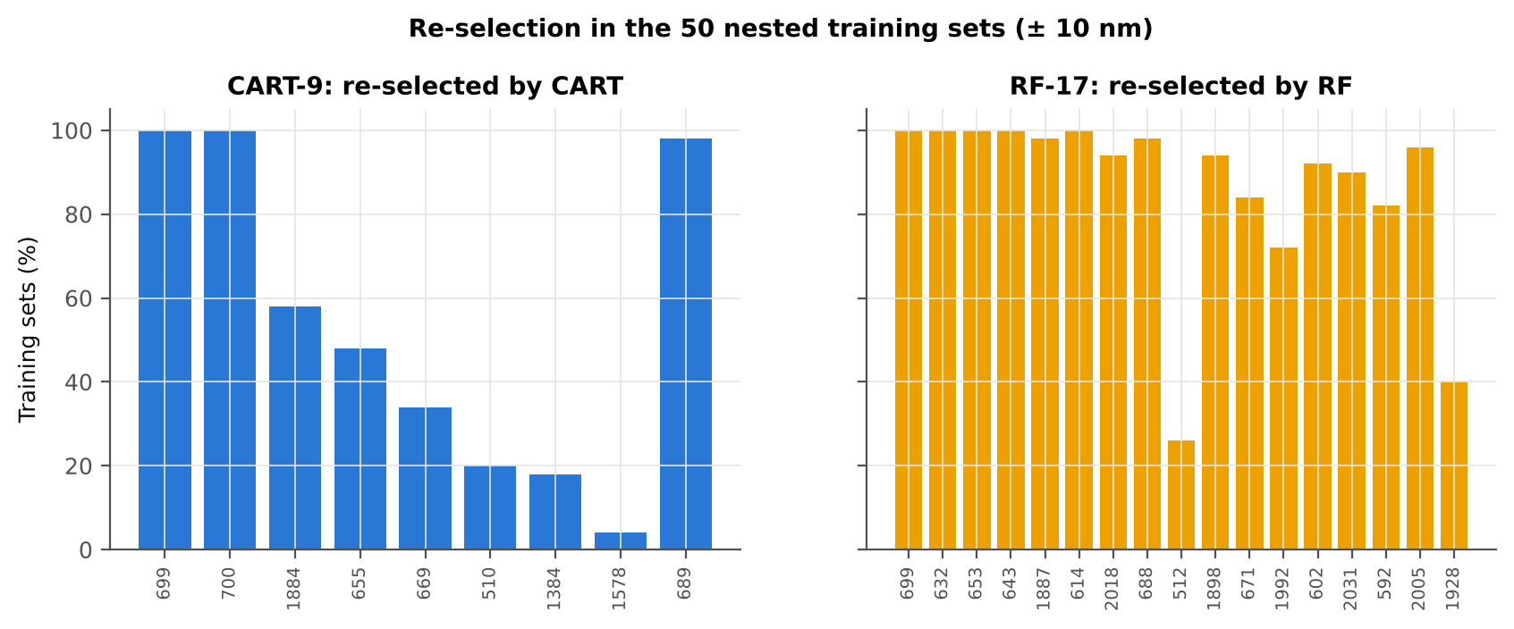
Figure 11. Re-selection of the CART and Random Forest bands in the 50 nested training sets (± 10 nm).
Random Forest is better than CART in both roles: as a classifier by +11.6 pts (Random Forest better in 40 of 50 folds, p = 6.9e-07) and as a band selector for QDA by +9.8 pts (p = 7.5e-06). Its band selection is also far more stable (mean pairwise Jaccard 0.670 vs 0.268 for CART). A single CART tree is unstable because small changes in the training plots change the split variables, whereas the forest averages 1000 trees.

4. Results — disease-sensitive features from raw reflectance

4.1 Band reflectance
Table 12. Most sensitive raw reflectance band of each region (threshold classifier validated on plots).
Region | Wavelength (nm) | AUC | Direction | Hedges g | BA plot-grouped cross-validation | BA hold-out
400–499 | 494 | 0.611 | D > H | 0.29 | 56.4 % | 54.6 %
500–599 | 599 | 0.693 | D > H | 0.71 | 63.6 % | 63.6 %
600–679 | 650 | 0.785 | D > H | 0.95 | 71.2 % | 69.2 %
680–759 | 693 | 0.773 | D > H | 0.93 | 68.5 % | 70.0 %
760–1349 | 761 | 0.628 | D < H | -0.31 | 60.2 % | 61.1 %
1350–1430 | 1415 | 0.699 | D > H | 0.69 | 67.2 % | 64.8 %
1431–1799 | 1431 | 0.693 | D > H | 0.68 | 65.6 % | 64.7 %
1800–1950 | 1892 | 0.757 | D > H | 0.80 | 69.0 % | 69.3 %
1951–2349 | 1998 | 0.743 | D > H | 0.77 | 66.5 % | 67.3 %
2350–2500 | 2498 | 0.662 | D > H | 0.65 | 64.1 % | 63.6 %

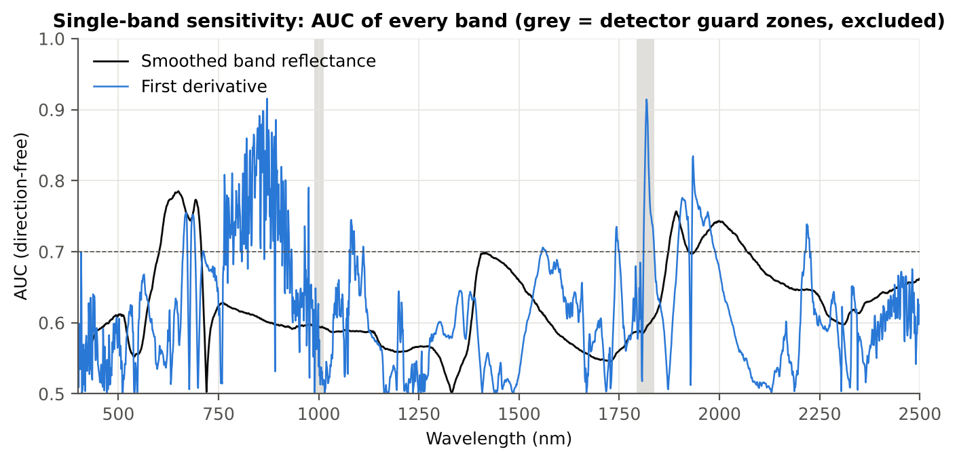
Figure 12. AUC of every band: raw reflectance and first derivative (grey: detector guard zones).
The best single reflectance band is at 650 nm (AUC 0.785, diseased > healthy); 286 bands have AUC ≥ 0.70. A threshold on a single band classifies new plots with a balanced accuracy of at most about 71 % — the disease signal is spread over many bands.

4.2 Continuum removal
Table 13. Continuum-removal parameters ranked by AUC.
name | Mean healthy | Mean diseased | AUC | Direction | BA plot-grouped cross-validation | BA hold-out
CR3 water 970 depth/area | 0.015 | 0.015 | 0.792 | D > H | 78.1 % | 78.6 %
CR3 water 970 width | 66.312 | 63.368 | 0.757 | D < H | 74.0 % | 75.0 %
CR6 water 1940 position | 1912.000 | 1917.049 | 0.743 | D > H | 70.4 % | 71.1 %
CR2 red right area | 26.550 | 24.355 | 0.736 | D < H | 70.0 % | 65.6 %
CR6 water 1940 symmetry | 0.237 | 0.251 | 0.718 | D > H | 71.9 % | 71.7 %
CR2 red area | 95.852 | 89.212 | 0.716 | D < H | 69.0 % | 66.6 %
CR2 red depth/area | 0.008 | 0.009 | 0.710 | D > H | 68.7 % | 66.7 %
CR2 red width | 130.438 | 126.417 | 0.696 | D < H | 69.8 % | 64.9 %
CR2 red depth | 0.795 | 0.763 | 0.695 | D < H | 60.8 % | 59.8 %
CR2 red left area | 69.302 | 64.857 | 0.692 | D < H | 61.3 % | 62.7 %
CR3 water 970 right area | 1.992 | 1.726 | 0.689 | D < H | 68.1 % | 68.8 %
CR6 water 1940 right area | 178.425 | 168.183 | 0.687 | D < H | 62.6 % | 63.6 %

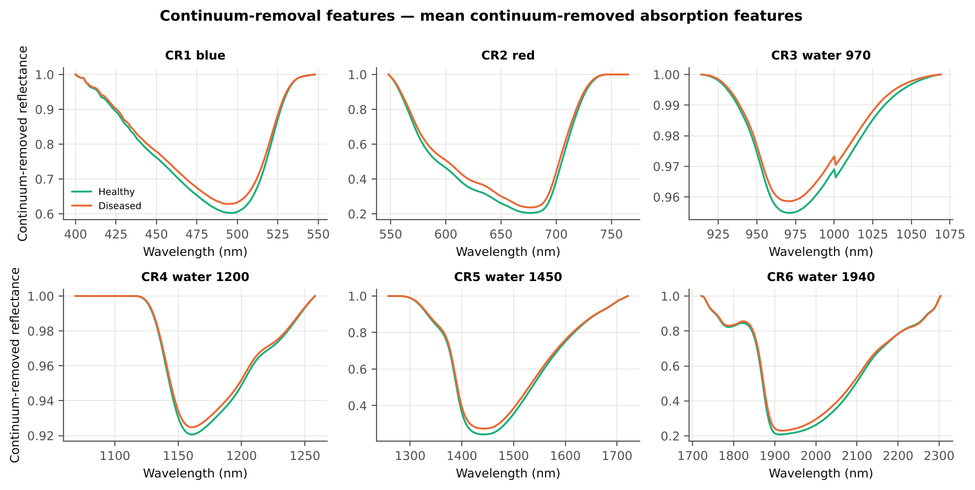
Figure 13. Mean continuum-removed absorption features of healthy and diseased plots.
The strongest continuum-removal parameter is the depth/area ratio of the 970-nm water feature (AUC 0.792; higher in diseased plots), followed by the width of the 970-nm feature (narrower in diseased plots), the position and symmetry of the 1940-nm feature and the area of the red (chlorophyll) feature (smaller in diseased plots). These describe a narrower 970-nm water absorption (higher depth-to-area ratio) and a weaker chlorophyll absorption (smaller red-feature area) in diseased plots.

4.3 Vegetation indices
Table 14. The 15 most sensitive of the 87 vegetation indices.
name | Mean healthy | Mean diseased | AUC | Direction | BA plot-grouped cross-validation | BA hold-out
RARSb | 4.458 | 4.026 | 0.747 | D < H | 71.3 % | 68.8 %
RVS2 | -1.455 | -1.561 | 0.737 | D < H | 64.2 % | 64.8 %
NDVI761 | 0.692 | 0.648 | 0.736 | D < H | 64.0 % | 63.8 %
SR761 | 5.581 | 4.833 | 0.736 | D < H | 64.0 % | 63.8 %
PRI515 | -0.152 | -0.136 | 0.735 | D > H | 61.5 % | 63.7 %
NWI2 | -0.027 | -0.021 | 0.734 | D > H | 71.1 % | 71.8 %
PSSRb | 4.837 | 4.224 | 0.732 | D < H | 70.8 % | 67.9 %
PSNDb | 0.654 | 0.609 | 0.732 | D < H | 70.8 % | 67.9 %
NDVI850 | 0.690 | 0.650 | 0.731 | D < H | 68.0 % | 65.1 %
Ctr2 | 0.244 | 0.289 | 0.720 | D > H | 64.3 % | 64.3 %
PRI | 0.059 | 0.049 | 0.720 | D < H | 70.6 % | 70.6 %
GNDVI | 0.537 | 0.505 | 0.714 | D < H | 61.9 % | 64.2 %
NDVI780 | 0.726 | 0.688 | 0.713 | D < H | 63.5 % | 62.0 %
NWI4 | -0.026 | -0.022 | 0.713 | D > H | 72.6 % | 72.1 %
GM2 | 3.064 | 2.708 | 0.713 | D < H | 67.2 % | 65.9 %

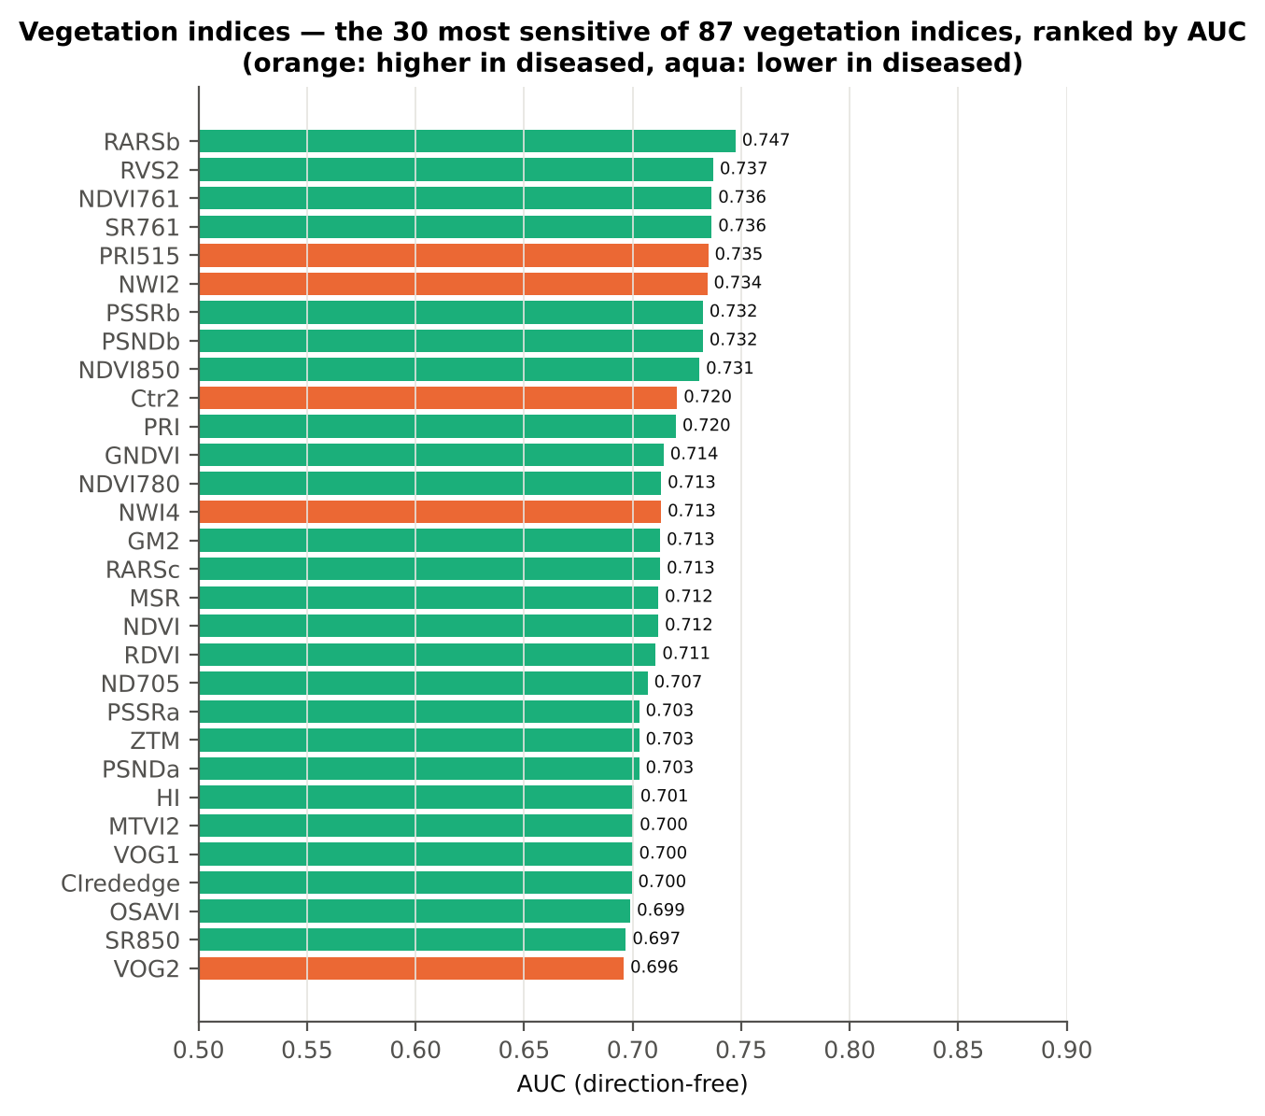
Figure 14. The 30 most sensitive vegetation indices ranked by AUC (orange: higher in diseased, aqua: lower in diseased).
No published index exceeds AUC 0.75: the best are the chlorophyll-b ratio RARSb, the red-edge stress index RVS2, the red-NIR ratios NDVI761/SR761, PRI515, the water index NWI2 and the pigment ratios PSSRb/PSNDb. Published indices use fixed wavelengths chosen for other purposes and capture only part of the white-rust signal.

4.4 Optimised two-band index
Table 15. Optimised two-band indices (all band pairs searched; pairs straddling a detector join excluded).
name | Mean healthy | Mean diseased | AUC | Direction | BA plot-grouped cross-validation | BA hold-out
NDSI(870,872) | 7.9e-05 | -2.8e-05 | 0.916 | D < H | 86.2 % | 87.8 %
DI(870,872) | 9.6e-05 | -3.1e-05 | 0.916 | D < H | 81.8 % | 84.5 %

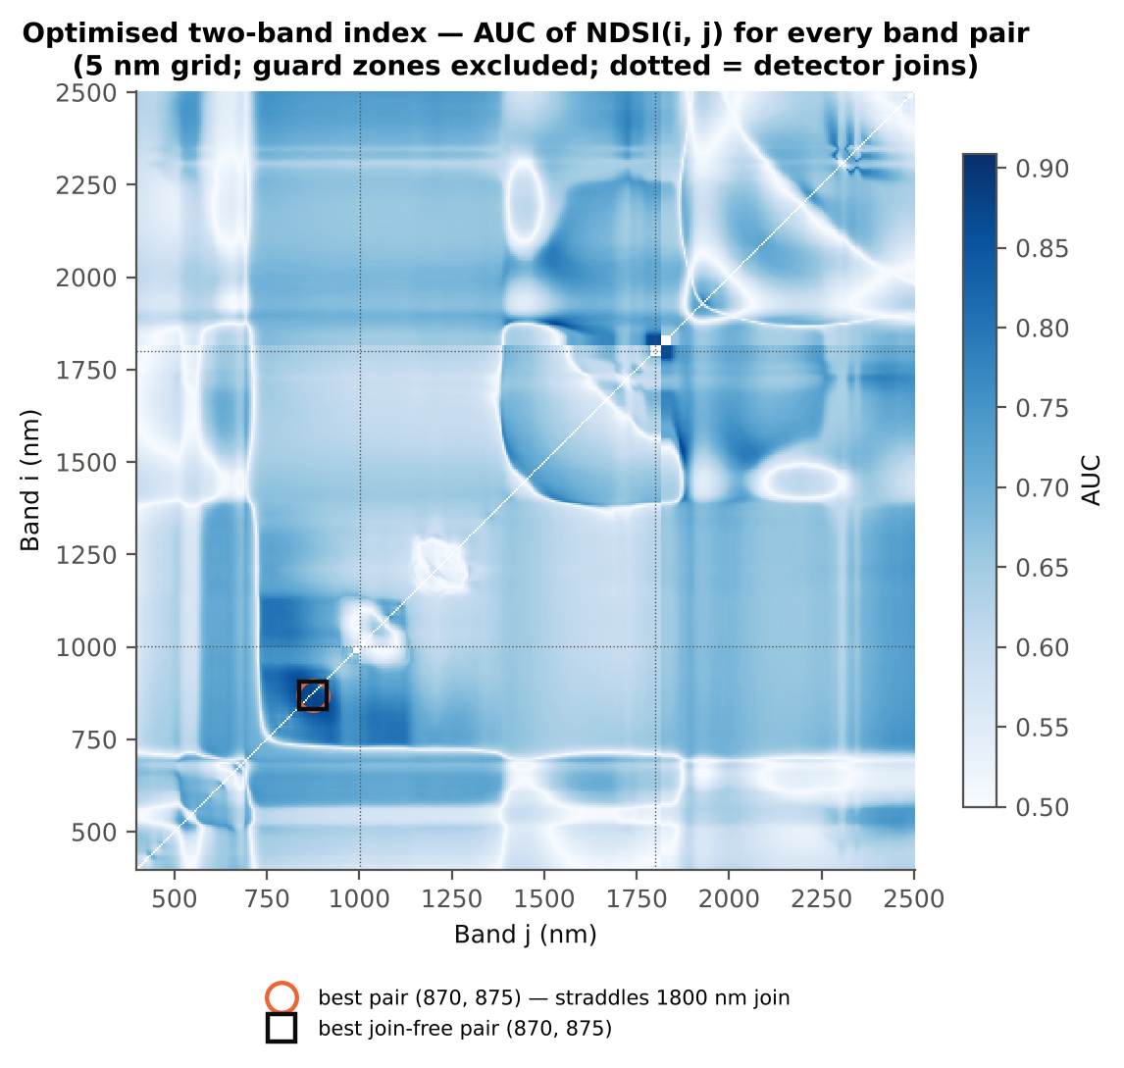
Figure 15. AUC of the normalised-difference index for every band pair.
The best pair is (870, 872) nm (AUC 0.916) — two adjacent bands on the near-infrared shoulder, i.e. a local slope, the same information as the first derivative at 871 nm. When the pair is searched inside the training plots only, the honest balanced accuracy is 78.5 % (NDSI) and 82.6 % (difference index); the pair (870, 875) nm was found in almost every training set, so the location is stable.

4.5 First-, second- and third-derivative spectra
Table 16. Band-wise derivative sensitivity (central differences of raw reflectance; guard zones excluded from the ranking).
Derivative | Significant (FDR) | Best AUC outside guard | at (nm) | Best AUC inside guard (excluded)
First derivative (central difference of raw reflectance) | 677 | 0.916 | 871 | 0.914 at 1818 nm
Second derivative (central difference of raw reflectance) | 488 | 0.829 | 741 | 0.883 at 1805 nm
Third derivative (central difference of raw reflectance) | 375 | 0.832 | 738 | 0.849 at 1819 nm

Table 17. Most sensitive derivative band of each region.
Derivative | Region (nm) | Band (nm) | AUC | Direction | Hedges g
D1 | 400–499 | 407 | 0.700 | D > H | 0.91
D1 | 500–599 | 564 | 0.668 | D > H | 0.39
D1 | 600–679 | 670 | 0.755 | D < H | -0.87
D1 | 680–759 | 686 | 0.752 | D > H | 0.89
D1 | 760–1349 | 871 | 0.916 | D > H | 1.57
D1 | 1350–1430 | 1354 | 0.645 | D > H | 0.49
D1 | 1431–1799 | 1743 | 0.735 | D > H | 0.29
D1 | 1800–1950 | 1934 | 0.834 | D > H | 0.96
D1 | 1951–2349 | 1952 | 0.762 | D > H | 0.90
D1 | 2350–2500 | 2481 | 0.675 | D < H | -0.67
D2 | 400–499 | 419 | 0.700 | D > H | 0.71
D2 | 500–599 | 561 | 0.746 | D > H | 0.98
D2 | 600–679 | 679 | 0.753 | D > H | 0.87
D2 | 680–759 | 741 | 0.829 | D > H | 1.52
D2 | 760–1349 | 976 | 0.779 | D < H | -1.05
D2 | 1350–1430 | 1373 | 0.698 | D > H | 0.47
D2 | 1431–1799 | 1736 | 0.736 | D > H | 0.90
D2 | 1800–1950 | 1915 | 0.820 | D > H | 1.10
D2 | 1951–2349 | 2007 | 0.722 | D < H | -0.77
D2 | 2350–2500 | 2387 | 0.684 | D < H | -0.72
D3 | 400–499 | 418 | 0.697 | D > H | 0.69
D3 | 500–599 | 552 | 0.721 | D > H | 0.88
D3 | 600–679 | 651 | 0.797 | D < H | -1.14
D3 | 680–759 | 738 | 0.832 | D < H | -1.17
D3 | 760–1349 | 1240 | 0.814 | D > H | 1.17
D3 | 1350–1430 | 1375 | 0.683 | D < H | -0.70
D3 | 1431–1799 | 1760 | 0.751 | D > H | 0.97
D3 | 1800–1950 | 1912 | 0.808 | D < H | -1.21
D3 | 1951–2349 | 2276 | 0.742 | D > H | 0.92
D3 | 2350–2500 | 2358 | 0.681 | D < H | -0.71

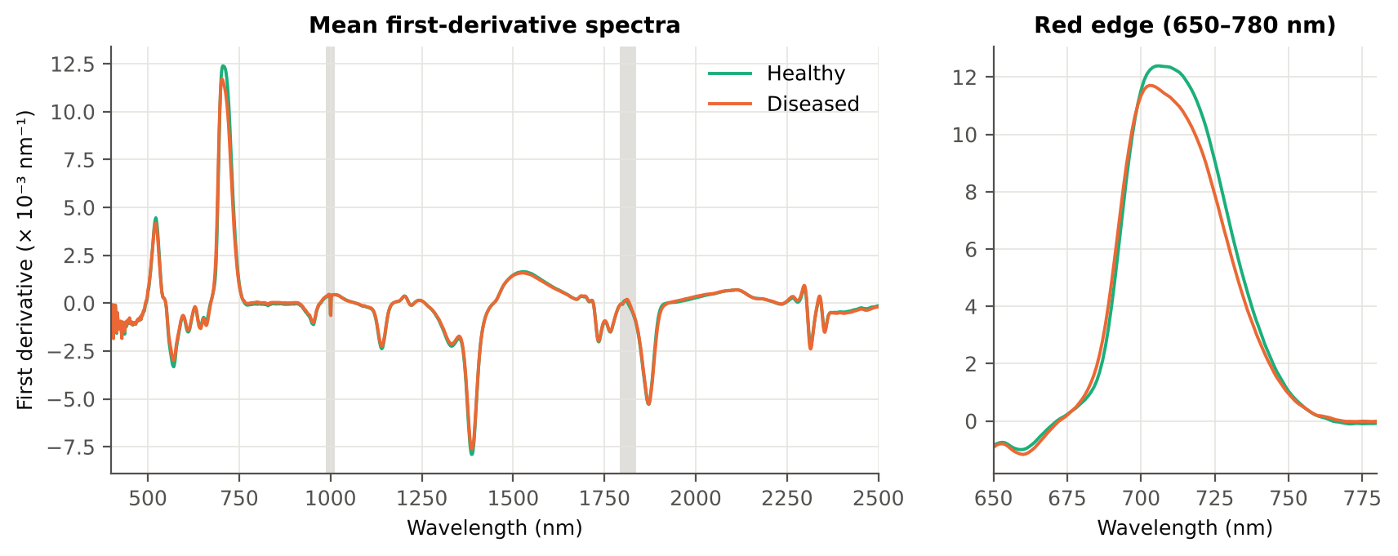
Figure 16. Mean first-derivative spectra of healthy and diseased plots and the red-edge region.
Derivatives are the most discriminating single features: the first derivative at 871 nm reaches AUC 0.916 (Hedges' g = 1.57), the second derivative at 741 nm 0.829 and the third derivative at 738 nm 0.832. In diseased plots the reflectance on the NIR shoulder (780–900 nm) still rises with wavelength, whereas in healthy plots it has already levelled off or falls slightly — a change in the shape of the NIR plateau that the reflectance itself (AUC ≤ 0.63 in this region) does not reveal, because it is masked by brightness differences between plots. The second and third derivatives at 737–741 nm describe a change in the curvature of the upper red edge.

4.6 Red-edge parameters
Table 18. Red-edge and edge parameters ranked by AUC.
name | Mean healthy | Mean diseased | AUC | Direction | BA plot-grouped cross-validation | BA hold-out
Ro (red well reflectance) | 0.094 | 0.107 | 0.752 | D > H | 63.1 % | 63.2 %
REIP, Lagrangian interpolation (nm) | 707.490 | 704.622 | 0.702 | D < H | 70.5 % | 68.9 %
REIP, linear extrapolation (nm) | 706.930 | 703.189 | 0.700 | D < H | 68.6 % | 66.2 %
λr = REP (red-edge position, nm) | 707.438 | 704.632 | 0.696 | D < H | 66.5 % | 65.0 %
REP, linear 4-point (nm) | 715.827 | 714.676 | 0.690 | D < H | 68.2 % | 66.6 %
Red-edge slope (R750 − R700)/50 | 0.008 | 0.007 | 0.690 | D < H | 70.1 % | 66.1 %
λo (red well position, nm) | 671.604 | 672.354 | 0.675 | D > H | 65.3 % | 65.7 %
SDr (red-edge area) | 0.505 | 0.474 | 0.670 | D < H | 65.6 % | 61.2 %
SDy (yellow-edge area) | -0.075 | -0.068 | 0.642 | D > H | 56.1 % | 56.1 %
Dr = REV (red-edge amplitude) | 0.013 | 0.012 | 0.638 | D < H | 58.4 % | 58.5 %
Dy (yellow-edge amplitude) | -0.003 | -0.003 | 0.636 | D > H | 51.8 % | 55.1 %
Rg/Ro | 2.668 | 2.444 | 0.626 | D < H | 54.0 % | 55.9 %
(Rg − Ro)/(Rg + Ro) | 0.446 | 0.405 | 0.626 | D < H | 54.0 % | 55.9 %

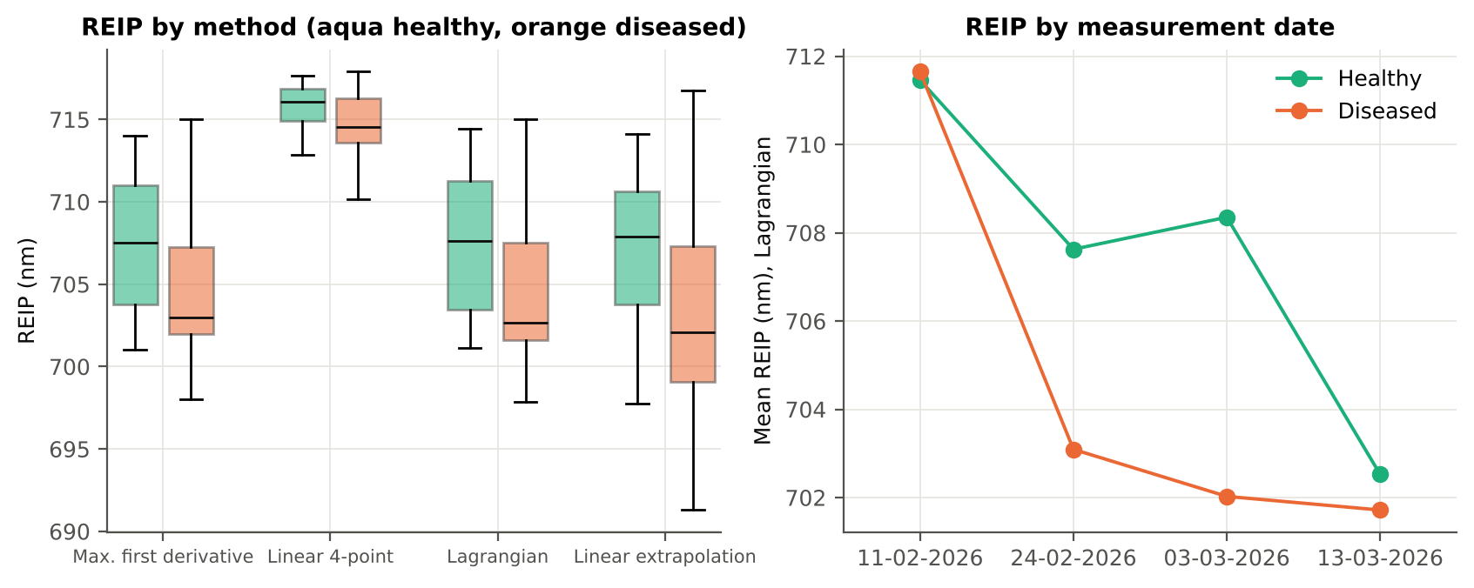
Figure 17. Red-edge inflection point by four methods (left) and by date (right).
The red well reflectance Ro (minimum reflectance 640–680 nm) is higher in diseased plots (AUC 0.75). The red-edge inflection point shifts to shorter wavelengths in diseased plots (Lagrangian: 707.5 → 704.6 nm, a 2.9-nm 'blue shift'; AUC 0.70), the classical sign of chlorophyll loss; the four REIP methods agree on the direction.

4.7 Correlation spectra
Table 19. Band of maximum |r| (point-biserial correlation with disease status) per region, and whether its sign is the same on all four dates.
Spectrum | Region (nm) | Band of max |r| | r | Same sign on all 4 dates
Reflectance | 400–499 | 499 | +0.139 | no
Reflectance | 500–599 | 599 | +0.298 | no
Reflectance | 600–679 | 648 | +0.385 | no
Reflectance | 680–759 | 695 | +0.376 | no
Reflectance | 760–1349 | 760 | -0.136 | no
Reflectance | 1350–1430 | 1421 | +0.288 | yes
Reflectance | 1431–1799 | 1431 | +0.287 | yes
Reflectance | 1800–1950 | 1890 | +0.330 | yes
Reflectance | 1951–2349 | 2005 | +0.320 | yes
Reflectance | 2350–2500 | 2500 | +0.275 | yes
First derivative | 400–499 | 407 | +0.369 | no
First derivative | 500–599 | 530 | -0.187 | yes
First derivative | 600–679 | 669 | -0.364 | no
First derivative | 680–759 | 686 | +0.364 | yes
First derivative | 760–1349 | 871 | +0.566 | yes
First derivative | 1350–1430 | 1351 | +0.214 | no
First derivative | 1431–1799 | 1749 | +0.300 | yes
First derivative | 1800–1950 | 1910 | -0.403 | yes
First derivative | 1951–2349 | 1952 | +0.365 | yes
First derivative | 2350–2500 | 2481 | -0.282 | yes

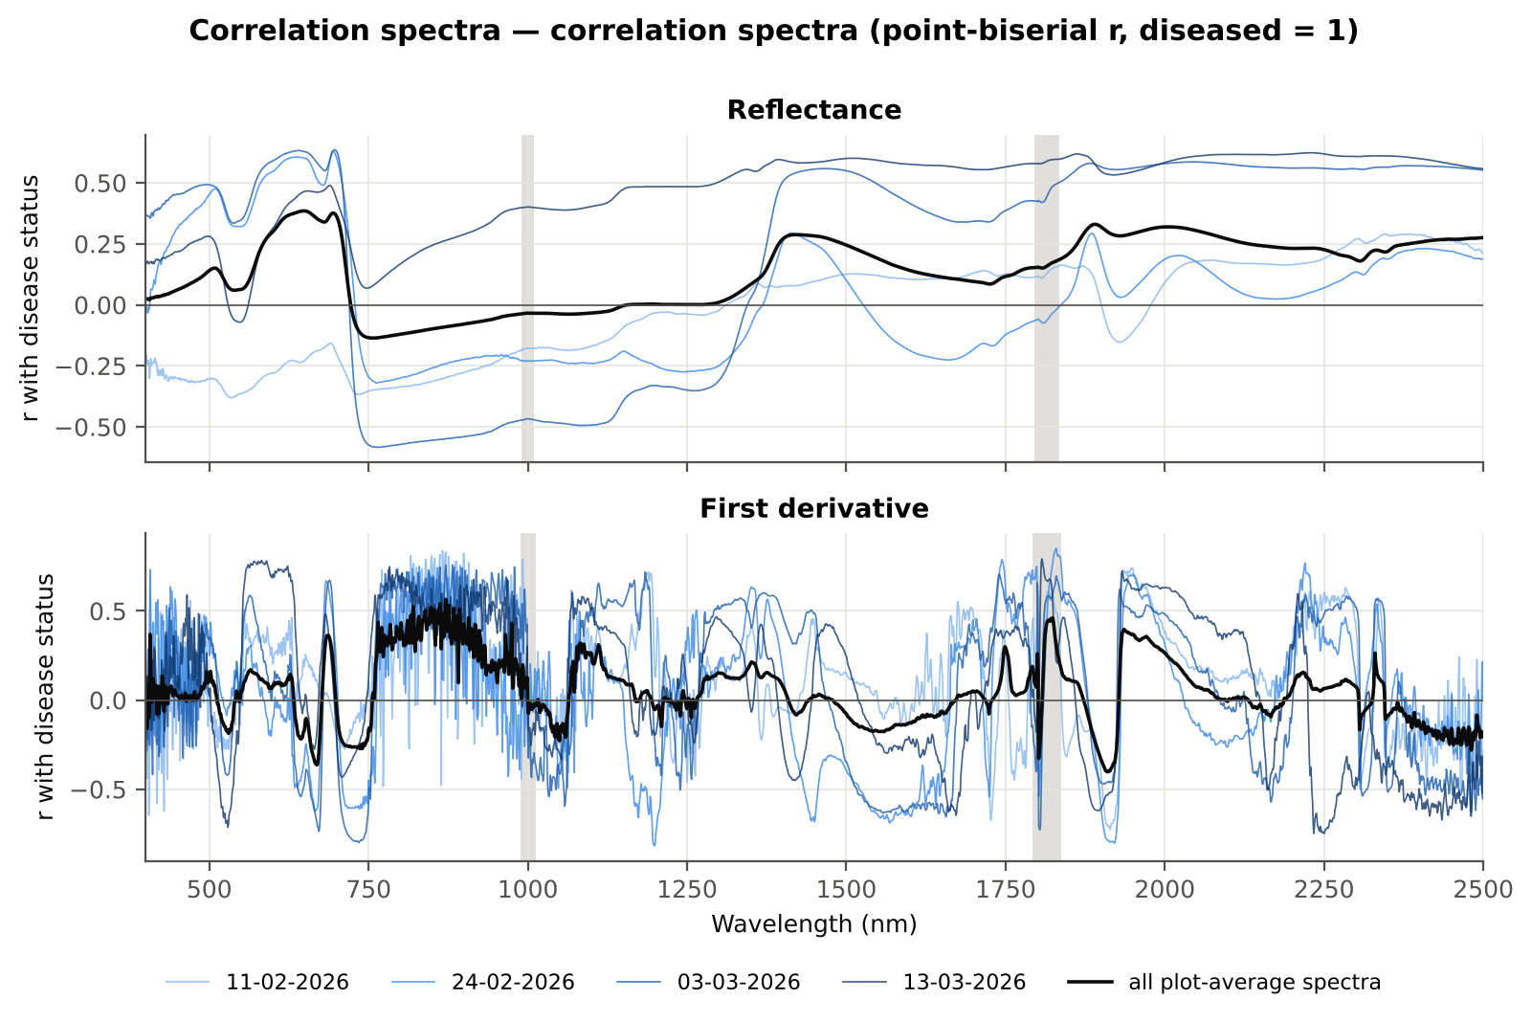
Figure 18. Correlation of reflectance and first derivative with disease status, all spectra and each date.
The largest correlation is again for the first derivative at 871 nm (r = +0.57), and its sign is the same on all four dates. Correlations of reflectance in the SWIR are consistent across dates; those in the visible change sign between dates, i.e. the visible signal depends on the growth stage.

4.8 CART versus Random Forest on each feature group
Table 20. Balanced accuracy of CART and Balanced Random Forest on each feature group (nested plot-grouped cross-validation and 30 % plot hold-out).
Feature group | Features | CART cross-validation | RF cross-validation | CART hold-out | RF hold-out
Full spectrum (raw reflectance) | 2101 | 66.5 % | 77.4 % | 67.4 % | 71.1 %
Band reflectance | 2039 | 66.5 % | 77.5 % | 67.4 % | 71.5 %
Continuum-removal parameters | 48 | 86.8 % | 93.2 % | 82.3 % | 91.7 %
Vegetation indices | 87 | 71.5 % | 78.3 % | 70.3 % | 75.2 %
Derivatives + edge parameters | 6092 | 81.6 % | 94.1 % | 79.6 % | 93.9 %
All disease-sensitive features combined pool | 8266 | 81.6 % | 92.6 % | 80.5 % | 92.6 %
Derivatives incl. guard-zone bands (artefact test) | 6326 | 86.4 % | 95.6 % | 86.5 % | 95.5 %
Selected (top 15 non-redundant, chosen inside each training set) | 15 | 80.8 % | 87.6 % | 80.2 % | 86.8 %

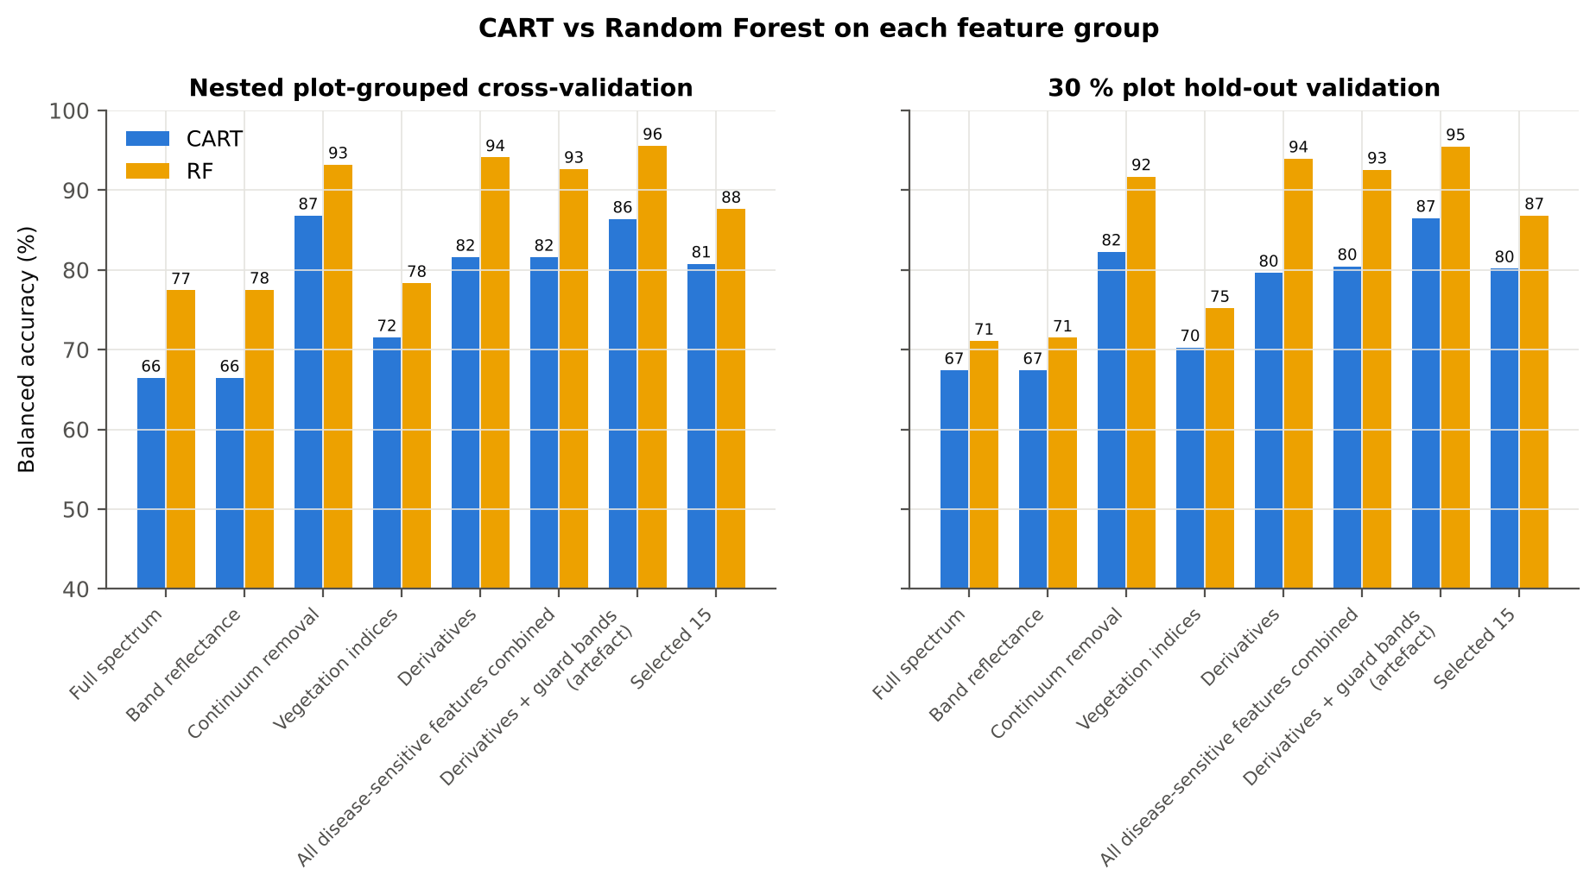
Figure 19. CART versus Random Forest on each feature group.
Random Forest beats CART on every feature group (Wilcoxon p < 0.001 in cross-validation). The derivative-and-edge group (94.1 %) and the continuum-removal parameters (93.2 %) give by far the highest accuracy, against 77.5 % for band reflectance and 78.3 % for the vegetation indices. Including the guard-zone bands beside the detector joins raises the derivative group further (95.6 %), but these bands carry an instrument artefact and were excluded.

5. Results — four tiers on the combined feature pool

5.1 Pool and Tier 1
Table 21. Composition of the combined pool, Tier-1 significant features and the features chosen by CART and Random Forest.
Feature type | Features | Tier-1 significant | CART-4 | CART-2 (1-SE) | RF-17 | RF-10 | RF-4 (size-matched)
Band reflectance | 2039 | 1000 | 0 | 0 | 0 | 0 | 0
Continuum removal | 48 | 25 | 0 | 0 | 0 | 0 | 0
Vegetation index | 85 | 58 | 0 | 0 | 0 | 0 | 0
Second-derivative band | 2019 | 489 | 2 | 1 | 7 | 3 | 1
Third-derivative band | 2019 | 394 | 1 | 0 | 4 | 1 | 0
Edge parameter | 23 | 12 | 0 | 0 | 0 | 0 | 0
First-derivative band | 2031 | 638 | 1 | 1 | 6 | 6 | 3

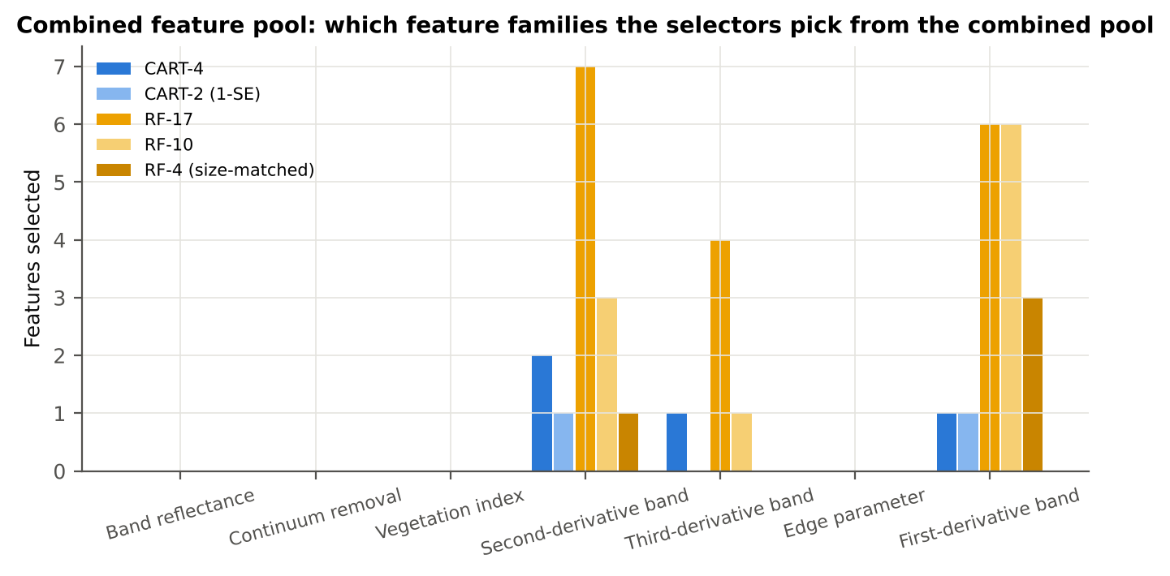
Figure 20. Feature types chosen by CART and Random Forest from the combined pool.
The pool contains 8264 features, of which 2616 passed Tier 1.

5.2 Tier 2 — selected features
CART (CART-4) chose first derivative at 871 nm, second derivative at 682 nm, third derivative at 1244 nm, second derivative at 557 nm. Random Forest (RF-17) chose first derivative at 871 nm, first derivative at 852 nm, second derivative at 737 nm, first derivative at 893 nm, second derivative at 682 nm, third derivative at 738 nm, first derivative at 839 nm, first derivative at 784 nm, second derivative at 1240 nm, first derivative at 820 nm, third derivative at 1240 nm, second derivative at 934 nm, second derivative at 889 nm, third derivative at 888 nm, second derivative at 1720 nm, third derivative at 1077 nm, second derivative at 1918 nm. Both selectors chose only derivative features; no reflectance band, vegetation index or continuum-removal parameter entered the RF-17 set.
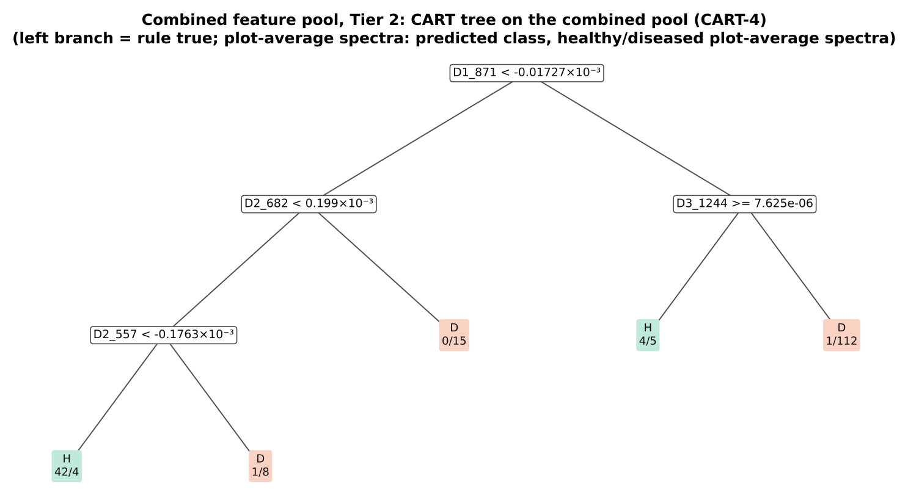
Figure 21. CART tree on the combined pool (CART-4).
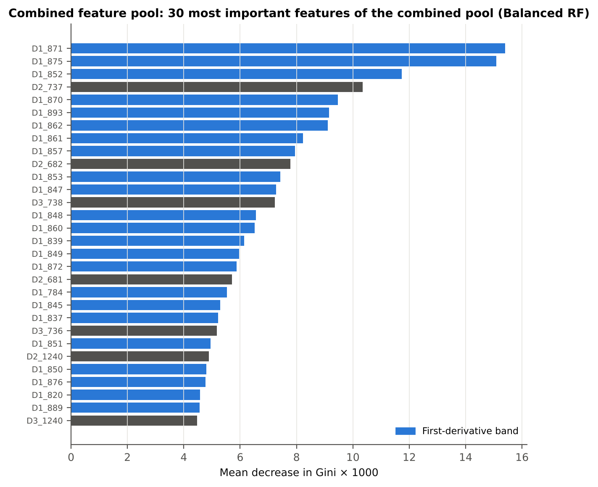
Figure 22. The 30 most important features of the combined pool (Balanced Random Forest).

5.3 Tiers 3 and 4
Table 22. Jeffries–Matusita distance on the feature sets of the combined pool.
Set | Features | JM
CART-4 | 4 | 1.200
CART-2 (1-SE) | 2 | 0.996
RF-17 | 17 | 1.954
RF-10 | 10 | 1.796
RF-4 (size-matched) | 4 | 1.017

Table 23. Error matrix of QDA (equal priors) on the RF-17 features of the combined pool, spectrum-level 10-fold cross-validation.
Classified \ Reference | Healthy | Diseased | Row total | User's accuracy
Healthy | 40 | 5 | 45 | 88.9 %
Diseased | 8 | 139 | 147 | 94.6 %
Column total | 48 | 144 | 192
Producer's accuracy | 83.3 % | 96.5 %
Overall accuracy | 93.2 % | Balanced accuracy | 89.9 % | κ = 0.816

Table 24. Tier 4 on all feature sets of the combined pool (spectrum-level 10-fold cross-validation).
Set | Classifier | OA | BA | PA_H | PA_D | kappa | AUC
CART-4 | QDA equal priors | 88.5 % | 88.2 % | 87.5 % | 88.9 % | 0.714 | 0.959
CART-4 | QDA sample priors | 89.6 % | 86.8 % | 81.2 % | 92.4 % | 0.726 | 0.958
CART-4 | LDA equal priors | 78.6 % | 81.6 % | 87.5 % | 75.7 % | 0.526 | 0.934
CART-2 (1-SE) | QDA equal priors | 84.4 % | 83.3 % | 81.2 % | 85.4 % | 0.615 | 0.944
CART-2 (1-SE) | QDA sample priors | 89.6 % | 84.0 % | 72.9 % | 95.1 % | 0.710 | 0.944
CART-2 (1-SE) | LDA equal priors | 79.7 % | 83.0 % | 89.6 % | 76.4 % | 0.549 | 0.931
RF-17 | QDA equal priors | 93.2 % | 89.9 % | 83.3 % | 96.5 % | 0.816 | 0.971
RF-17 | QDA sample priors | 92.7 % | 87.5 % | 77.1 % | 97.9 % | 0.794 | 0.971
RF-17 | LDA equal priors | 94.3 % | 93.4 % | 91.7 % | 95.1 % | 0.850 | 0.984
RF-10 | QDA equal priors | 91.7 % | 91.7 % | 91.7 % | 91.7 % | 0.789 | 0.981
RF-10 | QDA sample priors | 93.2 % | 92.7 % | 91.7 % | 93.8 % | 0.826 | 0.981
RF-10 | LDA equal priors | 93.8 % | 93.1 % | 91.7 % | 94.4 % | 0.838 | 0.982
RF-4 (size-matched) | QDA equal priors | 84.4 % | 82.6 % | 79.2 % | 86.1 % | 0.610 | 0.934
RF-4 (size-matched) | QDA sample priors | 88.5 % | 81.2 % | 66.7 % | 95.8 % | 0.672 | 0.934
RF-4 (size-matched) | LDA equal priors | 85.4 % | 84.7 % | 83.3 % | 86.1 % | 0.641 | 0.906

J–M is 1.954 on the RF-17 features (separable) and 1.200 on the 4 CART features. QDA on the RF-17 features reaches a balanced accuracy of 89.9 % (OA 93.2 %, κ = 0.816) in the protocol of Das et al.
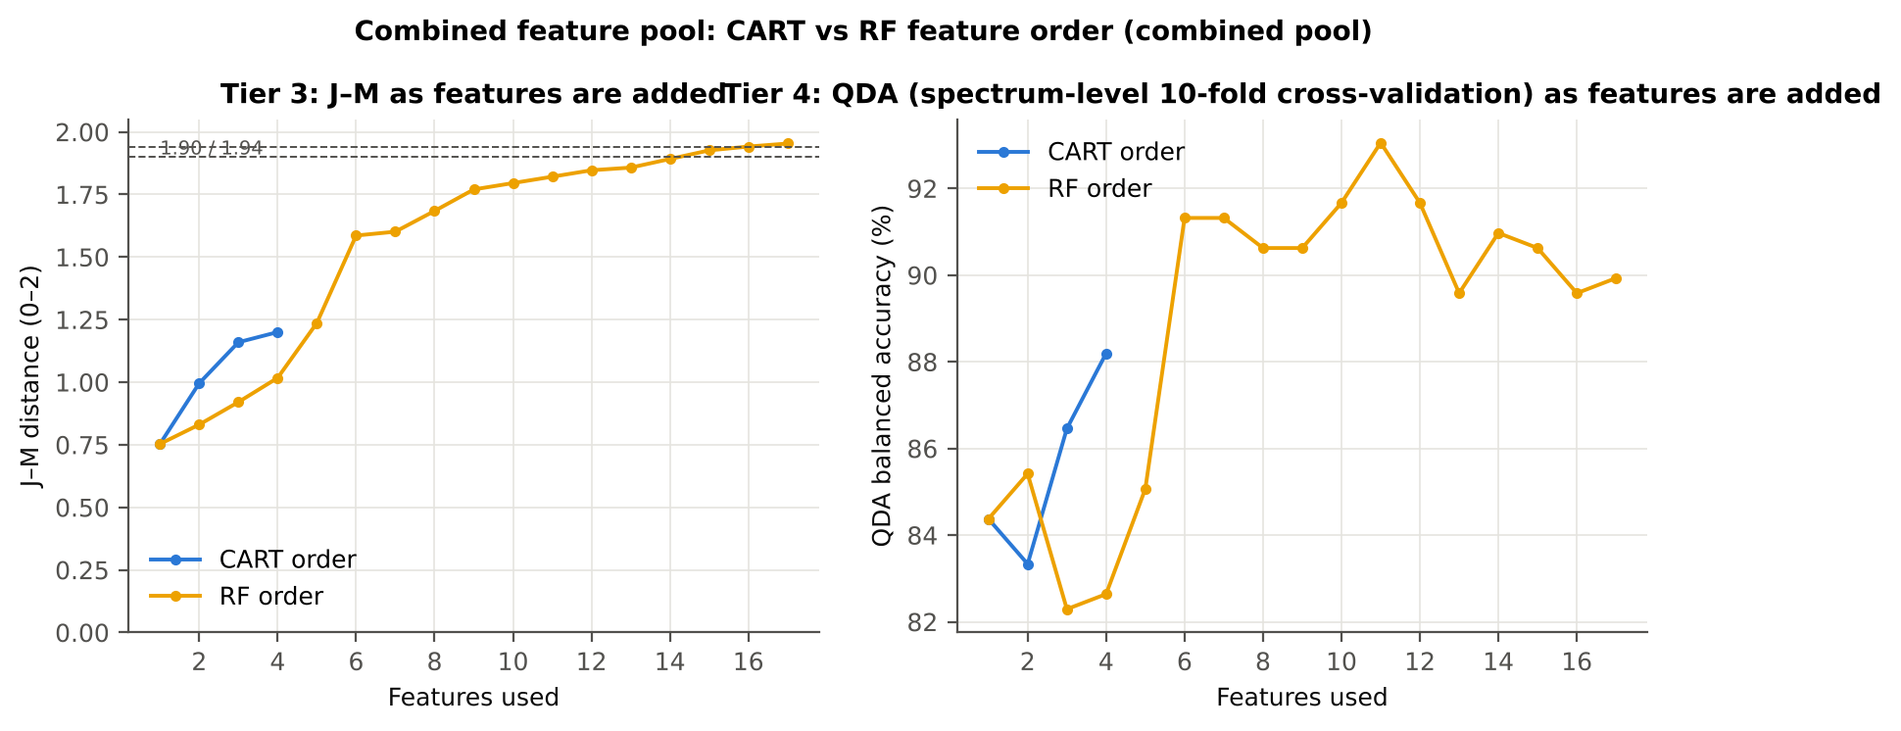
Figure 23. J–M and QDA balanced accuracy as the combined-pool features are added.

5.4 Validation
Table 25. Balanced accuracy of the four pipelines on the combined pool under each validation scheme.
Pipeline | Spectrum-level 10-fold cross-validation | Nested plot-grouped cross-validation | 30 % plot hold-out validation | Leave-one-date-out validation on new plots
CART classifier | 82.3 % | 82.9 % | 79.5 % | 53.2 %
Random Forest classifier | 92.7 % | 93.1 % | 92.3 % | 58.4 %
QDA on CART-selected features | 88.2 % | 84.4 % | 82.0 % | 52.8 %
QDA on Random Forest-selected features | 89.9 % | 87.2 % | 76.5 % | 49.8 %

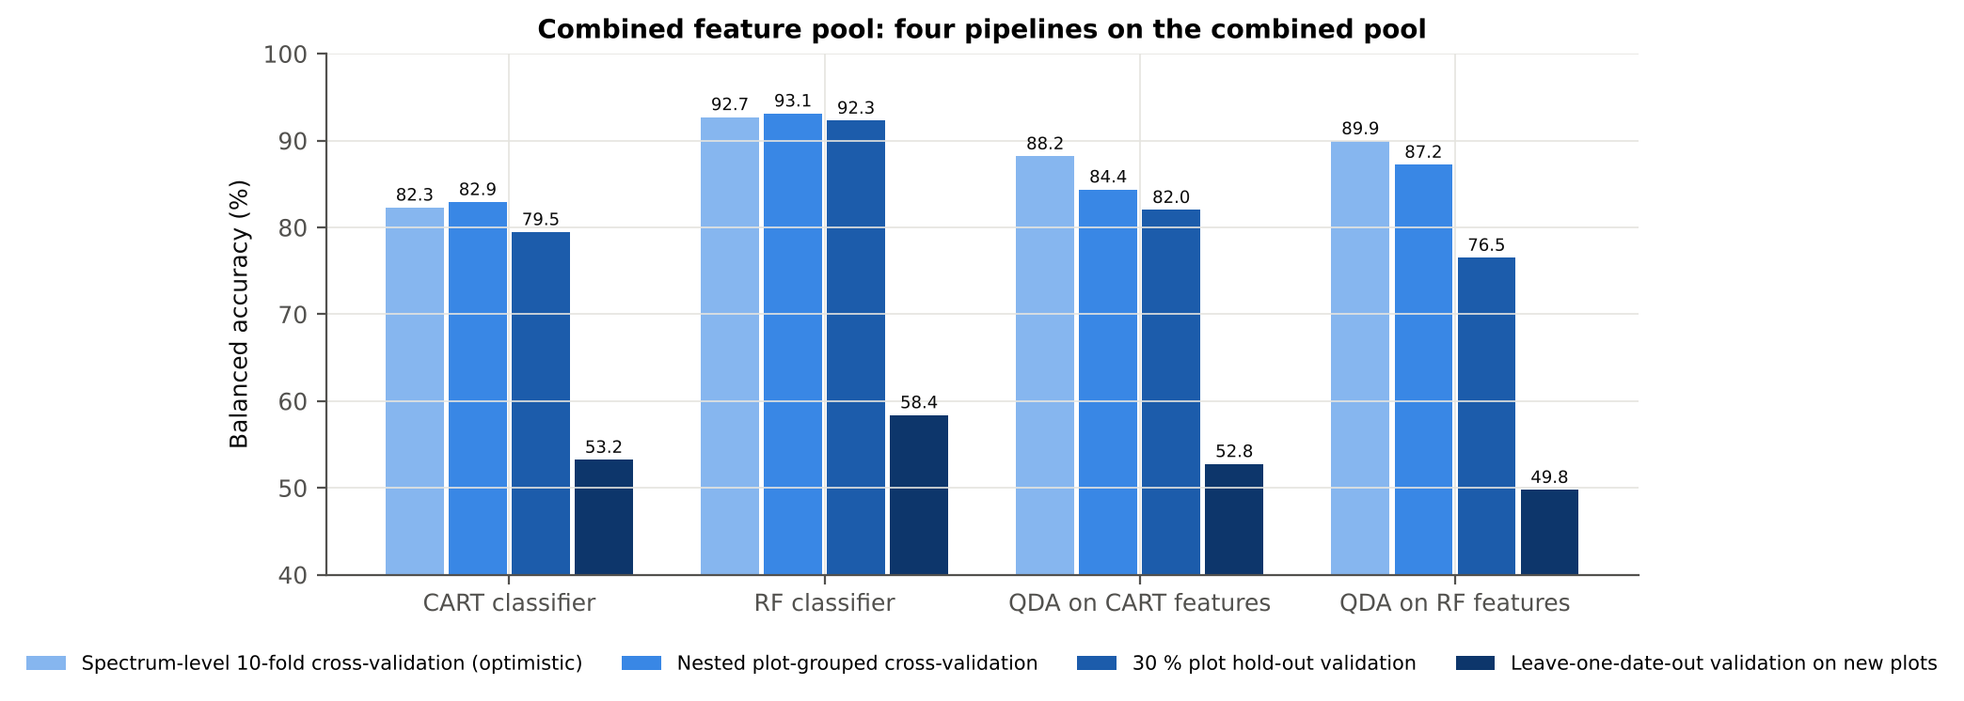
Figure 24. The four pipelines on the combined pool under the four validation schemes.
Table 26. Combined pool vs raw reflectance (paired over identical folds; positive = first better).
First | Second | Units | Mean difference (BA) | First better | Second better | Wilcoxon p
Combined pool: QDA on CART features | Reflectance: QDA on CART bands | Nested plot-grouped cross-validation (50 folds) | +6.8 pts | 31 | 12 | 6.1e-04
Combined pool: QDA on CART features | Reflectance: QDA on CART bands | 30 % plot hold-out validation (10 splits) | +10.0 pts | 8 | 2 | 0.010
Combined pool: QDA on RF features | Reflectance: QDA on RF bands | Nested plot-grouped cross-validation (50 folds) | -0.2 pts | 18 | 21 | 0.955
Combined pool: QDA on RF features | Reflectance: QDA on RF bands | 30 % plot hold-out validation (10 splits) | -3.2 pts | 3 | 7 | 0.307
Combined pool: RF classifier (Tier-1 features) | Reflectance: RF classifier (Tier-1 bands) | Nested plot-grouped cross-validation (50 folds) | +17.3 pts | 48 | 1 | 1.2e-09
Combined pool: RF classifier (Tier-1 features) | Reflectance: RF classifier (Tier-1 bands) | 30 % plot hold-out validation (10 splits) | +19.3 pts | 10 | 0 | 0.002
Combined pool: CART classifier (Tier-1 features) | Reflectance: CART classifier (Tier-1 bands) | Nested plot-grouped cross-validation (50 folds) | +19.0 pts | 43 | 3 | 5.2e-09
Combined pool: CART classifier (Tier-1 features) | Reflectance: CART classifier (Tier-1 bands) | 30 % plot hold-out validation (10 splits) | +15.5 pts | 10 | 0 | 0.002
Combined pool: QDA on RF features | Combined pool: QDA on CART features | Nested plot-grouped cross-validation (50 folds) | +2.8 pts | 26 | 17 | 0.113
Combined pool: QDA on RF features | Combined pool: QDA on CART features | 30 % plot hold-out validation (10 splits) | -5.5 pts | 3 | 7 | 0.084
Combined pool: QDA on RF features | CART vs Random Forest on each feature group — RF classifier on all 8266 features | Nested plot-grouped cross-validation (50 folds) | -5.1 pts | 9 | 26 | 0.006
Combined pool: QDA on RF features | CART vs Random Forest on each feature group — RF classifier on all 8266 features | 30 % plot hold-out validation (10 splits) | -16.1 pts | 0 | 10 | 0.002
Combined pool: QDA on RF features | CART vs Random Forest on each feature group — QDA on 15 features chosen by AUC | Nested plot-grouped cross-validation (50 folds) | -2.0 pts | 17 | 24 | 0.246
Combined pool: QDA on RF features | CART vs Random Forest on each feature group — QDA on 15 features chosen by AUC | 30 % plot hold-out validation (10 splits) | -8.6 pts | 1 | 9 | 0.045
Combined pool: RF classifier (Tier-1 features) | CART vs Random Forest on each feature group — RF classifier on all 8266 features | Nested plot-grouped cross-validation (50 folds) | +0.6 pts | 6 | 3 | 0.337
Combined pool: RF classifier (Tier-1 features) | CART vs Random Forest on each feature group — RF classifier on all 8266 features | 30 % plot hold-out validation (10 splits) | -0.3 pts | 2 | 4 | 0.656

The combined pool improves the tree-based classifiers strongly: the Random Forest classifier rises from 75.6 % on raw reflectance to 93.1 % on new plots (+17.3 points, p = 1.2e-09) and to 92.3 % on the 30 % plot hold-out; CART rises by 19.0 points. QDA on the CART features improves by 6.8 points, whereas QDA on the RF-17 features gains nothing over the raw RF-17 bands (87.2 % vs 86.8 %) and loses on the plot hold-out (76.5 %): 17 highly correlated derivative features and few healthy plots make the class covariance matrices of QDA unstable. On the combined pool the Random Forest itself is the best classifier.

5.5 Stability of the selected features
Table 27. Stability of the CART and Random Forest feature selections in the 50 nested training sets.
Method | Mean features | Unique features (union) | Stability index (±10 nm) | Mean pairwise Jaccard (±10 nm)
CART | 3.9 | 29 | 0.034 | 0.350
RF | 17.0 | 125 | 0.152 | 0.562

Table 28. Feature types selected in the 50 nested training sets.
Selector | Feature type | Selected (50 training sets) | Share
CART | First-derivative band | 92 | 46.9 %
CART | Second-derivative band | 75 | 38.3 %
CART | Third-derivative band | 27 | 13.8 %
CART | Continuum removal | 2 | 1.0 %
RF | First-derivative band | 387 | 45.5 %
RF | Second-derivative band | 234 | 27.5 %
RF | Third-derivative band | 193 | 22.7 %
RF | Continuum removal | 24 | 2.8 %
RF | Band reflectance | 10 | 1.2 %
RF | Vegetation index | 2 | 0.2 %

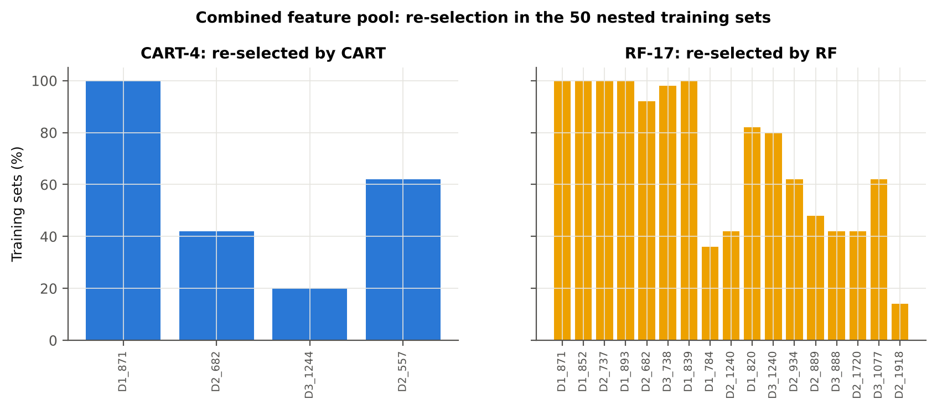
Figure 25. Re-selection of the CART and Random Forest features of the combined pool in the 50 nested training sets.

5.6 Disease-specific features
Table 29. Disease-specific features: the features chosen by CART and Random Forest from the combined pool, with class means, direction, AUC, FDR q and re-selection in the 50 nested training sets (CART / Random Forest).
Feature | Type | Selected by | Mean healthy | Mean diseased | Direction | AUC | q (FDR) | Re-selected CART / RF
First derivative at 871 nm | First derivative | CART + Random Forest | -4.8e-05 | 1.6e-05 | D > H | 0.916 | 1.4e-20 | 100 % / 100 %
First derivative at 852 nm | First derivative | Random Forest | -5.6e-05 | 1.5e-05 | D > H | 0.891 | 4.1e-18 | 10 % / 100 %
Second derivative at 737 nm | Second derivative | Random Forest | -3.4e-04 | -2.5e-04 | D > H | 0.806 | 3.4e-08 | 0 % / 100 %
First derivative at 893 nm | First derivative | Random Forest | -5.5e-05 | 4.5e-06 | D > H | 0.886 | 1.0e-17 | 0 % / 100 %
Second derivative at 682 nm | Second derivative | CART + Random Forest | 1.3e-04 | 2.1e-04 | D > H | 0.806 | 1.5e-14 | 42 % / 92 %
Third derivative at 738 nm | Third derivative | Random Forest | 2.3e-05 | -1.2e-05 | D < H | 0.832 | 3.8e-13 | 0 % / 98 %
First derivative at 839 nm | First derivative | Random Forest | -3.4e-05 | 3.3e-05 | D > H | 0.860 | 1.6e-14 | 10 % / 100 %
First derivative at 784 nm | First derivative | Random Forest | -7.1e-05 | 2.1e-05 | D > H | 0.810 | 4.0e-09 | 0 % / 36 %
Second derivative at 1240 nm | Second derivative | Random Forest | -7.9e-06 | 1.5e-06 | D > H | 0.762 | 1.5e-09 | 22 % / 42 %
First derivative at 820 nm | First derivative | Random Forest | -7.9e-05 | -3.6e-06 | D > H | 0.860 | 5.1e-14 | 0 % / 82 %
Third derivative at 1240 nm | Third derivative | Random Forest | -7.2e-06 | -6.4e-07 | D > H | 0.814 | 2.4e-12 | 20 % / 80 %
Second derivative at 934 nm | Second derivative | Random Forest | 8.4e-06 | -4.5e-05 | D < H | 0.763 | 2.6e-08 | 0 % / 62 %
Second derivative at 889 nm | Second derivative | Random Forest | 3.6e-05 | -1.3e-05 | D < H | 0.745 | 6.5e-09 | 0 % / 48 %
Third derivative at 888 nm | Third derivative | Random Forest | 2.6e-05 | -7.1e-06 | D < H | 0.723 | 2.3e-06 | 4 % / 42 %
Second derivative at 1720 nm | Second derivative | Random Forest | -3.1e-05 | -4.0e-05 | D < H | 0.657 | 1.4e-03 | 0 % / 42 %
Third derivative at 1077 nm | Third derivative | Random Forest | 8.7e-07 | -8.8e-06 | D < H | 0.723 | 1.1e-09 | 8 % / 62 %
Second derivative at 1918 nm | Second derivative | Random Forest | 4.4e-06 | 1.3e-05 | D > H | 0.815 | 2.2e-10 | 2 % / 14 %
Third derivative at 1244 nm | Third derivative | CART | 1.5e-06 | -1.2e-06 | D < H | 0.645 | 2.0e-02 | 20 % / 80 %
Second derivative at 557 nm | Second derivative | CART | -2.2e-04 | -1.9e-04 | D > H | 0.721 | 1.3e-05 | 62 % / 4 %

The disease-specific features of white rust at plot level fall into three groups:
- Slope of the near-infrared shoulder — first derivative at 820–893 nm (871, 852, 893, 839, 820, 784 nm; AUC 0.81–0.92). Diseased plots have a positive slope where healthy plots are flat or slightly negative. The first derivative at 871 nm is the single best feature (AUC 0.916), chosen by both CART and Random Forest and re-selected in every training set.
- Curvature of the red edge — second derivative at 682 nm and second/third derivative at 737–741 nm (AUC 0.81–0.83): the lower and upper bends of the red edge, consistent with the blue shift of the red-edge position caused by chlorophyll loss.
- Derivatives in the water-absorption regions — second and third derivatives at 934, 1077, 1240–1244, 1720 and 1918 nm (AUC 0.65–0.82): changes in the shape of the 970-, 1200-, 1730- and 1940-nm absorption features, i.e. leaf water and dry matter.
These features are significant after FDR control (q ≤ 0.02), their direction is consistent, and Random Forest re-selects the RF-17 features (within ± 10 nm) in 14–100 % of the training sets — 15 of the 17 in at least 42 %, the first derivatives at 852–893 nm in all of them. They describe the shape of the spectrum rather than its level, which makes them less sensitive to brightness differences between plots and dates than single reflectance bands.

6. Synthesis and transfer to new dates
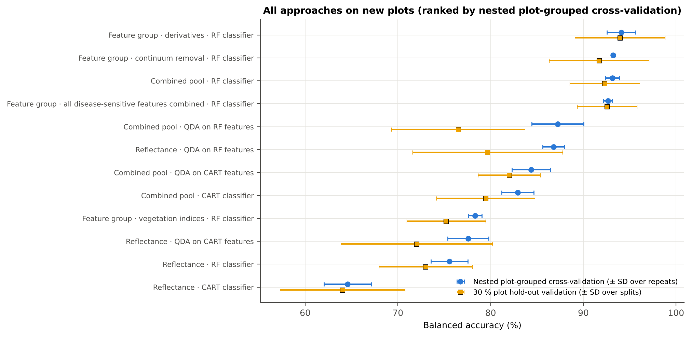
Figure 26. Balanced accuracy of all approaches on new plots (nested plot-grouped cross-validation ± SD over repeats; 30 % plot hold-out ± SD over splits).
Table 30. All approaches ranked by the nested plot-grouped balanced accuracy.
Approach | Nested plot-grouped cross-validation | 30 % plot hold-out validation | Leave-one-date-out validation
Feature group · derivatives incl. guard bands (artefact): RF | 95.6 % | 95.5 % | –
Feature group · derivatives + edge: RF | 94.1 % | 93.9 % | –
Feature group · continuum removal: RF | 93.2 % | 91.7 % | –
Combined feature pool · four tiers: RF classifier (Balanced RF) | 93.1 % | 92.3 % | 58.4 %
Feature group · all disease-sensitive features combined: RF | 92.6 % | 92.6 % | –
Feature group · selected 15: QDA | 88.7 % | 85.1 % | –
Feature group · selected 15: RF | 87.6 % | 86.8 % | –
Combined feature pool · four tiers: QDA on RF-17 (RF-selected) | 87.2 % | 76.5 % | 49.8 %
Feature group · continuum removal: CART | 86.8 % | 82.3 % | –
Raw reflectance · four tiers: QDA on RF-17 (RF-selected) | 86.8 % | 79.7 % | 51.8 %
Feature group · derivatives incl. guard bands (artefact): CART | 86.4 % | 86.5 % | –
Combined feature pool · four tiers: QDA on CART-4 (CART-selected) | 84.4 % | 82.0 % | 52.8 %
Combined feature pool · four tiers: CART classifier (rpart) | 82.9 % | 79.5 % | 53.2 %
Feature group · all disease-sensitive features combined: CART | 81.6 % | 80.5 % | –
Feature group · derivatives + edge: CART | 81.6 % | 79.6 % | –
Feature group · selected 15: CART | 80.8 % | 80.2 % | –
Single feature · optimised NDSI, all pairs — brackets the 1800 nm join (search nested) | 78.5 % | 78.2 % | –
Single feature · optimised NDSI, join-free pairs (search nested) | 78.5 % | 78.2 % | –
Feature group · vegetation indices: RF | 78.3 % | 75.2 % | –
Single feature · best single continuum-removal parameter: CR3 water 970 depth/area (threshold) | 78.1 % | 78.6 % | –

Table 31. Leave-one-date-out validation on new plots: balanced accuracy on each held-out date.
Feature set · pipeline | 11-02-2026 | 24-02-2026 | 03-03-2026 | 13-03-2026
Reflectance · CART classifier | 48.8 % | 53.2 % | 61.3 % | 51.1 %
Reflectance · RF classifier | 51.0 % | 55.9 % | 65.0 % | 50.0 %
Reflectance · QDA on CART features | 45.0 % | 69.7 % | 73.3 % | 50.0 %
Reflectance · QDA on RF features | 52.3 % | 53.8 % | 51.2 % | 50.0 %
Combined pool · CART classifier | 50.0 % | 55.5 % | 58.4 % | 49.1 %
Combined pool · RF classifier | 50.0 % | 77.3 % | 56.2 % | 50.0 %
Combined pool · QDA on CART features | 43.3 % | 61.6 % | 56.1 % | 50.0 %
Combined pool · QDA on RF features | 47.5 % | 50.3 % | 51.2 % | 50.0 %

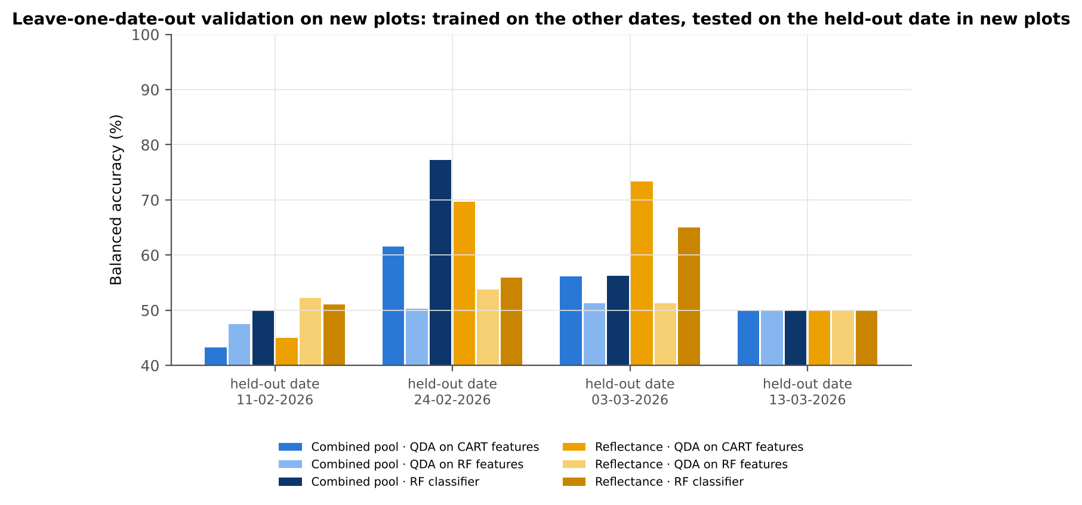
Figure 27. Leave-one-date-out validation on new plots, by held-out date.
When a whole date is held out, all pipelines drop to 43–77 % and the last date (13-03-2026) is classified at chance level by every pipeline: a model trained on the earlier dates does not apply to the late-season spectra, in which, for example, the NIR difference between the classes has changed sign. The spectral expression of white rust changes with the growth stage (and the canopy and leaf age), so a classifier should be calibrated with plots of the target stage.
Table 32. AUC of the best feature of each family on all spectra and its range over dates, growth stages and varieties.
Feature | AUC all plot-average spectra | AUC range over dates | over growth stages | over varieties
Band reflectance R650 | 0.785 | 0.69–0.95 | 0.56–0.91 | 0.74–0.83
First derivative D1_871 | 0.916 | 0.81–1.00 | 0.83–0.96 | 0.89–0.93
Continuum-removal features CR3 water 970 depth/area | 0.792 | 0.54–0.98 | 0.64–0.98 | 0.77–0.82
Vegetation indices RARSb | 0.747 | 0.63–0.95 | 0.50–0.89 | 0.69–0.80
Red-edge / edge parameter Ro (red well reflectance) | 0.752 | 0.67–0.91 | 0.54–0.89 | 0.72–0.78
REIP (Lagrangian) | 0.702 | 0.50–0.97 | 0.55–0.89 | 0.68–0.71

7. Discussion

7.1 Which wavelengths separate healthy and diseased plots?
Tier 1 identifies the red (600–680 nm), the red edge, the water bands around 1400 and 1900 nm and SWIR-2 as the regions where diseased plots differ from healthy plots, while the NIR plateau does not differ in level. CART and Random Forest concentrate on the red edge and red (699, 700, 689, 669, 655 nm; Random Forest 602–699 nm) with additional bands in the 1384–1928 nm water region. This matches the expected symptoms of white rust: chlorosis reduces chlorophyll absorption (higher red reflectance, blue-shifted red edge) and infected leaves lose water (higher SWIR reflectance, shallower water absorptions).

7.2 Plot averages versus single leaves
Averaging the leaves of a plot improves discrimination on new plots: compared with the leaf-level analysis of all 2264 leaf spectra (QDA on CART bands 72.0 %, combined pool 83.7 % in nested plot-grouped cross-validation), the plot averages give 77.6 % and 87.2 %, and the Random Forest on the combined pool 93.1 %. Averaging removes leaf-to-leaf variation (leaf position, age, angle, the presence or absence of a pustule under the probe) and random noise, so the derivative features — which amplify noise — become reliable even without smoothing. The price is fewer samples (192 instead of 2264) and a coarser unit: a plot average describes the plot, not an individual leaf.

7.3 Correction for the imbalanced classes
With 48 healthy and 144 diseased spectra an uncorrected classifier favours 'diseased': QDA with sample priors would recall only 72 % of the healthy plots on new plots. Equal priors in rpart and QDA and the balanced bootstrap of the Random Forest raise the healthy recall (QDA on CART bands: 80 % on new plots) at a similar balanced accuracy; balanced subsets confirm that the Tier-1 result does not depend on the imbalance. Random under-sampling was inferior because it discards most of the diseased spectra. Balanced accuracy, together with both recalls and κ, is therefore the appropriate summary.

7.4 CART versus Random Forest
Random Forest is the better choice in both roles. As a classifier it is 10–12 points better than a single CART tree; as a band selector its bands give a higher J–M (1.96 vs 1.52 on raw reflectance) and a higher QDA accuracy, and its selection is about twice as stable. CART remains useful for interpretation — a tree with a handful of thresholds (e.g. the first derivative at 871 nm at the root of the combined-pool tree) shows how the decision is made — but its selection depends strongly on the particular training plots.

7.5 Disease-specific features
The combined pool shows that the most discriminating information lies in the shape of the spectrum rather than in reflectance levels: all features selected from 8264 candidates were derivatives. The first derivative on the NIR shoulder (820–895 nm) is the single best feature; a change of this slope indicates altered internal leaf structure (disrupted mesophyll and epidermis around the sori) and possibly the white pustules, which scatter strongly. Curvature features at the lower (682 nm) and upper (737–741 nm) red edge reflect the chlorophyll loss that also shifts the red-edge position by about 3 nm. Derivative features of the 970-, 1200- and 1940-nm absorptions reflect the loss of leaf water. Continuum-removal parameters of the 970-nm water feature are almost as informative as a group (Random Forest 93 %), whereas published vegetation indices are clearly weaker (≤ 78 %).

7.6 Validation and limitations
- The spectrum-level 10-fold cross-validation of Das et al. is optimistic (by 3–4 points for QDA on CART bands) because the same plot on other dates is in training and test; nested plot-grouped cross-validation and the plot hold-out are the honest estimates for new plots.
- Only 12 healthy plots exist; each plot hold-out tests 4 of them, so hold-out accuracies vary by ± 5–8 points between splits.
- Transfer to a new date is weak (43–77 %, chance level for the last date, 13-03-2026): the models are valid for the dates and growth stages they were trained on.
- Raw (unsmoothed) derivatives were used as requested; plot averaging keeps their noise low, but derivatives beside the detector joins are artefact-prone and were excluded (with them the derivative group would reach 95.6 %).
- The feature lists of Table 5.6 were selected on all 192 spectra; their accuracy on new plots is given by the nested validation, in which the selection was repeated inside every training set.

8. Conclusions
- Healthy and white-rust-diseased mustard plots differ significantly at 1039 of 2101 bands (plot-average spectra, all dates), mainly in the red, at the red edge, in the water bands and in SWIR-2; the result is robust to the plot effect and to the class imbalance.
- The four tiers of Das et al. on raw reflectance select 9 CART bands (root 699 nm; J–M 1.521) and 17 Random Forest bands (J–M 1.960, separable); QDA with equal priors classifies new plots with 77.6 % (CART bands) and 86.8 % (Random Forest bands) balanced accuracy.
- Random Forest is superior to CART as classifier (+11.6 points) and as band selector, and its selection is more stable.
- Disease-sensitive features derived from raw reflectance — especially derivatives and continuum-removal parameters — separate the classes far better than reflectance bands or published vegetation indices; on the combined pool a Balanced Random Forest reaches 93.1 % on new plots.
- The disease-specific features of white rust at plot level are the first derivative of the NIR shoulder (820–895 nm, best at 871 nm), the curvature of the red edge (682 and 737–741 nm) and derivative features of the water absorptions (≈ 970, 1240 and 1918 nm).
- Models trained on some dates transfer poorly to a new growth stage; calibration with plots of the target stage is needed.

Recommendations
- Use plot-average spectra and derivative features (first derivative 820–895 nm; second/third derivative at the red edge) for white-rust detection with the contact probe.
- Select features with Balanced Random Forest importance and classify with a Balanced Random Forest (or QDA on a small, decorrelated feature set); report balanced accuracy with both recalls.
- Validate on new plots (plot-grouped, nested) and on new dates; do not rely on spectrum-level cross-validation.
- Calibrate for each growth stage, or collect further seasons before applying a model to a new stage.

References
Ambroise C, McLachlan GJ. 2002. Selection bias in gene extraction on the basis of microarray gene-expression data. Proceedings of the National Academy of Sciences 99:6562–6566.
Apan, A., Held, A., Phinn, S., Markley, J., 2004. Detecting sugarcane 'orange rust' disease using EO-1 Hyperion hyperspectral imagery. International Journal of Remote Sensing 25, 489–498.
Ashourloo, D., Mobasheri, M.R., Huete, A., 2014. Developing two spectral disease indices for detection of wheat leaf rust (Puccinia triticina). Remote Sensing 6, 4723–4740.
Babar MA, Reynolds MP, van Ginkel M, Klatt AR, Raun WR, Stone ML. 2006. Spectral reflectance indices as a potential indirect selection criteria for wheat yield under irrigation. Crop Science 46:578–588.
Barnes, E.M., Clarke, T.R., Richards, S.E., Colaizzi, P.D., Haberland, J., Kostrzewski, M., Waller, P., Choi, C., Riley, E., Thompson, T., Lascano, R.J., Li, H., Moran, M.S., 2000. Coincident detection of crop water stress, nitrogen status and canopy density using ground-based multispectral data. Proceedings of the 5th International Conference on Precision Agriculture, Bloomington, MN.
Barnes, J.D., Balaguer, L., Manrique, E., Elvira, S., Davison, A.W., 1992. A reappraisal of the use of DMSO for the extraction and determination of chlorophylls a and b in lichens and higher plants. Environmental and Experimental Botany 32, 85–100.
Bausch, W.C., Duke, H.R., 1996. Remote sensing of plant nitrogen status in corn. Transactions of the ASAE 39, 1869–1875.
Benjamini Y, Hochberg Y. 1995. Controlling the false discovery rate: a practical and powerful approach to multiple testing. Journal of the Royal Statistical Society B 57:289–300.
Bhattacharyya A. 1943. On a measure of divergence between two statistical populations defined by their probability distributions. Bulletin of the Calcutta Mathematical Society 35:99–109.
Blackburn, G.A., 1998. Spectral indices for estimating photosynthetic pigment concentrations: a test using senescent tree leaves. International Journal of Remote Sensing 19, 657–675.
Breiman L, Friedman JH, Olshen RA, Stone CJ. 1984. Classification and regression trees. Belmont (CA): Wadsworth.
Breiman L. 2001. Random forests. Machine Learning 45:5–32.
Brodersen KH, Ong CS, Stephan KE, Buhmann JM. 2010. The balanced accuracy and its posterior distribution. Proceedings of the 20th International Conference on Pattern Recognition, 3121–3124.
Broge, N.H., Leblanc, E., 2001. Comparing prediction power and stability of broadband and hyperspectral vegetation indices for estimation of green leaf area index and canopy chlorophyll density. Remote Sensing of Environment 76, 156–172.
Carter, G.A., 1994. Ratios of leaf reflectances in narrow wavebands as indicators of plant stress. International Journal of Remote Sensing 15, 697–703.
Chappelle, E.W., Kim, M.S., McMurtrey, J.E., 1992. Ratio analysis of reflectance spectra (RARS): an algorithm for the remote estimation of the concentrations of chlorophyll a, chlorophyll b, and carotenoids in soybean leaves. Remote Sensing of Environment 39, 239–247.
Chen C, Liaw A, Breiman L. 2004. Using random forest to learn imbalanced data. Technical Report 666, Department of Statistics, University of California, Berkeley.
Chen, J.M., 1996. Evaluation of vegetation indices and a modified simple ratio for boreal applications. Canadian Journal of Remote Sensing 22, 229–242.
Cho MA, Skidmore AK. 2006. A new technique for extracting the red edge position from hyperspectral data: the linear extrapolation method. Remote Sensing of Environment 101:181–193.
Clark RN, Roush TL. 1984. Reflectance spectroscopy: quantitative analysis techniques for remote sensing applications. Journal of Geophysical Research 89(B7):6329–6340.
Cohen J. 1960. A coefficient of agreement for nominal scales. Educational and Psychological Measurement 20:37–46.
Congalton RG. 1991. A review of assessing the accuracy of classifications of remotely sensed data. Remote Sensing of Environment 37:35–46.
Das B, Sahoo RN, Biswas A, Pargal S, Krishna G, Verma R, Chinnusamy V, Sehgal VK, Gupta VK. 2020. Discrimination of rice genotypes using field spectroradiometry. Geocarto International 35(1):64–77. doi:10.1080/10106049.2018.1506507
Dash, J., Curran, P.J., 2004. The MERIS terrestrial chlorophyll index. International Journal of Remote Sensing 25, 5403–5413.
Datt, B., 1999. Visible/near infrared reflectance and chlorophyll content in Eucalyptus leaves. International Journal of Remote Sensing 20, 2741–2759.
Daughtry, C.S.T., Walthall, C.L., Kim, M.S., Brown de Colstoun, E., McMurtrey, J.E., 2000. Estimating corn leaf chlorophyll concentration from leaf and canopy reflectance. Remote Sensing of Environment 74, 229–239.
Dawson TP, Curran PJ. 1998. A new technique for interpolating the reflectance red edge position. International Journal of Remote Sensing 19:2133–2139.
Filella, I., Peñuelas, J., 1994. The red edge position and shape as indicators of plant chlorophyll content, biomass and hydric status. International Journal of Remote Sensing 15, 1459–1470.
Galvão, L.S., Formaggio, A.R., Tisot, D.A., 2005. Discrimination of sugarcane varieties in southeastern Brazil with EO-1 Hyperion data. Remote Sensing of Environment 94, 523–534.
Gamon, J.A., Peñuelas, J., Field, C.B., 1992. A narrow-waveband spectral index that tracks diurnal changes in photosynthetic efficiency. Remote Sensing of Environment 41, 35–44.
Gamon, J.A., Surfus, J.S., 1999. Assessing leaf pigment content and activity with a reflectometer. New Phytologist 143, 105–117.
Gao, B.-C., 1996. NDWI — a normalized difference water index for remote sensing of vegetation liquid water from space. Remote Sensing of Environment 58, 257–266.
Gitelson, A.A., Gritz, Y., Merzlyak, M.N., 2003. Relationships between leaf chlorophyll content and spectral reflectance and algorithms for non-destructive chlorophyll assessment in higher plant leaves. Journal of Plant Physiology 160, 271–282.
Gitelson, A.A., Kaufman, Y.J., Stark, R., Rundquist, D., 2002a. Novel algorithms for remote estimation of vegetation fraction. Remote Sensing of Environment 80, 76–87.
Gitelson, A.A., Merzlyak, M.N., 1994. Spectral reflectance changes associated with autumn senescence of Aesculus hippocastanum L. and Acer platanoides L. leaves. Journal of Plant Physiology 143, 286–292.
Gitelson, A.A., Merzlyak, M.N., 1996. Signature analysis of leaf reflectance spectra: algorithm development for remote sensing of chlorophyll. Journal of Plant Physiology 148, 494–500.
Gitelson, A.A., Merzlyak, M.N., 1997. Remote estimation of chlorophyll content in higher plant leaves. International Journal of Remote Sensing 18, 2691–2697.
Gitelson, A.A., Merzlyak, M.N., Chivkunova, O.B., 2001. Optical properties and nondestructive estimation of anthocyanin content in plant leaves. Photochemistry and Photobiology 74, 38–45.
Gitelson, A.A., Zur, Y., Chivkunova, O.B., Merzlyak, M.N., 2002b. Assessing carotenoid content in plant leaves with reflectance spectroscopy. Photochemistry and Photobiology 75, 272–281.
Gong P, Pu R, Heald RC. 2002. Analysis of in situ hyperspectral data for nutrient estimation of giant sequoia. International Journal of Remote Sensing 23:1827–1850.
Guyot G, Baret F. 1988. Utilisation de la haute résolution spectrale pour suivre l'état des couverts végétaux. Proceedings of the 4th International Colloquium on Spectral Signatures of Objects in Remote Sensing, ESA SP-287, 279–286.
Haboudane D, Miller JR, Pattey E, Zarco-Tejada PJ, Strachan IB. 2004. Hyperspectral vegetation indices and novel algorithms for predicting green LAI of crop canopies. Remote Sensing of Environment 90:337–352.
Haboudane, D., Miller, J.R., Tremblay, N., Zarco-Tejada, P.J., Dextraze, L., 2002. Integrated narrow-band vegetation indices for prediction of crop chlorophyll content for application to precision agriculture. Remote Sensing of Environment 81, 416–426.
Hanley JA, McNeil BJ. 1982. The meaning and use of the area under a receiver operating characteristic (ROC) curve. Radiology 143:29–36.
Hardisky, M.A., Klemas, V., Smart, R.M., 1983. The influence of soil salinity, growth form, and leaf moisture on the spectral radiance of Spartina alterniflora canopies. Photogrammetric Engineering and Remote Sensing 49, 77–83.
Hastie T, Tibshirani R, Friedman J. 2009. The elements of statistical learning. 2nd ed. New York: Springer.
Hedges LV. 1981. Distribution theory for Glass's estimator of effect size and related estimators. Journal of Educational Statistics 6:107–128.
Hernández-Clemente, R., Navarro-Cerrillo, R.M., Suárez, L., Morales, F., Zarco-Tejada, P.J., 2011. Assessing structural effects on PRI for stress detection in conifer forests. Remote Sensing of Environment 115, 2360–2375.
Horler DNH, Dockray M, Barber J. 1983. The red edge of plant leaf reflectance. International Journal of Remote Sensing 4:273–288.
Huete, A., Didan, K., Miura, T., Rodriguez, E.P., Gao, X., Ferreira, L.G., 2002. Overview of the radiometric and biophysical performance of the MODIS vegetation indices. Remote Sensing of Environment 83, 195–213.
Huete, A.R., 1988. A soil-adjusted vegetation index (SAVI). Remote Sensing of Environment 25, 295–309.
Hunt, E.R., Doraiswamy, P.C., McMurtrey, J.E., Daughtry, C.S.T., Perry, E.M., Akhmedov, B., 2013. A visible band index for remote sensing leaf chlorophyll content at the canopy scale. International Journal of Applied Earth Observation and Geoinformation 21, 103–112.
Hunt, E.R., Rock, B.N., 1989. Detection of changes in leaf water content using near- and middle-infrared reflectances. Remote Sensing of Environment 30, 43–54.
Hurlbert SH. 1984. Pseudoreplication and the design of ecological field experiments. Ecological Monographs 54:187–211.
Jordan, C.F., 1969. Derivation of leaf-area index from quality of light on the forest floor. Ecology 50, 663–666.
Kokaly RF, Clark RN. 1999. Spectroscopic determination of leaf biochemistry using band-depth analysis of absorption features and stepwise multiple linear regression. Remote Sensing of Environment 67:267–287.
Kuncheva LI. 2007. A stability index for feature selection. Proceedings of the 25th IASTED International Multi-Conference: Artificial Intelligence and Applications, 390–395.
Lemaître G, Nogueira F, Aridas CK. 2017. Imbalanced-learn: a Python toolbox to tackle the curse of imbalanced datasets in machine learning. Journal of Machine Learning Research 18(17):1–5.
Levene H. 1960. Robust tests for equality of variances. In: Olkin I, editor. Contributions to probability and statistics. Stanford: Stanford University Press; p. 278–292.
Liaw A, Wiener M. 2002. Classification and regression by randomForest. R News 2(3):18–22.
Lichtenthaler, H.K., Lang, M., Sowinska, M., Heisel, F., Miehé, J.A., 1996. Detection of vegetation stress via a new high resolution fluorescence imaging system. Journal of Plant Physiology 148, 599–612.
Mahlein A-K, Rumpf T, Welke P, Dehne H-W, Plümer L, Steiner U, Oerke E-C. 2013. Development of spectral indices for detecting and identifying plant diseases. Remote Sensing of Environment 128:21–30.
Mahlein A-K. 2016. Plant disease detection by imaging sensors — parallels and specific demands for precision agriculture and plant phenotyping. Plant Disease 100:241–251.
Merton, R., 1998. Monitoring community hysteresis using spectral shift analysis and the red-edge vegetation stress index. Proceedings of the 7th Annual JPL Airborne Earth Science Workshop, Pasadena, CA.
Merton, R., Huntington, J., 1999. Early simulation results of the ARIES-1 satellite sensor for multi-temporal vegetation research derived from AVIRIS. Proceedings of the 8th Annual JPL Airborne Earth Science Workshop, Pasadena, CA.
Merzlyak, M.N., Gitelson, A.A., Chivkunova, O.B., Rakitin, V.Y., 1999. Non-destructive optical detection of pigment changes during leaf senescence and fruit ripening. Physiologia Plantarum 106, 135–141.
Metternicht, G., 2003. Vegetation indices derived from high-resolution airborne videography for precision crop management. International Journal of Remote Sensing 24, 2855–2877.
Nagler, P.L., Inoue, Y., Glenn, E.P., Russ, A.L., Daughtry, C.S.T., 2003. Cellulose absorption index (CAI) to quantify mixed soil–plant litter scenes. Remote Sensing of Environment 87, 310–325.
Pedregosa F, Varoquaux G, Gramfort A, et al. 2011. Scikit-learn: machine learning in Python. Journal of Machine Learning Research 12:2825–2830.
Peñuelas, J., Baret, F., Filella, I., 1995. Semi-empirical indices to assess carotenoids/chlorophyll a ratio from leaf spectral reflectance. Photosynthetica 31, 221–230.
Peñuelas, J., Gamon, J.A., Fredeen, A.L., Merino, J., Field, C.B., 1994. Reflectance indices associated with physiological changes in nitrogen- and water-limited sunflower leaves. Remote Sensing of Environment 48, 135–146.
Peñuelas, J., Piñol, J., Ogaya, R., Filella, I., 1997. Estimation of plant water concentration by the reflectance water index WI (R900/R970). International Journal of Remote Sensing 18, 2869–2875.
Pinheiro J, Bates D, R Core Team. 2023. nlme: linear and nonlinear mixed effects models. R package.
Qi, J., Chehbouni, A., Huete, A.R., Kerr, Y.H., Sorooshian, S., 1994. A modified soil adjusted vegetation index. Remote Sensing of Environment 48, 119–126.
R Core Team. 2024. R: a language and environment for statistical computing. Vienna: R Foundation for Statistical Computing.
Raun, W.R., Solie, J.B., Johnson, G.V., Stone, M.L., Lukina, E.V., Thomason, W.E., Schepers, J.S., 2001. In-season prediction of potential grain yield in winter wheat using canopy reflectance. Agronomy Journal 93, 131–138.
Richards JA. 2013. Remote sensing digital image analysis. 5th ed. Berlin: Springer.
Roberts DR, Bahn V, Ciuti S, et al. 2017. Cross-validation strategies for data with temporal, spatial, hierarchical, or phylogenetic structure. Ecography 40:913–929.
Rondeaux, G., Steven, M., Baret, F., 1996. Optimization of soil-adjusted vegetation indices. Remote Sensing of Environment 55, 95–107.
Roujean, J.-L., Breon, F.-M., 1995. Estimating PAR absorbed by vegetation from bidirectional reflectance measurements. Remote Sensing of Environment 51, 375–384.
Rouse, J.W., Haas, R.H., Schell, J.A., Deering, D.W., 1974. Monitoring vegetation systems in the Great Plains with ERTS. Proceedings of the 3rd ERTS Symposium, NASA SP-351, 309–317.
Saharan GS, Verma PR, Meena PD, Kumar A. 2014. White rust of crucifers: biology, ecology and management. New Delhi: Springer India.
Savitzky A, Golay MJE. 1964. Smoothing and differentiation of data by simplified least squares procedures. Analytical Chemistry 36:1627–1639.
Seabold S, Perktold J. 2010. Statsmodels: econometric and statistical modeling with Python. Proceedings of the 9th Python in Science Conference, 92–96.
Serrano, L., Peñuelas, J., Ustin, S.L., 2002. Remote sensing of nitrogen and lignin in Mediterranean vegetation from AVIRIS data: decomposing biochemical from structural signals. Remote Sensing of Environment 81, 355–364.
Sims, D.A., Gamon, J.A., 2002. Relationships between leaf pigment content and spectral reflectance across a wide range of species, leaf structures and developmental stages. Remote Sensing of Environment 81, 337–354.
Strobl C, Boulesteix A-L, Zeileis A, Hothorn T. 2007. Bias in random forest variable importance measures: illustrations, sources and a solution. BMC Bioinformatics 8:25.
Swain PH, Davis SM. 1978. Remote sensing: the quantitative approach. New York: McGraw-Hill.
Thenkabail, P.S., Smith, R.B., De Pauw, E., 2000. Hyperspectral vegetation indices and their relationships with agricultural crop characteristics. Remote Sensing of Environment 71, 158–182.
Therneau T, Atkinson B. 2023. rpart: recursive partitioning and regression trees. R package version 4.1.23.
Tsai, F., Philpot, W., 1998. Derivative analysis of hyperspectral data. Remote Sensing of Environment 66, 41–51.
Tucker, C.J., 1979. Red and photographic infrared linear combinations for monitoring vegetation. Remote Sensing of Environment 8, 127–150.
Varma S, Simon R. 2006. Bias in error estimation when using cross-validation for model selection. BMC Bioinformatics 7:91.
Venables WN, Ripley BD. 2002. Modern applied statistics with S. 4th ed. New York: Springer.
Vogelmann, J.E., Rock, B.N., Moss, D.M., 1993. Red edge spectral measurements from sugar maple leaves. International Journal of Remote Sensing 14, 1563–1575.
Welch BL. 1947. The generalization of 'Student's' problem when several different population variances are involved. Biometrika 34:28–35.
Wilcoxon F. 1945. Individual comparisons by ranking methods. Biometrics Bulletin 1:80–83.
Youden WJ. 1950. Index for rating diagnostic tests. Cancer 3:32–35.
Zarco-Tejada, P.J., Berjón, A., López-Lozano, R., Miller, J.R., Martín, P., Cachorro, V., González, M.R., de Frutos, A., 2005. Assessing vineyard condition with hyperspectral indices: leaf and canopy reflectance simulation in a row-structured discontinuous canopy. Remote Sensing of Environment 99, 271–287.
Zarco-Tejada, P.J., Miller, J.R., Noland, T.L., Mohammed, G.H., Sampson, P.H., 2001. Scaling-up and model inversion methods with narrowband optical indices for chlorophyll content estimation in closed forest canopies with hyperspectral data. IEEE Transactions on Geoscience and Remote Sensing 39, 1491–1507.

Appendix A. Cross-checks
Table 33. All cross-checks (51 passed, 8 flagged as limitations, 0 failed).
# | Step | What was checked | Result | Status
1 | Step 0 | Plot averaging: one spectrum per plot and date | 2264 leaf spectra → 192 plot-average spectra (48 healthy, 144 diseased; 48 plots × 4 dates) | PASS
2 | Step 0 | Plot averages equal the labelled workbooks' own =AVERAGE plot columns | 197 of 197 columns identical at all 2151 bands (max |Δ| 0.0e+00) | PASS
3 | Step 0 | Missing values in spectra | 0 | PASS
4 | Step 0 | Reflectance range (350–2500 nm) | 0.044 – 0.681 | PASS
5 | Step 0 | Wavelength grid identical in all files | 350–2500 nm, 1 nm, 2151 bands | PASS
6 | Step 0 | Plot-average formula columns ignored | 197 | PASS
7 | Step 0 | Second data block 13-03-2026: exact copies of block 1 (same plot) | 75 of 75 identical → removed | PASS
8 | Step 0 | Exact duplicates among the remaining spectra | 4 (the unnamed plot-27 spectra of 11-02-2026) → removed | FLAG
9 | Step 0 | Each plot has one class on every date | 48 of 48 plots | PASS
10 | Step 0 | Each plot has one variety on every date | 48 of 48 plots | PASS
11 | Step 0 | Healthy plots within 1–12, diseased plots within 13–48 | healthy plots [1, 2, 3, 4, 5, 6, 7, 8, 9, 10, 11, 12]; 36 diseased plots | PASS
12 | Step 0 | Repeated ASD file names within a date (counter restarted on 13-03-2026) | none in this data set | PASS
13 | Step 0 | Validation folds: nested plot-grouped cross-validation k, 30 % plot hold-out validation, leave-one-date-out validation on new plots units | Nested plot-grouped cross-validation k = 10 plot-grouped folds × 5 (StratifiedGroupKFold); 30 % plot hold-out validation holds out 4 healthy + 11 diseased plots; leave-one-date-out validation on new plots by Dat | PASS
14 | Tier 1 | Mixed model converged for every feature | 2101 of 2101 converged | PASS
15 | Tier 1 | Training sets with < 2 FDR-significant features (nested plot-grouped cross-validation/30 % plot hold-out validation/leave-one-date-out validation on new plots) | 0 of 100 training sets | PASS
16 | Tier 3 | J–M implementation (raw reflectance) | |Δα| = 4.3e-13 | PASS
17 | Tier 3 | Invertibility of the class covariances | max 1.1e+08 (ill-conditioned but below the ~1e12 limit of double precision: J–M and QDA are computable, yet se | FLAG
18 | Tier 3 | J–M is scale-invariant | max |ΔJ–M| = 2.5e-11 | PASS
19 | Tier 4 | QDA implementation (raw reflectance) | 99.47 % identical predictions; differing plot-average spectra have |P(diseased) − 0.5| ≤ 0.0155 | FLAG
20 | Tier 1 | Mixed model implementation | Spearman ρ of p-values 1.000 (statsmodels uses a Wald z-test, nlme a t-test with 46 df, so nlme p-values are l | PASS
21 | Tier 1 | Welch t-statistic | max |Δt| = 1.8e-15 | PASS
22 | Tier 1 | Benjamini–Hochberg q-values | max |Δq| = 1.1e-16 | PASS
23 | Tier 1 | ANOVA equivalence | max relative |F − t²| = 8.1e-12 | PASS
24 | Tier 1 | Class imbalance | median 944 significant bands per subset vs 1039 on all plot-average spectra | PASS
25 | Tier 1 | Pseudo-replication | 1014 of 2101 bands significant (Welch: 1039); plot ICC median 0.000 | PASS
26 | Tier 2 | CART implementation | root variable rpart 'WV699< 0.2012' vs sklearn 'WV699 < 0.2012' | PASS
27 | Tier 2 | Stability of the selected bands | 699 nm 100 %; 700 nm 100 %; 689 nm 98 % | PASS
28 | Tier 3 | J–M formula | 0.0e+00 | PASS
29 | Tier 4 | QDA in R | CART-9 equal: 99.48 % identical; CART-9 sample: 99.48 % identical; CART-1 (1-SE) equal: not compared (MASS::qd | FLAG
30 | A1 | Reproducibility: importance of seed 42 vs seed 7 (Spearman ρ) | 0.719; 16 of 17 peaks within ±10 nm | PASS
31 | A1 | R randomForest (stratified sampsize 48 + 48), mean decrease in Gini | ρ = 0.679; 16 of 17 peaks within ±10 nm; R out-of-bag BA 0.747 | PASS
32 | A1 | Permutation importance (drop in AUC, 5 plot-grouped folds) vs Gini, top-50 bands | ρ = 0.02; shuffling one band hardly changes the forest because its neighbours carry the same information | FLAG
33 | A1 | Ordinary RF with class weights only (no balanced bootstrap), out-of-bag | BA 0.747; healthy recall 0.65 | PASS
34 | Smoothing and detector-join correction | Smoothing preserves the signal | r ≥ 0.999988; 1039 (raw) vs 1039 (smoothed) significant bands | PASS
35 | Smoothing and detector-join correction | Detector artefact at the 1800/1801 nm join | start-up bump detected → guard zones applied | FLAG
36 | Continuum-removal features | Convex hull | max |Δ continuum| = 0.0e+00 | PASS
37 | Vegetation indices | Duplicated indices | max |mCARI1 − MTVI1| = 3.3e-16 (algebraically identical); AUC SR761 0.7364 = NDVI761 0.7364 (monotone transfor | PASS
38 | Derivative and edge features | REIP by four methods | r between methods 0.903 – 0.998 | PASS
39 | Derivative and edge features | REP by two methods (Excel) | see 'largest difference' on sheet derivative and edge features | PASS
40 | Derivative and edge features | Derivative filter | r = 1.0000 | PASS
41 | Correlation spectra | Correlation vs t-test | ρ = 0.9986 (r_pb is a monotone function of Student's t) | PASS
42 | Optimised two-band index | NDSI vs simple ratio | max |ΔAUC| = 0.0e+00 | PASS
43 | Optimised two-band index | Selection optimism | honest BA 78.5 % (cross-validation) / 78.2 % (hold-out) vs 87.2 % on all plot-average spectra | FLAG
44 | Optimised two-band index | Best pair straddles a detector join? | all-pair best NDSI(870,872) does not straddle a join (same as the join-free search); join-free best NDSI(870,8 | PASS
45 | Combined feature pool · Tier 1 | Mixed model converged for every feature | 8264 of 8264 converged | PASS
46 | Combined feature pool · Tier 1 | Training sets with < 2 FDR-significant features (nested plot-grouped cross-validation/30 % plot hold-out validation/leave-one-date-out validation on new plots) | 0 of 100 training sets | PASS
47 | Combined feature pool · Tier 3 | J–M implementation (combined feature pool) | |Δα| = 3.6e-15 | PASS
48 | Combined feature pool · Tier 3 | Invertibility of the class covariances | max 6.3e+02 (well below the ~1e12 limit of double precision) | PASS
49 | Combined feature pool · Tier 3 | J–M is scale-invariant | max |ΔJ–M| = 4.4e-15 | PASS
50 | Combined feature pool · Tier 4 | QDA implementation (combined feature pool) | 100.00 % identical predictions; differing plot-average spectra have |P(diseased) − 0.5| ≤ 0.0000 | PASS
51 | Validation | No plot in both training and test | passed for all folds | PASS
52 | Validation | No date in both training and test (leave-one-date-out validation on new plots) | passed (40 units) | PASS
53 | Validation | Every nested plot-grouped cross-validation and 30 % plot hold-out validation test fold contains both classes | passed (50 nested plot-grouped cross-validation folds, k = 10; 10 30 % plot hold-out validation splits) | PASS
54 | Validation | Identical folds in every step | same objects | PASS
55 | CART vs Random Forest on each feature group / raw-reflectance four tiers | CART vs Random Forest on each feature group full spectrum reproduces raw-reflectance four tiers | RF 77.4 % vs 75.6 %; CART 66.5 % vs 64.6 % | PASS
56 | Error matrices | Matrix sums equal the class totals | Spectrum-level 10-fold cross-validation totals 48 healthy / 144 diseased | PASS
57 | CART vs Random Forest on each feature group artefact test | Guard-zone bands inflate accuracy? | 95.6 % with vs 94.1 % without | FLAG
58 | Combined feature pool | Selected features next to the guard zones | CART: 0.0 %; RF: 0.2 % | PASS
59 | Numerics | QDA fits failing on singular covariances | 0 (raw-reflectance four tiers), 0 (combined feature pool) | PASS

Appendix B. Vegetation indices
Table 34. The 87 vegetation indices (R = reflectance at the given wavelength, nearest 1-nm band).
Index | Name | Equation (as computed) | Reference
WI | Water Index | R900 / R970 | Peñuelas et al., 1997
mCARI1 | Modified Chlorophyll Absorption in Reflectance Index 1 | 1.2[2.5(R761 − R651) − 1.3(R761 − R581)] | Haboudane et al., 2004
MTVI1 | Modified Triangular Vegetation Index 1 | 1.2[1.2(R761 − R581) − 2.5(R651 − R581)] | Haboudane et al., 2004
MTVI2 | Modified Triangular Vegetation Index 2 | 1.5[1.2(R761 − R581) − 2.5(R651 − R581)] / √[(2R761 + 1)² − (6R761 − 5√R651) − 0.5] | Haboudane et al., 2004
SR900 | Simple Ratio Index 900 | R900 / R680 | Jordan, 1969
SR850 | Simple Ratio Index 850 | R850 / R680 | Jordan, 1969
GNDVI | Green Normalized Difference Vegetation Index | (R850 − R580) / (R850 + R580) | Gitelson and Merzlyak, 1996
PRI | Photochemical Reflectance Index | (R531 − R570) / (R531 + R570) | Gamon et al., 1992
RARSa | Ratio Analysis of Reflectance Spectra, chlorophyll a | R675 / R700 | Chappelle et al., 1992
RARSb | Ratio Analysis of Reflectance Spectra, chlorophyll b | R675 / (R700 × R650) | Chappelle et al., 1992
RARSc | Ratio Analysis of Reflectance Spectra, carotenoids | R750 / R700 | Chappelle et al., 1992
PSSRa | Pigment Specific Simple Ratio, chlorophyll a | R800 / R680 | Blackburn, 1998
NDVI780 | Normalized Difference Vegetation Index 780 | (R780 − R670) / (R780 + R670) | Raun et al., 2001
SIPI | Structure Insensitive Pigment Index | (R800 − R445) / (R800 − R680) | Peñuelas et al., 1995
NCPI | Normalized Chlorophyll Pigment Ratio Index | (R670 − R450) / (R670 + R450) | Peñuelas et al., 1994
NPQI | Normalized Phaeophytinization Index | (R415 − R435) / (R415 + R435) | Barnes et al., 1992
PSRI | Plant Senescence Reflectance Index | (R680 − R500) / R750 | Merzlyak et al., 1999 (activity table: Peñuelas et al., 1995)
WI/ND | Ratio of Water Index and NDVI | (R900 / R970) / [(R900 − R680) / (R900 + R680)] | Peñuelas et al., 1997 (activity table: Hunt et al., 1989)
TCARI | Transformed Chlorophyll Absorption in Reflectance Index | 3[(R700 − R670) − 0.2(R700 − R550)(R700 / R670)] | Haboudane et al., 2002
VIGreen | Green Vegetation Index | (R760 − R550) / (R760 + R550) | Gitelson et al., 2002a
RVS1 | Red-Edge Vegetation Stress Index 1 | R651 + R750 | Merton, 1998
RVS2 | Red-Edge Vegetation Stress Index 2 | (R651 + R750) / (R651 − R750) | Merton, 1998
TVI | Triangle Vegetation Index | 0.5[120(R761 − R581) − 200(R651 − R581)] | Broge and Leblanc, 2001
RDVI | Renormalized Difference Vegetation Index | (R761 − R651) / √(R761 + R651) | Roujean and Breon, 1995
NDVI850 | Normalized Difference Vegetation Index 850 | (R850 − R651) / (R850 + R651) | Raun et al., 2001
SR761 | Simple Ratio Index 761 | R761 / R651 | Jordan, 1969
NDVI761 | Normalized Difference Vegetation Index 761 | (R761 − R651) / (R761 + R651) | Raun et al., 2001
PPR | Plant Pigment Ratio | R550 / R450 | Metternicht, 2003
NWI2 | Normalized Water Index 2 | (R970 − R850) / (R970 + R850) | Babar et al., 2006
NRI | Nitrogen Reflectance Index | (R570 − R670) / (R570 + R670) | Bausch and Duke, 1996
ARI | Anthocyanin Reflectance Index | 1/R550 − 1/R700 | Gitelson et al., 2001
NDVI | Normalized Difference Vegetation Index | (R800 − R670) / (R800 + R670) | Rouse et al., 1974
DVI | Difference Vegetation Index | R800 − R670 | Tucker, 1979
SAVI | Soil-Adjusted Vegetation Index | 1.5(R800 − R670) / (R800 + R670 + 0.5) | Huete, 1988
OSAVI | Optimized Soil-Adjusted Vegetation Index | 1.16(R800 − R670) / (R800 + R670 + 0.16) | Rondeaux et al., 1996
MSAVI | Modified Soil-Adjusted Vegetation Index | 0.5[2R800 + 1 − √((2R800 + 1)² − 8(R800 − R670))] | Qi et al., 1994
EVI | Enhanced Vegetation Index | 2.5(R800 − R670) / (R800 + 6R670 − 7.5R475 + 1) | Huete et al., 2002
MSR | Modified Simple Ratio | (R800/R670 − 1) / √(R800/R670 + 1) | Chen, 1996
MCARI | Modified Chlorophyll Absorption in Reflectance Index | [(R700 − R670) − 0.2(R700 − R550)](R700 / R670) | Daughtry et al., 2000
MCARI2 | Modified Chlorophyll Absorption in Reflectance Index 2 | 1.5[2.5(R800 − R670) − 1.3(R800 − R550)] / √[(2R800 + 1)² − (6R800 − 5√R670) − 0.5] | Haboudane et al., 2004
TCARI/OSAVI | TCARI / OSAVI ratio | TCARI / OSAVI | Haboudane et al., 2002
TGI | Triangular Greenness Index | −0.5[190(R670 − R550) − 120(R670 − R480)] | Hunt et al., 2013
GI | Greenness Index | R554 / R677 | Zarco-Tejada et al., 2005
CIgreen | Chlorophyll Index green | R780 / R550 − 1 | Gitelson et al., 2003
CIrededge | Chlorophyll Index red edge | R780 / R710 − 1 | Gitelson et al., 2003
ND705 | Red-edge Normalized Difference 705 | (R750 − R705) / (R750 + R705) | Gitelson and Merzlyak, 1994
mND705 | Modified Red-edge Normalized Difference 705 | (R750 − R705) / (R750 + R705 − 2R445) | Sims and Gamon, 2002
mSR705 | Modified Red-edge Simple Ratio 705 | (R750 − R445) / (R705 − R445) | Sims and Gamon, 2002
NDRE | Normalized Difference Red Edge | (R790 − R720) / (R790 + R720) | Barnes et al., 2000
MTCI | MERIS Terrestrial Chlorophyll Index | (R754 − R709) / (R709 − R681) | Dash and Curran, 2004
VOG1 | Vogelmann Red Edge Index 1 | R740 / R720 | Vogelmann et al., 1993
VOG2 | Vogelmann Red Edge Index 2 | (R734 − R747) / (R715 + R726) | Zarco-Tejada et al., 2001
ZTM | Zarco-Tejada and Miller index | R750 / R710 | Zarco-Tejada et al., 2001
Datt | Datt chlorophyll index | (R850 − R710) / (R850 − R680) | Datt, 1999
RVSI | Red-Edge Vegetation Stress Index (original definition) | (R714 + R752) / 2 − R733 | Merton and Huntington, 1999
GM1 | Gitelson–Merzlyak index 1 | R750 / R550 | Gitelson and Merzlyak, 1997
GM2 | Gitelson–Merzlyak index 2 | R750 / R700 | Gitelson and Merzlyak, 1997
PSSRb | Pigment Specific Simple Ratio, chlorophyll b | R800 / R635 | Blackburn, 1998
PSSRc | Pigment Specific Simple Ratio, carotenoids | R800 / R470 | Blackburn, 1998
PSNDa | Pigment Specific Normalized Difference, chlorophyll a | (R800 − R680) / (R800 + R680) | Blackburn, 1998
PSNDb | Pigment Specific Normalized Difference, chlorophyll b | (R800 − R635) / (R800 + R635) | Blackburn, 1998
CRI1 | Carotenoid Reflectance Index 1 | 1/R510 − 1/R550 | Gitelson et al., 2002b
CRI2 | Carotenoid Reflectance Index 2 | 1/R510 − 1/R700 | Gitelson et al., 2002b
ARI2 | Anthocyanin Reflectance Index 2 | R800(1/R550 − 1/R700) | Gitelson et al., 2001
RGRI | Red/Green Ratio Index | mean(R600–699) / mean(R500–599) | Gamon and Surfus, 1999
PRI515 | Photochemical Reflectance Index 515 | (R515 − R531) / (R515 + R531) | Hernández-Clemente et al., 2011
Ctr1 | Carter stress index 1 | R695 / R420 | Carter, 1994
Ctr2 | Carter stress index 2 | R695 / R760 | Carter, 1994
Lic | Lichtenthaler blue/red ratio | R440 / R690 | Lichtenthaler et al., 1996
HI | Healthy Index | (R534 − R698) / (R534 + R698) − 0.5R704 | Mahlein et al., 2013
CLSI | Cercospora Plot-average spectrum Spot Index | (R698 − R570) / (R698 + R570) − R734 | Mahlein et al., 2013
SBRI | Sugar Beet Rust Index | (R570 − R513) / (R570 + R513) + 0.5R704 | Mahlein et al., 2013
PMI | Powdery Mildew Index | (R520 − R584) / (R520 + R584) + R724 | Mahlein et al., 2013
LRDSI1 | Plot-average spectrum Rust Disease Severity Index 1 | 6.9(R605 / R455) − 1.2 | Ashourloo et al., 2014
LRDSI2 | Plot-average spectrum Rust Disease Severity Index 2 | 4.2(R695 / R455) − 0.38 | Ashourloo et al., 2014
DSWI | Disease–Water Stress Index | (R802 + R547) / (R1657 + R682) | Apan et al., 2004
NWI1 | Normalized Water Index 1 | (R970 − R900) / (R970 + R900) | Babar et al., 2006
NWI3 | Normalized Water Index 3 | (R970 − R920) / (R970 + R920) | Babar et al., 2006
NWI4 | Normalized Water Index 4 | (R970 − R880) / (R970 + R880) | Babar et al., 2006
NDWI | Normalized Difference Water Index | (R860 − R1240) / (R860 + R1240) | Gao, 1996
MSI | Moisture Stress Index | R1600 / R820 | Hunt and Rock, 1989
NDII | Normalized Difference Infrared Index | (R819 − R1649) / (R819 + R1649) | Hardisky et al., 1983
LWVI1 | Plot-average spectrum Water Vegetation Index 1 | (R1094 − R983) / (R1094 + R983) | Galvão et al., 2005
LWVI2 | Plot-average spectrum Water Vegetation Index 2 | (R1094 − R1205) / (R1094 + R1205) | Galvão et al., 2005
NDNI | Normalized Difference Nitrogen Index | [log(1/R1510) − log(1/R1680)] / [log(1/R1510) + log(1/R1680)] | Serrano et al., 2002
NDLI | Normalized Difference Lignin Index | [log(1/R1754) − log(1/R1680)] / [log(1/R1754) + log(1/R1680)] | Serrano et al., 2002
CAI | Cellulose Absorption Index | 0.5(R2000 + R2200) − R2100 | Nagler et al., 2003

Appendix C. Files
Table 35. Deliverables of this analysis.
File | Content
WhiteRust_Mustard_PlotAverage_AllDates_FourTier_CART_RF_K_Combined.xlsx | Excel workbook, 40 sheets: every step, table and figure, cross-checks and data (plot-average spectra, features, folds)
WhiteRust_Mustard_PlotAverage_AllDates_Presentation.pptx | Presentation of the methodological steps and results
WhiteRust_Mustard_PlotAverage_AllDates_Report.docx | This report

