ISRO INTERVIEW PREPARATION
Space Technology for Agriculture
A complete, point-wise study guide with diagrams, equations, research basis and model answers
SIF & FLEX • NISAR • Evapotranspiration (SEBAL / METRIC / ALEXI) • Eddy covariance
Crop & soil parameter retrieval • Meteorology & El Niño • Statistics & ML • Digital twins
Crop-residue burning • Conservation & regenerative agriculture • Carbon credits & MRV
Precision agriculture & VRT • FASAL, YES-TECH & PMFBY • IARI Agricultural Physics • IAIRO
PART II: study of 15 research papers with figure screenshots (YES-TECH, FASAL, NADAMS, MODIS fire, ET upscaling, eddy covariance, PROSAIL, digital twins)
Prepared: October 2026

Contents
1. How to use this guide 8
1.1 Self-introduction: “a short introduction, then your own research” 8
1.2 Agricultural Physics: the “1/2 line” rule 9
1.3 Engineering work at IARI 11
1.4 IAIRO — India AI Research Organisation 11
2. Remote-sensing foundations (quick refresher) 13
2.1 Electromagnetic radiation and the key laws 13
2.2 Four resolutions and the trade-off 14
2.3 Indian Earth-observation satellites relevant to agriculture 14
2.4 Vegetation and other indices (formula sheet) 15
2.5 Accuracy assessment basics 15
3. Sun-Induced Fluorescence (SIF) and the FLEX mission 17
3.1 Physics: the fate of absorbed light 17
3.2 Active vs passive fluorescence 18
3.3 How SIF is retrieved: the in-filling principle 19
3.4 SIF satellite missions 20
3.5 FLEX: mission details 20
3.6 Ground measurement of SIF 21
3.7 Agricultural applications of SIF 22
3.8 Limitations and research challenges 23
3.9 Interview questions on SIF and FLEX 23
4. NISAR: crop mapping and soil-moisture retrieval 25
4.1 SAR fundamentals you must be able to explain 25
4.2 NISAR mission specifications 26
4.3 Crop mapping with NISAR 26
4.4 Soil-moisture retrieval with NISAR 28
4.5 Other agricultural uses of NISAR 29
4.6 Interview questions on NISAR 30
5. Retrieving crop and soil parameters 31
5.1 Three families of retrieval methods 31
5.2 Crop parameters 31
5.3 Radiative transfer models (RTMs) 33
5.4 Soil parameters 34
5.5 Digital soil mapping (DSM): Dr. Bappa Das's line of work 35
5.6 Where parameter retrieval is heading 36
5.7 Interview questions 36
6. Evapotranspiration: SEBAL, METRIC, ALEXI and scaling 37
6.1 Definitions you must keep distinct 37
6.2 Measuring ET on the ground 37
6.3 The surface energy balance (SEB) 37
6.4 SEBAL (Bastiaanssen et al. 1998) 38
6.5 METRIC (Allen et al. 2007) 39
6.6 ALEXI and DisALEXI (Anderson et al. 1997, 2007) 40
6.7 Scaling instantaneous ET to daily ET 41
6.8 Eddy covariance (EC) and NRSC's work 42
6.9 Satellite ET products to know 44
6.10 Interview questions on ET 44
7. Meteorology for agriculture, including El Niño and “Super El Niño” 46
7.1 Core concepts 46
7.2 Indian summer monsoon (ISM) 46
7.3 ENSO, El Niño, La Niña and “Super El Niño” 47
7.4 Indian Ocean Dipole (IOD) and MJO 48
7.5 How El Niño affects Indian agriculture 48
7.6 Forecasts and agro-advisories in India 49
7.7 Interview questions 49
8. Statistics and machine learning for agricultural remote sensing 51
8.1 Statistical foundations 51
8.2 Machine-learning algorithms 51
8.3 The bias–variance trade-off, overfitting and validation 53
8.4 ML vs process-based models 54
8.5 Interview questions 55
9. Digital twins vs crop simulation models 56
9.1 Crop simulation models: a refresher 56
9.2 What makes something a digital twin 57
9.3 Data assimilation strategies 58
9.4 Digital-twin initiatives 59
9.5 Interview questions 60
10. Crop-residue burning: detection, FRP, burnt area and management 61
10.1 Why farmers burn and why it matters 61
10.2 Active-fire detection from thermal data 61
10.3 Fire radiative power (FRP) 62
10.4 The daily fire bulletin (CREAMS-IARI / NRSC) 63
10.5 Burnt-area mapping with Sentinel-2's two SWIR bands 64
10.6 Residue management options 66
10.7 Interview questions 68
11. Conservation agriculture, regenerative agriculture and biogeochemical cycles 69
11.1 CA in India: status and benefits 69
11.2 Identifying CA wheat fields from satellite data (the paper by Dr. Rajkumar) 70
11.3 Carbon cycle in agroecosystems 72
11.4 Other biogeochemical cycles 72
11.5 Interview questions 73
12. Carbon credits and MRV (monitoring, reporting, verification) 74
12.1 Types of carbon credits 74
12.2 How credits are assigned: the project cycle 75
12.3 MRV methodology for soil-carbon projects 76
12.4 Biochar and carbon credits 77
12.5 Who buys carbon credits? 77
12.6 The situation in India 78
12.7 IARI and Division of Agricultural Physics involvement in MRV 78
12.8 Interview questions 79
13. Precision agriculture and variable-rate technology 80
13.1 Principles 80
13.2 Tools and technologies 80
13.3 Variable-rate technology (VRT) 81
13.4 Applications 82
13.5 Applicability and adoption in India 83
13.6 ICAR Network Programme on Precision Agriculture (NePPA) and IARI's role 83
13.7 Space-based precision agriculture and the ISRO–SAC context 83
13.8 Interview questions 84
14. Crop insurance and yield estimation (the likely main focus) 85
14.1 The Indian crop-statistics and insurance ecosystem 85
14.2 FASAL: Forecasting Agricultural output using Space, Agro-meteorology and Land-based observations 86
14.3 Yield models used in FASAL and YES-TECH 87
14.4 PMFBY in brief 88
14.5 Yield-index approach for cereals vs weather-based approach for horticulture 90
14.6 YES-TECH: Yield Estimation System based on Technology 91
14.7 Yield modelling at insurance-unit (GP) level: a design you can present 92
14.8 What we (ISRO and research) can contribute to crop insurance 93
14.9 Key concepts in insurance economics 94
14.10 Interview questions on insurance and yield 94
15. Worked numerical examples 96
15.1 FAO-56 reference ET (ET₀) 96
15.2 SEBAL instantaneous and daily ET for one pixel 96
15.3 Spectral indices 97
15.4 Fire radiative power, biomass and emissions 97
15.5 Semi-physical (LUE) wheat yield 97
15.6 Insurance claim and smart sampling 98
15.7 Carbon credits from a zero-till + no-burn wheat farm 99
15.8 Accuracy statistics from a confusion matrix 99
15.9 GDD and phenology 99
15.10 Water-cloud model inversion 99
16. Research-paper summaries (concepts and evidence) 101
16.1 Evapotranspiration 101
16.2 SIF and FLEX 102
16.3 SAR and soil moisture 102
16.4 Fire and burnt area 103
16.5 Crop yield and parameter retrieval 104
16.6 Soil, carbon and conservation agriculture 105
17. Mock interview: long-form model answers and programme timeline 107
17.1 Insurance and yield (expected main focus) 107
17.2 Residue burning 108
17.3 ET, SIF and NISAR 109
17.4 Carbon, CA and precision agriculture 109
17.5 Opening and closing questions 110
18. Indian programmes, data portals and upcoming missions 111
18.1 Operational and digital-agriculture programmes 111
18.2 Data portals 111
18.3 Recent and upcoming missions relevant to agriculture 112
18.4 Topic-wise question bank (practise aloud) 112
19. PART II — Study of your 15 research papers (with figure screenshots) 114
19.1 How to cite a paper in the interview (30-second formula) 115
20. YES-TECH Manual for Implementation (MNCFC, January 2023) 116
20.1 Why this document is central to your interview 116
20.2 Background and rationale 116
20.3 The five approved approaches 117
20.4 Key implementation rules (memorise these) 118
20.5 Standard Operating Procedures (SOPs) 119
20.6 Mentor institutes (MITR): ISRO's role 129
20.7 Empanelment of Technology Implementation Partners (summary) 131
20.8 Critical appraisal: what you can add 131
20.9 Interview questions on the YES-TECH Manual 131
21. Parihar (2016): FASAL concept for crop forecasting under extreme weather 133
21.1 Why it matters 133
21.2 Context numbers to quote 133
21.3 Evolution: IRS-UP → LACA → CAPE → FASAL → MNCFC 133
21.4 Methods described 134
21.5 Extreme-event case studies in the paper 137
21.6 Takeaways and critique 139
22. Ray et al. (2016): operational assessment of extreme-weather impact on crops (MNCFC) 140
22.1 Why it matters 140
22.2 Background facts 140
22.3 Case study 1: rice inundation after Cyclone Phailin (Oct 2013) 140
22.4 Case study 2: NADAMS drought assessment 141
22.5 Case study 3: hailstorm and unseasonal rain, Feb–Mar 2015 142
22.6 Future plans stated by the authors 144
23. Moorthi et al. (2014): FASALSoft, ISRO's software framework for crop forecasting 146
23.1 Why it matters 146
23.2 Problem 146
23.3 System design 146
23.4 Takeaways 150
24. Tripathy et al. (2014): operational semi-physical spectral-spatial wheat yield model 151
24.1 Why it matters 151
24.2 Problem 151
24.3 Study area and data 151
24.4 Model equations 151
24.5 Results 153
24.6 Critique: what you would improve 155
25. Satheesh et al. (2025): spatial rice yield, semi-physical model vs DSSAT 157
25.1 Why it matters 157
25.2 Study area and data 157
25.3 Method A: rice mapping with Sentinel-1 (MAPscape-RICE) 158
25.4 Method B: DSSAT CERES-Rice with SAR-derived LAI 160
25.5 Method C: semi-physical model (SPM) 161
25.6 Results 162
25.7 Critique and extension 165
26. Fei et al. (2023): UAV multi-sensor data fusion and ensemble ML for wheat yield 167
26.1 Why it matters 167
26.2 Experiment 167
26.3 Features 169
26.4 Ensemble learning framework 169
26.5 Results 170
26.6 Relevance and critique 172
27. Saxena et al. (2019): drought assessment indicators, kharif 2017 vs 2018 (NADAMS) 174
27.1 Why it matters 174
27.2 Concepts defined in the paper 174
27.3 Data and indicators 175
27.4 Results: 2018 vs 2017 176
27.5 Critique and extension 180
28. Giglio, Schroeder & Justice (2016): MODIS Collection 6 active fire algorithm 182
28.1 Why it matters 182
28.2 Channels used 182
28.3 Algorithm steps (Collection 6) 182
28.4 Validation results (Stage-3, more than 2500 ASTER scenes) 187
28.5 Relevance to Indian residue burning 189
29. Cammalleri, Anderson & Kustas (2014): upscaling ET from instantaneous to daytime 190
29.1 Why it matters 190
29.2 Concept: self-preservation 190
29.3 Data and evaluation design 190
29.4 Results 191
29.5 How to use it in the interview 195
30. Goulden et al. (1996): carbon sequestration by long-term eddy covariance, methods and accuracy 196
30.1 Why it matters 196
30.2 Site and set-up 196
30.3 The three-part error framework (memorise) 196
30.4 Key results 197
30.5 Lessons for India and carbon MRV 200
31. Jacquemoud et al. (2009): PROSPECT + SAIL (PROSAIL), a review of use for vegetation characterisation 202
31.1 Why it matters 202
31.2 The models 202
31.3 Sensitivity analysis findings 203
31.4 Inversion: the cost function and approaches 206
32. Chen et al. (2022): wheat stripe rust detected by hyperspectral RS in the latent period 208
32.1 Why it matters 208
32.2 Experiment 208
32.3 Spectral features and models 209
32.4 Results 210
32.5 Critique and Indian application 212
33. Pylianidis, Osinga & Athanasiadis (2021): introducing digital twins to agriculture 213
33.1 Why it matters 213
33.2 Definitions and background 213
33.3 Method (mixed-method) 213
33.4 Findings 214
33.5 Characteristics that give DTs added value (Fig. 6) 216
33.6 Proposed roadmap: from simple to sophisticated 217
33.7 Distinctive characteristics of agricultural DTs (conclusion) 217
34. Melesse (2025): digital twin-based applications in crop monitoring 219
34.1 Review method 219
34.2 Five modelling approaches for crop DTs 220
34.3 Roles and application areas (Table 2 of the paper) 220
34.4 Architecture 221
34.5 Challenges and prospects 221
34.6 Synthesis of the two DT papers for your answer 221
35. Synthesis across the papers: comparisons, numbers and model answers 223
35.1 Yield-model families: evidence from your papers 223
35.2 Remote sensing for extreme events: one-page summary 223
35.3 Measurement and scaling lessons 224
35.4 Ten numbers from your papers to remember 224
35.5 Composite model answer: “How would you estimate GP-level yield for PMFBY?” 224
36. Rapid revision: formula sheet, abbreviations and rapid-fire Q&A 226
36.1 One-page formula sheet 226
36.2 Abbreviations 226
36.3 Rapid-fire questions (one-line answers) 228
37. References and further reading 232
37.1 The 15 papers studied in Part II 232
37.2 Other references cited in Part I 233

1. How to use this guide
This guide covers every topic in your interview notes. Each chapter follows the same pattern, so you can revise any topic in the same way: (i) one-line definition, (ii) underlying concept and physics, (iii) equations and diagrams, (iv) Indian programmes and IARI/ISRO work, (v) research basis (key papers), (vi) limitations and future direction, and (vii) likely interview questions with model answers.
Table 1. Topic map and expected weight in the interview
Topic | What the board is likely to probe | Priority
Crop insurance & yield estimation | FASAL models, YES-TECH, smart sampling of CCEs, GP-level ensemble, threshold yield, your contribution | Very high (main focus)
Crop residue burning | Active-fire detection, FRP, daily bulletin, dNBR/BAI burnt area, residue management (in-situ / ex-situ) | High
Evapotranspiration | SEB, SEBAL vs METRIC vs ALEXI, hot/cold pixel, instantaneous→daily scaling, eddy covariance | High
SIF & FLEX | Physics of fluorescence, FLORIS, tandem with Sentinel-3, FLD retrieval, ground measurement, GPP | High
NISAR | L/S-band, crop mapping, soil-moisture retrieval, water cloud model | High
Crop & soil parameters | LAI, chlorophyll, N, water; salinity indices; digital soil mapping; PROSAIL | Medium–High
Carbon credits & MRV, CA/RA | Sequestration vs reduction, VM0042, biochar, buyers, CCTS India, CA detection paper | Medium–High
Precision agriculture & VRT | Principles, tools, NePPA, applicability in India | Medium
Meteorology, Statistics & ML | ENSO/Super El Niño, IOD, monsoon; regression, validation, RF/XGBoost/LSTM | Medium
Digital twins vs crop models | Definitions, data assimilation, closed loop | Medium
Agricultural Physics, IARI engineering, IAIRO | One-line definitions, objectives, achievements | Opening questions

Before the interview: Verify the latest numbers on the morning of the interview: fire counts, NISAR product releases, FLEX commissioning status and PMFBY weights. These change month to month. Everything here is current to October 2026 as far as public sources show.

1.1 Self-introduction: “a short introduction, then your own research”
Keep the introduction to about 90 seconds. Use this structure and replace the bracketed parts with your own details:
- Who you are (1 line): “I am [name], a [M.Sc./Ph.D.] scholar in Agricultural Physics at ICAR-IARI, New Delhi, specialising in remote sensing and crop modelling.”
- Your research problem (2 lines): “My work estimates [crop yield / ET / residue burning / soil moisture] at [field / GP] scale by combining [Sentinel-1/2, SIF, weather] with [semi-physical / ML / crop models].”
- Method (2 lines): name the data, the model, the validation and the accuracy (for example “RMSE 0.42 t/ha, R² 0.78 against CCE yields”).
- Result and relevance (1 line): connect it to an ISRO or national programme (FASAL, YES-TECH, the CREAMS fire bulletin, NISAR cal/val).
- Why ISRO (1 line): “I want to take research-grade retrievals to operational, national-scale products.”
Tip: Every statement you make in the introduction invites a follow-up question. Mention only methods you can derive on a whiteboard, for example the LUE equation, the NBR formula, the energy balance or Random Forest.

1.2 Agricultural Physics: the “1/2 line” rule
One-line definition: Agricultural Physics applies the principles of physics (energy, mass and momentum transfer, radiation, and electromagnetic interaction) to understand, measure and manage the soil–plant–atmosphere continuum (SPAC) for sustainable crop production.
Half-line version: “Physics of the soil–plant–atmosphere system for agriculture.”

Objectives of the Division of Agricultural Physics (ICAR-IARI)
- Understand energy and water exchange in the SPAC: radiation, ET, soil heat and water flow.
- Develop remote-sensing and GIS methods for crop inventory, crop condition, yield forecasting, drought, residue burning and soil health.
- Advance agricultural meteorology: weather-based agro-advisories, crop–weather modelling and climate-change impact assessment.
- Study soil physical health: structure, compaction, hydraulic properties, conservation tillage and water-saving irrigation.
- Apply biophysics: hyperspectral phenotyping, stress detection, and nano-sensors for plants and soil.
- Human-resource development: M.Sc. and Ph.D. programmes in Agricultural Physics at the IARI Graduate School.
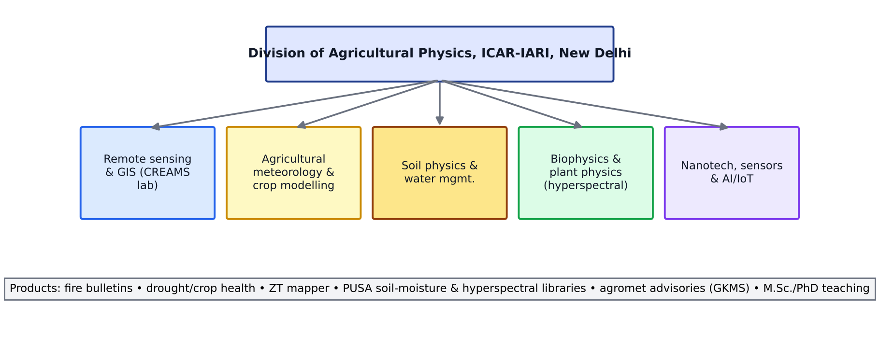
Figure 1. Structure and research areas of the Division of Agricultural Physics, ICAR-IARI (schematic).

Achievements to quote
Area | Achievement or product
Crop-residue burning | The CREAMS laboratory (Consortium for Research on Agroecosystem Monitoring and Modelling from Space) issues daily paddy-residue fire bulletins for Punjab, Haryana, UP, Delhi, Rajasthan and MP from MODIS/VIIRS active fires. It co-developed the ISRO–ICAR standard protocol for monitoring burning events, and maps wheat and rice burnt area. Bulletins go to MoA&FW, CAQM and state departments.
Conservation agriculture | Zero-Tillage Mapper: a time series of ZT-wheat adoption over about 63,000 fields in Fazilka (Punjab), 2018–2023 (Sehgal & Dhakar, CREAMS).
Crop monitoring | Drought and crop-health assessment, satellite-based crop monitoring for national initiatives, and support for crop area and yield estimation.
Hyperspectral & biophysics | Spectral libraries and indices for wheat yellow rust, nitrogen and water stress; hyperspectral soil-property estimation (R. N. Sahoo and colleagues).
Agrometeorology | Gramin Krishi Mausam Sewa (GKMS) agro-advisories for Delhi NCR; crop–weather relations and climate-change impact studies.
Soil physics | Soil compaction, hydraulic properties, irrigation scheduling, and tillage and residue effects on soil moisture and temperature.
Precision agriculture | IARI is the lead institute of ICAR-NePPA (Network Programme on Precision Agriculture, launched 8 Sep 2021, 16 partner institutes).

Name to remember: Dr. Vinay Kumar Sehgal heads the Division of Agricultural Physics and leads the CREAMS lab, which supplies residue-burning reports to the Ministry of Agriculture. Your notes mention a paper by “Dr. Vinay” that you couldn’t read clearly; Dr. Sehgal is the most likely author. Check his recent publications on CA mapping, residue burning or MRV before the interview.

1.3 Engineering work at IARI
IARI's Division of Agricultural Engineering, together with the Post-Harvest and Food Science divisions and the Water Technology Centre, works on machines and devices for small farms. Know three or four examples with a one-line description of each:
Technology | One-line description
Pusa Zero Energy Cool Chamber (ZECC) | A double brick-wall chamber with a wet sand cavity that keeps fruit and vegetables 10–15 °C cooler than ambient using evaporative cooling and no electricity.
Pusa-Farm SunFridge | A solar-powered on-farm cold room for perishables, with thermal storage for night-time cooling.
Conservation-agriculture machinery | Zero-till drills, raised-bed planters and residue-handling attachments adapted for rice–wheat systems (with PAU, CIMMYT and other partners).
Precision application | Sensor-based (NDVI) variable-rate N applicators, drone spraying trials and IoT soil-moisture-based irrigation controllers.
Water technology | Pressurised micro-irrigation, fertigation scheduling and wastewater reuse (Water Technology Centre).
PUSA Decomposer (microbiology, not engineering) | A fungal consortium (several Trichoderma/Aspergillus-type cellulolytic strains) sprayed on paddy stubble that decomposes it in about 20–25 days. Often asked together with residue management.

Caution: Before quoting a specific machine and its developer, check it against the latest IARI Annual Report. The board will appreciate precise claims more than broad ones.

1.4 IAIRO — India AI Research Organisation
- What: a national, execution-first AI research institution, modelled “in the spirit of ISRO, but for AI”.
- Where and when: at GIFT City, Gandhinagar. Gujarat gave in-principle approval in late December 2025, operations started on 1 January 2026, and the formal launch was on 30 January 2026.
- Legal form: a Section 8 non-profit run as a public-private partnership, positioned as a Focused Research Organisation under the IndiaAI Mission (MeitY).
- Funding: about ₹300 crore over five years, from the Gujarat government, the Centre and industry (the Indian Pharmaceutical Alliance has been reported as a partner).
- Leadership: Founding Director Dr. Amit Sheth, author of the launch position paper “Sovereign AI for India's Strategic Autonomy”.
- Mandate: frontier AI research, sovereign IP, retaining Indian AI talent, translating research into deployments, and evidence-based policy. Compute will combine on-premise GPUs with the IndiaAI Cloud.
- Agriculture relevance: foundation models for Earth observation, such as an Indian counterpart to NASA–IBM Prithvi, trained on Resourcesat, EOS-04, NISAR and Sentinel archives. Possible uses are crop-type mapping, yield nowcasting, pest-outbreak prediction and multilingual advisory (Bhashini).
Q. Why does India need IAIRO when IITs and IndiaAI already exist?
A. Universities optimise for papers and startups optimise for short-term revenue. IAIRO is meant to fill the gap between them with mission-mode, long-horizon, sovereign AI research that is translated into public-good deployments, the way ISRO did for space.
Q. How could IAIRO help ISRO's agriculture applications?
A. It could train geospatial foundation models on Indian satellite archives, build benchmark datasets such as CCE-linked yield labels and crop-type ground truth, and provide GPU compute for national-scale inference, for example GP-level yield under YES-TECH.

2. Remote-sensing foundations (quick refresher)
Every specialised topic later in the guide (SIF, NISAR, ET, burning, yield) rests on a few physical ideas. The board often opens with one of them before going deeper.

2.1 Electromagnetic radiation and the key laws
- Planck's law: spectral radiance of a black body, B(λ,T) = 2hc²/λ⁵ · 1/(e^(hc/λkT) − 1).
- Wien's displacement law: λmax = 2898/T µm. The Sun (≈5800 K) peaks at 0.5 µm, the Earth (≈300 K) at about 9.7 µm and a fire (≈1000 K) at about 2.9 µm, which is why fires are detected at 3.9 µm.
- Stefan–Boltzmann law: M = εσT⁴ with σ = 5.67×10⁻⁸ W m⁻² K⁻⁴. This is the basis of the outgoing longwave term in the energy balance.
- Kirchhoff's law: at thermal equilibrium, emissivity ε(λ) = absorptivity α(λ). For opaque bodies, reflectance = 1 − ε.
- Atmospheric windows: VIS–NIR (0.4–1.3 µm), SWIR (1.55–1.75 and 2.05–2.4 µm), MIR (3–5 µm), TIR (8–14 µm) and microwave (>1 cm, nearly all-weather).
Table 2. Spectral regions and agricultural information content
Region | Range | What it tells you about crops and soil
Blue | 0.45–0.52 µm | Chlorophyll and carotenoid absorption; aerosol correction
Green | 0.52–0.60 µm | Green reflectance peak; chlorophyll content (GCI, GNDVI)
Red | 0.63–0.69 µm | Strong chlorophyll absorption (red well)
Red edge | 0.69–0.75 µm | Position shifts with chlorophyll and N (REP, NDRE, CI-red-edge); Sentinel-2 B5–B7
NIR | 0.75–1.3 µm | Mesophyll scattering, LAI and biomass; high for healthy canopies
SWIR | 1.55–2.35 µm | Leaf water (NDWI/LSWI), cellulose/lignin (residue, CAI), burn scars (NBR), soil minerals and salinity
MIR | 3–5 µm | Active fires, FRP
TIR | 8–14 µm | LST, ET (SEBAL/METRIC/ALEXI), crop water stress (CWSI)
Microwave | 1 mm–1 m | SAR: structure, biomass, soil moisture, flooding; radiometers (SMAP, SMOS) for soil moisture

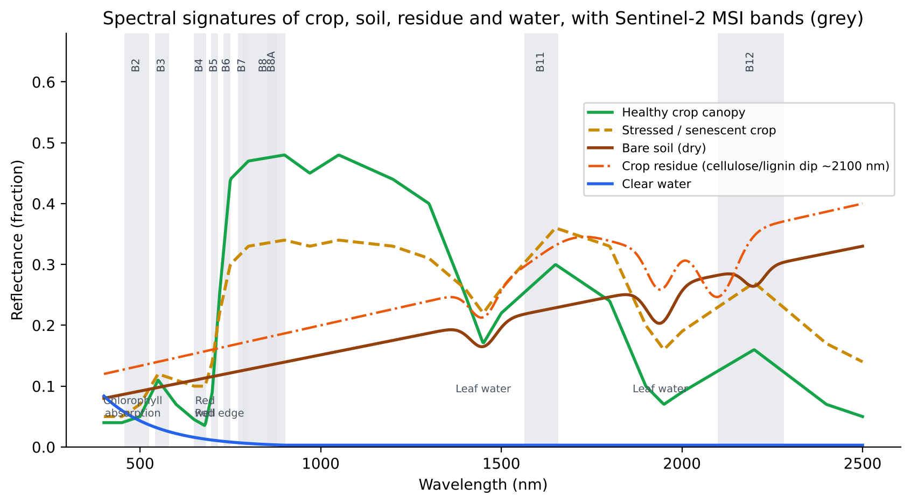
Figure 2. Typical spectral reflectance curves of healthy and stressed crop, bare soil, crop residue and water, with Sentinel-2 MSI band positions.

2.2 Four resolutions and the trade-off
- Spatial: pixel size, e.g. LISS-IV 5.8 m, Sentinel-2 10–20 m, Landsat 30 m, MODIS 250–1000 m.
- Spectral: number and width of bands, e.g. multispectral (4–13 bands) or hyperspectral (PRISMA, EnMAP, HySIS: >200 bands at about 10 nm).
- Radiometric: quantisation, e.g. 10-bit LISS-III, 12-bit Sentinel-2 and 14-bit Landsat-9, which set how finely brightness differences can be distinguished.
- Temporal: revisit, e.g. Sentinel-2 5 days (2 satellites), Sentinel-1 6–12 days, NISAR 12 days, MODIS daily and INSAT every 15–30 min.
- Trade-off: fine spatial resolution usually means a narrow swath and less frequent revisit. Data fusion (STARFM/ESTARFM), harmonised products (HLS) and constellations address this.

2.3 Indian Earth-observation satellites relevant to agriculture
Table 3. ISRO missions used in agricultural applications
Satellite | Sensor / key specs | Agricultural use
Resourcesat-2/2A | LISS-IV 5.8 m, LISS-III 23.5 m, AWiFS 56 m (5-day) | Crop acreage (FASAL), horticulture (CHAMAN), cropping system analysis
EOS-04 (RISAT-1A) | C-band SAR 5.4 GHz, multi-pol | Kharif rice and jute mapping under clouds, flood mapping
EOS-06 (Oceansat-3) | OCM-3, SSTM | Ocean colour and SST feeding monsoon forecasts
NISAR (with NASA) | L + S-band SAR, 12-day | Crop mapping, soil moisture, biomass, subsidence
INSAT-3D/3DR/3DS | Imager + Sounder; 6 channels; 15–30 min | Insolation, LST, rainfall (HEM/IMSRA), fog, ET (MOSDAC)
Cartosat-2/3 | Panchromatic < 1 m | Field boundaries, cadastral overlay, infrastructure
EOS-07 / EOS-08 | Microwave sounders, GNSS-R (EOS-08) | Atmospheric profiles; GNSS-R for soil moisture and flood detection
HySIS | Hyperspectral VNIR–SWIR | Soil and crop biochemistry research

2.4 Vegetation and other indices (formula sheet)
Table 4. Frequently used spectral indices (Sentinel-2 band numbers in brackets)
Index | Formula | Sensitive to
NDVI | (NIR − R)/(NIR + R) = (B8 − B4)/(B8 + B4) | Greenness and biomass; saturates at LAI > 3
EVI | 2.5(NIR − R)/(NIR + 6R − 7.5B + 1) | Biomass at high LAI; corrects for soil and atmosphere
SAVI | (1 + L)(NIR − R)/(NIR + R + L), L = 0.5 | Sparse canopies; reduces soil background
NDRE | (NIR − RE)/(NIR + RE) = (B8A − B5)/(B8A + B5) | Chlorophyll and N at high LAI
CIred-edge | NIR/RE − 1 = B7/B5 − 1 | Canopy chlorophyll content (Gitelson)
MTCI | (B6 − B5)/(B5 − B4) | Chlorophyll (MERIS/OLCI)
NDWI / LSWI | (NIR − SWIR1)/(NIR + SWIR1) = (B8 − B11)/(B8 + B11) | Leaf and canopy water; flooding at rice transplanting
NDTI | (SWIR1 − SWIR2)/(SWIR1 + SWIR2) = (B11 − B12)/(B11 + B12) | Crop residue cover, tillage
CAI | 0.5(R2.0 + R2.2) − R2.1 (hyperspectral) | Cellulose absorption: residue vs soil
NBR | (NIR − SWIR2)/(NIR + SWIR2) = (B8 − B12)/(B8 + B12) | Burn scars; dNBR for severity
BAI | 1/[(0.1 − R)² + (0.06 − NIR)²] | Charcoal signal after burning
MIRBI | 10·SWIR2 − 9.8·SWIR1 + 2 | Burnt area in SWIR (Trigg & Flasse)
PRI | (R531 − R570)/(R531 + R570) | Xanthophyll cycle, LUE
SI / NDSI (salinity) | √(B·R); (R − NIR)/(R + NIR) | Surface salt crust

2.5 Accuracy assessment basics
- Confusion matrix: rows are reference classes and columns are classified classes.
- Overall accuracy (OA) = Σ diagonal / N.
- Producer's accuracy = 1 − omission error. User's accuracy = 1 − commission error.
- Kappa κ = (po − pe)/(1 − pe). Many reviewers now prefer reporting OA together with area-adjusted estimates and their confidence intervals (Olofsson et al. 2014).
- Continuous variables: RMSE, MAE, bias, R², nRMSE (%) and Willmott's d. Always validate on independent data.
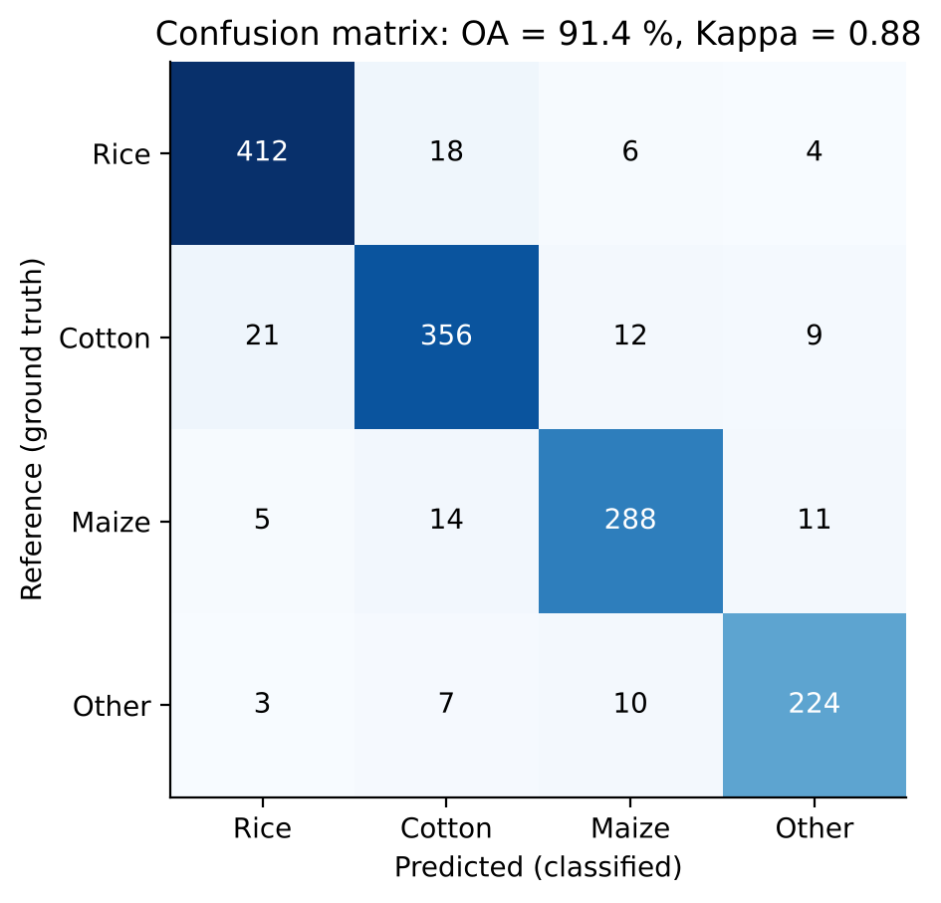
Figure 3. Example confusion matrix for a crop classification, with overall accuracy and kappa.

3. Sun-Induced Fluorescence (SIF) and the FLEX mission
One-line definition: Sun-induced chlorophyll fluorescence is the faint red and far-red light (650–800 nm) re-emitted by chlorophyll-a after absorbing sunlight. It is a direct, physiological signal of photosynthetic activity, unlike reflectance indices such as NDVI, which show only greenness (potential photosynthesis).

3.1 Physics: the fate of absorbed light
A photon absorbed by the light-harvesting antennae of photosystem II (PSII) or PSI has three competing de-excitation pathways:
- Photochemistry (ΦP): electron transport drives ATP/NADPH production and CO₂ fixation. This is the useful path and corresponds to GPP.
- Non-photochemical quenching (ΦN, NPQ): excess energy is dissipated as heat through the xanthophyll cycle (violaxanthin → zeaxanthin). This rises under stress and high light; PRI tracks it.
- Fluorescence (ΦF): about 0.5–3 % of absorbed energy is re-emitted at longer wavelengths. Emission peaks at ~685 nm (red, mostly PSII) and ~740 nm (far-red, PSI + PSII).
ΦP + ΦN + ΦF = 1 (energy conservation of absorbed photons)
SIF(λ) = PAR · fAPAR · ΦF(λ) · fesc(λ) GPP = PAR · fAPAR · ΦP (= APAR · LUEp)
Combining the two equations gives GPP = SIF · (ΦP / (ΦF · fesc)). The relationship between SIF and GPP is close to linear at canopy and ecosystem scale. Much of that linearity comes from the shared APAR term, and the ratio ΦP/ΦF varies under strong stress (Porcar-Castell et al. 2014; Mohammed et al. 2019).
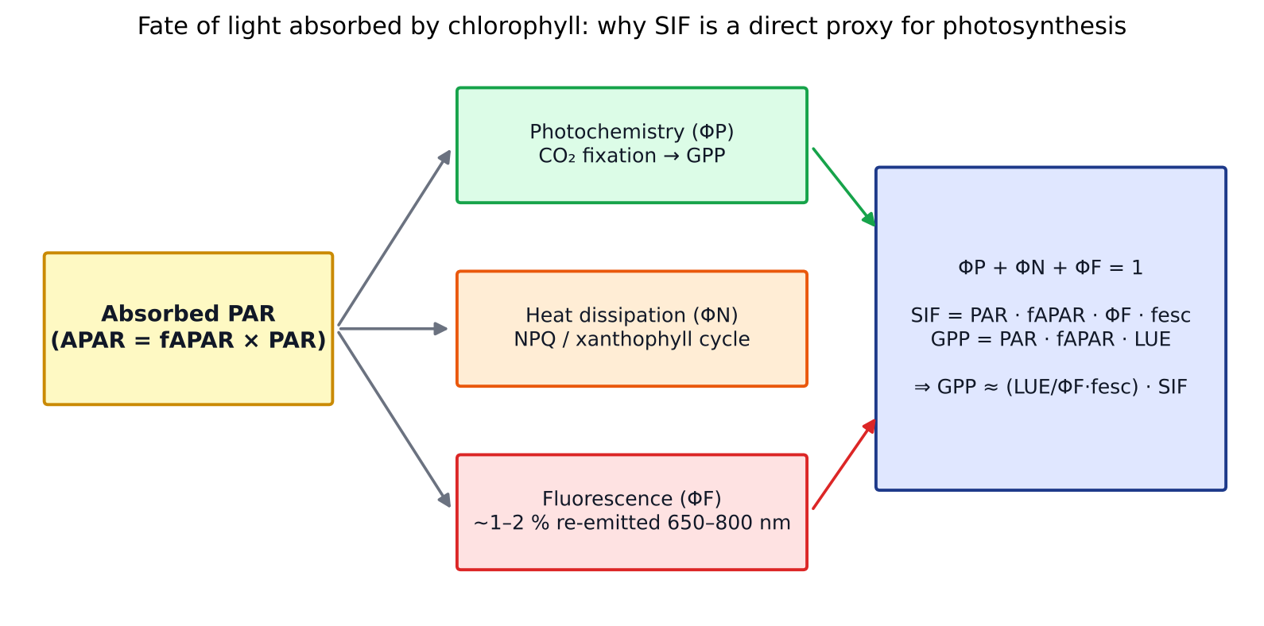
Figure 4. Partitioning of absorbed photosynthetically active radiation into photochemistry, heat and fluorescence. Concept redrawn after Porcar-Castell et al. (2014) and Mohammed et al. (2019).
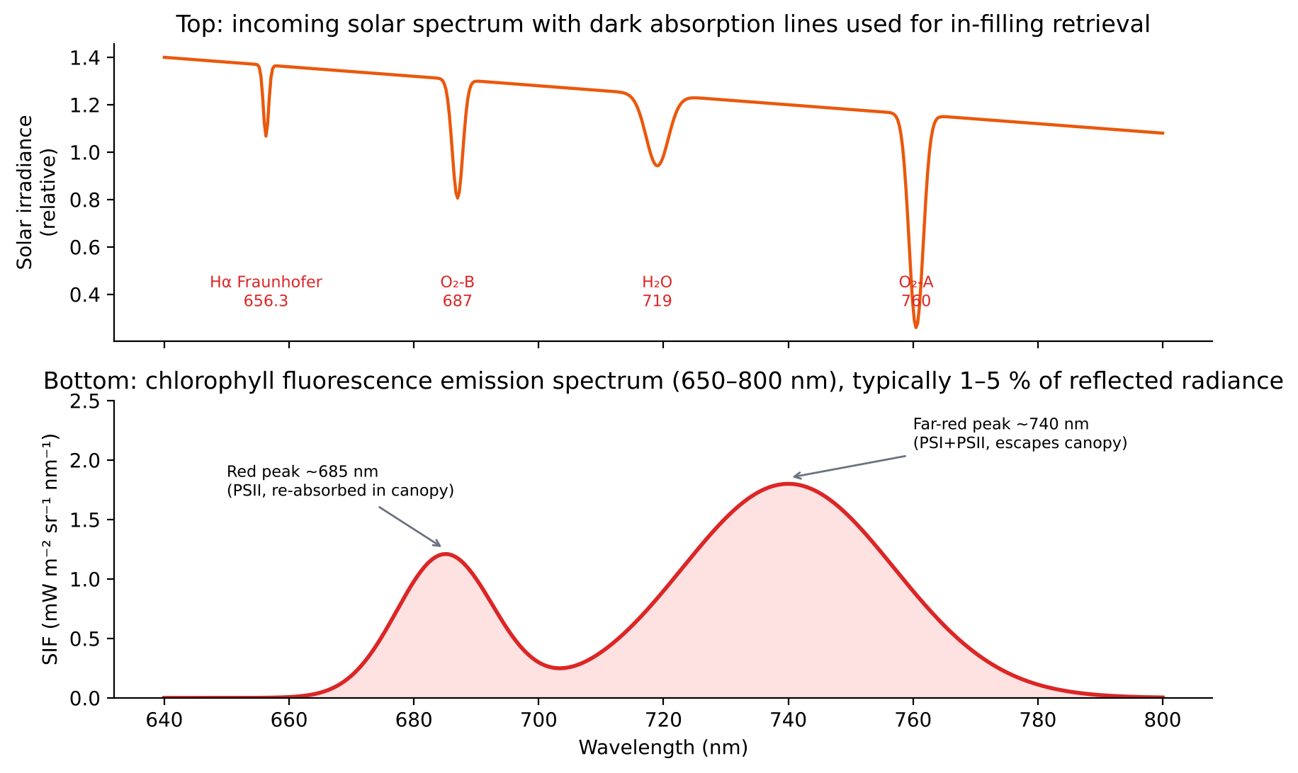
Figure 5. Top: solar irradiance with the Fraunhofer and telluric (O₂-A, O₂-B) absorption bands used to retrieve SIF. Bottom: the double-peaked fluorescence emission spectrum. Schematic redrawn after Meroni et al. (2009).

Why are the two peaks different?
- The red peak (685 nm) is strongly re-absorbed by chlorophyll inside the leaf and canopy, so its top-of-canopy value is much lower. It is more sensitive to PSII and to stress-driven changes in ΦF.
- The far-red peak (740 nm) escapes the canopy (high fesc) and depends strongly on canopy structure (LAI, leaf angle, clumping). It is the peak most satellites (OCO-2, TROPOMI, GOME-2) retrieve.
- The red/far-red ratio is used as an indicator of chlorophyll content and stress.

3.2 Active vs passive fluorescence
Aspect | Active (PAM, LIFT, LIF) | Passive SIF (sun-induced)
Light source | Artificial: saturating pulse or laser | Sunlight
Scale | Leaf (cm) to a few metres (LIFT) | Canopy to globe (tower, airborne, satellite)
Parameters | Fv/Fm (max PSII efficiency, ≈0.83 healthy), ΦPSII, qP, NPQ | SIF magnitude (mW m⁻² sr⁻¹ nm⁻¹), full spectrum
Measurement | Needs dark adaptation for Fv/Fm | No contact; continuous under sunlight
Use | Mechanistic plant physiology | Large-scale GPP, stress, yield

3.3 How SIF is retrieved: the in-filling principle
SIF is only about 1–5 % of the reflected radiance in the NIR, so it cannot be separated by reflectance alone. Retrieval works in dark absorption lines where incident light is very low. In those lines the relative contribution of emitted fluorescence is large and it "fills in" the line.
- Telluric O₂ bands: O₂-A (760 nm, far-red) and O₂-B (687 nm, red). These are deep and wide, so they suit tower, airborne and FLEX retrievals, but they need accurate atmospheric correction above about 100 m height.
- Solar Fraunhofer lines: Hα 656 nm, K I 770 nm and several lines at 745–758 nm. They are narrow and insensitive to atmosphere and clouds, and they are used by GOSAT, OCO-2 and TROPOMI.

Retrieval algorithms
Method | Principle | Notes
FLD (Plascyk 1975) | Two bands (inside and outside the line); assumes reflectance and F are constant across them. F = (Eout·Lin − Ein·Lout)/(Eout − Ein) | Simple; biased if reflectance changes
3FLD / iFLD | Uses two shoulders or corrects for the spectral slope of reflectance and F | Lower bias
SFM (spectral fitting; Meroni 2009) | Fits parametric shapes (polynomial reflectance + Gaussian/Lorentzian F) across the whole band | Gives the full spectrum; needs ≤0.3 nm resolution
SVD / PCA data-driven (Guanter 2012; Joiner 2013) | Learns the atmospheric/solar spectral variability from non-fluorescing targets (deserts, clouds); SIF is the residual | Standard for satellites
Physical / RTM inversion | Couples atmospheric RT (MODTRAN/libRadtran) with canopy RT (SCOPE) | Used for FLEX L2

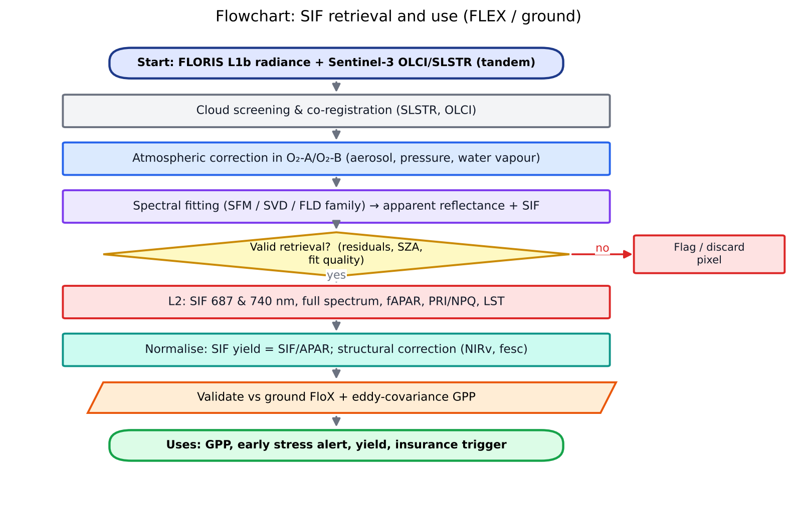
Figure 6. Flowchart of SIF retrieval and its use, from FLEX/Sentinel-3 radiance to agricultural applications.

3.4 SIF satellite missions
Table 5. Spaceborne SIF sources
Mission | Launch | Resolution | Remarks
GOSAT (TANSO-FTS) | 2009 | ~10 km footprints, sparse | First global SIF maps (Frankenberg 2011; Joiner 2011)
GOME-2 (MetOp-A/B/C) | 2006+ | 40×80 km | Long record, used for US Corn Belt GPP/yield (Guan 2016)
OCO-2 / OCO-3 | 2014 / 2019 | 1.3×2.25 km, narrow swath | Fine footprint; OCO-3 on ISS samples the diurnal cycle
TROPOMI (Sentinel-5P) | 2017 | 3.5×5.5 km, daily global | Workhorse for regional crop monitoring
TanSat (China) | 2016 | 2×2 km | CO₂ + SIF
FLEX (ESA EE-8) | 15 Sep 2026 | 300 m, 150 km swath | First mission designed for fluorescence; full spectrum and both peaks

3.5 FLEX: mission details
Parameter | Detail
Full name | FLuorescence EXplorer, ESA's 8th Earth Explorer (selected 2015)
Launch | 15 September 2026, Vega-C flight VV30, Kourou (French Guiana), launched together with Copernicus Sentinel-3C. Your notes have “Sep 2026”, which is correct.
Orbit | Sun-synchronous, about 815 km, 10:00 local descending node, tandem with Sentinel-3, a few seconds apart on the same ground track
Instrument | FLORIS (FLuORescence Imaging Spectrometer, Leonardo): pushbroom, 500–780 nm
Spectral sampling | High-resolution channel ~0.1 nm sampling / 0.3 nm resolution in O₂-B (677–697 nm) and O₂-A (740–780 nm); low-resolution 0.5–2 nm elsewhere
Spatial | 300 m × 300 m pixels; 150 km swath
Revisit | 27-day repeat (global land between about 75° N and 56° S); combined with Sentinel-3 for context
Platform | OHB System AG (Germany); planned life 3.5 years plus extension
Role of Sentinel-3 | OLCI gives reflectance, aerosol and water vapour; SLSTR gives LST and cloud screening, plus canopy temperature for NPQ and stress interpretation
Products | L1b radiance; L2: total SIF, SIF at 687 and 740 nm, full spectrum, fAPAR, PRI/NPQ proxy, canopy temperature; L3/L4 photosynthesis (GPP) and stress indicators
Airborne demonstrator | HyPlant (Forschungszentrum Jülich), flown in FLEXSense campaigns

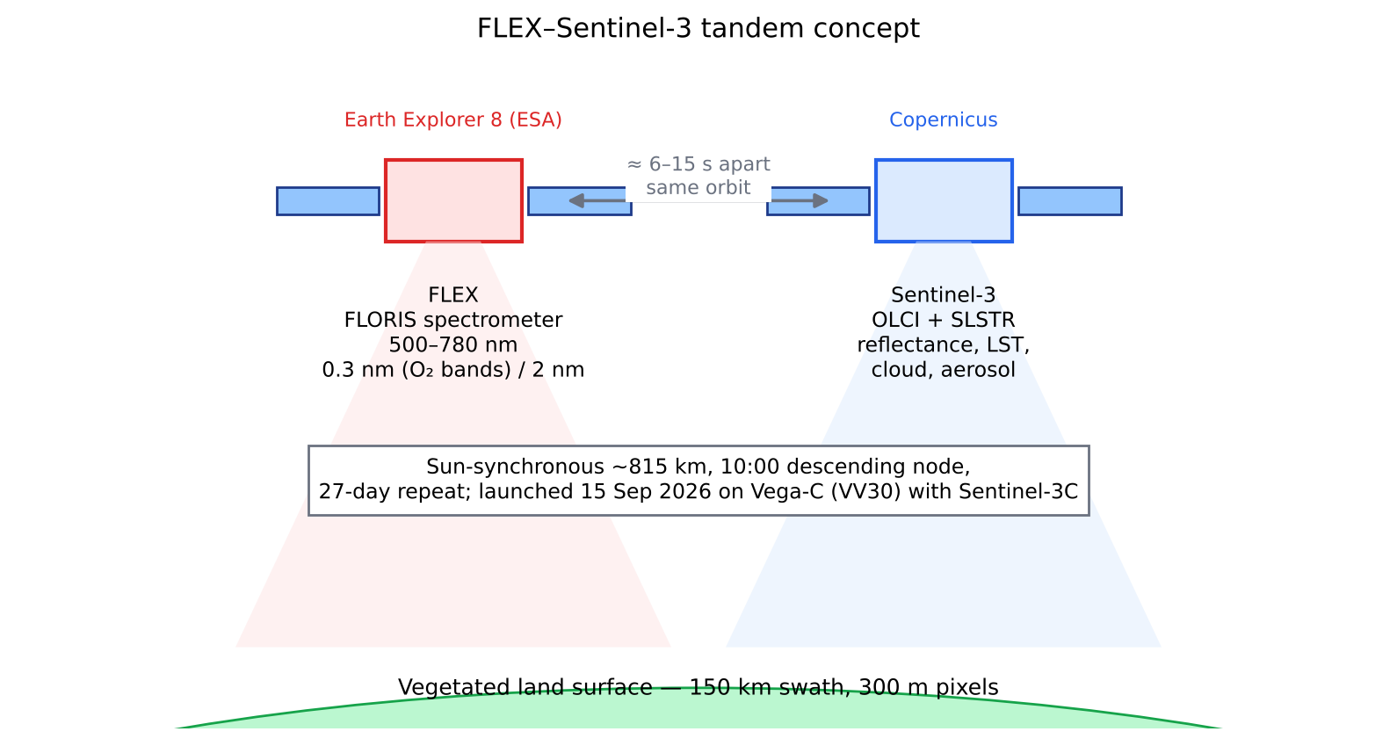
Figure 7. FLEX flying in tandem with Sentinel-3 (schematic based on Drusch et al. 2017 and ESA mission documentation).
Why FLEX is different: Unlike OCO-2 and TROPOMI, FLEX resolves both fluorescence peaks and the full emission spectrum at 300 m, close to field scale for large Indian plots and village scale for smallholders. This allows the photosynthetic efficiency signal to be separated from the APAR signal, which earlier missions could not do.

3.6 Ground measurement of SIF
Ground (proximal) SIF systems give continuous canopy measurements for process understanding and for FLEX calibration and validation.
- Instrument: two fibre-optic channels feed a high-resolution spectrometer, such as an Ocean Insight QE Pro (FWHM ≈ 0.3 nm, SNR > 1000) for fluorescence plus a broader-range unit for reflectance. Examples are FloX (JB Hyperspectral), Piccolo Doppio, PhotoSpec and FluoSpec2.
- Geometry: an upward cosine diffuser measures irradiance E(λ), and a downward bare fibre (about 25° FOV) or a rotating mirror measures canopy radiance L(λ). Readings alternate every few seconds and are cross-calibrated with a reference panel.
- Thermal stability: spectrometers sit in a Peltier-cooled housing because dark current and wavelength shifts corrupt the 0.1 nm-scale retrieval.
- Height: sensors are mounted 2–10 m above the canopy. Above about 20 m, O₂-band atmospheric absorption between sensor and canopy must be corrected.
- Retrieval: FLD/3FLD/iFLD or SFM at O₂-A and O₂-B. Quality control removes changing-cloud records and low-sun-angle data.
- Ancillary data: an eddy-covariance tower (GPP, ET), PAR sensors, leaf-level PAM fluorometry (Fv/Fm, NPQ) and LAI measurements.
- Networks: the ESA FLEX cal/val network (European Fluorescence Network), ChinaSpec and the US SIF network. In India, a ground SIF system next to an existing flux tower (NRSC/ISRO, IARI farm) would make an ideal FLEX cal/val super-site.
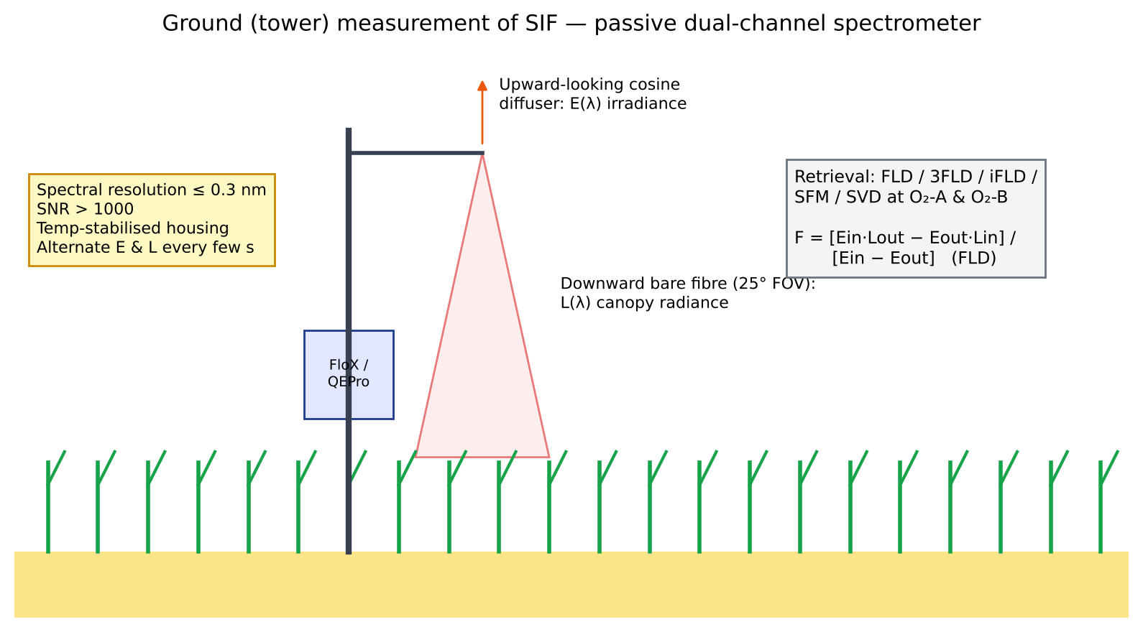
Figure 8. Tower-based passive SIF measurement: irradiance and radiance channels, and the FLD principle.
FLD: F = (Eout · Lin − Ein · Lout) / (Eout − Ein) (in = inside line, out = shoulder)

3.7 Agricultural applications of SIF
- GPP estimation: a near-linear SIF–GPP relationship holds across crops. C4 crops (maize, sugarcane) have higher GPP per unit SIF than C3 crops (wheat, rice).
- Yield forecasting: Guan et al. (2016) showed GOME-2 SIF explained US Corn Belt yields better than NDVI or EVI. TROPOMI SIF is now used for county-level yields, and FLEX's 300 m data could reach GP level.
- Early stress detection: SIF drops within hours to days of drought, heat or nitrogen stress, before visible greening loss (a lag of 1–3 weeks in NDVI). Sun et al. (2015) documented this for the 2012 US drought.
- Heat waves: helps separate heat stress (an ΦF/NPQ change) from water stress, together with Sentinel-3 LST.
- Nitrogen status: the red/far-red ratio and SIF yield (SIF/APAR) respond to N supply.
- Irrigation efficiency: SIF/ET gives a photosynthesis-based estimate of water productivity.
- Inputs to crop models and digital twins: SIF can be assimilated as a process-level observation of photosynthesis.

3.8 Limitations and research challenges
- The signal is weak (0.5–3 mW m⁻² sr⁻¹ nm⁻¹), so it needs high SNR and fine spectral resolution. Satellite SIF is noisy and must be averaged in time or space.
- Structural confounding: fesc depends on LAI, leaf angle and clumping. Methods to normalise it include the NIRv/FCVI approach and SIF/(NIRv·PAR).
- Sun-view geometry, the overpass time (one snapshot a day) and the need to scale to daily values (as with ET).
- Mixed pixels at 300 m in fragmented Indian smallholdings (median holding about 1 ha).
- Atmospheric correction in the O₂ bands (aerosols, surface pressure).

3.9 Interview questions on SIF and FLEX
Q. Why is SIF better than NDVI for detecting stress?
A. NDVI measures chlorophyll quantity and canopy structure, so it changes only once leaves yellow or wilt. SIF responds to the actual photosynthetic flux. When stomata close or heat damages PSII, ΦP and ΦF drop within hours, long before any change in pigments.
Q. Is SIF a measure of photosynthesis or of APAR?
A. Both. At canopy scale SIF ≈ APAR × ΦF × fesc. Much of the SIF–GPP correlation comes from APAR, and the physiological component (ΦF) adds information under stress. FLEX measures both peaks together with PRI, fAPAR and LST, so it can separate the two parts.
Q. Why fly FLEX in tandem with Sentinel-3?
A. SIF retrieval needs simultaneous reflectance (to model the background), aerosol and water vapour (for O₂-band atmospheric correction), cloud screening, and LST to interpret NPQ and stress. Sentinel-3 OLCI and SLSTR provide all of these a few seconds apart on the same ground track.
Q. How would you validate FLEX SIF over India?
A. Set up FloX-type ground systems in 300 m-homogeneous wheat and rice fields at IARI and at an NRSC flux-tower site. Measure continuously, upscale with Sentinel-2 or UAV hyperspectral data to 300 m, and compare at overpass time. Report bias, RMSE and the linearity of SIF with eddy-covariance GPP.
Q. What is Fv/Fm?
A. The maximum quantum efficiency of PSII, measured on dark-adapted leaves with a PAM fluorometer: (Fm − F0)/Fm. It is about 0.83 in healthy C3 leaves and decreases under photoinhibition.
Q. What are the O₂-A and O₂-B bands?
A. Absorption bands of atmospheric oxygen centred at 760 nm (A) and 687 nm (B). They make deep dark wells in the incoming spectrum, where the fluorescence in-filling signal is relatively large.

4. NISAR: crop mapping and soil-moisture retrieval
One-line definition: NISAR (NASA–ISRO Synthetic Aperture Radar) is the first dual-frequency (L- and S-band) imaging radar satellite. It gives all-weather, day-and-night, 12-day repeat observations of the Earth's surface for ecosystems, cryosphere, solid-earth deformation and agriculture.

4.1 SAR fundamentals you must be able to explain
- Active microwave: the radar transmits pulses and records the backscatter σ⁰ (dB). It works through clouds, which is critical for kharif crops during the monsoon.
- Synthetic aperture: the motion of the platform synthesises a long antenna, giving azimuth resolution of about L/2 (antenna length), independent of range.
- Wavelength vs penetration: X (3 cm) < C (5.6 cm, Sentinel-1/EOS-04) < S (9.4 cm) < L (24 cm) < P (70 cm). Longer wavelengths penetrate deeper into canopy and soil.
- Polarisation: HH, VV (co-pol) and HV/VH (cross-pol). Cross-pol is generated by volume (multiple) scattering, so it is a good biomass and canopy indicator.
- Dielectric constant (ε): dry soil ε ≈ 3–5 and water ε ≈ 80. Backscatter rises with soil moisture, which is the basis of SM retrieval.
- Geometric effects: foreshortening, layover and shadow; incidence-angle dependence (normalise to a reference angle, e.g. 40°).
- Speckle: coherent interference noise. Reduce it with multilooking, Lee/Refined-Lee/Gamma-MAP filters or temporal filtering.
- Interferometry (InSAR): phase difference gives deformation. Coherence drops when the field is ploughed, sown or harvested, so it can be used to detect tillage and harvest.
- Polarimetry: decompositions such as Freeman–Durden (surface/double/volume), Cloude–Pottier (H/A/α) and Yamaguchi describe scattering mechanisms.
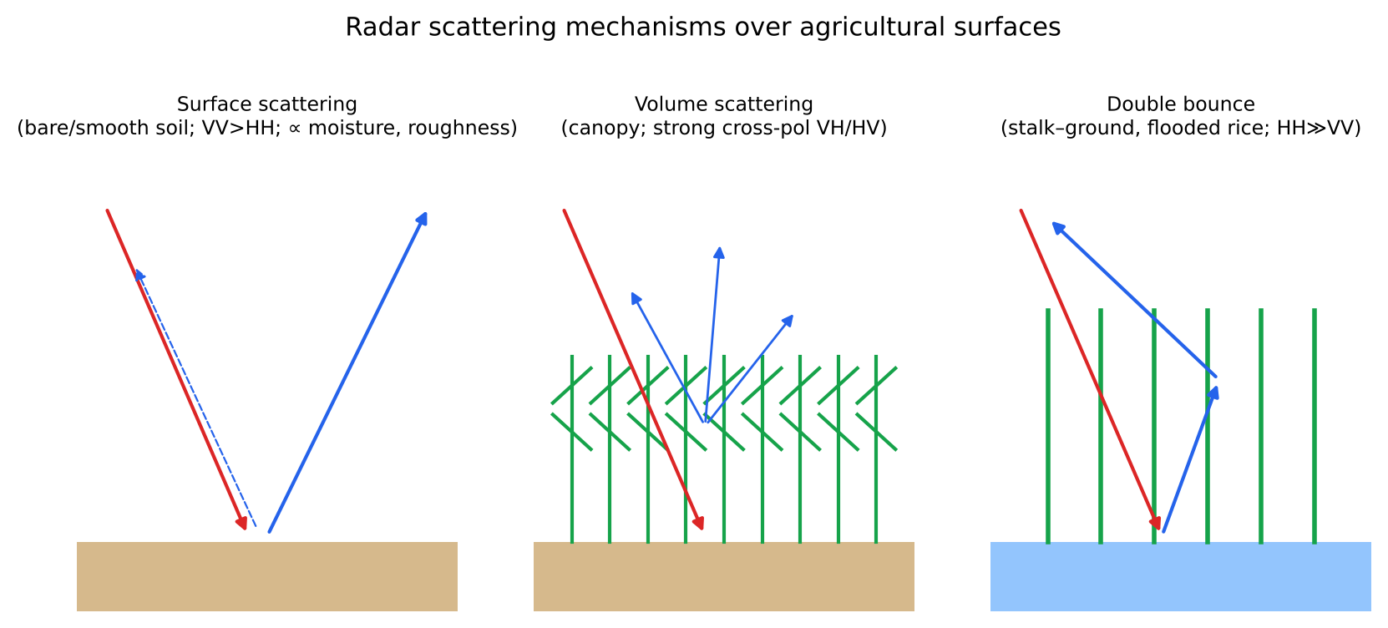
Figure 9. Surface, volume and double-bounce scattering mechanisms in agricultural fields (after Freeman–Durden decomposition concepts).

4.2 NISAR mission specifications
Parameter | Value
Partners | NASA/JPL (L-band SAR, reflector, GPS, data handling) and ISRO (S-band SAR, I-3K spacecraft bus, GSLV launch, operations)
Launch | 30 July 2025, GSLV-F16, Satish Dhawan Space Centre, Sriharikota
Orbit | Sun-synchronous, dawn–dusk, about 747 km, 98.4° inclination
Repeat | 12 days (about 6 days using ascending and descending passes)
Frequencies | L-band 1.257 GHz (24 cm), global coverage; S-band 3.2 GHz (9.4 cm), focused on India and selected sites
Antenna | 12 m deployable mesh reflector; SweepSAR digital beamforming
Swath / resolution | ~242 km swath; 3–10 m (mode dependent)
Polarisation | Single, dual and quad (full) polarimetric modes
Data | Free and open; through NASA ASF DAAC and ISRO Bhoonidhi
Mission life | 3 years (nominal); fuel for longer

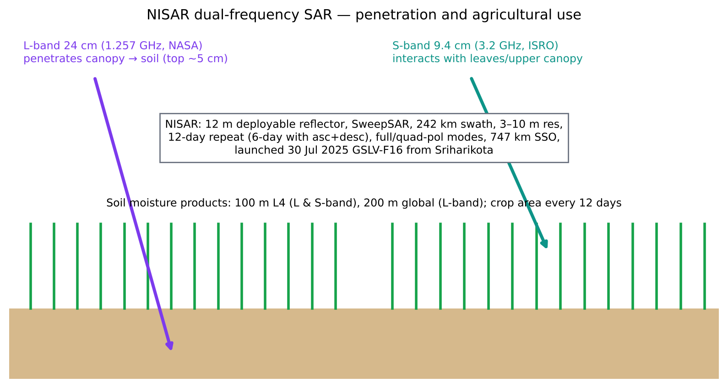
Figure 10. NISAR L-band (deeper penetration) and S-band (canopy) interaction with crops and soil.

4.3 Crop mapping with NISAR

Physical basis
- As a crop grows, volume scattering from leaves and stems raises cross-pol (HV/VH) backscatter, and attenuation changes co-pol.
- Rice: at puddling and transplanting, the flooded field reflects specularly, giving very low σ⁰ (−22 to −26 dB in VH). As tillers grow, stem–water double-bounce raises HH strongly. HH/VV > 1 is diagnostic of rice.
- Wheat and mustard: vertical stems attenuate VV more than HH. The VH/VV ratio rises with biomass.
- Sugarcane: high, stable backscatter all year from a tall, dense canopy (L-band saturates later, at about 100 t/ha biomass).
- L vs S vs C: L-band sees stems and soil, and saturates late. S-band (like C) is sensitive to leaves and the upper canopy and helps separate leafy crops. Together they help discriminate crop types and growth stages.
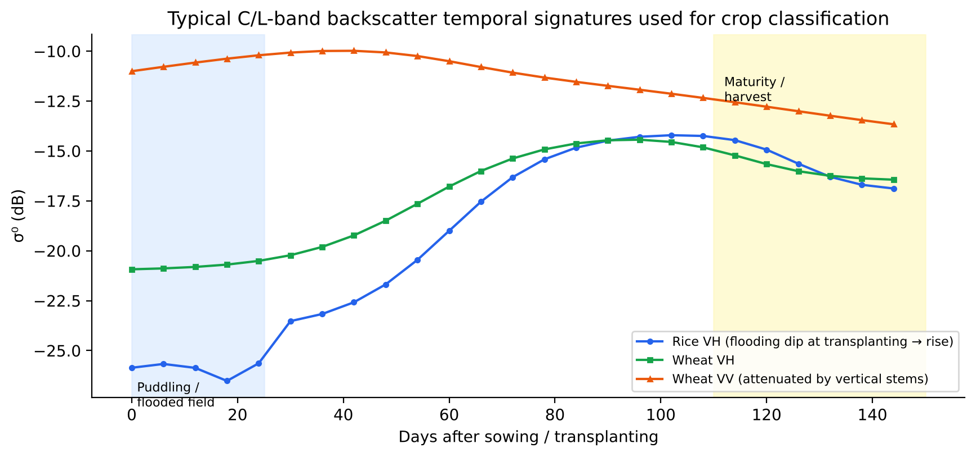
Figure 11. Backscatter time series for rice and wheat, showing the flooding dip at rice transplanting and the rise with canopy growth.

Workflow (as used for EOS-04 and Sentinel-1, adapted to NISAR)
- Download GCOV (geocoded polarimetric covariance) or RSLC products.
- Radiometric terrain correction (γ⁰), speckle filtering and conversion to dB.
- Build a multi-temporal stack (12-day composites) and derive features: HH, HV, VV, ratios, the Radar Vegetation Index RVI = 8σHV/(σHH + σVV + 2σHV), polarimetric entropy and alpha, and coherence.
- Collect training samples from field surveys, CROPIC/Digital Crop Survey geotagged photos or Bhuvan.
- Classify with Random Forest, SVM or a deep-learning model (1-D CNN / LSTM / Transformer on time series). Fuse with Sentinel-2 where cloud-free.
- Validate with independent samples: OA, kappa and area-adjusted accuracy.
- Estimate area by stratified sampling (FASAL approach) and update district and state acreage.
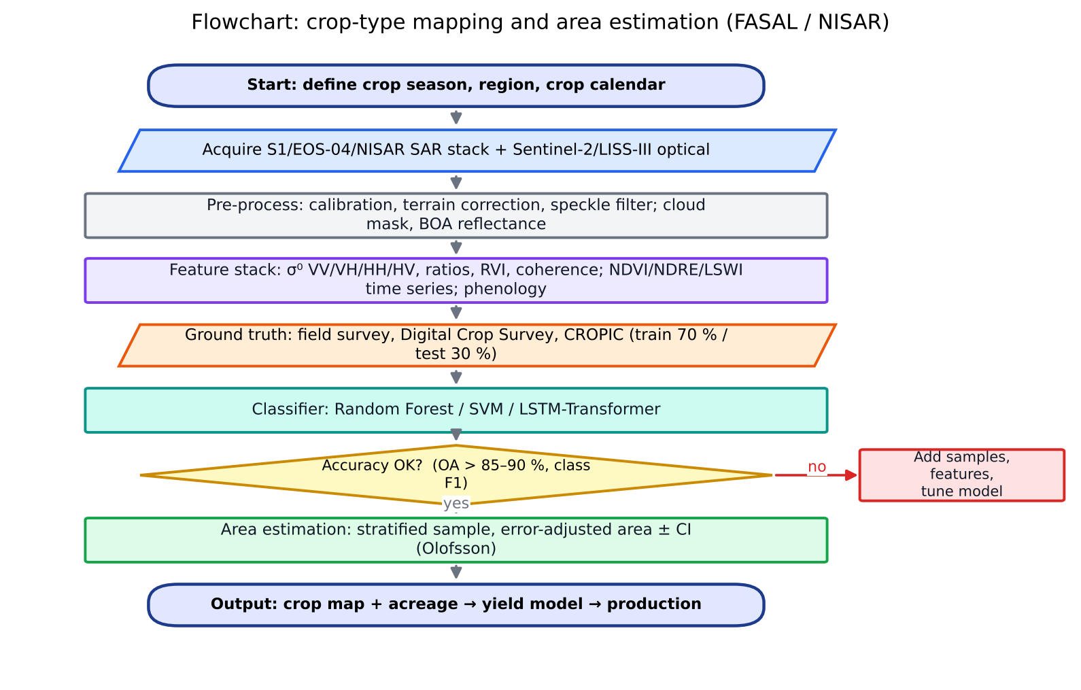
Figure 12. Flowchart of crop-type mapping and area estimation (FASAL / NISAR).
Official product: The NISAR Crop Area Product (L3, planned) is a binary active-crop/no-crop map every 12 days at about 100 m, computed from the coefficient of variation of HV backscatter over time. Cropland shows high temporal variability, while forests and urban areas are stable.

4.4 Soil-moisture retrieval with NISAR

Physical basis
Backscatter from bare soil depends on the dielectric constant (which rises with volumetric water content, Topp's equation), surface roughness (RMS height s, correlation length l), the incidence angle and the wavelength. Vegetation adds its own scattering and attenuates the soil signal, so it has to be corrected for.
Topp et al. (1980): θv = −5.3×10⁻² + 2.92×10⁻²·ε − 5.5×10⁻⁴·ε² + 4.3×10⁻⁶·ε³

The Water Cloud Model (Attema & Ulaby 1978)
σ⁰ = A·V₁·cosθ·(1 − γ²) + γ²·σ⁰soil, γ² = exp(−2·B·V₂ / cosθ)
V₁ and V₂ are vegetation descriptors (LAI, NDVI, vegetation water content or biomass). A and B are crop-specific coefficients fitted against field data. γ² is the two-way canopy transmissivity. Once the vegetation term is removed, σ⁰soil is inverted for moisture with a soil-scattering model.
Table 6. Soil-moisture retrieval approaches
Approach | Idea | Pros and cons
Change detection (Wagner/TU-Wien) | SM ∝ (σ⁰t − σ⁰dry)/(σ⁰wet − σ⁰dry); roughness assumed static over time | Simple and robust; gives relative SM; needs a long time series
Empirical regression | SM = a + b·σ⁰ calibrated on field data | Site-specific
Semi-empirical (Oh 1992, Dubois 1995) | Co-pol ratio and cross-pol relations with ε and ks | Works for bare soil; limited validity range
Physical (IEM, AIEM) | Integral Equation Model from EM theory | Accurate but needs roughness inputs
Machine learning (RF, ANN) | Learns σ⁰ + NDVI + soil texture + DEM → SM | Flexible; needs many in-situ points
Active–passive fusion (SMAP-style) | Disaggregates coarse radiometer SM using fine SAR σ⁰ | Fine resolution plus radiometer accuracy

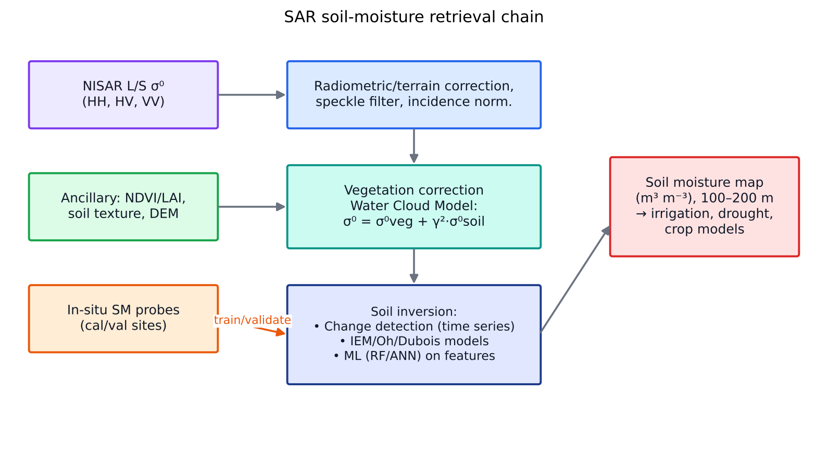
Figure 13. SAR soil-moisture retrieval chain from backscatter to soil-moisture map.

NISAR soil-moisture products
- NASA L3 global soil moisture: about 200 m (L-band), 12-day, top ~5 cm, multiple algorithms, requirement of ±0.06 m³ m⁻³.
- ISRO L4 (NRSC): 100 m L- and S-band soil-moisture products over India's agro-climatic regions, two observations every 12 days, distributed through Bhoonidhi. Preliminary products are being evaluated at core cal/val sites, and field-scale products are in progress.
- L-band penetrates vegetation better and samples deeper soil. S-band gives finer surface sensitivity and detail. Combining the two improves retrieval under crops.

4.5 Other agricultural uses of NISAR
- Above-ground biomass (L-band) for sugarcane and agroforestry, relevant to carbon MRV.
- Flood inundation and crop-loss assessment for PMFBY localized calamities. Inundation under the canopy shows as an HH double-bounce increase.
- Tillage, sowing and harvest dates from InSAR coherence drops (relevant to CA detection and residue burning).
- Land subsidence from groundwater depletion in Punjab, Haryana and Gujarat (InSAR), which links irrigation and aquifer health.
- Freeze/thaw and snow in Himalayan catchments (irrigation water supply).

4.6 Interview questions on NISAR
Q. Why is L-band better than C-band for soil moisture under crops?
A. At 24 cm wavelength the canopy is more transparent: attenuation is lower and L-band reaches the soil through moderate biomass (up to about 5 kg/m² vegetation water content). C-band saturates over dense crops and mostly measures the canopy.
Q. What does NISAR's S-band add for India?
A. S-band (9.4 cm) is sensitive to leaves and the upper canopy, which helps separate crop types and early growth stages and improves surface-soil-moisture detail. It was built by ISRO, and S-band acquisitions are planned mainly over India.
Q. How will you map kharif rice using NISAR?
A. Use a 12-day HH/HV time series. Look for the flooding minimum at transplanting, followed by a rapid rise in HH (double bounce) and HV (volume scattering). Classify with Random Forest on temporal features and validate with field data. Coherence and the HH/VV ratio help separate rice from other crops.
Q. Explain the Water Cloud Model in one line.
A. It treats the canopy as a uniform cloud of water droplets: total backscatter = vegetation volume scattering + two-way-attenuated soil backscatter, so the soil term can be isolated and inverted for moisture.
Q. Why does change detection work for soil moisture?
A. Over weeks, roughness and vegetation in a pixel change slowly compared with moisture. Scaling each observation between the driest and wettest observed backscatter therefore gives relative saturation, with no need for roughness parameters.

5. Retrieving crop and soil parameters
One-line definition: parameter retrieval is the quantitative estimation of biophysical and biochemical variables (LAI, chlorophyll, nitrogen, water content, phenology, soil moisture, salinity) from remotely sensed radiance. It uses empirical, physical (radiative-transfer) or hybrid machine-learning models.

5.1 Three families of retrieval methods
Family | How it works | Strengths and weaknesses
Parametric / empirical | Regression of a VI against field data (e.g. LAI = a·e^(b·NDVI)) | Simple and fast; site-, sensor- and crop-specific; saturation
Non-parametric ML | RF, SVR, GPR, ANN, CNN on bands and VIs | Captures non-linearity; needs large training sets; less transferable
Physically based (RTM inversion) | Invert PROSPECT+SAIL by LUT or optimisation | Generic, transferable; ill-posed (several parameter sets give the same spectrum); needs priors
Hybrid | Train ML (GPR/ANN) on RTM-simulated spectra, then apply to imagery | Generic and fast; basis of the SNAP S2 biophysical processor and ESA/ISRO operational LAI

5.2 Crop parameters

(a) Phenology
- What: dates of key stages such as sowing or emergence (SOS), peak or heading, senescence and harvest (EOS), and the length of season (LOS).
- Data: NDVI/EVI time series (MODIS, Sentinel-2, HLS), SAR backscatter and coherence (Sentinel-1, NISAR), and SIF.
- Smoothing: Savitzky–Golay, Whittaker, harmonic (HANTS) or double-logistic fitting. Use TIMESAT or the phenofit/greenbrown R packages.
- Extraction: threshold (e.g. 20 % of amplitude), maximum rate of change (first derivative) or curvature-change methods.
- Uses: crop calendars for FASAL, sowing-date-based crop models, insurance (prevented sowing), and detecting late or early sowing in CA fields.
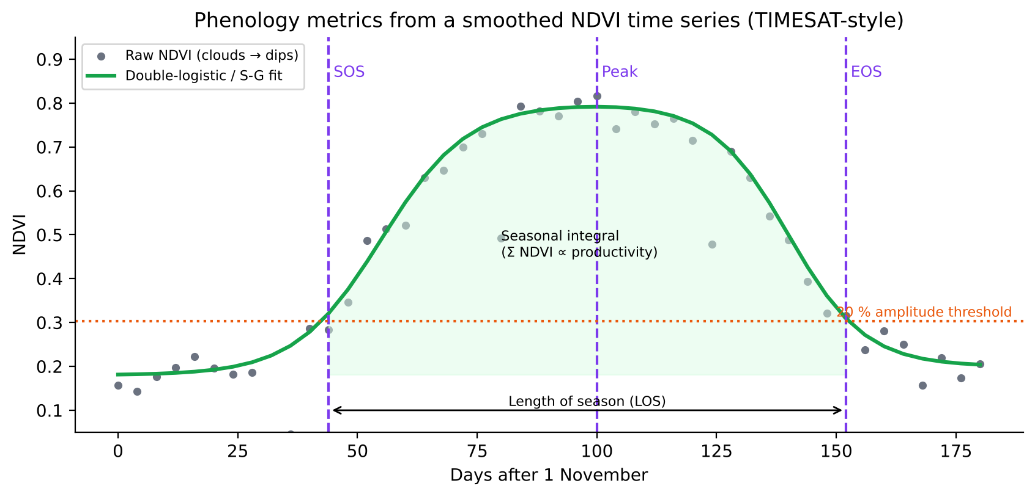
Figure 14. Phenology metrics (SOS, peak, EOS, LOS, seasonal integral) from a smoothed NDVI time series.

(b) Leaf Area Index (LAI)
- Definition: one-sided green leaf area per unit ground area (m² m⁻²). It drives light interception (fAPAR = 1 − e^(−k·LAI), Beer–Lambert law, k ≈ 0.5).
- Ground measurement: destructive sampling, LAI-2200 plant canopy analyser (gap fraction), AccuPAR ceptometer and digital hemispherical photography.
- Remote sensing: NDVI saturates at LAI ≈ 3. Red-edge indices (NDRE, CIre, MTCI), EVI and SAR (L-band) extend sensitivity. RTM-hybrid retrieval (SNAP) gives LAI, fAPAR and fCover from Sentinel-2.
- Products: MODIS MCD15 (500 m), Copernicus GLS (300 m) and the ISRO Resourcesat LAI product.

(c) Leaf and canopy water
- Variables: EWT/Cw (equivalent water thickness, g cm⁻²), FMC and CWC (canopy water content = Cw × LAI).
- Absorption features: 970, 1200, 1450 and 1940 nm. Multispectral indices use SWIR: NDWI(Gao) = (NIR − SWIR1)/(NIR + SWIR1), MSI = SWIR1/NIR and NDII.
- Thermal: canopy temperature and CWSI = (Tc − Twet)/(Tdry − Twet), from IR thermometers, UAV thermal cameras or Landsat TIR. Water stress closes stomata, which warms the canopy.
- Microwave: vegetation water content from L-band (the τ-ω model in SMAP) and VH backscatter.

(d) Chlorophyll and nitrogen
- Chlorophyll (Cab, µg cm⁻²): red-edge position (REP), MTCI, CIred-edge, TCARI/OSAVI (reduces LAI influence), and ground chlorophyll meters (SPAD-502, atLEAF).
- Nitrogen: most leaf N is in Rubisco and chlorophyll, so canopy chlorophyll content (CCC = Cab × LAI) is a strong proxy for canopy N. Use NDRE, CCCI, the leaf colour chart (LCC) and GreenSeeker NDVI to compute the N sufficiency index NSI = NDVI(field)/NDVI(N-rich strip).
- Hyperspectral: narrow bands at 550, 705, 720 and 750 nm and PLSR models. Crude protein and N content can be estimated directly from SWIR protein features at 1510, 2054 and 2172 nm.
- Application: in-season N top-dressing algorithms (Raun et al. 2002: NFOA = (YP₀ × RI − YP₀) × %N/NUE), i.e. precision N under VRT.
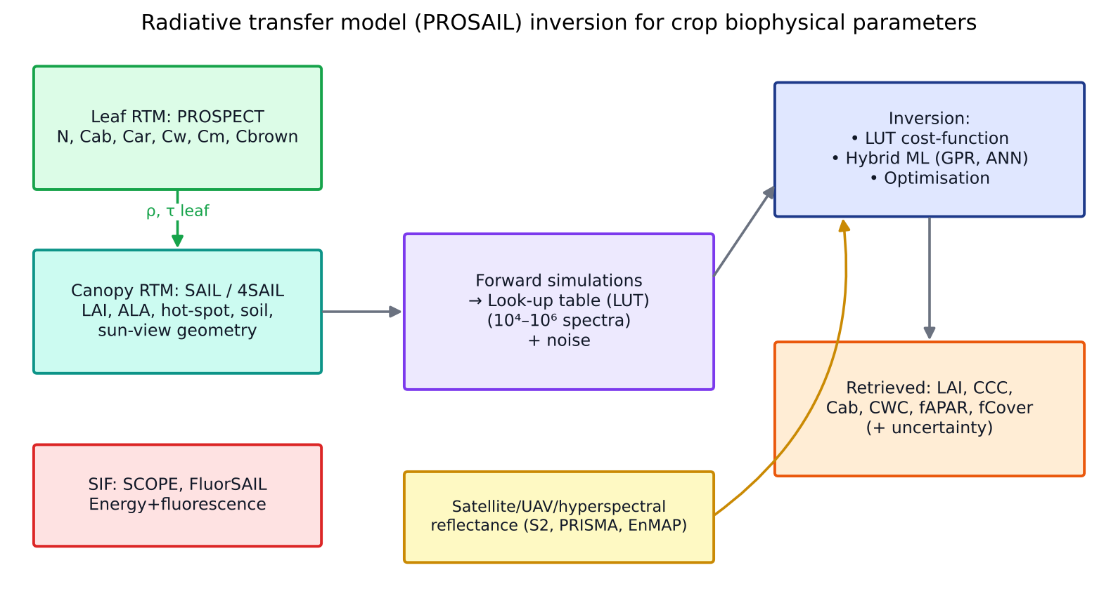
Figure 15. PROSAIL radiative-transfer inversion workflow for crop biophysical and biochemical parameter retrieval (after Jacquemoud et al. 2009; Verrelst et al. 2015).

5.3 Radiative transfer models (RTMs)
Table 7. Common RTMs for crops and soil
Model | What it simulates | Inputs
PROSPECT (-4/-5/-D/-PRO) | Leaf reflectance and transmittance 400–2500 nm (plate model) | N (structure), Cab, Car, Anth, Cw, Cm (dry matter), Cbrown; PROSPECT-PRO separates protein and CBC
SAIL / 4SAIL | Canopy bidirectional reflectance (turbid medium, 4-stream) | LAI, average leaf angle (ALA), hot spot, soil reflectance, solar and view zenith, relative azimuth
PROSAIL | PROSPECT + SAIL coupled; the most widely used crop RTM | All of the above
SCOPE (van der Tol 2009) | Energy balance + photosynthesis + fluorescence + reflectance | Vcmax, meteorology, LAI, Cab; used for FLEX
DART, LESS | 3-D ray tracing for heterogeneous canopies | 3-D scene; computationally heavy
Hapke, SOILSPECT, MARMIT | Soil reflectance as a function of moisture and roughness | Soil SSA, moisture film thickness
WCM, MIMICS, IEM | Microwave scattering from canopy and soil | Biomass, ε, roughness

Inversion strategies and the ill-posed problem
- LUT inversion: simulate 10⁴–10⁶ spectra, then for each pixel pick the n best matches (RMSE cost function) and take their mean or median as the solution.
- Ill-posedness: LAI and ALA compensate for each other. Constrain the inversion with prior distributions, add noise, use multi-angle or temporal information, or regularise.
- Hybrid ML: Gaussian Process Regression gives an uncertainty estimate with each prediction and is the basis of the ARTMO toolbox (Verrelst et al.) for Sentinel-2/3, PRISMA and EnMAP.

5.4 Soil parameters

(a) Soil moisture
Covered in detail in Chapter 4 (SAR). Other methods: optical/thermal triangle (TVDI from Ts–NDVI), OPTRAM (STR = (1 − SWIR)²/(2·SWIR) vs NDVI), passive microwave (SMAP 9–36 km, SMOS), GNSS-R (CYGNSS, ISRO EOS-08) and ground (TDR, FDR capacitance probes, gravimetric, cosmic-ray neutron COSMOS).

(b) Salinity and alkalinity (sodicity)
- Definitions: saline soil has ECe > 4 dS m⁻¹, pH < 8.5 and ESP < 15. Sodic (alkali) soil has ESP > 15, pH > 8.5 and low EC. Saline-sodic soils are both. India has about 6.7 Mha of salt-affected soils (ICAR-CSSRI), including Haryana, UP, Punjab, Gujarat and Rajasthan.
- Spectral behaviour: salt crusts raise VIS–NIR reflectance (white surface). Sodic soils show dispersed, crusted surfaces with high reflectance and poor vegetation. Evaporite minerals (gypsum and halite) have SWIR absorption features at 1.4, 1.9 and 2.2 µm.
- Indices: SI1 = √(G·R), SI2 = √(G² + R² + NIR²), SI3 = √(B·R), NDSI = (R − NIR)/(R + NIR), the Brightness Index BI = √(R² + NIR²), and the vegetation-based CRSI (canopy response salinity index). For SWIR, (SWIR1 − SWIR2)/(SWIR1 + SWIR2).
- Approach: combine indices with EM-38 apparent electrical conductivity surveys, ECe lab data and ML (RF, Cubist) in a digital soil mapping framework. Multi-year maximum-NDVI or yield-gap maps are also used because crops integrate root-zone salinity.
- Radar: salt increases the imaginary part of ε, which raises backscatter in wet saline soils.

(c) Soil organic carbon, texture and nutrients
- Diffuse reflectance spectroscopy (VNIR–SWIR, 350–2500 nm): SOC absorbs broadly across the visible range (darker soils) and at 1700/2300 nm. Clay minerals show OH features at 1400, 1900 and 2200 nm, and iron oxides at 480 and 900 nm.
- Models: PLSR, Cubist, SVR, RF and memory-based learning, using soil spectral libraries (the Indian soil spectral library effort; ICRAF/ISRIC; LUCAS in Europe).
- Bare-soil composites: multi-year Sentinel-2 bare-soil composites (SCMaP, GEOS3) to map SOC and texture in cropland.

5.5 Digital soil mapping (DSM): Dr. Bappa Das's line of work
Definition: DSM creates spatial soil information systems by numerical models that infer the spatial and temporal variation of soil properties from observations and environmental covariates (McBratney et al. 2003).
scorpan: S = f(s, c, o, r, p, a, n) + ε
s = soil (existing data), c = climate, o = organisms/vegetation (NDVI), r = relief (DEM derivatives: slope, TWI, curvature), p = parent material, a = age, n = spatial position. The ε term is modelled by kriging the residuals (regression kriging).
- Soil sampling: conditioned Latin hypercube (cLHS) or stratified random design. Analyse SOC, pH, EC, N, P, K and texture in the laboratory, or predict them from spectra.
- Covariate stack: Sentinel-2 and Landsat bare-soil and vegetation composites, SRTM/Cartosat DEM derivatives, climate (CHIRPS, IMD gridded data), geology and land use.
- Model: Random Forest, Quantile Regression Forest (for uncertainty), Cubist, XGBoost or regression kriging. In India, regression kriging is the most common, followed by RF and QRF (Geoderma Regional 2022 review).
- Validation: k-fold or spatial CV, reporting RMSE, R², Lin's concordance coefficient (CCC) and the prediction interval coverage probability (PICP).
- Products: GlobalSoilMap specification at 6 depths (0–5, 5–15, 15–30, 30–60, 60–100 and 100–200 cm) with 90 % prediction intervals, used for soil-health-card upscaling and fertiliser recommendations.
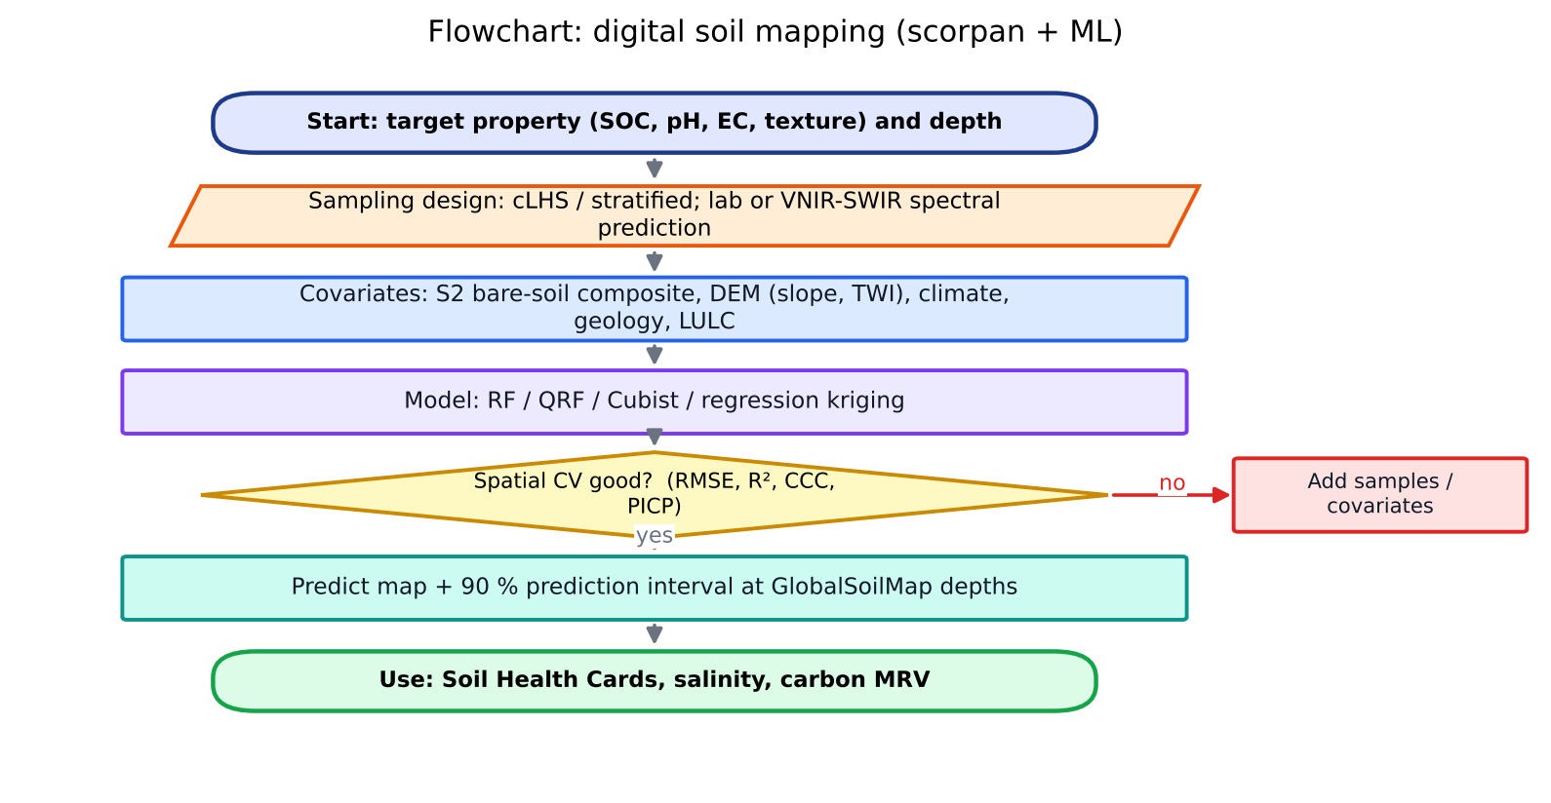
Figure 16. Flowchart of digital soil mapping with the scorpan framework and machine learning.
Dr. Bappa Das (ICAR) works on proximal and remote spectroscopy plus machine learning for soil and crop properties, and on DSM. Recent examples include ML-based soil organic carbon mapping in the Indian Himalayan region (Kalambukattu, Kumar, Das, Roy et al. 2025, Discover Soil) and VNIR–SWIR spectral prediction of soil properties with ML-model comparison. In the interview, cite the method (spectral library → ML → spatial covariates → uncertainty maps) rather than a specific title unless you have read the paper.

5.6 Where parameter retrieval is heading
- Hyperspectral missions: PRISMA (Italy), EnMAP (Germany), EMIT, ISRO's planned hyperspectral missions and CHIME (ESA Copernicus expansion) for operational N, protein and soil properties.
- Thermal missions: TRISHNA (ISRO–CNES, ~57 m TIR, near-daily), LSTM (ESA) and SBG for ET and water stress at field scale.
- Fluorescence: FLEX for photosynthetic efficiency.
- Foundation models and self-supervised learning (Prithvi, SatMAE, Clay) fine-tuned with few labels, plus physics-informed ML that embeds RTM or crop-model constraints.
- Data assimilation of retrieved LAI, SM and SIF into crop models (digital twins).
- UAV + satellite upscaling and uncertainty-aware products (GPR, QRF, Bayesian inversion).

5.7 Interview questions
Q. Why does NDVI saturate and how do you overcome it?
A. At LAI > 3, red reflectance is almost fully absorbed and stops changing, while NIR keeps increasing, so the normalised ratio flattens. Red-edge indices (NDRE, CIre), EVI, wide-dynamic-range VI, SAR backscatter or RTM inversion stay sensitive at high biomass.
Q. How would you map soil salinity in Haryana?
A. Use multi-date Sentinel-2 in the dry season (bare soil and salt crust) and compute SI, NDSI and BI. Add the multi-year maximum NDVI of crops and DEM-derived wetness. Train RF/QRF on EC measurements from field and EM-38 surveys. Validate with spatial CV and produce maps of salinity classes with uncertainty.
Q. What is the difference between LAI and fAPAR?
A. LAI is a structural quantity (leaf area per ground area). fAPAR is a radiative quantity (fraction of PAR absorbed), related to LAI non-linearly through Beer's law. Production-efficiency models such as LUE use fAPAR.
Q. What does PROSPECT simulate?
A. Leaf hemispherical reflectance and transmittance from 400 to 2500 nm as a function of the structure parameter N, chlorophyll, carotenoids, water, dry matter and brown pigments.

6. Evapotranspiration: SEBAL, METRIC, ALEXI and scaling
One-line definition: evapotranspiration (ET) is the combined loss of water from the soil surface (evaporation) and from plants (transpiration). Energetically it is the latent heat flux λET, which links the water, energy and carbon cycles.

6.1 Definitions you must keep distinct
Term | Meaning
ET₀ (reference ET) | ET from a hypothetical well-watered grass reference (0.12 m height, rs = 70 s m⁻¹, albedo 0.23), computed with FAO-56 Penman–Monteith. Depends on weather only.
ETr | Alfalfa reference ET (ASCE), about 1.2 × ET₀. Used by METRIC.
ETc (crop ET, potential) | ETc = Kc × ET₀ under standard (no-stress) conditions. Kc follows the crop stage (initial, development, mid, late).
AET / ETa (actual ET) | ETc,adj = Ks × Kc × ET₀ under real water or salinity stress. This is what SEB models estimate.
EF (evaporative fraction) | EF = λET/(Rn − G) = λET/(λET + H)
ETrF (= Kc × Ks) | ETrF = ETinst/ETr,inst. METRIC's fraction of reference ET. Your notes write it as AET/ET₀.

FAO-56 PM: ET₀ = [0.408·Δ·(Rn − G) + γ·(900/(T + 273))·u₂·(es − ea)] / [Δ + γ·(1 + 0.34·u₂)]

6.2 Measuring ET on the ground
- Weighing lysimeter: the most accurate method (mass balance). It is point-scale and expensive. IARI has lysimeter facilities.
- Bowen-ratio energy balance (BREB): β = H/λET = γ·ΔT/Δe, so λET = (Rn − G)/(1 + β).
- Eddy covariance (EC): a direct turbulent-flux measurement (Section 6.8).
- Scintillometer (LAS): path-averaged H over 0.5–5 km. Matches satellite pixels well.
- Sap-flow sensors: transpiration of individual plants.
- Soil water balance: ET = P + I − D − R − ΔS, using neutron probes or TDR.

6.3 The surface energy balance (SEB)
Rn = G + H + λET ⇒ λET = Rn − G − H
Rn = (1 − α)·Rs↓ + RL↓ − RL↑ − (1 − ε₀)·RL↓, RL↑ = ε₀·σ·Ts⁴
H = ρa·cp·dT / rah, rah = ln(z₂/z₁) / (k·u*) (corrected for stability with Monin–Obukhov theory)
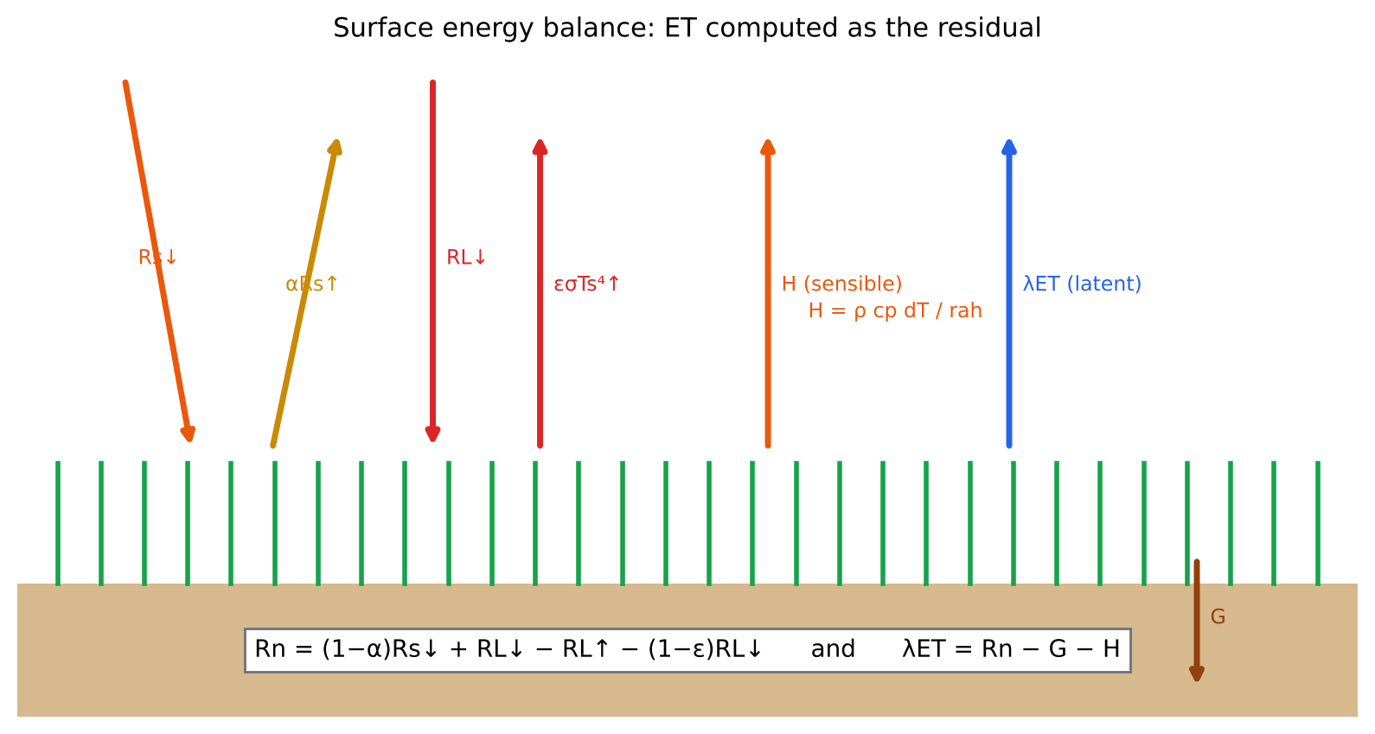
Figure 17. Surface energy balance components; ET is obtained as the residual.
Satellites measure albedo (VNIR) and land surface temperature Ts (TIR). Rn and G are computed fairly reliably. H is the difficult term because it needs the near-surface air-temperature gradient dT and the aerodynamic resistance rah. The single-source models (SEBAL, METRIC) and the two-source models (TSEB/ALEXI) differ mainly in how they estimate H.

6.4 SEBAL (Bastiaanssen et al. 1998)
- Full name: Surface Energy Balance Algorithm for Land.
- Key idea: dT (the surface–air temperature difference) is a linear function of Ts, dT = a + b·Ts. The coefficients come from two anchor pixels in the scene, so the absolute bias in Ts largely cancels.
- Cold pixel: well-watered, full-cover crop (or water body). SEBAL assumes H ≈ 0, so λET = Rn − G.
- Hot pixel: dry bare field with λET ≈ 0, so H = Rn − G.
- Iteration: start with neutral rah from the wind speed at a 200 m blending height, compute H, then the Monin–Obukhov length L, stability corrections ψm and ψh, then u* and rah, and repeat until convergence (5–10 iterations).
- Advantage: minimal ground data (wind speed) and self-calibrating within each image.
- Limitations: choosing anchor pixels is subjective; it needs both wet and dry extremes in the scene; the assumption of H = 0 at the cold pixel underestimates ET under advection, as in hot and dry NW India.
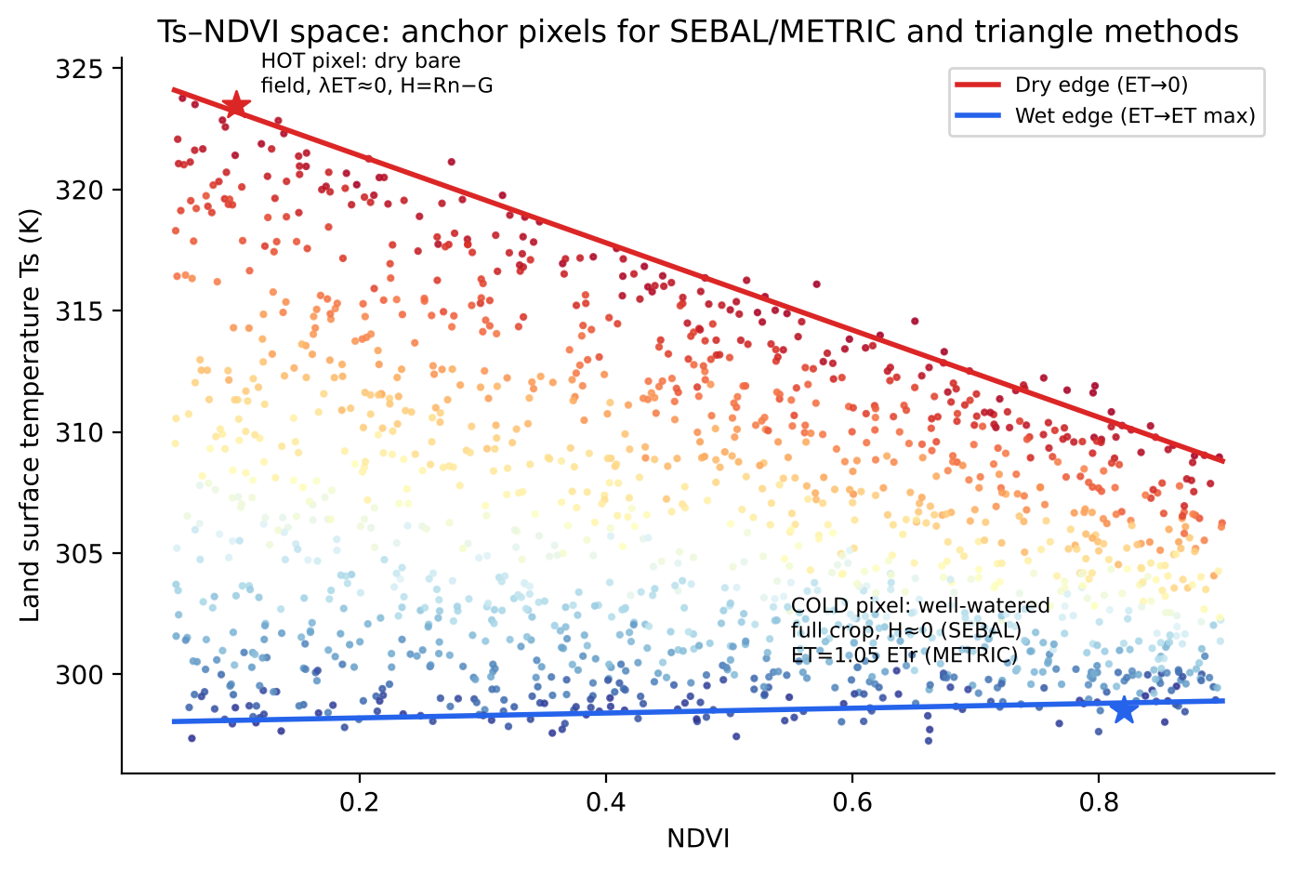
Figure 18. Ts–NDVI scatter showing hot and cold anchor pixels and the dry and wet edges (concept after Bastiaanssen et al. 1998; Allen et al. 2007).

6.5 METRIC (Allen et al. 2007)
- Full name: Mapping EvapoTranspiration at high Resolution with Internalized Calibration.
- Derived from SEBAL, with two important changes:
- (1) Cold pixel: λET = 1.05 × ETr (alfalfa reference) instead of H = 0. This accounts for advection, and hourly weather data calibrates it.
- (2) Scaling: uses ETrF = ETinst/ETr,inst (the reference ET fraction) to scale to daily and seasonal ET, instead of SEBAL's EF.
- Hot pixel: λET from a soil water balance (FAO-56) to account for residual soil evaporation after rain.
- Corrects for slope and aspect in mountainous terrain, uses Landsat 30 m data (TIR sharpened from 100 m), and is used for water-rights and irrigation management in the USA.
- Implementations: EEFlux, OpenET (Google Earth Engine) and geeSEBAL.
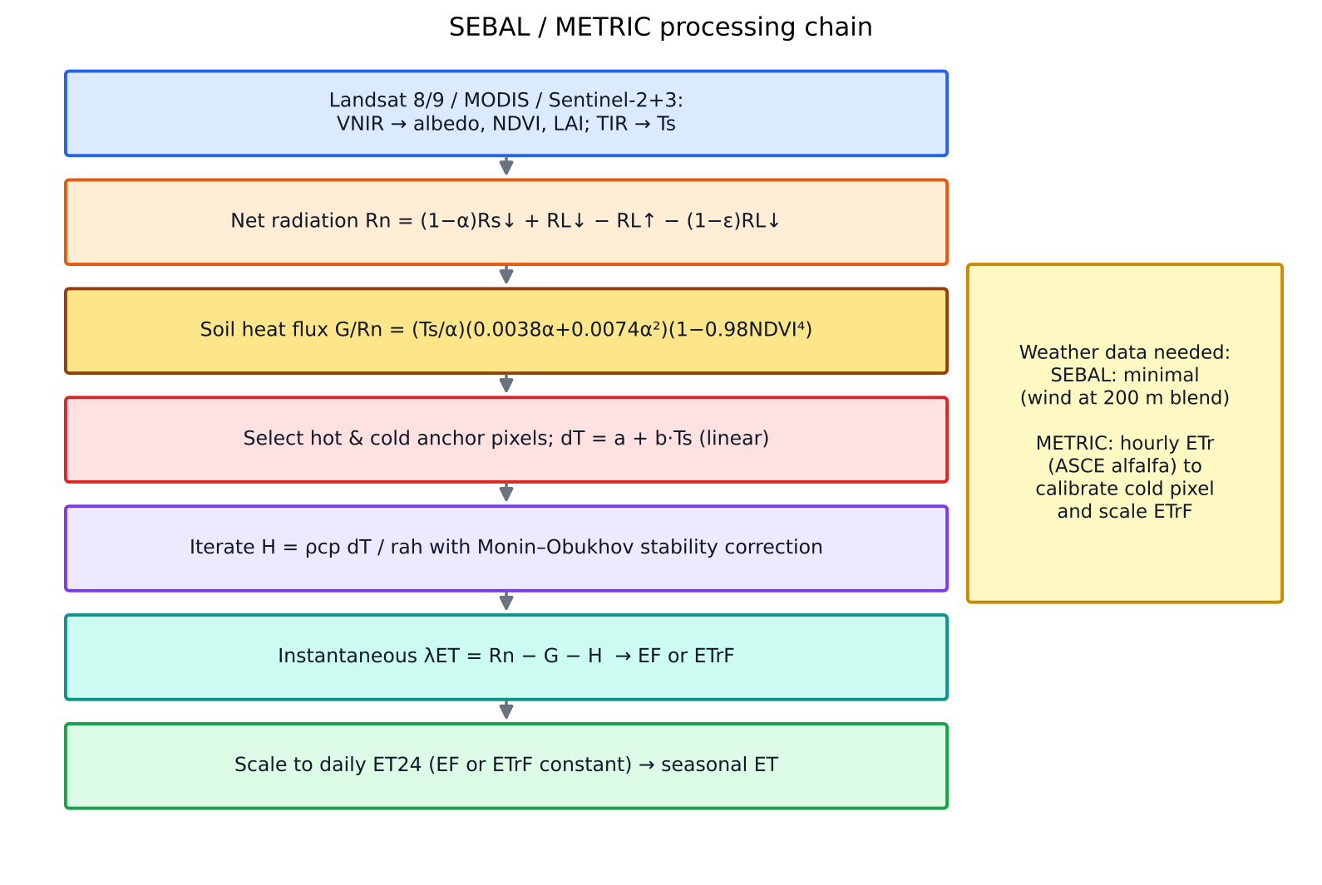
Figure 19. Processing chain of SEBAL and METRIC.

6.6 ALEXI and DisALEXI (Anderson et al. 1997, 2007)
- Full name: Atmosphere–Land EXchange Inverse model.
- Two-source energy balance (TSEB, Norman et al. 1995): separates soil and canopy, Ts⁴ = fc·Tc⁴ + (1 − fc)·Ts,soil⁴. Canopy transpiration is first estimated by Priestley–Taylor, λEc = 1.26·fG·Δ/(Δ + γ)·Rnc, and soil evaporation is the residual.
- Time-differencing: uses the morning rise in Ts between two geostationary observations (about 1.5 h after sunrise and 1.5 h before local noon), from GOES or MSG (INSAT-3D could be used for India).
- ABL coupling: the rise in Ts drives sensible-heat growth of the atmospheric boundary layer (a slab model, McNaughton & Spriggs). This closes the equations without air-temperature measurements, which are the main uncertainty in single-source models.
- Robust to absolute Ts errors (emissivity, atmospheric correction) because it uses the temporal change.
- DisALEXI: disaggregates the coarse (3–10 km) ALEXI flux to 30 m (Landsat) or 1 km (MODIS) using local TSEB and an ALEXI-derived air temperature.
- STARFM fusion: daily 30 m ET by fusing Landsat and MODIS (Cammalleri et al. 2014).
- ESI (Evaporative Stress Index) = 1 − AET/PET anomaly, used for flash-drought early warning (the US Drought Monitor uses it).
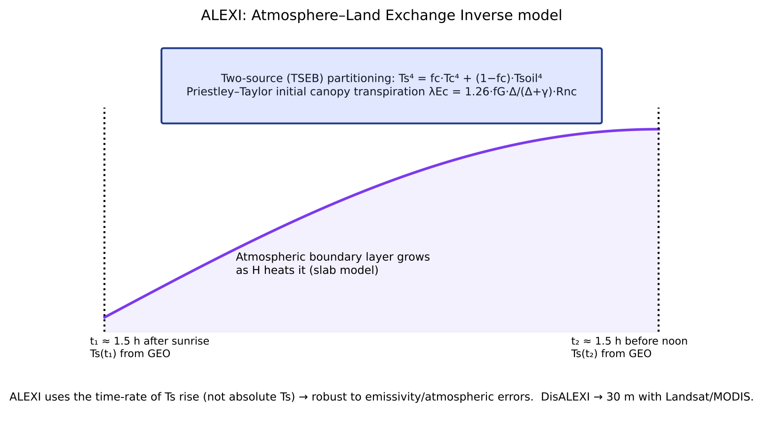
Figure 20. ALEXI concept: two-source partitioning and boundary-layer growth driven by the morning rise in surface temperature (after Anderson et al. 1997).
Table 8. SEB-based ET models compared
Aspect | SEBAL | METRIC | ALEXI / DisALEXI | SSEBop / SEBS
Source | Single | Single | Two (soil + canopy) | Single
H estimation | dT = a + bTs; anchor pixels | Same, cold pixel calibrated to ETr | Time-rate of Ts + ABL model | SSEBop: predefined dT from clear-sky energy; SEBS: kB⁻¹ roughness physics
Weather needs | Minimal | Hourly ETr | Morning sounding, GEO Ts | Ta grid (SSEBop) / full meteorology (SEBS)
Daily scaling | EF constant | ETrF constant | Rs (insolation) ratio | ETf × ET₀
Resolution | Landsat/MODIS | Landsat 30 m | 3–10 km → 30 m | MODIS/Landsat
Weakness | Anchor choice, advection | Anchor choice | Complexity, GEO data | Ta and roughness errors

6.7 Scaling instantaneous ET to daily ET
Polar orbiters such as Landsat (≈10:30) and MODIS Terra (10:30) and Aqua (13:30) give a single snapshot of λETinst (W m⁻²). Irrigation and crop-water-use studies need ET24 (mm day⁻¹) and seasonal ET.
Your notes' answer: The ratio of actual ET to reference ET (AET/ET₀, or ETrF) for a field stays nearly constant through the day, because both respond in the same way to the diurnal cycle of radiation and vapour-pressure deficit. So the ratio at overpass time is multiplied by the 24-hour reference ET from a weather observatory to give daily ET.
METRIC: ET24 = ETrF_inst × ETr,24 where ETrF_inst = ETinst / ETr,inst
SEBAL (EF method): ET24 = 86400 · EF · (Rn24 − G24) / λ, G24 ≈ 0
Table 9. Instantaneous-to-daily scaling methods
Method | Assumption | Comment
Evaporative fraction (EF) | EF = λET/(Rn − G) is constant through daytime (Shuttleworth 1989; Crago 1996, ‘self-preservation’) | Underestimates ET by 5–10 % under advection; EF has a slight U-shape through the day
Reference ET fraction (ETrF / Kc) | ETa/ETr is constant | Captures advection and wind effects; needs hourly weather; best in arid irrigated regions
Solar radiation ratio | ET24/ETinst = Rs24/Rs,inst | ALEXI uses it; simple, needs only insolation
Sine-function / Jackson | Diurnal ET follows a sine curve between sunrise and sunset | Good on clear days only
Temporal interpolation between overpasses | Linear or spline interpolation of ETrF, cloud gaps filled with water balance | Seasonal ET (METRIC)

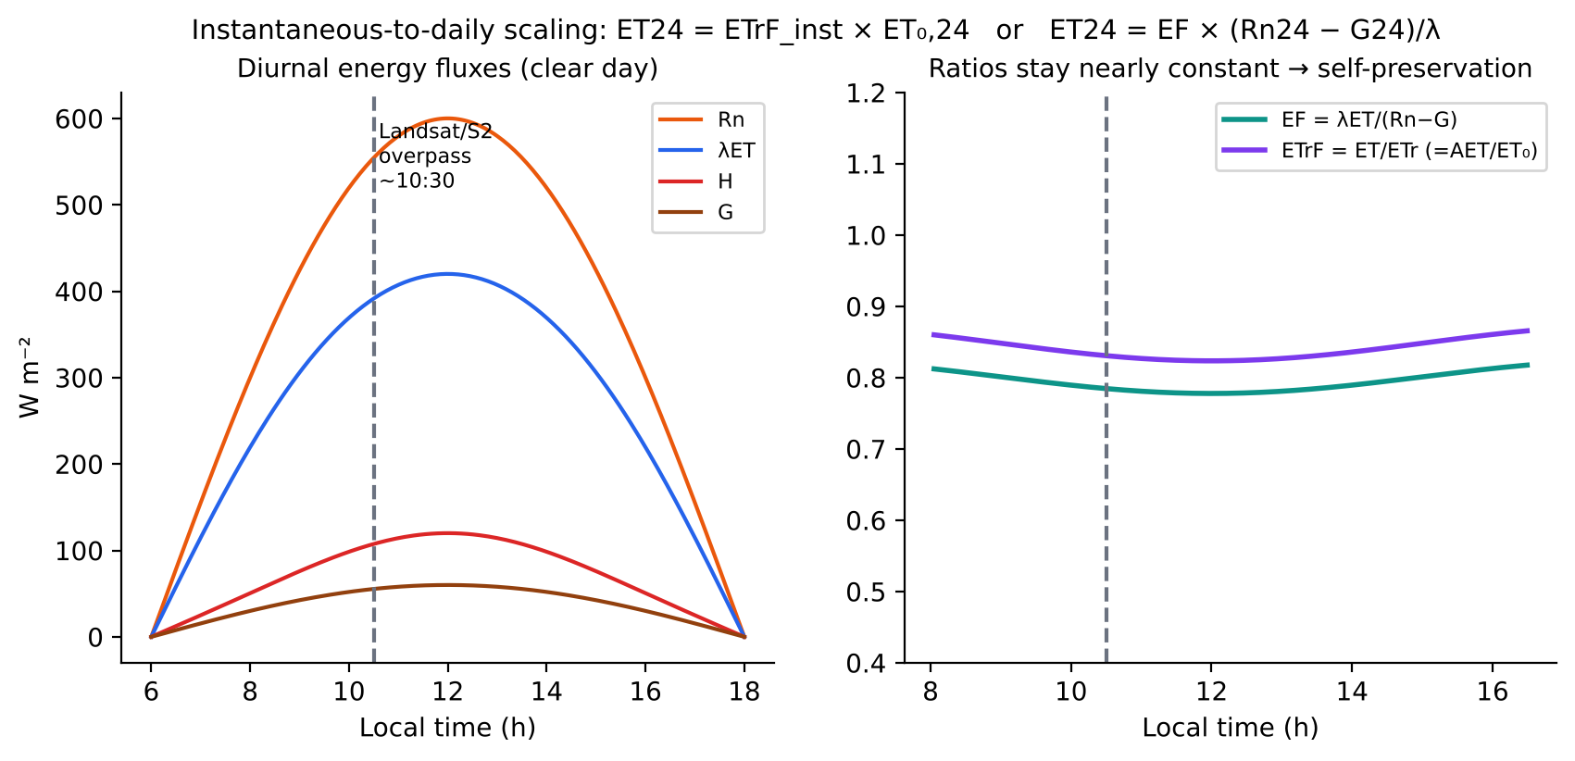
Figure 21. Diurnal course of energy fluxes and the near-constancy of EF and ETrF, the basis of daily scaling (after Crago 1996; Allen et al. 2007). Illustrative simulated curves.

6.8 Eddy covariance (EC) and NRSC's work
Principle: turbulent eddies carry scalars (heat, water vapour, CO₂) vertically. Using Reynolds decomposition (x = x̄ + x′), the vertical flux is the covariance of fluctuations in vertical wind (w′) and the scalar (c′), averaged over 30 minutes.
Fc = ρa·⟨w′c′⟩ (CO₂ = NEE), λE = λ·ρa·⟨w′q′⟩, H = ρa·cp·⟨w′T′⟩
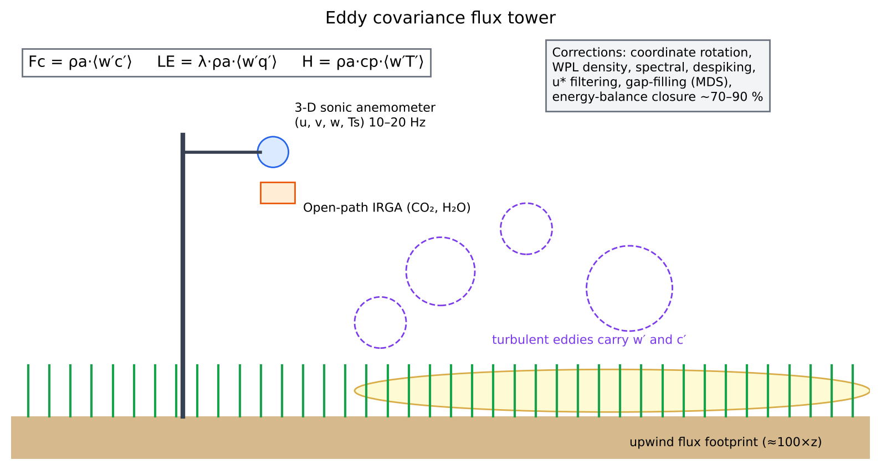
Figure 22. Eddy covariance flux tower: sonic anemometer, gas analyser, turbulent eddies and flux footprint.
- Instruments: 3-D sonic anemometer (Campbell CSAT3, Gill WindMaster) at 10–20 Hz; open-path (LI-7500) or closed-path (LI-7200) IRGA for CO₂ and H₂O; radiation (net radiometer), soil heat-flux plates, soil moisture and temperature, and PAR sensors.
- Processing (EddyPro, TK3): despiking, coordinate rotation (double/planar fit), time-lag correction, WPL (Webb–Pearman–Leuning) density correction, spectral corrections, stationarity and integral turbulence tests (Foken QC flags), *u filtering of night-time data, gap-filling (MDS, Reichstein 2005) and flux partitioning** of NEE into GPP and Reco (night-time Lloyd–Taylor or daytime Lasslop).
- Energy-balance closure: (H + λE)/(Rn − G) is typically 0.7–0.9. Causes of non-closure include large eddies, storage terms and footprint mismatch. Bowen-ratio closure forcing is used for model validation.
- Footprint: the upwind source area, roughly 100 × measurement height (Kljun 2015 FFP model). It must sit within a homogeneous field.
- Uses: validation of satellite ET (SEBAL/METRIC/MOD16) and GPP (SIF, LUE models), calibration of crop models, and carbon budgets for MRV.

Indian EC efforts: NRSC and partners
- ISRO Geosphere-Biosphere Programme, National Carbon Project (NCP), coordinated by NRSC, established EC flux towers over representative ecosystems: forest (e.g. tropical deciduous and sal forests), mangroves (Sundarbans) and agricultural systems. The towers quantify CO₂, H₂O and energy fluxes and validate satellite GPP/NPP and ET products.
- NRSC uses the flux data to calibrate LUE parameters (εmax) for crop productivity models, to validate INSAT-3D ET and insolation products (MOSDAC), and to develop soil and vegetation carbon-flux models.
- ICAR-NRRI Cuttack runs a long-term EC system over flooded rice (CH₄ and CO₂ fluxes). Other EC sites are at universities (IIT Kharagpur, ICRISAT) and in the IITM/MoES flux network.
- Gaps and opportunities: few cropland towers in the rice–wheat system of the IGP, no SIF instruments co-located with EC, and a need for an Indian FLUXNET-type open data portal.
Model answer: If asked about NRSC's EC work: “NRSC, under the ISRO-GBP National Carbon Project, operates a network of eddy-covariance flux towers across major Indian ecosystems. They give direct continuous measurements of net ecosystem CO₂ exchange, latent and sensible heat. NRSC uses them to calibrate light-use-efficiency GPP models and to validate satellite ET and carbon products.”

6.9 Satellite ET products to know
Product | Basis | Resolution / remarks
MOD16 (MODIS) | Penman–Monteith with MODIS LAI, albedo and meteorology | 500 m, 8-day; underestimates ET in irrigated areas
SSEBop (USGS FEWS NET) | Simplified SEB with predefined dT | 1 km global; Landsat version 30 m
GLEAM | Priestley–Taylor + soil-moisture stress | 0.1–0.25°, daily
WaPOR (FAO) | ETLook (two-source PM) | 100–250 m Africa/Near East; L1 global
OpenET | Ensemble of 6 models (METRIC, SSEBop, SIMS, PT-JPL, DisALEXI, geeSEBAL) | 30 m, USA
INSAT-3D ET (MOSDAC) | SEB/PM with INSAT LST and insolation | Daily, about 4 km, India
ECOSTRESS | PT-JPL on ISS TIR | 70 m, variable overpass time (samples the diurnal cycle)
TRISHNA (ISRO–CNES, upcoming) | TIR 57 m, near-daily | Will transform field-scale ET and irrigation monitoring in India

6.10 Interview questions on ET
Q. What is the difference between SEBAL and METRIC?
A. Both are single-source residual SEB models using hot and cold anchor pixels. METRIC calibrates the cold pixel to 1.05 × ETr from ground weather data instead of assuming H = 0, and scales instantaneous to daily ET with ETrF rather than EF. This makes it better under advection in arid, irrigated areas.
Q. Why does ALEXI not need air temperature?
A. It uses the time rate of change of surface temperature in the morning together with an atmospheric boundary-layer growth model. The ABL height and temperature become part of the solution, so no measured air temperature is needed, and absolute Ts errors cancel.
Q. Why is EF assumed constant through the day?
A. Under clear-sky, fair-weather conditions, available energy and latent heat follow similar diurnal shapes, so their ratio is self-preserving (Crago 1996). The assumption fails on cloudy days, with advection, and in the early morning and late evening.
Q. How do you validate satellite ET?
A. Compare with EC or lysimeter ET at overpass and daily scale, after correcting EC for energy-balance closure and matching the footprint to the pixel. Report RMSE, bias and R². Check seasonal totals against the soil water balance.
Q. What is the WPL correction?
A. The Webb–Pearman–Leuning correction removes apparent CO₂ and H₂O fluxes caused by air-density fluctuations from heat and water-vapour transfer. It is essential for open-path analysers.

7. Meteorology for agriculture, including El Niño and “Super El Niño”
One-line definition: agricultural meteorology studies how weather and climate interact with crops, soil, livestock and pests, and turns that knowledge into forecasts, advisories and risk tools for farming.

7.1 Core concepts
- Weather vs climate: weather is the state of the atmosphere over hours to days. Climate is the long-term statistics of weather, conventionally over a 30-year normal (e.g. 1991–2020).
- Radiation balance: shortwave in (≈ 0.48 of Rs is PAR), albedo, longwave exchange and the greenhouse effect.
- Humidity: vapour pressure e and saturation vapour pressure es(T) = 0.6108·exp(17.27T/(T + 237.3)) kPa. VPD = es − ea drives transpiration.
- Stability and lapse rates: the dry adiabatic rate is 9.8 K km⁻¹. Inversions trap smoke, which is why residue-burning smoke stagnates over Delhi in Oct–Nov under calm, cool conditions with a shallow boundary layer.
- Growing degree days: GDD = Σ[(Tmax + Tmin)/2 − Tbase]. Tbase is about 5 °C for wheat and 10 °C for rice and maize. GDD drives phenology in crop models.
- Heat stress: terminal heat in wheat (Tmax > 34 °C during grain filling) shortens the grain-filling period and reduces yield by about 3–5 % per °C.
- Agromet indices: SPI (standardised precipitation index), SPEI, the aridity index, the moisture adequacy index (AET/PET), the temperature-humidity index (THI) and the crop water stress index (CWSI).

7.2 Indian summer monsoon (ISM)
- June–September (JJAS) brings about 75 % of annual rainfall. The long-period average (LPA) is 87 cm (1971–2020 base).
- IMD categories: deficient < 90 % of LPA, below normal 90–95 %, normal 96–104 %, above normal 105–110 %, excess > 110 %.
- Drivers: land–sea thermal contrast, the ITCZ (monsoon trough) migration, the Somali jet (low-level westerly jet), the tropical easterly jet, the Tibetan high, and ENSO, IOD and MJO variability.
- Intra-seasonal behaviour: active and break spells (the 30–60-day Boreal Summer Intra-Seasonal Oscillation), and lows and depressions from the Bay of Bengal.
- Normal onset over Kerala is 1 June. In 2026 it was 4 June. Normal withdrawal starts from western Rajasthan around 17 September.
- Northeast monsoon (Oct–Dec) is important for Tamil Nadu and coastal Andhra Pradesh.
- Western disturbances bring winter rain over NW India that benefits rabi wheat. Untimely hail and rain at harvest cause losses that can trigger PMFBY claims.

7.3 ENSO, El Niño, La Niña and “Super El Niño”
- ENSO (El Niño–Southern Oscillation) is a coupled ocean–atmosphere oscillation of the tropical Pacific with a 2–7-year period.
- El Niño: weak trade winds, warm water spreading east, a deeper thermocline in the east and suppressed upwelling off Peru. The Walker circulation weakens and shifts east, giving subsidence over India and a weaker monsoon.
- La Niña: the opposite phase, usually bringing a normal or above-normal monsoon.
- Measurement: the Oceanic Niño Index (ONI) is the 3-month running mean SST anomaly in the Niño 3.4 region (5° N–5° S, 170°–120° W). El Niño means ONI ≥ +0.5 °C for at least 5 overlapping seasons. Atmospheric partner: the Southern Oscillation Index (Tahiti − Darwin pressure).
- Strength categories: weak (0.5–0.9), moderate (1.0–1.4), strong (1.5–1.9) and very strong (≥ 2.0 °C), informally called a “Super El Niño”. Examples: 1982–83, 1997–98, 2015–16 and 2023–24 (peak about +2.0).
- Super El Niño is not an official WMO category, but the media and many scientists use the term for ONI ≥ +2 °C events.
- 2026 status: NOAA gave an 82 % chance of El Niño developing in May–July 2026, and many models projected a strong to very strong event in 2026–27. IMD cut its monsoon forecast from 92 % to 90 % of LPA, and Skymet put the chance of drought at about 70 %. For comparison, monsoon rainfall in 2015, a super El Niño year, was 86 % of LPA. Check the latest IMD end-of-season figures before the interview.
- Not every El Niño causes drought: in 1997, a very strong El Niño, India's monsoon was normal because of a positive IOD. Roughly 60 % of Indian droughts are El Niño years.
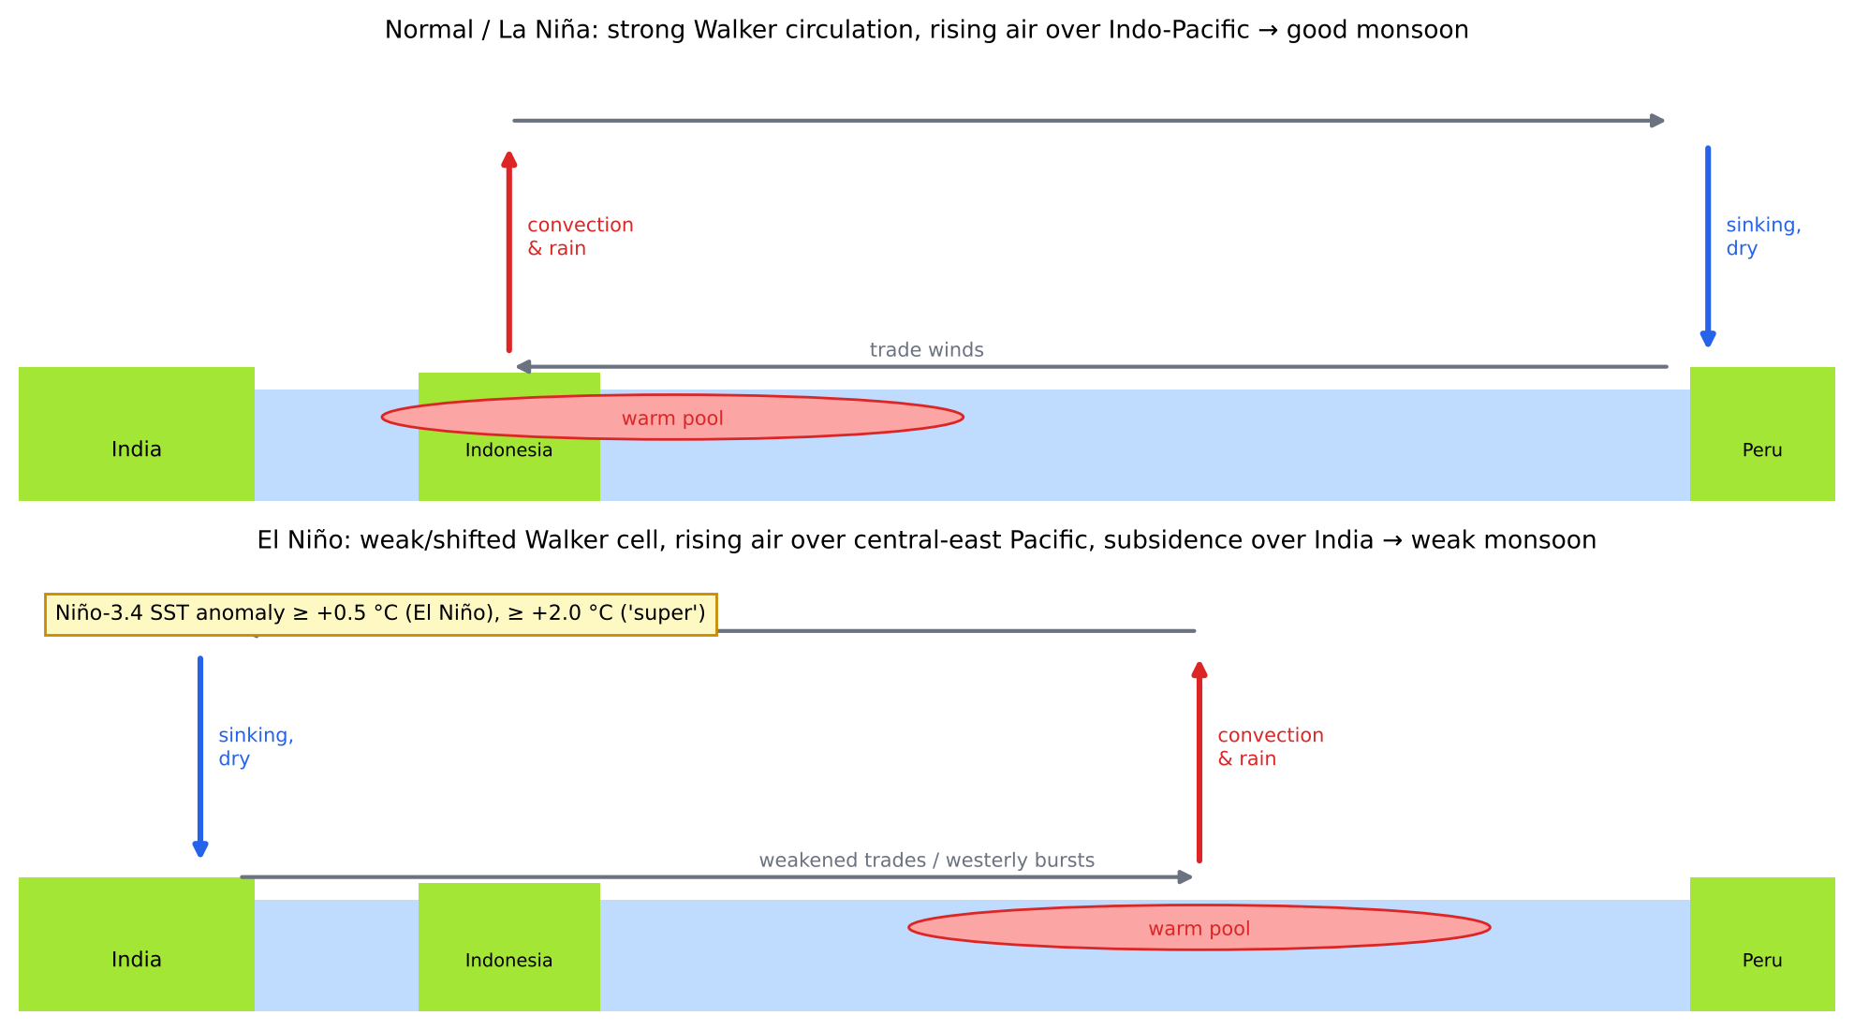
Figure 23. Walker circulation in normal/La Niña and El Niño conditions, and why El Niño weakens the Indian monsoon.

7.4 Indian Ocean Dipole (IOD) and MJO
- IOD: the SST difference between the western (50–70° E, 10° S–10° N) and south-eastern (90–110° E, 10° S–0°) Indian Ocean, measured by the Dipole Mode Index (DMI). A positive IOD (warm west) strengthens the monsoon and can offset El Niño, as in 1997, 2006 and 2019. IMD forecast neutral IOD conditions for 2026.
- MJO (Madden–Julian Oscillation): an eastward-moving envelope of convection with a 30–60-day period. Its phases 3–5 over the Indian Ocean favour active monsoon spells. IMD uses it in extended-range forecasts.

7.5 How El Niño affects Indian agriculture
Impact | Details
Kharif sowing and yield | Delayed onset and long breaks reduce sowing area of rainfed rice, pulses, soybean, cotton and groundnut. Rainfed areas (about 51 % of net sown area) are the most affected.
Reservoirs and groundwater | Lower storage limits rabi irrigation; more groundwater pumping.
Heat | El Niño years tend to bring hotter pre-monsoon and post-monsoon periods, terminal heat stress in wheat, and livestock heat stress.
Food inflation | Pulses, vegetables and edible oils; government stock management and export restrictions (rice in 2023).
Insurance | Higher PMFBY claims (prevented sowing, mid-season adversity, yield loss); weather-index products (RWBCIS) are triggered.
Response | District contingency plans (ICAR-CRIDA), short-duration varieties, the Crop Weather Watch Group, seed banks, MGNREGA water conservation, and GKMS advisories.

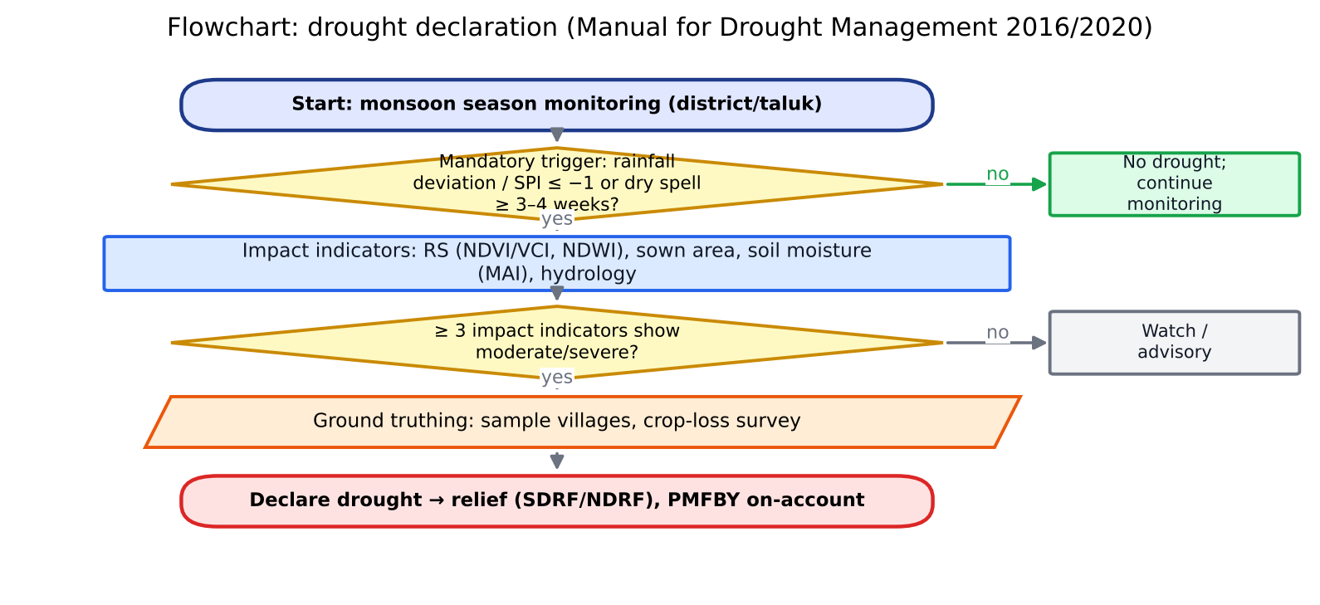
Figure 24. Flowchart of drought declaration under the Manual for Drought Management (2016, revised 2020).

7.6 Forecasts and agro-advisories in India
- IMD forecasting system: nowcast (0–3 h), short range (1–3 days), medium range (3–10 days, GFS/NCUM models at about 12 km), extended range (2–4 weeks, the MME of CFSv2) and seasonal forecasts (MMCFS, issued in April and June).
- GKMS (Gramin Krishi Mausam Sewa): 130 Agromet Field Units (AMFUs) at SAUs and ICAR institutes and District Agromet Units (DAMUs) at KVKs (DAMUs were discontinued in 2024; check whether they have been restored). They issue twice-weekly district and block-level advisories through Meghdoot, Mausam and Kisan SMS.
- Satellite meteorology: INSAT-3D/3DR/3DS provide imager and sounder data, insolation, LST, rainfall (IMSRA/HE), fog, outgoing longwave radiation and cloud-motion winds (MOSDAC). Oceansat-3 gives SST and SCATSAT-type winds. Bharat Forecast System (BharatFS), launched in 2025, runs at about 6 km resolution.
- Weather in crop insurance: reference automatic weather stations (AWS/ARG) for RWBCIS triggers, and the WINDS programme (a network of AWS and rain gauges at taluk and GP level).

7.7 Interview questions
Q. What is a Super El Niño and how does it affect India?
A. A very strong El Niño with the Niño-3.4 SST anomaly at or above +2 °C, such as 1997–98, 2015–16 and the event projected for 2026–27. It weakens the Walker circulation and causes subsidence over India. This tends to bring a deficient monsoon, delayed kharif sowing, heat stress and higher food inflation, unless a positive IOD offsets it.
Q. Why didn't the 1997 El Niño cause drought?
A. A strong positive Indian Ocean Dipole developed at the same time. It enhanced convection over the western Indian Ocean and moisture transport to India, which offset El Niño's suppression.
Q. How can remote sensing help during an El Niño year?
A. Through near-real-time sowing progress from SAR, crop condition (NDVI/VCI), soil moisture (NISAR, SMAP), ET deficit and ESI, SIF-based stress detection, and reservoir area monitoring. All of these feed drought declaration (the Manual for Drought Management 2016/2020) and insurance.
Q. Define SPI.
A. The Standardised Precipitation Index fits a gamma distribution to long-term precipitation totals over a chosen time scale (1, 3, 6 or 12 months) and transforms the result to a standard normal variate. SPI ≤ −1 is moderately dry, ≤ −1.5 severely dry and ≤ −2 extremely dry.

8. Statistics and machine learning for agricultural remote sensing
One-line definition: statistics quantifies uncertainty and relationships in data. Machine learning (ML) builds models that learn patterns from data to predict or classify without explicitly programmed rules. In agricultural remote sensing both are used for classification (crop type), regression (yield, LAI, SM) and forecasting.

8.1 Statistical foundations
Table 10. Statistics to know
Concept | What to say
Mean, median, SD, CV | CV = SD/mean × 100. CV of CCE yields drives the required sample size.
Correlation vs regression | Pearson r measures linear association. Regression models the dependence Y = β₀ + β₁X + ε (OLS minimises Σε²).
R² and adjusted R² | R² = 1 − SSres/SStot. Adjusted R² penalises extra predictors.
Error metrics | RMSE = √(Σ(P − O)²/n); MAE; bias = mean(P − O); nRMSE = RMSE/mean(O) (< 10 % excellent, 10–20 % good, 20–30 % fair); MAPE
Hypothesis testing | H₀ vs H₁; p-value; Type I (α) and Type II (β) errors; t-test, ANOVA, χ²
Multicollinearity | VIF > 10 is problematic. Fix with ridge/LASSO, PCA or variable selection.
Autocorrelation | Spatial (Moran's I, variogram) and temporal (ACF). It violates the independence assumption and inflates validation scores.
Sampling | Simple random, stratified, cluster, systematic, PPS. Stratification by RS crop vigour increases CCE efficiency.
Sample size | n = (z·CV/E)², e.g. CV 30 %, error 10 %, 95 % confidence gives n ≈ 35
Geostatistics | Semi-variogram γ(h) (nugget, sill, range), ordinary kriging, regression kriging, co-kriging
Time series | Trend (Mann–Kendall, Sen's slope), ARIMA, seasonal decomposition; yield detrending (technology trend)
Bayesian | Posterior ∝ likelihood × prior. Used in data assimilation, BMA ensembles and uncertainty quantification.

8.2 Machine-learning algorithms
Table 11. Common ML algorithms in agricultural remote sensing
Algorithm | Idea | Agri use / note
Random Forest (Breiman 2001) | Ensemble of decision trees on bootstrap samples (bagging) with random feature subsets; majority vote or mean; OOB error; feature importance | The default for crop classification and yield; robust and little tuning needed
Gradient boosting (XGBoost, LightGBM, CatBoost) | Sequential trees fitted to residuals with regularisation and learning rate | Often the best on tabular yield data; SHAP for interpretation
SVM / SVR | Maximum-margin hyperplane; kernel trick (RBF) | Small training sets; hyperspectral data
Gaussian Process Regression | Bayesian non-parametric; gives mean and variance | LAI/Cab retrieval with uncertainty (ARTMO)
k-NN | Prediction from the nearest neighbours in feature space | LUT inversion and gap-filling
ANN / MLP | Layers of weighted sums plus non-linear activations; backpropagation | RTM-hybrid inversion
CNN | Convolutions extract spatial features | Field-boundary delineation (U-Net), pest and disease images
RNN / LSTM / GRU | Memory gates for sequences | Crop type from time series; in-season yield forecasting
Transformers / attention | Self-attention over time and space | SITS-BERT, TempCNN vs Transformer for crop mapping; foundation models (Prithvi)
Unsupervised (k-means, ISODATA) | Clustering without labels | Management zones in precision agriculture

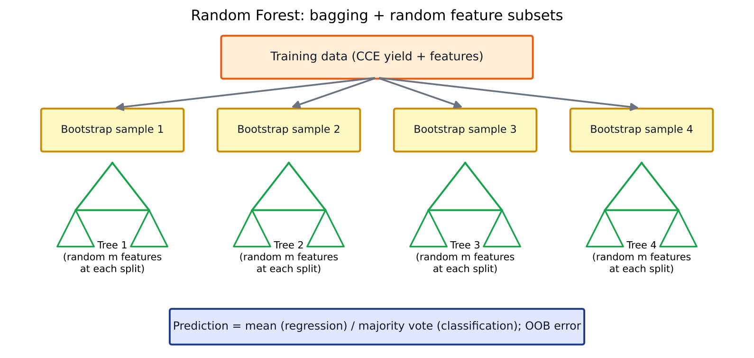
Figure 25. Random Forest: bootstrap aggregation of decision trees with random feature subsets.
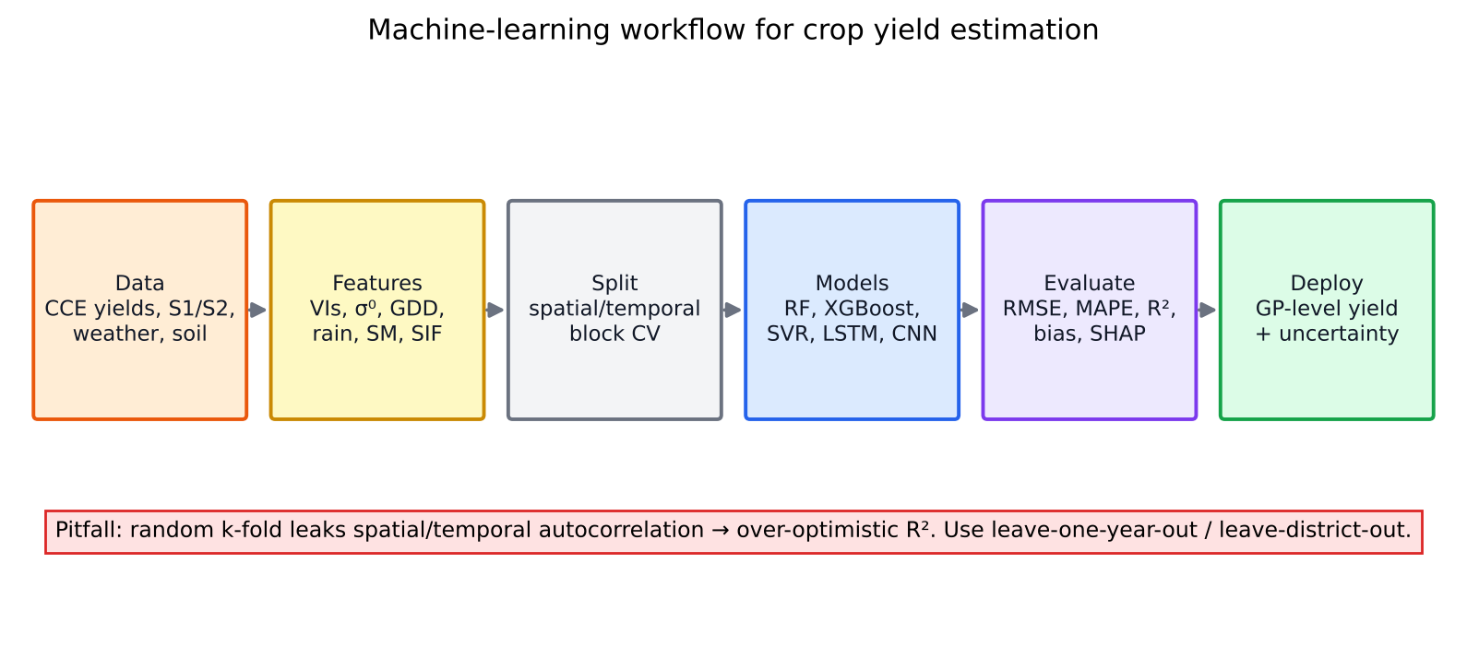
Figure 26. End-to-end ML workflow for yield estimation, including the spatial cross-validation pitfall.

8.3 The bias–variance trade-off, overfitting and validation
- Bias is error from overly simple assumptions (underfitting). Variance is sensitivity to the training sample (overfitting). Total error = bias² + variance + irreducible noise.
- Regularisation: L1 (LASSO, which selects variables), L2 (ridge), dropout, early stopping and tree depth limits.
- Cross-validation: k-fold, leave-one-out, and especially spatial block CV / leave-one-district-out and leave-one-year-out for yield. These test the ability to predict a new year or region, which is the operational need.
- Hyperparameter tuning: grid or random search and Bayesian optimisation, done inside nested CV.
- Class imbalance: stratified sampling, SMOTE and class weights; report F1, precision and recall rather than OA alone.
- Interpretability: permutation importance, partial dependence plots, SHAP values and attention maps. Explaining models matters for insurance, where farmers and insurers dispute outcomes.
- Uncertainty: quantile regression forests, prediction intervals, ensembles and Monte-Carlo dropout.
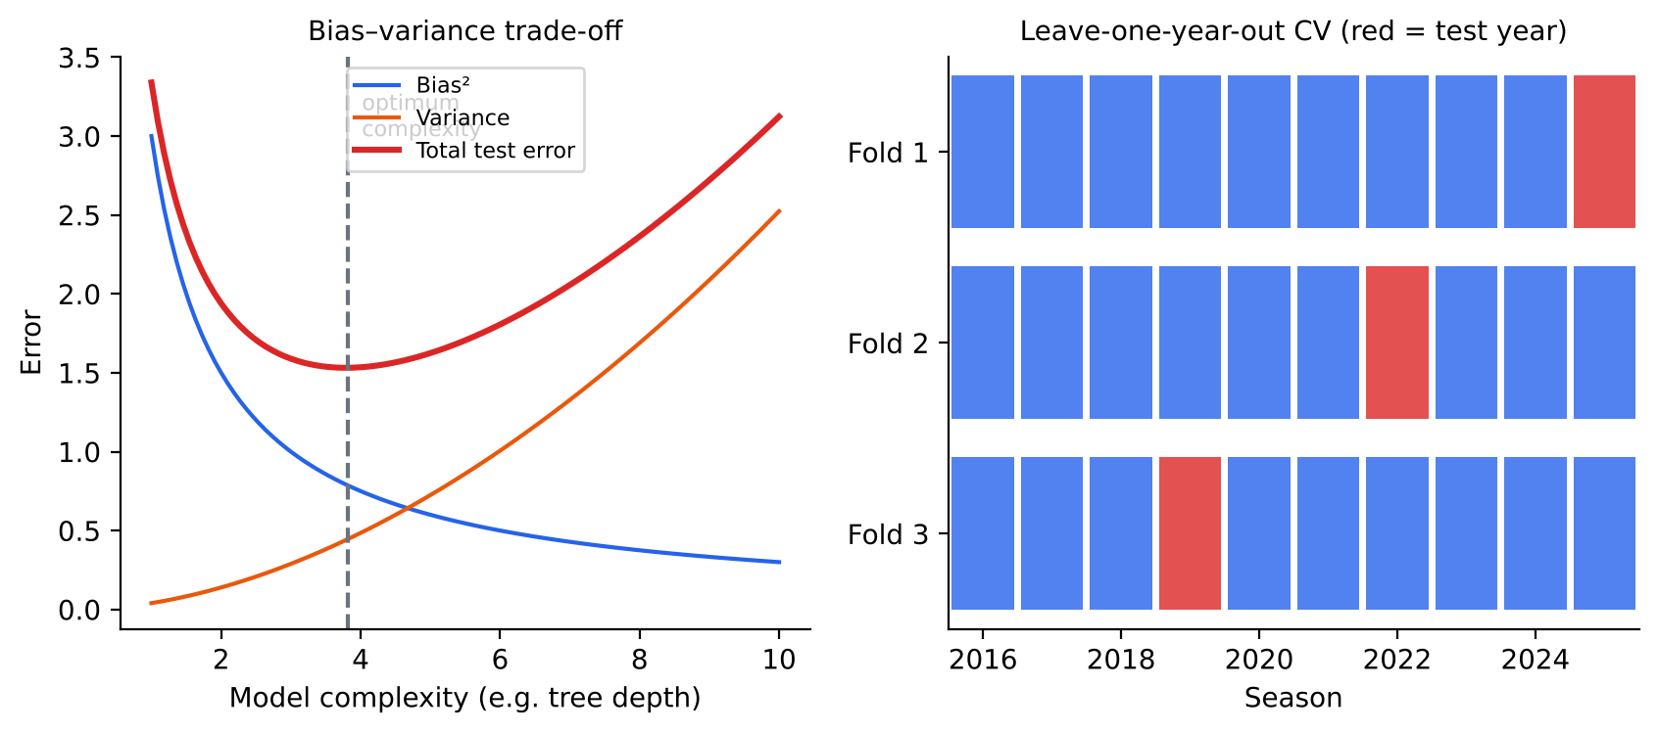
Figure 27. Left: the bias–variance trade-off. Right: leave-one-year-out cross-validation for yield models.
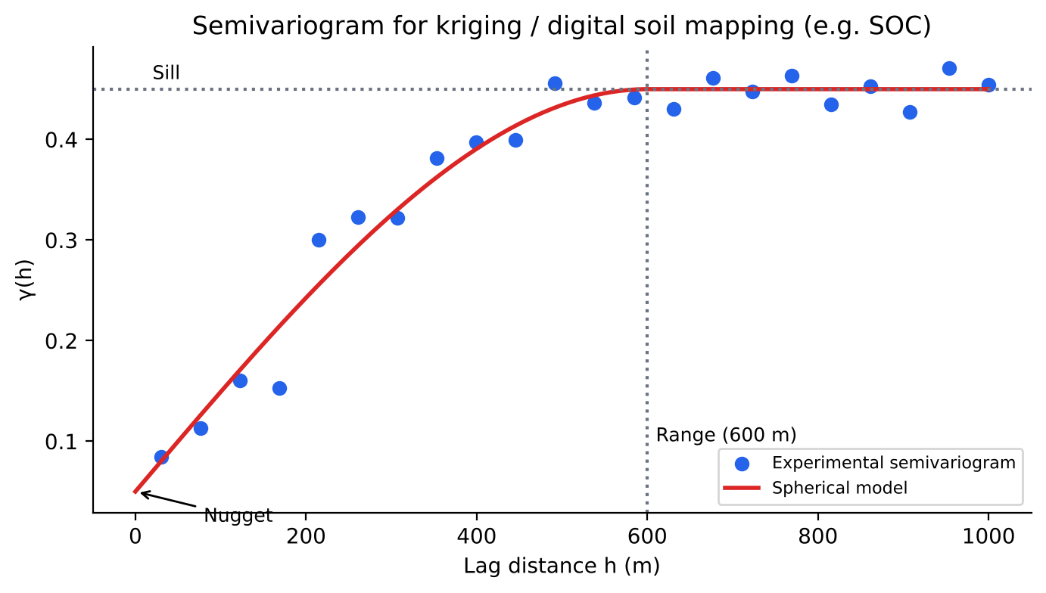
Figure 28. Semivariogram (nugget, sill, range) used in kriging and digital soil mapping.

8.4 ML vs process-based models
Aspect | Process (crop simulation) models | ML models
Basis | Physiology: photosynthesis, phenology, water and N balance | Statistical patterns in data
Data need | Detailed inputs: soil, management, cultivar coefficients | Large labelled datasets
Extrapolation | Better for new climates and scenarios | Poor outside the training domain
Interpretability | High (mechanistic) | Lower (needs XAI)
Scale | Point-based; regional runs need gridded inputs | Scales easily with RS data
Hybrid | Assimilate RS data, use ML emulators, physics-informed ML | Use crop-model outputs as features

8.5 Interview questions
Q. Why can't you use random k-fold CV for yield models?
A. Neighbouring fields and the same year share weather and soils, so a random split puts near-duplicates in training and test sets. This leakage inflates R². Operational forecasting predicts an unseen year, so use leave-one-year-out or spatial block CV.
Q. What is out-of-bag (OOB) error in Random Forest?
A. Each tree is trained on a bootstrap sample that leaves out about 37 % of the data. Those left-out samples are predicted by the trees that did not see them, which gives a built-in, nearly unbiased estimate of generalisation error.
Q. How do you choose between RF and LSTM for crop classification?
A. RF works well with engineered temporal features (monthly composites, phenological metrics) and modest data. LSTMs and Transformers learn directly from irregular raw time series, need more labels and compute, and are usually better for large areas and early-season classification. Benchmark both under the same spatial CV.
Q. What is SHAP?
A. SHapley Additive exPlanations: a game-theory method that attributes each prediction to the contributions of its features, consistently and locally. For example, it can show that VH backscatter in August and rainfall in September drove a low yield prediction.
Q. Kriging vs IDW?
A. IDW is a deterministic distance-weighted average. Kriging is a best linear unbiased predictor that uses the modelled spatial autocorrelation (variogram) and gives a prediction variance.

9. Digital twins vs crop simulation models
One-line definitions: a crop simulation model is a set of mathematical equations representing crop growth and development as functions of weather, soil, genotype and management. An agricultural digital twin is a living virtual replica of a real farm or field, continuously synchronised with observations from sensors and satellites. It is used to monitor, predict and prescribe actions in near-real time, in a closed loop with the physical system.

9.1 Crop simulation models: a refresher
Table 12. Major crop simulation models
Model | Origin | Key features
DSSAT (CERES, CROPGRO) | IBSNAT/ICASA, USA | 42+ crops; daily step; genetic coefficients (P1, P5, G1…); soil water and N; widely used in India
APSIM | CSIRO/Queensland, Australia | Modular; farming systems, rotations and residue; strong soil processes
InfoCrop | ICAR-IARI (Aggarwal et al. 2006) | Indian crops; pests, GHG emissions and climate-change impact; generic crop model
WOFOST | Wageningen, Netherlands | Used in the EU MARS and MCYFS forecasting systems and in FASAL research; potential and water-limited yield
AquaCrop | FAO | Water-driven (WP × Tr); few parameters; irrigation planning
ORYZA | IRRI | Rice; flooded and aerobic conditions
STICS, CropSyst, EPIC | France, USA | Soil–crop–environment

Core processes
- Phenology: thermal time or GDD plus photoperiod and vernalisation.
- Carbon assimilation: radiation-use efficiency (biomass = RUE × intercepted PAR), or leaf photosynthesis (Farquhar) integrated over the canopy.
- Partitioning: dry matter to leaves, stems, roots and grain with stage-dependent coefficients. Yield = HI × biomass, or grain number × grain weight.
- Water balance: infiltration, runoff (SCS curve number), drainage (tipping bucket), ET (Priestley–Taylor or Penman–Monteith), and a stress factor from the supply/demand ratio.
- Nitrogen balance: mineralisation, nitrification, leaching, volatilisation, uptake and N stress.
- Uses: yield-gap analysis (potential vs actual), climate-change impact, sowing-date and irrigation optimisation, and forecasting (FASAL).
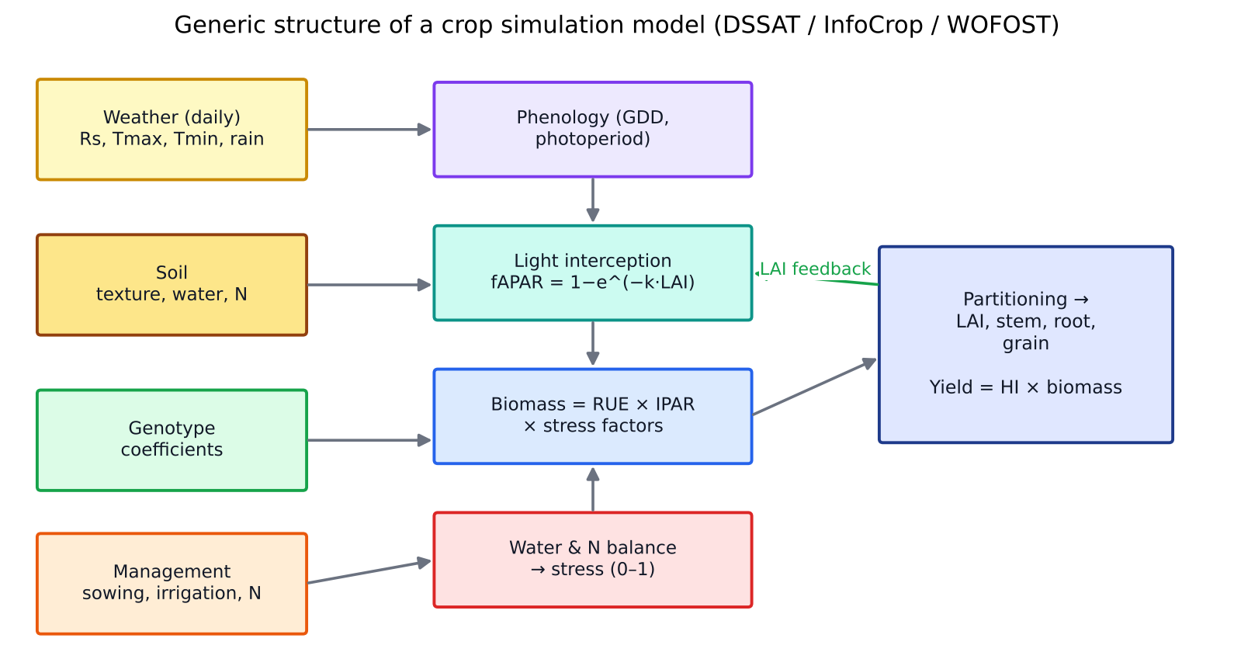
Figure 29. Generic structure of a crop simulation model (DSSAT / InfoCrop / WOFOST).

9.2 What makes something a digital twin
- Physical entity: the field, farm, orchard or greenhouse.
- Virtual entity: a model, which can be a crop simulation model, an ML model or a hybrid.
- Data connection (physical → virtual): a continuous stream from IoT soil-moisture probes, weather stations, UAVs, satellites (Sentinel, NISAR, FLEX) and farmer logs.
- Data assimilation: observations update model states and parameters, using the Ensemble Kalman Filter (EnKF), particle filters or variational (4D-Var) methods, or forcing and calibration.
- Feedback (virtual → physical): recommendations or automatic actions such as irrigation valves, VRT prescriptions, pest alerts or insurance triggers.
- Persistence and fidelity: the twin exists for the whole life cycle (the season and beyond) and its level of fidelity is fit for purpose.
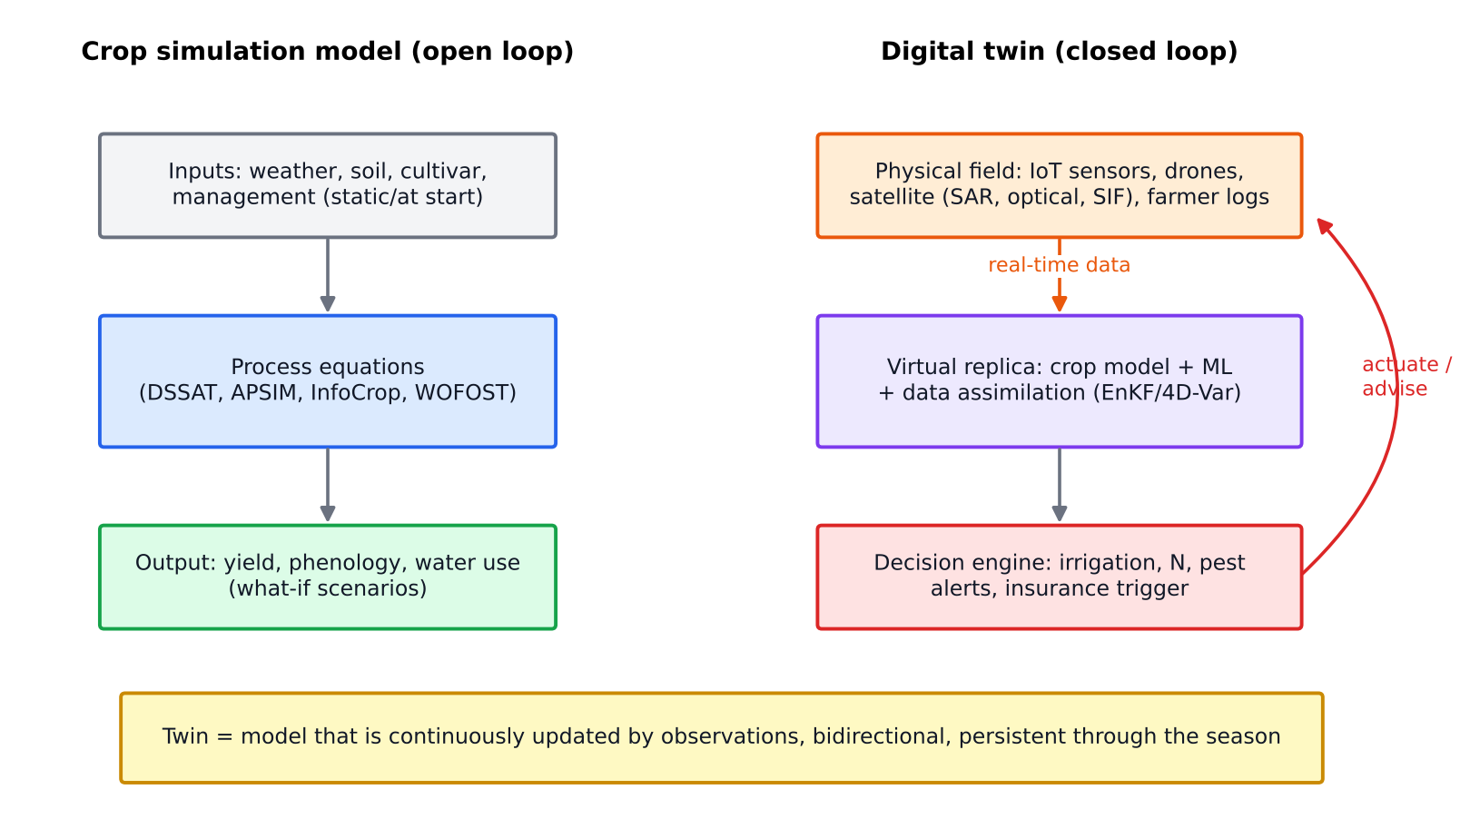
Figure 30. Open-loop crop simulation model compared with a closed-loop agricultural digital twin.
Table 13. Crop model vs digital twin
Aspect | Crop simulation model | Digital twin
Nature | Static tool; runs offline | Dynamic, live and persistent
Data flow | One-way, inputs set at the start | Two-way; continuous real-time data
State updating | None (open loop) | Data assimilation keeps the model on track
Purpose | Scenario analysis, research | Operational monitoring, prediction and control
Components | Equations only | Sensors + IoT + model + AI + visualisation + actuation
Spatial unit | Point or homogeneous field | Field to farm to region; GIS-integrated
Uncertainty | Usually deterministic | Probabilistic (ensembles) and updated
Example | DSSAT run for a 2050 climate scenario | Wheat field twin that assimilates Sentinel-2 LAI and probe soil moisture to schedule irrigation and forecast yield

One-line distinction: A crop model can be the engine inside a digital twin. The twin adds the live data connection, assimilation, feedback and persistence. Every digital twin needs a model, but a model on its own is not a twin.

9.3 Data assimilation strategies
- Forcing: replace a simulated state (e.g. LAI) with the observed value at each observation date. Simple, but it ignores observation error.
- Calibration / re-initialisation: adjust parameters or initial conditions (sowing date, soil water) so the simulated LAI matches the observed trajectory. Optimisers include SCE-UA, PSO and MCMC.
- Sequential updating (EnKF): run an ensemble of model runs, and at each observation update states in proportion to the model and observation error covariances (the Kalman gain).
- Variational (4D-Var): minimise a cost function over a time window.
- Variables assimilated: LAI, fAPAR, soil moisture (SAR), ET, SIF and canopy cover.
- Research example: assimilating Sentinel-2 LAI and Sentinel-1/NISAR soil moisture into WOFOST/DSSAT improves district wheat-yield RMSE by about 20–40 % over the open loop (Huang et al. 2019 review).
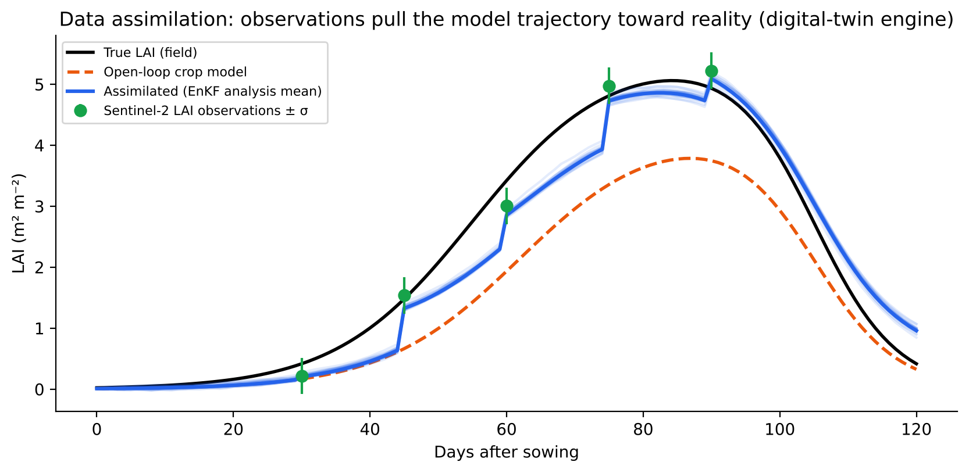
Figure 31. Data assimilation of Sentinel-2 LAI into a crop model (EnKF), the engine of a digital twin. Illustrative simulation.

9.4 Digital-twin initiatives
- Destination Earth (EU): Earth-system digital twins for climate adaptation and extremes.
- NVIDIA Earth-2 and Google Weather/AI models used for digital-twin weather.
- Agriculture: Wageningen's Digital Twins programme, the USDA/NASA Harvest crop twin concepts, and the commercial platforms Cropin (India) and xarvio.
- Possible ISRO and India direction: a national “Krishi Digital Twin” combining Bhuvan/Bhoonidhi EO data, the AgriStack farmer registry, Digital Crop Survey geo-tagged crop data, Soil Health Cards, IMD forecasts and crop models. It could serve FASAL, YES-TECH and advisory at GP level.

9.5 Interview questions
Q. Is DSSAT a digital twin?
A. No. DSSAT is a process model that runs open loop with fixed inputs. It becomes the engine of a digital twin only when it is continuously updated with real-time observations through data assimilation and feeds decisions back to the field.
Q. What role can ISRO data play in an agricultural digital twin?
A. ISRO data provide the observation layer for the twin. That includes crop type and sowing date (EOS-04/NISAR), LAI and chlorophyll (Resourcesat/Sentinel), soil moisture (NISAR L4 100 m), ET (INSAT, TRISHNA), weather (INSAT-3DS) and photosynthesis (FLEX SIF via international data). All of these can be assimilated.
Q. What is the Ensemble Kalman Filter in one line?
A. A Monte-Carlo approach to the Kalman filter. An ensemble of model runs represents the forecast uncertainty, and each observation updates every member in proportion to the relative model and observation error.

10. Crop-residue burning: detection, FRP, burnt area and management
One-line definition: crop-residue burning is the deliberate in-field burning of the straw and stubble left after harvest, mainly paddy straw in Oct–Nov in Punjab and Haryana and wheat stubble in Apr–May. Farmers burn residue to clear fields quickly for the next crop. It is a major source of air pollution, GHG emissions and nutrient loss.

10.1 Why farmers burn and why it matters
- Narrow window: combine-harvested paddy (late October) leaves only 15–20 days before wheat sowing. The Punjab Preservation of Subsoil Water Act 2009 delayed paddy transplanting to mid-June to save groundwater, which pushed harvest later and squeezed the window further.
- Combine harvesting leaves loose straw and 30–40 cm stubble that is hard to manage without machinery.
- Low economic value: high-silica paddy straw is unsuitable as fodder (unlike wheat straw, used as bhusa).
- Scale: India produces about 500 Mt of crop residue per year, with about 90–140 Mt surplus, of which roughly 85–90 Mt is burnt (MNRE and various estimates). Punjab produces about 20 Mt of paddy straw a year.
- Impacts: PM2.5 and PM10, CO, black carbon, CO₂, CH₄ and N₂O. Burning contributes up to 30–40 % of Delhi's PM2.5 on peak days (SAFAR/DSS estimates). Each tonne of straw burnt loses about 5.5 kg N, 2.3 kg P, 25 kg K and 1.2 kg S, and burning kills soil microbes and raises topsoil temperature.
- Policy: the Commission for Air Quality Management (CAQM) Act 2021, National Green Tribunal orders, environmental compensation fines, and the Crop Residue Management (CRM) scheme (since 2018), which subsidises machinery at 50 % for individuals and 80 % for CHCs and FPOs.

10.2 Active-fire detection from thermal data

Physics
A fire at 800–1200 K emits strongly in the mid-infrared (3.7–4 µm), as Wien's law predicts, while the 300 K background peaks near 10 µm. Even a fire occupying 0.01 % of a 1 km pixel raises the 4 µm brightness temperature by many kelvin, much more than the 11 µm temperature. The difference T4 − T11 is the basis of detection.
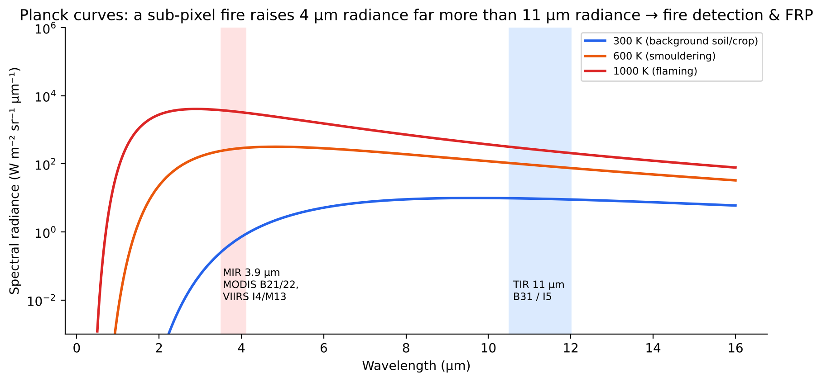
Figure 32. Planck curves for background and fire temperatures, showing why the 3.9 µm channel is sensitive to sub-pixel fires.

Sensors and algorithms
Table 14. Active-fire sensors used for India
Sensor | Platform / overpass | Resolution | Notes
MODIS (MOD14/MYD14, Collection 6.1) | Terra 10:30 / Aqua 13:30 | 1 km | Contextual algorithm (Giglio 2016); bands 21/22 (3.9 µm) and 31 (11 µm); FRP from band 21/22
VIIRS (VNP14IMG) | S-NPP, NOAA-20, NOAA-21, about 13:30 | 375 m (I-band) | I4 (3.74 µm), I5 (11.45 µm); about 3–4× more small agricultural fires than MODIS; M13 for FRP
INSAT-3D/3DR | Geostationary, every 15–30 min | 4 km MIR | Diurnal sampling of afternoon fires; low sensitivity
Sentinel-3 SLSTR | 10:00 | 1 km | Night-time fire product
Landsat 8/9, Sentinel-2 | 10:30 | 30 m / 20 m SWIR | Active flame fronts visible in SWIR; mainly used for burnt area

- Contextual fire algorithm (MODIS/VIIRS): (1) cloud and water masking; (2) potential-fire test, e.g. T4 > 310 K and ΔT = T4 − T11 > 10 K by day; (3) compare with neighbouring background pixels (mean and MAD of T4 and ΔT); (4) reject false alarms from sun-glint, desert boundaries and hot bare soil; (5) assign a confidence class (low, nominal, high).
- Data delivery: NASA FIRMS (Fire Information for Resource Management System) provides near-real-time data within 3 hours.

10.3 Fire radiative power (FRP)
Definition: FRP is the rate of radiant energy emitted by a fire (MW). It is proportional to the fuel combustion rate, so integrating FRP over time gives fire radiative energy (FRE, MJ), and FRE converts directly to biomass burnt and emissions.
MIR radiance method (Wooster et al. 2003, 2005): FRP = (Asampl · σ / a) · (L4 − L4,bg)
Biomass burnt (kg) = 0.368 kg MJ⁻¹ × FRE (MJ) Emission_x = Biomass × EF_x (g/kg)
- Asampl is the pixel area, a is a sensor-specific constant (about 3×10⁻⁹ W m⁻² sr⁻¹ µm⁻¹ K⁻⁴), and L4 and L4,bg are the MIR radiances of the fire and background pixels.
- Typical values: small agricultural fires in Punjab are 1–30 MW per VIIRS pixel. Forest or large fires can exceed 100 MW.
- Why it matters: fire counts do not show the size or intensity of fires. FRP and FRE quantify emissions. The GFAS (CAMS, ECMWF) emission inventory is built on FRP.
- Limitations: a polar orbiter gives one or two snapshots a day, so diurnal integration needs GEO data or a fitted diurnal-cycle model. Small or smouldering fires are missed, and so are fires under cloud or smoke.

10.4 The daily fire bulletin (CREAMS-IARI / NRSC)
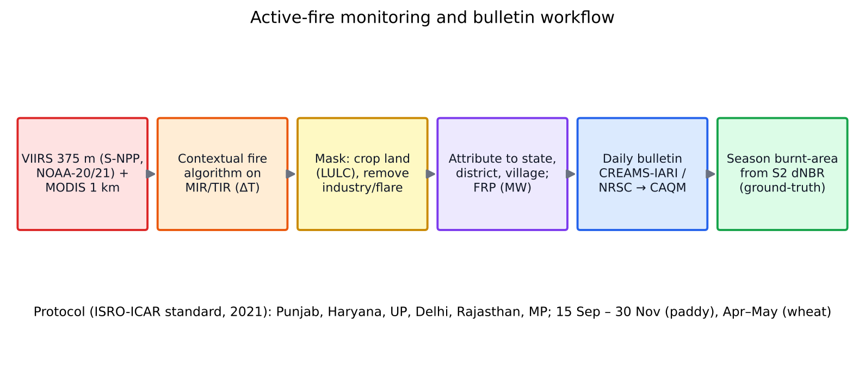
Figure 33. Workflow from satellite fire detection to the daily residue-burning bulletin.
- Who: the CREAMS laboratory, Division of Agricultural Physics, ICAR-IARI, issues the daily bulletin under the ISRO–ICAR standard protocol (developed with ISRO-NRSC and released in 2021). Bulletins go to MoA&FW, CAQM, MoEFCC and the state agriculture and pollution-control departments.
- Coverage: Punjab, Haryana, Uttar Pradesh, Delhi, Madhya Pradesh and Rajasthan, for paddy residue from 15 September to 30 November. Wheat-residue burning is also monitored.
- Content: daily and cumulative fire-event counts by state and district, a comparison with previous years (2020–2025), maps, and FRP-based intensity classes.
- Protocol rules: use VIIRS 375 m and MODIS 1 km; mask to agricultural land; remove persistent industrial heat sources; merge detections within a spatial and temporal window to avoid double counting; standardise the season and region definitions so that states and agencies report the same numbers.
- Trend: official counts fell sharply in 2023–2025. Government reports claim about a 90 % reduction in Punjab and Haryana in 2025 compared with 2022.
- Criticism (iFOREST 2025): burning has shifted to the late afternoon, after the polar-orbiter overpasses at about 10:30 and 13:30, so a large share of fires may go undetected. Burnt-area analysis (Sentinel-2) shows a much smaller decline than fire counts. This is why the board may ask about geostationary monitoring and burnt-area mapping.
Remember: Fire counts measure active flames at the moment of overpass. Burnt area measures the cumulative scar. Use both: counts for daily enforcement, burnt area for season totals and emission estimates. Geostationary sensors (INSAT-3DS, GEO-KOMPSAT, Himawari) help capture late-afternoon burning.

10.5 Burnt-area mapping with Sentinel-2's two SWIR bands
Burning removes green vegetation (NIR drops sharply) and leaves char, ash and exposed dry soil (SWIR2 at 2.19 µm rises). The opposite movement of NIR and SWIR2 is captured by the Normalised Burn Ratio. Sentinel-2 has two SWIR bands: B11 (1610 nm, 20 m) and B12 (2190 nm, 20 m).
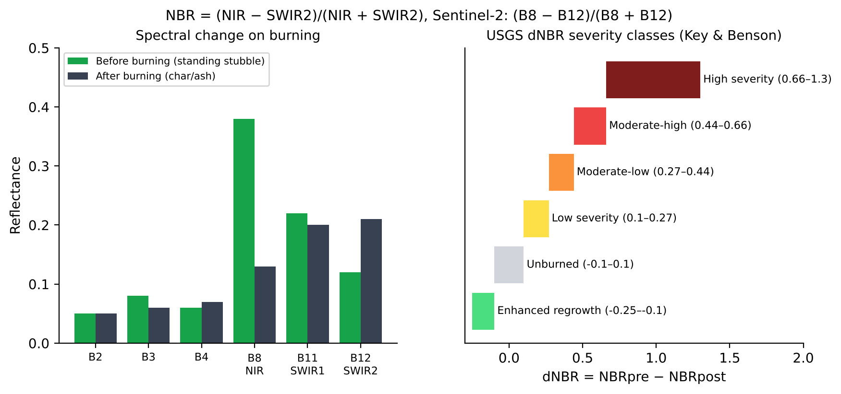
Figure 34. Spectral change from burning, and the USGS dNBR burn-severity classes (thresholds from Key & Benson 2006). Reflectance values are illustrative.
Table 15. Burn-sensitive indices
Index | Formula (Sentinel-2) | Remarks
NBR | (B8 − B12)/(B8 + B12) | High for vegetation, low or negative for burnt surfaces
dNBR | NBRpre − NBRpost | Severity: > 0.1 burnt; > 0.27 moderate; > 0.66 high (Key & Benson 2006)
RdNBR / RBR | dNBR/√  NBRpre  ; dNBR/(NBRpre + 1.001) | Normalises for low pre-fire biomass (stubble)
NBR2 | (B11 − B12)/(B11 + B12) | Uses both SWIR bands; sensitive to moisture and char; good for post-harvest stubble
BAI | 1/[(0.1 − B4)² + (0.06 − B8)²] | Distance to the charcoal spectral point (Chuvieco 2002)
BAIS2 | (1 − √(B6·B7·B8A/B4))·((B12 − B8A)/√(B12 + B8A) + 1) | Sentinel-2 specific, uses the red edge (Filipponi 2018)
MIRBI | 10·B12 − 9.8·B11 + 2 | SWIR-only; robust for agricultural burns (Trigg & Flasse 2001)
CSI / NDVI / SAVI | NIR/SWIR; NDVI drop | Vegetation indices that respond to burning (loss of green cover)

Workflow for paddy-season burnt area (Punjab)
- Make a paddy mask from Sentinel-1 VH time series (flooding signature) or a crop map.
- Build cloud-masked Sentinel-2 composites at 5–10 day intervals from October to November, using Google Earth Engine and the s2cloudless cloud mask.
- Compute NBR, NBR2, MIRBI and BAIS2. Compare each date with the post-harvest stubble date to get dNBR. Important: the right comparison is harvested stubble vs burnt stubble, not green crop vs burnt.
- Classify burnt, unburnt stubble, harvested-and-removed, and sown wheat with Random Forest trained on field or VIIRS-guided samples, or use thresholds (e.g. dNBR > 0.1 and NBR2 drop).
- Validate with field photos, PlanetScope imagery and active-fire points (commission and omission errors).
- Aggregate by village and district and compare with fire counts. The ratio of burnt area to fire count shows detection gaps.
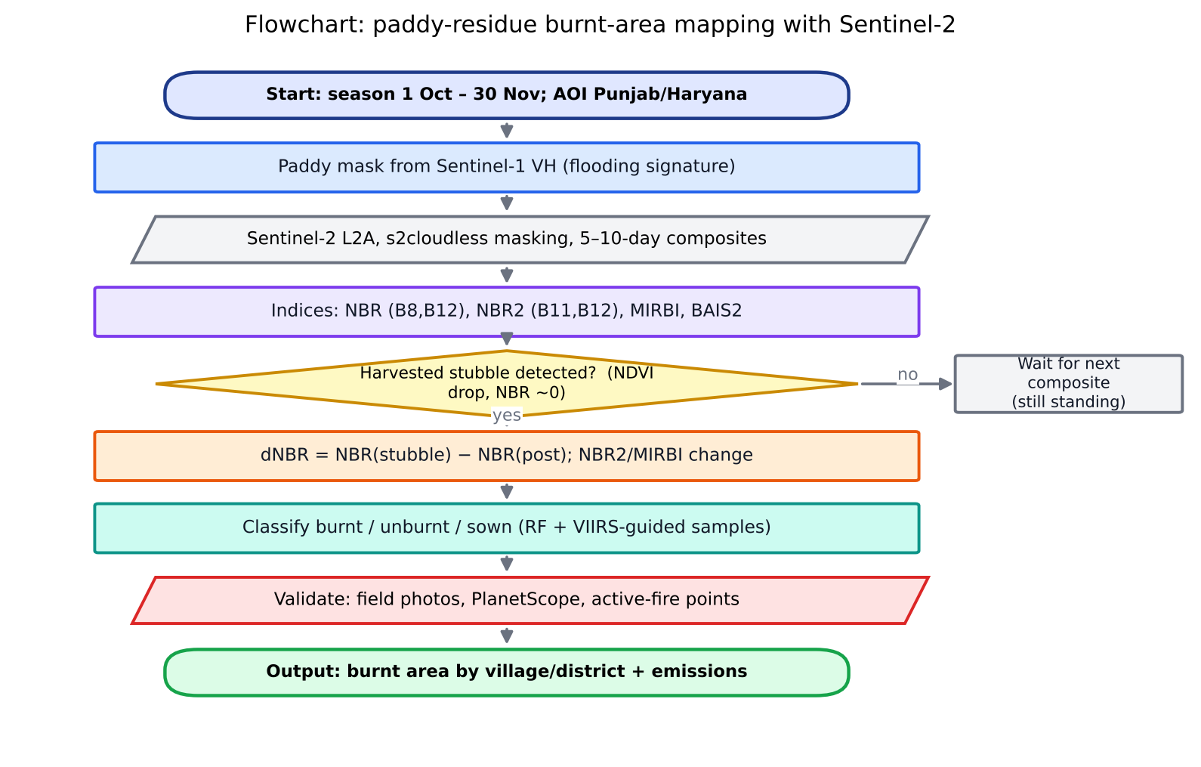
Figure 35. Flowchart of paddy-residue burnt-area mapping with Sentinel-2.

10.6 Residue management options
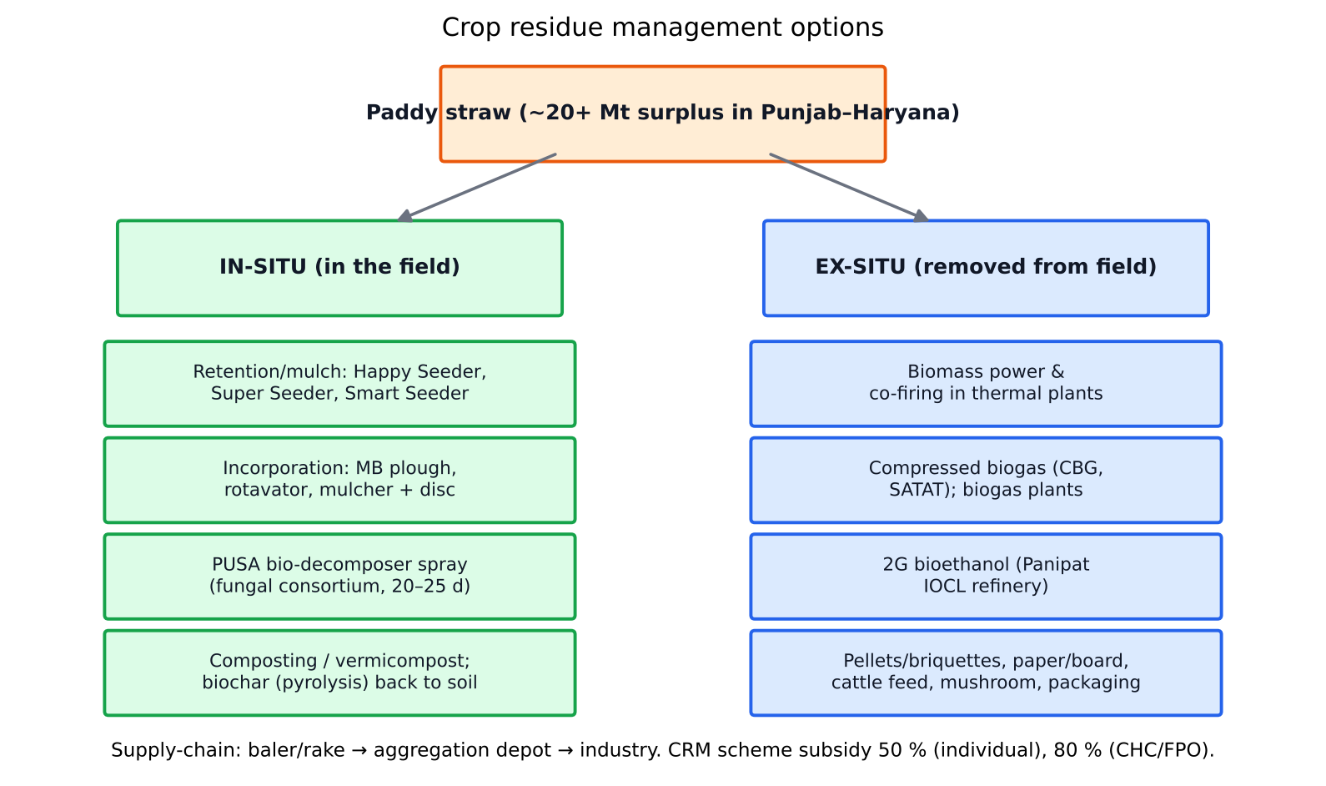
Figure 36. Classification of crop-residue management options.

In-situ management (residue stays in the field)
Option | How | Pros and cons
Retention / mulching | Residue kept on the surface; wheat sown directly with the Happy Seeder (PAU/ACIAR), Super Seeder or Smart Seeder. Stubble is cut, a slot is drilled and straw is placed as mulch. | Conserves moisture, moderates soil temperature against terminal heat, suppresses weeds and builds SOC. Needs a high-HP tractor; slow field capacity.
Incorporation | Straw is chopped (mulcher, Super Straw Management System on combines), then mixed into soil with a reversible MB plough, rotavator or disc harrow. | Adds organic matter; but needs high energy and time, can immobilise N early (wide C:N about 60–80:1) and releases more CO₂ quickly.
PUSA bio-decomposer | A fungal consortium developed by ICAR-IARI (capsule or liquid formulation), sprayed on stubble at about 10 L concentrate in 500 L water per ha; decomposes residue in about 20–25 days with adequate moisture. | Cheap; but performance depends on moisture and temperature (November cold slows it), and the time window is tight.
Composting | Pit or windrow composting with cow dung and urea to correct C:N; vermicomposting. | Produces valuable manure; needs labour and transport.
Biochar | Pyrolysis of straw at 350–600 °C with limited oxygen; biochar returned to soil. | Stable C (half-life of centuries), counts for carbon credits, improves CEC and water retention; kilns cost money.

Residue incorporation vs residue retention
Aspect | Incorporation (mixed into soil) | Retention (surface mulch, zero-till)
Tillage | Intensive (plough or rotavator) | None or minimum
Decomposition | Faster (soil contact, microbes) | Slower; stays as mulch through the season
Soil moisture | Moderate benefit | High: less evaporation and better infiltration
Soil temperature | Little effect | Lower soil temperature in spring; protects against terminal heat
Weeds | Buries weed seeds | Mulch suppresses Phalaris minor
N dynamics | Early N immobilisation | Gradual N release
SOC | Increases, but tillage oxidises some C | Greater long-term SOC build-up in the surface layer
Energy and cost | High fuel, about ₹3,000–5,000/ha extra | Lower operational cost; machine purchase is the cost
GHG | More CO₂ from tillage | Lower fuel CO₂; possible N₂O trade-offs

Ex-situ management (residue removed)
- Collection: rake + baler (rectangular or round bales), then aggregation at depots. The supply chain and storage cost about ₹1,500–2,500 per tonne.
- Biomass power and co-firing: the Ministry of Power mandates 5–7 % co-firing of biomass pellets in thermal power plants (SAMARTH mission). Punjab has biomass power plants of about 10–18 MW.
- Compressed biogas (CBG): under SATAT (Sustainable Alternative Towards Affordable Transportation), straw goes through anaerobic digestion to raw biogas (about 55–60 % CH₄), which is upgraded to more than 90 % CH₄ as CBG. The by-product is fermented organic manure. An example is the Verbio plant at Lehragaga, Sangrur, Punjab.
- 2G bioethanol: lignocellulose is pre-treated, hydrolysed enzymatically and fermented into ethanol. An example is the IOCL Panipat 2G ethanol refinery (inaugurated 2022; about 100 kL/day from about 2 lakh t of straw a year), which supports the E20 ethanol blending target.
- Other uses: pellets and briquettes for industrial boilers, paper and cardboard, packaging, mushroom cultivation, animal bedding, and fodder after urea-molasses enrichment.

10.7 Interview questions
Q. What is FRP and why is it better than fire counts?
A. Fire radiative power is the radiant energy release rate of a fire in MW, derived from the excess MIR radiance. It scales with the combustion rate, so integrating it over time gives the biomass burnt and the emissions. Counts treat a small fire and a large fire equally.
Q. Why use SWIR2 in NBR rather than SWIR1?
A. Charred surfaces and ash raise reflectance most strongly at about 2.2 µm, and green vegetation absorbs there because of leaf water. The NIR–SWIR2 contrast is therefore the largest. SWIR1 is used in NBR2 to separate burnt from merely dry stubble.
Q. Why do official fire counts fall faster than burnt area?
A. Possible causes: burning shifted after satellite overpass times; fires are smaller and short-lived; there is cloud or haze; and fewer detections at the same time as some genuine reduction. Burnt-area mapping from Sentinel-2, geostationary detection and ground verification are needed to confirm the trend.
Q. Which crops' residues are burnt, and when?
A. Paddy straw in Punjab, Haryana and western UP (Oct–Nov, before wheat), wheat stubble (Apr–May, before the kharif crop or green manure), and sugarcane trash in UP and Maharashtra.
Q. Recommend a residue strategy for a 2-acre Punjab farmer.
A. Hire a Super Seeder or Happy Seeder through a CHC (subsidised under CRM) for in-situ mulching. Use the PUSA decomposer where there are 20+ days before sowing. Where a CBG plant or baler aggregator is nearby, sell the bales (about ₹1,500–2,000/t). Carbon-credit aggregation for no-burn plus zero-tillage can add income.

11. Conservation agriculture, regenerative agriculture and biogeochemical cycles
Conservation agriculture (CA), one line (FAO): a farming system that rests on three linked principles: (1) minimum mechanical soil disturbance (zero or reduced tillage), (2) permanent soil organic cover (residue or cover crops, at least 30 %) and (3) species diversification (rotations and intercrops).
Regenerative agriculture (RA), one line: an outcome-oriented approach that aims to restore soil health, biodiversity, water cycles and the carbon cycle. It combines CA principles with integrated livestock, organic inputs, reduced synthetic chemicals and agroforestry. It is defined more by outcomes (rising SOC, biodiversity) than by fixed practices.
Table 16. Conservation vs regenerative agriculture
Aspect | Conservation agriculture | Regenerative agriculture
Definition | Practice-based (3 principles) | Outcome-based (soil health, carbon, biodiversity)
Tillage | Zero or minimum | Minimum; tillage allowed if it serves the outcomes
Inputs | Herbicides often used for weed control | Reduced synthetic inputs; compost, biologicals
Livestock | Not central | Integrated grazing encouraged
Origins | FAO, CIMMYT, the Rice-Wheat Consortium (IGP) | Rodale Institute, the corporate sustainability movement
Carbon credits | Eligible under VM0042 (reduced tillage, residue retention) | Same; plus agroforestry and cover crops

11.1 CA in India: status and benefits
- Zero-tillage wheat after rice in the IGP covers about 2–3 Mha (estimates vary). Adoption is driven by the Happy Seeder, the Super Seeder and CRM subsidies.
- Benefits: wheat sown 1–2 weeks earlier (avoids terminal heat), savings of about ₹2,500–3,000/ha in tillage costs, 20–30 % irrigation water saving, less Phalaris minor weed pressure, higher SOC over the long term, and lower diesel CO₂.
- Long-term trials: CIMMYT–BISA (Karnal, Ladhowal), ICAR-CSSRI and ICAR-IARI show SOC gains of 0.2–0.5 t C/ha/yr in the 0–15 cm layer under ZT plus residue retention, compared with conventional puddled transplanted rice followed by conventionally tilled wheat (results depend on depth).
- Constraints: machinery cost and availability, herbicide-based weed management, rodent and termite pests in mulch, farmer mindset, and fragmented holdings.

11.2 Identifying CA wheat fields from satellite data (the paper by Dr. Rajkumar)
Context: Dr. Rajkumar Dhakar and Dr. V. K. Sehgal of the CREAMS lab (Division of Agricultural Physics, IARI) developed a Zero-Tillage Mapper. It tracked the time series of ZT adoption in wheat across about 63,000 fields in Fazilka, Punjab (2018–2023), and it was presented at Geospatial World Forum/GSI 2025. Related international studies map tillage in the IGP with Sentinel-2 and Random Forest on Google Earth Engine (e.g. Zhou et al., Remote Sensing 2021). Read the exact published paper before quoting numbers. The method logic below is what the board will test.
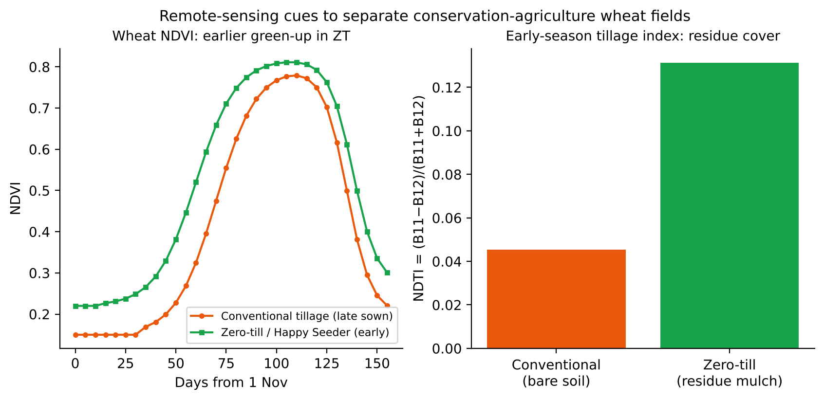
Figure 37. Remote-sensing signatures that separate zero-till (CA) wheat from conventionally tilled wheat. Illustrative curves based on the detection logic of Zhou et al. (2021) and the IARI CREAMS ZT Mapper.

Detection principles
- Residue cover at sowing: ZT fields keep paddy straw or anchored stubble on the surface, while conventional fields are ploughed to bare soil. Cellulose and lignin absorb at about 2.1 µm, so NDTI = (B11 − B12)/(B11 + B12) and the cellulose absorption index (CAI) are higher on residue than on bare soil.
- No burning: CA fields show no fire detection and no burn scar (dNBR) between paddy harvest and wheat sowing. Fire and burnt-area products are used as a negative filter.
- Sowing date and green-up: ZT and Happy Seeder fields are sown immediately after harvest, so NDVI rises 7–15 days earlier than in conventional fields, which need ploughing and planking.
- Surface roughness and tillage operations: conventional fields show a sudden InSAR coherence loss or a VV backscatter change (ploughing). ZT fields stay coherent and smooth.
- Classification: features (NDTI, NBR2 and SWIR brightness at sowing, green-up date, VH/VV change, coherence) feed a Random Forest or SVM. Training uses field surveys and CRM machine-usage records. Validation reports OA, F1 and kappa.
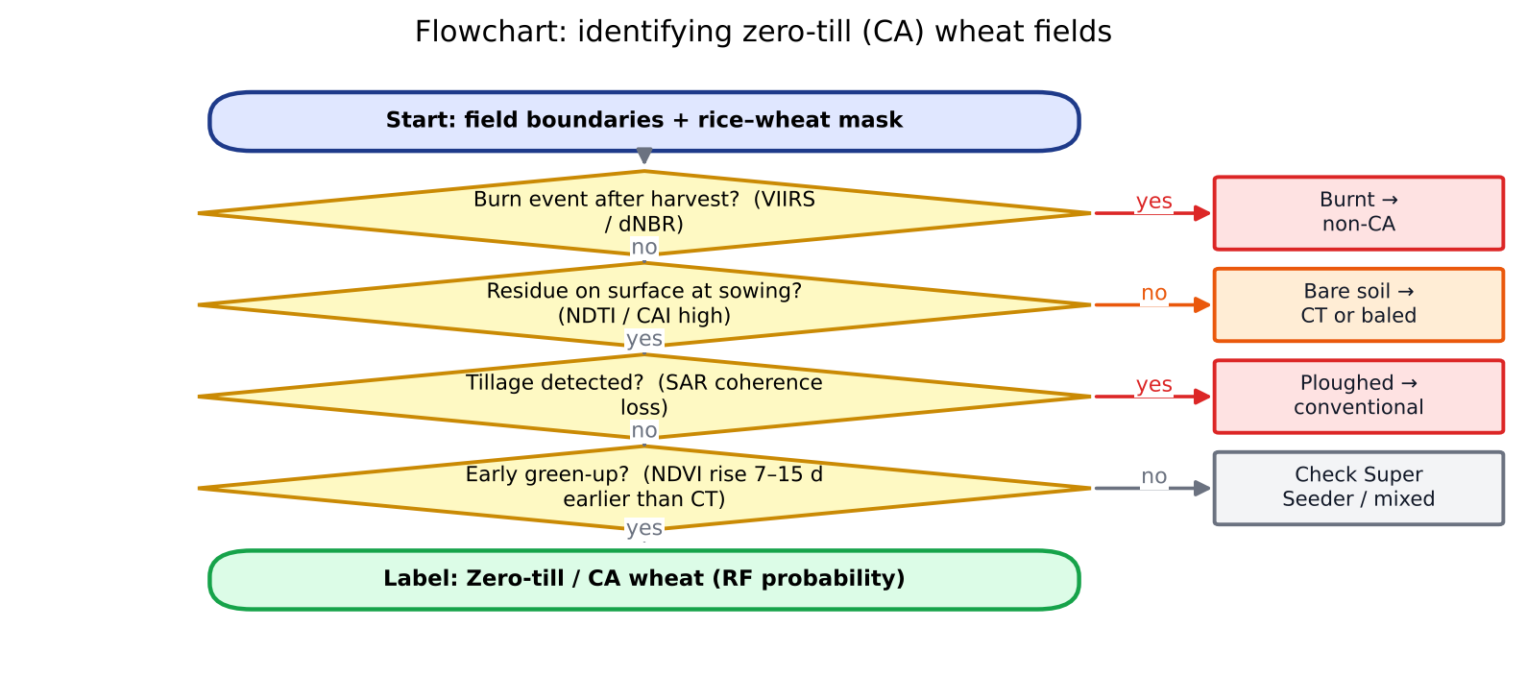
Figure 38. Decision flowchart for identifying zero-till (CA) wheat fields from satellite data.

Challenges
- Clouds and fog in November–December reduce Sentinel-2 availability. Use Sentinel-1/NISAR as a fallback.
- Super Seeder fields partly incorporate residue (rotary action), which gives a mixed residue signal.
- Residue removed by baling followed by zero-till sowing (no mulch) looks like conventional tillage.
- Soil moisture changes SWIR reflectance and the NDTI dynamic range. Use the moisture-robust indices (NDTI) or the dry-date composites.
- Small fields (0.5–2 ha) and mixed pixels. Sentinel-2's 10–20 m is adequate for most Punjab fields.

11.3 Carbon cycle in agroecosystems
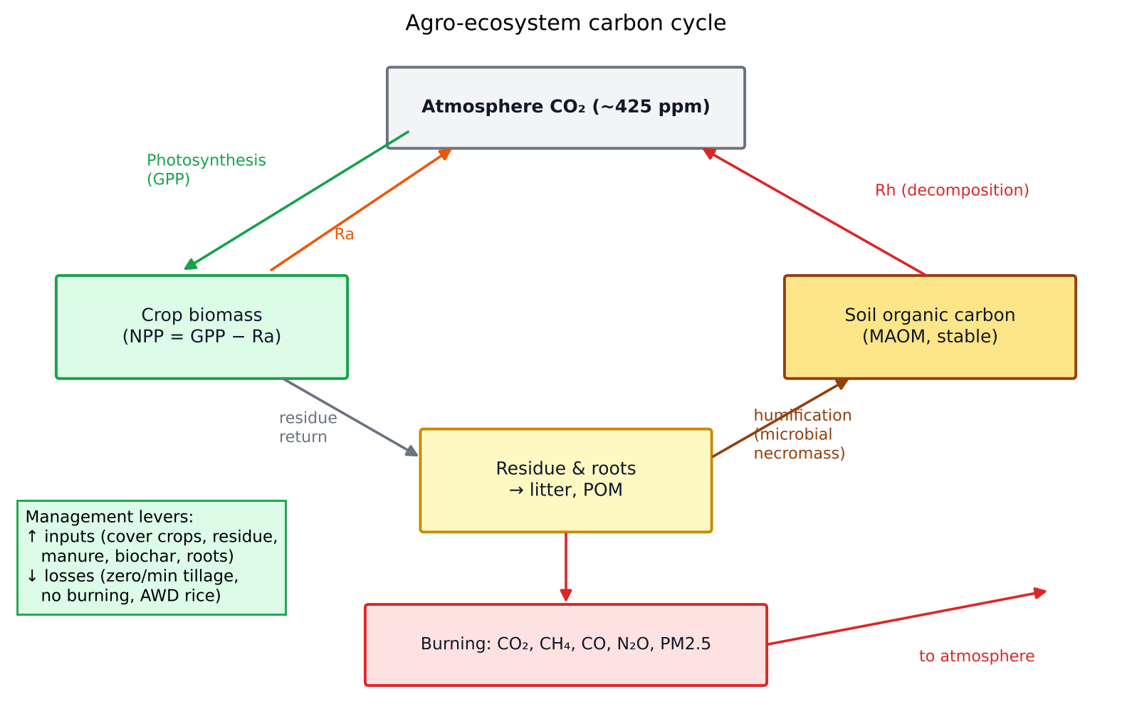
Figure 39. The agroecosystem carbon cycle and the management levers that build soil organic carbon.
- Carbon pools: atmosphere (about 875 GtC, about 425 ppm CO₂ in 2026), vegetation (about 450–650 GtC), soils (about 1,500–2,400 GtC to 1 m) and oceans (about 38,000 GtC).
- Fluxes: GPP → NPP (= GPP − autotrophic respiration Ra) → litter and roots → SOC, which is lost by heterotrophic respiration (Rh). NEP = NPP − Rh. NEE = −NEP (measured by eddy covariance).
- SOC fractions: particulate organic matter (POM, fast turnover) and mineral-associated organic matter (MAOM, stable, protected on clay surfaces). The current paradigm (Lehmann & Kleber 2015; Cotrufo 2013 MEMS) holds that microbial necromass forms MAOM.
- Factors: climate (warm, moist conditions speed decomposition), clay content, tillage (breaks aggregates and exposes C), residue inputs, and nitrogen.
- Equilibrium: SOC rises after a practice change until a new steady state is reached (about 20–30 years). This is why permanence is a concern in carbon credits.
- 4 per 1000 initiative (COP21): a 0.4 % annual increase in global soil C would offset the annual increase in atmospheric CO₂.

11.4 Other biogeochemical cycles
Cycle | Key processes | Agricultural relevance
Nitrogen | Fixation (biological and Haber–Bosch), mineralisation, nitrification (NH₄⁺ → NO₃⁻), denitrification (NO₃⁻ → N₂O/N₂), volatilisation (NH₃), leaching | Urea NUE is only 30–40 %; N₂O has a GWP of 273 (AR6); neem-coated urea and nano-urea; precision N
Phosphorus | Weathering, fixation by Fe/Al (acid soils) and Ca (alkaline soils), microbial solubilisation; no gaseous phase | Legacy P, PSB biofertilisers, eutrophication
Sulphur | Mineralisation, oxidation (SO₄²⁻), reduction (H₂S) in flooded soils | Oilseed nutrition
Methane (C) | Methanogenesis in anaerobic flooded rice (archaea); oxidation by methanotrophs | Rice CH₄ is about 10 % of India's agricultural GHG; AWD cuts CH₄ by 30–50 %; DSR
Water | Precipitation, infiltration, ET, runoff, groundwater recharge | Linked to the energy balance and the carbon cycle (water-use efficiency)

11.5 Interview questions
Q. How would you distinguish a zero-till wheat field from a conventional one using satellites?
A. At sowing, ZT fields have surface residue (high NDTI/CAI in Sentinel-2 SWIR bands), no fire or burn scar, and an earlier NDVI green-up. Conventional fields show bare-soil spectra after ploughing, a coherence loss in SAR and later emergence. A Random Forest on these temporal features, trained with field data, maps CA adoption.
Q. Is regenerative agriculture the same as organic farming?
A. No. Organic farming is defined by prohibited inputs (no synthetic fertilisers or pesticides) and by certification. Regenerative agriculture is defined by soil-health outcomes and can use judicious synthetic inputs. Practices overlap.
Q. Why does tillage reduce SOC?
A. Tillage breaks soil aggregates, exposes physically protected organic matter to microbes and oxygen, and raises soil temperature and aeration. All of these accelerate decomposition and CO₂ loss, and tillage also increases erosion.

12. Carbon credits and MRV (monitoring, reporting, verification)
One-line definition: a carbon credit is a tradable certificate representing one tonne of CO₂-equivalent (tCO₂e) either removed from the atmosphere or prevented from being emitted. It is verified by an independent third party and issued on a registry, so a buyer can claim it against their own emissions.

12.1 Types of carbon credits
Basis | Avoidance / reduction credits | Removal / sequestration credits
Mechanism | Emissions that would have occurred are prevented | CO₂ is physically taken out of the atmosphere and stored
Agriculture examples | No residue burning; AWD in rice (CH₄↓); efficient N (N₂O↓); less diesel through ZT; biogas replacing firewood | SOC build-up (ZT, cover crops, residue retention); agroforestry; biochar
Permanence | Permanent once avoided | Reversible (SOC can be lost if practices stop); needs a buffer pool
Price (2024–26) | Lower (US$2–10/t for many nature-based avoidance credits) | Higher (US$15–40/t for SOC; US$100–200/t for durable biochar)
Market preference | Declining for net-zero claims | Preferred (Oxford Offsetting Principles; SBTi net-zero)

Sequestration vs reduction: Carbon sequestration removes CO₂ already in the air and locks it into soil, biomass or biochar. Emission reduction prevents new CO₂, CH₄ or N₂O from entering the air. Both earn credits, but removals are more valuable for net-zero claims and harder to guarantee because they can be reversed.

12.2 How credits are assigned: the project cycle
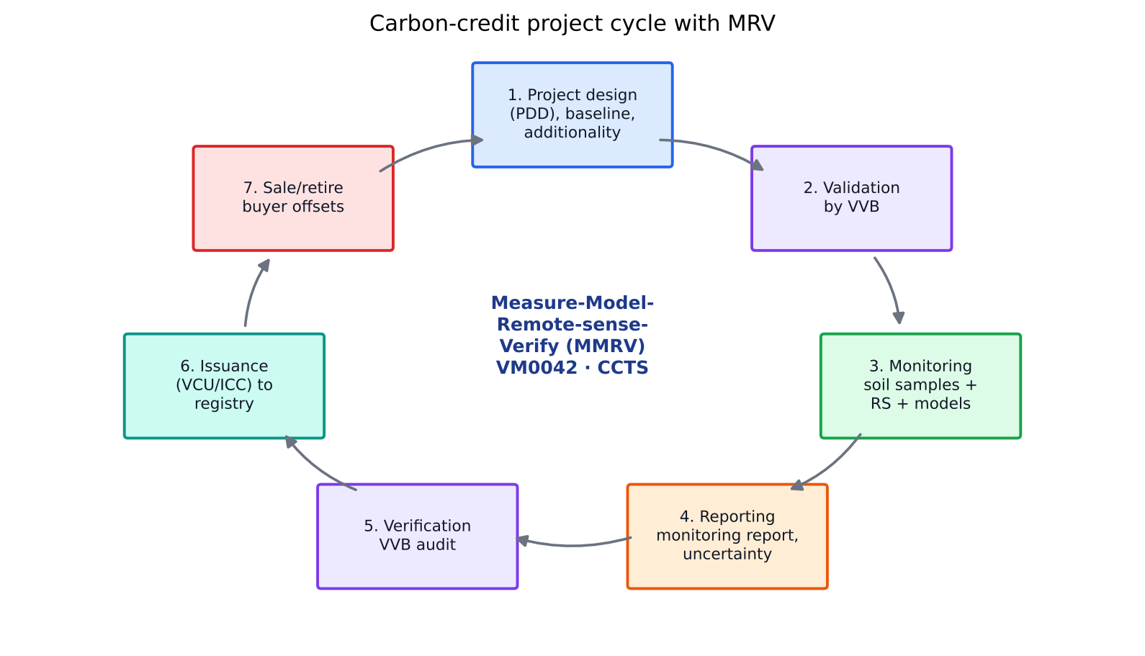
Figure 40. Carbon-credit project cycle with MRV at its core.
- Choose a methodology: e.g. Verra VM0042 (Improved Agricultural Land Management, v2.0/2.1), Gold Standard Soil Organic Carbon Framework, Verra VMD0053 (SOC model calibration), Puro.earth or Isometric Biochar methodologies, or VM0044 (biochar).
- Project Design Document (PDD): project boundary (fields, by GIS polygons), baseline scenario (what would have happened), additionality (the practice would not occur without carbon finance), leakage, permanence and risk.
- Validation by an accredited Validation/Verification Body (VVB), then registration on the registry.
- Implementation and monitoring: farmer enrolment, a practice-change record (sowing method, residue, N use), soil sampling and modelling plus remote sensing.
- Calculation: net removals = (project − baseline) SOC change + emission reductions − leakage − uncertainty deduction − buffer contribution (10–20 % non-permanence buffer).
- Verification by the VVB (desk review, field visits, re-sampling), then issuance of credits (VCUs on Verra, GS-VERs, or Indian Carbon Credit Certificates).
- Sale and retirement: buyers retire credits against their claims. Revenue is shared with farmers (typically 50–70 % to farmers in good programmes).

Key quality criteria (ICVCM Core Carbon Principles)
- Additionality: the activity would not happen anyway (regulatory surplus and financial barriers).
- Baseline: a conservative, realistic counterfactual.
- Permanence: storage lasts at least 40 years (VM0042 requires monitoring and a buffer). Reversals are compensated.
- Leakage: emissions displaced elsewhere are deducted, e.g. yield loss forcing land conversion elsewhere.
- No double counting: each tonne is claimed once only. Corresponding adjustments under Paris Agreement Article 6 apply to internationally transferred credits.
- Robust MRV: quantification is transparent, conservative and independently verified.
- Co-benefits and safeguards: smallholder benefit-sharing, free prior and informed consent, and SDG impacts.

12.3 MRV methodology for soil-carbon projects
Soil carbon changes slowly (about 0.1–1 t C/ha/yr) against a large background stock (30–60 t C/ha in the top 30 cm) with high spatial variability, so measurement alone is expensive. Modern MRV is MMRV: measure + model + remote sense + verify.
Table 17. Three quantification approaches in VM0042
Approach | Description | When used
Measure-and-remeasure | Direct stratified soil sampling (SOC % × bulk density × depth, equivalent soil mass basis) at baseline and every 5 years | Costly; gold standard; for calibration
Measure-and-model | Calibrated biogeochemical models (DayCent, RothC, DNDC, APSIM) driven by practice data; soil samples validate the models | Most common; needs model validation for the region (VMD0053)
Default factors | IPCC Tier 1/2 emission factors (e.g. N₂O EF 1 %, rice CH₄ scaling factors) | For N₂O and CH₄ components

Role of remote sensing in MRV
- Practice verification: tillage (NDTI, SAR coherence), residue burning (VIIRS fires, dNBR), cover crops (winter NDVI), rice flooding regime for AWD (Sentinel-1 water detection), sowing dates and crop rotation (crop-type maps).
- Model drivers: NPP/GPP (LUE, SIF), biomass and residue amount (from yield maps), and soil moisture.
- Stratification of soil sampling: use bare-soil composites, DEM and NDVI history to design efficient sampling (cLHS), which reduces the number of cores needed.
- Direct SOC mapping: spectral bare-soil SOC prediction (Sentinel-2, hyperspectral PRISMA/EnMAP), which is emerging.
- Agroforestry biomass: GEDI LiDAR, NISAR L-band, high-resolution imagery for tree counts, and allometry.
- Digital MRV (dMRV): farmer app records, geo-tagged photos and blockchain registries, which cut verification cost. Transaction costs often exceed credit value for smallholders.
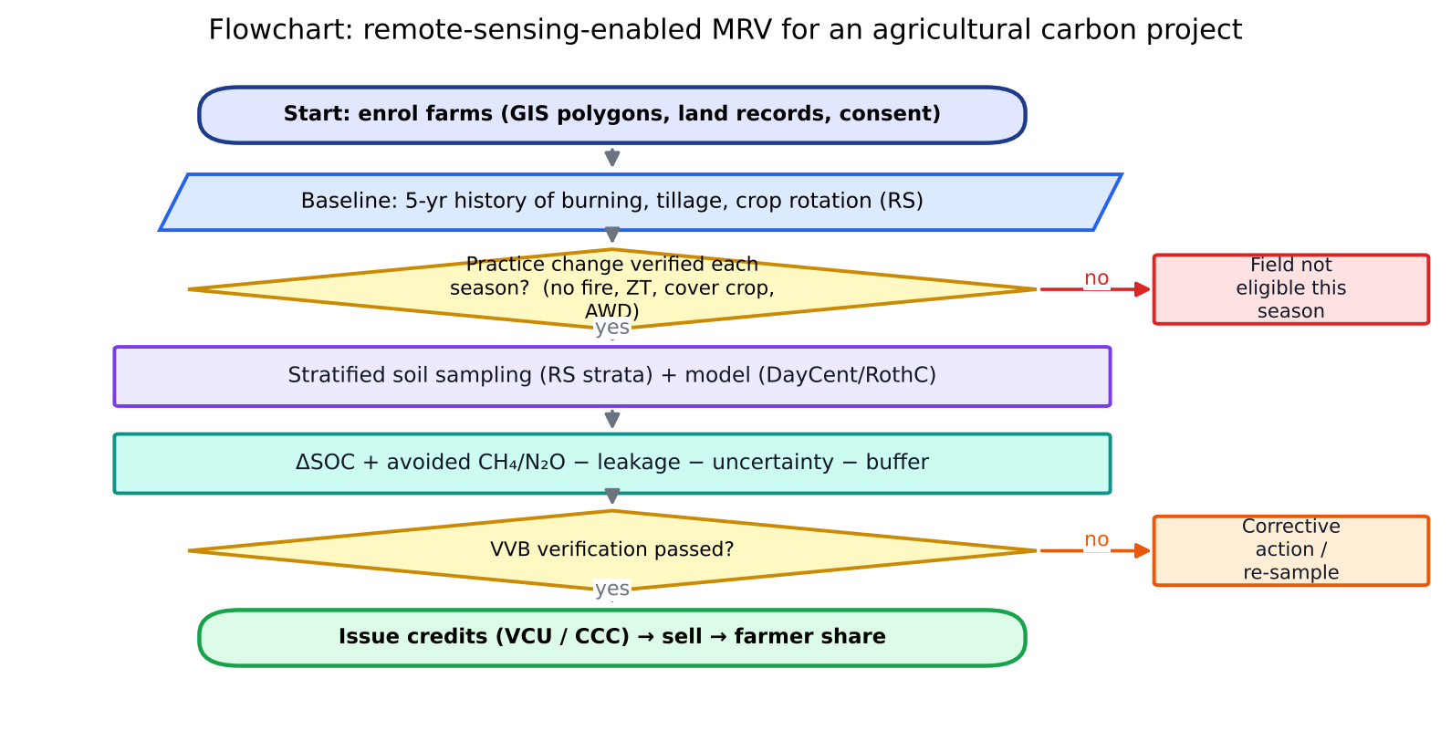
Figure 41. Flowchart of remote-sensing-enabled MRV for an agricultural carbon project.

12.4 Biochar and carbon credits
- What: charcoal produced by pyrolysis of biomass (300–700 °C, low oxygen). About 50 % of the feedstock C ends up in a highly aromatic, recalcitrant form.
- Permanence: H/Corg < 0.7 (EBC/IBI criteria) indicates stability. 100-year persistence is about 70–90 % depending on the H/Corg ratio and temperature.
- Calculation: credits = biochar mass × C content × permanence factor − project emissions (feedstock transport, pyrolysis energy, CH₄ from kilns) − leakage.
- Benefits: better CEC, water holding, liming effect and microbial habitat; lower N₂O; possible yield gains in acidic and degraded soils.
- Markets: biochar is one of the largest categories of durable carbon removal (CDR) purchases, with buyers such as Microsoft and Frontier at about US$120–200/t. India has projects on paddy straw, cotton stalk and Prosopis juliflora, with credits on Puro.earth, Isometric and Verra VM0044.

12.5 Who buys carbon credits?
- Voluntary carbon market (VCM): corporations with net-zero or ESG commitments (tech, aviation, oil and gas, FMCG, banks). Examples: Microsoft, Google, Shell, Delta, and Indian firms such as Infosys, Wipro and Tata Steel. Brokers and exchanges include Xpansiv CBL and AirCarbon.
- Compliance markets: EU ETS, California cap-and-trade and the CORSIA aviation scheme. Article 6.2 and 6.4 buyers include Japan JCM, Singapore and Switzerland.
- Agriculture-specific buyers: food and beverage companies reducing Scope 3 emissions through insetting within their own supply chains (Nestlé, PepsiCo, Unilever).

12.6 The situation in India
Element | Status
Legal basis | Energy Conservation (Amendment) Act 2022 enables a national carbon market
Carbon Credit Trading Scheme (CCTS) 2023 | Notified by the Ministry of Power (June 2023). The Bureau of Energy Efficiency (BEE) is the administrator and Grid Controller of India the registry. Two mechanisms: a compliance mechanism (GHG emission-intensity targets for obligated sectors such as aluminium, cement, chlor-alkali, pulp and paper, and refineries; intensity targets notified in 2025) and an offset mechanism (voluntary projects earn Indian Carbon Credit Certificates, CCC)
Offset methodologies | BEE approved initial methodologies including renewable energy, green hydrogen, mangroves and agroforestry. Agriculture-related methods (rice cultivation, SOC) are under development or consultation
Green Credit Programme (2023, MoEFCC) | Separate non-carbon green credits for tree plantation, water conservation and similar activities, administered by ICFRE
Article 6 | India listed activities eligible for international transfer (e.g. green hydrogen, storage, CCUS), with corresponding adjustments only for these
Agri projects in the VCM | Developers such as Varaha, Boomitra, Grow Indigo (Mahyco) and the NABARD-backed pilots: Verra VM0042 projects for DSR, AWD, ZT, no-burn and agroforestry with thousands of smallholders across Punjab, Haryana, MP and Telangana
Challenges | Smallholder fragmentation, high MRV cost per hectare, baseline and additionality on smallholdings, land records, trust and benefit-sharing, credit price volatility
Research (ICAR/IARI) | Cariappa et al. (Scientific Reports 2024) used farmer surveys and remote sensing to assess CA eligibility under VM0042 in the IGP. IARI's CREAMS ZT mapping and burning monitoring provide remote-sensing evidence of practice change, the core of MRV

12.7 IARI and Division of Agricultural Physics involvement in MRV
- Practice monitoring at scale: fire-event and burnt-area maps (no-burn verification), the Zero-Tillage Mapper (CA adoption), and crop-type and sowing-date maps. These are the activity data of MRV.
- Flux and soil measurements: soil-physics and agromet labs measure SOC, bulk density, soil respiration and GHG fluxes (chamber and EC), which provide model calibration data.
- Modelling: InfoCrop (IARI), DSSAT and APSIM run for SOC and GHG scenarios. Remote-sensing-derived NPP feeds into RothC.
- Hyperspectral soil SOC: spectral libraries and ML models for low-cost SOC estimation.
- Policy inputs: technical support to MoA&FW and NITI Aayog on agricultural carbon markets and on standard protocols (as for fire monitoring).
- The paper by “Dr. Vinay”: most likely by Dr. Vinay Kumar Sehgal (Head, Division of Agricultural Physics) and colleagues, on remote-sensing-based monitoring of residue management and conservation practices for climate and MRV applications. Check the exact title in his Google Scholar list before the interview.

12.8 Interview questions
Q. What is additionality? Give an agriculture example.
A. A credit is additional only if the emission reduction or removal would not have happened without carbon-credit revenue. Example: a Punjab farmer adopts zero tillage plus residue retention only because the carbon payment covers the Super Seeder rental. If ZT were already common practice or legally mandated, it would not be additional.
Q. How can remote sensing reduce MRV cost?
A. Remote sensing verifies practices (tillage, burning, cover crops, flooding) over every enrolled field without visits. It stratifies soil sampling to reduce the number of cores, provides model drivers (NPP, biomass, soil moisture), and detects reversals. This turns MRV from field-by-field audits into wall-to-wall digital monitoring.
Q. Why is soil carbon controversial as an offset?
A. It is hard to measure accurately (high variability, slow change, depth issues). It is reversible, saturates over time, and has additionality and leakage problems. Model-based estimates can be over-optimistic. Strong MRV, conservative uncertainty deductions and buffer pools are therefore essential.
Q. What is the difference between CCTS compliance and offset mechanisms?
A. Under compliance, obligated industries get emission-intensity targets. Those that beat their targets earn credits, and those that miss must buy them. Under the offset mechanism, non-obligated entities (including agriculture and forestry projects) voluntarily register projects under approved methodologies and earn carbon credit certificates.

13. Precision agriculture and variable-rate technology
One-line definition: precision agriculture (PA) is a management strategy that gathers, processes and analyses temporal, spatial and individual data and combines it with other information. It supports management decisions according to estimated variability, for better resource-use efficiency, productivity, quality, profitability and sustainability (International Society of Precision Agriculture, 2019).
In five words: “right input, right place, right time, right amount” (and right source, the 4R nutrient stewardship framework).

13.1 Principles
- Variability exists: spatial variability within and between fields (soil, topography, pests) and temporal variability between seasons and within a season.
- Variability can be measured: GNSS, sensors and remote sensing.
- Variability is manageable: management zones and variable-rate application.
- Managing it pays: economic and environmental benefits outweigh the cost of the technology.
- Closed-loop cycle: data, analysis, decision, application, evaluation, then back to data.
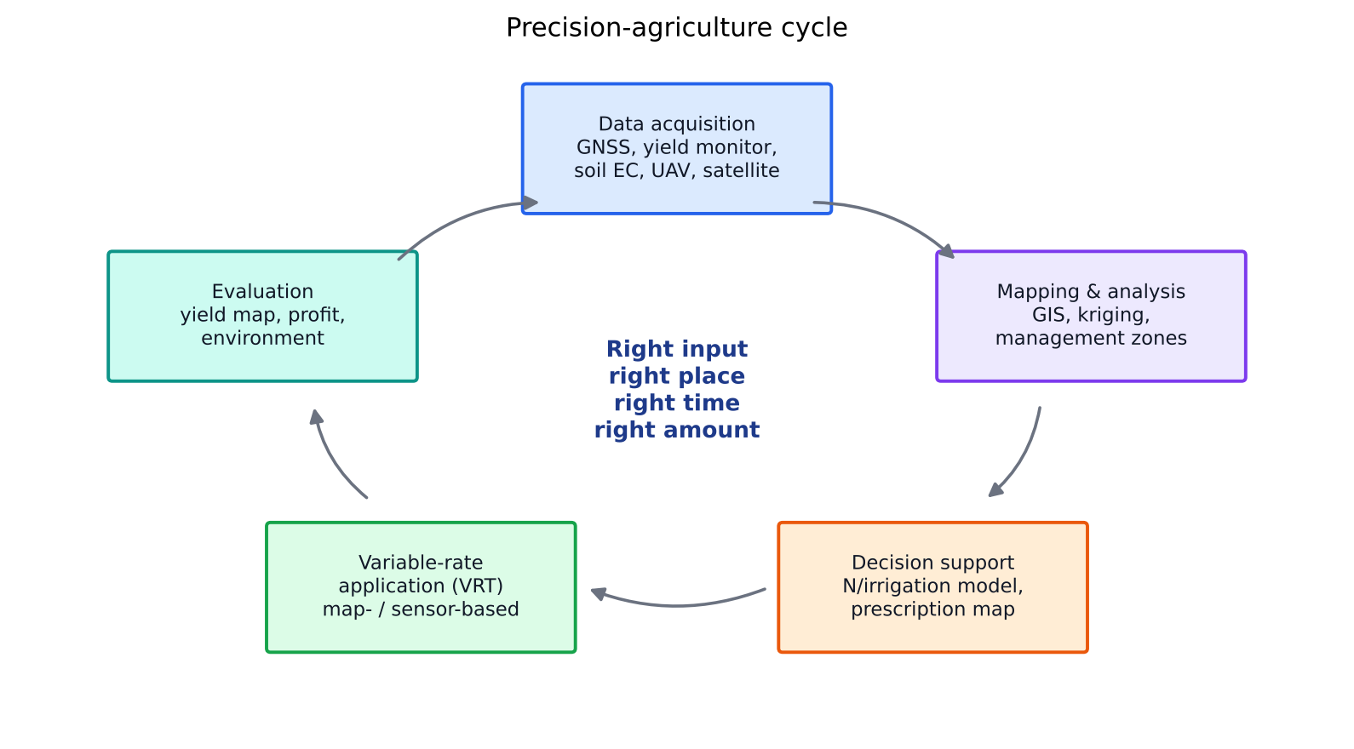
Figure 42. The precision-agriculture management cycle.

13.2 Tools and technologies
Table 18. Precision-agriculture toolkit and applicability in India
Tool | Function | Applicability in India
GNSS (GPS, NavIC/IRNSS, GAGAN) | Positioning; auto-steer (RTK ±2 cm); geo-referencing samples | High (phones, NavIC); RTK limited to large farms and CHCs
Remote sensing (satellite) | Crop vigour, stress, N status, ET, yield prediction; Sentinel-2 free 10 m | High: scalable, low cost; cloud cover limits kharif use; holdings are small
UAVs / drones | High-resolution multispectral and thermal imaging; spraying (Kisan drones; Namo Drone Didi scheme) | Growing fast; DGCA rules; spraying viable through custom hiring
Proximal crop sensors | GreenSeeker (NDVI), Crop Circle, SPAD, LCC | High (LCC, GreenSeeker): low cost, proven for N in rice and wheat (PAU, IARI)
Soil sensors | EC mapping (EM-38, Veris), pH, moisture probes (capacitance), NPK sensors | Medium; IoT moisture probes for irrigation spreading
GIS and geostatistics | Kriging, management zones (fuzzy k-means), prescription maps | High (QGIS, Bhuvan, GEE)
Yield monitors | Mass-flow sensor + GNSS on combine; yield maps | Low (custom combines lack them); potential with CHC combines
Variable-rate technology (VRT) | Applies inputs at variable rate from a map or sensor | Low–medium; research prototypes at IARI, PAU and CIAE
Laser land leveller | Precision levelling; ±2 cm | High: widely adopted in Punjab and Haryana; saves 20–25 % water
Decision-support systems | Crop models, Nutrient Expert (IPNI/CIMMYT), irrigation schedulers, AI apps | High via mobile phones (Kisan e-Mitra, Krishi DSS)
IoT and AI | Sensor networks, automated drip and fertigation, pest traps with image AI | Medium; horticulture, polyhouses

13.3 Variable-rate technology (VRT)
- Map-based VRT: a prescription map is prepared in advance from soil tests, yield maps or imagery. The applicator reads the map and its GNSS position. Best for P, K, lime and seed rate (slowly varying properties).
- Sensor-based (on-the-go) VRT: a real-time sensor (e.g. GreenSeeker NDVI) and an algorithm compute the rate instantly. Best for in-season N (fast-changing properties).
- Hybrid: a map defines zones and sensors fine-tune the rate within each zone.
- Components: controller, GNSS receiver, actuators (variable-speed hydraulic motors, pulse-width-modulated nozzles), flow sensors and the prescription software.
- Inputs that can vary: seed rate (variable-rate seeding), fertiliser (N, P, K), lime, pesticides (spot spraying with machine vision, “see and spray”), irrigation (VRI pivots) and plant-growth regulators.
- N algorithm example (Raun et al.): YP₀ = f(INSEY = NDVI/days from sowing). The response index RI = NDVI(N-rich strip)/NDVI(farmer field). N rate = (YP_N − YP₀) × grain N %/NUE.
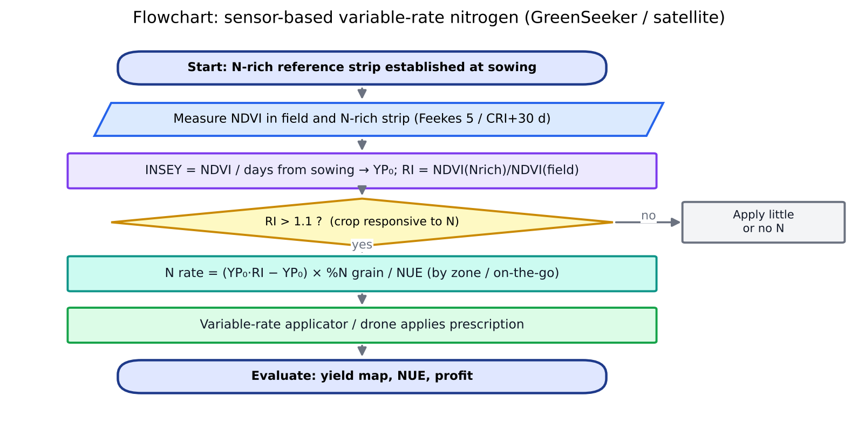
Figure 43. Flowchart of sensor-based variable-rate nitrogen management.
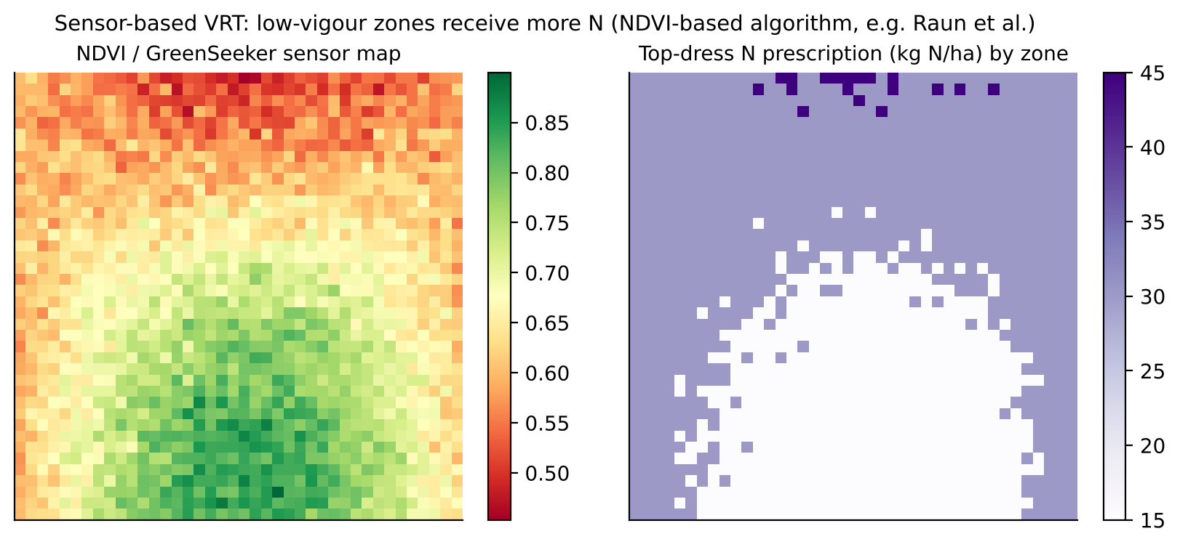
Figure 44. Sensor-based VRT: an NDVI vigour map converted into a zone-wise N top-dressing prescription.

13.4 Applications
- Nutrient management: site-specific nutrient management (SSNM), the LCC and GreenSeeker for N in rice and wheat (10–15 % N saving at the same yield), and Soil Health Card based zone recommendations.
- Water: soil-moisture-sensor-based drip and sprinkler irrigation, thermal CWSI scheduling, and ET-based scheduling (FAO-56 + Kc from NDVI).
- Crop protection: drone spraying, early pest and disease detection (hyperspectral, AI image apps), and weather-based forecast models.
- Harvest and post-harvest: yield mapping, quality sensing (protein NIR) and logistics.
- Horticulture and protected cultivation: fertigation, climate control, precision orchards (canopy-volume-based spraying).

13.5 Applicability and adoption in India
Constraints | Enablers and the way forward
Small, fragmented holdings (86 % of holdings < 2 ha; average 1.08 ha) | Treat a group of farms or a village as the ‘precision unit’; FPO and CHC custom hiring of VRT and drones
High equipment cost; low farmer literacy in digital tools | Low-cost sensors (LCC, phone-based NDVI); subsidies (SMAM, Kisan drone)
Lack of yield monitors and data infrastructure | AgriStack, Digital Crop Survey, Soil Health Card digital records, Bhuvan, NavIC
Heterogeneity within small plots is often smaller than between plots | Satellite-based (Sentinel-2) zone mapping at village scale; between-farm precision
Weak extension linkage | KVKs, apps in local languages (Bhashini), the ICAR-NePPA network

13.6 ICAR Network Programme on Precision Agriculture (NePPA) and IARI's role
- Launched: 8 September 2021 by Dr. Trilochan Mohapatra (then Secretary DARE and DG ICAR).
- Lead institute: ICAR-IARI, New Delhi (coordination; the then Director, Dr. A. K. Singh). 16 partner institutes across 7 subject-matter divisions: crop science, NRM, engineering, horticulture, animal science, fisheries and others.
- Aim: develop precision ag-techs for better input-use efficiency, a safe production environment and profitable, quality produce. This covers precision crop production as well as precision livestock farming and precision aquaculture.
- Components: sensor development (soil, crop and nano-sensors), drone and AI applications, IoT-based irrigation and fertigation, VRT machinery, decision-support systems, and data analytics. The ICAR Data Centre handles data storage and analytics.
- IARI's role: overall coordination, plus Agricultural Physics work on remote sensing, hyperspectral and crop sensors, Agricultural Engineering work on VRT machines and drones, and Water Technology Centre work on precision irrigation. IARI also hosts the steering and monitoring framework (monitoring presented by Dr. Anil Rai, ADG ICT).

13.7 Space-based precision agriculture and the ISRO–SAC context
- SAC (Space Applications Centre, Ahmedabad) pioneered crop production forecasting (the CAPE project) and develops methods and pilots for space-based precision farming. These include field-level crop condition, N-stress mapping from red-edge and hyperspectral data, soil moisture, and site-specific advisory.
- Satellite-based PA in India: village-scale management zones from multi-year Sentinel-2/Resourcesat NDVI, field-level advisories in local languages (pilot projects with state agriculture departments), and integration with NavIC for geotagging.
- Future: NISAR soil moisture (100 m), TRISHNA thermal ET (57 m), hyperspectral missions for N and protein, and FLEX SIF for stress. Together these allow within-season, field-scale prescriptions.

13.8 Interview questions
Q. Is precision agriculture relevant for Indian smallholders?
A. Yes, in adapted forms. Low-cost tools (LCC, GreenSeeker, phone apps), satellite-based advisories at field or village level, CHC-based drone and VRT services, and laser levelling deliver precision benefits without each farmer owning equipment. Precision across farms in a village can matter more than variability within a single farm.
Q. Map-based vs sensor-based VRT?
A. Map-based VRT uses a prescription prepared earlier from soil, yield or imagery data. It suits slowly varying properties such as P, K and lime. Sensor-based VRT measures crop status on the go and computes the rate in real time. It suits in-season N.
Q. How does GreenSeeker work?
A. It is an active optical sensor that emits red (≈660 nm) and NIR (≈770 nm) light and measures the reflected fraction to compute NDVI, independent of sunlight. NDVI is related to yield potential through the INSEY algorithm, and comparison with an N-rich reference strip gives the top-dress N rate.

14. Crop insurance and yield estimation (the likely main focus)
One-line definition: crop yield estimation predicts or measures the production per unit area of a crop at a chosen spatial unit (field, GP, district) and time (in season or at harvest). In India these estimates drive food-security planning (FASAL) and crop-insurance claim settlement (PMFBY/YES-TECH).

14.1 The Indian crop-statistics and insurance ecosystem
Table 19. Institutions and programmes
Body / programme | Role
MNCFC (Mahalanobis National Crop Forecast Centre), DA&FW | Set up in 2012 in New Delhi. Runs FASAL, CHAMAN, NADAMS and technical support for PMFBY (YES-TECH, smart sampling)
ISRO (SAC, NRSC) | Developed the methods (CAPE → FASAL), provide satellite data (Resourcesat, EOS-04, NISAR), and act as mentors for ML/DL yield models
IMD / IASRI / SAUs | Agro-meteorological yield models; statistical methodology for CCEs (ICAR-IASRI); state-level testing
NSO / DES / state agriculture departments | General Crop Estimation Surveys (GCES): CCEs for official yield statistics
PMFBY (since Kharif 2016) | Area-yield-index insurance for food crops, oilseeds and annual commercial/horticultural crops
RWBCIS | Restructured Weather-Based Crop Insurance Scheme: weather-index cover, popular for horticulture
Digital tools | YES-TECH, WINDS (weather station network), CROPIC (crop photos), DigiClaim, NCIP portal, AIDE app, Krishi Rakshak helpline 14447

14.2 FASAL: Forecasting Agricultural output using Space, Agro-meteorology and Land-based observations
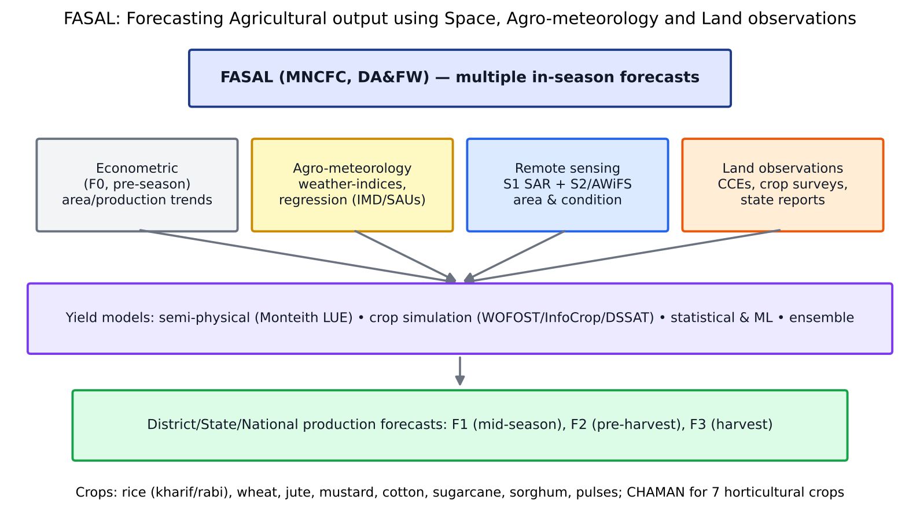
Figure 45. FASAL's multiple-forecast framework combining econometric, agromet, remote-sensing and field data.
- History: the CAPE (Crop Acreage and Production Estimation) project at SAC (late 1980s) led to the FASAL concept in 2006 and to operational forecasting at MNCFC since 2012.
- Crops: kharif and rabi rice, wheat, jute, rapeseed–mustard, cotton, sugarcane, rabi sorghum and rabi pulses, at national, state and district levels.
- CHAMAN (Coordinated Horticulture Assessment and Management using geoiNformatics, 2014): area and production of 7 horticultural crops (banana, mango, citrus, potato, onion, tomato, chilli) in major districts. It also covers site suitability and post-harvest infrastructure.
- Area estimation: a stratified random sampling design (5 km × 5 km segments). Rabi crops are classified from multi-date Resourcesat AWiFS/LISS-III and Sentinel-2 data, and kharif crops from SAR (Sentinel-1, EOS-04) because of clouds. Classification accuracy is above 90 %.
- Yield estimation: a multi-model approach (Section 14.3). Production = area × yield.
- Forecast stages: a pre-season econometric forecast, then mid-season (RS + weather) and pre-harvest forecasts, and a final estimate, given before the DES advance estimates.

14.3 Yield models used in FASAL and YES-TECH

(a) Semi-physical (light-use-efficiency) model
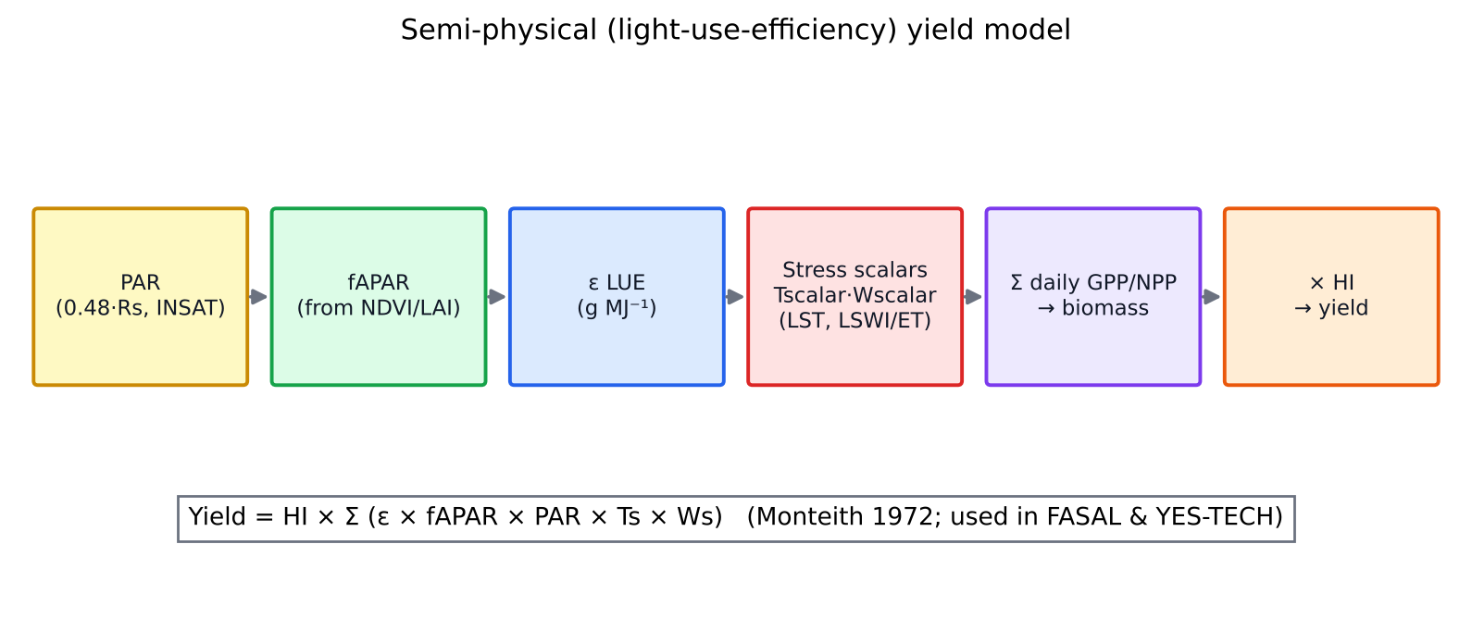
Figure 46. Semi-physical (Monteith LUE) yield model chain (after Monteith 1972).
GPP/NPP = Σ ε · fAPAR · PAR · Tscalar · Wscalar ; Yield = HI × Biomass
- PAR = about 0.48 × incoming shortwave (INSAT-3D insolation). fAPAR from NDVI (fAPAR ≈ 1.24·NDVI − 0.168) or LAI (Beer's law).
- ε (RUE): about 2.5–3.0 g MJ⁻¹ for wheat and rice (C3) and 3.5–4.0 for maize (C4), reduced by stress scalars: temperature (a CASA/VPM function) and water (LSWI-based or ET/PET-based Ws = 0.5 + 0.5·ETa/ETp).
- HI: a crop-specific harvest index (wheat about 0.40–0.45, rice 0.45–0.50), possibly modulated by stress during grain filling.
- Pros: physically interpretable and spatially explicit (pixel-wise). It works without CCE calibration and needs only a few parameters.
- Cons: the ε and HI assumptions, mixed pixels and cloud gaps. Calibration against CCEs is still recommended.

(b) Crop simulation models with RS assimilation
- WOFOST, DSSAT and InfoCrop, run on a 5 km grid or at GP level with gridded weather (IMD), soil (NBSS&LUP) and RS-derived sowing dates.
- Assimilation of RS LAI and soil moisture (Chapter 9) corrects the model trajectory.
- Pros: handles weather extremes mechanistically and extends the forecast with weather scenarios. Cons: needs many inputs (cultivar, management) and calibration.

(c) Statistical and agro-meteorological models
- Spectral–yield regression: Yield = a + b·(peak NDVI or Σ NDVI) + c·trend.
- Weather-indices (Agrawal/IASRI) model: weekly weather variables (Tmax, Tmin, rain, RH) weighted by their correlation with yield over the crop season, with a time trend. IMD and AMFUs use it for district forecasts.
- Pros: simple. Cons: stationarity assumption, limited spatial detail, and overfitting with short time series.

(d) Machine-learning models
- RF, XGBoost, SVR and ANN, using features from Sentinel-1/2 time series (NDVI, NDRE, VH, VH/VV), weather (GDD, rain, heat days), soil (texture, SOC), SIF, ET and soil moisture. CCE yields are the labels.
- Deep learning (LSTM, CNN-LSTM, Transformers) on pixel or GP time series.
- Pros: captures non-linearity and makes use of many predictors. Cons: needs many good-quality CCE labels, transfers poorly between years, and is less interpretable (mitigated by SHAP).

(e) Ensemble
- Combines the models above using simple averaging, inverse-RMSE weighting (w_i = (1/RMSE_i²)/Σ(1/RMSE_j²)), Bayesian model averaging, or stacking, where a meta-learner such as ridge or RF is trained on base-model predictions.
- Why it helps: different models have different errors, so averaging reduces variance and the risk that one model fails in an unusual year. Ensembles consistently beat their individual members in insurance pilots.
- Model spread across ensemble members is a useful uncertainty indicator: GPs with high disagreement can be flagged for extra CCEs.
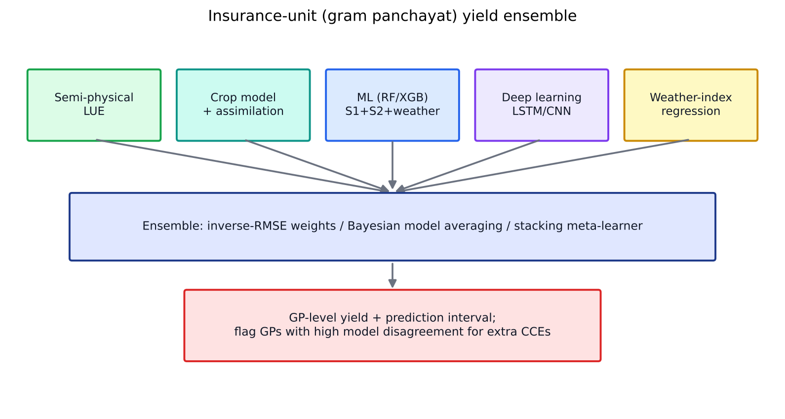
Figure 47. GP-level ensemble yield modelling with uncertainty-driven CCE allocation.

14.4 PMFBY in brief
Feature | Provision
Launch | Kharif 2016; restructured 2020 (voluntary for all farmers); continued to 2025-26 with a technology fund (FIAT, the Fund for Innovation and Technology)
Farmer premium | 2 % kharif, 1.5 % rabi (food and oilseed crops), 5 % annual commercial and horticultural crops; the rest is shared between Centre and states (90:10 in NE states)
Approach | Area approach: the insurance unit (IU) is the village or gram panchayat for major crops and a larger unit for minor crops
Risks covered | Prevented sowing (claim up to 25 % of sum insured), mid-season adversity (on-account payment of 25 %), standing crop yield loss, post-harvest losses (14 days, individual farm), localised calamities (hail, landslide, inundation, cloudburst, natural fire: individual farm)
Threshold yield (TY) | Average yield of the best 5 of the last 7 years × indemnity level (70/80/90 %)
Claim | Claim = (TY − AY)/TY × sum insured, where AY is the actual yield from CCEs and/or YES-TECH
CCEs | At least 4 CCEs per GP/IU per major crop; recorded on the CCE-Agri app with geotagged photos and timestamps

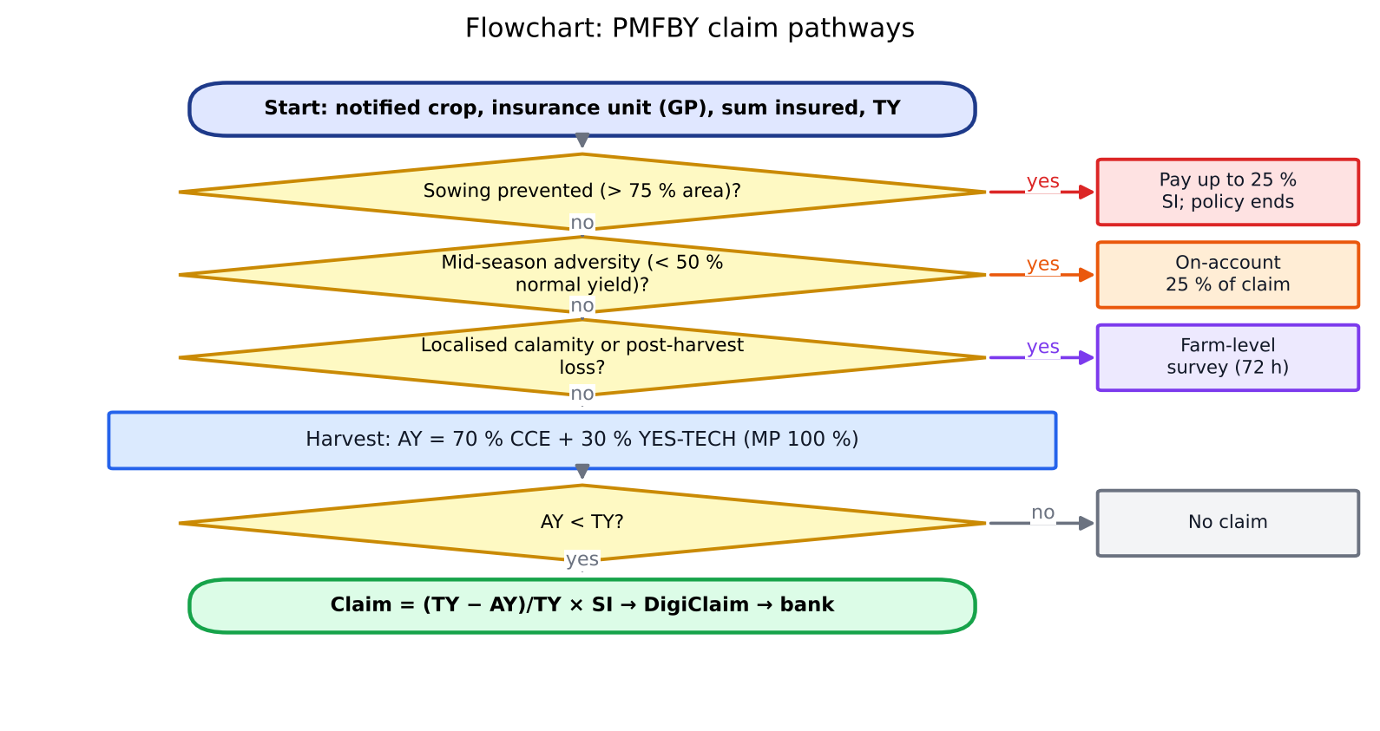
Figure 48. Flowchart of PMFBY claim pathways (prevented sowing, mid-season adversity, localised loss, yield shortfall).
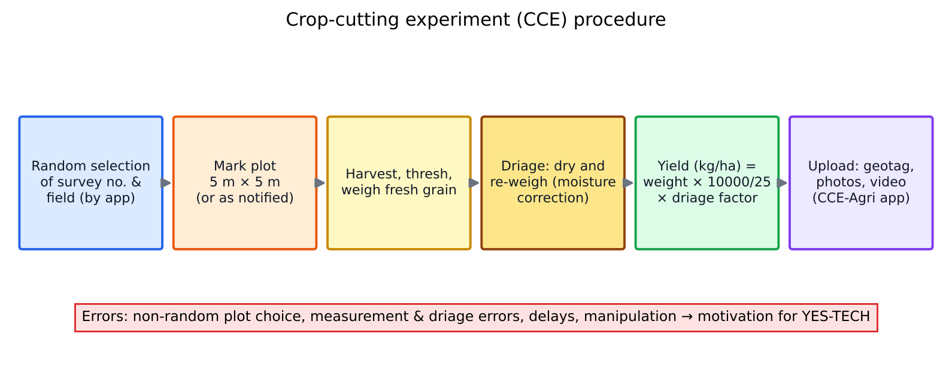
Figure 49. Crop-cutting experiment (CCE) procedure and its sources of error.
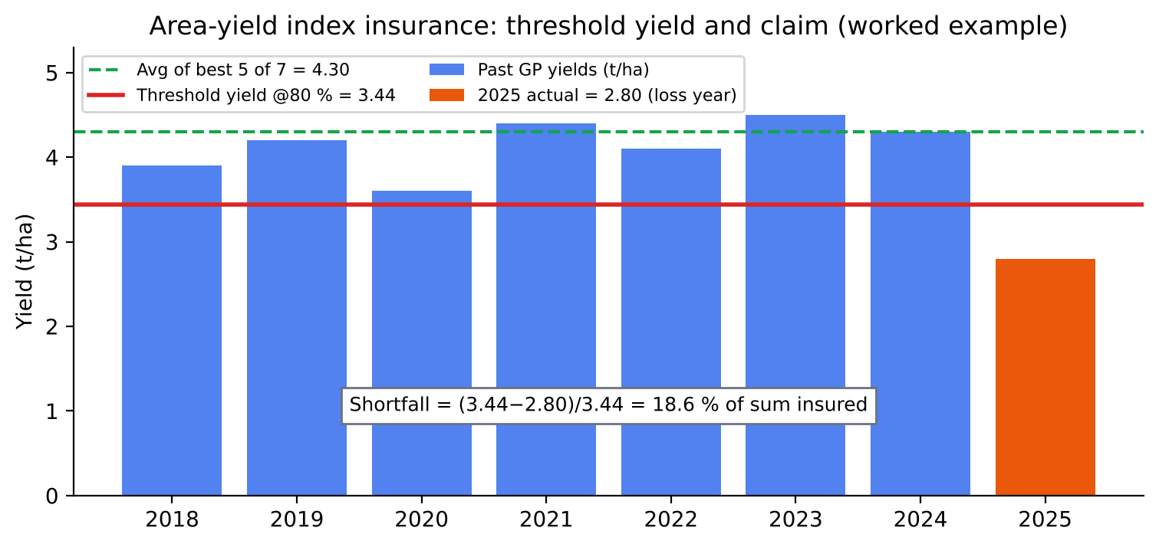
Figure 50. Worked example of threshold yield and claim calculation under the area-yield-index approach.
Practice this: Worked example: past yields over 7 years = 3.9, 4.2, 3.6, 4.4, 4.1, 4.5, 4.3 t/ha. Best 5 average = (4.5 + 4.4 + 4.3 + 4.2 + 4.1)/5 = 4.30. At 80 % indemnity, TY = 3.44 t/ha. If AY = 2.80 t/ha, shortfall = (3.44 − 2.80)/3.44 = 18.6 %. With a sum insured of ₹50,000/ha, the claim is ₹9,300/ha.

14.5 Yield-index approach for cereals vs weather-based approach for horticulture
Table 20. Area-yield index vs weather index insurance
Aspect | Yield-index (PMFBY, cereals and pulses) | Weather-index (RWBCIS, horticulture)
Index | Actual area yield of the IU (GP) measured by CCEs/technology | Weather parameters (rain deficit or excess, temperature, RH, wind, hail) from reference AWS/WINDS
Trigger | AY < threshold yield (TY = best-5-of-7 average × indemnity level) | Parameter crosses a trigger (e.g. cumulative rain < X mm in a phase), with payout scaled from strike to exit
Why suited | Cereals have long yield records and many CCEs; yield integrates all perils | Perennial and horticultural crops lack yield history; yield measurement is difficult (multiple pickings); weather is the dominant peril
Basis risk | Lower (it measures the outcome) but suffers CCE errors and delays | High: weather at the station may not match farm loss
Settlement speed | Slow (harvest plus CCE compilation) | Fast (data are available immediately)
RS role | Smart sampling, direct yield estimation (YES-TECH) | Satellite rainfall, soil moisture, LST and ET indices to reduce basis risk; gap-filling where AWS are sparse

14.6 YES-TECH: Yield Estimation System based on Technology
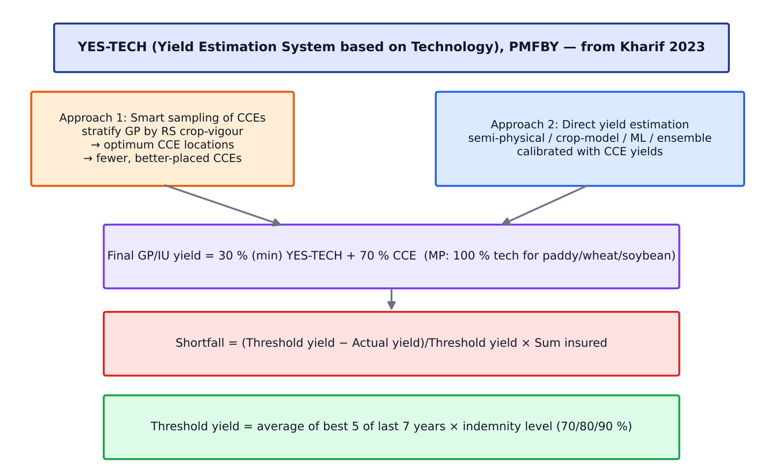
Figure 51. YES-TECH's two pathways (smart sampling and direct estimation) and how they feed claim settlement.
- Start: Kharif 2023 for paddy and wheat, after pilots run by MNCFC (2019–2022, building on the KISAN project of 2015–16). Soybean was added from Kharif 2024. About 10 states take part, including MP, Maharashtra, UP, Odisha, Haryana, Rajasthan and Tamil Nadu.
- Weightage: at least 30 % of the final yield must come from YES-TECH, with the rest from CCEs. Madhya Pradesh uses 100 % YES-TECH weightage for its notified crops.
- Governing document: the YES-TECH Manual (2023), which sets out data, models, accuracy criteria and the empanelment of Technology Providing Agencies (TPAs). MNCFC and NRSC act as technical mentors.
- Model families allowed: (1) index-based / semi-physical (RS yield proxies, LUE models), (2) crop simulation models with RS inputs, (3) statistical and ML/DL models, and (4) hybrid and ensemble models.
- Process: acreage and crop map, then feature extraction (VI time series, SAR, weather, soil), then model training on historical and current CCEs, then GP-level yield, accuracy checks against holdout CCEs, and finally submission to the NCIP portal.
- Benefits: faster claim settlement, fewer disputes, less CCE workload, lower manipulation risk, and objective, spatially consistent data.
- Criticism and challenges: model accuracy at GP level for heterogeneous smallholdings, cloud cover in kharif, quality of the CCEs used for training, transparency of proprietary models, and the need for third-party audits and standard validation protocols (CSE 2025 commentary).

Two ways remote sensing is used in crop insurance
 | 1. Smart sampling of CCEs | 2. Direct yield estimation
Goal | Improve CCE efficiency: fewer, better-placed CCEs | Estimate GP yield directly with models
Method | Stratify the GP or district by RS crop-vigour classes (NDVI, VCI, LAI, SIF). Allocate CCEs in proportion to stratum area and variance (Neyman allocation). Select plots within strata at random | Semi-physical, crop model, ML and ensemble models calibrated with CCEs
Output | Optimised CCE locations; lower sampling error; optimum number of CCEs | GP-level yield blended at ≥ 30 % with CCE yield
Advantage | Keeps the CCE (ground truth) but reduces bias and cost | Wall-to-wall, timely, objective
Risk | Still depends on CCE execution quality | Model error, especially in anomalous years

Neyman allocation: nh = n · (Nh·Sh) / Σ(Nh·Sh) (Nh = stratum size, Sh = stratum SD)

14.7 Yield modelling at insurance-unit (GP) level: a design you can present
- Crop mask and field boundaries: a crop map from Sentinel-1/NISAR + Sentinel-2 (RF/LSTM), with field boundaries from a U-Net or Bhu-Naksha cadastral maps, and Digital Crop Survey (AgriStack) plot-level crop data for training.
- Features per field: NDVI, NDRE, LSWI and VH time series; phenology (SOS, peak, EOS); SIF (TROPOMI now, FLEX from 2027); ET and ESI; NISAR soil moisture; weather (IMD gridded, WINDS GP rain gauges) such as heat days and dry spells; soil (Soil Health Card, DSM).
- Base models: (i) semi-physical LUE, (ii) WOFOST/DSSAT with LAI and SM assimilation, (iii) XGBoost/RF, (iv) LSTM, (v) agromet weather-index regression.
- Training: with multi-year CCE data (geotagged), using leave-one-year-out CV and spatial blocks.
- Ensemble: stacking with uncertainty (quantile regression or ensemble spread). Aggregate field-level yields to GP with area weighting.
- Validation: against an independent holdout of CCEs. Report RMSE and MAPE (target < 10–15 % at GP level), bias, and the share of GPs within ±20 %.
- Decision layer: blend with CCEs (≥ 30 %), flag high-uncertainty GPs for additional CCEs, and give early-warning loss estimates at the mid-season stage.
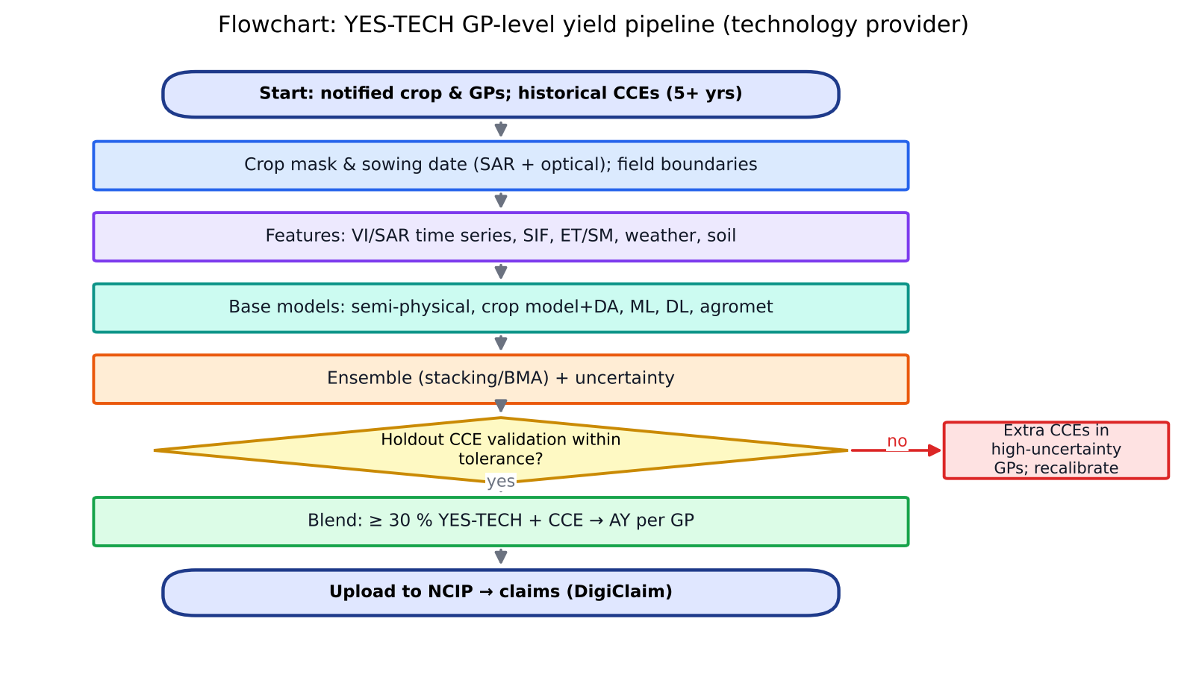
Figure 52. Flowchart of a YES-TECH GP-level yield pipeline run by a technology provider.

14.8 What we (ISRO and research) can contribute to crop insurance
- Better yield models: a GP-level ensemble with uncertainty, and integrating new sensors (NISAR, FLEX SIF, TRISHNA ET).
- Designing insurance for the areas remote sensing can cover:
- Extend cover to non-notified and minor crops and to tenant and sharecropper farmers using RS-based area and yield indices.
- Hybrid index products: a weather index plus a satellite index (soil moisture, ET deficit or ESI, NDVI/VCI or SIF anomaly) to reduce basis risk for horticulture and rainfed crops.
- Parametric triggers for localised calamities: flood inundation from SAR (NISAR, EOS-04), hail damage from sudden NDVI or backscatter change, and fire from VIIRS.
- Prevented-sowing assessment from SAR-based sowing detection by the cut-off date.
- Pasture and fodder insurance for livestock using NDVI anomalies (as in Kenya's IBLI index-based livestock insurance).
- Premium rating and risk zonation: long-term RS yield variability maps for actuarial pricing at GP level.
- Fraud and dispute reduction: check claimed sown area against the RS crop map, use CROPIC photos with AI verification, and audit CCE plot locations.
- Faster settlement: DigiClaim combined with early RS estimates.
- Capacity building: standard validation protocols, open benchmark datasets and audits of TPA models.

14.9 Key concepts in insurance economics
- Basis risk: the mismatch between the index payout and the farmer's actual loss. It is the main weakness of index insurance. Reduce it with finer units (GP), better indices (RS) and hybrid triggers.
- Moral hazard: insured farmers neglect management. Area-yield insurance limits this because an individual's actions barely affect the GP average.
- Adverse selection: high-risk farmers enrol more. Mandatory or bundled enrolment and risk-based premiums reduce it.
- Loss ratio = claims paid / gross premium. Under PMFBY it has typically been about 60–90 %, varying by state and season.
- Actuarial premium rate (APR): set by insurers through bidding. The farmer pays a capped share and the government pays the rest.

14.10 Interview questions on insurance and yield
Q. What is YES-TECH and how does it work?
A. YES-TECH is the technology-based yield estimation system under PMFBY, started in Kharif 2023 for paddy and wheat and extended to soybean in 2024. Empanelled agencies use remote sensing, weather and models (semi-physical, crop simulation, ML or ensemble), calibrated with CCEs, to estimate GP-level yield. That yield gets at least 30 % weight in the final yield used for claims (100 % in MP).
Q. What is smart sampling?
A. Remote sensing stratifies an insurance unit or district by crop condition. CCEs are then allocated across strata to reduce sampling error (Neyman allocation) and placed at random within strata. This gives a more representative yield with fewer CCEs.
Q. Why combine models into an ensemble?
A. Individual models have different structural errors. Semi-physical models miss management effects, ML models fail outside their training range, and crop models depend on their inputs. Weighted or stacked ensembles reduce variance and the risk of one model failing in an unusual year, and the spread between models gives an uncertainty estimate.
Q. How do you compute threshold yield?
A. The average of the best 5 of the last 7 years' yields of the insurance unit, multiplied by the indemnity level (70, 80 or 90 %). The claim is the shortfall fraction (TY − AY)/TY times the sum insured.
Q. Why is weather-based insurance used for horticulture?
A. Horticultural crops have multiple pickings, long durations, poor yield records and difficult CCEs, and their main perils (frost, high temperature, excess rain at flowering, wind) are captured well by weather parameters. RWBCIS therefore uses weather triggers for quick payouts, at the cost of higher basis risk.
Q. What accuracy is acceptable for GP-level yield?
A. Operational targets are usually RMSE or MAPE of 10–15 % of mean yield and low bias. The model should also rank GPs correctly (high Spearman correlation), because claims depend on shortfall relative to threshold yield.
Q. How can FLEX or NISAR improve insurance?
A. NISAR gives cloud-free sowing, crop-area and soil-moisture data every 12 days, which helps prevented-sowing and mid-season adversity claims and rice yield models. FLEX SIF at 300 m detects photosynthetic stress early and directly improves yield prediction, especially under heat or drought.

15. Worked numerical examples
Boards often ask candidates to “show the calculation”. Each example below uses realistic Indian values. Practise them on paper until you can do them without notes.

15.1 FAO-56 reference ET (ET₀)
Given (Delhi, March): mean T = 25 °C, Rn = 15 MJ m⁻² day⁻¹, G ≈ 0, u₂ = 2 m s⁻¹, VPD (es − ea) = 1.2 kPa, P = 101.3 kPa.
- es(25) = 0.6108·exp(17.27×25/(25 + 237.3)) = 0.6108 × 5.187 = 3.168 kPa
- Δ = 4098·es/(T + 237.3)² = 4098 × 3.168/68,801 = 0.1887 kPa °C⁻¹
- γ = 0.665×10⁻³ × P = 0.0674 kPa °C⁻¹
- Numerator = 0.408×0.1887×15 + 0.0674×(900/298)×2×1.2 = 1.155 + 0.489 = 1.643
- Denominator = 0.1887 + 0.0674×(1 + 0.34×2) = 0.1887 + 0.1132 = 0.3019
- ET₀ = 1.643/0.3019 ≈ 5.4 mm day⁻¹. For wheat at mid-season (Kc = 1.15), ETc = 6.3 mm day⁻¹.

15.2 SEBAL instantaneous and daily ET for one pixel
Given (Landsat overpass, 10:30): Rs↓ = 850 W m⁻², albedo α = 0.18, surface emissivity ε₀ = 0.97, Ts = 305 K (31.85 °C), RL↓ = 380 W m⁻², NDVI = 0.70.
Step | Calculation | Result
Outgoing longwave | RL↑ = 0.97 × 5.67×10⁻⁸ × 305⁴ | 476 W m⁻²
Net radiation | Rn = (1 − 0.18)×850 + 380 − 476 − 0.03×380 | 590 W m⁻²
G/Rn (Bastiaanssen) | (31.85/0.18)(0.0038×0.18 + 0.0074×0.18²)(1 − 0.98×0.7⁴) | 0.125
Soil heat flux | G = 0.125 × 590 | 74 W m⁻²
Hot pixel | Ts = 318 K, H = Rn − G = 480 W m⁻², rah = 30 s m⁻¹ → dT = H·rah/ρcp = 480×30/1155 | 12.5 K
Cold pixel | Ts = 300 K, dT = 0 (H = 0) | 0 K
Linear dT–Ts | b = 12.5/(318 − 300) = 0.693; a = −0.693×300 | dT = −207.9 + 0.693·Ts
Our pixel dT | 0.693 × (305 − 300) | 3.46 K
Sensible heat | H = 1155 × 3.46/35 (rah = 35 s m⁻¹ after stability iteration) | 114 W m⁻²
Latent heat | λET = 590 − 74 − 114 | 402 W m⁻²
Evaporative fraction | EF = 402/(590 − 74) | 0.78
Daily ET (EF method) | ET24 = 86400 × 0.78 × Rn24 (180 W m⁻²)/2.45×10⁶ | 4.9 mm day⁻¹

METRIC alternative: ETinst = 402/2.45×10⁶ × 3600 = 0.59 mm h⁻¹. With ETr,inst = 0.75 mm h⁻¹ the reference fraction is ETrF = 0.79. With daily ETr,24 = 7.0 mm, ET24 = 0.79 × 7.0 = 5.5 mm day⁻¹. The ETrF method gives the higher value because it accounts for the afternoon increase in evaporative demand (advection), which the EF method misses.

15.3 Spectral indices
Case | Reflectances | Index
NDVI, healthy wheat | NIR 0.40, Red 0.06 | (0.40 − 0.06)/(0.46) = 0.74
NBR, green crop before burning | NIR 0.38, SWIR2 0.12 | 0.26/0.50 = 0.52
NBR, burnt field | NIR 0.13, SWIR2 0.21 | −0.08/0.34 = −0.24
dNBR, green → burnt | 0.52 − (−0.24) | 0.76 → high severity
NBR, harvested stubble (pre-burn) | NIR 0.22, SWIR2 0.20 | 0.05
dNBR, stubble → burnt | 0.05 − (−0.24) | 0.29 → moderate-low

Lesson: For residue burning the right pre-fire image is harvested stubble, not the green crop. Using the green crop overstates severity and confuses harvest with burning. This is a common examiner trap.

15.4 Fire radiative power, biomass and emissions
- VIIRS pixel area: 375 m × 375 m = 140,625 m².
- MIR excess radiance over the background: ΔL₄ = 2.0 W m⁻² sr⁻¹ µm⁻¹. Take a = 3.0×10⁻⁹ W m⁻² sr⁻¹ µm⁻¹ K⁻⁴.
- FRP = A·σ/a·ΔL₄ = 140,625 × (5.67×10⁻⁸/3.0×10⁻⁹) × 2.0 = 5.3 MW.
- If the fire burns at about this rate for 30 minutes: FRE = 5.3 MW × 1800 s = 9,540 MJ.
- Biomass burnt = 0.368 kg MJ⁻¹ × 9,540 = 3.5 t, roughly 0.6 ha of paddy straw at 6 t ha⁻¹.
- Emissions (rice-straw EFs: CO₂ about 1,460, CO about 93, PM2.5 about 8.3 g kg⁻¹): CO₂ = 5.1 t, CO = 326 kg, PM2.5 = 29 kg.

Bottom-up regional emission (IPCC equation)
E = A × B × Cf × EF (A = burnt area, B = residue load, Cf = combustion factor)
Example (Punjab): A = 1.0 Mha burnt, B = 7 t ha⁻¹ and Cf = 0.8 give 5.6 Mt dry matter burnt. That produces about 8.2 Mt CO₂ and about 46,000 t PM2.5 (EF 8.3 g/kg). This is why accurate burnt-area mapping (A) matters as much as fire counts.

15.5 Semi-physical (LUE) wheat yield
Given: 120-day season, mean Rs = 18 MJ m⁻² day⁻¹, PAR = 0.48·Rs = 8.64, mean fAPAR = 0.50, ε = 2.8 g MJ⁻¹ APAR, mean stress scalar Ts × Ws = 0.85, HI = 0.40.
Biomass = 8.64 × 0.50 × 2.8 × 0.85 × 120 = 1,234 g m⁻² = 12.3 t ha⁻¹ ; Yield = 0.40 × 12.3 = 4.9 t ha⁻¹
Sensitivity: a heat wave in March lowers the mean stress scalar to 0.75 and the yield to 4.3 t/ha, a 12 % loss. Under the insurance example in Chapter 14 this could be near or below the threshold yield. The model therefore links weather shocks directly to insurance claims.

15.6 Insurance claim and smart sampling

(a) Claim
Past 7-year GP yields: 3.9, 4.2, 3.6, 4.4, 4.1, 4.5, 4.3 t/ha. Best 5 = 4.5, 4.4, 4.3, 4.2, 4.1, with a mean of 4.30. Indemnity is 80 %, so TY = 3.44. Actual yield blended: 30 % × YES-TECH 2.70 + 70 % × CCE 2.85 = 2.805. Shortfall = (3.44 − 2.805)/3.44 = 18.5 %. With a sum insured of ₹50,000/ha, the claim is ₹9,230/ha.

(b) Number of CCEs needed
n = (z·CV/E)² = (1.96 × 30/10)² ≈ 35 CCEs (district-level, CV 30 %, ±10 % error at 95 % confidence)

(c) Neyman vs proportional allocation of 12 CCEs in a GP
Vigour stratum | Area Nh (ha) | Yield SD Sh (t/ha) | Proportional nh | Neyman nh
Low | 200 | 0.8 | 2.4 → 2 | 12×160/540 = 3.6 → 4
Medium | 500 | 0.4 | 6.0 → 6 | 12×200/540 = 4.4 → 4
High | 300 | 0.6 | 3.6 → 4 | 12×180/540 = 4.0 → 4

Neyman allocation moves CCEs toward the more variable low-vigour stratum, where stressed and lodged patches make yield uncertain. This reduces the variance of the GP mean for the same total number of CCEs.
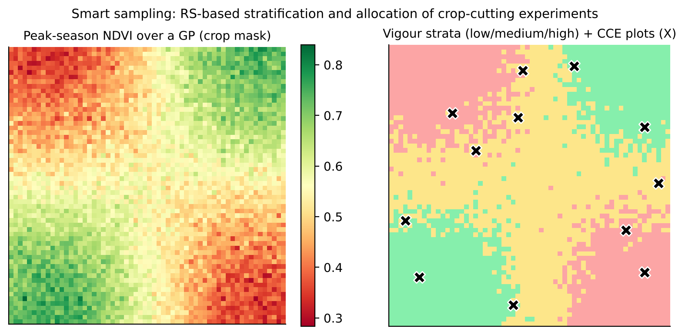
Figure 53. Smart sampling: NDVI-based stratification of an insurance unit and allocation of CCE plots across strata.

15.7 Carbon credits from a zero-till + no-burn wheat farm
Component | Calculation | tCO₂e/ha/yr
SOC sequestration (removal) | 0.3 t C/ha/yr × 44/12 | 1.10
Avoided CH₄ from burning | 4.8 t burnt × 2.7 kg CH₄/t × GWP 27 | 0.35
Avoided N₂O from burning | 4.8 t × 0.07 kg N₂O/t × GWP 273 | 0.09
Diesel saved (no ploughing) | 40 L × 2.68 kg CO₂/L | 0.11
Gross |  | 1.65
Uncertainty deduction (15 %) |  | −0.25
Buffer pool (15 % of removals) | 0.15 × 1.10 | −0.17
Net credits issued |  | ≈ 1.24

At US$15/credit this is about US$18.6/ha (≈ ₹1,550/ha). The farmer's 60 % share is about ₹930/ha/yr. This shows why aggregation of thousands of farmers and low-cost remote-sensing MRV are essential for smallholder carbon projects. Note that CO₂ from burning straw is biogenic and is not counted, while CH₄ and N₂O are.

Biochar credit
1 t biochar × 0.70 C × 0.80 permanence × 3.667 = 2.05 tCO₂e − 0.15 project emissions ≈ 1.9 credits

15.8 Accuracy statistics from a confusion matrix
Using the confusion matrix in Chapter 2: N = 1400, diagonal sum = 1280, so OA = 91.4 %. Expected chance agreement pe = Σ(row × column totals)/N² = 512,250/1,960,000 = 0.261. κ = (0.914 − 0.261)/(1 − 0.261) = 0.88. Rice producer's accuracy = 412/441 = 93.4 % and user's accuracy = 412/440 = 93.6 %.

15.9 GDD and phenology
Wheat sown on 10 November with Tmax 24 °C, Tmin 8 °C and Tbase 5 °C gives a daily GDD of (24 + 8)/2 − 5 = 11 °C·day. If anthesis needs about 1,100 GDD, it occurs after about 100 days (mid-February) at that average. Warmer temperatures bring anthesis forward and shorten grain filling, so terminal heat risk rises with late sowing. This is the agronomic reason zero-till early sowing helps.

15.10 Water-cloud model inversion
Given: VV σ⁰ = −12 dB (0.0631 linear), θ = 35° (cos θ = 0.819), wheat LAI = 2.5 (V₁ = V₂ = LAI), A = 0.0012, B = 0.091.
- γ² = exp(−2×0.091×2.5/0.819) = exp(−0.556) = 0.574
- σ⁰veg = 0.0012 × 2.5 × 0.819 × (1 − 0.574) = 0.00105
- σ⁰soil = (0.0631 − 0.00105)/0.574 = 0.108 (−9.7 dB)
- Use an empirical soil relation calibrated locally, e.g. σ⁰soil(dB) = −20 + 35·θv, giving θv = (−9.7 + 20)/35 ≈ 0.29 m³ m⁻³ (moist soil after irrigation).

16. Research-paper summaries (concepts and evidence)
Each summary gives the objective, the data and method, the key finding and how to use it in the interview. Mentioning one or two of these by author and year shows depth.

16.1 Evapotranspiration

SEBAL: the original energy-balance algorithm
Bastiaanssen, Menenti, Feddes & Holtslag (1998), J. Hydrology 212–213
- Objective: estimate regional ET from satellite data with minimal ground data.
- Method: residual SEB; dT linearly related to Ts and calibrated with hot and cold pixels; Monin–Obukhov iteration for rah.
- Finding: ET within about 10–20 % (instantaneous) and 5 % (seasonal) of field measurements in Egypt, Spain and Niger.
- Use: the ‘internal calibration’ idea removes most of the absolute Ts bias, which is why SEBAL spread worldwide.

METRIC
Allen, Tasumi & Trezza (2007), J. Irrig. Drain. Eng. 133(4)
- Objective: an operational, high-resolution ET model for water-rights management.
- Method: SEBAL-based, but the cold pixel is calibrated to 1.05 ETr (alfalfa reference) from weather stations, and the ETrF method is used for daily and seasonal scaling.
- Finding: seasonal ET within about 4–7 % of lysimeters in Idaho.
- Use: explains why ETrF (AET/ET₀) scaling beats EF scaling under advection.

ALEXI two-source time-integrated model
Anderson, Norman, Diak, Kustas & Mecikalski (1997), Remote Sens. Environ. 60
- Objective: remove the need for air temperature and accurate absolute Ts.
- Method: TSEB coupled with an ABL growth model using the morning rise in GOES Ts.
- Finding: robust continental-scale fluxes; the basis of the ESI drought product.
- Use: cite it when asked how to estimate ET without ground meteorology, for example with INSAT data.

Evaporative fraction self-preservation
Crago (1996), J. Hydrology 180
- Finding: EF is approximately constant during daytime under fair weather, with small concave-up deviations (lower at mid-day).
- Use: the theoretical basis for instantaneous-to-daily scaling and its known 5–10 % underestimation.

16.2 SIF and FLEX

Global crop photosynthesis from SIF
Guanter et al. (2014), PNAS 111(14)
- Objective: test whether satellite SIF captures cropland photosynthesis better than models.
- Data: GOME-2 SIF compared with flux-tower GPP in the US Corn Belt.
- Finding: SIF-based GPP peaks were 40–60 % higher than those of carbon-cycle models, which underestimate agricultural productivity.
- Use: SIF captures the high intensity of irrigated, high-input crops (relevant to Punjab and Haryana).

SIF improves crop productivity monitoring
Guan et al. (2016), Global Change Biology 22
- Finding: GOME-2 SIF explained US county maize and soybean yield and GPP better than EVI and NDVI. C4 vs C3 LUE differences must be accounted for.
- Use: supports SIF as a yield predictor in YES-TECH-type models once FLEX data are available.

Drought onset detected by SIF
Sun et al. (2015), J. Geophys. Res. Biogeosci. 120
- Finding: during the 2012 US flash drought, GOME-2 SIF declined earlier and more strongly than NDVI or EVI, tracking the GPP drop.
- Use: early-warning and mid-season adversity triggers for PMFBY.

50 years of SIF remote sensing (review)
Mohammed et al. (2019), Remote Sens. Environ. 231
- Content: physiology, the leaf-to-canopy scaling (fesc), retrieval methods (FLD, SFM, SVD), instruments and missions, and open challenges.
- Use: the go-to reference for explaining why SIF ≠ GPP everywhere (APAR dominance, structural effects).

FLEX mission concept
Drusch et al. (2017), IEEE TGRS 55(3)
- Content: FLORIS design (500–780 nm, 0.3 nm in the O₂ bands), tandem with Sentinel-3, 300 m resolution and the products (full SIF spectrum, PRI and NPQ, photosynthesis).
- Use: cite it for mission specifications; FLEX launched on 15 Sep 2026.

16.3 SAR and soil moisture

Water Cloud Model
Attema & Ulaby (1978), Radio Science 13
- Idea: the canopy is modelled as a cloud of identical water droplets held in place by the vegetation. Backscatter = volume term + attenuated soil term.
- Use: the standard vegetation correction for SAR soil moisture (Sentinel-1, NISAR).

Change detection soil moisture
Wagner, Lemoine & Rott (1999), Remote Sens. Environ. 70
- Idea: normalise backscatter between the historical dry and wet references to get relative soil moisture; roughness is assumed static.
- Use: the basis of the ASCAT and Copernicus SSM products and one of the NISAR algorithms.

Topp's equation
Topp, Davis & Annan (1980), Water Resour. Res. 16
- Idea: an empirical polynomial between the dielectric constant and volumetric water content, valid across mineral soils.
- Use: the basis of TDR probes and dielectric-to-moisture conversion in radar retrievals.

16.4 Fire and burnt area

MODIS Collection 6 active fire algorithm
Giglio, Schroeder & Justice (2016), Remote Sens. Environ. 178
- Method: a contextual algorithm using the 4 µm and 11 µm brightness temperatures, a background characterisation window and false-alarm rejection. FRP is computed from MIR radiance.
- Use: describes the algorithm behind FIRMS data used in the IARI bulletin.

FRP to biomass combustion
Wooster, Roberts, Perry & Kaufman (2005), J. Geophys. Res. 110
- Finding: laboratory burns gave a combustion factor of 0.368 ± 0.015 kg MJ⁻¹, independent of fuel type.
- Use: converts FRE to biomass burnt and emissions (see the Chapter 15 example).

Normalised Burn Ratio and CBI
Key & Benson (2006), USDA FIREMON RMRS-GTR-164
- Method: NBR from Landsat NIR and SWIR2; dNBR calibrated against the field Composite Burn Index.
- Use: gives the dNBR severity thresholds; adapt them for stubble (low pre-fire biomass) using RdNBR or RBR.

MODIS fire characteristics in north India
Vadrevu, Ellicott, Badarinath & Vermote (2011), Environmental Pollution 159
- Finding: strong seasonal peaks of paddy-residue fires in Punjab in Oct–Nov, linked to rises in aerosol optical depth over the IGP.
- Use: early evidence of the regional air-quality link to burning.

Missing emissions from post-monsoon fires
Liu, Marlier et al. (2020), Environ. Res. Commun. 2
- Finding: MODIS burned-area and active-fire products miss a large share of small agricultural fires in NW India, so emissions are underestimated. Finer sensors (VIIRS, Sentinel-2) detect much more.
- Use: supports your argument for combining VIIRS counts with Sentinel-2 burnt area, and with GEO data for late-afternoon fires.

16.5 Crop yield and parameter retrieval

Monteith light-use efficiency
Monteith (1972), J. Appl. Ecol. 9
- Idea: crop dry matter is proportional to intercepted (absorbed) solar radiation; ε is fairly conservative for a given crop type.
- Use: the foundation of the semi-physical yield model in FASAL and YES-TECH.

Scalable Crop Yield Mapper (SCYM)
Lobell et al. (2015), Remote Sens. Environ. 164
- Method: run a crop model (APSIM) many times with varied weather, soil and management; fit a regression of simulated yield on simulated VIs and weather; apply the regression to satellite VIs.
- Finding: field-level maize and soybean yield without any ground calibration.
- Use: a model for calibration-free GP-level yield in data-poor areas, a hybrid of crop model and ML.

Smallholder wheat yields and sowing dates in India
Jain et al. (2016), Remote Sensing 8(10), 860
- Data: SkySat and Landsat micro-satellite data with crop-cut data in Bihar.
- Finding: field-scale yield and sowing-date mapping is feasible for smallholders. Late sowing reduces yield, consistent with terminal heat.
- Use: evidence that field-level remote sensing works in Indian smallholder systems.

Assimilating remote sensing into crop models (review)
Huang et al. (2019), Agric. For. Meteorol. 276–277
- Content: forcing, calibration and updating (EnKF, PF, 4D-Var) strategies; variables (LAI, SM, ET); gains in yield accuracy.
- Use: cite it when explaining the crop-model-to-digital-twin link.

Retrieval of vegetation properties (review)
Verrelst et al. (2015), ISPRS J. Photogramm. 108
- Content: parametric, non-parametric, physical and hybrid retrieval methods compared, with their strengths and weaknesses.
- Use: the framework in Chapter 5.1 comes from this review.

PROSPECT + SAIL review
Jacquemoud et al. (2009), Remote Sens. Environ. 113
- Content: 20 years of PROSAIL use, inversion approaches and the ill-posed problem.
- Use: cite it for RTM basics.

Optical-sensor-based N management
Raun et al. (2002), Agron. J. 94
- Finding: GreenSeeker NDVI-based in-season N (the INSEY algorithm) increased NUE by more than 15 % in winter wheat compared with uniform rates.
- Use: the standard example of sensor-based VRT.

16.6 Soil, carbon and conservation agriculture

On digital soil mapping
McBratney, Mendonça Santos & Minasny (2003), Geoderma 117
- Idea: the scorpan framework S = f(s, c, o, r, p, a, n) + spatially autocorrelated residuals.
- Use: the conceptual basis of DSM (Dr. Bappa Das's line of work).

The contentious nature of soil organic matter
Lehmann & Kleber (2015), Nature 528
- Idea: SOM is a continuum of progressively decomposed compounds. Persistence depends on accessibility and mineral protection rather than intrinsic ‘humic’ recalcitrance.
- Use: explains why MAOM and aggregation (helped by zero tillage) matter for permanence in carbon credits.

Tillage mapping with Sentinel-2 in the IGP
Zhou et al. (2021), Remote Sensing 13(24), 5108
- Method: Sentinel-2 time series, tillage indices (NDTI and related), Random Forest on Google Earth Engine across the Indo-Gangetic Plains.
- Finding: field-level ZT and CT discrimination is feasible at regional scale in smallholder systems.
- Use: the same principle as the IARI CREAMS Zero-Tillage Mapper (Dhakar & Sehgal).

CA eligibility for carbon credits
Cariappa et al. (2024), Scientific Reports
- Method: farmer surveys and remote sensing to assess whether CA practices in the IGP meet Verra VM0042 requirements (additionality, baseline, practice change).
- Use: shows that remote-sensing-based practice verification is central to agricultural MRV in India.

Area estimation and accuracy assessment good practice
Olofsson et al. (2014), Remote Sens. Environ. 148
- Idea: pixel counting is biased. Use a stratified sample of reference data to estimate class area with confidence intervals (error-adjusted area).
- Use: the right way to report crop area (FASAL) and burnt area.

17. Mock interview: long-form model answers and programme timeline
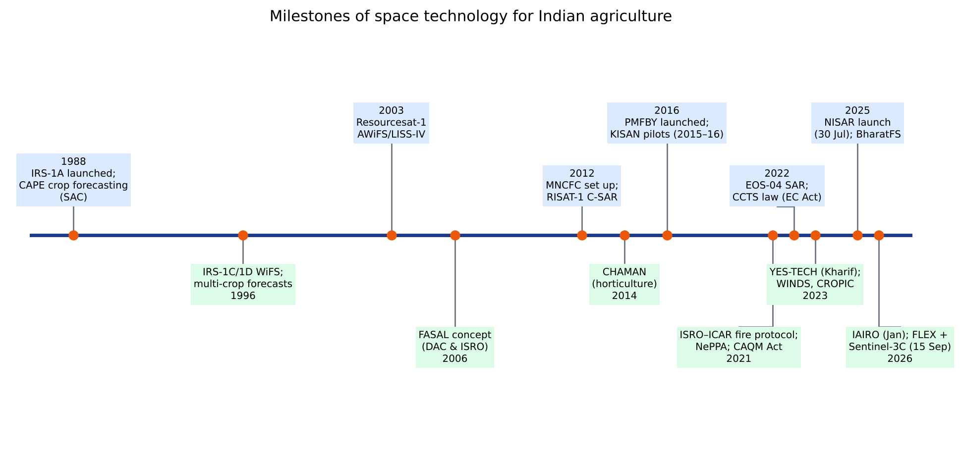
Figure 54. Milestones of space technology applications for Indian agriculture (1988–2026).
Use the PREP structure for every long answer: Point (one-line definition), Reason (the physics or principle), Example (Indian programme or paper), Path forward (limitation and your contribution). Aim for 90–120 seconds per answer.

17.1 Insurance and yield (expected main focus)
Q. You have to estimate paddy yield for 500 gram panchayats in Odisha for Kharif 2026 under YES-TECH. How will you do it?
A. Point: I would build a GP-level ensemble yield system calibrated with CCEs. Steps: (1) A rice mask from Sentinel-1 and NISAR 12-day VH/HH time series, which work through monsoon clouds, with transplanting dates taken from the flooding minimum. (2) Features: SAR backscatter trajectories, cloud-free Sentinel-2 NDVI/NDRE where available, TROPOMI SIF (FLEX when operational), IMD gridded rainfall, heat-stress days, NISAR soil moisture and soil properties. (3) Five base models: an LUE semi-physical model, WOFOST or ORYZA with LAI assimilation, XGBoost, LSTM and a weather-index regression. (4) Train on 5 years of geotagged CCEs with leave-one-year-out validation. (5) Stack the models, and use the spread between members as uncertainty. (6) Validate on holdout CCEs, targeting MAPE below 12 %. (7) Deliver GP yields with the 30 % blending, and flag high-uncertainty GPs for additional CCEs. Caveats: cloud cover, cyclone and flood years (which need SAR inundation layers), and CCE quality.
Q. What are the weaknesses of CCE-based yield estimation, and how does technology help?
A. CCEs are expensive and labour-intensive (lakhs per season). They can be biased by non-random plot selection and manipulation. Measurement and driage errors occur, results arrive late (which delays claims), and a few points per GP may not represent heterogeneous fields. Technology helps in two ways. Smart sampling stratifies by RS vigour so CCEs are fewer and more representative. Direct estimation produces wall-to-wall model yields. CROPIC photos and the CCE-Agri app add transparency through geotagging and video.
Q. Design an insurance product for a horticulture belt where CCEs are not feasible.
A. A hybrid weather and satellite index. Weather triggers (from WINDS or AWS) cover frost, high temperature at flowering and excess rain. A satellite layer (Sentinel-2 or FLEX canopy stress, LST from Sentinel-3 or TRISHNA, NISAR soil moisture) reduces basis risk by confirming crop-level impact. Payouts are tiered from strike to exit. The product is priced from 20+ years of reanalysis weather and RS anomaly history, and parametric settlement could happen within 15 days. A localised-loss window covers hail, verified with CROPIC photos and SAR change detection.
Q. Why is basis risk a problem and how would you reduce it?
A. Basis risk is the mismatch between the index payout and a farmer's actual loss. A farmer who loses the crop but gets no payout loses trust, and adoption falls. It can be reduced with smaller units (GP rather than block), better indices (field-level RS yield instead of station weather), multi-index triggers and gap-filling of weather data with satellite rainfall and soil moisture. Audits and grievance channels that use satellite evidence also help.

17.2 Residue burning
Q. The Ministry says fire counts in Punjab fell 90 % but Delhi's AQI is still poor in November. Explain.
A. (1) Detection gaps: polar orbiters pass at about 10:30 and 13:30, and farmers have shifted burning to the late afternoon, so many fires are missed. Small, short fires and fires under smoke or cloud are also missed. (2) Burnt area from Sentinel-2 dNBR shows a smaller decline than counts, so actual burning fell less than the counts suggest. (3) Meteorology: low November boundary-layer height, calm winds and inversions trap pollutants regardless of the source. (4) Other sources: vehicles, construction dust, industry, biomass for heating and firecrackers. (5) Long-range transport depends on the wind direction (north-westerlies carry smoke to Delhi). Solution: combine VIIRS counts, GEO fire detection, Sentinel-2 burnt area and FRP-based emission inventories, and attribute sources with chemical transport models.
Q. Explain how you would map burnt area for the 2026 paddy season and validate it.
A. Start with a paddy mask (Sentinel-1). Build 5-day Sentinel-2 composites from 1 October to 30 November and compute NBR, NBR2, MIRBI and BAIS2. Detect the transition from harvested stubble to burnt as a dNBR increase, plus NBR2 and MIRBI thresholds, refined with a Random Forest trained on VIIRS-guided and field samples. Validate with stratified random points interpreted on PlanetScope imagery and field photos, and report the error-adjusted area (Olofsson 2014) by district.

17.3 ET, SIF and NISAR
Q. You have only a Landsat image and one weather station. How do you get daily ET for wheat fields?
A. Run METRIC. Compute albedo, NDVI, LAI and emissivity, and LST from TIRS. Calculate Rn, then G, then select hot and cold pixels, with the cold pixel set to ET = 1.05 ETr from the station's hourly data. Iterate H with Monin–Obukhov stability to get instantaneous λET, then ETrF. Daily ET = ETrF × ETr,24 from the same station. For the season, interpolate ETrF between cloud-free images and multiply by daily ETr.
Q. How does FLEX help Indian agriculture specifically?
A. (1) Early stress detection for heat waves in March during wheat grain filling and for dry spells in rainfed kharif crops. (2) GPP and yield at 300 m, closer to the GP scale than TROPOMI. (3) Separating structure from physiology using both fluorescence peaks, PRI and LST. (4) Inputs to yield models and insurance. (5) Science: C3/C4 differences and irrigation effects on photosynthesis. India can contribute ground cal/val super-sites (FloX instruments next to EC towers at IARI and NRSC sites) and help develop algorithms for heterogeneous smallholder landscapes.
Q. Compare optical and SAR for kharif crop mapping.
A. Optical sensors give spectral and biochemical detail (chlorophyll, water) but clouds block them in July–September. SAR is all-weather and sensitive to structure, moisture and flooding, which suits rice, but it is affected by speckle and roughness. In practice, SAR (Sentinel-1, EOS-04 and now NISAR L/S) forms the backbone of kharif mapping and optical data are fused in where available.

17.4 Carbon, CA and precision agriculture
Q. Can a Punjab farmer earn carbon credits for not burning straw? What would MRV look like?
A. Yes, under methodologies such as VM0042, through avoided CH₄ and N₂O from burning, SOC gains from residue retention and zero tillage, and reduced diesel. MRV: baseline burning history from 5+ years of VIIRS and Sentinel-2 data; project-period monitoring showing no fires or burn scars, a ZT signature (NDTI, early green-up) and wheat sowing; soil sampling stratified by remote sensing; a calibrated model (DayCent or RothC) for SOC; then verification by a VVB. Credits are small per hectare (about 1–1.5 tCO₂e), so aggregation and low-cost digital MRV are essential. IARI's CREAMS fire and ZT mapping already supplies the practice-verification layer.
Q. What is your view on precision agriculture for small farms?
A. Precision should be knowledge-intensive, not capital-intensive. Satellite-based field and village zoning, LCC and GreenSeeker-based N management, laser levelling, sensor-based irrigation and drone spraying through CHCs give most of the benefit. ICAR-NePPA (led by IARI) and AgriStack data integration can scale these approaches.

17.5 Opening and closing questions
Q. Why ISRO and not academia?
A. ISRO turns science into operational national services (FASAL, NADAMS, fire bulletins, NISAR products). I want my retrieval and modelling research to reach millions of farmers through such services, with the scale, data and mission discipline that only ISRO offers.
Q. What is one limitation of your own research?
A. Say it honestly, then give a remedy. For example: my model was validated over two seasons in one agro-climatic zone. To make it operational I would test leave-one-year-out across zones, add SAR for cloud-prone years and quantify uncertainty.
Q. Where do you see agricultural remote sensing in 10 years?
A. Field-scale, daily, multi-sensor (optical, SAR including NISAR, thermal including TRISHNA, SIF including FLEX, hyperspectral) data fused by foundation models and assimilated into digital twins. It will provide GP-level yield, water and carbon accounting that directly drives insurance, advisories and carbon markets, with India building sovereign AI capability through bodies such as IAIRO.

18. Indian programmes, data portals and upcoming missions

18.1 Operational and digital-agriculture programmes
Programme | What to know
NADAMS | National Agricultural Drought Assessment and Monitoring System. Started by NRSC in 1989 and now with MNCFC. Monthly district and sub-district drought assessment from NDVI, NDWI, VCI and SASI (shortwave angle slope index), soil moisture, rainfall and sown area. Feeds drought declaration under the Manual for Drought Management (2016, revised 2020): rainfall and dry-spell triggers, then impact indicators (remote-sensing vegetation indices, sown area, soil moisture, hydrology), then ground truth.
KISAN (2015–16) | C(K)rop Insurance using Space technology And geoiNformatics. Pilots in several states testing smart sampling of CCEs and RS and crop-model yield estimation. A precursor to YES-TECH.
Krishi-DSS (Aug 2024) | Krishi Decision Support System: a geospatial platform of DA&FW and ISRO integrating crop maps, drought, soil, weather and reservoir data for policy decisions.
AgriStack / Digital Agriculture Mission (2024) | Digital public infrastructure: Farmers' Registry (Kisan ID), geo-referenced village maps and Crop Sown Registry (the Digital Crop Survey, plot-level crop data via mobile app, which provides ideal training labels for crop mapping and yield models).
CROPIC | Collection of Real-time Observations and Photos of Crops. Geotagged smartphone photos taken 4–5 times per season, with AI analysis of crop stage, health and damage. Supports PMFBY loss assessment.
WINDS | Weather Information Network and Data Systems: AWS at block level and rain gauges at GP level, with data shared to a national server for insurance and advisories.
DigiClaim | Digital claim calculation and direct bank transfer under PMFBY, integrated with PFMS.
Soil Health Card (2015) | Grid-based soil testing (12 parameters) with fertiliser recommendations; data useful for DSM.
GKMS / Meghdoot | Agromet advisories from IMD and ICAR; the Meghdoot app shows them in local languages.
ISRO–ICAR fire protocol (2021) | Standard protocol for satellite monitoring of residue burning; the basis of the daily CREAMS bulletin.

18.2 Data portals
Portal | Content
Bhuvan (NRSC, 2009) | ISRO geoportal: imagery, thematic maps (LULC, wasteland), Bhuvan-Fasal and crop-related services, NDVI and fire layers, a mobile geotagging app
Bhoonidhi (NRSC) | ISRO's EO data hub: Resourcesat, Cartosat, EOS-04, NISAR L/S products (including 100 m soil moisture) and some open data
MOSDAC (SAC) | Meteorological and oceanographic data: INSAT-3D/3DR/3DS insolation, LST, rainfall, ET, Oceansat-3
VEDAS (SAC) | Visualisation of Earth observation Data and Archival System: analysis-ready products and agricultural apps
NICES (NRSC) | National Information System for Climate and Environment Studies: essential climate variables
FIRMS (NASA) | Near-real-time MODIS and VIIRS active fires and FRP
Copernicus Data Space / GEE | Sentinel-1/2/3/5P data; Google Earth Engine for large-area analysis
ASF DAAC (NASA) | NISAR L-band global products, Sentinel-1

18.3 Recent and upcoming missions relevant to agriculture
Table 21. Missions to mention when asked “what next?”
Mission | Status | Agricultural relevance
NISAR (NASA–ISRO) | Launched 30 Jul 2025 | L/S SAR: crop area every 12 days, soil moisture at 100–200 m, biomass, floods
FLEX (ESA) | Launched 15 Sep 2026 | SIF at 300 m: photosynthesis, early stress, GPP
Sentinel-3C | Launched 15 Sep 2026 (with FLEX) | OLCI and SLSTR continuity; FLEX tandem partner
Sentinel-2C / 1C | Launched Sep 2024 / Dec 2024 | Continuity of 10 m optical and C-band SAR
Biomass (ESA, P-band) | Launched Apr 2025 | Forest biomass and carbon (agroforestry MRV)
TRISHNA (ISRO–CNES) | Upcoming | TIR about 57 m, near-daily revisit: field-scale ET, crop water stress, irrigation
CHIME (ESA) | Upcoming (late 2020s) | Hyperspectral 400–2500 nm: N, protein, soil properties
LSTM (ESA) | Upcoming | High-resolution thermal for ET and water productivity
ROSE-L (ESA) | Upcoming | L-band SAR continuity with NISAR
Resourcesat-3 series, Oceansat-3A | Planned (ISRO) | AWiFS and LISS continuity for FASAL; ocean inputs for the monsoon
EOS-08 GNSS-R | Launched Aug 2024 | Soil-moisture and flood sensing from reflected GNSS signals

18.4 Topic-wise question bank (practise aloud)

Remote-sensing basics
- Why is the red edge useful for nitrogen? What is the REP?
- What is the difference between radiance, reflectance and brightness temperature?
- Explain BRDF and why Sentinel-2 data need normalisation (NBAR).
- What is atmospheric correction? Name two methods (Sen2Cor, 6S, FLAASH).
- Why do we use surface reflectance rather than DN for time-series analysis?

SIF and FLEX
- Draw the SIF spectrum and mark the O₂ bands.
- Why is the red peak smaller at canopy level?
- How is SIF related to APAR and LUE? What is SIF yield?
- What does Sentinel-3 contribute to FLEX?
- How would you set up a FLEX cal/val site at IARI?

NISAR and SAR
- Explain speckle and how to reduce it.
- Why does rice show a low backscatter at transplanting?
- What is InSAR coherence and how can it detect tillage and harvest?
- Write the water cloud model and explain each term.
- L-band vs C-band for biomass: which saturates first, and why?

ET and eddy covariance
- Write the energy-balance equation and show which terms satellites measure.
- How are hot and cold pixels selected in METRIC? What errors arise from a wrong choice?
- Why use ETrF instead of EF in arid regions?
- What is the flux footprint? How does it affect validation?
- What is energy-balance closure and why is it never 100 %?

Burning, CA and carbon
- Explain the contextual fire-detection algorithm in steps.
- What is FRP? How do you convert it to emissions?
- Which Sentinel-2 bands and indices map burnt area? Why use stubble, not the green crop, as the pre-fire reference?
- Compare residue incorporation and retention for SOC and wheat yield.
- Explain additionality, permanence and leakage with agricultural examples.
- Who buys agricultural carbon credits, and what is India's CCTS?

Insurance and yield
- Calculate threshold yield and the claim for a given yield series.
- Explain smart sampling with Neyman allocation.
- List the model types allowed under YES-TECH and the pros and cons of each.
- What is basis risk? How would you reduce it for horticulture?
- How would you validate GP-level yield estimates?
- Why might ML yield models fail in an El Niño year?

19. PART II — Study of your 15 research papers (with figure screenshots)
Part II is a structured study of every paper you shared. Each chapter follows the same template so you can revise quickly and cite precisely in the interview:
- Citation card: authors, year, journal, institution.
- Why it matters for the ISRO interview: links to FASAL, YES-TECH, NADAMS, the fire bulletin, ET, SIF/FLEX and digital twins.
- Problem and objective.
- Study area and data: sensors, resolution and ground data.
- Method, point by point: with the paper's own flowchart as a screenshot.
- Key equations.
- Results: the exact numbers to quote.
- Figure screenshots: the paper's own figures with their original captions, rendered directly from the PDF you provided.
- Strengths, limitations and what you would improve: your own research angle.
- Likely interview questions with model answers.
Table 22. The 15 papers studied in Part II and the topics they support
Ch. | Paper | Type | Supports topic
20 | MNCFC (2023) — YES-TECH Manual for Implementation under PMFBY | Government manual | Crop insurance, GP-level yield, CHF, ensemble
21 | Parihar (2016) — FASAL concept for extreme weather events, MAUSAM 67(1) | Review (SAC-ISRO) | FASAL, CAPE, SAR rice, floods, hail, pests
22 | Ray, Singh, Neetu & Mamatha (2016) — Operational system for extreme weather impact, MAUSAM 67(1) | Operational case studies (MNCFC) | Phailin floods, NADAMS drought, hailstorm 2015
23 | Moorthi et al. (2014) — FASALSoft, Journal of Geomatics 8(1) | Software framework (SAC) | Operational FASAL processing chain
24 | Tripathy et al. (2014) — Operational semi-physical wheat yield model, ISPRS Archives XL-8 | Model development (SAC/MNCFC) | Semi-physical (Monteith) yield model
25 | Satheesh et al. (2025) — Spatial rice yield: semi-physical vs DSSAT, Plant Science Today 12(3) | Comparative study (TNAU) | SPM vs crop simulation, SAR LAI, CCE agreement
26 | Fei et al. (2023) — UAV multi-sensor fusion + ensemble ML for wheat yield, Precision Agriculture 24 | ML / UAV phenotyping | Ensemble learning, stacking, data fusion
27 | Saxena et al. (2019) — Drought assessment indicators 2017 vs 2018, ISPRS Archives XLII-3/W6 | Operational drought (MNCFC) | Drought Manual 2016, NADAMS triggers
28 | Giglio, Schroeder & Justice (2016) — MODIS Collection 6 active fire algorithm, RSE 178 | Algorithm + validation | Fire detection, FRP, residue burning
29 | Cammalleri, Anderson & Kustas (2014) — Upscaling ET from instantaneous to daytime, HESS 18 | Methods comparison | Instantaneous-to-daily ET scaling
30 | Goulden et al. (1996) — Carbon sequestration by long-term eddy covariance, Global Change Biology 2 | Measurement accuracy | Eddy covariance, u* filtering, MRV
31 | Jacquemoud et al. (2009) — PROSPECT + SAIL review, RSE 113 | Review | Radiative transfer, parameter retrieval
32 | Chen et al. (2022) — Wheat stripe rust by hyperspectral RS in latent period, Life 12 | Experimental | Hyperspectral disease detection, soil N
33 | Pylianidis, Osinga & Athanasiadis (2021) — Introducing digital twins to agriculture, COMPAG 184 | Review + roadmap | Digital twins vs models
34 | Melesse (2025) — Digital twin-based applications in crop monitoring, Heliyon 11 | Systematic review | DT modelling approaches, architecture

About the screenshots: Screenshots in Part II are taken directly from the PDFs you uploaded and are reproduced only for your personal interview preparation. Each caption names the source paper and its original figure number, so you can cite it exactly, e.g. “as shown in Fig. 3 of Tripathy et al. 2014…”.

19.1 How to cite a paper in the interview (30-second formula)
- Who and where: “Tripathy and colleagues at SAC, in 2014…”
- What problem: “…needed an operational, spatial wheat-yield model for the six major wheat states…”
- How: “…using Monteith's efficiency model with Kalpana-VHRR PAR, MODIS fAPAR, an LSWI water scalar and a temperature scalar…”
- Result: “…state-level RMSE of 0.15 t/ha, 3.45 % underestimation.”
- Your critique and extension: “At district level R² fell to 0.58, so I would add Sentinel-2 resolution, SAR for kharif and an ensemble with ML, which is exactly the YES-TECH direction.”

20. YES-TECH Manual for Implementation (MNCFC, January 2023)
Citation card: Yield Estimation System based on Technology (YES-TECH) under PMFBY — Manual for Implementation. Mahalanobis National Crop Forecast Centre, DA&FW, MoA&FW, New Delhi, January 2023. Expert Committee chaired by Dr C. S. Murthy (Director, MNCFC), with members from ICAR-IASRI, SAC-ISRO (Dr Bimal Bhattacharya), NRSC-ISRO (Dr Karun Kumar Choudhary), BISA-CIMMYT, IIT Hyderabad, DA&FW, Maharashtra and Odisha; Member-Secretary Dr Sunil Dubey (MNCFC).

20.1 Why this document is central to your interview
- It is the official rulebook for technology-based yield in crop insurance, your likely main focus.
- It names ISRO centres (SAC, NRSC, NESAC) as mentor institutes (MITR), so the board expects you to know ISRO's exact role.
- It defines the five approved approaches, the 30 % blending rule, the CHF index and the Correction Factor, which are favourite interview questions.

20.2 Background and rationale
- PMFBY (from Kharif 2016) is an area-yield insurance contract. The Insurance Unit (IU) is generally a Gram Panchayat.
- Threshold Yield (TY) = 70 %, 80 % or 90 % of the average yield of the best five of the past seven years of the IU. The current year's shortfall from TY is applied to the sum insured.
- Actuarial premium rates are set at district level for each crop from the IUs' past risk profile.
- Yield is measured by Crop Cutting Experiments (CCEs). Their limitations are (a) a limited number of measurements, (b) a time-consuming process and (c) vulnerability to human error and subjectivity, which lead to biased estimates, disputes and delayed claims.
- Between 2016 and 2022 DA&FW engaged around 50 technology agencies for GP-level pilots (high-resolution RS, UAV, crop models, AI/ML, IoT, picture-based analysis). Pilots ran in 2019 and 2020 (kharif and rabi) for paddy and wheat across agro-climatic zones.
- The Expert Committee recommended five approaches for national roll-out from the 2023 season. Discussions took place at the national workshop (13 Sep 2022), the 8th National Review Meeting, Kochi (20–21 Oct 2022) and the NLMC (Nov 2022).
- Early-adopter states noted in the manual: Maharashtra and Madhya Pradesh.

20.3 The five approved approaches
Table 23. YES-TECH approaches as described in the manual
Approach | Core idea | Critical issues (per manual)
1. Semi-physical model | Monteith RUE: biomass from PAR × fAPAR × RUE × water and temperature stress; Yield = Biomass × HI | Precise variety and planting/harvest dates; empirical fAPAR–NDVI; stress factors at IU scale; constant RUE valid only for the whole season; cloud-free 10–30 m NDVI/LSWI; HI calibration with CCEs
2. AI models (ML/DL) | RF, SVM, DNN on satellite indices, weather, hydrology and soil features | Needs large volumes of yield data covering low, medium and high ranges; feature selection; hyper-parameter optimisation; consistency
3. Crop simulation models | DSSAT, APSIM, InfoCrop (calibrated for India), optionally with RS assimilation (LAI, SM) | Genetic coefficients; sowing dates; spatial inputs; heterogeneous IUs need care
4. Ensemble models | Combine ML, CSM and semi-physical outputs by averaging, voting or stacking | Benefits: higher accuracy, lower variance, better generalisation
5. Parametric index — Crop Health Factor (CHF) | Indirect: composite index of crop performance from RS and weather, blended with CCE yields | Index design, weights (entropy), stratification of IUs

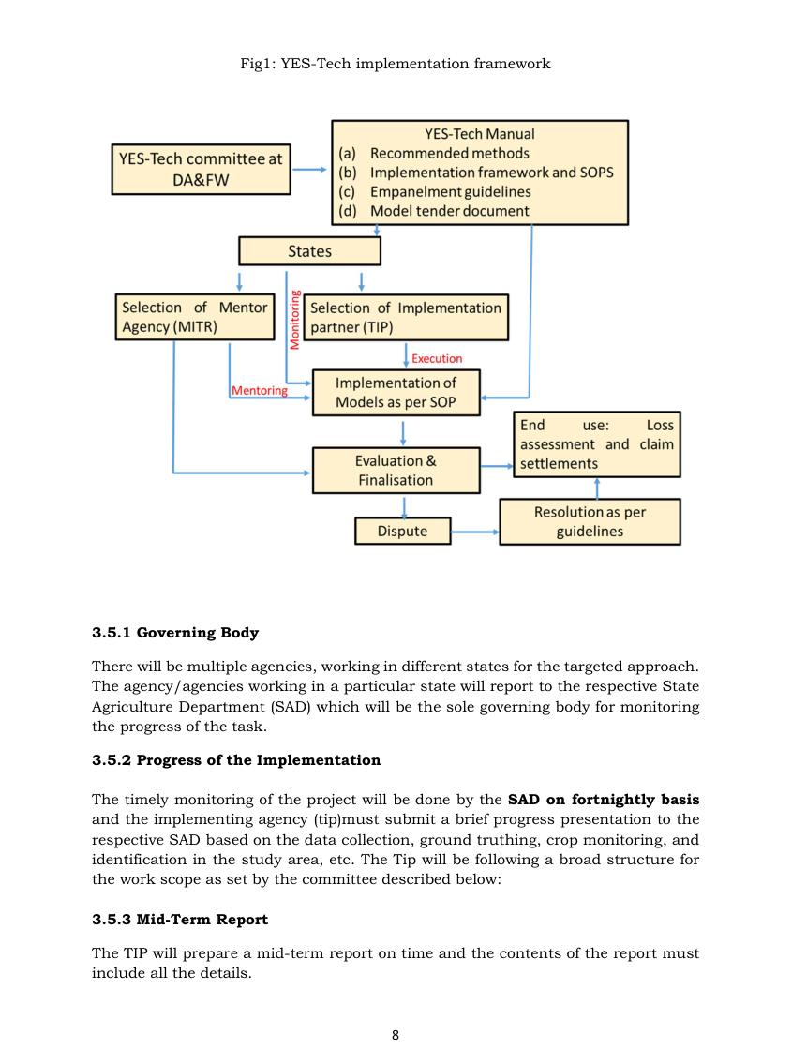
Figure 55. Screenshot — YES-TECH Manual (2023), Fig. 1: YES-TECH implementation framework (States, TIP, MITR, MNCFC).

20.4 Key implementation rules (memorise these)
- Back-casting: the models must be run for the current year and all past years from 2017 onwards, for consistency.
- Blending: direct approaches give 70 % weight to CCE yield + 30 % to modelled yield. The indirect CHF approach gives 70 % to CCE-yield deviation from threshold + 30 % to CHF deviation from threshold. States may assign more than 30 %.
- Why 30 %: large enough to have a meaningful impact on loss assessment, and technology benefits only show when a significant minimum weight is given. Modelled outputs are not used to change AY or TY values.
- Model choice is the State's, but it must be declared at the start of the season for transparency.
- Cost: about ₹12–20 lakh per district per season using public 10–30 m satellite data. UAV data is not mandatory and not included in that cost.
- Actors: TIP (Technology Implementation Partner, chosen by empanelment and tender, contract 3–5 years, at most 2 agencies per State) and MITR (Mentoring Institute for Technology and Review), with the State Agriculture Department as governing body and MNCFC coordinating.
- Reporting: fortnightly progress to the SAD, a mid-term report (crop classification, NDVI profile and deviation from the last normal year, weather deviation) and a final yield report with GP-level estimates from 2017 onwards. Delivery is through a web portal and dashboard.
- Data sharing: the State shares CCE data with the TIP within 30 days of CCEs. All field, CCE and drone data are shared with MNCFC's central repository.

20.5 Standard Operating Procedures (SOPs)

(a) Crop mapping: common to all five approaches
- Current and historical crop maps from SAR + optical, 5–30 m, classified district-wise and checked against cloud-free optical images at maximum vegetative stage.
- Accuracy rule: commission error < 10 %, while omission error up to 20 % is acceptable. This keeps IU-average crop indicators representative of true crop pixels.

(b) Semi-physical SOP
NPP (Biomass) = RUE × fAPAR × PAR × Wscalar × Temperature stress; Yield = Biomass × HI (HI from CCEs)
Table 24. Input data listed in the YES-TECH semi-physical SOP (Table 1 of the manual, summarised)
Input | Sensor / source | Resolution
Daily insolation → PAR | INSAT-3D Imager (MOSDAC) | 1 km
fAPAR (8-day) | MODIS (Terra), Sentinel-3 OLCI; Sentinel-2 to be developed by TIP | 0.5 km / 0.3 km / 10–20 m
NDVI and LSWI at maximum vegetative stage | Sentinel-2 MSI, Landsat-8 OLI | 10–20 m / 30 m
Crop mask, sowing date | Sentinel-1 SAR, Sentinel-2, Landsat-8 (TIP) | 10–30 m
Harvest index | District CCEs | District
Daily Tmin, Tmax | IMD gridded (0.5°), 5 km grids; WRF forecast (SAC) | 0.5° / 5 km

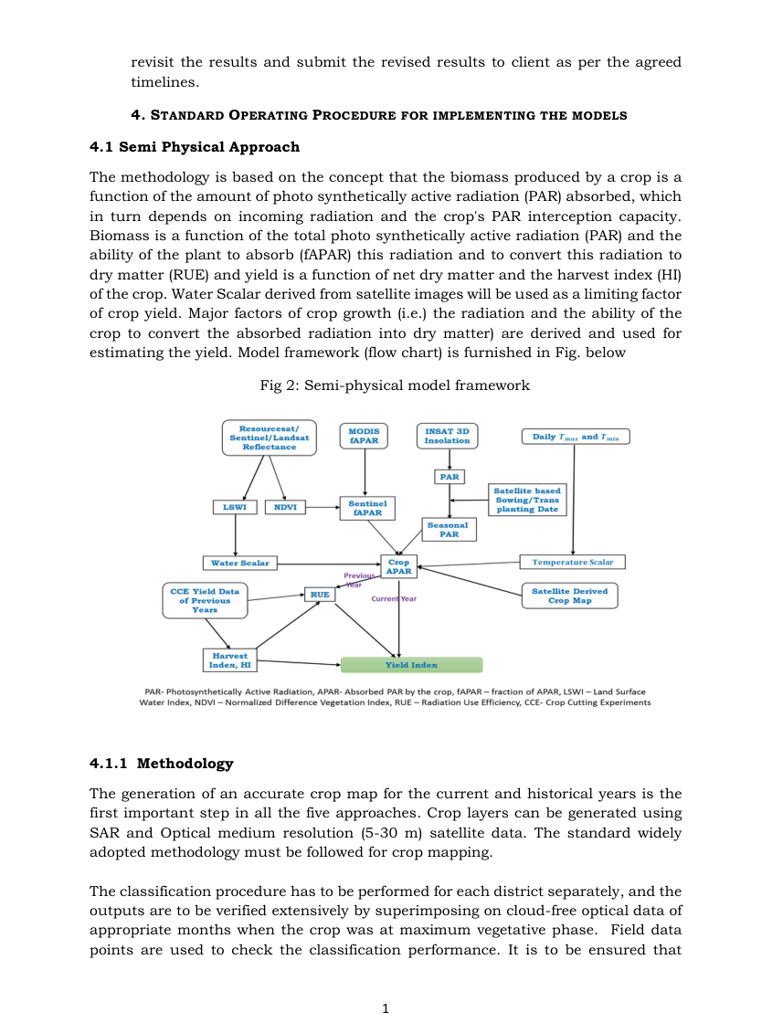
Figure 56. Screenshot — YES-TECH Manual (2023), Fig. 2: Semi-physical model framework.

(c) ML/DL SOP
- Workflow: pre-processing, feature design, train/validation split, algorithm choice, training, optimisation, evaluation and testing. Datasets must be harmonised to the same spatial and temporal resolution, with mutually exclusive train, validation and test sets.
- Features (Table 2 of the manual): reflectance bands and greenness indices (NDVI, EVI, red edge) from S2, L8 and MODIS; wetness indices (NDWI, LSWI); radar (VH, VV, RVI) from S1 and EOS-04; rainfall, rainy days, dry and wet spells, temperature, GDD and heat or cold waves (IMD, CHIRPS); fAPAR and LAI; soil (NBSS&LUP), DEM (SRTM), soil moisture (SMAP, AMSR-E).
- Good practice: each feature must carry unique information; check multicollinearity; normalise; gap-fill and remove outliers; regularise; report feature importance; use MAE, RMSE and nRMSE.
- Must document: for neural networks, the architecture, activation, learning algorithm, learning rate, loss, regularisation, epochs and batch size. For tree models, the number of trees, features per node, split criterion and minimum leaf size.
- Validation: stratified random sampling across yield classes, with at least 30 % of each class held out for validation. Deliver IU yields for the current year plus at least 5 historical years.
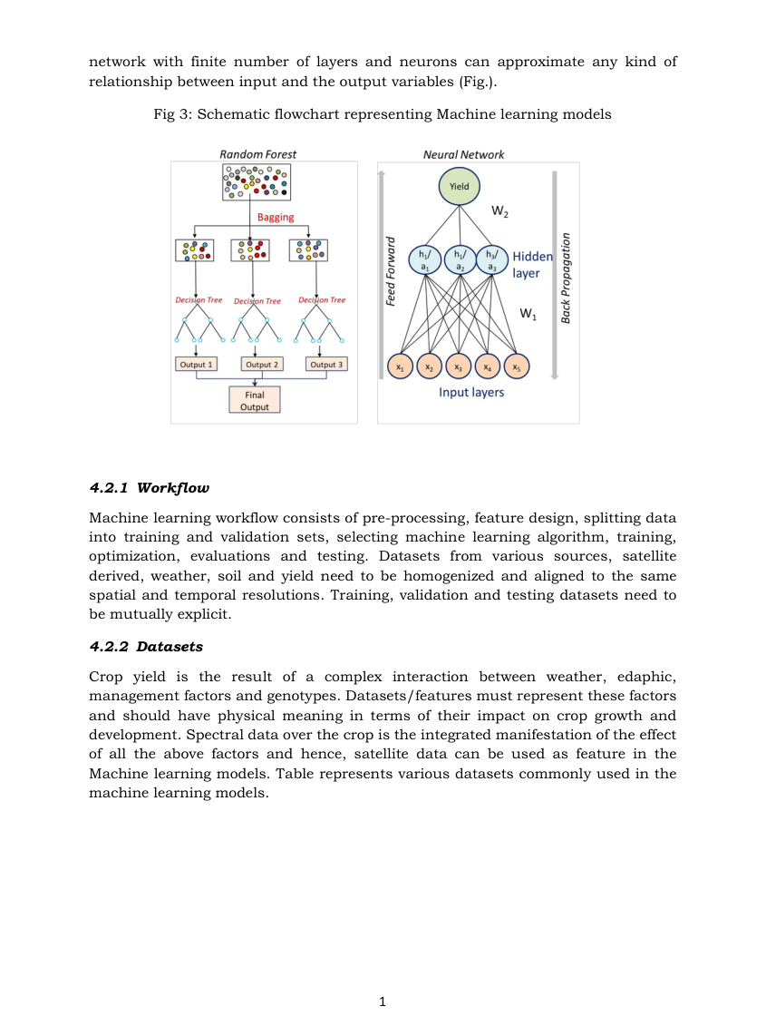
Figure 57. Screenshot — YES-TECH Manual (2023), Fig. 3: Schematic flowchart representing machine-learning models.

(d) Crop simulation model SOP
- Calibrated Indian models: DSSAT, APSIM, InfoCrop, already tested for wheat, rice, maize, sorghum, potato, soybean, chickpea, mustard, groundnut, cotton and coconut.
- Processes: phenology, photosynthesis, partitioning, LAI, source–sink balance; stresses (water, N, temperature, flooding, frost); soil water and N balance; SOC dynamics.
- Inputs (Table 3 of the manual): IMD station plus gridded weather (≥ 7 years), soil (NBSS&LUP, Soil Health Card, SoilGrids), management (fertiliser, seed rate, cultivars, irrigation), RS sowing dates, LAI and soil moisture for assimilation.
- Granularity rule: spatial simulation over soil, weather and sowing variations, with crop-area-weighted aggregation to IU, or RS assimilation using peer-reviewed methods.
- Acceptance rule: nRMSE between observed and modelled yield must not exceed 30 % on historical data. IUs above 30 % must not use this method.
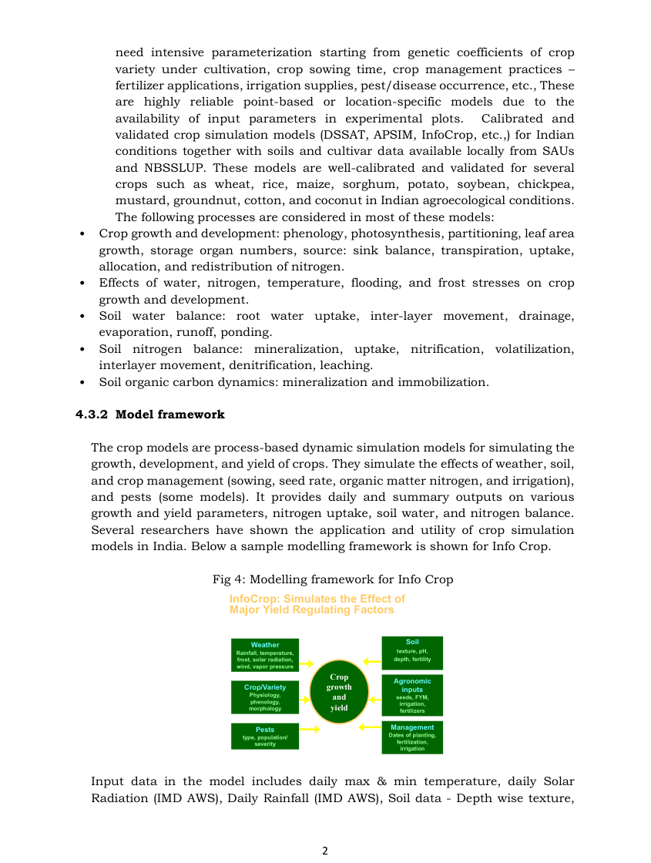
Figure 58. Screenshot — YES-TECH Manual (2023), Fig. 4: Modelling framework for InfoCrop (soil, weather, crop/variety, agronomic inputs, pests).

(e) Ensemble SOP
- Methods: weighted averaging, voting, stacking, bagging and boosting.
- ML members named in the manual: linear regression, Random Forest, ExtraTrees, gradient boosting (CatBoost), neural networks (PyTorch TabNet) and k-NN. Simulation members: ORYZA, WOFOST, InfoCrop, DSSAT, APSIM with data assimilation.
- Inputs: Sentinel-1 (IW, VV/VH, 10 m), Sentinel-2 (10 m), Landsat-8/9, MODIS VIs (250 m); weather (IMD, ERA5, CHIRPS); soil (NBSS&LUP, SoilGrids); CCE and ground-truth observations.
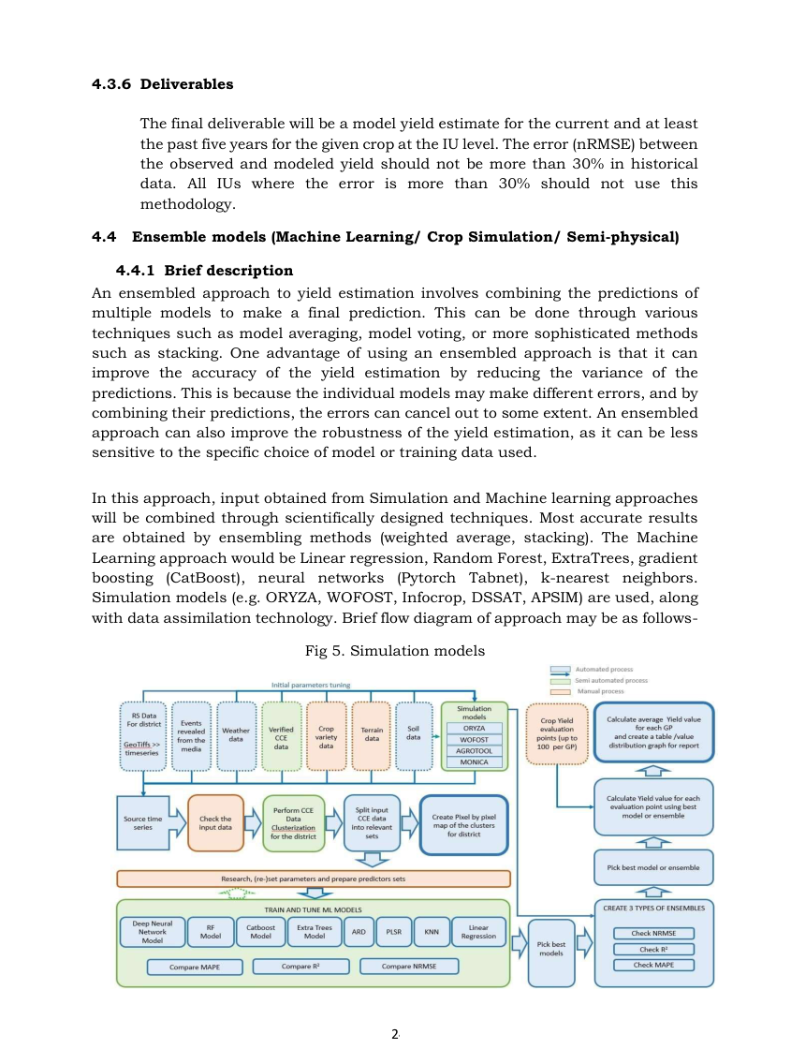
Figure 59. Screenshot — YES-TECH Manual (2023), Fig. 5: Ensemble of simulation and ML models (flow diagram).

(f) Crop Health Factor (CHF): the indirect approach
- Field protocol: mobile-based crop surveillance with reference points (revisited) and random points (at least once). Each block gets 10–20 GT points, with 1–2 per GP at each visit.
- Indicators for paddy (Table 4 of the manual) and their sign: season's maximum NDVI (+), season's maximum LSWI (+), season's maximum backscatter (+), integrated VH backscatter (+), integrated fAPAR (+), crop-condition variability, i.e. maximum CV of NDVI and LSWI (−), rainfall (+, capped at 150 % of normal) and rainy days (+).
- Season maximum = mean of the peak fortnight value and the higher of its neighbours (n − 1 or n + 1), which reduces noise.
- Stratification: IUs in each district are grouped into homogeneous, contiguous strata of at least 4 IUs (using NDVI, rainfall and soil water-holding capacity). For example, 4 IUs × 4 years = 16 scenarios, enough for stable weights.
- Normalisation: min–max, x = (X − min)/(max − min) for positive indicators and (max − X)/(max − min) for negative ones.
- Weights: entropy method, chosen over PCA or PLS because it makes no linearity assumption. Ej = −(1/ln n) Σ pij ln pij, then wj = (1 − Ej)/(m − Σ Ej), and CHF = Σ wj·xij.
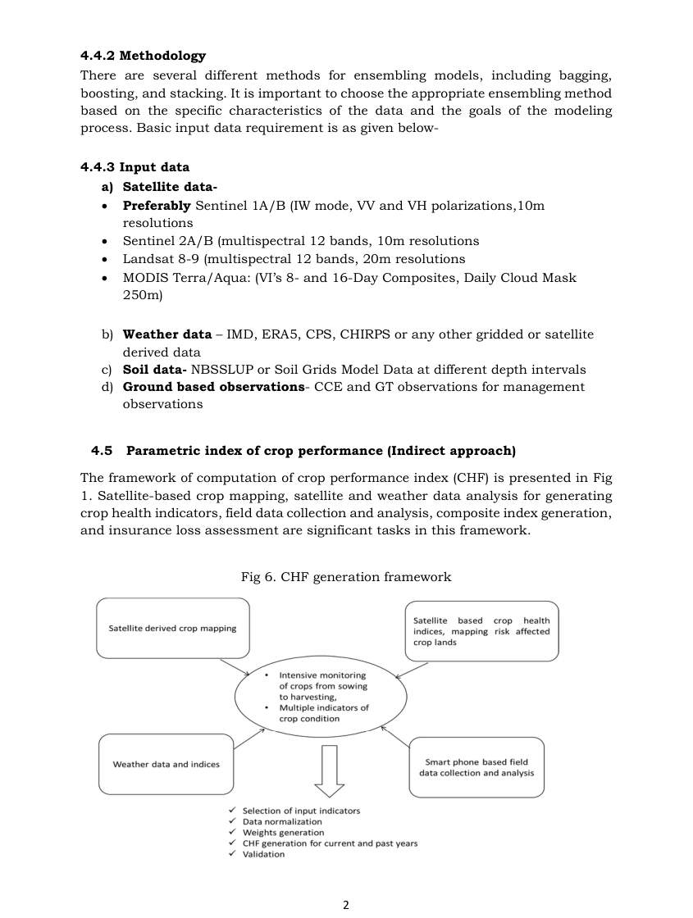
Figure 60. Screenshot — YES-TECH Manual (2023), Fig. 6: CHF generation framework.
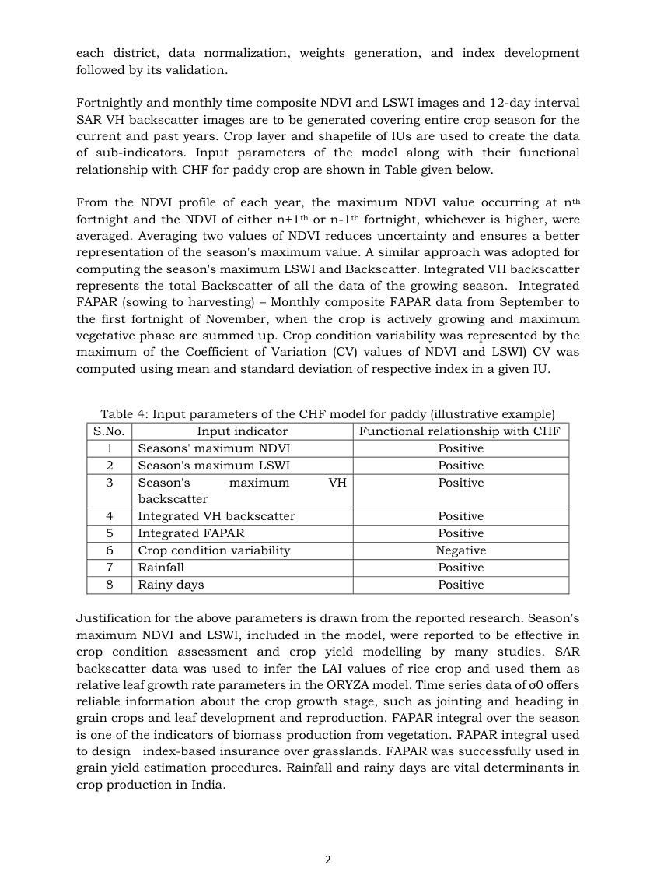
Figure 61. Screenshot — YES-TECH Manual (2023), Table 4: input parameters of the CHF model for paddy and their functional relationship.

(g) Correction Factor for end-of-season risks (applies to all models)
- Covers risks in the last 30–40 days before harvest that models do not parameterise: unseasonal rain, floods and cyclones (submergence, lodging, panic harvest), hot and dry winds (poor grain set), weather-induced pests and post-flood pests (e.g. BPH in rice).
- Two components: (a) affected or exposed area, from harvest-progression maps and pre/post-event index anomalies compared with no-event years; (b) yield-loss fraction, from weather indices and mobile field data.
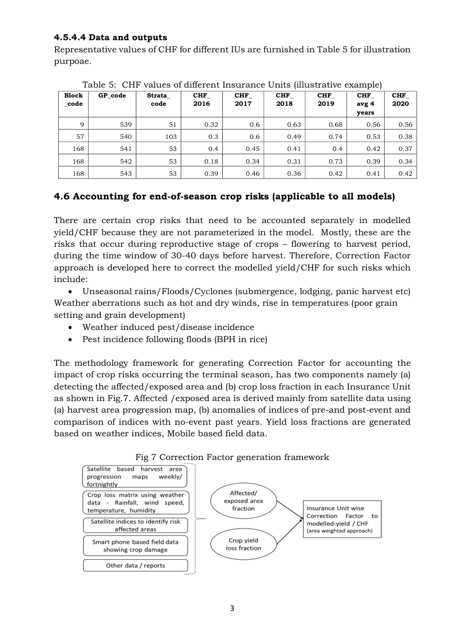
Figure 62. Screenshot — YES-TECH Manual (2023), Table 5 (illustrative CHF values per IU) and Fig. 7: Correction Factor generation framework.

20.6 Mentor institutes (MITR): ISRO's role
MITR | States (from Table 6 of the manual)
SAC-ISRO | Delhi, Goa, Gujarat, Haryana, Kerala, Punjab, Rajasthan, Uttar Pradesh, Uttarakhand, Dadra & Nagar Haveli and Daman & Diu
NRSC-ISRO | Andhra Pradesh, Chandigarh, Chhattisgarh, Jharkhand, Karnataka, Madhya Pradesh, Maharashtra, Odisha, Tamil Nadu, Telangana, West Bengal
ICAR / NESAC-ISRO | North-eastern states: Arunachal Pradesh, Assam, Manipur, Meghalaya, Mizoram, Nagaland, Sikkim, Tripura
ICAR | A&N Islands, Bihar, Himachal Pradesh, J&K, Ladakh, Lakshadweep, Puducherry

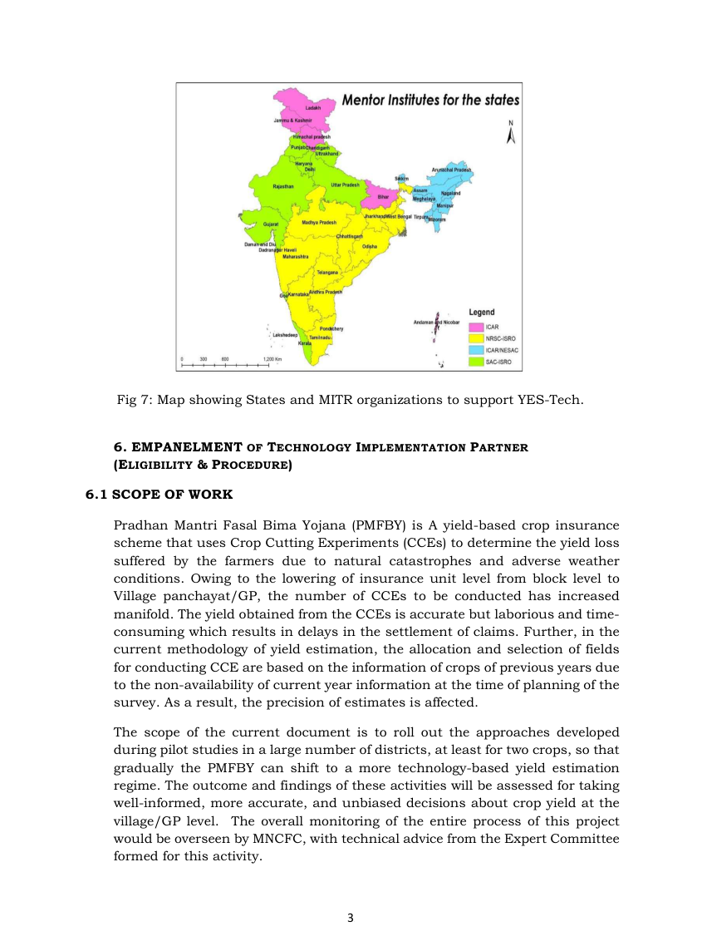
Figure 63. Screenshot — YES-TECH Manual (2023): map showing States and their MITR organisations.

20.7 Empanelment of Technology Implementation Partners (summary)
- Open to government, private, international (with an Indian technical unit) and autonomous agencies. Required on-roll experts in RS, agriculture, data analytics and ML/AI.
- Proven agencies: rice (kharif) and rice/wheat (rabi) yield work in ≥ 25 districts across 4–5 states in the last three years, validated by government.
- New agencies: at least 25 experts, an in-house RS lab, mobile and web app capability, ≥ 10,000 ground observations, turnover of at least ₹50 lakh, and peer-reviewed publications.
- Technical evaluation: minimum 70/100 marks. Experience is worth up to 30 marks; innovative technologies up to 20 (≥ 10 m optical 2, SAR 2, AI/ML 2); capacity to handle 200 districts per season up to 10; personnel up to 10.

20.8 Critical appraisal: what you can add
- Uncertainty: the manual sets accuracy rules (nRMSE ≤ 30 % for CSM) but no standard uncertainty band per IU. Propose prediction intervals and extra CCEs where uncertainty is high.
- Validation protocol: require leave-one-year-out and spatial-block validation for ML, plus independent audit by the MITR.
- New sensors: NISAR L/S-band soil moisture and crop area (12-day), FLEX SIF (300 m) and TRISHNA thermal ET can strengthen the stress scalars of the semi-physical model and the CHF indicators.
- Smallholder heterogeneity: use 10 m Sentinel-2 and field boundaries (AgriStack, Digital Crop Survey) to keep crop-pixel purity within the commission-error limit.
- Horticulture and non-cereals: extend CHF-type indices with weather-index triggers (RWBCIS-style hybrid).

20.9 Interview questions on the YES-TECH Manual
Q. What are the five approaches approved under YES-TECH?
A. Semi-physical (Monteith RUE), AI/ML/DL, crop simulation models (DSSAT, APSIM, InfoCrop, optionally with RS assimilation), ensembles of these, and the indirect parametric Crop Health Factor.
Q. What is the blending rule?
A. At least 30 % weight to technology. For direct approaches the final yield is 0.7 × CCE yield + 0.3 × modelled yield. For CHF it is 70 % CCE-yield deviation from threshold + 30 % CHF deviation from threshold. States may give more weight; MP uses 100 % for its notified crops.
Q. How are CHF weights derived and why that method?
A. By the entropy method, which assigns larger weights to indicators with more information (variability) across scenarios. Unlike PCA or PLS it needs no linearity assumption and gives unbiased, balanced weights.
Q. What is the role of ISRO in YES-TECH?
A. SAC, NRSC and NESAC act as Mentoring Institutes for Technology and Review for assigned States. They mentor, monitor and evaluate TIP methodologies and results. ISRO also supplies key inputs: INSAT-3D insolation via MOSDAC, EOS-04 SAR, crop-mapping and semi-physical methods, and the WRF forecasts from SAC.
Q. What crop-map accuracy does the manual require and why the asymmetry?
A. Commission error below 10 % and omission error up to 20 %. Including non-crop pixels (commission) contaminates IU-average indicators, while missing some crop pixels (omission) only reduces the sample without biasing it.
Q. Why must models be back-cast to 2017?
A. To show that the model is consistent across good and bad years and to allow comparison with historical CCE yields. Threshold-yield logic also depends on multi-year behaviour.
Q. What is the Correction Factor?
A. An adjustment for end-of-season risks (last 30–40 days: unseasonal rain, lodging, cyclones, hot winds, pest outbreaks) that models do not capture. It combines satellite-detected affected area with a weather- and field-based yield-loss fraction.

21. Parihar (2016): FASAL concept for crop forecasting under extreme weather
Citation card: Jai Singh Parihar (2016). FASAL concept in meeting the requirements of assessment and forecasting crop production affected by extreme weather events. MAUSAM 67(1): 93–104. Space Applications Centre, ISRO, Ahmedabad.

21.1 Why it matters
- It is the history and logic of FASAL, written by the scientist who led CAPE and FASAL at SAC. Quote it for “how did ISRO's crop forecasting evolve?”.
- It covers SAR-based kharif rice, floods (Super Cyclone 1999, Phailin 2013), drought (NADAMS), hailstorms, and pest and disease forecasting.

21.2 Context numbers to quote
- India: 329 Mha geographical area, 142 Mha under agriculture, only 37 % irrigated. Annual precipitation 420 Mha-m, 15 agro-climatic zones, about 215 crops.
- Agricultural remote sensing in India began in 1969 with the coconut root-wilt study in Kerala using colour-infrared aerial photography (Dakshinamurthy et al. 1971).
- Global precursors: LARS (Purdue, 1966), LACIE (NASA–NOAA–USDA, Landsat MSS wheat + NOAA weather) and MARS (EU JRC).

21.3 Evolution: IRS-UP → LACA → CAPE → FASAL → MNCFC
Stage | Key points from the paper
IRS-UP (1980s) | Crop Production Forecasting, Crop Stress Detection and Crop Yield Modelling studies. Landsat MSS wheat acreage in Karnal (Haryana) with Maximum Likelihood classification of February data (Dadhwal & Parihar 1985).
LACA (1986) | Large Area Crop Acreage estimation under the Remote Sensing Application Missions of DOS.
CAPE | Crop Acreage and Production Estimation, at the request of DAC. Peak-vegetative-stage multispectral data, MXL classification, stratified random sampling. Covered wheat, rice, groundnut, sugarcane and rapeseed-mustard. Software: CAPEMAN.
FASAL (concept 2006; launched 2007-08) | Forecasting Agricultural output using Space, Agrometeorology and Land based observations (Parihar & Oza 2006). Multiple in-season forecasts: econometric and weather early, coarse high-temporal RS mid-season, RS acreage plus RS-weather yield later. Started with Kharif rice in Odisha, then 6 crops: wheat, kharif rice, rabi rice, winter potato, rapeseed-mustard, jute. Partners: SAC (RS), IMD (agromet), IEG (econometrics), SRSACs, SAUs, ICAR.
Institutionalisation | Mahalanobis National Crop Forecast Centre by DAC.

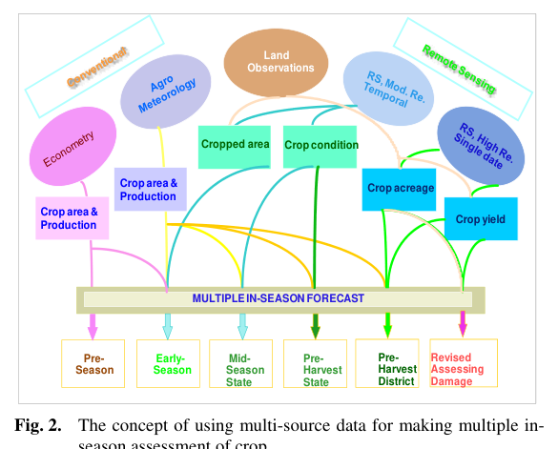
Figure 64. Screenshot — Parihar (2016), Fig. 2: concept of multi-source data for multiple in-season crop assessment (pre-season → early → mid → pre-harvest → revised/damage).

21.4 Methods described
- Multi-temporal optical (WiFS/AWiFS): register multi-date images to a master, compute NDVI, classify sample segments with a hierarchical decision-rule classifier using in-season ground truth, aggregate acreage to state and national level. Yield from multiple regression on weather using a correlation-weighted regression approach.
- Multi-temporal SAR (Radarsat-1/2, then RISAT-1): decision rules based on the temporal evolution of C-band backscatter. Wetland rice shows a very low σ⁰ at flooding and then a rise. Rice yield from rainfall–yield statistical relations. Operational since 1998 for kharif rice.
- Single-date optical: a boundary-mask approach (whole administrative unit) or a sample-segment approach (grid segments chosen by simple or stratified random sampling, Cochran 1963). MXL classification.
- Yield forecasting: crop simulation models (InfoCrop, WOFOST) driven by RS-derived sowing date, LAI and NDVI; VI–yield empirical relations (wheat, cotton, mustard; IRS LISS-I rice in Odisha; wheat in Punjab); MODIS growth-profile approach (Oza et al. 2010); weather-based models using IMD surface data.
- Early-season kharif prospects: a satellite-rainfall-driven bucket soil-moisture model (Available Soil Moisture, ASM) with soil, slope and an irrigated-area mask, giving separate scenarios for wetland rice and other crops.
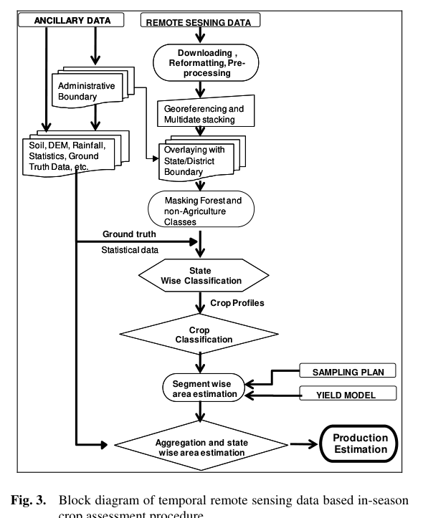
Figure 65. Screenshot — Parihar (2016), Fig. 3: block diagram of temporal remote-sensing-based in-season crop assessment (pre-processing → masking → classification → sampling plan → yield model → production).
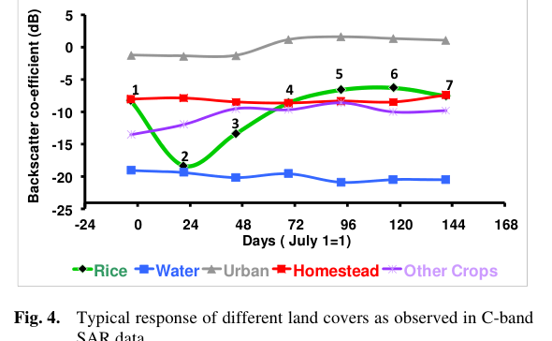
Figure 66. Screenshot — Parihar (2016), Fig. 4: typical response of land covers (rice, water, urban, homestead, other crops) in C-band SAR over the season.
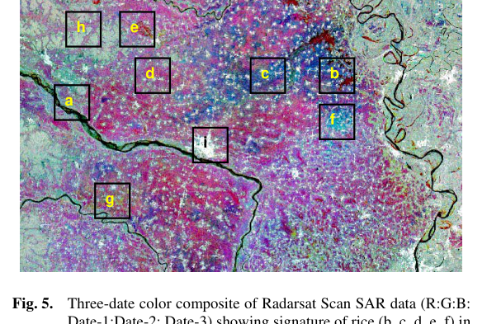
Figure 67. Screenshot — Parihar (2016), Fig. 5: three-date colour composite of Radarsat ScanSAR showing rice at different growth stages and other land covers.
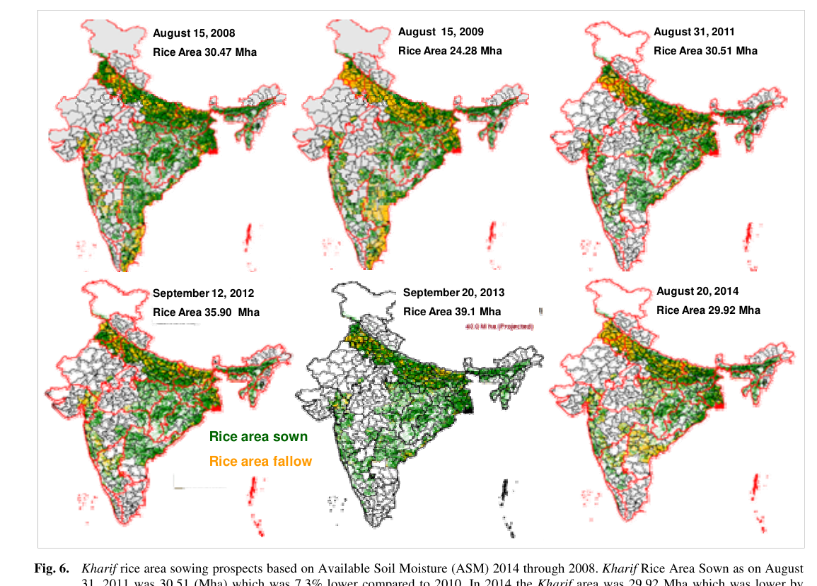
Figure 68. Screenshot — Parihar (2016), Fig. 6: kharif rice area sowing prospects from Available Soil Moisture (2008–2014).

21.5 Extreme-event case studies in the paper
- Floods and cyclones: Super Cyclone (29–30 Oct 1999), mapped with Radarsat data acquired on 2 and 4 Nov 1999 and then with optical-VI damage classes. Phailin (Oct 2013), mapped with RISAT-1 data of 14 Oct 2013. Inundated rice area was available within a day of SAR acquisition through online data transfer.
- Drought: NDVI growth profile against a normal year plus rainfall, under NADAMS (NOAA-AVHRR, MODIS, WiFS, AWiFS). SAR backscatter profiles are used in cloudy kharif seasons (e.g. the 2011 rice decline in Begusarai and Samastipur, Bihar).
- Hailstorm (late Feb–Mar 2014, MP, Rajasthan, Maharashtra): Resourcesat-2 AWiFS NDVI showed a 10–30 % negative deviation from the mean of the previous four years.
- Pests and diseases: early wheat-rust forecasting from TIROS cloud movement (Nagarajan & Singh 1973); WRF-forecast temperature and RH plus AWiFS NDVI/LSWI for yellow rust in Punjab (Dutta et al. 2014); TOVS-derived temperature and humidity to predict mustard aphid onset and peak (±7 days, 25 km grids); MODIS LSWI to detect potato late blight (Bardhaman, West Bengal).
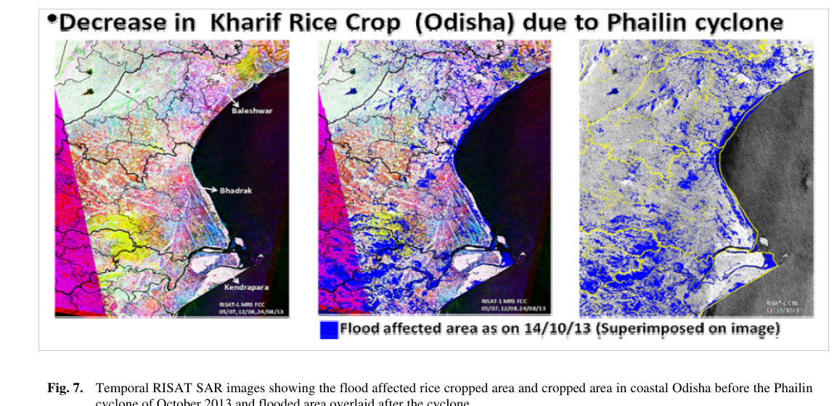
Figure 69. Screenshot — Parihar (2016), Fig. 7: temporal RISAT-1 SAR showing flood-affected rice in coastal Odisha after Cyclone Phailin (Oct 2013).
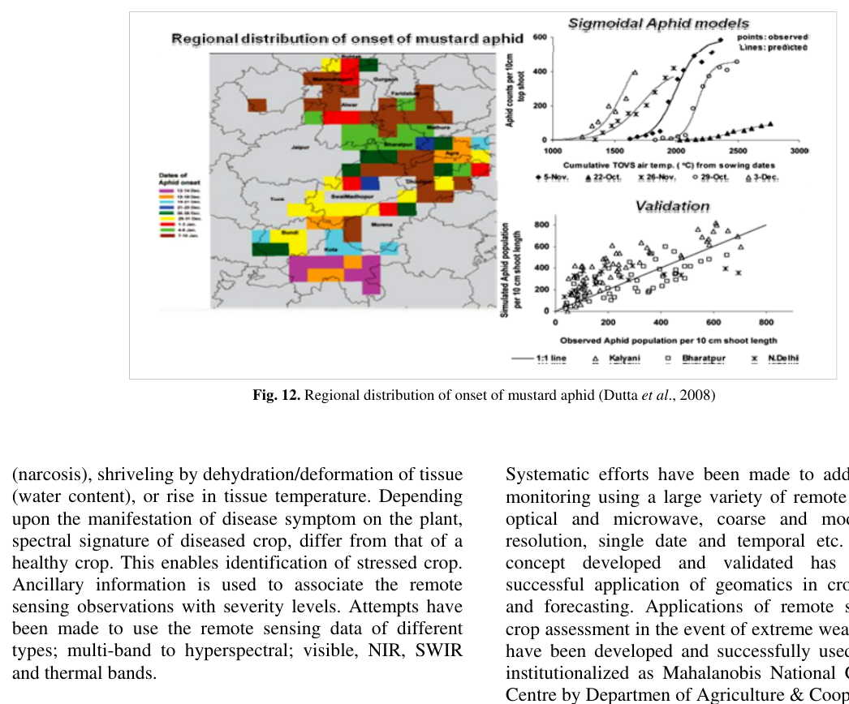
Figure 70. Screenshot — Parihar (2016), Fig. 12: regional distribution of the onset of mustard aphid (Dutta et al. 2008).

21.6 Takeaways and critique
- Strength: a design based on multiple sources and multiple stages, which is still the backbone of MNCFC's operations and the conceptual parent of YES-TECH's ensemble thinking.
- Limitations: state- and district-level yield relied on weather regressions with coarse data. GP-level insurance needs finer (10–30 m) RS, SAR time series and ML or ensemble models, which is the YES-TECH direction.
- Your angle: SAR continuity has gone from RISAT-1 to EOS-04 to NISAR (L+S), and stress detection can use SIF (FLEX) and NISAR soil moisture.
Q. What was the first agricultural remote-sensing experiment in India?
A. The 1969–70 coconut root-wilt study in Kerala using colour-infrared aerial photography (Dakshinamurthy et al. 1971).
Q. How does FASAL achieve multiple in-season forecasts?
A. By integrating econometric and weather models early in the season (before crops are visible), coarse high-temporal RS mid-season, and RS acreage with RS-weather yield models later. Ground observations support every stage, giving pre-season, early, mid-season, pre-harvest and revised forecasts.
Q. Why is SAR used for kharif rice?
A. Monsoon clouds block optical data. C-band SAR shows the distinct flooded-field minimum and the subsequent rise in backscatter as rice grows. The SAR procedure has been operational for kharif rice since 1998.

22. Ray et al. (2016): operational assessment of extreme-weather impact on crops (MNCFC)
Citation card: Shibendu S. Ray, Suresh K. Singh, Neetu and S. Mamatha (2016). Establishing an operational system for assessment and forecasting the impact of extreme weather events on crop production. MAUSAM 67(1): 289–296. Mahalanobis National Crop Forecast Centre, New Delhi.

22.1 Why it matters
- It shows how MNCFC turned ISRO technology into operations, the institutional path you will be asked about.
- Three case studies: flood (Phailin), drought (NADAMS) and hailstorm/unseasonal rain (2015). Each maps to a PMFBY risk: localised calamity, mid-season adversity and yield loss.

22.2 Background facts
- FASAL was launched by the Ministry of Agriculture in 2006, with technology from ISRO. It has three components: econometric, agromet and RS forecasts, given early, mid-season and pre-harvest.
- MNCFC was established in April 2012 and gives national, state and district forecasts for 8 major crops together with State Agriculture Departments and SRSACs.
- Crop-condition indices: VNIR (NDVI, SAVI, EVI), SWIR (NDWI, SASI, the shortwave angle slope index), thermal (CWSI, the VI–temperature trapezoid), and long-term indices VCI, TCI and VHI (Kogan).
VCI = 100 (NDVIi − NDVImin)/(NDVImax − NDVImin); TCI = 100 (BTmax − BT)/(BTmax − BTmin); VHI = a·VCI + b·TCI
All three indices run from 0 (extreme stress) to 100 (favourable), and 50 is average.

22.3 Case study 1: rice inundation after Cyclone Phailin (Oct 2013)
- Multi-date RISAT-1 SAR (MRS mode) with ground truth and hierarchical classification gave the rice map. NRSC's flood map (Radarsat + RISAT) was overlaid on it.
- Total rice inundated: 132.4 thousand ha. Most affected districts: Baleshwar (35.79), Bhadrak (20.50), Jajpur (16.13), Kendrapara (15.79) and Puri (11.32 thousand ha).
- Post-event ground truth: 16 of 18 sites correct (89 % accuracy). This was the first quantitative information given to the Central and State governments.
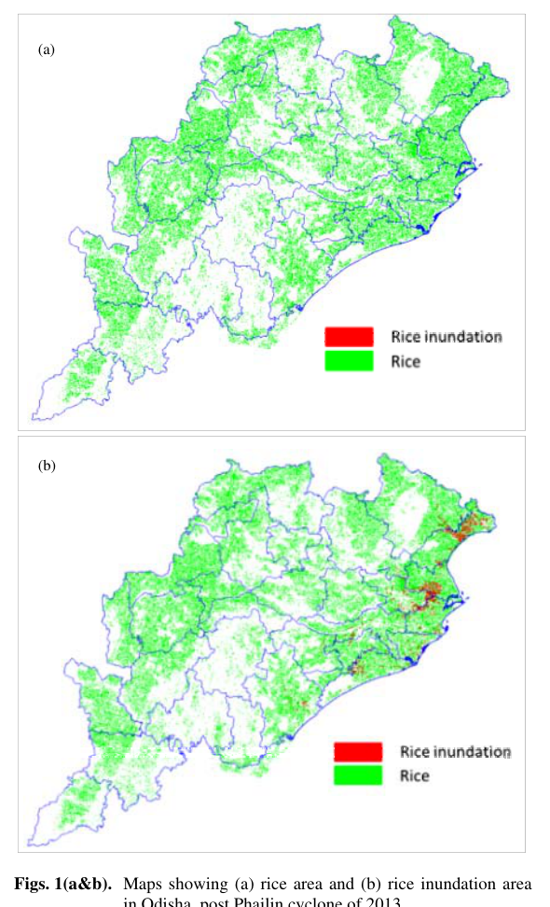
Figure 71. Screenshot — Ray et al. (2016), Fig. 1: (a) rice area and (b) rice inundation area in Odisha after Cyclone Phailin, 2013.

22.4 Case study 2: NADAMS drought assessment
- 16 % of India's area is drought-prone, about 50 million people are affected annually, and 68–70 % of sown area is vulnerable.
- NADAMS was conceived by NRSC and transferred to MNCFC from 2012. It covers 14 states (5 at sub-district level: AP, Haryana, Karnataka, Maharashtra, Telangana) and issues monthly reports.
- Inputs: NDVI, NDWI, SASI and VCI (NOAA-AVHRR, MODIS, AWiFS), soil moisture, rainfall, sowing progress and irrigated area, combined through logical modelling.
- Results: the most drought districts were in 2012, then 2014, then 2013. In 28 of 39 cases the NADAMS count was within ±5 districts of the state declarations. On average NADAMS assessed fewer districts than the states declared.
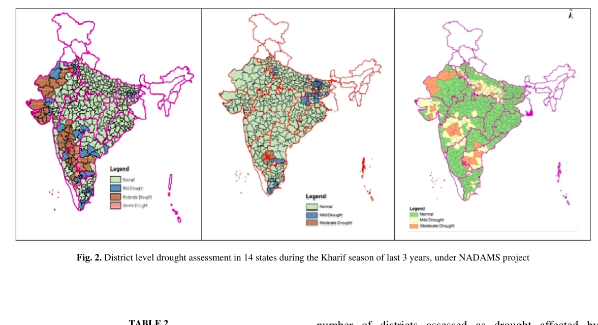
Figure 72. Screenshot — Ray et al. (2016), Fig. 2: district-level drought assessment in 14 states, kharif 2012–2014 (NADAMS).

22.5 Case study 3: hailstorm and unseasonal rain, Feb–Mar 2015
- Unofficial reports put potential damage to rabi crops at about 100 lakh ha in northern India.
- Method: AWiFS NDVI deviation (2015 vs 2014) within the FASAL wheat mask, combined with IMD gridded rainfall (25 Feb–20 Mar 2015) in logical modelling to classify damage. Ground truth in 4 states showed lodging.
- Smart-sampling CCEs: 49 CCE sites in Betul and Hoshangabad (MP), stratified using pre-event NDVI. 16 sites were affected, with mean yield 2381 vs 2568 kg/ha (about 7 % lower).
- Most affected: Haryana, Rajasthan and MP.
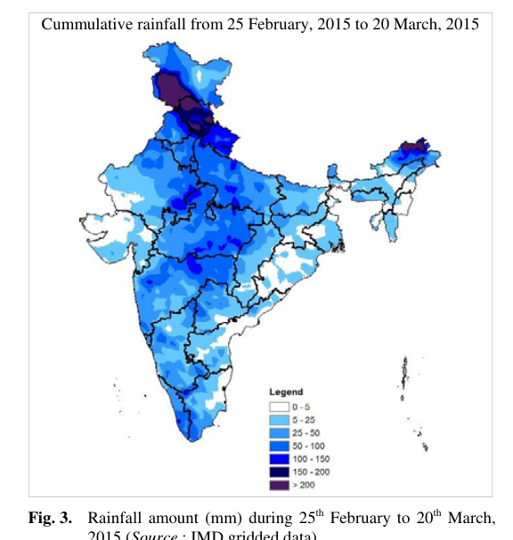
Figure 73. Screenshot — Ray et al. (2016), Fig. 3: rainfall (mm) during 25 Feb–20 Mar 2015 (IMD gridded data).
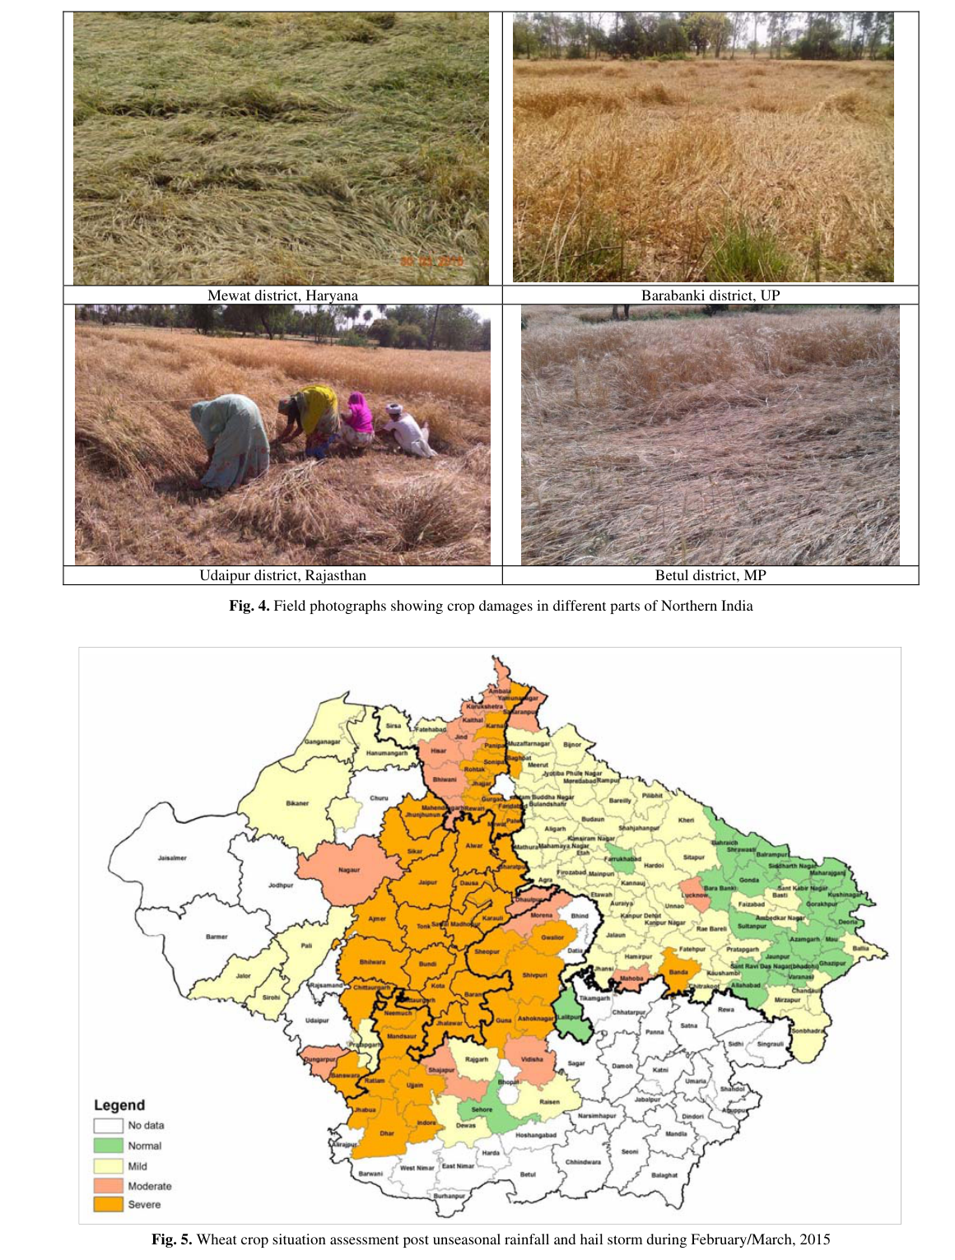
Figure 74. Screenshot — Ray et al. (2016), Fig. 5: wheat crop situation after unseasonal rainfall and hailstorm, Feb–Mar 2015.

22.6 Future plans stated by the authors
- Flood damage depends on inundation depth and duration, which needs high-temporal SAR and SAR + DEM, altimetry or TIN methods for depth.
- Evaluate new drought indices (VegDRI, NDDI).
- Structural (lodging) damage from RS, and quantifying yield impact.
- Insurance and relief need production loss at GP or block level. A constellation of about 5 satellites (3 optical + 2 microwave) is needed for disaster coverage (Navalgund et al. 2010). The Ministry launched a pilot on technology for disaggregated yield and damage assessment, the seed of KISAN and later YES-TECH.
Q. How did MNCFC assess rice inundation after Phailin?
A. It classified rice from multi-date RISAT-1 SAR and overlaid NRSC's SAR-derived flood map, giving district-wise inundated rice (132.4 thousand ha in total). Accuracy was 89 % against post-event ground truth.
Q. Define VCI and VHI.
A. VCI = 100 (NDVI − NDVImin)/(NDVImax − NDVImin), the vegetation condition relative to multi-year extremes. VHI combines it with the thermal condition index TCI. Both run from 0 (stress) to 100 (favourable).
Q. How was smart sampling used in the hailstorm study?
A. CCE sites were stratified with pre-event NDVI, so affected and unaffected strata were both sampled. That allowed the hail impact to be quantified at about 7 % lower yield, a direct precursor of YES-TECH smart sampling.

23. Moorthi et al. (2014): FASALSoft, ISRO's software framework for crop forecasting
Citation card: S. Manthira Moorthi, M. P. Oza, I. Misra, R. K. Gambhir, N. P. Darji, S. Sharma, D. K. Jain, D. Dhar, K. Padia, R. Ramakrishnan, S. Chowdhury and J. S. Parihar (2014). FASALSoft — An ISRO software framework for crop production forecast using remote sensing data analysis. Journal of Geomatics 8(1): 27–33. Space Applications Centre, ISRO.

23.1 Why it matters
- It shows the engineering side of operational crop forecasting: how SAC built an in-house, FOSS-based distributed system. It is relevant if the board asks about ISRO software, automation or scaling YES-TECH to 200+ districts.
- Operational at MNCFC since June 2012. It produced the 2012–13 National-State Forecasts.

23.2 Problem
- FASAL processing originally used commercial (COTS) software, with manual housekeeping, georeferencing and registration.
- Earlier packages were only partly automated: CAPEMAN and CAPEWORKS (single-date analysis) and SARCROPS (Radarsat ScanSAR only).
- Mandate: build from fresh developments and FOSS only, with no COTS.

23.3 System design
- Two forecast types: State and District Forecast (SDF) and National and State Forecast (NSF).
- Four subsystems: ADMIN, ARCHIVE, COMPUTE, QUERY. ADMIN and QUERY are web applications on a client–server architecture.
- User hierarchy: CFA (Chief FASALSoft Administrator: creates the master work order and manages the central system), RFA (Regional Administrator: splits it into regional and job orders and aggregates results), FAN (Analyst: processes the assigned scenes), FEU (End User: views and queries results).
- Work orders: CFA chooses year, crop, forecast type and number, creating a Master Work Order. This is split into regional work orders (by state) and then job orders (scene- or template-based) for FANs. Compute runs at the FAN, aggregation at the RFA.
- Core geospatial tasks: (a) georeferencing, (b) multi-date image registration, (c) supervised classification, then aggregation and area statistics. It also builds crop-yield models from correlation-weighted weather variables.
- Databases: CFA DB (one), RFA DB (one per regional node), and the Digital Crop Folder (DCF). The DCF stores metadata, crop calendar, georeferencing, classification output and confusion matrix for each crop, year and forecast, with master-to-slave database replication. A weather and crop database holds weekly met-subdivision rainfall and Tmax/Tmin plus historical area, yield and production.
- Technology: GDAL/OGR, Shapelib, PostgreSQL, GeoTools; SAC libraries (projection, resampling, registration, classification, microwave calibration, regression); more than 75 database tables; more than 10 formats (CEOS, GeoTIFF, HDF); C, C++, Java and J2EE; Windows 7 64-bit.
- Data: Resourcesat-1/2 LISS-III and AWiFS; Radarsat-2 ScanSAR/Wide-2; RISAT-1 MRS.
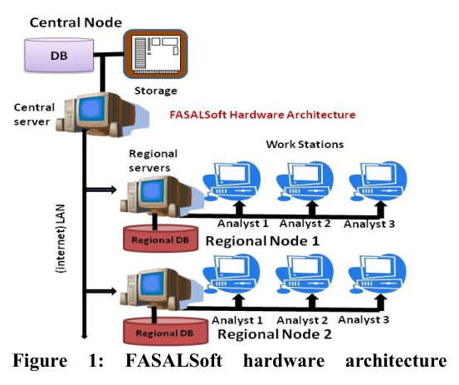
Figure 75. Screenshot — Moorthi et al. (2014), Fig. 1: FASALSoft hardware architecture (central node, regional nodes and analyst workstations).
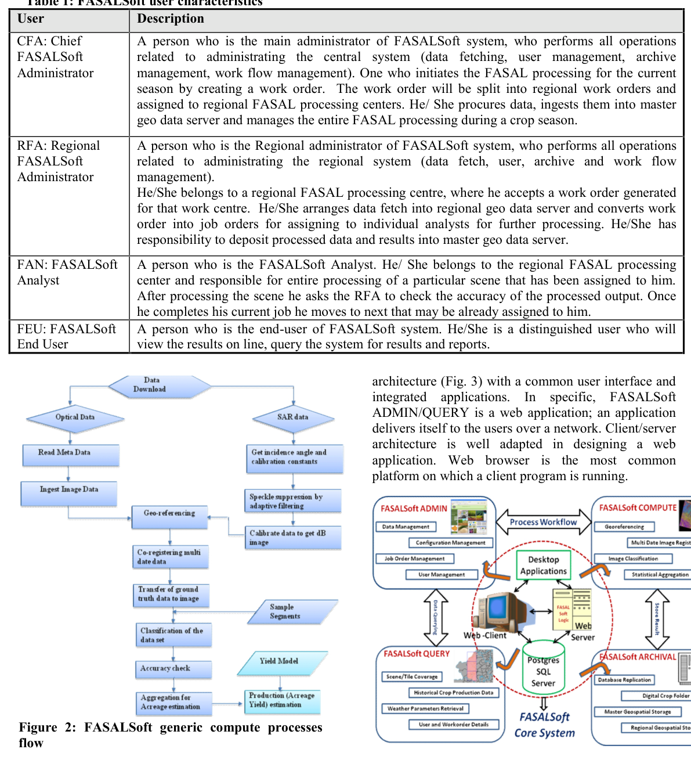
Figure 76. Screenshot — Moorthi et al. (2014), Fig. 2: FASALSoft generic compute-process flow (optical and SAR branches → registration → classification → aggregation).
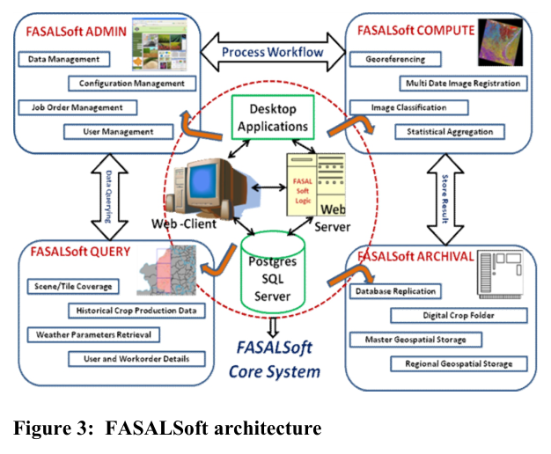
Figure 77. Screenshot — Moorthi et al. (2014), Fig. 3: FASALSoft architecture (ADMIN, COMPUTE, QUERY, ARCHIVE around a PostgreSQL core).
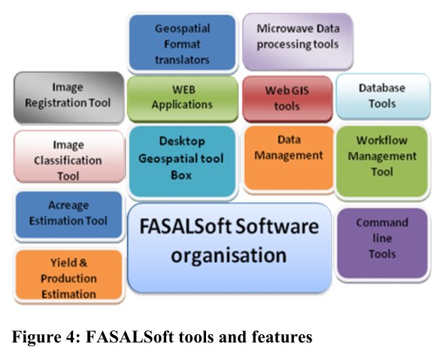
Figure 78. Screenshot — Moorthi et al. (2014), Fig. 4: FASALSoft tools and features.
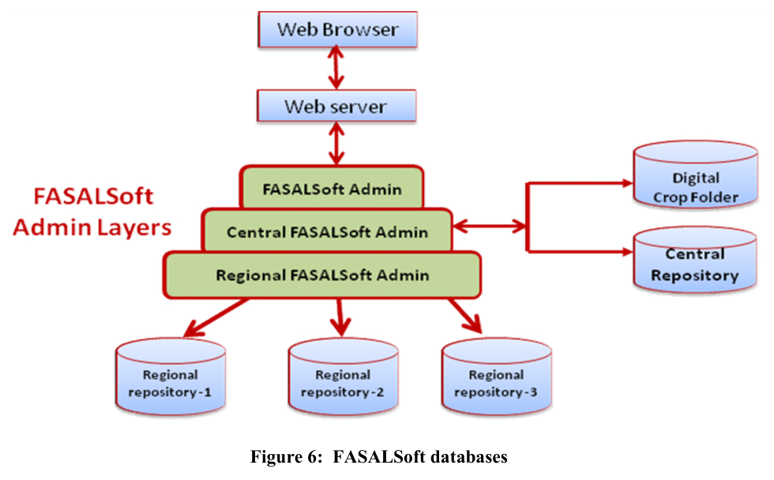
Figure 79. Screenshot — Moorthi et al. (2014), Fig. 6: FASALSoft databases and admin layers.

23.4 Takeaways
- Operational RS needs workflow, data provenance (DCF) and distributed computing, not just algorithms. YES-TECH's “web portal/dashboard” requirement follows the same philosophy.
- Modern extension: move FASALSoft-style processing to cloud or HPC (e.g. Bhoonidhi plus GPU compute, Google Earth Engine-like analysis-ready data cubes), add ML/DL modules, and add NISAR and EOS-04 ingest.
Q. What is FASALSoft?
A. SAC-ISRO's in-house, FOSS-based, distributed software for the FASAL crop-forecast workflow. It automates georeferencing, multi-date registration, classification, aggregation and yield-model building, organised around ADMIN, ARCHIVE, COMPUTE and QUERY subsystems and a Digital Crop Folder database. It has been operational at MNCFC since June 2012.
Q. What is the Digital Crop Folder?
A. A database that captures all parameters, data details, processing steps and results (classification, confusion matrix and so on) for each crop, year and forecast number, so analyses are reproducible and can be queried in later years.

24. Tripathy et al. (2014): operational semi-physical spectral-spatial wheat yield model
Citation card: R. Tripathy, K. N. Chaudhary, R. Nigam, K. R. Manjunath, P. Chauhan, S. S. Ray and J. S. Parihar (2014). Operational semi-physical spectral-spatial wheat yield model development. ISPRS Archives XL-8: 977–981 (ISPRS TC VIII Symposium, Hyderabad). EPSA, SAC-ISRO and MNCFC.

24.1 Why it matters
- It is the Indian operational reference for the semi-physical model, YES-TECH approach no. 1. Expect to derive it on the whiteboard.
- It shows how to combine INSAT (Kalpana-VHRR) insolation, MODIS fAPAR and LSWI, IMD temperature and an AWiFS wheat mask.

24.2 Problem
- VI-based empirical yield models are location-specific, need frequent coefficient updates and explain only 50–60 % of yield variability.
- Crop simulation models are data-intensive. They were developed at field scale and are hard to run regionally. Satellite surface temperature also differs from the 2 m air temperature these models were calibrated on.
- Solution: an intermediate, physiologically based Monteith efficiency model using RS inputs, extended with water and temperature stress.

24.3 Study area and data
- Six states, Punjab, Haryana, Rajasthan, MP, UP and Bihar: about 85 % of wheat area and 90 % of production. Punjab, Haryana and western UP are irrigated; Rajasthan, MP and Bihar are largely rainfed.
- Season from mid-October to end-April, processed in 8-day steps at 1 km.
- PAR: daily Kalpana-1 VHRR insolation (MOSDAC), summed to 8-day values, with 50 % of insolation taken as PAR.
- fAPAR: MODIS 8-day 1 km product (LP DAAC). Surface reflectance MOD09A1 (500 m) for LSWI. For the remaining season, the average of the previous 3 years (2011–2013) was used as the “normal” fAPAR.
- Temperature: IMD daily Tmax/Tmin interpolated to a 5 km grid. Wheat mask: RS2-AWiFS (MNCFC). Crop duration and HI: CGMS project. RUEmax: literature (about 3.0 g MJ⁻¹ for wheat).

24.4 Model equations
ΔDM (NPP) = PAR × fAPAR × ε × Wscalar × Tscalar (8-day steps, summed sowing → harvest)
LSWI = (NIR − SWIR1)/(NIR + SWIR1); Wscalar = (1 + LSWI)/(1 + LSWImax)
Tscalar = (T − Tmin)(T − Tmax) / [(T − Tmin)(T − Tmax) − (T − Topt)²], wheat: Tmin 5 °C, Topt 25 °C, Tmax 35 °C
Grain yield = HI × Σ NPP (pixel yield averaged over wheat pixels → district → state)
- Nitrogen deficiency is assumed to be captured through fAPAR (NDVI). The remaining stresses are water and temperature.
- Water stress was applied only up to the flowering stage. LSWImax is the spatial maximum across all states on a given date.
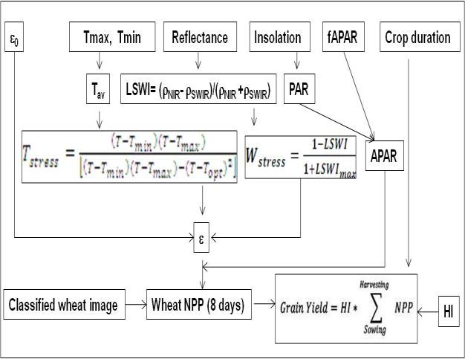
Figure 80. Screenshot — Tripathy et al. (2014), Fig. 1: methodology for wheat yield estimation using the RS-based modified Monteith model.
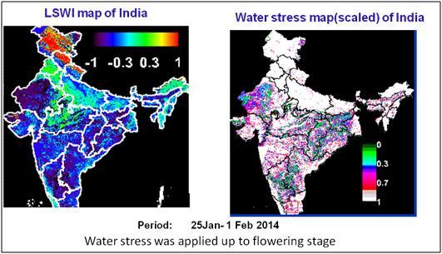
Figure 81. Screenshot — Tripathy et al. (2014), Fig. 2: LSWI and water-stress map of India, 25 Jan–1 Feb 2014 (1 = no stress, 0 = maximum stress).
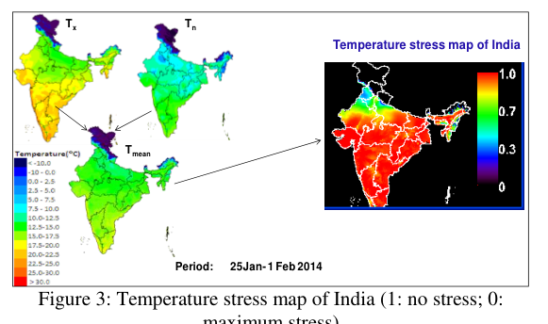
Figure 82. Screenshot — Tripathy et al. (2014), Fig. 3: temperature-stress map of India (25 Jan–1 Feb 2014).

24.5 Results
Table 25. State-level estimated vs reported wheat yield, 2013-14 (Tripathy et al. 2014, Table 2)
State | Estimated (t/ha) | Reported (t/ha) | Difference (%)
Bihar | 2.15 | 2.35 | −8.75
Haryana | 4.47 | 4.55 | −1.79
MP | 2.12 | 2.41 | −11.76
Punjab | 4.62 | 4.62 | +0.13
Rajasthan | 3.09 | 3.18 | −2.78
UP | 3.03 | 3.08 | −1.43
Average | 3.25 | 3.36 | −3.45

- State level: an average underestimation of 3.45 %, RMSE 0.15 t/ha, R² = 0.996. All states were within 10 % except MP (−11.8 %).
- Water stress was highest in MP in February. In Punjab Wscalar ranged from 0.7 to 1.
- Temperature stress in late January was highest in Punjab and Haryana (cold). By late March, stress was highest in MP and Bihar (heat).
- Pixel yield: 3–6 t/ha in Punjab and Haryana, 1–3 t/ha in Bihar, 0.7–4 t/ha in MP.
- District level (211 districts): pooled R² = 0.58, RMSE = 0.57 t/ha. Punjab RMSE 0.38 and Haryana 0.43 t/ha (within 15 %). Rajasthan had the highest RMSE (1.05 t/ha).
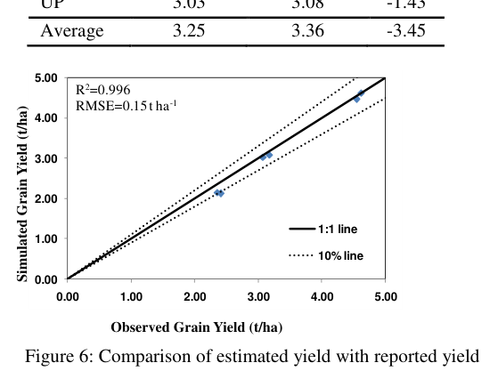
Figure 83. Screenshot — Tripathy et al. (2014), Fig. 6: estimated vs reported state-level wheat yield (R² = 0.996, RMSE = 0.15 t/ha).
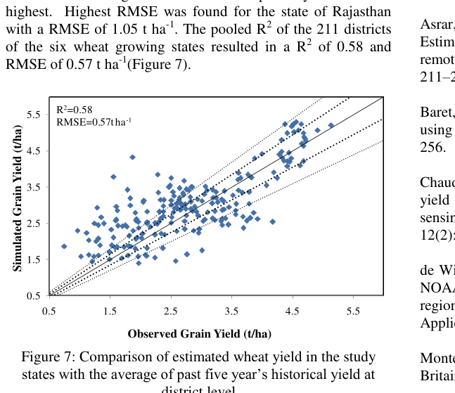
Figure 84. Screenshot — Tripathy et al. (2014), Fig. 7: district-level comparison (R² = 0.58, RMSE = 0.57 t/ha).

24.6 Critique: what you would improve
- Scale gap: the excellent state result (errors average out) degrades at district level, and GP level would be harder still. Use Sentinel-2 10–20 m fAPAR and LSWI, field boundaries and crop-specific HI.
- Constant HI and RUE: HI drops with terminal heat. Make HI a function of grain-filling temperature or calibrate it with CCEs, as YES-TECH requires.
- Remainder of season used the 3-year normal fAPAR, which loses current-year anomalies. Combine with weather forecasts or crop-model projections.
- New inputs: INSAT-3DS insolation, NISAR soil moisture for Wscalar, and SIF as a direct photosynthesis proxy.
Q. Write the semi-physical model used by SAC for wheat.
A. Grain yield = HI × Σ(PAR × fAPAR × εmax × Wscalar × Tscalar), where PAR = 0.5 × Kalpana/INSAT insolation, fAPAR is from MODIS, Wscalar = (1 + LSWI)/(1 + LSWImax), Tscalar is the Raich et al. function with Tmin 5, Topt 25 and Tmax 35 °C for wheat, and HI is the cultivar-specific harvest index.
Q. Why is LSWI used for water stress?
A. It uses NIR and SWIR (about 1.6 µm). SWIR reflectance increases as leaf and canopy water falls, so LSWI drops under water stress. Normalising by the maximum LSWI gives a 0–1 scalar.
Q. Why is the model accurate at state level but not district level?
A. Pixel and district errors (mixed 1 km pixels, uniform RUE and HI, interpolated temperature, normal-year fAPAR) partly cancel when aggregated to large areas. At district level the errors no longer cancel, so R² falls to 0.58 and RMSE rises to 0.57 t/ha.

25. Satheesh et al. (2025): spatial rice yield, semi-physical model vs DSSAT
Citation card: S. Satheesh, S. Pazhanivelan, D. Suresh Kumar, K. P. Ragunath, R. Kumaraperumal, A. P. Sivamurugan, D. Muthumanickam, N. S. Sudarmanian and S. Sakthivel (2025). Spatial rice yield estimation using semi-physical and crop simulation models: a comparative approach. Plant Science Today 12(3): 1–10. Tamil Nadu Agricultural University, Coimbatore. Funded by the MNCFC pilot project on GP-level crop estimation using advanced technologies.

25.1 Why it matters
- It compares two YES-TECH-approved approaches (semi-physical and crop simulation) head to head against CCE yields on the same region and season. Use it to answer “which model would you choose?”.
- It uses Sentinel-1 SAR for rice area and for LAI to spatialise DSSAT, a practical form of RS–crop model integration.

25.2 Study area and data
- Cauvery Delta Zone (CDZ), Tamil Nadu: Thanjavur, Thiruvarur, Nagapattinam, Mayiladuthurai (10°00′–11°15′ N, 78°45′–79°55′ E). Irrigation from Mettur Dam plus the northeast monsoon (900–1200 mm).
- Rice seasons: Kuruvai (Jun–Sep), Samba (Aug–Jan, the season studied, 2024-25) and Thaladi (Oct–Feb).
- Data: INSAT-3DR daily insolation (1 km), MODIS 8-day fAPAR (500 m), MODIS surface reflectance (500 m), Sentinel-1 rice mask (20 m) and IMD gridded temperature (5 km).
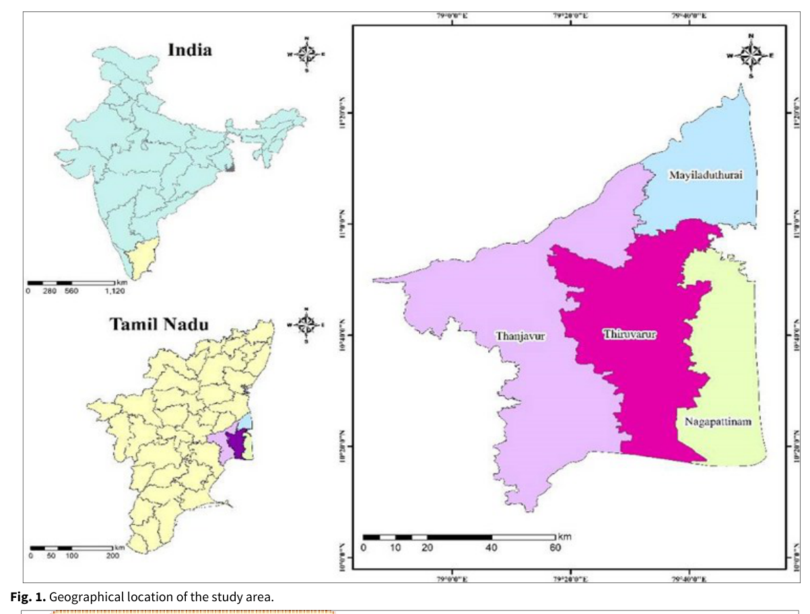
Figure 85. Screenshot — Satheesh et al. (2025), Fig. 1: geographical location of the Cauvery delta zone study area.

25.3 Method A: rice mapping with Sentinel-1 (MAPscape-RICE)
- Strip mosaicking of same-orbit scenes.
- Co-registration of all dates.
- Time-series speckle filtering (equivalent number of looks).
- Terrain geocoding, radiometric calibration and incidence-angle normalisation (cosine law), using a DEM and range-Doppler.
- ANLD (adaptive non-local means) filtering.
- Atmospheric correction (interpolation-based, for moisture-induced anomalies).
- Rule-based rice detection from temporal σ° profiles, calibrated to local agronomy.
Result: rice area 2,98,087 ha (Thanjavur 1,06,914; Thiruvarur 1,01,825; Mayiladuthurai 45,640; Nagapattinam 43,708). Accuracy 93.9 %, kappa 0.88 (182 rice + 95 non-rice ground points).
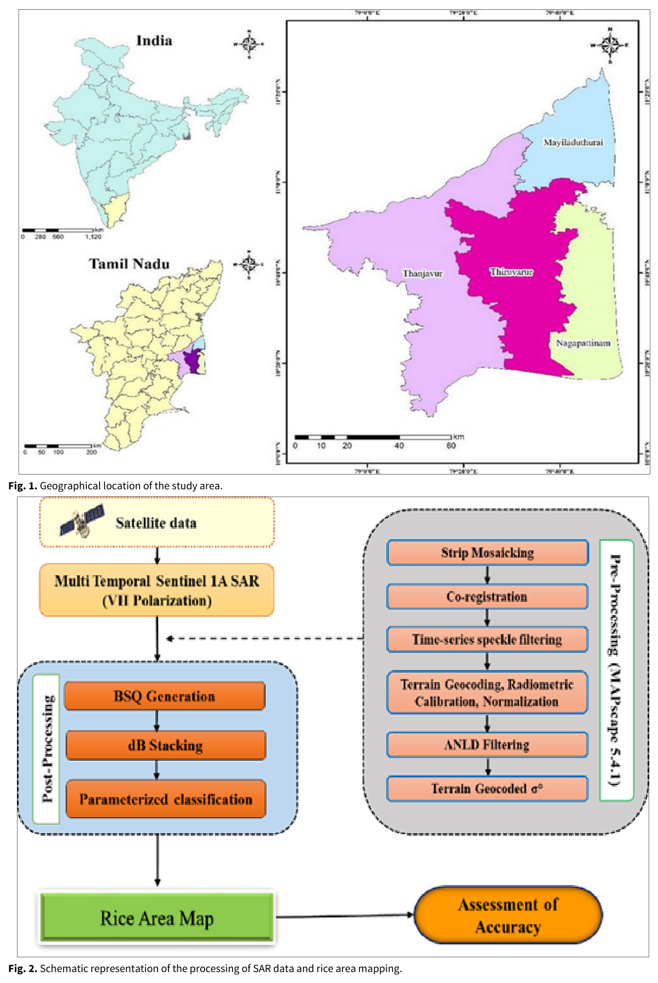
Figure 86. Screenshot — Satheesh et al. (2025), Fig. 2: SAR processing and rice-area mapping workflow.
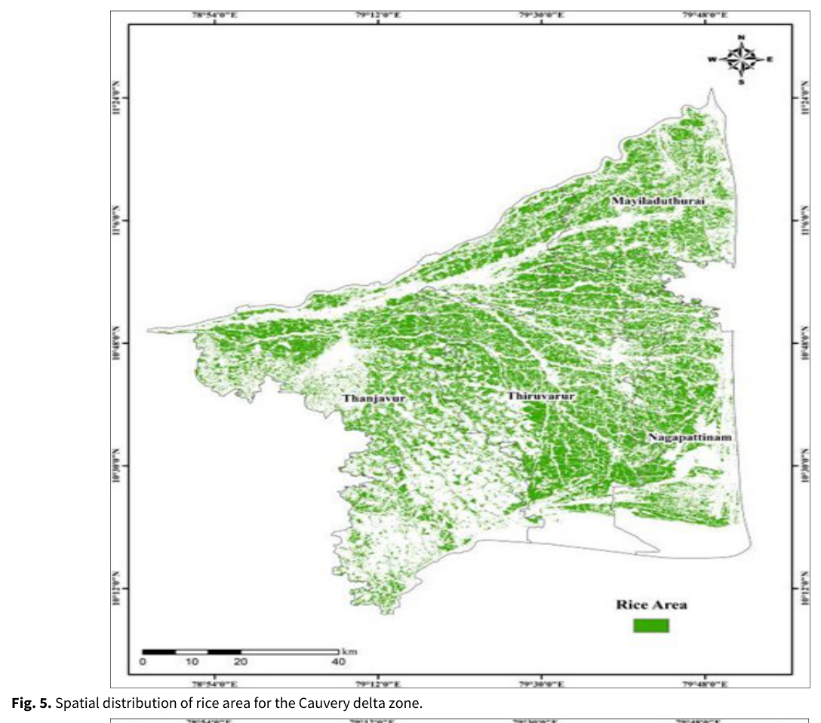
Figure 87. Screenshot — Satheesh et al. (2025), Fig. 5: spatial distribution of rice area in the Cauvery delta zone.

25.4 Method B: DSSAT CERES-Rice with SAR-derived LAI
- DSSAT v4.7 CERES-Rice. Weather files from WeatherMan (Tmax 27.9–35.8 °C, Tmin 20.6–25.8 °C, Rs 13.4–21.7 MJ m⁻² d⁻¹, 945 mm seasonal rain).
- Soil: TNAU 1:50,000 data covering 22 soil series (sand 21–86 %, clay 8–54 %, BD 1.28–1.65, OC 0.04–1.43 %), built with SBuild.
- Cultivars CR 1009, BPT 5204 and ADT 45, with genetic coefficients from GENCALC. Management files from XBuild.
- Spatialisation: regress SAR backscatter (dB) on simulated and measured LAI, then apply it to flowering-stage σ° images to get an LAI map. Next, regress simulated yield on LAI and apply it to the LAI map to get a yield map.
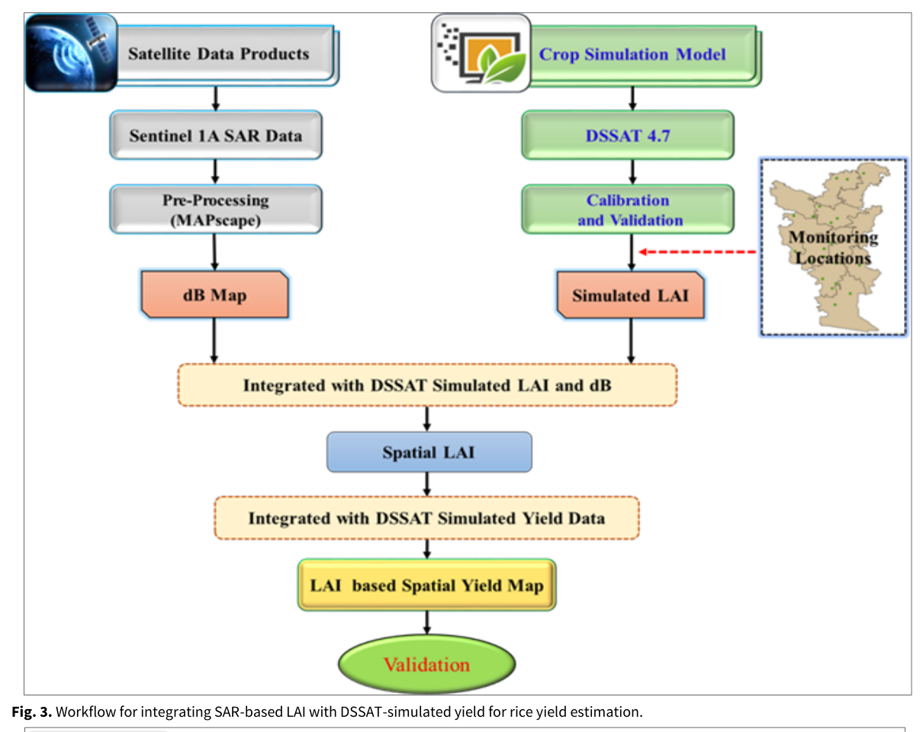
Figure 88. Screenshot — Satheesh et al. (2025), Fig. 3: workflow integrating SAR-based LAI with DSSAT-simulated yield.

25.5 Method C: semi-physical model (SPM)
PAR = 0.48 × INSAT-3DR insolation (8-day, resampled 4 km → 500 m)
NPP = PAR × FPAR × RUE × Wstress × Tstress (RUE = 2.9 g MJ⁻¹); Yield = ΣNPP × HI
Wstress = (1 + LSWI)/(1 + LSWImax); Tstress = (T−Tmin)(T−Tmax)/[(T−Tmin)(T−Tmax) − (T−Topt)²]
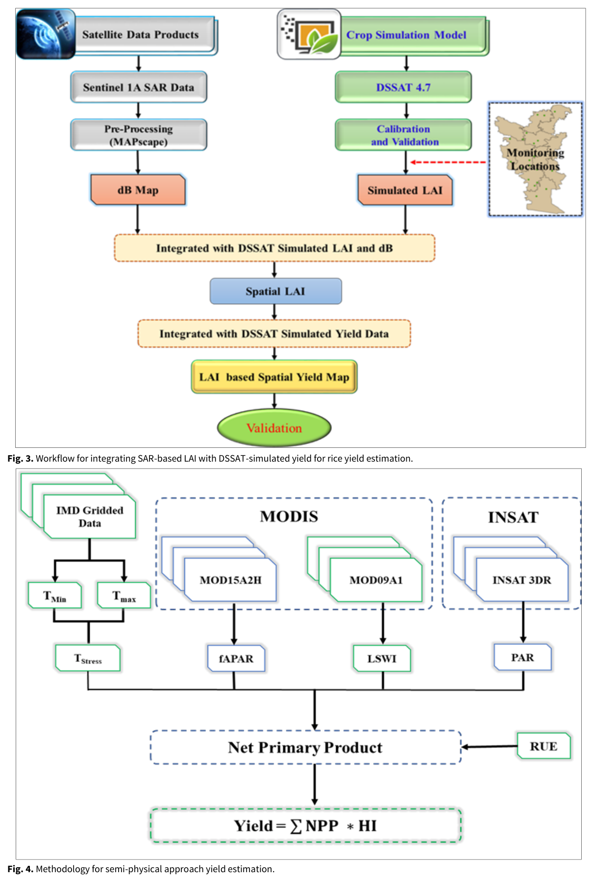
Figure 89. Screenshot — Satheesh et al. (2025), Fig. 4: methodology for semi-physical yield estimation.

25.6 Results
Table 26. District comparison with CCE yields (Satheesh et al. 2025, Table 3)
District | CCE (kg/ha) | SPM (kg/ha) | DSSAT (kg/ha) | SPM agreement (%) | DSSAT agreement (%)
Mayiladuthurai | 3597 | 3975 | 3355 | 84.4 | 87.6
Nagapattinam | 3588 | 3897 | 3426 | 84.2 | 85.5
Thanjavur | 3774 | 4379 | 3822 | 81.4 | 91.3
Thiruvarur | 3624 | 4024 | 3689 | 83.4 | 90.1
Mean | 3646 | 4068 | 3573 | 83.3 | 88.6

- DSSAT: 88.6 % agreement with CCE (district range 85.5–91.3 %), mean simulated yield 3524 kg/ha in the spatial run.
- SPM: 83.3 % agreement. It overestimated yield (mean about 4.07–4.47 t/ha vs CCE 3.65 t/ha), because stress was minimal (irrigated delta) and RUE was held constant.
- PAR ranged 150–315 MJ m⁻² (peak in September 2024, lowest in November due to clouds).
- Trade-off: DSSAT is more accurate but needs calibration and data (soil, cultivar, management). SPM is scalable and easy in data-scarce areas but sensitive to input resolution (500 m MODIS) and its assumptions.
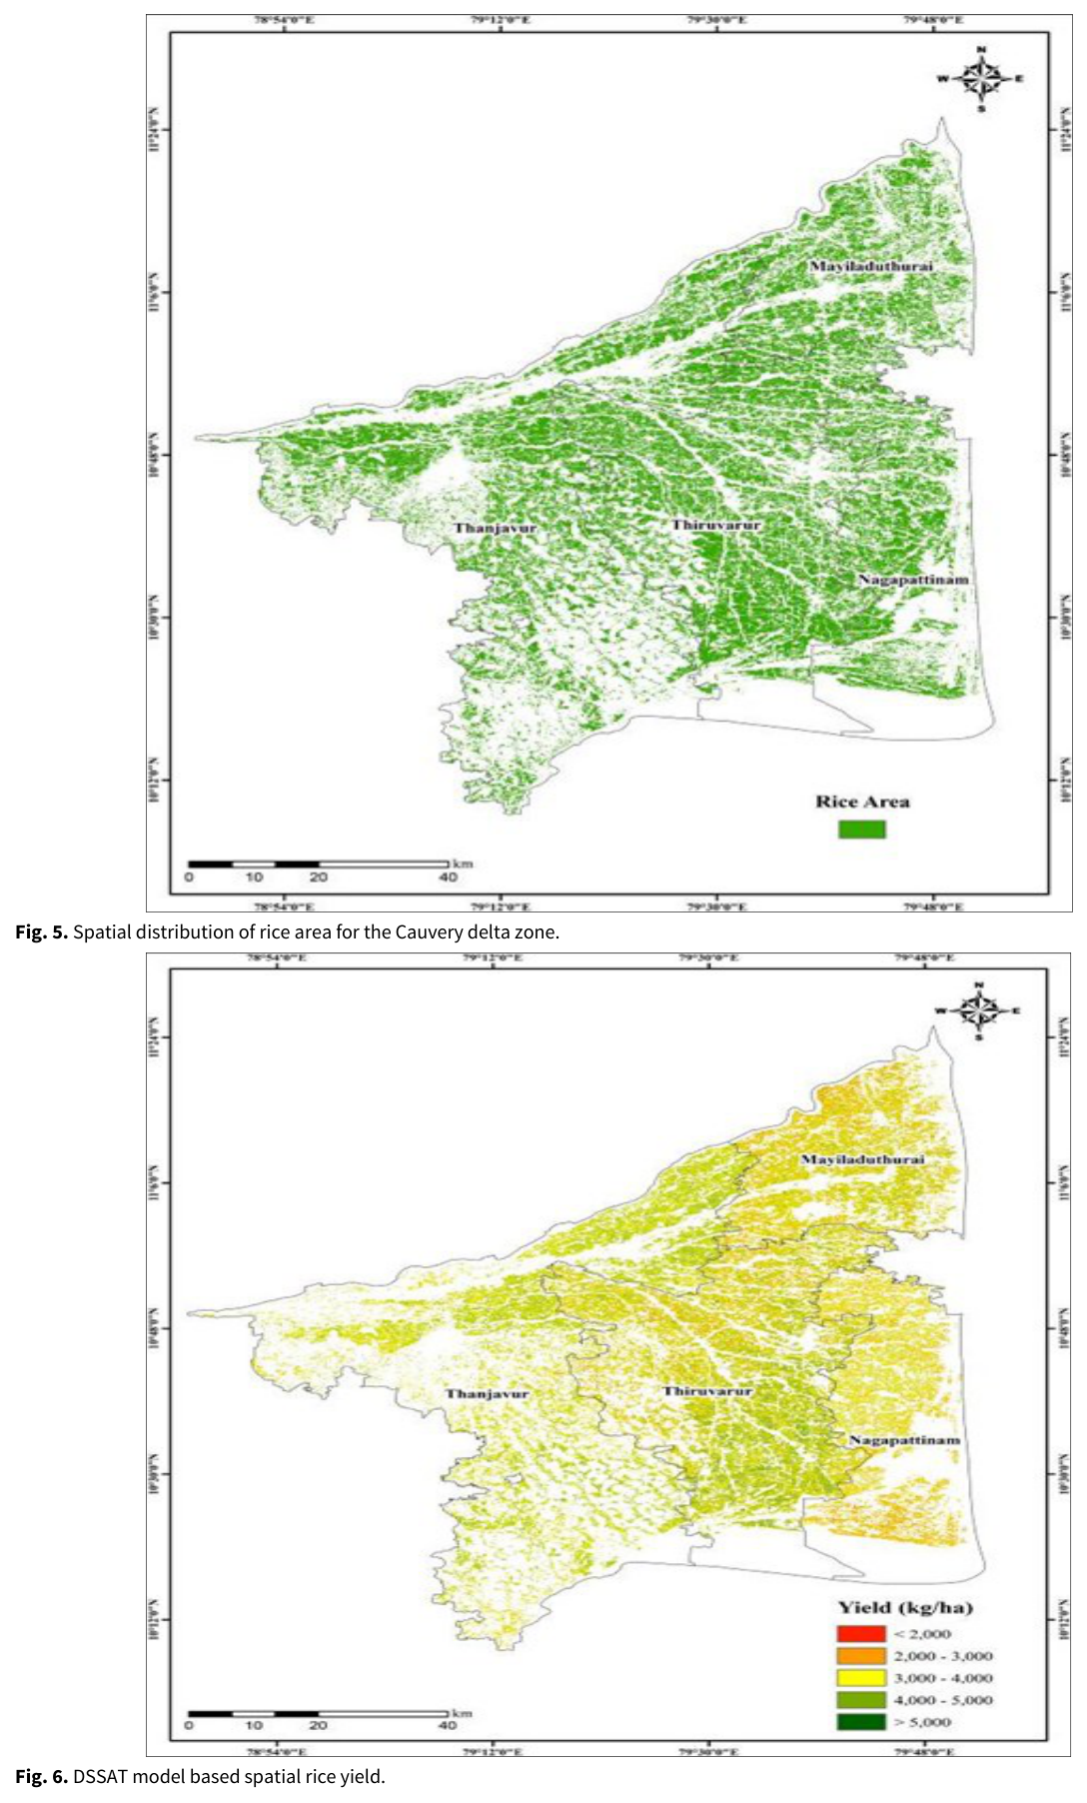
Figure 90. Screenshot — Satheesh et al. (2025), Fig. 6: DSSAT-based spatial rice yield.
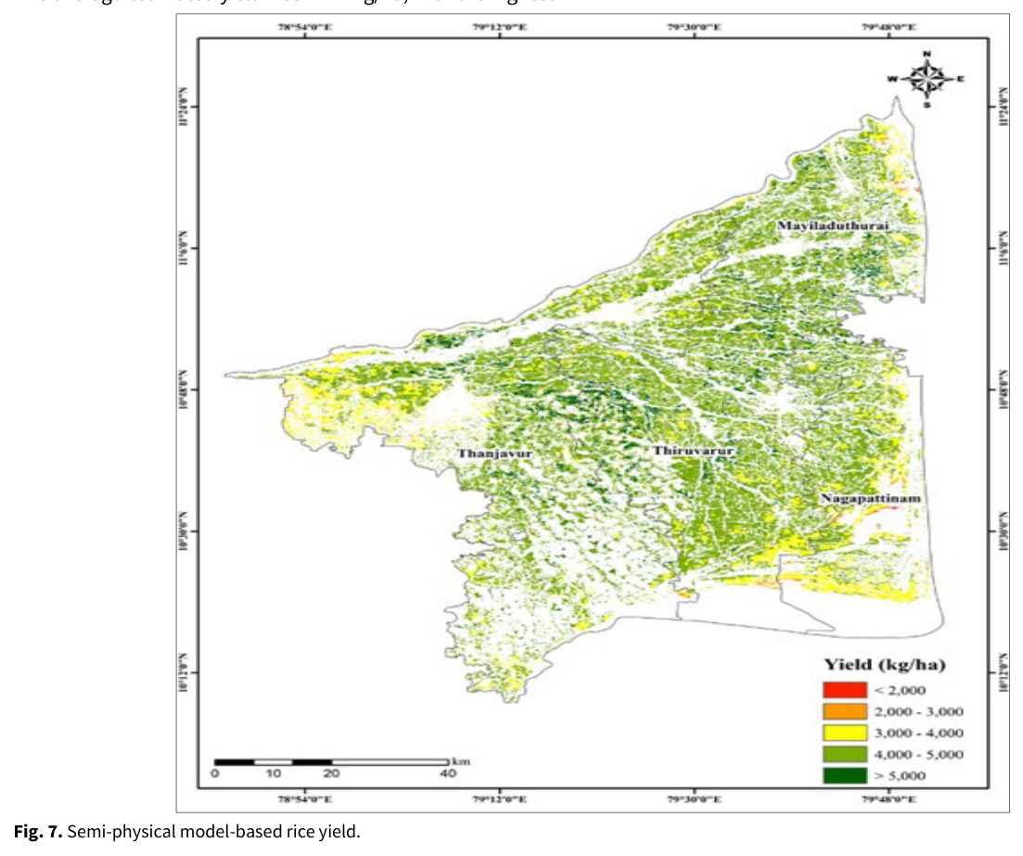
Figure 91. Screenshot — Satheesh et al. (2025), Fig. 7: semi-physical-model rice yield.
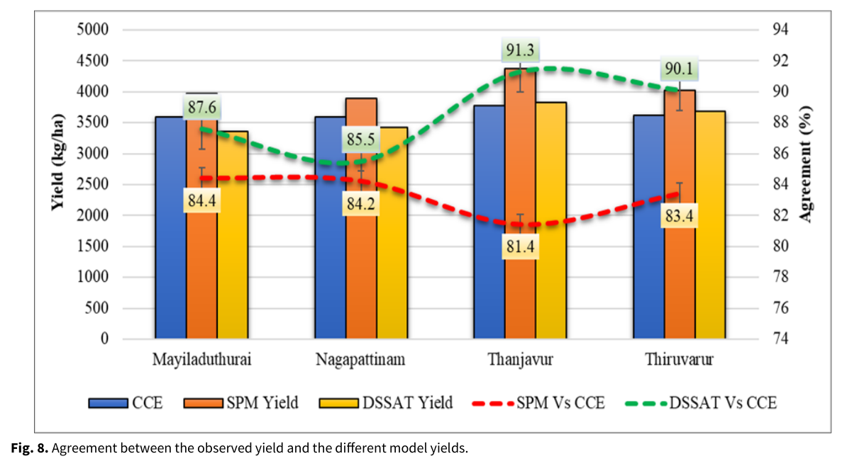
Figure 92. Screenshot — Satheesh et al. (2025), Fig. 8: agreement between observed (CCE) yield and the two model yields.

25.7 Critique and extension
- SPM bias: the 500 m MODIS fAPAR mixes rice with other cover. Use Sentinel-2 fAPAR (SNAP) or SAR-derived LAI, and calibrate RUE and HI with CCEs. A flood or submergence stress term is needed for the delta.
- DSSAT spatialisation via an LAI–yield regression is a simple “forcing” approach. EnKF assimilation of LAI time series would be more rigorous (see Chapter 9).
- Ensemble: the authors suggest adding ML. A stacked ensemble of SPM + DSSAT + ML is exactly YES-TECH approach no. 4.
- “Agreement %” is not a standard metric. Report RMSE, nRMSE, bias and R² at GP level.
Q. Which model would you recommend for GP-level rice yield in an irrigated delta?
A. Use DSSAT/CERES-Rice where soil, cultivar and management data exist (88.6 % agreement in the Cauvery delta). For scale, run an ensemble with a CCE-calibrated semi-physical model on 10–20 m Sentinel inputs plus an ML model. Report per-GP uncertainty and blend at least 30 % with CCEs, as YES-TECH requires.
Q. How did they use SAR to spatialise DSSAT?
A. They regressed Sentinel-1 backscatter at flowering on LAI to make an LAI map, then regressed DSSAT-simulated yield on LAI and applied it pixel-wise to get a spatial yield map.

26. Fei et al. (2023): UAV multi-sensor data fusion and ensemble ML for wheat yield
Citation card: Shuaipeng Fei, Muhammad Adeel Hassan, Yonggui Xiao, Xin Su, Zhen Chen, Qian Cheng, Fuyi Duan, Riqiang Chen and Yuntao Ma (2023). UAV-based multi-sensor data fusion and machine learning algorithm for yield prediction in wheat. Precision Agriculture 24: 187–212. Chinese Academy of Agricultural Sciences and partners.

26.1 Why it matters
- It is a clear, rigorous example of ensemble (stacking) learning and multi-sensor data fusion, the same idea YES-TECH recommends for GP-level yield, here at plot scale.
- Good for ML questions: nested cross-validation, hyper-parameter tuning, RPD/RPIQ metrics, VIF and collinearity.

26.2 Experiment
- Xinxiang, Henan (CAAS station). 30 wheat cultivars × 3 irrigation treatments (light, moderate, high) × replicates = 180 plots of 11.2 m², 2019–2020. Irrigation significantly affected yield (P < 0.001).
- UAV: DJI M210 with MicaSense RedEdge-MX (blue 475, green 560, red 668, red-edge 717, NIR 842 nm) and Zenmuse XT2 (thermal 7.5–13.5 µm, 640×512; RGB 4000×3000). Flown at grain filling, 30 m altitude, 85 %/80 % overlap, 11:00–13:00, with GCPs from differential GNSS.
- Processing: Pix4D for orthomosaics and DSM (structure from motion), radiometric calibration panels, thermal calibration board (T = 0.2813·DN − 295.98), and plot polygons with edges excluded.
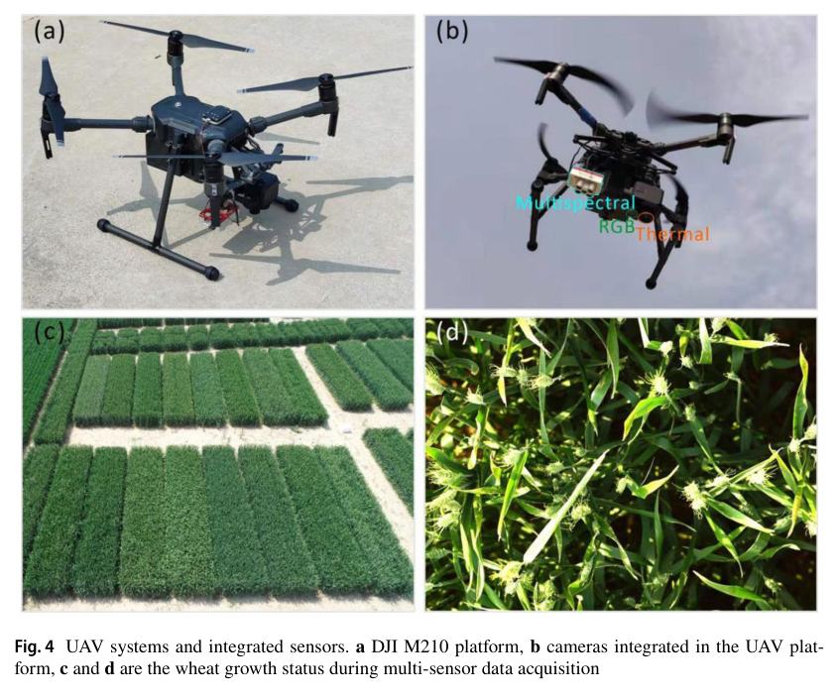
Figure 93. Screenshot — Fei et al. (2023), Fig. 4: UAV system and integrated sensors; wheat at data acquisition.
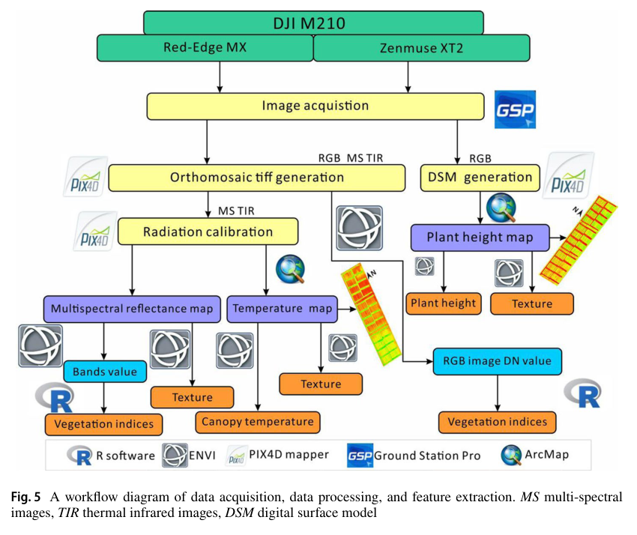
Figure 94. Screenshot — Fei et al. (2023), Fig. 5: workflow of data acquisition, processing and feature extraction.

26.3 Features
- Multispectral: 24 VIs including NDVI, GNDVI, RVI, NDREI, EVI, OSAVI, MCARI, TCARI, NRI, TVI, MSR, SIPI, PSRI, CIRE, MCARI/OSAVI and TCARI/OSAVI.
- RGB: colour indices (IKAW, IPCA, ExR, ExG, ExGR, MGRVI, RGBVI, INT) and crop height from CHM = DSM − bare-soil DEM (R² = 0.84 against field heights).
- Thermal: canopy temperature, which differs significantly between irrigation treatments.
- Texture: GLCM mean, variance, homogeneity, contrast, dissimilarity, entropy, second moment and correlation for each band, height and temperature layer.

26.4 Ensemble learning framework
- Base learners: Cubist, SVM (RBF), deep neural network (DNN, dropout, ReLU), ridge regression (RR), Random Forest.
- Train/test split 4:1, repeated 80 times.
- Outer 5-fold CV on the training set gives out-of-sample predictions for each base learner. An inner 10-fold CV tunes hyper-parameters.
- Stacking: the out-of-sample prediction matrix trains a ridge-regression meta-learner (StRR).
- Metrics: R², RMSE, RPD = SD/RMSE, RPIQ = IQR/RMSE, averaged over 400 tests. VIF checks collinearity between sensor and model predictions.
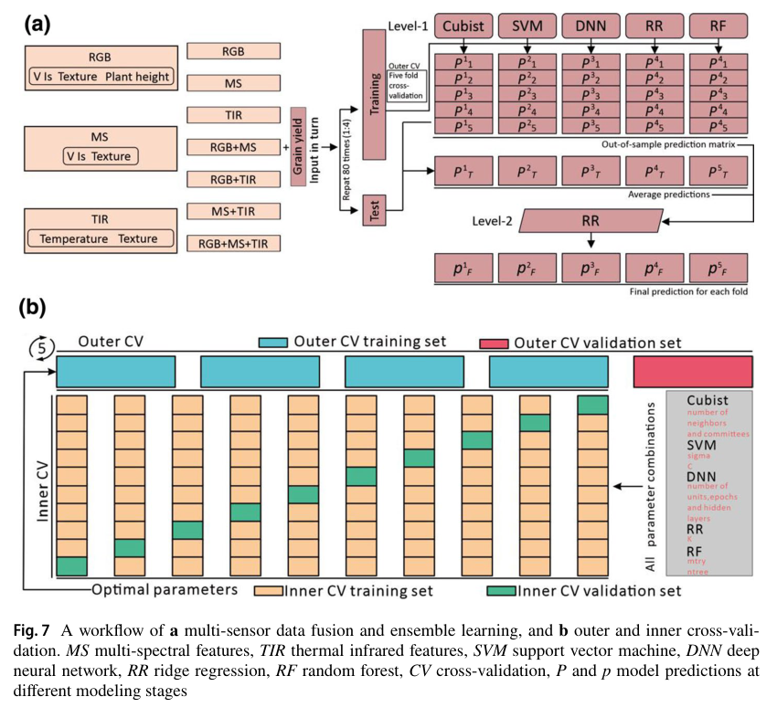
Figure 95. Screenshot — Fei et al. (2023), Fig. 7: (a) multi-sensor fusion and ensemble-learning workflow; (b) nested outer/inner cross-validation.

26.5 Results
- Single sensor: RF was best for MS (R² 0.509) and thermal (0.599). DNN was best for RGB (0.606).
- Two sensors: RF on RGB + TIR (0.670) and on MS + TIR (0.629). DNN on RGB + MS (0.648).
- Three sensors: DNN reached R² 0.670. Individual base learners ranged from 0.527 to 0.670.
- Stacking ensemble: R² up to 0.692, RMSE 0.916 t/ha, RPD 1.771, RPIQ 2.602, better than every individual model.
- Thermal (canopy temperature) is highly informative under differential irrigation (water stress). Fusion adds complementary spectral, structural and thermal information.
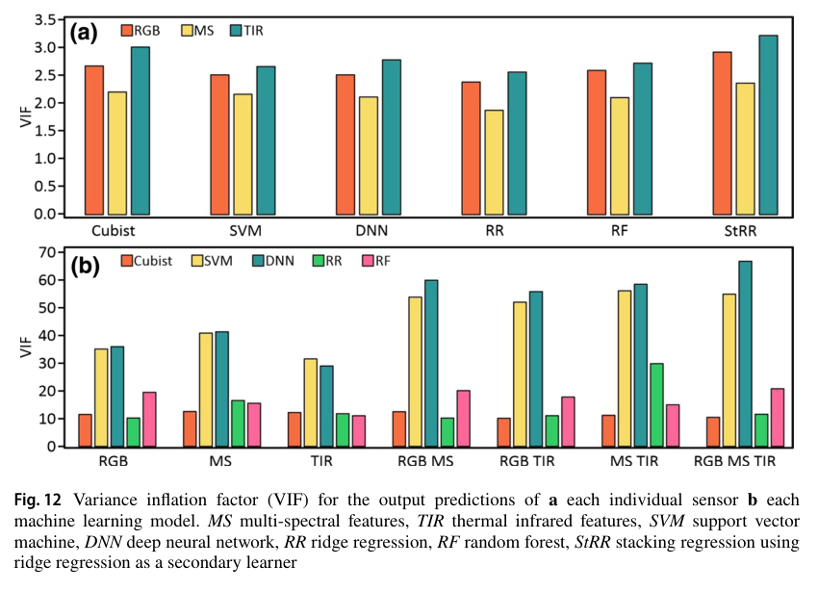
Figure 96. Screenshot — Fei et al. (2023), Fig. 12: variance inflation factor (VIF) between individual sensor/model outputs.
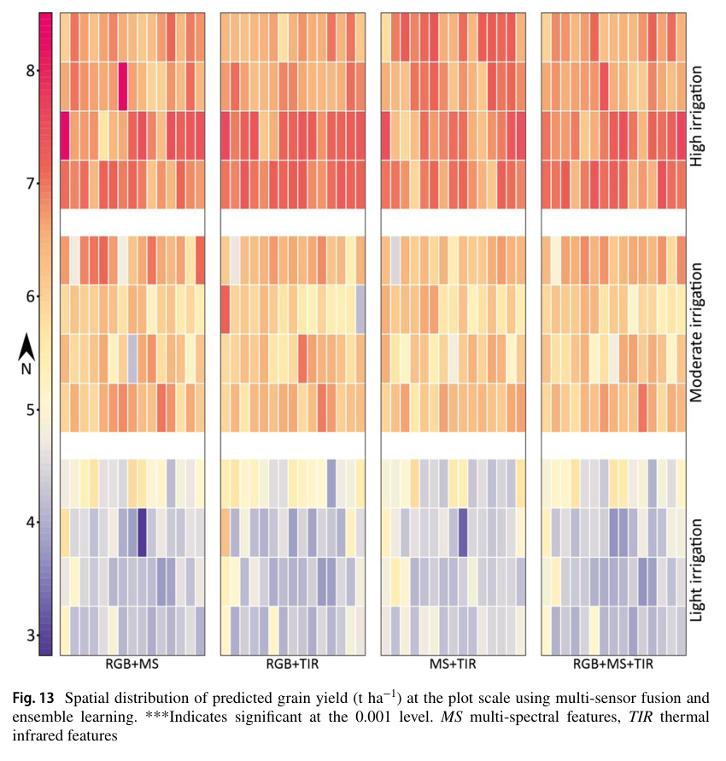
Figure 97. Screenshot — Fei et al. (2023), Fig. 13: spatial distribution of predicted grain yield across plots.

26.6 Relevance and critique
- Transfer to insurance: replace the UAV with Sentinel-1/2, Landsat thermal and future TRISHNA, the plots with GPs and the base learners with semi-physical, CSM and ML models. The stacking logic is the same.
- Limitations: one site and one season, a breeding trial (not farmer fields), and a single acquisition date. Year-to-year transfer is untested.
Q. What is stacking and why does it help?
A. Stacking trains a meta-learner (here ridge regression) on the out-of-fold predictions of diverse base learners. It exploits their complementary errors, so accuracy beats the best single model (R² 0.692 vs ≤ 0.670 in Fei et al.).
Q. Define RPD and RPIQ.
A. RPD = SD of observed values ÷ RMSE. RPIQ = interquartile range ÷ RMSE. Higher is better. RPIQ is preferred for skewed data.
Q. Why nested cross-validation?
A. The inner CV tunes hyper-parameters and the outer CV estimates performance on data not used for tuning. This avoids optimistic bias, and it also produces the out-of-fold predictions needed to train the stacking meta-learner without leakage.

27. Saxena et al. (2019): drought assessment indicators, kharif 2017 vs 2018 (NADAMS)
Citation card: Shalini Saxena, K. Choudhary, R. Saxena, A. Rabha, Preeti Tahlani and S. S. Ray (2019). Comparison of agricultural situation of India for two years (2017 and 2018) using various drought assessment indicators during south west monsoon season in India. ISPRS Archives XLII-3/W6: 499–505 (ISPRS–GEOGLAM–ISRS Workshop, New Delhi, Feb 2019). MNCFC, DAC&FW.

27.1 Why it matters
- It shows the Manual for Drought Management (Dec 2016) procedure applied operationally by MNCFC under NADAMS: Trigger 1 (rainfall) → Trigger 2 (impact indicators) → ground truth.
- Drought declaration drives relief (SDRF/NDRF) and links to PMFBY mid-season adversity. It is also a classic example of El Niño-year assessment.

27.2 Concepts defined in the paper
- Types of drought: meteorological, hydrological, agricultural and socio-economic. Agricultural drought is a soil-moisture deficiency during crop growth, when transpiration plus evaporation demand exceeds available soil moisture.
- About 70 % of India's annual rainfall comes from the SW monsoon (Jun–Sep). Drought indicators include delayed onset, early withdrawal and long gaps between effective rains.
- New Drought Manual 2016, 3 levels: (1) Trigger 1: rainfall deviation or SPI plus dry spell. (2) Trigger 2: 3 of 4 impact indicators (crop sowing, remote sensing, soil moisture, hydrology) assess severity. (3) For moderate or severe cases, the State does ground truthing.
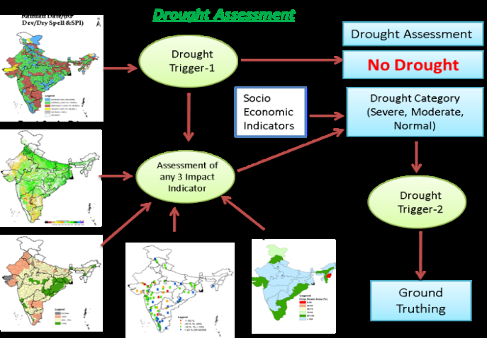
Figure 98. Screenshot — Saxena et al. (2019), Fig. 2: flow chart of the drought-assessment methodology (Trigger 1 → impact indicators → drought category → ground truthing).

27.3 Data and indicators
Indicator | Data / formula | Level
NDVI | (NIR − R)/(NIR + R); Resourcesat-2 AWiFS (56 m), MODIS (250 m). Deviation from the recent normal year (state-specific) | District / taluk
NDWI (surface wetness) | (NIR − SWIR)/(NIR + SWIR); MODIS 250 m | District / taluk
PASM | Percent Available Soil Moisture, top 30 cm, from an NRSC daily water-balance model: (SMc − PWP)/(FC − PWP) × 100, using NOAA-CPC rainfall, global PET and NBSS&LUP 1:0.5 M soils | District
SPI | Gamma fit of long-term precipitation (NOAA CPC 0.5°, 1979–2018) transformed to a standard normal | Grid / district
Rainfall and dry spell | IMD weekly district rainfall. Dry spell = > 50 % deficit for 3 consecutive weeks (light soils) or 4 weeks (heavy soils). Scanty = > 60 % deficit in September | District
Crop sown area, irrigation, reservoirs | DAC&FW Crops Division; DES land-use statistics; CWC reservoir storage | State / district

27.4 Results: 2018 vs 2017
- Monsoon onset over Kerala: 30 May 2017 and 29 May 2018. Season rainfall: 2017 −5 % (841.3 vs 887.5 mm); 2018 −9 % of LPA (to 26 Sep), with 12 of 36 sub-divisions (32 % of area) deficient.
- 2018: 284 of 553 districts in 17 states had Trigger 1 = Yes, from 282 dry-spell districts, 20 with < 50 % rainfall and 9 scanty (e.g. Kachchh, Banaskantha, Patan, Fazilka, Firozpur, Jalore). Severe drought was found in AP (Anantapur, Nellore, Kadapa, Prakasam), Karnataka (Chikballapur, Chitradurga, Raichur), Rajasthan (Jalore) and Maharashtra (Aurangabad).
- 2017: also 284 districts with Trigger 1 = Yes, but none had both impact indicators severe. 4 were moderate–moderate (Mahendragarh, Rewari, Jaipur, Jhunjhunu) and 230 were normal or mild.
- In 2018 the kharif sown area was 1052.38 lakh ha, vs 1072.79 lakh ha in 2017. Ground surveys in 12 states confirmed dry soils and poor cotton and groundnut in Karnataka and Gujarat.
- Conclusion: even with a normal monsoon onset in 2018, long dry spells in July–August delayed paddy transplanting, stunted crops and depleted reservoirs, producing drought.
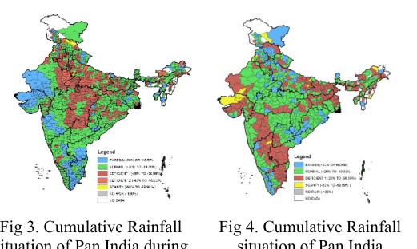
Figure 99. Screenshot — Saxena et al. (2019), Figs 3–4: cumulative rainfall situation, 1 Jun–30 Sep 2017 and 2018.
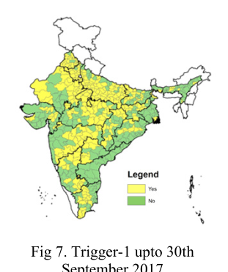
Figure 100. Screenshot — Saxena et al. (2019), Figs 7–8: Trigger-1 districts up to 30 September 2017 and 2018.
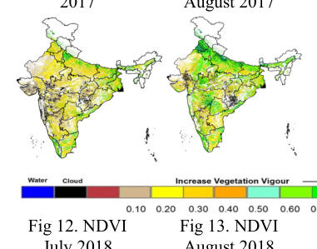
Figure 101. Screenshot — Saxena et al. (2019), Figs 12–13: AWiFS NDVI, July and August 2018.
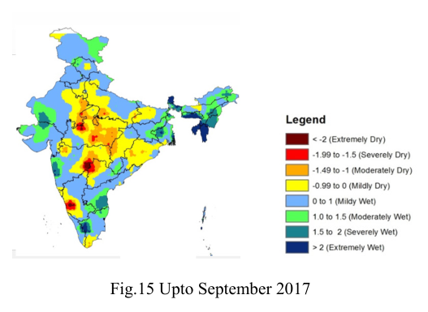
Figure 102. Screenshot — Saxena et al. (2019), Fig. 15: SPI up to September 2017.
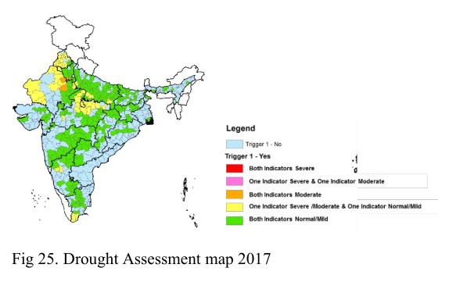
Figure 103. Screenshot — Saxena et al. (2019), Fig. 25: drought assessment map, 2017.
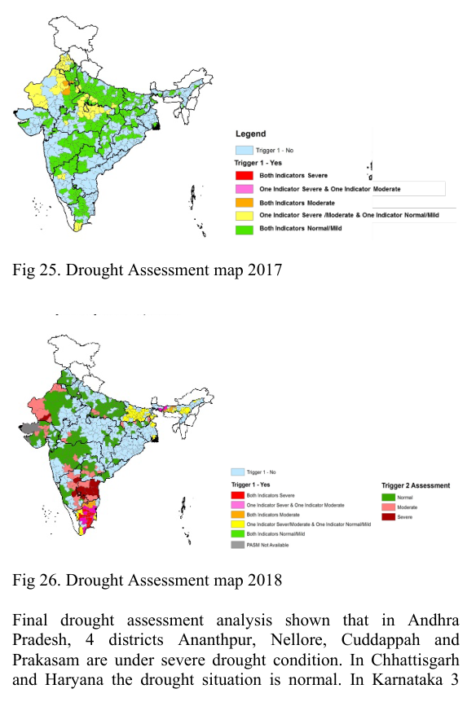
Figure 104. Screenshot — Saxena et al. (2019), Fig. 26: drought assessment map, 2018.

27.5 Critique and extension
- Coarse PASM (CPC rainfall) and NDVI deviation lag behind real stress. Add NISAR 100 m soil moisture, ESI/ET anomaly (thermal) and SIF for earlier flash-drought detection.
- A “recent normal year” baseline is subjective. Use long-term percentiles (VCI) or anomalies from a 10+ year climatology.
Q. Describe the 2016 Drought Manual procedure.
A. Trigger 1 checks rainfall deviation or SPI and dry spells. If it is on, Trigger 2 assesses 3 of 4 impact indicators (crop sowing, RS vegetation and water indices, soil moisture, hydrology) to grade severity. Moderate or severe districts are then verified by state ground truthing before declaration.
Q. What is a dry spell in this methodology?
A. Rainfall deficit above 50 % for three consecutive weeks in light soils or four weeks in heavy soils.
Q. What is PASM?
A. Percent Available Soil Moisture = (current SM − wilting point)/(field capacity − wilting point) × 100, for the top 30 cm, from NRSC's daily water-balance model.

28. Giglio, Schroeder & Justice (2016): MODIS Collection 6 active fire algorithm
Citation card: Louis Giglio, Wilfrid Schroeder and Christopher O. Justice (2016). The collection 6 MODIS active fire detection algorithm and fire products. Remote Sensing of Environment 178: 31–41. University of Maryland.

28.1 Why it matters
- MODIS (MOD14/MYD14) and its VIIRS successor feed NASA FIRMS, which the IARI CREAMS daily residue-burning bulletin uses. You must be able to explain the algorithm step by step and the FRP formula.

28.2 Channels used
Band | λ (µm) | Purpose
1 | 0.65 | Sun-glint and coastal false-alarm rejection; cloud masking
2 | 0.86 | Bright-surface, glint and coastal rejection; cloud masking
7 | 2.1 | Sun-glint and coastal rejection
21 | 4.0 | High-range (saturates at a higher temperature) fire channel
22 | 4.0 | Low-range fire channel (main T4)
31 | 11.0 | Fire detection, cloud masking, forest-clearing rejection
32 | 12.0 | Cloud masking

28.3 Algorithm steps (Collection 6)
- Land/water/coast masking with the updated MOD03 1 km mask. Coast pixels are not processed. New in C6: water pixels are processed too, to detect offshore gas flares.
- Cloud masking (day, SZA < 85°): (ρ0.65 + ρ0.86 > 1.2) or (T12 < 265 K) or (ρ0.65 + ρ0.86 > 0.7 and T12 < 285 K) or (water pixel and ρ0.86 > 0.25 and T12 < 300 K). Night: T12 < 265 K. The thresholds were relaxed slightly so thick smoke is not called cloud.
- Potential fire pixels: T4 > T4, ΔT (= T4 − T11) > ΔT, and ρ0.86 < 0.35 by day. New in C6: dynamic thresholds for each of the 1354 scan positions, computed over a 301 × 30 moving window: T4 = mean(T4) + 5 K (bounded 300–330 K) and ΔT = mean(ΔT) + 5 K (bounded 10–35 K). C5 used fixed 310 K (305 K at night) and 10 K.
- Background characterisation: valid neighbours in a window of up to 21 × 21, giving means and mean absolute deviations (T̄4, δ4, T̄11, δ11, ΔT̄, δΔT). The background must be land-only or water-only, matching the pixel.
- Tentative detection: absolute test (1) T4 > 360 K (320 K at night), OR contextual tests (2) ΔT > ΔT̄ + 3.5 δΔT, (3) ΔT > ΔT̄ + 6 K, (4) T4 > T̄4 + 3 δ4, and (5) T11 > T̄11 + δ11 − 4 K or (6) δ′4 > 5 K. Day: (1), or (2)–(4) plus (5) or (6). Night: (1), or (2)–(4).
- Rejection tests (day): sun glint (glint angle < 2°, or < 10° with bright reflectances, or < 15° near water), desert boundary, coastal, and the new forest-clearing test, which removes hot bare clearings in tropical forest. There is also a water-pixel coastal rejection.
- Confidence: the geometric mean of sub-confidences C1–C5, which use T4, standardised z4 and zΔT, and the numbers of adjacent cloud and water pixels.
- FRP (new in C6): the Wooster radiance method replaces the Kaufman empirical formula.
FRP ≈ (Apix · σ / (a · τ4)) · (L4 − L̄4), a = 3.0 × 10⁻⁹ W m⁻² sr⁻¹ µm⁻¹ K⁻⁴ (MODIS), τ4 = 1 in Level 2
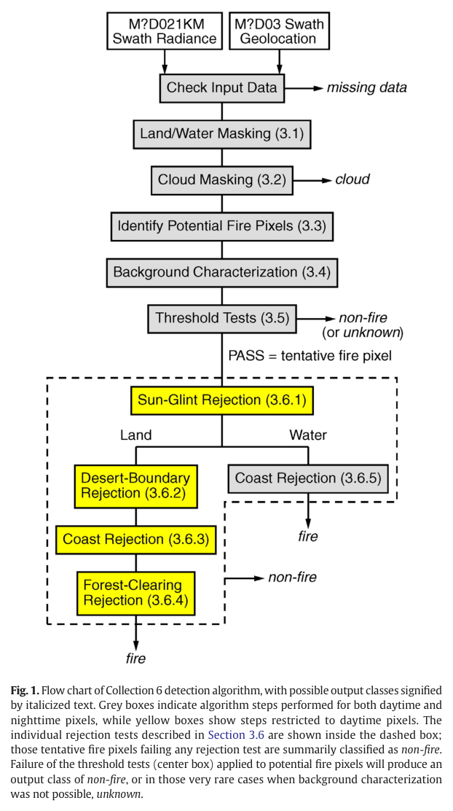
Figure 105. Screenshot — Giglio et al. (2016), Fig. 1: flow chart of the Collection 6 detection algorithm (grey = day and night steps; yellow = daytime-only rejection tests).
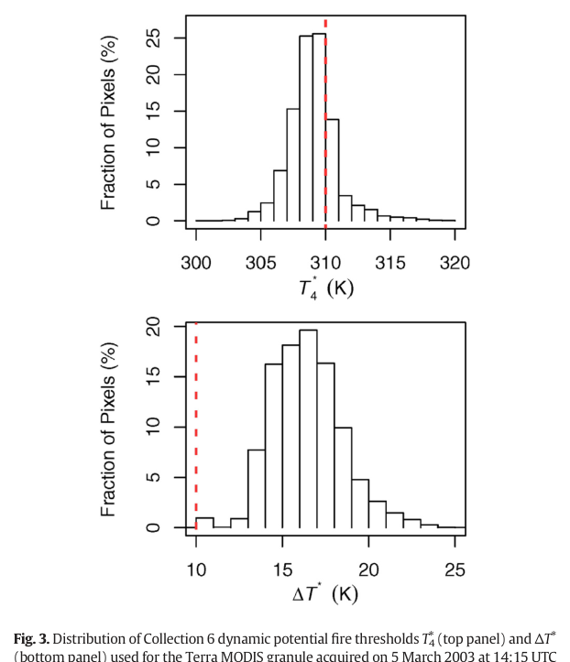
Figure 106. Screenshot — Giglio et al. (2016), Fig. 3: distribution of dynamic potential-fire thresholds T4 and ΔT compared with the fixed C5 thresholds.
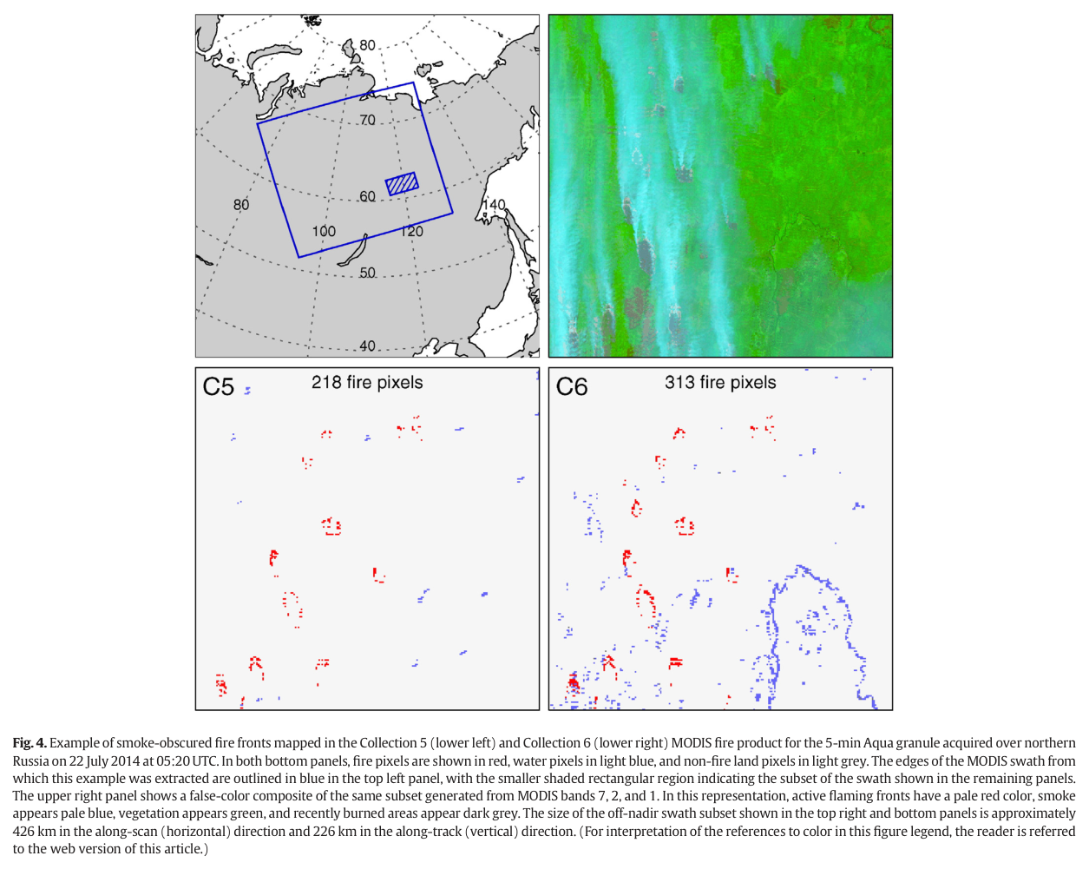
Figure 107. Screenshot — Giglio et al. (2016), Fig. 4: smoke-obscured fire fronts mapped in C5 vs C6 (northern Russia, 22 July 2014).
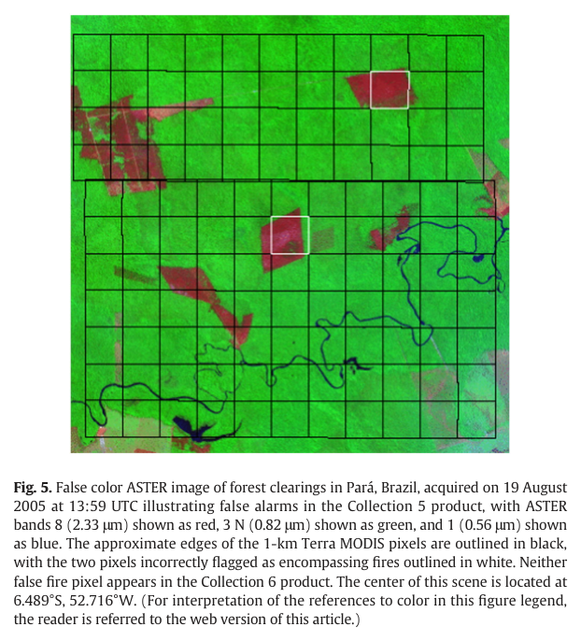
Figure 108. Screenshot — Giglio et al. (2016), Fig. 5: ASTER image of forest clearings (Pará, Brazil) that caused C5 false alarms, removed in C6.

28.4 Validation results (Stage-3, more than 2500 ASTER scenes)
- Daytime global commission error: 1.2 % (C6) vs 2.4 % (C5). No night-time false alarms were found (838 fire pixels among about 500,000 night pixels).
- Omission error for all fire sizes (ASTER fires as small as about 4 m²) was 86.2 %, but below 10 % for fires of ≥ 140 ASTER pixels, stabilising at about 5 % for > 250 pixels. Small fires are the main source of omission, which matters for small Punjab stubble fires.
- Probability of detection ranged from 7 % (Middle East) to 26 % (Australia), driven by median fire size. C6 gained about 3 % in boreal regions.
- The C6 FRP fell on average 16 % (mean 56.9 → 47.7 MW) for commonly detected pixels, with slight increases only above about 500 MW.
- False alarms are higher in high-tree-cover areas (clearings). Industrial heat sources are excluded via persistence analysis.
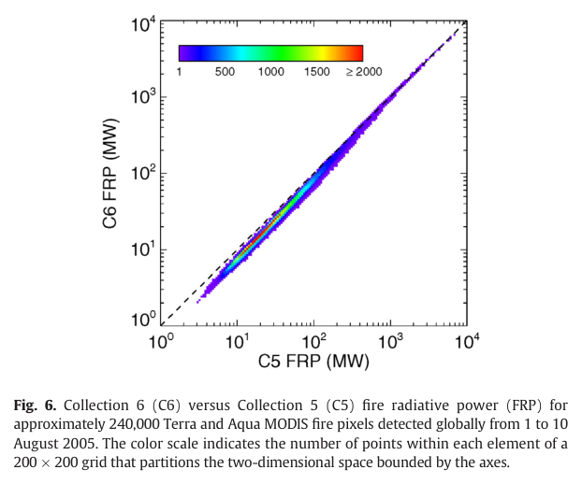
Figure 109. Screenshot — Giglio et al. (2016), Fig. 6: C6 vs C5 fire radiative power for about 240,000 fire pixels.
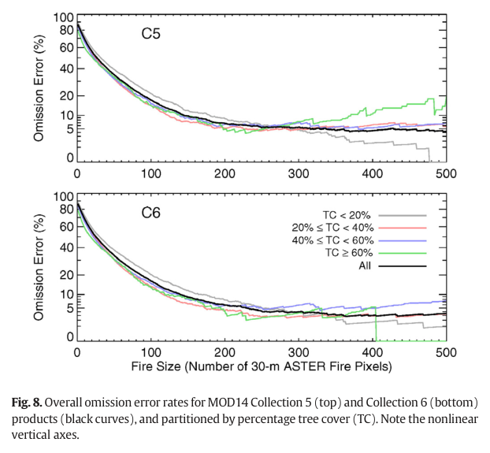
Figure 110. Screenshot — Giglio et al. (2016), Fig. 8: omission error vs fire size (number of 30 m ASTER fire pixels) for C5 and C6.
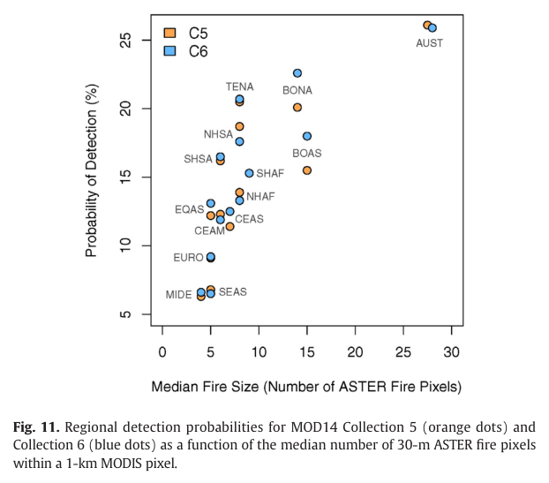
Figure 111. Screenshot — Giglio et al. (2016), Fig. 11: regional detection probability vs median fire size.

28.5 Relevance to Indian residue burning
- Punjab and Haryana stubble fires are small and short, so 1 km MODIS misses many of them. This is why VIIRS 375 m and Sentinel-2 burnt-area mapping are used, and why fire counts underestimate burning (Chapter 10).
- Overpass timing (Terra 10:30, Aqua 13:30) plus the shift of burning to the late afternoon makes geostationary detection (INSAT-3DS) and burnt-area mapping necessary.
- Use FRP rather than counts for emissions, and remember that the Level-2 FRP assumes τ4 = 1 (no atmospheric correction).
Q. Explain the MODIS contextual fire algorithm.
A. After cloud and water masking, potential fire pixels are flagged when 4 µm brightness temperature and the 4−11 µm difference exceed thresholds (dynamic in C6). Each is compared with statistics of valid background neighbours: it must stand out by several MADs in ΔT and T4, or exceed 360 K absolutely. Daytime candidates then pass sun-glint, desert, coastal and forest-clearing rejection tests. A confidence is assigned and FRP is computed from the excess 4 µm radiance.
Q. What changed in Collection 6?
A. Dynamic potential-fire thresholds, cloud tests tuned so smoke is not masked, processing over water for gas flares, a forest-clearing rejection test, and the Wooster radiance-based FRP. Daytime commission error halved from 2.4 % to 1.2 %.
Q. Why do fire counts underestimate stubble burning?
A. Omission is very high for small fires (86 % over all ASTER-detected fire sizes, < 10 % only for large fires). Agricultural fires are small and short, and many burn outside the 10:30 and 13:30 overpasses, so many are missed.

29. Cammalleri, Anderson & Kustas (2014): upscaling ET from instantaneous to daytime
Citation card: C. Cammalleri, M. C. Anderson and W. P. Kustas (2014). Upscaling of evapotranspiration fluxes from instantaneous to daytime scales for thermal remote sensing applications. Hydrology and Earth System Sciences 18: 1885–1894. USDA-ARS Hydrology and Remote Sensing Laboratory, Beltsville (ALEXI group).

29.1 Why it matters
- It directly answers your notes' question on instantaneous-to-daily scaling and gives the evidence for which reference variable works best. It extends the “AET/ET₀ ratio stays constant” idea from your notes.

29.2 Concept: self-preservation
ETd−X = β · (1/λ) · (λETt / Xt) · Xd
λETt is the instantaneous latent heat at overpass time t. X is the reference variable at time t (Xt) and integrated over the day (Xd). β is a bias-correction factor. The assumption is that ET/X is conserved through the day (Crago 1996).
Table 27. Upscaling methods compared
Method | Reference variable X | Notes
EF | Available energy Rn − G0 | Commonly used (SEBAL). β = 1.1 is applied because EF is higher in early morning and late afternoon, so midday EF underestimates the daytime mean
RS | Incoming solar radiation Rs at the surface | Needs only insolation, available from geostationary satellites
TOA | Top-of-atmosphere (clear-sky) irradiance | No data needed at all, but blind to clouds
REF | FAO-56 reference ET (ETo) | Used in METRIC/Trezza 2002 for irrigated agriculture; needs full meteorology
RN / RSW (variants) | Rn only (G ignored) / net shortwave only | Test the value of the G and longwave components

29.3 Data and evaluation design
- 12 AmeriFlux EC towers (croplands at Mead, Bondville, Brooks Field, Fermi; forests; grasslands; savannas), each with 2 years of half-hourly data.
- Three “truths” for daytime ET because of EC energy-balance non-closure: Unclosed, Residual (λET = Rn − G − H) and Bowen (closure forced preserving the Bowen ratio).
- Only days clear at overpass (Rs/RTOA > 0.70). Seven overpass times, 09:00 to 15:00. Up to 21 ensemble estimates per day (7 times × 3 closure scenarios).
- Accuracy classes: acceptable (between ETmin and ETmax), moderate (within Δ = 0.5 × (ETmax − ETmin) beyond them), major (further). This is a new uncertainty-aware evaluation in place of a single “truth”.
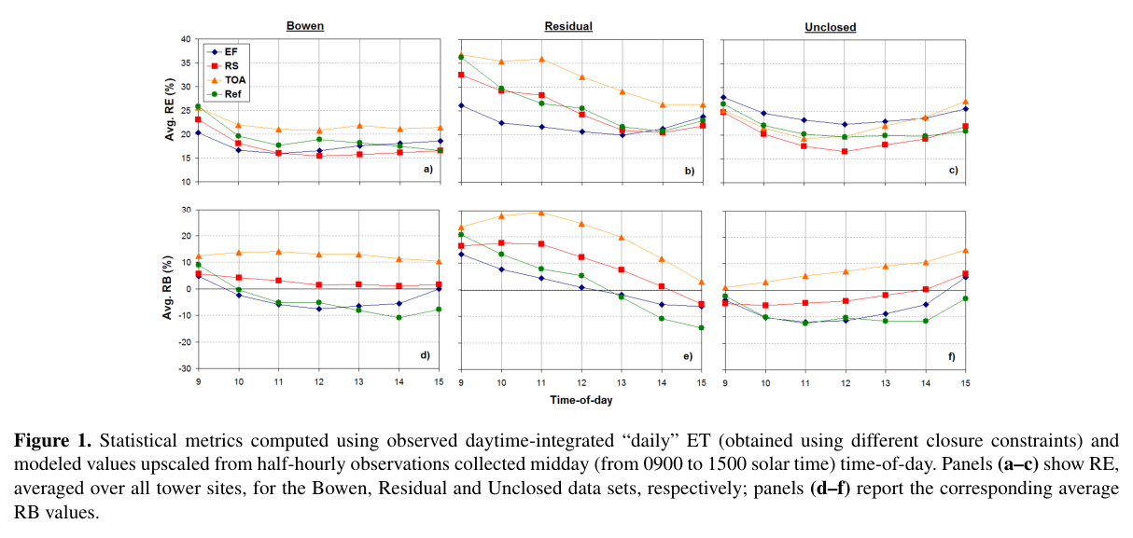
Figure 112. Screenshot — Cammalleri et al. (2014), Fig. 1: relative error and bias of the upscaling methods vs overpass time under Bowen, Residual and Unclosed closure.

29.4 Results
- The choice of closure method changes the apparent ranking of methods, a key lesson for validating ET with eddy covariance.
- Acceptable-accuracy frequency: RS 46 %, REF 44 %, EF 43 % and TOA 43 %. RS had the lowest site-to-site SD (5 %).
- Bias: RS is practically unbiased (27 % over, 27 % under). TOA overestimates (38 %, worse on partly cloudy days, R² = 0.74 with clear-sky fraction). REF and EF underestimate (37 % and 41 %).
- β = 1.1 for EF raised accuracy from 41 % to 43 % and cut underestimation from 50 % to 41 %.
- Time of day: only RS is uniform across overpass times. EF has least bias for early (09–10 h) or late (15 h) overpasses. TOA is biased high in the morning, REF biased low in the afternoon.
- Season: RS is stable all year (SD 3 %). EF works well June–August but underestimates in up to 75 % of cases from November to January. Neglecting G (RN) increases seasonality, while net shortwave (RSW) reduces it. The longwave term causes EF's seasonality.
- REF (ETo) is good for 10:00 overpasses (Landsat, Terra) but has a stable negative bias; β ≈ 1.2 is suggested.
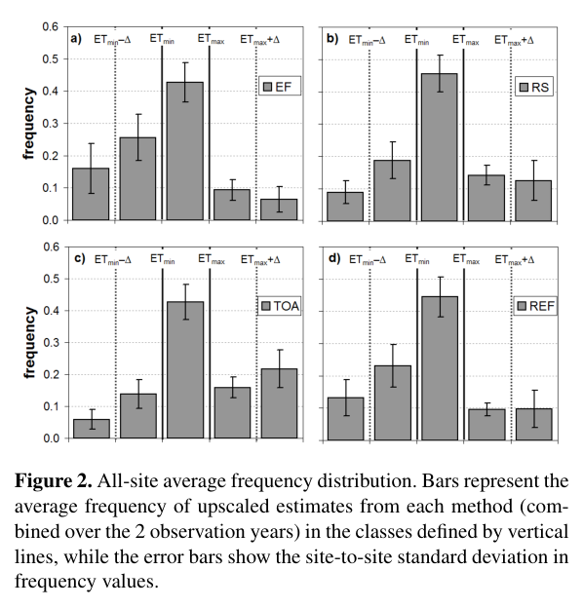
Figure 113. Screenshot — Cammalleri et al. (2014), Fig. 2: all-site average frequency distribution of upscaled ET in accuracy classes for each method.
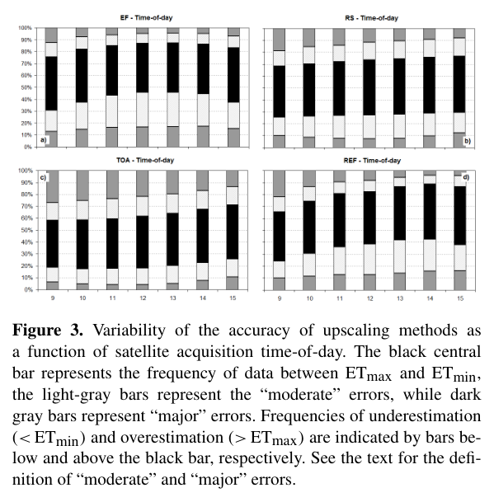
Figure 114. Screenshot — Cammalleri et al. (2014), Fig. 3: accuracy of upscaling methods as a function of satellite overpass time.
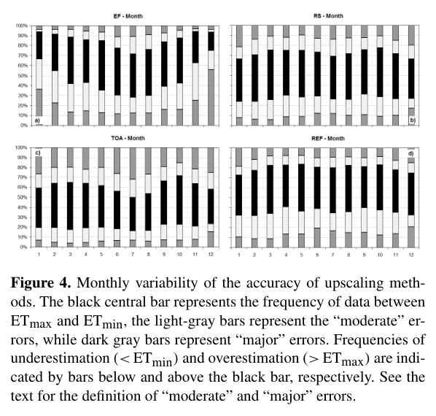
Figure 115. Screenshot — Cammalleri et al. (2014), Fig. 4: monthly variability of accuracy for EF, RS, TOA and REF.
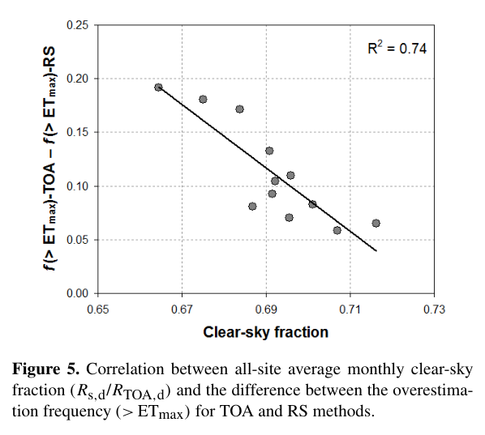
Figure 116. Screenshot — Cammalleri et al. (2014), Fig. 5: TOA overestimation vs monthly clear-sky fraction (R² = 0.74).

29.5 How to use it in the interview
- Say: “Self-preservation is not perfect. Cammalleri et al. (2014) showed with 12 AmeriFlux towers that solar-radiation scaling is the most robust and unbiased. EF underestimates outside summer, and ETo-based scaling (METRIC's ETrF) is good for morning overpasses but biased low.”
- For India: INSAT-3D/3DS hourly insolation makes RS scaling operationally attractive for Landsat, Sentinel-3 and TRISHNA-based ET. For irrigated rabi wheat with Landsat at 10:30, ETrF × ETr is also acceptable.
- Validation lesson: report results under multiple closure assumptions when using EC towers (NRSC, NRRI).
Q. Which reference variable is best for daily ET scaling and why?
A. Incoming solar radiation (RS method). It had the highest acceptable-accuracy frequency (46 %), no systematic bias, and stable performance across seasons and overpass times. It also only needs insolation, which geostationary satellites provide.
Q. Why does the EF method underestimate daily ET?
A. EF is not truly constant. It is higher in early morning and late afternoon, so the midday value is below the daytime mean, especially in winter, when the longwave component makes it seasonal. A correction β ≈ 1.1 is applied.
Q. Why does energy-balance closure matter for this evaluation?
A. EC towers typically close only 70–90 % of the energy balance. The ‘true’ daily ET depends on whether you use unclosed fluxes, residual λET or Bowen-ratio-preserved closure, and the ranking of methods changes with that choice. Hence the paper's ensemble ETmin–ETmax evaluation.

30. Goulden et al. (1996): carbon sequestration by long-term eddy covariance, methods and accuracy
Citation card: M. L. Goulden, J. W. Munger, S.-M. Fan, B. C. Daube and S. C. Wofsy (1996). Measurements of carbon sequestration by long-term eddy covariance: methods and a critical evaluation of accuracy. Global Change Biology 2: 169–182. Harvard University (Harvard Forest, Massachusetts).

30.1 Why it matters
- It is the classic paper on the accuracy of eddy covariance: the error framework, *u filtering** and gap-filling uncertainty. These underpin carbon MRV, flux-tower validation of satellite GPP and ET, and NRSC's flux network.

30.2 Site and set-up
- Harvard Forest (42°32′ N, 72°11′ W, 340 m), a 50–70-year-old aggrading deciduous forest (red oak, red maple) with a 20–24 m canopy, measured 1990–1994.
- A 31 m narrow tower (to minimise flow distortion). The 3-axis sonic anemometer at 30 m points west into the prevailing wind. A closed-path IRGA (LI-COR 6262) in a hut is fed by a 50 m Teflon tube at 6–8 L/min, with pressure controlled at 60 kPa. Auto-calibration (1 % CO₂ addition) runs every 5 h, and sampling is at 4 Hz.
- Flux = 30-minute covariance of w′ and c′: linear detrending, time lag from the maximum correlation, coordinate rotation to zero mean vertical wind, and a high-frequency damping correction (0–2 % by day, 0–5 % at night) scaled by the ratio of fast- to slow-response heat flux.
- A CO₂ profile at 8 levels gives storage below 30 m. NEE = eddy flux + storage. Ancillary: PPFD, net radiation, temperature, humidity, soil temperature and soil respiration chambers.

30.3 The three-part error framework (memorise)
Error type | Meaning | Finding / correction
1. Uniform systematic | Constant fractional error regardless of conditions (e.g. gas-analyser span). A 15 % error in hourly flux gives a 15 % error in the annual total | Energy-budget analysis suggests −20 to 0 % for turbulent fluxes; turbulent fluxes underestimate available energy by about 5–10 %
2. Selective systematic | Accuracy varies with the environment, e.g. calm nights | Night flux was underestimated when *u < 0.17 m s⁻¹ (compared with chambers). Calm-night data are replaced by a respiration–temperature model. A small night bias causes a large overestimate of annual sequestration**
3. Sampling uncertainty | Gaps (maintenance, failures, lightning) filled to compute annual totals | Monte Carlo: ±0.3 t C ha⁻¹ y⁻¹ (90 % CI). Long gaps in active seasons hurt most, while short scattered gaps are acceptable

30.4 Key results
- Annual net carbon sequestration (1994): 2.1 t C ha⁻¹ y⁻¹, with sampling uncertainty ±0.3 and an overall uncertainty of −0.3 to +0.8 t C ha⁻¹ y⁻¹.
- Long-term precision of the EC system is better than ±5 %.
- The light response of daytime photosynthesis was very tight (scatter about ±5 µmol m⁻² s⁻¹). Night-time respiration followed soil temperature.
- About half the annual sampling uncertainty came from a July data gap after lightning damage. Winter gaps mattered little.
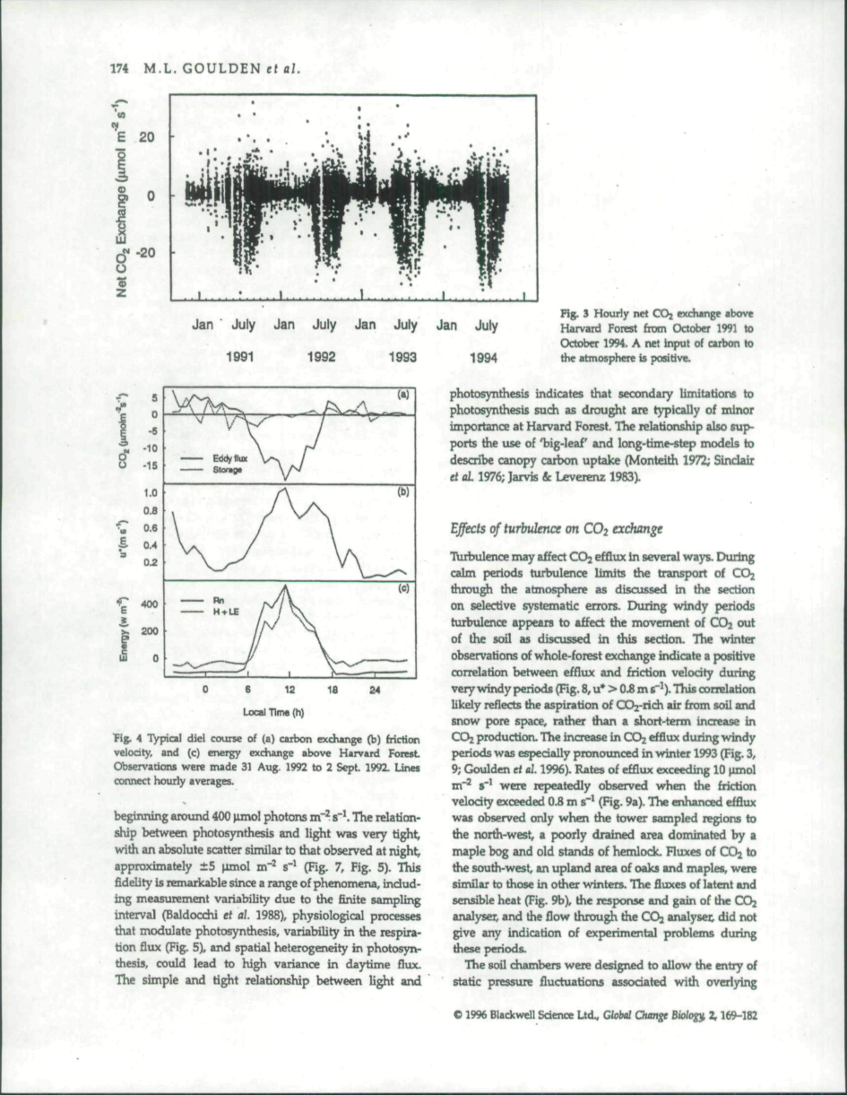
Figure 117. Screenshot — Goulden et al. (1996), page with Fig. 4: typical diel course of carbon exchange and friction velocity (scanned page).
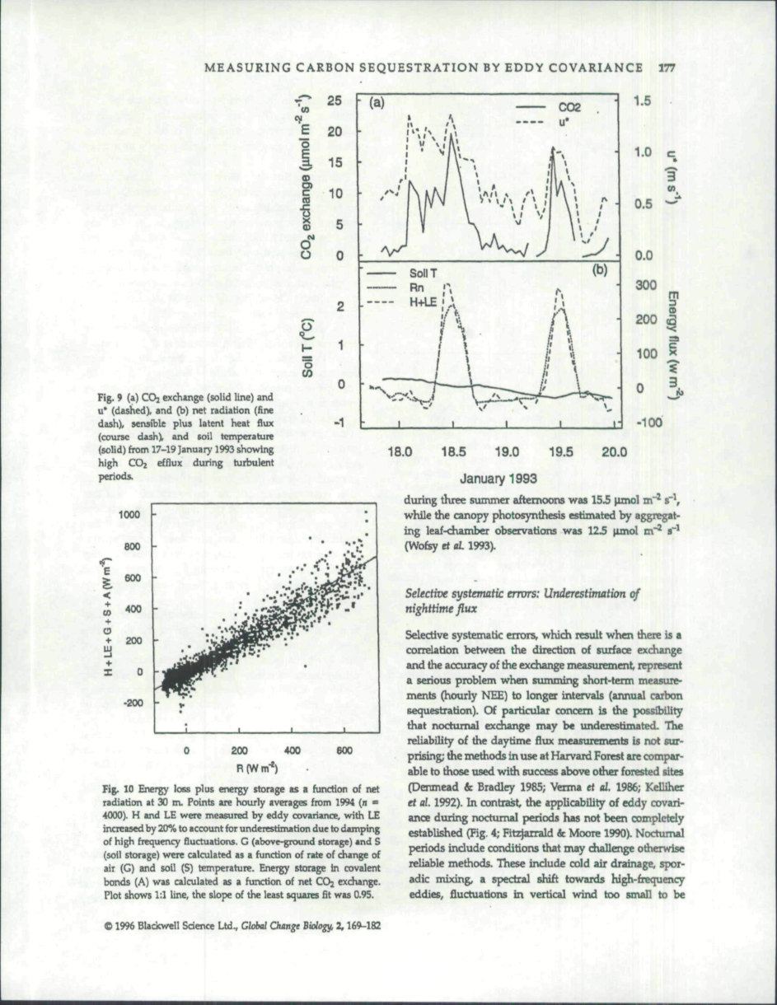
Figure 118. Screenshot — Goulden et al. (1996), page with Fig. 9 and Fig. 10: energy loss plus storage vs net radiation (energy-balance closure).
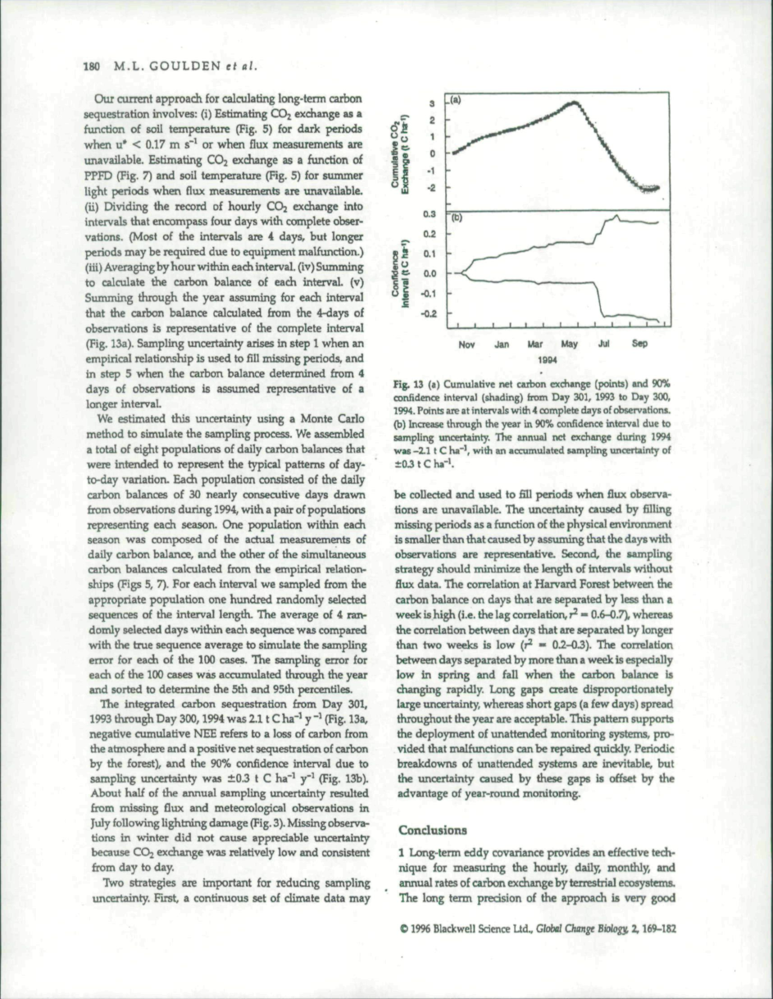
Figure 119. Screenshot — Goulden et al. (1996), page with Fig. 13: cumulative net carbon exchange and growth of sampling uncertainty through the year.

30.5 Lessons for India and carbon MRV
- Annual NEE is a small difference of two large fluxes (GPP and Reco), so *night-time bias control (u filter) and gap-filling** are critical. This applies equally to farm-level carbon-credit claims.
- Use EC towers to calibrate and validate satellite GPP (LUE, SIF), ET and soil-carbon models in MRV. Report uncertainty explicitly, as ICVCM principles demand.
- Indian towers (NRSC, NRRI rice) should apply the same QA: closure checks, u* thresholds, storage terms and Monte-Carlo uncertainty.
Q. What is u* filtering and why is it needed?
A. On calm nights (low friction velocity) turbulence is weak and CO₂ from respiration pools or drains away instead of reaching the sensor, so eddy flux underestimates respiration. Goulden et al. found this below u* ≈ 0.17 m/s. Those periods are discarded and filled with a temperature–respiration model; otherwise annual sequestration is overestimated.
Q. List the three error categories in long-term EC.
A. Uniform systematic errors (constant fractional bias, e.g. calibration), selective systematic errors (bias depending on conditions, e.g. calm nights), and sampling uncertainty (from gaps and gap-filling, estimated by Monte Carlo).
Q. Why does a small night-time error matter so much?
A. Annual sequestration = daytime uptake − night-time and winter respiration, a small residual of two large numbers. A few percent of night-time underestimation translates into a large relative overestimate of net uptake.

31. Jacquemoud et al. (2009): PROSPECT + SAIL (PROSAIL), a review of use for vegetation characterisation
Citation card: S. Jacquemoud, W. Verhoef, F. Baret, C. Bacour, P. J. Zarco-Tejada, G. P. Asner, C. François and S. L. Ustin (2009). PROSPECT + SAIL models: A review of use for vegetation characterization. Remote Sensing of Environment 113: S56–S66.

31.1 Why it matters
- PROSAIL is the most used radiative transfer model (RTM) for crops. It is the basis of LAI, fAPAR and chlorophyll retrieval (e.g. the Sentinel-2 SNAP biophysical processor) and of precision-farming N services. This answers “retrieving crop parameters” and “radiative transfer models” in your notes.

31.2 The models
- SAIL (Scattering by Arbitrary Inclined Leaves; Verhoef 1984) extends the Suits (1972) 1-D model. It treats the canopy as a turbid medium and solves four up- and down-welling fluxes for the bidirectional reflectance factor. Variants: SAILH (hot spot, after Kuusk 1991), 4SAIL (fast, robust; also thermal emission), GeoSAIL and 2M-SAIL (vertical heterogeneity), 4SAIL2 (crown clumping), FLSAIL and FluorSAIL (fluorescence).
- PROSPECT (Jacquemoud & Baret 1990) models leaf directional–hemispherical reflectance and transmittance from 400 to 2500 nm using the plate model (Allen et al. 1969). Inputs are the structure parameter N (number of layers) and biochemistry. Later versions separate chlorophylls and carotenoids (Feret et al. 2008).
- PROSAIL coupling (Baret et al. 1992): PROSPECT's leaf ρ and τ go into SAIL along with soil reflectance (or a Hapke soil BRDF) and geometry, and can be coupled to an atmospheric RTM for top-of-atmosphere radiance. Outputs: canopy reflectance, plus fAPAR and albedo.
Table 28. Main PROSAIL variables (Jacquemoud et al. 2009, Table 1)
Model | Symbol | Quantity | Unit
PROSPECT | N | Leaf structure parameter | –
PROSPECT | Cab | Chlorophyll a + b | µg cm⁻²
PROSPECT | Cw | Equivalent water thickness | cm
PROSPECT | Cm | Dry matter content | g cm⁻²
PROSPECT | Cbp | Brown pigments | –
SAIL | LAI | Leaf area index | –
SAIL | LIDF (ALA) | Leaf inclination distribution (average leaf angle) | –
SAIL | sL | Hot-spot parameter | –
SAIL | ρs | Soil reflectance | –
SAIL | SKYL | Diffuse/total radiation | –
SAIL | θs, θv, φsv | Solar zenith, view zenith, relative azimuth | deg

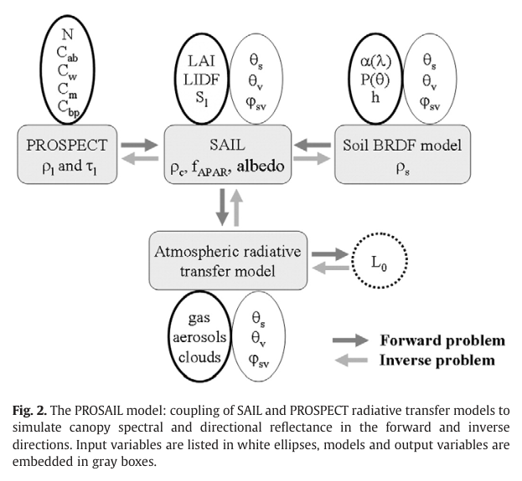
Figure 120. Screenshot — Jacquemoud et al. (2009), Fig. 2: the PROSAIL model, coupling PROSPECT and SAIL (with soil BRDF and atmospheric RT) in forward and inverse directions.

31.3 Sensitivity analysis findings
- Red edge: spectral shifts are driven mainly by chlorophyll and LAI and are almost insensitive to soil and atmosphere. With 1 nm PROSPECT, the red-edge position jumps from about 695 to about 725 nm when Cab exceeds 45 µg cm⁻² (Le Maire et al. 2004).
- LAI effect (Fig. 3): increasing LAI lowers red and raises NIR reflectance, with no effect at the 1450 nm water band. SWIR is sensitive to LAI between 1000 and 1400 nm, so be careful with water indices.
- Variance decomposition (DOES method, Bacour et al.): Cab explains about 60 % of reflectance variance in the visible. In the NIR, ALA and LAI contribute equally. In the SWIR, Cw about 50 % (1450–2100 nm). Interactions: Cab–LAI and Cab–ALA about 8 % each in the VIS, LAI–ALA 5–6 % in the NIR.
- Directional: Cab is best seen in the backward (shadow-free) direction. LAI is best seen in oblique directions and ALA near nadir. Accurate Cab, LAI and ALA estimation needs at least three view angles (forward, nadir, backward).
- N barely changes canopy reflectance, and LAI and ALA compensate for each other, which is the root of ill-posedness.
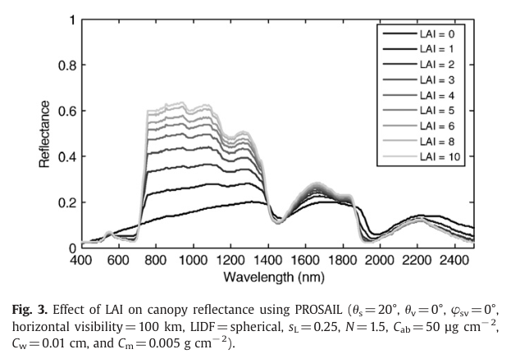
Figure 121. Screenshot — Jacquemoud et al. (2009), Fig. 3: effect of LAI (0–10) on canopy reflectance simulated with PROSAIL.
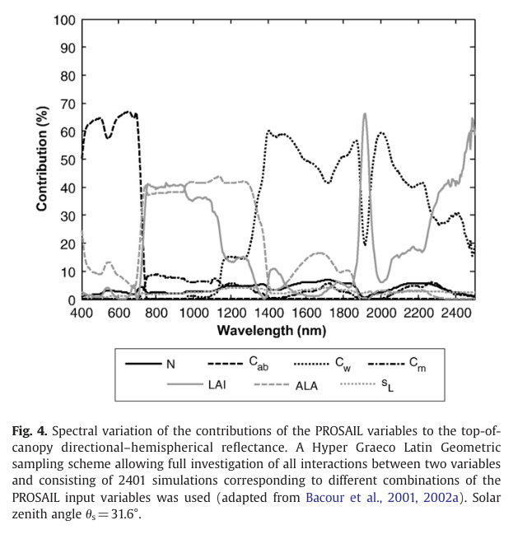
Figure 122. Screenshot — Jacquemoud et al. (2009), Fig. 4: spectral contribution of each PROSAIL variable to canopy reflectance (sensitivity analysis).
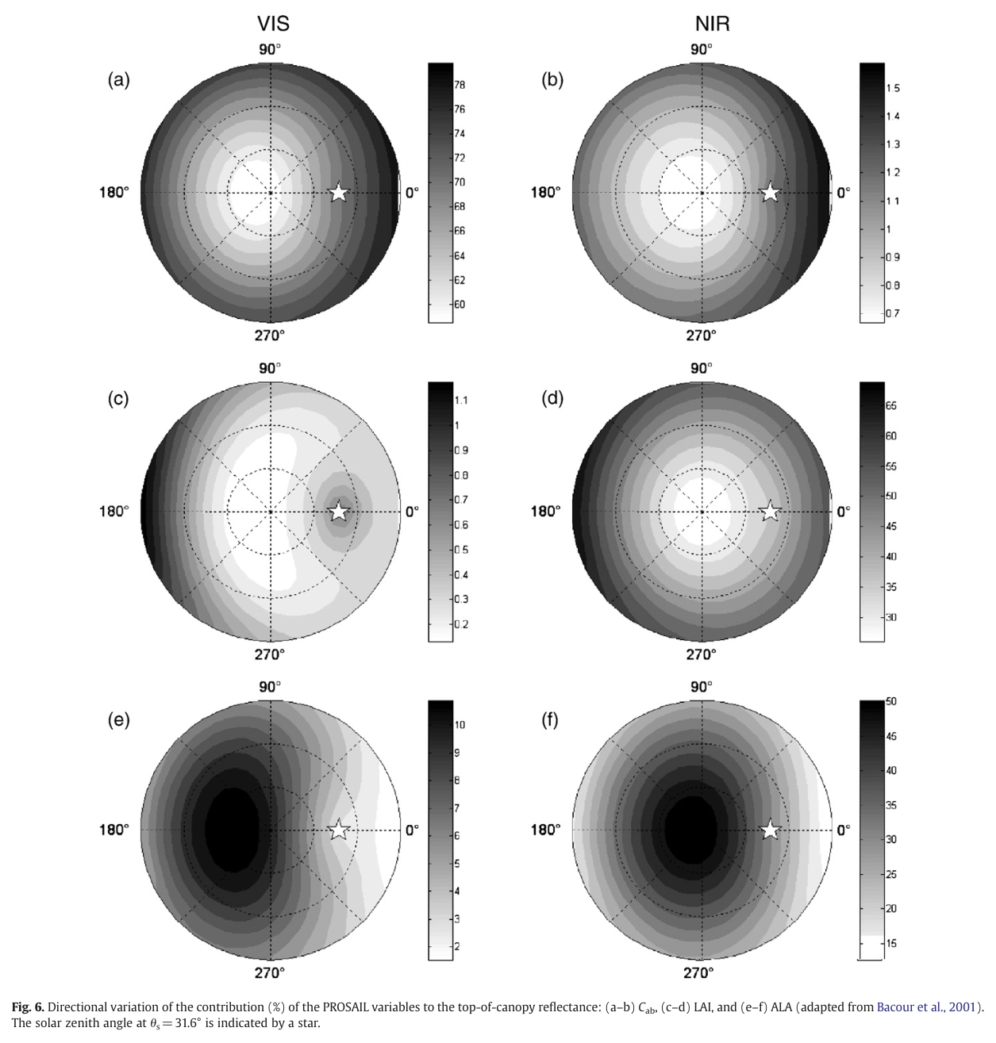
Figure 123. Screenshot — Jacquemoud et al. (2009), Fig. 6: directional variation of the contribution of Cab, LAI and ALA.

31.4 Inversion: the cost function and approaches
δ² = Σᵢ [(Rᵢ − mᵢ(x))/σRᵢ]² + Σⱼ [(xⱼ − xⱼᵖʳⁱᵒʳ)/σxⱼ]²
- The first term is the misfit between observed and simulated reflectance. The second is a penalty for departure from prior information, which regularises the problem.
- Observation-space methods: iterative optimisation (simplex, quasi-Newton, genetic algorithms), MCMC, and look-up tables (LUT), which find the global minimum if sampling is dense and suit operational use.
- Variable-space methods: VIs calibrated with RTM simulations, and artificial neural networks trained on simulated data (POLDER, VEGETATION, MERIS, Landsat; global LAI, fAPAR, fCover and CWC maps).
- Canopy-level products (Cab × LAI = canopy chlorophyll content, Cw × LAI = canopy water) are retrieved more robustly than leaf-level values.
- Operational use: FarmStar (Infoterra) uses PROSAIL physics for field-level LAI and nitrogen recommendations (precision farming).
- Limits: SAIL assumes a horizontally homogeneous turbid medium, so clumped or row crops and forests violate it. Prior distributions of leaf biochemistry are poorly documented. Inversion “is still a job for a specialist”.
Q. Why couple PROSPECT with SAIL?
A. SAIL alone needs leaf reflectance, leaf transmittance and soil reflectance at every wavelength, so inverting it from hyperspectral data is under-determined. PROSPECT describes leaf optics with only a few biochemical parameters, imposing a strong spectral constraint and allowing joint retrieval of leaf biochemistry and canopy structure.
Q. What makes PROSAIL inversion ill-posed and how is it regularised?
A. Different combinations (e.g. LAI and leaf angle) produce similar spectra, and measurement and model errors add ambiguity. It is regularised with prior distributions, multi-angle or multi-temporal constraints, retrieval of canopy-integrated variables, and LUT or hybrid ML inversion with added noise.
Q. Which wavelengths are most informative for chlorophyll, LAI and water?
A. Chlorophyll: the visible, especially around 550 nm and the red edge (about 700 nm), which do not saturate. LAI and leaf angle: the NIR. Water: the SWIR, 1450–2100 nm.

32. Chen et al. (2022): wheat stripe rust detected by hyperspectral RS in the latent period
Citation card: Jing Chen, Ainisai Saimi, Minghao Zhang, Qi Liu and Zhanhong Ma (2022). Epidemic of wheat stripe rust detected by hyperspectral remote sensing and its potential correlation with soil nitrogen during latent period. Life 12(9): 1377. Xinjiang Agricultural University and China Agricultural University.

32.1 Why it matters
- Wheat yellow (stripe) rust is a key disease in Punjab and Haryana (see Parihar 2016, Dutta et al. 2014). The paper shows pre-symptomatic (latent-period) detection with hyperspectral data, which is relevant to the IARI hyperspectral work and to pest-related PMFBY or advisory triggers.
- It links disease severity to soil nitrogen, which connects to precision N management.

32.2 Experiment
- Kaifeng Experimental Station, Henan, 2016–2018. Cultivars Mingxian 169 (highly susceptible), Beijing 0045 (moderately susceptible) and Nongda 195 (resistant). Inoculum: an equal mix of races CYR31, CYR32 and CYR33 at graded spore concentrations.
- 54 plots (3 × 4 m) in a randomised block with 3 replicates. Latent period: 25 days (2017), 20 days (2018). Five spectral measurements during each latent period.
- ASD FieldSpec HandHeld 2: 325–1075 nm, 3 nm bandwidth, 25° FOV, 1.3 m height, 11:30–14:30. 4050 spectra (2016-17) and 4320 (2017-18).
- Ground truth of latent infection: duplex real-time PCR quantifying Puccinia striiformis f. sp. tritici (Pst) DNA relative to wheat DNA, giving the Molecular Disease Index MDI = Pst DNA (pg)/wheat DNA (ng). Detection limits are 0.4 pg (Pst) and 0.5 ng (wheat).
- Symptom-period field survey: incidence I, severity S, Disease Index DI = I × S × 100, and AUDPC = Σ (Yᵢ + Yᵢ₊₁)/2 · (tᵢ₊₁ − tᵢ). Soil total N (0–20 cm) was measured by semi-micro Kjeldahl.
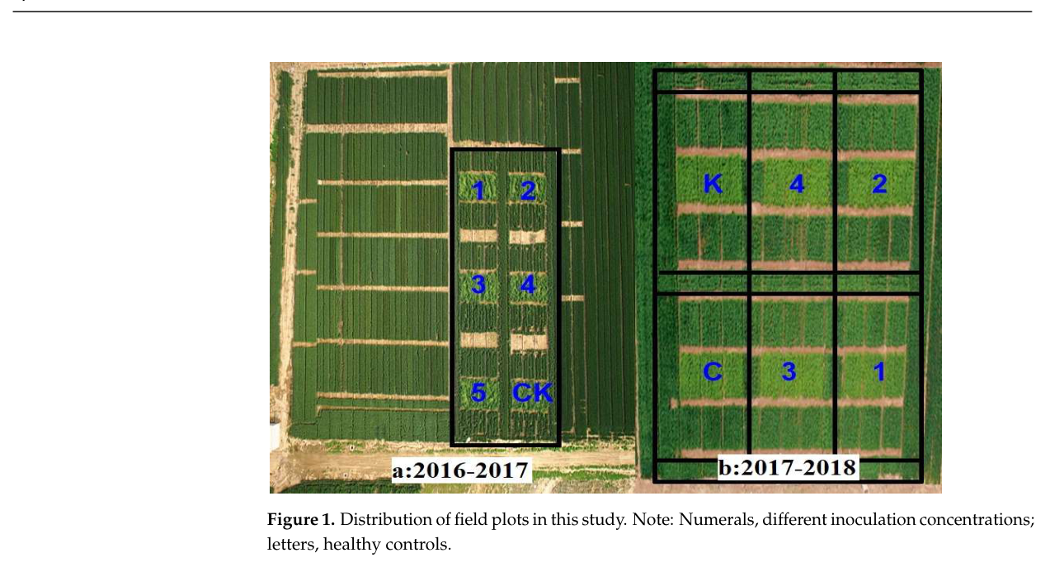
Figure 124. Screenshot — Chen et al. (2022), Fig. 1: distribution of field plots (numerals = inoculation concentrations; letters = healthy controls).
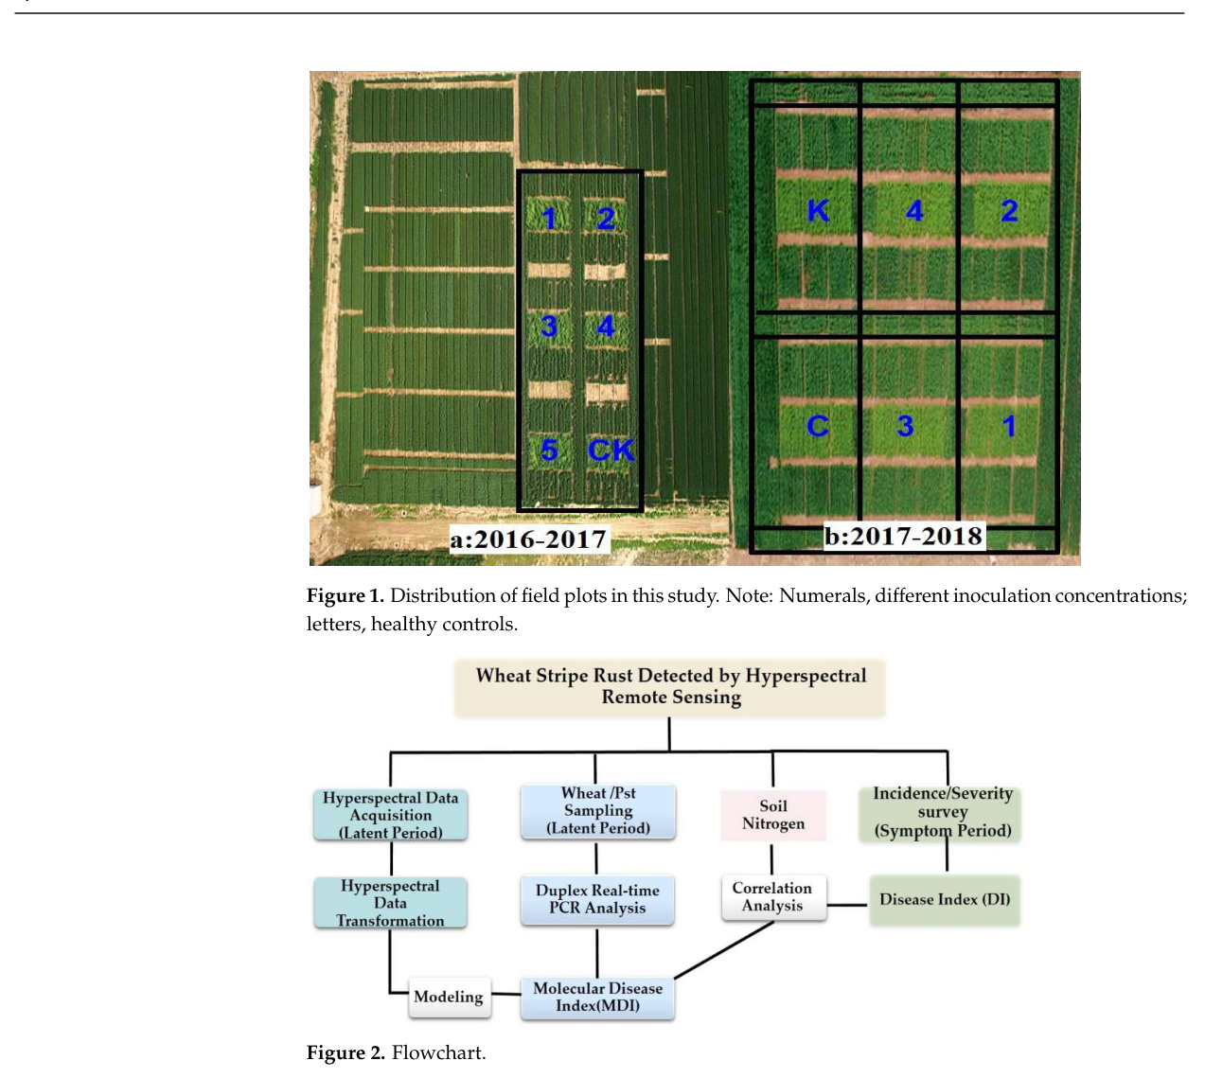
Figure 125. Screenshot — Chen et al. (2022), Fig. 2: study flowchart (hyperspectral acquisition, duplex PCR, modelling, soil N correlation).

32.3 Spectral features and models
- Type 1 (transformations): R, R′ (1st derivative), R″ (2nd derivative), log₁₀(1/R) (the pseudo-absorption coefficient), and its 1st and 2nd derivatives. Derivatives remove low-frequency background, and log(1/R) reduces illumination effects and enhances visible differences.
- Type 2: 22 vegetation indices plus trilateral parameters (red-, yellow- and blue-edge positions and amplitudes).
- Type 3: five equal sub-bands of 325–1075 nm (325–474, 475–624, 625–774, 775–924, 925–1075 nm).
- Classifiers: DPLS (discriminant partial least squares, good for small-sample, high-dimensional, collinear data) and SVM. Train-to-test ratios tested: 1:1, 2:1, 3:1, 4:1 and 5:1.

32.4 Results
- Across 325–1075 nm, the average recognition accuracy was 75–80 %.
- Best sub-bands: DPLS 80 % in 325–474 nm (blue/UV) and SVM 83 % in 475–624 nm (green–yellow). The visible region carries pigment and cell-structure changes during the latent period.
- Disease index of WSR was positively correlated with soil nitrogen, so higher N favours more severe rust during the latent period. This supports avoiding excess N under epidemic risk.
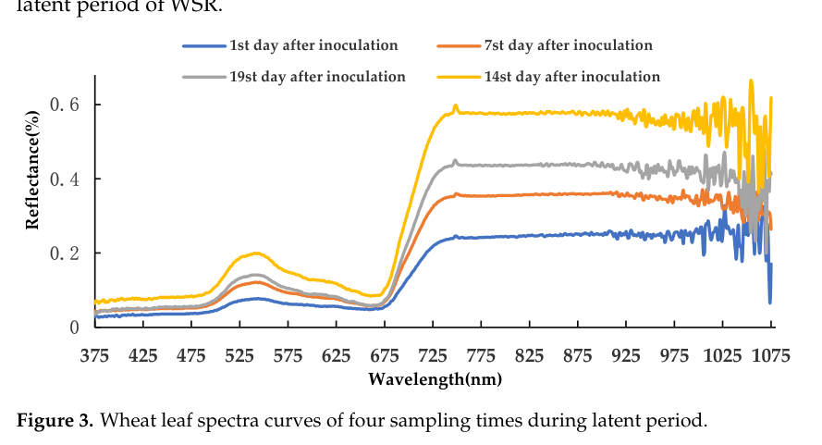
Figure 126. Screenshot — Chen et al. (2022), Fig. 3: wheat canopy spectra at four sampling times during the latent period.
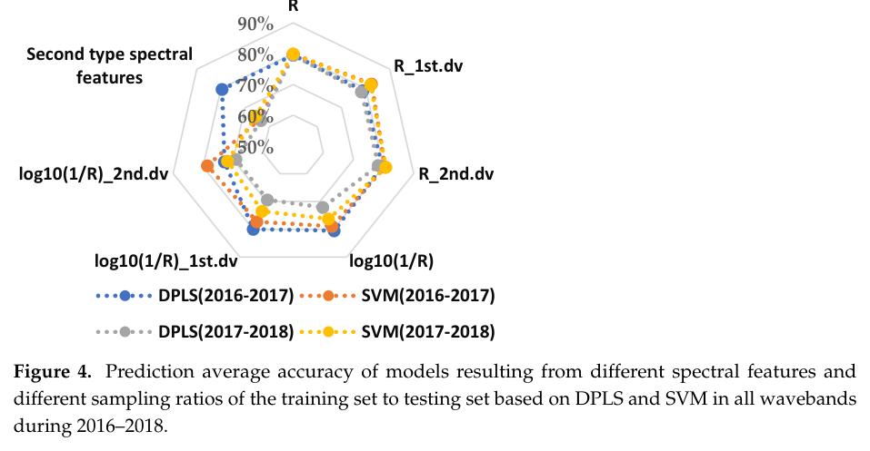
Figure 127. Screenshot — Chen et al. (2022), Fig. 4: prediction accuracy for different spectral features and training/testing ratios.
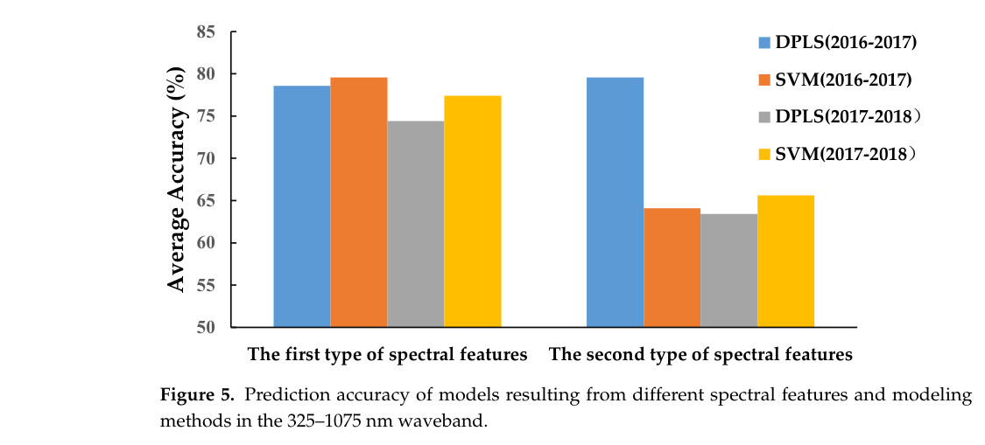
Figure 128. Screenshot — Chen et al. (2022), Fig. 5: prediction accuracy of DPLS and SVM across spectral feature types (325–1075 nm).
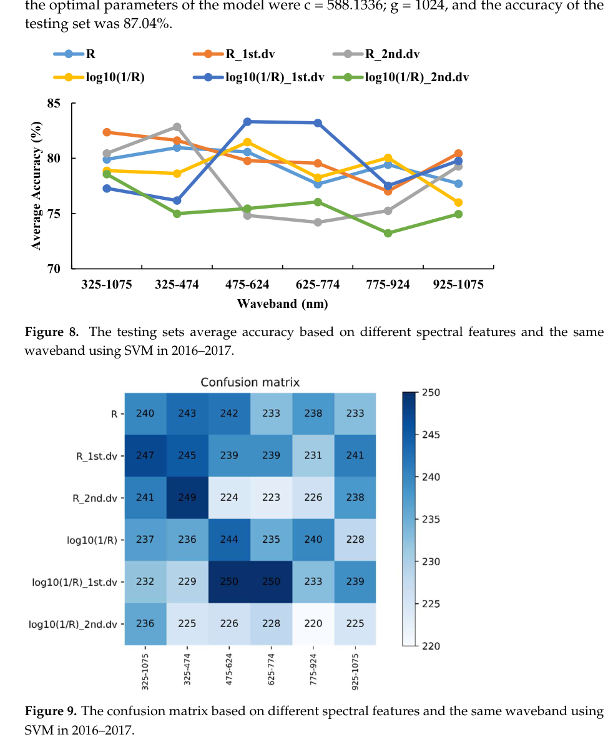
Figure 129. Screenshot — Chen et al. (2022), Fig. 9: confusion matrices by spectral feature and waveband (SVM, 2016–2017).

32.5 Critique and Indian application
- Proximal, plot-scale and artificially inoculated. Scaling to satellites (PRISMA, EnMAP, the future ISRO hyperspectral missions) needs canopy-mixing and atmospheric handling. UAV hyperspectral sensors are an intermediate step.
- The instrument range (325–1075 nm) excludes the SWIR, so water-related features were not tested.
- For India: combine weather-based yellow-rust risk models (temperature and RH, as in Dutta et al. 2014) with hyperspectral or red-edge scouting in Punjab and Haryana, and with N recommendations.
Q. How can a disease be detected before symptoms appear?
A. During the latent period the pathogen alters pigment content, cell structure and water status, which changes reflectance subtly, especially in the visible bands. Hyperspectral derivatives and log(1/R) transforms, with DPLS or SVM classifiers trained against PCR-quantified pathogen DNA, detected infection with 80–83 % accuracy in the best sub-bands.
Q. What is AUDPC?
A. Area Under the Disease Progress Curve: the trapezoidal integral of disease intensity over time, Σ (Yᵢ + Yᵢ₊₁)/2 × (tᵢ₊₁ − tᵢ). It summarises cumulative epidemic development.

33. Pylianidis, Osinga & Athanasiadis (2021): introducing digital twins to agriculture
Citation card: Christos Pylianidis, Sjoukje Osinga and Ioannis N. Athanasiadis (2021). Introducing digital twins to agriculture. Computers and Electronics in Agriculture 184: 105942. Wageningen University & Research. Open access (CC BY).

33.1 Why it matters
- It gives the standard definition of a digital twin (DT), the service categories, the maturity (TRL) framing, and a roadmap from simple to sophisticated agricultural DTs. Quote it when asked “Digital twin vs crop simulation model”.

33.2 Definitions and background
- The DT concept was coined by M. Grieves (2014 white paper) in product lifecycle management. There is no single accepted definition.
- Working definition (Clark et al. 2019, IBM), adopted in the paper: “a dynamic virtual representation of a physical object or system, usually across multiple stages of its lifecycle, that uses real-world data, simulation, or machine learning models combined with data analysis to enable understanding, learning, and reasoning. DT can be used to answer what-if questions and should be able to present insights in an intuitive way.”
- Industry users: Siemens, General Electric, NASA, the US Air Force, Oracle, ANSYS, SAP, Altair. Tools: Predix, Simcenter 3D.

33.3 Method (mixed-method)
- RQ1: to what extent are DTs applied in agriculture? A literature plus grey-literature review of 2017–2020 found 28 use cases.
- RQ2: what roadmap should adoption follow? Use cases from other disciplines (Web of Science reviews) were compared.
- Each use case was tagged by service category (Tao et al. 2018; Cimino et al. 2019), TRL grouped into Concept (EU TRL 1–2), Prototype (3–6) and Deployed (7–9), and the physical twin type (plants or trees, animals, products, fields or farms or landscapes, buildings or greenhouses, machinery, supply chains).
Table 29. DT service categories used in the paper (Table 1, summarised)
Service category | Definition
Real-time monitoring | Monitor and log the status of a system
Energy consumption analysis | Analyse and minimise energy use
System failure analysis and prediction | Identify sources of failure and when maintenance is needed
Optimisation / update | Find optimal operating parameters and update the system
Behaviour analysis / user operation guide | Analyse human operations and give feedback
Technology integration | Bring deployed technologies under one umbrella to control and visualise
Virtual maintenance | Test maintenance strategies virtually (absent in agriculture)

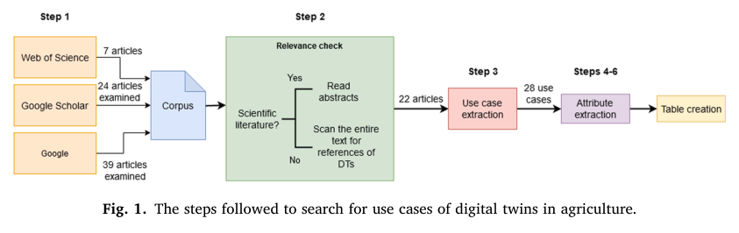
Figure 130. Screenshot — Pylianidis et al. (2021), Fig. 1: steps to search for DT use cases in agriculture.

33.4 Findings
- Few agricultural DTs exist, and many are only conceptual. 13 of 28 were commercial, and 7 of those 13 appeared only in non-scientific literature, so industry is ahead of academia.
- DTs in other disciplines date from 2011, in agriculture only from 2017. The reasons: risk-averse small farms, living physical twins that are hard to model, a weak data culture, and the integration burden.
- Most agricultural DTs perform monitoring, with few doing optimisation or failure prediction. Virtual maintenance was absent. Supply chains and machinery were among the twinned systems.
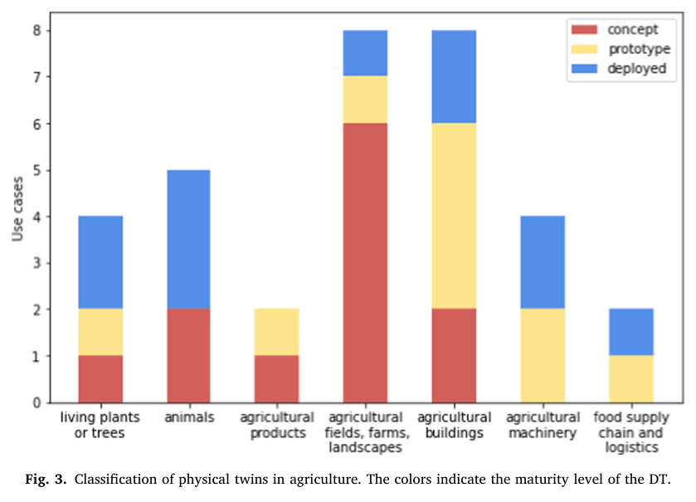
Figure 131. Screenshot — Pylianidis et al. (2021), Fig. 3: classification of physical twins in agriculture, coloured by maturity level (concept, prototype, deployed).
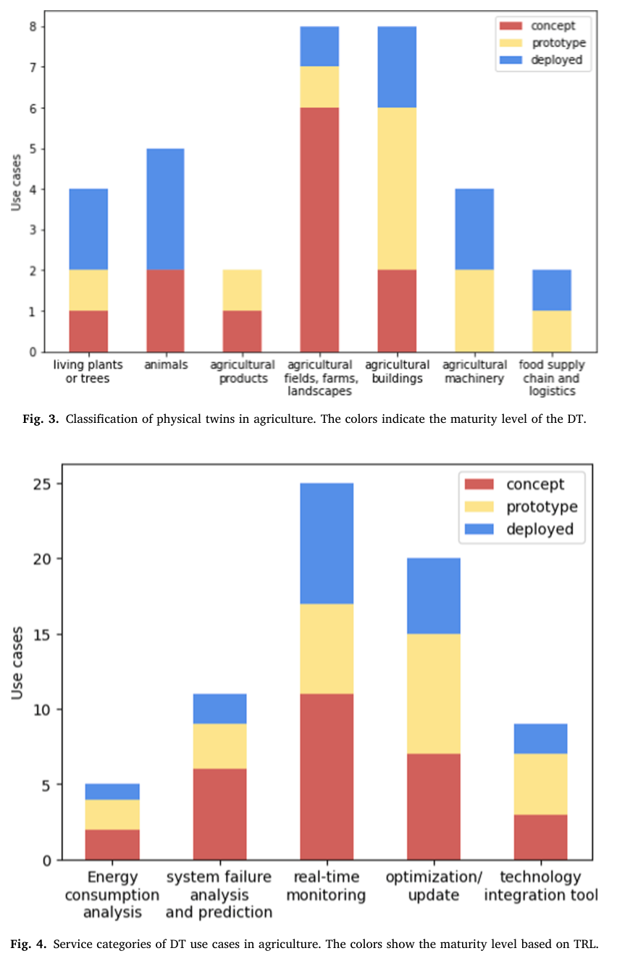
Figure 132. Screenshot — Pylianidis et al. (2021), Fig. 4: service categories of agricultural DT use cases by TRL.

33.5 Characteristics that give DTs added value (Fig. 6)
- Personalised curation of complex systems: adapts to the idiosyncrasies of each physical twin by learning from its data.
- Operation streamlining: an automated pipeline from sensing to simulation, reports and actuation, without user effort.
- Information fusion: heterogeneous sources give a complete picture of past, current and future states.
- Uncertainty quantification: cumulative uncertainty, communicated to users.
- Permission-level controls: different transparency for different users.
- Human-centred intelligence: human–machine interfaces for safety.
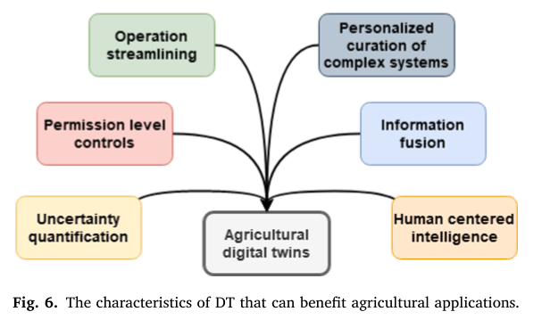
Figure 133. Screenshot — Pylianidis et al. (2021), Fig. 6: characteristics of DTs that can benefit agricultural applications.

33.6 Proposed roadmap: from simple to sophisticated
- Monitoring + user interface + analytics (the minimum for anything to be called a DT), e.g. greenhouse microclimate monitoring against thresholds.
- + Actuators: e.g. closing greenhouse windows and notifying the farmer and supply chain.
- + Simulation: what-if analysis, e.g. mastitis risk per cow, or testing a harvester virtually on one's own field.
- + Learning: finding patterns where mechanisms are unclear, e.g. swine-fever risk.
- Landscape DT (towards Digital Earth): many farm twins interacting, covering inter-field water flow, fertiliser dispersion and leaching, and site-specific variable rates learned from history.
- + Human–machine interface: worker safety around harvesters and grain bins.

33.7 Distinctive characteristics of agricultural DTs (conclusion)
- Living systems and perishable products: non-deterministic, harder to integrate and synchronise.
- Spatio-temporal scale: from a single plant to a region, so cross-scale effects matter. Slow response rates mean high-frequency synchronisation is not needed initially, which suits satellite revisit (5–12 days).
- Pitfalls: neglecting the real system, high resource needs, skills, synchronisation, component integration and unproven ROI.
Q. What is the minimum a system needs to be called an agricultural digital twin, per Pylianidis et al.?
A. At least monitoring, interface and analytics components, continuously linked to the physical system. Actuation, simulation and learning components are added along the roadmap.
Q. How are agricultural DTs different from industrial DTs?
A. They twin living systems and perishable products (non-deterministic, idiosyncratic) and span scales from plants to landscapes. They evolve slowly, so lower update frequency is acceptable, but synchronisation and modelling are harder than for machines.

34. Melesse (2025): digital twin-based applications in crop monitoring
Citation card: Tsega Y. Melesse (2025). Digital twin-based applications in crop monitoring. Heliyon 11: e42137. Bahir Dar Institute of Technology, Ethiopia. Open access (CC BY).

34.1 Review method
- Scopus search for (“digital twin”) AND (“agriculture” OR “smart farming” OR “precision farming”), 2018–2024. 318 records were found and 58 retained after screening and eligibility checks.
- Publication growth: 1.26 % (2018) → 4.09 % (2019) → 4.72 % (2020) → 42.14 % (2023) → 21.7 % (2024, partial year).
- Document types: conference papers 42.1 %, articles 29.9 %, reviews 11.8 %, book chapters 8.9 %.
- Countries: India leads with 39 publications, followed by China (38), the UK (23), and Germany and Russia (22 each). This is worth mentioning: India is a research leader in agricultural DTs.
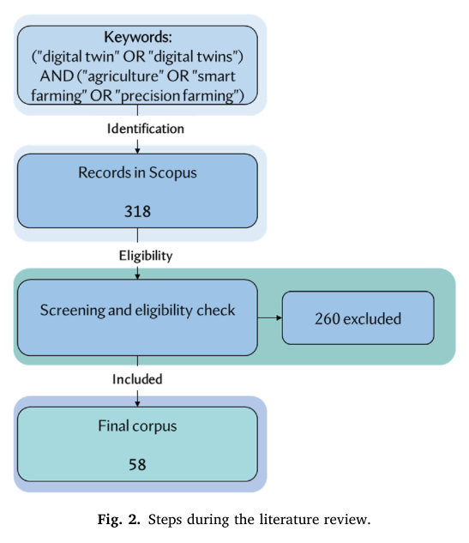
Figure 134. Screenshot — Melesse (2025), Fig. 2: steps of the systematic literature review (318 → 58 papers).
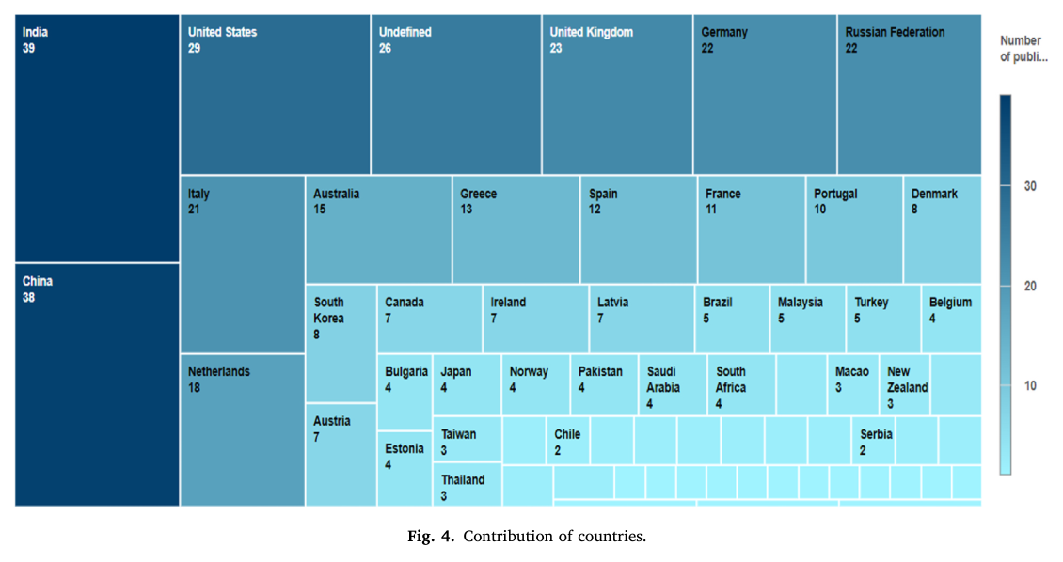
Figure 135. Screenshot — Melesse (2025), Fig. 4: contribution of countries to DT-in-agriculture publications.

34.2 Five modelling approaches for crop DTs
Approach | Description / example | Strength and weakness
Physics-based | Crop processes (photosynthesis, transpiration, nutrient uptake); CERES, APSIM | Mechanistic, but simplifications and input-data quality limit it; struggles with irregular rain and extremes
Data-driven | ML/DL (neural networks, RF) for yield, anomalies and soil moisture; deep learning on satellite images (India, USA); pest detection from drone imagery | Often more accurate and simpler to implement; needs data and is less interpretable
Hybrid | Physics + data, e.g. APSIM + ML for weather responses; greenhouse crop model + sensor network | Combines physiological understanding with adaptability
Agent-based | Individual plants or insects as agents, e.g. simulating wheat-rust spread; machinery and worker behaviour | Captures interactions and emergent behaviour
Spatial (GIS) | Spatially explicit models, e.g. erosion risk in vineyards, irrigation optimisation, land-use and rotation planning | Handles space–time variability over large areas

34.3 Roles and application areas (Table 2 of the paper)
- Crop-health monitoring in real time; farm management and planning; irrigation management (test drip, sprinkler or flood strategies virtually before field use); pest and disease outbreak prediction; supply-chain optimisation (harvest timing, logistics, post-harvest loss); yield prediction; climate-impact analysis; resource optimisation; sustainability compliance and record-keeping.

34.4 Architecture
- Three-layer view: physical world, communication protocol, cyber world.
- Five-layer smart-farming DT (Fig. 6): physical space (environmental, camera and chemical sensors; satellite RS), data storage (current and historical), network, digital space with data analysis and visualisation (rules, knowledge, AI/ML), and an application layer (alerts to farmers and service providers, e.g. the best time to irrigate).
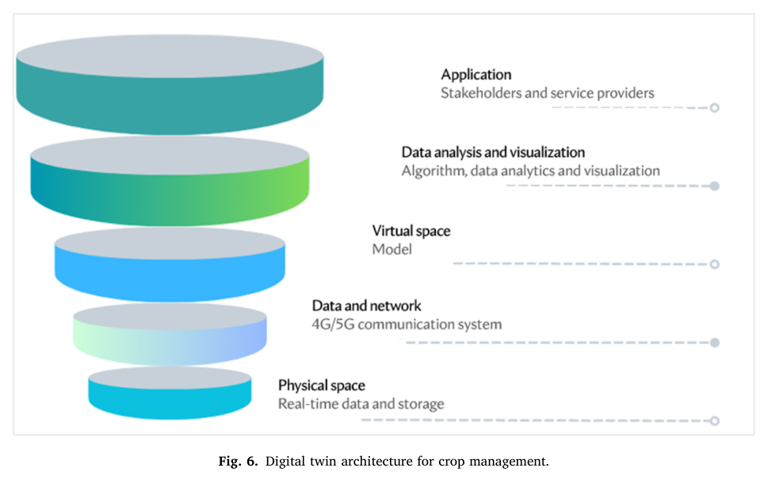
Figure 136. Screenshot — Melesse (2025), Fig. 6: digital twin architecture for crop management.

34.5 Challenges and prospects
- Challenges: data quality and integration (formats and standards), model complexity, technology cost, cybersecurity and data privacy, rural connectivity, physical security of equipment, replicating living systems, synchronisation of physical and virtual twins, and satellite data affected by weather (clouds).
- Prospects: precision-agriculture optimisation, predictive analytics, resource optimisation, remote monitoring and automation (drones), and decision support. Future research needs standard methods, comparison with traditional practice, multi-season evaluation and end-user perspectives.

34.6 Synthesis of the two DT papers for your answer
Model answer: “A crop simulation model like DSSAT or InfoCrop is one possible engine of a digital twin. Following Pylianidis et al. (2021), a DT needs at least monitoring, interface and analytics, and becomes richer with actuation, simulation and learning. Melesse (2025) lists five ways to build that engine: physics-based, data-driven, hybrid, agent-based and spatial. For ISRO the observation layer is Bhuvan/Bhoonidhi EO (EOS-04, NISAR, Resourcesat, INSAT). Data assimilation keeps the twin synchronised, and the slow dynamics of crops make a 5–12-day satellite revisit adequate.”
Q. Name the five modelling approaches for crop digital twins.
A. Physics-based (crop models), data-driven (ML/DL), hybrid (both), agent-based (individual plants or pests as agents), and spatial (GIS-based) models.
Q. Which country leads publications on agricultural digital twins according to Melesse (2025)?
A. India, with 39 publications, closely followed by China with 38.

35. Synthesis across the papers: comparisons, numbers and model answers

35.1 Yield-model families: evidence from your papers
Table 30. What your papers say about each yield-modelling approach
Approach | Evidence (paper → result) | Strength | Weakness
Semi-physical (Monteith) | Tripathy 2014: state RMSE 0.15 t/ha, −3.45 %; district R² 0.58. Satheesh 2025: 83.3 % agreement, overestimation | Physiological, few parameters, scalable, INSAT + MODIS inputs | Constant RUE/HI; coarse pixels; weak at district/GP; stress-term quality
Crop simulation (DSSAT/InfoCrop/WOFOST) | Satheesh 2025: DSSAT + SAR-LAI 88.6 % agreement; YES-TECH: nRMSE ≤ 30 % rule | Mechanistic G × E × M; what-if analysis; handles extremes | Data and calibration heavy; genetic coefficients; spatialisation
ML/DL | Fei 2023: base learners R² 0.527–0.670 (UAV); YES-TECH SOP requirements | Non-linear; uses many features | Needs many labels across yield ranges; transferability; interpretability
Ensemble (stacking) | Fei 2023: stacking R² 0.692 > best single model; YES-TECH approach 4 | Lower variance; robust | Complexity; needs out-of-fold predictions
Index (CHF) | YES-TECH: entropy-weighted NDVI, LSWI, VH, fAPAR, rainfall, CV | Objective, transparent; good for insurance contracts | Not a yield; needs stratification and calibration
Weather/statistical | Parihar 2016: correlation-weighted weather regressions in FASAL | Early-season, simple | Stationarity; coarse

35.2 Remote sensing for extreme events: one-page summary
Event | Method (paper) | Key number
Cyclone floods | RISAT-1/Radarsat SAR rice map + NRSC flood layer (Parihar 2016; Ray 2016) | Phailin: 132.4 thousand ha rice inundated; 89 % accuracy
Drought | NADAMS: NDVI/NDWI/SASI/VCI + PASM + rainfall + sowing; Drought Manual triggers (Ray 2016; Saxena 2019) | 2018: 284 of 553 districts with Trigger 1 = Yes
Hailstorm / unseasonal rain | AWiFS NDVI deviation + IMD rainfall; NDVI-stratified CCEs (Ray 2016) | Affected sites about 7 % lower yield (2381 vs 2568 kg/ha)
Pest/disease | TOVS-based aphid model; WRF + NDVI/LSWI yellow rust; MODIS LSWI late blight (Parihar 2016); hyperspectral latent-period rust (Chen 2022) | Aphid peak ±7 days; rust detection 80–83 %
Residue fires | MODIS C6 contextual algorithm + FRP (Giglio 2016) | Commission 1.2 %; omission high for small fires

35.3 Measurement and scaling lessons
- ET scaling (Cammalleri 2014): solar-radiation scaling is most robust. EF underestimates in winter (β = 1.1). ETo scaling suits morning overpasses.
- Eddy covariance (Goulden 1996): separate uniform systematic, selective systematic (u* < 0.17 m/s nights) and sampling errors. Annual NEP was 2.1 t C/ha with an uncertainty of −0.3 to +0.8.
- RTM retrieval (Jacquemoud 2009): use PROSAIL with priors, LUT or ANN inversion, and canopy-level products. Cab dominates the visible, LAI and ALA the NIR, Cw the SWIR.
- Operational software (Moorthi 2014): workflow, provenance (Digital Crop Folder) and distributed processing are as important as algorithms.
- Digital twins (Pylianidis 2021; Melesse 2025): monitoring, interface and analytics at minimum. Five modelling approaches. India leads publications.

35.4 Ten numbers from your papers to remember
- 30 % minimum technology weight in YES-TECH; ₹12–20 lakh per district per season.
- nRMSE ≤ 30 % acceptance for crop simulation models in YES-TECH.
- Crop map: commission < 10 %, omission ≤ 20 % (YES-TECH).
- Tripathy 2014: state-level RMSE 0.15 t/ha; district-level R² 0.58, RMSE 0.57 t/ha.
- Satheesh 2025: DSSAT 88.6 % vs SPM 83.3 % agreement; rice-map accuracy 93.9 % (κ 0.88).
- Fei 2023: stacking R² 0.692, RMSE 0.916 t/ha.
- Phailin 2013: 132.4 thousand ha of rice inundated.
- MODIS C6: daytime commission error 1.2 % (vs 2.4 % in C5); mean FRP 16 % lower.
- Cammalleri 2014: RS method 46 % acceptable and unbiased; EF underestimates in up to 75 % of winter cases.
- Goulden 1996: u* threshold 0.17 m/s; NEP 2.1 ± 0.3 t C/ha/yr.

35.5 Composite model answer: “How would you estimate GP-level yield for PMFBY?”
“I would follow the YES-TECH framework, with SAC or NRSC as mentor. Step 1: crop mapping with Sentinel-1/EOS-04/NISAR SAR plus Sentinel-2, meeting the commission < 10 % rule. Satheesh et al. reached 93.9 % accuracy for delta rice with Sentinel-1. Step 2: three base models. (a) A semi-physical Monteith model as in Tripathy et al., but at 10–20 m with INSAT-3DS PAR, Sentinel-2 fAPAR, an LSWI or NISAR soil-moisture water scalar, and CCE-calibrated HI. (b) DSSAT or InfoCrop spatialised with SAR-derived LAI, which gave 88.6 % agreement in the Cauvery delta. (c) A gradient-boosting or LSTM model on S1/S2 time series, weather and soil. Step 3: stack them with a ridge meta-learner as Fei et al. did, validated leave-one-year-out against CCEs from 2017 onward. Step 4: apply the Correction Factor for late-season hail or floods using SAR and NDVI anomalies, as in the 2015 hail and Phailin studies. Step 5: blend at least 30 % with CCEs, place extra smart-sampled CCEs where ensemble spread is high, and report uncertainty.”

36. Rapid revision: formula sheet, abbreviations and rapid-fire Q&A

36.1 One-page formula sheet
Quantity | Formula
Wien / Stefan–Boltzmann | λmax = 2898/T µm ; M = εσT⁴
NDVI / EVI | (NIR − R)/(NIR + R) ; 2.5(NIR − R)/(NIR + 6R − 7.5B + 1)
NDRE / CIre | (NIR − RE)/(NIR + RE) ; NIR/RE − 1
NBR / dNBR | (B8 − B12)/(B8 + B12) ; NBRpre − NBRpost
NDTI | (B11 − B12)/(B11 + B12)
RVI (SAR) | 8σHV/(σHH + σVV + 2σHV)
Water cloud model | σ⁰ = A·V₁·cosθ(1 − γ²) + γ²σ⁰soil ; γ² = exp(−2BV₂/cosθ)
Energy balance | Rn = G + H + λET ; H = ρcp·dT/rah
SEBAL dT | dT = a + b·Ts (from hot and cold pixels)
EF / ETrF | EF = λET/(Rn − G) ; ETrF = ETinst/ETr,inst
Daily ET | ET24 = ETrF × ETr,24 or 86400·EF·Rn24/λ
FAO-56 Kc | ETc = Kc·ET₀ ; ETa = Ks·Kc·ET₀
EC flux | F = ρ⟨w′c′⟩
SIF | SIF = PAR·fAPAR·ΦF·fesc
FLD | F = (Eout·Lin − Ein·Lout)/(Eout − Ein)
LUE yield | Yield = HI·Σ(ε·fAPAR·PAR·Ts·Ws)
Beer's law | fAPAR = 1 − exp(−k·LAI)
FRP → biomass | Biomass (kg) = 0.368 × FRE (MJ)
Threshold yield | TY = mean(best 5 of 7 years) × indemnity level
Claim | (TY − AY)/TY × sum insured
Neyman allocation | nh = n·NhSh/ΣNhSh
RMSE / nRMSE | √(Σ(P − O)²/n) ; RMSE/Ō × 100
Kappa | (po − pe)/(1 − pe)
GDD | Σ[(Tmax + Tmin)/2 − Tbase]
CWSI | (Tc − Twet)/(Tdry − Twet)
Topp equation | θv = −0.053 + 0.0292ε − 5.5×10⁻⁴ε² + 4.3×10⁻⁶ε³

36.2 Abbreviations
Abbreviation | Expansion
ALEXI | Atmosphere–Land EXchange Inverse
AWD | Alternate Wetting and Drying
BAI | Burned Area Index
CAQM | Commission for Air Quality Management in NCR and adjoining areas
CBG | Compressed Bio-Gas
CCE | Crop Cutting Experiment
CCTS | Carbon Credit Trading Scheme (India, 2023)
CHAMAN | Coordinated Horticulture Assessment and Management using geoiNformatics
CREAMS | Consortium for Research on Agroecosystem Monitoring and Modelling from Space (IARI)
CROPIC | Collection of Real-time Observations and Photos of Crops
DSM | Digital Soil Mapping
EC | Eddy Covariance / Electrical Conductivity
ESI | Evaporative Stress Index
FASAL | Forecasting Agricultural output using Space, Agro-meteorology and Land-based observations
FIRMS | Fire Information for Resource Management System (NASA)
FLEX / FLORIS | FLuorescence EXplorer / FLuORescence Imaging Spectrometer
FRP / FRE | Fire Radiative Power / Energy
GKMS | Gramin Krishi Mausam Sewa
IAIRO | India AI Research Organisation (GIFT City)
ICVCM | Integrity Council for the Voluntary Carbon Market
IOD | Indian Ocean Dipole
LUE / RUE | Light / Radiation Use Efficiency
METRIC | Mapping EvapoTranspiration at high Resolution with Internalized Calibration
MNCFC | Mahalanobis National Crop Forecast Centre
MRV / dMRV | Monitoring (Measurement), Reporting and Verification / digital MRV
NBR | Normalised Burn Ratio
NePPA | Network Programme on Precision Agriculture (ICAR)
NISAR | NASA–ISRO Synthetic Aperture Radar
ONI | Oceanic Niño Index
PMFBY | Pradhan Mantri Fasal Bima Yojana
PROSAIL | PROSPECT + SAIL radiative transfer model
RWBCIS | Restructured Weather Based Crop Insurance Scheme
SATAT | Sustainable Alternative Towards Affordable Transportation
SEBAL | Surface Energy Balance Algorithm for Land
SIF | Sun-Induced (chlorophyll) Fluorescence
TPA | Technology Providing Agency (YES-TECH)
TRISHNA | Thermal infraRed Imaging Satellite for High-resolution Natural resource Assessment (ISRO–CNES)
TSEB | Two-Source Energy Balance
VCU | Verified Carbon Unit (Verra)
VRT | Variable-Rate Technology
VVB | Validation/Verification Body
WINDS | Weather Information Network and Data Systems
YES-TECH | Yield Estimation System based on TECHnology

36.3 Rapid-fire questions (one-line answers)
Q. When did FLEX launch?
A. 15 September 2026, on Vega-C VV30 from Kourou, together with Sentinel-3C.
Q. FLEX spatial resolution and swath?
A. 300 m; 150 km.
Q. FLEX spectral range?
A. 500–780 nm (FLORIS), 0.3 nm resolution in the O₂ bands.
Q. Wavelengths of the SIF peaks?
A. About 685 nm (red) and 740 nm (far-red).
Q. When did NISAR launch?
A. 30 July 2025, GSLV-F16, Sriharikota.
Q. NISAR bands and their builders?
A. L-band 24 cm (NASA) and S-band 9.4 cm (ISRO).
Q. NISAR repeat cycle and swath?
A. 12 days; about 242 km.
Q. NISAR soil-moisture resolution in India?
A. 100 m L4 products (L and S), distributed via Bhoonidhi.
Q. Which polarisation is most sensitive to biomass?
A. Cross-pol (HV/VH), from volume scattering.
Q. Why is HH high for rice?
A. Double-bounce between the water surface and vertical stems.
Q. Hot pixel in SEBAL?
A. Dry bare field where λET ≈ 0, so H = Rn − G.
Q. Cold pixel in METRIC?
A. Well-watered crop with ET = 1.05 ETr.
Q. Basis of daily scaling?
A. EF or ETrF (AET/ET₀) stays nearly constant through the day.
Q. Which model uses the morning rise in Ts?
A. ALEXI.
Q. What is energy-balance closure?
A. (H + λE)/(Rn − G); typically 0.7–0.9 for EC towers.
Q. Which VIIRS band detects fire?
A. I4 (3.74 µm) at 375 m, with I5 (11.45 µm) for background.
Q. Unit of FRP?
A. Megawatts (MW).
Q. Which Sentinel-2 bands are used for NBR?
A. B8 (NIR) and B12 (SWIR2); NBR2 uses B11 and B12.
Q. dNBR threshold for burnt?
A. > 0.1 (low severity from 0.1 to 0.27).
Q. Who issues the daily residue-burning bulletin?
A. The CREAMS lab, Division of Agricultural Physics, IARI, under the ISRO–ICAR protocol.
Q. States covered by the bulletin?
A. Punjab, Haryana, UP, Delhi, MP and Rajasthan.
Q. What is the PUSA decomposer?
A. A fungal-consortium spray from IARI that decomposes paddy stubble in about 20–25 days.
Q. Where is the 2G ethanol plant that uses paddy straw?
A. IOCL Panipat, Haryana.
Q. Three CA principles?
A. Minimum soil disturbance, permanent soil cover, crop diversification.
Q. Index for residue cover?
A. NDTI (B11, B12) or CAI (hyperspectral).
Q. One carbon credit equals?
A. 1 tCO₂e reduced or removed.
Q. Verra methodology for agricultural soil carbon?
A. VM0042 Improved Agricultural Land Management.
Q. Who administers India's CCTS?
A. The Bureau of Energy Efficiency (BEE), Ministry of Power.
Q. Biochar stability criterion?
A. Molar H/Corg < 0.7.
Q. What is additionality?
A. The reduction would not occur without carbon finance.
Q. Lead institute of NePPA?
A. ICAR-IARI; launched 8 September 2021 with 16 partners.
Q. Map-based vs sensor-based VRT?
A. A prescription prepared in advance vs a real-time on-the-go rate.
Q. Which agency runs FASAL?
A. MNCFC (DA&FW), with ISRO methodology.
Q. CHAMAN crops?
A. Banana, mango, citrus, potato, onion, tomato and chilli.
Q. YES-TECH start and crops?
A. Kharif 2023 for paddy and wheat; soybean from Kharif 2024.
Q. Minimum YES-TECH weightage?
A. 30 % (100 % in MP).
Q. Threshold yield?
A. Mean of best 5 of 7 years × indemnity level.
Q. PMFBY farmer premiums?
A. 2 % kharif, 1.5 % rabi, 5 % commercial and horticultural crops.
Q. Insurance unit for major crops?
A. Village or gram panchayat.
Q. Semi-physical model?
A. Monteith LUE: Σ ε·fAPAR·PAR·stress × HI.
Q. Super El Niño?
A. ONI ≥ +2.0 °C (an informal term).
Q. Niño 3.4 region?
A. 5° N–5° S, 170°–120° W.
Q. What can offset El Niño's effect on the monsoon?
A. A positive Indian Ocean Dipole.
Q. Monsoon LPA?
A. 87 cm (1971–2020).
Q. Digital twin vs crop model?
A. The twin is a live, closed-loop, data-assimilating replica, while a crop model is an open-loop simulation.
Q. EnKF?
A. Ensemble Kalman Filter, a data-assimilation method.
Q. PROSPECT inputs?
A. N, Cab, Car, Cw, Cm, Cbrown.
Q. scorpan?
A. Soil, climate, organisms, relief, parent material, age, position (DSM).
Q. Saline vs sodic soil?
A. Saline: EC > 4 dS/m, pH < 8.5. Sodic: ESP > 15, pH > 8.5.
Q. Who is IAIRO's founding director?
A. Dr. Amit Sheth.

37. References and further reading
Read the original papers below for the topics you mention in your self-introduction. For the IARI-specific papers (Dr. Rajkumar Dhakar on CA mapping, Dr. V. K. Sehgal, Dr. Bappa Das), confirm exact titles in Google Scholar or the IARI repository before quoting them.

37.1 The 15 papers studied in Part II
- MNCFC (2023). Yield Estimation System based on Technology (YES-TECH) under PMFBY — Manual for Implementation. DA&FW, New Delhi.
- Parihar, J.S. (2016). FASAL concept in meeting the requirements of assessment and forecasting crop production affected by extreme weather events. MAUSAM 67(1): 93–104.
- Ray, S.S., Singh, S.K., Neetu, Mamatha, S. (2016). Establishing an operational system for assessment and forecasting the impact of extreme weather events on crop production. MAUSAM 67(1): 289–296.
- Moorthi, S.M., Oza, M.P., Misra, I. et al. (2014). FASALSoft — An ISRO software framework for crop production forecast using remote sensing data analysis. Journal of Geomatics 8(1): 27–33.
- Tripathy, R., Chaudhary, K.N., Nigam, R., Manjunath, K.R., Chauhan, P., Ray, S.S., Parihar, J.S. (2014). Operational semi-physical spectral-spatial wheat yield model development. ISPRS Archives XL-8: 977–981.
- Satheesh, S., Pazhanivelan, S., Suresh Kumar, D. et al. (2025). Spatial rice yield estimation using semi-physical and crop simulation models: a comparative approach. Plant Science Today 12(3): 1–10.
- Fei, S., Hassan, M.A., Xiao, Y. et al. (2023). UAV-based multi-sensor data fusion and machine learning algorithm for yield prediction in wheat. Precision Agriculture 24: 187–212.
- Saxena, S., Choudhary, K., Saxena, R., Rabha, A., Tahlani, P., Ray, S.S. (2019). Comparison of agricultural situation of India for two years (2017 and 2018) using various drought assessment indicators during south west monsoon season in India. ISPRS Archives XLII-3/W6: 499–505.
- Giglio, L., Schroeder, W., Justice, C.O. (2016). The collection 6 MODIS active fire detection algorithm and fire products. Remote Sensing of Environment 178: 31–41.
- Cammalleri, C., Anderson, M.C., Kustas, W.P. (2014). Upscaling of evapotranspiration fluxes from instantaneous to daytime scales for thermal remote sensing applications. HESS 18: 1885–1894.
- Goulden, M.L., Munger, J.W., Fan, S.-M., Daube, B.C., Wofsy, S.C. (1996). Measurements of carbon sequestration by long-term eddy covariance: methods and a critical evaluation of accuracy. Global Change Biology 2: 169–182.
- Jacquemoud, S., Verhoef, W., Baret, F. et al. (2009). PROSPECT + SAIL models: a review of use for vegetation characterization. Remote Sensing of Environment 113: S56–S66.
- Chen, J., Saimi, A., Zhang, M., Liu, Q., Ma, Z. (2022). Epidemic of wheat stripe rust detected by hyperspectral remote sensing and its potential correlation with soil nitrogen during latent period. Life 12: 1377.
- Pylianidis, C., Osinga, S., Athanasiadis, I.N. (2021). Introducing digital twins to agriculture. Computers and Electronics in Agriculture 184: 105942.
- Melesse, T.Y. (2025). Digital twin-based applications in crop monitoring. Heliyon 11: e42137.

37.2 Other references cited in Part I
- Allen, R.G., Pereira, L.S., Raes, D., Smith, M. (1998). Crop evapotranspiration — FAO Irrigation and Drainage Paper 56. FAO, Rome.
- Allen, R.G., Tasumi, M., Trezza, R. (2007). Satellite-based energy balance for mapping evapotranspiration with internalized calibration (METRIC) — Model. J. Irrig. Drain. Eng. 133(4), 380–394.
- Anderson, M.C., Norman, J.M., Diak, G.R., Kustas, W.P., Mecikalski, J.R. (1997). A two-source time-integrated model for estimating surface fluxes using thermal infrared remote sensing. Remote Sens. Environ. 60, 195–216.
- Anderson, M.C. et al. (2007). A climatological study of evapotranspiration and moisture stress across the continental United States based on thermal remote sensing (ALEXI). J. Geophys. Res. 112, D10117.
- Attema, E.P.W., Ulaby, F.T. (1978). Vegetation modeled as a water cloud. Radio Science 13(2), 357–364.
- Bastiaanssen, W.G.M., Menenti, M., Feddes, R.A., Holtslag, A.A.M. (1998). A remote sensing surface energy balance algorithm for land (SEBAL). J. Hydrol. 212–213, 198–212.
- Breiman, L. (2001). Random forests. Machine Learning 45, 5–32.
- Cariappa, A.G.A. et al. (2024). Study of conservation-agriculture eligibility for carbon credits under Verra VM0042 using farmer surveys and remote sensing. Scientific Reports (April 2024). [Title paraphrased — verify.]
- Chuvieco, E., Martín, M.P., Palacios, A. (2002). Assessment of different spectral indices in the red–near-infrared spectral domain for burned land discrimination. Int. J. Remote Sens. 23, 5103–5110.
- Crago, R.D. (1996). Conservation and variability of the evaporative fraction during the daytime. J. Hydrol. 180, 173–194.
- Drusch, M. et al. (2017). The FLuorescence EXplorer mission concept — ESA's Earth Explorer 8. IEEE Trans. Geosci. Remote Sens. 55(3), 1273–1284.
- ESA (2026). FLEX and Sentinel-3C launched on Vega-C (VV30), 15 September 2026. esa.int.
- Frankenberg, C. et al. (2011). New global observations of the terrestrial carbon cycle from GOSAT: patterns of plant fluorescence with gross primary productivity. Geophys. Res. Lett. 38, L17706.
- Giglio, L., Schroeder, W., Justice, C.O. (2016). The collection 6 MODIS active fire detection algorithm and fire products. Remote Sens. Environ. 178, 31–41.
- Guan, K. et al. (2016). Improving the monitoring of crop productivity using spaceborne solar-induced fluorescence. Global Change Biology 22, 716–726.
- Guanter, L. et al. (2014). Global and time-resolved monitoring of crop photosynthesis with chlorophyll fluorescence. PNAS 111(14), E1327–E1333.
- Huang, J. et al. (2019). Assimilation of remote sensing into crop growth models: current status and perspectives. Agric. For. Meteorol. 276–277, 107609.
- Jacquemoud, S. et al. (2009). PROSPECT + SAIL models: a review of use for vegetation characterization. Remote Sens. Environ. 113, S56–S66.
- Kalambukattu, J.G., Kumar, S., Das, B., Roy, T. et al. (2025). Machine-learning based mapping of soil organic carbon in the Indian Himalayan region. Discover Soil.
- Key, C.H., Benson, N.C. (2006). Landscape assessment: ground measure of severity, the Composite Burn Index; and remote sensing of severity, the Normalized Burn Ratio. USDA FIREMON, RMRS-GTR-164-CD.
- Lehmann, J., Kleber, M. (2015). The contentious nature of soil organic matter. Nature 528, 60–68.
- McBratney, A.B., Mendonça Santos, M.L., Minasny, B. (2003). On digital soil mapping. Geoderma 117, 3–52.
- Meroni, M. et al. (2009). Remote sensing of solar-induced chlorophyll fluorescence: review of methods and applications. Remote Sens. Environ. 113, 2037–2051.
- Mohammed, G.H. et al. (2019). Remote sensing of solar-induced chlorophyll fluorescence (SIF) in vegetation: 50 years of progress. Remote Sens. Environ. 231, 111177.
- Monteith, J.L. (1972). Solar radiation and productivity in tropical ecosystems. J. Appl. Ecol. 9, 747–766.
- Norman, J.M., Kustas, W.P., Humes, K.S. (1995). Source approach for estimating soil and vegetation energy fluxes in observations of directional radiometric surface temperature. Agric. For. Meteorol. 77, 263–293.
- Olofsson, P. et al. (2014). Good practices for estimating area and assessing accuracy of land change. Remote Sens. Environ. 148, 42–57.
- Porcar-Castell, A. et al. (2014). Linking chlorophyll a fluorescence to photosynthesis for remote sensing applications. J. Exp. Bot. 65, 4065–4095.
- Raun, W.R. et al. (2002). Improving nitrogen use efficiency in cereal grain production with optical sensing and variable rate application. Agron. J. 94, 815–820.
- Sehgal, V.K., Dhakar, R. et al. (2025). Scaling geospatial research for operational agricultural applications in India (Zero-Tillage Mapper; residue-burning monitoring). Geospatial World Forum / GSI 2025 presentation, CREAMS Lab, ICAR-IARI.
- Sun, Y. et al. (2015). Drought onset mechanisms revealed by satellite solar-induced chlorophyll fluorescence. J. Geophys. Res. Biogeosci. 120, 2427–2440.
- Topp, G.C., Davis, J.L., Annan, A.P. (1980). Electromagnetic determination of soil water content. Water Resour. Res. 16, 574–582.
- Trigg, S., Flasse, S. (2001). An evaluation of different bi-spectral spaces for discriminating burned shrub-savannah. Int. J. Remote Sens. 22, 2641–2647.
- Verrelst, J. et al. (2015). Optical remote sensing and the retrieval of terrestrial vegetation bio-geophysical properties — a review. ISPRS J. Photogramm. Remote Sens. 108, 273–290.
- Wagner, W., Lemoine, G., Rott, H. (1999). A method for estimating soil moisture from ERS scatterometer and soil data. Remote Sens. Environ. 70, 191–207.
- Wooster, M.J., Roberts, G., Perry, G.L.W., Kaufman, Y.J. (2005). Retrieval of biomass combustion rates and totals from fire radiative power observations. J. Geophys. Res. 110, D24311.
- Zhou, W. et al. (2021). Using Sentinel-2 to track field-level tillage practices at regional scales in smallholder systems. Remote Sensing 13(24), 5108.
- Government and programme sources: PMFBY Operational Guidelines (2020) and YES-TECH Manual (2023), DA&FW; MNCFC FASAL and CHAMAN documentation; ISRO NISAR soil-moisture product page (isro.gov.in); ICAR press release on NePPA (8 Sep 2021); BEE Carbon Credit Trading Scheme 2023; Verra VM0042 v2.1; ISRO–ICAR standard protocol for crop-residue burning monitoring (2021); iFOREST report on stubble burning (2025); Business Today/The Week reports on the IAIRO launch (30 Jan 2026); IMD monsoon forecasts 2026.
Final advice: Spend the last day on Chapter 14 (insurance), Chapter 10 (burning) and Chapters 15, 20–35 (worked examples and paper studies) and 36 (rapid revision). Draw the energy-balance, SIF-fate, NBR and YES-TECH diagrams from memory once each.

