Discrimination of healthy and white-rust-diseased mustard leaves by date, growth stage and variety
Nine separate four-tier hierarchical analyses (Das et al., 2020) with imbalance correction, CART versus Random Forest, validation on new plots, disease-sensitive spectral features (K1–K4) and the four-tier analysis of the combined feature pool
Leaf level · ASD FieldSpec contact probe · 4 dates (11-02, 24-02, 03-03, 13-03-2026) · vegetative and pod-formation stages · varieties V1, V2, V3
Animesh Panda · Division of Agricultural Physics, ICAR-Indian Agricultural Research Institute, New Delhi
Methods, results and interpretation · companion to the nine Excel workbooks (WhiteRust_Subsets)

Contents

(Right-click → Update field in Word to refresh the page numbers.)

Summary
Leaf reflectance spectra (350–2500 nm, 1 nm) of healthy and white-rust (Albugo candida) diseased mustard leaves were analysed separately for nine subsets: each of the four measurement dates, the vegetative and the pod-formation growth stage (the flowering stage had been analysed before), and each of the three varieties. In every subset the four-tier hierarchical method of Das et al. (2020) was applied — Tier 1 Welch t-test with Benjamini–Hochberg false-discovery rate, Tier 2 CART band selection (rpart, equal priors), Tier 3 Jeffries–Matusita (J–M) separability and Tier 4 quadratic discriminant analysis (QDA, equal priors) — with corrections for the class imbalance (1 : 4.9 to 1 : 5.1 diseased to healthy), multiple testing and pseudo-replication, and repeated with Random Forest (RF) as the Tier-2 selector. Each analysis was validated on new plots (nested plot-grouped cross-validation V3 and 30 % plot hold-out V4) and on an unseen date or variety (V5). Disease-sensitive features (K1 band reflectance, K2 continuum-removed absorption features, K3 31 vegetation indices, K4 first-derivative bands, edge parameters and the red-edge inflection point) were extracted, and the four tiers were applied to their combined pool (Part C, 4150 features).
On raw reflectance (Part A) the number of significant bands rose from 216 of 2101 on 11-02-2026 to 2050 on 03-03-2026 as symptoms developed, while no band reached significance in the pooled vegetative stage, where the disease effect in the visible changed sign between its two dates and the difference between the dates inflated the within-class variance. CART selected 7–20 bands per subset, mainly in the red edge (690–760 nm), the green peak and the SWIR water bands near 1400 and 1880–2000 nm; J–M on CART bands was 1.50–1.86 and on RF-17 bands 1.66–1.93, i.e. below the 1.90 separability threshold except for RF bands on 03-03-2026. QDA with equal priors on CART bands reached a balanced accuracy (BA) of 69.6–84.3 % on new plots (V3).
The combined feature pool was clearly better in most subsets: QDA on the 17 RF-selected features reached 69.9–93.6 % (V3), on average 8.2 points above QDA on CART reflectance bands, and the best pipeline of each subset reached 74.4–94.8 %. The RF-selected features were almost all first-derivative bands and continuum-removed water-absorption parameters (970 and 1940 nm), and their J–M exceeded 1.90 in 6 of 9 subsets. Discrimination was best on single dates (24-02-2026: 89.3–93.6 %; 03-03-2026: 88.6–94.8 % across the four pipelines) and in the vegetative stage (80.0–90.5 %), and weakest at pod formation (69.9–74.4 %) and on 13-03-2026 (74.4–80.1 %), when senescence makes healthy leaves resemble diseased ones. Within a date, features chosen on two varieties transferred well to the third (V5 77.7–93.6 % for the RF classifier on the combined pool), but models transferred poorly to an unseen date (V5 55.8–73.4 %). White rust can therefore be detected reliably from leaf spectra within a date or growth stage with derivative and continuum-removed features, but a practical model needs calibration data from the date or stage to which it is applied.

1. Introduction
An earlier analysis pooled all four dates, three growth stages and three varieties (2264 leaves) and obtained balanced accuracies of 72 % with the four-tier method on reflectance and 84 % on the combined feature pool, but transfer to an unseen date was poor (53–62 %): the date and growth stage changed the spectra more than the disease did. Pooling therefore mixes the disease signal with phenological variation. This report repeats the complete analysis separately for each date, for the vegetative and the pod-formation growth stage and for each variety, to answer four questions:
- Which wavelengths and features discriminate healthy and white-rust-diseased leaves on each date, in each growth stage and in each variety, and how does the disease signal develop over the season?
- How separable are the classes (J–M) and how accurately can they be classified (QDA, CART, RF) within each subset, on new plots?
- Is Random Forest a better band selector and classifier than CART in every subset, and do the disease-sensitive features (K1–K4) and their combined pool beat raw reflectance consistently?
- Do models transfer to an unseen variety (within a date) or to an unseen date (within a stage or variety)?
Each subset has its own Excel workbook (39 sheets) with every table, figure and cross-check; this report collects the results, explains the methods and compares the nine subsets.

2. Materials and methods

2.1 Data and the nine subsets
Leaf reflectance was recorded with an ASD FieldSpec spectroradiometer and contact probe (350–2500 nm, 1 nm interval) in 48 plots: 12 healthy control plots (plots 1–12) and 36 inoculated plots (13–48), 16 plots per variety (4 healthy, 12 inoculated). The four date files were cleaned once for all subsets: plot-average (=AVERAGE) columns were ignored (leaf level only); 75 spectra of a second data block on 13-03-2026 that repeated plots 13, 34, 38, 41 and 42 exactly, and four unnamed spectra of plot 27 on 11-02-2026 identical to Mustard00215–00218, were removed. Leaf position and disease score were not used: the response is healthy vs diseased. The subset filter was applied after this cleaning, so every subset contains only unique spectra.
Table 1. The nine subsets (H = healthy, D = diseased). The flowering stage was analysed in an earlier workbook and is not repeated here.
Subset | Leaves (H / D) | Ratio D : H | Plots (H / D) | Dates | Growth stages | Varieties
Date 11-02-2026 | 428 (72 / 356) | 4.9 | 12 / 36 | 11-02-2026 | Flowering, Vegetative | V1, V2, V3
Date 24-02-2026 | 540 (90 / 450) | 5.0 | 12 / 36 | 24-02-2026 | Flowering, Vegetative | V1, V2, V3
Date 03-03-2026 | 648 (108 / 540) | 5.0 | 12 / 36 | 03-03-2026 | Flowering, Pod formation | V1, V2, V3
Date 13-03-2026 | 648 (108 / 540) | 5.0 | 12 / 36 | 13-03-2026 | Flowering, Pod formation | V1, V2, V3
Vegetative | 564 (93 / 471) | 5.1 | 11 / 33 | 11-02-2026, 24-02-2026 | Vegetative | V1, V2, V3
Pod formation | 540 (90 / 450) | 5.0 | 9 / 27 | 03-03-2026, 13-03-2026 | Pod formation | V1, V2, V3
Variety V1 | 746 (126 / 620) | 4.9 | 4 / 12 | 11-02-2026, 24-02-2026, 03-03-2026, 13-03-2026 | Flowering, Pod formation, Vegetative | V1
Variety V2 | 766 (126 / 640) | 5.1 | 4 / 12 | 11-02-2026, 24-02-2026, 03-03-2026, 13-03-2026 | Flowering, Pod formation, Vegetative | V2
Variety V3 | 752 (126 / 626) | 5.0 | 4 / 12 | 11-02-2026, 24-02-2026, 03-03-2026, 13-03-2026 | Flowering, Pod formation, Vegetative | V3

Single-date subsets contain all three varieties and, on 11-02 and 24-02-2026, a few flowering leaves besides the vegetative ones; on 03-03 and 13-03-2026 flowering and pod-formation leaves. The stage subsets combine two dates each (vegetative: 11-02 and 24-02-2026; pod formation: 03-03 and 13-03-2026) and the variety subsets all four dates. On 03-03-2026 only one healthy plot (9 leaves) was at pod formation, so the pod-formation subset is dominated by 13-03-2026.

2.2 Pre-processing
The contact probe has its own light source at a few millimetres from the leaf, so there is no atmospheric path; the water-absorption bands (1350–1430, 1800–1950, 2350–2500 nm), which Das et al. (2020) removed for canopy data, were kept because they carry leaf-water information. The 350–399 nm detector edge was removed (its noise, the standard deviation of the Savitzky–Golay residual, was more than 100 times that of 500–699 nm). Tiers 1–4 of Part A used the raw reflectance of 400–2500 nm (2101 bands). Part K used splice-corrected and Savitzky–Golay-smoothed spectra with guard zones at the detector joins (section 2.7).

2.3 The four-tier method and the imbalance corrections
Tier 1 — statistical screening. With two classes the one-way ANOVA of Das et al. reduces to a two-sample test. Welch's unequal-variance t-test was applied at every band and the p-values adjusted with the Benjamini–Hochberg false-discovery rate (q < 0.05):
t = (x̄_D − x̄_H) / √(s²_D/n_D + s²_H/n_H), q₍ᵢ₎ = min_{k ≥ i} p₍ₖ₎ · m / k
Checks: one-way ANOVA (rule of Das et al.), 1000 balanced random subsets with equal numbers of healthy and diseased leaves (does significance survive without the large diseased class?), and a linear mixed model with a random plot intercept (leaves of one plot are not independent; Hurlbert, 1984). The −log₁₀(p) of every band was plotted against wavelength.
Tier 2 — CART band selection. rpart (R) with method = 'class', Gini splitting, minsplit 20, minbucket 7, cp 0.01 and prior = c(0.5, 0.5), so that both classes carry equal weight despite the imbalance. The bands used as split variables form the CART set. Stability: 200 plot-level bootstrap trees and the trees of the nested training sets; a band counts as re-selected when a band within ± 10 nm is chosen.
Random Forest as the alternative Tier-2 selector. A Balanced Random Forest (imbalanced-learn; each tree on a bootstrap sample with equal numbers of both classes; 1000 trees, √p candidate bands per split) was fitted to the Tier-1 bands; importance = mean decrease in Gini impurity. Because neighbouring bands are almost identical, bands were picked as importance peaks at least 10 nm apart: the 17 highest form RF-17 (the size of the CART set of Das et al.), the 10 highest RF-10. Checks: second seed, R randomForest, permutation importance and an ordinary class-weighted forest.
Tier 3 — Jeffries–Matusita distance. With class means μ and covariance matrices Σ of the selected bands:
α = ⅛ (μ_H − μ_D)ᵀ [(Σ_H + Σ_D)/2]⁻¹ (μ_H − μ_D) + ½ ln{ |(Σ_H + Σ_D)/2| / √(|Σ_H| |Σ_D|) }, J–M = 2 (1 − e^(−α))
J–M ranges from 0 to 2; classes are called separable at J–M ≥ 1.90, and Das et al. used 1.94 (97 % of 2).
Tier 4 — quadratic discriminant analysis with equal prior probabilities (π_H = π_D = 0.5; the sample priors 0.17 / 0.83 would favour 'diseased'), leaf-level stratified 10-fold cross-validation as in Das et al., summarised in an error matrix (rows = classified, columns = reference) with producer's and user's accuracy, overall accuracy (OA), Cohen's κ and the balanced accuracy BA = ½ (recall healthy + recall diseased), the headline metric because OA is dominated by the large diseased class.

2.4 Validation designs
The protocol of Das et al. (bands chosen on all leaves, then leaf-level 10-fold CV) is optimistic when leaves of one plot are both in training and test and when selection and evaluation use the same leaves (selection bias; Ambroise and McLachlan, 2002). Five schemes were therefore used, with identical folds in every step of a subset:
- V1 — leaf-level stratified 10-fold CV, bands fixed (the protocol of Das et al.).
- V2 — plot-grouped k-fold CV, bands fixed (removes plot leakage, keeps selection bias).
- V3 — nested plot-grouped k-fold CV × 5 repeats: Tier 1, band selection and classifier refitted inside every training set; folds grouped by plot across all dates, k = min(10, number of plots of the smaller class), so that every test fold contains both classes. This is the honest estimate for new plots.
- V4 — 30 % of the plots of each class held out × 10 random splits; everything refitted on the remaining plots.
- V5 — transfer: in subsets with several dates (stages, varieties) leave-one-date-out on the V4 test plots (train on the other dates' training plots, test on the held-out date's test plots); in single-date subsets leave-one-variety-out (train on two varieties, test on the third).
Table 2. Validation design of each subset. Variety subsets have only four healthy plots, so V3 uses 4 folds. Skipped V5 units: the held-out date had no leaves of the test plots, or the training set had fewer than 5 leaves of a class.
Subset | V3 folds (k × 5) | V3 fold assignment | V4 held out (H + D plots) | V5 type | V5 units (skipped)
Date 11-02-2026 | 10 × 5 = 50 | StratifiedGroupKFold | 4 + 11 | leave-one-variety-out | 3
Date 24-02-2026 | 10 × 5 = 50 | StratifiedGroupKFold | 4 + 11 | leave-one-variety-out | 3
Date 03-03-2026 | 10 × 5 = 50 | StratifiedGroupKFold | 4 + 11 | leave-one-variety-out | 3
Date 13-03-2026 | 10 × 5 = 50 | StratifiedGroupKFold | 4 + 11 | leave-one-variety-out | 3
Vegetative | 10 × 5 = 50 | StratifiedGroupKFold | 3 + 10 | leave-one-date-out | 20
Pod formation | 9 × 5 = 45 | StratifiedGroupKFold | 3 + 8 | leave-one-date-out | 14 (6)
Variety V1 | 4 × 5 = 20 | StratifiedGroupKFold | 1 + 4 | leave-one-date-out | 40
Variety V2 | 4 × 5 = 20 | StratifiedGroupKFold | 1 + 4 | leave-one-date-out | 40
Variety V3 | 4 × 5 = 20 | StratifiedGroupKFold | 1 + 4 | leave-one-date-out | 40

Fallback when Tier 1 finds nothing. In weak-signal subsets some training sets (and, in the vegetative stage, all leaves) had fewer than two FDR-significant bands. Tier 2 then received the bands with uncorrected p < 0.05 (or the 20 smallest p-values), so that the pipeline can still be evaluated; every such case is flagged in the cross-checks.

2.5 Disease-sensitive features (Part K)
- K0 — splice correction at the ASD detector joins (1000/1001 and 1800/1801 nm), Savitzky–Golay smoothing (window 11, order 2), first and second derivatives (windows 15 and 21), guard zones excluded from rankings (reflectance 990–1010 and 1795–1835 nm; derivative 988–1012 and 1793–1837 nm).
- K1 — smoothed band reflectance at every band: Welch t + FDR, Hedges' g, AUC and a threshold classifier validated on plots.
- K2 — continuum removal (upper convex hull) in six absorption windows (495, 675, 970, 1200, 1450, 1940 nm): depth, position, area, width and symmetry (30 parameters; Clark and Roush, 1984; Kokaly and Clark, 1999).
- K3 — 31 vegetation indices of the flowering-stage workbook, plus K3b: the optimised two-band normalised difference (NDSI) and difference index searched over all band pairs, with pairs straddling a detector join excluded and the search repeated inside training plots (honest estimate).
- K4 — first-derivative bands, 20 edge parameters (blue, yellow and red edge amplitude, position and area; green peak; red well) and K4b the red-edge inflection point (REIP) by four methods (maximum first derivative; linear four-point, Guyot and Baret, 1988; Lagrangian, Dawson and Curran, 1998; linear extrapolation, Cho and Skidmore, 2006).
- K6 — point-biserial correlation spectra of reflectance and first derivative with disease status; K5 — CART and Balanced RF on each feature group, with identical plot-grouped folds.

2.6 Four tiers on the combined feature pool (Part C)
All K1 reflectance bands, the 30 K2 parameters, the 31 K3 indices, the first-derivative bands and the 20 edge parameters were pooled (4150 features after removing exact duplicates), and the same four tiers, settings and folds as in Part A were applied: Welch + FDR, CART and RF-17 selection, J–M and QDA with equal priors, with V1–V5 validation. RF peaks were picked within each spectral series, and every scalar feature (index, CR parameter, edge parameter) was its own candidate.

2.7 Cross-checks and software
Every step was cross-checked by an independent implementation or recomputation: Welch t vs SciPy; BH q vs statsmodels; ANOVA F = t²; mixed model R nlme vs statsmodels; rpart vs scikit-learn trees; QDA vs manual discriminant functions and R MASS::qda; J–M by Cholesky vs explicit inverse; RF importance vs a second seed, R randomForest and permutation importance; continuum removal, indices and REP recomputed by Excel formulas; assertions that no plot (and in V5 no date or variety) occurs in both training and test. Software: Python 3.13 (NumPy, SciPy, pandas, statsmodels, scikit-learn 1.9, imbalanced-learn 0.14, matplotlib, openpyxl) and R 4.3.3 (rpart 4.1.23, MASS, nlme, randomForest 4.7).
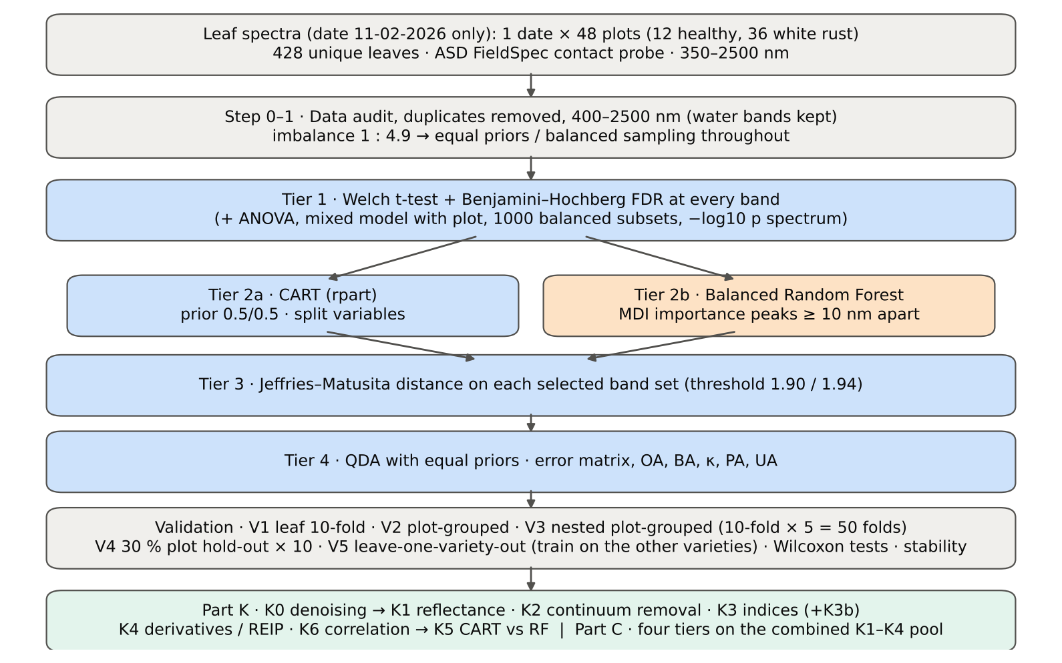
Figure 1. Workflow of each subset analysis (shown for date 11-02-2026; the validation design follows Table 3).

3. Results across the nine subsets

3.1 Spectral differences between healthy and diseased leaves
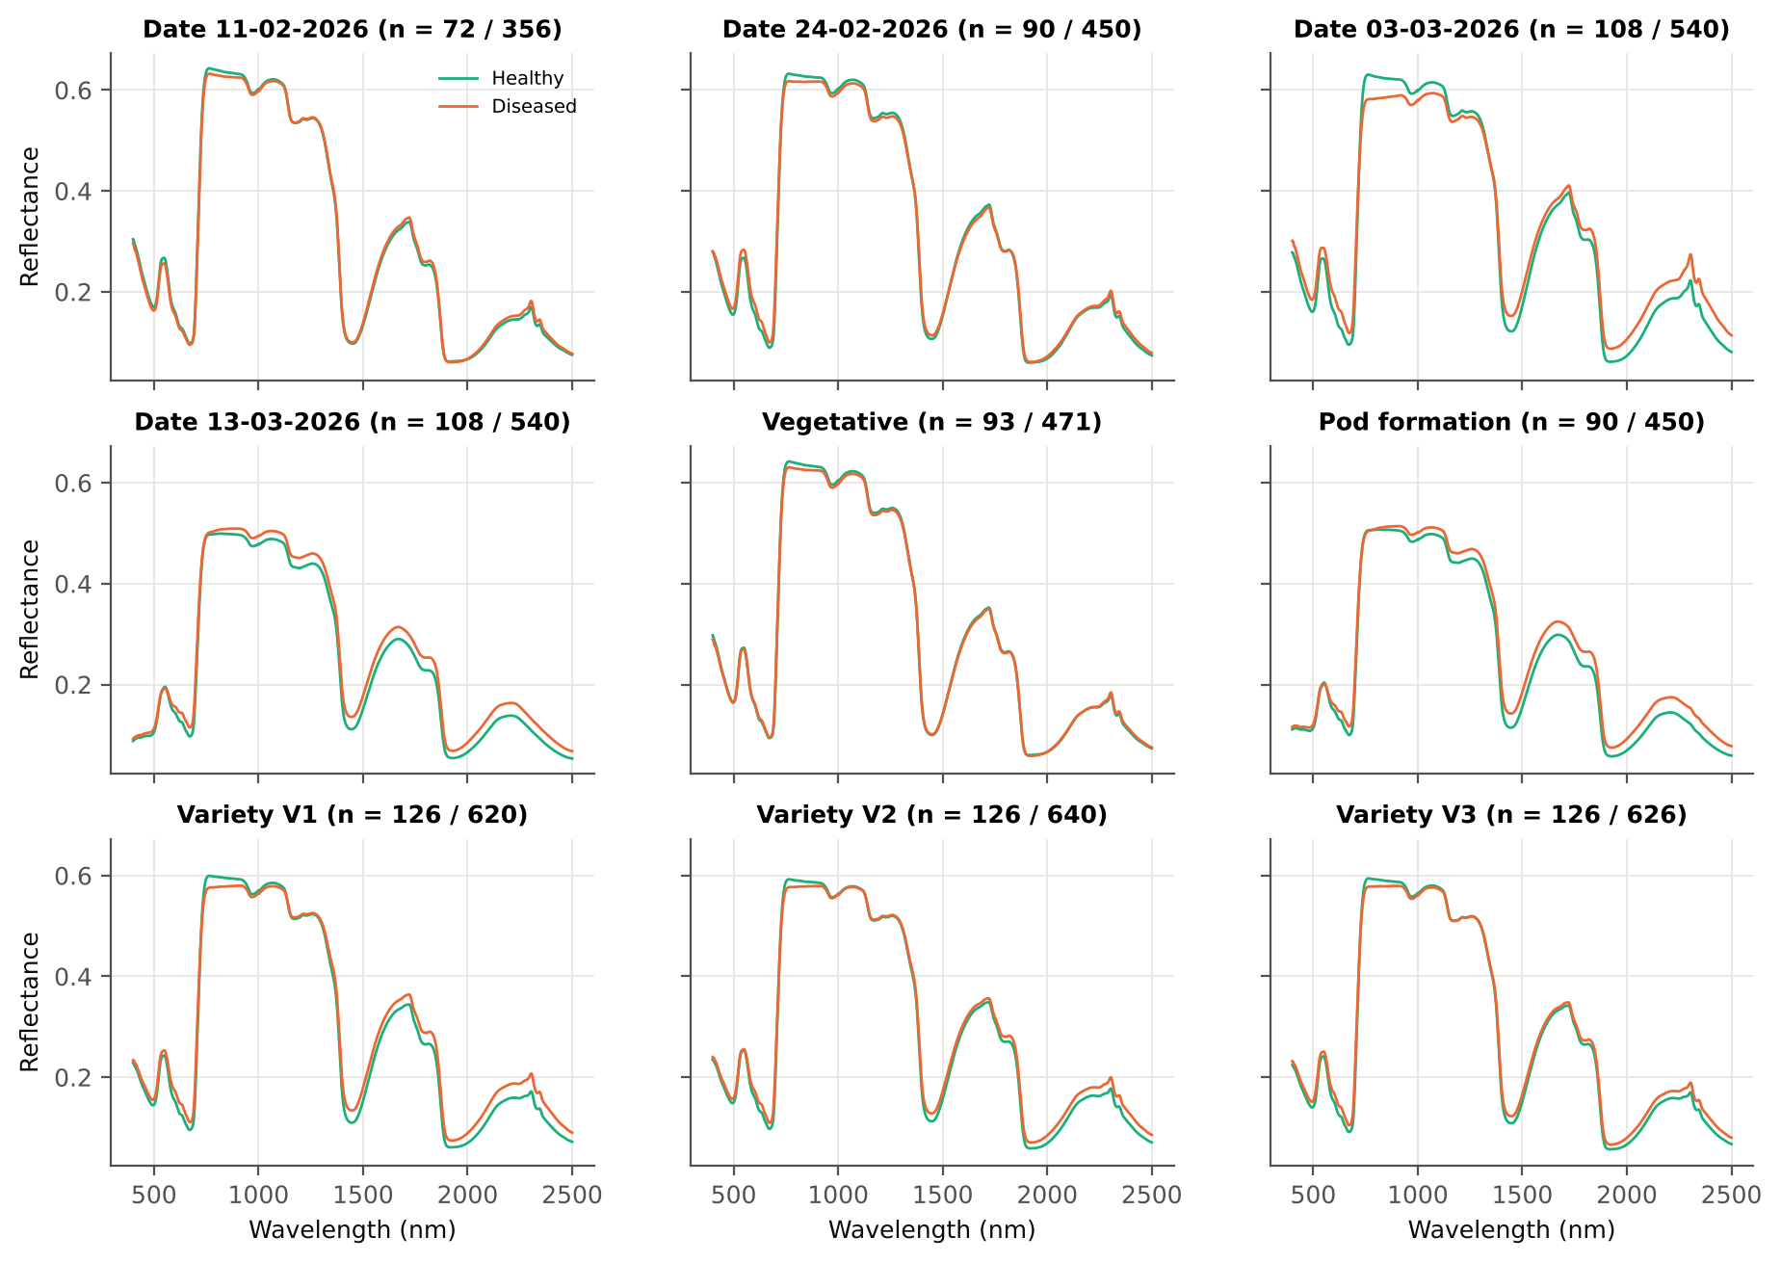
Figure 2. Mean reflectance of healthy (aqua) and diseased (orange) leaves in each subset (n = healthy / diseased).
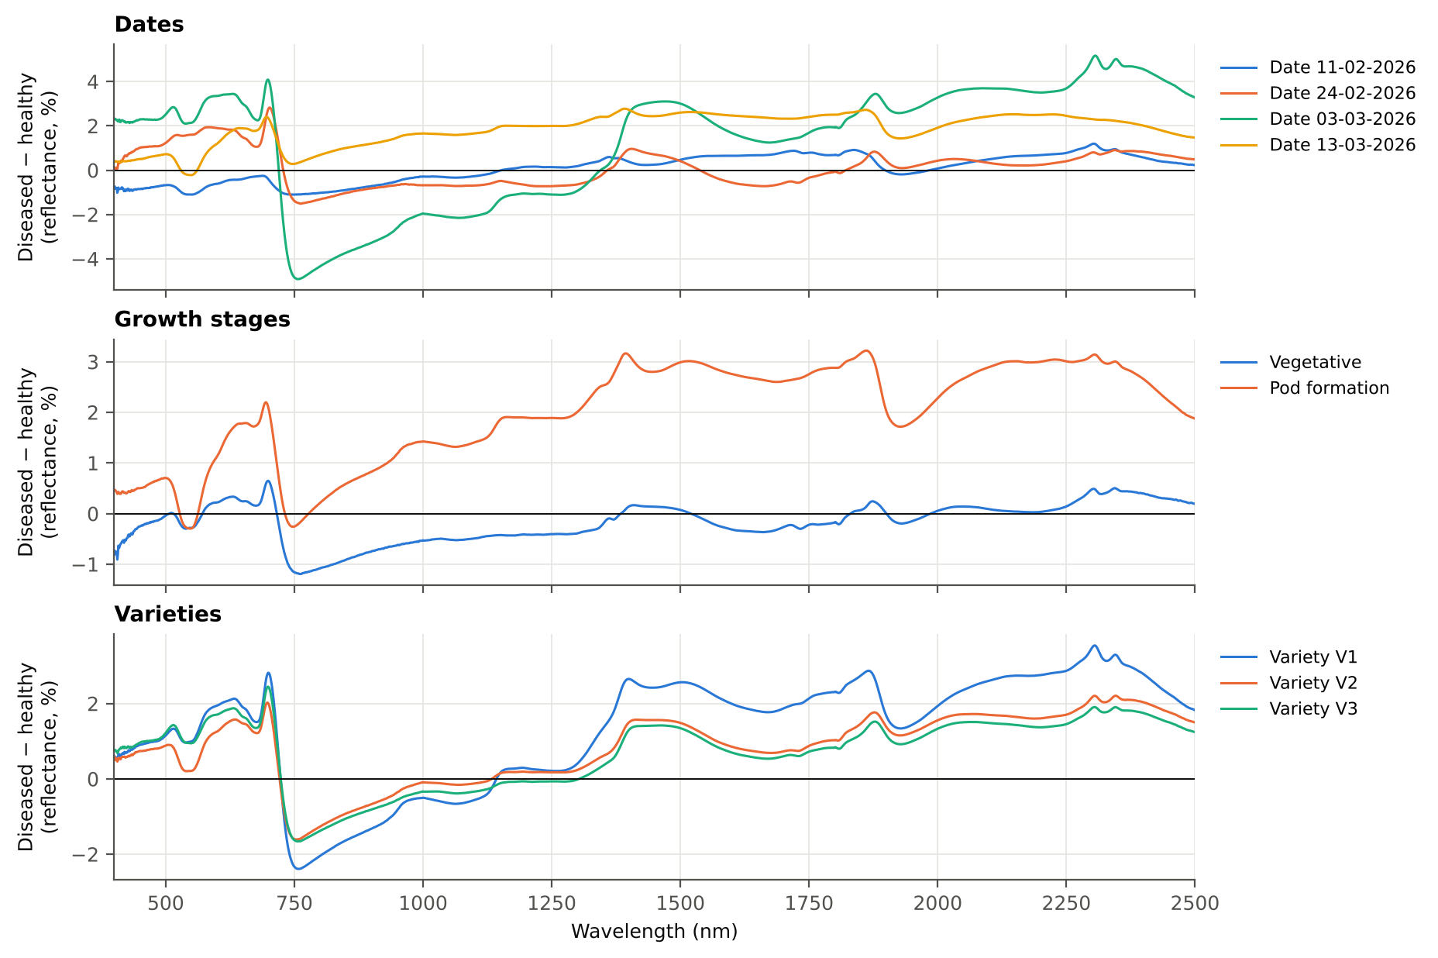
Figure 3. Difference spectra (mean diseased − mean healthy reflectance, in % reflectance) by date, growth stage and variety.
The difference spectra show how the disease effect develops. On 11-02-2026 diseased leaves reflected slightly less than healthy leaves in the visible and NIR (differences < 1.2 %), whereas on 24-02 and 03-03-2026 they reflected more in the visible (chlorophyll loss, white pustules) and in the SWIR beyond 1400 nm (lower leaf water), and less on the NIR plateau at 750–1000 nm (mesophyll damage). The effect was largest on 03-03-2026 (up to +4 to +5 % in the visible and SWIR and −5 % in the NIR). On 13-03-2026 diseased leaves reflected more at all wavelengths, including the NIR (+0.3 to +2.5 %), as senescence of the late-season leaves overlays the disease effect. In the vegetative stage the visible difference has opposite signs on its two dates, so it cancels when the dates are pooled, and only a small NIR decrease remains; at pod formation the SWIR difference is large (+2 to +3 %) but the NIR difference is small. The three varieties show the same pattern with V1 strongest.

3.2 Tier 1 — how many bands differ
Table 3. Tier 1 results by subset (raw reflectance, 400–2500 nm). Mixed model = random plot intercept (pseudo-replication); balanced subsets = significant in at least 95 % of 1000 subsets with equal class sizes.
Subset | Welch + FDR | Mixed model + FDR | Balanced subsets ≥ 95 % | Best K1 band (nm) | AUC | Bands AUC ≥ 0.70
Date 11-02-2026 | 216 of 2101 | 0 | 0 | 777 | 0.641 | 0
Date 24-02-2026 | 1176 of 2101 | 167 | 169 | 695 | 0.747 | 72
Date 03-03-2026 | 2050 of 2101 | 2010 | 1890 | 1999 | 0.842 | 1329
Date 13-03-2026 | 1933 of 2101 | 1697 | 1666 | 1881 | 0.782 | 1156
Vegetative | 0 of 2101 | 0 | 0 | 762 | 0.638 | 0
Pod formation | 1683 of 2101 | 820 | 1338 | 1393 | 0.767 | 978
Variety V1 | 1608 of 2101 | 1470 | 1224 | 1884 | 0.732 | 225
Variety V2 | 1087 of 2101 | 907 | 644 | 1895 | 0.688 | 0
Variety V3 | 1150 of 2101 | 0 | 569 | 691 | 0.686 | 0

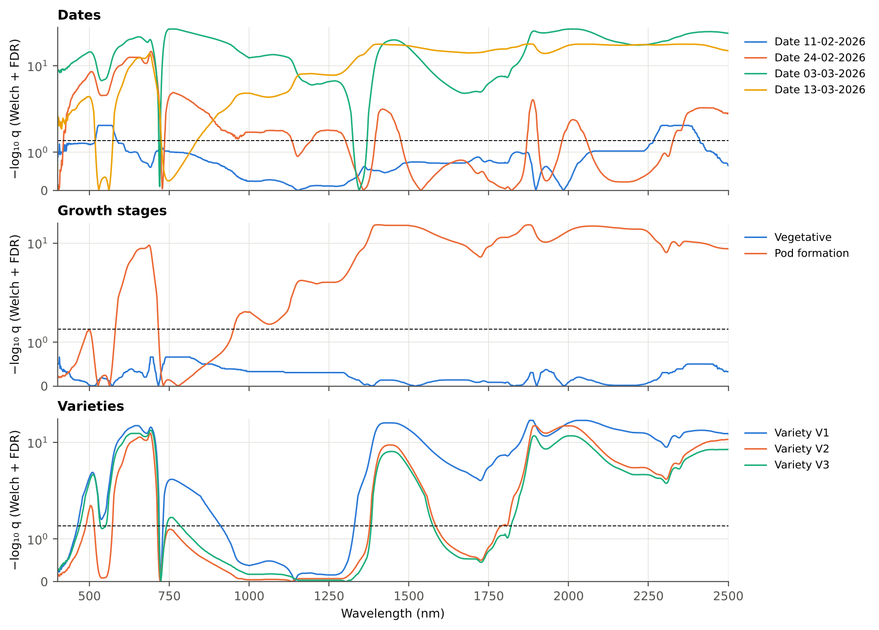
Figure 4. Significance spectra: −log₁₀ q of the Welch t-test (BH-FDR) against wavelength, by date, growth stage and variety (dashed line q = 0.05; symmetric-log scale).
The disease signal grew over the season: 11-02-2026 216, 24-02-2026 1176, 03-03-2026 2050, 13-03-2026 1933 significant bands. On 11-02-2026 the significant bands are confined to the green (≈ 500–600 nm) and SWIR-2 (≈ 2260–2410 nm) and none survives the plot random effect, so symptoms were only beginning. On 03-03-2026, 2050 of 2101 bands are significant and 2010 remain so with the plot effect. The vegetative stage has no FDR-significant band at all, because the visible difference changes sign between its two dates and the date difference inflates the variance within each class, and V3 has no band significant with the mixed model although 1150 are significant by Welch: with only four healthy plots per variety the between-plot variation absorbs the class difference. These subsets warn that leaf-level significance can be produced by a few plots.

3.3 Tier 2 — bands selected by CART and by Random Forest
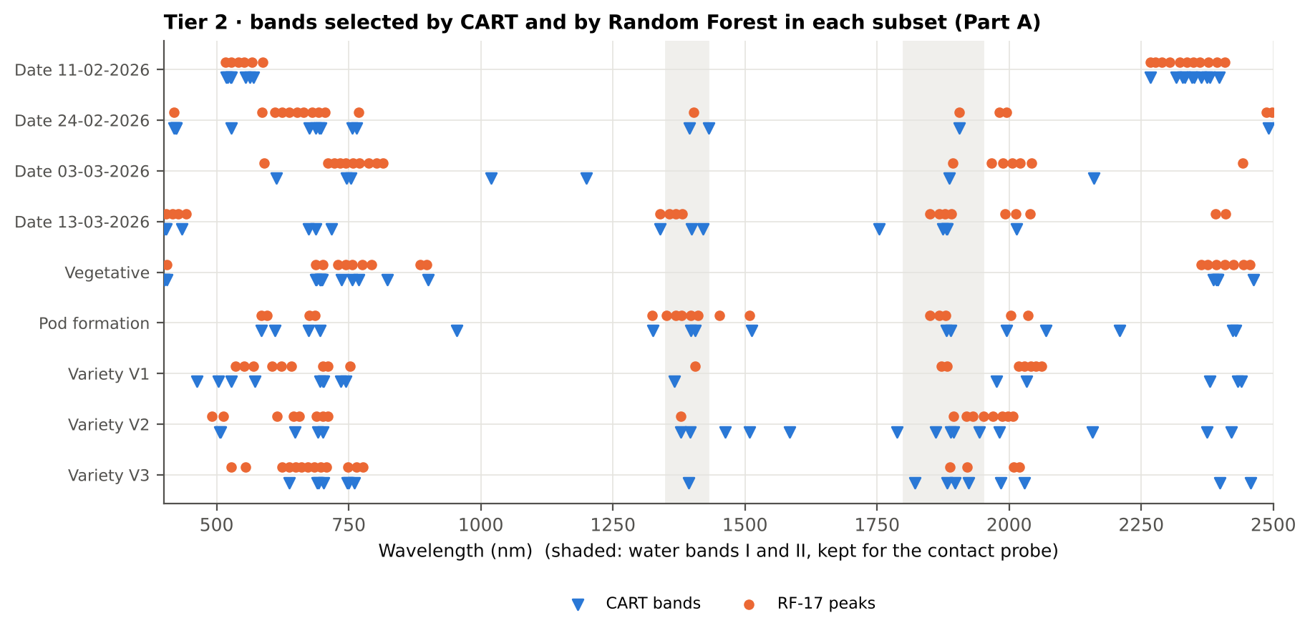
Figure 5. Bands selected by CART (blue triangles) and the 17 RF importance peaks (orange dots) in each subset (Part A, raw reflectance).
Table 4. Tier 2 band sets by subset.
Subset | CART set | Root band (nm) | CART bands (nm, order of use) | RF-17 peaks (nm, by importance)
Date 11-02-2026 | CART-17 | 518 | 518, 2380, 2350, 2364, 2267, 2328, 2374, 521, 563, 2332, 526, 555, 2346, 528, 2397, 2316, 570 | 517, 528, 567, 587, 552, 2408, 541, 2267, 2393, 2304, 2289, 2348, 2377, 2337, 2277, 2323, 2361
Date 24-02-2026 | CART-15 | 697 | 697, 2491, 687, 756, 527, 1432, 422, 419, 1395, 694, 765, 1905, 423, 676, 424 | 693, 705, 624, 664, 1905, 652, 1981, 638, 2498, 586, 419, 610, 681, 769, 2487, 1403, 1995
Date 03-03-2026 | CART-7 | 754 | 754, 613, 2160, 1200, 1886, 746, 1019 | 758, 745, 770, 1988, 788, 2021, 803, 2006, 1894, 733, 2442, 815, 711, 1967, 2042, 723, 590
Date 13-03-2026 | CART-14 | 1875 | 1875, 1881, 1339, 434, 2014, 1399, 1882, 404, 401, 687, 1421, 674, 1754, 717 | 1369, 1878, 405, 2040, 2013, 1867, 417, 1357, 442, 1339, 1381, 428, 1891, 1992, 2409, 1850, 2390
Vegetative | CART-20 | 757 | 757, 2392, 699, 400, 700, 689, 696, 688, 736, 697, 695, 769, 2462, 402, 406, 823, 2395, 900, 2387, 2394 | 406, 688, 701, 730, 744, 2456, 757, 2364, 2392, 2443, 2375, 2425, 2408, 898, 775, 886, 793
Pod formation | CART-16 | 1397 | 1397, 1881, 1406, 584, 2209, 2070, 696, 2428, 954, 1995, 2423, 1326, 1889, 674, 1513, 610 | 1397, 585, 1369, 1411, 1880, 1380, 1452, 2035, 1850, 596, 1868, 1351, 2003, 686, 1324, 1508, 676
Variety V1 | CART-15 | 701 | 701, 2432, 2380, 1366, 463, 572, 744, 2033, 735, 527, 503, 703, 2439, 1976, 695 | 701, 1883, 2041, 2051, 642, 622, 711, 552, 2018, 2029, 2061, 1872, 605, 536, 1406, 753, 569
Variety V2 | CART-19 | 1895 | 1895, 2421, 701, 1944, 1463, 1584, 1889, 648, 1861, 507, 506, 2158, 691, 2374, 1396, 1508, 1788, 1378, 1981 | 1895, 1931, 1951, 1987, 1997, 1969, 1379, 701, 689, 1919, 2007, 711, 491, 615, 657, 513, 645
Variety V3 | CART-16 | 693 | 693, 2399, 1883, 747, 1923, 1394, 2029, 1897, 1984, 702, 750, 761, 1822, 638, 690, 2457 | 697, 749, 765, 708, 660, 1888, 638, 777, 2020, 685, 527, 2008, 673, 624, 1921, 649, 555

Both selectors return to the same regions in most subsets: the red edge (≈ 690–760 nm), the green peak (≈ 520–590 nm) and the SWIR water bands near 1400 nm and 1880–2020 nm. RF concentrates its 17 peaks in one or two regions (it ranks neighbouring, correlated bands), whereas CART picks complementary regions. On 11-02-2026 both selectors use only the green and the SWIR-2 end (2260–2410 nm), consistent with Tier 1.

3.4 Tier 3 — separability (J–M distance)
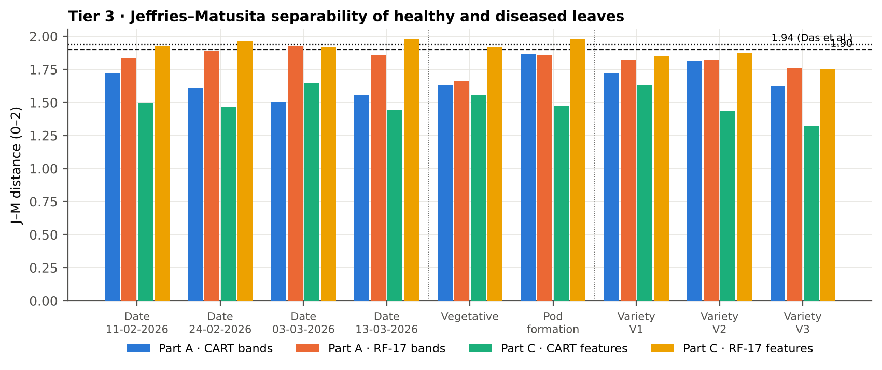
Figure 6. J–M distance of healthy and diseased leaves on the CART and RF-17 sets of Part A (raw reflectance) and Part C (combined pool). Dashed 1.90, dotted 1.94.
Table 5. J–M distance (0–2) by subset.
Subset | Part A CART | Part A RF-17 | Part C CART | Part C RF-17
Date 11-02-2026 | 1.720 (CART-17) | 1.831 | 1.490 (CART-4) | 1.932
Date 24-02-2026 | 1.604 (CART-15) | 1.891 | 1.465 (CART-4) | 1.965
Date 03-03-2026 | 1.501 (CART-7) | 1.928 | 1.646 (CART-5) | 1.918
Date 13-03-2026 | 1.557 (CART-14) | 1.861 | 1.445 (CART-8) | 1.980
Vegetative | 1.633 (CART-20) | 1.664 | 1.560 (CART-8) | 1.917
Pod formation | 1.864 (CART-16) | 1.858 | 1.478 (CART-10) | 1.980
Variety V1 | 1.721 (CART-15) | 1.819 | 1.630 (CART-12) | 1.853
Variety V2 | 1.813 (CART-19) | 1.821 | 1.437 (CART-11) | 1.872
Variety V3 | 1.624 (CART-16) | 1.763 | 1.325 (CART-10) | 1.751

On raw reflectance no band set reaches 1.94; only RF-17 on 03-03-2026 (1.93) passes 1.90, and pod formation comes close (1.86). In the combined pool the 17 RF-selected features pass 1.90 in 6 of 9 subsets and 1.94 in 3 (Date 24-02-2026, Date 13-03-2026, Pod formation). The small CART sets of Part C (4–12 features) have lower J–M, because J–M grows with the number of features; their classification accuracy is nevertheless high (Table 8).

3.5 Tier 4 and validation — accuracy on new plots
Table 6. Balanced accuracy (%) of the four pipelines on new plots (V3, nested plot-grouped CV, mean of 5 repeats), Part A (raw reflectance) and Part C (combined pool). clf = classifier; QDA-CART / QDA-RF = QDA with equal priors on the CART- or RF-selected features.
Subset | A: CART clf | A: RF clf | A: QDA-CART | A: QDA-RF | C: CART clf | C: RF clf | C: QDA-CART | C: QDA-RF
Date 11-02-2026 | 55.9 | 59.9 | 81.1 | 77.4 | 91.1 | 91.8 | 92.1 | 88.3
Date 24-02-2026 | 64.6 | 69.3 | 79.6 | 83.6 | 90.0 | 92.8 | 89.3 | 93.6
Date 03-03-2026 | 74.4 | 79.5 | 84.3 | 86.2 | 89.0 | 88.6 | 94.8 | 93.1
Date 13-03-2026 | 69.8 | 74.1 | 75.7 | 80.6 | 74.4 | 78.8 | 80.1 | 76.3
Vegetative | 51.2 | 50.9 | 71.5 | 72.8 | 80.0 | 88.4 | 90.5 | 89.2
Pod formation | 62.6 | 67.0 | 70.0 | 77.8 | 74.2 | 73.8 | 74.4 | 69.9
Variety V1 | 61.8 | 67.7 | 75.6 | 73.9 | 74.6 | 80.0 | 79.1 | 81.0
Variety V2 | 62.3 | 63.7 | 70.9 | 71.4 | 75.2 | 80.1 | 73.7 | 75.9
Variety V3 | 61.0 | 65.2 | 69.6 | 66.2 | 72.7 | 76.8 | 76.4 | 84.8
All dates pooled | 64.7 | 70.7 | 72.0 | 69.1 | 80.1 | 86.1 | 78.2 | 83.7

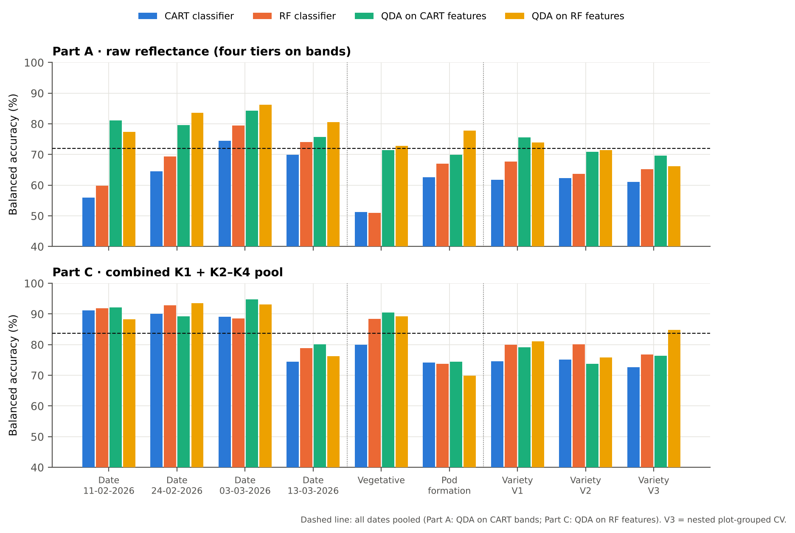
Figure 7. Balanced accuracy on new plots (V3) of the four pipelines in Part A and Part C, by subset. Dashed line: the same pipeline with all dates pooled.
QDA with equal priors on the CART bands of Das et al. reached 69.6–84.3 % on new plots, above the pooled result (72.0 %) on all four dates and in V1, slightly below it in the vegetative stage, at pod formation and in V2 and V3, and up to 84.3 % on 03-03-2026. As classifiers on reflectance, CART and RF were weaker than QDA on the selected bands in every subset; in the weak-signal subsets (11-02-2026, vegetative) they stayed near chance (50.9–59.9 % for RF), while QDA on the few CART bands still reached 71.5–81.1 %. In the combined pool all pipelines improved: QDA on RF features gained -0.0 to 17.7 points over QDA on CART reflectance bands, and the best pipeline per subset reached 74.4–94.8 %. The exceptions are 13-03-2026 and pod formation, where the combined pool gained little.
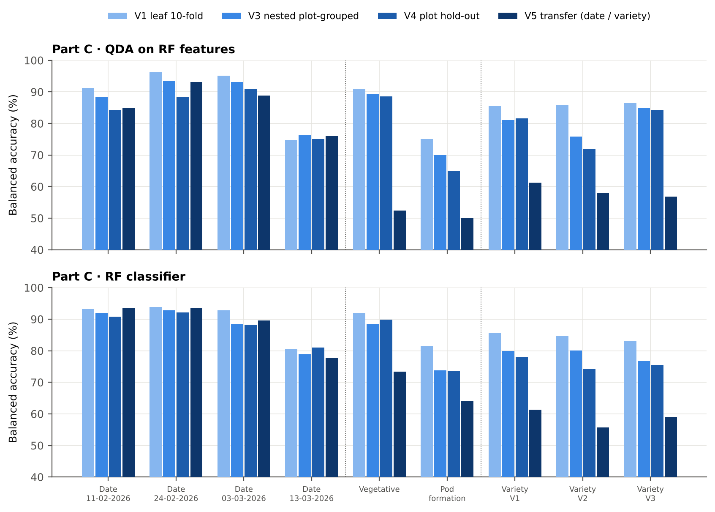
Figure 8. Part C: balanced accuracy of QDA on RF features and of the RF classifier under the four validation schemes, by subset.
For QDA on CART bands, the leaf-level estimate of Das et al. (V1) differed from the nested plot-grouped estimate (V3) by -4.0 to +10.8 points; it was clearly optimistic only in V2 (+10.8) and in the vegetative stage (+8.7), where selection on all leaves and plot effects matter most, and close to V3 elsewhere. In the combined pool (QDA on RF features) V1 − V3 ranged from -1.4 to +9.8 points. The plot hold-out (V4) agreed with V3 within a few points. Transfer (V5) is discussed in section 3.8.

3.6 CART versus Random Forest
Table 7. CART versus RF in Part A: paired Wilcoxon signed-rank tests over the V3 folds (positive = RF better), and stability of the selected bands (mean pairwise Jaccard index, ± 10 nm, over the nested training sets).
Subset | RF − CART classifier (V3) | RF better / folds | p | QDA: RF − CART bands | p | Jaccard RF / CART
Date 11-02-2026 | 4.6 pts | 33 / 50 | 0.005 | -2.8 pts | 0.205 | 0.39 / 0.27
Date 24-02-2026 | 4.8 pts | 33 / 50 | 0.004 | 4.3 pts | 0.004 | 0.62 / 0.38
Date 03-03-2026 | 5.9 pts | 38 / 50 | 2.0e-6 | 1.8 pts | 0.259 | 0.68 / 0.29
Date 13-03-2026 | 3.3 pts | 34 / 50 | 0.004 | 4.9 pts | 0.009 | 0.47 / 0.34
Vegetative | 0.0 pts | 24 / 50 | 0.992 | 1.4 pts | 0.335 | 0.37 / 0.39
Pod formation | 5.1 pts | 32 / 45 | 0.003 | 7.8 pts | 5.6e-5 | 0.45 / 0.27
Variety V1 | 5.9 pts | 20 / 20 | 8.8e-5 | -1.8 pts | 0.455 | 0.56 / 0.23
Variety V2 | 1.6 pts | 9 / 20 | 0.295 | 0.6 pts | 0.575 | 0.56 / 0.27
Variety V3 | 4.3 pts | 19 / 20 | 1.6e-4 | -3.3 pts | 0.006 | 0.58 / 0.33

As a classifier, RF beat CART in 7 of 9 subsets (by 3.3–5.9 points, Wilcoxon p < 0.01); in V2 the advantage (+1.6 points) was not significant and in the vegetative stage the two performed alike. As band selectors for QDA the result was mixed: the RF bands were significantly better on 24-02-2026, on 13-03-2026 and at pod formation (+4 to +8 points), the CART bands in V3 (-3.3 points), and the difference was not significant in the other five subsets. RF selected its bands more consistently than CART in eight subsets (mean pairwise Jaccard 0.37–0.68 vs 0.23–0.39); only in the vegetative stage were both equally unstable (0.37 vs 0.39), consistent with the absence of a clear Tier-1 signal there.

3.7 Disease-sensitive features (Part K)
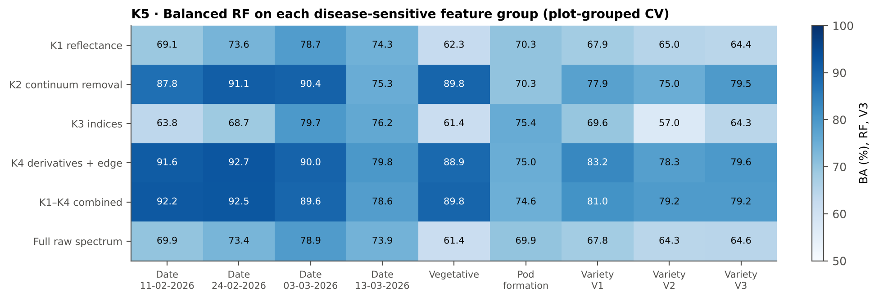
Figure 9. K5: balanced accuracy of a Balanced RF on each feature group, by subset (plot-grouped CV, V3).
Table 8. Most informative feature group and the most sensitive single feature of each family, by subset (AUC is direction-free: 0.5 = no separation).
Subset | Best group (RF, V3) | Best D1 band (AUC) | Best K2 parameter (AUC) | Best K3 index (AUC) | Best edge parameter (AUC)
Date 11-02-2026 | K1–K4 combined pool 92.2 % | 872 nm (0.90) | CR6 water 1940 symmetry (0.92) | NWI2 (0.68) | Rg (green peak reflectance) (0.63)
Date 24-02-2026 | K4 derivatives + edge parameters 92.7 % | 1920 nm (0.92) | CR6 water 1940 symmetry (0.93) | ARI (0.81) | REP, linear 4-point (nm) (0.74)
Date 03-03-2026 | K2 continuum removal 90.4 % | 884 nm (0.90) | CR6 water 1940 area (0.89) | NWI2 (0.87) | SDr (red-edge area) (0.84)
Date 13-03-2026 | K4 derivatives + edge parameters 79.8 % | 626 nm (0.83) | CR3 water 970 width (0.86) | ARI (0.83) | (SDr − SDy)/(SDr + SDy) (0.85)
Vegetative | K2 continuum removal 89.8 % | 1918 nm (0.89) | CR6 water 1940 symmetry (0.91) | NCPI (0.67) | SDr (red-edge area) (0.63)
Pod formation | K3 vegetation indices 75.4 % | 800 nm (0.79) | CR3 water 970 width (0.85) | ARI (0.77) | (SDr − SDy)/(SDr + SDy) (0.79)
Variety V1 | K4 derivatives + edge parameters 83.2 % | 873 nm (0.82) | CR3 water 970 width (0.78) | NWI2 (0.76) | REP, linear 4-point (nm) (0.68)
Variety V2 | K1–K4 combined pool 79.2 % | 884 nm (0.75) | CR3 water 970 width (0.77) | NWI2 (0.67) | Ro (red well reflectance) (0.64)
Variety V3 | K4 derivatives + edge parameters 79.6 % | 848 nm (0.81) | CR3 water 970 width (0.75) | RVS2 (0.67) | Ro (red well reflectance) (0.67)

In 7 of 9 subsets the first-derivative (K4) and continuum-removed (K2) groups were far more informative than reflectance (K1) or the 31 indices (K3), by 10.7–27.5 points of RF accuracy; on Date 13-03-2026 and Pod formation the groups performed alike, because late-season senescence changes reflectance level and shape together. The most sensitive single features recur across subsets: the symmetry or area of the 1940 nm water absorption feature (CR6), the width of the 970 nm water feature (CR3), first-derivative bands on the NIR shoulder at 845–885 nm and near 1920 nm, and the water and anthocyanin indices NWI2 and ARI. The best single features reach AUC 0.90–0.93 on the first three dates but only 0.77–0.85 at pod formation and in the varieties.

3.8 Red-edge shift and transfer to new dates and varieties
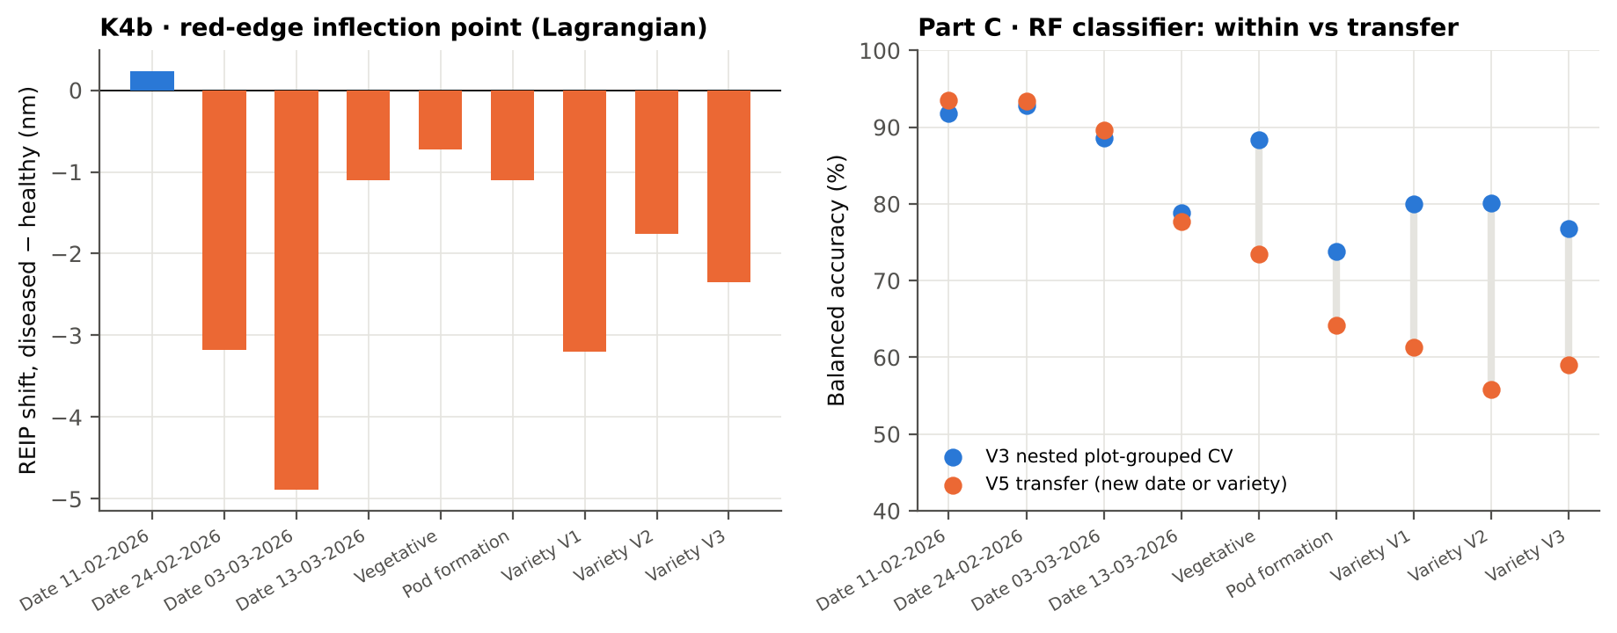
Figure 10. Left: REIP shift (diseased − healthy, Lagrangian method). Right: Part C RF classifier, nested plot-grouped CV (V3) versus transfer to an unseen variety (dates) or an unseen date (stages, varieties) (V5).
The red-edge inflection point shifted to shorter wavelengths in diseased leaves in eight subsets (blue shift of chlorophyll loss): most on 03-03-2026 (−4.9 nm), on 24-02-2026 (−3.2 nm) and in V1 (−3.2 nm), little in the vegetative stage and at pod formation (−0.7 to −1.1 nm), and not at all on 11-02-2026 (+0.2 nm).
Transfer differed sharply between the two kinds of V5. Within a single date, features and classifiers chosen on two varieties worked on the third almost as well as on new plots of the same varieties (V5 77.7–93.6 % for the RF classifier on the combined pool). Across dates, accuracy fell to 55.8–73.4 % in the stage and variety subsets: the spectral change between dates (phenology, leaf age, measurement conditions) is larger than the disease effect, and its direction is not the same on every date (Figure 2).

3.9 What the combined-pool selectors chose (Part C)
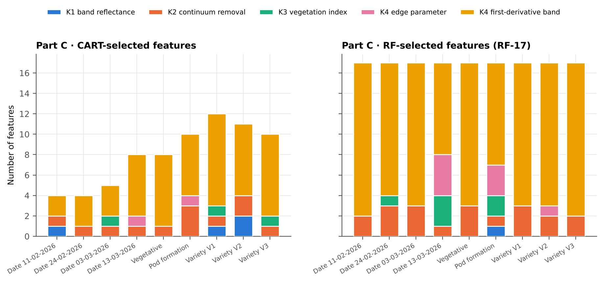
Figure 11. Feature types chosen by CART and by RF (RF-17) from the combined pool, by subset.
RF-17 consisted almost entirely of first-derivative bands, with two or three continuum-removed water parameters; edge parameters and indices entered mainly on 13-03-2026 and at pod formation, and reflectance bands almost never. CART chose fewer features (4–12) and a more varied mix, usually one continuum-removed water parameter at or near the root of the tree.

4. Results by subset
Each section below follows the steps of the workbook of that subset: data and validation design, Tiers 1–4 on raw reflectance with CART and RF, validation, disease-sensitive features, the four tiers on the combined pool, transfer, interpretation and cross-checks. Sheet numbers in the workbooks: 03–09 (Steps 0–6), 10–13 (Part A1–A4), 14–22 (Part K), 23–30 (Part C), 31 (V5), 32 (strata), 33 (cross-checks).

4.1 Date 11-02-2026 — date 11-02-2026 only

4.1.1 Data and validation design
This subset contains 428 leaf spectra (72 healthy, 356 diseased; ratio 1 : 4.9) from 12 healthy and 36 diseased plots, measured on 11-02-2026; growth stages Flowering, Vegetative; varieties V1, V2, V3. V3 used 10-fold plot-grouped CV × 5 (50 training sets), V4 held out 4 healthy + 11 diseased plots × 10, and V5 was leave-one-variety-out (3 units).
Table 9. Date 11-02-2026: leaf spectra by date and growth stage.
Date | Growth stage | Healthy | Diseased
11-02-2026 | Flowering | 9 | 45
11-02-2026 | Vegetative | 63 | 311

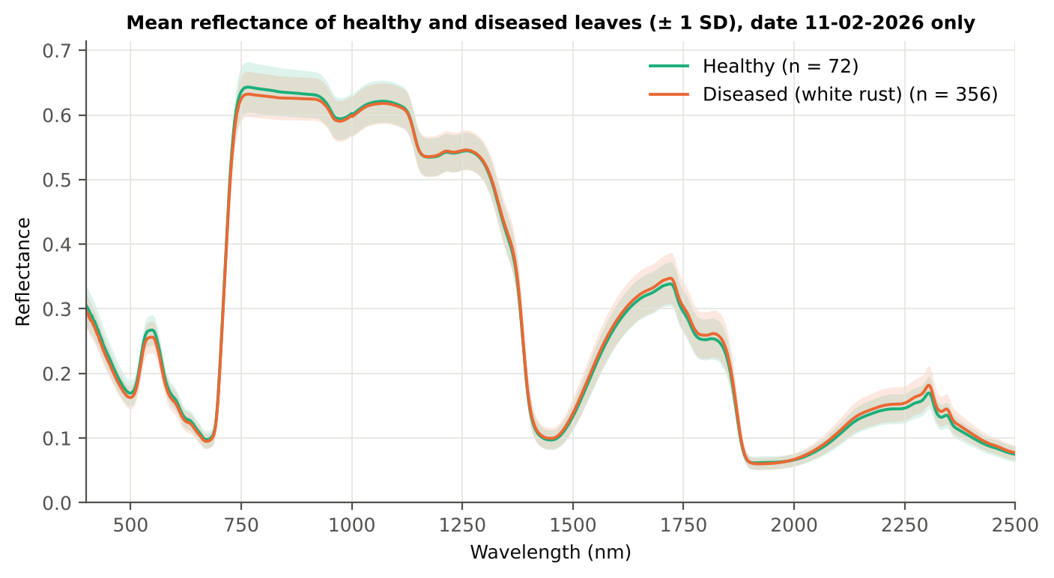
Figure 12. Date 11-02-2026: mean reflectance of healthy and diseased leaves (± 1 SD).

4.1.2 Tier 1 — statistical screening
Table 10. Date 11-02-2026: number of significant bands by test.
Test | Significant bands (of 2101)
Welch t-test + BH-FDR q < 0.05 (used for Tier 2) | 216
One-way ANOVA p < 0.05, uncorrected (rule of Das et al.) | 821
One-way ANOVA + BH-FDR q < 0.05 | 310
Welch t-test p < 0.05, uncorrected | 851
Mixed model (random plot effect) + BH-FDR q < 0.05 | 0
Balanced subsets (72 vs 72): significant in ≥ 95 % of 1000 subsets | 0
Levene test p < 0.05 (unequal variances → Welch) | 109

Table 11. Date 11-02-2026: largest contiguous ranges of FDR-significant bands.
Contiguous significant range (nm) | Bands
2267–2411 | 145
517–587 | 71

Table 12. Date 11-02-2026: ten bands with the largest |t|.
Band (nm) | Mean H | Mean D | Welch t | q (BH) | Hedges g | AUC
541 | 0.2662 | 0.2552 | -3.66 | 1.99e-2 | -0.46 | 0.633
542 | 0.2664 | 0.2554 | -3.66 | 1.99e-2 | -0.46 | 0.632
538 | 0.2650 | 0.2541 | -3.65 | 1.99e-2 | -0.46 | 0.632
543 | 0.2666 | 0.2556 | -3.64 | 1.99e-2 | -0.46 | 0.632
539 | 0.2655 | 0.2546 | -3.64 | 1.99e-2 | -0.46 | 0.633
544 | 0.2668 | 0.2558 | -3.64 | 1.99e-2 | -0.46 | 0.631
540 | 0.2659 | 0.2550 | -3.63 | 1.99e-2 | -0.46 | 0.632
550 | 0.2669 | 0.2559 | -3.63 | 1.99e-2 | -0.46 | 0.631
549 | 0.2671 | 0.2561 | -3.63 | 1.99e-2 | -0.46 | 0.631
537 | 0.2642 | 0.2535 | -3.63 | 1.99e-2 | -0.46 | 0.632

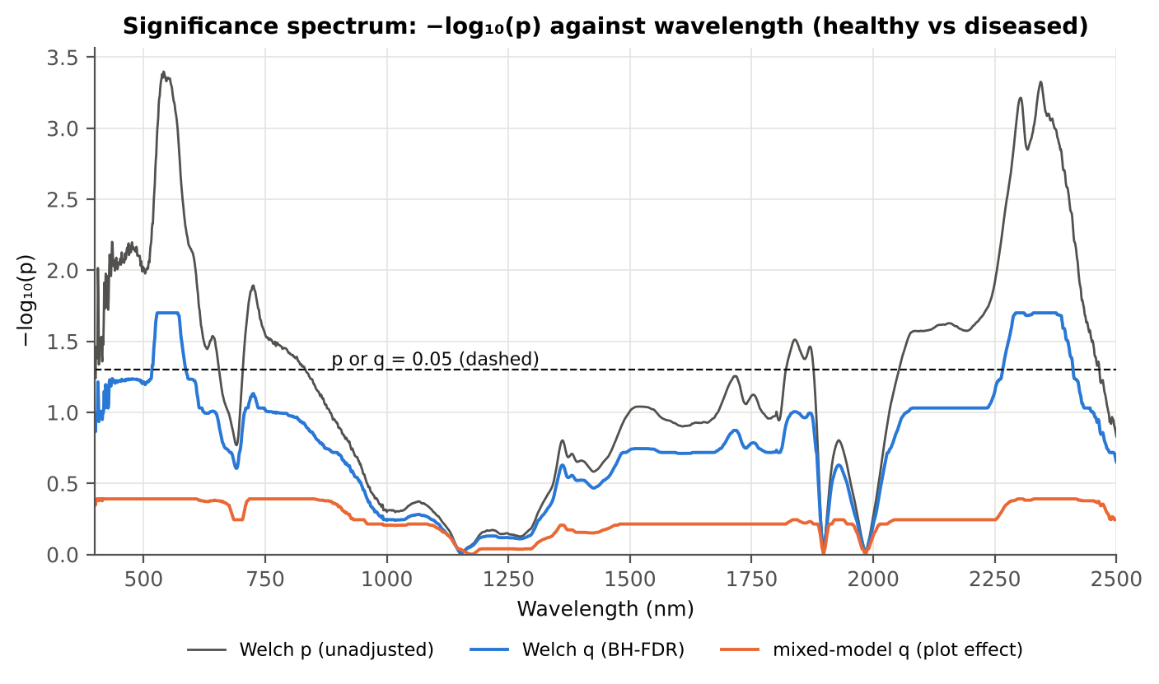
Figure 13. Date 11-02-2026: −log₁₀(p) against wavelength (Welch p, BH q and mixed-model q; dashed p or q = 0.05).

4.1.3 Tier 2 — CART and Random Forest band selection
Table 13. Date 11-02-2026: the CART-17 bands selected by rpart (prior 0.5/0.5) and how often a band within ± 10 nm is re-selected.
Band (nm) | Region | First used at node | Bootstrap re-selection | Nested-CV re-selection
518 | Green (500–599) | 1 | 97.0 % | 76.0 %
521 | Green (500–599) | 12 | 98.0 % | 82.0 %
526 | Green (500–599) | 25 | 99.5 % | 64.0 %
528 | Green (500–599) | 50 | 96.0 % | 64.0 %
555 | Green (500–599) | 28 | 73.5 % | 34.0 %
563 | Green (500–599) | 14 | 73.5 % | 38.0 %
570 | Green (500–599) | 101 | 75.5 % | 34.0 %
2267 | SWIR-2 (1951–2349) | 7 | 78.5 % | 46.0 %
2316 | SWIR-2 (1951–2349) | 69 | 38.5 % | 26.0 %
2328 | SWIR-2 (1951–2349) | 8 | 35.5 % | 46.0 %
2332 | SWIR-2 (1951–2349) | 17 | 36.5 % | 48.0 %
2346 | SWIR-2 (1951–2349) | 34 | 61.0 % | 74.0 %
2350 | SWIR-2 end (2350–2500) | 3 | 65.5 % | 74.0 %
2364 | SWIR-2 end (2350–2500) | 4 | 56.5 % | 34.0 %
2374 | SWIR-2 end (2350–2500) | 10 | 66.5 % | 56.0 %
2380 | SWIR-2 end (2350–2500) | 2 | 68.0 % | 54.0 %
2397 | SWIR-2 end (2350–2500) | 57 | 73.0 % | 36.0 %

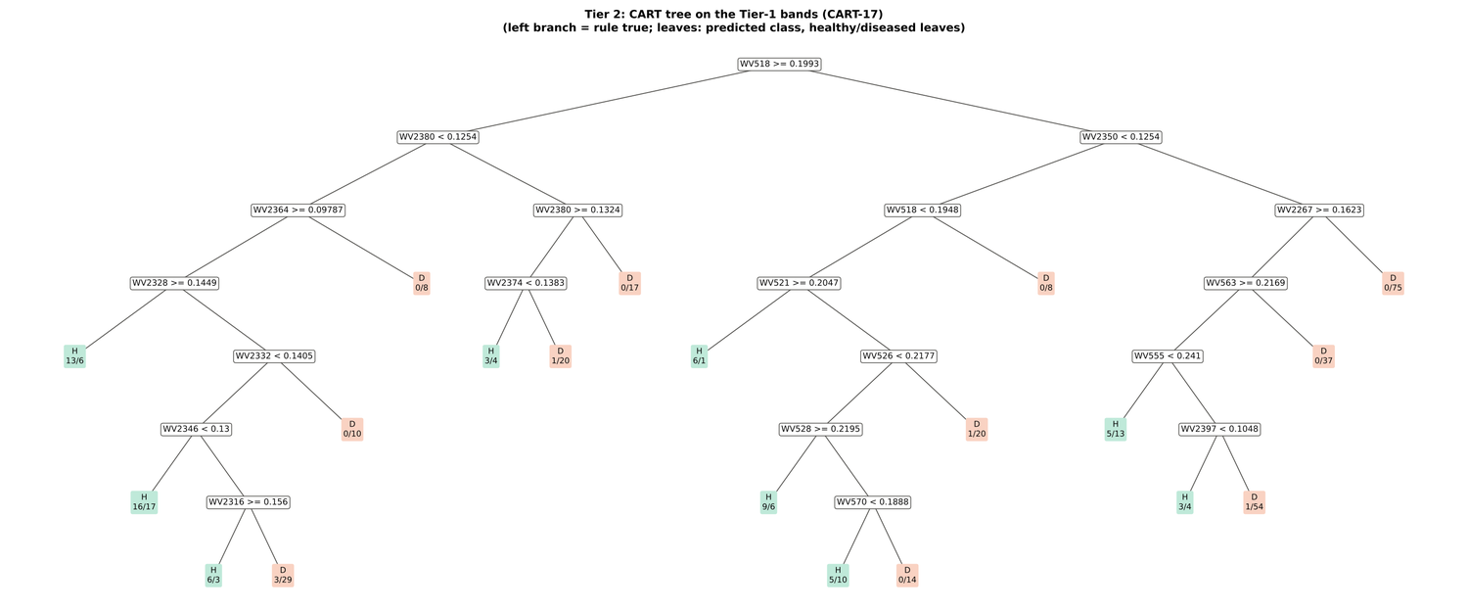
Figure 14. Date 11-02-2026: CART tree on the Tier-1 bands (CART-17).
RF-17 importance peaks: 517, 528, 567, 587, 552, 2408, 541, 2267, 2393, 2304, 2289, 2348, 2377, 2337, 2277, 2323, 2361 nm.
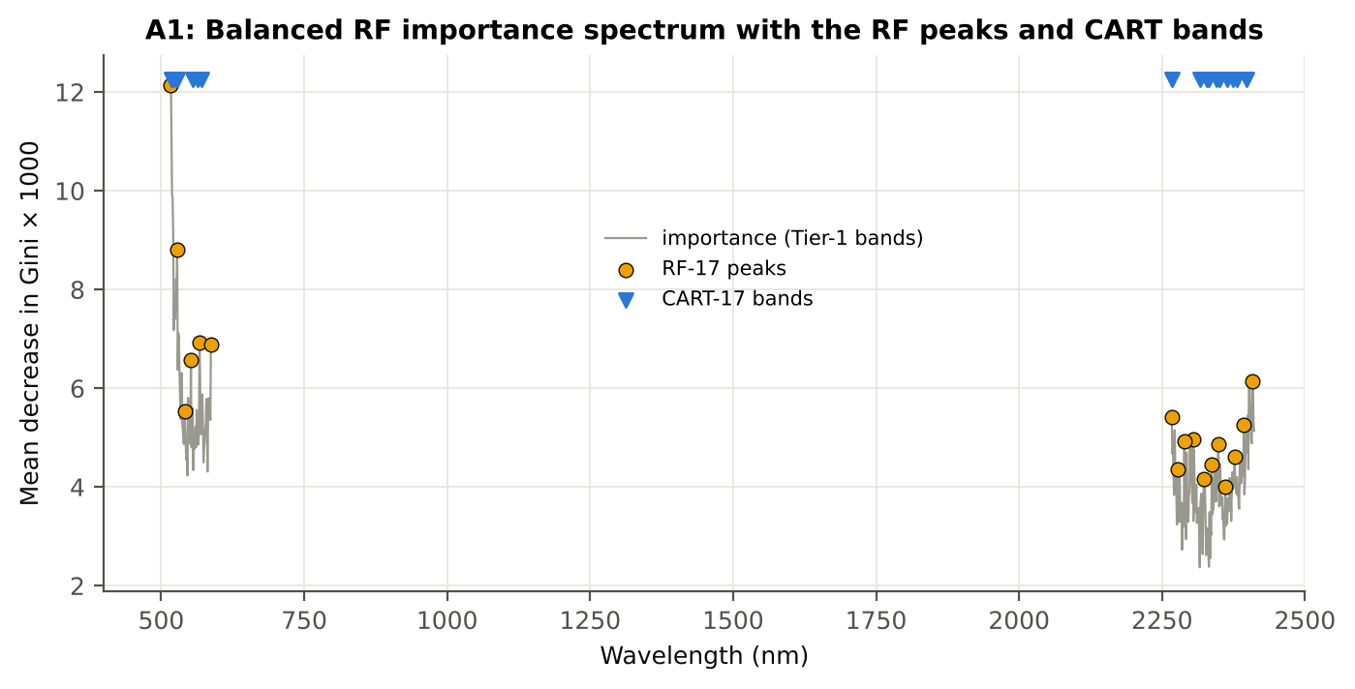
Figure 15. Date 11-02-2026: Balanced RF importance spectrum with the RF-17 peaks and the CART bands.

4.1.4 Tier 3 and Tier 4 — separability and classification
Table 14. Date 11-02-2026: Jeffries–Matusita distance of healthy and diseased leaves.
Band set | Bands | α (Bhattacharyya) | J–M (0–2) | √J–M | Separability
CART-17 | 17 | 1.966 | 1.720 | 1.311 | below 1.90
CART-2 (1-SE) | 2 | 0.068 | 0.132 | 0.364 | below 1.90
RF-17 | 17 | 2.470 | 1.831 | 1.353 | below 1.90
RF-10 | 10 | 1.083 | 1.323 | 1.150 | below 1.90

Table 15. Date 11-02-2026: error matrix of QDA (equal priors) on the CART-17 bands, leaf-level 10-fold CV (V1; as Table 2 of Das et al.).
Classified \ Reference | Healthy | Diseased | Row total | User's accuracy
Healthy | 52 | 24 | 76 | 68.4 %
Diseased | 20 | 332 | 352 | 94.3 %
Column total | 72 | 356 | 428
Producer's accuracy | 72.2 % | 93.3 %
Overall accuracy | 89.7 % | Balanced accuracy | 82.7 % | κ = 0.641

Table 16. Date 11-02-2026: Tier 4 on all band sets (V1), with equal and sample priors and LDA for comparison.
Band set | Classifier | OA | BA | PA healthy | PA diseased | κ
CART-17 | QDA equal priors | 89.7 % | 82.7 % | 72.2 % | 93.3 % | 0.641
CART-17 | QDA sample priors | 89.0 % | 76.2 % | 56.9 % | 95.5 % | 0.572
CART-17 | LDA equal priors | 92.3 % | 94.8 % | 98.6 % | 91.0 % | 0.765
CART-2 (1-SE) | QDA equal priors | 54.9 % | 61.8 % | 72.2 % | 51.4 % | 0.128
CART-2 (1-SE) | QDA sample priors | 82.5 % | 49.6 % | 0.0 % | 99.2 % | -0.014
CART-2 (1-SE) | LDA equal priors | 61.7 % | 62.0 % | 62.5 % | 61.5 % | 0.149
RF-17 | QDA equal priors | 91.1 % | 86.9 % | 80.6 % | 93.3 % | 0.699
RF-17 | QDA sample priors | 91.8 % | 84.6 % | 73.6 % | 95.5 % | 0.703
RF-17 | LDA equal priors | 90.4 % | 94.2 % | 100.0 % | 88.5 % | 0.721
RF-10 | QDA equal priors | 90.4 % | 87.6 % | 83.3 % | 91.8 % | 0.687
RF-10 | QDA sample priors | 89.5 % | 77.1 % | 58.3 % | 95.8 % | 0.590
RF-10 | LDA equal priors | 88.3 % | 88.5 % | 88.9 % | 88.2 % | 0.649

4.1.5 Validation and CART versus RF (Part A)
Table 17. Date 11-02-2026: balanced accuracy of the four pipelines on raw reflectance under the validation schemes.
Pipeline | V1 | V3 (± SD) | V4 (± SD) | V5 | AUC V3 | κ V3
CART classifier | 57.9 % | 55.9 % ± 2.6 | 54.6 % ± 7.0 | 54.5 % | 0.579 | 0.084
RF classifier | 57.3 % | 59.9 % ± 3.5 | 57.1 % ± 5.5 | 58.7 % | 0.639 | 0.141
QDA on CART features | 82.7 % | 81.1 % ± 2.9 | 76.0 % ± 8.6 | 76.9 % | 0.886 | 0.565
QDA on RF features | 86.9 % | 77.4 % ± 2.8 | 72.8 % ± 12.7 | 71.6 % | 0.859 | 0.453

Table 18. Date 11-02-2026: validation of QDA on CART bands — effect of the imbalance correction (equal vs sample priors) and of random under-sampling (V3-RUS).
Scheme | Priors | BA | SD | OA | PA healthy | PA diseased
V1 · leaf-level 10-fold, bands fixed | equal (corrected) | 82.7 % | – | 89.7 % | 72.2 % | 93.3 %
V2 · plot-grouped 10-fold, bands fixed | equal (corrected) | 82.2 % | – | 88.8 % | 72.2 % | 92.1 %
V3 · nested plot-grouped 10-fold × 5 = 50 folds | equal (corrected) | 81.1 % | 2.9 | 86.5 % | 73.1 % | 89.2 %
V4 · 30 % plot hold-out × 10 | equal (corrected) | 76.0 % | 8.6 | 83.2 % | 64.8 % | 87.2 %
V5 · leave-one-variety-out (train on the other varieties) (3 units) | equal (corrected) | 76.9 % | – | 82.7 % | 68.1 % | 85.7 %
V1 · leaf-level 10-fold, bands fixed | sample (uncorrected) | 76.2 % | – | 89.0 % | 56.9 % | 95.5 %
V2 · plot-grouped 10-fold, bands fixed | sample (uncorrected) | 76.5 % | – | 88.5 % | 58.3 % | 94.7 %
V3 · nested plot-grouped 10-fold × 5 = 50 folds | sample (uncorrected) | 75.8 % | 3.2 | 88.5 % | 56.7 % | 94.9 %
V4 · 30 % plot hold-out × 10 | sample (uncorrected) | 68.6 % | 8.4 | 84.5 % | 42.9 % | 94.2 %
V5 · leave-one-variety-out (train on the other varieties) (3 units) | sample (uncorrected) | 74.4 % | – | 87.8 % | 54.2 % | 94.7 %
V3-RUS · nested + random under-sampling | equal (corrected) | 74.2 % | – | 73.6 % | 75.0 % | 73.3 %
V3-RUS · nested + random under-sampling | sample (uncorrected) | 74.2 % | – | 73.6 % | 75.0 % | 73.3 %

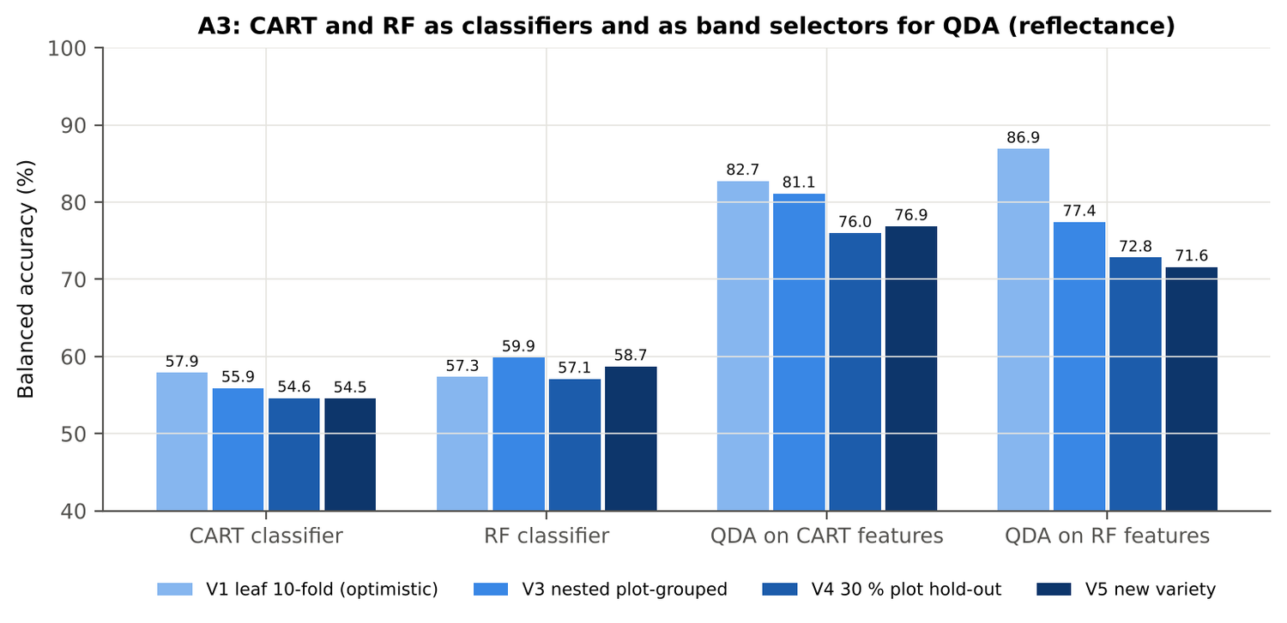
Figure 16. Date 11-02-2026: CART and RF as classifiers and as band selectors for QDA (Part A).
Table 19. Date 11-02-2026: paired comparisons on identical folds (positive = first pipeline better).
Comparison | Units | n | Mean Δ BA | First better | Wilcoxon p
RF classifier − CART classifier | V3 nested (folds) | 50 | 4.6 pts | 33 | 0.005
RF classifier − CART classifier | V4 hold-out (splits) | 10 | 2.5 pts | 7 | 0.375
QDA on RF features − QDA on CART features | V3 nested (folds) | 50 | -2.8 pts | 23 | 0.205
QDA on RF features − QDA on CART features | V4 hold-out (splits) | 10 | -3.2 pts | 4 | 0.713
QDA on CART features − CART classifier | V3 nested (folds) | 50 | 24.4 pts | 49 | 0.0e+0
QDA on CART features − CART classifier | V4 hold-out (splits) | 10 | 21.4 pts | 10 | 0.002
QDA on RF features − RF classifier | V3 nested (folds) | 50 | 17.0 pts | 41 | 0.0e+0
QDA on RF features − RF classifier | V4 hold-out (splits) | 10 | 15.7 pts | 9 | 0.004

4.1.6 Disease-sensitive features (Part K)
Table 20. Date 11-02-2026: most sensitive single features of each family (threshold classifier validated on plots).
Family | Feature | AUC | Direction | BA plot-grouped CV | BA hold-out
K2 continuum removal | CR6 water 1940 symmetry | 0.916 | D > H | 87.9 % | 88.5 %
K2 continuum removal | CR6 water 1940 position | 0.857 | D > H | 80.5 % | 81.0 %
K2 continuum removal | CR3 water 970 width | 0.747 | D < H | 69.2 % | 66.0 %
K3 index | NWI2 | 0.684 | D > H | 63.9 % | 62.3 %
K3 index | RVS1 | 0.671 | D < H | 60.9 % | 61.3 %
K3 index | WI | 0.627 | D < H | 60.6 % | 55.4 %
K4 edge parameter | Rg (green peak reflectance) | 0.631 | D < H | 56.2 % | 59.0 %
K4 edge parameter | λy (yellow-edge position, nm) | 0.610 | D < H | 61.0 % | 60.7 %
K4 first derivative | D1 872 nm | 0.897 | D > H | – | –
K4 first derivative | D1 871 nm | 0.895 | D > H | – | –
K4 first derivative | D1 873 nm | 0.888 | D > H | – | –
K1 reflectance | R 777 nm (760–1349) | 0.641 | D < H | 63.0 % | –
K1 reflectance | R 748 nm (680–759) | 0.640 | D < H | 58.5 % | –
K3b optimised index | NDSI(1928,2493) | 0.939 |  | 87.5 % | –
K3b optimised index | DI(885,886) | 0.927 |  | 83.7 % | –

Table 21. Date 11-02-2026: K5 — CART vs Balanced RF on each feature group (balanced accuracy).
Feature group | CART (V3) | RF (V3) | CART (V4) | RF (V4)
Full raw spectrum | 59.8 % | 69.9 % | 59.2 % | 64.9 %
K1 band reflectance | 60.7 % | 69.1 % | 59.3 % | 66.0 %
K2 continuum removal | 89.3 % | 87.8 % | 83.1 % | 89.3 %
K3 vegetation indices | 59.7 % | 63.8 % | 56.7 % | 61.2 %
K4 derivatives + edge parameters | 87.3 % | 91.6 % | 81.6 % | 90.1 %
K1–K4 combined pool | 90.7 % | 92.2 % | 86.7 % | 91.2 %
K4 incl. guard bands (artefact test) | 88.1 % | 95.5 % | 86.0 % | 94.1 %
K-selected 15 | 92.3 % | 91.3 % | 90.3 % | 91.6 %

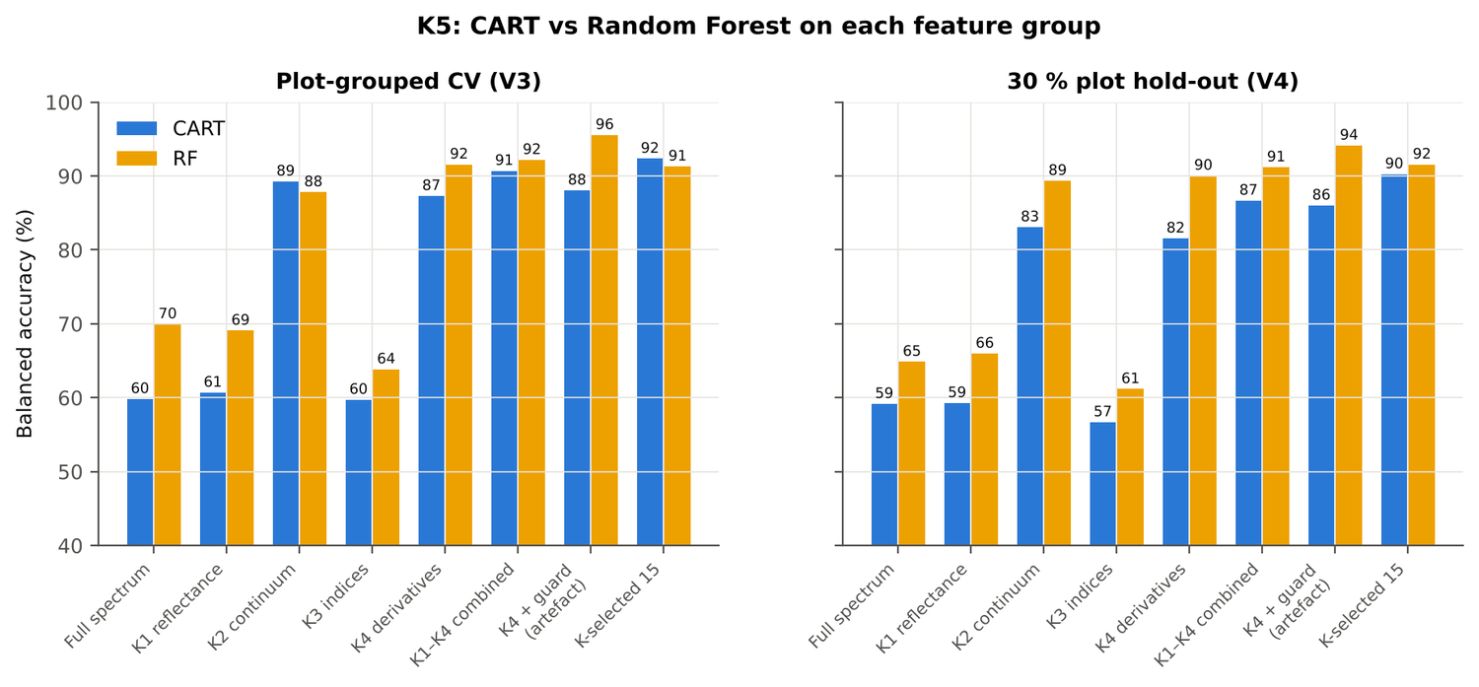
Figure 17. Date 11-02-2026: K5 — CART vs RF on each disease-sensitive feature group.
Table 22. Date 11-02-2026: red-edge inflection point by four methods.
REIP method | Healthy (nm) | Diseased (nm) | Shift (nm) | AUC | BA plot-grouped CV
maximum first derivative | 711.3 | 711.6 | 0.23 | 0.524 | 43.8 %
Lagrangian interpolation | 711.4 | 711.6 | 0.23 | 0.522 | 38.8 %
linear 4-point interpolation | 717.0 | 717.0 | 0.03 | 0.515 | 42.8 %
linear extrapolation | 711.5 | 711.7 | 0.25 | 0.513 | 38.5 %

4.1.7 Four tiers on the combined feature pool (Part C)
Tier 1: 1374 of 4150 features significant. Tier 2: CART selected 4 features (CR6 water 1940 symmetry, D1 903 nm, D1 871 nm, R 432 nm); RF-17: CR6 water 1940 symmetry, D1 872 nm, D1 1943 nm, D1 1916 nm, D1 885 nm, D1 1954 nm, D1 851 nm, D1 903 nm, CR6 water 1940 position, D1 1906 nm, D1 1192 nm, D1 2228 nm, D1 1971 nm, D1 1726 nm, D1 1927 nm, D1 2281 nm, D1 2337 nm. Tier 3: J–M 1.490 (CART set) and 1.932 (RF-17), separable (≥ 1.90) for RF-17.
Table 23. Date 11-02-2026: composition of the combined pool and of the selected sets.
Feature type | Features | Tier-1 significant | CART-4 | RF-17
K1 band reflectance | 2039 | 403 | 1 | 0
K2 continuum removal | 30 | 7 | 1 | 2
K3 vegetation index | 30 | 5 | 0 | 0
K4 edge parameter | 20 | 6 | 0 | 0
K4 first-derivative band | 2031 | 953 | 2 | 15

Table 24. Date 11-02-2026: balanced accuracy of the four pipelines on the combined pool.
Pipeline | V1 | V3 (± SD) | V4 (± SD) | V5 | AUC V3 | κ V3
CART classifier | 94.1 % | 91.1 % ± 2.4 | 87.4 % ± 4.7 | 90.4 % | 0.925 | 0.727
RF classifier | 93.2 % | 91.8 % ± 0.7 | 90.8 % ± 5.1 | 93.6 % | 0.976 | 0.757
QDA on CART features | 94.5 % | 92.1 % ± 1.1 | 90.5 % ± 3.3 | 90.6 % | 0.974 | 0.744
QDA on RF features | 91.2 % | 88.3 % ± 0.8 | 84.3 % ± 7.0 | 84.8 % | 0.969 | 0.746

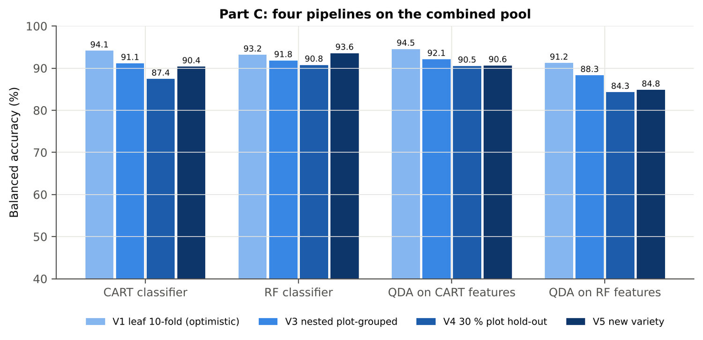
Figure 18. Date 11-02-2026: four pipelines on the combined pool under V1, V3, V4 and V5.
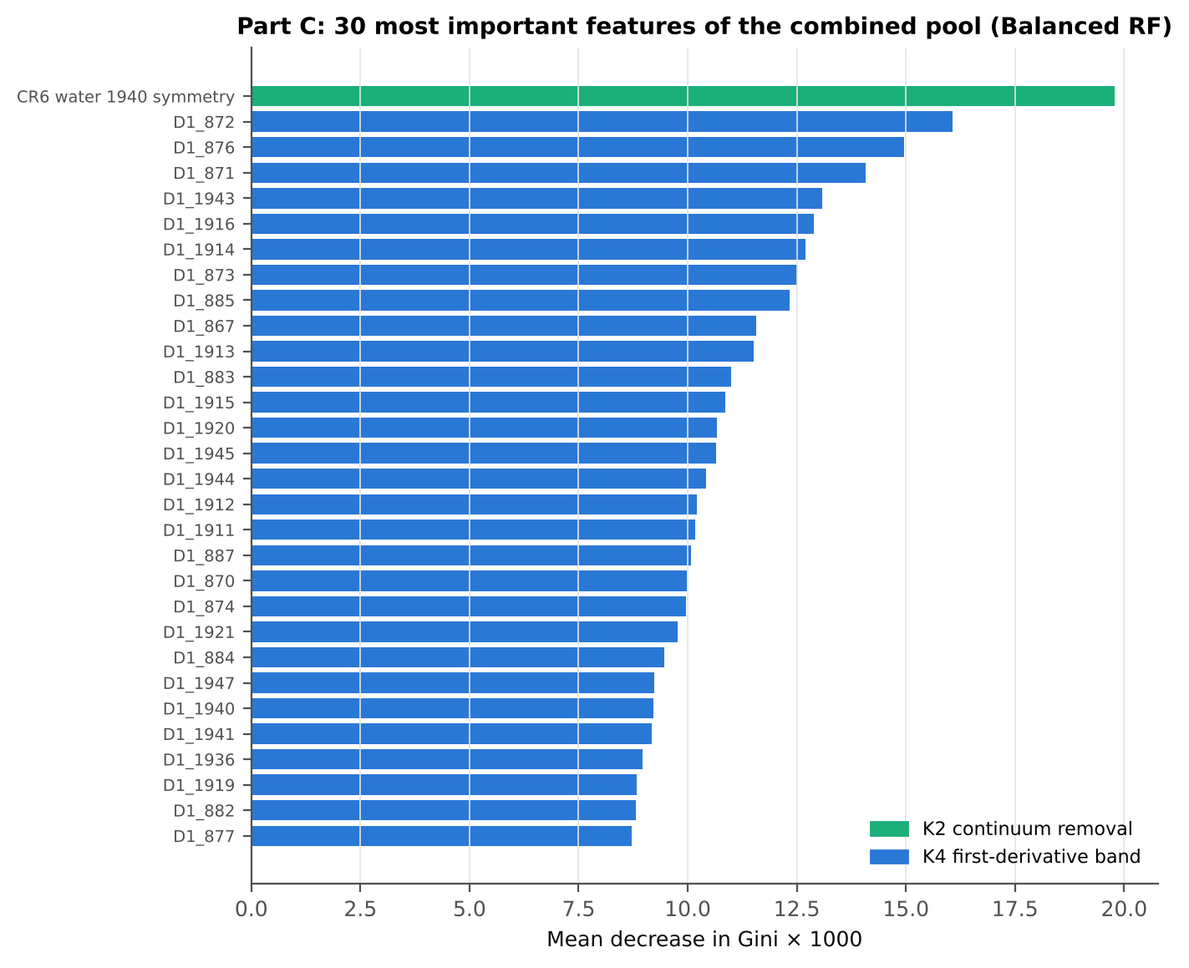
Figure 19. Date 11-02-2026: the 30 most important features of the combined pool (Balanced RF).
Table 25. Date 11-02-2026: combined pool vs reflectance vs K5 (paired over the V3 folds).
First | Second | Mean Δ BA | First better / n | Wilcoxon p
Combined pool: QDA on CART features | Reflectance: QDA on CART bands | 11.7 pts | 44 / 50 | 1.0e-8
Combined pool: QDA on RF features | Reflectance: QDA on RF bands | 10.3 pts | 40 / 50 | 2.4e-6
Combined pool: RF classifier (Tier-1 features) | Reflectance: RF classifier (Tier-1 bands) | 31.1 pts | 50 / 50 | 0.0e+0
Combined pool: CART classifier (Tier-1 features) | Reflectance: CART classifier (Tier-1 bands) | 35.2 pts | 49 / 50 | 0.0e+0
Combined pool: QDA on RF features | Combined pool: QDA on CART features | -4.2 pts | 13 / 50 | 0.002
Combined pool: QDA on RF features | K5: RF classifier on all 4151 features | -4.2 pts | 14 / 50 | 2.1e-4
Combined pool: QDA on RF features | K5: QDA on 15 features chosen by AUC | -1.2 pts | 15 / 50 | 0.317
Combined pool: RF classifier (Tier-1 features) | K5: RF classifier on all 4151 features | -0.3 pts | 5 / 50 | 0.438

4.1.8 Transfer (V5)
Table 26. Date 11-02-2026: balanced accuracy by held-out variety (trained on the other two varieties).
Feature set · pipeline | V1 | V2 | V3
Reflectance · CART classifier | 56.7 % | 53.8 % | 53.2 %
Reflectance · RF classifier | 53.3 % | 57.9 % | 64.7 %
Reflectance · QDA on CART features | 61.7 % | 78.3 % | 90.7 %
Reflectance · QDA on RF features | 63.3 % | 72.1 % | 79.3 %
Combined pool · CART classifier | 87.5 % | 93.3 % | 90.2 %
Combined pool · RF classifier | 94.6 % | 93.8 % | 92.4 %
Combined pool · QDA on CART features | 92.1 % | 90.8 % | 89.1 %
Combined pool · QDA on RF features | 75.8 % | 91.3 % | 87.4 %

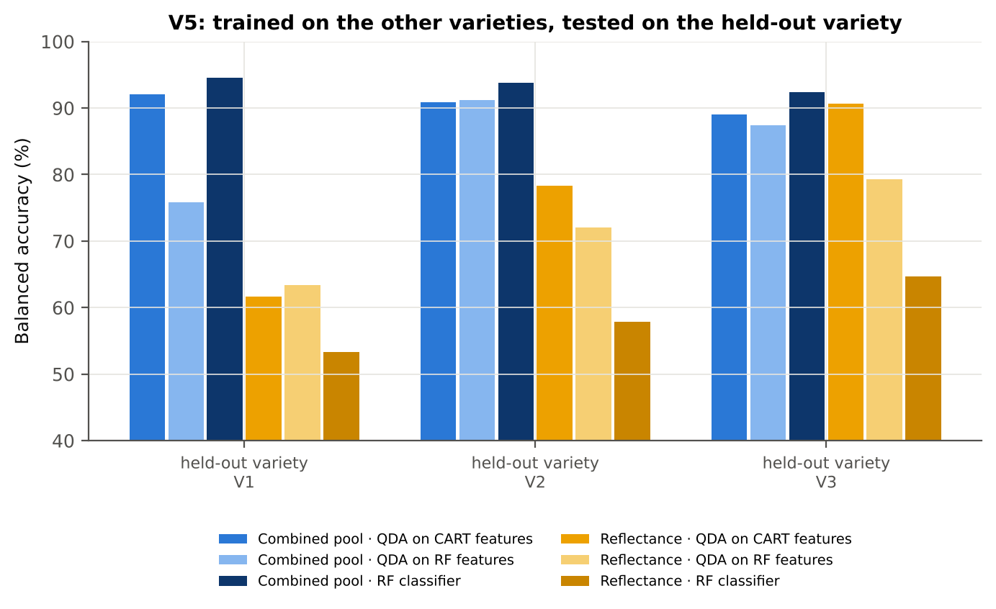
Figure 20. Date 11-02-2026: V5 transfer by held-out variety.

4.1.9 Interpretation
Tier 1: healthy and white-rust leaves differ significantly at 216 of 2101 bands (Welch + BH-FDR); 0 bands remain significant with a random plot effect and 0 in ≥ 95 % of 1000 balanced subsets. The most sensitive single band (smoothed reflectance) reaches AUC 0.64 at 777 nm.
Tier 2: CART (rpart, prior 0.5/0.5) selected 17 bands (root 518 nm): 518, 2380, 2350, 2364, 2267, 2328, 2374, 521, 563, 2332, 526, 555, 2346, 528, 2397, 2316, 570 nm. The Balanced RF importance peaks (RF-17) were 517, 528, 567, 587, 552, 2408, 541, 2267, 2393, 2304, 2289, 2348, 2377, 2337, 2277, 2323, 2361 nm.
Tier 3: J–M = 1.72 on the CART bands and 1.83 on the RF bands: neither set reaches the 1.90 separability threshold (Das et al. used 1.94).
Tier 4: QDA with equal priors on the CART bands gives BA 82.7 % in the paper's protocol (V1; healthy recall 72.2 %, diseased recall 93.3 %) and 81.1 % ± 2.9 % (V3 nested, plot-grouped) / 76.0 % (V4 hold-out plots) on new plots.
CART vs RF: as classifiers RF beats CART by 4.6 points (V3, RF better in 33 of 50 folds, p = 0.005); as band selectors for QDA the RF bands give -2.8 points vs the CART bands (p = 0.205). RF selection is more stable than CART selection (Jaccard ±10 nm 0.39 vs 0.27).
Disease-sensitive features (Part K): the strongest group for RF is K4 derivatives + edge parameters (BA 91.6 %, V3) vs 69.1 % for reflectance; best single features: first derivative at 872 nm (AUC 0.90), CR6 water 1940 symmetry (AUC 0.92), NWI2 (AUC 0.68), Rg (green peak reflectance) (AUC 0.63). REIP (maximum first derivative) shifts by +0.2 nm in diseased leaves (AUC 0.52).
Part C (four tiers on the combined K1 + K2–K4 pool, 4150 features, 1374 significant): CART chose 4 features, RF 17 (J–M 1.49 / 1.93); QDA on the RF features reaches 88.3 % (V3) / 84.3 % (V4), +10.9 points vs QDA on RF reflectance bands; best pipeline on the pool: QDA on CART features (92.1 %, V3).
Transfer (V5, leave-one-variety-out): QDA on CART reflectance bands 76.9 %, QDA on combined-pool RF features 84.8 % (close to the V3 estimate, 88.3 %), i.e. features chosen on two varieties transfer well to the third. Best pipeline under transfer: combined pool: RF classifier (93.6 %).
Compared with all dates, stages and varieties pooled (V3: reflectance QDA-CART 72.0 %, combined-pool QDA-RF 83.7 %; J–M 1.27), this subset gives 81.1 % and 88.3 % (J–M 1.72): analysing it separately improves discrimination.

Recommendations for this subset
- Use first-derivative and continuum-removed features rather than single reflectance bands for this subset; the four-tier selection with RF importance on the combined pool and a QDA or RF classifier is the recommended pipeline.
- Report balanced accuracy with both class recalls and the priors used; the classes are imbalanced (1 : 4.9) and equal priors / balanced sampling were applied throughout.
- Base conclusions on the plot-grouped estimates (V3 10-fold × 5 = 50 folds, V4 10 hold-outs), not on the leaf-level V1 estimate.
- Interpret features near the ASD detector joins (≈ 1000 and 1800 nm) with care; guard zones were excluded from the rankings.
- For application to a new variety, the most robust pipeline here was combined pool: RF classifier (V5 BA 93.6 %).

Cross-checks
44 checks passed, 3 were flagged and 0 failed. Flagged items are limitations reported in the workbook, not errors: Exact duplicates among the remaining spectra; Training sets with < 2 FDR-significant features (nested V3/V4/V5); QDA in R.

4.2 Date 24-02-2026 — date 24-02-2026 only

4.2.1 Data and validation design
This subset contains 540 leaf spectra (90 healthy, 450 diseased; ratio 1 : 5.0) from 12 healthy and 36 diseased plots, measured on 24-02-2026; growth stages Flowering, Vegetative; varieties V1, V2, V3. V3 used 10-fold plot-grouped CV × 5 (50 training sets), V4 held out 4 healthy + 11 diseased plots × 10, and V5 was leave-one-variety-out (3 units).
Table 27. Date 24-02-2026: leaf spectra by date and growth stage.
Date | Growth stage | Healthy | Diseased
24-02-2026 | Flowering | 60 | 290
24-02-2026 | Vegetative | 30 | 160

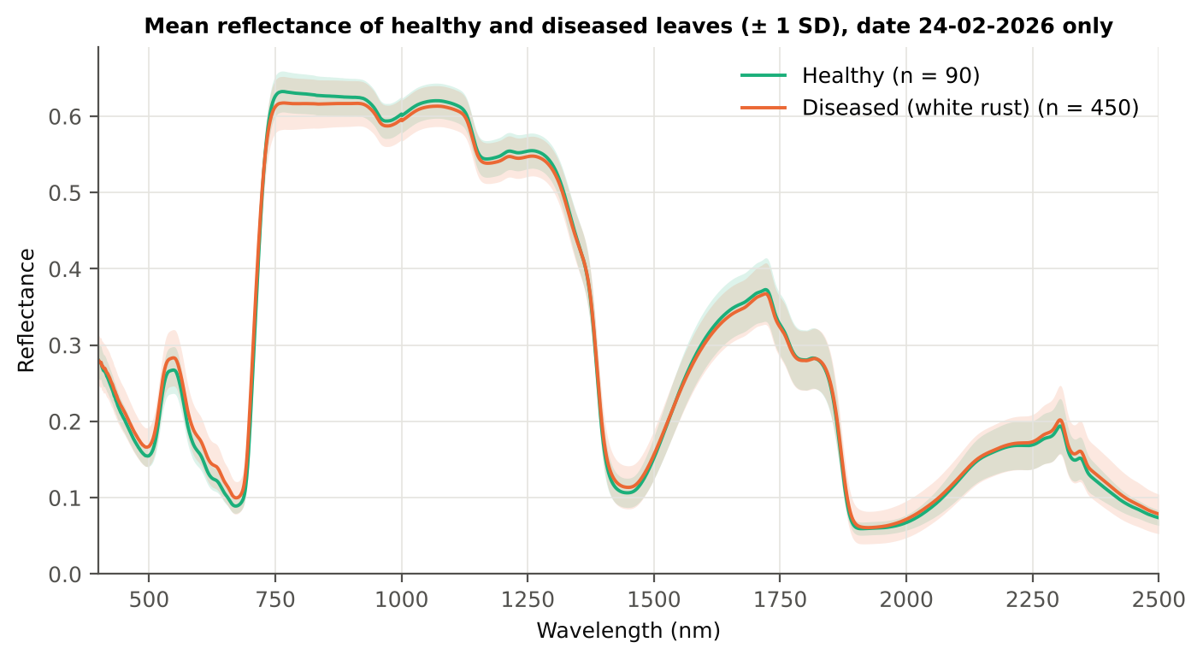
Figure 21. Date 24-02-2026: mean reflectance of healthy and diseased leaves (± 1 SD).

4.2.2 Tier 1 — statistical screening
Table 28. Date 24-02-2026: number of significant bands by test.
Test | Significant bands (of 2101)
Welch t-test + BH-FDR q < 0.05 (used for Tier 2) | 1176
One-way ANOVA p < 0.05, uncorrected (rule of Das et al.) | 1057
One-way ANOVA + BH-FDR q < 0.05 | 462
Welch t-test p < 0.05, uncorrected | 1255
Mixed model (random plot effect) + BH-FDR q < 0.05 | 167
Balanced subsets (90 vs 90): significant in ≥ 95 % of 1000 subsets | 169
Levene test p < 0.05 (unequal variances → Welch) | 704

Table 29. Date 24-02-2026: largest contiguous ranges of FDR-significant bands.
Contiguous significant range (nm) | Bands
736–1133 | 398
419–722 | 304
2327–2500 | 174
1195–1301 | 107
1395–1474 | 80
1980–2056 | 77
1870–1905 | 36

Table 30. Date 24-02-2026: ten bands with the largest |t|.
Band (nm) | Mean H | Mean D | Welch t | q (BH) | Hedges g | AUC
693 | 0.1246 | 0.1459 | 9.87 | 0.00e+0 | 0.74 | 0.745
692 | 0.1183 | 0.1383 | 9.84 | 0.00e+0 | 0.73 | 0.742
694 | 0.1320 | 0.1546 | 9.83 | 0.00e+0 | 0.75 | 0.746
695 | 0.1403 | 0.1642 | 9.75 | 0.00e+0 | 0.75 | 0.747
691 | 0.1129 | 0.1316 | 9.74 | 0.00e+0 | 0.71 | 0.739
696 | 0.1496 | 0.1746 | 9.62 | 0.00e+0 | 0.76 | 0.746
690 | 0.1085 | 0.1258 | 9.58 | 0.00e+0 | 0.69 | 0.733
697 | 0.1598 | 0.1857 | 9.45 | 0.00e+0 | 0.76 | 0.745
689 | 0.1048 | 0.1210 | 9.36 | 0.00e+0 | 0.67 | 0.728
698 | 0.1707 | 0.1975 | 9.26 | 0.00e+0 | 0.75 | 0.742

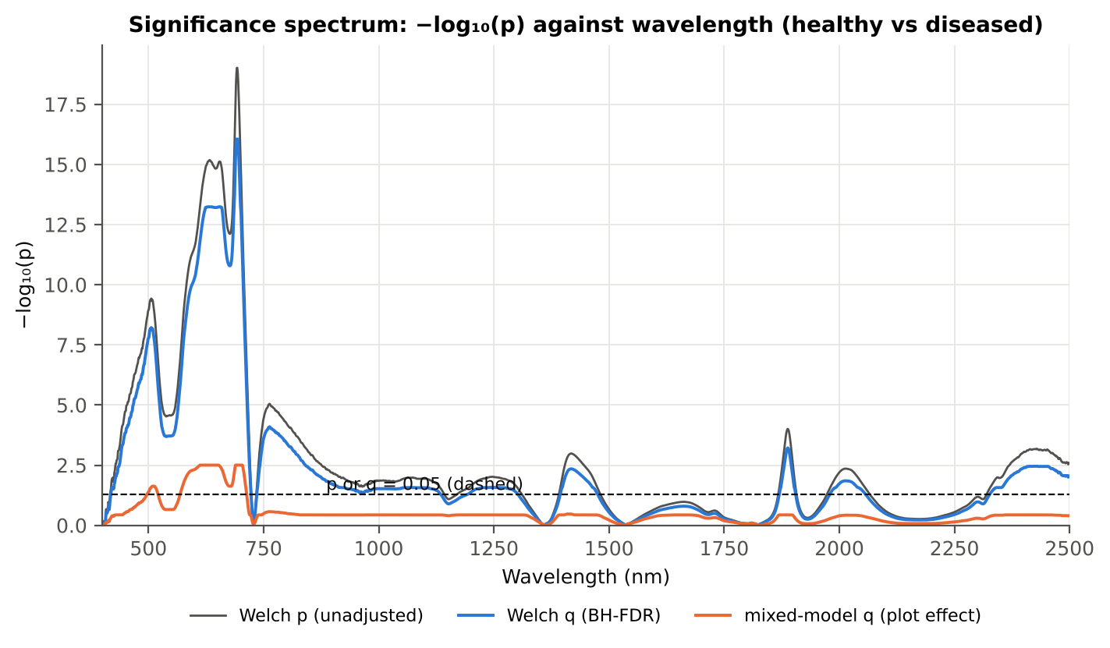
Figure 22. Date 24-02-2026: −log₁₀(p) against wavelength (Welch p, BH q and mixed-model q; dashed p or q = 0.05).

4.2.3 Tier 2 — CART and Random Forest band selection
Table 31. Date 24-02-2026: the CART-15 bands selected by rpart (prior 0.5/0.5) and how often a band within ± 10 nm is re-selected.
Band (nm) | Region | First used at node | Bootstrap re-selection | Nested-CV re-selection
419 | Blue (400–499) | 12 | 65.0 % | 64.0 %
422 | Blue (400–499) | 9 | 66.0 % | 72.0 %
423 | Blue (400–499) | 55 | 67.0 % | 72.0 %
424 | Blue (400–499) | 110 | 67.0 % | 78.0 %
527 | Green (500–599) | 6 | 34.0 % | 54.0 %
676 | Red (600–679) | 65 | 34.0 % | 44.0 %
687 | Red edge (680–759) | 3 | 91.0 % | 100.0 %
694 | Red edge (680–759) | 16 | 100.0 % | 100.0 %
697 | Red edge (680–759) | 1 | 100.0 % | 100.0 %
756 | Red edge (680–759) | 4 | 39.5 % | 68.0 %
765 | NIR (760–1349) | 18 | 31.0 % | 68.0 %
1395 | Water band I (1350–1430) | 13 | 45.5 % | 46.0 %
1432 | SWIR-1 (1431–1799) | 8 | 8.0 % | 22.0 %
1905 | Water band II (1800–1950) | 32 | 48.5 % | 52.0 %
2491 | SWIR-2 end (2350–2500) | 2 | 54.0 % | 70.0 %

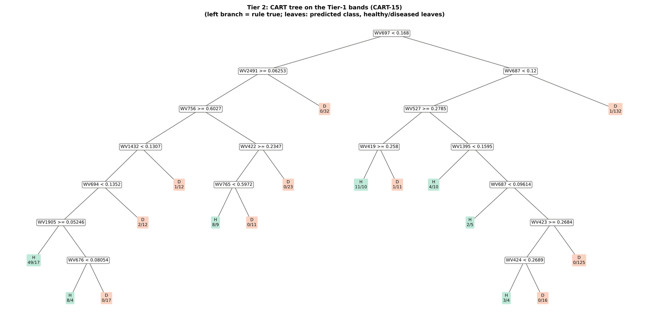
Figure 23. Date 24-02-2026: CART tree on the Tier-1 bands (CART-15).
RF-17 importance peaks: 693, 705, 624, 664, 1905, 652, 1981, 638, 2498, 586, 419, 610, 681, 769, 2487, 1403, 1995 nm.
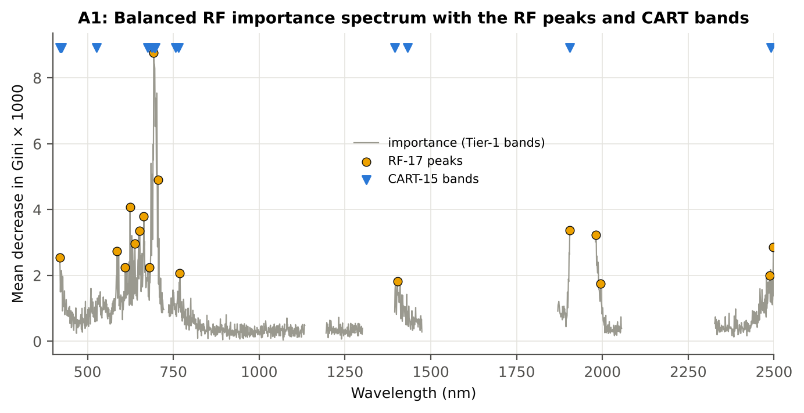
Figure 24. Date 24-02-2026: Balanced RF importance spectrum with the RF-17 peaks and the CART bands.

4.2.4 Tier 3 and Tier 4 — separability and classification
Table 32. Date 24-02-2026: Jeffries–Matusita distance of healthy and diseased leaves.
Band set | Bands | α (Bhattacharyya) | J–M (0–2) | √J–M | Separability
CART-15 | 15 | 1.619 | 1.604 | 1.266 | below 1.90
CART-1 (1-SE) | 1 | 0.177 | 0.325 | 0.570 | below 1.90
RF-17 | 17 | 2.908 | 1.891 | 1.375 | below 1.90
RF-10 | 10 | 1.381 | 1.497 | 1.224 | below 1.90
RF-15 (size-matched) | 15 | 2.257 | 1.791 | 1.338 | below 1.90

Table 33. Date 24-02-2026: error matrix of QDA (equal priors) on the CART-15 bands, leaf-level 10-fold CV (V1; as Table 2 of Das et al.).
Classified \ Reference | Healthy | Diseased | Row total | User's accuracy
Healthy | 71 | 124 | 195 | 36.4 %
Diseased | 19 | 326 | 345 | 94.5 %
Column total | 90 | 450 | 540
Producer's accuracy | 78.9 % | 72.4 %
Overall accuracy | 73.5 % | Balanced accuracy | 75.7 % | κ = 0.350

Table 34. Date 24-02-2026: Tier 4 on all band sets (V1), with equal and sample priors and LDA for comparison.
Band set | Classifier | OA | BA | PA healthy | PA diseased | κ
CART-15 | QDA equal priors | 73.5 % | 75.7 % | 78.9 % | 72.4 % | 0.350
CART-15 | QDA sample priors | 80.9 % | 76.6 % | 70.0 % | 83.1 % | 0.436
CART-15 | LDA equal priors | 75.4 % | 76.8 % | 78.9 % | 74.7 % | 0.377
CART-1 (1-SE) | QDA equal priors | 54.3 % | 67.2 % | 86.7 % | 47.8 % | 0.173
CART-1 (1-SE) | QDA sample priors | 83.3 % | 50.0 % | 0.0 % | 100.0 % | 0.000
CART-1 (1-SE) | LDA equal priors | 65.0 % | 71.0 % | 80.0 % | 62.0 % | 0.250
RF-17 | QDA equal priors | 85.2 % | 84.9 % | 84.4 % | 85.3 % | 0.567
RF-17 | QDA sample priors | 88.0 % | 83.9 % | 77.8 % | 90.0 % | 0.610
RF-17 | LDA equal priors | 91.1 % | 91.6 % | 92.2 % | 90.9 % | 0.722
RF-10 | QDA equal priors | 62.2 % | 72.9 % | 88.9 % | 56.9 % | 0.252
RF-10 | QDA sample priors | 72.8 % | 76.6 % | 82.2 % | 70.9 % | 0.351
RF-10 | LDA equal priors | 74.8 % | 77.8 % | 82.2 % | 73.3 % | 0.380
RF-15 (size-matched) | QDA equal priors | 77.2 % | 80.1 % | 84.4 % | 75.8 % | 0.423
RF-15 (size-matched) | QDA sample priors | 82.4 % | 81.9 % | 81.1 % | 82.7 % | 0.502
RF-15 (size-matched) | LDA equal priors | 87.8 % | 90.9 % | 95.6 % | 86.2 % | 0.650

4.2.5 Validation and CART versus RF (Part A)
Table 35. Date 24-02-2026: balanced accuracy of the four pipelines on raw reflectance under the validation schemes.
Pipeline | V1 | V3 (± SD) | V4 (± SD) | V5 | AUC V3 | κ V3
CART classifier | 71.7 % | 64.6 % ± 3.0 | 67.0 % ± 5.5 | 67.8 % | 0.665 | 0.222
RF classifier | 72.1 % | 69.3 % ± 1.2 | 68.3 % ± 3.4 | 72.1 % | 0.786 | 0.331
QDA on CART features | 75.7 % | 79.6 % ± 1.6 | 74.2 % ± 5.0 | 73.9 % | 0.875 | 0.418
QDA on RF features | 84.9 % | 83.6 % ± 1.7 | 79.4 % ± 4.4 | 79.2 % | 0.891 | 0.529

Table 36. Date 24-02-2026: validation of QDA on CART bands — effect of the imbalance correction (equal vs sample priors) and of random under-sampling (V3-RUS).
Scheme | Priors | BA | SD | OA | PA healthy | PA diseased
V1 · leaf-level 10-fold, bands fixed | equal (corrected) | 75.7 % | – | 73.5 % | 78.9 % | 72.4 %
V2 · plot-grouped 10-fold, bands fixed | equal (corrected) | 72.8 % | – | 71.7 % | 74.4 % | 71.1 %
V3 · nested plot-grouped 10-fold × 5 = 50 folds | equal (corrected) | 79.6 % | 1.6 | 77.1 % | 83.3 % | 75.9 %
V4 · 30 % plot hold-out × 10 | equal (corrected) | 74.2 % | 5.0 | 71.9 % | 77.7 % | 70.6 %
V5 · leave-one-variety-out (train on the other varieties) (3 units) | equal (corrected) | 73.9 % | – | 67.6 % | 83.3 % | 64.4 %
V1 · leaf-level 10-fold, bands fixed | sample (uncorrected) | 76.6 % | – | 80.9 % | 70.0 % | 83.1 %
V2 · plot-grouped 10-fold, bands fixed | sample (uncorrected) | 73.1 % | – | 79.6 % | 63.3 % | 82.9 %
V3 · nested plot-grouped 10-fold × 5 = 50 folds | sample (uncorrected) | 80.8 % | 1.9 | 84.1 % | 75.8 % | 85.7 %
V4 · 30 % plot hold-out × 10 | sample (uncorrected) | 72.5 % | 6.3 | 79.2 % | 62.1 % | 83.0 %
V5 · leave-one-variety-out (train on the other varieties) (3 units) | sample (uncorrected) | 73.9 % | – | 76.5 % | 70.0 % | 77.8 %
V3-RUS · nested + random under-sampling | equal (corrected) | 69.8 % | – | 61.5 % | 82.2 % | 57.3 %
V3-RUS · nested + random under-sampling | sample (uncorrected) | 69.8 % | – | 61.5 % | 82.2 % | 57.3 %

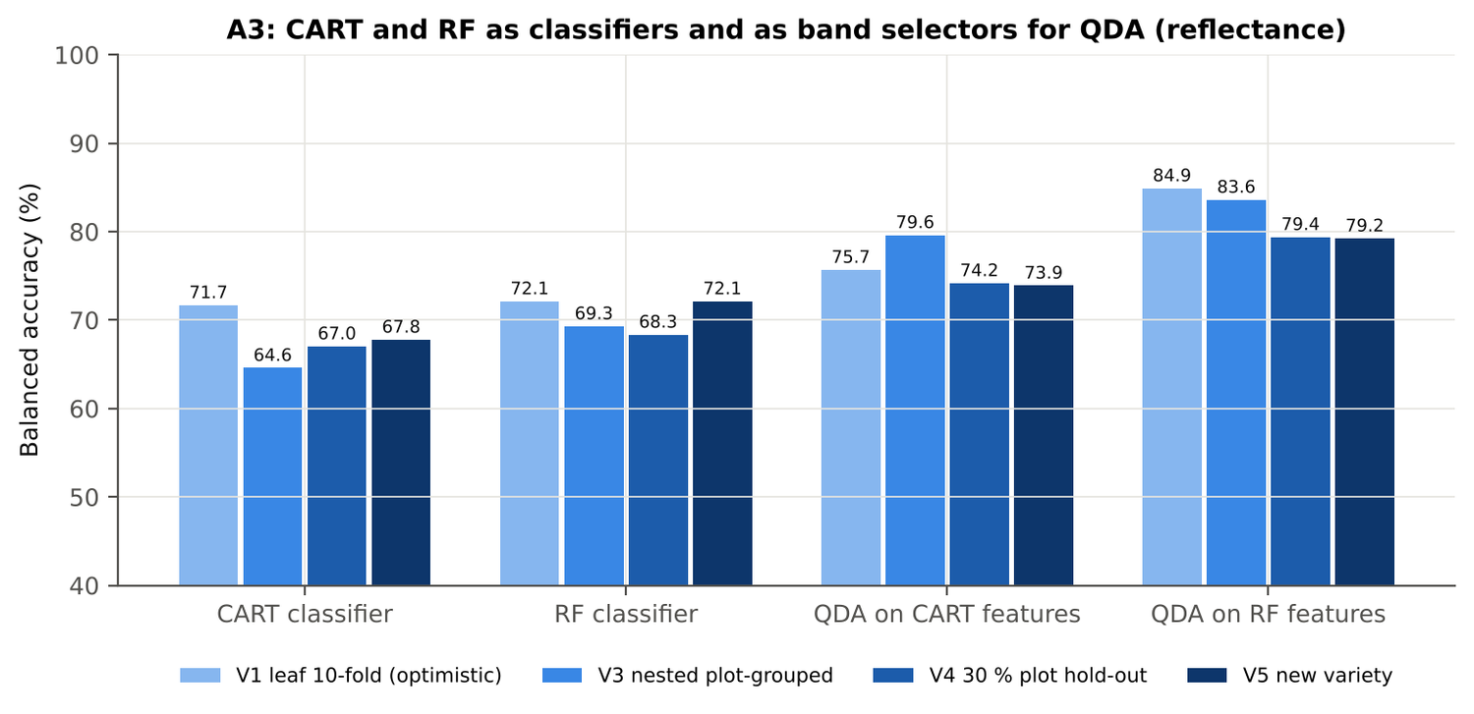
Figure 25. Date 24-02-2026: CART and RF as classifiers and as band selectors for QDA (Part A).
Table 37. Date 24-02-2026: paired comparisons on identical folds (positive = first pipeline better).
Comparison | Units | n | Mean Δ BA | First better | Wilcoxon p
RF classifier − CART classifier | V3 nested (folds) | 50 | 4.8 pts | 33 | 0.004
RF classifier − CART classifier | V4 hold-out (splits) | 10 | 1.3 pts | 8 | 0.375
QDA on RF features − QDA on CART features | V3 nested (folds) | 50 | 4.3 pts | 32 | 0.004
QDA on RF features − QDA on CART features | V4 hold-out (splits) | 10 | 5.2 pts | 8 | 0.027
QDA on CART features − CART classifier | V3 nested (folds) | 50 | 15.4 pts | 43 | 0.0e+0
QDA on CART features − CART classifier | V4 hold-out (splits) | 10 | 7.1 pts | 9 | 0.084
QDA on RF features − RF classifier | V3 nested (folds) | 50 | 14.8 pts | 40 | 1.0e-6
QDA on RF features − RF classifier | V4 hold-out (splits) | 10 | 11.0 pts | 10 | 0.002

4.2.6 Disease-sensitive features (Part K)
Table 38. Date 24-02-2026: most sensitive single features of each family (threshold classifier validated on plots).
Family | Feature | AUC | Direction | BA plot-grouped CV | BA hold-out
K2 continuum removal | CR6 water 1940 symmetry | 0.926 | D > H | 88.2 % | 87.5 %
K2 continuum removal | CR6 water 1940 position | 0.906 | D > H | 84.9 % | 83.4 %
K2 continuum removal | CR3 water 970 symmetry | 0.821 | D > H | 80.1 % | 79.5 %
K3 index | ARI | 0.809 | D > H | 75.3 % | 73.2 %
K3 index | RARSc | 0.768 | D < H | 67.1 % | 66.6 %
K3 index | NCPI | 0.752 | D > H | 62.5 % | 63.1 %
K4 edge parameter | REP, linear 4-point (nm) | 0.736 | D < H | 65.7 % | 63.5 %
K4 edge parameter | λr = REP (red-edge position, nm) | 0.720 | D < H | 66.3 % | 62.6 %
K4 first derivative | D1 1920 nm | 0.920 | D < H | – | –
K4 first derivative | D1 1919 nm | 0.920 | D < H | – | –
K4 first derivative | D1 1921 nm | 0.919 | D < H | – | –
K1 reflectance | R 695 nm (680–759) | 0.747 | D > H | 70.6 % | –
K1 reflectance | R 630 nm (600–679) | 0.711 | D > H | 67.9 % | –
K3b optimised index | NDSI(1920,1921) | 0.927 |  | 90.9 % | –
K3b optimised index | DI(1920,1921) | 0.921 |  | 89.7 % | –

Table 39. Date 24-02-2026: K5 — CART vs Balanced RF on each feature group (balanced accuracy).
Feature group | CART (V3) | RF (V3) | CART (V4) | RF (V4)
Full raw spectrum | 70.5 % | 73.4 % | 69.5 % | 71.6 %
K1 band reflectance | 69.1 % | 73.6 % | 69.7 % | 72.1 %
K2 continuum removal | 87.1 % | 91.1 % | 85.8 % | 90.1 %
K3 vegetation indices | 67.9 % | 68.7 % | 67.5 % | 68.3 %
K4 derivatives + edge parameters | 89.5 % | 92.7 % | 90.3 % | 92.1 %
K1–K4 combined pool | 90.6 % | 92.5 % | 90.4 % | 92.0 %
K4 incl. guard bands (artefact test) | 91.9 % | 94.9 % | 89.8 % | 92.9 %
K-selected 15 | 86.3 % | 90.9 % | 88.2 % | 90.5 %

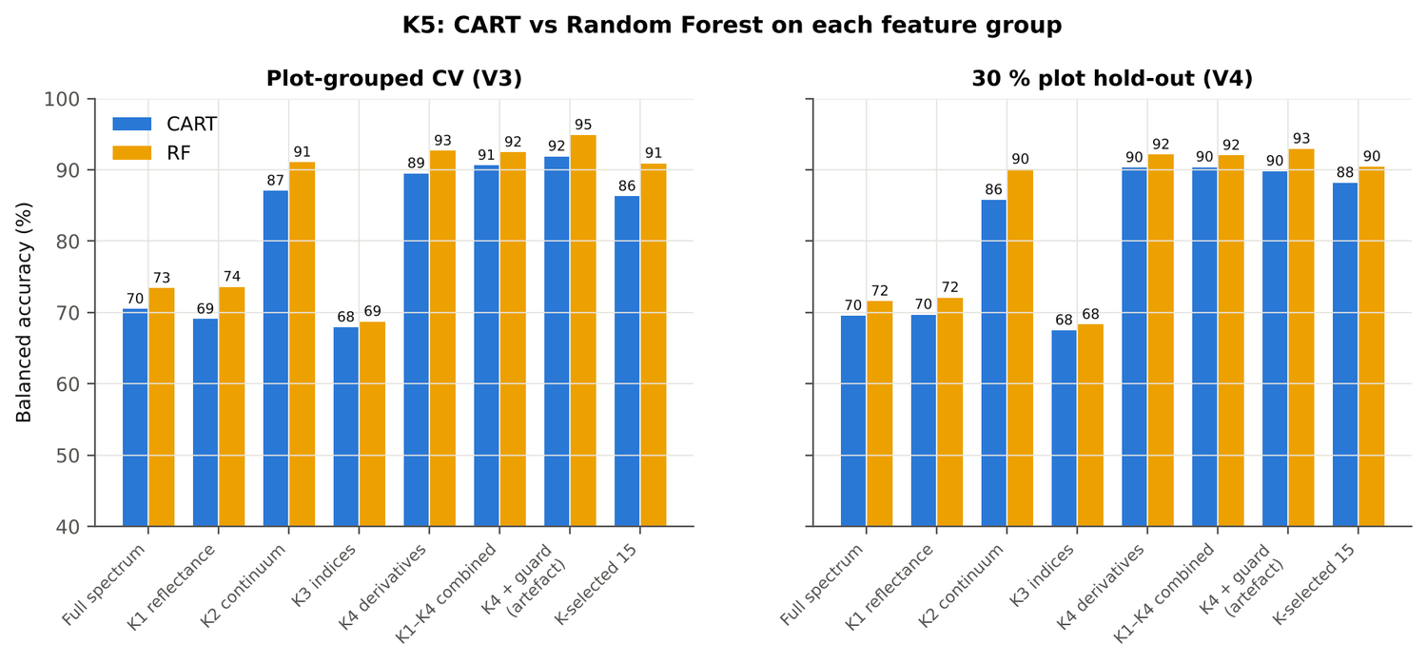
Figure 26. Date 24-02-2026: K5 — CART vs RF on each disease-sensitive feature group.
Table 40. Date 24-02-2026: red-edge inflection point by four methods.
REIP method | Healthy (nm) | Diseased (nm) | Shift (nm) | AUC | BA plot-grouped CV
linear 4-point interpolation | 716.1 | 714.4 | -1.70 | 0.736 | 65.7 %
linear extrapolation | 708.2 | 703.4 | -4.78 | 0.723 | 64.7 %
maximum first derivative | 708.6 | 705.4 | -3.21 | 0.720 | 66.3 %
Lagrangian interpolation | 708.6 | 705.4 | -3.18 | 0.719 | 64.7 %

4.2.7 Four tiers on the combined feature pool (Part C)
Tier 1: 2510 of 4150 features significant. Tier 2: CART selected 4 features (D1 1922 nm, D1 972 nm, D1 1722 nm, CR6 water 1940 symmetry); RF-17: D1 1922 nm, CR6 water 1940 symmetry, D1 1912 nm, CR6 water 1940 position, D1 2223 nm, D1 1743 nm, CR3 water 970 symmetry, D1 1198 nm, D1 1949 nm, D1 1938 nm, D1 860 nm, D1 1959 nm, D1 832 nm, ARI, D1 847 nm, D1 1530 nm, D1 1971 nm. Tier 3: J–M 1.465 (CART set) and 1.965 (RF-17), separable (≥ 1.94, Das et al.) for RF-17.
Table 41. Date 24-02-2026: composition of the combined pool and of the selected sets.
Feature type | Features | Tier-1 significant | CART-4 | RF-17
K1 band reflectance | 2039 | 1170 | 0 | 0
K2 continuum removal | 30 | 18 | 1 | 3
K3 vegetation index | 30 | 25 | 0 | 1
K4 edge parameter | 20 | 15 | 0 | 0
K4 first-derivative band | 2031 | 1282 | 3 | 13

Table 42. Date 24-02-2026: balanced accuracy of the four pipelines on the combined pool.
Pipeline | V1 | V3 (± SD) | V4 (± SD) | V5 | AUC V3 | κ V3
CART classifier | 90.2 % | 90.0 % ± 0.4 | 91.1 % ± 3.9 | 92.6 % | 0.902 | 0.754
RF classifier | 93.9 % | 92.8 % ± 0.8 | 92.1 % ± 3.3 | 93.4 % | 0.976 | 0.819
QDA on CART features | 94.9 % | 89.3 % ± 1.4 | 89.9 % ± 4.3 | 87.9 % | 0.939 | 0.680
QDA on RF features | 96.2 % | 93.6 % ± 0.8 | 88.4 % ± 4.0 | 93.1 % | 0.979 | 0.818

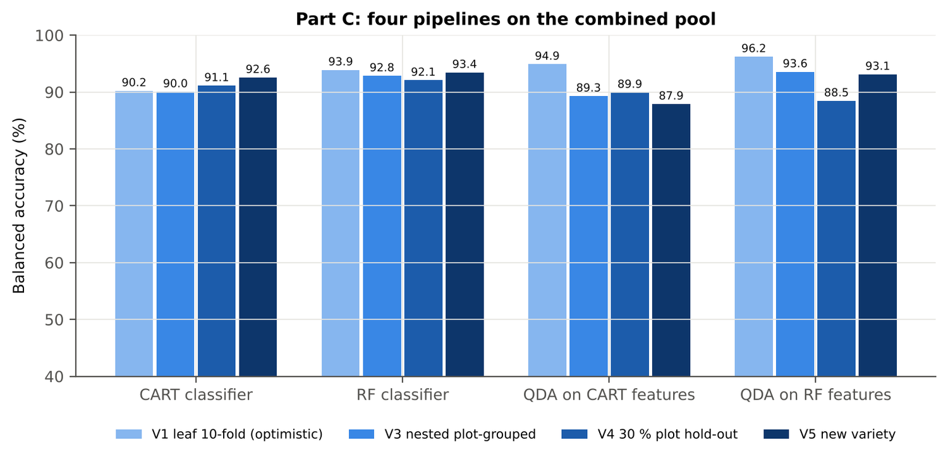
Figure 27. Date 24-02-2026: four pipelines on the combined pool under V1, V3, V4 and V5.
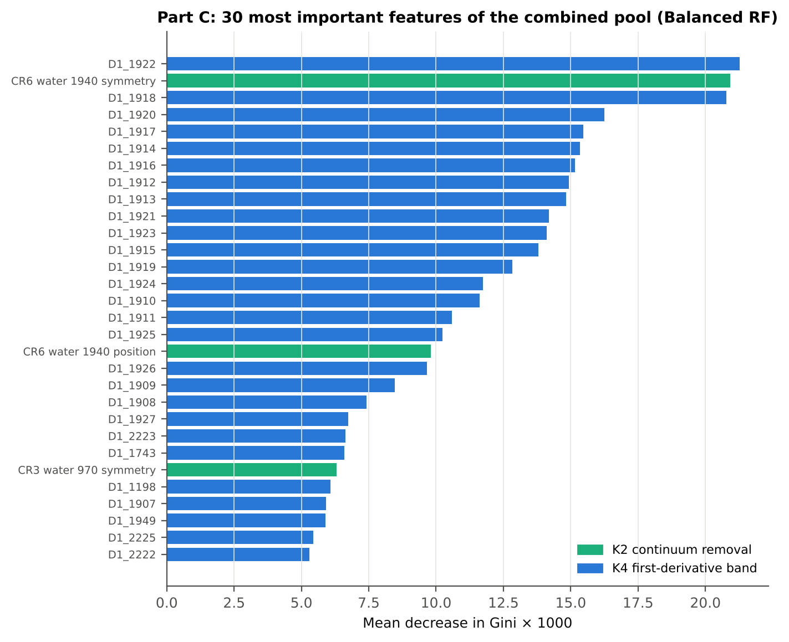
Figure 28. Date 24-02-2026: the 30 most important features of the combined pool (Balanced RF).
Table 43. Date 24-02-2026: combined pool vs reflectance vs K5 (paired over the V3 folds).
First | Second | Mean Δ BA | First better / n | Wilcoxon p
Combined pool: QDA on CART features | Reflectance: QDA on CART bands | 9.8 pts | 34 / 50 | 9.7e-6
Combined pool: QDA on RF features | Reflectance: QDA on RF bands | 9.7 pts | 41 / 50 | 1.9e-7
Combined pool: RF classifier (Tier-1 features) | Reflectance: RF classifier (Tier-1 bands) | 23.5 pts | 49 / 50 | 0.0e+0
Combined pool: CART classifier (Tier-1 features) | Reflectance: CART classifier (Tier-1 bands) | 25.5 pts | 50 / 50 | 0.0e+0
Combined pool: QDA on RF features | Combined pool: QDA on CART features | 4.2 pts | 33 / 50 | 8.5e-4
Combined pool: QDA on RF features | K5: RF classifier on all 4151 features | 1.4 pts | 26 / 50 | 0.050
Combined pool: QDA on RF features | K5: QDA on 15 features chosen by AUC | 1.9 pts | 20 / 50 | 0.001
Combined pool: RF classifier (Tier-1 features) | K5: RF classifier on all 4151 features | 0.4 pts | 16 / 50 | 0.051

4.2.8 Transfer (V5)
Table 44. Date 24-02-2026: balanced accuracy by held-out variety (trained on the other two varieties).
Feature set · pipeline | V1 | V2 | V3
Reflectance · CART classifier | 66.1 % | 65.3 % | 71.7 %
Reflectance · RF classifier | 79.5 % | 66.5 % | 70.0 %
Reflectance · QDA on CART features | 68.5 % | 80.3 % | 72.0 %
Reflectance · QDA on RF features | 74.8 % | 76.1 % | 86.0 %
Combined pool · CART classifier | 91.8 % | 92.1 % | 93.7 %
Combined pool · RF classifier | 91.8 % | 94.4 % | 94.0 %
Combined pool · QDA on CART features | 90.1 % | 86.4 % | 87.0 %
Combined pool · QDA on RF features | 88.4 % | 96.4 % | 94.3 %

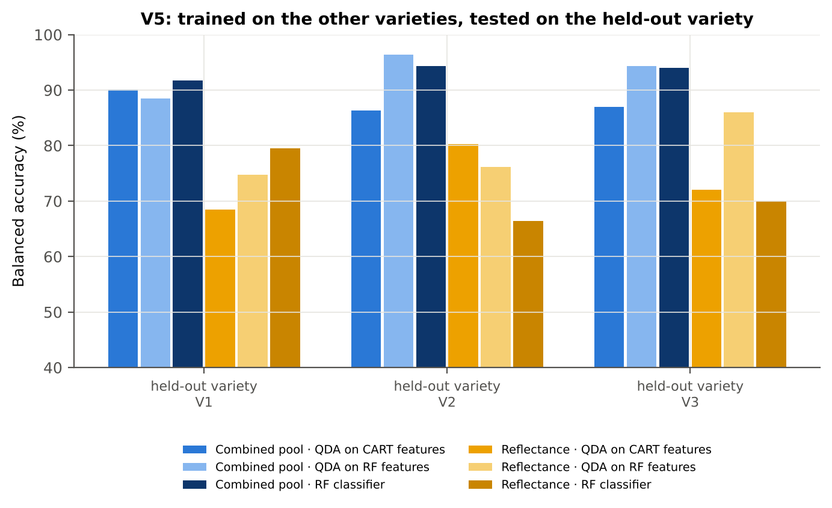
Figure 29. Date 24-02-2026: V5 transfer by held-out variety.

4.2.9 Interpretation
Tier 1: healthy and white-rust leaves differ significantly at 1176 of 2101 bands (Welch + BH-FDR); 167 bands remain significant with a random plot effect and 169 in ≥ 95 % of 1000 balanced subsets. The most sensitive single band (smoothed reflectance) reaches AUC 0.75 at 695 nm.
Tier 2: CART (rpart, prior 0.5/0.5) selected 15 bands (root 697 nm): 697, 2491, 687, 756, 527, 1432, 422, 419, 1395, 694, 765, 1905, 423, 676, 424 nm. The Balanced RF importance peaks (RF-17) were 693, 705, 624, 664, 1905, 652, 1981, 638, 2498, 586, 419, 610, 681, 769, 2487, 1403, 1995 nm.
Tier 3: J–M = 1.60 on the CART bands and 1.89 on the RF bands: neither set reaches the 1.90 separability threshold (Das et al. used 1.94).
Tier 4: QDA with equal priors on the CART bands gives BA 75.7 % in the paper's protocol (V1; healthy recall 78.9 %, diseased recall 72.4 %) and 79.6 % ± 1.6 % (V3 nested, plot-grouped) / 74.2 % (V4 hold-out plots) on new plots.
CART vs RF: as classifiers RF beats CART by 4.8 points (V3, RF better in 33 of 50 folds, p = 0.004); as band selectors for QDA the RF bands give +4.3 points vs the CART bands (p = 0.004). RF selection is more stable than CART selection (Jaccard ±10 nm 0.62 vs 0.38).
Disease-sensitive features (Part K): the strongest group for RF is K4 derivatives + edge parameters (BA 92.7 %, V3) vs 73.6 % for reflectance; best single features: first derivative at 1920 nm (AUC 0.92), CR6 water 1940 symmetry (AUC 0.93), ARI (AUC 0.81), REP, linear 4-point (nm) (AUC 0.74). REIP (linear 4-point interpolation) shifts by -1.7 nm in diseased leaves (AUC 0.74).
Part C (four tiers on the combined K1 + K2–K4 pool, 4150 features, 2510 significant): CART chose 4 features, RF 17 (J–M 1.47 / 1.96); QDA on the RF features reaches 93.6 % (V3) / 88.5 % (V4), +10.0 points vs QDA on RF reflectance bands; best pipeline on the pool: QDA on RF features (93.6 %, V3).
Transfer (V5, leave-one-variety-out): QDA on CART reflectance bands 73.9 %, QDA on combined-pool RF features 93.1 % (close to the V3 estimate, 93.6 %), i.e. features chosen on two varieties transfer well to the third. Best pipeline under transfer: combined pool: RF classifier (93.4 %).
Compared with all dates, stages and varieties pooled (V3: reflectance QDA-CART 72.0 %, combined-pool QDA-RF 83.7 %; J–M 1.27), this subset gives 79.6 % and 93.6 % (J–M 1.60): analysing it separately improves discrimination.

Recommendations for this subset
- Use first-derivative and continuum-removed features rather than single reflectance bands for this subset; the four-tier selection with RF importance on the combined pool and a QDA or RF classifier is the recommended pipeline.
- Report balanced accuracy with both class recalls and the priors used; the classes are imbalanced (1 : 5.0) and equal priors / balanced sampling were applied throughout.
- Base conclusions on the plot-grouped estimates (V3 10-fold × 5 = 50 folds, V4 10 hold-outs), not on the leaf-level V1 estimate.
- Interpret features near the ASD detector joins (≈ 1000 and 1800 nm) with care; guard zones were excluded from the rankings.
- For application to a new variety, the most robust pipeline here was combined pool: RF classifier (V5 BA 93.4 %).

Cross-checks
45 checks passed, 2 were flagged and 0 failed. Flagged items are limitations reported in the workbook, not errors: Exact duplicates among the remaining spectra; Permutation importance (drop in AUC, 5 plot-grouped folds) vs Gini, top-50 bands.

4.3 Date 03-03-2026 — date 03-03-2026 only

4.3.1 Data and validation design
This subset contains 648 leaf spectra (108 healthy, 540 diseased; ratio 1 : 5.0) from 12 healthy and 36 diseased plots, measured on 03-03-2026; growth stages Flowering, Pod formation; varieties V1, V2, V3. V3 used 10-fold plot-grouped CV × 5 (50 training sets), V4 held out 4 healthy + 11 diseased plots × 10, and V5 was leave-one-variety-out (3 units).
Table 45. Date 03-03-2026: leaf spectra by date and growth stage.
Date | Growth stage | Healthy | Diseased
03-03-2026 | Flowering | 99 | 495
03-03-2026 | Pod formation | 9 | 45

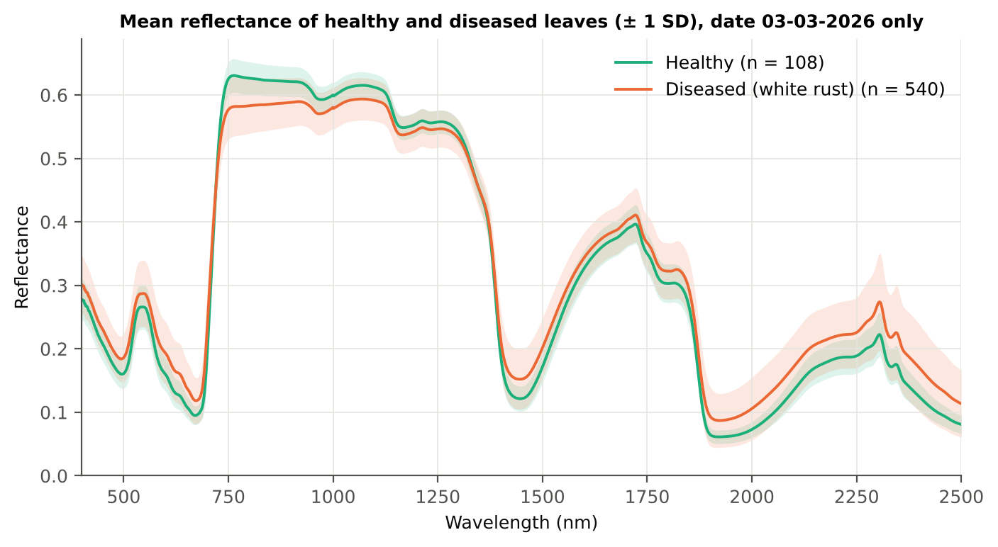
Figure 30. Date 03-03-2026: mean reflectance of healthy and diseased leaves (± 1 SD).

4.3.2 Tier 1 — statistical screening
Table 46. Date 03-03-2026: number of significant bands by test.
Test | Significant bands (of 2101)
Welch t-test + BH-FDR q < 0.05 (used for Tier 2) | 2050
One-way ANOVA p < 0.05, uncorrected (rule of Das et al.) | 2043
One-way ANOVA + BH-FDR q < 0.05 | 2043
Welch t-test p < 0.05, uncorrected | 2051
Mixed model (random plot effect) + BH-FDR q < 0.05 | 2010
Balanced subsets (108 vs 108): significant in ≥ 95 % of 1000 subsets | 1890
Levene test p < 0.05 (unequal variances → Welch) | 1790

Table 47. Date 03-03-2026: largest contiguous ranges of FDR-significant bands.
Contiguous significant range (nm) | Bands
1370–2500 | 1131
723–1324 | 602
400–716 | 317

Table 48. Date 03-03-2026: ten bands with the largest |t|.
Band (nm) | Mean H | Mean D | Welch t | q (BH) | Hedges g | AUC
755 | 0.6291 | 0.5799 | -15.06 | 0.00e+0 | -1.11 | 0.827
757 | 0.6298 | 0.5807 | -15.06 | 0.00e+0 | -1.11 | 0.826
756 | 0.6295 | 0.5803 | -15.06 | 0.00e+0 | -1.11 | 0.826
758 | 0.6301 | 0.5809 | -15.06 | 0.00e+0 | -1.11 | 0.826
759 | 0.6303 | 0.5811 | -15.05 | 0.00e+0 | -1.11 | 0.826
754 | 0.6285 | 0.5795 | -15.04 | 0.00e+0 | -1.11 | 0.826
760 | 0.6304 | 0.5813 | -15.03 | 0.00e+0 | -1.11 | 0.826
761 | 0.6305 | 0.5815 | -15.02 | 0.00e+0 | -1.11 | 0.826
762 | 0.6306 | 0.5817 | -15.01 | 0.00e+0 | -1.11 | 0.826
753 | 0.6279 | 0.5790 | -15.01 | 0.00e+0 | -1.11 | 0.826

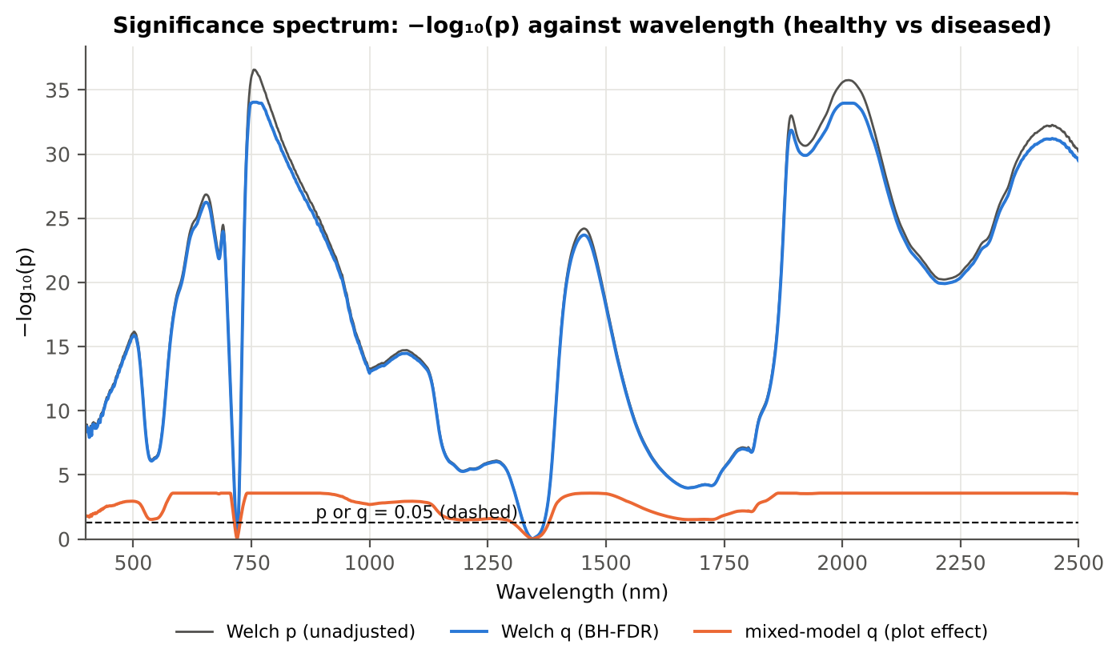
Figure 31. Date 03-03-2026: −log₁₀(p) against wavelength (Welch p, BH q and mixed-model q; dashed p or q = 0.05).

4.3.3 Tier 2 — CART and Random Forest band selection
Table 49. Date 03-03-2026: the CART-7 bands selected by rpart (prior 0.5/0.5) and how often a band within ± 10 nm is re-selected.
Band (nm) | Region | First used at node | Bootstrap re-selection | Nested-CV re-selection
613 | Red (600–679) | 2 | 14.0 % | 54.0 %
746 | Red edge (680–759) | 8 | 94.5 % | 100.0 %
754 | Red edge (680–759) | 1 | 93.0 % | 96.0 %
1019 | NIR (760–1349) | 17 | 27.0 % | 36.0 %
1200 | NIR (760–1349) | 4 | 3.0 % | 4.0 %
1886 | Water band II (1800–1950) | 5 | 23.0 % | 26.0 %
2160 | SWIR-2 (1951–2349) | 3 | 3.5 % | 32.0 %

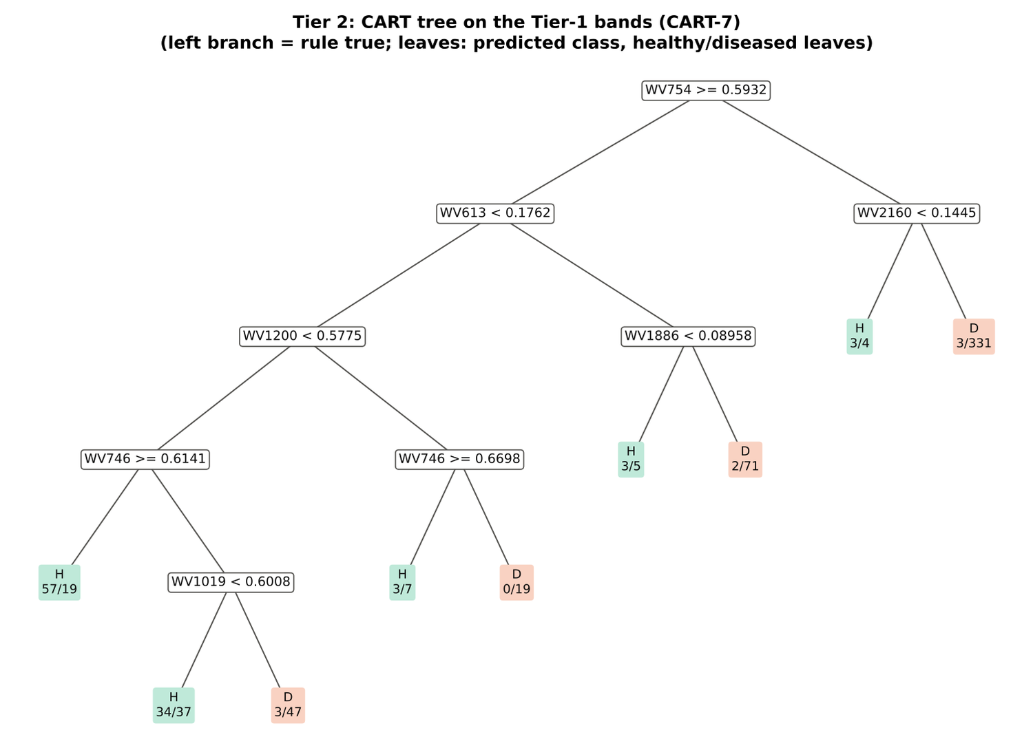
Figure 32. Date 03-03-2026: CART tree on the Tier-1 bands (CART-7).
RF-17 importance peaks: 758, 745, 770, 1988, 788, 2021, 803, 2006, 1894, 733, 2442, 815, 711, 1967, 2042, 723, 590 nm.
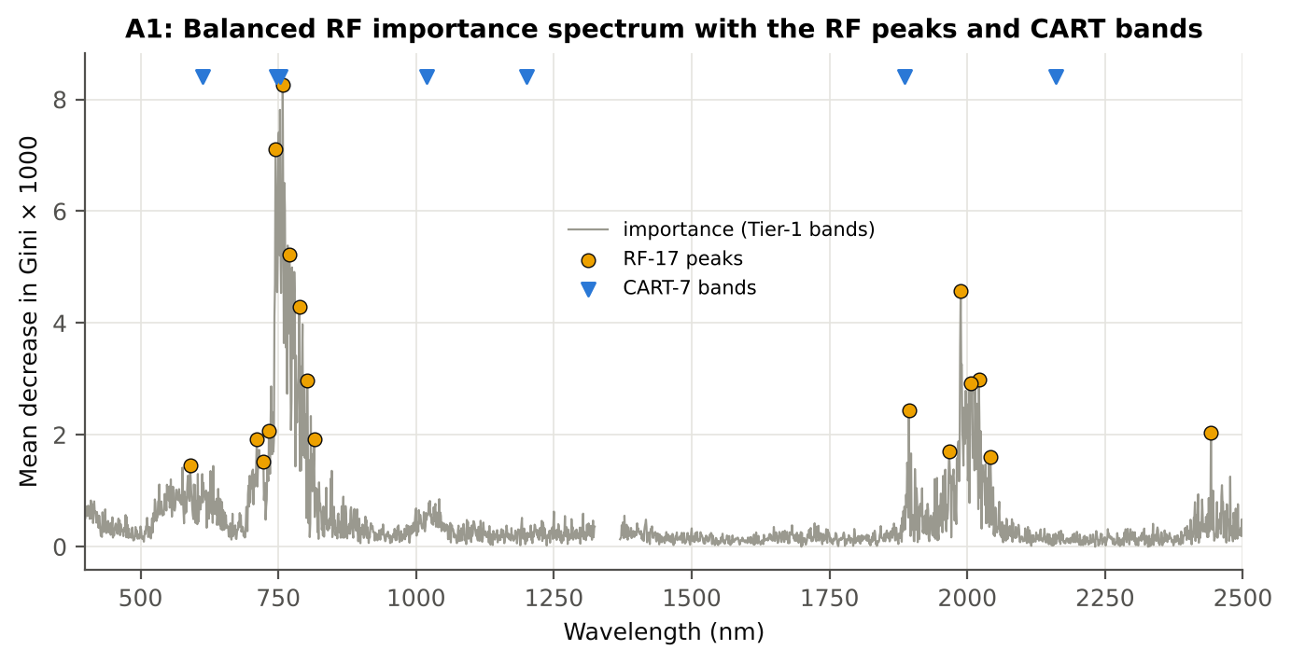
Figure 33. Date 03-03-2026: Balanced RF importance spectrum with the RF-17 peaks and the CART bands.

4.3.4 Tier 3 and Tier 4 — separability and classification
Table 50. Date 03-03-2026: Jeffries–Matusita distance of healthy and diseased leaves.
Band set | Bands | α (Bhattacharyya) | J–M (0–2) | √J–M | Separability
CART-7 | 7 | 1.389 | 1.501 | 1.225 | below 1.90
CART-2 (1-SE) | 2 | 0.473 | 0.754 | 0.868 | below 1.90
RF-17 | 17 | 3.330 | 1.928 | 1.389 | separable (≥ 1.90)
RF-10 | 10 | 1.713 | 1.639 | 1.280 | below 1.90
RF-7 (size-matched) | 7 | 1.094 | 1.330 | 1.153 | below 1.90

Table 51. Date 03-03-2026: error matrix of QDA (equal priors) on the CART-7 bands, leaf-level 10-fold CV (V1; as Table 2 of Das et al.).
Classified \ Reference | Healthy | Diseased | Row total | User's accuracy
Healthy | 99 | 125 | 224 | 44.2 %
Diseased | 9 | 415 | 424 | 97.9 %
Column total | 108 | 540 | 648
Producer's accuracy | 91.7 % | 76.8 %
Overall accuracy | 79.3 % | Balanced accuracy | 84.3 % | κ = 0.479

Table 52. Date 03-03-2026: Tier 4 on all band sets (V1), with equal and sample priors and LDA for comparison.
Band set | Classifier | OA | BA | PA healthy | PA diseased | κ
CART-7 | QDA equal priors | 79.3 % | 84.3 % | 91.7 % | 76.8 % | 0.479
CART-7 | QDA sample priors | 84.9 % | 83.5 % | 81.5 % | 85.6 % | 0.552
CART-7 | LDA equal priors | 77.6 % | 82.5 % | 89.8 % | 75.2 % | 0.447
CART-2 (1-SE) | QDA equal priors | 71.6 % | 79.3 % | 90.7 % | 67.8 % | 0.364
CART-2 (1-SE) | QDA sample priors | 85.3 % | 71.2 % | 50.0 % | 92.4 % | 0.446
CART-2 (1-SE) | LDA equal priors | 72.8 % | 78.9 % | 88.0 % | 69.8 % | 0.371
RF-17 | QDA equal priors | 80.7 % | 84.4 % | 89.8 % | 78.9 % | 0.497
RF-17 | QDA sample priors | 84.6 % | 85.2 % | 86.1 % | 84.3 % | 0.559
RF-17 | LDA equal priors | 86.9 % | 88.8 % | 91.7 % | 85.9 % | 0.622
RF-10 | QDA equal priors | 74.4 % | 80.9 % | 90.7 % | 71.1 % | 0.401
RF-10 | QDA sample priors | 83.3 % | 84.4 % | 86.1 % | 82.8 % | 0.534
RF-10 | LDA equal priors | 82.7 % | 85.6 % | 89.8 % | 81.3 % | 0.533
RF-7 (size-matched) | QDA equal priors | 77.6 % | 83.2 % | 91.7 % | 74.8 % | 0.452
RF-7 (size-matched) | QDA sample priors | 84.9 % | 83.9 % | 82.4 % | 85.4 % | 0.555
RF-7 (size-matched) | LDA equal priors | 77.9 % | 82.3 % | 88.9 % | 75.7 % | 0.449

4.3.5 Validation and CART versus RF (Part A)
Table 53. Date 03-03-2026: balanced accuracy of the four pipelines on raw reflectance under the validation schemes.
Pipeline | V1 | V3 (± SD) | V4 (± SD) | V5 | AUC V3 | κ V3
CART classifier | 74.6 % | 74.4 % ± 1.3 | 72.0 % ± 5.5 | 73.2 % | 0.758 | 0.396
RF classifier | 80.7 % | 79.5 % ± 0.7 | 76.7 % ± 7.5 | 78.2 % | 0.879 | 0.479
QDA on CART features | 84.3 % | 84.3 % ± 2.9 | 81.2 % ± 7.9 | 84.2 % | 0.906 | 0.499
QDA on RF features | 84.4 % | 86.2 % ± 1.6 | 84.6 % ± 3.5 | 84.7 % | 0.928 | 0.569

Table 54. Date 03-03-2026: validation of QDA on CART bands — effect of the imbalance correction (equal vs sample priors) and of random under-sampling (V3-RUS).
Scheme | Priors | BA | SD | OA | PA healthy | PA diseased
V1 · leaf-level 10-fold, bands fixed | equal (corrected) | 84.3 % | – | 79.3 % | 91.7 % | 76.8 %
V2 · plot-grouped 10-fold, bands fixed | equal (corrected) | 83.2 % | – | 77.5 % | 91.7 % | 74.6 %
V3 · nested plot-grouped 10-fold × 5 = 50 folds | equal (corrected) | 84.3 % | 2.9 | 80.7 % | 89.8 % | 78.8 %
V4 · 30 % plot hold-out × 10 | equal (corrected) | 81.2 % | 7.9 | 79.4 % | 83.9 % | 78.4 %
V5 · leave-one-variety-out (train on the other varieties) (3 units) | equal (corrected) | 84.2 % | – | 79.8 % | 90.7 % | 77.6 %
V1 · leaf-level 10-fold, bands fixed | sample (uncorrected) | 83.5 % | – | 84.9 % | 81.5 % | 85.6 %
V2 · plot-grouped 10-fold, bands fixed | sample (uncorrected) | 82.5 % | – | 83.8 % | 80.6 % | 84.4 %
V3 · nested plot-grouped 10-fold × 5 = 50 folds | sample (uncorrected) | 83.9 % | 3.1 | 85.3 % | 81.8 % | 86.0 %
V4 · 30 % plot hold-out × 10 | sample (uncorrected) | 79.7 % | 8.0 | 83.4 % | 73.9 % | 85.5 %
V5 · leave-one-variety-out (train on the other varieties) (3 units) | sample (uncorrected) | 83.7 % | – | 84.0 % | 83.3 % | 84.1 %
V3-RUS · nested + random under-sampling | equal (corrected) | 79.9 % | – | 72.1 % | 91.7 % | 68.2 %
V3-RUS · nested + random under-sampling | sample (uncorrected) | 79.9 % | – | 72.1 % | 91.7 % | 68.2 %

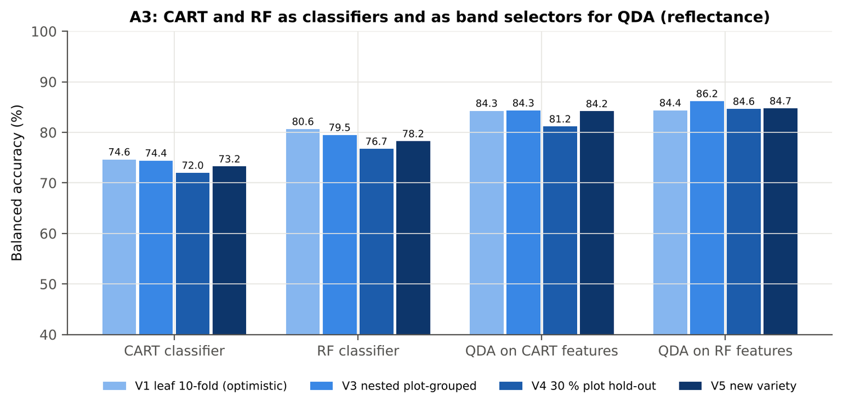
Figure 34. Date 03-03-2026: CART and RF as classifiers and as band selectors for QDA (Part A).
Table 55. Date 03-03-2026: paired comparisons on identical folds (positive = first pipeline better).
Comparison | Units | n | Mean Δ BA | First better | Wilcoxon p
RF classifier − CART classifier | V3 nested (folds) | 50 | 5.9 pts | 38 | 2.0e-6
RF classifier − CART classifier | V4 hold-out (splits) | 10 | 4.7 pts | 8 | 0.049
QDA on RF features − QDA on CART features | V3 nested (folds) | 50 | 1.8 pts | 25 | 0.259
QDA on RF features − QDA on CART features | V4 hold-out (splits) | 10 | 3.5 pts | 6 | 0.232
QDA on CART features − CART classifier | V3 nested (folds) | 50 | 10.4 pts | 42 | 0.0e+0
QDA on CART features − CART classifier | V4 hold-out (splits) | 10 | 9.2 pts | 8 | 0.010
QDA on RF features − RF classifier | V3 nested (folds) | 50 | 6.3 pts | 31 | 7.8e-4
QDA on RF features − RF classifier | V4 hold-out (splits) | 10 | 7.9 pts | 8 | 0.010

4.3.6 Disease-sensitive features (Part K)
Table 56. Date 03-03-2026: most sensitive single features of each family (threshold classifier validated on plots).
Family | Feature | AUC | Direction | BA plot-grouped CV | BA hold-out
K2 continuum removal | CR6 water 1940 area | 0.886 | D < H | 80.3 % | 80.9 %
K2 continuum removal | CR3 water 970 position | 0.873 | D < H | 86.5 % | 88.9 %
K2 continuum removal | CR3 water 970 width | 0.868 | D < H | 89.2 % | 91.6 %
K3 index | NWI2 | 0.869 | D > H | 79.3 % | 78.3 %
K3 index | TVI | 0.849 | D < H | 78.9 % | 78.8 %
K3 index | RDVI | 0.848 | D < H | 77.1 % | 76.6 %
K4 edge parameter | SDr (red-edge area) | 0.843 | D < H | 78.1 % | 76.9 %
K4 edge parameter | λr = REP (red-edge position, nm) | 0.767 | D < H | 71.9 % | 70.6 %
K4 first derivative | D1 884 nm | 0.895 | D > H | – | –
K4 first derivative | D1 883 nm | 0.891 | D > H | – | –
K4 first derivative | D1 966 nm | 0.890 | D > H | – | –
K1 reflectance | R 1999 nm (1951–2349) | 0.842 | D > H | 75.3 % | –
K1 reflectance | R 1893 nm (1800–1950) | 0.829 | D > H | 75.9 % | –
K3b optimised index | NDSI(2081,2315) | 0.914 |  | 82.2 % | –
K3b optimised index | DI(966,968) | 0.915 |  | 85.7 % | –

Table 57. Date 03-03-2026: K5 — CART vs Balanced RF on each feature group (balanced accuracy).
Feature group | CART (V3) | RF (V3) | CART (V4) | RF (V4)
Full raw spectrum | 74.7 % | 78.9 % | 72.0 % | 77.4 %
K1 band reflectance | 75.6 % | 78.7 % | 72.9 % | 77.2 %
K2 continuum removal | 88.9 % | 90.4 % | 90.5 % | 90.1 %
K3 vegetation indices | 77.6 % | 79.7 % | 76.4 % | 77.8 %
K4 derivatives + edge parameters | 86.3 % | 90.0 % | 85.9 % | 89.7 %
K1–K4 combined pool | 89.9 % | 89.6 % | 90.2 % | 88.8 %
K4 incl. guard bands (artefact test) | 89.9 % | 92.1 % | 90.9 % | 93.6 %
K-selected 15 | 84.0 % | 88.7 % | 82.6 % | 88.3 %

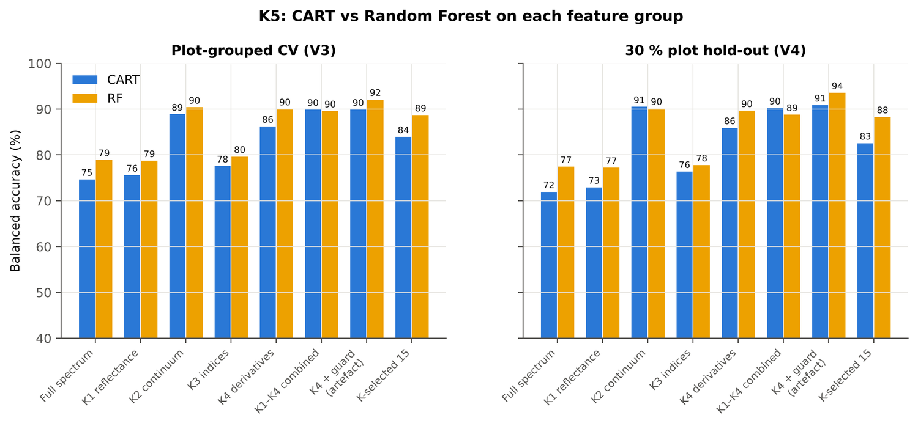
Figure 35. Date 03-03-2026: K5 — CART vs RF on each disease-sensitive feature group.
Table 58. Date 03-03-2026: red-edge inflection point by four methods.
REIP method | Healthy (nm) | Diseased (nm) | Shift (nm) | AUC | BA plot-grouped CV
linear extrapolation | 709.0 | 701.2 | -7.78 | 0.778 | 73.3 %
Lagrangian interpolation | 709.1 | 704.2 | -4.89 | 0.769 | 71.6 %
maximum first derivative | 709.1 | 704.2 | -4.86 | 0.767 | 71.9 %
linear 4-point interpolation | 715.9 | 712.9 | -3.02 | 0.746 | 68.3 %

4.3.7 Four tiers on the combined feature pool (Part C)
Tier 1: 3774 of 4150 features significant. Tier 2: CART selected 5 features (CR3 water 970 width, D1 1073 nm, PRI, D1 1658 nm, D1 1744 nm); RF-17: D1 973 nm, CR3 water 970 width, D1 911 nm, CR3 water 970 position, D1 898 nm, D1 886 nm, CR6 water 1940 area, D1 984 nm, D1 1067 nm, D1 799 nm, D1 813 nm, D1 1653 nm, D1 785 nm, D1 868 nm, D1 825 nm, D1 1077 nm, D1 720 nm. Tier 3: J–M 1.646 (CART set) and 1.918 (RF-17), separable (≥ 1.90) for RF-17.
Table 59. Date 03-03-2026: composition of the combined pool and of the selected sets.
Feature type | Features | Tier-1 significant | CART-5 | RF-17
K1 band reflectance | 2039 | 1989 | 0 | 0
K2 continuum removal | 30 | 28 | 1 | 3
K3 vegetation index | 30 | 29 | 1 | 0
K4 edge parameter | 20 | 16 | 0 | 0
K4 first-derivative band | 2031 | 1712 | 3 | 14

Table 60. Date 03-03-2026: balanced accuracy of the four pipelines on the combined pool.
Pipeline | V1 | V3 (± SD) | V4 (± SD) | V5 | AUC V3 | κ V3
CART classifier | 91.7 % | 89.0 % ± 1.2 | 90.0 % ± 3.3 | 91.0 % | 0.914 | 0.713
RF classifier | 92.8 % | 88.6 % ± 1.6 | 88.3 % ± 5.3 | 89.6 % | 0.963 | 0.691
QDA on CART features | 97.0 % | 94.8 % ± 1.1 | 94.6 % ± 2.6 | 96.4 % | 0.988 | 0.845
QDA on RF features | 95.1 % | 93.1 % ± 1.4 | 90.9 % ± 4.0 | 88.9 % | 0.978 | 0.865

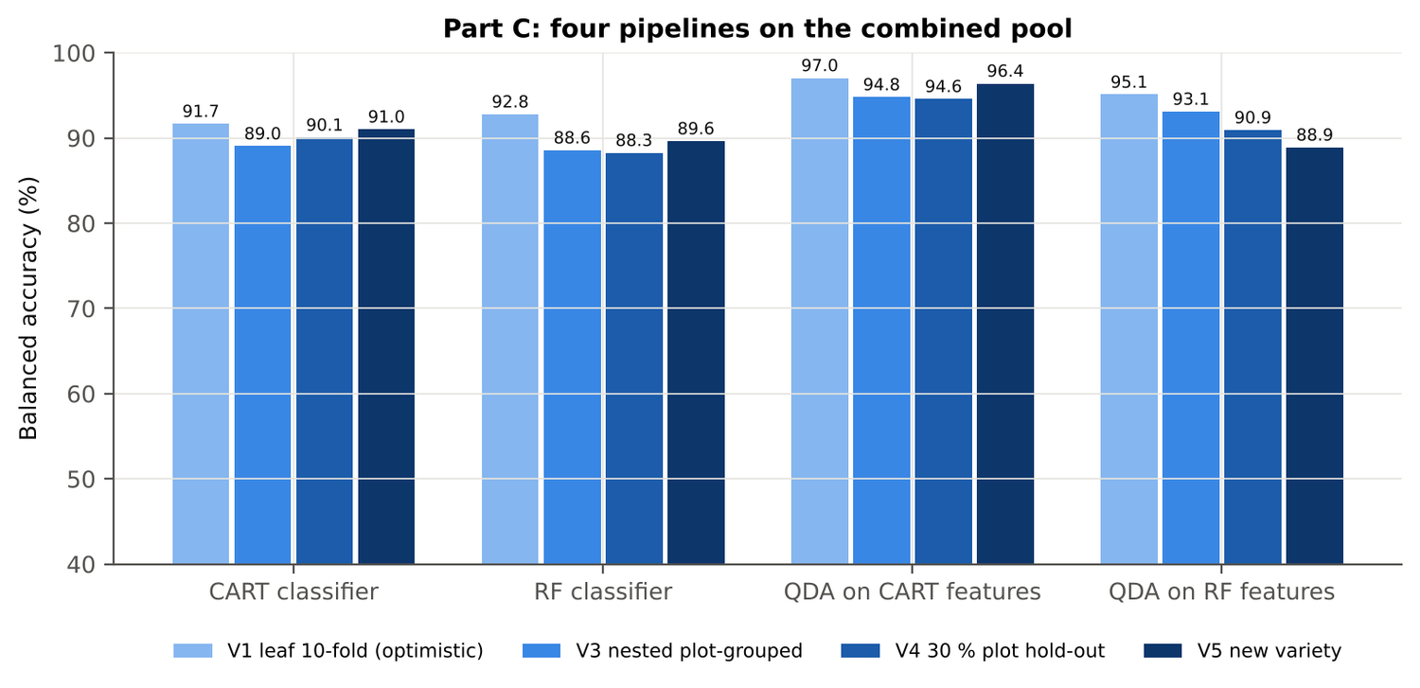
Figure 36. Date 03-03-2026: four pipelines on the combined pool under V1, V3, V4 and V5.
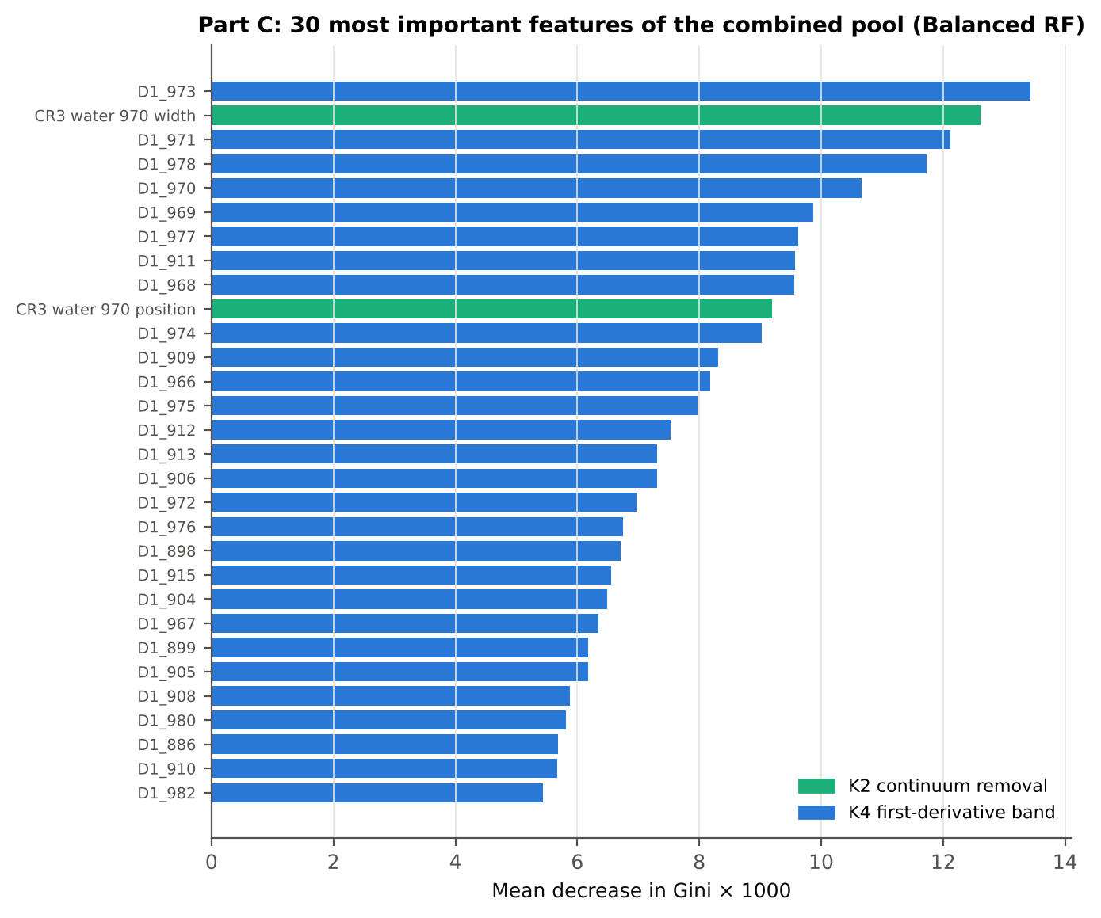
Figure 37. Date 03-03-2026: the 30 most important features of the combined pool (Balanced RF).
Table 61. Date 03-03-2026: combined pool vs reflectance vs K5 (paired over the V3 folds).
First | Second | Mean Δ BA | First better / n | Wilcoxon p
Combined pool: QDA on CART features | Reflectance: QDA on CART bands | 9.9 pts | 46 / 50 | 0.0e+0
Combined pool: QDA on RF features | Reflectance: QDA on RF bands | 6.3 pts | 40 / 50 | 7.9e-7
Combined pool: RF classifier (Tier-1 features) | Reflectance: RF classifier (Tier-1 bands) | 8.7 pts | 46 / 50 | 1.0e-8
Combined pool: CART classifier (Tier-1 features) | Reflectance: CART classifier (Tier-1 bands) | 14.7 pts | 49 / 50 | 0.0e+0
Combined pool: QDA on RF features | Combined pool: QDA on CART features | -1.9 pts | 16 / 50 | 0.043
Combined pool: QDA on RF features | K5: RF classifier on all 4151 features | 2.8 pts | 36 / 50 | 0.004
Combined pool: QDA on RF features | K5: QDA on 15 features chosen by AUC | 0.7 pts | 24 / 50 | 0.225
Combined pool: RF classifier (Tier-1 features) | K5: RF classifier on all 4151 features | -1.1 pts | 4 / 50 | 4.4e-4

4.3.8 Transfer (V5)
Table 62. Date 03-03-2026: balanced accuracy by held-out variety (trained on the other two varieties).
Feature set · pipeline | V1 | V2 | V3
Reflectance · CART classifier | 77.2 % | 66.7 % | 75.8 %
Reflectance · RF classifier | 79.4 % | 74.7 % | 80.6 %
Reflectance · QDA on CART features | 76.1 % | 84.4 % | 91.9 %
Reflectance · QDA on RF features | 87.5 % | 81.4 % | 85.3 %
Combined pool · CART classifier | 90.6 % | 89.4 % | 93.1 %
Combined pool · RF classifier | 90.8 % | 89.2 % | 88.9 %
Combined pool · QDA on CART features | 94.7 % | 97.5 % | 96.9 %
Combined pool · QDA on RF features | 93.3 % | 80.3 % | 93.1 %

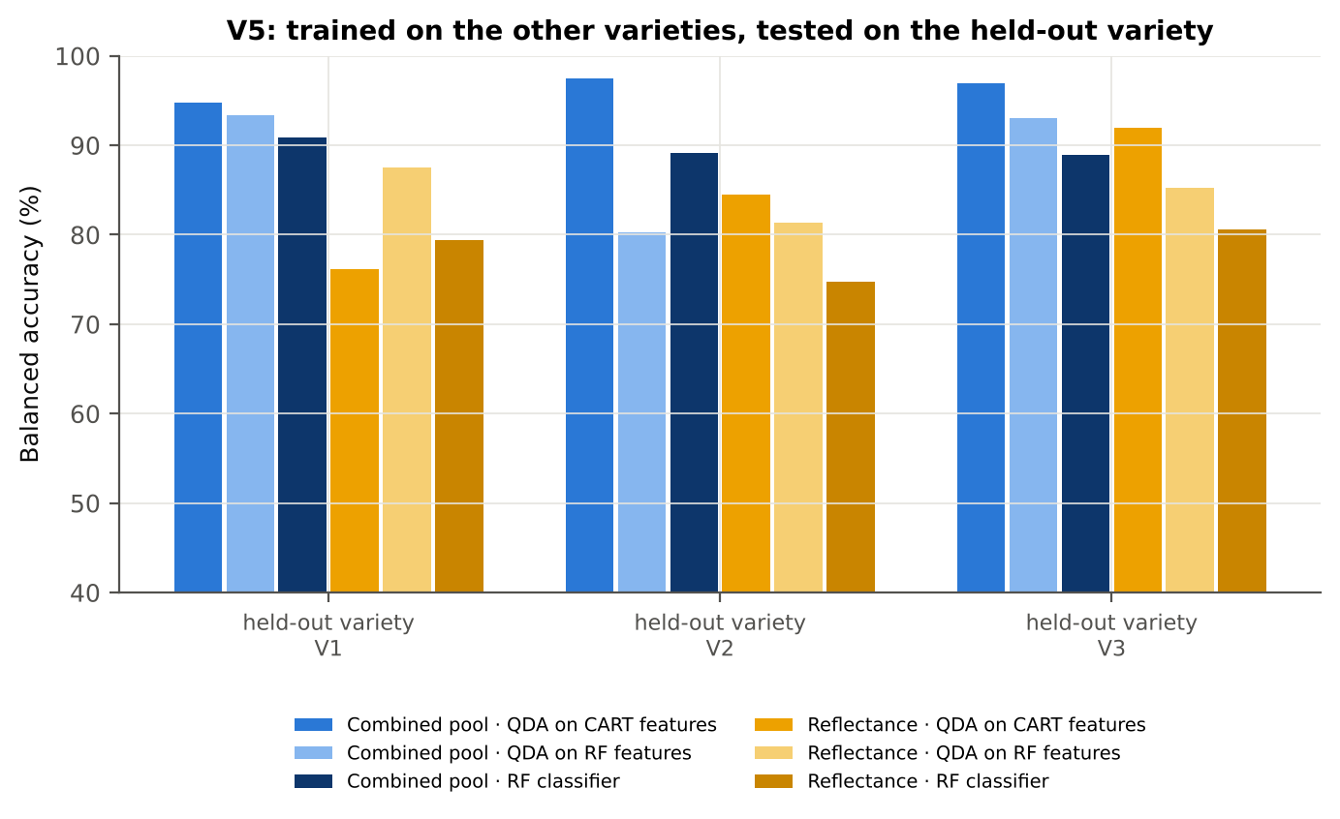
Figure 38. Date 03-03-2026: V5 transfer by held-out variety.

4.3.9 Interpretation
Tier 1: healthy and white-rust leaves differ significantly at 2050 of 2101 bands (Welch + BH-FDR); 2010 bands remain significant with a random plot effect and 1890 in ≥ 95 % of 1000 balanced subsets. The most sensitive single band (smoothed reflectance) reaches AUC 0.84 at 1999 nm.
Tier 2: CART (rpart, prior 0.5/0.5) selected 7 bands (root 754 nm): 754, 613, 2160, 1200, 1886, 746, 1019 nm. The Balanced RF importance peaks (RF-17) were 758, 745, 770, 1988, 788, 2021, 803, 2006, 1894, 733, 2442, 815, 711, 1967, 2042, 723, 590 nm.
Tier 3: J–M = 1.50 on the CART bands and 1.93 on the RF bands: only the RF bands reach the 1.90 separability threshold (but not 1.94, the threshold of Das et al.).
Tier 4: QDA with equal priors on the CART bands gives BA 84.3 % in the paper's protocol (V1; healthy recall 91.7 %, diseased recall 76.9 %) and 84.3 % ± 2.9 % (V3 nested, plot-grouped) / 81.2 % (V4 hold-out plots) on new plots.
CART vs RF: as classifiers RF beats CART by 5.9 points (V3, RF better in 38 of 50 folds, p = 2.3e-06); as band selectors for QDA the RF bands give +1.8 points vs the CART bands (p = 0.259). RF selection is more stable than CART selection (Jaccard ±10 nm 0.67 vs 0.29).
Disease-sensitive features (Part K): the strongest group for RF is K2 continuum removal (BA 90.4 %, V3) vs 78.7 % for reflectance; best single features: first derivative at 884 nm (AUC 0.90), CR6 water 1940 area (AUC 0.89), NWI2 (AUC 0.87), SDr (red-edge area) (AUC 0.84). REIP (linear extrapolation) shifts by -7.8 nm in diseased leaves (AUC 0.78).
Part C (four tiers on the combined K1 + K2–K4 pool, 4150 features, 3774 significant): CART chose 5 features, RF 17 (J–M 1.65 / 1.92); QDA on the RF features reaches 93.1 % (V3) / 90.9 % (V4), +6.9 points vs QDA on RF reflectance bands; best pipeline on the pool: QDA on CART features (94.8 %, V3).
Transfer (V5, leave-one-variety-out): QDA on CART reflectance bands 84.2 %, QDA on combined-pool RF features 88.9 % (close to the V3 estimate, 93.1 %), i.e. features chosen on two varieties transfer well to the third. Best pipeline under transfer: combined pool: QDA on CART features (96.4 %).
Compared with all dates, stages and varieties pooled (V3: reflectance QDA-CART 72.0 %, combined-pool QDA-RF 83.7 %; J–M 1.27), this subset gives 84.3 % and 93.1 % (J–M 1.50): analysing it separately improves discrimination.

Recommendations for this subset
- Use first-derivative and continuum-removed features rather than single reflectance bands for this subset; the four-tier selection with RF importance on the combined pool and a QDA or RF classifier is the recommended pipeline.
- Report balanced accuracy with both class recalls and the priors used; the classes are imbalanced (1 : 5.0) and equal priors / balanced sampling were applied throughout.
- Base conclusions on the plot-grouped estimates (V3 10-fold × 5 = 50 folds, V4 10 hold-outs), not on the leaf-level V1 estimate.
- Interpret features near the ASD detector joins (≈ 1000 and 1800 nm) with care; guard zones were excluded from the rankings.
- For application to a new variety, the most robust pipeline here was combined pool: QDA on CART features (V5 BA 96.4 %).

Cross-checks
43 checks passed, 4 were flagged and 0 failed. Flagged items are limitations reported in the workbook, not errors: Exact duplicates among the remaining spectra; QDA implementation (Part A (raw reflectance)); QDA in R; Selection optimism.

4.4 Date 13-03-2026 — date 13-03-2026 only

4.4.1 Data and validation design
This subset contains 648 leaf spectra (108 healthy, 540 diseased; ratio 1 : 5.0) from 12 healthy and 36 diseased plots, measured on 13-03-2026; growth stages Flowering, Pod formation; varieties V1, V2, V3. V3 used 10-fold plot-grouped CV × 5 (50 training sets), V4 held out 4 healthy + 11 diseased plots × 10, and V5 was leave-one-variety-out (3 units).
Table 63. Date 13-03-2026: leaf spectra by date and growth stage.
Date | Growth stage | Healthy | Diseased
13-03-2026 | Flowering | 27 | 135
13-03-2026 | Pod formation | 81 | 405

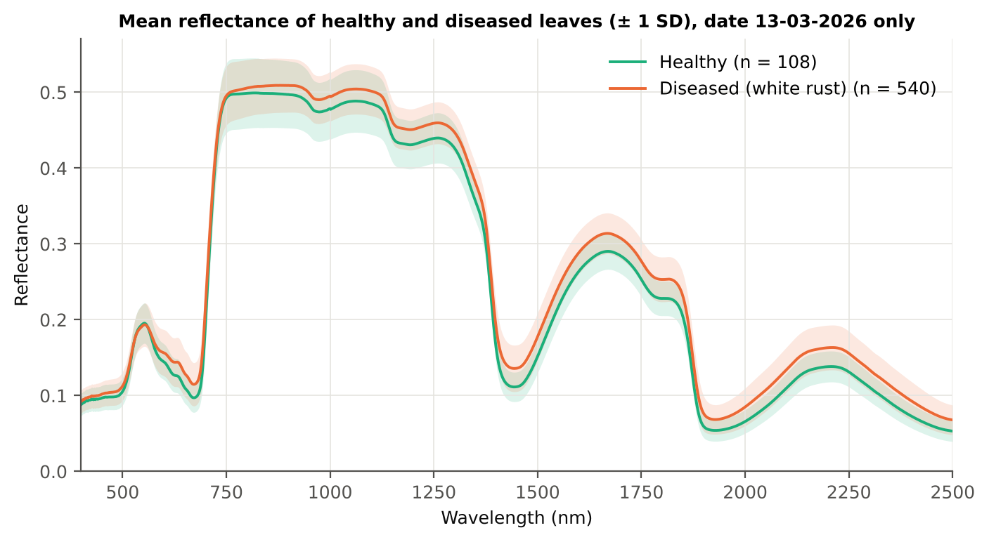
Figure 39. Date 13-03-2026: mean reflectance of healthy and diseased leaves (± 1 SD).

4.4.2 Tier 1 — statistical screening
Table 64. Date 13-03-2026: number of significant bands by test.
Test | Significant bands (of 2101)
Welch t-test + BH-FDR q < 0.05 (used for Tier 2) | 1933
One-way ANOVA p < 0.05, uncorrected (rule of Das et al.) | 1954
One-way ANOVA + BH-FDR q < 0.05 | 1953
Welch t-test p < 0.05, uncorrected | 1937
Mixed model (random plot effect) + BH-FDR q < 0.05 | 1697
Balanced subsets (108 vs 108): significant in ≥ 95 % of 1000 subsets | 1666
Levene test p < 0.05 (unequal variances → Welch) | 1365

Table 65. Date 13-03-2026: largest contiguous ranges of FDR-significant bands.
Contiguous significant range (nm) | Bands
837–2500 | 1664
574–724 | 151
400–517 | 118

Table 66. Date 13-03-2026: ten bands with the largest |t|.
Band (nm) | Mean H | Mean D | Welch t | q (BH) | Hedges g | AUC
1879 | 0.1035 | 0.1281 | 11.28 | 0.00e+0 | 0.86 | 0.779
1880 | 0.0998 | 0.1242 | 11.27 | 0.00e+0 | 0.86 | 0.779
1878 | 0.1073 | 0.1323 | 11.27 | 0.00e+0 | 0.86 | 0.779
1881 | 0.0962 | 0.1203 | 11.26 | 0.00e+0 | 0.85 | 0.780
1877 | 0.1112 | 0.1364 | 11.26 | 0.00e+0 | 0.87 | 0.778
1876 | 0.1152 | 0.1407 | 11.24 | 0.00e+0 | 0.87 | 0.778
1882 | 0.0928 | 0.1165 | 11.24 | 0.00e+0 | 0.85 | 0.779
1875 | 0.1194 | 0.1451 | 11.21 | 0.00e+0 | 0.87 | 0.777
1883 | 0.0895 | 0.1129 | 11.20 | 0.00e+0 | 0.84 | 0.779
1874 | 0.1236 | 0.1495 | 11.19 | 0.00e+0 | 0.88 | 0.777

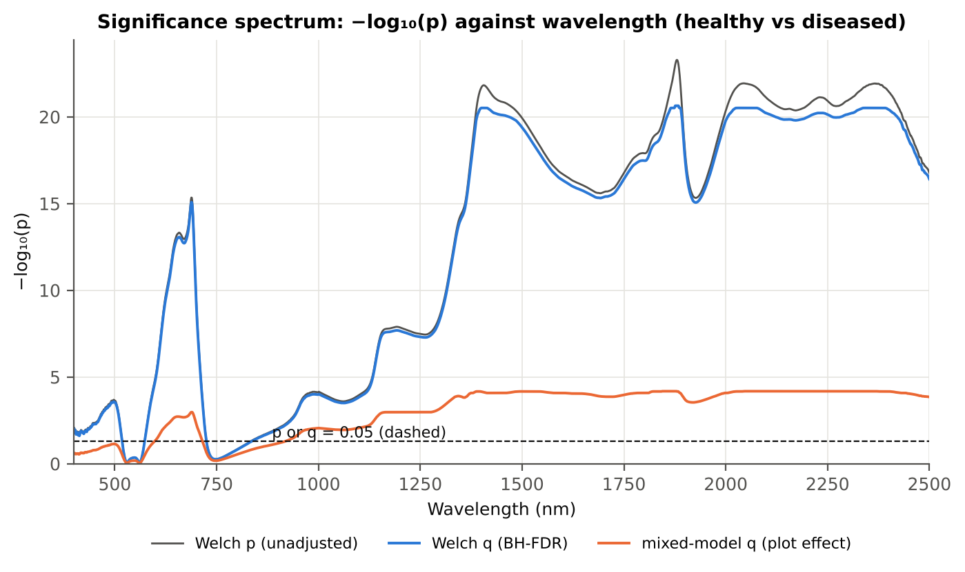
Figure 40. Date 13-03-2026: −log₁₀(p) against wavelength (Welch p, BH q and mixed-model q; dashed p or q = 0.05).

4.4.3 Tier 2 — CART and Random Forest band selection
Table 67. Date 13-03-2026: the CART-14 bands selected by rpart (prior 0.5/0.5) and how often a band within ± 10 nm is re-selected.
Band (nm) | Region | First used at node | Bootstrap re-selection | Nested-CV re-selection
401 | Blue (400–499) | 28 | 89.0 % | 80.0 %
404 | Blue (400–499) | 15 | 93.0 % | 80.0 %
434 | Blue (400–499) | 5 | 30.0 % | 48.0 %
674 | Red (600–679) | 60 | 29.5 % | 46.0 %
687 | Red edge (680–759) | 30 | 71.0 % | 90.0 %
717 | Red edge (680–759) | 240 | 15.5 % | 38.0 %
1339 | NIR (760–1349) | 3 | 26.0 % | 88.0 %
1399 | Water band I (1350–1430) | 11 | 26.5 % | 42.0 %
1421 | Water band I (1350–1430) | 57 | 13.5 % | 44.0 %
1754 | SWIR-1 (1431–1799) | 120 | 6.5 % | 32.0 %
1875 | Water band II (1800–1950) | 1 | 54.0 % | 94.0 %
1881 | Water band II (1800–1950) | 2 | 66.0 % | 96.0 %
1882 | Water band II (1800–1950) | 14 | 67.5 % | 96.0 %
2014 | SWIR-2 (1951–2349) | 7 | 22.0 % | 46.0 %

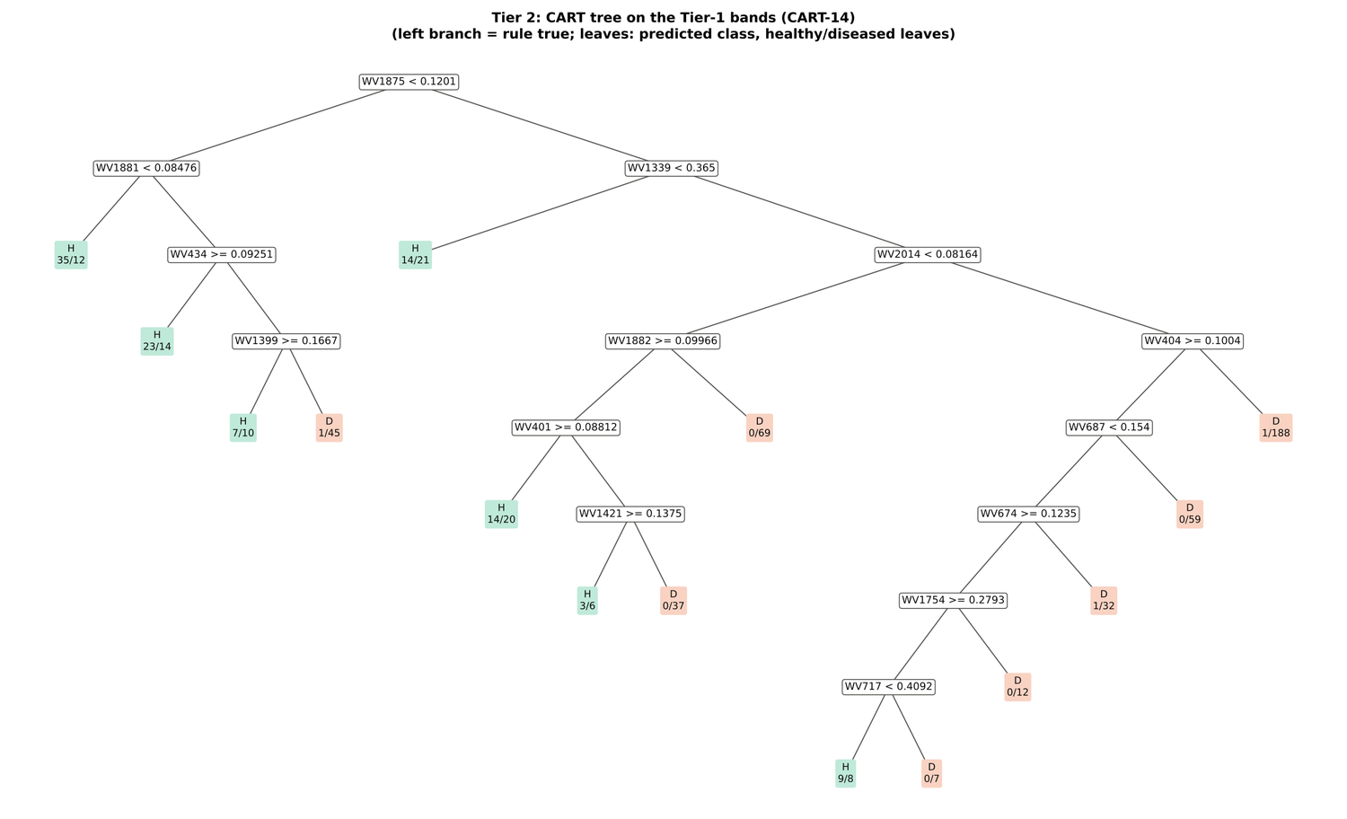
Figure 41. Date 13-03-2026: CART tree on the Tier-1 bands (CART-14).
RF-17 importance peaks: 1369, 1878, 405, 2040, 2013, 1867, 417, 1357, 442, 1339, 1381, 428, 1891, 1992, 2409, 1850, 2390 nm.
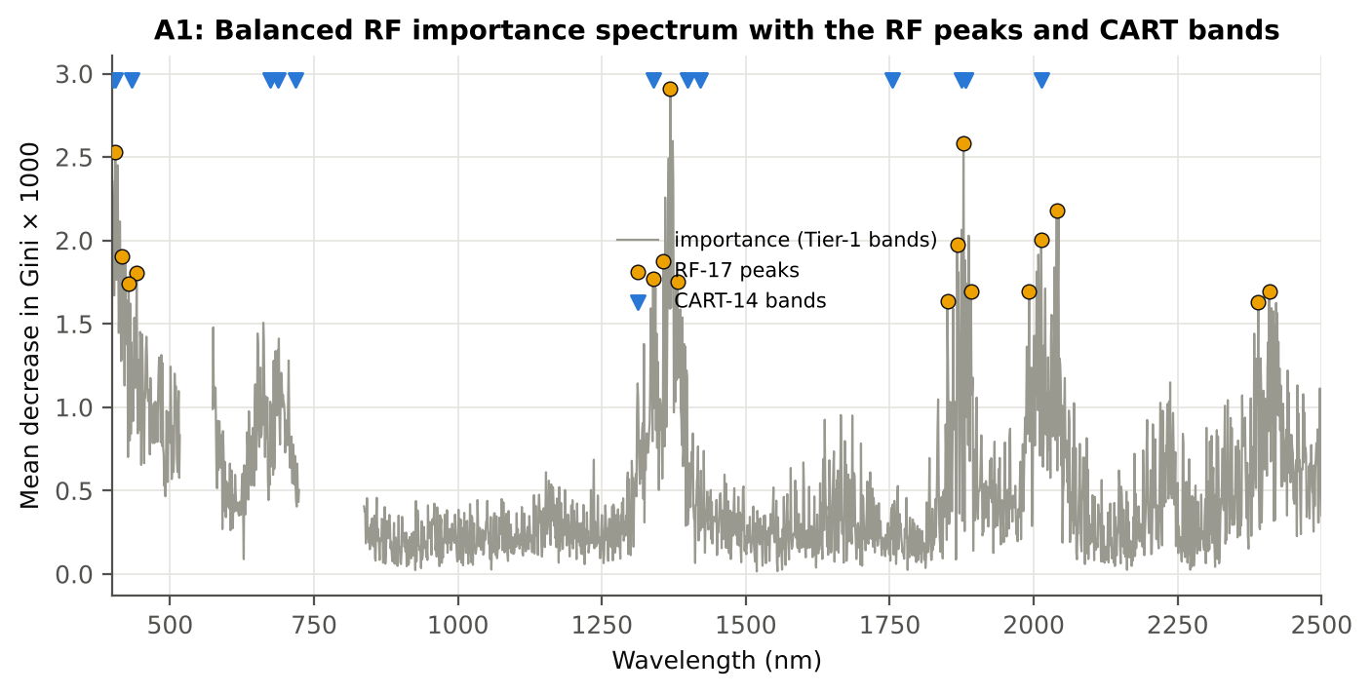
Figure 42. Date 13-03-2026: Balanced RF importance spectrum with the RF-17 peaks and the CART bands.

4.4.4 Tier 3 and Tier 4 — separability and classification
Table 68. Date 13-03-2026: Jeffries–Matusita distance of healthy and diseased leaves.
Band set | Bands | α (Bhattacharyya) | J–M (0–2) | √J–M | Separability
CART-14 | 14 | 1.508 | 1.557 | 1.248 | below 1.90
CART-2 (1-SE) | 2 | 0.214 | 0.386 | 0.621 | below 1.90
RF-17 | 17 | 2.668 | 1.861 | 1.364 | below 1.90
RF-10 | 10 | 1.638 | 1.611 | 1.269 | below 1.90
RF-14 (size-matched) | 14 | 2.156 | 1.769 | 1.330 | below 1.90

Table 69. Date 13-03-2026: error matrix of QDA (equal priors) on the CART-14 bands, leaf-level 10-fold CV (V1; as Table 2 of Das et al.).
Classified \ Reference | Healthy | Diseased | Row total | User's accuracy
Healthy | 90 | 129 | 219 | 41.1 %
Diseased | 18 | 411 | 429 | 95.8 %
Column total | 108 | 540 | 648
Producer's accuracy | 83.3 % | 76.1 %
Overall accuracy | 77.3 % | Balanced accuracy | 79.7 % | κ = 0.421

Table 70. Date 13-03-2026: Tier 4 on all band sets (V1), with equal and sample priors and LDA for comparison.
Band set | Classifier | OA | BA | PA healthy | PA diseased | κ
CART-14 | QDA equal priors | 77.3 % | 79.7 % | 83.3 % | 76.1 % | 0.421
CART-14 | QDA sample priors | 84.3 % | 79.4 % | 72.2 % | 86.7 % | 0.510
CART-14 | LDA equal priors | 83.6 % | 80.9 % | 76.8 % | 85.0 % | 0.512
CART-2 (1-SE) | QDA equal priors | 59.7 % | 67.3 % | 78.7 % | 55.9 % | 0.193
CART-2 (1-SE) | QDA sample priors | 84.9 % | 56.1 % | 13.0 % | 99.3 % | 0.183
CART-2 (1-SE) | LDA equal priors | 69.9 % | 72.3 % | 75.9 % | 68.7 % | 0.292
RF-17 | QDA equal priors | 95.7 % | 93.0 % | 88.9 % | 97.0 % | 0.847
RF-17 | QDA sample priors | 96.0 % | 90.6 % | 82.4 % | 98.7 % | 0.849
RF-17 | LDA equal priors | 92.1 % | 92.3 % | 92.6 % | 92.0 % | 0.749
RF-10 | QDA equal priors | 94.6 % | 93.4 % | 91.7 % | 95.2 % | 0.817
RF-10 | QDA sample priors | 95.8 % | 90.8 % | 83.3 % | 98.3 % | 0.845
RF-10 | LDA equal priors | 91.8 % | 92.1 % | 92.6 % | 91.7 % | 0.741
RF-14 (size-matched) | QDA equal priors | 93.7 % | 92.5 % | 90.7 % | 94.3 % | 0.789
RF-14 (size-matched) | QDA sample priors | 94.6 % | 89.7 % | 82.4 % | 97.0 % | 0.803
RF-14 (size-matched) | LDA equal priors | 91.2 % | 92.1 % | 93.5 % | 90.7 % | 0.727

4.4.5 Validation and CART versus RF (Part A)
Table 71. Date 13-03-2026: balanced accuracy of the four pipelines on raw reflectance under the validation schemes.
Pipeline | V1 | V3 (± SD) | V4 (± SD) | V5 | AUC V3 | κ V3
CART classifier | 73.2 % | 69.8 % ± 1.6 | 70.2 % ± 4.9 | 72.8 % | 0.744 | 0.302
RF classifier | 75.6 % | 74.1 % ± 0.6 | 75.2 % ± 5.3 | 72.1 % | 0.833 | 0.392
QDA on CART features | 79.7 % | 75.7 % ± 1.3 | 75.6 % ± 6.9 | 69.8 % | 0.849 | 0.358
QDA on RF features | 93.0 % | 80.6 % ± 2.4 | 78.5 % ± 8.2 | 75.8 % | 0.887 | 0.508

Table 72. Date 13-03-2026: validation of QDA on CART bands — effect of the imbalance correction (equal vs sample priors) and of random under-sampling (V3-RUS).
Scheme | Priors | BA | SD | OA | PA healthy | PA diseased
V1 · leaf-level 10-fold, bands fixed | equal (corrected) | 79.7 % | – | 77.3 % | 83.3 % | 76.1 %
V2 · plot-grouped 10-fold, bands fixed | equal (corrected) | 76.3 % | – | 75.9 % | 76.8 % | 75.7 %
V3 · nested plot-grouped 10-fold × 5 = 50 folds | equal (corrected) | 75.7 % | 1.3 | 74.3 % | 78.0 % | 73.5 %
V4 · 30 % plot hold-out × 10 | equal (corrected) | 75.6 % | 6.9 | 72.9 % | 79.7 % | 71.4 %
V5 · leave-one-variety-out (train on the other varieties) (3 units) | equal (corrected) | 69.8 % | – | 68.2 % | 72.2 % | 67.4 %
V1 · leaf-level 10-fold, bands fixed | sample (uncorrected) | 79.4 % | – | 84.3 % | 72.2 % | 86.7 %
V2 · plot-grouped 10-fold, bands fixed | sample (uncorrected) | 78.1 % | – | 83.3 % | 70.4 % | 85.9 %
V3 · nested plot-grouped 10-fold × 5 = 50 folds | sample (uncorrected) | 77.5 % | 1.1 | 83.9 % | 68.0 % | 87.1 %
V4 · 30 % plot hold-out × 10 | sample (uncorrected) | 76.3 % | 6.0 | 82.7 % | 66.4 % | 86.2 %
V5 · leave-one-variety-out (train on the other varieties) (3 units) | sample (uncorrected) | 72.3 % | – | 79.2 % | 62.0 % | 82.6 %
V3-RUS · nested + random under-sampling | equal (corrected) | 67.2 % | – | 62.6 % | 74.1 % | 60.4 %
V3-RUS · nested + random under-sampling | sample (uncorrected) | 67.2 % | – | 62.6 % | 74.1 % | 60.4 %

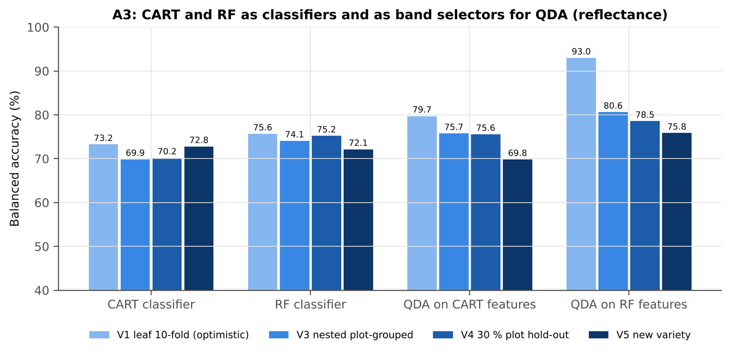
Figure 43. Date 13-03-2026: CART and RF as classifiers and as band selectors for QDA (Part A).
Table 73. Date 13-03-2026: paired comparisons on identical folds (positive = first pipeline better).
Comparison | Units | n | Mean Δ BA | First better | Wilcoxon p
RF classifier − CART classifier | V3 nested (folds) | 50 | 3.3 pts | 34 | 0.004
RF classifier − CART classifier | V4 hold-out (splits) | 10 | 5.0 pts | 10 | 0.002
QDA on RF features − QDA on CART features | V3 nested (folds) | 50 | 4.9 pts | 34 | 0.009
QDA on RF features − QDA on CART features | V4 hold-out (splits) | 10 | 3.0 pts | 7 | 0.232
QDA on CART features − CART classifier | V3 nested (folds) | 50 | 5.2 pts | 31 | 0.004
QDA on CART features − CART classifier | V4 hold-out (splits) | 10 | 5.4 pts | 6 | 0.131
QDA on RF features − RF classifier | V3 nested (folds) | 50 | 6.8 pts | 32 | 0.002
QDA on RF features − RF classifier | V4 hold-out (splits) | 10 | 3.4 pts | 6 | 0.322

4.4.6 Disease-sensitive features (Part K)
Table 74. Date 13-03-2026: most sensitive single features of each family (threshold classifier validated on plots).
Family | Feature | AUC | Direction | BA plot-grouped CV | BA hold-out
K2 continuum removal | CR3 water 970 width | 0.859 | D < H | 78.3 % | 80.2 %
K2 continuum removal | CR6 water 1940 area | 0.741 | D < H | 69.0 % | 71.1 %
K2 continuum removal | CR6 water 1940 width | 0.729 | D < H | 66.7 % | 66.6 %
K3 index | ARI | 0.832 | D > H | 72.2 % | 71.1 %
K3 index | PSRI | 0.820 | D > H | 76.3 % | 77.9 %
K3 index | NCPI | 0.787 | D > H | 71.8 % | 73.5 %
K4 edge parameter | (SDr − SDy)/(SDr + SDy) | 0.849 | D < H | 77.1 % | 75.9 %
K4 edge parameter | SDr/SDy | 0.836 | D < H | 76.4 % | 75.2 %
K4 first derivative | D1 626 nm | 0.829 | D > H | – | –
K4 first derivative | D1 627 nm | 0.829 | D > H | – | –
K4 first derivative | D1 625 nm | 0.825 | D > H | – | –
K1 reflectance | R 1881 nm (1800–1950) | 0.782 | D > H | 72.0 % | –
K1 reflectance | R 1393 nm (1350–1430) | 0.776 | D > H | 71.2 % | –
K3b optimised index | NDSI(585,693) | 0.854 |  | 78.3 % | –
K3b optimised index | DI(580,694) | 0.856 |  | 77.5 % | –

Table 75. Date 13-03-2026: K5 — CART vs Balanced RF on each feature group (balanced accuracy).
Feature group | CART (V3) | RF (V3) | CART (V4) | RF (V4)
Full raw spectrum | 69.5 % | 73.9 % | 69.5 % | 76.2 %
K1 band reflectance | 70.7 % | 74.3 % | 68.6 % | 76.5 %
K2 continuum removal | 72.3 % | 75.3 % | 72.8 % | 77.0 %
K3 vegetation indices | 76.4 % | 76.2 % | 74.0 % | 78.1 %
K4 derivatives + edge parameters | 75.3 % | 79.8 % | 73.1 % | 80.0 %
K1–K4 combined pool | 74.2 % | 78.6 % | 75.9 % | 80.8 %
K4 incl. guard bands (artefact test) | 82.7 % | 88.6 % | 82.5 % | 88.0 %
K-selected 15 | 75.6 % | 79.8 % | 78.4 % | 81.6 %

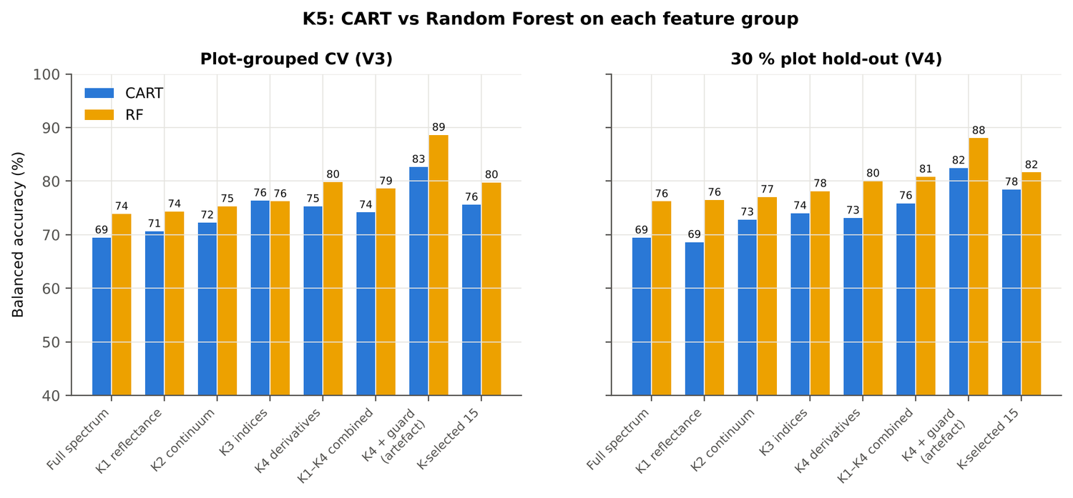
Figure 44. Date 13-03-2026: K5 — CART vs RF on each disease-sensitive feature group.
Table 76. Date 13-03-2026: red-edge inflection point by four methods.
REIP method | Healthy (nm) | Diseased (nm) | Shift (nm) | AUC | BA plot-grouped CV
Lagrangian interpolation | 704.7 | 703.6 | -1.10 | 0.586 | 53.6 %
maximum first derivative | 704.7 | 703.6 | -1.11 | 0.586 | 54.0 %
linear extrapolation | 701.9 | 700.0 | -1.84 | 0.584 | 55.0 %
linear 4-point interpolation | 714.0 | 713.0 | -0.95 | 0.576 | 57.8 %

4.4.7 Four tiers on the combined feature pool (Part C)
Tier 1: 3530 of 4150 features significant. Tier 2: CART selected 8 features ((SDr − SDy)/(SDr + SDy), CR3 water 970 width, D1 1428 nm, D1 436 nm, D1 1080 nm, D1 681 nm, D1 1927 nm, D1 2251 nm); RF-17: D1 626 nm, SDr/SDy, (SDr − SDy)/(SDr + SDy), CR3 water 970 width, ARI, PSRI, D1 596 nm, D1 1934 nm, SIPI, D1 562 nm, D1 2248 nm, D1 1672 nm, D1 983 nm, D1 2209 nm, SDy (yellow-edge area), Dy (yellow-edge amplitude), D1 584 nm. Tier 3: J–M 1.445 (CART set) and 1.980 (RF-17), separable (≥ 1.94, Das et al.) for RF-17.
Table 77. Date 13-03-2026: composition of the combined pool and of the selected sets.
Feature type | Features | Tier-1 significant | CART-8 | RF-17
K1 band reflectance | 2039 | 1868 | 0 | 0
K2 continuum removal | 30 | 24 | 1 | 1
K3 vegetation index | 30 | 26 | 0 | 3
K4 edge parameter | 20 | 18 | 1 | 4
K4 first-derivative band | 2031 | 1594 | 6 | 9

Table 78. Date 13-03-2026: balanced accuracy of the four pipelines on the combined pool.
Pipeline | V1 | V3 (± SD) | V4 (± SD) | V5 | AUC V3 | κ V3
CART classifier | 79.1 % | 74.4 % ± 1.3 | 77.7 % ± 4.9 | 70.7 % | 0.703 | 0.419
RF classifier | 80.5 % | 78.8 % ± 1.4 | 81.0 % ± 5.9 | 77.7 % | 0.892 | 0.507
QDA on CART features | 83.0 % | 80.1 % ± 1.8 | 77.7 % ± 5.3 | 74.8 % | 0.885 | 0.427
QDA on RF features | 74.8 % | 76.3 % ± 0.9 | 75.0 % ± 4.9 | 76.1 % | 0.894 | 0.314

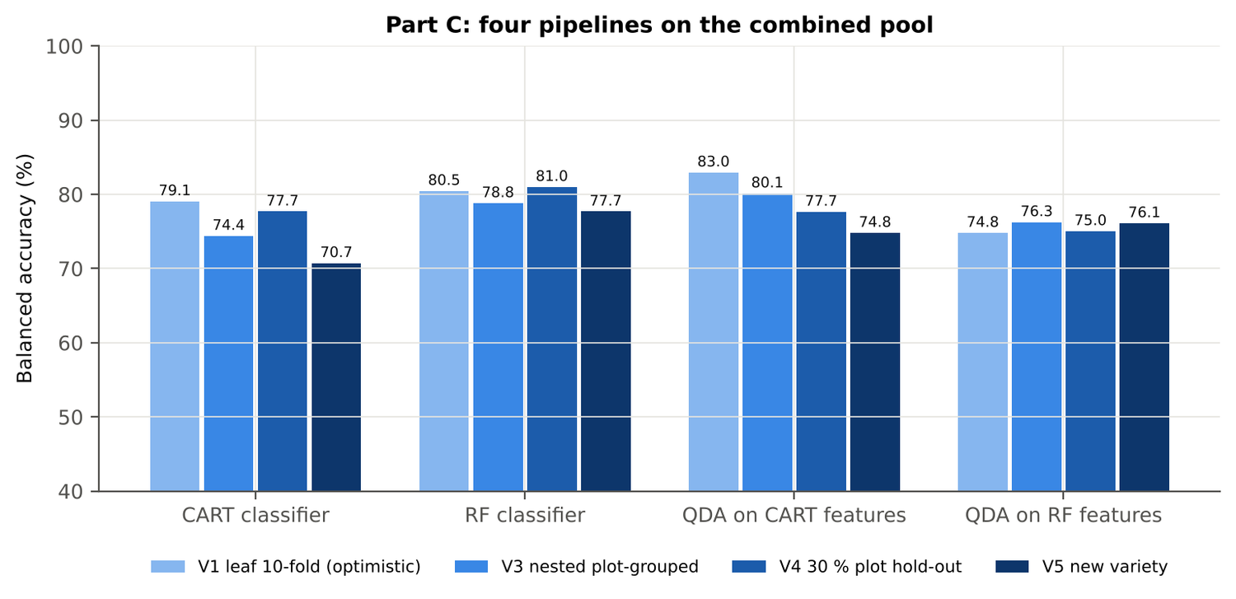
Figure 45. Date 13-03-2026: four pipelines on the combined pool under V1, V3, V4 and V5.
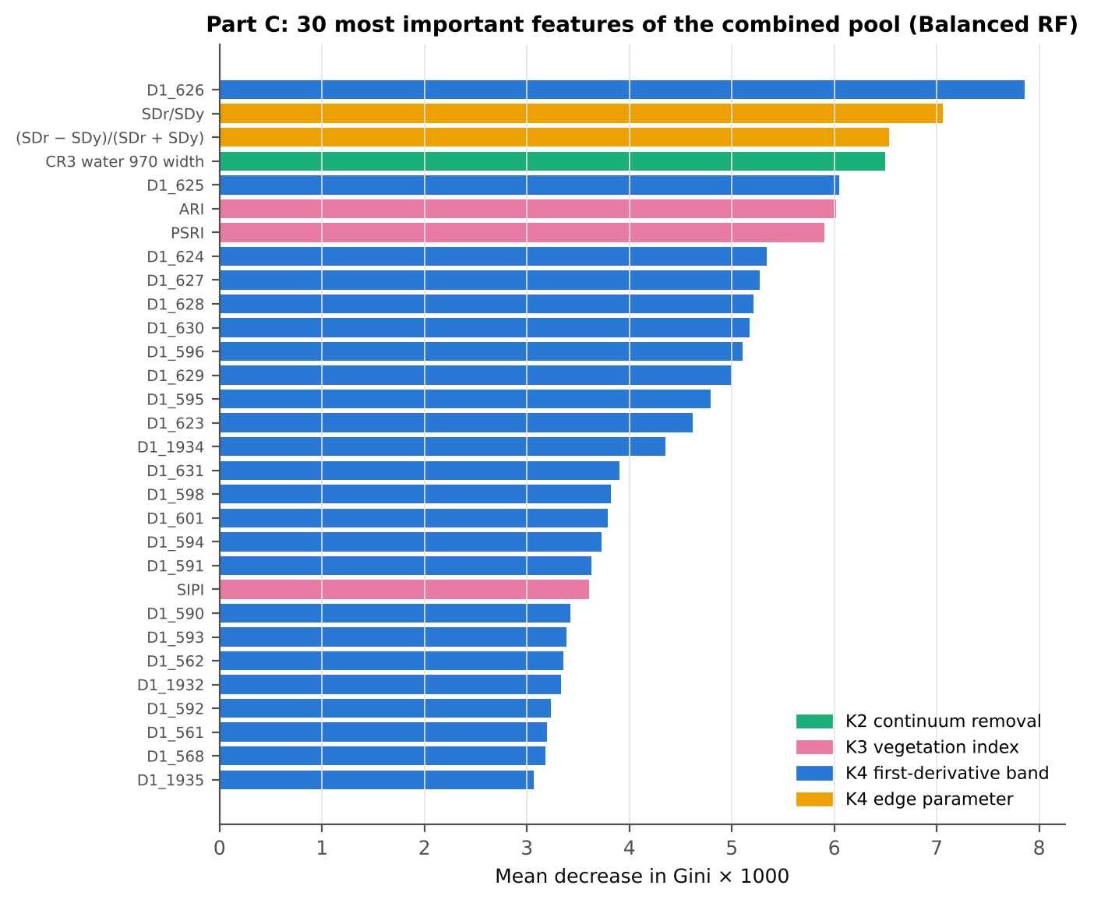
Figure 46. Date 13-03-2026: the 30 most important features of the combined pool (Balanced RF).
Table 79. Date 13-03-2026: combined pool vs reflectance vs K5 (paired over the V3 folds).
First | Second | Mean Δ BA | First better / n | Wilcoxon p
Combined pool: QDA on CART features | Reflectance: QDA on CART bands | 5.1 pts | 32 / 50 | 0.013
Combined pool: QDA on RF features | Reflectance: QDA on RF bands | -4.1 pts | 17 / 50 | 0.022
Combined pool: RF classifier (Tier-1 features) | Reflectance: RF classifier (Tier-1 bands) | 5.0 pts | 36 / 50 | 1.8e-4
Combined pool: CART classifier (Tier-1 features) | Reflectance: CART classifier (Tier-1 bands) | 4.5 pts | 34 / 50 | 0.005
Combined pool: QDA on RF features | Combined pool: QDA on CART features | -4.3 pts | 12 / 50 | 0.001
Combined pool: QDA on RF features | K5: RF classifier on all 4151 features | -2.0 pts | 21 / 50 | 0.184
Combined pool: QDA on RF features | K5: QDA on 15 features chosen by AUC | 0.8 pts | 24 / 50 | 0.213
Combined pool: RF classifier (Tier-1 features) | K5: RF classifier on all 4151 features | 0.3 pts | 16 / 50 | 0.872

4.4.8 Transfer (V5)
Table 80. Date 13-03-2026: balanced accuracy by held-out variety (trained on the other two varieties).
Feature set · pipeline | V1 | V2 | V3
Reflectance · CART classifier | 75.8 % | 74.2 % | 68.3 %
Reflectance · RF classifier | 74.2 % | 73.9 % | 68.3 %
Reflectance · QDA on CART features | 69.4 % | 62.8 % | 77.2 %
Reflectance · QDA on RF features | 72.8 % | 62.8 % | 91.9 %
Combined pool · CART classifier | 73.1 % | 70.6 % | 68.6 %
Combined pool · RF classifier | 80.3 % | 77.8 % | 75.0 %
Combined pool · QDA on CART features | 72.8 % | 70.3 % | 81.4 %
Combined pool · QDA on RF features | 83.3 % | 70.0 % | 75.0 %

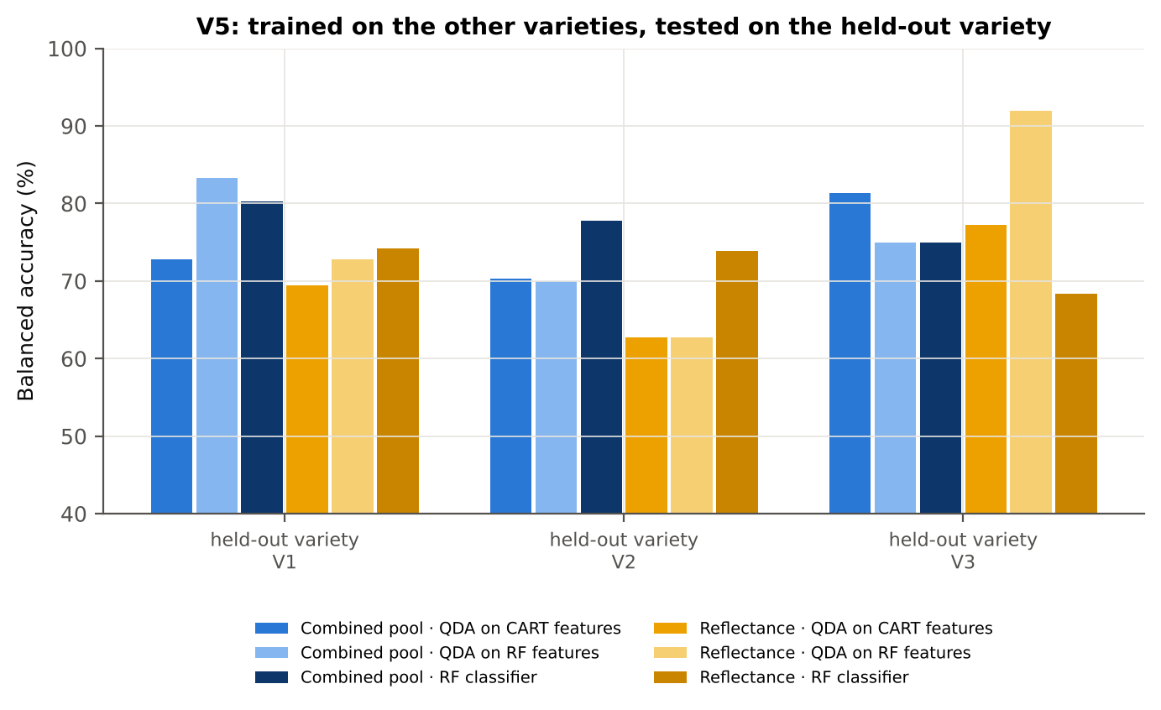
Figure 47. Date 13-03-2026: V5 transfer by held-out variety.

4.4.9 Interpretation
Tier 1: healthy and white-rust leaves differ significantly at 1933 of 2101 bands (Welch + BH-FDR); 1697 bands remain significant with a random plot effect and 1666 in ≥ 95 % of 1000 balanced subsets. The most sensitive single band (smoothed reflectance) reaches AUC 0.78 at 1881 nm.
Tier 2: CART (rpart, prior 0.5/0.5) selected 14 bands (root 1875 nm): 1875, 1881, 1339, 434, 2014, 1399, 1882, 404, 401, 687, 1421, 674, 1754, 717 nm. The Balanced RF importance peaks (RF-17) were 1369, 1878, 405, 2040, 2013, 1867, 417, 1357, 442, 1339, 1381, 428, 1891, 1992, 2409, 1850, 2390 nm.
Tier 3: J–M = 1.56 on the CART bands and 1.86 on the RF bands: neither set reaches the 1.90 separability threshold (Das et al. used 1.94).
Tier 4: QDA with equal priors on the CART bands gives BA 79.7 % in the paper's protocol (V1; healthy recall 83.3 %, diseased recall 76.1 %) and 75.7 % ± 1.3 % (V3 nested, plot-grouped) / 75.6 % (V4 hold-out plots) on new plots.
CART vs RF: as classifiers RF beats CART by 3.3 points (V3, RF better in 34 of 50 folds, p = 0.004); as band selectors for QDA the RF bands give +4.9 points vs the CART bands (p = 0.009). RF selection is more stable than CART selection (Jaccard ±10 nm 0.47 vs 0.34).
Disease-sensitive features (Part K): the strongest group for RF is K4 derivatives + edge parameters (BA 79.8 %, V3) vs 74.3 % for reflectance; best single features: first derivative at 626 nm (AUC 0.83), CR3 water 970 width (AUC 0.86), ARI (AUC 0.83), (SDr − SDy)/(SDr + SDy) (AUC 0.85). REIP (Lagrangian interpolation) shifts by -1.1 nm in diseased leaves (AUC 0.59).
Part C (four tiers on the combined K1 + K2–K4 pool, 4150 features, 3530 significant): CART chose 8 features, RF 17 (J–M 1.44 / 1.98); QDA on the RF features reaches 76.3 % (V3) / 75.0 % (V4), -4.4 points vs QDA on RF reflectance bands; best pipeline on the pool: QDA on CART features (80.1 %, V3).
Transfer (V5, leave-one-variety-out): QDA on CART reflectance bands 69.8 %, QDA on combined-pool RF features 76.1 % (close to the V3 estimate, 76.3 %), i.e. features chosen on two varieties transfer well to the third. Best pipeline under transfer: combined pool: RF classifier (77.7 %).
Compared with all dates, stages and varieties pooled (V3: reflectance QDA-CART 72.0 %, combined-pool QDA-RF 83.7 %; J–M 1.27), this subset gives 75.7 % and 76.3 % (J–M 1.56): discrimination is lower than in the pooled analysis (fewer leaves and plots).

Recommendations for this subset
- Use first-derivative and continuum-removed features rather than single reflectance bands for this subset; the four-tier selection with RF importance on the combined pool and a QDA or RF classifier is the recommended pipeline.
- Report balanced accuracy with both class recalls and the priors used; the classes are imbalanced (1 : 5.0) and equal priors / balanced sampling were applied throughout.
- Base conclusions on the plot-grouped estimates (V3 10-fold × 5 = 50 folds, V4 10 hold-outs), not on the leaf-level V1 estimate.
- Interpret features near the ASD detector joins (≈ 1000 and 1800 nm) with care; guard zones were excluded from the rankings.
- For application to a new variety, the most robust pipeline here was combined pool: RF classifier (V5 BA 77.7 %).

Cross-checks
43 checks passed, 4 were flagged and 0 failed. Flagged items are limitations reported in the workbook, not errors: Exact duplicates among the remaining spectra; QDA in R; Permutation importance (drop in AUC, 5 plot-grouped folds) vs Gini, top-50 bands; Selection optimism.

4.5 Vegetative — vegetative growth stage only

4.5.1 Data and validation design
This subset contains 564 leaf spectra (93 healthy, 471 diseased; ratio 1 : 5.1) from 11 healthy and 33 diseased plots, measured on 11-02-2026, 24-02-2026; growth stages Vegetative; varieties V1, V2, V3. V3 used 10-fold plot-grouped CV × 5 (50 training sets), V4 held out 3 healthy + 10 diseased plots × 10, and V5 was leave-one-date-out on new plots (20 units).
Table 81. Vegetative: leaf spectra by date and growth stage.
Date | Growth stage | Healthy | Diseased
11-02-2026 | Vegetative | 63 | 311
24-02-2026 | Vegetative | 30 | 160

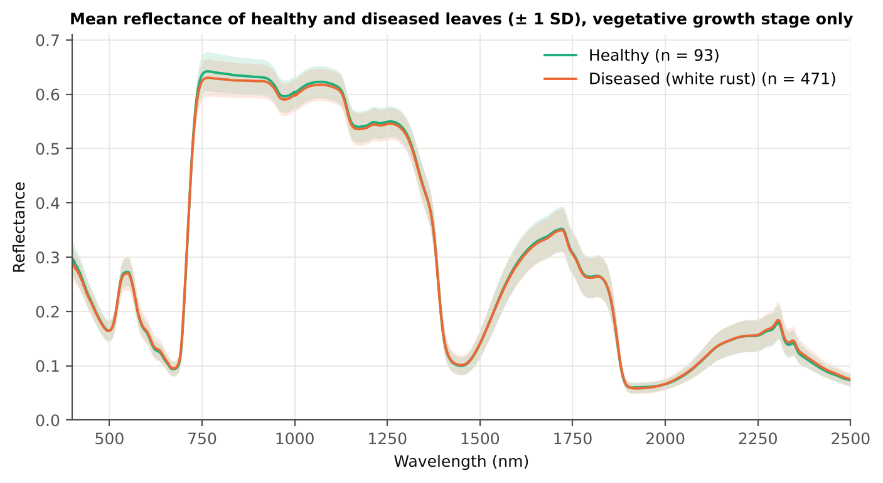
Figure 48. Vegetative: mean reflectance of healthy and diseased leaves (± 1 SD).

4.5.2 Tier 1 — statistical screening
Table 82. Vegetative: number of significant bands by test.
Test | Significant bands (of 2101)
Welch t-test + BH-FDR q < 0.05 (used for Tier 2) | 0
One-way ANOVA p < 0.05, uncorrected (rule of Das et al.) | 243
One-way ANOVA + BH-FDR q < 0.05 | 0
Welch t-test p < 0.05, uncorrected | 296
Mixed model (random plot effect) + BH-FDR q < 0.05 | 0
Balanced subsets (93 vs 93): significant in ≥ 95 % of 1000 subsets | 0
Levene test p < 0.05 (unequal variances → Welch) | 74

Fallback applied: only 0 band(s) passed the FDR correction on all leaves, so Tier 2 received the 296 bands with uncorrected p < 0.05.
Table 83. Vegetative: ten bands with the largest |t|.
Band (nm) | Mean H | Mean D | Welch t | q (BH) | Hedges g | AUC
695 | 0.1408 | 0.1467 | 2.97 | 2.18e-1 | 0.25 | 0.548
694 | 0.1327 | 0.1384 | 2.96 | 2.18e-1 | 0.25 | 0.552
696 | 0.1497 | 0.1559 | 2.94 | 2.18e-1 | 0.24 | 0.543
761 | 0.6419 | 0.6300 | -2.93 | 2.18e-1 | -0.34 | 0.638
763 | 0.6422 | 0.6302 | -2.93 | 2.18e-1 | -0.34 | 0.638
760 | 0.6417 | 0.6298 | -2.93 | 2.18e-1 | -0.34 | 0.638
762 | 0.6421 | 0.6301 | -2.92 | 2.18e-1 | -0.34 | 0.638
764 | 0.6422 | 0.6303 | -2.92 | 2.18e-1 | -0.34 | 0.638
759 | 0.6415 | 0.6297 | -2.91 | 2.18e-1 | -0.34 | 0.638
693 | 0.1257 | 0.1310 | 2.90 | 2.18e-1 | 0.25 | 0.558

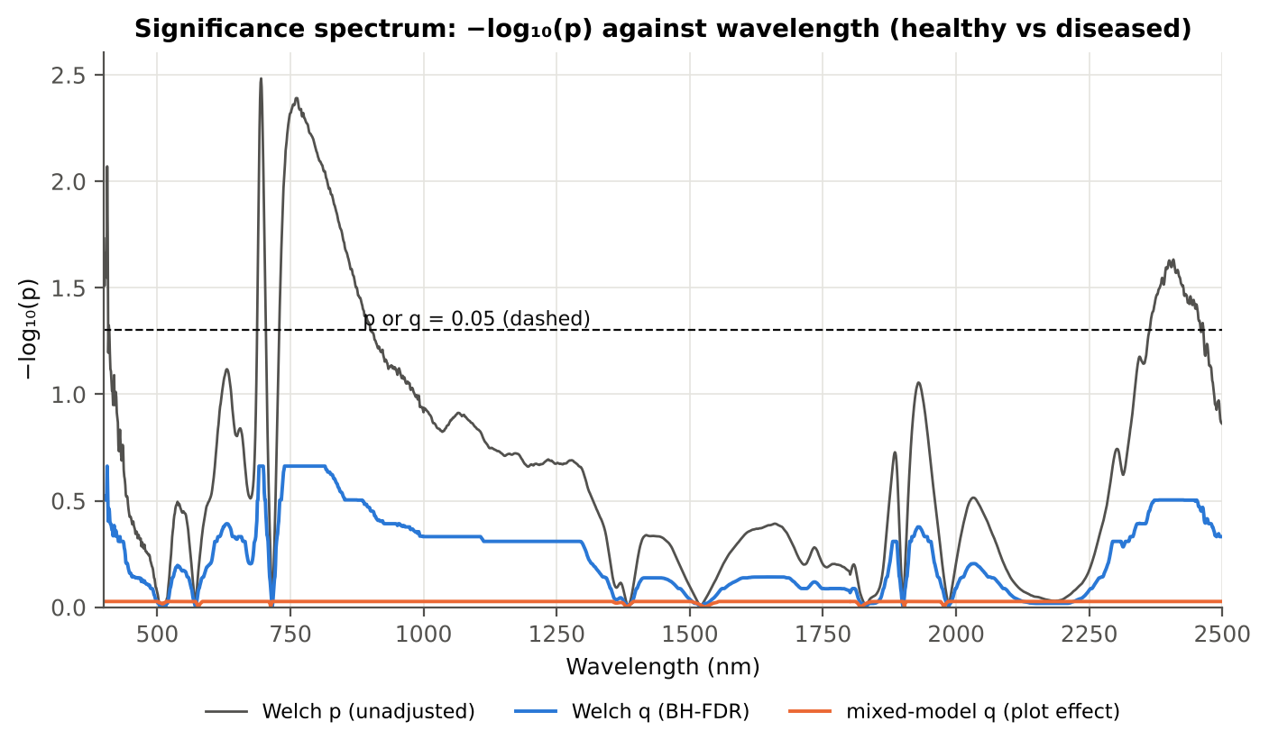
Figure 49. Vegetative: −log₁₀(p) against wavelength (Welch p, BH q and mixed-model q; dashed p or q = 0.05).

4.5.3 Tier 2 — CART and Random Forest band selection
Table 84. Vegetative: the CART-20 bands selected by rpart (prior 0.5/0.5) and how often a band within ± 10 nm is re-selected.
Band (nm) | Region | First used at node | Bootstrap re-selection | Nested-CV re-selection
400 | Blue (400–499) | 4 | 99.0 % | 70.0 %
402 | Blue (400–499) | 150 | 99.0 % | 70.0 %
406 | Blue (400–499) | 151 | 99.0 % | 72.0 %
688 | Red edge (680–759) | 75 | 95.5 % | 86.0 %
689 | Red edge (680–759) | 9 | 95.5 % | 86.0 %
695 | Red edge (680–759) | 27 | 99.0 % | 86.0 %
696 | Red edge (680–759) | 12 | 99.0 % | 86.0 %
697 | Red edge (680–759) | 25 | 99.0 % | 86.0 %
699 | Red edge (680–759) | 3 | 97.5 % | 86.0 %
700 | Red edge (680–759) | 6 | 97.5 % | 86.0 %
736 | Red edge (680–759) | 18 | 88.5 % | 70.0 %
757 | Red edge (680–759) | 1 | 47.0 % | 70.0 %
769 | NIR (760–1349) | 37 | 29.5 % | 52.0 %
823 | NIR (760–1349) | 302 | 12.5 % | 34.0 %
900 | NIR (760–1349) | 1208 | 24.5 % | 12.0 %
2387 | SWIR-2 end (2350–2500) | 2417 | 36.5 % | 28.0 %
2392 | SWIR-2 end (2350–2500) | 2 | 43.0 % | 40.0 %
2394 | SWIR-2 end (2350–2500) | 4835 | 42.0 % | 42.0 %
2395 | SWIR-2 end (2350–2500) | 604 | 43.0 % | 44.0 %
2462 | SWIR-2 end (2350–2500) | 108 | 59.5 % | 34.0 %

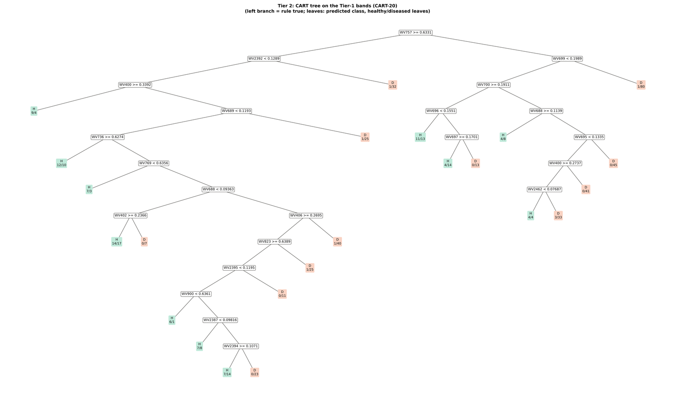
Figure 50. Vegetative: CART tree on the Tier-1 bands (CART-20).
RF-17 importance peaks: 406, 688, 701, 730, 744, 2456, 757, 2364, 2392, 2443, 2375, 2425, 2408, 898, 775, 886, 793 nm.
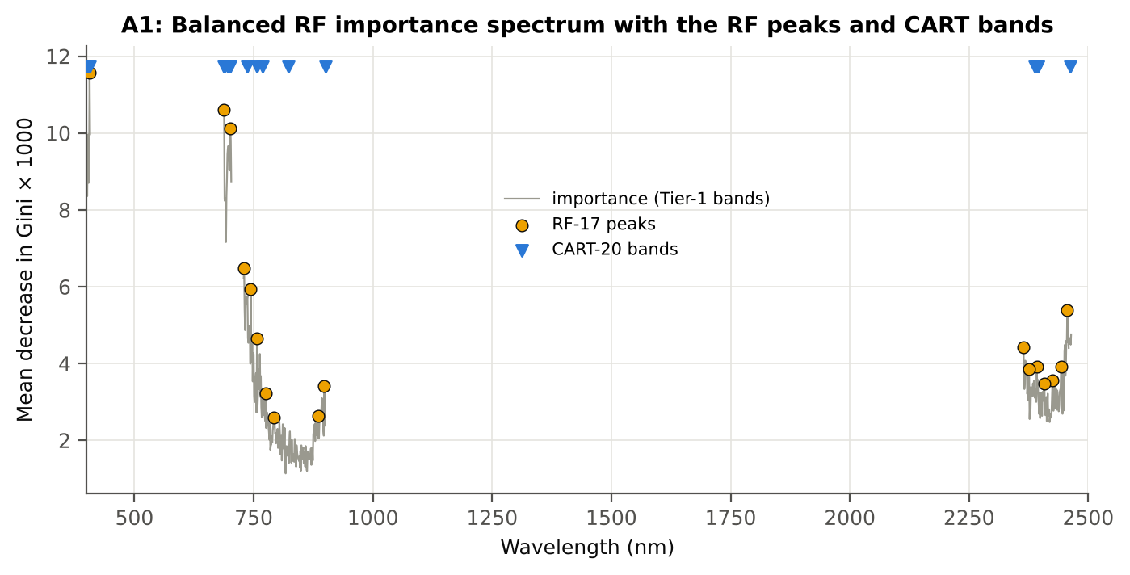
Figure 51. Vegetative: Balanced RF importance spectrum with the RF-17 peaks and the CART bands.

4.5.4 Tier 3 and Tier 4 — separability and classification
Table 85. Vegetative: Jeffries–Matusita distance of healthy and diseased leaves.
Band set | Bands | α (Bhattacharyya) | J–M (0–2) | √J–M | Separability
CART-20 | 20 | 1.694 | 1.633 | 1.278 | below 1.90
CART-1 (1-SE) | 1 | 0.015 | 0.030 | 0.173 | below 1.90
RF-17 | 17 | 1.784 | 1.664 | 1.290 | below 1.90
RF-10 | 10 | 0.508 | 0.797 | 0.893 | below 1.90
RF-20 (size-matched) | 20 | 2.513 | 1.838 | 1.356 | below 1.90

Table 86. Vegetative: error matrix of QDA (equal priors) on the CART-20 bands, leaf-level 10-fold CV (V1; as Table 2 of Das et al.).
Classified \ Reference | Healthy | Diseased | Row total | User's accuracy
Healthy | 66 | 50 | 116 | 56.9 %
Diseased | 27 | 421 | 448 | 94.0 %
Column total | 93 | 471 | 564
Producer's accuracy | 71.0 % | 89.4 %
Overall accuracy | 86.4 % | Balanced accuracy | 80.2 % | κ = 0.549

Table 87. Vegetative: Tier 4 on all band sets (V1), with equal and sample priors and LDA for comparison.
Band set | Classifier | OA | BA | PA healthy | PA diseased | κ
CART-20 | QDA equal priors | 86.4 % | 80.2 % | 71.0 % | 89.4 % | 0.549
CART-20 | QDA sample priors | 89.2 % | 78.0 % | 61.3 % | 94.7 % | 0.588
CART-20 | LDA equal priors | 80.8 % | 83.8 % | 88.2 % | 79.4 % | 0.493
CART-1 (1-SE) | QDA equal priors | 62.6 % | 59.5 % | 54.8 % | 64.1 % | 0.122
CART-1 (1-SE) | QDA sample priors | 83.2 % | 49.8 % | 0.0 % | 99.6 % | -0.007
CART-1 (1-SE) | LDA equal priors | 56.6 % | 59.3 % | 63.4 % | 55.2 % | 0.106
RF-17 | QDA equal priors | 86.4 % | 83.2 % | 78.5 % | 87.9 % | 0.573
RF-17 | QDA sample priors | 87.9 % | 79.0 % | 65.6 % | 92.4 % | 0.570
RF-17 | LDA equal priors | 85.3 % | 88.6 % | 93.5 % | 83.7 % | 0.591
RF-10 | QDA equal priors | 55.0 % | 62.7 % | 74.2 % | 51.2 % | 0.134
RF-10 | QDA sample priors | 77.0 % | 62.9 % | 41.9 % | 83.9 % | 0.236
RF-10 | LDA equal priors | 64.7 % | 65.1 % | 65.6 % | 64.5 % | 0.190
RF-20 (size-matched) | QDA equal priors | 89.2 % | 83.2 % | 74.2 % | 92.1 % | 0.628
RF-20 (size-matched) | QDA sample priors | 91.0 % | 80.3 % | 64.5 % | 96.2 % | 0.649
RF-20 (size-matched) | LDA equal priors | 90.1 % | 92.8 % | 96.8 % | 88.8 % | 0.703

4.5.5 Validation and CART versus RF (Part A)
Table 88. Vegetative: balanced accuracy of the four pipelines on raw reflectance under the validation schemes.
Pipeline | V1 | V3 (± SD) | V4 (± SD) | V5 | AUC V3 | κ V3
CART classifier | 58.5 % | 51.2 % ± 3.5 | 51.9 % ± 4.0 | 51.9 % | 0.515 | 0.018
RF classifier | 59.0 % | 50.9 % ± 3.5 | 55.0 % ± 4.1 | 48.4 % | 0.511 | 0.015
QDA on CART features | 80.2 % | 71.5 % ± 2.5 | 66.5 % ± 8.2 | 48.9 % | 0.805 | 0.317
QDA on RF features | 83.2 % | 72.8 % ± 6.0 | 70.4 % ± 11.1 | 51.6 % | 0.829 | 0.342

Table 89. Vegetative: validation of QDA on CART bands — effect of the imbalance correction (equal vs sample priors) and of random under-sampling (V3-RUS).
Scheme | Priors | BA | SD | OA | PA healthy | PA diseased
V1 · leaf-level 10-fold, bands fixed | equal (corrected) | 80.2 % | – | 86.4 % | 71.0 % | 89.4 %
V2 · plot-grouped 10-fold, bands fixed | equal (corrected) | 77.0 % | – | 85.3 % | 64.5 % | 89.4 %
V3 · nested plot-grouped 10-fold × 5 = 50 folds | equal (corrected) | 71.5 % | 2.5 | 74.4 % | 67.1 % | 75.8 %
V4 · 30 % plot hold-out × 10 | equal (corrected) | 66.5 % | 8.2 | 68.0 % | 64.4 % | 68.5 %
V5 · leave-one-date-out on new plots (20 units) | equal (corrected) | 48.9 % | 7.0 | 54.6 % | 40.5 % | 57.3 %
V1 · leaf-level 10-fold, bands fixed | sample (uncorrected) | 78.0 % | – | 89.2 % | 61.3 % | 94.7 %
V2 · plot-grouped 10-fold, bands fixed | sample (uncorrected) | 73.9 % | – | 87.4 % | 53.8 % | 94.1 %
V3 · nested plot-grouped 10-fold × 5 = 50 folds | sample (uncorrected) | 70.0 % | 2.5 | 82.6 % | 51.2 % | 88.8 %
V4 · 30 % plot hold-out × 10 | sample (uncorrected) | 65.3 % | 5.9 | 79.7 % | 45.2 % | 85.5 %
V5 · leave-one-date-out on new plots (20 units) | sample (uncorrected) | 47.1 % | 5.5 | 65.9 % | 20.4 % | 73.9 %
V3-RUS · nested + random under-sampling | equal (corrected) | 67.7 % | – | 61.9 % | 76.3 % | 59.0 %
V3-RUS · nested + random under-sampling | sample (uncorrected) | 67.7 % | – | 61.9 % | 76.3 % | 59.0 %

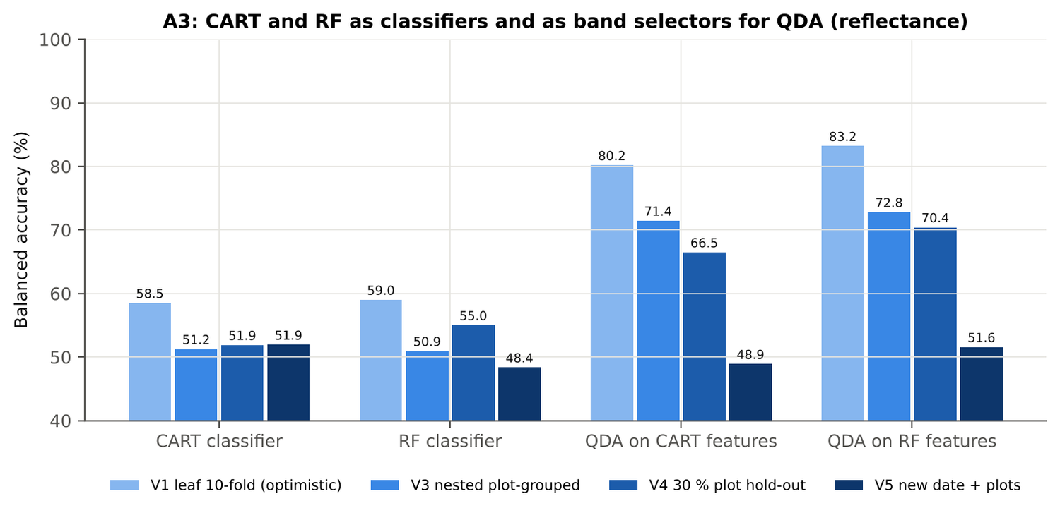
Figure 52. Vegetative: CART and RF as classifiers and as band selectors for QDA (Part A).
Table 90. Vegetative: paired comparisons on identical folds (positive = first pipeline better).
Comparison | Units | n | Mean Δ BA | First better | Wilcoxon p
RF classifier − CART classifier | V3 nested (folds) | 50 | 0.0 pts | 24 | 0.992
RF classifier − CART classifier | V4 hold-out (splits) | 10 | 3.1 pts | 8 | 0.193
QDA on RF features − QDA on CART features | V3 nested (folds) | 50 | 1.4 pts | 28 | 0.335
QDA on RF features − QDA on CART features | V4 hold-out (splits) | 10 | 3.9 pts | 7 | 0.375
QDA on CART features − CART classifier | V3 nested (folds) | 50 | 20.2 pts | 47 | 0.0e+0
QDA on CART features − CART classifier | V4 hold-out (splits) | 10 | 14.6 pts | 10 | 0.002
QDA on RF features − RF classifier | V3 nested (folds) | 50 | 21.6 pts | 43 | 0.0e+0
QDA on RF features − RF classifier | V4 hold-out (splits) | 10 | 15.4 pts | 9 | 0.006

4.5.6 Disease-sensitive features (Part K)
Table 91. Vegetative: most sensitive single features of each family (threshold classifier validated on plots).
Family | Feature | AUC | Direction | BA plot-grouped CV | BA hold-out
K2 continuum removal | CR6 water 1940 symmetry | 0.913 | D > H | 85.7 % | 87.6 %
K2 continuum removal | CR6 water 1940 position | 0.856 | D > H | 73.9 % | 76.1 %
K2 continuum removal | CR3 water 970 width | 0.651 | D < H | 59.2 % | 62.0 %
K3 index | NCPI | 0.669 | D > H | 60.8 % | 57.0 %
K3 index | TVI | 0.637 | D < H | 53.6 % | 54.6 %
K3 index | MTVI1 | 0.632 | D < H | 54.4 % | 55.8 %
K4 edge parameter | SDr (red-edge area) | 0.633 | D < H | 52.8 % | 55.4 %
K4 edge parameter | SDy (yellow-edge area) | 0.614 | D > H | 57.2 % | 53.7 %
K4 first derivative | D1 1918 nm | 0.891 | D < H | – | –
K4 first derivative | D1 1919 nm | 0.890 | D < H | – | –
K4 first derivative | D1 1917 nm | 0.889 | D < H | – | –
K1 reflectance | R 758 nm (680–759) | 0.638 | D < H | 59.2 % | –
K1 reflectance | R 762 nm (760–1349) | 0.638 | D < H | 57.0 % | –
K3b optimised index | NDSI(1913,1928) | 0.898 |  | 87.0 % | –
K3b optimised index | DI(1912,1926) | 0.892 |  | 85.2 % | –

Table 92. Vegetative: K5 — CART vs Balanced RF on each feature group (balanced accuracy).
Feature group | CART (V3) | RF (V3) | CART (V4) | RF (V4)
Full raw spectrum | 59.0 % | 61.4 % | 55.7 % | 62.2 %
K1 band reflectance | 58.8 % | 62.3 % | 57.9 % | 63.8 %
K2 continuum removal | 82.2 % | 89.8 % | 83.9 % | 89.5 %
K3 vegetation indices | 58.4 % | 61.4 % | 62.0 % | 62.6 %
K4 derivatives + edge parameters | 80.7 % | 88.9 % | 82.4 % | 91.2 %
K1–K4 combined pool | 80.4 % | 89.8 % | 82.6 % | 91.5 %
K4 incl. guard bands (artefact test) | 83.1 % | 92.1 % | 84.7 % | 93.5 %
K-selected 15 | 81.7 % | 88.9 % | 82.7 % | 91.0 %

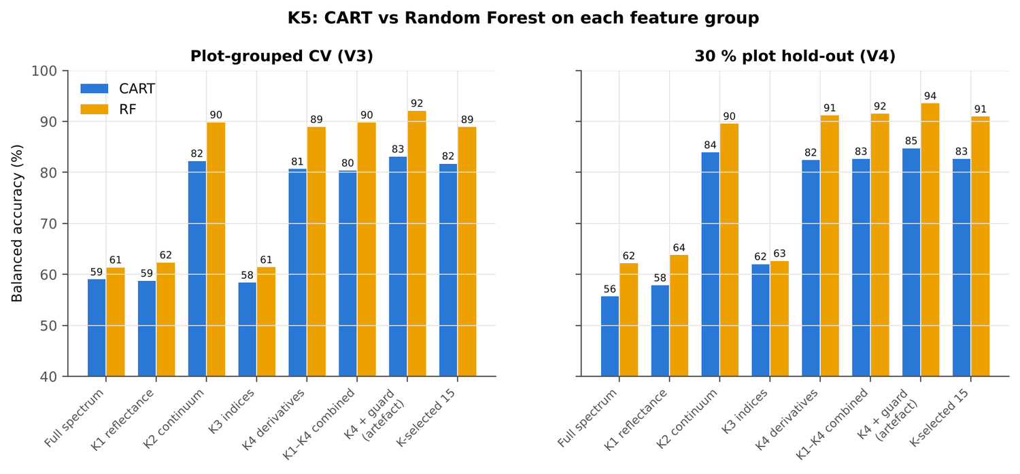
Figure 53. Vegetative: K5 — CART vs RF on each disease-sensitive feature group.
Table 93. Vegetative: red-edge inflection point by four methods.
REIP method | Healthy (nm) | Diseased (nm) | Shift (nm) | AUC | BA plot-grouped CV
linear 4-point interpolation | 716.5 | 716.0 | -0.54 | 0.542 | 53.1 %
linear extrapolation | 709.5 | 708.2 | -1.26 | 0.540 | 51.3 %
Lagrangian interpolation | 709.8 | 709.0 | -0.73 | 0.536 | 50.6 %
maximum first derivative | 709.8 | 709.0 | -0.72 | 0.534 | 53.1 %

4.5.7 Four tiers on the combined feature pool (Part C)
Tier 1: 832 of 4150 features significant. Tier 2: CART selected 8 features (CR6 water 1940 symmetry, D1 857 nm, D1 2331 nm, D1 888 nm, D1 400 nm, D1 870 nm, D1 1917 nm, D1 1683 nm); RF-17: D1 1918 nm, CR6 water 1940 symmetry, D1 871 nm, D1 852 nm, D1 1950 nm, CR6 water 1940 position, D1 1937 nm, D1 2224 nm, D1 885 nm, CR3 water 970 symmetry, D1 1726 nm, D1 2332 nm, D1 2235 nm, D1 840 nm, D1 1557 nm, D1 2282 nm, D1 1742 nm. Tier 3: J–M 1.560 (CART set) and 1.917 (RF-17), separable (≥ 1.90) for RF-17.
Table 94. Vegetative: composition of the combined pool and of the selected sets.
Feature type | Features | Tier-1 significant | CART-8 | RF-17
K1 band reflectance | 2039 | 90 | 0 | 0
K2 continuum removal | 30 | 8 | 1 | 3
K3 vegetation index | 30 | 9 | 0 | 0
K4 edge parameter | 20 | 4 | 0 | 0
K4 first-derivative band | 2031 | 721 | 7 | 14

Table 95. Vegetative: balanced accuracy of the four pipelines on the combined pool.
Pipeline | V1 | V3 (± SD) | V4 (± SD) | V5 | AUC V3 | κ V3
CART classifier | 86.6 % | 80.0 % ± 0.3 | 83.6 % ± 5.0 | 69.2 % | 0.806 | 0.534
RF classifier | 92.0 % | 88.4 % ± 1.2 | 89.8 % ± 2.7 | 73.4 % | 0.948 | 0.681
QDA on CART features | 91.9 % | 90.5 % ± 0.5 | 89.7 % ± 3.9 | 71.4 % | 0.954 | 0.717
QDA on RF features | 90.8 % | 89.2 % ± 1.5 | 88.6 % ± 4.3 | 52.5 % | 0.949 | 0.720

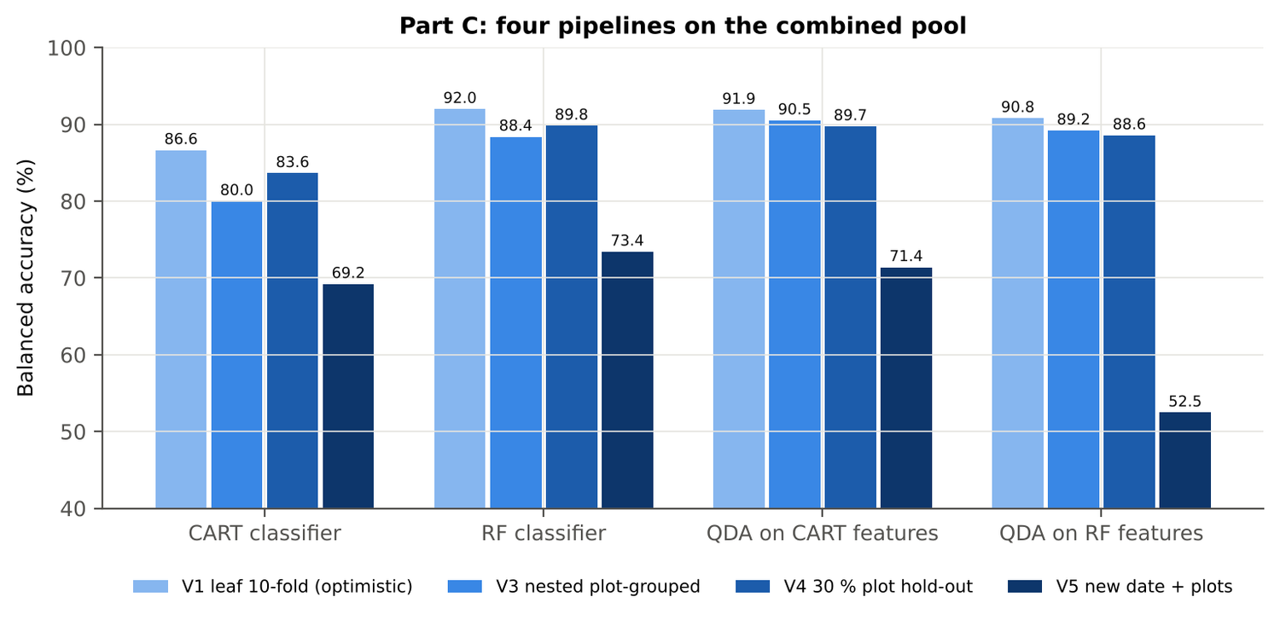
Figure 54. Vegetative: four pipelines on the combined pool under V1, V3, V4 and V5.
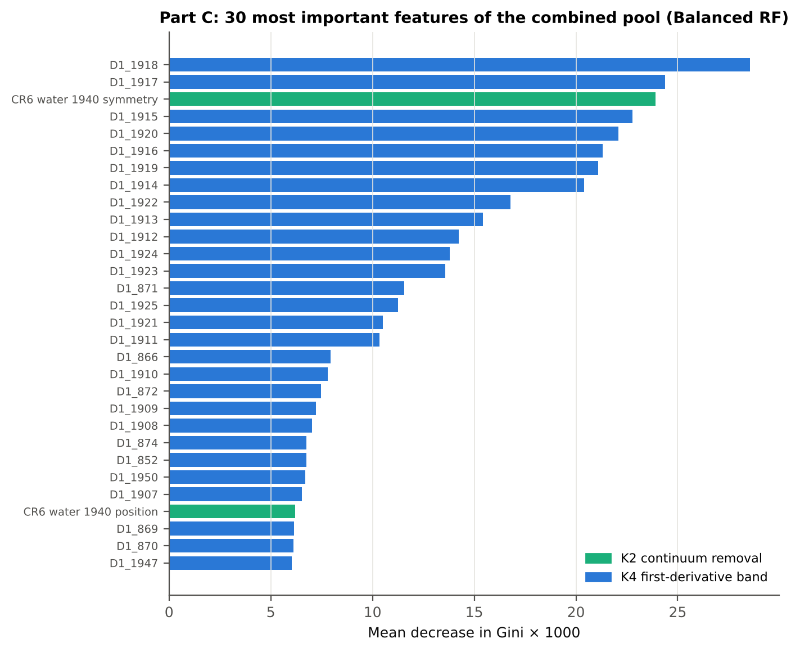
Figure 55. Vegetative: the 30 most important features of the combined pool (Balanced RF).
Table 96. Vegetative: combined pool vs reflectance vs K5 (paired over the V3 folds).
First | Second | Mean Δ BA | First better / n | Wilcoxon p
Combined pool: QDA on CART features | Reflectance: QDA on CART bands | 18.9 pts | 45 / 50 | 0.0e+0
Combined pool: QDA on RF features | Reflectance: QDA on RF bands | 16.4 pts | 41 / 50 | 4.9e-7
Combined pool: RF classifier (Tier-1 features) | Reflectance: RF classifier (Tier-1 bands) | 37.2 pts | 50 / 50 | 0.0e+0
Combined pool: CART classifier (Tier-1 features) | Reflectance: CART classifier (Tier-1 bands) | 28.6 pts | 46 / 50 | 0.0e+0
Combined pool: QDA on RF features | Combined pool: QDA on CART features | -1.1 pts | 15 / 50 | 0.254
Combined pool: QDA on RF features | K5: RF classifier on all 4151 features | -0.6 pts | 19 / 50 | 0.717
Combined pool: QDA on RF features | K5: QDA on 15 features chosen by AUC | 0.7 pts | 18 / 50 | 0.480
Combined pool: RF classifier (Tier-1 features) | K5: RF classifier on all 4151 features | -1.4 pts | 9 / 50 | 0.015

4.5.8 Transfer (V5)
Table 97. Vegetative: balanced accuracy by held-out date (trained on the other dates, tested on new plots of the held-out date).
Feature set · pipeline | 11-02-2026 | 24-02-2026
Reflectance · CART classifier | 50.6 % | 48.2 %
Reflectance · RF classifier | 47.7 % | 47.1 %
Reflectance · QDA on CART features | 44.1 % | 57.4 %
Reflectance · QDA on RF features | 47.9 % | 57.0 %
Combined pool · CART classifier | 65.4 % | 65.5 %
Combined pool · RF classifier | 74.4 % | 64.9 %
Combined pool · QDA on CART features | 66.7 % | 72.9 %
Combined pool · QDA on RF features | 49.9 % | 58.0 %

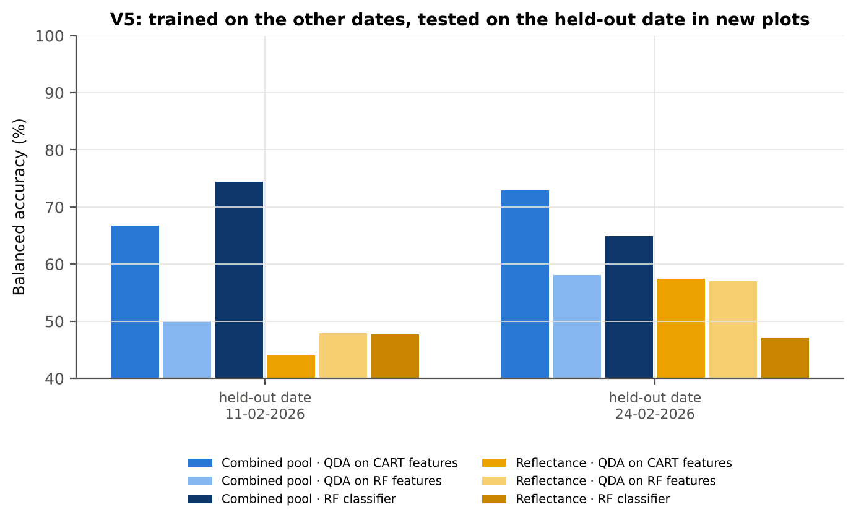
Figure 56. Vegetative: V5 transfer by held-out date.

4.5.9 Interpretation
Tier 1: healthy and white-rust leaves differ significantly at 0 of 2101 bands (Welch + BH-FDR); 0 bands remain significant with a random plot effect and 0 in ≥ 95 % of 1000 balanced subsets. The most sensitive single band (smoothed reflectance) reaches AUC 0.64 at 762 nm. Because fewer than 2 bands passed the FDR correction, Tier 2 used the 296 bands with uncorrected p < 0.05.
Tier 2: CART (rpart, prior 0.5/0.5) selected 20 bands (root 757 nm): 757, 2392, 699, 400, 700, 689, 696, 688, 736, 697, 695, 769, 2462, 402, 406, 823, 2395, 900, 2387, 2394 nm. The Balanced RF importance peaks (RF-17) were 406, 688, 701, 730, 744, 2456, 757, 2364, 2392, 2443, 2375, 2425, 2408, 898, 775, 886, 793 nm.
Tier 3: J–M = 1.63 on the CART bands and 1.66 on the RF bands: neither set reaches the 1.90 separability threshold (Das et al. used 1.94).
Tier 4: QDA with equal priors on the CART bands gives BA 80.2 % in the paper's protocol (V1; healthy recall 71.0 %, diseased recall 89.4 %) and 71.4 % ± 2.5 % (V3 nested, plot-grouped) / 66.5 % (V4 hold-out plots) on new plots.
CART vs RF: as classifiers RF and CART perform alike (+0.0 points; V3, RF better in 24 of 50 folds, p = 0.992); as band selectors for QDA the RF bands give +1.4 points vs the CART bands (p = 0.335). RF selection is about as stable as CART selection (Jaccard ±10 nm 0.37 vs 0.39).
Disease-sensitive features (Part K): the strongest group for RF is K2 continuum removal (BA 89.8 %, V3) vs 62.3 % for reflectance; best single features: first derivative at 1918 nm (AUC 0.89), CR6 water 1940 symmetry (AUC 0.91), NCPI (AUC 0.67), SDr (red-edge area) (AUC 0.63). REIP (linear 4-point interpolation) shifts by -0.5 nm in diseased leaves (AUC 0.54).
Part C (four tiers on the combined K1 + K2–K4 pool, 4150 features, 832 significant): CART chose 8 features, RF 17 (J–M 1.56 / 1.92); QDA on the RF features reaches 89.2 % (V3) / 88.6 % (V4), +16.4 points vs QDA on RF reflectance bands; best pipeline on the pool: QDA on CART features (90.5 %, V3).
Transfer (V5, leave-one-date-out on new plots): QDA on CART reflectance bands 48.9 %, QDA on combined-pool RF features 52.5 % — a clear drop from the V3 estimate (89.2 %); the date/stage effect limits transfer. Best pipeline under transfer: combined pool: RF classifier (73.4 %).
Compared with all dates, stages and varieties pooled (V3: reflectance QDA-CART 72.0 %, combined-pool QDA-RF 83.7 %; J–M 1.27), this subset gives 71.4 % and 89.2 % (J–M 1.63): analysing it separately improves discrimination.

Recommendations for this subset
- Use first-derivative and continuum-removed features rather than single reflectance bands for this subset; the four-tier selection with RF importance on the combined pool and a QDA or RF classifier is the recommended pipeline.
- Report balanced accuracy with both class recalls and the priors used; the classes are imbalanced (1 : 5.1) and equal priors / balanced sampling were applied throughout.
- Base conclusions on the plot-grouped estimates (V3 10-fold × 5 = 50 folds, V4 10 hold-outs), not on the leaf-level V1 estimate.
- Interpret features near the ASD detector joins (≈ 1000 and 1800 nm) with care; guard zones were excluded from the rankings.
- For application to a new date, the most robust pipeline here was combined pool: RF classifier (V5 BA 73.4 %); accuracy on an unseen date is much lower than within the date, so calibrate with leaves of the target date or growth stage.

Cross-checks
40 checks passed, 8 were flagged and 0 failed. Flagged items are limitations reported in the workbook, not errors: Exact duplicates among the remaining spectra; Fewer than 2 FDR-significant features on all leaves; Training sets with < 2 FDR-significant features (nested V3/V4/V5); Invertibility of the class covariances; QDA in R; Permutation importance (drop in AUC, 5 plot-grouped folds) vs Gini, top-50 bands; Detector artefact at the 1800/1801 nm join; Selection optimism.

4.6 Pod formation — pod-formation growth stage only

4.6.1 Data and validation design
This subset contains 540 leaf spectra (90 healthy, 450 diseased; ratio 1 : 5.0) from 9 healthy and 27 diseased plots, measured on 03-03-2026, 13-03-2026; growth stages Pod formation; varieties V1, V2, V3. V3 used 9-fold plot-grouped CV × 5 (45 training sets), V4 held out 3 healthy + 8 diseased plots × 10, and V5 was leave-one-date-out on new plots (14 units, 6 skipped).
Table 98. Pod formation: leaf spectra by date and growth stage.
Date | Growth stage | Healthy | Diseased
03-03-2026 | Pod formation | 9 | 45
13-03-2026 | Pod formation | 81 | 405

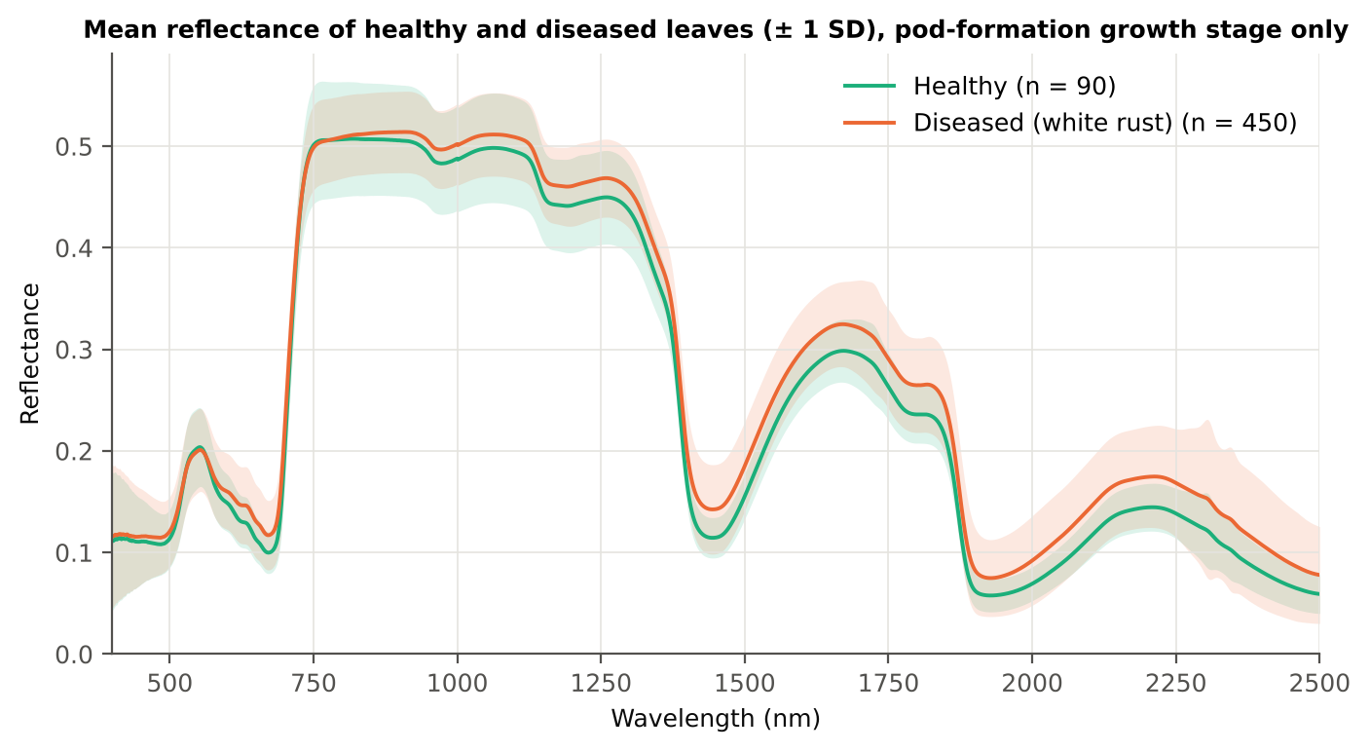
Figure 57. Pod formation: mean reflectance of healthy and diseased leaves (± 1 SD).

4.6.2 Tier 1 — statistical screening
Table 99. Pod formation: number of significant bands by test.
Test | Significant bands (of 2101)
Welch t-test + BH-FDR q < 0.05 (used for Tier 2) | 1683
One-way ANOVA p < 0.05, uncorrected (rule of Das et al.) | 1708
One-way ANOVA + BH-FDR q < 0.05 | 1700
Welch t-test p < 0.05, uncorrected | 1702
Mixed model (random plot effect) + BH-FDR q < 0.05 | 820
Balanced subsets (90 vs 90): significant in ≥ 95 % of 1000 subsets | 1338
Levene test p < 0.05 (unequal variances → Welch) | 1313

Table 100. Pod formation: largest contiguous ranges of FDR-significant bands.
Contiguous significant range (nm) | Bands
952–2500 | 1549
582–715 | 134

Table 101. Pod formation: ten bands with the largest |t|.
Band (nm) | Mean H | Mean D | Welch t | q (BH) | Hedges g | AUC
1400 | 0.1663 | 0.1976 | 9.96 | 0.00e+0 | 0.76 | 0.765
1399 | 0.1707 | 0.2020 | 9.96 | 0.00e+0 | 0.76 | 0.765
1401 | 0.1622 | 0.1933 | 9.96 | 0.00e+0 | 0.75 | 0.764
1398 | 0.1753 | 0.2068 | 9.95 | 0.00e+0 | 0.76 | 0.765
1402 | 0.1583 | 0.1894 | 9.95 | 0.00e+0 | 0.75 | 0.764
1397 | 0.1802 | 0.2118 | 9.94 | 0.00e+0 | 0.77 | 0.765
1403 | 0.1547 | 0.1857 | 9.94 | 0.00e+0 | 0.74 | 0.764
1404 | 0.1514 | 0.1822 | 9.93 | 0.00e+0 | 0.74 | 0.763
1396 | 0.1854 | 0.2170 | 9.93 | 0.00e+0 | 0.77 | 0.765
1405 | 0.1483 | 0.1789 | 9.91 | 0.00e+0 | 0.73 | 0.763

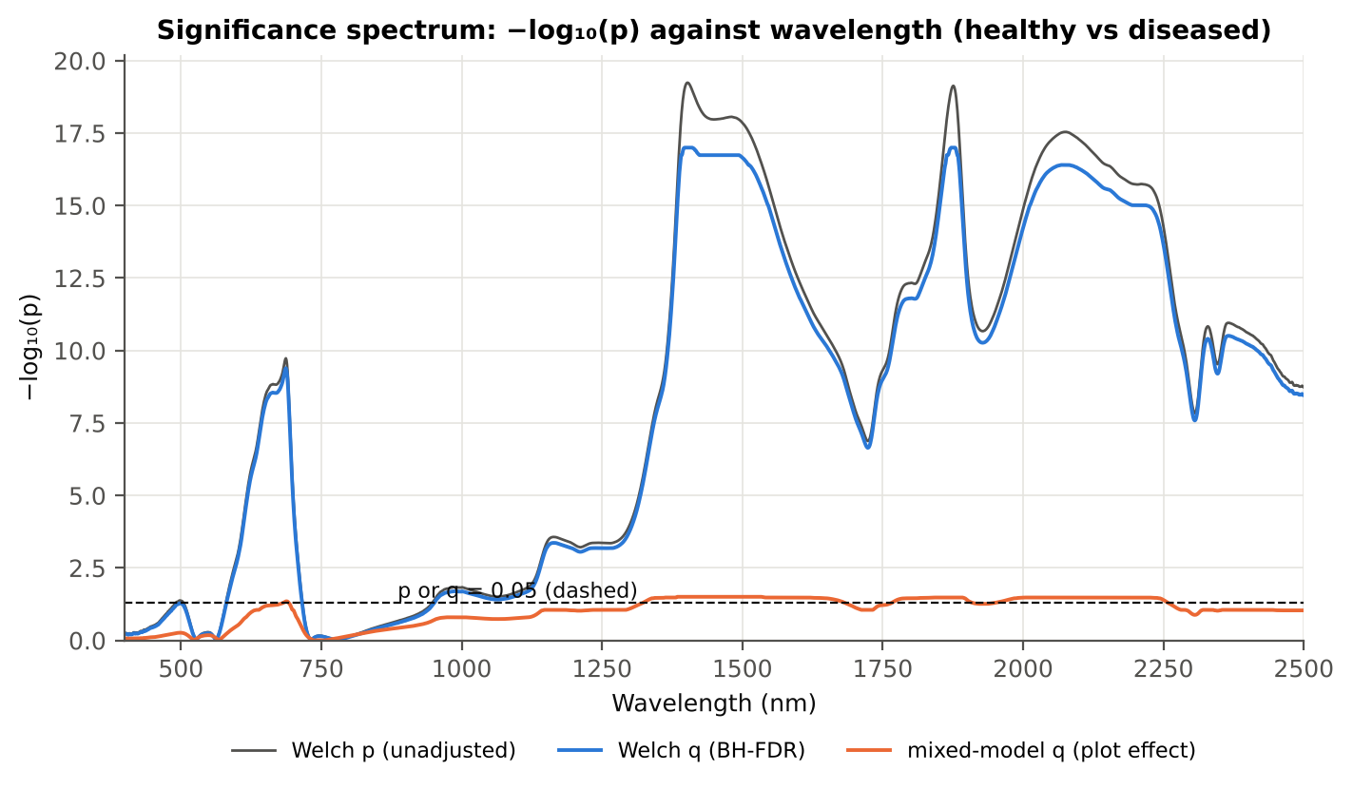
Figure 58. Pod formation: −log₁₀(p) against wavelength (Welch p, BH q and mixed-model q; dashed p or q = 0.05).

4.6.3 Tier 2 — CART and Random Forest band selection
Table 102. Pod formation: the CART-16 bands selected by rpart (prior 0.5/0.5) and how often a band within ± 10 nm is re-selected.
Band (nm) | Region | First used at node | Bootstrap re-selection | Nested-CV re-selection
584 | Green (500–599) | 5 | 79.5 % | 46.7 %
610 | Red (600–679) | 101 | 10.5 % | 20.0 %
674 | Red (600–679) | 50 | 51.5 % | 71.1 %
696 | Red edge (680–759) | 11 | 65.5 % | 64.4 %
954 | NIR (760–1349) | 20 | 34.0 % | 20.0 %
1326 | NIR (760–1349) | 41 | 24.0 % | 4.4 %
1397 | Water band I (1350–1430) | 1 | 59.0 % | 88.9 %
1406 | Water band I (1350–1430) | 3 | 47.0 % | 80.0 %
1513 | SWIR-1 (1431–1799) | 100 | 8.5 % | 24.4 %
1881 | Water band II (1800–1950) | 2 | 77.5 % | 82.2 %
1889 | Water band II (1800–1950) | 49 | 69.0 % | 77.8 %
1995 | SWIR-2 (1951–2349) | 24 | 13.0 % | 28.9 %
2070 | SWIR-2 (1951–2349) | 10 | 7.5 % | 4.4 %
2209 | SWIR-2 (1951–2349) | 6 | 5.5 % | 26.7 %
2423 | SWIR-2 end (2350–2500) | 25 | 15.0 % | 28.9 %
2428 | SWIR-2 end (2350–2500) | 12 | 14.0 % | 24.4 %

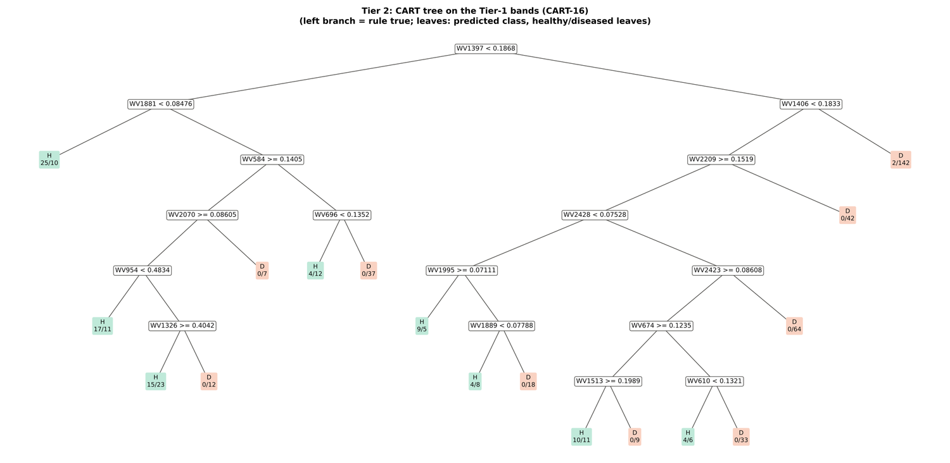
Figure 59. Pod formation: CART tree on the Tier-1 bands (CART-16).
RF-17 importance peaks: 1397, 585, 1369, 1411, 1880, 1380, 1452, 2035, 1850, 596, 1868, 1351, 2003, 686, 1324, 1508, 676 nm.
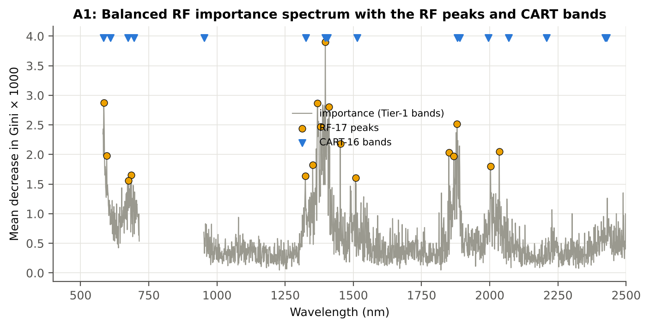
Figure 60. Pod formation: Balanced RF importance spectrum with the RF-17 peaks and the CART bands.

4.6.4 Tier 3 and Tier 4 — separability and classification
Table 103. Pod formation: Jeffries–Matusita distance of healthy and diseased leaves.
Band set | Bands | α (Bhattacharyya) | J–M (0–2) | √J–M | Separability
CART-16 | 16 | 2.689 | 1.864 | 1.365 | below 1.90
CART-1 (1-SE) | 1 | 0.201 | 0.364 | 0.603 | below 1.90
RF-17 | 17 | 2.642 | 1.858 | 1.363 | below 1.90
RF-10 | 10 | 1.433 | 1.523 | 1.234 | below 1.90
RF-16 (size-matched) | 16 | 2.371 | 1.813 | 1.347 | below 1.90

Table 104. Pod formation: error matrix of QDA (equal priors) on the CART-16 bands, leaf-level 10-fold CV (V1; as Table 2 of Das et al.).
Classified \ Reference | Healthy | Diseased | Row total | User's accuracy
Healthy | 75 | 165 | 240 | 31.3 %
Diseased | 15 | 285 | 300 | 95.0 %
Column total | 90 | 450 | 540
Producer's accuracy | 83.3 % | 63.3 %
Overall accuracy | 66.7 % | Balanced accuracy | 73.3 % | κ = 0.280

Table 105. Pod formation: Tier 4 on all band sets (V1), with equal and sample priors and LDA for comparison.
Band set | Classifier | OA | BA | PA healthy | PA diseased | κ
CART-16 | QDA equal priors | 66.7 % | 73.3 % | 83.3 % | 63.3 % | 0.280
CART-16 | QDA sample priors | 72.0 % | 75.2 % | 80.0 % | 70.4 % | 0.334
CART-16 | LDA equal priors | 82.0 % | 79.0 % | 74.4 % | 83.6 % | 0.473
CART-1 (1-SE) | QDA equal priors | 52.4 % | 64.8 % | 83.3 % | 46.2 % | 0.147
CART-1 (1-SE) | QDA sample priors | 83.3 % | 50.0 % | 0.0 % | 100.0 % | 0.000
CART-1 (1-SE) | LDA equal priors | 63.7 % | 68.4 % | 75.6 % | 61.3 % | 0.220
RF-17 | QDA equal priors | 74.8 % | 76.0 % | 77.8 % | 74.2 % | 0.364
RF-17 | QDA sample priors | 81.3 % | 78.6 % | 74.4 % | 82.7 % | 0.459
RF-17 | LDA equal priors | 84.3 % | 83.0 % | 81.1 % | 84.9 % | 0.538
RF-10 | QDA equal priors | 67.4 % | 73.8 % | 83.3 % | 64.2 % | 0.288
RF-10 | QDA sample priors | 79.8 % | 78.1 % | 75.6 % | 80.7 % | 0.436
RF-10 | LDA equal priors | 81.7 % | 79.7 % | 76.7 % | 82.7 % | 0.473
RF-16 (size-matched) | QDA equal priors | 70.6 % | 74.8 % | 81.1 % | 68.4 % | 0.319
RF-16 (size-matched) | QDA sample priors | 78.3 % | 77.7 % | 76.7 % | 78.7 % | 0.415
RF-16 (size-matched) | LDA equal priors | 84.4 % | 82.2 % | 78.9 % | 85.6 % | 0.535

4.6.5 Validation and CART versus RF (Part A)
Table 106. Pod formation: balanced accuracy of the four pipelines on raw reflectance under the validation schemes.
Pipeline | V1 | V3 (± SD) | V4 (± SD) | V5 | AUC V3 | κ V3
CART classifier | 63.4 % | 62.6 % ± 1.3 | 60.9 % ± 6.1 | 51.1 % | 0.639 | 0.185
RF classifier | 70.8 % | 67.0 % ± 0.7 | 68.8 % ± 5.4 | 49.9 % | 0.725 | 0.273
QDA on CART features | 73.3 % | 70.0 % ± 2.2 | 67.6 % ± 11.5 | 49.9 % | 0.757 | 0.249
QDA on RF features | 76.0 % | 77.8 % ± 2.9 | 72.9 % ± 10.1 | 50.0 % | 0.822 | 0.475

Table 107. Pod formation: validation of QDA on CART bands — effect of the imbalance correction (equal vs sample priors) and of random under-sampling (V3-RUS).
Scheme | Priors | BA | SD | OA | PA healthy | PA diseased
V1 · leaf-level 10-fold, bands fixed | equal (corrected) | 73.3 % | – | 66.7 % | 83.3 % | 63.3 %
V2 · plot-grouped 9-fold, bands fixed | equal (corrected) | 66.3 % | – | 63.1 % | 71.1 % | 61.6 %
V3 · nested plot-grouped 9-fold × 5 = 45 folds | equal (corrected) | 70.0 % | 2.2 | 66.5 % | 75.1 % | 64.8 %
V4 · 30 % plot hold-out × 10 | equal (corrected) | 67.6 % | 11.5 | 68.3 % | 66.9 % | 68.2 %
V5 · leave-one-date-out on new plots (14 units) | equal (corrected) | 49.9 % | – | 66.5 % | 0.8 % | 99.0 %
V1 · leaf-level 10-fold, bands fixed | sample (uncorrected) | 75.2 % | – | 72.0 % | 80.0 % | 70.4 %
V2 · plot-grouped 9-fold, bands fixed | sample (uncorrected) | 67.9 % | – | 69.4 % | 65.6 % | 70.2 %
V3 · nested plot-grouped 9-fold × 5 = 45 folds | sample (uncorrected) | 71.0 % | 2.2 | 74.1 % | 66.4 % | 75.6 %
V4 · 30 % plot hold-out × 10 | sample (uncorrected) | 67.6 % | 11.0 | 74.7 % | 57.0 % | 78.1 %
V5 · leave-one-date-out on new plots (14 units) | sample (uncorrected) | 49.8 % | – | 66.8 % | 0.0 % | 99.7 %
V3-RUS · nested + random under-sampling | equal (corrected) | 59.6 % | – | 54.8 % | 66.7 % | 52.4 %
V3-RUS · nested + random under-sampling | sample (uncorrected) | 59.6 % | – | 54.8 % | 66.7 % | 52.4 %

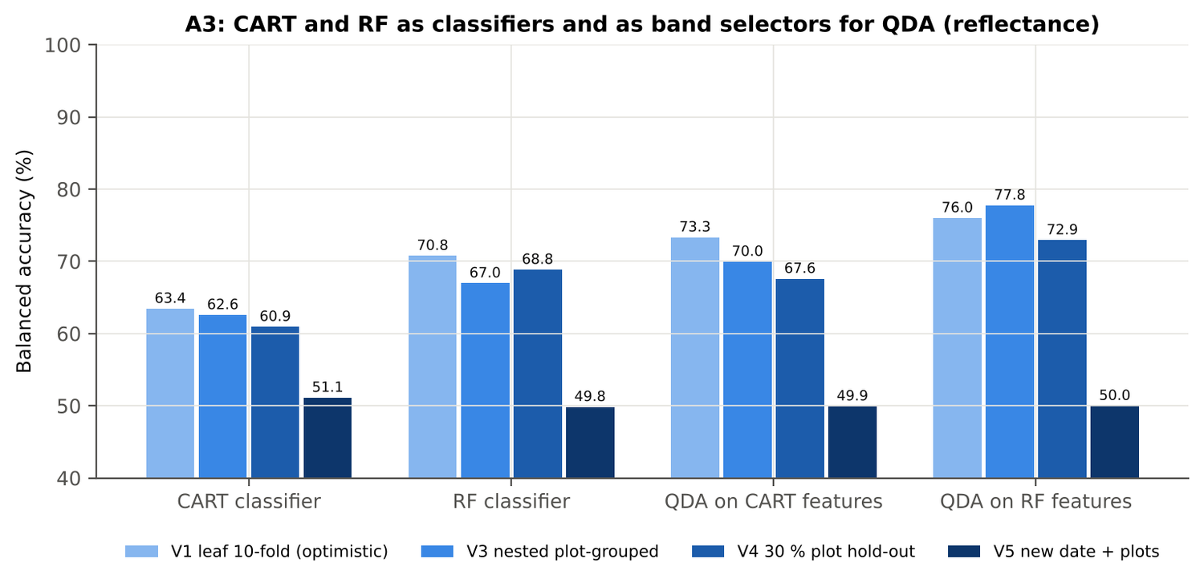
Figure 61. Pod formation: CART and RF as classifiers and as band selectors for QDA (Part A).
Table 108. Pod formation: paired comparisons on identical folds (positive = first pipeline better).
Comparison | Units | n | Mean Δ BA | First better | Wilcoxon p
RF classifier − CART classifier | V3 nested (folds) | 45 | 5.1 pts | 32 | 0.003
RF classifier − CART classifier | V4 hold-out (splits) | 10 | 7.9 pts | 10 | 0.002
QDA on RF features − QDA on CART features | V3 nested (folds) | 45 | 7.8 pts | 33 | 5.6e-5
QDA on RF features − QDA on CART features | V4 hold-out (splits) | 10 | 5.3 pts | 7 | 0.160
QDA on CART features − CART classifier | V3 nested (folds) | 45 | 9.3 pts | 32 | 9.0e-4
QDA on CART features − CART classifier | V4 hold-out (splits) | 10 | 6.6 pts | 7 | 0.160
QDA on RF features − RF classifier | V3 nested (folds) | 45 | 12.0 pts | 37 | 8.0e-6
QDA on RF features − RF classifier | V4 hold-out (splits) | 10 | 4.1 pts | 7 | 0.193

4.6.6 Disease-sensitive features (Part K)
Table 109. Pod formation: most sensitive single features of each family (threshold classifier validated on plots).
Family | Feature | AUC | Direction | BA plot-grouped CV | BA hold-out
K2 continuum removal | CR3 water 970 width | 0.846 | D < H | 76.8 % | 78.1 %
K2 continuum removal | CR3 water 970 area | 0.736 | D < H | 67.1 % | 66.9 %
K2 continuum removal | CR3 water 970 depth | 0.701 | D < H | 63.9 % | 63.8 %
K3 index | ARI | 0.766 | D > H | 67.2 % | 66.7 %
K3 index | PSRI | 0.762 | D > H | 73.4 % | 73.7 %
K3 index | NWI2 | 0.747 | D > H | 66.6 % | 65.9 %
K4 edge parameter | (SDr − SDy)/(SDr + SDy) | 0.786 | D < H | 74.8 % | 73.6 %
K4 edge parameter | SDr/SDy | 0.773 | D < H | 74.0 % | 72.9 %
K4 first derivative | D1 800 nm | 0.787 | D > H | – | –
K4 first derivative | D1 799 nm | 0.787 | D > H | – | –
K4 first derivative | D1 797 nm | 0.786 | D > H | – | –
K1 reflectance | R 1393 nm (1350–1430) | 0.767 | D > H | 70.1 % | –
K1 reflectance | R 1877 nm (1800–1950) | 0.763 | D > H | 65.0 % | –
K3b optimised index | NDSI(553,1881) | 0.795 |  | 70.5 % | –
K3b optimised index | DI(580,693) | 0.801 |  | 75.5 % | –

Table 110. Pod formation: K5 — CART vs Balanced RF on each feature group (balanced accuracy).
Feature group | CART (V3) | RF (V3) | CART (V4) | RF (V4)
Full raw spectrum | 64.5 % | 69.9 % | 61.6 % | 70.1 %
K1 band reflectance | 64.6 % | 70.3 % | 61.7 % | 69.7 %
K2 continuum removal | 72.5 % | 70.3 % | 65.5 % | 69.9 %
K3 vegetation indices | 77.7 % | 75.4 % | 73.1 % | 72.8 %
K4 derivatives + edge parameters | 74.6 % | 75.0 % | 73.4 % | 73.1 %
K1–K4 combined pool | 77.7 % | 74.6 % | 71.9 % | 72.9 %
K4 incl. guard bands (artefact test) | 79.6 % | 85.2 % | 76.6 % | 81.5 %
K-selected 15 | 73.5 % | 75.1 % | 70.8 % | 73.9 %

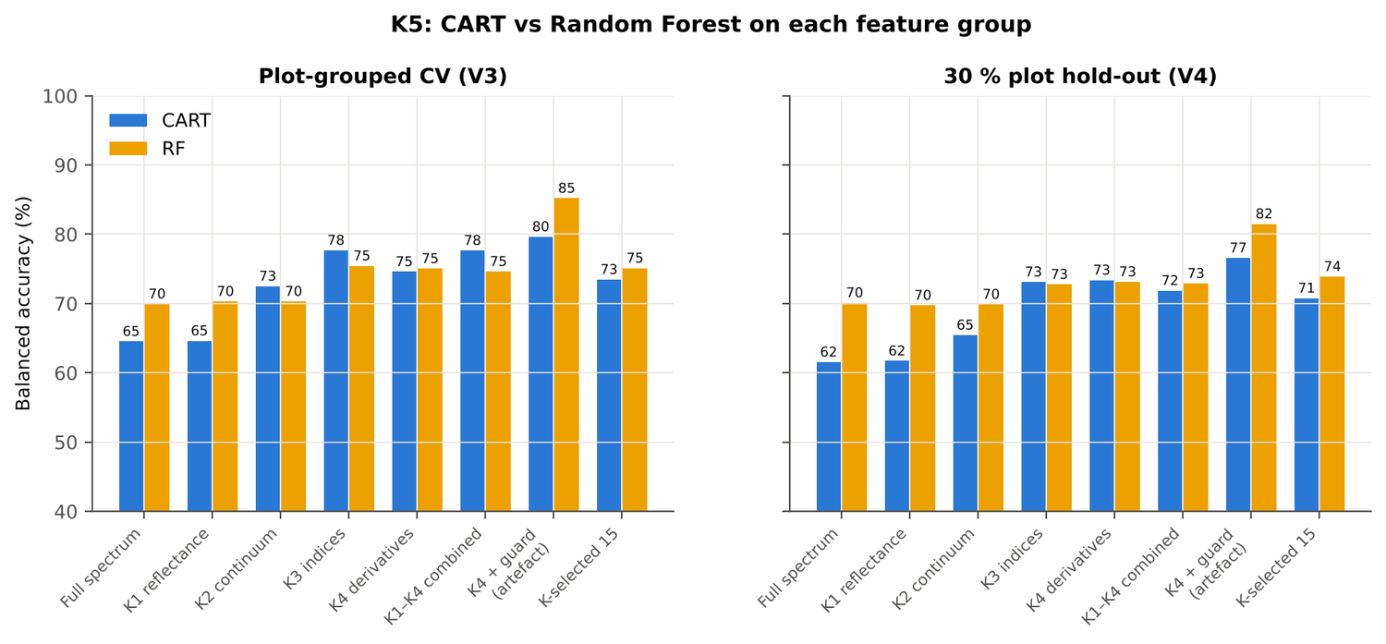
Figure 62. Pod formation: K5 — CART vs RF on each disease-sensitive feature group.
Table 111. Pod formation: red-edge inflection point by four methods.
REIP method | Healthy (nm) | Diseased (nm) | Shift (nm) | AUC | BA plot-grouped CV
Lagrangian interpolation | 704.8 | 703.7 | -1.10 | 0.571 | 56.5 %
maximum first derivative | 704.8 | 703.6 | -1.12 | 0.571 | 57.6 %
linear extrapolation | 702.0 | 700.1 | -1.85 | 0.570 | 53.9 %
linear 4-point interpolation | 713.8 | 713.0 | -0.76 | 0.559 | 52.2 %

4.6.7 Four tiers on the combined feature pool (Part C)
Tier 1: 2879 of 4150 features significant. Tier 2: CART selected 10 features ((SDr − SDy)/(SDr + SDy), CR3 water 970 width, D1 1429 nm, CR3 water 970 symmetry, CR2 red depth, D1 1417 nm, D1 1934 nm, D1 984 nm, D1 2458 nm, D1 636 nm); RF-17: CR3 water 970 width, SDr/SDy, PSRI, D1 806 nm, ARI, (SDr − SDy)/(SDr + SDy), D1 625 nm, D1 2208 nm, D1 796 nm, D1 601 nm, D1 785 nm, D1 561 nm, D1 1935 nm, SDy (yellow-edge area), D1 591 nm, R 1368 nm, D1 1420 nm. Tier 3: J–M 1.478 (CART set) and 1.980 (RF-17), separable (≥ 1.94, Das et al.) for RF-17.
Table 112. Pod formation: composition of the combined pool and of the selected sets.
Feature type | Features | Tier-1 significant | CART-10 | RF-17
K1 band reflectance | 2039 | 1619 | 0 | 1
K2 continuum removal | 30 | 23 | 3 | 1
K3 vegetation index | 30 | 25 | 0 | 2
K4 edge parameter | 20 | 15 | 1 | 3
K4 first-derivative band | 2031 | 1197 | 6 | 10

Table 113. Pod formation: balanced accuracy of the four pipelines on the combined pool.
Pipeline | V1 | V3 (± SD) | V4 (± SD) | V5 | AUC V3 | κ V3
CART classifier | 77.7 % | 74.2 % ± 1.4 | 70.9 % ± 6.6 | 52.2 % | 0.758 | 0.405
RF classifier | 81.4 % | 73.8 % ± 0.8 | 73.7 % ± 5.1 | 64.2 % | 0.859 | 0.424
QDA on CART features | 80.6 % | 74.4 % ± 3.6 | 69.3 % ± 8.6 | 54.4 % | 0.792 | 0.314
QDA on RF features | 75.0 % | 69.9 % ± 1.2 | 64.9 % ± 7.3 | 50.0 % | 0.774 | 0.240

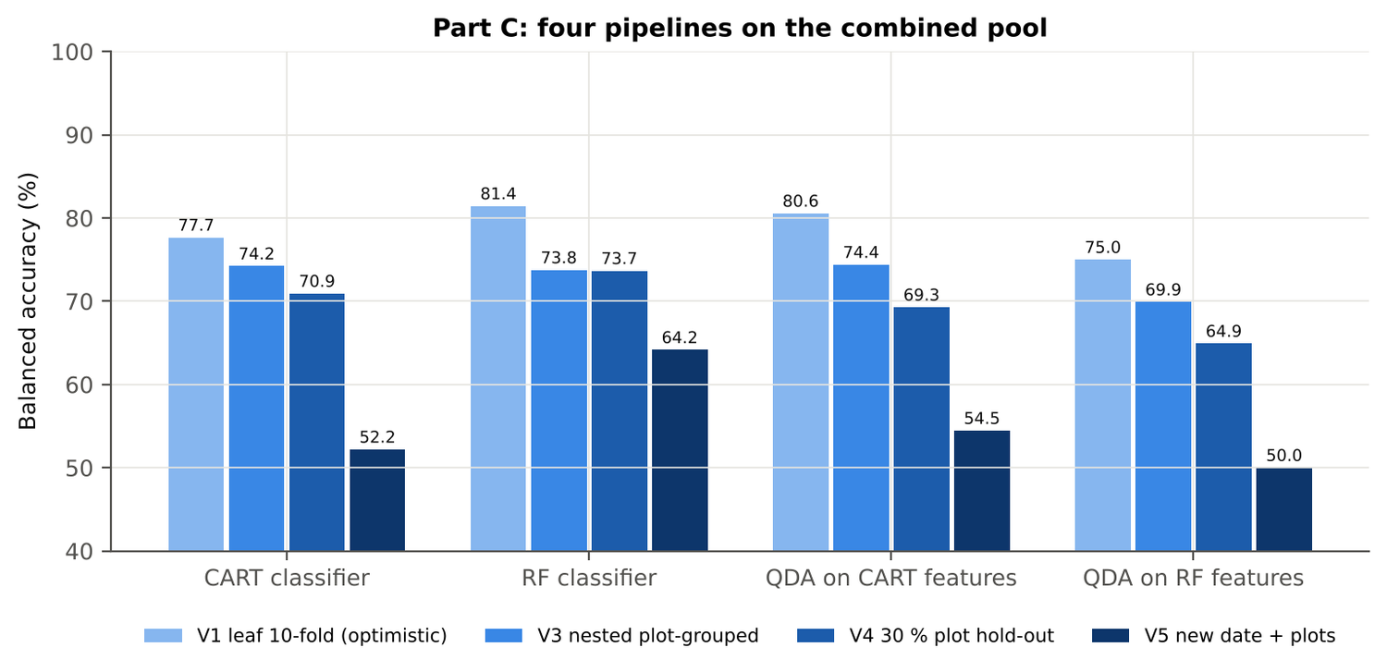
Figure 63. Pod formation: four pipelines on the combined pool under V1, V3, V4 and V5.
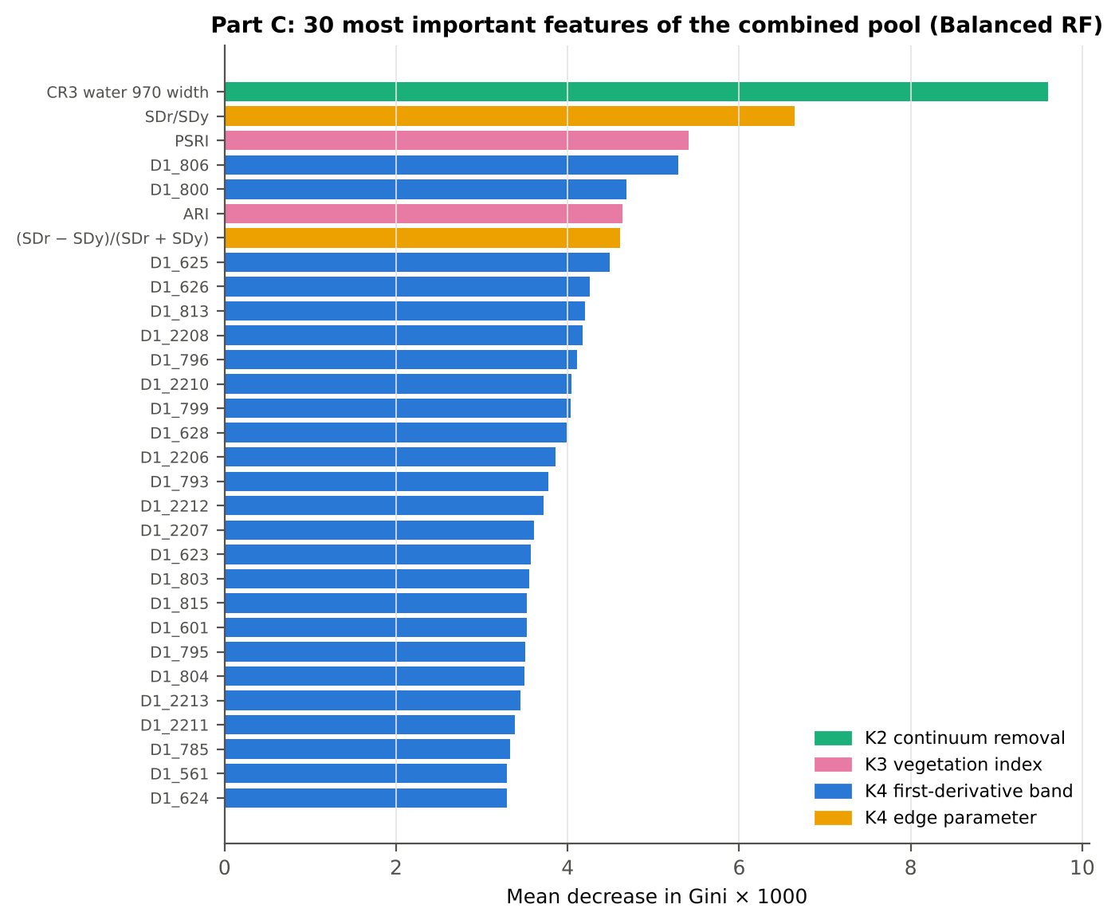
Figure 64. Pod formation: the 30 most important features of the combined pool (Balanced RF).
Table 114. Pod formation: combined pool vs reflectance vs K5 (paired over the V3 folds).
First | Second | Mean Δ BA | First better / n | Wilcoxon p
Combined pool: QDA on CART features | Reflectance: QDA on CART bands | 4.6 pts | 29 / 45 | 0.025
Combined pool: QDA on RF features | Reflectance: QDA on RF bands | -7.6 pts | 11 / 45 | 6.0e-4
Combined pool: RF classifier (Tier-1 features) | Reflectance: RF classifier (Tier-1 bands) | 7.1 pts | 37 / 45 | 1.1e-6
Combined pool: CART classifier (Tier-1 features) | Reflectance: CART classifier (Tier-1 bands) | 12.7 pts | 37 / 45 | 1.3e-6
Combined pool: QDA on RF features | Combined pool: QDA on CART features | -4.4 pts | 13 / 45 | 0.002
Combined pool: QDA on RF features | K5: RF classifier on all 4151 features | -3.5 pts | 20 / 45 | 0.142
Combined pool: QDA on RF features | K5: QDA on 15 features chosen by AUC | -0.4 pts | 16 / 45 | 0.497
Combined pool: RF classifier (Tier-1 features) | K5: RF classifier on all 4151 features | -0.8 pts | 10 / 45 | 0.101

4.6.8 Transfer (V5)
Table 115. Pod formation: balanced accuracy by held-out date (trained on the other dates, tested on new plots of the held-out date).
Feature set · pipeline | 03-03-2026 | 13-03-2026
Reflectance · CART classifier | 62.2 % | 49.6 %
Reflectance · RF classifier | 50.0 % | 50.2 %
Reflectance · QDA on CART features | 50.0 % | 49.8 %
Reflectance · QDA on RF features | 50.0 % | 50.0 %
Combined pool · CART classifier | 49.2 % | 51.6 %
Combined pool · RF classifier | 50.0 % | 67.5 %
Combined pool · QDA on CART features | 50.0 % | 54.2 %
Combined pool · QDA on RF features | 50.0 % | 50.0 %

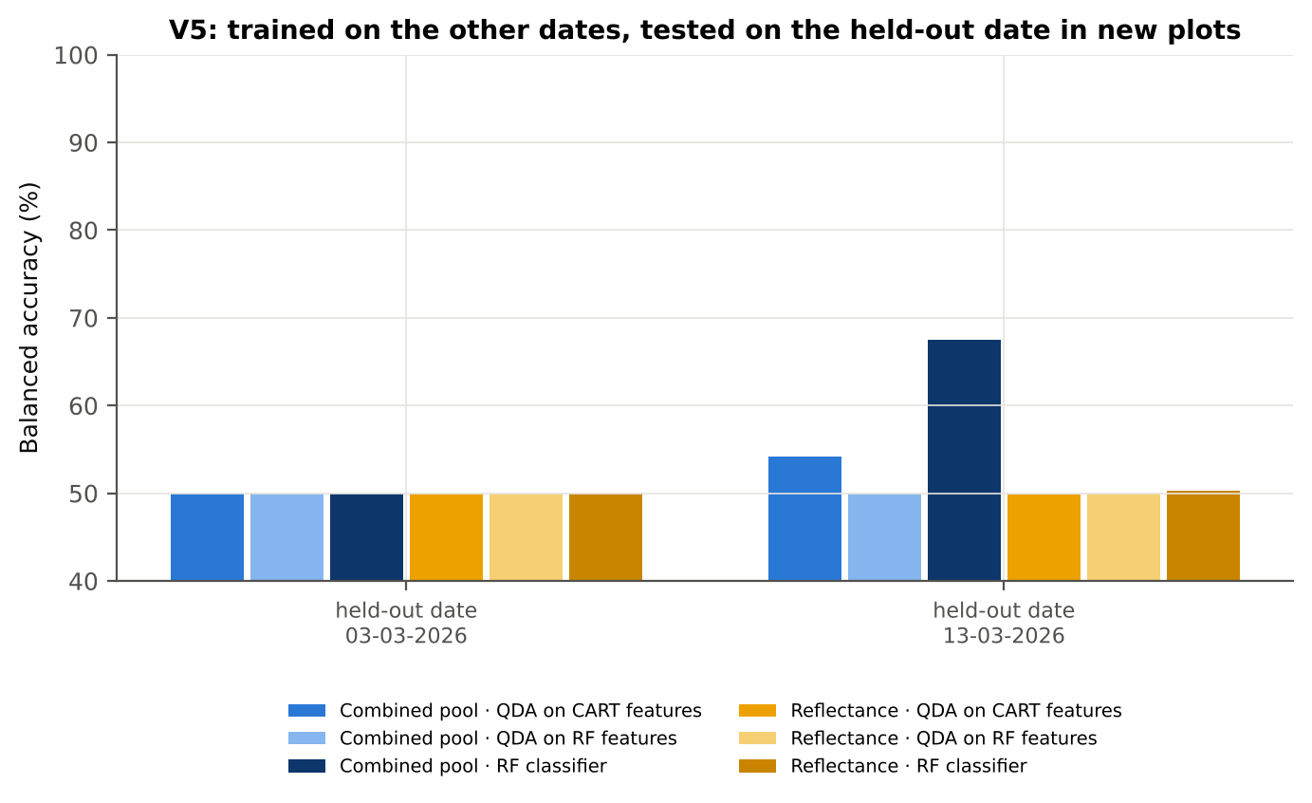
Figure 65. Pod formation: V5 transfer by held-out date.

4.6.9 Interpretation
Tier 1: healthy and white-rust leaves differ significantly at 1683 of 2101 bands (Welch + BH-FDR); 820 bands remain significant with a random plot effect and 1338 in ≥ 95 % of 1000 balanced subsets. The most sensitive single band (smoothed reflectance) reaches AUC 0.77 at 1393 nm.
Tier 2: CART (rpart, prior 0.5/0.5) selected 16 bands (root 1397 nm): 1397, 1881, 1406, 584, 2209, 2070, 696, 2428, 954, 1995, 2423, 1326, 1889, 674, 1513, 610 nm. The Balanced RF importance peaks (RF-17) were 1397, 585, 1369, 1411, 1880, 1380, 1452, 2035, 1850, 596, 1868, 1351, 2003, 686, 1324, 1508, 676 nm.
Tier 3: J–M = 1.86 on the CART bands and 1.86 on the RF bands: neither set reaches the 1.90 separability threshold (Das et al. used 1.94).
Tier 4: QDA with equal priors on the CART bands gives BA 73.3 % in the paper's protocol (V1; healthy recall 83.3 %, diseased recall 63.3 %) and 70.0 % ± 2.2 % (V3 nested, plot-grouped) / 67.6 % (V4 hold-out plots) on new plots.
CART vs RF: as classifiers RF beats CART by 5.1 points (V3, RF better in 32 of 45 folds, p = 0.003); as band selectors for QDA the RF bands give +7.8 points vs the CART bands (p = 5.6e-05). RF selection is more stable than CART selection (Jaccard ±10 nm 0.45 vs 0.27).
Disease-sensitive features (Part K): the strongest group for RF is K3 vegetation indices (BA 75.4 %, V3) vs 70.3 % for reflectance; best single features: first derivative at 800 nm (AUC 0.79), CR3 water 970 width (AUC 0.85), ARI (AUC 0.77), (SDr − SDy)/(SDr + SDy) (AUC 0.79). REIP (Lagrangian interpolation) shifts by -1.1 nm in diseased leaves (AUC 0.57).
Part C (four tiers on the combined K1 + K2–K4 pool, 4150 features, 2879 significant): CART chose 10 features, RF 17 (J–M 1.48 / 1.98); QDA on the RF features reaches 69.9 % (V3) / 64.9 % (V4), -7.8 points vs QDA on RF reflectance bands; best pipeline on the pool: QDA on CART features (74.4 %, V3).
Transfer (V5, leave-one-date-out on new plots): QDA on CART reflectance bands 49.9 %, QDA on combined-pool RF features 50.0 % — a clear drop from the V3 estimate (69.9 %); the date/stage effect limits transfer. Best pipeline under transfer: combined pool: RF classifier (64.2 %).
Compared with all dates, stages and varieties pooled (V3: reflectance QDA-CART 72.0 %, combined-pool QDA-RF 83.7 %; J–M 1.27), this subset gives 70.0 % and 69.9 % (J–M 1.86): discrimination is lower than in the pooled analysis (fewer leaves and plots).

Recommendations for this subset
- Use K3 vegetation indices features rather than single reflectance bands for this subset; the four-tier selection with RF importance on the combined pool and a QDA or RF classifier is the recommended pipeline.
- Report balanced accuracy with both class recalls and the priors used; the classes are imbalanced (1 : 5.0) and equal priors / balanced sampling were applied throughout.
- Base conclusions on the plot-grouped estimates (V3 9-fold × 5 = 45 folds, V4 10 hold-outs), not on the leaf-level V1 estimate.
- Interpret features near the ASD detector joins (≈ 1000 and 1800 nm) with care; guard zones were excluded from the rankings.
- For application to a new date, the most robust pipeline here was combined pool: RF classifier (V5 BA 64.2 %); accuracy on an unseen date is much lower than within the date, so calibrate with leaves of the target date or growth stage.

Cross-checks
42 checks passed, 5 were flagged and 0 failed. Flagged items are limitations reported in the workbook, not errors: Exact duplicates among the remaining spectra; Permutation importance (drop in AUC, 5 plot-grouped folds) vs Gini, top-50 bands; Detector artefact at the 1800/1801 nm join; Selection optimism; Best pair straddles a detector join?.

4.7 Variety V1 — variety V1 only

4.7.1 Data and validation design
This subset contains 746 leaf spectra (126 healthy, 620 diseased; ratio 1 : 4.9) from 4 healthy and 12 diseased plots, measured on 11-02-2026, 24-02-2026, 03-03-2026, 13-03-2026; growth stages Flowering, Pod formation, Vegetative; varieties V1. V3 used 4-fold plot-grouped CV × 5 (20 training sets), V4 held out 1 healthy + 4 diseased plots × 10, and V5 was leave-one-date-out on new plots (40 units).
Table 116. Variety V1: leaf spectra by date and growth stage.
Date | Growth stage | Healthy | Diseased
11-02-2026 | Flowering | 9 | 45
11-02-2026 | Vegetative | 15 | 75
24-02-2026 | Flowering | 24 | 110
24-02-2026 | Vegetative | 6 | 30
03-03-2026 | Flowering | 27 | 135
03-03-2026 | Pod formation | 9 | 45
13-03-2026 | Flowering | 9 | 45
13-03-2026 | Pod formation | 27 | 135

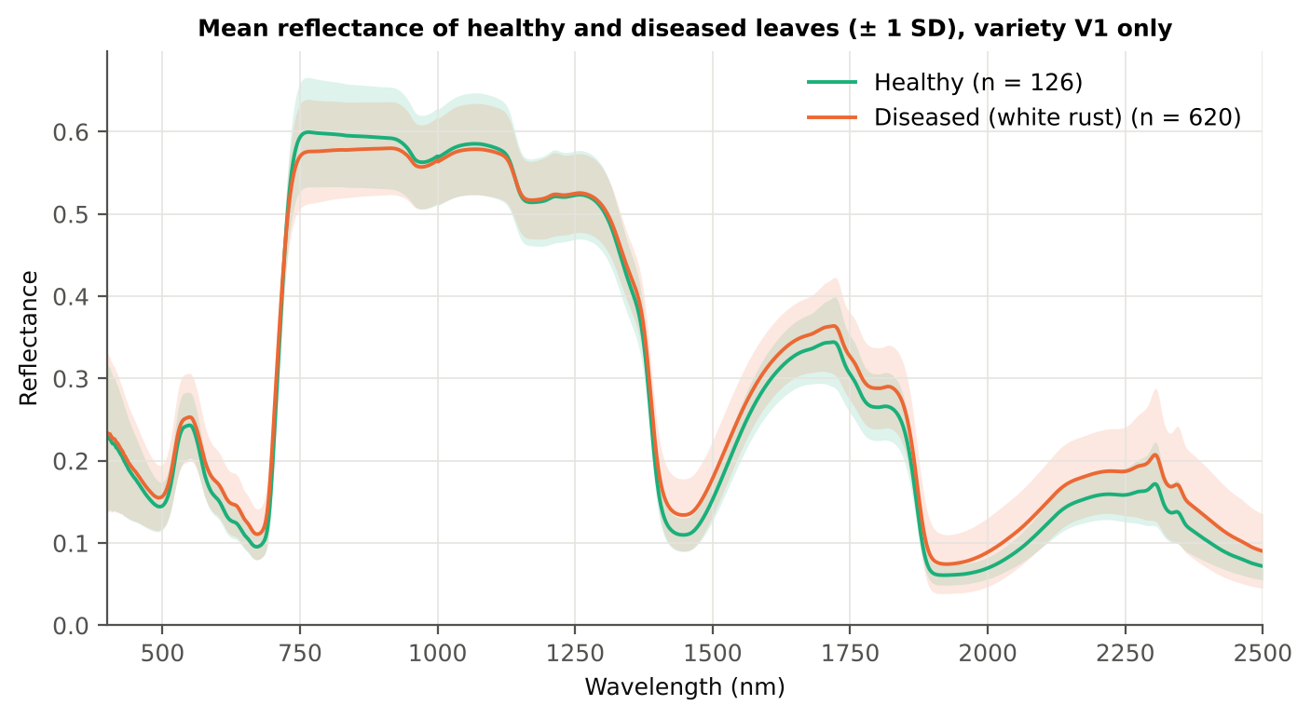
Figure 66. Variety V1: mean reflectance of healthy and diseased leaves (± 1 SD).

4.7.2 Tier 1 — statistical screening
Table 117. Variety V1: number of significant bands by test.
Test | Significant bands (of 2101)
Welch t-test + BH-FDR q < 0.05 (used for Tier 2) | 1608
One-way ANOVA p < 0.05, uncorrected (rule of Das et al.) | 1616
One-way ANOVA + BH-FDR q < 0.05 | 1593
Welch t-test p < 0.05, uncorrected | 1624
Mixed model (random plot effect) + BH-FDR q < 0.05 | 1470
Balanced subsets (126 vs 126): significant in ≥ 95 % of 1000 subsets | 1224
Levene test p < 0.05 (unequal variances → Welch) | 1060

Table 118. Variety V1: largest contiguous ranges of FDR-significant bands.
Contiguous significant range (nm) | Bands
1330–2500 | 1171
463–718 | 256
731–911 | 181

Table 119. Variety V1: ten bands with the largest |t|.
Band (nm) | Mean H | Mean D | Welch t | q (BH) | Hedges g | AUC
1882 | 0.0963 | 0.1212 | 10.28 | 0.00e+0 | 0.59 | 0.729
1883 | 0.0928 | 0.1172 | 10.28 | 0.00e+0 | 0.58 | 0.730
1881 | 0.1000 | 0.1254 | 10.26 | 0.00e+0 | 0.59 | 0.728
1884 | 0.0895 | 0.1134 | 10.26 | 0.00e+0 | 0.57 | 0.729
1880 | 0.1040 | 0.1298 | 10.23 | 0.00e+0 | 0.60 | 0.728
1885 | 0.0864 | 0.1098 | 10.22 | 0.00e+0 | 0.56 | 0.729
1879 | 0.1081 | 0.1343 | 10.18 | 0.00e+0 | 0.60 | 0.726
1886 | 0.0836 | 0.1065 | 10.17 | 0.00e+0 | 0.56 | 0.729
1878 | 0.1124 | 0.1390 | 10.12 | 0.00e+0 | 0.61 | 0.725
1887 | 0.0810 | 0.1034 | 10.10 | 0.00e+0 | 0.55 | 0.728

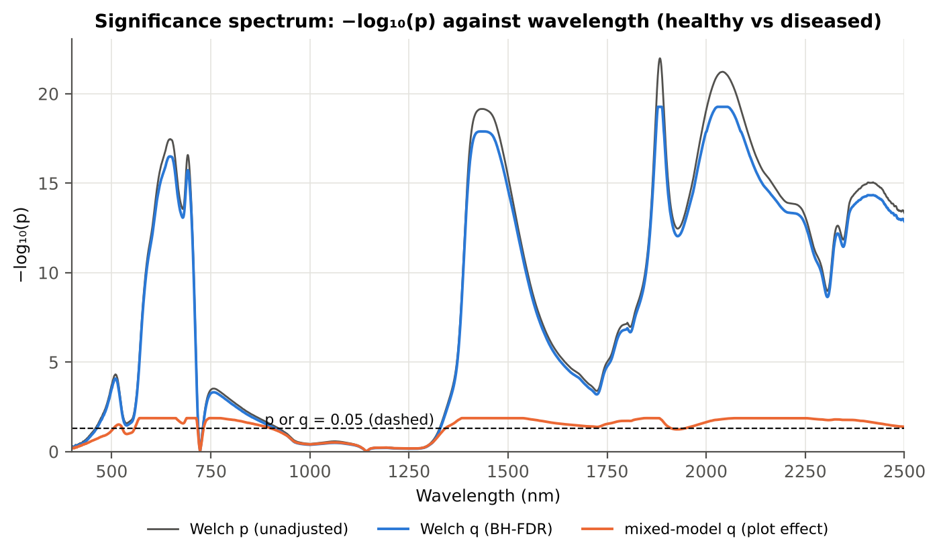
Figure 67. Variety V1: −log₁₀(p) against wavelength (Welch p, BH q and mixed-model q; dashed p or q = 0.05).

4.7.3 Tier 2 — CART and Random Forest band selection
Table 120. Variety V1: the CART-15 bands selected by rpart (prior 0.5/0.5) and how often a band within ± 10 nm is re-selected.
Band (nm) | Region | First used at node | Bootstrap re-selection | Nested-CV re-selection
463 | Blue (400–499) | 6 | 35.5 % | 10.0 %
503 | Green (500–599) | 149 | 31.0 % | 20.0 %
527 | Green (500–599) | 74 | 45.5 % | 25.0 %
572 | Green (500–599) | 9 | 45.5 % | 55.0 %
695 | Red edge (680–759) | 1196 | 87.5 % | 90.0 %
701 | Red edge (680–759) | 1 | 97.5 % | 100.0 %
703 | Red edge (680–759) | 298 | 98.0 % | 100.0 %
735 | Red edge (680–759) | 37 | 65.0 % | 65.0 %
744 | Red edge (680–759) | 18 | 61.0 % | 60.0 %
1366 | Water band I (1350–1430) | 4 | 26.0 % | 45.0 %
1976 | SWIR-2 (1951–2349) | 598 | 9.5 % | 10.0 %
2033 | SWIR-2 (1951–2349) | 19 | 18.5 % | 15.0 %
2380 | SWIR-2 end (2350–2500) | 3 | 24.0 % | 30.0 %
2432 | SWIR-2 end (2350–2500) | 2 | 19.5 % | 25.0 %
2439 | SWIR-2 end (2350–2500) | 299 | 21.5 % | 30.0 %

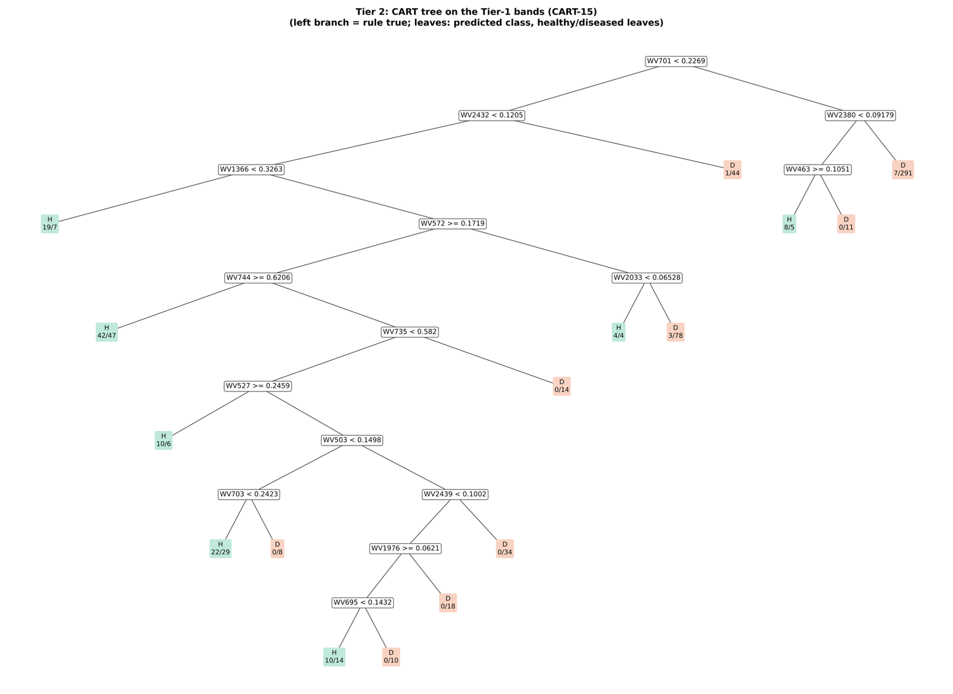
Figure 68. Variety V1: CART tree on the Tier-1 bands (CART-15).
RF-17 importance peaks: 701, 1883, 2041, 2051, 642, 622, 711, 552, 2018, 2029, 2061, 1872, 605, 536, 1406, 753, 569 nm.
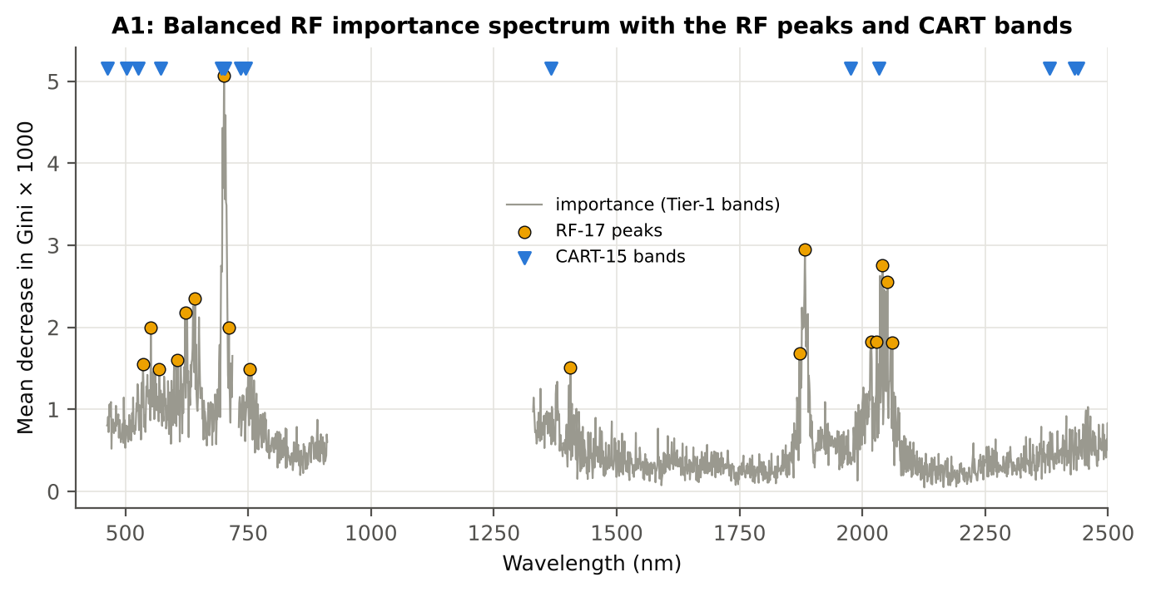
Figure 69. Variety V1: Balanced RF importance spectrum with the RF-17 peaks and the CART bands.

4.7.4 Tier 3 and Tier 4 — separability and classification
Table 121. Variety V1: Jeffries–Matusita distance of healthy and diseased leaves.
Band set | Bands | α (Bhattacharyya) | J–M (0–2) | √J–M | Separability
CART-15 | 15 | 1.969 | 1.721 | 1.312 | below 1.90
CART-1 (1-SE) | 1 | 0.103 | 0.195 | 0.442 | below 1.90
RF-17 | 17 | 2.404 | 1.819 | 1.349 | below 1.90
RF-10 | 10 | 1.221 | 1.410 | 1.187 | below 1.90
RF-15 (size-matched) | 15 | 2.109 | 1.757 | 1.326 | below 1.90

Table 122. Variety V1: error matrix of QDA (equal priors) on the CART-15 bands, leaf-level 10-fold CV (V1; as Table 2 of Das et al.).
Classified \ Reference | Healthy | Diseased | Row total | User's accuracy
Healthy | 109 | 269 | 378 | 28.8 %
Diseased | 17 | 351 | 368 | 95.4 %
Column total | 126 | 620 | 746
Producer's accuracy | 86.5 % | 56.6 %
Overall accuracy | 61.7 % | Balanced accuracy | 71.6 % | κ = 0.240

Table 123. Variety V1: Tier 4 on all band sets (V1), with equal and sample priors and LDA for comparison.
Band set | Classifier | OA | BA | PA healthy | PA diseased | κ
CART-15 | QDA equal priors | 61.7 % | 71.6 % | 86.5 % | 56.6 % | 0.240
CART-15 | QDA sample priors | 67.7 % | 72.7 % | 80.2 % | 65.2 % | 0.283
CART-15 | LDA equal priors | 72.4 % | 76.1 % | 81.8 % | 70.5 % | 0.347
CART-1 (1-SE) | QDA equal priors | 50.0 % | 66.1 % | 90.5 % | 41.8 % | 0.153
CART-1 (1-SE) | QDA sample priors | 83.1 % | 50.0 % | 0.0 % | 100.0 % | 0.000
CART-1 (1-SE) | LDA equal priors | 60.5 % | 67.7 % | 78.6 % | 56.8 % | 0.201
RF-17 | QDA equal priors | 69.2 % | 75.1 % | 84.1 % | 66.1 % | 0.314
RF-17 | QDA sample priors | 74.8 % | 77.9 % | 82.5 % | 73.2 % | 0.383
RF-17 | LDA equal priors | 78.7 % | 83.7 % | 91.3 % | 76.1 % | 0.470
RF-10 | QDA equal priors | 55.6 % | 67.6 % | 85.7 % | 49.5 % | 0.182
RF-10 | QDA sample priors | 62.2 % | 69.0 % | 79.4 % | 58.7 % | 0.220
RF-10 | LDA equal priors | 65.0 % | 69.8 % | 77.0 % | 62.6 % | 0.241
RF-15 (size-matched) | QDA equal priors | 66.9 % | 75.0 % | 87.3 % | 62.7 % | 0.298
RF-15 (size-matched) | QDA sample priors | 74.9 % | 78.3 % | 83.3 % | 73.2 % | 0.388
RF-15 (size-matched) | LDA equal priors | 78.0 % | 83.3 % | 91.3 % | 75.3 % | 0.460

4.7.5 Validation and CART versus RF (Part A)
Table 124. Variety V1: balanced accuracy of the four pipelines on raw reflectance under the validation schemes.
Pipeline | V1 | V3 (± SD) | V4 (± SD) | V5 | AUC V3 | κ V3
CART classifier | 65.0 % | 61.8 % ± 2.0 | 60.8 % ± 6.2 | 56.1 % | 0.583 | 0.176
RF classifier | 69.7 % | 67.7 % ± 0.6 | 65.6 % ± 5.2 | 57.7 % | 0.744 | 0.268
QDA on CART features | 71.6 % | 75.6 % ± 2.1 | 74.5 % ± 8.6 | 55.9 % | 0.811 | 0.330
QDA on RF features | 75.1 % | 73.9 % ± 1.5 | 74.9 % ± 5.4 | 58.5 % | 0.805 | 0.304

Table 125. Variety V1: validation of QDA on CART bands — effect of the imbalance correction (equal vs sample priors) and of random under-sampling (V3-RUS).
Scheme | Priors | BA | SD | OA | PA healthy | PA diseased
V1 · leaf-level 10-fold, bands fixed | equal (corrected) | 71.6 % | – | 61.7 % | 86.5 % | 56.6 %
V2 · plot-grouped 4-fold, bands fixed | equal (corrected) | 69.6 % | – | 61.0 % | 82.5 % | 56.6 %
V3 · nested plot-grouped 4-fold × 5 = 20 folds | equal (corrected) | 75.6 % | 2.1 | 70.6 % | 83.0 % | 68.1 %
V4 · 30 % plot hold-out × 10 | equal (corrected) | 74.5 % | 8.6 | 69.5 % | 81.3 % | 67.7 %
V5 · leave-one-date-out on new plots (40 units) | equal (corrected) | 55.9 % | 4.0 | 68.7 % | 38.3 % | 73.4 %
V1 · leaf-level 10-fold, bands fixed | sample (uncorrected) | 72.7 % | – | 67.7 % | 80.2 % | 65.2 %
V2 · plot-grouped 4-fold, bands fixed | sample (uncorrected) | 71.1 % | – | 68.2 % | 75.4 % | 66.8 %
V3 · nested plot-grouped 4-fold × 5 = 20 folds | sample (uncorrected) | 74.7 % | 2.5 | 75.9 % | 72.9 % | 76.5 %
V4 · 30 % plot hold-out × 10 | sample (uncorrected) | 74.9 % | 8.0 | 75.6 % | 73.9 % | 75.9 %
V5 · leave-one-date-out on new plots (40 units) | sample (uncorrected) | 54.0 % | 3.6 | 72.1 % | 29.2 % | 78.8 %
V3-RUS · nested + random under-sampling | equal (corrected) | 70.2 % | – | 62.6 % | 81.8 % | 58.7 %
V3-RUS · nested + random under-sampling | sample (uncorrected) | 70.2 % | – | 62.6 % | 81.8 % | 58.7 %

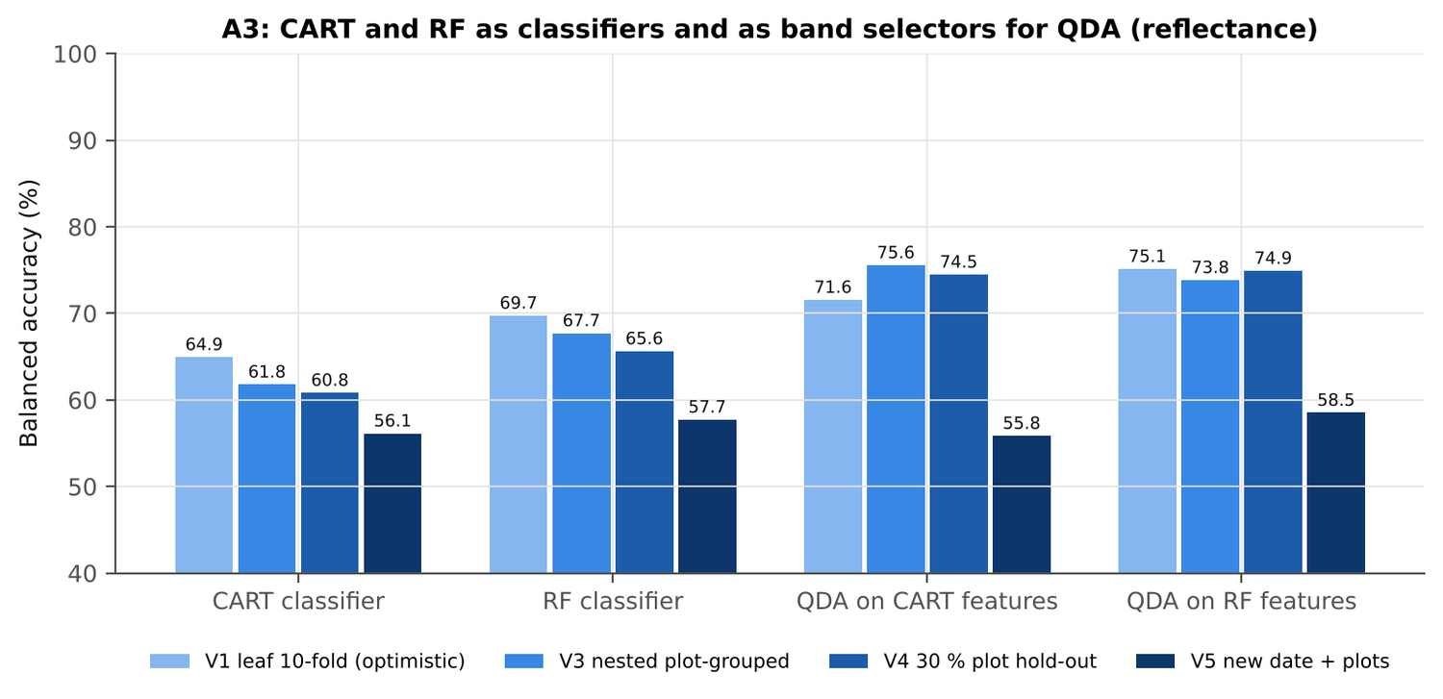
Figure 70. Variety V1: CART and RF as classifiers and as band selectors for QDA (Part A).
Table 126. Variety V1: paired comparisons on identical folds (positive = first pipeline better).
Comparison | Units | n | Mean Δ BA | First better | Wilcoxon p
RF classifier − CART classifier | V3 nested (folds) | 20 | 5.9 pts | 20 | 8.8e-5
RF classifier − CART classifier | V4 hold-out (splits) | 10 | 4.8 pts | 10 | 0.002
QDA on RF features − QDA on CART features | V3 nested (folds) | 20 | -1.8 pts | 9 | 0.455
QDA on RF features − QDA on CART features | V4 hold-out (splits) | 10 | 0.4 pts | 4 | 0.922
QDA on CART features − CART classifier | V3 nested (folds) | 20 | 13.7 pts | 20 | 8.8e-5
QDA on CART features − CART classifier | V4 hold-out (splits) | 10 | 13.7 pts | 10 | 0.002
QDA on RF features − RF classifier | V3 nested (folds) | 20 | 6.0 pts | 16 | 5.1e-4
QDA on RF features − RF classifier | V4 hold-out (splits) | 10 | 9.3 pts | 10 | 0.002

4.7.6 Disease-sensitive features (Part K)
Table 127. Variety V1: most sensitive single features of each family (threshold classifier validated on plots).
Family | Feature | AUC | Direction | BA plot-grouped CV | BA hold-out
K2 continuum removal | CR3 water 970 width | 0.781 | D < H | 73.2 % | 75.0 %
K2 continuum removal | CR6 water 1940 position | 0.729 | D > H | 66.4 % | 65.8 %
K2 continuum removal | CR3 water 970 area | 0.707 | D < H | 65.5 % | 65.4 %
K3 index | NWI2 | 0.764 | D > H | 68.2 % | 67.7 %
K3 index | WI | 0.735 | D < H | 67.5 % | 67.6 %
K3 index | RARSc | 0.703 | D < H | 64.5 % | 65.1 %
K4 edge parameter | REP, linear 4-point (nm) | 0.675 | D < H | 62.1 % | 63.8 %
K4 edge parameter | λr = REP (red-edge position, nm) | 0.673 | D < H | 63.7 % | 65.5 %
K4 first derivative | D1 873 nm | 0.822 | D > H | – | –
K4 first derivative | D1 872 nm | 0.822 | D > H | – | –
K4 first derivative | D1 874 nm | 0.820 | D > H | – | –
K1 reflectance | R 1884 nm (1800–1950) | 0.732 | D > H | 67.3 % | –
K1 reflectance | R 2035 nm (1951–2349) | 0.720 | D > H | 66.1 % | –
K3b optimised index | NDSI(826,932) | 0.819 |  | 74.5 % | –
K3b optimised index | DI(872,877) | 0.826 |  | 74.7 % | –

Table 128. Variety V1: K5 — CART vs Balanced RF on each feature group (balanced accuracy).
Feature group | CART (V3) | RF (V3) | CART (V4) | RF (V4)
Full raw spectrum | 62.0 % | 67.8 % | 59.3 % | 65.9 %
K1 band reflectance | 63.0 % | 67.9 % | 57.8 % | 67.0 %
K2 continuum removal | 74.5 % | 77.9 % | 71.9 % | 73.4 %
K3 vegetation indices | 65.9 % | 69.6 % | 65.6 % | 69.1 %
K4 derivatives + edge parameters | 74.8 % | 83.2 % | 74.0 % | 80.7 %
K1–K4 combined pool | 74.2 % | 81.0 % | 71.6 % | 78.8 %
K4 incl. guard bands (artefact test) | 78.6 % | 88.9 % | 82.3 % | 87.1 %
K-selected 15 | 75.3 % | 79.1 % | 74.0 % | 76.9 %

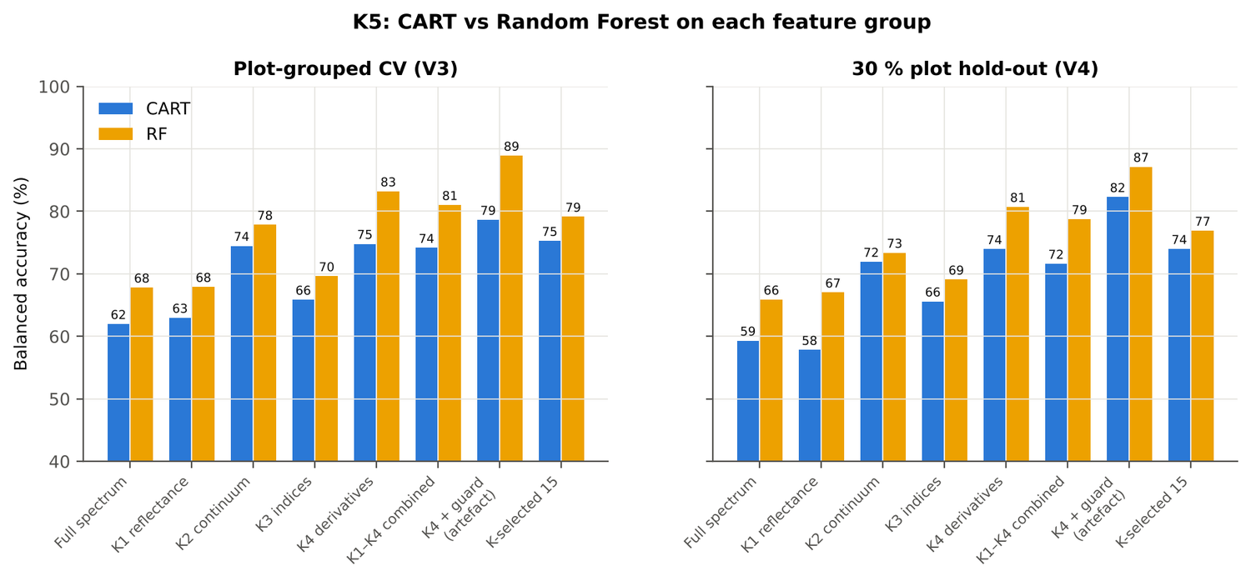
Figure 71. Variety V1: K5 — CART vs RF on each disease-sensitive feature group.
Table 129. Variety V1: red-edge inflection point by four methods.
REIP method | Healthy (nm) | Diseased (nm) | Shift (nm) | AUC | BA plot-grouped CV
linear extrapolation | 708.3 | 703.3 | -5.02 | 0.682 | 65.0 %
linear 4-point interpolation | 715.9 | 714.0 | -1.86 | 0.675 | 62.1 %
maximum first derivative | 708.9 | 705.7 | -3.22 | 0.673 | 63.7 %
Lagrangian interpolation | 708.9 | 705.7 | -3.20 | 0.672 | 62.7 %

4.7.7 Four tiers on the combined feature pool (Part C)
Tier 1: 3083 of 4150 features significant. Tier 2: CART selected 12 features (D1 863 nm, D1 1792 nm, D1 2204 nm, D1 629 nm, R 1380 nm, ARI, CR6 water 1940 symmetry, D1 2223 nm, D1 1937 nm, D1 1758 nm, D1 872 nm, D1 1070 nm); RF-17: D1 873 nm, D1 895 nm, D1 862 nm, D1 1935 nm, D1 883 nm, D1 848 nm, CR3 water 970 width, D1 1792 nm, D1 905 nm, CR6 water 1940 symmetry, D1 835 nm, D1 1916 nm, D1 2220 nm, D1 2207 nm, D1 1947 nm, CR6 water 1940 position, D1 823 nm. Tier 3: J–M 1.630 (CART set) and 1.853 (RF-17), below 1.90 for RF-17.
Table 130. Variety V1: composition of the combined pool and of the selected sets.
Feature type | Features | Tier-1 significant | CART-12 | RF-17
K1 band reflectance | 2039 | 1565 | 1 | 0
K2 continuum removal | 30 | 26 | 1 | 3
K3 vegetation index | 30 | 23 | 1 | 0
K4 edge parameter | 20 | 15 | 0 | 0
K4 first-derivative band | 2031 | 1454 | 9 | 14

Table 131. Variety V1: balanced accuracy of the four pipelines on the combined pool.
Pipeline | V1 | V3 (± SD) | V4 (± SD) | V5 | AUC V3 | κ V3
CART classifier | 77.3 % | 74.6 % ± 2.1 | 71.9 % ± 2.7 | 55.4 % | 0.710 | 0.431
RF classifier | 85.6 % | 80.0 % ± 1.0 | 78.0 % ± 4.1 | 61.3 % | 0.886 | 0.503
QDA on CART features | 85.3 % | 79.1 % ± 1.1 | 78.0 % ± 4.6 | 59.9 % | 0.865 | 0.403
QDA on RF features | 85.4 % | 81.0 % ± 1.1 | 81.5 % ± 4.1 | 61.2 % | 0.878 | 0.497

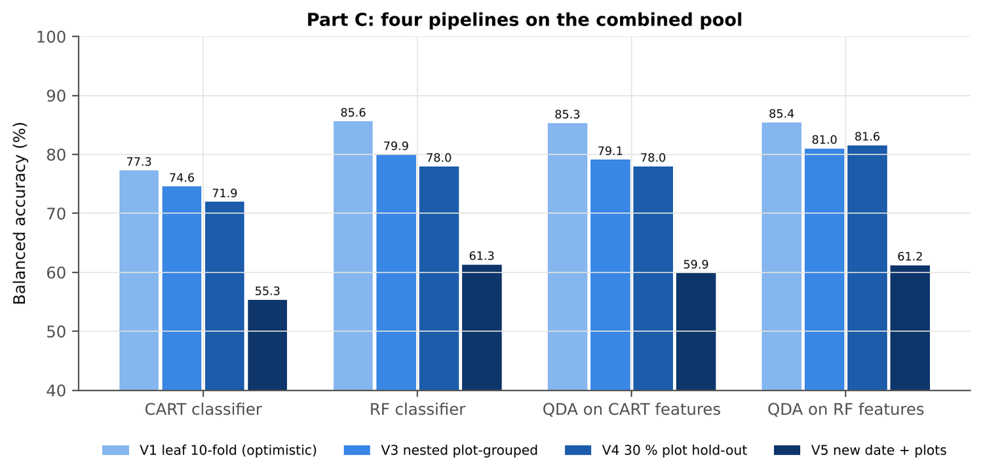
Figure 72. Variety V1: four pipelines on the combined pool under V1, V3, V4 and V5.
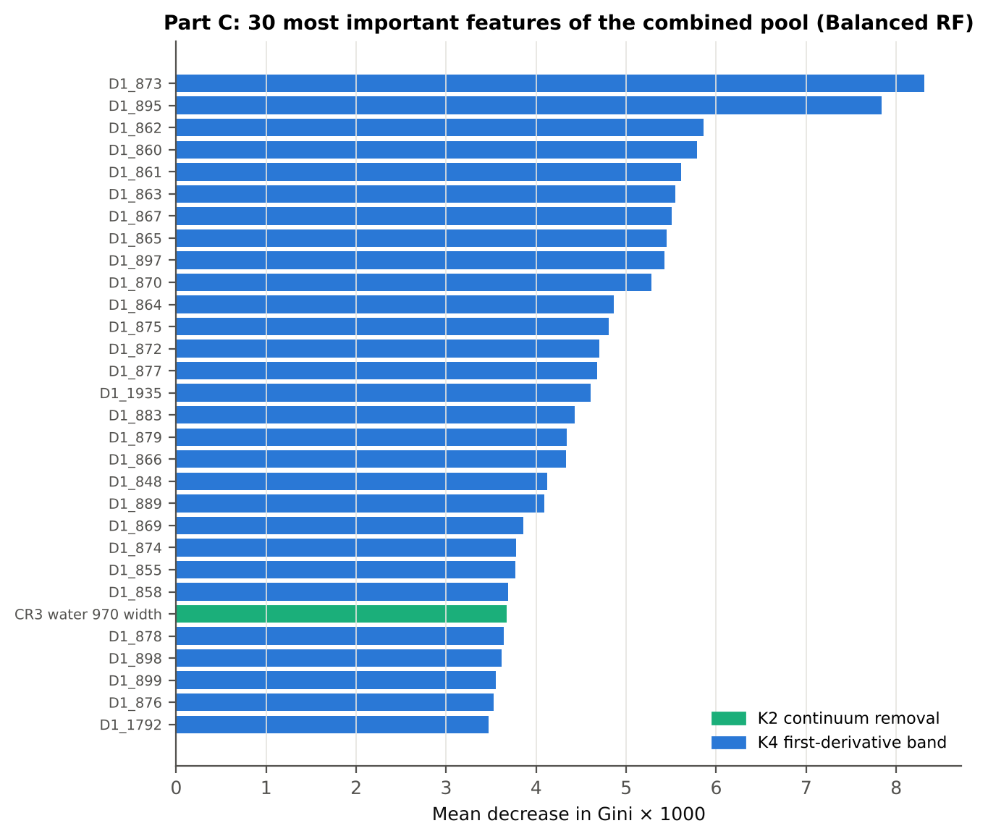
Figure 73. Variety V1: the 30 most important features of the combined pool (Balanced RF).
Table 132. Variety V1: combined pool vs reflectance vs K5 (paired over the V3 folds).
First | Second | Mean Δ BA | First better / n | Wilcoxon p
Combined pool: QDA on CART features | Reflectance: QDA on CART bands | 3.6 pts | 14 / 20 | 0.019
Combined pool: QDA on RF features | Reflectance: QDA on RF bands | 7.0 pts | 19 / 20 | 1.4e-4
Combined pool: RF classifier (Tier-1 features) | Reflectance: RF classifier (Tier-1 bands) | 12.0 pts | 20 / 20 | 8.8e-5
Combined pool: CART classifier (Tier-1 features) | Reflectance: CART classifier (Tier-1 bands) | 12.5 pts | 19 / 20 | 1.0e-4
Combined pool: QDA on RF features | Combined pool: QDA on CART features | 1.6 pts | 11 / 20 | 0.279
Combined pool: QDA on RF features | K5: RF classifier on all 4151 features | -0.1 pts | 12 / 20 | 0.881
Combined pool: QDA on RF features | K5: QDA on 15 features chosen by AUC | 1.7 pts | 11 / 20 | 0.161
Combined pool: RF classifier (Tier-1 features) | K5: RF classifier on all 4151 features | -1.1 pts | 4 / 20 | 0.044

4.7.8 Transfer (V5)
Table 133. Variety V1: balanced accuracy by held-out date (trained on the other dates, tested on new plots of the held-out date).
Feature set · pipeline | 11-02-2026 | 24-02-2026 | 03-03-2026 | 13-03-2026
Reflectance · CART classifier | 55.2 % | 58.6 % | 59.8 % | 49.8 %
Reflectance · RF classifier | 51.5 % | 66.6 % | 58.4 % | 50.7 %
Reflectance · QDA on CART features | 44.8 % | 71.0 % | 55.3 % | 50.0 %
Reflectance · QDA on RF features | 48.3 % | 72.4 % | 60.9 % | 50.0 %
Combined pool · CART classifier | 59.0 % | 73.8 % | 43.1 % | 49.1 %
Combined pool · RF classifier | 59.6 % | 75.7 % | 61.1 % | 50.0 %
Combined pool · QDA on CART features | 48.3 % | 72.9 % | 65.5 % | 49.9 %
Combined pool · QDA on RF features | 66.4 % | 65.5 % | 65.1 % | 50.0 %

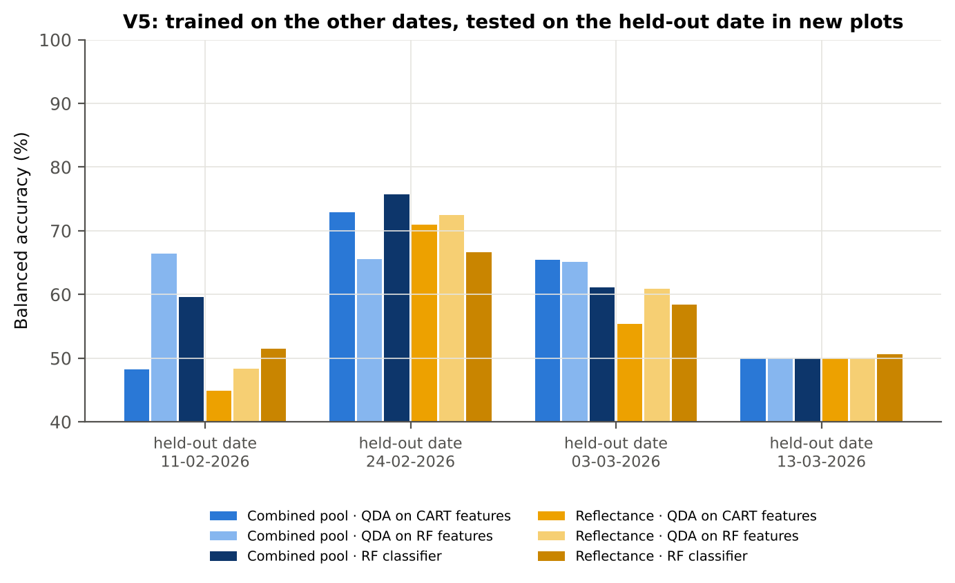
Figure 74. Variety V1: V5 transfer by held-out date.

4.7.9 Interpretation
Tier 1: healthy and white-rust leaves differ significantly at 1608 of 2101 bands (Welch + BH-FDR); 1470 bands remain significant with a random plot effect and 1224 in ≥ 95 % of 1000 balanced subsets. The most sensitive single band (smoothed reflectance) reaches AUC 0.73 at 1884 nm.
Tier 2: CART (rpart, prior 0.5/0.5) selected 15 bands (root 701 nm): 701, 2432, 2380, 1366, 463, 572, 744, 2033, 735, 527, 503, 703, 2439, 1976, 695 nm. The Balanced RF importance peaks (RF-17) were 701, 1883, 2041, 2051, 642, 622, 711, 552, 2018, 2029, 2061, 1872, 605, 536, 1406, 753, 569 nm.
Tier 3: J–M = 1.72 on the CART bands and 1.82 on the RF bands: neither set reaches the 1.90 separability threshold (Das et al. used 1.94).
Tier 4: QDA with equal priors on the CART bands gives BA 71.6 % in the paper's protocol (V1; healthy recall 86.5 %, diseased recall 56.6 %) and 75.6 % ± 2.1 % (V3 nested, plot-grouped) / 74.5 % (V4 hold-out plots) on new plots.
CART vs RF: as classifiers RF beats CART by 5.9 points (V3, RF better in 20 of 20 folds, p = 8.8e-05); as band selectors for QDA the RF bands give -1.8 points vs the CART bands (p = 0.455). RF selection is more stable than CART selection (Jaccard ±10 nm 0.56 vs 0.23).
Disease-sensitive features (Part K): the strongest group for RF is K4 derivatives + edge parameters (BA 83.2 %, V3) vs 67.9 % for reflectance; best single features: first derivative at 873 nm (AUC 0.82), CR3 water 970 width (AUC 0.78), NWI2 (AUC 0.76), REP, linear 4-point (nm) (AUC 0.67). REIP (linear extrapolation) shifts by -5.0 nm in diseased leaves (AUC 0.68).
Part C (four tiers on the combined K1 + K2–K4 pool, 4150 features, 3083 significant): CART chose 12 features, RF 17 (J–M 1.63 / 1.85); QDA on the RF features reaches 81.0 % (V3) / 81.6 % (V4), +7.2 points vs QDA on RF reflectance bands; best pipeline on the pool: QDA on RF features (81.0 %, V3).
Transfer (V5, leave-one-date-out on new plots): QDA on CART reflectance bands 55.8 %, QDA on combined-pool RF features 61.2 % — a clear drop from the V3 estimate (81.0 %); the date/stage effect limits transfer. Best pipeline under transfer: combined pool: RF classifier (61.3 %).
Compared with all dates, stages and varieties pooled (V3: reflectance QDA-CART 72.0 %, combined-pool QDA-RF 83.7 %; J–M 1.27), this subset gives 75.6 % and 81.0 % (J–M 1.72): discrimination is lower than in the pooled analysis (fewer leaves and plots).

Recommendations for this subset
- Use first-derivative and continuum-removed features rather than single reflectance bands for this subset; the four-tier selection with RF importance on the combined pool and a QDA or RF classifier is the recommended pipeline.
- Report balanced accuracy with both class recalls and the priors used; the classes are imbalanced (1 : 4.9) and equal priors / balanced sampling were applied throughout.
- Base conclusions on the plot-grouped estimates (V3 4-fold × 5 = 20 folds, V4 10 hold-outs), not on the leaf-level V1 estimate.
- Interpret features near the ASD detector joins (≈ 1000 and 1800 nm) with care; guard zones were excluded from the rankings.
- For application to a new date, the most robust pipeline here was combined pool: RF classifier (V5 BA 61.3 %); accuracy on an unseen date is much lower than within the date, so calibrate with leaves of the target date or growth stage.
- Only 4 healthy plots are in this subset: validation folds hold few healthy plots each, so the SDs of V3/V4 are large and the results should be confirmed with more healthy plots.

Cross-checks
42 checks passed, 5 were flagged and 0 failed. Flagged items are limitations reported in the workbook, not errors: Exact duplicates among the remaining spectra; Permutation importance (drop in AUC, 4 plot-grouped folds) vs Gini, top-50 bands; Detector artefact at the 1800/1801 nm join; Selection optimism; Best pair straddles a detector join?.

4.8 Variety V2 — variety V2 only

4.8.1 Data and validation design
This subset contains 766 leaf spectra (126 healthy, 640 diseased; ratio 1 : 5.1) from 4 healthy and 12 diseased plots, measured on 11-02-2026, 24-02-2026, 03-03-2026, 13-03-2026; growth stages Flowering, Pod formation, Vegetative; varieties V2. V3 used 4-fold plot-grouped CV × 5 (20 training sets), V4 held out 1 healthy + 4 diseased plots × 10, and V5 was leave-one-date-out on new plots (40 units).
Table 134. Variety V2: leaf spectra by date and growth stage.
Date | Growth stage | Healthy | Diseased
11-02-2026 | Vegetative | 24 | 120
24-02-2026 | Flowering | 18 | 90
24-02-2026 | Vegetative | 12 | 70
03-03-2026 | Flowering | 36 | 180
13-03-2026 | Flowering | 9 | 45
13-03-2026 | Pod formation | 27 | 135

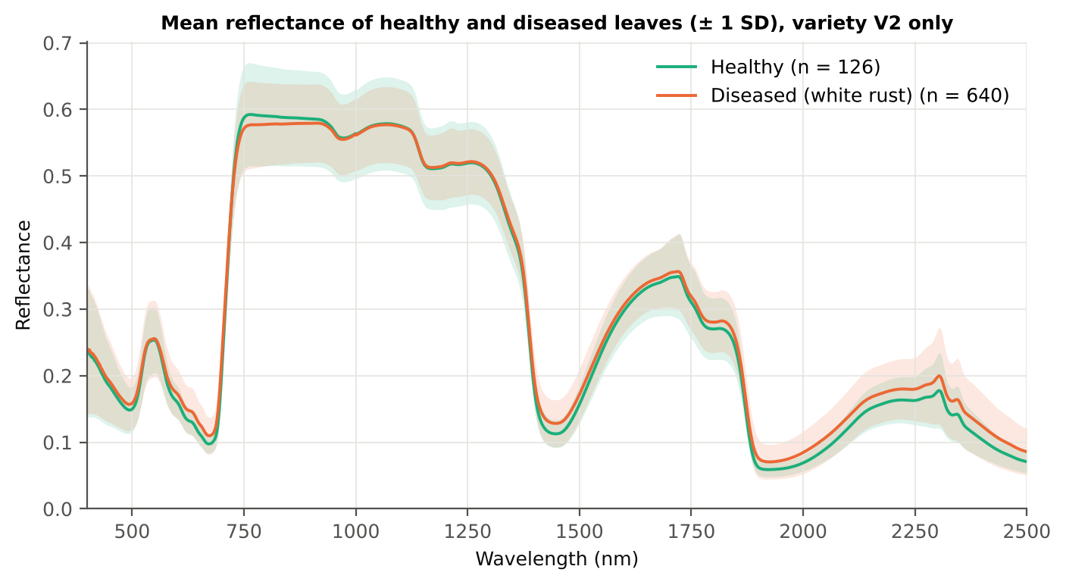
Figure 75. Variety V2: mean reflectance of healthy and diseased leaves (± 1 SD).

4.8.2 Tier 1 — statistical screening
Table 135. Variety V2: number of significant bands by test.
Test | Significant bands (of 2101)
Welch t-test + BH-FDR q < 0.05 (used for Tier 2) | 1087
One-way ANOVA p < 0.05, uncorrected (rule of Das et al.) | 1219
One-way ANOVA + BH-FDR q < 0.05 | 1130
Welch t-test p < 0.05, uncorrected | 1183
Mixed model (random plot effect) + BH-FDR q < 0.05 | 907
Balanced subsets (126 vs 126): significant in ≥ 95 % of 1000 subsets | 644
Levene test p < 0.05 (unequal variances → Welch) | 1096

Table 136. Variety V2: largest contiguous ranges of FDR-significant bands.
Contiguous significant range (nm) | Bands
1788–2500 | 713
1378–1585 | 208
573–712 | 140
489–514 | 26

Table 137. Variety V2: ten bands with the largest |t|.
Band (nm) | Mean H | Mean D | Welch t | q (BH) | Hedges g | AUC
1894 | 0.0677 | 0.0829 | 9.37 | 0.00e+0 | 0.53 | 0.683
1893 | 0.0691 | 0.0845 | 9.37 | 0.00e+0 | 0.53 | 0.683
1895 | 0.0665 | 0.0814 | 9.36 | 0.00e+0 | 0.53 | 0.683
1892 | 0.0707 | 0.0863 | 9.35 | 0.00e+0 | 0.53 | 0.683
1896 | 0.0654 | 0.0801 | 9.33 | 0.00e+0 | 0.52 | 0.683
1891 | 0.0724 | 0.0883 | 9.32 | 0.00e+0 | 0.53 | 0.682
1998 | 0.0684 | 0.0838 | 9.31 | 0.00e+0 | 0.53 | 0.676
1999 | 0.0687 | 0.0842 | 9.31 | 0.00e+0 | 0.53 | 0.676
1997 | 0.0681 | 0.0835 | 9.31 | 0.00e+0 | 0.53 | 0.676
2000 | 0.0690 | 0.0845 | 9.31 | 0.00e+0 | 0.53 | 0.676

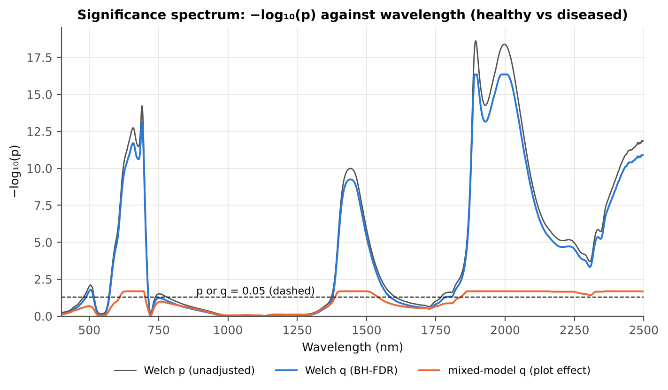
Figure 76. Variety V2: −log₁₀(p) against wavelength (Welch p, BH q and mixed-model q; dashed p or q = 0.05).

4.8.3 Tier 2 — CART and Random Forest band selection
Table 138. Variety V2: the CART-19 bands selected by rpart (prior 0.5/0.5) and how often a band within ± 10 nm is re-selected.
Band (nm) | Region | First used at node | Bootstrap re-selection | Nested-CV re-selection
506 | Green (500–599) | 42 | 43.5 % | 0.0 %
507 | Green (500–599) | 40 | 43.5 % | 0.0 %
648 | Red (600–679) | 20 | 43.0 % | 70.0 %
691 | Red edge (680–759) | 81 | 66.0 % | 70.0 %
701 | Red edge (680–759) | 3 | 83.5 % | 80.0 %
1378 | Water band I (1350–1430) | 345 | 70.5 % | 60.0 %
1396 | Water band I (1350–1430) | 86 | 57.5 % | 60.0 %
1463 | SWIR-1 (1431–1799) | 6 | 11.0 % | 15.0 %
1508 | SWIR-1 (1431–1799) | 168 | 19.0 % | 15.0 %
1584 | SWIR-1 (1431–1799) | 10 | 49.0 % | 15.0 %
1788 | SWIR-1 (1431–1799) | 172 | 32.0 % | 10.0 %
1861 | Water band II (1800–1950) | 21 | 47.5 % | 60.0 %
1889 | Water band II (1800–1950) | 12 | 86.0 % | 75.0 %
1895 | Water band II (1800–1950) | 1 | 83.0 % | 75.0 %
1944 | Water band II (1800–1950) | 5 | 20.5 % | 35.0 %
1981 | SWIR-2 (1951–2349) | 690 | 30.0 % | 35.0 %
2158 | SWIR-2 (1951–2349) | 43 | 6.0 % | 20.0 %
2374 | SWIR-2 end (2350–2500) | 84 | 12.0 % | 25.0 %
2421 | SWIR-2 end (2350–2500) | 2 | 23.0 % | 5.0 %

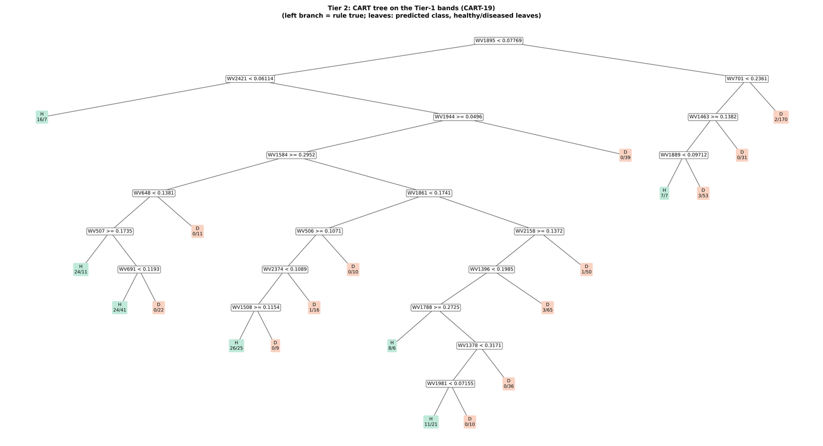
Figure 77. Variety V2: CART tree on the Tier-1 bands (CART-19).
RF-17 importance peaks: 1895, 1931, 1951, 1987, 1997, 1969, 1379, 701, 689, 1919, 2007, 711, 491, 615, 657, 513, 645 nm.
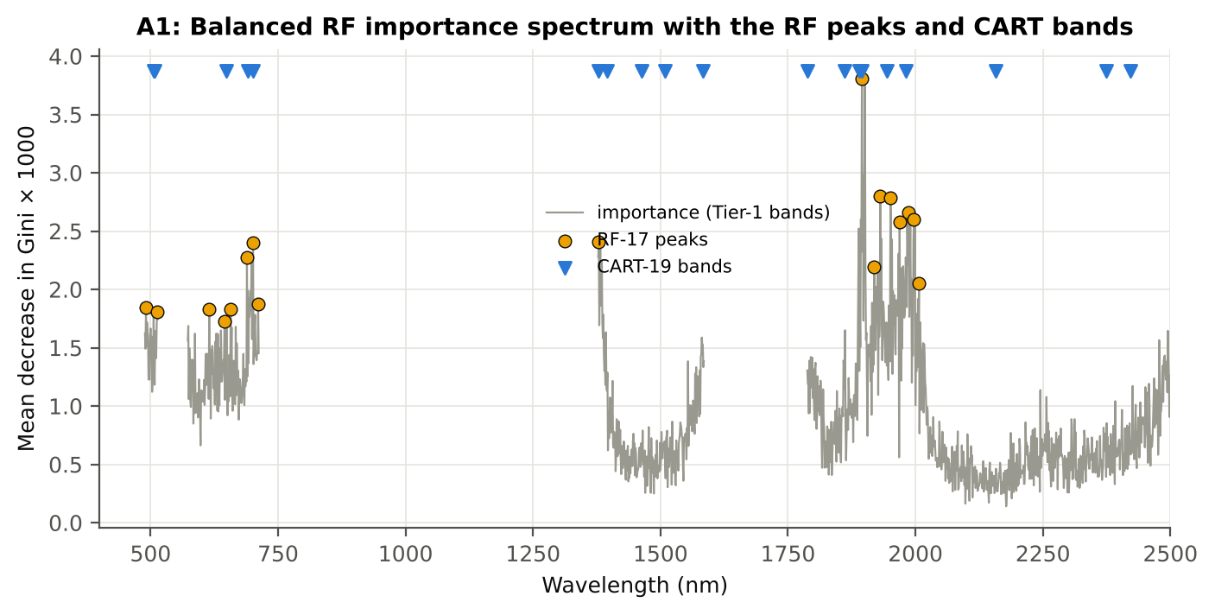
Figure 78. Variety V2: Balanced RF importance spectrum with the RF-17 peaks and the CART bands.

4.8.4 Tier 3 and Tier 4 — separability and classification
Table 139. Variety V2: Jeffries–Matusita distance of healthy and diseased leaves.
Band set | Bands | α (Bhattacharyya) | J–M (0–2) | √J–M | Separability
CART-19 | 19 | 2.372 | 1.813 | 1.347 | below 1.90
CART-1 (1-SE) | 1 | 0.255 | 0.451 | 0.671 | below 1.90
RF-17 | 17 | 2.413 | 1.821 | 1.349 | below 1.90
RF-10 | 10 | 1.285 | 1.447 | 1.203 | below 1.90
RF-19 (size-matched) | 19 | 2.799 | 1.878 | 1.370 | below 1.90

Table 140. Variety V2: error matrix of QDA (equal priors) on the CART-19 bands, leaf-level 10-fold CV (V1; as Table 2 of Das et al.).
Classified \ Reference | Healthy | Diseased | Row total | User's accuracy
Healthy | 110 | 154 | 264 | 41.7 %
Diseased | 16 | 486 | 502 | 96.8 %
Column total | 126 | 640 | 766
Producer's accuracy | 87.3 % | 75.9 %
Overall accuracy | 77.8 % | Balanced accuracy | 81.6 % | κ = 0.439

Table 141. Variety V2: Tier 4 on all band sets (V1), with equal and sample priors and LDA for comparison.
Band set | Classifier | OA | BA | PA healthy | PA diseased | κ
CART-19 | QDA equal priors | 77.8 % | 81.6 % | 87.3 % | 75.9 % | 0.439
CART-19 | QDA sample priors | 83.4 % | 83.7 % | 84.1 % | 83.3 % | 0.528
CART-19 | LDA equal priors | 82.9 % | 82.1 % | 81.0 % | 83.3 % | 0.508
CART-1 (1-SE) | QDA equal priors | 41.6 % | 60.9 % | 89.7 % | 32.2 % | 0.093
CART-1 (1-SE) | QDA sample priors | 83.5 % | 50.0 % | 0.0 % | 100.0 % | 0.000
CART-1 (1-SE) | LDA equal priors | 55.0 % | 65.1 % | 80.2 % | 50.0 % | 0.155
RF-17 | QDA equal priors | 69.7 % | 78.0 % | 90.5 % | 65.6 % | 0.337
RF-17 | QDA sample priors | 75.1 % | 77.8 % | 81.8 % | 73.8 % | 0.380
RF-17 | LDA equal priors | 77.3 % | 79.1 % | 81.8 % | 76.4 % | 0.413
RF-10 | QDA equal priors | 61.6 % | 73.2 % | 90.5 % | 55.9 % | 0.249
RF-10 | QDA sample priors | 69.6 % | 73.2 % | 78.6 % | 67.8 % | 0.295
RF-10 | LDA equal priors | 72.9 % | 72.3 % | 71.4 % | 73.1 % | 0.311
RF-19 (size-matched) | QDA equal priors | 69.2 % | 77.7 % | 90.5 % | 65.0 % | 0.331
RF-19 (size-matched) | QDA sample priors | 73.8 % | 77.6 % | 83.3 % | 71.9 % | 0.366
RF-19 (size-matched) | LDA equal priors | 77.7 % | 78.3 % | 79.4 % | 77.3 % | 0.411

4.8.5 Validation and CART versus RF (Part A)
Table 142. Variety V2: balanced accuracy of the four pipelines on raw reflectance under the validation schemes.
Pipeline | V1 | V3 (± SD) | V4 (± SD) | V5 | AUC V3 | κ V3
CART classifier | 62.6 % | 62.3 % ± 2.7 | 60.1 % ± 3.9 | 51.4 % | 0.601 | 0.189
RF classifier | 67.8 % | 63.7 % ± 1.1 | 63.3 % ± 3.7 | 49.4 % | 0.715 | 0.212
QDA on CART features | 81.6 % | 70.9 % ± 1.6 | 69.8 % ± 7.5 | 52.1 % | 0.805 | 0.260
QDA on RF features | 78.0 % | 71.4 % ± 3.1 | 68.1 % ± 5.5 | 56.6 % | 0.803 | 0.266

Table 143. Variety V2: validation of QDA on CART bands — effect of the imbalance correction (equal vs sample priors) and of random under-sampling (V3-RUS).
Scheme | Priors | BA | SD | OA | PA healthy | PA diseased
V1 · leaf-level 10-fold, bands fixed | equal (corrected) | 81.6 % | – | 77.8 % | 87.3 % | 75.9 %
V2 · plot-grouped 4-fold, bands fixed | equal (corrected) | 75.3 % | – | 77.9 % | 71.4 % | 79.2 %
V3 · nested plot-grouped 4-fold × 5 = 20 folds | equal (corrected) | 70.9 % | 1.6 | 67.2 % | 76.3 % | 65.4 %
V4 · 30 % plot hold-out × 10 | equal (corrected) | 69.8 % | 7.5 | 70.5 % | 68.9 % | 70.6 %
V5 · leave-one-date-out on new plots (40 units) | equal (corrected) | 52.1 % | 6.2 | 63.5 % | 36.6 % | 67.7 %
V1 · leaf-level 10-fold, bands fixed | sample (uncorrected) | 83.7 % | – | 83.4 % | 84.1 % | 83.3 %
V2 · plot-grouped 4-fold, bands fixed | sample (uncorrected) | 73.5 % | – | 80.7 % | 62.7 % | 84.2 %
V3 · nested plot-grouped 4-fold × 5 = 20 folds | sample (uncorrected) | 72.4 % | 2.9 | 75.7 % | 67.5 % | 77.3 %
V4 · 30 % plot hold-out × 10 | sample (uncorrected) | 70.1 % | 9.1 | 77.0 % | 60.7 % | 79.4 %
V5 · leave-one-date-out on new plots (40 units) | sample (uncorrected) | 51.0 % | 4.0 | 68.1 % | 27.7 % | 74.4 %
V3-RUS · nested + random under-sampling | equal (corrected) | 63.5 % | – | 51.8 % | 81.0 % | 46.1 %
V3-RUS · nested + random under-sampling | sample (uncorrected) | 63.5 % | – | 51.8 % | 81.0 % | 46.1 %

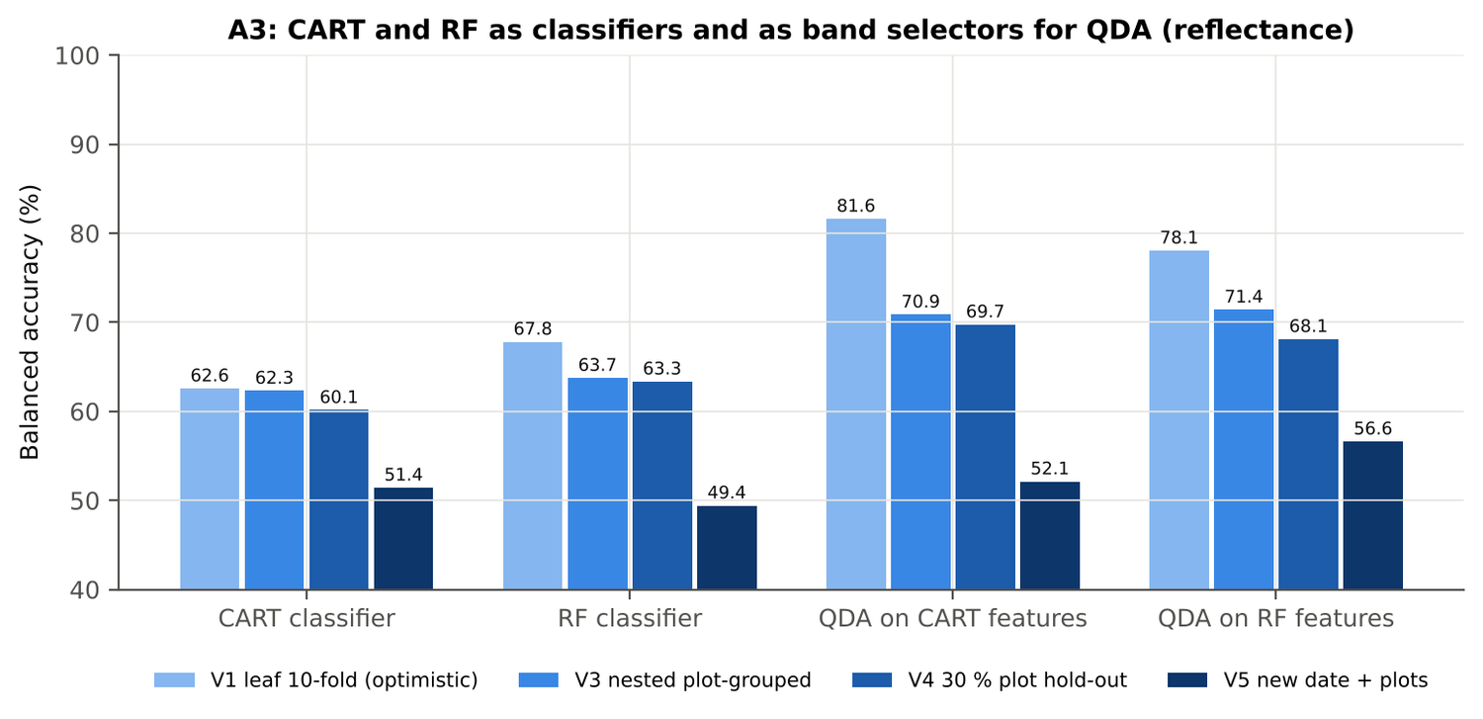
Figure 79. Variety V2: CART and RF as classifiers and as band selectors for QDA (Part A).
Table 144. Variety V2: paired comparisons on identical folds (positive = first pipeline better).
Comparison | Units | n | Mean Δ BA | First better | Wilcoxon p
RF classifier − CART classifier | V3 nested (folds) | 20 | 1.6 pts | 9 | 0.295
RF classifier − CART classifier | V4 hold-out (splits) | 10 | 3.2 pts | 7 | 0.084
QDA on RF features − QDA on CART features | V3 nested (folds) | 20 | 0.6 pts | 11 | 0.575
QDA on RF features − QDA on CART features | V4 hold-out (splits) | 10 | -1.6 pts | 4 | 0.492
QDA on CART features − CART classifier | V3 nested (folds) | 20 | 8.4 pts | 17 | 2.9e-4
QDA on CART features − CART classifier | V4 hold-out (splits) | 10 | 9.6 pts | 9 | 0.014
QDA on RF features − RF classifier | V3 nested (folds) | 20 | 7.4 pts | 15 | 7.8e-4
QDA on RF features − RF classifier | V4 hold-out (splits) | 10 | 4.8 pts | 7 | 0.064

4.8.6 Disease-sensitive features (Part K)
Table 145. Variety V2: most sensitive single features of each family (threshold classifier validated on plots).
Family | Feature | AUC | Direction | BA plot-grouped CV | BA hold-out
K2 continuum removal | CR3 water 970 width | 0.767 | D < H | 72.5 % | 69.6 %
K2 continuum removal | CR6 water 1940 position | 0.661 | D > H | 59.6 % | 60.2 %
K2 continuum removal | CR6 water 1940 symmetry | 0.645 | D > H | 62.1 % | 65.8 %
K3 index | NWI2 | 0.673 | D > H | 64.3 % | 62.5 %
K3 index | RVS2 | 0.651 | D < H | 63.5 % | 64.0 %
K3 index | NDVI761 | 0.650 | D < H | 63.0 % | 63.6 %
K4 edge parameter | Ro (red well reflectance) | 0.644 | D > H | 56.5 % | 55.0 %
K4 edge parameter | SDr (red-edge area) | 0.615 | D < H | 58.2 % | 56.9 %
K4 first derivative | D1 884 nm | 0.746 | D > H | – | –
K4 first derivative | D1 883 nm | 0.745 | D > H | – | –
K4 first derivative | D1 873 nm | 0.745 | D > H | – | –
K1 reflectance | R 1895 nm (1800–1950) | 0.688 | D > H | 63.1 % | –
K1 reflectance | R 1990 nm (1951–2349) | 0.679 | D > H | 63.0 % | –
K3b optimised index | NDSI(872,873) | 0.754 |  | 69.0 % | –
K3b optimised index | DI(849,850) | 0.759 |  | 66.2 % | –

Table 146. Variety V2: K5 — CART vs Balanced RF on each feature group (balanced accuracy).
Feature group | CART (V3) | RF (V3) | CART (V4) | RF (V4)
Full raw spectrum | 61.9 % | 64.3 % | 58.6 % | 62.1 %
K1 band reflectance | 62.7 % | 65.0 % | 60.1 % | 61.3 %
K2 continuum removal | 73.8 % | 75.0 % | 73.0 % | 73.1 %
K3 vegetation indices | 57.5 % | 57.0 % | 53.6 % | 51.5 %
K4 derivatives + edge parameters | 67.2 % | 78.3 % | 63.5 % | 75.1 %
K1–K4 combined pool | 75.0 % | 79.2 % | 73.0 % | 75.3 %
K4 incl. guard bands (artefact test) | 76.8 % | 81.1 % | 76.6 % | 78.6 %
K-selected 15 | 71.7 % | 74.6 % | 66.7 % | 70.1 %

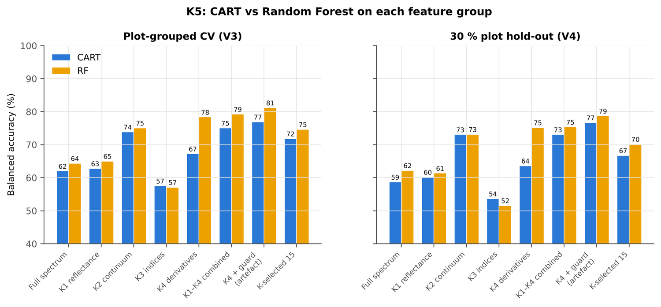
Figure 80. Variety V2: K5 — CART vs RF on each disease-sensitive feature group.
Table 147. Variety V2: red-edge inflection point by four methods.
REIP method | Healthy (nm) | Diseased (nm) | Shift (nm) | AUC | BA plot-grouped CV
linear extrapolation | 705.8 | 702.9 | -2.85 | 0.608 | 55.4 %
Lagrangian interpolation | 707.2 | 705.4 | -1.76 | 0.605 | 56.9 %
maximum first derivative | 707.2 | 705.4 | -1.75 | 0.604 | 55.9 %
linear 4-point interpolation | 715.2 | 714.0 | -1.20 | 0.596 | 55.3 %

4.8.7 Four tiers on the combined feature pool (Part C)
Tier 1: 2046 of 4150 features significant. Tier 2: CART selected 11 features (CR3 water 970 width, D1 2224 nm, D1 1838 nm, D1 619 nm, D1 1082 nm, R 705 nm, D1 1102 nm, D1 1788 nm, D1 968 nm, CR6 water 1940 symmetry, R 685 nm); RF-17: CR3 water 970 width, D1 2220 nm, D1 872 nm, D1 1935 nm, D1 861 nm, D1 884 nm, D1 1917 nm, D1 2210 nm, CR6 water 1940 symmetry, D1 847 nm, D1 1838 nm, D1 1743 nm, D1 907 nm, D1 987 nm, D1 1062 nm, SDr/SDy, D1 1791 nm. Tier 3: J–M 1.437 (CART set) and 1.872 (RF-17), below 1.90 for RF-17.
Table 148. Variety V2: composition of the combined pool and of the selected sets.
Feature type | Features | Tier-1 significant | CART-11 | RF-17
K1 band reflectance | 2039 | 1046 | 2 | 0
K2 continuum removal | 30 | 19 | 2 | 2
K3 vegetation index | 30 | 22 | 0 | 0
K4 edge parameter | 20 | 15 | 0 | 1
K4 first-derivative band | 2031 | 944 | 7 | 14

Table 149. Variety V2: balanced accuracy of the four pipelines on the combined pool.
Pipeline | V1 | V3 (± SD) | V4 (± SD) | V5 | AUC V3 | κ V3
CART classifier | 80.0 % | 75.2 % ± 3.3 | 75.3 % ± 7.1 | 57.5 % | 0.792 | 0.416
RF classifier | 84.7 % | 80.1 % ± 1.8 | 74.2 % ± 4.6 | 55.8 % | 0.851 | 0.497
QDA on CART features | 82.7 % | 73.7 % ± 2.6 | 75.8 % ± 3.5 | 60.2 % | 0.833 | 0.301
QDA on RF features | 85.7 % | 75.9 % ± 2.0 | 71.8 % ± 8.3 | 57.8 % | 0.833 | 0.427

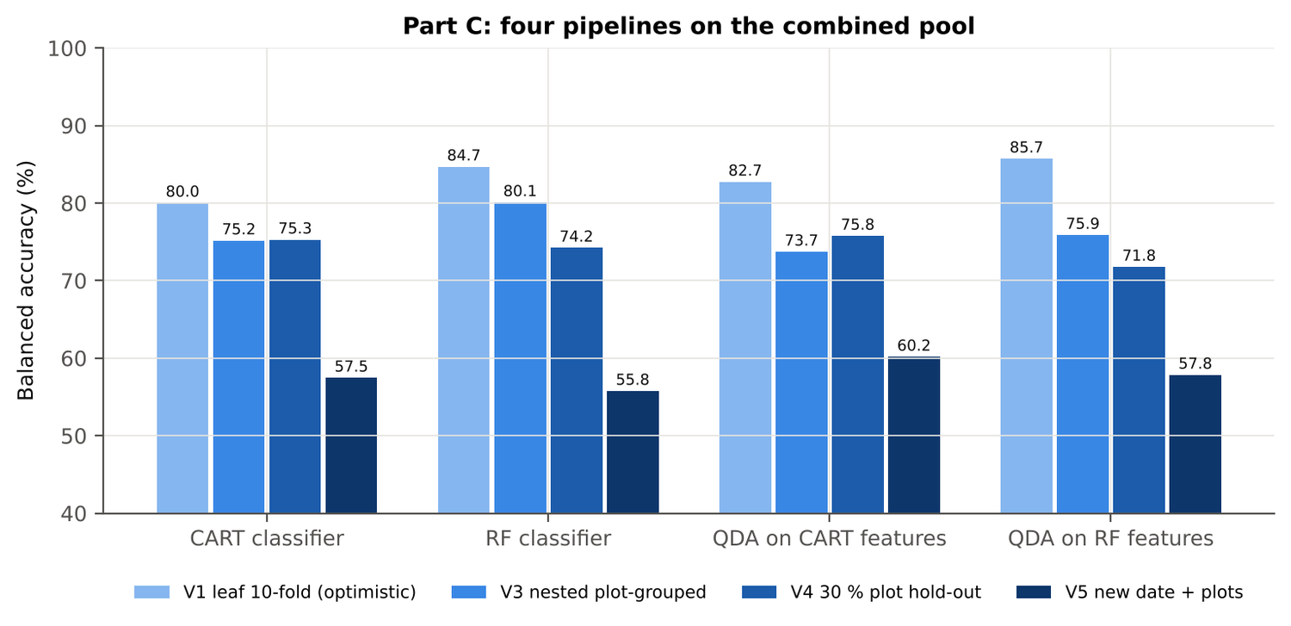
Figure 81. Variety V2: four pipelines on the combined pool under V1, V3, V4 and V5.
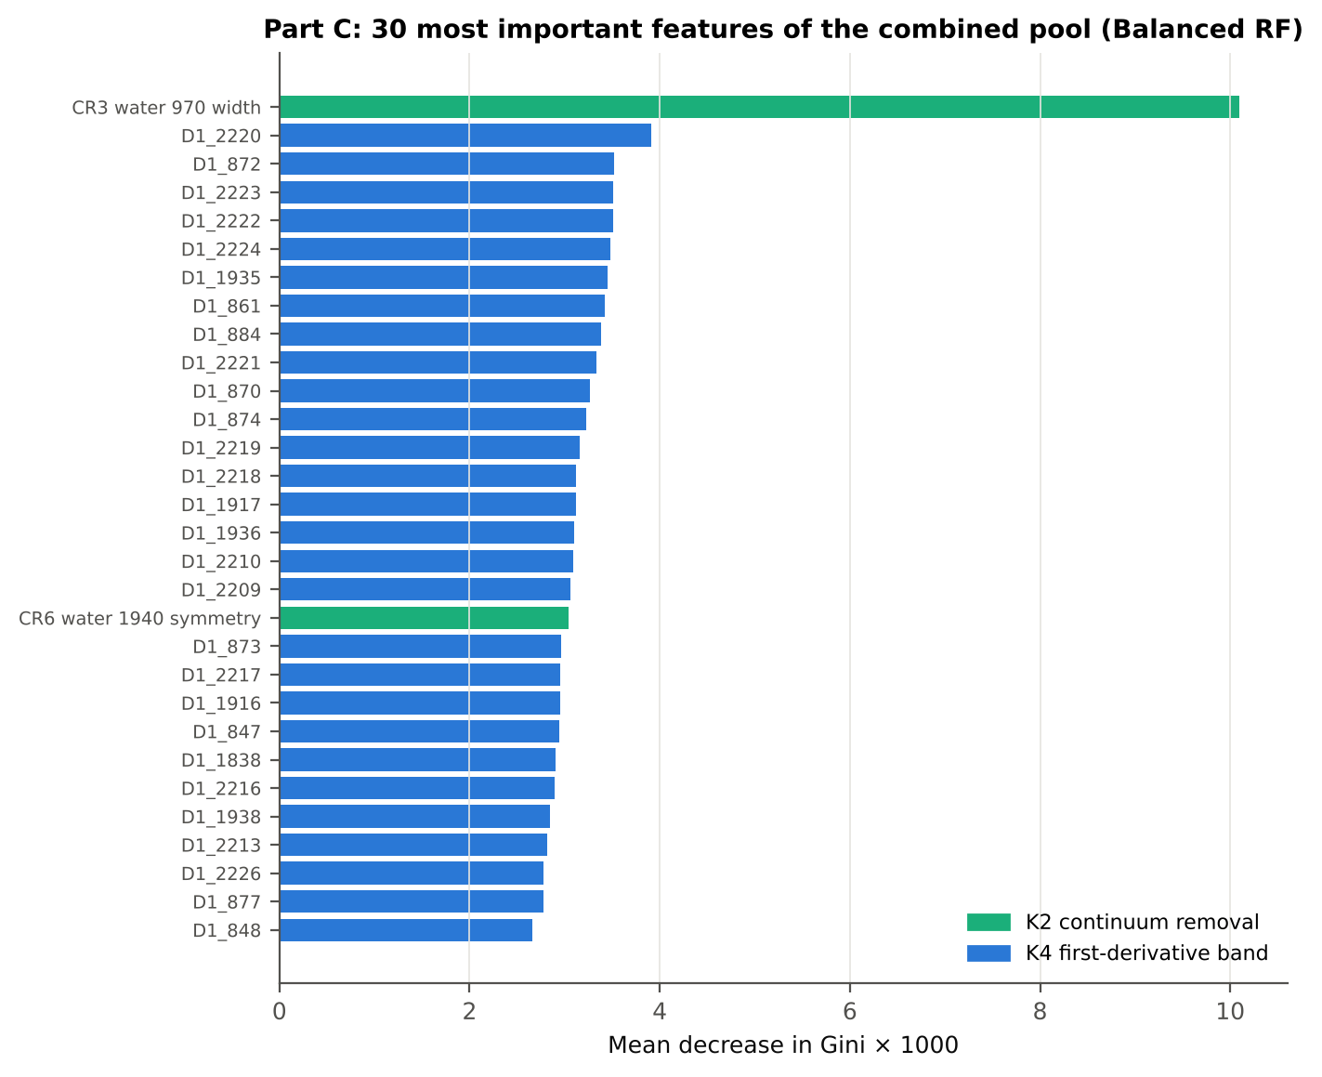
Figure 82. Variety V2: the 30 most important features of the combined pool (Balanced RF).
Table 150. Variety V2: combined pool vs reflectance vs K5 (paired over the V3 folds).
First | Second | Mean Δ BA | First better / n | Wilcoxon p
Combined pool: QDA on CART features | Reflectance: QDA on CART bands | 2.7 pts | 14 / 20 | 0.048
Combined pool: QDA on RF features | Reflectance: QDA on RF bands | 4.5 pts | 15 / 20 | 0.040
Combined pool: RF classifier (Tier-1 features) | Reflectance: RF classifier (Tier-1 bands) | 16.4 pts | 20 / 20 | 8.8e-5
Combined pool: CART classifier (Tier-1 features) | Reflectance: CART classifier (Tier-1 bands) | 12.5 pts | 20 / 20 | 8.8e-5
Combined pool: QDA on RF features | Combined pool: QDA on CART features | 2.4 pts | 13 / 20 | 0.093
Combined pool: QDA on RF features | K5: RF classifier on all 4151 features | -3.4 pts | 8 / 20 | 0.036
Combined pool: QDA on RF features | K5: QDA on 15 features chosen by AUC | 4.5 pts | 18 / 20 | 0.004
Combined pool: RF classifier (Tier-1 features) | K5: RF classifier on all 4151 features | 1.1 pts | 10 / 20 | 0.296

4.8.8 Transfer (V5)
Table 151. Variety V2: balanced accuracy by held-out date (trained on the other dates, tested on new plots of the held-out date).
Feature set · pipeline | 11-02-2026 | 24-02-2026 | 03-03-2026 | 13-03-2026
Reflectance · CART classifier | 47.5 % | 47.6 % | 57.0 % | 50.2 %
Reflectance · RF classifier | 45.6 % | 45.8 % | 52.4 % | 50.3 %
Reflectance · QDA on CART features | 49.6 % | 50.1 % | 54.9 % | 50.0 %
Reflectance · QDA on RF features | 56.8 % | 52.7 % | 63.0 % | 50.0 %
Combined pool · CART classifier | 54.3 % | 60.8 % | 59.8 % | 50.7 %
Combined pool · RF classifier | 60.1 % | 54.0 % | 54.4 % | 49.9 %
Combined pool · QDA on CART features | 49.5 % | 61.4 % | 75.5 % | 48.0 %
Combined pool · QDA on RF features | 60.6 % | 59.6 % | 59.4 % | 50.0 %

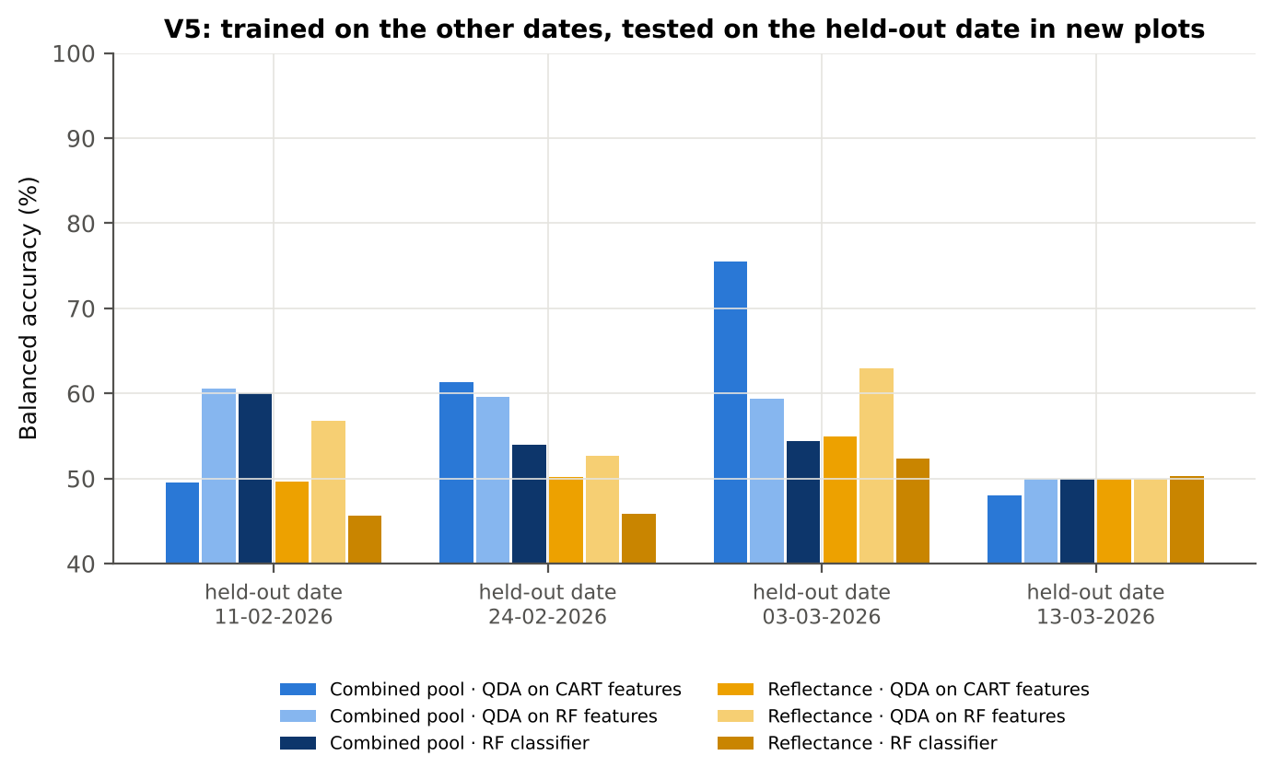
Figure 83. Variety V2: V5 transfer by held-out date.

4.8.9 Interpretation
Tier 1: healthy and white-rust leaves differ significantly at 1087 of 2101 bands (Welch + BH-FDR); 907 bands remain significant with a random plot effect and 644 in ≥ 95 % of 1000 balanced subsets. The most sensitive single band (smoothed reflectance) reaches AUC 0.69 at 1895 nm.
Tier 2: CART (rpart, prior 0.5/0.5) selected 19 bands (root 1895 nm): 1895, 2421, 701, 1944, 1463, 1584, 1889, 648, 1861, 507, 506, 2158, 691, 2374, 1396, 1508, 1788, 1378, 1981 nm. The Balanced RF importance peaks (RF-17) were 1895, 1931, 1951, 1987, 1997, 1969, 1379, 701, 689, 1919, 2007, 711, 491, 615, 657, 513, 645 nm.
Tier 3: J–M = 1.81 on the CART bands and 1.82 on the RF bands: neither set reaches the 1.90 separability threshold (Das et al. used 1.94).
Tier 4: QDA with equal priors on the CART bands gives BA 81.6 % in the paper's protocol (V1; healthy recall 87.3 %, diseased recall 75.9 %) and 70.9 % ± 1.5 % (V3 nested, plot-grouped) / 69.7 % (V4 hold-out plots) on new plots.
CART vs RF: as classifiers RF and CART perform alike (+1.6 points; V3, RF better in 9 of 20 folds, p = 0.295); as band selectors for QDA the RF bands give +0.6 points vs the CART bands (p = 0.575). RF selection is more stable than CART selection (Jaccard ±10 nm 0.56 vs 0.27).
Disease-sensitive features (Part K): the strongest group for RF is K4 derivatives + edge parameters (BA 78.3 %, V3) vs 64.9 % for reflectance; best single features: first derivative at 884 nm (AUC 0.75), CR3 water 970 width (AUC 0.77), NWI2 (AUC 0.67), Ro (red well reflectance) (AUC 0.64). REIP (linear extrapolation) shifts by -2.8 nm in diseased leaves (AUC 0.61).
Part C (four tiers on the combined K1 + K2–K4 pool, 4150 features, 2046 significant): CART chose 11 features, RF 17 (J–M 1.44 / 1.87); QDA on the RF features reaches 75.9 % (V3) / 71.8 % (V4), +4.5 points vs QDA on RF reflectance bands; best pipeline on the pool: RF classifier (80.1 %, V3).
Transfer (V5, leave-one-date-out on new plots): QDA on CART reflectance bands 52.1 %, QDA on combined-pool RF features 57.8 % — a clear drop from the V3 estimate (75.9 %); the date/stage effect limits transfer. Best pipeline under transfer: combined pool: QDA on CART features (60.2 %).
Compared with all dates, stages and varieties pooled (V3: reflectance QDA-CART 72.0 %, combined-pool QDA-RF 83.7 %; J–M 1.27), this subset gives 70.9 % and 75.9 % (J–M 1.81): discrimination is lower than in the pooled analysis (fewer leaves and plots).

Recommendations for this subset
- Use first-derivative and continuum-removed features rather than single reflectance bands for this subset; the four-tier selection with RF importance on the combined pool and a QDA or RF classifier is the recommended pipeline.
- Report balanced accuracy with both class recalls and the priors used; the classes are imbalanced (1 : 5.1) and equal priors / balanced sampling were applied throughout.
- Base conclusions on the plot-grouped estimates (V3 4-fold × 5 = 20 folds, V4 10 hold-outs), not on the leaf-level V1 estimate.
- Interpret features near the ASD detector joins (≈ 1000 and 1800 nm) with care; guard zones were excluded from the rankings.
- For application to a new date, the most robust pipeline here was combined pool: QDA on CART features (V5 BA 60.2 %); accuracy on an unseen date is much lower than within the date, so calibrate with leaves of the target date or growth stage.
- Only 4 healthy plots are in this subset: validation folds hold few healthy plots each, so the SDs of V3/V4 are large and the results should be confirmed with more healthy plots.

Cross-checks
40 checks passed, 7 were flagged and 0 failed. Flagged items are limitations reported in the workbook, not errors: Exact duplicates among the remaining spectra; Training sets with < 2 FDR-significant features (nested V3/V4/V5); QDA in R; Permutation importance (drop in AUC, 4 plot-grouped folds) vs Gini, top-50 bands; Detector artefact at the 1800/1801 nm join; Selection optimism; Best pair straddles a detector join?.

4.9 Variety V3 — variety V3 only

4.9.1 Data and validation design
This subset contains 752 leaf spectra (126 healthy, 626 diseased; ratio 1 : 5.0) from 4 healthy and 12 diseased plots, measured on 11-02-2026, 24-02-2026, 03-03-2026, 13-03-2026; growth stages Flowering, Pod formation, Vegetative; varieties V3. V3 used 4-fold plot-grouped CV × 5 (20 training sets), V4 held out 1 healthy + 4 diseased plots × 10, and V5 was leave-one-date-out on new plots (40 units).
Table 152. Variety V3: leaf spectra by date and growth stage.
Date | Growth stage | Healthy | Diseased
11-02-2026 | Vegetative | 24 | 116
24-02-2026 | Flowering | 18 | 90
24-02-2026 | Vegetative | 12 | 60
03-03-2026 | Flowering | 36 | 180
13-03-2026 | Flowering | 9 | 45
13-03-2026 | Pod formation | 27 | 135

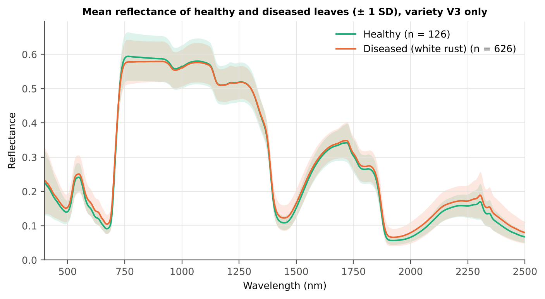
Figure 84. Variety V3: mean reflectance of healthy and diseased leaves (± 1 SD).

4.9.2 Tier 1 — statistical screening
Table 153. Variety V3: number of significant bands by test.
Test | Significant bands (of 2101)
Welch t-test + BH-FDR q < 0.05 (used for Tier 2) | 1150
One-way ANOVA p < 0.05, uncorrected (rule of Das et al.) | 1213
One-way ANOVA + BH-FDR q < 0.05 | 1135
Welch t-test p < 0.05, uncorrected | 1249
Mixed model (random plot effect) + BH-FDR q < 0.05 | 0
Balanced subsets (126 vs 126): significant in ≥ 95 % of 1000 subsets | 569
Levene test p < 0.05 (unequal variances → Welch) | 878

Table 154. Variety V3: largest contiguous ranges of FDR-significant bands.
Contiguous significant range (nm) | Bands
1820–2500 | 681
1383–1575 | 193
551–717 | 167
469–534 | 66
742–784 | 43

Table 155. Variety V3: ten bands with the largest |t|.
Band (nm) | Mean H | Mean D | Welch t | q (BH) | Hedges g | AUC
692 | 0.1204 | 0.1416 | 9.09 | 0.00e+0 | 0.57 | 0.685
691 | 0.1152 | 0.1356 | 9.08 | 0.00e+0 | 0.57 | 0.686
693 | 0.1264 | 0.1485 | 9.07 | 0.00e+0 | 0.57 | 0.683
690 | 0.1109 | 0.1304 | 9.02 | 0.00e+0 | 0.56 | 0.685
694 | 0.1333 | 0.1561 | 9.00 | 0.00e+0 | 0.57 | 0.681
689 | 0.1074 | 0.1259 | 8.92 | 0.00e+0 | 0.56 | 0.684
695 | 0.1411 | 0.1646 | 8.91 | 0.00e+0 | 0.57 | 0.678
688 | 0.1045 | 0.1222 | 8.79 | 0.00e+0 | 0.55 | 0.683
696 | 0.1498 | 0.1737 | 8.77 | 0.00e+0 | 0.56 | 0.675
687 | 0.1022 | 0.1190 | 8.64 | 0.00e+0 | 0.55 | 0.681

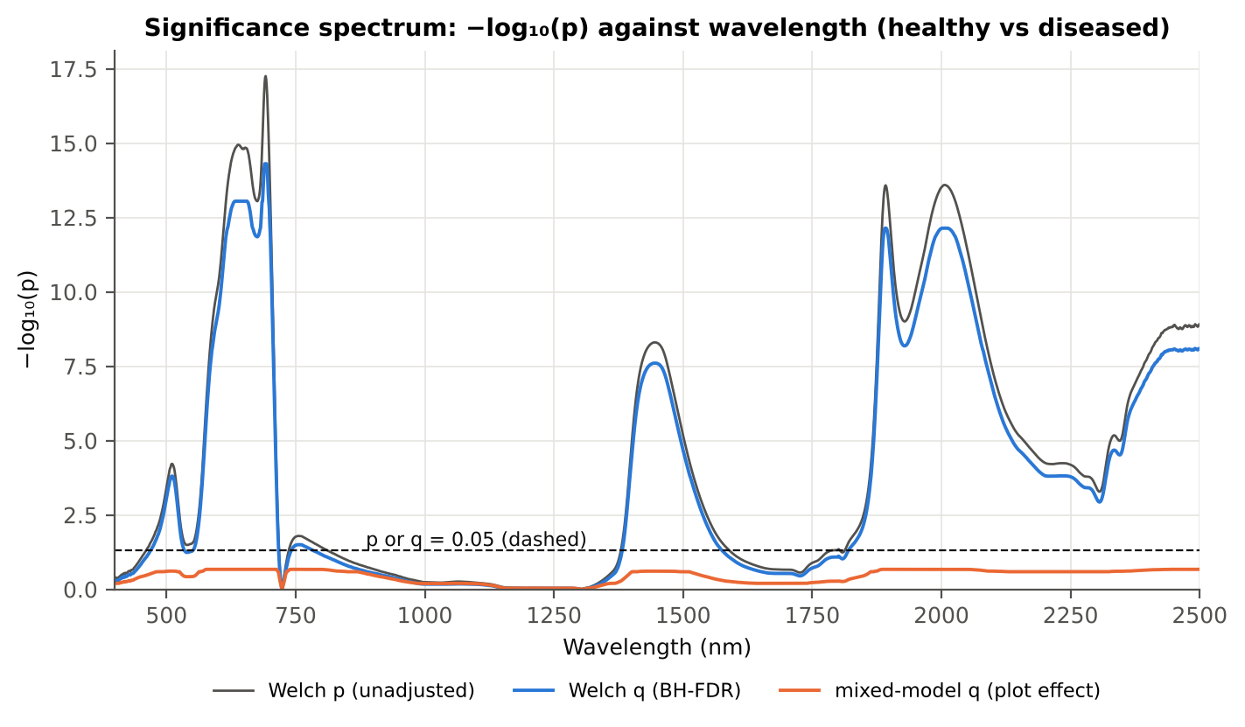
Figure 85. Variety V3: −log₁₀(p) against wavelength (Welch p, BH q and mixed-model q; dashed p or q = 0.05).

4.9.3 Tier 2 — CART and Random Forest band selection
Table 156. Variety V3: the CART-16 bands selected by rpart (prior 0.5/0.5) and how often a band within ± 10 nm is re-selected.
Band (nm) | Region | First used at node | Bootstrap re-selection | Nested-CV re-selection
638 | Red (600–679) | 354 | 28.5 % | 60.0 %
690 | Red edge (680–759) | 709 | 87.0 % | 95.0 %
693 | Red edge (680–759) | 1 | 93.0 % | 100.0 %
702 | Red edge (680–759) | 22 | 96.0 % | 100.0 %
747 | Red edge (680–759) | 5 | 63.0 % | 25.0 %
750 | Red edge (680–759) | 44 | 64.5 % | 25.0 %
761 | NIR (760–1349) | 88 | 31.5 % | 0.0 %
1394 | Water band I (1350–1430) | 10 | 45.0 % | 25.0 %
1822 | Water band II (1800–1950) | 177 | 9.0 % | 0.0 %
1883 | Water band II (1800–1950) | 3 | 61.5 % | 50.0 %
1897 | Water band II (1800–1950) | 13 | 65.0 % | 50.0 %
1923 | Water band II (1800–1950) | 6 | 53.5 % | 75.0 %
1984 | SWIR-2 (1951–2349) | 20 | 22.0 % | 15.0 %
2029 | SWIR-2 (1951–2349) | 11 | 33.0 % | 50.0 %
2399 | SWIR-2 end (2350–2500) | 2 | 18.0 % | 15.0 %
2457 | SWIR-2 end (2350–2500) | 1418 | 11.5 % | 15.0 %

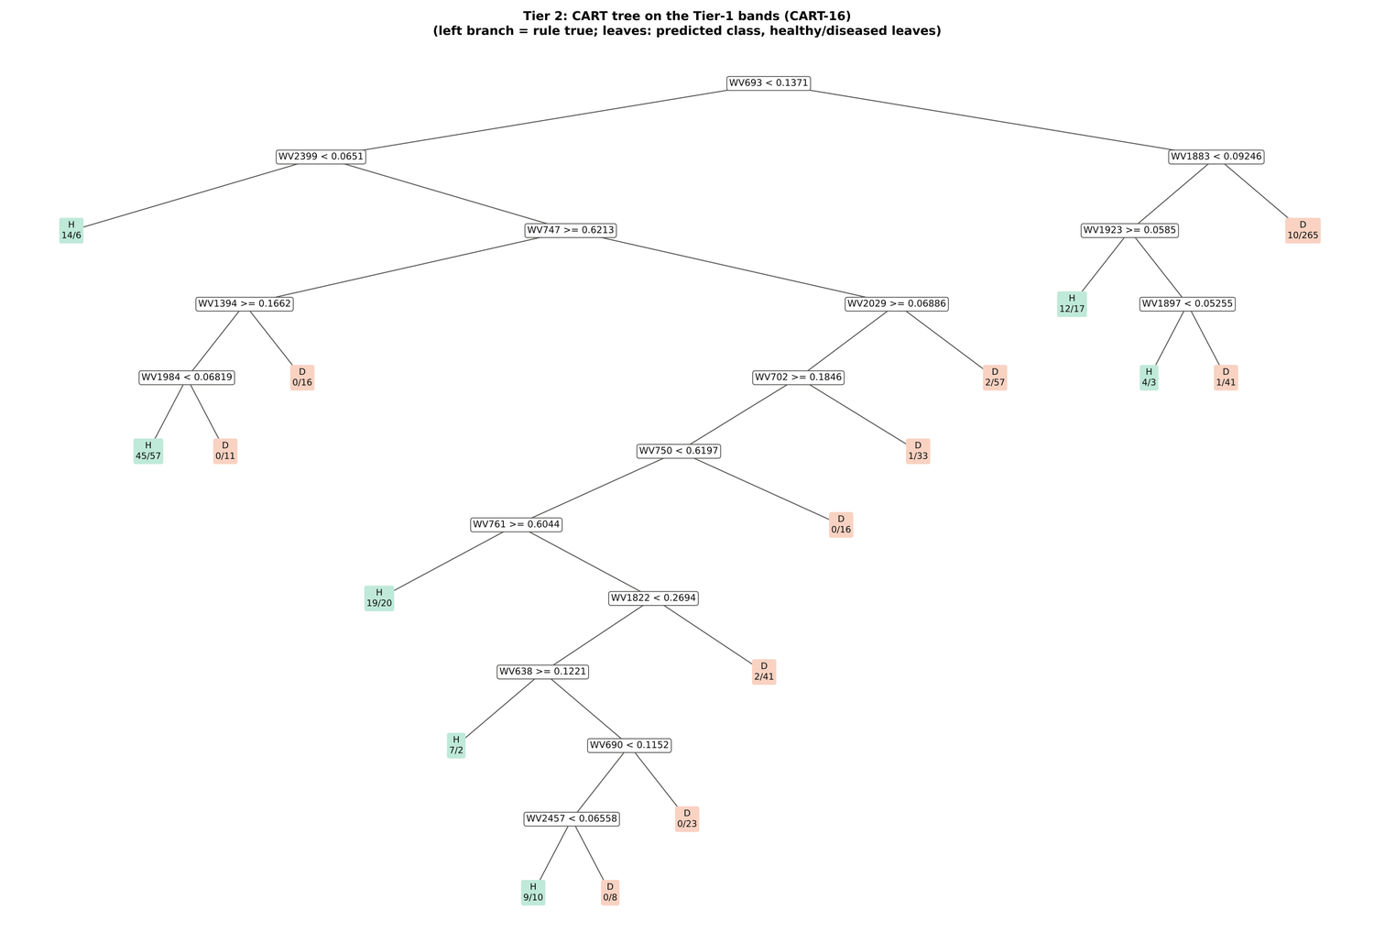
Figure 86. Variety V3: CART tree on the Tier-1 bands (CART-16).
RF-17 importance peaks: 697, 749, 765, 708, 660, 1888, 638, 777, 2020, 685, 527, 2008, 673, 624, 1921, 649, 555 nm.
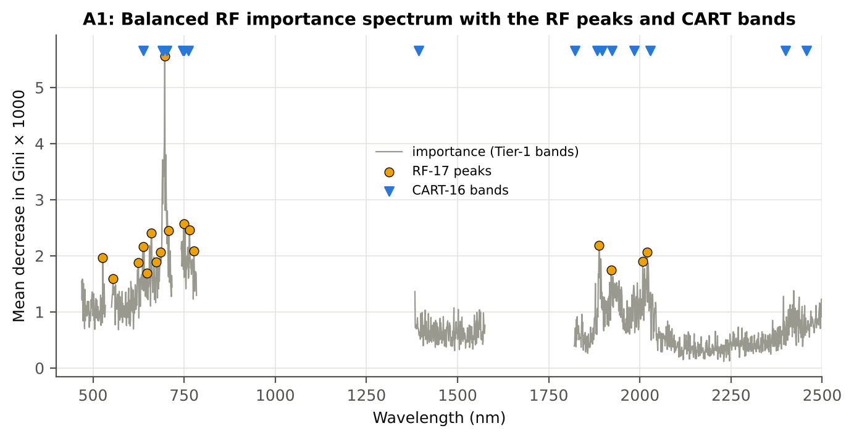
Figure 87. Variety V3: Balanced RF importance spectrum with the RF-17 peaks and the CART bands.

4.9.4 Tier 3 and Tier 4 — separability and classification
Table 157. Variety V3: Jeffries–Matusita distance of healthy and diseased leaves.
Band set | Bands | α (Bhattacharyya) | J–M (0–2) | √J–M | Separability
CART-16 | 16 | 1.672 | 1.624 | 1.274 | below 1.90
CART-4 (1-SE) | 4 | 0.439 | 0.710 | 0.843 | below 1.90
RF-17 | 17 | 2.132 | 1.763 | 1.328 | below 1.90
RF-10 | 10 | 0.849 | 1.144 | 1.070 | below 1.90
RF-16 (size-matched) | 16 | 1.876 | 1.694 | 1.301 | below 1.90

Table 158. Variety V3: error matrix of QDA (equal priors) on the CART-16 bands, leaf-level 10-fold CV (V1; as Table 2 of Das et al.).
Classified \ Reference | Healthy | Diseased | Row total | User's accuracy
Healthy | 108 | 291 | 399 | 27.1 %
Diseased | 18 | 335 | 353 | 94.9 %
Column total | 126 | 626 | 752
Producer's accuracy | 85.7 % | 53.5 %
Overall accuracy | 58.9 % | Balanced accuracy | 69.6 % | κ = 0.210

Table 159. Variety V3: Tier 4 on all band sets (V1), with equal and sample priors and LDA for comparison.
Band set | Classifier | OA | BA | PA healthy | PA diseased | κ
CART-16 | QDA equal priors | 58.9 % | 69.6 % | 85.7 % | 53.5 % | 0.210
CART-16 | QDA sample priors | 69.7 % | 73.9 % | 80.2 % | 67.6 % | 0.305
CART-16 | LDA equal priors | 68.3 % | 71.8 % | 77.0 % | 66.6 % | 0.278
CART-4 (1-SE) | QDA equal priors | 45.9 % | 63.0 % | 88.9 % | 37.2 % | 0.119
CART-4 (1-SE) | QDA sample priors | 71.7 % | 62.1 % | 47.6 % | 76.5 % | 0.192
CART-4 (1-SE) | LDA equal priors | 56.9 % | 62.1 % | 69.8 % | 54.3 % | 0.135
RF-17 | QDA equal priors | 56.4 % | 67.5 % | 84.1 % | 50.8 % | 0.183
RF-17 | QDA sample priors | 64.1 % | 69.9 % | 78.6 % | 61.2 % | 0.236
RF-17 | LDA equal priors | 68.6 % | 72.3 % | 77.8 % | 66.8 % | 0.284
RF-10 | QDA equal priors | 55.6 % | 66.7 % | 83.3 % | 50.0 % | 0.173
RF-10 | QDA sample priors | 68.8 % | 68.2 % | 67.5 % | 69.0 % | 0.246
RF-10 | LDA equal priors | 64.5 % | 69.5 % | 77.0 % | 62.0 % | 0.234
RF-16 (size-matched) | QDA equal priors | 59.2 % | 69.1 % | 84.1 % | 54.1 % | 0.207
RF-16 (size-matched) | QDA sample priors | 66.8 % | 71.5 % | 78.6 % | 64.4 % | 0.265
RF-16 (size-matched) | LDA equal priors | 69.2 % | 73.9 % | 81.0 % | 66.8 % | 0.301

4.9.5 Validation and CART versus RF (Part A)
Table 160. Variety V3: balanced accuracy of the four pipelines on raw reflectance under the validation schemes.
Pipeline | V1 | V3 (± SD) | V4 (± SD) | V5 | AUC V3 | κ V3
CART classifier | 60.9 % | 61.0 % ± 1.4 | 59.5 % ± 3.6 | 51.8 % | 0.607 | 0.162
RF classifier | 69.8 % | 65.2 % ± 1.2 | 63.8 % ± 4.0 | 52.6 % | 0.699 | 0.229
QDA on CART features | 69.6 % | 69.6 % ± 0.5 | 66.9 % ± 7.1 | 52.6 % | 0.777 | 0.230
QDA on RF features | 67.5 % | 66.2 % ± 1.0 | 69.8 % ± 4.1 | 55.8 % | 0.742 | 0.175

Table 161. Variety V3: validation of QDA on CART bands — effect of the imbalance correction (equal vs sample priors) and of random under-sampling (V3-RUS).
Scheme | Priors | BA | SD | OA | PA healthy | PA diseased
V1 · leaf-level 10-fold, bands fixed | equal (corrected) | 69.6 % | – | 58.9 % | 85.7 % | 53.5 %
V2 · plot-grouped 4-fold, bands fixed | equal (corrected) | 67.2 % | – | 59.6 % | 78.6 % | 55.8 %
V3 · nested plot-grouped 4-fold × 5 = 20 folds | equal (corrected) | 69.6 % | 0.5 | 63.3 % | 79.0 % | 60.1 %
V4 · 30 % plot hold-out × 10 | equal (corrected) | 66.9 % | 7.1 | 56.1 % | 81.5 % | 52.3 %
V5 · leave-one-date-out on new plots (40 units) | equal (corrected) | 52.6 % | 7.2 | 65.8 % | 34.6 % | 70.6 %
V1 · leaf-level 10-fold, bands fixed | sample (uncorrected) | 73.9 % | – | 69.7 % | 80.2 % | 67.6 %
V2 · plot-grouped 4-fold, bands fixed | sample (uncorrected) | 70.1 % | – | 69.2 % | 71.4 % | 68.7 %
V3 · nested plot-grouped 4-fold × 5 = 20 folds | sample (uncorrected) | 70.5 % | 0.8 | 69.5 % | 71.9 % | 69.0 %
V4 · 30 % plot hold-out × 10 | sample (uncorrected) | 70.2 % | 6.3 | 65.8 % | 76.1 % | 64.3 %
V5 · leave-one-date-out on new plots (40 units) | sample (uncorrected) | 52.1 % | 6.4 | 69.9 % | 27.8 % | 76.5 %
V3-RUS · nested + random under-sampling | equal (corrected) | 62.8 % | – | 49.7 % | 82.5 % | 43.1 %
V3-RUS · nested + random under-sampling | sample (uncorrected) | 62.8 % | – | 49.7 % | 82.5 % | 43.1 %

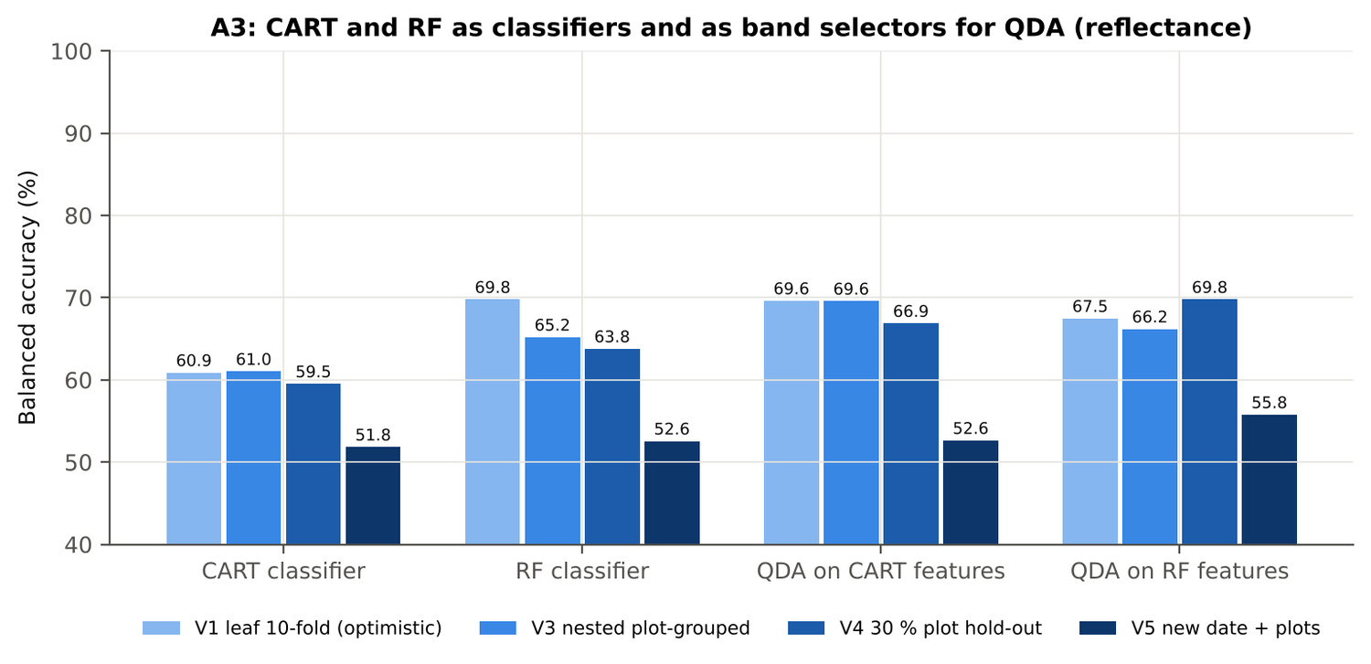
Figure 88. Variety V3: CART and RF as classifiers and as band selectors for QDA (Part A).
Table 162. Variety V3: paired comparisons on identical folds (positive = first pipeline better).
Comparison | Units | n | Mean Δ BA | First better | Wilcoxon p
RF classifier − CART classifier | V3 nested (folds) | 20 | 4.3 pts | 19 | 1.6e-4
RF classifier − CART classifier | V4 hold-out (splits) | 10 | 4.3 pts | 9 | 0.014
QDA on RF features − QDA on CART features | V3 nested (folds) | 20 | -3.3 pts | 4 | 0.006
QDA on RF features − QDA on CART features | V4 hold-out (splits) | 10 | 2.9 pts | 6 | 0.193
QDA on CART features − CART classifier | V3 nested (folds) | 20 | 8.2 pts | 18 | 4.4e-4
QDA on CART features − CART classifier | V4 hold-out (splits) | 10 | 7.4 pts | 8 | 0.020
QDA on RF features − RF classifier | V3 nested (folds) | 20 | 0.7 pts | 12 | 0.501
QDA on RF features − RF classifier | V4 hold-out (splits) | 10 | 6.0 pts | 9 | 0.004

4.9.6 Disease-sensitive features (Part K)
Table 163. Variety V3: most sensitive single features of each family (threshold classifier validated on plots).
Family | Feature | AUC | Direction | BA plot-grouped CV | BA hold-out
K2 continuum removal | CR3 water 970 width | 0.750 | D < H | 68.8 % | 67.2 %
K2 continuum removal | CR6 water 1940 symmetry | 0.682 | D > H | 68.1 % | 68.8 %
K2 continuum removal | CR6 water 1940 position | 0.669 | D > H | 63.6 % | 63.9 %
K3 index | RVS2 | 0.671 | D < H | 59.2 % | 57.6 %
K3 index | NDVI761 | 0.671 | D < H | 58.0 % | 57.4 %
K3 index | SR761 | 0.671 | D < H | 58.0 % | 57.4 %
K4 edge parameter | Ro (red well reflectance) | 0.667 | D > H | 59.1 % | 55.3 %
K4 edge parameter | λb (blue-edge position, nm) | 0.651 | D < H | 62.7 % | 61.5 %
K4 first derivative | D1 848 nm | 0.810 | D > H | – | –
K4 first derivative | D1 847 nm | 0.809 | D > H | – | –
K4 first derivative | D1 849 nm | 0.808 | D > H | – | –
K1 reflectance | R 691 nm (680–759) | 0.686 | D > H | 62.0 % | –
K1 reflectance | R 660 nm (600–679) | 0.675 | D > H | 61.5 % | –
K3b optimised index | NDSI(849,851) | 0.826 |  | 74.1 % | –
K3b optimised index | DI(849,851) | 0.827 |  | 74.1 % | –

Table 164. Variety V3: K5 — CART vs Balanced RF on each feature group (balanced accuracy).
Feature group | CART (V3) | RF (V3) | CART (V4) | RF (V4)
Full raw spectrum | 58.4 % | 64.6 % | 57.6 % | 64.1 %
K1 band reflectance | 63.7 % | 64.4 % | 61.7 % | 63.7 %
K2 continuum removal | 73.6 % | 79.5 % | 73.2 % | 80.4 %
K3 vegetation indices | 61.9 % | 64.3 % | 60.2 % | 62.5 %
K4 derivatives + edge parameters | 75.7 % | 79.6 % | 72.9 % | 78.6 %
K1–K4 combined pool | 75.9 % | 79.2 % | 71.6 % | 78.7 %
K4 incl. guard bands (artefact test) | 78.3 % | 87.0 % | 82.5 % | 85.7 %
K-selected 15 | 74.0 % | 80.7 % | 73.7 % | 76.3 %

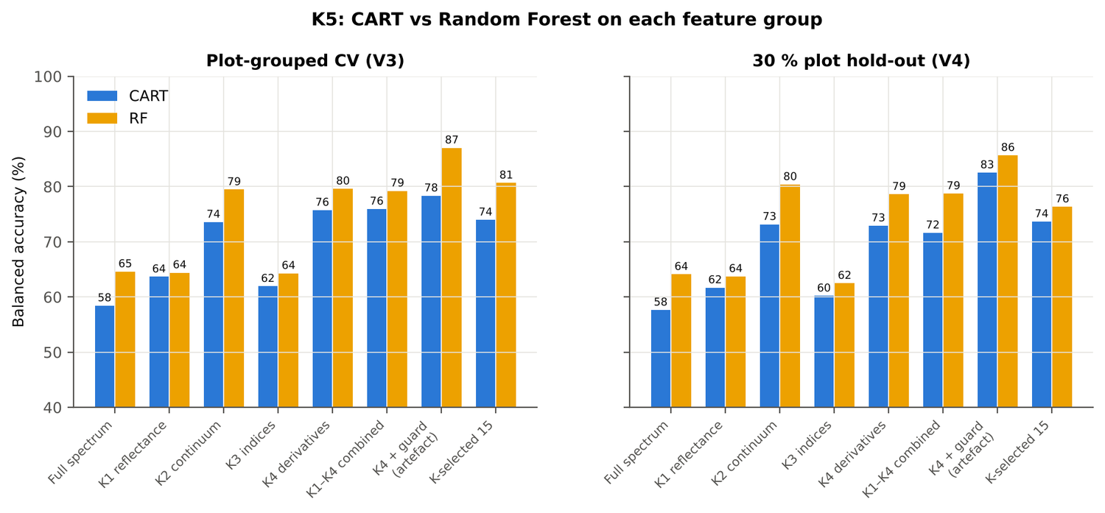
Figure 89. Variety V3: K5 — CART vs RF on each disease-sensitive feature group.
Table 165. Variety V3: red-edge inflection point by four methods.
REIP method | Healthy (nm) | Diseased (nm) | Shift (nm) | AUC | BA plot-grouped CV
linear extrapolation | 707.6 | 703.9 | -3.70 | 0.636 | 60.3 %
Lagrangian interpolation | 708.4 | 706.1 | -2.35 | 0.630 | 60.8 %
maximum first derivative | 708.4 | 706.0 | -2.34 | 0.629 | 61.1 %
linear 4-point interpolation | 715.7 | 714.2 | -1.55 | 0.628 | 60.9 %

4.9.7 Four tiers on the combined feature pool (Part C)
Tier 1: 2119 of 4150 features significant. Tier 2: CART selected 10 features (D1 851 nm, D1 2224 nm, CR6 water 1940 symmetry, ARI, D1 2494 nm, D1 972 nm, D1 1930 nm, D1 677 nm, D1 1838 nm, D1 1059 nm); RF-17: D1 856 nm, D1 846 nm, D1 872 nm, CR6 water 1940 symmetry, D1 834 nm, D1 2225 nm, CR3 water 970 width, D1 1919 nm, D1 1945 nm, D1 1934 nm, D1 979 nm, D1 885 nm, D1 1057 nm, D1 817 nm, D1 1839 nm, D1 899 nm, D1 1905 nm. Tier 3: J–M 1.325 (CART set) and 1.751 (RF-17), below 1.90 for RF-17.
Table 166. Variety V3: composition of the combined pool and of the selected sets.
Feature type | Features | Tier-1 significant | CART-10 | RF-17
K1 band reflectance | 2039 | 1128 | 0 | 0
K2 continuum removal | 30 | 18 | 1 | 2
K3 vegetation index | 30 | 22 | 1 | 0
K4 edge parameter | 20 | 15 | 0 | 0
K4 first-derivative band | 2031 | 936 | 8 | 15

Table 167. Variety V3: balanced accuracy of the four pipelines on the combined pool.
Pipeline | V1 | V3 (± SD) | V4 (± SD) | V5 | AUC V3 | κ V3
CART classifier | 76.2 % | 72.7 % ± 2.3 | 71.6 % ± 3.8 | 59.9 % | 0.733 | 0.362
RF classifier | 83.1 % | 76.8 % ± 0.5 | 75.6 % ± 4.6 | 59.0 % | 0.863 | 0.438
QDA on CART features | 80.1 % | 76.4 % ± 1.1 | 76.4 % ± 4.9 | 54.4 % | 0.840 | 0.351
QDA on RF features | 86.4 % | 84.8 % ± 1.1 | 84.3 % ± 3.1 | 56.8 % | 0.918 | 0.574

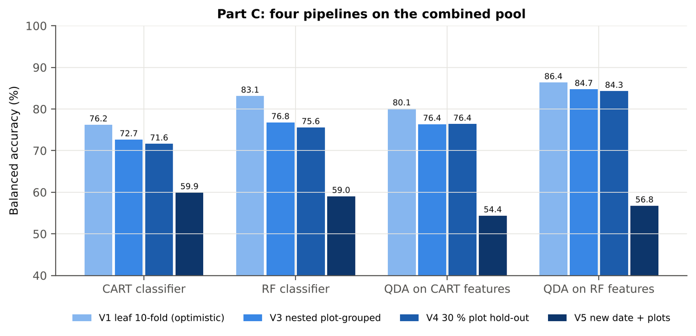
Figure 90. Variety V3: four pipelines on the combined pool under V1, V3, V4 and V5.
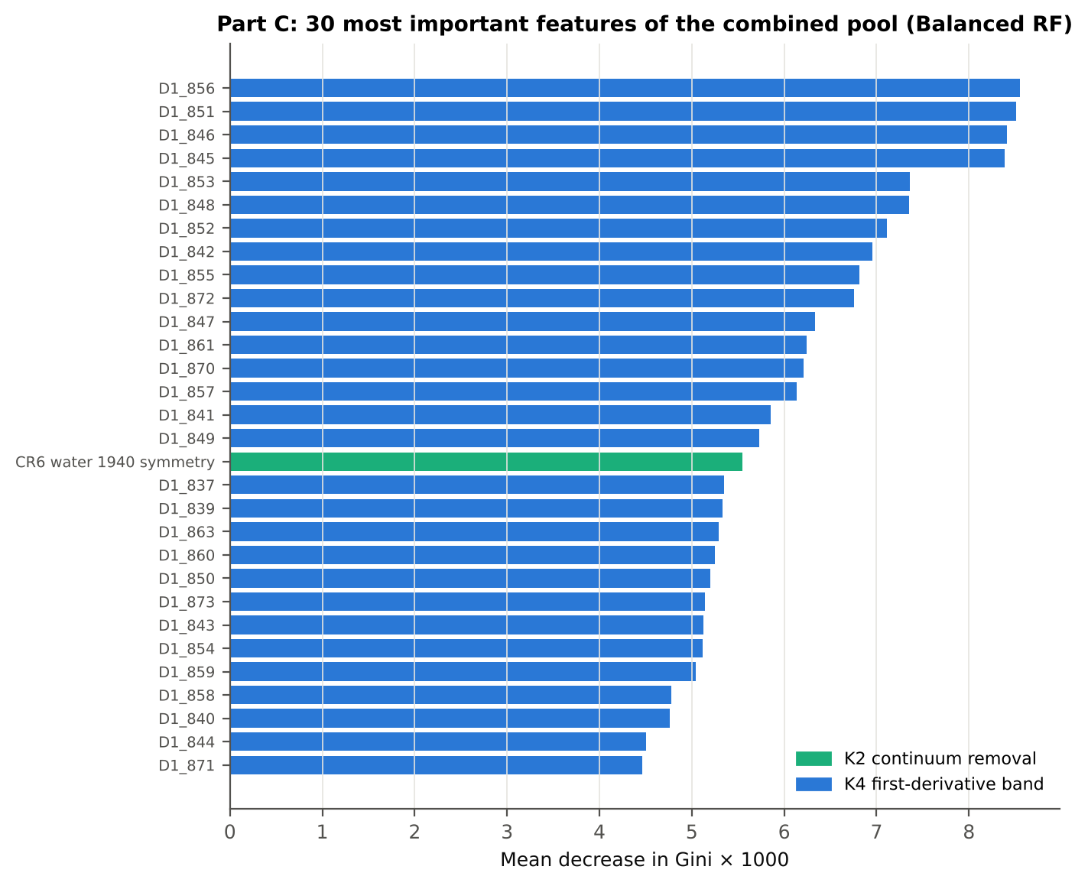
Figure 91. Variety V3: the 30 most important features of the combined pool (Balanced RF).
Table 168. Variety V3: combined pool vs reflectance vs K5 (paired over the V3 folds).
First | Second | Mean Δ BA | First better / n | Wilcoxon p
Combined pool: QDA on CART features | Reflectance: QDA on CART bands | 7.0 pts | 19 / 20 | 4.4e-4
Combined pool: QDA on RF features | Reflectance: QDA on RF bands | 18.4 pts | 20 / 20 | 8.5e-5
Combined pool: RF classifier (Tier-1 features) | Reflectance: RF classifier (Tier-1 bands) | 11.4 pts | 20 / 20 | 8.5e-5
Combined pool: CART classifier (Tier-1 features) | Reflectance: CART classifier (Tier-1 bands) | 11.3 pts | 18 / 20 | 1.8e-4
Combined pool: QDA on RF features | Combined pool: QDA on CART features | 8.2 pts | 16 / 20 | 8.7e-4
Combined pool: QDA on RF features | K5: RF classifier on all 4151 features | 5.3 pts | 15 / 20 | 0.036
Combined pool: QDA on RF features | K5: QDA on 15 features chosen by AUC | 5.6 pts | 14 / 20 | 0.004
Combined pool: RF classifier (Tier-1 features) | K5: RF classifier on all 4151 features | -2.4 pts | 5 / 20 | 0.005

4.9.8 Transfer (V5)
Table 169. Variety V3: balanced accuracy by held-out date (trained on the other dates, tested on new plots of the held-out date).
Feature set · pipeline | 11-02-2026 | 24-02-2026 | 03-03-2026 | 13-03-2026
Reflectance · CART classifier | 51.8 % | 49.3 % | 54.1 % | 50.8 %
Reflectance · RF classifier | 50.5 % | 53.4 % | 54.1 % | 51.2 %
Reflectance · QDA on CART features | 51.7 % | 53.0 % | 55.1 % | 50.9 %
Reflectance · QDA on RF features | 50.9 % | 64.9 % | 55.4 % | 50.0 %
Combined pool · CART classifier | 57.9 % | 69.0 % | 52.2 % | 59.2 %
Combined pool · RF classifier | 54.4 % | 76.6 % | 54.5 % | 49.8 %
Combined pool · QDA on CART features | 58.0 % | 54.3 % | 56.8 % | 50.3 %
Combined pool · QDA on RF features | 62.3 % | 55.9 % | 59.3 % | 50.0 %

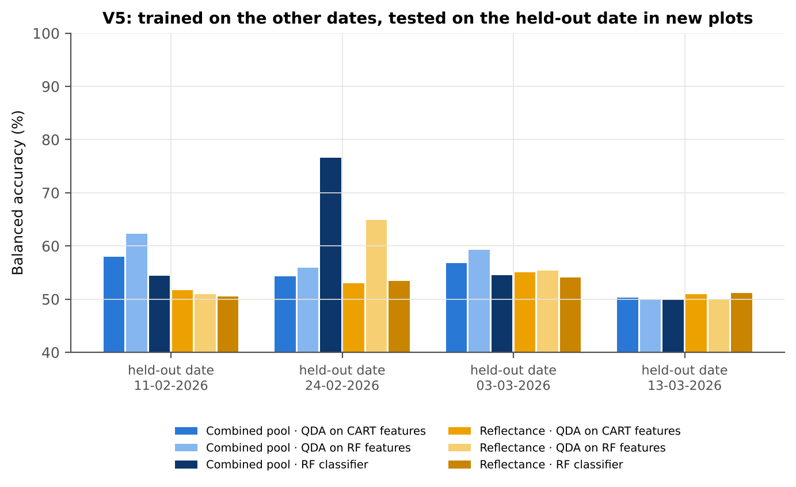
Figure 92. Variety V3: V5 transfer by held-out date.

4.9.9 Interpretation
Tier 1: healthy and white-rust leaves differ significantly at 1150 of 2101 bands (Welch + BH-FDR); 0 bands remain significant with a random plot effect and 569 in ≥ 95 % of 1000 balanced subsets. The most sensitive single band (smoothed reflectance) reaches AUC 0.69 at 691 nm.
Tier 2: CART (rpart, prior 0.5/0.5) selected 16 bands (root 693 nm): 693, 2399, 1883, 747, 1923, 1394, 2029, 1897, 1984, 702, 750, 761, 1822, 638, 690, 2457 nm. The Balanced RF importance peaks (RF-17) were 697, 749, 765, 708, 660, 1888, 638, 777, 2020, 685, 527, 2008, 673, 624, 1921, 649, 555 nm.
Tier 3: J–M = 1.62 on the CART bands and 1.76 on the RF bands: neither set reaches the 1.90 separability threshold (Das et al. used 1.94).
Tier 4: QDA with equal priors on the CART bands gives BA 69.6 % in the paper's protocol (V1; healthy recall 85.7 %, diseased recall 53.5 %) and 69.6 % ± 0.6 % (V3 nested, plot-grouped) / 66.9 % (V4 hold-out plots) on new plots.
CART vs RF: as classifiers RF beats CART by 4.3 points (V3, RF better in 19 of 20 folds, p = 1.6e-04); as band selectors for QDA the RF bands give -3.3 points vs the CART bands (p = 0.006). RF selection is more stable than CART selection (Jaccard ±10 nm 0.58 vs 0.33).
Disease-sensitive features (Part K): the strongest group for RF is K4 derivatives + edge parameters (BA 79.6 %, V3) vs 64.4 % for reflectance; best single features: first derivative at 848 nm (AUC 0.81), CR3 water 970 width (AUC 0.75), RVS2 (AUC 0.67), Ro (red well reflectance) (AUC 0.67). REIP (linear extrapolation) shifts by -3.7 nm in diseased leaves (AUC 0.64).
Part C (four tiers on the combined K1 + K2–K4 pool, 4150 features, 2119 significant): CART chose 10 features, RF 17 (J–M 1.33 / 1.75); QDA on the RF features reaches 84.7 % (V3) / 84.3 % (V4), +18.6 points vs QDA on RF reflectance bands; best pipeline on the pool: QDA on RF features (84.7 %, V3).
Transfer (V5, leave-one-date-out on new plots): QDA on CART reflectance bands 52.6 %, QDA on combined-pool RF features 56.8 % — a clear drop from the V3 estimate (84.7 %); the date/stage effect limits transfer. Best pipeline under transfer: combined pool: CART classifier (59.9 %).
Compared with all dates, stages and varieties pooled (V3: reflectance QDA-CART 72.0 %, combined-pool QDA-RF 83.7 %; J–M 1.27), this subset gives 69.6 % and 84.7 % (J–M 1.62): discrimination is similar to the pooled analysis.

Recommendations for this subset
- Use first-derivative and continuum-removed features rather than single reflectance bands for this subset; the four-tier selection with RF importance on the combined pool and a QDA or RF classifier is the recommended pipeline.
- Report balanced accuracy with both class recalls and the priors used; the classes are imbalanced (1 : 5.0) and equal priors / balanced sampling were applied throughout.
- Base conclusions on the plot-grouped estimates (V3 4-fold × 5 = 20 folds, V4 10 hold-outs), not on the leaf-level V1 estimate.
- Interpret features near the ASD detector joins (≈ 1000 and 1800 nm) with care; guard zones were excluded from the rankings.
- For application to a new date, the most robust pipeline here was combined pool: CART classifier (V5 BA 59.9 %); accuracy on an unseen date is much lower than within the date, so calibrate with leaves of the target date or growth stage.
- Only 4 healthy plots are in this subset: validation folds hold few healthy plots each, so the SDs of V3/V4 are large and the results should be confirmed with more healthy plots.

Cross-checks
40 checks passed, 7 were flagged and 0 failed. Flagged items are limitations reported in the workbook, not errors: Exact duplicates among the remaining spectra; QDA implementation (Part A (raw reflectance)); QDA in R; Permutation importance (drop in AUC, 4 plot-grouped folds) vs Gini, top-50 bands; Detector artefact at the 1800/1801 nm join; Selection optimism; QDA implementation (Part C (combined pool)).

5. Discussion

5.1 Development of the disease signal over the season
The four dates trace the epidemic. On 11-02-2026 the plots had been inoculated recently and symptoms were developing: only 216 bands differed (none with the plot effect), no single band reached AUC 0.70, the REIP did not shift, and diseased leaves were, if anything, slightly darker. Yet the derivative and continuum-removed features already separated the classes (RF 91.6 % on K4, best single feature CR6 water 1940 symmetry AUC 0.92), so changes in band shape — the NIR shoulder and the 1940 nm water feature — preceded visible changes in reflectance level. By 24-02 and 03-03-2026 white rust had produced the classical pattern of chlorophyll loss (higher visible reflectance, blue shift of the red edge up to -4.9 nm), mesophyll damage (lower NIR) and water loss (higher SWIR), and discrimination peaked (combined pool 93–94 %). On 13-03-2026, with most plants at pod formation and leaves senescing, healthy leaves also lost chlorophyll and water, the contrast narrowed and accuracy fell to 80.1 %.

5.2 Growth stage
The vegetative stage illustrates why pooling can hide a disease effect: neither of its two dates is uninformative, but the difference spectra have opposite signs in the visible and NIR on 11-02 and 24-02-2026, so no reflectance band is significant when they are pooled (Tier 1 fallback). Derivative and continuum-removed features, which describe band shape rather than level, separated the classes on both dates and gave 89.2 % (QDA on RF features) on new plots — the largest gain of the combined pool over reflectance (17.7 points). Pod formation was the most difficult subset (best 74.4 %): senescence and pod development change the spectra of healthy leaves in the same direction as the disease, the healthy class is represented by few plots on 03-03-2026, and the combined pool gained nothing over reflectance. Detection at pod formation should therefore rely on earlier measurements.

5.3 Varieties
The three varieties behaved alike: the same regions were selected (red edge, NIR shoulder, water bands), the difference spectra had the same shape with V1 strongest, and the combined pool reached 75.9–84.8 % on new plots. With only four healthy plots per variety, between-plot variation is large relative to the class difference (V3: no band significant with the mixed model), plot-grouped folds contain one healthy plot each, and validation estimates varied more between folds (V3 SD up to 2.0 points; V1 exceeded V3 by 10.8 points in V2). Variety-specific models should therefore be built with more healthy plots per variety.

5.4 CART versus Random Forest
Across subsets, RF was the better classifier and the more stable band selector, as in the pooled analysis. As a selector of bands for QDA (the Tier-2 role in Das et al.), neither method was consistently better on reflectance. In the combined pool the small CART sets (4–12 features) were about as accurate as RF-17 (within ± 5 points in eight subsets; CART better on 11-02-2026, 13-03-2026 and at pod formation, RF-17 clearly better in V3: 84.8 vs 76.4 %). CART remains useful for interpretation (its root split is usually a water or red-edge feature with a clear threshold), but RF importance gives the more reproducible feature ranking.

5.5 Disease-sensitive features versus reflectance
The most consistent result of the nine analyses is that first-derivative bands and continuum-removed water-absorption parameters discriminate white rust far better than reflectance bands or broad-band vegetation indices. Derivatives and continuum removal remove the brightness differences between leaves and dates and isolate band shape: the slope of the NIR shoulder (845–885 nm), the shape of the 970 nm and 1940 nm water absorptions and the red-edge slope. The four-tier analysis of the combined pool selects precisely these features and brings J–M above the 1.90 separability threshold in most subsets, which raw reflectance achieved only once (RF bands on 03-03-2026).

5.6 Transfer and practical use
Within a date the disease signal is consistent across varieties (V5 77.7–93.6 %), so a model calibrated on some varieties can be applied to others measured on the same day. Across dates the signal is not stable: a model trained on one or three dates classified an unseen date with 55.8–73.4 % balanced accuracy (RF classifier on the combined pool; QDA on RF features 50.0–61.2 %). Practical detection therefore requires date- or stage-specific calibration — for example a few reference healthy and diseased leaves measured at each survey — or features that are normalised against the healthy reference of the same date.

5.7 Separate versus pooled analysis
Compared with the pooled analysis of all 2264 leaves (QDA on CART bands 72.0 %, combined pool 83.7 % on new plots, J–M 1.27 on CART bands), the separate analyses gave higher accuracy and separability on 11-02, 24-02 and 03-03-2026 and in the vegetative stage, similar or slightly lower accuracy in the varieties, and lower accuracy on 13-03-2026 and at pod formation. Separate analyses also reveal what pooling hides: the late onset of a reflectance signal, the sign change between the vegetative dates, and the senescence confound at pod formation.

5.8 Limitations
- Healthy vs diseased is a plot-level label; disease severity and leaf position were not used, so mildly infected leaves of inoculated plots are labelled diseased.
- Subsets are smaller than the pooled data (428–766 leaves; 4 healthy plots per variety), so validation SDs are larger and J–M and QDA covariances are less well estimated (condition numbers are reported in the cross-checks).
- Dates and growth stages are confounded (vegetative on 11-02 and 24-02, pod formation mainly on 13-03-2026).
- In the vegetative stage and on 11-02-2026 Tier 1 needed the fallback rule; the results of Tier 2 there rest on bands with uncorrected p < 0.05.
- All results refer to leaf-level contact-probe spectra; canopy or airborne data would require masking of the atmospheric water bands.

6. Conclusions and recommendations
- White rust changes mustard leaf reflectance on every date, in both growth stages and in every variety, but the size and even the direction of the reflectance change depend on the date: from 216 significant bands on 11-02-2026 to 2050 on 03-03-2026.
- The four-tier method of Das et al. (2020) with imbalance correction works within each subset: CART selects 7–20 bands in the red edge, green and water-band regions, and QDA with equal priors classifies new plots with 69.6–84.3 % balanced accuracy; J–M on reflectance bands stays below 1.90 except on 03-03-2026 (RF bands).
- Random Forest is the better classifier (8 of 9 subsets) and the more stable selector; as a band selector for QDA neither RF nor CART is consistently better.
- First-derivative bands (NIR shoulder 845–885 nm, 1920 nm) and continuum-removed water features (970 nm width, 1940 nm symmetry/area) are the most disease-sensitive features in nearly all subsets; the four tiers on the combined pool reach 74.4–94.8 % on new plots and J–M ≥ 1.90 in 6 of 9 subsets.
- Discrimination is best at mid-season (best pipeline 93.6 % on 24-02-2026 and 94.8 % on 03-03-2026) and in the vegetative stage (90.5 %), and weakest at pod formation (74.4 %) because of senescence.
- Models transfer across varieties within a date but not across dates; calibrate per date or growth stage.

Recommendations
- For detection, use the combined pool reduced to RF-selected first-derivative and continuum-removed features, classified by QDA with equal priors or by a Balanced RF; report balanced accuracy and both class recalls.
- Measure at mid-season (flowering to early pod set) when the contrast is largest; at pod formation, include senescence-aware features or rely on earlier dates.
- Validate with folds grouped by plot and test on new dates; include healthy reference leaves from every date in the calibration.
- Use at least 8–10 healthy plots per variety for variety-specific models, and record a disease-severity score per leaf in future campaigns.

References
Ambroise C, McLachlan GJ. 2002. Selection bias in gene extraction on the basis of microarray gene-expression data. Proceedings of the National Academy of Sciences 99:6562–6566.
Babar MA, Reynolds MP, van Ginkel M, Klatt AR, Raun WR, Stone ML. 2006. Spectral reflectance indices as a potential indirect selection criteria for wheat yield under irrigation. Crop Science 46:578–588.
Benjamini Y, Hochberg Y. 1995. Controlling the false discovery rate: a practical and powerful approach to multiple testing. Journal of the Royal Statistical Society B 57:289–300.
Bhattacharyya A. 1943. On a measure of divergence between two statistical populations defined by their probability distributions. Bulletin of the Calcutta Mathematical Society 35:99–109.
Breiman L. 2001. Random forests. Machine Learning 45:5–32.
Breiman L, Friedman JH, Olshen RA, Stone CJ. 1984. Classification and regression trees. Belmont (CA): Wadsworth.
Brodersen KH, Ong CS, Stephan KE, Buhmann JM. 2010. The balanced accuracy and its posterior distribution. Proceedings of the 20th International Conference on Pattern Recognition, 3121–3124.
Chen C, Liaw A, Breiman L. 2004. Using random forest to learn imbalanced data. Technical Report 666, Department of Statistics, University of California, Berkeley.
Cho MA, Skidmore AK. 2006. A new technique for extracting the red edge position from hyperspectral data: the linear extrapolation method. Remote Sensing of Environment 101:181–193.
Clark RN, Roush TL. 1984. Reflectance spectroscopy: quantitative analysis techniques for remote sensing applications. Journal of Geophysical Research 89(B7):6329–6340.
Cohen J. 1960. A coefficient of agreement for nominal scales. Educational and Psychological Measurement 20:37–46.
Congalton RG. 1991. A review of assessing the accuracy of classifications of remotely sensed data. Remote Sensing of Environment 37:35–46.
Das B, Sahoo RN, Biswas A, Pargal S, Krishna G, Verma R, Chinnusamy V, Sehgal VK, Gupta VK. 2020. Discrimination of rice genotypes using field spectroradiometry. Geocarto International 35(1):64–77. doi:10.1080/10106049.2018.1506507
Dawson TP, Curran PJ. 1998. A new technique for interpolating the reflectance red edge position. International Journal of Remote Sensing 19:2133–2139.
Gong P, Pu R, Heald RC. 2002. Analysis of in situ hyperspectral data for nutrient estimation of giant sequoia. International Journal of Remote Sensing 23:1827–1850.
Guyot G, Baret F. 1988. Utilisation de la haute résolution spectrale pour suivre l'état des couverts végétaux. Proceedings of the 4th International Colloquium on Spectral Signatures of Objects in Remote Sensing, ESA SP-287, 279–286.
Haboudane D, Miller JR, Pattey E, Zarco-Tejada PJ, Strachan IB. 2004. Hyperspectral vegetation indices and novel algorithms for predicting green LAI of crop canopies. Remote Sensing of Environment 90:337–352.
Hanley JA, McNeil BJ. 1982. The meaning and use of the area under a receiver operating characteristic (ROC) curve. Radiology 143:29–36.
Hastie T, Tibshirani R, Friedman J. 2009. The elements of statistical learning. 2nd ed. New York: Springer.
Hedges LV. 1981. Distribution theory for Glass's estimator of effect size and related estimators. Journal of Educational Statistics 6:107–128.
Horler DNH, Dockray M, Barber J. 1983. The red edge of plant leaf reflectance. International Journal of Remote Sensing 4:273–288.
Hurlbert SH. 1984. Pseudoreplication and the design of ecological field experiments. Ecological Monographs 54:187–211.
Kokaly RF, Clark RN. 1999. Spectroscopic determination of leaf biochemistry using band-depth analysis of absorption features and stepwise multiple linear regression. Remote Sensing of Environment 67:267–287.
Kuncheva LI. 2007. A stability index for feature selection. Proceedings of the 25th IASTED International Multi-Conference: Artificial Intelligence and Applications, 390–395.
Lemaître G, Nogueira F, Aridas CK. 2017. Imbalanced-learn: a Python toolbox to tackle the curse of imbalanced datasets in machine learning. Journal of Machine Learning Research 18(17):1–5.
Levene H. 1960. Robust tests for equality of variances. In: Olkin I, editor. Contributions to probability and statistics. Stanford: Stanford University Press; p. 278–292.
Liaw A, Wiener M. 2002. Classification and regression by randomForest. R News 2(3):18–22.
Mahlein A-K. 2016. Plant disease detection by imaging sensors — parallels and specific demands for precision agriculture and plant phenotyping. Plant Disease 100:241–251.
Mahlein A-K, Rumpf T, Welke P, Dehne H-W, Plümer L, Steiner U, Oerke E-C. 2013. Development of spectral indices for detecting and identifying plant diseases. Remote Sensing of Environment 128:21–30.
Pedregosa F, Varoquaux G, Gramfort A, et al. 2011. Scikit-learn: machine learning in Python. Journal of Machine Learning Research 12:2825–2830.
Pinheiro J, Bates D, R Core Team. 2023. nlme: linear and nonlinear mixed effects models. R package.
R Core Team. 2024. R: a language and environment for statistical computing. Vienna: R Foundation for Statistical Computing.
Richards JA. 2013. Remote sensing digital image analysis. 5th ed. Berlin: Springer.
Roberts DR, Bahn V, Ciuti S, et al. 2017. Cross-validation strategies for data with temporal, spatial, hierarchical, or phylogenetic structure. Ecography 40:913–929.
Saharan GS, Verma PR, Meena PD, Kumar A. 2014. White rust of crucifers: biology, ecology and management. New Delhi: Springer India.
Savitzky A, Golay MJE. 1964. Smoothing and differentiation of data by simplified least squares procedures. Analytical Chemistry 36:1627–1639.
Seabold S, Perktold J. 2010. Statsmodels: econometric and statistical modeling with Python. Proceedings of the 9th Python in Science Conference, 92–96.
Strobl C, Boulesteix A-L, Zeileis A, Hothorn T. 2007. Bias in random forest variable importance measures: illustrations, sources and a solution. BMC Bioinformatics 8:25.
Swain PH, Davis SM. 1978. Remote sensing: the quantitative approach. New York: McGraw-Hill.
Therneau T, Atkinson B. 2023. rpart: recursive partitioning and regression trees. R package version 4.1.23.
Varma S, Simon R. 2006. Bias in error estimation when using cross-validation for model selection. BMC Bioinformatics 7:91.
Venables WN, Ripley BD. 2002. Modern applied statistics with S. 4th ed. New York: Springer.
Welch BL. 1947. The generalization of 'Student's' problem when several different population variances are involved. Biometrika 34:28–35.
Wilcoxon F. 1945. Individual comparisons by ranking methods. Biometrics Bulletin 1:80–83.
Youden WJ. 1950. Index for rating diagnostic tests. Cancer 3:32–35.
Vegetation-index sources (formulas in workbook sheet 17): Jordan 1969; Gitelson & Merzlyak 1996; Gamon et al. 1992; Chappelle et al. 1992; Blackburn 1998; Raun et al. 2001; Peñuelas et al. 1994, 1995, 1997; Barnes et al. 1992; Merzlyak et al. 1999; Haboudane et al. 2002; Gitelson et al. 2001, 2002; Merton 1998; Broge & Leblanc 2001; Roujean & Bréon 1995; Metternicht 2003; Bausch & Duke 1996.

Appendix A. Cross-check summary by subset
Table 170. Cross-checks of each subset analysis (all workbooks recalculated in LibreOffice with 0 formula errors).
Subset | PASS | FLAG | FAIL | Flagged items (limitations reported in the workbook)
Date 11-02-2026 | 44 | 3 | 0 | Exact duplicates among the remaining spectra; Training sets with < 2 FDR-significant features (nested V3/V4/V5); QDA in R
Date 24-02-2026 | 45 | 2 | 0 | Exact duplicates among the remaining spectra; Permutation importance (drop in AUC, 5 plot-grouped folds) vs Gini, top-50 bands
Date 03-03-2026 | 43 | 4 | 0 | Exact duplicates among the remaining spectra; QDA implementation (Part A (raw reflectance)); QDA in R; Selection optimism
Date 13-03-2026 | 43 | 4 | 0 | Exact duplicates among the remaining spectra; QDA in R; Permutation importance (drop in AUC, 5 plot-grouped folds) vs Gini, top-50 bands; Selection optimism
Vegetative | 40 | 8 | 0 | Exact duplicates among the remaining spectra; Fewer than 2 FDR-significant features on all leaves; Training sets with < 2 FDR-significant features (nested V3/V4/V5); Invertibility of the class covariances; QDA in R; Permutation importance (drop in AUC, 5 plot-grouped folds) vs Gini, top-50 bands; Detector artefact at the 1800/1801 nm join; Selection optimism
Pod formation | 42 | 5 | 0 | Exact duplicates among the remaining spectra; Permutation importance (drop in AUC, 5 plot-grouped folds) vs Gini, top-50 bands; Detector artefact at the 1800/1801 nm join; Selection optimism; Best pair straddles a detector join?
Variety V1 | 42 | 5 | 0 | Exact duplicates among the remaining spectra; Permutation importance (drop in AUC, 4 plot-grouped folds) vs Gini, top-50 bands; Detector artefact at the 1800/1801 nm join; Selection optimism; Best pair straddles a detector join?
Variety V2 | 40 | 7 | 0 | Exact duplicates among the remaining spectra; Training sets with < 2 FDR-significant features (nested V3/V4/V5); QDA in R; Permutation importance (drop in AUC, 4 plot-grouped folds) vs Gini, top-50 bands; Detector artefact at the 1800/1801 nm join; Selection optimism; Best pair straddles a detector join?
Variety V3 | 40 | 7 | 0 | Exact duplicates among the remaining spectra; QDA implementation (Part A (raw reflectance)); QDA in R; Permutation importance (drop in AUC, 4 plot-grouped folds) vs Gini, top-50 bands; Detector artefact at the 1800/1801 nm join; Selection optimism; QDA implementation (Part C (combined pool))

Appendix B. The nine workbooks
Table 171. Excel workbooks (39 sheets each: README, summary, design, Steps 0–6, Part A1–A4, Part K0–K6, Part C0–C7, V5, strata, cross-checks, band-by-band and feature tables, folds, chart data).
Workbook | Subset
01_WhiteRust_Mustard_Leaf_Date_11-02-2026_FourTier_CART_RF_K_Combined.xlsx | date 11-02-2026 only
02_WhiteRust_Mustard_Leaf_Date_24-02-2026_FourTier_CART_RF_K_Combined.xlsx | date 24-02-2026 only
03_WhiteRust_Mustard_Leaf_Date_03-03-2026_FourTier_CART_RF_K_Combined.xlsx | date 03-03-2026 only
04_WhiteRust_Mustard_Leaf_Date_13-03-2026_FourTier_CART_RF_K_Combined.xlsx | date 13-03-2026 only
05_WhiteRust_Mustard_Leaf_Stage_Vegetative_FourTier_CART_RF_K_Combined.xlsx | vegetative growth stage only
06_WhiteRust_Mustard_Leaf_Stage_PodFormation_FourTier_CART_RF_K_Combined.xlsx | pod-formation growth stage only
07_WhiteRust_Mustard_Leaf_Variety_V1_FourTier_CART_RF_K_Combined.xlsx | variety V1 only
08_WhiteRust_Mustard_Leaf_Variety_V2_FourTier_CART_RF_K_Combined.xlsx | variety V2 only
09_WhiteRust_Mustard_Leaf_Variety_V3_FourTier_CART_RF_K_Combined.xlsx | variety V3 only

