Spectroscopic detection of white rust (Albugo candida) in mustard with integrated machine learning and sequential floating forward selection
Step-by-step application and critical re-evaluation of the ML-SFFS methodology of Tian et al. (2021, Remote Sensing of Environment 257, 112350) on plot-average hyperspectral data
Thesis chapter – methods, results, interpretation and verified references
Data: 48 plots × 4 measurement dates (11 Feb – 13 Mar 2026), ASD FieldSpec contact-probe leaf spectra averaged per plot

Contents

(Right-click the table of contents and choose 'Update field' if page numbers are missing.)

1. Introduction

1.1 Background
White rust, caused by the oomycete Albugo candida, is one of the most damaging diseases of rapeseed-mustard; it produces chlorotic lesions and white pustules on leaves and, after systemic infection, malformed inflorescences ('stag heads') (Saharan et al., 2014). Because control depends on timely intervention, a non-destructive method that detects infection early – before symptoms are obvious to the eye – is of considerable practical value.
Reflectance spectroscopy records how a leaf absorbs and scatters light from the visible (VIS, 400–700 nm) through the near-infrared (NIR, 700–1300 nm) to the short-wave infrared (SWIR, 1300–2500 nm). Pathogen attack changes leaf pigments (chlorophyll, carotenoids, anthocyanins), the internal cell structure and the water status, and each of these changes leaves a trace in a different part of the spectrum (Mahlein et al., 2013, 2018). The difficulty is that the early changes are small and spread over thousands of narrow, strongly correlated bands; a large number of candidate spectral features must therefore be reduced to a small, informative and interpretable set.

1.2 The methodology of Tian et al. (2021)
Tian et al. (2021) proposed an integrated machine-learning and feature-selection methodology (ML-SFFS) to detect rice leaf blast from the asymptomatic to the mild stage. Their workflow has three modules (their Fig. 2): (i) data preparation – statistical analysis of leaf biochemistry and spectral processing (spectral indices, continuous wavelet transform); (ii) feature selection – assessment of the spectral separability of every reflectance band, spectral index (SI) and wavelet coefficient with a thresholding technique, retention of the top 5 % features per date, intersection across dates, one representative per spectral region, and collinearity reduction with the variance inflation factor (VIF < 10); and (iii) classification – sequential floating forward selection (SFFS; Pudil et al., 1994) wrapped around linear discriminant analysis (LDA), k-nearest neighbours (k-NN, k = 3) or a support vector machine (SVM), evaluated by 4-fold cross-validation repeated 100 times. The result is the optimal feature combination (OFC) and its overall accuracy (OA) for each day after inoculation (DAI). They reported OAs above 65 %, 80 % and 95 % for the asymptomatic, early and mild stages, with two to four features per OFC.

1.3 Objectives
This chapter applies the ML-SFFS methodology, step by step, to the plot-average hyperspectral data of a white-rust experiment in mustard, using the raw plot-average reflectance and the features derived from it (continuum-removal parameters, vegetation indices, first- to third-order derivatives and red-edge parameters). The specific objectives are:
- to reproduce every step of Tian et al. (2021) on these data and document each step with its concept, method, results and cross-checks;
- to identify the disease-specific spectral features (DSSFs) of white rust and interpret them physiologically;
- to determine the optimal feature combinations and classification accuracies for each measurement date and each infection stage (date × inoculation timing);
- to correct the procedure where the data or the method required it (class imbalance, instrument artefacts, multi-date consistency, selection bias) and to quantify how much the corrections change the conclusions.

2. Materials

2.1 Experimental design
The experiment comprised 48 plots: three mustard varieties (V1, V2, V3) inoculated at four timings (D1–D4, inoculation on different days after sowing) in three replications (R1–R3), i.e. 36 inoculated plots, plus 12 uninoculated control plots – one for each variety × inoculation-timing combination – grouped in a separate block (C). The design is fully balanced (Table 1). The same 48 plots were measured on four dates, here called T1 (11 Feb 2026), T2 (24 Feb), T3 (3 Mar) and T4 (13 Mar); the crops progressed from the vegetative stage through flowering to pod formation over this period.
Table 1. Treatment design: number of plots per block, variety (V1–V3) and inoculation timing (D1–D4).
Block | V1 · D1 | V1 · D2 | V1 · D3 | V1 · D4 | V2 · D1 | V2 · D2 | V2 · D3 | V2 · D4 | V3 · D1 | V3 · D2 | V3 · D3 | V3 · D4
C | 1 | 1 | 1 | 1 | 1 | 1 | 1 | 1 | 1 | 1 | 1 | 1
R1 | 1 | 1 | 1 | 1 | 1 | 1 | 1 | 1 | 1 | 1 | 1 | 1
R2 | 1 | 1 | 1 | 1 | 1 | 1 | 1 | 1 | 1 | 1 | 1 | 1
R3 | 1 | 1 | 1 | 1 | 1 | 1 | 1 | 1 | 1 | 1 | 1 | 1

D1–D4 denote inoculation timings (groups of days after sowing); the analysis assumes D1 is the earliest inoculation. The measurement dates are labelled T1–T4 throughout to avoid confusion with D1–D4.

2.2 Spectral measurements and plot averaging
Leaf reflectance (350–2500 nm, 1-nm interval) was measured with an ASD FieldSpec spectroradiometer and contact probe, which illuminates the leaf with its own lamp, so the water-absorption regions near 1450 and 1940 nm carry leaf-water information rather than atmospheric noise. Between 428 and 648 leaf spectra were recorded per date; the spectra of each plot (3–15 leaves) were averaged to one plot spectrum. Averaging makes the plot the experimental unit, avoids pseudo-replication and reduces random leaf-to-leaf and instrument noise. The plot averages had been verified against the data owner's own averaging formulas (48 of 48 identical) in the source workbooks.

2.3 Candidate spectral features
Six families of candidate features were derived from the raw (unsmoothed) plot-average reflectance (Table 2): the reflectance bands themselves; the first, second and third derivatives (central finite differences, Δλ = 1 nm; Tsai and Philpot, 1998); continuous wavelet coefficients (added in this study to follow Tian et al., 2021); 87 published vegetation indices (VIs); 48 continuum-removal (CR) parameters of six absorption windows (Clark and Roush, 1984; Kokaly and Clark, 1999); and 23 red-edge parameters (Horler et al., 1983; Gong et al., 2002).
Table 2. Candidate features per date after restriction of the spectral range (Section 3.1).
Feature family | Number of candidates per date
Reflectance band | 1939
First derivative | 1939
Second derivative | 1939
Third derivative | 1939
Wavelet coefficient (CWT, Mexican hat) | 11634
Vegetation index | 87
Continuum-removal parameter | 48
Red-edge parameter | 23

3. Methods
The analysis follows the three modules of Tian et al. (2021) as Steps 1–6 (Figure 1); Step 7 collects the cross-checks. Where the method had to be corrected, the paper-faithful result is reported beside the corrected one; the corrections are coded C1–C9 and summarised in Table 3.
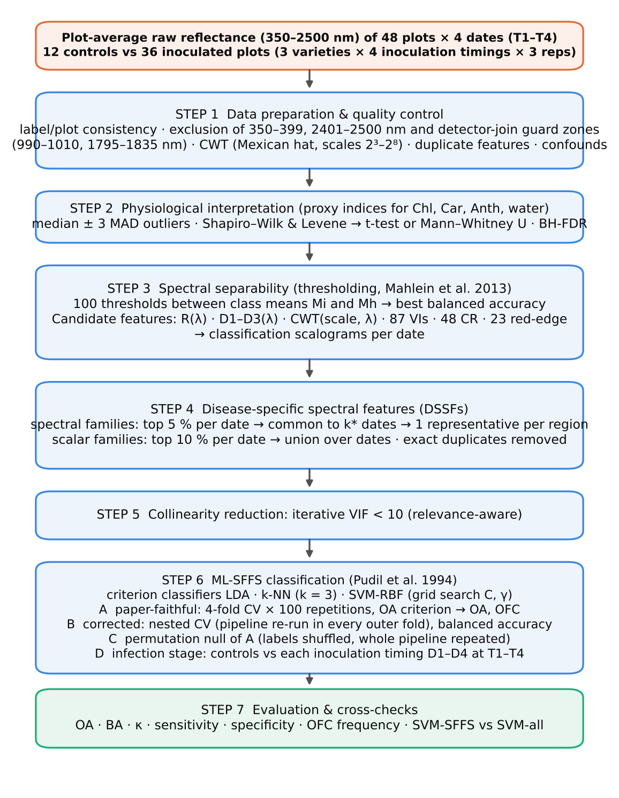
Figure 1. Workflow of the analysis (analogue of Tian et al., 2021, Fig. 2). Steps 1–5 build the pool of disease-specific spectral features (DSSFs); Step 6 selects the optimal feature combination with ML-SFFS and evaluates it in four ways (A–D).
Table 3. Corrections to the procedure of Tian et al. (2021) and their reasons.
Code | Issue | Correction applied | Reason
C1 | Spectral range and instrument artefacts | Bands 350–399 nm and 2401–2500 nm (low signal-to-noise at the detector ends) and the detector-join guard zones 990–1010 nm and 1795–1835 nm (ASD VNIR/SWIR1 and SWIR1/SWIR2 joins) were excluded from the band, derivative and wavelet candidates. | Several derivatives at 1800–1835 nm reached AUC = 1.0 on single dates – a step artefact of the detector join, not leaf biology. The guard zones are the same as those of the source workbooks.
C2 | Class imbalance (12 healthy vs 36 diseased plots) | Balanced accuracy BA = (sensitivity + specificity)/2 chooses the optimal threshold and ranks the features; OA, BA, κ, sensitivity and specificity are all reported. In the corrected analysis LDA uses equal priors and the SVM class-balanced weights. | With a 3:1 ratio a classifier that calls every plot 'diseased' already reaches OA = 75 %; OA alone overstates performance (Brodersen et al., 2010).
C3 | Multi-date consistency rule | Explicit rule: a feature is 'common' if it is in the top 5 % on at least k* of the 4 dates, where k* is the largest k (4, 3, 2) that leaves ≥ 1 common feature in that family. One representative (highest mean BA) is kept per contiguous region (8-connected regions in the scale × wavelength plane for the CWT). | The four dates span vegetative to pod-formation stages, so strict 4-date intersection left almost no features.
C4 | Selection bias / optimistic accuracy | Procedure A replicates the paper exactly. Procedure B (nested CV) repeats the whole pipeline – separability, DSSF pool, VIF, SFFS and SVM tuning – inside every outer training fold, and tests the selected model only on the held-out plots (10 × stratified 4-fold, folds by plot so that a plot never appears in training and test on any date). Procedure C (label permutation) measures how high procedure A goes when the labels carry no information. | The maximum of many CV estimates is biased upwards (Ambroise and McLachlan, 2002; Varma and Simon, 2006; Cawley and Talbot, 2010).
C5 | Collinearity reduction rule | Iterative VIF: while any VIF ≥ 10, the least separable (lowest mean BA) of the features with VIF ≥ 10 is removed; the plain 'drop the highest VIF' rule is reported for comparison. Exact duplicate indices (|r| > 0.9999) were removed first. | The plain rule removed the most informative indices (HI, ARI, Lic) and every reflectance band while keeping weak, uncorrelated ones.
C6 | Feature scaling and classifier details | Features z-scored inside each training fold (scaler never sees test plots); k-NN k = 3, Euclidean (Minkowski p = 2), uniform weights; SVM-RBF with exponential grid C ∈ {2⁻¹, 2¹, 2³, 2⁵, 2⁷}, γ ∈ {2⁻⁵, 2⁻³, 2⁻¹, 2¹}/p (Hsu et al., 2003). | Equivalent to the R defaults except the kknn kernel weighting, which is replaced by the standard unweighted k-NN.
C7 | Statistical tests | Same decision rule (Shapiro–Wilk + Levene → Student t, else Mann–Whitney U, outliers = median ± 3 MAD) plus Benjamini–Hochberg FDR over all tests. | 32 proxy tests (8 proxies × 4 dates) inflate false positives without correction.
C8 | No measured leaf biochemistry | Published index proxies of the same constituents were tested (CIrededge, MTCI, REIP, CRI1, ARI, PRI, WI, NDWI). | Proxies are themselves spectral; they indicate, but do not prove, the biochemical changes.
C9 | Experimental design confounds (treatment file) | The 12 control plots form their own block (C), separate from the inoculated replications R1–R3, and were always measured first on every date (spectra 1–100). Variety and inoculation timing are balanced (each V × D combination once in C and once in each of R1–R3). Detection rates are therefore reported per inoculation timing and per variety (Step 6D); the block/measurement-order confound is stated as a limitation. | Healthy-vs-diseased differences may partly include field-position and measurement-time effects that cannot be separated from disease with this layout.

3.1 Step 1 – Data preparation and quality control

Concept
Before any feature is evaluated the data must be shown to be consistent (labels, plots, treatments) and free of instrument artefacts, because a feature-selection procedure will pick up any systematic difference between the classes – including differences that have nothing to do with the disease.

Procedure
- Consistency. Class labels, varieties and the treatment file were compared plot by plot across the four workbooks.
- Spectral range (C1). Bands 350–399 nm and 2401–2500 nm (low signal-to-noise at the detector ends) and the guard zones 990–1010 nm and 1795–1835 nm around the joins of the three ASD detectors were excluded from the band, derivative and wavelet candidates. Exploratory analysis showed first derivatives at 1825–1830 nm separating the classes perfectly on single dates – a step artefact of the SWIR1/SWIR2 detector join, not leaf biology.
- Continuous wavelet transform (CWT). Following Cheng et al. (2010) and Tian et al. (2021), every plot spectrum was decomposed with the Mexican-hat (second derivative of a Gaussian) mother wavelet at dyadic scales 2¹–2⁸; scales 3–8 were retained. Computations used PyWavelets (Lee et al., 2019).
- Confounds (C9). The measurement order and block structure were inspected.
W(a, λ) = ∫ R(x) · a^{−1/2} ψ((x − λ)/a) dx, ψ(t) = (2/(√3 π^{1/4})) (1 − t²) e^{−t²/2}
R = reflectance, a = scale (2^{j} nm, j = 3…8), λ = wavelength; each W(a, λ) is one candidate wavelet feature (Torrence and Compo, 1998; Cheng et al., 2010).

3.2 Step 2 – Physiological interpretation

Concept
Tian et al. (2021) first showed which leaf constituents change during infection, because this explains why particular spectral regions become disease-specific. Leaf biochemistry was not measured in this experiment, so published spectral proxies of the same four constituents were tested instead (C8): chlorophyll – CIrededge (Gitelson et al., 2003), MTCI (Dash and Curran, 2004) and the red-edge inflection point by linear four-point interpolation (Guyot and Baret, 1988); carotenoids – CRI1 (Gitelson et al., 2002); anthocyanins – ARI (Gitelson et al., 2001); xanthophyll-cycle activity – PRI (Gamon et al., 1992); water – WI (Peñuelas et al., 1997) and NDWI (Gao, 1996).

Procedure
The decision rule of Tian et al. (2021) was applied to each proxy and date: values outside the median ± 3 MAD of each group were treated as outliers (Leys et al., 2013); if both groups were normal (Shapiro–Wilk; Shapiro and Wilk, 1965) and their variances equal (Levene, 1960), an independent Student t-test was used, otherwise the Mann–Whitney U test (Mann and Whitney, 1947). In addition (C7), the 32 p-values were adjusted with the Benjamini–Hochberg false-discovery rate (Benjamini and Hochberg, 1995). The effect size is Hedges' g (positive = higher in diseased plots).

3.3 Step 3 – Spectral separability by thresholding

Concept
The separability of a single feature is the accuracy with which one threshold on that feature separates healthy from diseased plots (Mahlein et al., 2013; Tian et al., 2021, Fig. 3). It is a simple, model-free filter that can be computed for tens of thousands of features and displayed as a 'classification scalogram' along the wavelength axis.

Procedure
For every feature and date the class means M_{h} (healthy) and M_{i} (infected) were computed and the interval between them divided into 100 equal steps; each step t_{k} = M_{h} + k(M_{i} − M_{h})/100 (k = 0…100) was used as a threshold, plots on the M_{i} side being called diseased. Because only 12 of the 48 plots are healthy, the best threshold was chosen by the balanced accuracy (C2):
BA = (Se + Sp)/2, Se = TP/(TP + FN), Sp = TN/(TN + FP), OA = (TP + TN)/N
A classifier that calls every plot 'diseased' has OA = 36/48 = 75 % but BA = 50 %; BA is therefore the appropriate criterion for imbalanced classes (Brodersen et al., 2010).

3.4 Step 4 – Extraction of disease-specific spectral features (DSSFs)
The rules of Tian et al. (2021) were applied with an explicit consistency criterion (C3):
- For the continuous families (reflectance, D1–D3, CWT) the features in the top 5 % of separability were marked on each date (ties included).
- A feature was 'common' if it was marked on at least k* of the four dates, where k* is the largest value (4, then 3, then 2) for which the family still has at least one common feature. Tian et al. intersected only the DAIs at which common features existed; with four dates spanning vegetative to pod-formation stages, the strict four-date intersection left almost nothing.
- Common features were grouped into contiguous wavelength regions (for the CWT, 8-connected regions in the scale × wavelength plane) and the feature with the highest mean balanced accuracy was kept as the region's representative.
- For the scalar families (VIs, CR and red-edge parameters) the top 10 % of each family on each date were retained and the union taken over the dates – the analogue of Tian et al.'s union of the yearly top-10 spectral indices.
- Exactly duplicated features (|r| > 0.9999) were removed.

3.5 Step 5 – Collinearity reduction (VIF)
The candidate DSSFs were z-scored within each date and stacked over the four dates, and the variance inflation factor of feature j was computed as
VIF_{j} = 1/(1 − R_{j}²)
where R_{j}² is the coefficient of determination of feature j regressed on all other features. Tian et al. (2021) retained features with VIF < 10 without stating the iteration rule. Here (C5) the VIFs were recomputed after every removal and, while any VIF was ≥ 10, the least separable of the features with VIF ≥ 10 was removed (relevance-aware rule); the commonly used 'drop the largest VIF' rule is reported for comparison. The threshold of 10 is a rule of thumb whose limits are discussed by O'Brien (2007).

3.6 Step 6 – ML-SFFS classification

Classifiers
- LDA (Fisher, 1936) projects the features on the direction that maximises the ratio of between-class to within-class variance; it assumes normal classes with a common covariance.
- k-NN (Cover and Hart, 1967) assigns a plot to the majority class of its k = 3 nearest training plots (Euclidean = Minkowski p = 2 distance on z-scored features).
- SVM (Cortes and Vapnik, 1995; LIBSVM, Chang and Lin, 2011) with a radial basis function kernel K(x, x′) = exp(−γ‖x − x′‖²); C and γ were chosen by grid search, C ∈ {2⁻¹, 2¹, 2³, 2⁵, 2⁷}, γ ∈ {2⁻⁵, 2⁻³, 2⁻¹, 2¹}/p for p features (Hsu et al., 2003).
All features were z-scored with the mean and standard deviation of the training plots of each fold (C6). The classifiers were implemented with scikit-learn (Pedregosa et al., 2011).

Sequential floating forward selection
SFFS (Pudil et al., 1994) is a wrapper method: the classifier's cross-validated accuracy is the criterion J of a feature subset. Starting from the empty set, it repeats:
- Inclusion: add the feature that gives the largest J;
- Conditional exclusion: find the least significant feature of the current subset (the one whose removal gives the largest J); remove it if the reduced subset is better than the best subset of that size found so far, and repeat this step; otherwise return to inclusion.
- Stop when the subset reaches the maximum size (8 features) or J = 100 %; the OFC is the subset with the highest J (ties → fewer features).
The floating backward steps correct poor early decisions of plain forward selection, which is why SFFS approximates the exhaustive search closely at a fraction of its cost (Pudil et al., 1994; Saeys et al., 2007).

Evaluation
- A – paper-faithful (Tian et al., 2021). For every date and classifier: stratified 4-fold CV partition, SFFS with J = OA, repeated 100 times with new partitions; reported OA = mean of the 100 optimal accuracies; OFC = the most frequent optimal combination. SVM-all = SVM with all DSSFs.
- B – corrected nested CV (C4). 10 repetitions × stratified 4-fold outer CV over plots (the same held-out plots on every date). Inside each outer training set the complete pipeline – separability, DSSF pool, VIF, SFFS (J = balanced accuracy, inner 4-fold CV × 3) and SVM grid search – was re-run, and the selected model classified the held-out plots. LDA used equal priors and the SVM class-balanced weights. This removes the selection bias of A (Ambroise and McLachlan, 2002; Varma and Simon, 2006; Cawley and Talbot, 2010).
- C – permutation null. The plot labels were shuffled (the same shuffle on all dates) and procedure A was re-run in full: 20 permutations × 5 repetitions for LDA and k-NN, 4 × 2 for the SVM (Ojala and Garriga, 2010).
- D – infection stages. (i) Paper-faithful ML-SFFS of the 12 controls against the 9 plots of each inoculation timing on each date (16 stages; fixed DSSF pool; 4-fold CV × 100); (ii) the unbiased per-group detection rate and per-variety accuracy from the nested-CV predictions of B.
κ = (OA − p_{e})/(1 − p_{e}), p_{e} = [(TP + FP)(TP + FN) + (FN + TN)(FP + TN)]/N²
Cohen's kappa (Cohen, 1960) corrects OA for chance agreement; Se, Sp and BA as in Section 3.3.

3.7 Step 7 – Cross-checks and software
Every step was verified by an independent route (Table 14): Excel formulas recompute class means, threshold accuracies and summary accuracies from the stored data; derivatives and wavelet coefficients were recomputed directly; the VIF was recomputed with statsmodels; SFFS was compared with an exhaustive search; the accuracy functions with scikit-learn; and the nested folds were checked for leakage. All references were checked against publisher or repository records. The analysis used Python 3 with NumPy, pandas, SciPy, statsmodels, scikit-learn 1.9 and PyWavelets 1.10.

4. Results

4.1 Data quality and design
Class labels and varieties were identical on all four dates and agreed with the treatment file; the design was balanced (Table 1). Two properties of the data must be borne in mind when reading the results:
- Measurement order and block (C9). The 12 control plots form their own block and were measured first on every date (spectra 1–100). Disease is therefore partly confounded with field position and measurement time; this cannot be removed by any analysis of these data.
- Duplicated indices. RARSc ≡ GM2; mCARI1 ≡ MTVI1 (algebraically identical definitions; one of each pair is redundant).
- Detector joins. The guard zones removed spurious 'perfect' features at the detector joins (Section 3.1).
Table 4. Plots, leaves and growth stages per measurement date.
Date | Plots healthy | Plots diseased | Leaf spectra | Growth stages | Spectrum no. range healthy
T1 (11 Feb) | 12 | 36 | 428 | Vegetative: 44; Flowering: 4 | 1–70
T2 (24 Feb) | 12 | 36 | 540 | Flowering: 28; Vegetative: 20 | 1–85
T3 (3 Mar) | 12 | 36 | 648 | Flowering: 44; Pod formation: 4 | 1–100
T4 (13 Mar) | 12 | 36 | 648 | Pod formation: 36; Flowering: 12 | 1–100

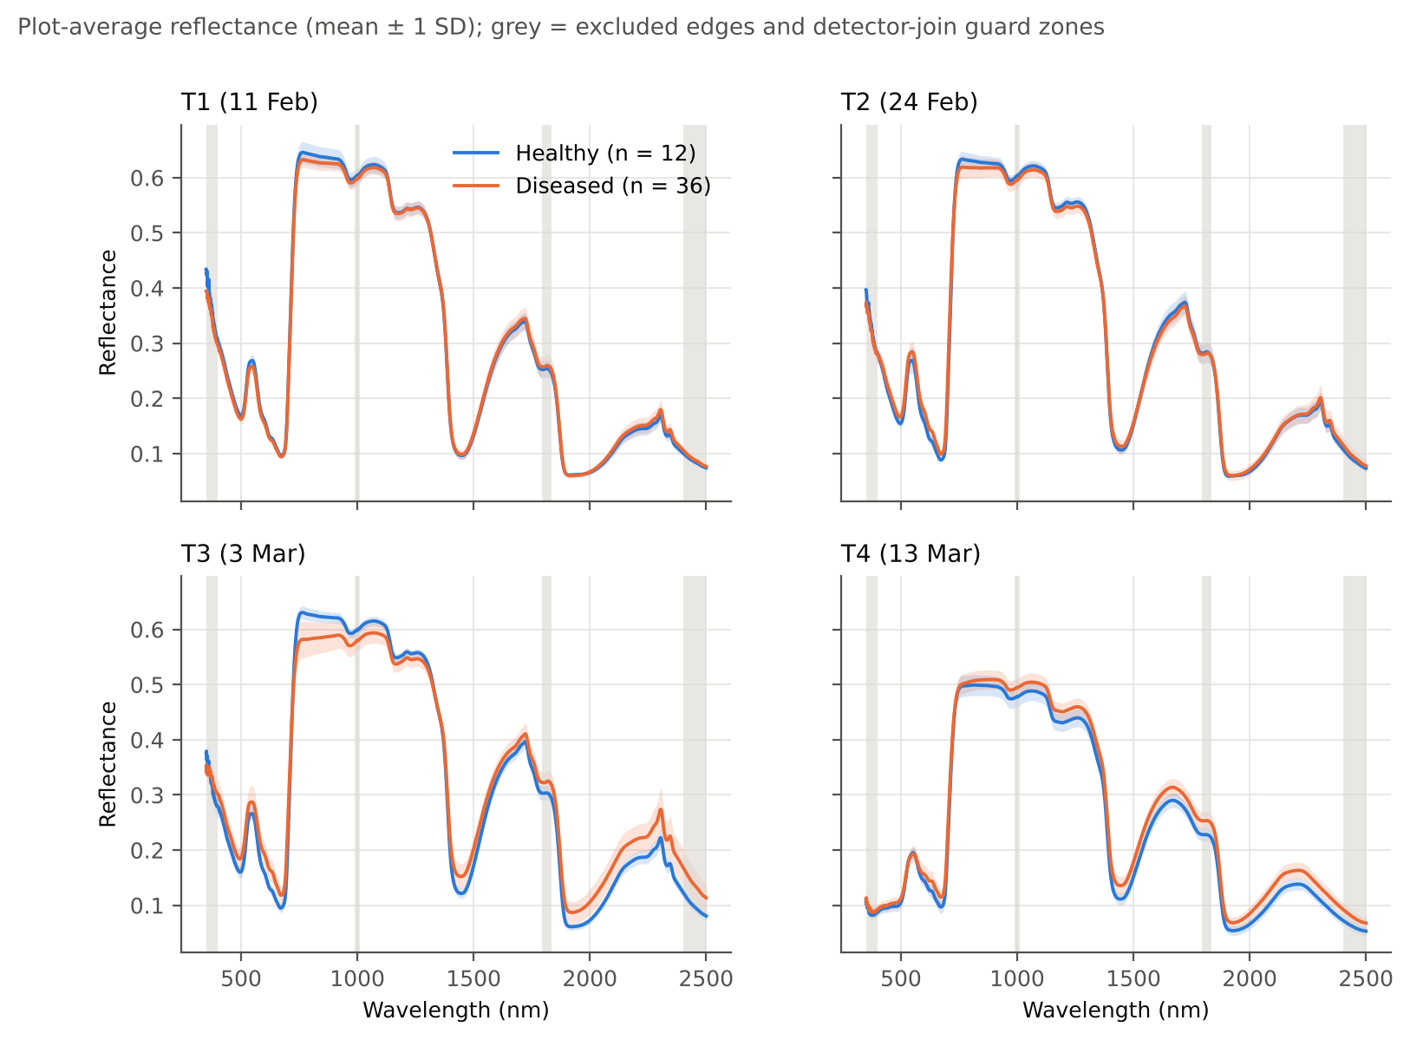
Figure 2. Plot-average reflectance of healthy (blue) and diseased (orange) plots on the four dates (mean ± 1 SD). Grey: excluded detector edges and detector-join guard zones.

4.2 Physiological responses to white rust
On T1 none of the pigment proxies differed between healthy and diseased plots, but both water indices were lower in the diseased plots (WI: q = 0.049; NDWI: q = 0.006). On T2 and T3 the chlorophyll proxies CIrededge and MTCI and the red-edge position were significantly lower in the diseased plots (on T4 only CIrededge remained significant); the carotenoid index CRI1 and PRI were lower and the anthocyanin index ARI strongly higher on T2–T4; the water indices were lower again on T3 and T4 but not on T2 (Table 5, Figure 3). 22 of the 32 tests were significant after FDR correction.
This is the same pattern that Tian et al. (2021) measured for rice blast – loss of chlorophyll and carotenoids, a contrary increase in anthocyanins and a later loss of water – except that the water signal appeared first here. An early water signal is consistent with the biology of white rust, whose pustules rupture the epidermis and increase transpiration losses, but the controls' separate block and measurement order (C9) could also contribute to an early difference and the finding should be confirmed in a randomised layout.
Table 5. Healthy vs diseased plots for the physiological proxies (decision rule of Tian et al., 2021, plus BH-FDR).
Date | Proxy | Constituent | Test | p | q (BH) | Hedges g | Direction
T1 (11 Feb) | CIrededge | Chlorophyll | Student t | 7.0e-01 | 8.0e-01 | -0.13 | lower in diseased
T1 (11 Feb) | MTCI | Chlorophyll | Student t | 8.4e-01 | 9.0e-01 | +0.07 | higher in diseased
T1 (11 Feb) | CRI1 | Carotenoids | Student t | 1.7e-01 | 2.2e-01 | +0.48 | higher in diseased
T1 (11 Feb) | ARI | Anthocyanins | Student t | 2.8e-01 | 3.5e-01 | +0.36 | higher in diseased
T1 (11 Feb) | PRI | Xanthophyll / photosynthetic efficiency | Student t | 9.5e-01 | 9.5e-01 | +0.02 | higher in diseased
T1 (11 Feb) | WI | Water | Student t | 3.3e-02 | 4.9e-02 | -0.72 | lower in diseased
T1 (11 Feb) | NDWI | Water | Student t | 3.9e-03 | 6.3e-03 | -1.00 | lower in diseased
T1 (11 Feb) | REIP (4-point) | Chlorophyll (red-edge position) | Student t | 8.4e-01 | 9.0e-01 | +0.07 | higher in diseased
T2 (24 Feb) | CIrededge | Chlorophyll | Student t | 3.9e-06 | 1.0e-05 | -1.72 | lower in diseased
T2 (24 Feb) | MTCI | Chlorophyll | Student t | 1.5e-05 | 3.3e-05 | -1.58 | lower in diseased
T2 (24 Feb) | CRI1 | Carotenoids | Student t | 3.2e-03 | 5.4e-03 | -1.02 | lower in diseased
T2 (24 Feb) | ARI | Anthocyanins | Student t | 2.1e-09 | 1.1e-08 | +2.44 | higher in diseased
T2 (24 Feb) | PRI | Xanthophyll / photosynthetic efficiency | Student t | 1.8e-06 | 5.9e-06 | -1.79 | lower in diseased
T2 (24 Feb) | WI | Water | Student t | 4.5e-01 | 5.4e-01 | -0.25 | lower in diseased
T2 (24 Feb) | NDWI | Water | Student t | 8.7e-01 | 9.0e-01 | -0.05 | lower in diseased
T2 (24 Feb) | REIP (4-point) | Chlorophyll (red-edge position) | Student t | 3.6e-05 | 6.7e-05 | -1.51 | lower in diseased
T3 (3 Mar) | CIrededge | Chlorophyll | Student t | 2.1e-10 | 1.3e-09 | -2.66 | lower in diseased
T3 (3 Mar) | MTCI | Chlorophyll | Student t | 4.4e-12 | 9.2e-11 | -3.07 | lower in diseased
T3 (3 Mar) | CRI1 | Carotenoids | Student t | 3.3e-05 | 6.6e-05 | -1.51 | lower in diseased
T3 (3 Mar) | ARI | Anthocyanins | Student t | 1.6e-10 | 1.3e-09 | +2.68 | higher in diseased
T3 (3 Mar) | PRI | Xanthophyll / photosynthetic efficiency | Student t | 5.7e-11 | 6.0e-10 | -2.78 | lower in diseased
T3 (3 Mar) | WI | Water | Mann-Whitney U | 3.6e-06 | 1.0e-05 | -1.85 | lower in diseased
T3 (3 Mar) | NDWI | Water | Mann-Whitney U | 4.1e-06 | 1.0e-05 | -1.75 | lower in diseased
T3 (3 Mar) | REIP (4-point) | Chlorophyll (red-edge position) | Student t | 3.3e-08 | 1.5e-07 | -2.21 | lower in diseased
T4 (13 Mar) | CIrededge | Chlorophyll | Student t | 1.8e-02 | 2.7e-02 | -0.81 | lower in diseased
T4 (13 Mar) | MTCI | Chlorophyll | Student t | 1.3e-01 | 1.8e-01 | -0.50 | lower in diseased
T4 (13 Mar) | CRI1 | Carotenoids | Student t | 1.8e-04 | 3.2e-04 | -1.34 | lower in diseased
T4 (13 Mar) | ARI | Anthocyanins | Student t | 5.7e-12 | 9.2e-11 | +3.01 | higher in diseased
T4 (13 Mar) | PRI | Xanthophyll / photosynthetic efficiency | Student t | 7.7e-06 | 1.8e-05 | -1.65 | lower in diseased
T4 (13 Mar) | WI | Water | Student t | 3.0e-07 | 1.2e-06 | -1.98 | lower in diseased
T4 (13 Mar) | NDWI | Water | Student t | 1.8e-06 | 5.9e-06 | -1.79 | lower in diseased
T4 (13 Mar) | REIP (4-point) | Chlorophyll (red-edge position) | Student t | 1.8e-01 | 2.3e-01 | -0.45 | lower in diseased

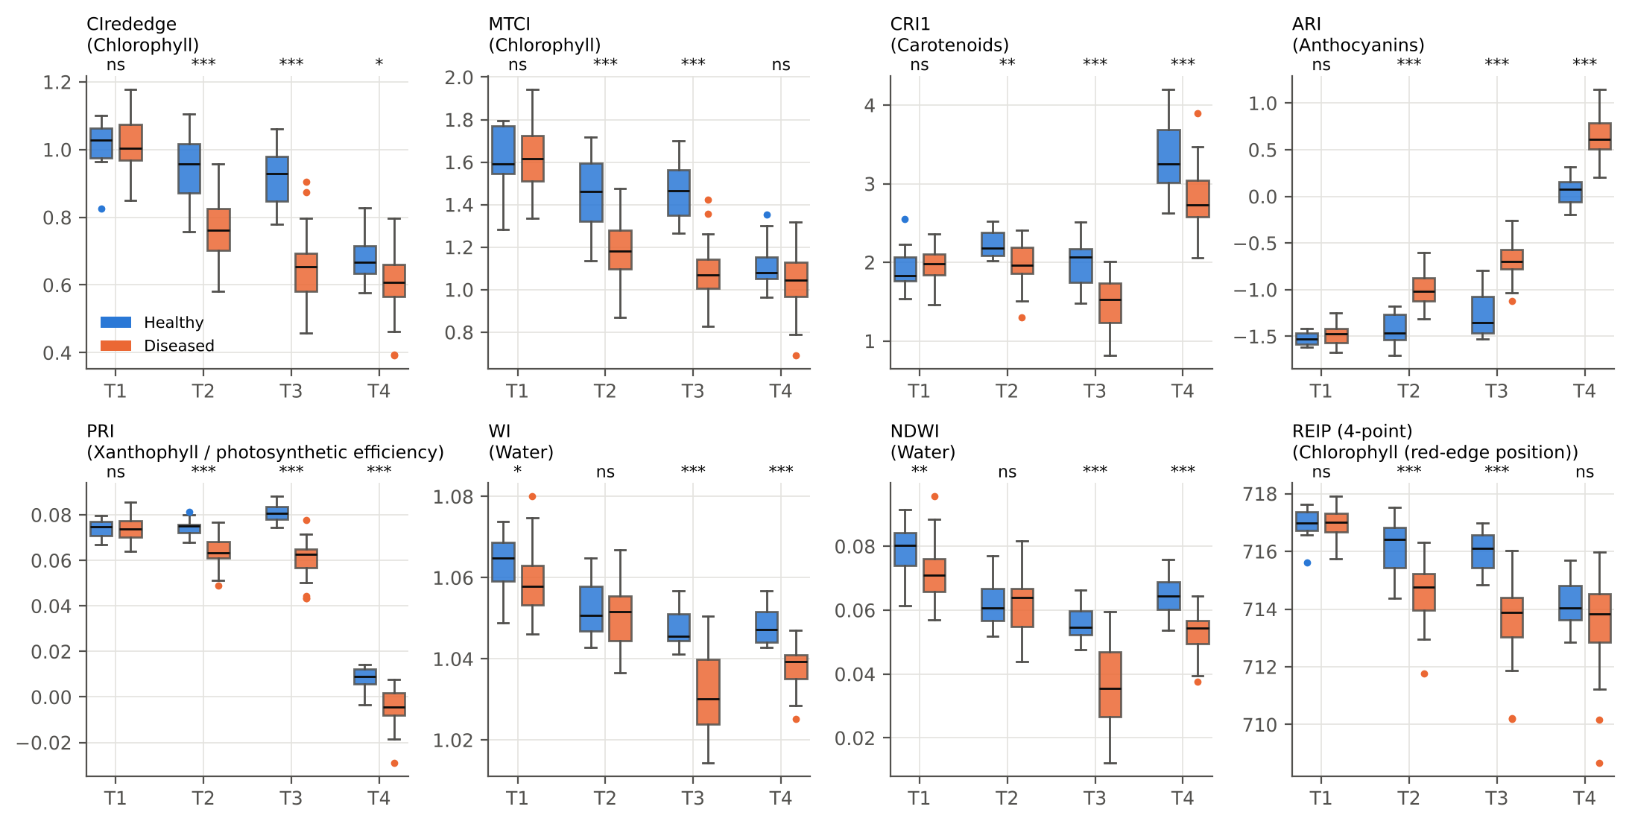
Figure 3. Physiological proxies of healthy (blue) and diseased (orange) plots on T1–T4 (analogue of Tian et al., 2021, Fig. 4). Stars: BH-adjusted q < 0.05 (∗), < 0.01 (∗∗), < 0.001 (∗∗∗); ns = not significant. Boxes show all plots; the tests exclude median ± 3 MAD outliers.

4.3 Spectral separability
Separability increased from T1 to T3 for most features (Figures 5–9). On T1 the most separable regions were the visible bands (400–650 nm) and the NIR plateau slope (800–900 nm, first derivative); on T2 the red and red-edge region (580–720 nm) dominated; on T3 almost every region separated the classes (the 95th percentile of BA exceeded 0.9 for reflectance) and on T4 the SWIR regions (1400–2350 nm) were most separable. This shift with date mirrors the shift in Tian et al. (2021) from pigment-related VIS features early to water-related SWIR features late.
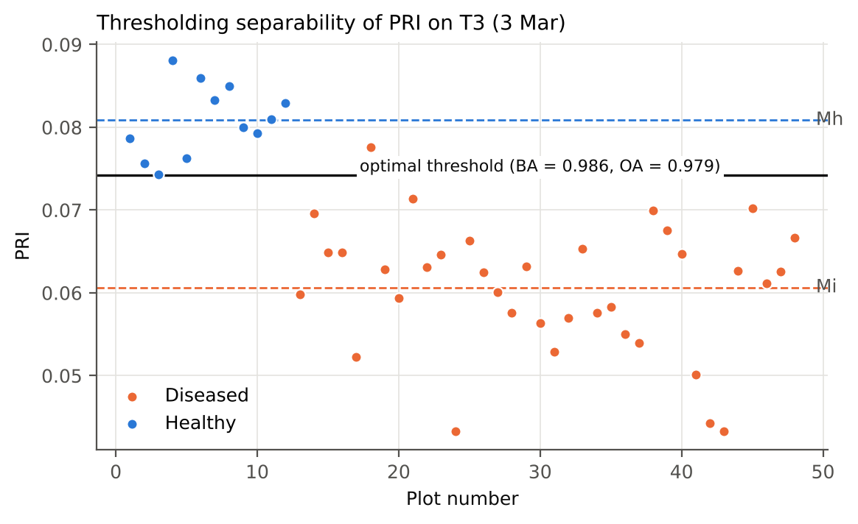
Figure 4. Thresholding separability (analogue of Tian et al., 2021, Fig. 3): PRI of the 48 plots on T3, class means Mh and Mi and the optimal threshold.
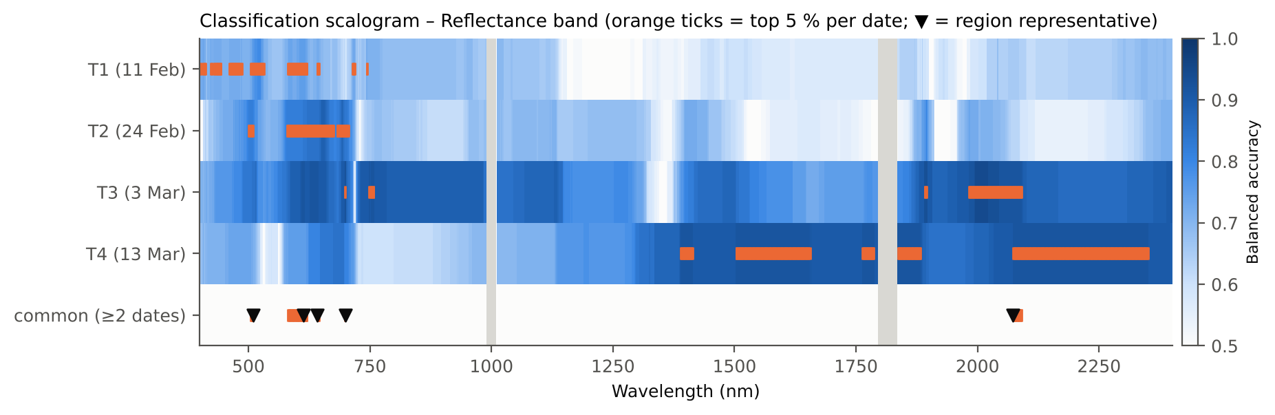
Figure 5. Classification scalogram of the reflectance bands (analogue of Tian et al., 2021, Fig. 6). Shade = balanced accuracy; orange ticks = top 5 % on each date; bottom row = features common to k* dates; ▼ = region representatives.
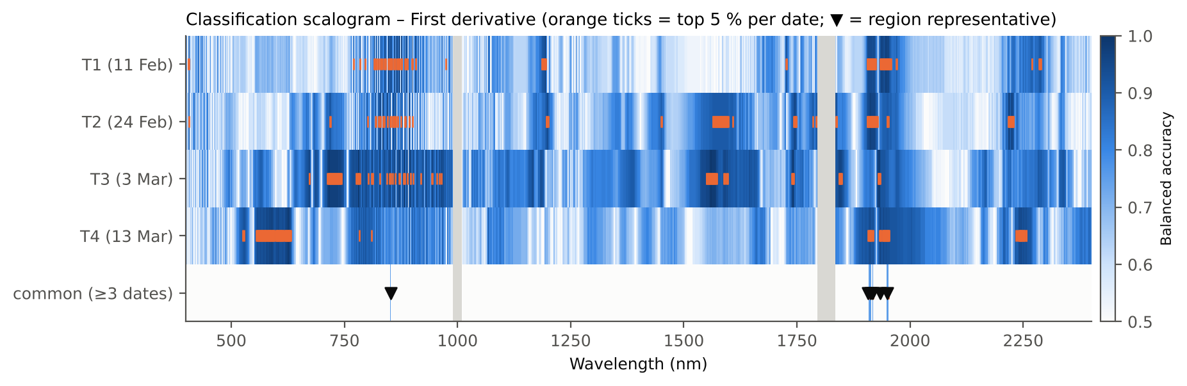
Figure 6. Classification scalogram of the first derivatives (analogue of Tian et al., 2021, Fig. 6). Shade = balanced accuracy; orange ticks = top 5 % on each date; bottom row = features common to k* dates; ▼ = region representatives.
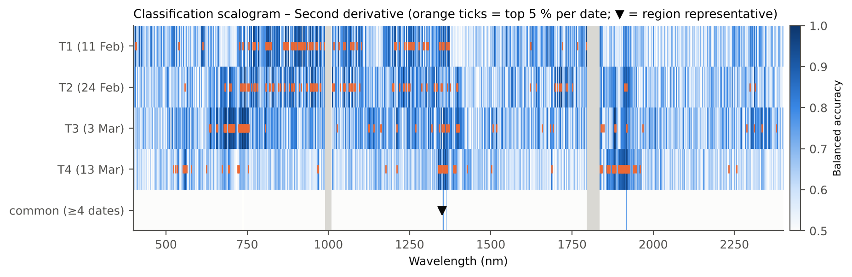
Figure 7. Classification scalogram of the second derivatives.
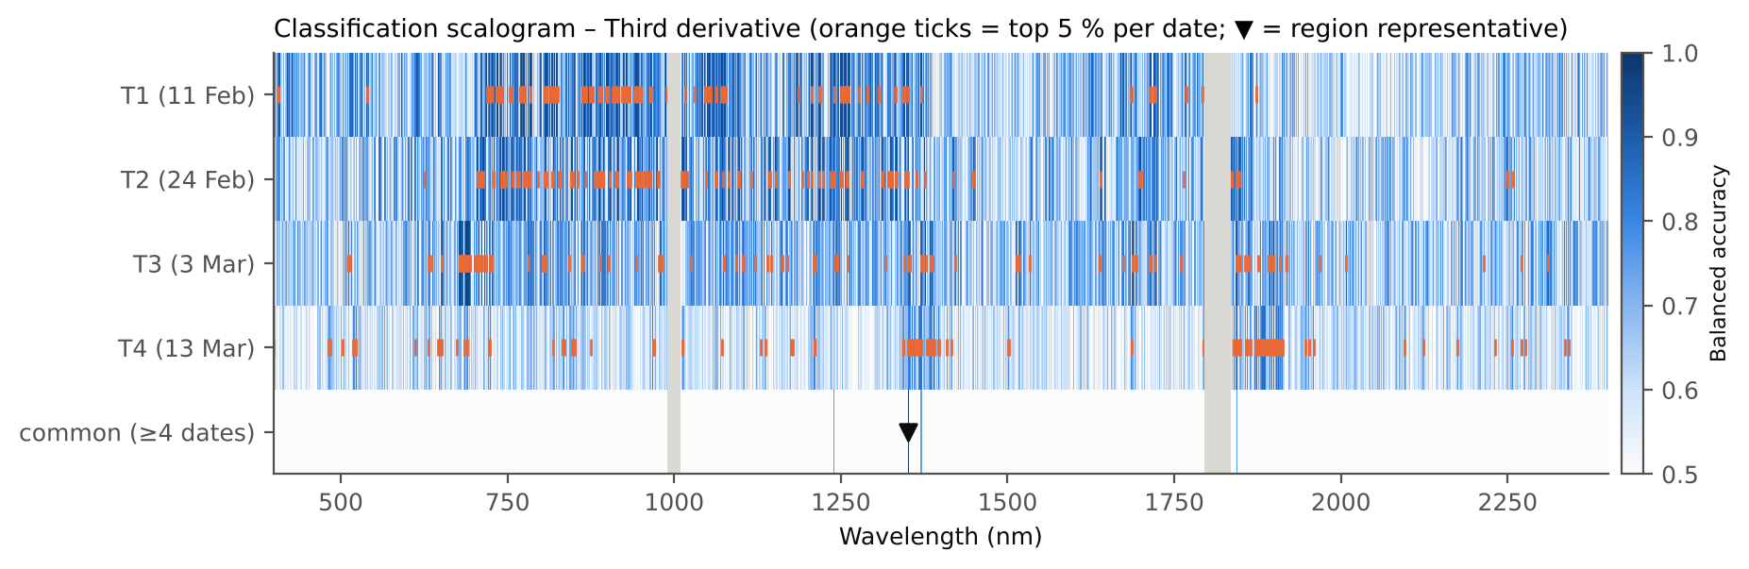
Figure 8. Classification scalogram of the third derivatives.
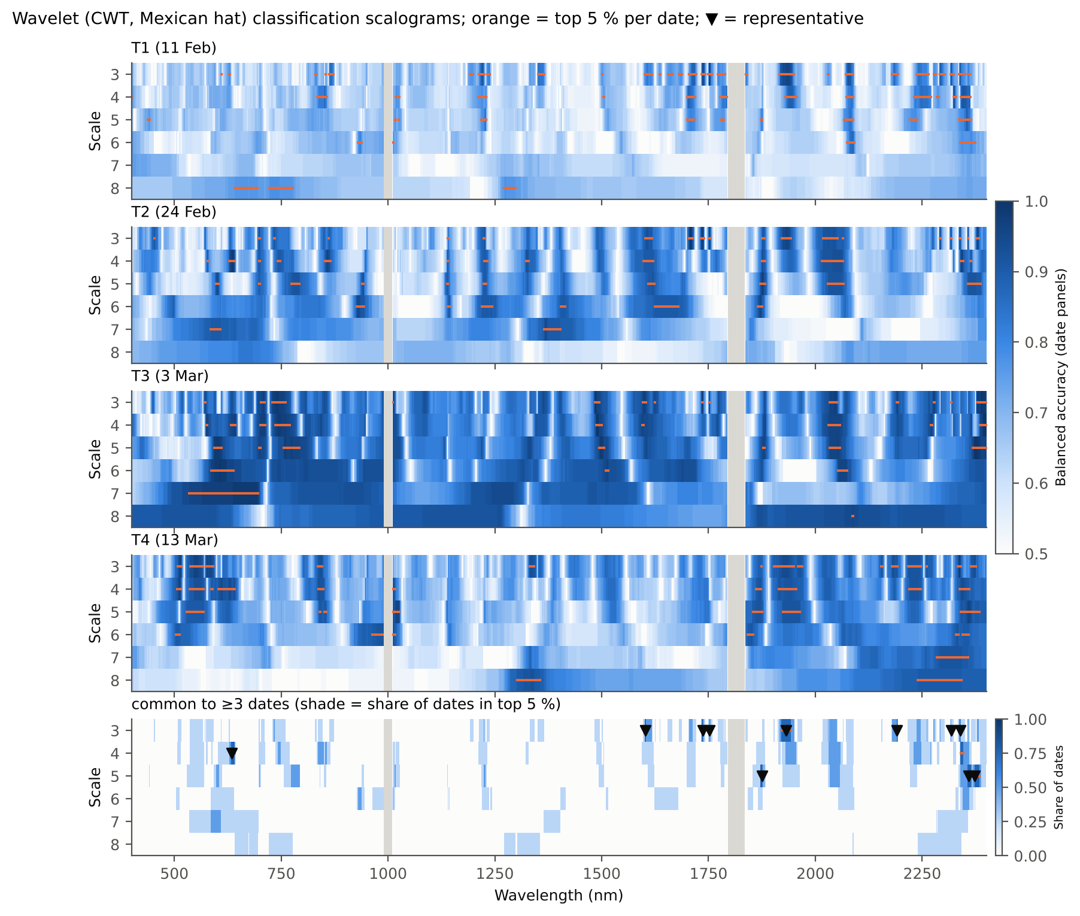
Figure 9. Classification scalograms of the wavelet coefficients, scales 3–8 (analogue of Tian et al., 2021, Fig. 7).

4.4 Disease-specific spectral features and collinearity reduction
The consistency level k* reached was 2 dates for reflectance bands, 3 dates for first derivatives, 4 dates for second derivatives, 4 dates for third derivatives, 3 dates for wavelet coefficients. Together with the union of the per-date top-10 % scalar features this gave 85 candidate DSSFs; after removal of 1 exact duplicate and iterative VIF reduction, 16 DSSFs remained, all with VIF < 10 (largest 7.68; Table 6, Figure 10). The plain 'drop the largest VIF' rule would have kept 25 features but would have discarded every reflectance band and the most separable indices (HI, ARI, Lic) while keeping weakly separable ones.
Table 6. The final pool of disease-specific spectral features (analogue of Tian et al., 2021, Table 2).
Code | Feature | Family | Region | Dates in top | Mean BA | VIF | Physical meaning
F1 | R_641 | Reflectance band | R_641 … R_646 | 2 | 0.823 | 4.82 | Red reflectance at 641 nm, shoulder of the chlorophyll a/b red absorption; rises when chlorophyll is lost
F2 | D1_852 | First derivative | D1_852 | 3 | 0.906 | 3.14 | Slope of the NIR plateau at 852 nm; governed by mesophyll (intercellular) scattering - cf. WF850 of Tian et al. (2021)
F3 | D2_1350 | Second derivative | D2_1350 | 4 | 0.917 | 2.14 | Curvature at the onset of the 1400-nm water absorption band (leaf water)
F4 | S3_1736 | Wavelet coefficient (CWT, Mexican hat) | S3_1735 … S3_1736 | 3 | 0.924 | 5.35 | Wavelet feature (scale 3) at 1736 nm; C-H absorption of lignin/cellulose/protein near 1730 nm (Kokaly and Clark, 1999)
F5 | S3_1752 | Wavelet coefficient (CWT, Mexican hat) | S3_1752 | 3 | 0.858 | 3.33 | Wavelet feature (scale 3) at 1752 nm; C-H / cellulose-lignin absorption region (cf. NDLI band 1754 nm)
F6 | S3_1932 | Wavelet coefficient (CWT, Mexican hat) | S3_1921 … S3_1942 | 3 | 0.927 | 7.68 | Wavelet feature (scale 3) at 1932 nm; centre of the 1940-nm leaf-water absorption
F7 | S3_2318 | Wavelet coefficient (CWT, Mexican hat) | S3_2318 | 3 | 0.906 | 4.58 | Wavelet feature (scale 3) at 2318 nm; protein/cellulose absorption near 2.30 um (Kokaly and Clark, 1999)
F8 | S4_634 | Wavelet coefficient (CWT, Mexican hat) | S4_633 … S4_641 | 3 | 0.892 | 5.08 | Wavelet feature (scale 4) at 634 nm; local shape of the yellow-red (chlorophyll) absorption edge - cf. WF608 of Tian et al. (2021)
F9 | S5_1875 | Wavelet coefficient (CWT, Mexican hat) | S5_1872 … S5_1876 | 3 | 0.906 | 6.80 | Wavelet feature (scale 5) at 1875 nm; short-wave shoulder of the 1940-nm water band
F10 | ARI2 | Vegetation index | - | 2 | 0.878 | 6.24 | Modified anthocyanin reflectance index R800(1/R550 - 1/R700); anthocyanin accumulation (Gitelson et al., 2001)
F11 | Lic | Vegetation index | - | 2 | 0.865 | 4.33 | Blue/red reflectance ratio R440/R690 (after the F440/F690 stress ratio of Lichtenthaler et al., 1996)
F12 | CR6 1721–2304 nm: left area (nm) | Continuum-removal parameter | - | 2 | 0.882 | 3.12 | Continuum-removed area of the 1940-nm water band, short-wave side
F13 | CR3 914–1069 nm: depth / area (1/nm) | Continuum-removal parameter | - | 2 | 0.806 | 3.21 | Band-depth / area of the 970-nm water band (shape of the weak water absorption)
F14 | CR6 1721–2304 nm: right area (nm) | Continuum-removal parameter | - | 3 | 0.868 | 7.16 | Continuum-removed area of the 1940-nm water band, long-wave side
F15 | CR1 400–548 nm: right area (nm) | Continuum-removal parameter | - | 1 | 0.681 | 1.70 | Continuum-removed area of the blue (carotenoid + chlorophyll) absorption, long-wave side
F16 | Blue-edge position λb (nm) | Red-edge parameter | - | 1 | 0.625 | 1.24 | Wavelength of the maximum first derivative in 490-530 nm (Gong et al., 2002)

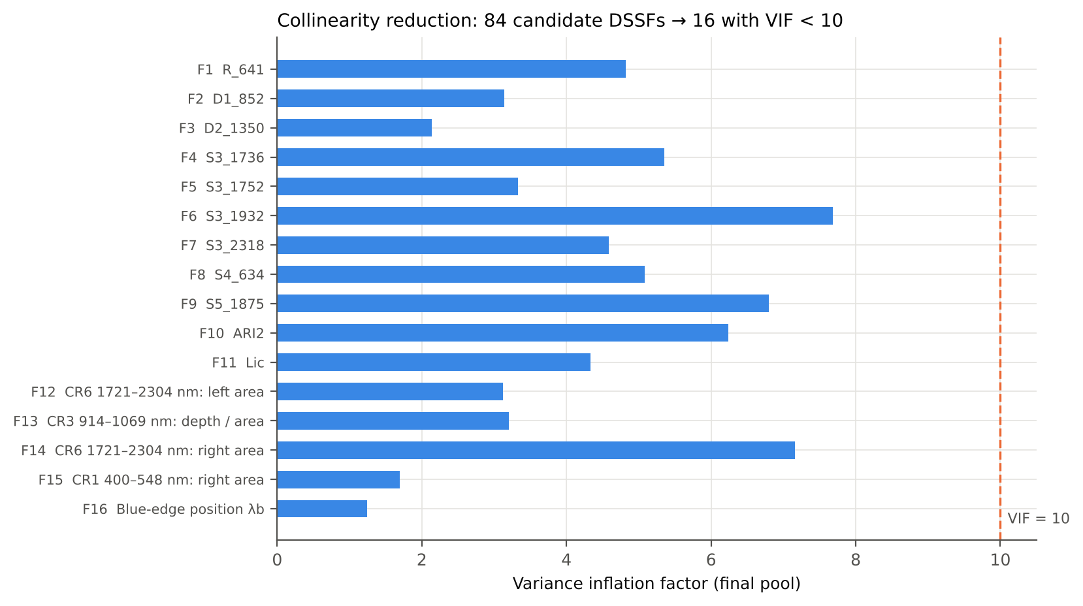
Figure 10. Variance inflation factors of the final 16 DSSFs.
The pool contains features of every family and of every main absorption process: pigment absorption in the red (F1 R₆₄₁, F8 wavelet at 634 nm, F11 Lic), the anthocyanin index ARI2 (F10), the NIR plateau slope (F2, first derivative at 852 nm), water absorptions at 970 nm (F13), 1350–1400 nm (F3) and 1940 nm (F6, F9, F12, F14), and C–H absorptions of dry matter near 1730–1750 nm and 2300 nm (F4, F5, F7). Two of these closely match the optimal wavelet features of Tian et al. (2021): the NIR slope near 850 nm (their WF_{850,4} and WF_{866,5}) and the yellow–red edge near 610–640 nm (their WF_{608,5}).

4.5 ML-SFFS classification – paper-faithful (procedure A)
With the paper's procedure, one to four DSSFs (on average 1.1–3.7) were enough to separate healthy from diseased plots almost perfectly on every date (Table 7). The mean OA ranged from 94.9 % (LDA, T1) to 100 %, and the SVM reached at least 99.7 % on every date, matching Tian et al.'s finding that SVM-SFFS was the best of the three classifiers. Feature selection improved on the use of all DSSFs most on T1 (gain 6.9–8.0 percentage points, Table 8, Figure 11), as in Tian et al. (2021), whose SVM-SFFS exceeded SVM-all by about 10 % at the early stages.
Table 7. Paper-faithful ML-SFFS: optimal feature combination and accuracy (4-fold CV × 100; analogue of Tian et al., 2021, Table 3).
Date | Classifier | Most frequent OFC | OFC frequency (%) | Mean no. of features | Mean OA | SD OA | Mean BA | Mean kappa
T1 (11 Feb) | LDA | F5 | 48 | 2.24 | 94.9 | 1.6 | 95.6 | 0.871
T1 (11 Feb) | kNN | F5, F13 | 18 | 3.14 | 97.4 | 1.2 | 97.6 | 0.933
T1 (11 Feb) | SVM | F5, F8, F13 | 30 | 2.89 | 99.7 | 0.7 | 99.6 | 0.993
T2 (24 Feb) | LDA | F2, F8 | 61 | 2.38 | 99.7 | 0.8 | 99.7 | 0.991
T2 (24 Feb) | kNN | F2, F8 | 98 | 2.01 | 100.0 | 0.0 | 100.0 | 1.000
T2 (24 Feb) | SVM | F2, F8 | 67 | 2.05 | 100.0 | 0.0 | 100.0 | 1.000
T3 (3 Mar) | LDA | F2, F4 | 52 | 2.09 | 100.0 | 0.0 | 100.0 | 1.000
T3 (3 Mar) | kNN | F13 | 33 | 1.69 | 100.0 | 0.0 | 100.0 | 1.000
T3 (3 Mar) | SVM | F5 | 81 | 1.15 | 100.0 | 0.0 | 100.0 | 1.000
T4 (13 Mar) | LDA | F1, F8, F13 | 26 | 3.62 | 99.9 | 0.5 | 99.8 | 0.997
T4 (13 Mar) | kNN | F9, F13 | 38 | 2.71 | 100.0 | 0.0 | 100.0 | 1.000
T4 (13 Mar) | SVM | F1, F3, F4, F13 | 30 | 3.72 | 100.0 | 0.0 | 100.0 | 1.000
OA, SD OA and BA in %; OFC frequency = % of the 100 repetitions in which the most frequent OFC was selected. Codes F1–F16 as in Table 6.
Table 8. SFFS-selected features vs all 16 DSSFs (procedure A; analogue of Tian et al., 2021, Fig. 8).
Date | Classifier | SFFS OA | All-DSSF OA | Gain OA (pp) | SFFS BA | All-DSSF BA | Gain BA (pp)
T1 (11 Feb) | LDA | 94.9 | 86.9 | 8.0 | 95.6 | 85.4 | 10.2
T1 (11 Feb) | kNN | 97.4 | 90.5 | 6.9 | 97.6 | 92.2 | 5.4
T1 (11 Feb) | SVM | 99.7 | 92.5 | 7.2 | 99.6 | 91.1 | 8.5
T2 (24 Feb) | LDA | 99.7 | 96.3 | 3.4 | 99.7 | 95.8 | 3.9
T2 (24 Feb) | kNN | 100.0 | 97.3 | 2.7 | 100.0 | 98.2 | 1.8
T2 (24 Feb) | SVM | 100.0 | 99.3 | 0.7 | 100.0 | 99.5 | 0.5
T3 (3 Mar) | LDA | 100.0 | 99.7 | 0.3 | 100.0 | 99.6 | 0.4
T3 (3 Mar) | kNN | 100.0 | 100.0 | 0.0 | 100.0 | 99.9 | 0.1
T3 (3 Mar) | SVM | 100.0 | 100.0 | 0.0 | 100.0 | 100.0 | 0.0
T4 (13 Mar) | LDA | 99.9 | 95.5 | 4.4 | 99.8 | 95.3 | 4.4
T4 (13 Mar) | kNN | 100.0 | 97.6 | 2.4 | 100.0 | 96.6 | 3.4
T4 (13 Mar) | SVM | 100.0 | 99.1 | 0.9 | 100.0 | 98.1 | 1.9

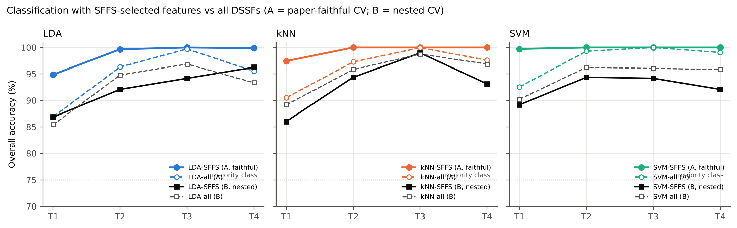
Figure 11. Overall accuracy with SFFS-selected features vs all DSSFs, for the paper-faithful (A, coloured) and nested (B, black) evaluation.
The OFCs differed between dates and classifiers, but a few features recurred (Figure 12): F8 (S4_634), F13 (CR3 water absorption 914–1069 nm: depth / area (1/nm)), F2 (D1_852), F5 (S3_1752) were selected most often over all dates and classifiers. On T2 the pair F2 + F8 (NIR slope at 852 nm + wavelet at 634 nm) was the OFC of all three classifiers.
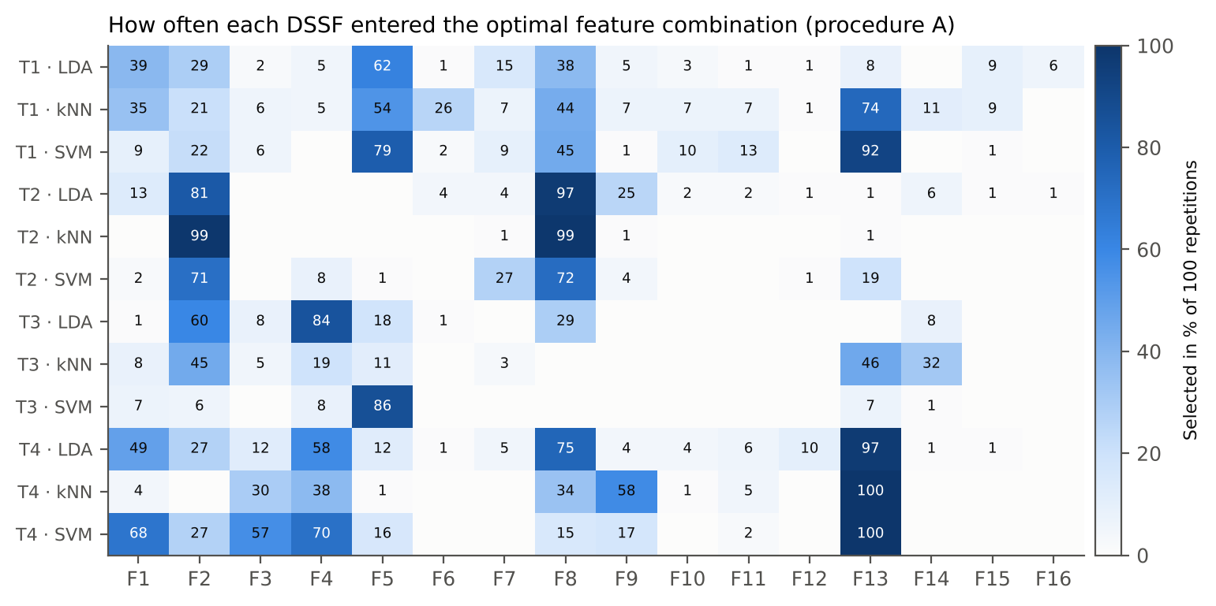
Figure 12. Percentage of the 100 repetitions in which each DSSF was part of the optimal feature combination (procedure A).
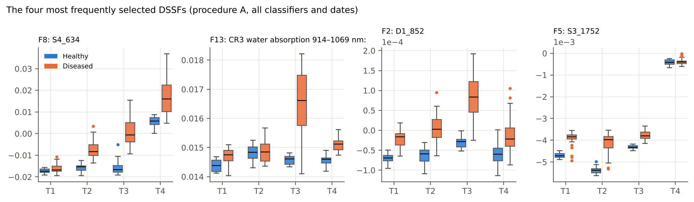
Figure 13. The four most frequently selected DSSFs of healthy (blue) and diseased (orange) plots on T1–T4.

4.6 Corrected estimates – nested cross-validation (procedure B)
When the test plots took no part in any selection step, the accuracies were lower (Table 9, Figure 14): balanced accuracy 83.5–98.8 % (OA 86.0–99.0 %, κ 0.64–0.97). The paper-faithful procedure overstated the balanced accuracy by 1.2–14.1 percentage points (Table 10), most on T1 (9.4–14.1 pp). Detection nevertheless remained high from the first date: on T1 the best nested BA was 86.4 %, and from T2 onwards 87.2–98.8 %. Sensitivity (diseased plots recognised) was higher than specificity (controls recognised) in 10 of the 12 date × classifier combinations, the usual consequence of having three times more diseased plots.
Under nested CV the SFFS subsets were no longer clearly better than all DSSFs: the all-DSSF classifiers reached BA 83.3–97.5 % and were at least as accurate as SFFS in 9 of the 12 combinations. Part of the advantage of SFFS in procedure A is therefore the optimism of selecting the best of many subsets on the same plots.
Table 9. Nested cross-validation (procedure B): accuracy on held-out plots (10 × 4-fold).
Date | Classifier | OA | BA | SD BA | kappa | Sensitivity | Specificity | All-DSSF BA | Mean no. of features
T1 (11 Feb) | LDA | 86.9 | 86.2 | 6.1 | 0.67 | 87.5 | 85.0 | 83.3 | 3.2
T1 (11 Feb) | kNN | 86.0 | 83.5 | 4.0 | 0.64 | 88.6 | 78.3 | 88.9 | 3.4
T1 (11 Feb) | SVM | 89.2 | 86.4 | 4.2 | 0.72 | 91.9 | 80.8 | 91.2 | 2.9
T2 (24 Feb) | LDA | 92.1 | 93.1 | 5.2 | 0.80 | 91.1 | 95.0 | 94.3 | 2.7
T2 (24 Feb) | kNN | 94.4 | 92.9 | 4.7 | 0.85 | 95.8 | 90.0 | 96.1 | 2.5
T2 (24 Feb) | SVM | 94.4 | 92.6 | 5.9 | 0.85 | 96.1 | 89.2 | 97.5 | 2.1
T3 (3 Mar) | LDA | 94.2 | 94.2 | 4.0 | 0.86 | 94.2 | 94.2 | 96.5 | 2.5
T3 (3 Mar) | kNN | 99.0 | 98.8 | 2.7 | 0.97 | 99.2 | 98.3 | 97.5 | 2.1
T3 (3 Mar) | SVM | 94.2 | 93.1 | 3.5 | 0.85 | 95.3 | 90.8 | 97.1 | 1.6
T4 (13 Mar) | LDA | 96.2 | 95.3 | 3.9 | 0.90 | 97.2 | 93.3 | 92.2 | 2.8
T4 (13 Mar) | kNN | 93.1 | 89.0 | 3.8 | 0.81 | 97.2 | 80.8 | 95.1 | 2.0
T4 (13 Mar) | SVM | 92.1 | 87.2 | 5.3 | 0.78 | 96.9 | 77.5 | 94.7 | 1.8
Accuracies in %.
Table 10. Optimism of the paper-faithful estimate: procedure A minus procedure B.
Date | Classifier | A: faithful OA | A: faithful BA | B: nested OA | B: nested BA | Optimism OA (pp) | Optimism BA (pp)
T1 (11 Feb) | LDA | 94.9 | 95.6 | 86.9 | 86.2 | 8.0 | 9.4
T1 (11 Feb) | kNN | 97.4 | 97.6 | 86.0 | 83.5 | 11.4 | 14.1
T1 (11 Feb) | SVM | 99.7 | 99.6 | 89.2 | 86.4 | 10.6 | 13.2
T2 (24 Feb) | LDA | 99.7 | 99.7 | 92.1 | 93.1 | 7.6 | 6.7
T2 (24 Feb) | kNN | 100.0 | 100.0 | 94.4 | 92.9 | 5.6 | 7.1
T2 (24 Feb) | SVM | 100.0 | 100.0 | 94.4 | 92.6 | 5.6 | 7.4
T3 (3 Mar) | LDA | 100.0 | 100.0 | 94.2 | 94.2 | 5.8 | 5.8
T3 (3 Mar) | kNN | 100.0 | 100.0 | 99.0 | 98.8 | 1.0 | 1.2
T3 (3 Mar) | SVM | 100.0 | 100.0 | 94.2 | 93.1 | 5.8 | 6.9
T4 (13 Mar) | LDA | 99.9 | 99.8 | 96.2 | 95.3 | 3.6 | 4.5
T4 (13 Mar) | kNN | 100.0 | 100.0 | 93.1 | 89.0 | 6.9 | 11.0
T4 (13 Mar) | SVM | 100.0 | 100.0 | 92.1 | 87.2 | 7.9 | 12.8

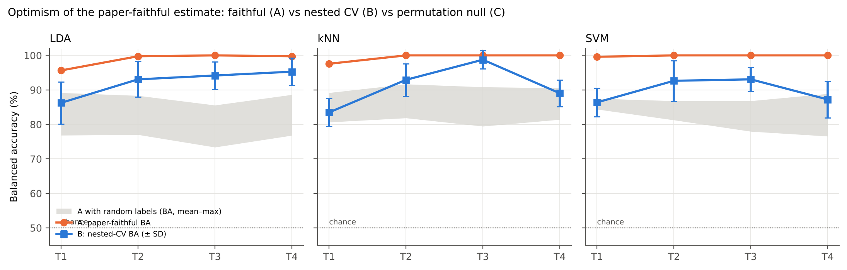
Figure 14. Balanced accuracy of the paper-faithful procedure (A, orange), of nested CV (B, blue, ± SD) and of procedure A with randomly permuted labels (C, grey band: mean–maximum).
The DSSF pool rebuilt inside the 40 outer folds was not identical to the full-data pool (median 18 features), but its core was stable; the features entering it most often were CR6 water absorption 1721–2304 nm: left area (nm) (100 % of folds), D2_1350 (78 % of folds), ARI2 (75 % of folds), D1_852 (72 % of folds), CR6 water absorption 1721–2304 nm: right area (nm) (60 % of folds).

4.7 Permutation null (procedure C)
With randomly shuffled labels – i.e. with no disease information at all – the paper-faithful procedure still reported a mean OA of 85.1–91.7 % and a mean BA of 73.4–84.4 %, with single permutations reaching OA 95.0 % (Table 11, Figure 15). These are the accuracies that the selection steps produce by chance on 48 plots and 19,548 candidate features. The observed accuracies of LDA and k-NN were higher than every permuted value on every date (p = 0.048, the smallest p attainable with 20 permutations); the four SVM permutations are indicative only (smallest attainable p = 0.20).
Table 11. Permutation null of procedure A.
Date | Classifier | Permutations | Null OA mean | Null OA max | Null BA mean | Observed OA (A) | Observed BA (A) | p (OA)
T1 (11 Feb) | LDA | 20 | 86.9 | 92.1 | 76.8 | 94.9 | 95.6 | 0.048
T1 (11 Feb) | kNN | 20 | 88.7 | 94.2 | 80.6 | 97.4 | 97.6 | 0.048
T1 (11 Feb) | SVM | 4 | 91.7 | 92.7 | 84.4 | 99.7 | 99.6 | 0.200
T2 (24 Feb) | LDA | 20 | 86.9 | 91.7 | 77.0 | 99.7 | 99.7 | 0.048
T2 (24 Feb) | kNN | 20 | 89.7 | 95.0 | 81.8 | 100.0 | 100.0 | 0.048
T2 (24 Feb) | SVM | 4 | 89.1 | 90.6 | 81.2 | 100.0 | 100.0 | 0.200
T3 (3 Mar) | LDA | 20 | 85.1 | 91.7 | 73.4 | 100.0 | 100.0 | 0.048
T3 (3 Mar) | kNN | 20 | 88.0 | 94.6 | 79.4 | 100.0 | 100.0 | 0.048
T3 (3 Mar) | SVM | 4 | 88.3 | 92.7 | 78.0 | 100.0 | 100.0 | 0.200
T4 (13 Mar) | LDA | 20 | 86.9 | 93.8 | 76.8 | 99.9 | 99.8 | 0.048
T4 (13 Mar) | kNN | 20 | 89.1 | 95.0 | 81.4 | 100.0 | 100.0 | 0.048
T4 (13 Mar) | SVM | 4 | 87.2 | 93.8 | 76.6 | 100.0 | 100.0 | 0.200
Accuracies in %.
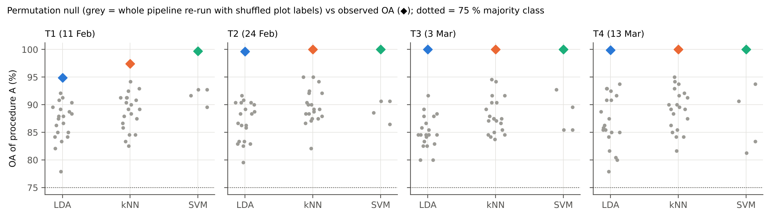
Figure 15. Procedure A with shuffled labels (grey points: one per permutation) and with the true labels (diamonds).

4.8 Detection by infection stage (procedure D)
Treated as separate infection stages (controls vs one inoculation timing on one date; Table 12), the paper-faithful SVM-SFFS reached OA 97.1–100.0 % with on average 1.0–2.1 features; stage × classifier combinations with a mean OA below 100 % – T1: 11 of 12 (lowest 95.3 %), T2: 5 of 12 (lowest 97.6 %), T4: 3 of 12 (lowest 99.0 %). The unbiased nested-CV predictions (Table 13, Figure 16) show that the SVM recognised 89–100 % of the inoculated plots of every timing on every date (lowest: D4 on T3 (3 Mar)), while 9–22 % of the control plots were false alarms. Differences between inoculation timings were small: the lowest detection rate on each date belonged to D3/D4 on T1; D2 on T2; D4 on T3; D3/D4 on T4. The later inoculations (D3/D4) were lowest on T1, T3, T4, consistent with a shorter infection period, but with 9 plots per group one plot is 11 percentage points and none of these differences is statistically meaningful.
Table 12. Paper-faithful SVM-SFFS per infection stage: 12 controls vs the 9 plots of one inoculation timing (4-fold CV × 100).
Date | Inoculation timing | Classifier | Mean OA | Mean BA | Mean no. of features | Most frequent OFC | OFC frequency (%)
T1 (11 Feb) | D1 | SVM | 99.7 | 99.7 | 2.08 | F2, F16 | 30
T1 (11 Feb) | D2 | SVM | 98.5 | 98.2 | 1.57 | F3, F13 | 33
T1 (11 Feb) | D3 | SVM | 100.0 | 100.0 | 2.00 | F2, F8 | 93
T1 (11 Feb) | D4 | SVM | 97.1 | 96.6 | 1.49 | F2 | 60
T2 (24 Feb) | D1 | SVM | 100.0 | 100.0 | 1.00 | F2 | 100
T2 (24 Feb) | D2 | SVM | 100.0 | 100.0 | 1.05 | F2 | 95
T2 (24 Feb) | D3 | SVM | 100.0 | 100.0 | 1.01 | F4 | 51
T2 (24 Feb) | D4 | SVM | 99.9 | 99.9 | 1.05 | F8 | 95
T3 (3 Mar) | D1 | SVM | 100.0 | 100.0 | 1.00 | F2 | 100
T3 (3 Mar) | D2 | SVM | 100.0 | 100.0 | 1.00 | F2 | 81
T3 (3 Mar) | D3 | SVM | 100.0 | 100.0 | 1.01 | F4 | 99
T3 (3 Mar) | D4 | SVM | 100.0 | 100.0 | 1.00 | F14 | 44
T4 (13 Mar) | D1 | SVM | 100.0 | 100.0 | 1.19 | F10 | 81
T4 (13 Mar) | D2 | SVM | 100.0 | 100.0 | 1.33 | F13 | 67
T4 (13 Mar) | D3 | SVM | 100.0 | 100.0 | 1.00 | F10 | 100
T4 (13 Mar) | D4 | SVM | 100.0 | 100.0 | 1.27 | F8 | 82
LDA and k-NN results are given in the Excel workbook (sheet S20).
Table 13. Plots called 'diseased' by the nested-CV SVM models (%). Controls: false-alarm rate; inoculated groups: detection rate.
Group | T1 (11 Feb) | T2 (24 Feb) | T3 (3 Mar) | T4 (13 Mar)
Control | 19 | 11 | 9 | 22
D1 | 93 | 100 | 99 | 98
D2 | 92 | 93 | 100 | 99
D3 | 91 | 94 | 93 | 96
D4 | 91 | 97 | 89 | 96

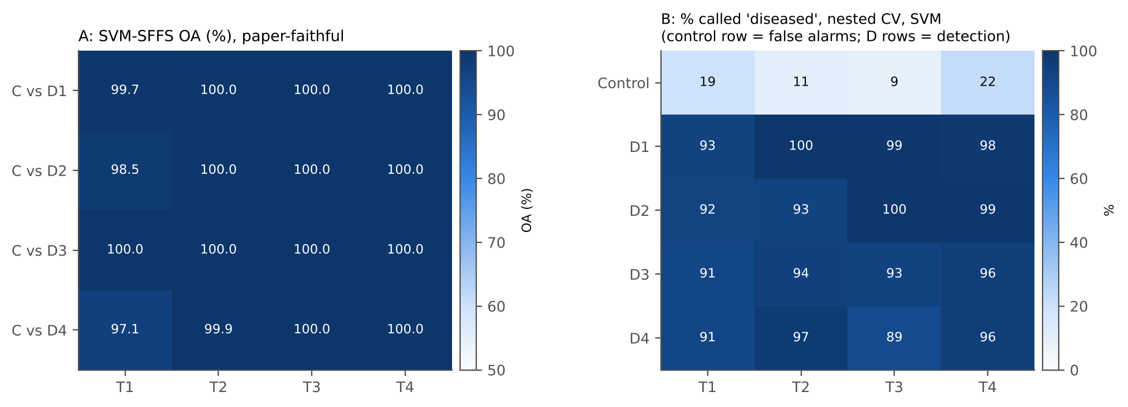
Figure 16. Infection-stage analysis: (left) paper-faithful SVM-SFFS accuracy for controls vs each inoculation timing; (right) nested-CV detection rate of each group.
By variety (nested CV, SVM), inoculated plots were classified correctly in 87–99 % of cases for all three varieties, whereas the accuracy for control plots varied more (57–95 %), mainly because each variety has only four control plots.

4.9 Cross-checks
All 18 verification checks passed; 3 items are flagged because they are properties of the data or of the original procedure that must be reported (Table 14). In the Excel workbook, live formulas reproduce the Python class means, the threshold balanced accuracies of all 16 DSSFs on all four dates and the summary accuracies of procedures A and B exactly (largest difference < 10⁻¹⁵).
Table 14. Cross-checks of every step.
Step | Check | Independent route | Result | Status
1 | Class labels identical for the 48 plots on all 4 dates | comparison of sheet 01 of every workbook | identical | PASS
1 | Treatment file agrees with the spectral workbooks | plot-by-plot comparison of variety and control status | variety match: True; controls = healthy: True | PASS
1 | Design balanced (each Variety x Inoculation timing once per block C, R1, R2, R3) | cross-tabulation of the treatment file | balanced | PASS
1 | Measurement order of the control plots | spectrum file numbers of sheet 01 | control plots measured first on every date (spectra 1–100) and form their own block C – confounded with class (limitation) | FLAG
1 | First derivative of the workbook = central difference of the reflectance | recomputed from sheet 02 | max |Δ| = 5.20e-16 | PASS
1 | CWT coefficients (PyWavelets 'mexh') = direct convolution with the Mexican-hat (Ricker) wavelet | explicit convolution at scale 2⁴ | r = 0.999634 (interior wavelengths) | PASS
1 | Identical vegetation indices in the source workbooks | pairwise comparison of the 87 index columns | RARSc ≡ GM2; mCARI1 ≡ MTVI1 (algebraically identical definitions; one of each pair is redundant) | FLAG
2 | BH-FDR q ≥ p for every test and decision rule applied | re-applied with scipy | q ≥ p in all 32 tests; test chosen by Shapiro–Wilk + Levene | PASS
3 | Threshold separability agrees with the threshold-free AUC | Spearman correlation over the 87 indices (T3) | ρ = 0.923 | PASS
3 | 100-step threshold grid vs exhaustive optimal threshold | all mid-points between sorted values (T3 indices) | grid BA ≤ exhaustive BA for all; mean gap 0.0035; largest gap 0.194 for TGI (the paper’s grid is restricted to the interval between the class means and can miss an optimum lying outside it) | PASS
4 | Representative features lie inside the analysed range and outside the guard zones | wavelength check | all inside 400–2400 nm, none in 990–1010 or 1795–1835 nm | PASS
5 | VIF of the final pool recomputed with statsmodels | statsmodels variance_inflation_factor (OLS) | max VIF 7.68; max |Δ| to own value 5.3e-14 | PASS
6 | OA, BA and kappa functions = scikit-learn | accuracy_score, balanced_accuracy_score, cohen_kappa_score | identical | PASS
6 | SFFS finds the optimum of an exhaustive search | all 696 subsets of ≤ 3 features (LDA, T1, one partition) | SFFS OA = 0.9583 with 3 features; exhaustive best (≤ 3 features) = 0.9583 | PASS
6 | Nested CV: every plot tested exactly once per repetition, same test plots on every date | set comparison of the outer folds | 10 repetitions × 4 folds: disjoint and complete | PASS
6 | Scaler and SVM parameters fitted on training plots only | code inspection (mlsffs._zfit, s04_run.nested_fold) | z-scores use training mean/SD; grid search uses inner folds only | PASS
6 | 100 repetitions per date and classifier in procedure A | count of result rows | 1200 rows = 4 dates × 3 classifiers × 100 | PASS
6 | 100 repetitions per stage (date × inoculation timing × classifier) in procedure D | count of result rows | 48 stage × classifier cells, repetitions min 100 / max 100 | PASS
6 | Observed OA of procedure A exceeds every permuted-label OA (LDA, k-NN) | 20 permutations × 5 repetitions per date | p = 1/21 = 0.048 in all 8 cases (smallest attainable) | PASS
6 | Permuted-label OA of procedure A far above 75 % majority / 50 % BA chance | mean of the null distribution | null OA 85.1–91.7 %, null BA 73.4–84.4 % – demonstrates the optimism of A | FLAG
6 | Nested (B) accuracy ≤ faithful (A) accuracy | difference A − B | optimism 1.2–14.1 percentage points (BA) | PASS

5. Discussion

5.1 Physiological interpretation of the disease-specific features
The selected DSSFs follow the physiological changes in Section 4.2. The NIR plateau slope at 852 nm (F2) was among the most frequently selected features (procedure A) and among the most stable members of the nested-CV pools. In the NIR, reflectance is governed by multiple scattering at the cell-wall/air interfaces of the mesophyll (Jacquemoud and Baret, 1990); white-rust pustules disrupt the epidermis and the intercellular structure. On every date the NIR reflectance of the controls declined from 800 to 900 nm (negative first derivative at 852 nm), whereas that of the diseased plots was flatter or rising. Tian et al. (2021) reached the same conclusion for rice blast, where wavelet features at 850–866 nm captured the collapse of the intercellular structure, and they noted that this region had been under-exploited in disease detection.
The yellow–red edge (F8, wavelet at 634 nm; F1, R₆₄₁; F11, R₄₄₀/R₆₉₀) and the anthocyanin index ARI2 (F10) record pigment changes: loss of chlorophyll raises red reflectance (R₆₄₁ was higher in diseased plots from T2) and lowers the blue/red ratio Lic, and shifts the red edge to shorter wavelengths, while anthocyanins accumulate in stressed tissue (Gitelson et al., 2001). The water features at 970 nm (F13), 1350 nm (F3) and 1940 nm (F6, F9, F12, F14) agree with the early decrease of the water indices, and the wavelet features at 1736, 1752 and 2318 nm (F4, F5, F7) lie in the C–H absorption regions of cellulose, lignin and protein (Kokaly and Clark, 1999), suggesting changes in leaf dry matter as tissue is colonised and pustules form. Because these interpretations rest on spectral proxies rather than measured biochemistry (C8), they should be presented as consistent with, not proof of, the underlying changes.

5.2 How optimistic is the paper-faithful accuracy?
Procedure A reports the best of many cross-validated accuracies – over thousands of candidate features (Step 3), over the subsets visited by SFFS and over the SVM parameter grid – evaluated on the same plots. With 48 plots and 19,548 candidate features some feature combination will separate the classes by chance, and the permutation test shows how large this effect is: 85.1–91.7 % OA without any disease information. The nested CV (B) removes this bias and should be reported as the accuracy of the method; procedure A remains useful for comparison with Tian et al. (2021) and for identifying the optimal feature combinations, which are the features consistently chosen across repetitions and folds. The same caution applies to the accuracies of Tian et al. (2021), which were obtained in the same way, and is a general lesson from other fields (Ambroise and McLachlan, 2002; Varma and Simon, 2006; Cawley and Talbot, 2010).

5.3 Comparison with Tian et al. (2021)
- Agreement. A few DSSFs (one to four) suffice; SVM-SFFS is the most accurate criterion classifier in procedure A; feature selection helps most at the earliest date; pigment features dominate early and water/SWIR features late; NIR wavelet/derivative features near 850 nm are among the most robust indicators.
- Differences. In this study the water signal appeared before the pigment signal; derivatives and continuum-removal parameters, which Tian et al. did not use, entered the pool; and the corrected (nested) balanced accuracies are 1–14 points lower than the paper-faithful ones.
- Design. The plot-average spectra of field plots are less noisy than single-leaf spectra but mix leaves at different stages of infection; the infection stage is defined here by the inoculation timing and the measurement date rather than by visual lesion scoring.

5.4 Limitations
- Confounded layout (C9). All controls were in one block and measured first on every date, so part of the healthy–diseased difference may reflect field position or measurement time (e.g. leaf temperature, instrument drift). A randomised layout and a randomised measurement order are needed to rule this out.
- Imbalance and sample size. 12 vs 36 plots (9 per inoculation group) give wide uncertainty; one misclassified control changes specificity by 8 points.
- No measured biochemistry (C8). The physiological interpretation relies on spectral proxies.
- Inoculation timings. The days after sowing of D1–D4 and the sowing date were not available, so infection stage could not be expressed as days after inoculation as in the paper.
- Computation. The SVM permutation test used only 4 permutations; in procedure D(i) the DSSF pool was chosen on all plots (optimistic, like procedure A).
- Single season and site. Transfer to other seasons, sites or canopy-level sensors has not been tested.

5.5 Recommendations
- Report the nested-CV accuracies (procedure B) as the performance of the method and the paper-faithful values (procedure A) only for comparison with Tian et al. (2021).
- Use the stable core of DSSFs – NIR slope near 850 nm, yellow-red edge near 635 nm, anthocyanin (ARI2), water absorptions at 970, 1350 and 1940 nm – as candidate indicators for an independent season.
- In future experiments, randomise the controls among the blocks and the measurement order, record the inoculation dates, and measure chlorophyll, anthocyanin and water content on a subset of leaves.

6. Conclusions
- The ML-SFFS methodology of Tian et al. (2021) could be applied step by step to plot-average spectra of white-rust-infected mustard. From 19,548 candidate features, 16 disease-specific spectral features covering pigment, NIR-structure, water and dry-matter absorptions were extracted.
- White rust lowered the water indices first (T1) and the chlorophyll and carotenoid indices from T2 onwards, while the anthocyanin index rose – the physiological basis of the selected features.
- With the paper's procedure, one to four features gave 94.9–100 % overall accuracy on every date, SVM-SFFS being the best classifier.
- Corrected for selection bias by nested cross-validation, the balanced accuracy was 83.5–98.8 %; the paper-faithful values are optimistic by 1–14 percentage points, and the procedure reaches 85.1–91.7 % OA even with random labels.
- Detection rates were similar for all four inoculation timings and all three varieties; the confounding of controls with block and measurement order is the main limitation to be removed in future experiments.

References
All references were checked against publisher, repository or indexing records (October 2026); the verification status of each is listed in the Excel workbook (sheet S24). References to the remaining vegetation indices are given in the source workbooks.
Ambroise, C., McLachlan, G.J., 2002. Selection bias in gene extraction on the basis of microarray gene-expression data. Proceedings of the National Academy of Sciences USA 99 (10), 6562–6566. https://doi.org/10.1073/pnas.102102699
Benjamini, Y., Hochberg, Y., 1995. Controlling the false discovery rate: a practical and powerful approach to multiple testing. Journal of the Royal Statistical Society Series B 57 (1), 289–300. https://doi.org/10.1111/j.2517-6161.1995.tb02031.x
Brodersen, K.H., Ong, C.S., Stephan, K.E., Buhmann, J.M., 2010. The balanced accuracy and its posterior distribution. In: Proceedings of the 20th International Conference on Pattern Recognition (ICPR), Istanbul, pp. 3121–3124. https://doi.org/10.1109/ICPR.2010.764
Cawley, G.C., Talbot, N.L.C., 2010. On over-fitting in model selection and subsequent selection bias in performance evaluation. Journal of Machine Learning Research 11, 2079–2107.
Chang, C.-C., Lin, C.-J., 2011. LIBSVM: a library for support vector machines. ACM Transactions on Intelligent Systems and Technology 2 (3), 27:1–27:27. https://doi.org/10.1145/1961189.1961199
Cheng, T., Rivard, B., Sánchez-Azofeifa, G.A., Feng, J., Calvo-Polanco, M., 2010. Continuous wavelet analysis for the detection of green attack damage due to mountain pine beetle infestation. Remote Sensing of Environment 114 (4), 899–910. https://doi.org/10.1016/j.rse.2009.12.005
Clark, R.N., Roush, T.L., 1984. Reflectance spectroscopy: quantitative analysis techniques for remote sensing applications. Journal of Geophysical Research 89 (B7), 6329–6340. https://doi.org/10.1029/JB089iB07p06329
Cohen, J., 1960. A coefficient of agreement for nominal scales. Educational and Psychological Measurement 20 (1), 37–46. https://doi.org/10.1177/001316446002000104
Cortes, C., Vapnik, V., 1995. Support-vector networks. Machine Learning 20, 273–297. https://doi.org/10.1007/BF00994018
Cover, T.M., Hart, P.E., 1967. Nearest neighbor pattern classification. IEEE Transactions on Information Theory 13 (1), 21–27.
Dash, J., Curran, P.J., 2004. The MERIS terrestrial chlorophyll index. International Journal of Remote Sensing 25 (23), 5403–5413. https://doi.org/10.1080/0143116042000274015
Fisher, R.A., 1936. The use of multiple measurements in taxonomic problems. Annals of Eugenics 7 (2), 179–188. https://doi.org/10.1111/j.1469-1809.1936.tb02137.x
Gamon, J.A., Peñuelas, J., Field, C.B., 1992. A narrow-waveband spectral index that tracks diurnal changes in photosynthetic efficiency. Remote Sensing of Environment 41 (1), 35–44. https://doi.org/10.1016/0034-4257(92)90059-S
Gao, B.-C., 1996. NDWI—a normalized difference water index for remote sensing of vegetation liquid water from space. Remote Sensing of Environment 58 (3), 257–266. https://doi.org/10.1016/S0034-4257(96)00067-3
Gitelson, A.A., Gritz, Y., Merzlyak, M.N., 2003. Relationships between leaf chlorophyll content and spectral reflectance and algorithms for non-destructive chlorophyll assessment in higher plant leaves. Journal of Plant Physiology 160 (3), 271–282. https://doi.org/10.1078/0176-1617-00887
Gitelson, A.A., Merzlyak, M.N., Chivkunova, O.B., 2001. Optical properties and nondestructive estimation of anthocyanin content in plant leaves. Photochemistry and Photobiology 74 (1), 38–45. https://doi.org/10.1562/0031-8655(2001)074<0038:OPANEO>2.0.CO;2
Gitelson, A.A., Zur, Y., Chivkunova, O.B., Merzlyak, M.N., 2002. Assessing carotenoid content in plant leaves with reflectance spectroscopy. Photochemistry and Photobiology 75 (3), 272–281. https://doi.org/10.1562/0031-8655(2002)075<0272:ACCIPL>2.0.CO;2
Gong, P., Pu, R., Heald, R.C., 2002. Analysis of in situ hyperspectral data for nutrient estimation of giant sequoia. International Journal of Remote Sensing 23 (9), 1827–1850. https://doi.org/10.1080/01431160110075622
Guyot, G., Baret, F., 1988. Utilisation de la haute résolution spectrale pour suivre l'état des couverts végétaux. In: Proceedings of the 4th International Colloquium on Spectral Signatures of Objects in Remote Sensing, Aussois, France, 18–22 January 1988. ESA SP-287, pp. 279–286.
Horler, D.N.H., Dockray, M., Barber, J., 1983. The red edge of plant leaf reflectance. International Journal of Remote Sensing 4 (2), 273–288. https://doi.org/10.1080/01431168308948546
Hsu, C.-W., Chang, C.-C., Lin, C.-J., 2003. A practical guide to support vector classification. Technical report, Department of Computer Science, National Taiwan University, Taipei (revised 2016).
Huang, Y., Li, Z., Risinger, A.L., Enslow, B.T., Zeman, C.J., Gong, J., Yang, Y., Schanze, K.S., 2019. Fluorescence spectral shape analysis for nucleotide identification. Proceedings of the National Academy of Sciences USA 116 (31), 15386–15391.
Jacquemoud, S., Baret, F., 1990. PROSPECT: a model of leaf optical properties spectra. Remote Sensing of Environment 34 (2), 75–91.
Kohavi, R., 1995. A study of cross-validation and bootstrap for accuracy estimation and model selection. In: Proceedings of the 14th International Joint Conference on Artificial Intelligence (IJCAI), Montreal, pp. 1137–1145.
Kokaly, R.F., Clark, R.N., 1999. Spectroscopic determination of leaf biochemistry using band-depth analysis of absorption features and stepwise multiple linear regression. Remote Sensing of Environment 67 (3), 267–287.
Lee, G.R., Gommers, R., Wasilewski, F., Wohlfahrt, K., O'Leary, A., 2019. PyWavelets: a Python package for wavelet analysis. Journal of Open Source Software 4 (36), 1237. https://doi.org/10.21105/joss.01237
Levene, H., 1960. Robust tests for equality of variances. In: Olkin, I., et al. (Eds.), Contributions to Probability and Statistics: Essays in Honor of Harold Hotelling. Stanford University Press, Stanford, pp. 278–292.
Leys, C., Ley, C., Klein, O., Bernard, P., Licata, L., 2013. Detecting outliers: do not use standard deviation around the mean, use absolute deviation around the median. Journal of Experimental Social Psychology 49 (4), 764–766. https://doi.org/10.1016/j.jesp.2013.03.013
Lichtenthaler, H.K., Lang, M., Sowinska, M., Heisel, F., Miehé, J.A., 1996. Detection of vegetation stress via a new high resolution fluorescence imaging system. Journal of Plant Physiology 148 (5), 599–612.
Mahlein, A.-K., Kuska, M.T., Behmann, J., Polder, G., Walter, A., 2018. Hyperspectral sensors and imaging technologies in phytopathology: state of the art. Annual Review of Phytopathology 56, 535–558. https://doi.org/10.1146/annurev-phyto-080417-050100
Mahlein, A.-K., Rumpf, T., Welke, P., Dehne, H.-W., Plümer, L., Steiner, U., Oerke, E.-C., 2013. Development of spectral indices for detecting and identifying plant diseases. Remote Sensing of Environment 128, 21–30. https://doi.org/10.1016/j.rse.2012.09.019
Mann, H.B., Whitney, D.R., 1947. On a test of whether one of two random variables is stochastically larger than the other. Annals of Mathematical Statistics 18 (1), 50–60. https://doi.org/10.1214/aoms/1177730491
O'Brien, R.M., 2007. A caution regarding rules of thumb for variance inflation factors. Quality & Quantity 41 (5), 673–690. https://doi.org/10.1007/s11135-006-9018-6
Ojala, M., Garriga, G.C., 2010. Permutation tests for studying classifier performance. Journal of Machine Learning Research 11, 1833–1863.
Pedregosa, F., Varoquaux, G., Gramfort, A., Michel, V., Thirion, B., Grisel, O., Blondel, M., Prettenhofer, P., Weiss, R., Dubourg, V., Vanderplas, J., Passos, A., Cournapeau, D., Brucher, M., Perrot, M., Duchesnay, É., 2011. Scikit-learn: machine learning in Python. Journal of Machine Learning Research 12, 2825–2830.
Peñuelas, J., Piñol, J., Ogaya, R., Filella, I., 1997. Estimation of plant water concentration by the reflectance water index WI (R900/R970). International Journal of Remote Sensing 18 (13), 2869–2875. https://doi.org/10.1080/014311697217396
Pudil, P., Novovičová, J., Kittler, J., 1994. Floating search methods in feature selection. Pattern Recognition Letters 15 (11), 1119–1125.
Saeys, Y., Inza, I., Larrañaga, P., 2007. A review of feature selection techniques in bioinformatics. Bioinformatics 23 (19), 2507–2517. https://doi.org/10.1093/bioinformatics/btm344
Saharan, G.S., Verma, P.R., Meena, P.D., Kumar, A., 2014. White Rust of Crucifers: Biology, Ecology and Management. Springer India, New Delhi.
Shapiro, S.S., Wilk, M.B., 1965. An analysis of variance test for normality (complete samples). Biometrika 52 (3–4), 591–611. https://doi.org/10.1093/biomet/52.3-4.591
Tian, L., Xue, B., Wang, Z., Li, D., Yao, X., Cao, Q., Zhu, Y., Cao, W., Cheng, T., 2021. Spectroscopic detection of rice leaf blast infection from asymptomatic to mild stages with integrated machine learning and feature selection. Remote Sensing of Environment 257, 112350. https://doi.org/10.1016/j.rse.2021.112350
Torrence, C., Compo, G.P., 1998. A practical guide to wavelet analysis. Bulletin of the American Meteorological Society 79 (1), 61–78.
Tsai, F., Philpot, W., 1998. Derivative analysis of hyperspectral data. Remote Sensing of Environment 66 (1), 41–51.
Varma, S., Simon, R., 2006. Bias in error estimation when using cross-validation for model selection. BMC Bioinformatics 7, 91. https://doi.org/10.1186/1471-2105-7-91
Zhang, J., Yuan, L., Pu, R., Loraamm, R.W., Yang, G., Wang, J., 2014. Comparison between wavelet spectral features and conventional spectral features in detecting yellow rust for winter wheat. Computers and Electronics in Agriculture 100, 79–87. https://doi.org/10.1016/j.compag.2013.11.001

Errors found in the reference list of Tian et al. (2021)
Table 15. Reference errors in Tian et al. (2021) detected during cross-checking.
Reference | As printed | Correct
Fisher (1936) | Title given as 'The use of multiple measures in taxonomic problems' | Correct title: 'The use of multiple measurements in taxonomic problems', Ann. Eugenics 7 (2), 179–188
Chang and Lin (2011) | Title given only as 'Libsvm'; pages '1–27' | LIBSVM: a library for support vector machines. ACM TIST 2 (3), 27:1–27:27
Huang et al. (2019) | No journal, volume or pages; authors 'Enslowd IV, B.T.' and 'Gonge, J.'; Zeman omitted | PNAS 116 (31), 15386–15391; authors Huang, Li, Risinger, Enslow, Zeman, Gong, Yang, Schanze
Jacquemoud and Féret (1990) | Co-author given as Féret, J.B.; no volume | Jacquemoud, S., Baret, F., 1990. PROSPECT. Remote Sens. Environ. 34, 75–91
Leys et al. (2013) as used in Tian et al. | Text: outliers = 'median minus/plus three standard deviations' | Leys et al. recommend the median ± k·MAD (k = 2.5 moderately, 3 very conservative); median ± 3 MAD is used here

Appendix A. Paper vs this study
Table 16. Design and method of Tian et al. (2021) and of this study.
Aspect | Tian et al. (2021) | This study
Pathosystem | Rice leaf blast (Magnaporthe oryzae), greenhouse | White rust (Albugo candida) of mustard, field plots
Sampling unit | Single leaves (paired infected/healthy) | Plot average of 3–15 leaf spectra per plot (48 plots)
Classes | Balanced (26+26, 45+45) | Imbalanced: 12 healthy vs 36 diseased
Time points | 5 DAIs (2018) + 6 DAIs (2019) | 4 measurement dates T1–T4 (11 Feb, 24 Feb, 3 Mar, 13 Mar 2026) on the same 48 plots
Infection stage | Asymptomatic / early / mild, defined by DAI and visible lesions | Measurement date T1–T4 × inoculation timing D1–D4 (days after sowing) – 16 stage combinations (Step 6D)
Design | Pots, paired infected and healthy leaves | 3 varieties × 4 inoculation timings × 3 replications (R1–R3) + 12 uninoculated controls (block C)
Biochemistry | Measured Ca+b, Cx+c, Canth, Cw | Not measured → spectral proxies (C8)
Candidate features | Reflectance bands, 97 SIs, CWT coefficients | Reflectance bands, D1–D3 derivatives, CWT coefficients, 87 VIs, 48 CR parameters, 23 red-edge parameters
Spectral range | 350–2500 nm | 400–2400 nm without detector-join guard zones (C1)
Separability | Thresholding, OA | Thresholding, balanced accuracy (C2)
Feature extraction | Top 5 % per DAI → intersection → 1 representative per region; SIs: top-10 union | Same, with explicit consistency level k* (C3); scalar families top 10 % union
Collinearity | VIF < 10 | Iterative relevance-aware VIF < 10 (C5)
Classifiers | LDA, k-NN (k = 3), SVM-RBF (grid search) | Same (C6)
Validation | 4-fold CV × 100 repetitions, mean optimal OA, modal OFC | A: identical replication; B: nested CV (C4); C: permutation null; D: stage-wise (controls vs each inoculation timing)
Software | R 4.0.1 (caret, kknn, e1071), IDL wavelet toolkit | Python 3 (scikit-learn, PyWavelets, SciPy, statsmodels)

Appendix B. Guide to the accompanying files
Table 17. Files delivered with this chapter.
File | Content
WhiteRust_ML-SFFS_TianMethod_Analysis.xlsx | 25 sheets, one per step (S00 contents … S24 references); green cells are live Excel formulas that recompute key results
WhiteRust_ML-SFFS_TianMethod_Slides.pptx | Step-by-step slides of the workflow, results and corrections
WhiteRust_ML-SFFS_TianMethod_Thesis_Chapter.docx | This document
code/ (Python, JavaScript) | Scripts that reproduce every number: s01_load … s12_doc

