Discrimination of healthy and white-rust-diseased mustard leaves at three leaf levels (L3, L5 and LL)
Four-tier hierarchical analysis (Das et al., 2020) with imbalance correction on raw reflectance and on the combined disease-sensitive features, CART versus Random Forest, honest validation on new plots and new dates — all dates, growth stages and varieties combined
Leaf level · ASD FieldSpec contact probe · L3: 861 leaves (144 healthy, 717 diseased) · L5: 808 leaves (135 healthy, 673 diseased) · LL: 594 leaves (99 healthy, 495 diseased)
Animesh Panda · Division of Agricultural Physics, ICAR-Indian Agricultural Research Institute, New Delhi
Methods, results and interpretation · companion to the three Excel workbooks (WhiteRust_LeafLevels)

Contents

(Right-click → Update field in Word to refresh the page numbers.)

Summary
Leaf reflectance spectra (350–2500 nm, 1 nm) of healthy and white-rust (Albugo candida) diseased mustard leaves were analysed separately for three leaf levels — L3, L5 and LL — with all four measurement dates, the three growth stages and the three varieties combined in each analysis (L3: 144 healthy and 717 diseased leaves; L5: 135 healthy and 673 diseased leaves; LL: 99 healthy and 495 diseased leaves; 12 healthy and 36 diseased plots each). The leaf levels were taken from the leaf-level workbooks supplied for this analysis; plot, variety and growth stage were attached by exact spectral matching to the labelled ASD workbooks, so that every validation could keep the leaves of one plot together.
At each leaf level the four-tier hierarchical method of Das et al. (2020) was applied twice: first on raw reflectance (2101 bands, 400–2500 nm) and then on the combined pool of disease-sensitive features (band reflectance + continuum-removal features + vegetation indices + derivative and edge features, 4150 features). Tier 1 used Welch's t-test with the Benjamini–Hochberg false-discovery rate, Tier 2 CART (rpart) band selection with equal priors — repeated with a Balanced Random Forest as the alternative selector — Tier 3 the Jeffries–Matusita (J–M) distance and Tier 4 quadratic discriminant analysis (QDA) with equal priors. The 1 : 5 imbalance between healthy and diseased leaves was corrected throughout (equal priors, balanced bootstrap samples, balanced accuracy as the headline metric), and every result was validated by leaf-level 10-fold cross-validation (the protocol of Das et al.), nested plot-grouped cross-validation, a 30 % plot hold-out and leave-one-date-out validation on new plots.
On raw reflectance, L3 1199, L5 1301, LL 1468 of 2101 bands differed significantly between healthy and diseased leaves. CART selected L3 25, L5 24, LL 19 bands; J–M on the CART bands was L3 1.89, L5 1.88, LL 1.86 and on the 17 Random Forest importance peaks L3 1.79, L5 1.77, LL 1.84. QDA with equal priors on the CART bands classified new plots (nested plot-grouped cross-validation) with a balanced accuracy of L3 71.9 %, L5 74.0 %, LL 71.7 %. On the combined feature pool QDA on the 17 Random Forest-selected features reached L3 81.7 %, L5 83.3 %, LL 79.7 %, and the best pipeline L3 81.9 %, L5 83.3 %, LL 79.8 %; the selected features were mainly first-derivative bands and continuum-removed water-absorption parameters. Transfer to an unseen date in unseen plots was much weaker (Random Forest classifier on the combined pool: L3 61.2 %, L5 59.6 %, LL 53.4 %).

1. Introduction
White rust (Albugo candida) produces white pustules and chlorosis on mustard leaves, changing leaf pigments, structure and water content and hence the leaf reflectance spectrum. Leaves at different positions on the plant differ in age and exposure, so the spectral signature of the disease may differ between leaf levels. Earlier analyses pooled all leaves (2264 spectra) or analysed each date, growth stage and variety separately. This report analyses each leaf level separately, with all dates, growth stages and varieties combined, to answer:
- Which wavelengths and disease-sensitive features discriminate healthy and diseased leaves at leaf levels L3, L5 and LL?
- How separable are the classes (J–M distance) and how accurately can they be classified (QDA, CART, Random Forest) at each leaf level, on new plots and on new dates?
- Is Random Forest a better band selector and classifier than CART, and does the combined pool of disease-sensitive features improve on raw reflectance?
- Which leaf level is best suited for detecting white rust?
Each leaf level has its own Excel workbook (40 sheets, including a glossary) with every table, figure and cross-check; this report collects the results, explains the methods and compares the three leaf levels. Validation schemes and feature steps are written out in full in both.

2. Materials and methods

2.1 Data: leaf-level workbooks and plot information
Three workbooks with leaf-level spectra were supplied: 2_date.xlsx (11-02-2026 and 24-02-2026, healthy and diseased sheets), 2_more_date.xlsx (03-03-2026 healthy and diseased, 13-03-2026 healthy) and lased_date_diseased.xlsx (13-03-2026 diseased). Each sheet holds one column per leaf spectrum (350–2500 nm, 1 nm) whose header is the leaf level L3, L5 or LL; 2267 spectra in all. Plot-average columns were not used (leaf level only), and disease score was not used: the response is healthy vs diseased.
The sheets carry no plot numbers. Because leaves of one plot share the plot environment, an honest validation must keep them together, so every spectrum was matched exactly (all 2151 bands identical) to the labelled ASD export workbooks of the four dates, which give plot, variety and growth stage. All spectra matched, and the healthy/diseased label and the date of every sheet agreed with the labelled files. Four spectra of plot 27 on 11-02-2026 (Mustard00215–00218) occur twice in the leaf-level sheet (two L3 and two L5 pairs of identical columns); one copy of each was kept, as in the earlier analyses. One labelled spectrum (Mustard00574, plot 44, 03-03-2026, diseased) is not in the leaf-level workbooks and was not used.
Table 1. The three leaf-level data sets (all four dates and three varieties in each).
Leaf level | Leaves (healthy / diseased) | Ratio diseased : healthy | Plots (healthy / diseased) | Leaves per plot and date | Growth stages
L3 | 861 (144 / 717) | 5.0 | 12 / 36 | 3 (healthy), 5 (diseased) | Flowering, Pod formation, Vegetative
L5 | 808 (135 / 673) | 5.0 | 12 / 36 | 3 (healthy), 5 (diseased) | Flowering, Pod formation, Vegetative
LL | 594 (99 / 495) | 5.0 | 12 / 36 | 3 (healthy), 5 (diseased) | Flowering, Pod formation, Vegetative

Table 2. Leaf spectra by leaf level, date and class.
Leaf level | Date | Healthy | Diseased
L3 | 11-02-2026 | 36 | 178
L3 | 24-02-2026 | 36 | 180
L3 | 03-03-2026 | 36 | 179
L3 | 13-03-2026 | 36 | 180
L5 | 11-02-2026 | 27 | 133
L5 | 24-02-2026 | 36 | 180
L5 | 03-03-2026 | 36 | 180
L5 | 13-03-2026 | 36 | 180
LL | 11-02-2026 | 9 | 45
LL | 24-02-2026 | 18 | 90
LL | 03-03-2026 | 36 | 180
LL | 13-03-2026 | 36 | 180

LL leaves are scarce on the first dates (on 11-02-2026 only 9 healthy and 45 diseased LL leaves), so the LL data set is dominated by the flowering and pod-formation dates, whereas L3 and L5 are balanced over the four dates.

2.2 Pre-processing
The contact probe illuminates the leaf with its own lamp at a few millimetres, so there is no atmospheric path; the water-absorption bands (1350–1430, 1800–1950, 2350–2500 nm), which Das et al. (2020) removed for canopy data, were kept because they carry leaf-water information. The noisy 350–399 nm detector edge was removed. The four tiers on raw reflectance used the reflectance of 400–2500 nm (2101 bands) without smoothing, as in Das et al. The disease-sensitive features used splice-corrected (detector joins at 1000/1001 and 1800/1801 nm) and Savitzky–Golay-smoothed spectra (window 11, order 2), with guard zones next to the joins excluded from the rankings.

2.3 The four-tier method with imbalance correction
Tier 1 — statistical screening. With two classes the one-way ANOVA of Das et al. reduces to a two-sample test; Welch's unequal-variance t-test was applied at every band and the p-values adjusted with the Benjamini–Hochberg false-discovery rate (q < 0.05):
t = (x̄_D − x̄_H) / √(s²_D/n_D + s²_H/n_H), q₍ᵢ₎ = min_{k ≥ i} p₍ₖ₎ · m / k
Checks: one-way ANOVA (rule of Das et al.), 1000 balanced random subsets with equal numbers of healthy and diseased leaves, and a linear mixed model with a random plot intercept (leaves nested in plots). The −log₁₀(p) of every band was plotted against wavelength.
Tier 2 — CART band selection (R rpart; Gini splitting, minsplit 20, minbucket 7, cp 0.01) with prior = c(0.5, 0.5) so that the minority healthy class weighs as much as the diseased class. The bands used as split variables form the CART set. Random Forest as the alternative selector: a Balanced Random Forest (each tree on a bootstrap sample with equal numbers of healthy and diseased leaves; 1000 trees, √p candidate bands per split); importance = mean decrease in Gini impurity; the 17 highest importance peaks at least 10 nm apart form the Random Forest band set (RF-17).
Tier 3 — Jeffries–Matusita distance on the selected bands (class means μ, covariance matrices Σ):
α = ⅛ (μ_H − μ_D)ᵀ [(Σ_H + Σ_D)/2]⁻¹ (μ_H − μ_D) + ½ ln{ |(Σ_H + Σ_D)/2| / √(|Σ_H| |Σ_D|) }, J–M = 2 (1 − e^(−α))
J–M ranges from 0 to 2; the classes are called separable at J–M ≥ 1.90 (Das et al. used 1.94).
Tier 4 — quadratic discriminant analysis with equal prior probabilities (π_H = π_D = 0.5; sample priors would favour 'diseased'), summarised in an error matrix (rows = classified, columns = reference) with producer's and user's accuracy, overall accuracy, Cohen's κ and the balanced accuracy = ½ (recall of healthy + recall of diseased), the headline metric because overall accuracy is dominated by the large diseased class.

2.4 Validation
- Leaf-level 10-fold cross-validation — bands chosen once on all leaves, leaves split at random into 10 folds (the protocol of Das et al.). Optimistic: leaves of one plot are in training and test, and selection and evaluation use the same leaves.
- Plot-grouped cross-validation — bands fixed, folds formed from whole plots (removes plot leakage).
- Nested plot-grouped cross-validation — Tier 1, band selection and classifier refitted inside every training set; 10 plot-grouped folds × 5 repeats (50 training sets), folds grouped by plot across all dates and every test fold containing both classes. The honest estimate for new plots.
- 30 % plot hold-out validation — 30 % of the plots of each class (4 healthy + 11 diseased) held out, everything refitted on the rest; 10 random splits.
- Leave-one-date-out validation on new plots — train on three dates (training plots of a hold-out split), test on the fourth date (test plots of the split); 10 splits × 4 dates. No leaf, plot or date of the test set is seen in training.
- Nested plot-grouped cross-validation with random under-sampling — as nested cross-validation but diseased leaves randomly under-sampled to the number of healthy leaves, as an alternative imbalance correction.
Paired Wilcoxon signed-rank tests compare pipelines on identical folds. When a training set has fewer than two FDR-significant bands, Tier 2 receives the bands with uncorrected p < 0.05 (flagged in the cross-checks).

2.5 Disease-sensitive feature extraction
- Smoothing and detector-join correction — splice correction, Savitzky–Golay smoothing and derivatives, guard zones.
- Band reflectance — smoothed reflectance at every band: Welch t + FDR, Hedges' g, AUC and a threshold classifier validated on plots.
- Continuum-removal features — depth, position, area, width and symmetry of six absorption features (495, 675, 970, 1200, 1450, 1940 nm) after division by the upper convex hull (Clark and Roush, 1984; Kokaly and Clark, 1999).
- Vegetation indices — the 31 indices of the flowering-stage workbook, plus the optimised two-band normalised-difference index searched over all band pairs (pairs straddling a detector join excluded; search repeated inside training plots).
- Derivative and edge features — first-derivative bands, 20 edge parameters and the red-edge inflection point by four methods (maximum first derivative; linear four-point, Guyot and Baret, 1988; Lagrangian, Dawson and Curran, 1998; linear extrapolation, Cho and Skidmore, 2006).
- Correlation spectra and CART vs Random Forest on each feature group — point-biserial correlation with disease status; CART and Balanced Random Forest fitted to each feature family on identical plot-grouped folds.

2.6 Four tiers on the combined feature pool
All band-reflectance, continuum-removal, vegetation-index, first-derivative and edge features were pooled (4150 features after removing exact duplicates), and the same four tiers, settings and validation folds were applied: Welch + FDR, CART and Random Forest selection, J–M and QDA with equal priors.

2.7 Cross-checks and software
Each step was cross-checked by an independent implementation or recomputation (Welch t vs SciPy; FDR vs statsmodels; ANOVA F = t²; mixed model R nlme vs statsmodels; rpart vs scikit-learn trees; QDA vs manual discriminant functions and R MASS::qda; J–M by Cholesky vs explicit inverse; Random Forest importance vs a second seed, R randomForest and permutation importance; continuum removal, indices and red-edge position recomputed by Excel formulas; assertions that no plot, and in leave-one-date-out no date, is in training and test). Software: Python 3.13 (NumPy, SciPy, pandas, statsmodels, scikit-learn, imbalanced-learn, matplotlib, openpyxl) and R 4.3.3 (rpart, MASS, nlme, randomForest).
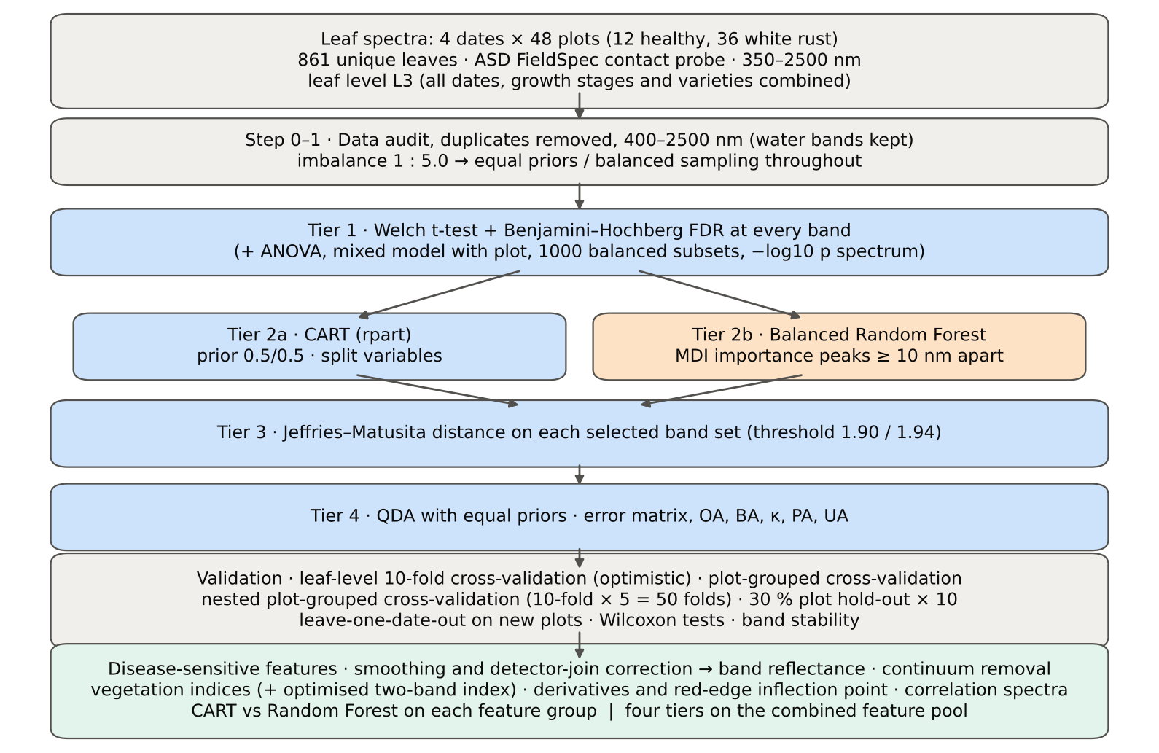
Figure 1. Workflow of each leaf-level analysis.

3. Results: comparison of the three leaf levels

3.1 Spectra of healthy and diseased leaves
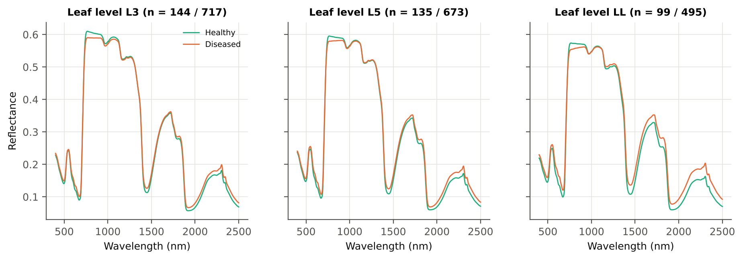
Figure 2. Mean reflectance of healthy (aqua) and diseased (orange) leaves at each leaf level (n = healthy / diseased).
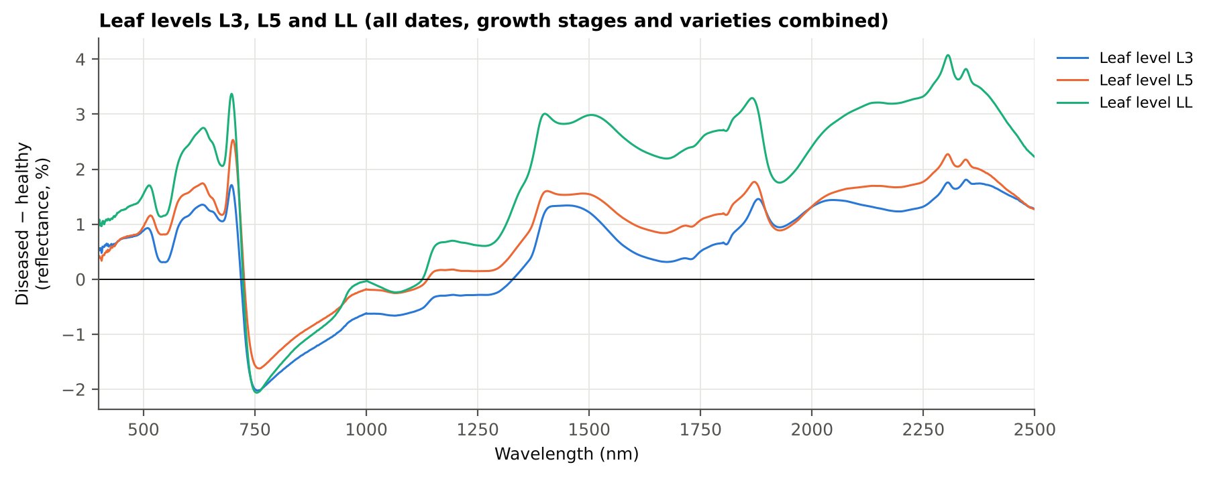
Figure 3. Difference spectra (mean diseased − mean healthy reflectance, %) at the three leaf levels.
At all three leaf levels the diseased leaves reflect more in the visible (chlorophyll loss and white pustules; largest near 700 nm: +1.6 % (L3), +2.3 % (L5), +2.7 % (LL) at the band of maximum |t|), less on the near-infrared shoulder (about −1.6 to −2.1 % at 750–760 nm, a sign of disturbed mesophyll structure) and more in the short-wave infrared beyond about 1300 nm (lower leaf water). The difference spectrum crosses zero on the red edge (≈ 720 nm), which shifts the red edge to shorter wavelengths, and approaches zero between 1000 and 1300 nm. The size of the change increases from the upper to the lower leaves: in the short-wave infrared the difference is about +0.3 to +1.8 % for L3, +0.8 to +2.3 % for L5 and +1.8 to +4.1 % for LL, i.e. the oldest (lowest) leaves carry the strongest disease signal, as expected for a disease that starts on and accumulates on the older leaves.

3.2 Tier 1 — how many bands differ
Table 3. Tier 1 results by leaf level (raw reflectance, 400–2500 nm).
Leaf level | Welch t-test + FDR (of 2101) | Mixed model (plot effect) + FDR | Significant in ≥ 95 % of balanced subsets | Most sensitive band (nm) | AUC | Bands with AUC ≥ 0.70
L3 | 1199 | 1068 | 580 | 1894 | 0.669 | 0
L5 | 1301 | 1132 | 896 | 694 | 0.701 | 2
LL | 1468 | 1467 | 1221 | 1887 | 0.738 | 375

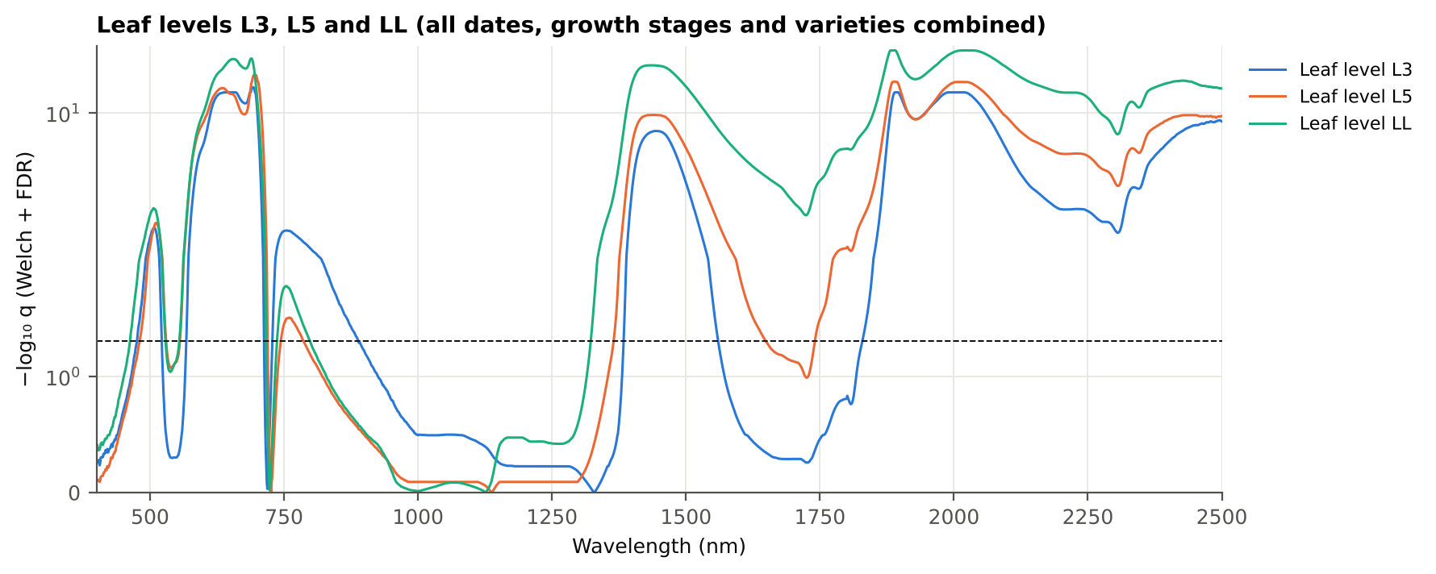
Figure 4. Significance spectra: −log₁₀ q of the Welch t-test (Benjamini–Hochberg) against wavelength at the three leaf levels (dashed line q = 0.05; symmetric-log scale).
Tier 1 confirms this gradient: 1199 (L3), 1301 (L5), 1468 (LL) of the 2101 bands differ significantly (Welch t-test + Benjamini–Hochberg), 1068 (L3), 1132 (L5), 1467 (LL) remain significant when the plot is added as a random effect (mixed model), and 580 (L3), 896 (L5), 1221 (LL) are significant in at least 95 % of the 1000 balanced random subsets (equal numbers of healthy and diseased leaves — the imbalance-corrected version of the test). At every leaf level all bands of the red region (600–679 nm) and of 1951–2500 nm are significant, whereas the near-infrared plateau (760–1349 nm) is mostly not (129 of 590 (L3), 27 of 590 (L5), 66 of 590 (LL)). The mixed model removes few bands at LL (1468 → 1467) but more at L3 and L5, i.e. at the upper leaf levels part of the difference is a between-plot effect. Although many bands are significant, single bands separate the classes only moderately: the best single-band AUC is 0.67 (L3), 0.70 (L5), 0.74 (LL), so a multivariate combination (Tiers 2–4) is required.

3.3 Tier 2 — bands selected by CART and by Random Forest
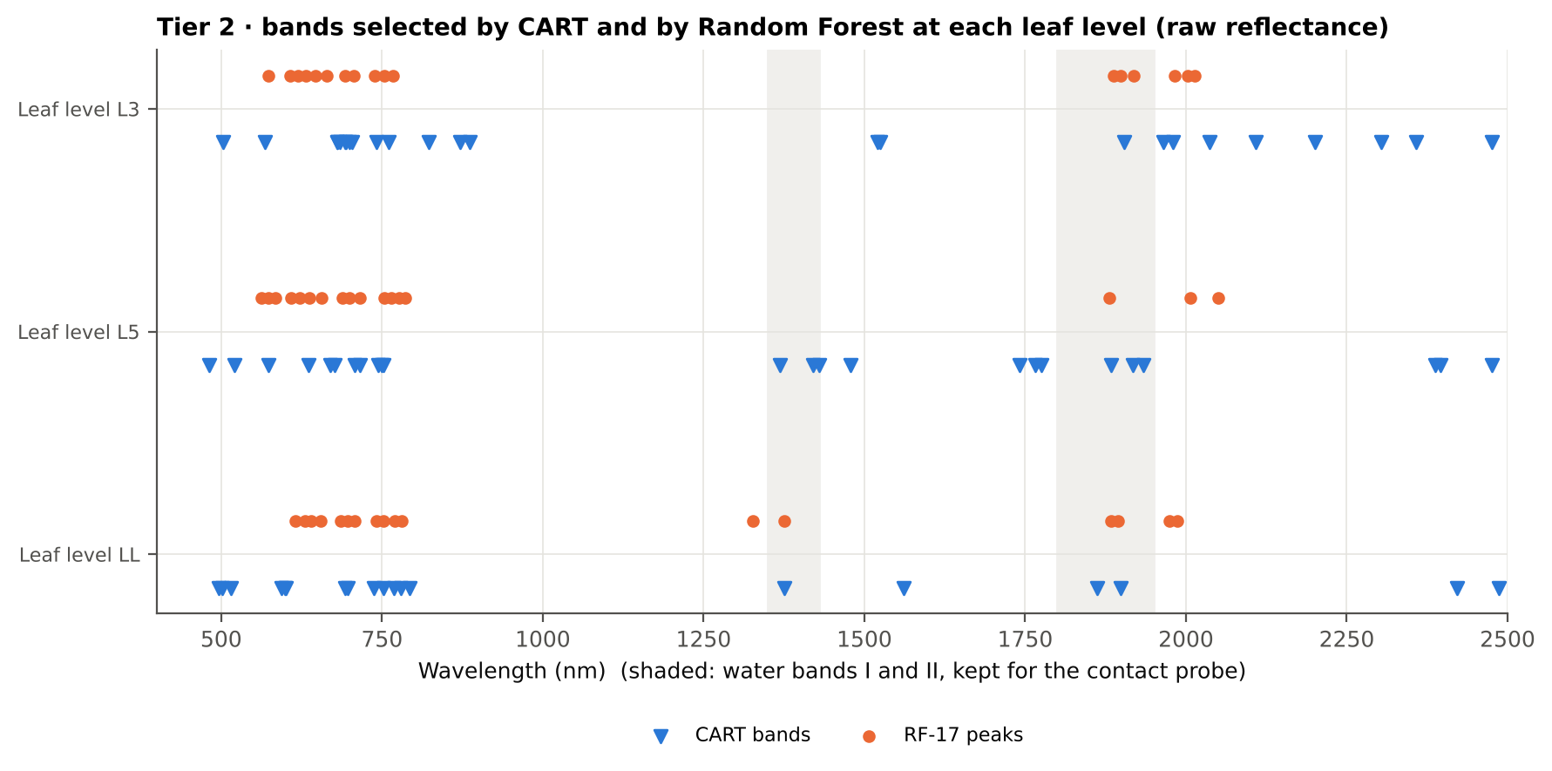
Figure 5. Bands selected by CART (blue triangles) and the 17 Random Forest importance peaks (orange dots) at each leaf level (raw reflectance).
Table 4. Tier 2 band sets by leaf level.
Leaf level | CART set | Root band (nm) | CART bands (nm, order of use) | Random Forest peaks RF-17 (nm, by importance)
L3 | CART-25 | 694 | 694, 741, 2036, 2200, 2358, 2108, 2303, 700, 684, 823, 680, 1521, 503, 871, 1980, 2475, 761, 886, 692, 1524, 681, 568, 704, 1965, 1904 | 692, 2003, 753, 739, 1983, 647, 631, 706, 1899, 664, 619, 767, 1919, 573, 2013, 607, 1887
L5 | CART-24 | 1884 | 1884, 708, 752, 1478, 1775, 715, 1766, 677, 2387, 1741, 670, 481, 1369, 520, 750, 573, 1420, 1917, 2475, 744, 2396, 636, 1933, 1429 | 700, 753, 1881, 689, 776, 764, 715, 786, 656, 637, 2050, 2007, 573, 584, 622, 609, 563
LL | CART-19 | 693 | 693, 752, 1862, 1898, 1376, 1561, 737, 599, 769, 501, 515, 779, 2421, 496, 2486, 697, 793, 594, 601 | 697, 616, 686, 1894, 655, 640, 630, 1883, 1986, 781, 741, 752, 770, 1974, 1375, 1327, 707

3.4 Tier 3 — separability (Jeffries–Matusita distance)
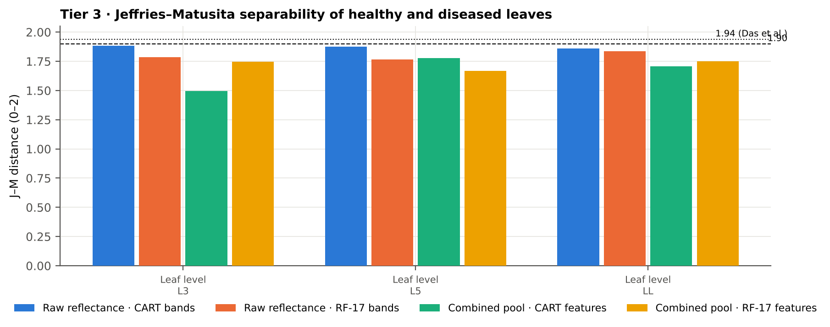
Figure 6. J–M distance on the CART and RF-17 sets, raw reflectance and combined feature pool, by leaf level (dashed 1.90, dotted 1.94).
Table 5. J–M distance (0–2) by leaf level.
Leaf level | Raw reflectance: CART bands | Raw reflectance: RF-17 | Combined pool: CART features | Combined pool: RF-17
L3 | 1.885 (CART-25) | 1.786 | 1.496 (CART-11) | 1.747
L5 | 1.876 (CART-24) | 1.767 | 1.776 (CART-13) | 1.667
LL | 1.861 (CART-19) | 1.836 | 1.709 (CART-7) | 1.751

None of the band sets reaches the separability threshold of J–M ≥ 1.90 (Das et al. used 1.94), but the CART bands of raw reflectance come close (1.89 (L3), 1.88 (L5), 1.86 (LL)); the RF-17 bands give 1.79 (L3), 1.77 (L5), 1.84 (LL). The leaf-level analyses are far more separable than all leaves pooled (J–M about 1.27 in the pooled analysis), because pooling mixes the spectra of young and old leaves and widens the class covariances. On the combined feature pool J–M is lower (CART 1.50 / 1.78 / 1.71; RF-17 1.75 / 1.67 / 1.75 for L3 / L5 / LL) even though classification is better (Section 3.5). J–M is calculated under the assumption of multivariate-normal classes and grows with the number of features; the combined-pool sets contain fewer features (CART 11 / 13 / 7) and mostly first-derivative bands, whose distributions are heavy-tailed. J–M is therefore a guide to separability, not a substitute for validated accuracy.

3.5 Tier 4 and validation — accuracy on new plots
Table 6. Balanced accuracy (%) of the four pipelines under nested plot-grouped cross-validation (new plots), raw reflectance and combined feature pool.
Leaf level | Raw reflectance: CART classifier | Raw reflectance: RF classifier | Raw reflectance: QDA on CART features | Raw reflectance: QDA on RF features | Combined pool: CART classifier | Combined pool: RF classifier | Combined pool: QDA on CART features | Combined pool: QDA on RF features
L3 | 59.9 | 63.5 | 71.9 | 69.6 | 72.5 | 80.6 | 81.9 | 81.7
L5 | 62.0 | 72.2 | 74.0 | 70.8 | 77.6 | 82.6 | 76.4 | 83.3
LL | 62.7 | 69.5 | 71.7 | 71.7 | 78.6 | 79.8 | 79.0 | 79.7
All leaves pooled (earlier analysis) | 64.7 | 70.7 | 72.0 | 69.1 | 80.1 | 86.1 | 78.2 | 83.7

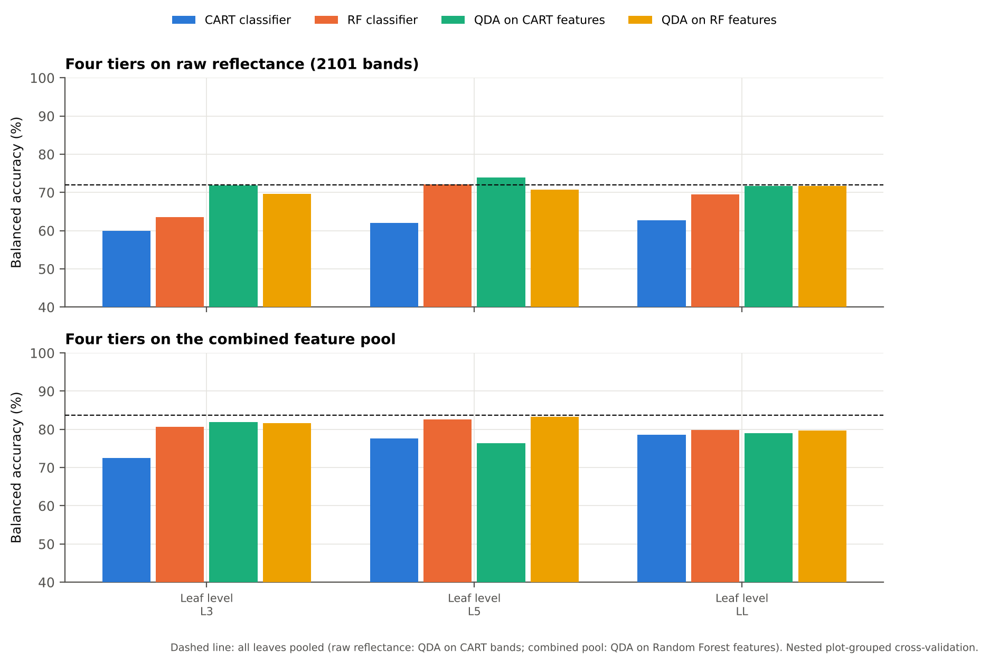
Figure 7. Balanced accuracy on new plots (nested plot-grouped cross-validation) of the four pipelines, raw reflectance (top) and combined feature pool (bottom). Dashed line: all leaves pooled.
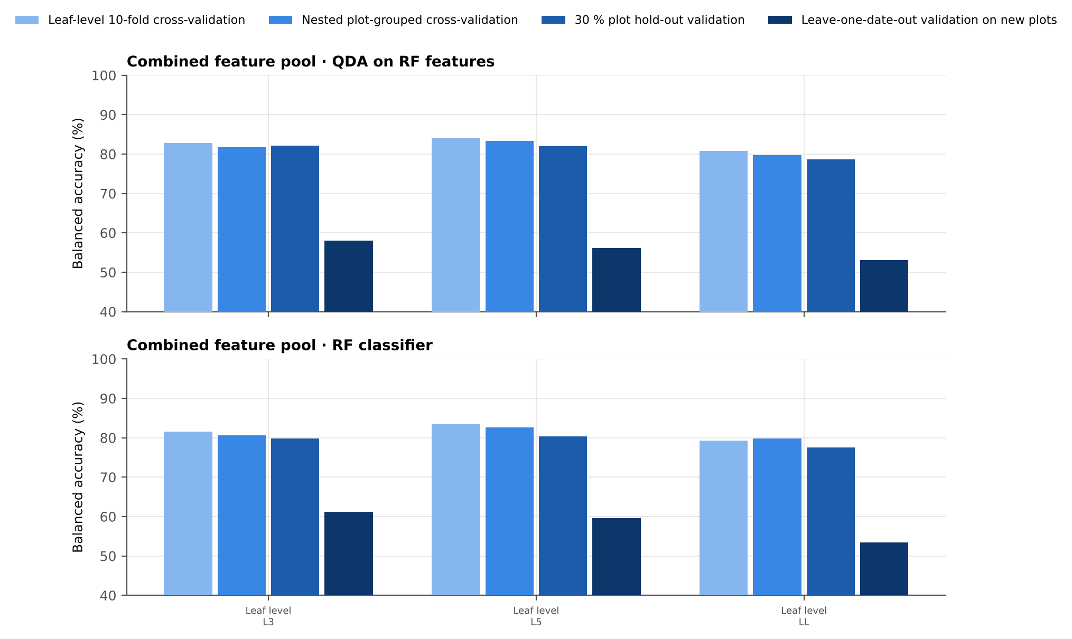
Figure 8. Combined feature pool: balanced accuracy of QDA on Random Forest features and of the Random Forest classifier under the four validation schemes.
Raw reflectance. With the protocol of Das et al. (leaf-level 10-fold cross-validation, bands chosen once on all leaves) QDA on the CART bands reaches a balanced accuracy of 74.4 % (L3), 78.8 % (L5), 75.1 % (LL); on new plots (nested plot-grouped cross-validation) it drops to 71.9 % (L3), 74.0 % (L5), 71.7 % (LL) — the leaf-level estimate is 2.5–5 points optimistic because leaves of the same plot are in training and test and the bands were selected on the test leaves. The 30 % plot hold-out validation agrees with the nested cross-validation within its standard deviation. Combined feature pool. All pipelines improve markedly: QDA on the RF-17 features reaches 81.7 % (L3), 83.3 % (L5), 79.7 % (LL) on new plots and the Random Forest classifier 80.6 % (L3), 82.6 % (L5), 79.8 % (LL); the gain over raw reflectance is significant at every level (paired Wilcoxon over the 50 folds, p < 0.001 for the Random Forest classifier: +16.7 points (L3), +10.4 points (L5), +10.2 points (LL)). The leaf-level estimate is only about 1 point higher than the nested estimate here, so the combined-pool result is robust for new plots. New dates. Leave-one-date-out validation on new plots is much weaker (combined pool, Random Forest classifier: 61.2 % (L3), 59.6 % (L5), 53.4 % (LL)). When 13-03-2026 (the last date, pod formation) is held out, the classifiers trained on the three earlier dates assign almost all of its leaves to one class (balanced accuracy about 50 %), i.e. the late-season spectra lie outside the range seen in training.

3.6 CART versus Random Forest
Table 7. CART versus Random Forest on raw reflectance: paired Wilcoxon tests over the 50 nested cross-validation folds (positive = Random Forest better) and stability of the selected bands (mean pairwise Jaccard index, ± 10 nm).
Leaf level | Random Forest − CART classifier | Random Forest better (folds) | p | QDA: Random Forest − CART bands | p | Stability (Jaccard) Random Forest / CART
L3 | 4.0 points | 35 / 50 | 1.5e-4 | -2.1 points | 0.023 | 0.67 / 0.33
L5 | 9.9 points | 43 / 50 | 0.0e+0 | -3.3 points | 0.006 | 0.55 / 0.32
LL | 6.6 points | 39 / 50 | 1.4e-5 | -0.3 points | 0.691 | 0.62 / 0.24

As classifiers the Balanced Random Forest beats CART at every leaf level (+4.0 points (L3), +9.9 points (L5), +6.6 points (LL); Random Forest better in 35 / 43 / 39 of 50 folds; p < 0.001), because averaging 1000 trees removes the instability of a single tree. As band selectors for QDA the RF-17 bands are not better than the CART bands on raw reflectance (-2.1 points, p = 0.023 (L3), -3.3 points, p = 0.006 (L5), -0.3 points, p = 0.691 (LL)): importance peaks cluster in correlated visible and red-edge regions, whereas CART picks complementary bands across the whole spectrum (visible, red edge, water bands and SWIR-2). On the combined pool the RF-17 features are equal to or better than the CART features for QDA (-0.3 points, p = 0.299 (L3), +7.1 points, p = 4.0e-8 (L5), +1.3 points, p = 0.177 (LL)). Random Forest selection is also much more stable: the mean Jaccard index of the bands re-selected in the 50 training sets is 0.67 / 0.55 / 0.62 for Random Forest vs 0.33 / 0.32 / 0.24 for CART (raw reflectance) and 0.72 / 0.73 / 0.65 vs 0.27 / 0.35 / 0.29 on the combined pool (L3 / L5 / LL).

3.7 Disease-sensitive features
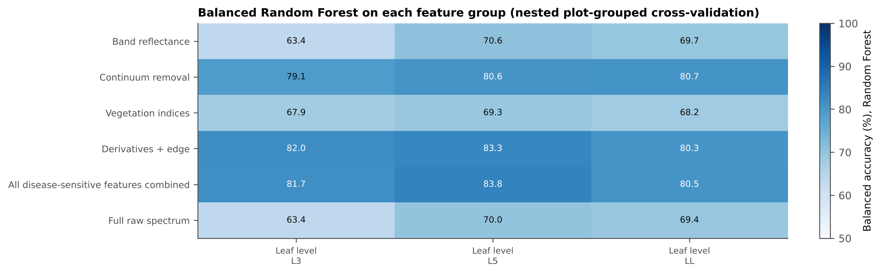
Figure 9. Balanced accuracy of a Balanced Random Forest on each feature group, by leaf level (nested plot-grouped cross-validation).
Table 8. Most informative feature group and most sensitive single features, by leaf level (AUC is direction-free: 0.5 = no separation).
Leaf level | Best feature group (Random Forest) | Best first-derivative band (AUC) | Best continuum-removal parameter (AUC) | Best vegetation index (AUC) | Best edge parameter (AUC)
L3 | Derivatives + edge parameters 82.0 % | 872 nm (0.83) | CR3 water 970 width (0.74) | NWI2 (0.68) | SDr (red-edge area) (0.63)
L5 | All disease-sensitive features combined 83.8 % | 873 nm (0.80) | CR3 water 970 width (0.75) | RARSc (0.69) | REP, linear 4-point (nm) (0.66)
LL | Continuum-removal features 80.7 % | 840 nm (0.78) | CR3 water 970 width (0.81) | NWI2 (0.74) | Ro (red well reflectance) (0.71)

Among the feature groups, derivative and edge features (82.0 % (L3), 83.3 % (L5), 80.3 % (LL)) and continuum-removal features (79.1 % (L3), 80.6 % (L5), 80.7 % (LL)) give the highest balanced accuracy with a Balanced Random Forest, clearly above band reflectance (63.4 % (L3), 70.6 % (L5), 69.7 % (LL)) and the vegetation indices (67.9 % (L3), 69.3 % (L5), 68.2 % (LL)). The most sensitive single feature is the first derivative at 840–875 nm (872 nm, AUC 0.83 (L3), 873 nm, AUC 0.80 (L5), 840 nm, AUC 0.78 (LL)): the diseased leaves have a steeper rising slope on the near-infrared shoulder because their reflectance is depressed at 750–800 nm but recovers towards 1000 nm. The second is the width of the 970 nm water-absorption feature after continuum removal (AUC 0.74 / 0.75 / 0.81; narrower in diseased leaves, i.e. less leaf water), followed by water indices (NWI2 0.68 (L3), RARSc 0.69 (L5), NWI2 0.74 (LL)). The optimised two-band index (detector-join-free search) also lies on the near-infrared shoulder (NDSI(849,850) (L3), NDSI(869,874) (L5), NDSI(827,828) (LL)); its honest balanced accuracy, with the band pair searched inside the training plots only, is 75.2 % (L3), 73.9 % (L5), 65.8 % (LL). Derivatives that include the guard zones beside the detector joins reach 87.9 / 89.0 / 88.6 %, but this is an instrument artefact (the 1000/1001 and 1800/1801 nm splice) and was excluded.

3.8 Red-edge shift and transfer to new dates
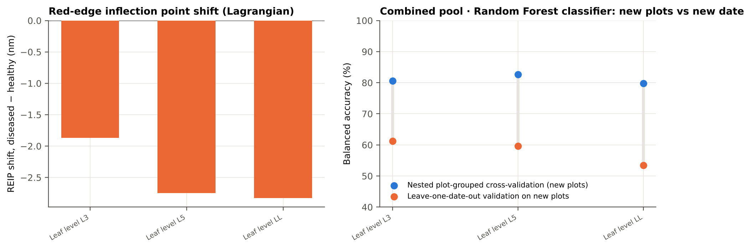
Figure 10. Left: red-edge inflection point shift (diseased − healthy, Lagrangian method). Right: Random Forest classifier on the combined pool, nested plot-grouped cross-validation vs leave-one-date-out validation on new plots.
The red-edge inflection point shifts to shorter wavelengths in diseased leaves at every level and with every method (Lagrangian: -1.9 nm (L3), -2.8 nm (L5), -2.8 nm (LL); linear extrapolation: -3.0 nm (L3), -4.2 nm (L5), -4.7 nm (LL)), the classic sign of chlorophyll loss; the shift grows from L3 to the lower leaves. As a single feature, however, it separates the classes only moderately (AUC 0.63 / 0.67 / 0.68). The right panel shows the main limitation of all models: the Random Forest classifier on the combined pool drops from 80.6 / 82.6 / 79.8 % on new plots of known dates to 61.2 / 59.6 / 53.4 % on a new date (L3 / L5 / LL). The disease signal is real, but its spectral expression changes with growth stage and date (canopy development, pustule maturity, senescence of lower leaves), so a model must be calibrated with leaves of the target stage.

3.9 What the selectors chose from the combined pool
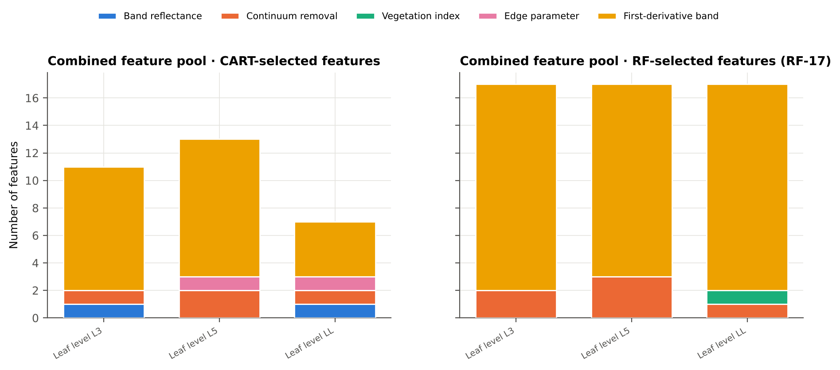
Figure 11. Feature types chosen by CART and by Random Forest (RF-17) from the combined pool, by leaf level.
From the 4150 features of the combined pool, Random Forest (RF-17) chose 15 / 14 / 15 first-derivative bands and 2 / 3 / 1 continuum-removal features (LL also one vegetation index) for L3 / L5 / LL; CART chose 9 / 10 / 4 first-derivative bands plus two or three continuum-removal, edge or reflectance features. No raw reflectance band entered the RF-17 sets. The first-derivative bands concentrate on the near-infrared shoulder (about 785–920 nm), with others in and beside the 1940 nm water band (1790–1960 nm) and in SWIR-2 (2200–2340 nm); the continuum-removal features chosen are the symmetry and position of the 1940 nm water absorption (L3, L5) and the width of the 970 nm water absorption (L5, LL — the most important feature at LL). The combined analysis therefore points to two physiological signals: altered leaf structure on the near-infrared shoulder and reduced leaf water in the water-absorption features.

4. Results for each leaf level
Each section follows the steps of the workbook of that leaf level: data and validation design; Tiers 1–4 on raw reflectance with CART and Random Forest; validation; disease-sensitive features; the four tiers on the combined feature pool; transfer to an unseen date; interpretation and cross-checks.

4.1 Leaf level L3

4.1.1 Data and validation design
861 leaf spectra (144 healthy, 717 diseased; ratio 1 : 5.0) from 12 healthy and 36 diseased plots, measured on 11-02-2026, 24-02-2026, 03-03-2026, 13-03-2026; growth stages Flowering, Pod formation, Vegetative; varieties V1, V2, V3. Nested plot-grouped cross-validation used 10 plot-grouped folds × 5 repeats (50 training sets); the 30 % plot hold-out held out 4 healthy + 11 diseased plots × 10; leave-one-date-out validation on new plots had 40 units.
Table 9. Leaf level L3: leaf spectra by date and growth stage.
Date | Growth stage | Healthy | Diseased
11-02-2026 | Flowering | 3 | 15
11-02-2026 | Vegetative | 33 | 163
24-02-2026 | Flowering | 21 | 105
24-02-2026 | Vegetative | 15 | 75
03-03-2026 | Flowering | 33 | 164
03-03-2026 | Pod formation | 3 | 15
13-03-2026 | Flowering | 9 | 45
13-03-2026 | Pod formation | 27 | 135

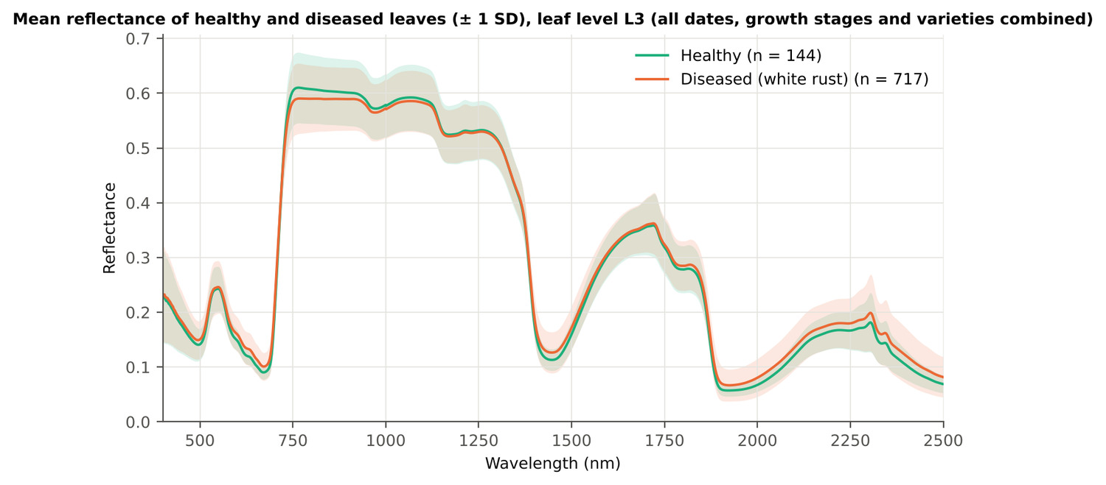
Figure 12. Leaf level L3: mean reflectance of healthy and diseased leaves (± 1 SD).
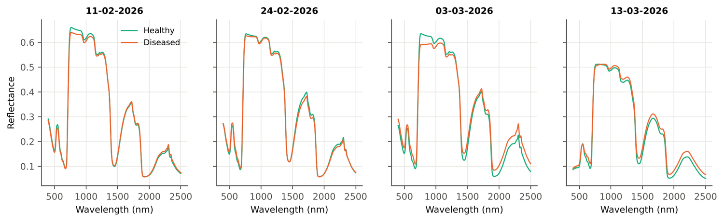
Figure 13. Leaf level L3: mean spectra of healthy and diseased leaves on each date.

4.1.2 Tier 1 — statistical screening on raw reflectance
Table 10. Leaf level L3: number of significant bands by test.
Test | Significant bands (of 2101)
Welch t-test + BH-FDR q < 0.05 (used for Tier 2) | 1199
One-way ANOVA p < 0.05, uncorrected (rule of Das et al.) | 1251
One-way ANOVA + BH-FDR q < 0.05 | 1187
Welch t-test p < 0.05, uncorrected | 1260
Mixed model (random plot effect) + BH-FDR q < 0.05 | 1068
Balanced subsets (144 vs 144): significant in ≥ 95 % of 1000 subsets | 580
Levene test p < 0.05 (unequal variances → Welch) | 696

Table 11. Leaf level L3: largest contiguous ranges of significant bands.
Contiguous significant range (nm) | Bands
1830–2500 | 671
1384–1560 | 177
729–888 | 160
568–712 | 145
476–521 | 46

Table 12. Leaf level L3: ten bands with the largest |t|.
Band (nm) | Mean healthy | Mean diseased | Welch t | q (FDR) | Hedges g | AUC
692 | 0.1166 | 0.1321 | 8.70 | 0.00e+0 | 0.50 | 0.654
693 | 0.1223 | 0.1382 | 8.67 | 0.00e+0 | 0.51 | 0.654
691 | 0.1118 | 0.1267 | 8.67 | 0.00e+0 | 0.50 | 0.653
690 | 0.1079 | 0.1222 | 8.59 | 0.00e+0 | 0.50 | 0.651
694 | 0.1289 | 0.1453 | 8.58 | 0.00e+0 | 0.51 | 0.653
689 | 0.1047 | 0.1184 | 8.47 | 0.00e+0 | 0.49 | 0.649
695 | 0.1364 | 0.1532 | 8.44 | 0.00e+0 | 0.50 | 0.651
688 | 0.1021 | 0.1152 | 8.32 | 0.00e+0 | 0.48 | 0.646
696 | 0.1448 | 0.1618 | 8.25 | 0.00e+0 | 0.50 | 0.649
687 | 0.1000 | 0.1126 | 8.15 | 0.00e+0 | 0.47 | 0.643

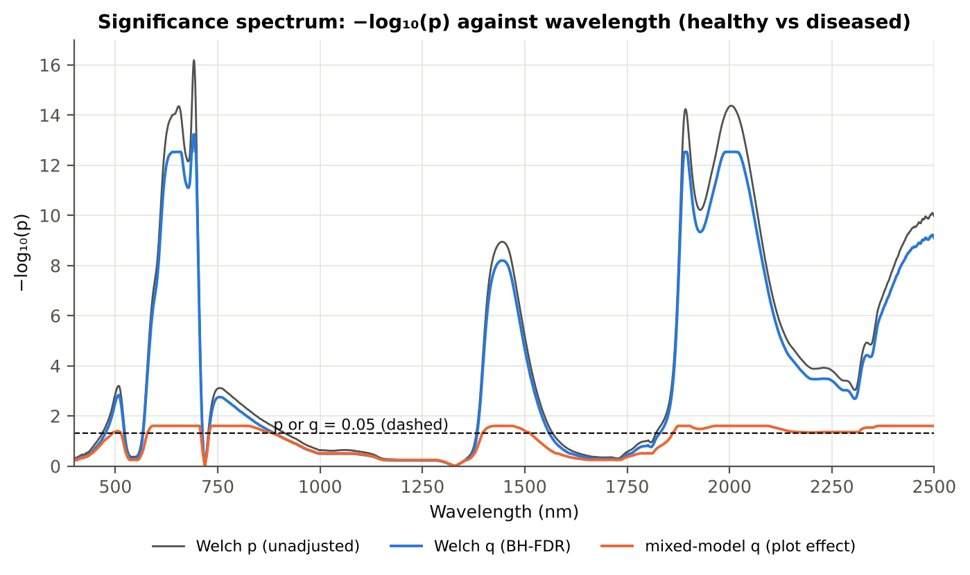
Figure 14. Leaf level L3: −log₁₀(p) against wavelength (Welch p, FDR q and mixed-model q; dashed p or q = 0.05).

4.1.3 Tier 2 — CART and Random Forest band selection
Table 13. Leaf level L3: the CART-25 bands selected by rpart (prior 0.5/0.5) and how often a band within ± 10 nm is re-selected.
Band (nm) | Region | First used at node | Bootstrap re-selection | Nested cross-validation re-selection
503 | Green (500–599) | 36 | 44.5 % | 44.0 %
568 | Green (500–599) | 354 | 43.0 % | 42.0 %
680 | Red edge (680–759) | 22 | 60.5 % | 58.0 %
681 | Red edge (680–759) | 177 | 61.0 % | 60.0 %
684 | Red edge (680–759) | 12 | 72.5 % | 94.0 %
692 | Red edge (680–759) | 146 | 94.0 % | 100.0 %
694 | Red edge (680–759) | 1 | 95.0 % | 100.0 %
700 | Red edge (680–759) | 11 | 98.0 % | 100.0 %
704 | Red edge (680–759) | 708 | 95.5 % | 100.0 %
741 | Red edge (680–759) | 2 | 69.0 % | 88.0 %
761 | NIR (760–1349) | 88 | 42.0 % | 70.0 %
823 | NIR (760–1349) | 18 | 5.0 % | 24.0 %
871 | NIR (760–1349) | 44 | 8.5 % | 20.0 %
886 | NIR (760–1349) | 92 | 11.0 % | 16.0 %
1521 | SWIR-1 (1431–1799) | 23 | 16.0 % | 12.0 %
1524 | SWIR-1 (1431–1799) | 176 | 20.5 % | 12.0 %
1904 | Water band II (1800–1950) | 2833 | 54.0 % | 60.0 %
1965 | SWIR-2 (1951–2349) | 1416 | 21.5 % | 10.0 %
1980 | SWIR-2 (1951–2349) | 46 | 33.0 % | 18.0 %
2036 | SWIR-2 (1951–2349) | 3 | 17.0 % | 66.0 %
2108 | SWIR-2 (1951–2349) | 6 | 5.5 % | 46.0 %
2200 | SWIR-2 (1951–2349) | 4 | 3.0 % | 38.0 %
2303 | SWIR-2 (1951–2349) | 9 | 11.0 % | 34.0 %
2358 | SWIR-2 end (2350–2500) | 5 | 21.5 % | 40.0 %
2475 | SWIR-2 end (2350–2500) | 73 | 25.5 % | 42.0 %

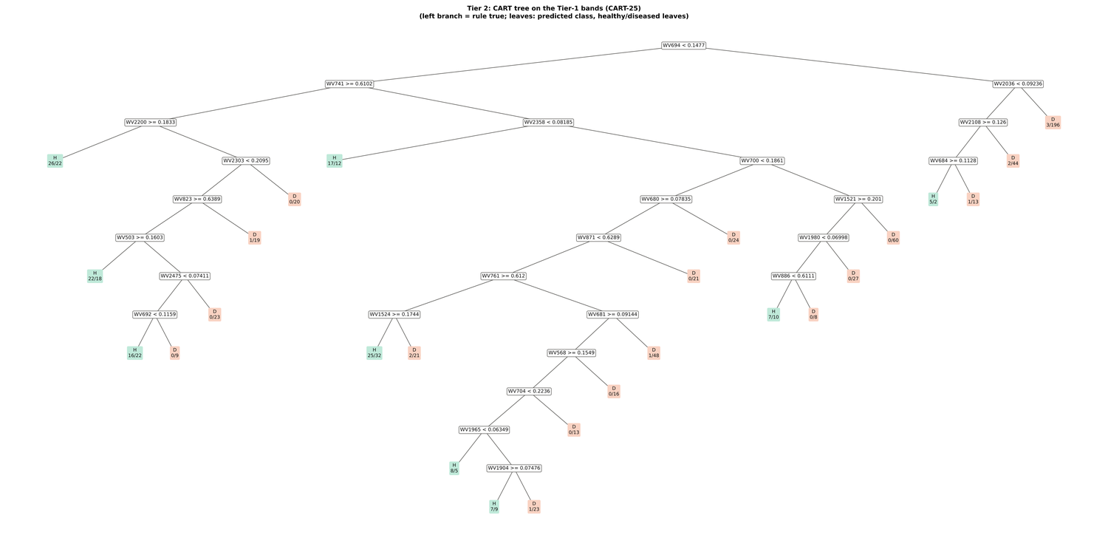
Figure 15. Leaf level L3: CART tree on the Tier-1 bands (CART-25).
Random Forest importance peaks (RF-17): 692, 2003, 753, 739, 1983, 647, 631, 706, 1899, 664, 619, 767, 1919, 573, 2013, 607, 1887 nm.
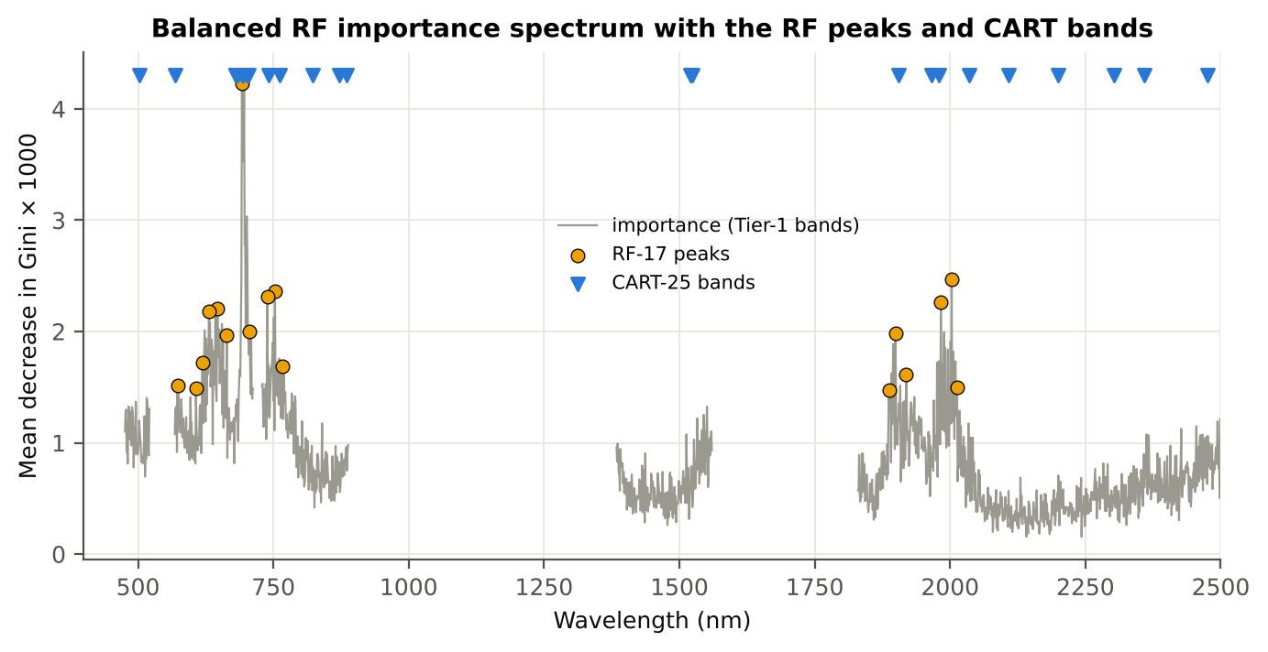
Figure 16. Leaf level L3: Balanced Random Forest importance spectrum with the RF-17 peaks and the CART bands.

4.1.4 Tier 3 and Tier 4 — separability and classification
Table 14. Leaf level L3: Jeffries–Matusita distance of healthy and diseased leaves.
Band set | Bands | α (Bhattacharyya) | J–M (0–2) | √J–M | Separability
CART-25 | 25 | 2.855 | 1.885 | 1.373 | below 1.90
CART-1 (1-SE) | 1 | 0.165 | 0.304 | 0.551 | below 1.90
RF-17 | 17 | 2.235 | 1.786 | 1.336 | below 1.90
RF-10 | 10 | 0.961 | 1.235 | 1.111 | below 1.90
RF-25 (size-matched) | 25 | 3.478 | 1.938 | 1.392 | separable (≥ 1.90)

Table 15. Leaf level L3: error matrix of QDA (equal priors) on the CART-25 bands, leaf-level 10-fold cross-validation (as Table 2 of Das et al.).
Classified \ Reference | Healthy | Diseased | Row total | User's accuracy
Healthy | 118 | 238 | 356 | 33.1 %
Diseased | 26 | 479 | 505 | 94.9 %
Column total | 144 | 717 | 861
Producer's accuracy | 81.9 % | 66.8 %
Overall accuracy | 69.3 % | Balanced accuracy | 74.4 % | κ = 0.307

Table 16. Leaf level L3: error matrix of QDA (equal priors) on the RF-17 bands, leaf-level 10-fold cross-validation.
Classified \ Reference | Healthy | Diseased | Row total | User's accuracy
Healthy | 127 | 365 | 492 | 25.8 %
Diseased | 17 | 352 | 369 | 95.4 %
Column total | 144 | 717 | 861
Producer's accuracy | 88.2 % | 49.1 %
Overall accuracy | 55.6 % | Balanced accuracy | 68.6 % | κ = 0.190

Table 17. Leaf level L3: Tier 4 on all band sets (leaf-level 10-fold cross-validation), equal and sample priors and LDA.
Band set | Classifier | Overall accuracy | Balanced accuracy | Recall healthy | Recall diseased | κ
CART-25 | QDA equal priors | 69.3 % | 74.4 % | 81.9 % | 66.8 % | 0.307
CART-25 | QDA sample priors | 75.0 % | 75.0 % | 75.0 % | 75.0 % | 0.358
CART-25 | LDA equal priors | 80.3 % | 80.4 % | 80.6 % | 80.2 % | 0.462
CART-1 (1-SE) | QDA equal priors | 43.8 % | 62.9 % | 91.7 % | 34.2 % | 0.113
CART-1 (1-SE) | QDA sample priors | 83.3 % | 50.0 % | 0.0 % | 100.0 % | 0.000
CART-1 (1-SE) | LDA equal priors | 53.0 % | 62.1 % | 75.7 % | 48.4 % | 0.125
RF-17 | QDA equal priors | 55.6 % | 68.6 % | 88.2 % | 49.1 % | 0.190
RF-17 | QDA sample priors | 60.9 % | 70.7 % | 85.4 % | 55.9 % | 0.227
RF-17 | LDA equal priors | 64.6 % | 68.5 % | 74.3 % | 62.6 % | 0.225
RF-10 | QDA equal priors | 47.5 % | 62.4 % | 84.7 % | 40.0 % | 0.116
RF-10 | QDA sample priors | 58.5 % | 64.6 % | 73.6 % | 55.5 % | 0.164
RF-10 | LDA equal priors | 56.1 % | 62.0 % | 70.8 % | 53.1 % | 0.132
RF-25 (size-matched) | QDA equal priors | 72.0 % | 77.9 % | 86.8 % | 69.0 % | 0.357
RF-25 (size-matched) | QDA sample priors | 76.1 % | 79.5 % | 84.7 % | 74.3 % | 0.407
RF-25 (size-matched) | LDA equal priors | 77.8 % | 77.0 % | 75.7 % | 78.2 % | 0.404

4.1.5 Validation and CART versus Random Forest (raw reflectance)
Table 18. Leaf level L3: balanced accuracy of the four pipelines on raw reflectance under each validation scheme.
Pipeline | Leaf-level 10-fold cross-validation | Nested plot-grouped cross-validation (± SD) | 30 % plot hold-out validation (± SD) | Leave-one-date-out validation on new plots | AUC (nested) | κ (nested)
CART classifier | 62.5 % | 59.9 % ± 1.1 | 58.6 % ± 3.5 | 52.6 % | 0.597 | 0.148
RF classifier | 66.3 % | 63.5 % ± 0.6 | 64.2 % ± 4.0 | 50.5 % | 0.708 | 0.211
QDA on CART features | 74.4 % | 71.9 % ± 1.7 | 69.8 % ± 3.5 | 53.0 % | 0.810 | 0.252
QDA on RF features | 68.6 % | 69.6 % ± 1.2 | 68.7 % ± 2.1 | 58.0 % | 0.793 | 0.212

Table 19. Leaf level L3: validation of QDA on CART bands — equal priors (imbalance correction) vs sample priors, and random under-sampling.
Validation scheme | Priors | Balanced accuracy | SD | Overall accuracy | Recall healthy | Recall diseased
Leaf-level 10-fold, bands fixed | equal (corrected) | 74.4 % | – | 69.3 % | 81.9 % | 66.8 %
Plot-grouped 10-fold, bands fixed | equal (corrected) | 73.7 % | – | 70.0 % | 79.2 % | 68.2 %
Nested plot-grouped 10-fold × 5 = 50 folds | equal (corrected) | 71.9 % | 1.7 | 63.7 % | 84.2 % | 59.6 %
30 % plot hold-out × 10 | equal (corrected) | 69.8 % | 3.5 | 65.4 % | 76.7 % | 63.0 %
Leave-one-date-out on new plots (40 units) | equal (corrected) | 53.0 % | 3.6 | 65.7 % | 33.3 % | 72.7 %
Leaf-level 10-fold, bands fixed | sample (uncorrected) | 75.0 % | – | 75.0 % | 75.0 % | 75.0 %
Plot-grouped 10-fold, bands fixed | sample (uncorrected) | 74.9 % | – | 75.3 % | 74.3 % | 75.4 %
Nested plot-grouped 10-fold × 5 = 50 folds | sample (uncorrected) | 73.2 % | 0.8 | 70.2 % | 77.8 % | 68.7 %
30 % plot hold-out × 10 | sample (uncorrected) | 70.3 % | 4.8 | 71.6 % | 68.3 % | 72.4 %
Leave-one-date-out on new plots (40 units) | sample (uncorrected) | 52.3 % | 3.9 | 69.2 % | 26.0 % | 78.6 %
Nested plot-grouped cross-validation with random under-sampling | equal (corrected) | 65.0 % | – | 52.7 % | 83.3 % | 46.6 %
Nested plot-grouped cross-validation with random under-sampling | sample (uncorrected) | 65.0 % | – | 52.7 % | 83.3 % | 46.6 %

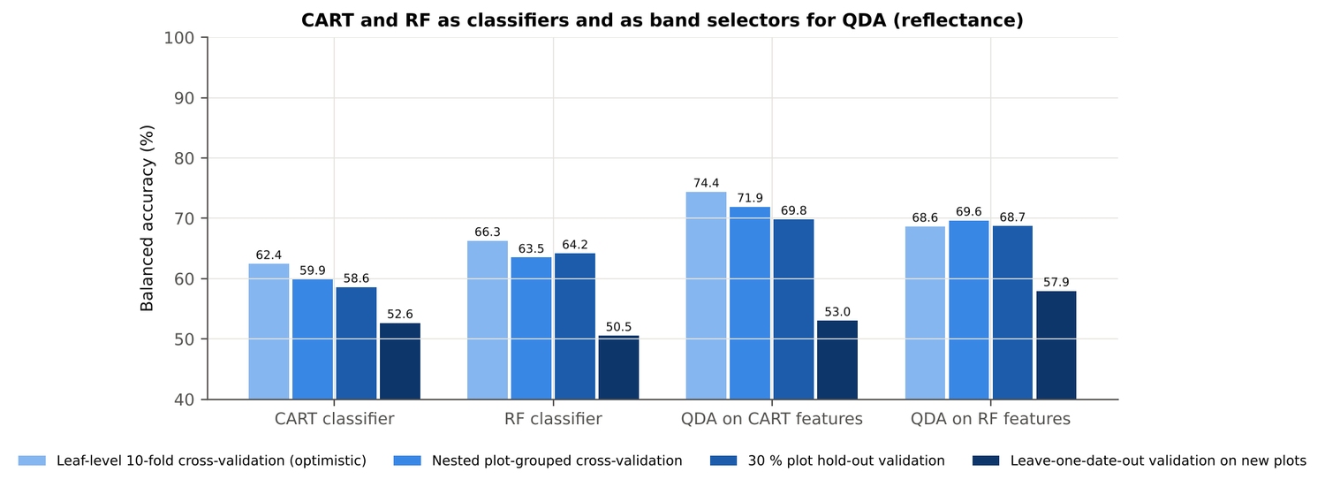
Figure 17. Leaf level L3: CART and Random Forest as classifiers and as band selectors for QDA (raw reflectance).
Table 20. Leaf level L3: paired comparisons on identical folds (positive = first pipeline better).
Comparison | Validation | n | Mean difference | First better | Wilcoxon p
RF classifier − CART classifier | Nested plot-grouped cross-validation (folds) | 50 | 4.0 points | 35 | 1.5e-4
RF classifier − CART classifier | 30 % plot hold-out validation (splits) | 10 | 5.6 points | 9 | 0.004
QDA on RF features − QDA on CART features | Nested plot-grouped cross-validation (folds) | 50 | -2.1 points | 17 | 0.023
QDA on RF features − QDA on CART features | 30 % plot hold-out validation (splits) | 10 | -1.1 points | 4 | 0.375
QDA on CART features − CART classifier | Nested plot-grouped cross-validation (folds) | 50 | 12.2 points | 48 | 0.0e+0
QDA on CART features − CART classifier | 30 % plot hold-out validation (splits) | 10 | 11.2 points | 10 | 0.002
QDA on RF features − RF classifier | Nested plot-grouped cross-validation (folds) | 50 | 6.1 points | 36 | 1.8e-5
QDA on RF features − RF classifier | 30 % plot hold-out validation (splits) | 10 | 4.6 points | 8 | 0.014

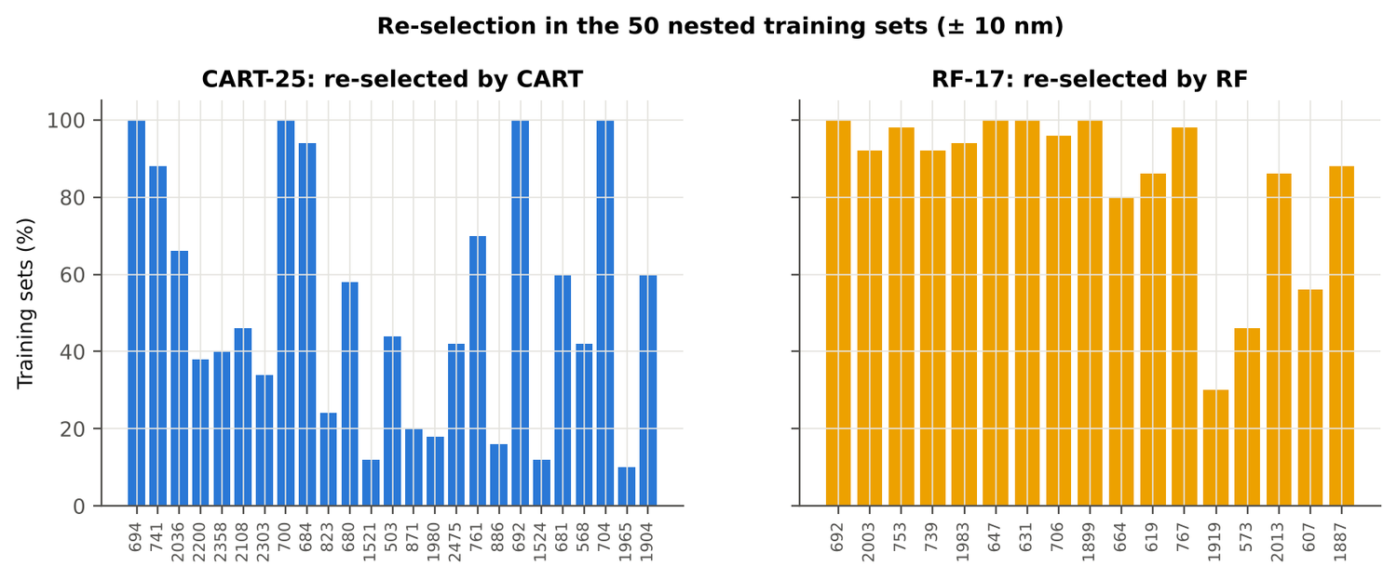
Figure 18. Leaf level L3: re-selection of the CART and Random Forest bands in the nested training sets.

4.1.6 Disease-sensitive features
Table 21. Leaf level L3: most sensitive single features of each family (threshold classifier validated on plots).
Family | Feature | AUC | Direction | Balanced accuracy, plot-grouped | Balanced accuracy, hold-out
Continuum removal | CR3 water 970 width | 0.745 | D < H | 68.1 % | 67.3 %
Continuum removal | CR6 water 1940 position | 0.689 | D > H | 61.9 % | 62.2 %
Continuum removal | CR6 water 1940 symmetry | 0.681 | D > H | 68.1 % | 67.2 %
Vegetation index | NWI2 | 0.683 | D > H | 63.8 % | 64.6 %
Vegetation index | RARSc | 0.656 | D < H | 59.5 % | 59.0 %
Vegetation index | RVS2 | 0.656 | D < H | 57.4 % | 57.2 %
Edge parameter | SDr (red-edge area) | 0.634 | D < H | 60.4 % | 59.5 %
Edge parameter | Ro (red well reflectance) | 0.633 | D > H | 58.7 % | 57.2 %
First derivative | 872 nm | 0.826 | D > H | – | –
First derivative | 873 nm | 0.824 | D > H | – | –
First derivative | 871 nm | 0.822 | D > H | – | –
Band reflectance | 1894 nm (1800–1950) | 0.669 | D > H | 61.8 % | –
Band reflectance | 1997 nm (1951–2349) | 0.662 | D > H | 63.0 % | –
Optimised two-band index | NDSI(849,850) | 0.841 |  | 78.0 % | –
Optimised two-band index | DI(872,874) | 0.834 |  | 73.4 % | –

Table 22. Leaf level L3: CART vs Balanced Random Forest on each feature group (balanced accuracy).
Feature group | CART (nested) | Random Forest (nested) | CART (hold-out) | Random Forest (hold-out)
Full raw spectrum | 59.4 % | 63.4 % | 58.5 % | 63.0 %
Band reflectance | 58.8 % | 63.4 % | 58.1 % | 64.5 %
Continuum-removal features | 79.1 % | 79.1 % | 74.7 % | 78.0 %
Vegetation indices | 66.3 % | 67.9 % | 67.3 % | 68.9 %
Derivatives + edge parameters | 71.7 % | 82.0 % | 72.5 % | 81.4 %
All disease-sensitive features combined | 72.6 % | 81.7 % | 72.5 % | 80.5 %
Derivatives incl. guard bands (artefact test) | 80.0 % | 87.9 % | 78.5 % | 86.2 %
15 selected features | 75.0 % | 80.7 % | 76.1 % | 80.7 %

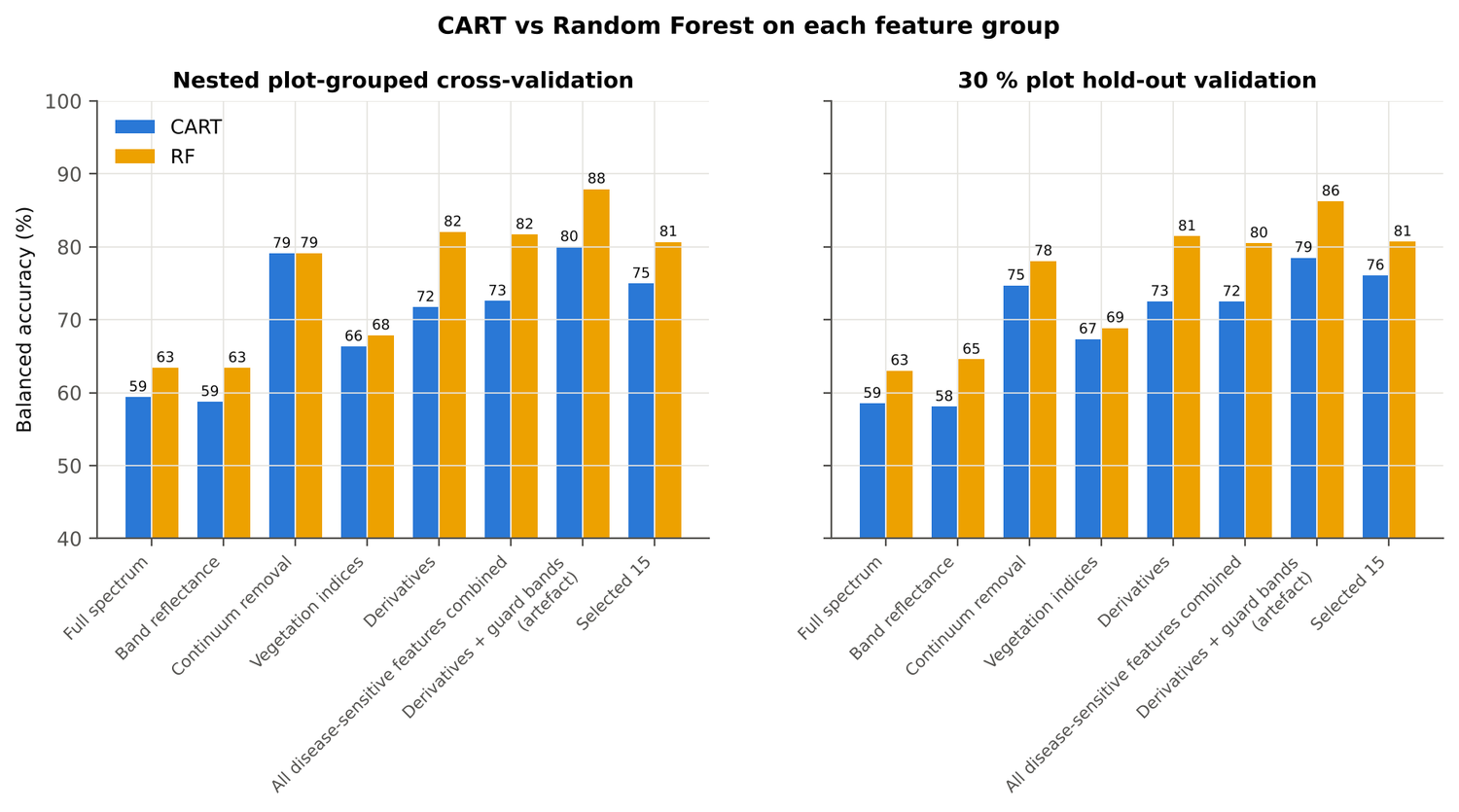
Figure 19. Leaf level L3: CART vs Random Forest on each disease-sensitive feature group.
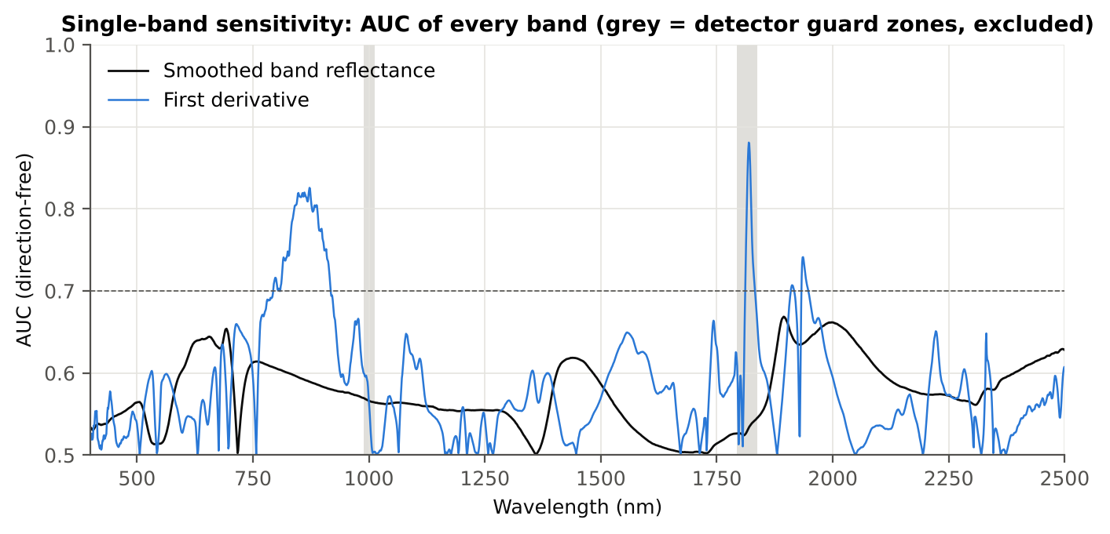
Figure 20. Leaf level L3: AUC of every band, band reflectance and first derivative.
Table 23. Leaf level L3: red-edge inflection point by four methods.
Red-edge inflection point method | Healthy (nm) | Diseased (nm) | Shift (nm) | AUC | Balanced accuracy, plot-grouped
linear extrapolation | 709.5 | 706.5 | -2.98 | 0.626 | 57.4 %
maximum first derivative | 709.6 | 707.7 | -1.90 | 0.616 | 59.5 %
Lagrangian interpolation | 709.6 | 707.7 | -1.87 | 0.615 | 58.9 %
linear 4-point interpolation | 716.4 | 715.4 | -0.94 | 0.611 | 54.7 %

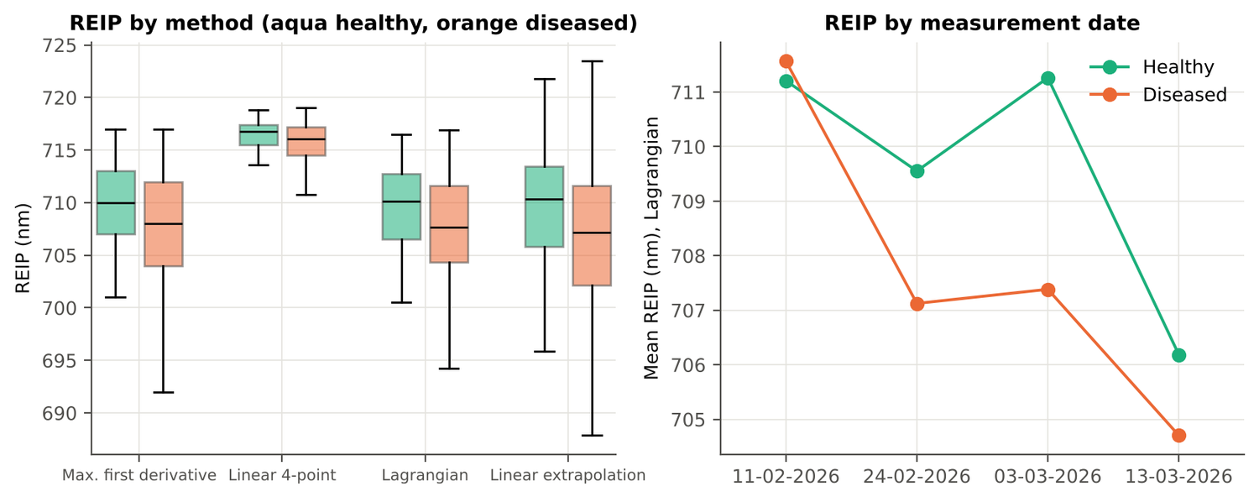
Figure 21. Leaf level L3: red-edge inflection point by method and by date.

4.1.7 Four tiers on the combined feature pool
Tier 1: 2340 of 4150 features significant. Tier 2: CART selected 11 features (D1 872 nm, CR6 water 1940 symmetry, D1 2209 nm, D1 1792 nm, D1 982 nm, D1 1359 nm, D1 2332 nm, D1 1046 nm, D1 814 nm, D1 847 nm, R 521 nm); Random Forest RF-17: D1 873 nm, D1 861 nm, D1 846 nm, CR6 water 1940 symmetry, D1 888 nm, D1 1792 nm, D1 2222 nm, D1 1916 nm, D1 1935 nm, D1 835 nm, D1 2210 nm, D1 905 nm, D1 982 nm, D1 1838 nm, D1 820 nm, D1 664 nm, CR3 water 970 symmetry. Tier 3: J–M 1.496 (CART set) and 1.747 (RF-17), below 1.90 for RF-17.
Table 24. Leaf level L3: composition of the combined pool and of the selected sets.
Feature type | Features | Tier-1 significant | CART-11 | RF-17
Band reflectance | 2039 | 1194 | 1 | 0
Continuum removal | 30 | 20 | 1 | 2
Vegetation index | 30 | 22 | 0 | 0
Edge parameter | 20 | 13 | 0 | 0
First-derivative band | 2031 | 1091 | 9 | 15

Table 25. Leaf level L3: error matrix of QDA (equal priors) on the RF-17 features of the combined pool, leaf-level 10-fold cross-validation.
Classified \ Reference | Healthy | Diseased | Row total | User's accuracy
Healthy | 123 | 142 | 265 | 46.4 %
Diseased | 21 | 575 | 596 | 96.5 %
Column total | 144 | 717 | 861
Producer's accuracy | 85.4 % | 80.2 %
Overall accuracy | 81.1 % | Balanced accuracy | 82.8 % | κ = 0.491

Table 26. Leaf level L3: balanced accuracy of the four pipelines on the combined pool under each validation scheme.
Pipeline | Leaf-level 10-fold cross-validation | Nested plot-grouped cross-validation (± SD) | 30 % plot hold-out validation (± SD) | Leave-one-date-out validation on new plots | AUC (nested) | κ (nested)
CART classifier | 73.7 % | 72.5 % ± 1.6 | 73.3 % ± 5.0 | 58.3 % | 0.746 | 0.381
RF classifier | 81.6 % | 80.6 % ± 0.6 | 79.9 % ± 3.2 | 61.2 % | 0.887 | 0.524
QDA on CART features | 87.3 % | 81.9 % ± 1.4 | 78.0 % ± 6.1 | 58.6 % | 0.892 | 0.476
QDA on RF features | 82.8 % | 81.7 % ± 0.8 | 82.2 % ± 2.9 | 58.1 % | 0.895 | 0.479

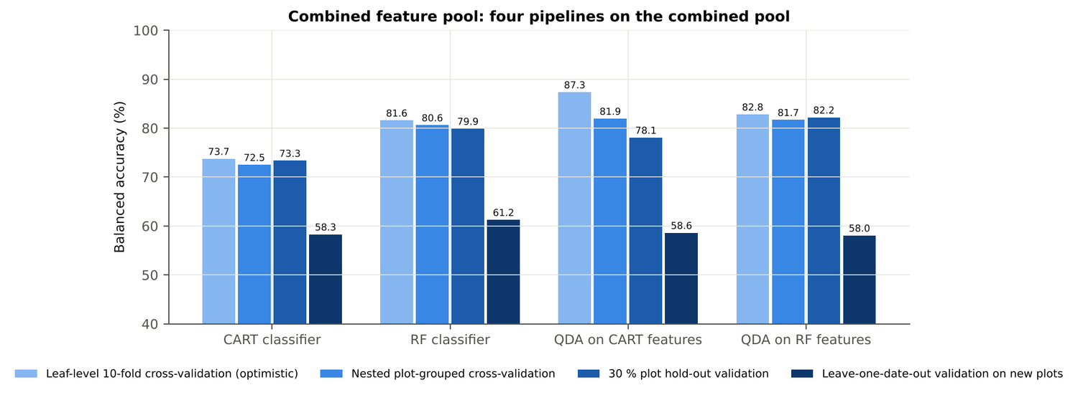
Figure 22. Leaf level L3: four pipelines on the combined pool under the four validation schemes.
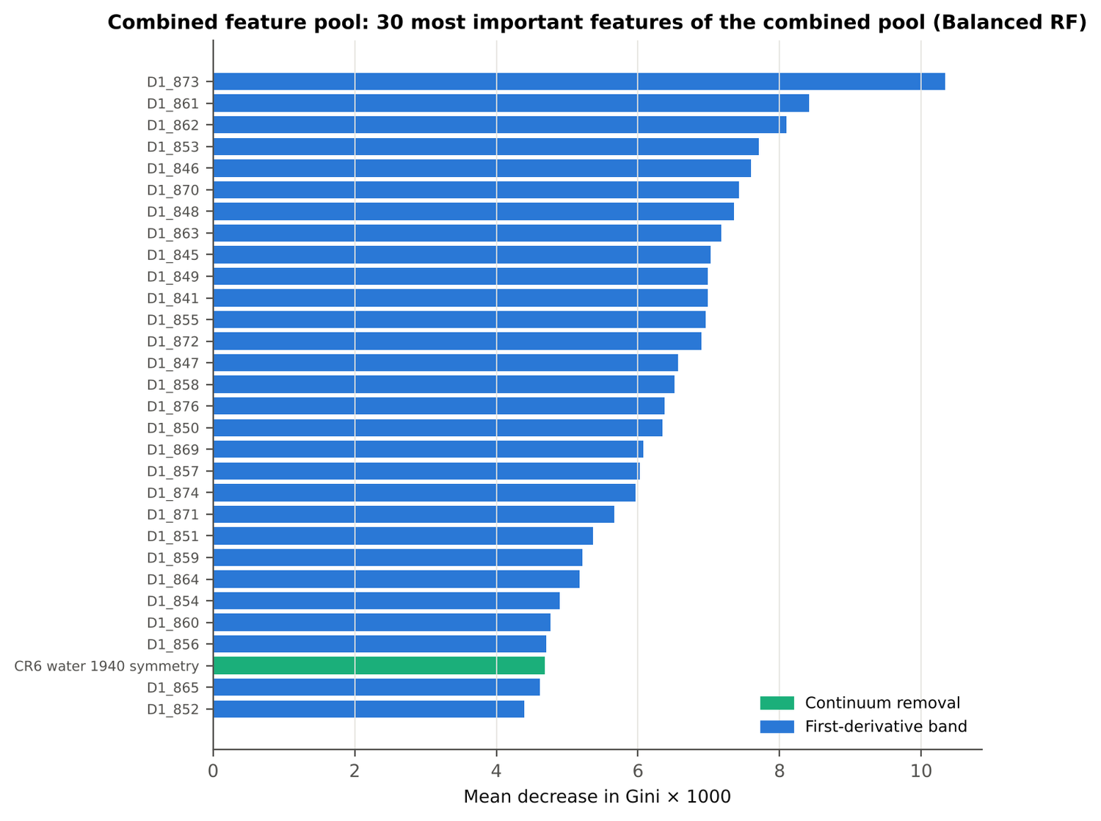
Figure 23. Leaf level L3: the 30 most important features of the combined pool (Balanced Random Forest).
Table 27. Leaf level L3: combined pool vs raw reflectance vs single feature groups (paired over the nested cross-validation folds).
First | Second | Mean difference | First better / n | Wilcoxon p
Combined pool: QDA on CART features | Reflectance: QDA on CART bands | 9.8 points | 43 / 50 | 2.0e-8
Combined pool: QDA on RF features | Reflectance: QDA on RF bands | 11.7 points | 48 / 50 | 0.0e+0
Combined pool: RF classifier (Tier-1 features) | Reflectance: RF classifier (Tier-1 bands) | 16.7 points | 50 / 50 | 0.0e+0
Combined pool: CART classifier (Tier-1 features) | Reflectance: CART classifier (Tier-1 bands) | 12.8 points | 45 / 50 | 2.0e-8
Combined pool: QDA on RF features | Combined pool: QDA on CART features | -0.3 points | 21 / 50 | 0.299
Combined pool: QDA on RF features | CART vs Random Forest on each feature group — RF classifier on all 4151 features | -0.1 points | 23 / 50 | 0.892
Combined pool: QDA on RF features | CART vs Random Forest on each feature group — QDA on 15 features chosen by AUC | -0.9 points | 20 / 50 | 0.093
Combined pool: RF classifier (Tier-1 features) | CART vs Random Forest on each feature group — RF classifier on all 4151 features | -1.2 points | 13 / 50 | 0.025

4.1.8 Transfer to an unseen date (leave-one-date-out validation on new plots)
Table 28. Leaf level L3: balanced accuracy on each held-out date (trained on the other three dates, tested on new plots of the held-out date).
Feature set · pipeline | Held-out 11-02-2026 | Held-out 24-02-2026 | Held-out 03-03-2026 | Held-out 13-03-2026
Reflectance · CART classifier | 51.2 % | 52.8 % | 56.0 % | 50.4 %
Reflectance · RF classifier | 48.4 % | 50.1 % | 53.4 % | 50.0 %
Reflectance · QDA on CART features | 47.2 % | 60.9 % | 53.9 % | 50.0 %
Reflectance · QDA on RF features | 56.9 % | 66.4 % | 58.3 % | 50.0 %
Combined pool · CART classifier | 58.0 % | 64.6 % | 57.4 % | 53.0 %
Combined pool · RF classifier | 64.7 % | 63.3 % | 66.8 % | 50.0 %
Combined pool · QDA on CART features | 56.3 % | 65.2 % | 62.5 % | 50.0 %
Combined pool · QDA on RF features | 63.8 % | 56.4 % | 61.8 % | 50.0 %

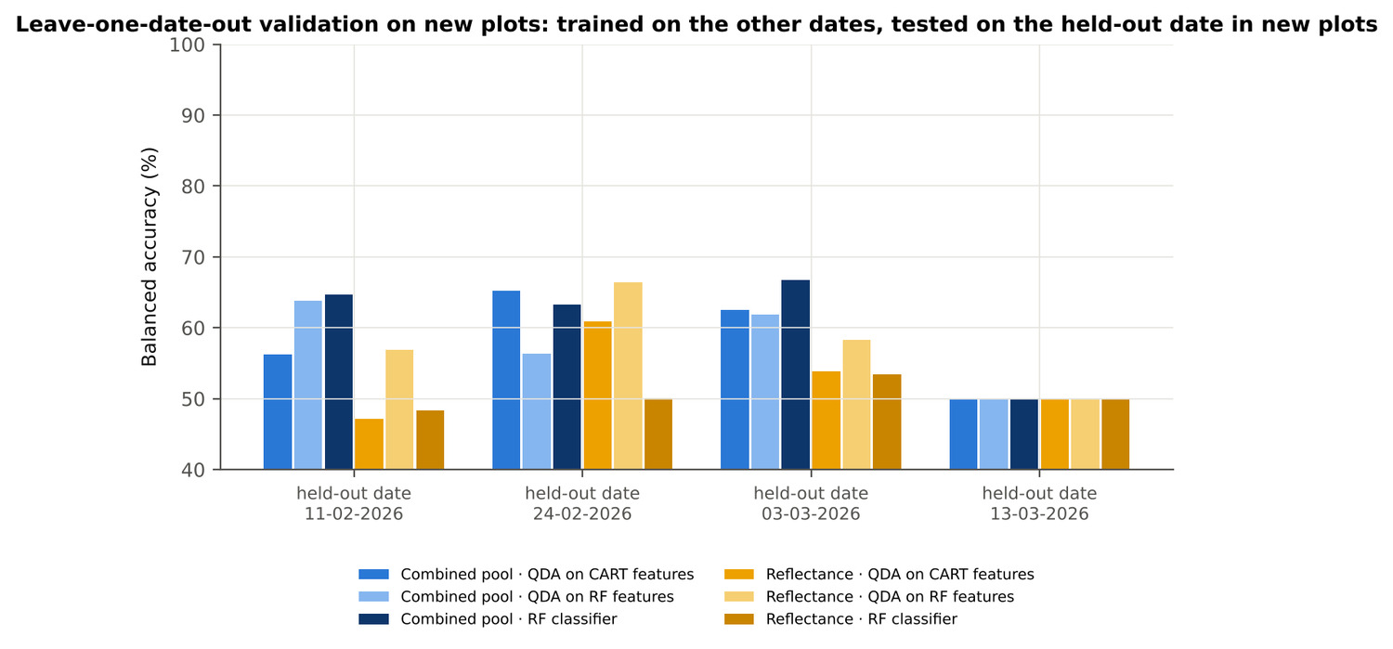
Figure 24. Leaf level L3: leave-one-date-out validation on new plots, by held-out date.

4.1.9 Interpretation
Tier 1: healthy and white-rust leaves differ significantly at 1199 of 2101 bands (Welch + BH-FDR); 1068 bands remain significant with a random plot effect and 580 in ≥ 95 % of 1000 balanced subsets. The most sensitive single band (smoothed reflectance) reaches AUC 0.67 at 1894 nm.
Tier 2: CART (rpart, prior 0.5/0.5) selected 25 bands (root 694 nm): 694, 741, 2036, 2200, 2358, 2108, 2303, 700, 684, 823, 680, 1521, 503, 871, 1980, 2475, 761, 886, 692, 1524, 681, 568, 704, 1965, 1904 nm. The Balanced RF importance peaks (RF-17) were 692, 2003, 753, 739, 1983, 647, 631, 706, 1899, 664, 619, 767, 1919, 573, 2013, 607, 1887 nm.
Tier 3: J–M = 1.88 on the CART bands and 1.79 on the RF bands: neither set reaches the 1.90 separability threshold (Das et al. used 1.94).
Tier 4: QDA with equal priors on the CART bands gives balanced accuracy 74.4 % in the paper's protocol (leaf-level 10-fold cross-validation; healthy recall 81.9 %, diseased recall 66.8 %) and 71.9 % ± 1.7 % (nested plot-grouped cross-validation) / 69.8 % (30 % plot hold-out validation) on new plots.
CART vs RF: as classifiers Random Forest beats CART by 4.0 points (nested plot-grouped cross-validation, Random Forest better in 35 of 50 folds, p = 1.5e-04); as band selectors for QDA the RF bands give -2.1 points vs the CART bands (p = 0.023). Random Forest selection is more stable than CART selection (Jaccard ±10 nm 0.67 vs 0.33).
Disease-sensitive features: the strongest group for the Random Forest is derivatives + edge parameters (balanced accuracy 82.0 %, nested plot-grouped cross-validation) vs 63.4 % for reflectance; best single features: first derivative at 872 nm (AUC 0.83), CR3 water 970 width (AUC 0.75), NWI2 (AUC 0.68), SDr (red-edge area) (AUC 0.63). red-edge inflection point (linear extrapolation) shifts by -3.0 nm in diseased leaves (AUC 0.63).
Combined feature pool (four tiers on the combined band reflectance + continuum-removal features + vegetation indices + derivative and edge features pool, 4150 features, 2340 significant): CART chose 11 features, RF 17 (J–M 1.50 / 1.75); QDA on the RF features reaches 81.7 % (nested plot-grouped cross-validation) / 82.2 % (30 % plot hold-out validation), +12.0 points vs QDA on RF reflectance bands; best pipeline on the pool: QDA on CART features (81.9 %, nested plot-grouped cross-validation).
Transfer (leave-one-date-out validation on new plots): QDA on CART reflectance bands 53.0 %, QDA on combined-pool RF features 58.0 % — a clear drop from the nested plot-grouped cross-validation estimate (81.7 %); the date/stage effect limits transfer. Best pipeline under transfer: combined pool: RF classifier (61.2 %).
Compared with all dates, stages and varieties pooled (nested plot-grouped cross-validation: reflectance QDA-CART 72.0 %, combined-pool QDA-RF 83.7 %; J–M 1.27), this subset gives 71.9 % and 81.7 % (J–M 1.88): discrimination is lower than in the pooled analysis (same plots, but only one leaf level, i.e. fewer leaves per plot).

Recommendations for leaf level L3
- Use first-derivative and continuum-removed features rather than single reflectance bands for this subset; the four-tier selection with RF importance on the combined pool and a QDA or RF classifier is the recommended pipeline.
- Report balanced accuracy with both class recalls and the priors used; the classes are imbalanced (1 : 5.0) and equal priors / balanced sampling were applied throughout.
- Base conclusions on the plot-grouped estimates (nested plot-grouped cross-validation 10-fold × 5 = 50 folds, 30 % plot hold-out validation 10 hold-outs), not on the leaf-level 10-fold cross-validation estimate.
- Interpret features near the ASD detector joins (≈ 1000 and 1800 nm) with care; guard zones were excluded from the rankings.
- For application to a new date, the most robust pipeline here was combined pool: RF classifier (leave-one-date-out validation on new plots balanced accuracy 61.2 %); accuracy on an unseen date is much lower than within the date, so calibrate with leaves of the target date or growth stage.

Cross-checks
46 checks passed, 8 were flagged and 0 failed. Flagged items are limitations reported in the workbook, not errors: Identical spectra inside the leaf-level files; Spectra of the labelled files that are not in the leaf-level files; Exact duplicates among the remaining spectra; Training sets with < 2 FDR-significant features (nested plot-grouped cross-validation/30 % plot hold-out validation/leave-one-date-out validation on new plots); QDA in R; Permutation importance (drop in AUC, 5 plot-grouped folds) vs Gini, top-50 bands; Detector artefact at the 1800/1801 nm join; Selection optimism.

4.2 Leaf level L5

4.2.1 Data and validation design
808 leaf spectra (135 healthy, 673 diseased; ratio 1 : 5.0) from 12 healthy and 36 diseased plots, measured on 11-02-2026, 24-02-2026, 03-03-2026, 13-03-2026; growth stages Flowering, Pod formation, Vegetative; varieties V1, V2, V3. Nested plot-grouped cross-validation used 10 plot-grouped folds × 5 repeats (50 training sets); the 30 % plot hold-out held out 4 healthy + 11 diseased plots × 10; leave-one-date-out validation on new plots had 40 units.
Table 29. Leaf level L5: leaf spectra by date and growth stage.
Date | Growth stage | Healthy | Diseased
11-02-2026 | Flowering | 3 | 15
11-02-2026 | Vegetative | 24 | 118
24-02-2026 | Flowering | 21 | 105
24-02-2026 | Vegetative | 15 | 75
03-03-2026 | Flowering | 33 | 165
03-03-2026 | Pod formation | 3 | 15
13-03-2026 | Flowering | 9 | 45
13-03-2026 | Pod formation | 27 | 135

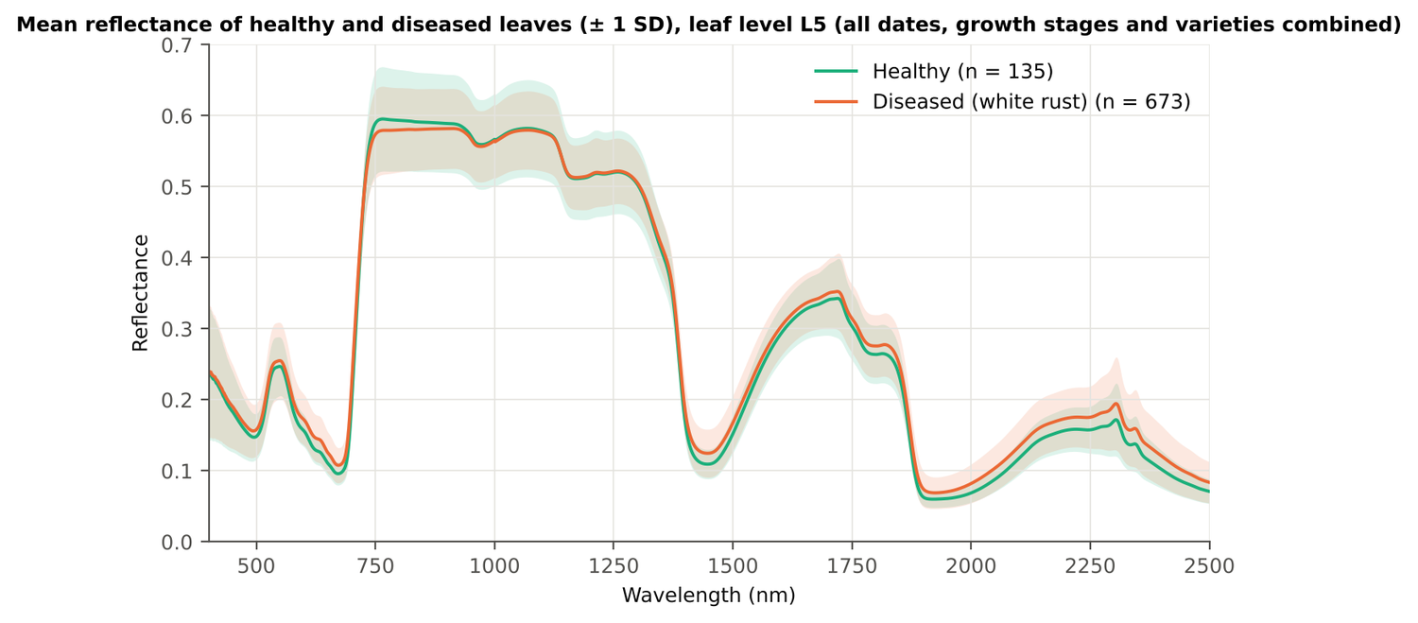
Figure 25. Leaf level L5: mean reflectance of healthy and diseased leaves (± 1 SD).
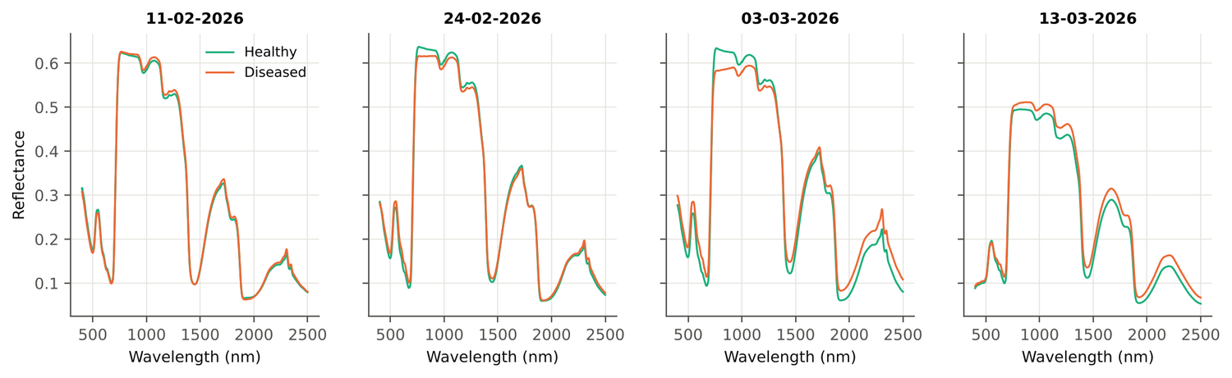
Figure 26. Leaf level L5: mean spectra of healthy and diseased leaves on each date.

4.2.2 Tier 1 — statistical screening on raw reflectance
Table 30. Leaf level L5: number of significant bands by test.
Test | Significant bands (of 2101)
Welch t-test + BH-FDR q < 0.05 (used for Tier 2) | 1301
One-way ANOVA p < 0.05, uncorrected (rule of Das et al.) | 1437
One-way ANOVA + BH-FDR q < 0.05 | 1332
Welch t-test p < 0.05, uncorrected | 1405
Mixed model (random plot effect) + BH-FDR q < 0.05 | 1132
Balanced subsets (135 vs 135): significant in ≥ 95 % of 1000 subsets | 896
Levene test p < 0.05 (unequal variances → Welch) | 1243

Table 31. Leaf level L5: largest contiguous ranges of significant bands.
Contiguous significant range (nm) | Bands
1741–2500 | 760
1366–1649 | 284
556–719 | 164
481–530 | 50
744–786 | 43

Table 32. Leaf level L5: ten bands with the largest |t|.
Band (nm) | Mean healthy | Mean diseased | Welch t | q (FDR) | Hedges g | AUC
695 | 0.1453 | 0.1682 | 9.41 | 0.00e+0 | 0.62 | 0.700
696 | 0.1539 | 0.1775 | 9.41 | 0.00e+0 | 0.62 | 0.699
694 | 0.1375 | 0.1595 | 9.37 | 0.00e+0 | 0.62 | 0.701
697 | 0.1632 | 0.1875 | 9.37 | 0.00e+0 | 0.62 | 0.697
698 | 0.1732 | 0.1980 | 9.30 | 0.00e+0 | 0.62 | 0.695
693 | 0.1306 | 0.1517 | 9.29 | 0.00e+0 | 0.61 | 0.700
699 | 0.1838 | 0.2089 | 9.19 | 0.00e+0 | 0.62 | 0.692
692 | 0.1246 | 0.1447 | 9.18 | 0.00e+0 | 0.61 | 0.699
700 | 0.1949 | 0.2202 | 9.05 | 0.00e+0 | 0.61 | 0.689
691 | 0.1195 | 0.1385 | 9.02 | 0.00e+0 | 0.60 | 0.698

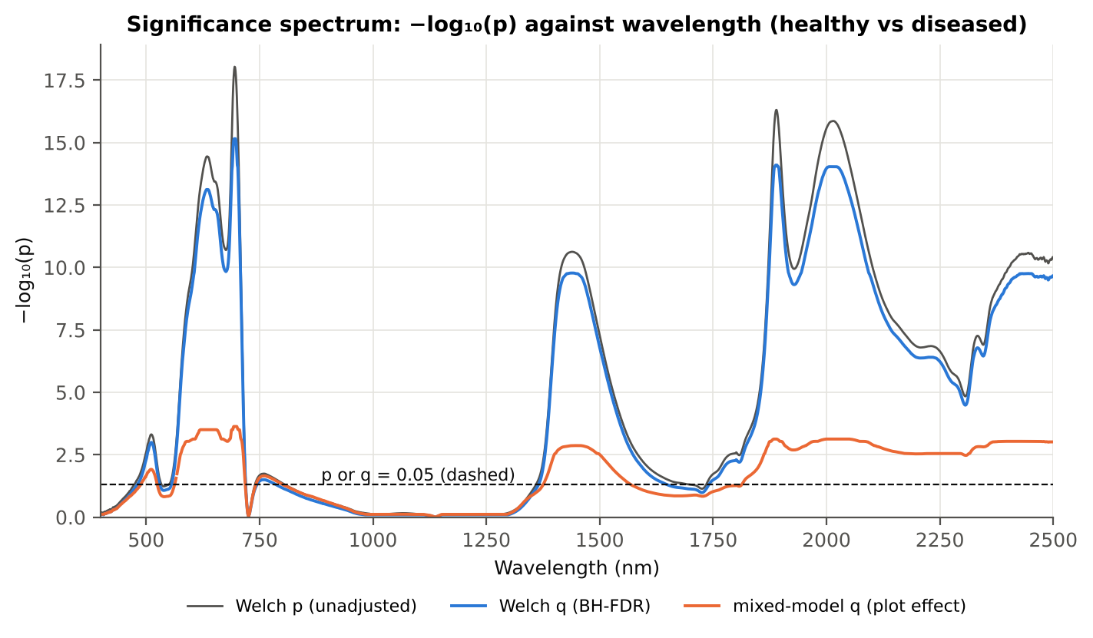
Figure 27. Leaf level L5: −log₁₀(p) against wavelength (Welch p, FDR q and mixed-model q; dashed p or q = 0.05).

4.2.3 Tier 2 — CART and Random Forest band selection
Table 33. Leaf level L5: the CART-24 bands selected by rpart (prior 0.5/0.5) and how often a band within ± 10 nm is re-selected.
Band (nm) | Region | First used at node | Bootstrap re-selection | Nested cross-validation re-selection
481 | Blue (400–499) | 278 | 26.5 % | 28.0 %
520 | Green (500–599) | 49 | 58.0 % | 72.0 %
573 | Green (500–599) | 138 | 40.0 % | 48.0 %
636 | Red (600–679) | 557 | 26.0 % | 22.0 %
670 | Red (600–679) | 17 | 33.0 % | 48.0 %
677 | Red (600–679) | 8 | 44.5 % | 48.0 %
708 | Red edge (680–759) | 2 | 94.5 % | 100.0 %
715 | Red edge (680–759) | 6 | 67.5 % | 66.0 %
744 | Red edge (680–759) | 553 | 67.5 % | 32.0 %
750 | Red edge (680–759) | 69 | 71.0 % | 38.0 %
752 | Red edge (680–759) | 3 | 73.5 % | 38.0 %
1369 | Water band I (1350–1430) | 34 | 50.5 % | 46.0 %
1420 | Water band I (1350–1430) | 139 | 22.0 % | 20.0 %
1429 | Water band I (1350–1430) | 2211 | 16.0 % | 22.0 %
1478 | SWIR-1 (1431–1799) | 4 | 26.0 % | 44.0 %
1741 | SWIR-1 (1431–1799) | 14 | 15.0 % | 14.0 %
1766 | SWIR-1 (1431–1799) | 7 | 8.0 % | 16.0 %
1775 | SWIR-1 (1431–1799) | 5 | 7.5 % | 8.0 %
1884 | Water band II (1800–1950) | 1 | 68.0 % | 90.0 %
1917 | Water band II (1800–1950) | 276 | 33.0 % | 28.0 %
1933 | Water band II (1800–1950) | 1105 | 14.0 % | 28.0 %
2387 | SWIR-2 end (2350–2500) | 12 | 14.0 % | 14.0 %
2396 | SWIR-2 end (2350–2500) | 556 | 14.5 % | 14.0 %
2475 | SWIR-2 end (2350–2500) | 552 | 11.0 % | 8.0 %

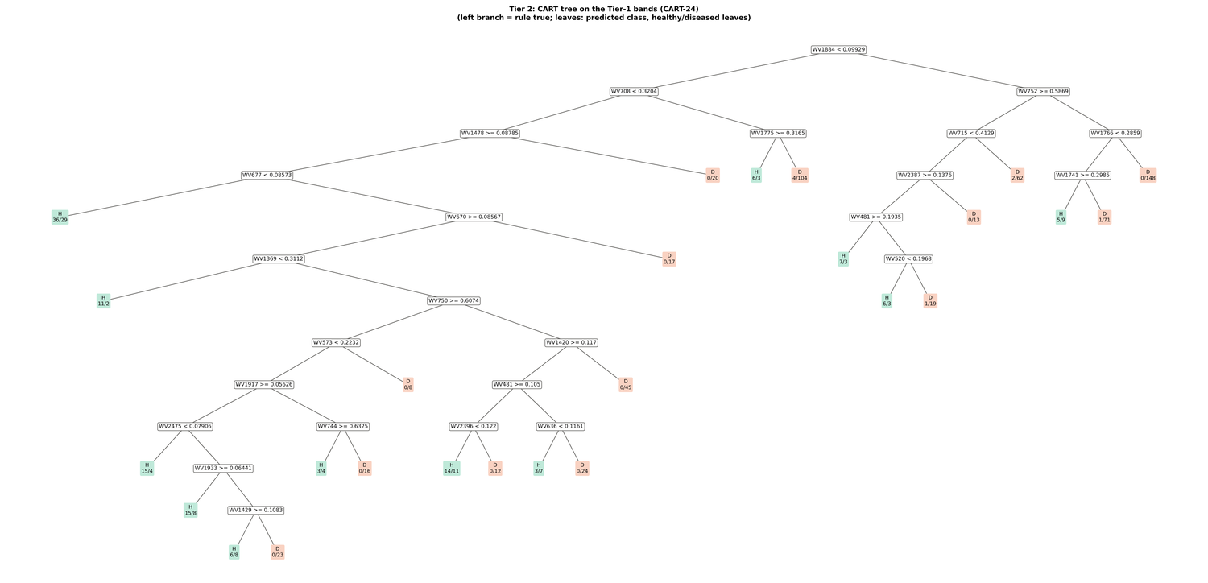
Figure 28. Leaf level L5: CART tree on the Tier-1 bands (CART-24).
Random Forest importance peaks (RF-17): 700, 753, 1881, 689, 776, 764, 715, 786, 656, 637, 2050, 2007, 573, 584, 622, 609, 563 nm.
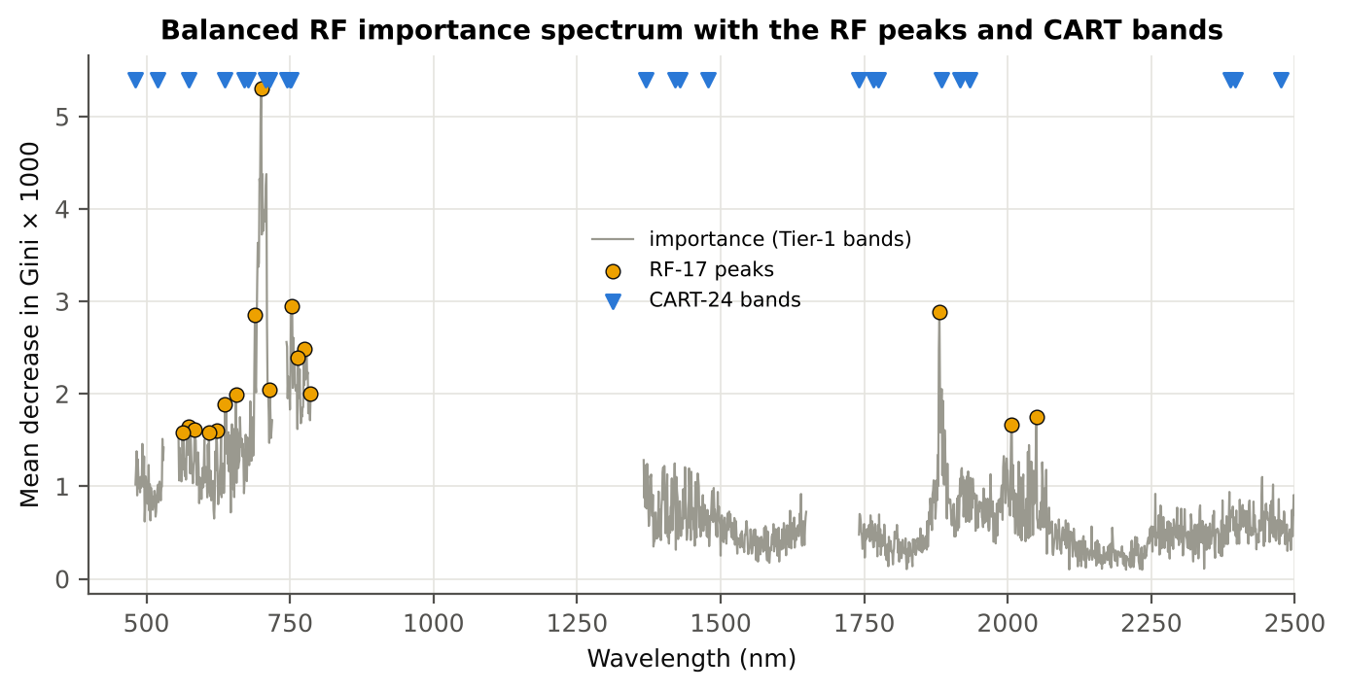
Figure 29. Leaf level L5: Balanced Random Forest importance spectrum with the RF-17 peaks and the CART bands.

4.2.4 Tier 3 and Tier 4 — separability and classification
Table 34. Leaf level L5: Jeffries–Matusita distance of healthy and diseased leaves.
Band set | Bands | α (Bhattacharyya) | J–M (0–2) | √J–M | Separability
CART-24 | 24 | 2.783 | 1.876 | 1.370 | below 1.90
CART-2 (1-SE) | 2 | 0.201 | 0.364 | 0.603 | below 1.90
RF-17 | 17 | 2.151 | 1.767 | 1.329 | below 1.90
RF-10 | 10 | 0.805 | 1.105 | 1.051 | below 1.90
RF-24 (size-matched) | 24 | 3.374 | 1.932 | 1.390 | separable (≥ 1.90)

Table 35. Leaf level L5: error matrix of QDA (equal priors) on the CART-24 bands, leaf-level 10-fold cross-validation (as Table 2 of Das et al.).
Classified \ Reference | Healthy | Diseased | Row total | User's accuracy
Healthy | 113 | 175 | 288 | 39.2 %
Diseased | 22 | 498 | 520 | 95.8 %
Column total | 135 | 673 | 808
Producer's accuracy | 83.7 % | 74.0 %
Overall accuracy | 75.6 % | Balanced accuracy | 78.8 % | κ = 0.397

Table 36. Leaf level L5: error matrix of QDA (equal priors) on the RF-17 bands, leaf-level 10-fold cross-validation.
Classified \ Reference | Healthy | Diseased | Row total | User's accuracy
Healthy | 120 | 295 | 415 | 28.9 %
Diseased | 15 | 378 | 393 | 96.2 %
Column total | 135 | 673 | 808
Producer's accuracy | 88.9 % | 56.2 %
Overall accuracy | 61.6 % | Balanced accuracy | 72.5 % | κ = 0.246

Table 37. Leaf level L5: Tier 4 on all band sets (leaf-level 10-fold cross-validation), equal and sample priors and LDA.
Band set | Classifier | Overall accuracy | Balanced accuracy | Recall healthy | Recall diseased | κ
CART-24 | QDA equal priors | 75.6 % | 78.8 % | 83.7 % | 74.0 % | 0.397
CART-24 | QDA sample priors | 81.7 % | 81.0 % | 80.0 % | 82.0 % | 0.485
CART-24 | LDA equal priors | 80.9 % | 81.8 % | 83.0 % | 80.5 % | 0.481
CART-2 (1-SE) | QDA equal priors | 50.7 % | 63.9 % | 83.7 % | 44.1 % | 0.136
CART-2 (1-SE) | QDA sample priors | 83.3 % | 50.0 % | 0.0 % | 100.0 % | 0.000
CART-2 (1-SE) | LDA equal priors | 59.9 % | 67.3 % | 78.5 % | 56.2 % | 0.194
RF-17 | QDA equal priors | 61.6 % | 72.5 % | 88.9 % | 56.2 % | 0.246
RF-17 | QDA sample priors | 66.8 % | 73.9 % | 84.4 % | 63.3 % | 0.286
RF-17 | LDA equal priors | 71.9 % | 75.4 % | 80.7 % | 70.1 % | 0.335
RF-10 | QDA equal priors | 61.3 % | 71.4 % | 86.7 % | 56.2 % | 0.235
RF-10 | QDA sample priors | 72.2 % | 72.3 % | 72.6 % | 72.1 % | 0.309
RF-10 | LDA equal priors | 67.1 % | 71.4 % | 77.8 % | 64.9 % | 0.265
RF-24 (size-matched) | QDA equal priors | 66.8 % | 75.3 % | 88.1 % | 62.6 % | 0.298
RF-24 (size-matched) | QDA sample priors | 70.5 % | 75.5 % | 83.0 % | 68.0 % | 0.325
RF-24 (size-matched) | LDA equal priors | 78.3 % | 79.9 % | 82.2 % | 77.6 % | 0.434

4.2.5 Validation and CART versus Random Forest (raw reflectance)
Table 38. Leaf level L5: balanced accuracy of the four pipelines on raw reflectance under each validation scheme.
Pipeline | Leaf-level 10-fold cross-validation | Nested plot-grouped cross-validation (± SD) | 30 % plot hold-out validation (± SD) | Leave-one-date-out validation on new plots | AUC (nested) | κ (nested)
CART classifier | 62.7 % | 62.0 % ± 1.8 | 61.6 % ± 3.3 | 52.4 % | 0.614 | 0.188
RF classifier | 74.3 % | 72.2 % ± 1.5 | 69.8 % ± 3.4 | 55.6 % | 0.781 | 0.351
QDA on CART features | 78.8 % | 74.0 % ± 1.5 | 73.9 % ± 4.3 | 56.0 % | 0.829 | 0.296
QDA on RF features | 72.5 % | 70.8 % ± 0.9 | 71.8 % ± 2.5 | 58.2 % | 0.791 | 0.233

Table 39. Leaf level L5: validation of QDA on CART bands — equal priors (imbalance correction) vs sample priors, and random under-sampling.
Validation scheme | Priors | Balanced accuracy | SD | Overall accuracy | Recall healthy | Recall diseased
Leaf-level 10-fold, bands fixed | equal (corrected) | 78.8 % | – | 75.6 % | 83.7 % | 74.0 %
Plot-grouped 10-fold, bands fixed | equal (corrected) | 77.8 % | – | 74.9 % | 82.2 % | 73.4 %
Nested plot-grouped 10-fold × 5 = 50 folds | equal (corrected) | 74.0 % | 1.5 | 68.2 % | 82.5 % | 65.4 %
30 % plot hold-out × 10 | equal (corrected) | 73.9 % | 4.3 | 70.9 % | 78.5 % | 69.2 %
Leave-one-date-out on new plots (40 units) | equal (corrected) | 56.0 % | 3.4 | 65.6 % | 40.7 % | 71.2 %
Leaf-level 10-fold, bands fixed | sample (uncorrected) | 81.0 % | – | 81.7 % | 80.0 % | 82.0 %
Plot-grouped 10-fold, bands fixed | sample (uncorrected) | 78.9 % | – | 80.7 % | 76.3 % | 81.6 %
Nested plot-grouped 10-fold × 5 = 50 folds | sample (uncorrected) | 75.4 % | 1.4 | 74.6 % | 76.7 % | 74.1 %
30 % plot hold-out × 10 | sample (uncorrected) | 75.6 % | 4.2 | 77.9 % | 72.0 % | 79.2 %
Leave-one-date-out on new plots (40 units) | sample (uncorrected) | 55.1 % | 3.9 | 70.3 % | 31.3 % | 79.0 %
Nested plot-grouped cross-validation with random under-sampling | equal (corrected) | 72.6 % | – | 64.7 % | 84.4 % | 60.8 %
Nested plot-grouped cross-validation with random under-sampling | sample (uncorrected) | 72.6 % | – | 64.7 % | 84.4 % | 60.8 %

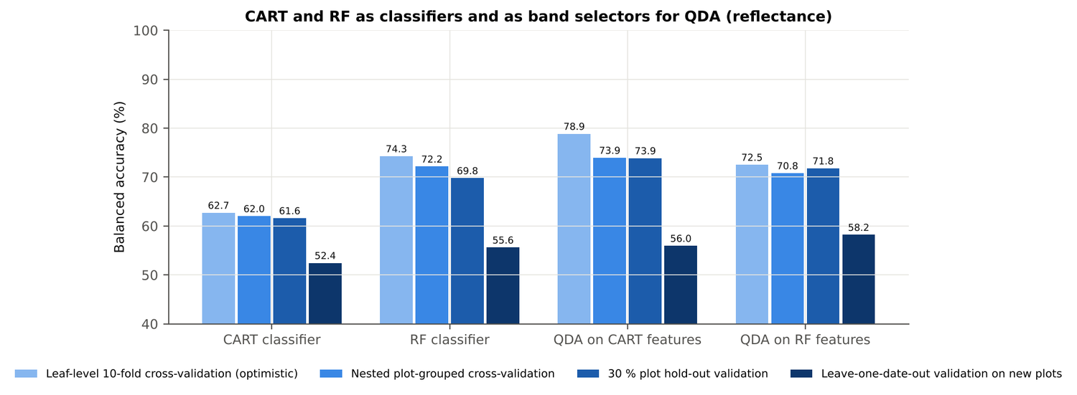
Figure 30. Leaf level L5: CART and Random Forest as classifiers and as band selectors for QDA (raw reflectance).
Table 40. Leaf level L5: paired comparisons on identical folds (positive = first pipeline better).
Comparison | Validation | n | Mean difference | First better | Wilcoxon p
RF classifier − CART classifier | Nested plot-grouped cross-validation (folds) | 50 | 9.9 points | 43 | 0.0e+0
RF classifier − CART classifier | 30 % plot hold-out validation (splits) | 10 | 8.2 points | 10 | 0.002
QDA on RF features − QDA on CART features | Nested plot-grouped cross-validation (folds) | 50 | -3.3 points | 17 | 0.006
QDA on RF features − QDA on CART features | 30 % plot hold-out validation (splits) | 10 | -2.1 points | 4 | 0.160
QDA on CART features − CART classifier | Nested plot-grouped cross-validation (folds) | 50 | 11.4 points | 41 | 1.0e-6
QDA on CART features − CART classifier | 30 % plot hold-out validation (splits) | 10 | 12.3 points | 10 | 0.002
QDA on RF features − RF classifier | Nested plot-grouped cross-validation (folds) | 50 | -1.7 points | 19 | 0.121
QDA on RF features − RF classifier | 30 % plot hold-out validation (splits) | 10 | 2.0 points | 8 | 0.160

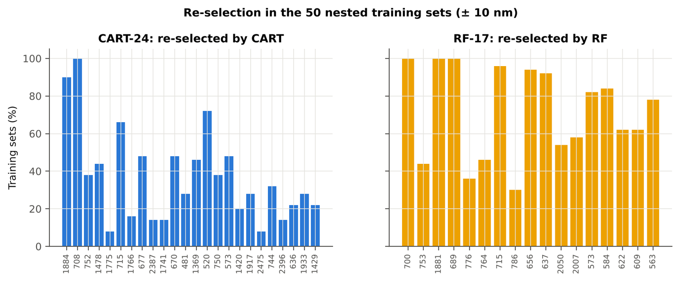
Figure 31. Leaf level L5: re-selection of the CART and Random Forest bands in the nested training sets.

4.2.6 Disease-sensitive features
Table 41. Leaf level L5: most sensitive single features of each family (threshold classifier validated on plots).
Family | Feature | AUC | Direction | Balanced accuracy, plot-grouped | Balanced accuracy, hold-out
Continuum removal | CR3 water 970 width | 0.750 | D < H | 68.7 % | 69.3 %
Continuum removal | CR6 water 1940 position | 0.686 | D > H | 67.8 % | 67.2 %
Continuum removal | CR2 red area | 0.676 | D < H | 62.8 % | 62.1 %
Vegetation index | RARSc | 0.688 | D < H | 64.1 % | 62.7 %
Vegetation index | NWI2 | 0.688 | D > H | 64.8 % | 64.5 %
Vegetation index | ARI | 0.679 | D > H | 69.0 % | 68.1 %
Edge parameter | REP, linear 4-point (nm) | 0.664 | D < H | 62.5 % | 62.1 %
Edge parameter | λr = REP (red-edge position, nm) | 0.660 | D < H | 64.5 % | 63.0 %
First derivative | 873 nm | 0.799 | D > H | – | –
First derivative | 872 nm | 0.798 | D > H | – | –
First derivative | 848 nm | 0.798 | D > H | – | –
Band reflectance | 694 nm (680–759) | 0.701 | D > H | 64.7 % | –
Band reflectance | 1889 nm (1800–1950) | 0.683 | D > H | 61.5 % | –
Optimised two-band index | NDSI(869,874) | 0.803 |  | 72.1 % | –
Optimised two-band index | DI(870,874) | 0.807 |  | 74.1 % | –

Table 42. Leaf level L5: CART vs Balanced Random Forest on each feature group (balanced accuracy).
Feature group | CART (nested) | Random Forest (nested) | CART (hold-out) | Random Forest (hold-out)
Full raw spectrum | 61.6 % | 70.0 % | 61.2 % | 69.0 %
Band reflectance | 62.7 % | 70.6 % | 62.2 % | 69.3 %
Continuum-removal features | 79.5 % | 80.6 % | 78.1 % | 80.9 %
Vegetation indices | 69.2 % | 69.3 % | 65.6 % | 67.7 %
Derivatives + edge parameters | 75.5 % | 83.3 % | 74.4 % | 81.2 %
All disease-sensitive features combined | 75.6 % | 83.8 % | 74.5 % | 80.9 %
Derivatives incl. guard bands (artefact test) | 81.3 % | 89.0 % | 80.6 % | 87.6 %
15 selected features | 74.5 % | 82.1 % | 73.7 % | 80.6 %

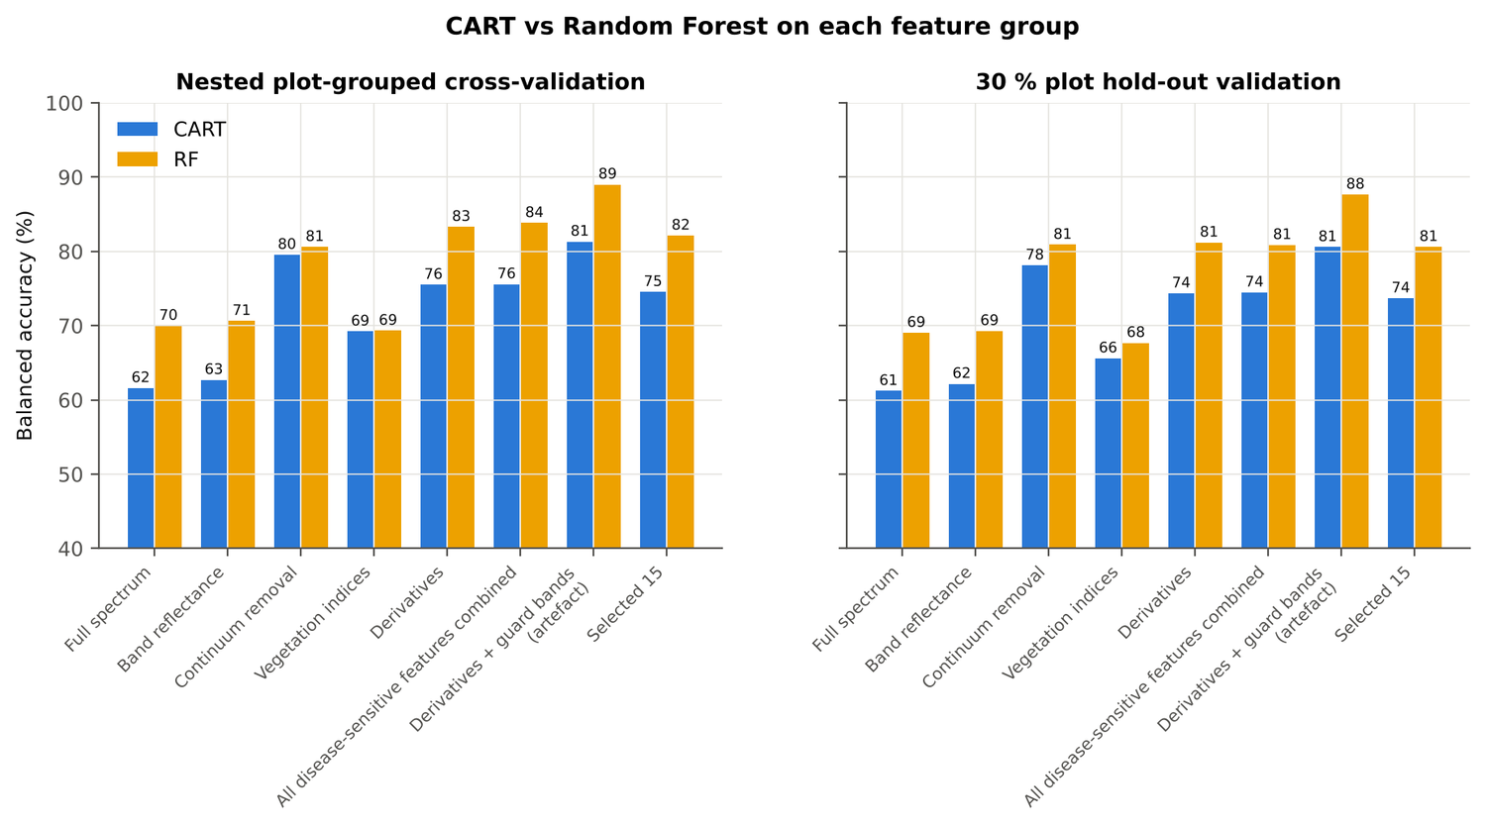
Figure 32. Leaf level L5: CART vs Random Forest on each disease-sensitive feature group.
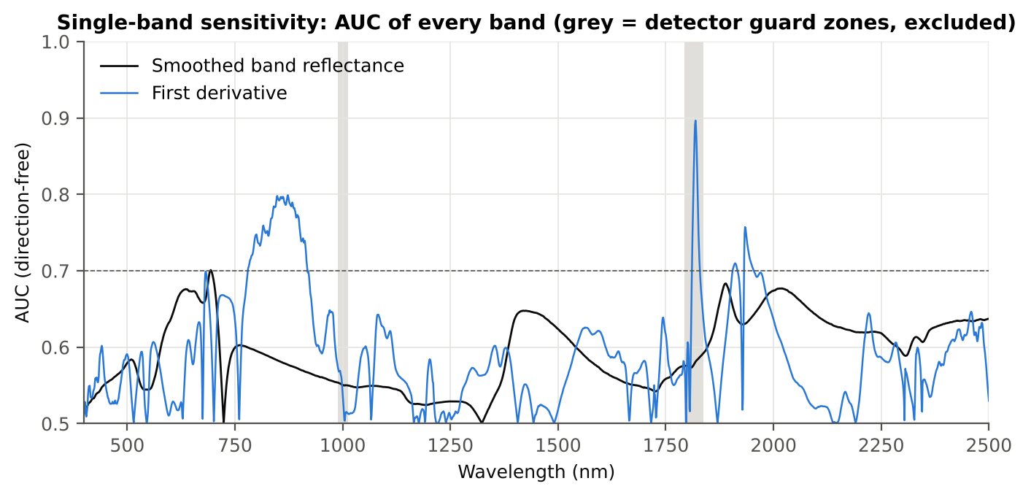
Figure 33. Leaf level L5: AUC of every band, band reflectance and first derivative.
Table 43. Leaf level L5: red-edge inflection point by four methods.
Red-edge inflection point method | Healthy (nm) | Diseased (nm) | Shift (nm) | AUC | Balanced accuracy, plot-grouped
linear extrapolation | 707.5 | 703.4 | -4.15 | 0.666 | 63.4 %
linear 4-point interpolation | 715.8 | 714.1 | -1.62 | 0.664 | 62.5 %
Lagrangian interpolation | 708.4 | 705.7 | -2.75 | 0.661 | 64.3 %
maximum first derivative | 708.4 | 705.7 | -2.74 | 0.660 | 64.5 %

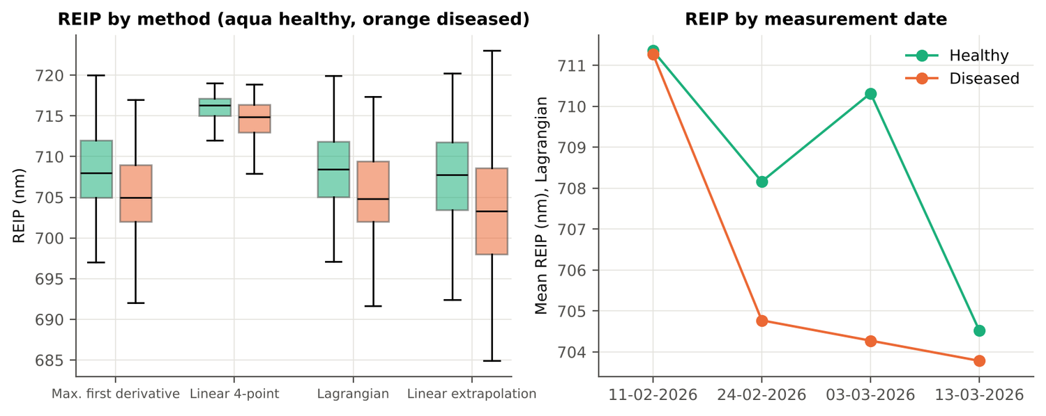
Figure 34. Leaf level L5: red-edge inflection point by method and by date.

4.2.7 Four tiers on the combined feature pool
Tier 1: 2369 of 4150 features significant. Tier 2: CART selected 13 features (D1 848 nm, D1 1913 nm, D1 2472 nm, CR5 water 1450 area, SDr/SDy, CR6 water 1940 symmetry, D1 628 nm, D1 2209 nm, D1 1838 nm, D1 2223 nm, D1 673 nm, D1 727 nm, D1 2495 nm); Random Forest RF-17: D1 848 nm, D1 859 nm, D1 1913 nm, CR6 water 1940 symmetry, D1 871 nm, D1 897 nm, CR3 water 970 width, D1 1942 nm, CR6 water 1940 position, D1 883 nm, D1 1956 nm, D1 1923 nm, D1 2207 nm, D1 1838 nm, D1 834 nm, D1 2333 nm, D1 2228 nm. Tier 3: J–M 1.776 (CART set) and 1.667 (RF-17), below 1.90 for RF-17.
Table 44. Leaf level L5: composition of the combined pool and of the selected sets.
Feature type | Features | Tier-1 significant | CART-13 | RF-17
Band reflectance | 2039 | 1251 | 0 | 0
Continuum removal | 30 | 22 | 2 | 3
Vegetation index | 30 | 23 | 0 | 0
Edge parameter | 20 | 14 | 1 | 0
First-derivative band | 2031 | 1059 | 10 | 14

Table 45. Leaf level L5: error matrix of QDA (equal priors) on the RF-17 features of the combined pool, leaf-level 10-fold cross-validation.
Classified \ Reference | Healthy | Diseased | Row total | User's accuracy
Healthy | 113 | 105 | 218 | 51.8 %
Diseased | 22 | 568 | 590 | 96.3 %
Column total | 135 | 673 | 808
Producer's accuracy | 83.7 % | 84.4 %
Overall accuracy | 84.3 % | Balanced accuracy | 84.0 % | κ = 0.547

Table 46. Leaf level L5: balanced accuracy of the four pipelines on the combined pool under each validation scheme.
Pipeline | Leaf-level 10-fold cross-validation | Nested plot-grouped cross-validation (± SD) | 30 % plot hold-out validation (± SD) | Leave-one-date-out validation on new plots | AUC (nested) | κ (nested)
CART classifier | 79.5 % | 77.6 % ± 2.1 | 76.5 % ± 3.3 | 57.0 % | 0.798 | 0.475
RF classifier | 83.5 % | 82.6 % ± 0.7 | 80.3 % ± 3.1 | 59.6 % | 0.916 | 0.573
QDA on CART features | 73.8 % | 76.4 % ± 2.2 | 76.4 % ± 4.5 | 61.2 % | 0.867 | 0.324
QDA on RF features | 84.0 % | 83.3 % ± 0.9 | 82.0 % ± 4.5 | 56.2 % | 0.898 | 0.525

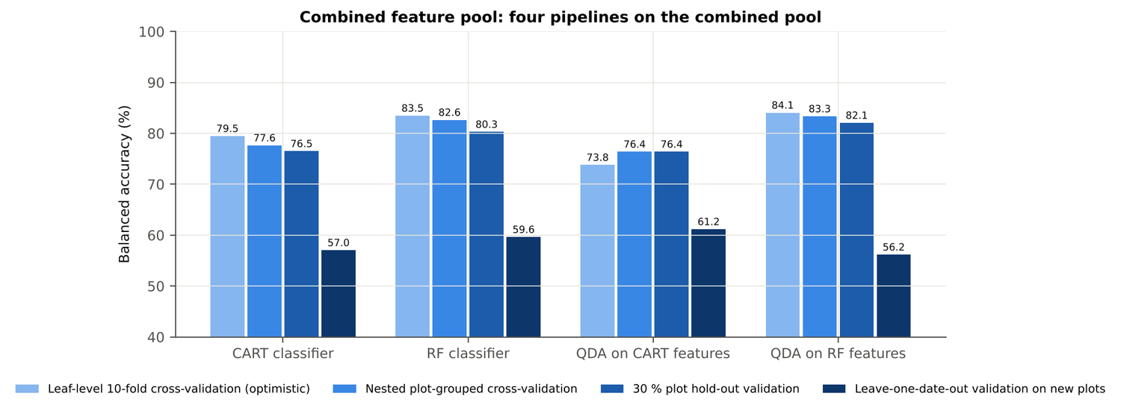
Figure 35. Leaf level L5: four pipelines on the combined pool under the four validation schemes.
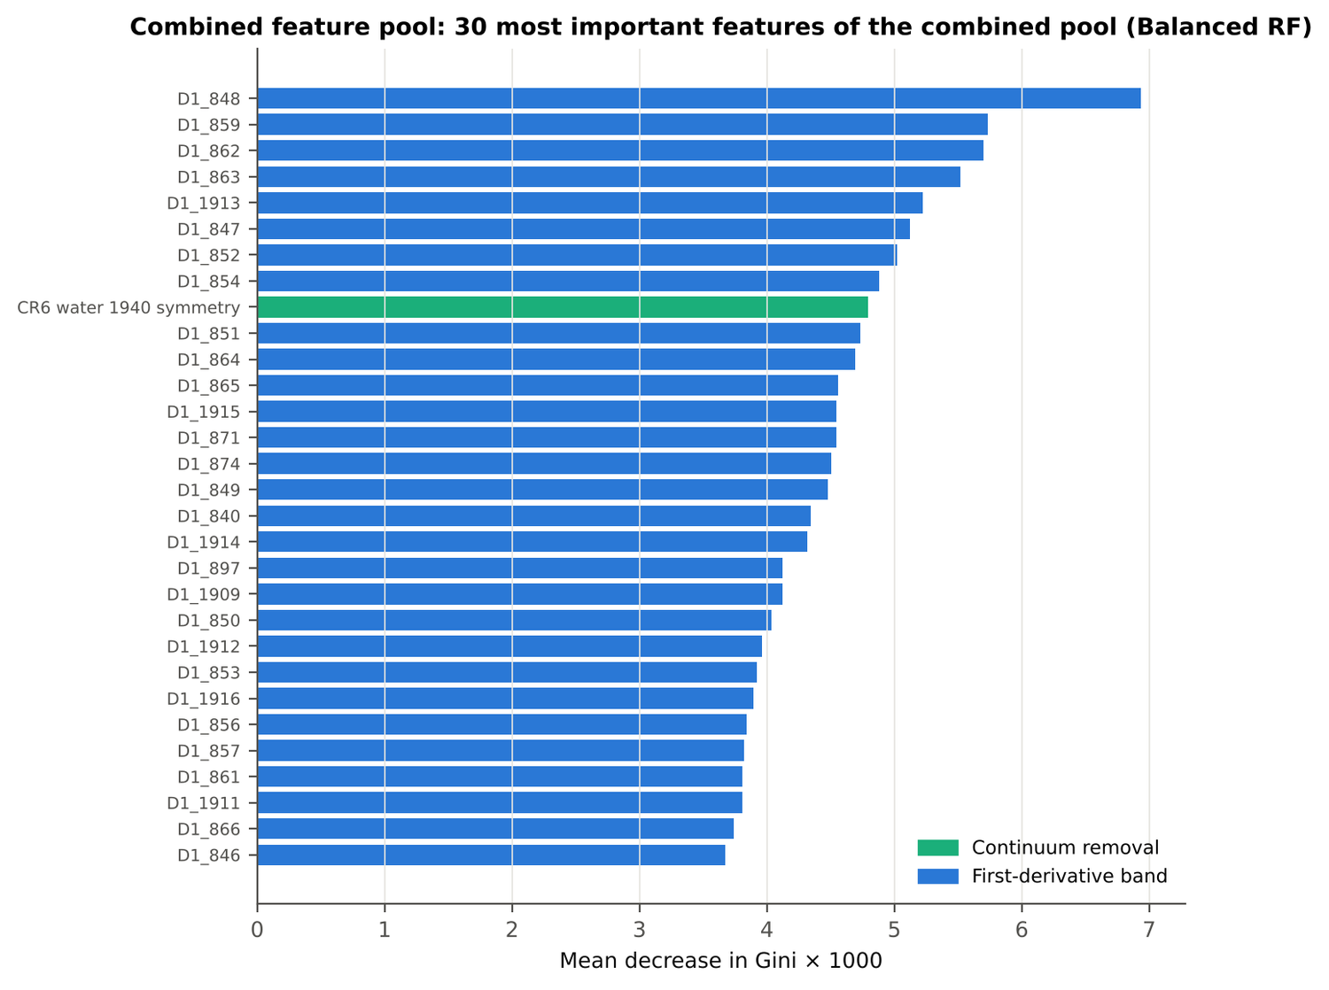
Figure 36. Leaf level L5: the 30 most important features of the combined pool (Balanced Random Forest).
Table 47. Leaf level L5: combined pool vs raw reflectance vs single feature groups (paired over the nested cross-validation folds).
First | Second | Mean difference | First better / n | Wilcoxon p
Combined pool: QDA on CART features | Reflectance: QDA on CART bands | 2.5 points | 33 / 50 | 0.029
Combined pool: QDA on RF features | Reflectance: QDA on RF bands | 12.9 points | 50 / 50 | 0.0e+0
Combined pool: RF classifier (Tier-1 features) | Reflectance: RF classifier (Tier-1 bands) | 10.4 points | 45 / 50 | 0.0e+0
Combined pool: CART classifier (Tier-1 features) | Reflectance: CART classifier (Tier-1 bands) | 15.0 points | 44 / 50 | 1.0e-8
Combined pool: QDA on RF features | Combined pool: QDA on CART features | 7.1 points | 43 / 50 | 4.0e-8
Combined pool: QDA on RF features | CART vs Random Forest on each feature group — RF classifier on all 4151 features | -0.3 points | 24 / 50 | 0.806
Combined pool: QDA on RF features | CART vs Random Forest on each feature group — QDA on 15 features chosen by AUC | -0.2 points | 24 / 50 | 0.959
Combined pool: RF classifier (Tier-1 features) | CART vs Random Forest on each feature group — RF classifier on all 4151 features | -1.1 points | 13 / 50 | 0.032

4.2.8 Transfer to an unseen date (leave-one-date-out validation on new plots)
Table 48. Leaf level L5: balanced accuracy on each held-out date (trained on the other three dates, tested on new plots of the held-out date).
Feature set · pipeline | Held-out 11-02-2026 | Held-out 24-02-2026 | Held-out 03-03-2026 | Held-out 13-03-2026
Reflectance · CART classifier | 48.4 % | 53.1 % | 55.7 % | 50.6 %
Reflectance · RF classifier | 49.8 % | 57.9 % | 59.4 % | 52.8 %
Reflectance · QDA on CART features | 52.0 % | 62.7 % | 58.1 % | 50.0 %
Reflectance · QDA on RF features | 55.9 % | 63.8 % | 61.4 % | 50.0 %
Combined pool · CART classifier | 56.4 % | 62.0 % | 57.8 % | 51.3 %
Combined pool · RF classifier | 55.7 % | 67.7 % | 63.0 % | 50.0 %
Combined pool · QDA on CART features | 58.3 % | 62.9 % | 71.3 % | 50.4 %
Combined pool · QDA on RF features | 59.2 % | 54.4 % | 61.6 % | 50.0 %

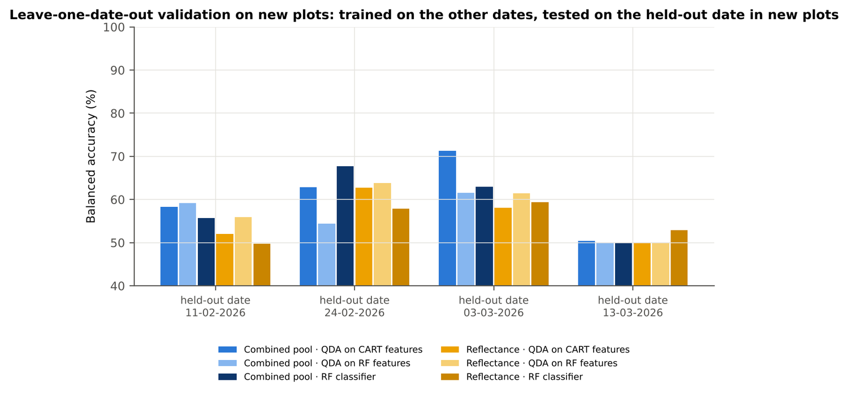
Figure 37. Leaf level L5: leave-one-date-out validation on new plots, by held-out date.

4.2.9 Interpretation
Tier 1: healthy and white-rust leaves differ significantly at 1301 of 2101 bands (Welch + BH-FDR); 1132 bands remain significant with a random plot effect and 896 in ≥ 95 % of 1000 balanced subsets. The most sensitive single band (smoothed reflectance) reaches AUC 0.70 at 694 nm.
Tier 2: CART (rpart, prior 0.5/0.5) selected 24 bands (root 1884 nm): 1884, 708, 752, 1478, 1775, 715, 1766, 677, 2387, 1741, 670, 481, 1369, 520, 750, 573, 1420, 1917, 2475, 744, 2396, 636, 1933, 1429 nm. The Balanced RF importance peaks (RF-17) were 700, 753, 1881, 689, 776, 764, 715, 786, 656, 637, 2050, 2007, 573, 584, 622, 609, 563 nm.
Tier 3: J–M = 1.88 on the CART bands and 1.77 on the RF bands: neither set reaches the 1.90 separability threshold (Das et al. used 1.94).
Tier 4: QDA with equal priors on the CART bands gives balanced accuracy 78.9 % in the paper's protocol (leaf-level 10-fold cross-validation; healthy recall 83.7 %, diseased recall 74.0 %) and 73.9 % ± 1.5 % (nested plot-grouped cross-validation) / 73.9 % (30 % plot hold-out validation) on new plots.
CART vs RF: as classifiers Random Forest beats CART by 9.9 points (nested plot-grouped cross-validation, Random Forest better in 43 of 50 folds, p = 4.6e-08); as band selectors for QDA the RF bands give -3.3 points vs the CART bands (p = 0.006). Random Forest selection is more stable than CART selection (Jaccard ±10 nm 0.55 vs 0.32).
Disease-sensitive features: the strongest group for the Random Forest is derivatives + edge parameters (balanced accuracy 83.3 %, nested plot-grouped cross-validation) vs 70.6 % for reflectance; best single features: first derivative at 873 nm (AUC 0.80), CR3 water 970 width (AUC 0.75), RARSc (AUC 0.69), REP, linear 4-point (nm) (AUC 0.66). red-edge inflection point (linear extrapolation) shifts by -4.1 nm in diseased leaves (AUC 0.67).
Combined feature pool (four tiers on the combined band reflectance + continuum-removal features + vegetation indices + derivative and edge features pool, 4150 features, 2369 significant): CART chose 13 features, RF 17 (J–M 1.78 / 1.67); QDA on the RF features reaches 83.3 % (nested plot-grouped cross-validation) / 82.1 % (30 % plot hold-out validation), +12.5 points vs QDA on RF reflectance bands; best pipeline on the pool: QDA on RF features (83.3 %, nested plot-grouped cross-validation).
Transfer (leave-one-date-out validation on new plots): QDA on CART reflectance bands 56.0 %, QDA on combined-pool RF features 56.2 % — a clear drop from the nested plot-grouped cross-validation estimate (83.3 %); the date/stage effect limits transfer. Best pipeline under transfer: combined pool: QDA on CART features (61.2 %).
Compared with all dates, stages and varieties pooled (nested plot-grouped cross-validation: reflectance QDA-CART 72.0 %, combined-pool QDA-RF 83.7 %; J–M 1.27), this subset gives 73.9 % and 83.3 % (J–M 1.88): discrimination is similar to the pooled analysis.

Recommendations for leaf level L5
- Use first-derivative and continuum-removed features rather than single reflectance bands for this subset; the four-tier selection with RF importance on the combined pool and a QDA or RF classifier is the recommended pipeline.
- Report balanced accuracy with both class recalls and the priors used; the classes are imbalanced (1 : 5.0) and equal priors / balanced sampling were applied throughout.
- Base conclusions on the plot-grouped estimates (nested plot-grouped cross-validation 10-fold × 5 = 50 folds, 30 % plot hold-out validation 10 hold-outs), not on the leaf-level 10-fold cross-validation estimate.
- Interpret features near the ASD detector joins (≈ 1000 and 1800 nm) with care; guard zones were excluded from the rankings.
- For application to a new date, the most robust pipeline here was combined pool: QDA on CART features (leave-one-date-out validation on new plots balanced accuracy 61.2 %); accuracy on an unseen date is much lower than within the date, so calibrate with leaves of the target date or growth stage.

Cross-checks
45 checks passed, 10 were flagged and 0 failed. Flagged items are limitations reported in the workbook, not errors: Identical spectra inside the leaf-level files; Spectra of the labelled files that are not in the leaf-level files; Exact duplicates among the remaining spectra; Mixed model converged for every feature; QDA in R; Permutation importance (drop in AUC, 5 plot-grouped folds) vs Gini, top-50 bands; Detector artefact at the 1800/1801 nm join; Selection optimism; Best pair straddles a detector join?; QDA implementation (combined feature pool).

4.3 Leaf level LL

4.3.1 Data and validation design
594 leaf spectra (99 healthy, 495 diseased; ratio 1 : 5.0) from 12 healthy and 36 diseased plots, measured on 11-02-2026, 24-02-2026, 03-03-2026, 13-03-2026; growth stages Flowering, Pod formation, Vegetative; varieties V1, V2, V3. Nested plot-grouped cross-validation used 10 plot-grouped folds × 5 repeats (50 training sets); the 30 % plot hold-out held out 4 healthy + 11 diseased plots × 10; leave-one-date-out validation on new plots had 40 units.
Table 49. Leaf level LL: leaf spectra by date and growth stage.
Date | Growth stage | Healthy | Diseased
11-02-2026 | Flowering | 3 | 15
11-02-2026 | Vegetative | 6 | 30
24-02-2026 | Flowering | 18 | 80
24-02-2026 | Vegetative | 0 | 10
03-03-2026 | Flowering | 33 | 165
03-03-2026 | Pod formation | 3 | 15
13-03-2026 | Flowering | 9 | 45
13-03-2026 | Pod formation | 27 | 135

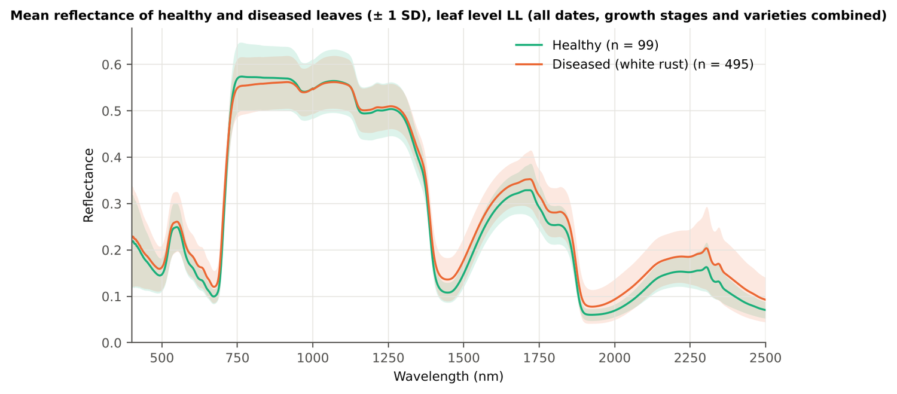
Figure 38. Leaf level LL: mean reflectance of healthy and diseased leaves (± 1 SD).
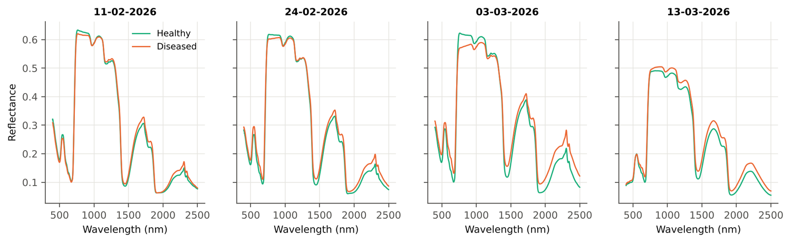
Figure 39. Leaf level LL: mean spectra of healthy and diseased leaves on each date.

4.3.2 Tier 1 — statistical screening on raw reflectance
Table 50. Leaf level LL: number of significant bands by test.
Test | Significant bands (of 2101)
Welch t-test + BH-FDR q < 0.05 (used for Tier 2) | 1468
One-way ANOVA p < 0.05, uncorrected (rule of Das et al.) | 1512
One-way ANOVA + BH-FDR q < 0.05 | 1486
Welch t-test p < 0.05, uncorrected | 1499
Mixed model (random plot effect) + BH-FDR q < 0.05 | 1467
Balanced subsets (99 vs 99): significant in ≥ 95 % of 1000 subsets | 1221
Levene test p < 0.05 (unequal variances → Welch) | 1240

Table 51. Leaf level LL: largest contiguous ranges of significant bands.
Contiguous significant range (nm) | Bands
1323–2500 | 1178
555–716 | 162
463–528 | 66
737–798 | 62

Table 52. Leaf level LL: ten bands with the largest |t|.
Band (nm) | Mean healthy | Mean diseased | Welch t | q (FDR) | Hedges g | AUC
1885 | 0.0851 | 0.1131 | 10.43 | 0.00e+0 | 0.64 | 0.736
1886 | 0.0824 | 0.1099 | 10.43 | 0.00e+0 | 0.63 | 0.737
1884 | 0.0880 | 0.1165 | 10.41 | 0.00e+0 | 0.64 | 0.735
1887 | 0.0799 | 0.1070 | 10.41 | 0.00e+0 | 0.63 | 0.736
1883 | 0.0911 | 0.1200 | 10.38 | 0.00e+0 | 0.64 | 0.735
1888 | 0.0776 | 0.1042 | 10.38 | 0.00e+0 | 0.62 | 0.737
1882 | 0.0944 | 0.1238 | 10.34 | 0.00e+0 | 0.65 | 0.734
1889 | 0.0756 | 0.1016 | 10.33 | 0.00e+0 | 0.61 | 0.737
2027 | 0.0779 | 0.1047 | 10.28 | 0.00e+0 | 0.62 | 0.729
2026 | 0.0775 | 0.1043 | 10.28 | 0.00e+0 | 0.62 | 0.729

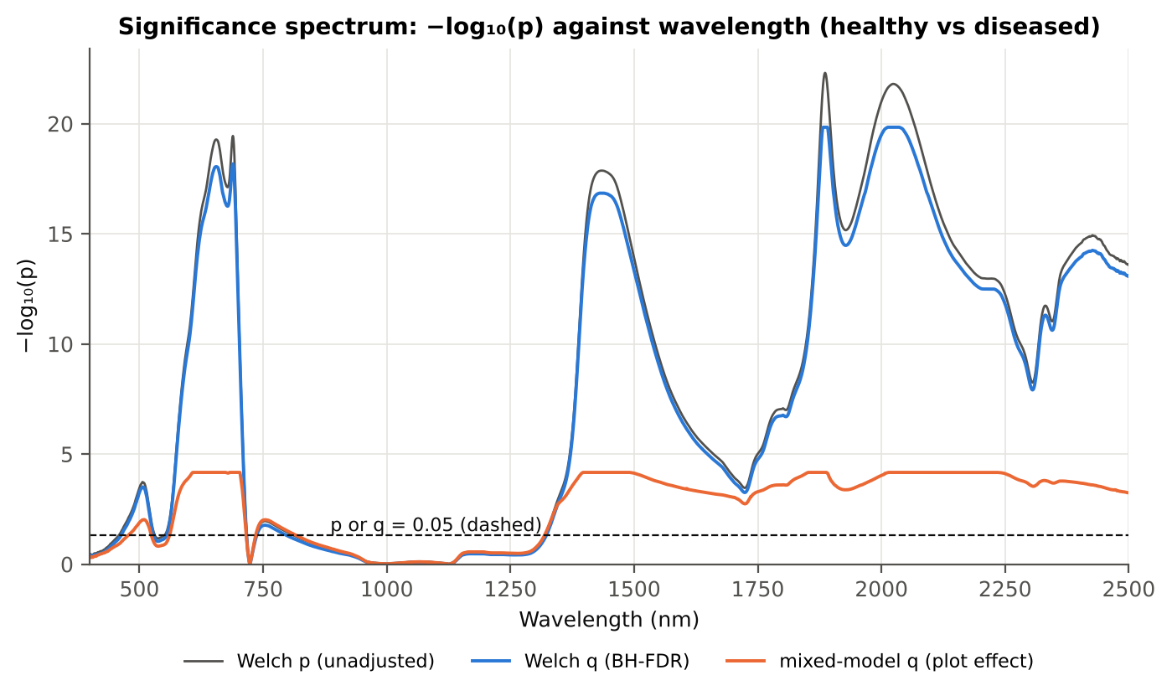
Figure 40. Leaf level LL: −log₁₀(p) against wavelength (Welch p, FDR q and mixed-model q; dashed p or q = 0.05).

4.3.3 Tier 2 — CART and Random Forest band selection
Table 53. Leaf level LL: the CART-19 bands selected by rpart (prior 0.5/0.5) and how often a band within ± 10 nm is re-selected.
Band (nm) | Region | First used at node | Bootstrap re-selection | Nested cross-validation re-selection
496 | Blue (400–499) | 30 | 28.0 % | 52.0 %
501 | Green (500–599) | 15 | 33.0 % | 50.0 %
515 | Green (500–599) | 20 | 47.0 % | 40.0 %
594 | Green (500–599) | 95 | 13.5 % | 12.0 %
599 | Green (500–599) | 10 | 13.5 % | 22.0 %
601 | Red (600–679) | 190 | 18.0 % | 26.0 %
693 | Red edge (680–759) | 1 | 75.0 % | 90.0 %
697 | Red edge (680–759) | 47 | 76.5 % | 90.0 %
737 | Red edge (680–759) | 7 | 59.0 % | 54.0 %
752 | Red edge (680–759) | 2 | 49.5 % | 60.0 %
769 | NIR (760–1349) | 11 | 17.0 % | 24.0 %
779 | NIR (760–1349) | 22 | 12.0 % | 28.0 %
793 | NIR (760–1349) | 89 | 19.0 % | 10.0 %
1376 | Water band I (1350–1430) | 5 | 58.5 % | 74.0 %
1561 | SWIR-1 (1431–1799) | 6 | 9.0 % | 10.0 %
1862 | Water band II (1800–1950) | 3 | 22.0 % | 28.0 %
1898 | Water band II (1800–1950) | 4 | 42.0 % | 40.0 %
2421 | SWIR-2 end (2350–2500) | 23 | 10.0 % | 16.0 %
2486 | SWIR-2 end (2350–2500) | 41 | 20.5 % | 28.0 %

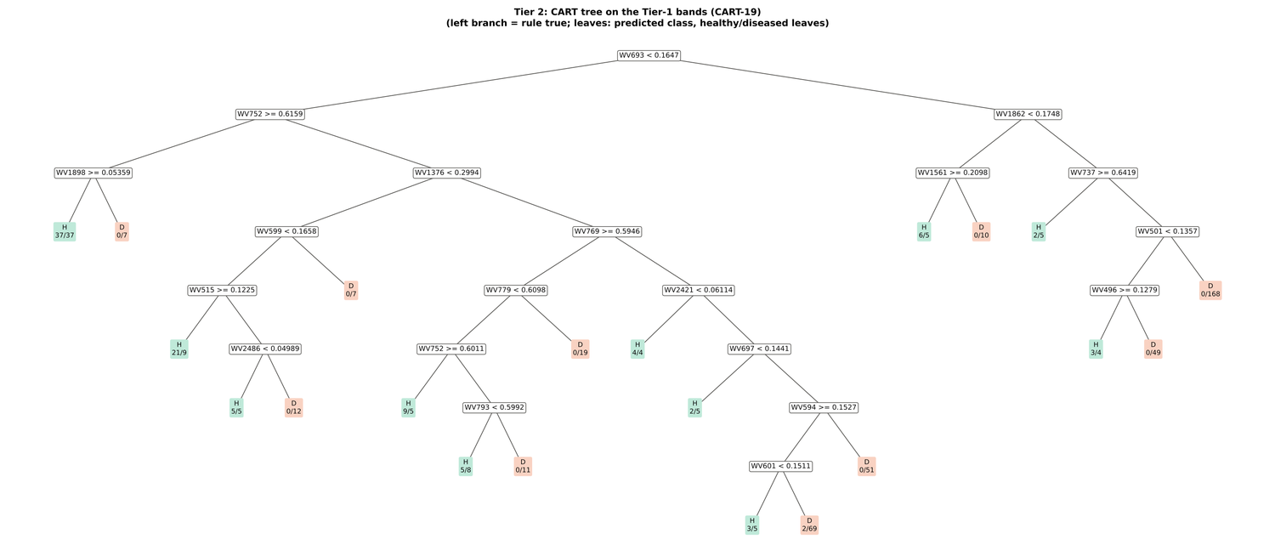
Figure 41. Leaf level LL: CART tree on the Tier-1 bands (CART-19).
Random Forest importance peaks (RF-17): 697, 616, 686, 1894, 655, 640, 630, 1883, 1986, 781, 741, 752, 770, 1974, 1375, 1327, 707 nm.
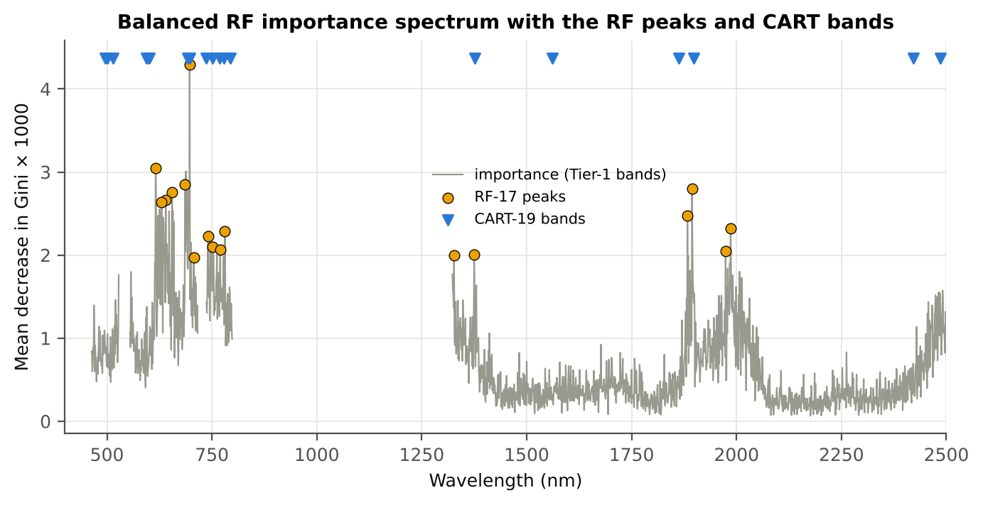
Figure 42. Leaf level LL: Balanced Random Forest importance spectrum with the RF-17 peaks and the CART bands.

4.3.4 Tier 3 and Tier 4 — separability and classification
Table 54. Leaf level LL: Jeffries–Matusita distance of healthy and diseased leaves.
Band set | Bands | α (Bhattacharyya) | J–M (0–2) | √J–M | Separability
CART-19 | 19 | 2.669 | 1.861 | 1.364 | below 1.90
CART-5 (1-SE) | 5 | 0.414 | 0.678 | 0.824 | below 1.90
RF-17 | 17 | 2.500 | 1.836 | 1.355 | below 1.90
RF-10 | 10 | 1.571 | 1.584 | 1.259 | below 1.90
RF-19 (size-matched) | 19 | 3.066 | 1.907 | 1.381 | separable (≥ 1.90)

Table 55. Leaf level LL: error matrix of QDA (equal priors) on the CART-19 bands, leaf-level 10-fold cross-validation (as Table 2 of Das et al.).
Classified \ Reference | Healthy | Diseased | Row total | User's accuracy
Healthy | 84 | 171 | 255 | 32.9 %
Diseased | 15 | 324 | 339 | 95.6 %
Column total | 99 | 495 | 594
Producer's accuracy | 84.9 % | 65.5 %
Overall accuracy | 68.7 % | Balanced accuracy | 75.1 % | κ = 0.309

Table 56. Leaf level LL: error matrix of QDA (equal priors) on the RF-17 bands, leaf-level 10-fold cross-validation.
Classified \ Reference | Healthy | Diseased | Row total | User's accuracy
Healthy | 86 | 202 | 288 | 29.9 %
Diseased | 13 | 293 | 306 | 95.8 %
Column total | 99 | 495 | 594
Producer's accuracy | 86.9 % | 59.2 %
Overall accuracy | 63.8 % | Balanced accuracy | 73.0 % | κ = 0.261

Table 57. Leaf level LL: Tier 4 on all band sets (leaf-level 10-fold cross-validation), equal and sample priors and LDA.
Band set | Classifier | Overall accuracy | Balanced accuracy | Recall healthy | Recall diseased | κ
CART-19 | QDA equal priors | 68.7 % | 75.1 % | 84.9 % | 65.5 % | 0.309
CART-19 | QDA sample priors | 71.9 % | 75.4 % | 80.8 % | 70.1 % | 0.335
CART-19 | LDA equal priors | 74.4 % | 76.6 % | 79.8 % | 73.3 % | 0.366
CART-5 (1-SE) | QDA equal priors | 61.5 % | 69.6 % | 81.8 % | 57.4 % | 0.220
CART-5 (1-SE) | QDA sample priors | 81.7 % | 62.7 % | 34.3 % | 91.1 % | 0.278
CART-5 (1-SE) | LDA equal priors | 68.0 % | 72.3 % | 78.8 % | 65.9 % | 0.279
RF-17 | QDA equal priors | 63.8 % | 73.0 % | 86.9 % | 59.2 % | 0.261
RF-17 | QDA sample priors | 69.4 % | 74.8 % | 82.8 % | 66.7 % | 0.310
RF-17 | LDA equal priors | 68.9 % | 70.4 % | 72.7 % | 68.1 % | 0.267
RF-10 | QDA equal priors | 56.6 % | 69.1 % | 87.9 % | 50.3 % | 0.196
RF-10 | QDA sample priors | 64.3 % | 71.7 % | 82.8 % | 60.6 % | 0.253
RF-10 | LDA equal priors | 65.3 % | 65.9 % | 66.7 % | 65.0 % | 0.203
RF-19 (size-matched) | QDA equal priors | 66.2 % | 74.9 % | 87.9 % | 61.8 % | 0.290
RF-19 (size-matched) | QDA sample priors | 70.9 % | 76.5 % | 84.9 % | 68.1 % | 0.335
RF-19 (size-matched) | LDA equal priors | 70.0 % | 69.1 % | 67.7 % | 70.5 % | 0.261

4.3.5 Validation and CART versus Random Forest (raw reflectance)
Table 58. Leaf level LL: balanced accuracy of the four pipelines on raw reflectance under each validation scheme.
Pipeline | Leaf-level 10-fold cross-validation | Nested plot-grouped cross-validation (± SD) | 30 % plot hold-out validation (± SD) | Leave-one-date-out validation on new plots | AUC (nested) | κ (nested)
CART classifier | 62.5 % | 62.7 % ± 2.1 | 61.9 % ± 6.3 | 54.0 % | 0.643 | 0.187
RF classifier | 71.5 % | 69.5 % ± 0.9 | 68.2 % ± 5.8 | 53.8 % | 0.772 | 0.291
QDA on CART features | 75.1 % | 71.7 % ± 1.4 | 69.0 % ± 6.7 | 53.7 % | 0.788 | 0.250
QDA on RF features | 73.0 % | 71.7 % ± 1.2 | 73.1 % ± 3.6 | 55.9 % | 0.794 | 0.252

Table 59. Leaf level LL: validation of QDA on CART bands — equal priors (imbalance correction) vs sample priors, and random under-sampling.
Validation scheme | Priors | Balanced accuracy | SD | Overall accuracy | Recall healthy | Recall diseased
Leaf-level 10-fold, bands fixed | equal (corrected) | 75.1 % | – | 68.7 % | 84.9 % | 65.5 %
Plot-grouped 10-fold, bands fixed | equal (corrected) | 72.2 % | – | 67.2 % | 79.8 % | 64.6 %
Nested plot-grouped 10-fold × 5 = 50 folds | equal (corrected) | 71.7 % | 1.4 | 63.9 % | 83.2 % | 60.1 %
30 % plot hold-out × 10 | equal (corrected) | 69.0 % | 6.7 | 64.7 % | 75.8 % | 62.3 %
Leave-one-date-out on new plots (40 units) | equal (corrected) | 53.7 % | 4.2 | 69.4 % | 28.9 % | 78.6 %
Leaf-level 10-fold, bands fixed | sample (uncorrected) | 75.4 % | – | 71.9 % | 80.8 % | 70.1 %
Plot-grouped 10-fold, bands fixed | sample (uncorrected) | 73.9 % | – | 72.0 % | 76.8 % | 71.1 %
Nested plot-grouped 10-fold × 5 = 50 folds | sample (uncorrected) | 71.2 % | 1.7 | 69.7 % | 73.5 % | 68.9 %
30 % plot hold-out × 10 | sample (uncorrected) | 69.1 % | 7.7 | 70.1 % | 67.3 % | 70.9 %
Leave-one-date-out on new plots (40 units) | sample (uncorrected) | 53.0 % | 4.8 | 72.2 % | 22.5 % | 83.6 %
Nested plot-grouped cross-validation with random under-sampling | equal (corrected) | 66.8 % | – | 56.1 % | 82.8 % | 50.7 %
Nested plot-grouped cross-validation with random under-sampling | sample (uncorrected) | 66.8 % | – | 56.1 % | 82.8 % | 50.7 %

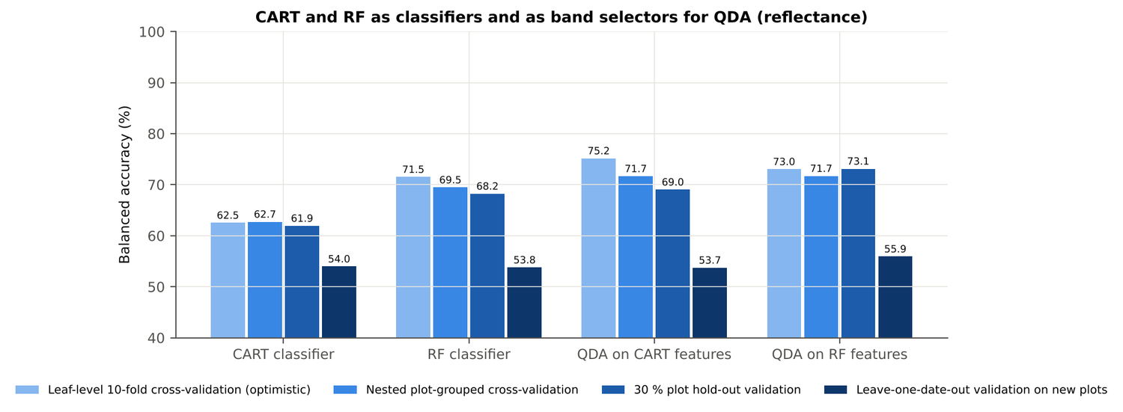
Figure 43. Leaf level LL: CART and Random Forest as classifiers and as band selectors for QDA (raw reflectance).
Table 60. Leaf level LL: paired comparisons on identical folds (positive = first pipeline better).
Comparison | Validation | n | Mean difference | First better | Wilcoxon p
RF classifier − CART classifier | Nested plot-grouped cross-validation (folds) | 50 | 6.6 points | 39 | 1.4e-5
RF classifier − CART classifier | 30 % plot hold-out validation (splits) | 10 | 6.3 points | 9 | 0.004
QDA on RF features − QDA on CART features | Nested plot-grouped cross-validation (folds) | 50 | -0.3 points | 20 | 0.691
QDA on RF features − QDA on CART features | 30 % plot hold-out validation (splits) | 10 | 4.1 points | 6 | 0.193
QDA on CART features − CART classifier | Nested plot-grouped cross-validation (folds) | 50 | 9.1 points | 41 | 2.0e-6
QDA on CART features − CART classifier | 30 % plot hold-out validation (splits) | 10 | 7.1 points | 8 | 0.010
QDA on RF features − RF classifier | Nested plot-grouped cross-validation (folds) | 50 | 2.3 points | 31 | 0.032
QDA on RF features − RF classifier | 30 % plot hold-out validation (splits) | 10 | 4.9 points | 7 | 0.064

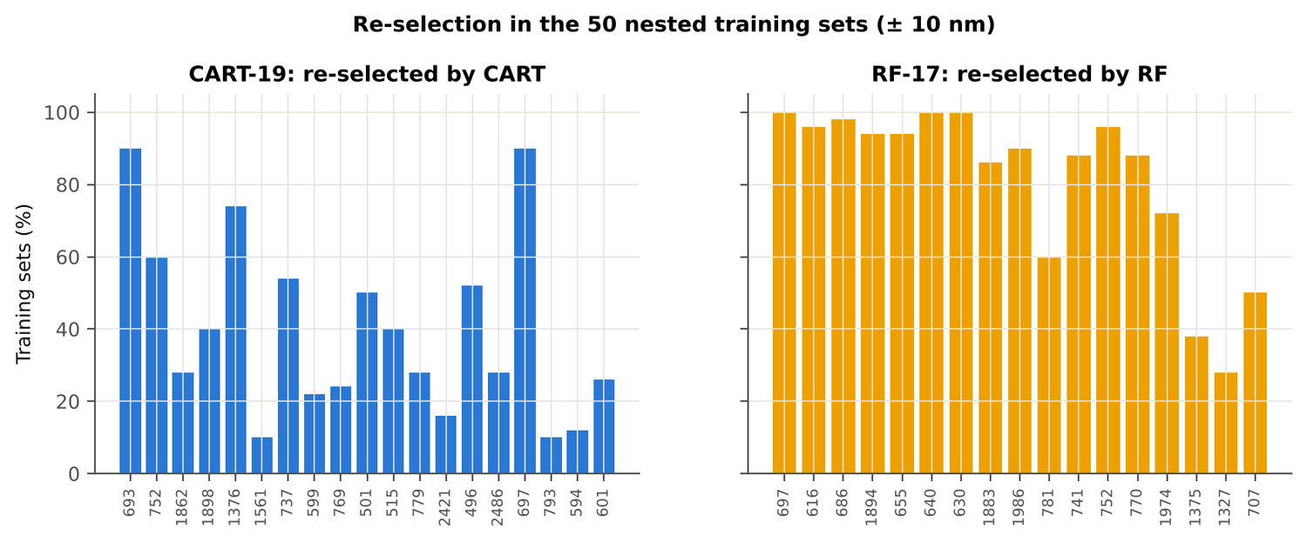
Figure 44. Leaf level LL: re-selection of the CART and Random Forest bands in the nested training sets.

4.3.6 Disease-sensitive features
Table 61. Leaf level LL: most sensitive single features of each family (threshold classifier validated on plots).
Family | Feature | AUC | Direction | Balanced accuracy, plot-grouped | Balanced accuracy, hold-out
Continuum removal | CR3 water 970 width | 0.812 | D < H | 70.7 % | 74.2 %
Continuum removal | CR2 red area | 0.719 | D < H | 66.8 % | 66.7 %
Continuum removal | CR2 red depth | 0.712 | D < H | 61.6 % | 63.4 %
Vegetation index | NWI2 | 0.742 | D > H | 69.1 % | 70.1 %
Vegetation index | RVS2 | 0.728 | D < H | 66.2 % | 66.3 %
Vegetation index | NDVI761 | 0.727 | D < H | 67.1 % | 66.2 %
Edge parameter | Ro (red well reflectance) | 0.711 | D > H | 64.6 % | 64.9 %
Edge parameter | λy (yellow-edge position, nm) | 0.677 | D > H | 65.7 % | 65.5 %
First derivative | 840 nm | 0.778 | D > H | – | –
First derivative | 833 nm | 0.778 | D > H | – | –
First derivative | 1934 nm | 0.778 | D > H | – | –
Band reflectance | 1887 nm (1800–1950) | 0.738 | D > H | 63.9 % | –
Band reflectance | 2023 nm (1951–2349) | 0.731 | D > H | 63.4 % | –
Optimised two-band index | NDSI(827,828) | 0.799 |  | 68.5 % | –
Optimised two-band index | DI(837,838) | 0.795 |  | 68.5 % | –

Table 62. Leaf level LL: CART vs Balanced Random Forest on each feature group (balanced accuracy).
Feature group | CART (nested) | Random Forest (nested) | CART (hold-out) | Random Forest (hold-out)
Full raw spectrum | 63.6 % | 69.4 % | 63.4 % | 69.9 %
Band reflectance | 62.9 % | 69.7 % | 64.5 % | 70.2 %
Continuum-removal features | 81.5 % | 80.7 % | 76.6 % | 78.2 %
Vegetation indices | 63.1 % | 68.2 % | 63.8 % | 68.9 %
Derivatives + edge parameters | 73.3 % | 80.3 % | 70.6 % | 78.7 %
All disease-sensitive features combined | 77.0 % | 80.5 % | 75.6 % | 77.4 %
Derivatives incl. guard bands (artefact test) | 81.9 % | 88.6 % | 83.3 % | 88.1 %
15 selected features | 73.6 % | 76.3 % | 72.1 % | 77.0 %

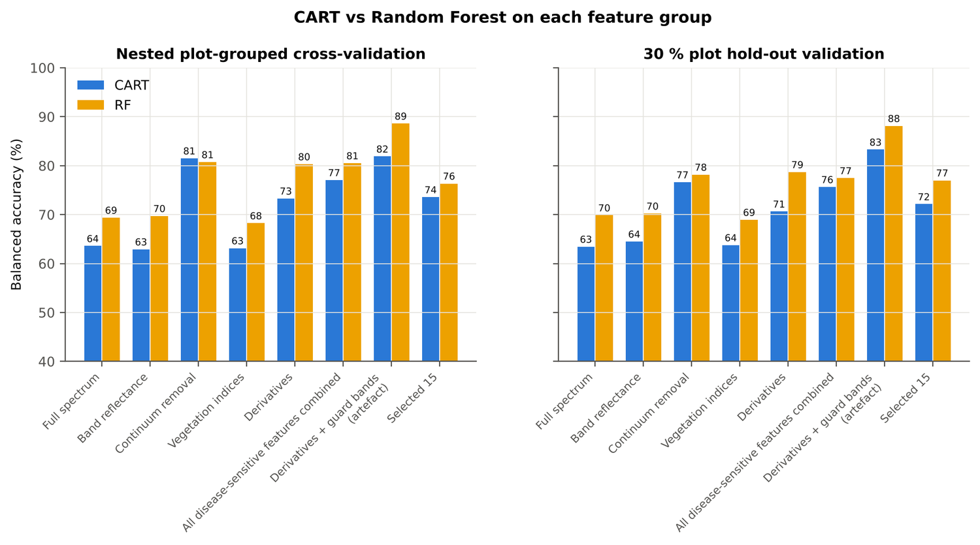
Figure 45. Leaf level LL: CART vs Random Forest on each disease-sensitive feature group.
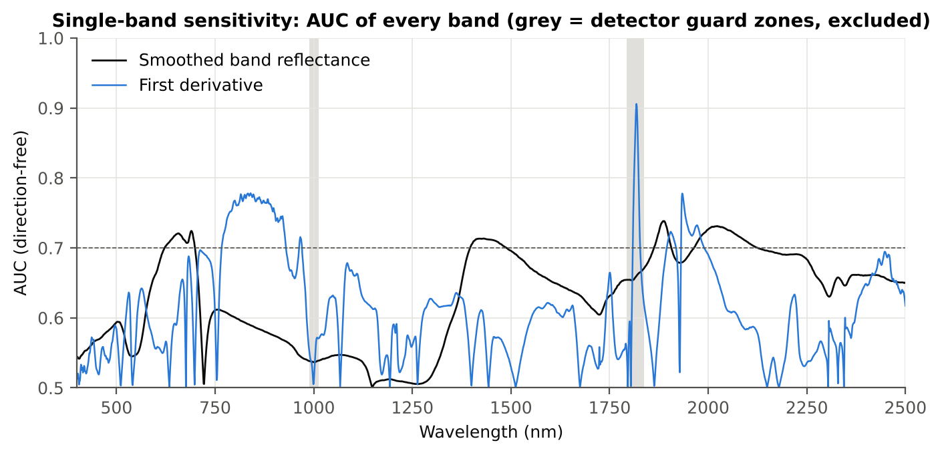
Figure 46. Leaf level LL: AUC of every band, band reflectance and first derivative.
Table 63. Leaf level LL: red-edge inflection point by four methods.
Red-edge inflection point method | Healthy (nm) | Diseased (nm) | Shift (nm) | AUC | Balanced accuracy, plot-grouped
linear extrapolation | 703.6 | 698.9 | -4.71 | 0.681 | 66.0 %
Lagrangian interpolation | 705.8 | 702.9 | -2.83 | 0.679 | 63.8 %
maximum first derivative | 705.7 | 702.9 | -2.80 | 0.677 | 65.5 %
linear 4-point interpolation | 714.2 | 712.0 | -2.28 | 0.667 | 64.7 %

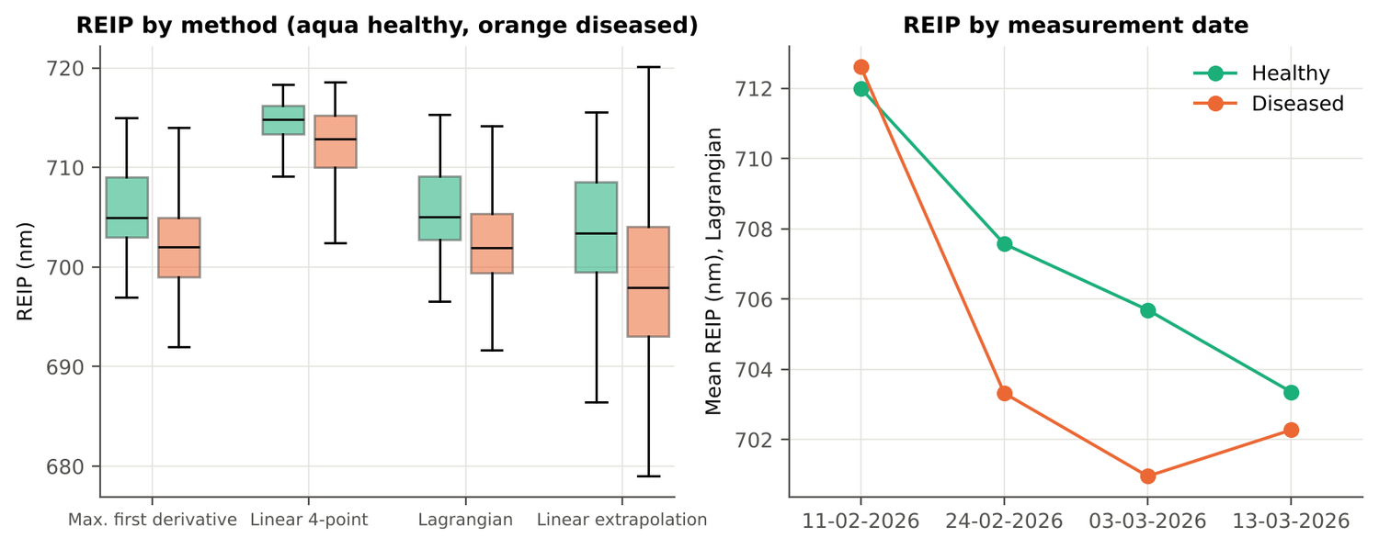
Figure 47. Leaf level LL: red-edge inflection point by method and by date.

4.3.7 Four tiers on the combined feature pool
Tier 1: 2858 of 4150 features significant. Tier 2: CART selected 7 features (CR3 water 970 width, D1 1923 nm, D1 2331 nm, SDr/SDy, R 600 nm, D1 1161 nm, D1 1087 nm); Random Forest RF-17: CR3 water 970 width, D1 1934 nm, D1 833 nm, D1 905 nm, D1 848 nm, D1 1922 nm, D1 815 nm, D1 802 nm, D1 892 nm, D1 2211 nm, D1 860 nm, D1 920 nm, D1 1166 nm, D1 2223 nm, D1 1724 nm, D1 786 nm, NWI2. Tier 3: J–M 1.709 (CART set) and 1.751 (RF-17), below 1.90 for RF-17.
Table 64. Leaf level LL: composition of the combined pool and of the selected sets.
Feature type | Features | Tier-1 significant | CART-7 | RF-17
Band reflectance | 2039 | 1425 | 1 | 0
Continuum removal | 30 | 23 | 1 | 1
Vegetation index | 30 | 23 | 0 | 1
Edge parameter | 20 | 16 | 1 | 0
First-derivative band | 2031 | 1371 | 4 | 15

Table 65. Leaf level LL: error matrix of QDA (equal priors) on the RF-17 features of the combined pool, leaf-level 10-fold cross-validation.
Classified \ Reference | Healthy | Diseased | Row total | User's accuracy
Healthy | 83 | 110 | 193 | 43.0 %
Diseased | 16 | 385 | 401 | 96.0 %
Column total | 99 | 495 | 594
Producer's accuracy | 83.8 % | 77.8 %
Overall accuracy | 78.8 % | Balanced accuracy | 80.8 % | κ = 0.447

Table 66. Leaf level LL: balanced accuracy of the four pipelines on the combined pool under each validation scheme.
Pipeline | Leaf-level 10-fold cross-validation | Nested plot-grouped cross-validation (± SD) | 30 % plot hold-out validation (± SD) | Leave-one-date-out validation on new plots | AUC (nested) | κ (nested)
CART classifier | 75.7 % | 78.6 % ± 1.8 | 75.2 % ± 7.2 | 54.6 % | 0.790 | 0.484
RF classifier | 79.3 % | 79.8 % ± 0.8 | 77.6 % ± 6.8 | 53.4 % | 0.879 | 0.485
QDA on CART features | 78.3 % | 79.0 % ± 1.6 | 76.6 % ± 3.0 | 54.7 % | 0.878 | 0.352
QDA on RF features | 80.8 % | 79.7 % ± 1.8 | 78.6 % ± 4.5 | 53.0 % | 0.884 | 0.431

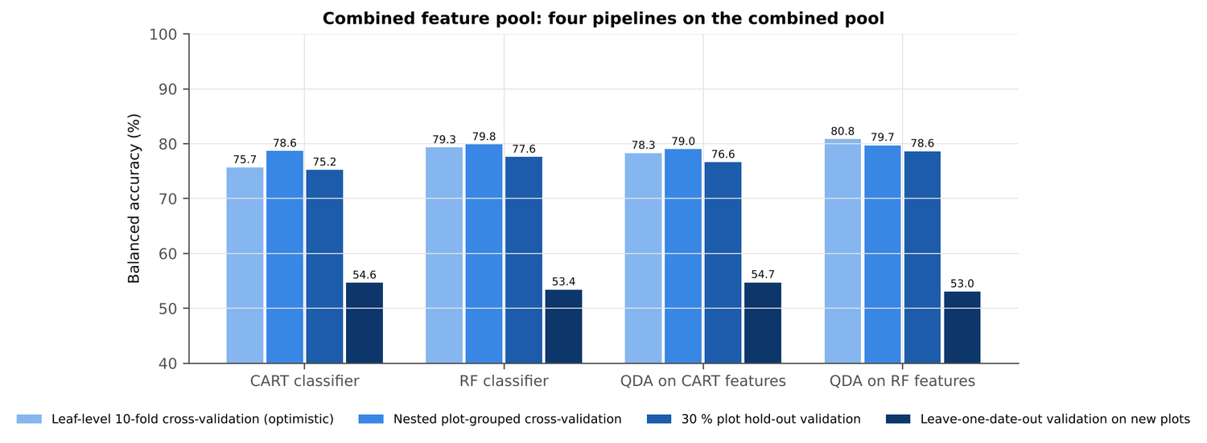
Figure 48. Leaf level LL: four pipelines on the combined pool under the four validation schemes.
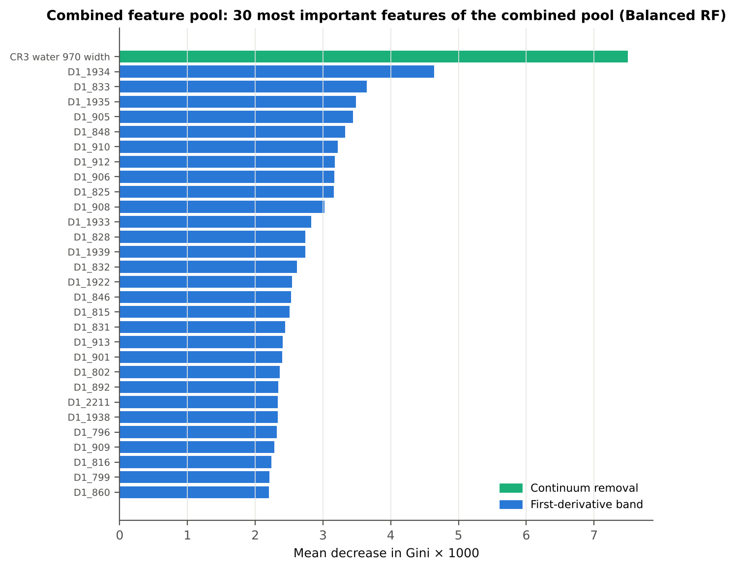
Figure 49. Leaf level LL: the 30 most important features of the combined pool (Balanced Random Forest).
Table 67. Leaf level LL: combined pool vs raw reflectance vs single feature groups (paired over the nested cross-validation folds).
First | Second | Mean difference | First better / n | Wilcoxon p
Combined pool: QDA on CART features | Reflectance: QDA on CART bands | 6.5 points | 37 / 50 | 3.5e-6
Combined pool: QDA on RF features | Reflectance: QDA on RF bands | 8.2 points | 44 / 50 | 6.2e-7
Combined pool: RF classifier (Tier-1 features) | Reflectance: RF classifier (Tier-1 bands) | 10.2 points | 44 / 50 | 2.0e-8
Combined pool: CART classifier (Tier-1 features) | Reflectance: CART classifier (Tier-1 bands) | 15.6 points | 44 / 50 | 9.0e-8
Combined pool: QDA on RF features | Combined pool: QDA on CART features | 1.3 points | 29 / 50 | 0.177
Combined pool: QDA on RF features | CART vs Random Forest on each feature group — RF classifier on all 4151 features | -0.5 points | 22 / 50 | 0.776
Combined pool: QDA on RF features | CART vs Random Forest on each feature group — QDA on 15 features chosen by AUC | 4.2 points | 37 / 50 | 4.0e-4
Combined pool: RF classifier (Tier-1 features) | CART vs Random Forest on each feature group — RF classifier on all 4151 features | -0.7 points | 14 / 50 | 0.123

4.3.8 Transfer to an unseen date (leave-one-date-out validation on new plots)
Table 68. Leaf level LL: balanced accuracy on each held-out date (trained on the other three dates, tested on new plots of the held-out date).
Feature set · pipeline | Held-out 11-02-2026 | Held-out 24-02-2026 | Held-out 03-03-2026 | Held-out 13-03-2026
Reflectance · CART classifier | 48.1 % | 49.6 % | 57.4 % | 51.7 %
Reflectance · RF classifier | 45.4 % | 54.6 % | 55.0 % | 51.8 %
Reflectance · QDA on CART features | 47.0 % | 57.5 % | 54.7 % | 49.6 %
Reflectance · QDA on RF features | 48.1 % | 66.9 % | 53.9 % | 50.0 %
Combined pool · CART classifier | 67.8 % | 51.8 % | 54.7 % | 50.5 %
Combined pool · RF classifier | 51.1 % | 57.5 % | 51.9 % | 50.0 %
Combined pool · QDA on CART features | 55.2 % | 58.0 % | 54.7 % | 50.0 %
Combined pool · QDA on RF features | 59.4 % | 56.0 % | 50.9 % | 50.0 %

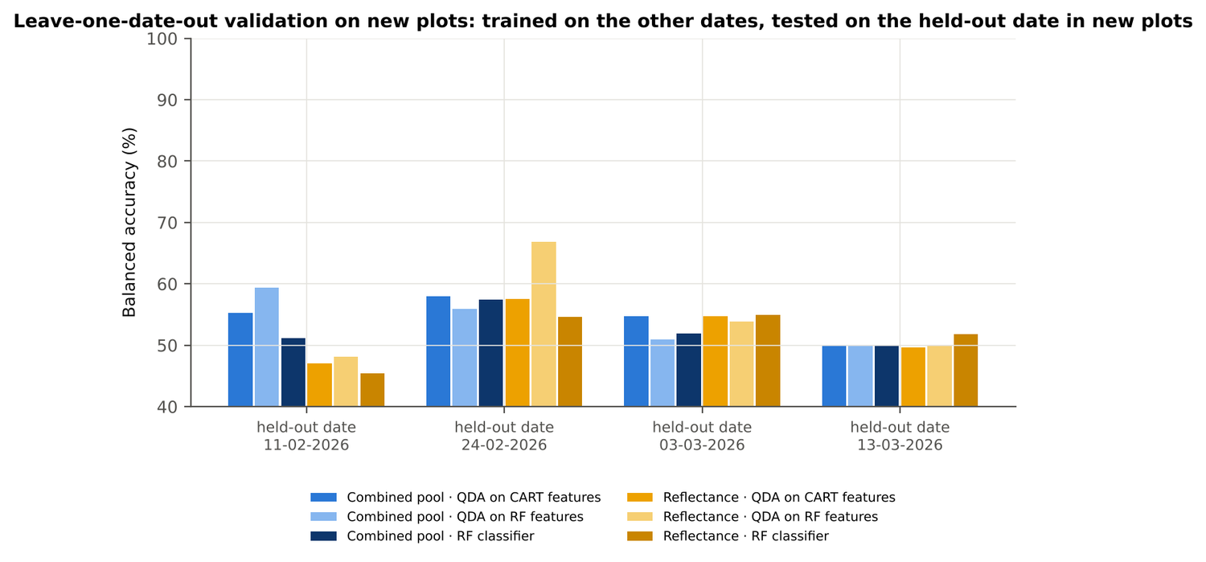
Figure 50. Leaf level LL: leave-one-date-out validation on new plots, by held-out date.

4.3.9 Interpretation
Tier 1: healthy and white-rust leaves differ significantly at 1468 of 2101 bands (Welch + BH-FDR); 1467 bands remain significant with a random plot effect and 1221 in ≥ 95 % of 1000 balanced subsets. The most sensitive single band (smoothed reflectance) reaches AUC 0.74 at 1887 nm.
Tier 2: CART (rpart, prior 0.5/0.5) selected 19 bands (root 693 nm): 693, 752, 1862, 1898, 1376, 1561, 737, 599, 769, 501, 515, 779, 2421, 496, 2486, 697, 793, 594, 601 nm. The Balanced RF importance peaks (RF-17) were 697, 616, 686, 1894, 655, 640, 630, 1883, 1986, 781, 741, 752, 770, 1974, 1375, 1327, 707 nm.
Tier 3: J–M = 1.86 on the CART bands and 1.84 on the RF bands: neither set reaches the 1.90 separability threshold (Das et al. used 1.94).
Tier 4: QDA with equal priors on the CART bands gives balanced accuracy 75.2 % in the paper's protocol (leaf-level 10-fold cross-validation; healthy recall 84.8 %, diseased recall 65.5 %) and 71.7 % ± 1.4 % (nested plot-grouped cross-validation) / 69.0 % (30 % plot hold-out validation) on new plots.
CART vs RF: as classifiers Random Forest beats CART by 6.6 points (nested plot-grouped cross-validation, Random Forest better in 39 of 50 folds, p = 1.4e-05); as band selectors for QDA the RF bands give -0.3 points vs the CART bands (p = 0.691). Random Forest selection is more stable than CART selection (Jaccard ±10 nm 0.62 vs 0.24).
Disease-sensitive features: the strongest group for the Random Forest is continuum removal (balanced accuracy 80.7 %, nested plot-grouped cross-validation) vs 69.7 % for reflectance; best single features: first derivative at 840 nm (AUC 0.78), CR3 water 970 width (AUC 0.81), NWI2 (AUC 0.74), Ro (red well reflectance) (AUC 0.71). red-edge inflection point (linear extrapolation) shifts by -4.7 nm in diseased leaves (AUC 0.68).
Combined feature pool (four tiers on the combined band reflectance + continuum-removal features + vegetation indices + derivative and edge features pool, 4150 features, 2858 significant): CART chose 7 features, RF 17 (J–M 1.71 / 1.75); QDA on the RF features reaches 79.7 % (nested plot-grouped cross-validation) / 78.6 % (30 % plot hold-out validation), +8.0 points vs QDA on RF reflectance bands; best pipeline on the pool: RF classifier (79.8 %, nested plot-grouped cross-validation).
Transfer (leave-one-date-out validation on new plots): QDA on CART reflectance bands 53.7 %, QDA on combined-pool RF features 53.0 % — a clear drop from the nested plot-grouped cross-validation estimate (79.7 %); the date/stage effect limits transfer. Best pipeline under transfer: reflectance: QDA on RF features (55.9 %).
Compared with all dates, stages and varieties pooled (nested plot-grouped cross-validation: reflectance QDA-CART 72.0 %, combined-pool QDA-RF 83.7 %; J–M 1.27), this subset gives 71.7 % and 79.7 % (J–M 1.86): discrimination is lower than in the pooled analysis (same plots, but only one leaf level, i.e. fewer leaves per plot).

Recommendations for leaf level LL
- Use first-derivative and continuum-removed features rather than single reflectance bands for this subset; the four-tier selection with RF importance on the combined pool and a QDA or RF classifier is the recommended pipeline.
- Report balanced accuracy with both class recalls and the priors used; the classes are imbalanced (1 : 5.0) and equal priors / balanced sampling were applied throughout.
- Base conclusions on the plot-grouped estimates (nested plot-grouped cross-validation 10-fold × 5 = 50 folds, 30 % plot hold-out validation 10 hold-outs), not on the leaf-level 10-fold cross-validation estimate.
- Interpret features near the ASD detector joins (≈ 1000 and 1800 nm) with care; guard zones were excluded from the rankings.
- For application to a new date, the most robust pipeline here was reflectance: QDA on RF features (leave-one-date-out validation on new plots balanced accuracy 55.9 %); accuracy on an unseen date is much lower than within the date, so calibrate with leaves of the target date or growth stage.

Cross-checks
46 checks passed, 9 were flagged and 0 failed. Flagged items are limitations reported in the workbook, not errors: Identical spectra inside the leaf-level files; Spectra of the labelled files that are not in the leaf-level files; Exact duplicates among the remaining spectra; Mixed model converged for every feature; Permutation importance (drop in AUC, 5 plot-grouped folds) vs Gini, top-50 bands; Detector artefact at the 1800/1801 nm join; Selection optimism; Best pair straddles a detector join?; QDA implementation (combined feature pool).

5. Discussion

5.1 Which leaf level is best for detecting white rust?
The spectral difference between healthy and diseased leaves increases from the upper leaves (L3) to the lowest leaves (LL): LL has the most significant bands (1468 of 2101), the largest reflectance differences (up to +4 % in SWIR-2), the most bands with AUC ≥ 0.70 (375, against 0 at L3) and the largest red-edge shift. White rust begins on and accumulates on older leaves, so the lowest leaves carry the strongest symptom.
Classification on new plots does not follow this order exactly. On the combined pool the highest balanced accuracy was obtained at L5 (QDA on RF features 83.3 %, Random Forest classifier 82.6 %), followed by L3 (81.7 %) and LL (79.7 %). LL has the fewest leaves (594; scarce on the early dates and only 46 leaves at the vegetative stage) and its healthy lower leaves also senesce, which increases the within-class variation. The differences between levels are a few points, comparable to two or three standard deviations of the nested cross-validation, so all three levels are usable; L5 is the best compromise between symptom strength and sample homogeneity.

5.2 Correction for the imbalanced classes
The data are imbalanced about 1 : 5 (healthy : diseased) at every level. Without correction a classifier can reach a high overall accuracy by calling every leaf diseased, so the correction was built into every step: balanced random subsets in Tier 1, prior = (0.5, 0.5) in rpart, balanced bootstrap samples in the Random Forest, equal prior probabilities in QDA, and balanced accuracy with both class recalls as the reported metric.
For QDA the equal priors shift the decision towards the minority class: under nested plot-grouped cross-validation the recall of healthy leaves rises from 77.8 % (L3), 76.7 % (L5), 73.5 % (LL) (sample priors) to 84.2 % (L3), 82.5 % (L5), 83.2 % (LL) (equal priors), at the cost of diseased recall; the balanced accuracy itself changes little (71.9 vs 73.2 % (L3), 74.0 vs 75.4 % (L5), 71.7 vs 71.2 % (LL), equal vs sample). The correction therefore protects the healthy class, which is the class that matters for not raising false alarms. Random under-sampling of the diseased leaves, the alternative correction, was worse (65.0 % (L3), 72.6 % (L5), 66.8 % (LL)) because it discards about 80 % of the diseased leaves.

5.3 Raw reflectance versus disease-sensitive features
The four tiers applied to raw reflectance reproduce the method of Das et al. (2020) and give a balanced accuracy of about 72–74 % on new plots. Adding the disease-sensitive features (continuum removal, vegetation indices, derivatives and edge parameters) raises the best pipeline to 79.8–83.3 %; across the four pipelines the gain over raw reflectance is 2.5–16.7 points and significant (paired Wilcoxon, p < 0.05) for every pipeline at every level. The features that matter — the slope of the near-infrared shoulder and the shape of the water-absorption features — are shape descriptors that are insensitive to the overall brightness differences between leaves, which explains why they generalise better than single reflectance bands.

5.4 CART versus Random Forest
Random Forest is the better classifier (4–10 points over CART at every level) and the more stable band selector, in agreement with the earlier pooled analysis. As a band selector for QDA on raw reflectance it is not better than CART, because importance ranking favours many correlated bands from the same region while the tree chooses complementary bands. On the combined pool, where the features are less correlated, the RF-17 set is equal to or better than the CART set. The recommended use is therefore Random Forest importance for selection and either QDA (the classifier of Das et al.) or the Random Forest itself for classification.

5.5 Validation, transfer to new dates and limitations
The leaf-level 10-fold cross-validation used by Das et al. is optimistic by 2.5–5 points on raw reflectance because leaves of one plot are in training and test and the bands are chosen on all leaves. The nested plot-grouped cross-validation and the 30 % plot hold-out validation, which keep all leaves of a plot together and repeat the selection inside each training set, are the honest estimates for new plots of the same season and are the numbers that should be reported.
Transfer to a new date is the main limitation (53–61 % balanced accuracy). The same 48 plots were measured on four dates spanning the vegetative, flowering and pod-formation stages, and the spectral expression of the disease changes with stage. A model for operational use must be calibrated with leaves of the target stage, or trained on several seasons.
- Only 12 healthy plots (36 diseased) are available, so each validation fold contains few healthy plots and the healthy class determines most of the uncertainty.
- The leaf level was taken from the supplied leaf-level workbooks; plot, variety and growth stage were attached by exact spectral matching (all spectra matched; four duplicated spectra of plot 27 on 11-02-2026 were kept once; Mustard00574 is not in the leaf-level workbooks).
- The contact-probe spectra have no atmospheric water-vapour absorption, so the water bands were kept; features next to the detector joins (1000/1001 and 1800/1801 nm) were excluded as artefact-prone.

6. Conclusions and recommendations
- Healthy and white-rust-diseased mustard leaves differ significantly at 1199 (L3), 1301 (L5), 1468 (LL) of 2101 bands; the differences are largest in the red and red edge, in the water bands and in SWIR-2, and increase from the upper (L3) to the lowest leaves (LL).
- With the four-tier method on raw reflectance (Welch + FDR → CART with equal priors → J–M → QDA with equal priors), J–M reaches 1.89 / 1.88 / 1.86 (L3 / L5 / LL; just below the 1.90 threshold) and QDA classifies new plots with a balanced accuracy of 71.9 / 74.0 / 71.7 %.
- The four tiers on the combined disease-sensitive feature pool raise the balanced accuracy on new plots to 81.9 / 83.3 / 79.8 % (best pipeline); the selected features are first-derivative bands on the near-infrared shoulder (about 785–920 nm) and continuum-removed water-absorption features.
- Random Forest beats CART as a classifier at every leaf level (+4.0 / 9.9 / 6.6 points, p < 0.001) and selects far more stable bands; as a band selector for QDA it equals CART.
- Leaf level L5 gave the highest accuracy on new plots, LL the strongest spectral differences; all three levels are usable.
- Transfer to a new date in new plots is weak (61.2 / 59.6 / 53.4 %); the models are reliable within the growth stages they were calibrated on.

Recommendations
- Use leaf level L5 (or L5 together with LL) for leaf-level detection of white rust with the contact probe.
- Use first-derivative features of the near-infrared shoulder (about 800–920 nm) and continuum-removed water-absorption features (970 and 1940 nm) rather than single reflectance bands.
- Select features with Balanced Random Forest importance and classify with QDA (equal priors) or the Balanced Random Forest; report balanced accuracy with both class recalls.
- Report plot-grouped (nested cross-validation or plot hold-out) accuracy, not leaf-level cross-validation, and state the priors and imbalance correction used.
- Calibrate the model for each growth stage, or add data from further dates and seasons, before applying it to a new date.

References
Ambroise C, McLachlan GJ. 2002. Selection bias in gene extraction on the basis of microarray gene-expression data. Proceedings of the National Academy of Sciences 99:6562–6566.
Babar MA, Reynolds MP, van Ginkel M, Klatt AR, Raun WR, Stone ML. 2006. Spectral reflectance indices as a potential indirect selection criteria for wheat yield under irrigation. Crop Science 46:578–588.
Benjamini Y, Hochberg Y. 1995. Controlling the false discovery rate: a practical and powerful approach to multiple testing. Journal of the Royal Statistical Society B 57:289–300.
Bhattacharyya A. 1943. On a measure of divergence between two statistical populations defined by their probability distributions. Bulletin of the Calcutta Mathematical Society 35:99–109.
Breiman L. 2001. Random forests. Machine Learning 45:5–32.
Breiman L, Friedman JH, Olshen RA, Stone CJ. 1984. Classification and regression trees. Belmont (CA): Wadsworth.
Brodersen KH, Ong CS, Stephan KE, Buhmann JM. 2010. The balanced accuracy and its posterior distribution. Proceedings of the 20th International Conference on Pattern Recognition, 3121–3124.
Chen C, Liaw A, Breiman L. 2004. Using random forest to learn imbalanced data. Technical Report 666, Department of Statistics, University of California, Berkeley.
Cho MA, Skidmore AK. 2006. A new technique for extracting the red edge position from hyperspectral data: the linear extrapolation method. Remote Sensing of Environment 101:181–193.
Clark RN, Roush TL. 1984. Reflectance spectroscopy: quantitative analysis techniques for remote sensing applications. Journal of Geophysical Research 89(B7):6329–6340.
Cohen J. 1960. A coefficient of agreement for nominal scales. Educational and Psychological Measurement 20:37–46.
Congalton RG. 1991. A review of assessing the accuracy of classifications of remotely sensed data. Remote Sensing of Environment 37:35–46.
Das B, Sahoo RN, Biswas A, Pargal S, Krishna G, Verma R, Chinnusamy V, Sehgal VK, Gupta VK. 2020. Discrimination of rice genotypes using field spectroradiometry. Geocarto International 35(1):64–77. doi:10.1080/10106049.2018.1506507
Dawson TP, Curran PJ. 1998. A new technique for interpolating the reflectance red edge position. International Journal of Remote Sensing 19:2133–2139.
Gong P, Pu R, Heald RC. 2002. Analysis of in situ hyperspectral data for nutrient estimation of giant sequoia. International Journal of Remote Sensing 23:1827–1850.
Guyot G, Baret F. 1988. Utilisation de la haute résolution spectrale pour suivre l'état des couverts végétaux. Proceedings of the 4th International Colloquium on Spectral Signatures of Objects in Remote Sensing, ESA SP-287, 279–286.
Haboudane D, Miller JR, Pattey E, Zarco-Tejada PJ, Strachan IB. 2004. Hyperspectral vegetation indices and novel algorithms for predicting green LAI of crop canopies. Remote Sensing of Environment 90:337–352.
Hanley JA, McNeil BJ. 1982. The meaning and use of the area under a receiver operating characteristic (ROC) curve. Radiology 143:29–36.
Hastie T, Tibshirani R, Friedman J. 2009. The elements of statistical learning. 2nd ed. New York: Springer.
Hedges LV. 1981. Distribution theory for Glass's estimator of effect size and related estimators. Journal of Educational Statistics 6:107–128.
Horler DNH, Dockray M, Barber J. 1983. The red edge of plant leaf reflectance. International Journal of Remote Sensing 4:273–288.
Hurlbert SH. 1984. Pseudoreplication and the design of ecological field experiments. Ecological Monographs 54:187–211.
Kokaly RF, Clark RN. 1999. Spectroscopic determination of leaf biochemistry using band-depth analysis of absorption features and stepwise multiple linear regression. Remote Sensing of Environment 67:267–287.
Kuncheva LI. 2007. A stability index for feature selection. Proceedings of the 25th IASTED International Multi-Conference: Artificial Intelligence and Applications, 390–395.
Lemaître G, Nogueira F, Aridas CK. 2017. Imbalanced-learn: a Python toolbox to tackle the curse of imbalanced datasets in machine learning. Journal of Machine Learning Research 18(17):1–5.
Levene H. 1960. Robust tests for equality of variances. In: Olkin I, editor. Contributions to probability and statistics. Stanford: Stanford University Press; p. 278–292.
Liaw A, Wiener M. 2002. Classification and regression by randomForest. R News 2(3):18–22.
Mahlein A-K. 2016. Plant disease detection by imaging sensors — parallels and specific demands for precision agriculture and plant phenotyping. Plant Disease 100:241–251.
Mahlein A-K, Rumpf T, Welke P, Dehne H-W, Plümer L, Steiner U, Oerke E-C. 2013. Development of spectral indices for detecting and identifying plant diseases. Remote Sensing of Environment 128:21–30.
Pedregosa F, Varoquaux G, Gramfort A, et al. 2011. Scikit-learn: machine learning in Python. Journal of Machine Learning Research 12:2825–2830.
Pinheiro J, Bates D, R Core Team. 2023. nlme: linear and nonlinear mixed effects models. R package.
R Core Team. 2024. R: a language and environment for statistical computing. Vienna: R Foundation for Statistical Computing.
Richards JA. 2013. Remote sensing digital image analysis. 5th ed. Berlin: Springer.
Roberts DR, Bahn V, Ciuti S, et al. 2017. Cross-validation strategies for data with temporal, spatial, hierarchical, or phylogenetic structure. Ecography 40:913–929.
Saharan GS, Verma PR, Meena PD, Kumar A. 2014. White rust of crucifers: biology, ecology and management. New Delhi: Springer India.
Savitzky A, Golay MJE. 1964. Smoothing and differentiation of data by simplified least squares procedures. Analytical Chemistry 36:1627–1639.
Seabold S, Perktold J. 2010. Statsmodels: econometric and statistical modeling with Python. Proceedings of the 9th Python in Science Conference, 92–96.
Strobl C, Boulesteix A-L, Zeileis A, Hothorn T. 2007. Bias in random forest variable importance measures: illustrations, sources and a solution. BMC Bioinformatics 8:25.
Swain PH, Davis SM. 1978. Remote sensing: the quantitative approach. New York: McGraw-Hill.
Therneau T, Atkinson B. 2023. rpart: recursive partitioning and regression trees. R package version 4.1.23.
Varma S, Simon R. 2006. Bias in error estimation when using cross-validation for model selection. BMC Bioinformatics 7:91.
Venables WN, Ripley BD. 2002. Modern applied statistics with S. 4th ed. New York: Springer.
Welch BL. 1947. The generalization of 'Student's' problem when several different population variances are involved. Biometrika 34:28–35.
Wilcoxon F. 1945. Individual comparisons by ranking methods. Biometrics Bulletin 1:80–83.
Youden WJ. 1950. Index for rating diagnostic tests. Cancer 3:32–35.
Vegetation-index sources (formulas in workbook sheet 17): Jordan 1969; Gitelson & Merzlyak 1996; Gamon et al. 1992; Chappelle et al. 1992; Blackburn 1998; Raun et al. 2001; Peñuelas et al. 1994, 1995, 1997; Barnes et al. 1992; Merzlyak et al. 1999; Haboudane et al. 2002; Gitelson et al. 2001, 2002; Merton 1998; Broge & Leblanc 2001; Roujean & Bréon 1995; Metternicht 2003; Bausch & Duke 1996.

Appendix A. Cross-check summary by leaf level
Table 69. Cross-checks of each leaf-level analysis (all workbooks recalculated in LibreOffice with 0 formula errors).
Leaf level | PASS | FLAG | FAIL | Flagged items (limitations reported in the workbook)
L3 | 46 | 8 | 0 | Identical spectra inside the leaf-level files; Spectra of the labelled files that are not in the leaf-level files; Exact duplicates among the remaining spectra; Training sets with < 2 FDR-significant features (nested plot-grouped cross-validation/30 % plot hold-out validation/leave-one-date-out validation on new plots); QDA in R; Permutation importance (drop in AUC, 5 plot-grouped folds) vs Gini, top-50 bands; Detector artefact at the 1800/1801 nm join; Selection optimism
L5 | 45 | 10 | 0 | Identical spectra inside the leaf-level files; Spectra of the labelled files that are not in the leaf-level files; Exact duplicates among the remaining spectra; Mixed model converged for every feature; QDA in R; Permutation importance (drop in AUC, 5 plot-grouped folds) vs Gini, top-50 bands; Detector artefact at the 1800/1801 nm join; Selection optimism; Best pair straddles a detector join?; QDA implementation (combined feature pool)
LL | 46 | 9 | 0 | Identical spectra inside the leaf-level files; Spectra of the labelled files that are not in the leaf-level files; Exact duplicates among the remaining spectra; Mixed model converged for every feature; Permutation importance (drop in AUC, 5 plot-grouped folds) vs Gini, top-50 bands; Detector artefact at the 1800/1801 nm join; Selection optimism; Best pair straddles a detector join?; QDA implementation (combined feature pool)

Appendix B. The three workbooks
Table 70. Excel workbooks (40 sheets each: README, glossary, summary, design, data audit, pre-processing, Tiers 1–4, validation, Random Forest steps, disease-sensitive feature steps, four tiers on the combined pool, transfer to new dates, within-strata checks, cross-checks, band-by-band and feature tables, folds, chart data).
Workbook | Leaf level
1_WhiteRust_Mustard_LeafLevel_L3_FourTier_CART_RF_K_Combined.xlsx | leaf level L3 (all dates, growth stages and varieties combined)
2_WhiteRust_Mustard_LeafLevel_L5_FourTier_CART_RF_K_Combined.xlsx | leaf level L5 (all dates, growth stages and varieties combined)
3_WhiteRust_Mustard_LeafLevel_LL_FourTier_CART_RF_K_Combined.xlsx | leaf level LL (all dates, growth stages and varieties combined)

