Discrimination of healthy and white-rust-diseased mustard leaves using field spectroradiometry
A four-tier hierarchical analysis (Das et al., 2020) with imbalance correction, CART versus Random Forest band selection, disease-sensitive feature extraction and the four-tier analysis of the combined feature pool
Leaf level · 2264 leaf spectra (378 healthy, 1886 diseased) · four dates, three growth stages and three varieties combined
Animesh Panda · Division of Agricultural Physics, ICAR-Indian Agricultural Research Institute, New Delhi
Methods, results and interpretation for thesis use · companion to the Excel workbook and the presentation

Contents

(Right-click → Update field in Word to refresh the page numbers.)

Summary
Leaf reflectance (ASD contact probe, 350–2500 nm) of 2264 mustard leaves (378 healthy, 1886 white-rust-diseased; 48 plots; four dates; vegetative, flowering and pod-formation stages; three varieties) was analysed with the four-tier hierarchical method of Das et al. (2020) — Welch t-test with FDR, CART band selection, Jeffries–Matusita separability and QDA — with corrections for the 1 : 5 class imbalance (equal priors, balanced sampling, balanced accuracy), multiple testing and pseudo-replication, and with validation in which every selection step was repeated inside training data grouped by plot.
On reflectance, 1653 bands differed significantly; CART selected 11 bands (root 1893 nm) and a Balanced Random Forest 17 importance peaks in the red / red edge (621–773 nm) and the 1880–2020 nm water region. J–M distances (1.27 and 1.67) stayed below 1.90, and QDA with equal priors reached a balanced accuracy of 71.1 % in the paper's protocol and 72.0 ± 1.5 % (nested plot-grouped CV) and 72.8 ± 4.7 % (independent hold-out plots) on new plots. As classifiers, RF beat CART by 6 points (p < 10⁻⁹).
Disease-sensitive features — first-derivative bands, continuum-removed absorption parameters, 31 vegetation indices, edge parameters and the red-edge inflection point (blue shift of 1.5–3.9 nm in diseased leaves) — were extracted. Applying the four tiers to the combined pool of 4150 features selected mainly first-derivative bands near 845–875 and 1915–1945 nm and the width of the 970 nm and symmetry of the 1940 nm water features; QDA on the 17 RF-selected features reached 83.7 % (V3) and 84.6 % (V4), 15 points above reflectance (50 of 50 folds better). A Balanced RF on all features reached 86 %.
Performance on an unseen date in unseen plots was only 53–62 %, because growth stage shifts the spectra more than the disease does. White rust is detectable from leaf spectra across varieties, but a model for practical use must be trained on the growth stages to which it will be applied.

1. Introduction
White rust, caused by the oomycete Albugo candida (Pers.) Roussel ex Kuntze, is one of the most damaging foliar diseases of Indian mustard (Brassica juncea). Local infection produces white, raised sori (pustules) mainly on the abaxial leaf surface, with chlorosis of the surrounding tissue; systemic infection deforms inflorescences into 'stag heads' (Saharan et al., 2014). Because symptoms change leaf pigments, cell structure and water status, they alter the leaf reflectance spectrum, which can be measured rapidly and non-destructively with a field spectroradiometer (Mahlein, 2016).
A hyperspectral spectrum contains about two thousand strongly correlated bands, many more than the number of samples needed to estimate a classifier reliably. Das et al. (2020) proposed a four-tier hierarchical method to reduce such data to a few discriminating wavelengths and to test whether these are sufficient: Tier 1 screens every band with one-way ANOVA; Tier 2 selects a small set of wavelengths with classification and regression trees (CART); Tier 3 quantifies the spectral separability of the classes with the Jeffries–Matusita (J–M) distance on the selected wavelengths; Tier 4 classifies the samples with quadratic discriminant analysis (QDA) under 10-fold cross-validation. They discriminated 14 rice genotypes from 336 canopy spectra with 98 % overall accuracy.
This study applies the same hierarchy to a different problem — healthy versus white-rust-diseased mustard leaves measured with a contact probe on four dates, three growth stages and three varieties, all pooled — and adds what this problem requires: (i) corrections for the 1 : 5 class imbalance, for multiple testing and for the nesting of leaves in plots; (ii) honest validation in which every selection step is repeated inside the training data and test plots (and test dates) are never seen during training; (iii) a comparison of CART with Random Forest (RF) as the Tier-2 selector and as a classifier; (iv) extraction of disease-sensitive spectral features (band reflectance, continuum-removed absorption features, vegetation indices, first-derivative spectra and the red-edge inflection point); and (v) the four-tier analysis applied to the combined pool of all these features.

1.1 Objectives
- Identify the wavelengths at which healthy and white-rust-diseased mustard leaves differ, irrespective of date, growth stage and variety (Tier 1).
- Select a minimal discriminating band set with CART as in Das et al. (2020), and with Random Forest as an alternative (Tier 2).
- Quantify the separability of the two classes on the selected bands (Tier 3) and the classification accuracy of QDA (Tier 4).
- Validate the complete pipeline on new plots and new dates, and test whether the differences between approaches are significant.
- Extract disease-sensitive spectral features (K1–K4) and evaluate CART and RF on each feature family and on the combined feature pool, including the full four-tier analysis of the combined pool.

2. Materials and methods

2.1 Data
Leaf reflectance was recorded with an ASD FieldSpec spectroradiometer and contact probe (350–2500 nm, 1 nm) on 11-02-2026, 24-02-2026, 03-03-2026 and 13-03-2026 in 48 plots: 12 healthy control plots (plots 1–12) and 36 inoculated plots (13–48) of three varieties (V1–V3). Each date was exported as one workbook with one column per leaf spectrum and descriptor rows for plot, variety, growth stage (vegetative, flowering, pod formation) and the healthy/diseased label. Plot-average columns (=AVERAGE formulas) were not used: the analysis is at leaf level. Exact duplicates were removed: 75 spectra in a second data block of the 13-03-2026 file repeated plots 13, 34, 38, 41 and 42, and four unnamed spectra of plot 27 on 11-02-2026 were identical to Mustard00215–00218. 2264 unique leaf spectra remained (378 healthy, 1886 diseased; ratio 1 : 4.99). Leaf position and disease score were not used; the response is healthy vs diseased.
Table 1. Leaf spectra by date and class.
Date | Healthy | Diseased | Total
11-02-2026 | 72 | 356 | 428
24-02-2026 | 90 | 450 | 540
03-03-2026 | 108 | 540 | 648
13-03-2026 | 108 | 540 | 648

Table 2. Leaf spectra by growth stage (all dates).
Growth stage | Healthy | Diseased
Flowering | 195 | 965
Pod formation | 90 | 450
Vegetative | 93 | 471

2.2 Pre-processing and band set (Step 0–1)
Das et al. (2020) removed 1350–1430, 1800–1950 and 2350–2500 nm because of atmospheric water vapour in canopy measurements. The contact probe illuminates the leaf with its own lamp at a few millimetres, so there is no atmospheric path and these bands carry leaf-water information; they were kept. The 350–399 nm detector edge was removed because its noise (standard deviation of the Savitzky–Golay residual) was about 116 times that of 500–699 nm. Tiers 1–4 used the raw reflectance of 400–2500 nm (2101 bands), as in the original method. Outliers were screened with the spectral angle to the class median spectrum and flagged, not removed.

2.3 Tier 1 — statistical screening
With two classes the one-way ANOVA of Das et al. reduces to a two-sample test (F = t² of Student's t). Because the class variances differ at many bands (Levene's test) and the classes are unbalanced, Welch's unequal-variance t-test was used:
t = (x̄_D − x̄_H) / √(s²_D/n_D + s²_H/n_H), ν = (s²_D/n_D + s²_H/n_H)² / [ (s²_D/n_D)²/(n_D−1) + (s²_H/n_H)²/(n_H−1) ]
Testing 2101 bands at α = 0.05 would yield about 105 false positives under the null hypothesis, so p-values were adjusted with the Benjamini–Hochberg false-discovery rate (FDR; Benjamini and Hochberg, 1995): q₍ᵢ₎ = min over k ≥ i of p₍ₖ₎·m/k. Bands with q < 0.05 passed to Tier 2. Three checks accompany the test: (a) one-way ANOVA, the rule of Das et al.; (b) 1000 balanced random subsets of 378 healthy and 378 diseased leaves, to show that significance is not an artefact of the large diseased class; (c) a linear mixed model y = β₀ + β₁·Disease + u_plot + ε with a random plot intercept (REML), because leaves of one plot share the plot environment (pseudo-replication; Hurlbert, 1984). The −log₁₀(p) of every band was plotted against wavelength (significance spectrum). Effect size is reported as Hedges' g (bias-corrected standardised mean difference).

2.4 Tier 2 — CART band selection
Classification and regression trees (Breiman et al., 1984) split the data recursively; at each node the band and threshold are chosen that most reduce the Gini impurity G = 1 − Σk pk², where p_k is the (prior-weighted) proportion of class k in the node. The bands used as split variables form the selected set. As in Das et al., the R package rpart was used (Therneau and Atkinson, 2023), with method = 'class', split = 'gini', minsplit = 20, minbucket = 7, cp = 0.01 and no competitor or surrogate splits. Correction for imbalance: prior = c(0.5, 0.5), so that each class carries equal weight in the impurity and in the class assigned to a terminal node. The complexity parameter was cross-validated with folds grouped by plot; the 1-SE rule gives a smaller tree. Stability was assessed by refitting rpart on 200 plot-level bootstrap samples and in the 50 nested training sets of V3; a band counts as re-selected when a band within ± 10 nm is chosen.

2.5 Random Forest as an alternative Tier-2 selector and classifier
A Random Forest (Breiman, 2001) averages many trees grown on bootstrap samples with a random subset of √p candidate bands at each split, which makes it far more stable than a single tree. For imbalanced classes the Balanced Random Forest grows each tree on a bootstrap sample with equal numbers of both classes (Chen et al., 2004), implemented in imbalanced-learn (Lemaître et al., 2017): BalancedRandomForestClassifier with samplingstrategy = 'all', replacement = True, bootstrap = False, maxfeatures = √p, 500 trees (1000 for importance), random_state = 42. Band importance is the mean decrease in Gini impurity (MDI). Because neighbouring bands are nearly identical, bands were picked as importance peaks: local maxima of the importance spectrum at least 10 nm apart; the 17 highest peaks give RF-17 (the size of the CART set of Das et al.) and the 10 highest RF-10. Checks: a second forest with another seed, the R package randomForest (Liaw and Wiener, 2002) with stratified balanced sampling, permutation importance (Strobl et al., 2007) and an ordinary class-weighted forest.

2.6 Tier 3 — Jeffries–Matusita distance
The J–M distance measures the separability of two class distributions assumed multivariate normal (Swain and Davis, 1978; Richards, 2013). With class means μ and covariance matrices Σ of the selected bands, the Bhattacharyya distance is
α = ⅛ (μ_H − μ_D)ᵀ [(Σ_H + Σ_D)/2]⁻¹ (μ_H − μ_D) + ½ ln{ |(Σ_H + Σ_D)/2| / √(|Σ_H| |Σ_D|) }
J–M = 2 (1 − e^(−α)) (0 to 2); √J–M ranges from 0 to √2
Das et al. printed J–M = √[2(1 − e^(−α))] (Eq. 1) but applied thresholds of 1.90 and 1.94 (97 % of 2), which belong to the 0–2 scale; both scales are reported here and the thresholds are applied on the 0–2 scale. The distance was computed with a Cholesky factorisation and verified with explicit inverses and determinants; the J–M of a class with itself must be zero.

2.7 Tier 4 — quadratic discriminant analysis
QDA assigns a leaf x to the class with the largest discriminant score
δ_k(x) = −½ ln|Σ_k| − ½ (x − μ_k)ᵀ Σ_k⁻¹ (x − μ_k) + ln π_k
with a separate covariance matrix for each class (Hastie et al., 2009). Correction for imbalance: equal prior probabilities πH = πD = 0.5 (the sample priors 0.17/0.83 would favour 'diseased'); sample priors and LDA are reported for comparison. As in Das et al., accuracy was estimated by 10-fold cross-validation and summarised in an error matrix (rows = classified, columns = reference) with producer's and user's accuracies (Congalton, 1991). QDA was cross-checked against MASS::qda in R (Venables and Ripley, 2002) and against manual discriminant functions.

2.8 Accuracy measures
With unequal classes, overall accuracy (OA) is dominated by the diseased class. The headline metric is therefore the balanced accuracy BA = ½ (PAH + PAD), the mean of the producer's accuracies (recalls) of both classes (Brodersen et al., 2010). Cohen's κ (Cohen, 1960), the area under the ROC curve (AUC; Hanley and McNeil, 1982), user's accuracies and F1 are also reported.

2.9 Validation design
Choosing bands on all leaves and then cross-validating on the same leaves is optimistic (selection bias; Ambroise and McLachlan, 2002; Varma and Simon, 2006), and leaves of one plot are more alike than leaves of different plots, so leaf-level folds leak plot information (Roberts et al., 2017). Five schemes were used, with identical folds in every step:
Table 3. Validation schemes. Plots are grouped across all dates, so no plot contributes to both training and test data.
Scheme | Test data | Refitted on the training data | Purpose
V1 | leaf-level stratified 10-fold (seed 42) | classifier only (bands fixed) | reproduces Das et al.; optimistic
V2 | 10 folds grouped by plot (seed 42) | classifier only | removes plot leakage
V3 | 10 folds grouped by plot × 5 repeats (seeds 101–105) | Tier 1 + selection + classifier (nested) | honest estimate for new plots
V4 | 30 % of plots (4 healthy + 11 diseased) × 10 splits | everything | independent hold-out plots
V5 | one held-out date in the V4 test plots (40 units) | everything (other dates, training plots) | unseen date and unseen plots

Pipelines were compared with the paired Wilcoxon signed-rank test (Wilcoxon, 1945) over the 50 V3 folds and the 10 V4 splits, which share the same test leaves. The stability of band selection was summarised by the share of bands selected in every training set and by the mean pairwise Jaccard similarity of the selected sets (± 10 nm; Kuncheva, 2007).

2.10 Disease-sensitive feature extraction (Part K)

K0 — detector splice correction, smoothing and guard zones
The ASD records 350–1000, 1001–1800 and 1801–2500 nm with three detectors; small steps occur at the joins. For each join a straight line was fitted to the 10 nm before it and the following detector was shifted additively to continue that line. Spectra were smoothed with a Savitzky–Golay filter (window 11, order 2; Savitzky and Golay, 1964); first and second derivatives used windows 15 and 21. A date-dependent start-up rise after 1801 nm was detected, so guard zones (990–1010 and 1795–1835 nm for reflectance; 988–1012 and 1793–1837 nm for the first derivative; 985–1015 and 1790–1840 nm for the second) were excluded from feature ranking; results with the guard bands are reported to show the size of the artefact.

K1 — band reflectance
For every smoothed band: Welch's t-test with FDR, Hedges' g, the direction-free AUC (max(AUC, 1 − AUC)) and a single-band threshold classifier. The threshold maximises Youden's J = sensitivity + specificity − 1 (Youden, 1950); threshold and direction were chosen on the training plots and applied to the test plots (V3, V4).

K2 — continuum-removed absorption features
In six windows (400–548, 548–765, 914–1069, 1069–1258, 1258–1721 and 1721–2304 nm) the reflectance was divided by its upper convex hull (continuum removal; Clark and Roush, 1984; Kokaly and Clark, 1999). From the continuum-removed curve CR(λ): depth = 1 − min CR, position = wavelength of the minimum, area = Σ (1 − CR), width = full width at half depth, symmetry = share of the area left of the position — 30 parameters.

K3 — disease-sensitive spectral (vegetation) indices
The 31 indices of the flowering-stage analysis were computed (e.g. NDVI, GNDVI, PRI, MTVI2, TCARI, ARI, PSRI, NWI2, WI; formulas in workbook sheet 17). mCARI1 and MTVI1 are algebraically identical in the given form. An optimised two-band index (K3b) was searched exhaustively: NDSI(i, j) = (Ri − Rj)/(Ri + Rj) and DI(i, j) = Ri − Rj for all pairs on a 5 nm grid, refined at 1 nm; the search was repeated inside 20 training sets for an unbiased estimate.

K4 — first-derivative spectra, edge parameters and the red-edge inflection point (REIP)
First-derivative bands were tested like K1. Twenty edge parameters were derived (Gong et al., 2002): amplitude, position and area (sum of the derivative) of the blue (490–530 nm), yellow (550–582 nm) and red (680–760 nm) edges, green-peak and red-well reflectance and position, the linear four-point red-edge position and six ratios. The REIP was estimated by four methods: maximum of the first derivative (Horler et al., 1983); linear four-point interpolation, REP = 700 + 40 [(R670 + R780)/2 − R700] / (R740 − R700) (Guyot and Baret, 1988); three-point Lagrangian interpolation of the derivative around its maximum (Dawson and Curran, 1998); and linear extrapolation of the far-red (680–694 nm) and NIR (724–760 nm) derivative lines (Cho and Skidmore, 2006).

K6 — correlation spectra
Severity scores were not used, so the point-biserial correlation r between each band (reflectance and first derivative) and the binary disease status (healthy = 0, diseased = 1) was computed on all leaves and on each date; r is a monotone function of Student's t.

K5 — CART versus Random Forest on each feature group
Each feature group — raw spectrum, K1, K2, K3, K4, the combined pool, and K4 including the guard bands (artefact test) — was classified by CART and by a Balanced RF in V3 and V4 without pre-screening; RF − CART was tested with the paired Wilcoxon test. A compact set of 15 non-redundant features (|r| < 0.9) with the highest AUC was also chosen inside every training set and classified by RF, CART and QDA.

2.11 Four-tier analysis of the combined feature pool (Part C)
The K1 bands, 30 K2 parameters, 31 K3 indices, K4 first-derivative bands and 20 edge parameters (guard zones excluded) form a pool of 4151 features; exact duplicates (|r| ≥ 0.99999) were removed, leaving 4150. The four tiers were then applied exactly as in Part A: Welch t + FDR; CART (rpart, equal priors) and Balanced RF selection (peaks within each spectral series; every scalar feature its own candidate; candidates with |r| ≥ 0.999 to a chosen feature skipped to keep covariances invertible); J–M; QDA with equal priors; validation V1–V5 with identical folds; comparison with Part A and K5 by paired Wilcoxon tests.

2.12 Additional checks
- V5: transfer to an unseen date in unseen plots (Section 2.9).
- Stratified checks: the AUC of key features and the balanced accuracy of the classifiers within each date, growth stage and variety.
- Sensitivity analyses: band range (350–2500 and 450–2450 nm) and the four duplicate spectra kept.
- Cross-checks at every step (independent implementations, Excel recomputation, R versus Python) — workbook sheet 33.

2.13 Software
Python 3.13 with NumPy, SciPy, pandas, statsmodels (Seabold and Perktold, 2010), scikit-learn (Pedregosa et al., 2011), imbalanced-learn and matplotlib; R 4.3.3 (R Core Team, 2024) with rpart, MASS and randomForest. The code is organised as a reusable, configuration-driven pipeline.

3. Results

3.1 Data audit and spectra (Step 0–1)
All quality checks passed (no missing values; reflectance 0.026 – 0.935; one class and one variety per plot). The mean spectra (Figure 1) show the typical shape of green leaves.
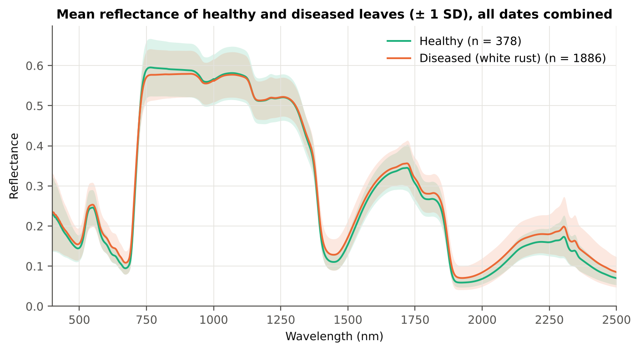
Figure 1. Mean reflectance (± 1 SD) of healthy and diseased leaves, all dates combined (as Figure 3 of Das et al., 2020).
Diseased leaves reflect slightly more in the visible (chlorophyll loss, white pustules) and in the SWIR beyond 1350 nm (lower leaf water), and less on the NIR plateau at 750–930 nm (damage to the mesophyll structure).
The differences are small compared with the variation between dates and growth stages (lower panels): the mean spectra of the four dates differ more than healthy and diseased leaves within a date.
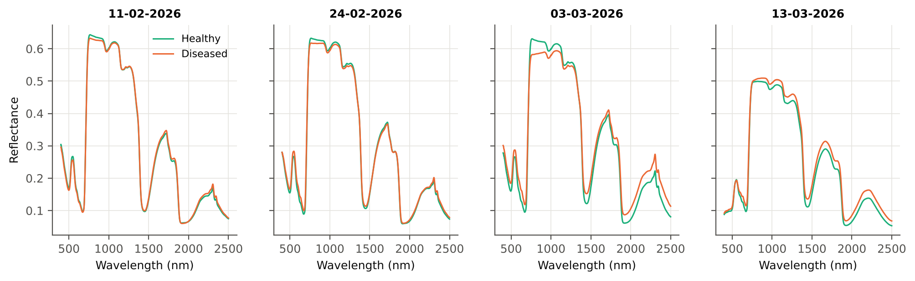
Figure 2. Mean spectra of healthy and diseased leaves on each date.
Table 4. Noise by spectral region (SD of the Savitzky–Golay residual).
Range (nm) | Noise (SD) | × 500–699 nm
350–399 | 6.4e-03 | 115.7
400–499 | 7.7e-04 | 13.9
500–699 | 5.6e-05 | 1.0
700–1000 | 7.1e-05 | 1.3
1001–1349 | 5.2e-05 | 0.9
1350–1430 | 1.7e-05 | 0.3
1431–1799 | 1.1e-05 | 0.2
1800–1950 | 1.9e-05 | 0.3
1951–2349 | 1.7e-05 | 0.3
2350–2500 | 7.9e-05 | 1.4

3.2 Tier 1 — significant wavelengths
1653 of 2101 bands differed significantly between healthy and diseased leaves (Welch + FDR, q < 0.05). In 1000 balanced subsets the median number of significant bands was 1568; 1335 bands were significant in at least 95 % of subsets. With a random plot effect 1604 bands remained significant.
Table 5. Number of significant bands by test.
Test | Significant bands
Welch t-test + BH-FDR q < 0.05 (used for Tier 2) | 1653
One-way ANOVA p < 0.05, uncorrected (rule of Das et al.) | 1675
One-way ANOVA + BH-FDR q < 0.05 | 1667
Welch t-test p < 0.05, uncorrected | 1664
Mixed model (random plot effect) + BH-FDR q < 0.05 | 1604
Balanced subsets (378 vs 378): significant in ≥ 95 % of 1000 subsets | 1335
Levene test p < 0.05 (unequal variances → Welch) | 1386

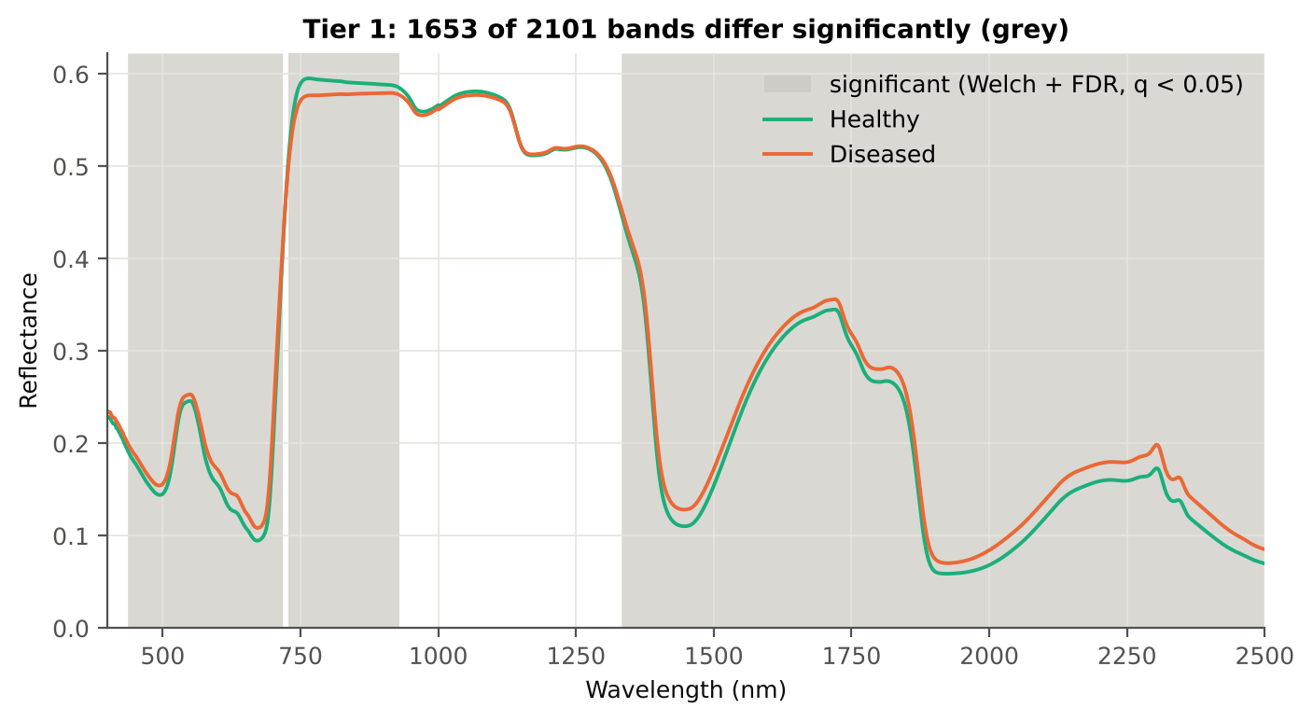
Figure 3. Bands with a significant difference between healthy and diseased leaves (grey; Welch + FDR), with the class means (as Figure 4 of Das et al., 2020).
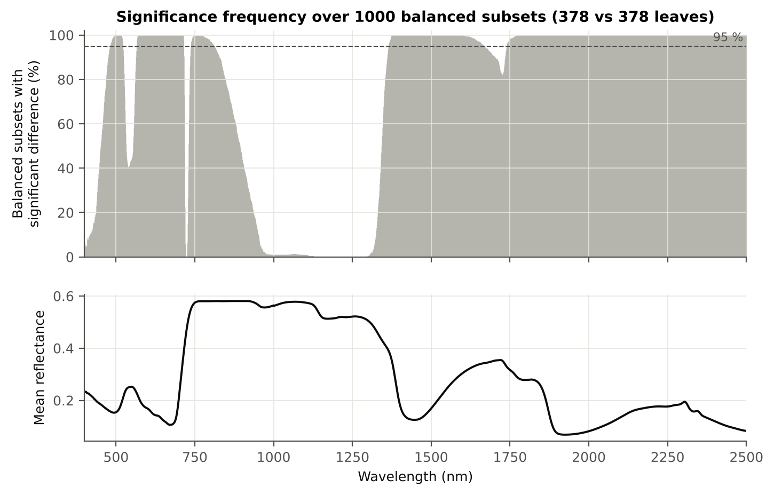
Figure 4. Share of 1000 balanced subsets (378 vs 378 leaves) in which each band differs significantly, and the mean spectrum (as Figure 5 of Das et al., 2020).
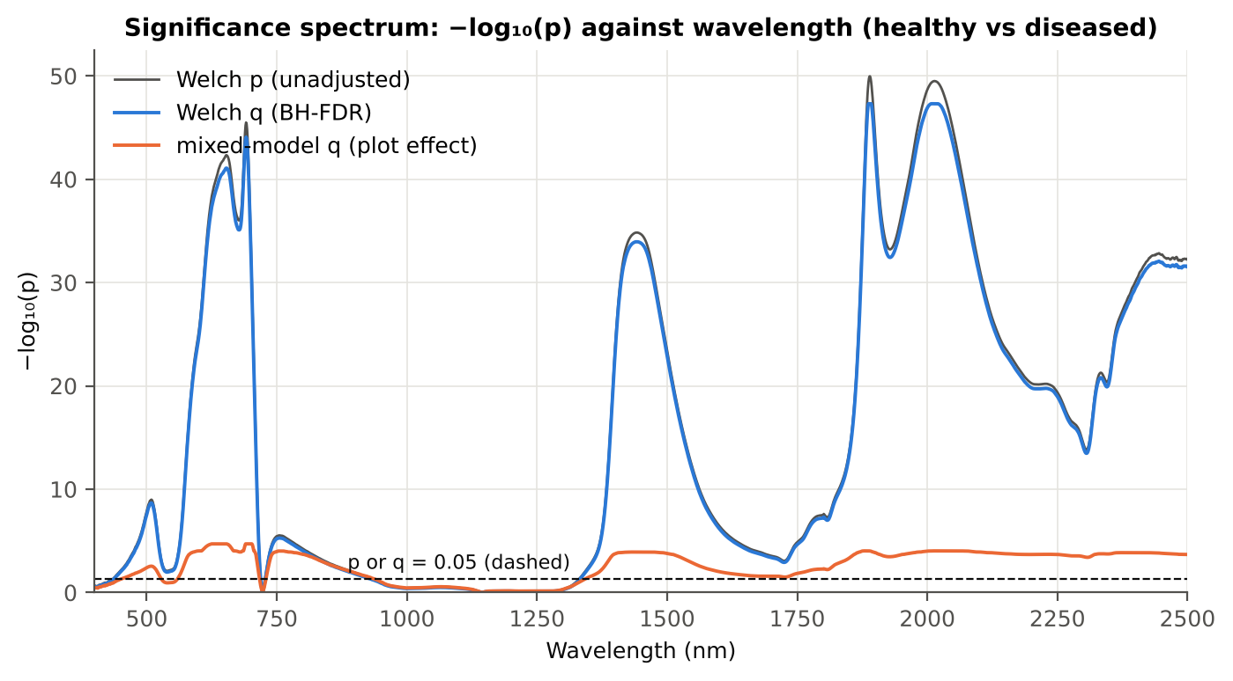
Figure 5. Significance spectrum: −log₁₀(p) of Welch's test, its FDR-adjusted q and the mixed-model q against wavelength; dashed line = 0.05.
The Welch test is extremely significant in the red / red edge (≈ 650–700 nm) and in the water bands (1400–1450, 1880–2020 nm); it is not significant at 931–1332 nm (NIR) or at 719–727 nm, where the healthy and diseased curves cross.
With a random plot effect (orange) the significance drops by tens of orders of magnitude, because the effective sample size is the number of plots (48), not the number of leaves; still 1604 bands remain significant.
Table 6. Significance by spectral region.
Region | Bands | Welch+FDR significant | Mixed-model significant | Band of max |t| | Max t
Blue (400–499) | 100 | 63 | 49 | 499 | 5.7
Green (500–599) | 100 | 100 | 70 | 599 | 10.8
Red (600–679) | 80 | 80 | 80 | 653 | 14.4
Red edge (680–759) | 80 | 71 | 67 | 691 | 15.0
NIR (760–1349) | 590 | 188 | 187 | 760 | -4.7
Water band I (1350–1430) | 81 | 81 | 81 | 1430 | 12.9
SWIR-1 (1431–1799) | 369 | 369 | 369 | 1442 | 12.9
Water band II (1800–1950) | 151 | 151 | 151 | 1889 | 15.5
SWIR-2 (1951–2349) | 399 | 399 | 399 | 2015 | 15.4
SWIR-2 end (2350–2500) | 151 | 151 | 151 | 2445 | 12.4

3.3 Tier 2 — CART band selection
CART selected 11 bands: 1893, 2405, 767, 702, 1333, 540, 1729, 588, 1874, 1531, 1872 nm. The 1-SE tree retained 4 bands (1893, 2405, 767, 1333 nm).
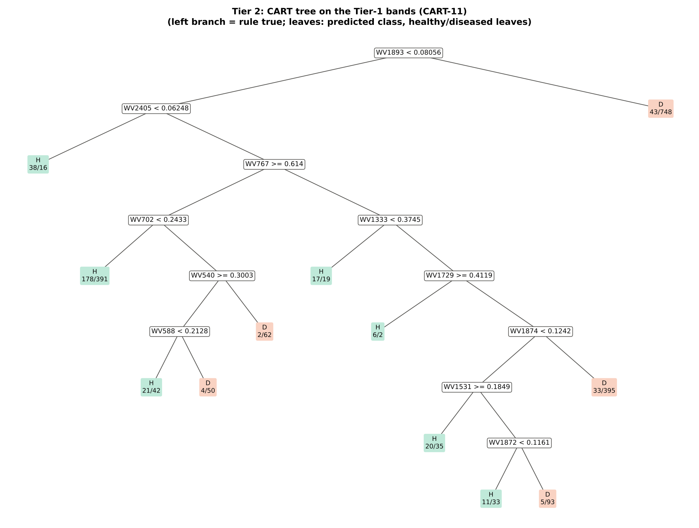
Figure 6. CART tree on the Tier-1 bands (rpart, prior 0.5/0.5; as Figure 6 of Das et al., 2020). Leaves: predicted class and numbers of healthy/diseased leaves.
Table 7. Wavelengths selected by CART, with re-selection frequency in 200 plot-level bootstraps and 50 nested training sets.
Band (nm) | Region | First used at node | Welch t | Bootstrap re-selection (±10 nm) | Nested-CV re-selection (±10 nm) | Mixed model significant
540 | Green | 21 | 2.7 | 25.0 % | 10.0 % | no
588 | Green | 42 | 9.8 | 13.5 % | 4.0 % | yes
702 | Red edge | 10 | 12.1 | 88.0 % | 56.0 % | yes
767 | NIR | 5 | -4.6 | 33.0 % | 84.0 % | yes
1333 | NIR | 11 | 2.1 | 38.0 % | 46.0 % | no
1531 | SWIR-1 | 94 | 8.4 | 7.5 % | 12.0 % | yes
1729 | SWIR-1 | 23 | 3.4 | 20.5 % | 46.0 % | yes
1872 | Water band II | 189 | 12.0 | 33.5 % | 46.0 % | yes
1874 | Water band II | 47 | 12.6 | 35.5 % | 46.0 % | yes
1893 | Water band II | 1 | 15.3 | 62.0 % | 86.0 % | yes
2405 | SWIR-2 end | 2 | 12.0 | 19.5 % | 76.0 % | yes

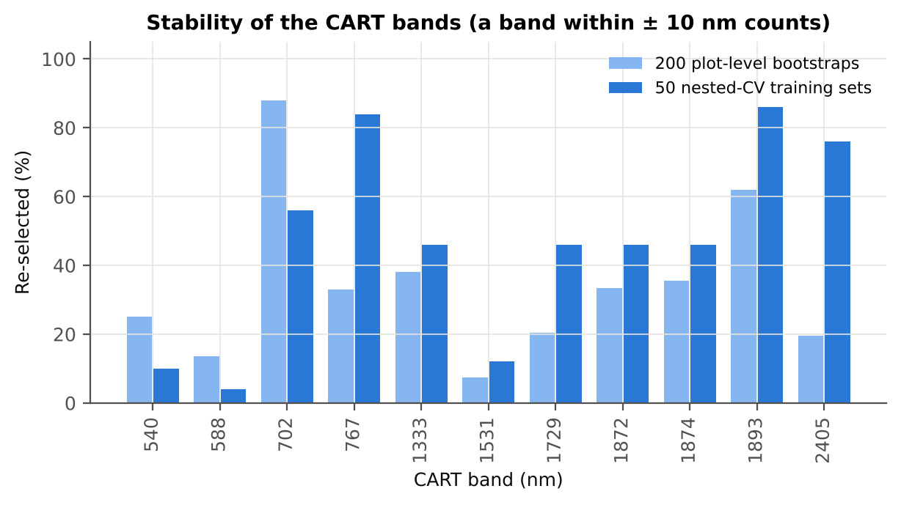
Figure 7. Re-selection frequency of each CART band (± 10 nm).
The root split is at 1893 nm (water band II): leaves with R1893 ≥ 0.081 are almost all diseased (748 of 791). The tree then uses 2405 nm, the NIR shoulder at 767 nm, the red edge at 702 nm and the green region (540, 588 nm).
Only 1893, 767 and 2405 nm are re-selected in more than 75 % of the nested training sets; the other CART bands change from sample to sample — a single tree is an unstable band selector.

3.4 Tier 3 — J–M separability
Table 8. J–M distance between healthy and diseased leaves for each band set (0–2 scale).
Set | Features | JM
CART-11 | 11 | 1.266
CART-4 (1-SE) | 4 | 0.634
RF-17 | 17 | 1.665
RF-10 | 10 | 1.181
RF-11 (size-matched) | 11 | 1.232

J–M increases steadily as bands are added but stays below 1.90 for both band sets: on the CART bands 1.27, on the RF bands 1.67. By the criterion of Das et al. the classes are not spectrally separable — healthy and diseased leaves overlap, as expected when four dates, three stages and three varieties are pooled.
The 1-SE tree (4 bands) gives J–M 0.63.
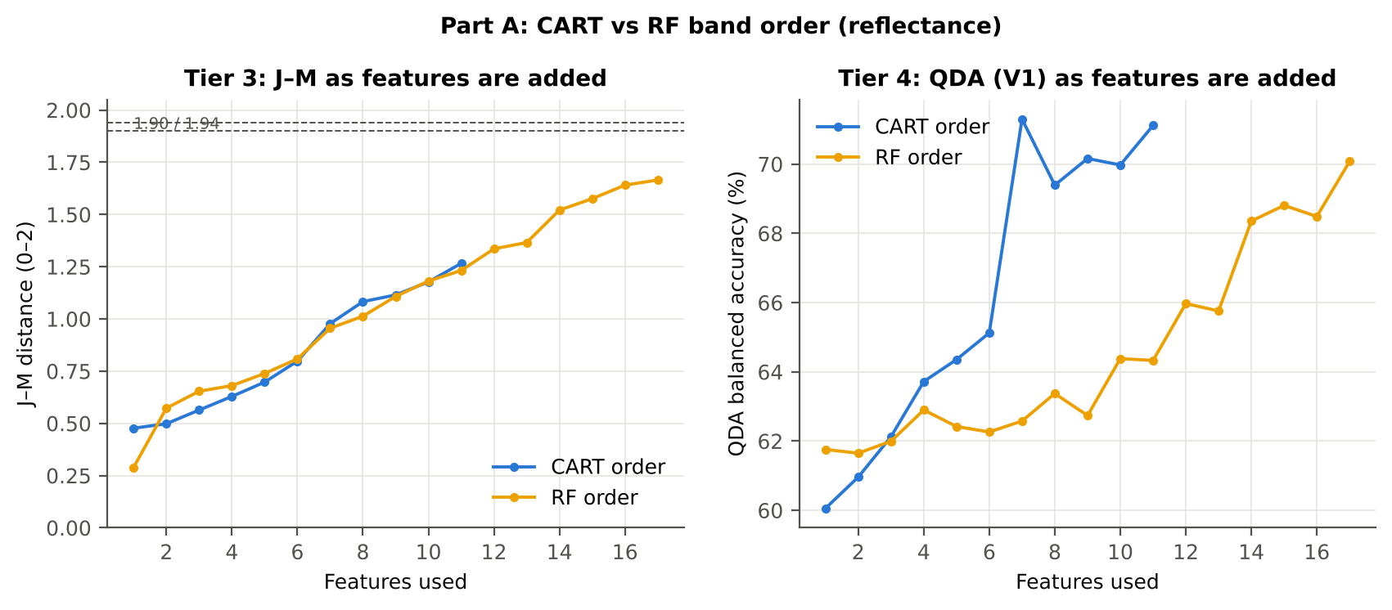
Figure 8. J–M distance and QDA balanced accuracy as the CART bands (blue) and the RF bands (yellow) are added in order of selection.

3.5 Tier 4 — QDA classification
Table 9. Error matrix of QDA (equal priors, 10-fold CV) on the CART-11 bands (as Table 2 of Das et al., 2020).
Classified \ Reference | Healthy | Diseased | Row total | User's accuracy
Healthy | 336 | 880 | 1216 | 27.6 %
Diseased | 42 | 1006 | 1048 | 96.0 %
Column total | 378 | 1886 | 2264
Producer's accuracy | 88.9 % | 53.3 %
Overall accuracy | 59.3 % | Balanced accuracy | 71.1 % | κ = 0.224

Table 10. Tier 4 on each band set: QDA with equal and sample priors, and LDA (V1).
Set | Classifier | OA | BA | PA_H | PA_D | kappa | AUC
CART-11 | QDA equal priors | 59.3 % | 71.1 % | 88.9 % | 53.3 % | 0.224 | 0.829
CART-11 | QDA sample priors | 72.2 % | 76.1 % | 82.0 % | 70.3 % | 0.344 | 0.829
CART-11 | LDA equal priors | 75.2 % | 76.6 % | 78.6 % | 74.5 % | 0.374 | 0.826
CART-4 (1-SE) | QDA equal priors | 45.0 % | 63.2 % | 90.5 % | 35.8 % | 0.117 | 0.689
CART-4 (1-SE) | QDA sample priors | 75.0 % | 57.7 % | 31.7 % | 83.6 % | 0.146 | 0.689
CART-4 (1-SE) | LDA equal priors | 60.6 % | 63.4 % | 67.7 % | 59.2 % | 0.160 | 0.669
RF-17 | QDA equal priors | 55.4 % | 70.1 % | 92.1 % | 48.1 % | 0.200 | 0.810
RF-17 | QDA sample priors | 62.9 % | 72.3 % | 86.5 % | 58.2 % | 0.251 | 0.810
RF-17 | LDA equal priors | 69.9 % | 74.9 % | 82.3 % | 67.4 % | 0.315 | 0.826
RF-10 | QDA equal priors | 48.2 % | 64.4 % | 88.6 % | 40.1 % | 0.134 | 0.749
RF-10 | QDA sample priors | 59.7 % | 68.6 % | 82.0 % | 55.2 % | 0.204 | 0.749
RF-10 | LDA equal priors | 61.4 % | 66.2 % | 73.5 % | 58.9 % | 0.189 | 0.729
RF-11 (size-matched) | QDA equal priors | 48.3 % | 64.3 % | 88.4 % | 40.3 % | 0.134 | 0.761
RF-11 (size-matched) | QDA sample priors | 59.8 % | 69.4 % | 83.9 % | 54.9 % | 0.211 | 0.761
RF-11 (size-matched) | LDA equal priors | 63.1 % | 68.2 % | 75.9 % | 60.5 % | 0.215 | 0.744

With equal priors QDA recognises 88.9 % of healthy leaves but only 53.3 % of diseased leaves (BA 71.1 %, OA 59.3 %, κ 0.22). With sample priors the balance reverses (PA 82.0 / 70.3 %), and the balanced accuracy is higher (76.1 %): the broad covariance of the diseased class makes equal priors over-correct. Both are reported; equal priors follow the imbalance correction of the flowering-stage analysis.
Python and R (MASS::qda) give identical predictions except for 1–3 leaves whose posterior probability lies within 0.004 of 0.5.

3.6 Validation of the four-tier pipeline
Table 11. QDA on CART bands under the validation schemes (mean over repeats).
Scheme | Priors | OA | BA | BA_SD | kappa | PA_H | PA_D
V1 · leaf-level 10-fold, bands fixed | equal (corrected) | 59.3 % | 71.1 % | – | 0.224 | 88.9 % | 53.3 %
V2 · plot-grouped 10-fold, bands fixed | equal (corrected) | 58.7 % | 70.4 % | – | 0.216 | 87.8 % | 52.9 %
V3 · nested plot-grouped 10-fold × 5 | equal (corrected) | 61.0 % | 72.0 % | 1.5 % | 0.239 | 88.5 % | 55.5 %
V4 · 30 % plot hold-out × 10 | equal (corrected) | 63.2 % | 72.8 % | 4.7 % | 0.274 | 88.0 % | 57.7 %
V5 · new date and new plots (leave-one-date-out × 10) | equal (corrected) | 63.3 % | 54.6 % | 3.3 % | 0.070 | 40.8 % | 68.3 %
V1 · leaf-level 10-fold, bands fixed | sample (uncorrected) | 72.2 % | 76.1 % | – | 0.344 | 82.0 % | 70.3 %
V2 · plot-grouped 10-fold, bands fixed | sample (uncorrected) | 72.3 % | 75.3 % | – | 0.337 | 79.6 % | 70.9 %
V3 · nested plot-grouped 10-fold × 5 | sample (uncorrected) | 72.1 % | 76.0 % | 0.9 % | 0.342 | 81.9 % | 70.1 %
V4 · 30 % plot hold-out × 10 | sample (uncorrected) | 72.5 % | 75.2 % | 5.2 % | 0.356 | 79.7 % | 70.8 %
V5 · new date and new plots (leave-one-date-out × 10) | sample (uncorrected) | 66.7 % | 54.0 % | 2.6 % | 0.067 | 33.9 % | 74.0 %
V3-RUS · nested + random under-sampling | equal (corrected) | 61.2 % | 72.4 % | – | 0.243 | 89.2 % | 55.6 %
V3-RUS · nested + random under-sampling | sample (uncorrected) | 61.2 % | 72.4 % | – | 0.243 | 89.2 % | 55.6 %

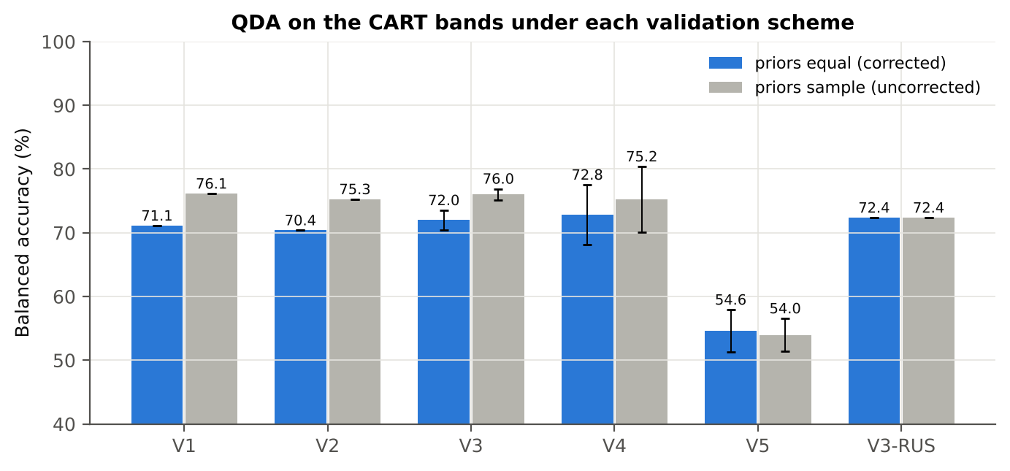
Figure 9. Balanced accuracy of QDA on the CART bands by validation scheme and prior.
Selection bias and plot leakage are small here: the nested, plot-grouped estimate (V3, 72.0 %) and the hold-out estimate (V4, 72.8 %) equal the paper-protocol estimate (V1, 71.1 %). Random under-sampling instead of equal priors gives the same result (72.4 %).
Removing 350–399 nm matters: with the noisy detector edge CART picks 350 and 353 nm and the nested accuracy falls to 68.8 %. Trimming both edges (450–2450 nm) gives the same bands and accuracy as the main analysis.
Table 12. Sensitivity of the pipeline to the analysed band range.
Band set | CART bands | BA V1 | BA V3 nested | BA V4 hold-out
400–2500 nm (main: 350–399 removed) | 11 | 71.1 % | 72.0 % | 72.8 %
350–2500 nm (nothing removed) | 12 | 67.2 % | 68.8 % | 71.5 %
450–2450 nm (both detector edges trimmed) | 11 | 71.1 % | 72.2 % | 73.1 %

Table 13. Sensitivity to the four duplicate spectra of plot 27.
Data | CART bands | BA V1 | BA V3 | BA V4
main: exact duplicates removed (n = 2264) | 11 | 71.1 % | 72.0 % | 72.8 %
4 unnamed plot-27 copies kept (n = 2268) | 11 | 71.0 % | 71.2 % | 73.1 %

3.7 CART versus Random Forest (Part A1–A4)
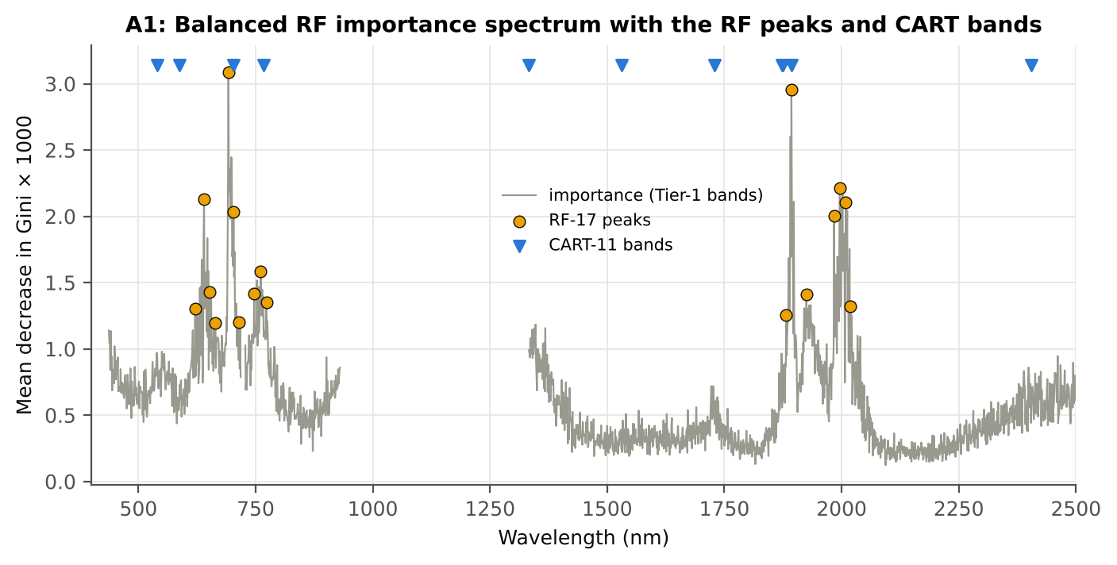
Figure 10. Balanced RF importance spectrum (MDI), the RF-17 peaks and the CART bands.
Table 14. Band sets selected by CART and RF.
Band set | Bands | Wavelengths (nm)
CART-11 | 11 | 1893, 2405, 767, 702, 1333, 540, 1729, 588, 1874, 1531, 1872
CART-4 (1-SE) | 4 | 1893, 2405, 767, 1333
RF-17 | 17 | 692, 1893, 1996, 640, 2009, 703, 1984, 761, 651, 747, 1925, 773, 2019, 621, 1882, 715, 664
RF-10 | 10 | 692, 1893, 1996, 640, 2009, 703, 1984, 761, 651, 747
RF-11 (size-matched) | 11 | 692, 1893, 1996, 640, 2009, 703, 1984, 761, 651, 747, 1925

Table 15. Checks of the RF importance.
Check | Value | Status
Reproducibility: importance of seed 42 vs seed 7 (Spearman ρ) | 0.891 | PASS
R randomForest (stratified sampsize 378 + 378), mean decrease in Gini | ρ = 0.893 | PASS
Permutation importance (drop in AUC, 5 plot-grouped folds) vs Gini, top-50 bands | ρ = -0.06 | FLAG
Ordinary RF with class weights only (no balanced bootstrap), out-of-bag | BA 0.703 | PASS

On all leaves the RF bands separate the classes better than the CART bands (J–M 1.67 vs 1.27) but QDA on them is not more accurate (BA 70.1 vs 71.1 %): RF picks many correlated bands in the same two regions, CART picks complementary regions (green, red edge, NIR, SWIR).
RF-17 concentrates on the red / red edge (621–773 nm) and on 1882–2019 nm, the same two regions where Tier 1 is most significant.
Table 16. Error matrix of QDA (equal priors, 10-fold CV) on the RF-17 bands.
Classified \ Reference | Healthy | Diseased | Row total | User's accuracy
Healthy | 348 | 979 | 1327 | 26.2 %
Diseased | 30 | 907 | 937 | 96.8 %
Column total | 378 | 1886 | 2264
Producer's accuracy | 92.1 % | 48.1 %
Overall accuracy | 55.4 % | Balanced accuracy | 70.1 % | κ = 0.200

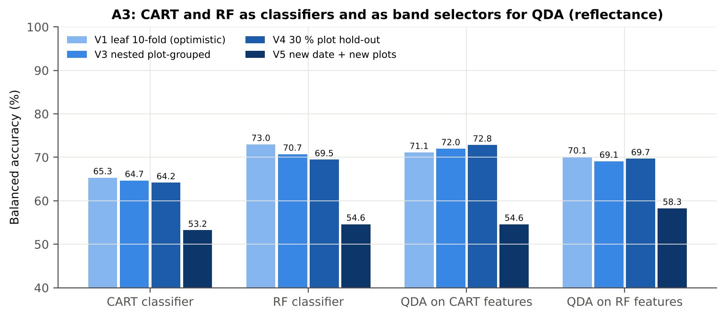
Figure 11. Balanced accuracy of CART and RF as classifiers and as band selectors for QDA, under V1, V3, V4 and V5.
Table 17. Validation of the four pipelines (mean over repeats).
Pipeline | Scheme | BA | BA_SD | AUC | kappa
CART classifier | V1 | 65.3 % | – | 0.681 | 0.224
CART classifier | V3 | 64.7 % | 1.3 % | 0.674 | 0.206
CART classifier | V4 | 64.2 % | 1.8 % | 0.658 | 0.217
CART classifier | V5 | 53.2 % | 2.7 % | 0.530 | 0.048
RF classifier | V1 | 73.0 % | – | 0.818 | 0.372
RF classifier | V3 | 70.7 % | 0.4 % | 0.791 | 0.336
RF classifier | V4 | 69.5 % | 2.0 % | 0.778 | 0.326
RF classifier | V5 | 54.6 % | 1.3 % | 0.588 | 0.071
QDA on CART features | V1 | 71.1 % | – | 0.829 | 0.224
QDA on CART features | V3 | 72.0 % | 1.5 % | 0.840 | 0.239
QDA on CART features | V4 | 72.8 % | 4.7 % | 0.839 | 0.274
QDA on CART features | V5 | 54.6 % | 3.3 % | 0.574 | 0.070
QDA on RF features | V1 | 70.1 % | – | 0.810 | 0.200
QDA on RF features | V3 | 69.1 % | 0.3 % | 0.806 | 0.194
QDA on RF features | V4 | 69.7 % | 3.3 % | 0.814 | 0.219
QDA on RF features | V5 | 58.3 % | 2.4 % | 0.608 | 0.126

Table 18. Paired Wilcoxon tests on identical folds (positive = first pipeline better).
Comparison | Units | Mean difference | First better | Second better | Wilcoxon p
RF classifier − CART classifier | V3 nested (folds) | +6.0 pts | 48 | 2 | 9.8e-14
RF classifier − CART classifier | V4 hold-out (splits) | +5.3 pts | 10 | 0 | 0.002
QDA on RF features − QDA on CART features | V3 nested (folds) | -3.1 pts | 15 | 35 | 0.003
QDA on RF features − QDA on CART features | V4 hold-out (splits) | -3.2 pts | 2 | 8 | 0.105
QDA on CART features − CART classifier | V3 nested (folds) | +7.7 pts | 45 | 5 | 1.6e-09
QDA on CART features − CART classifier | V4 hold-out (splits) | +8.7 pts | 9 | 1 | 0.004
QDA on RF features − RF classifier | V3 nested (folds) | -1.4 pts | 21 | 29 | 0.087
QDA on RF features − RF classifier | V4 hold-out (splits) | +0.2 pts | 5 | 5 | 1.000

RF beats CART as a classifier by 6.0 points (V3, 48 of 50 folds) and 5.3 points (V4, 10 of 10).
QDA on CART bands beats QDA on RF bands by 3.1 points in V3 (35 of 50 folds, p = 0.003); in V4 the difference is not significant.
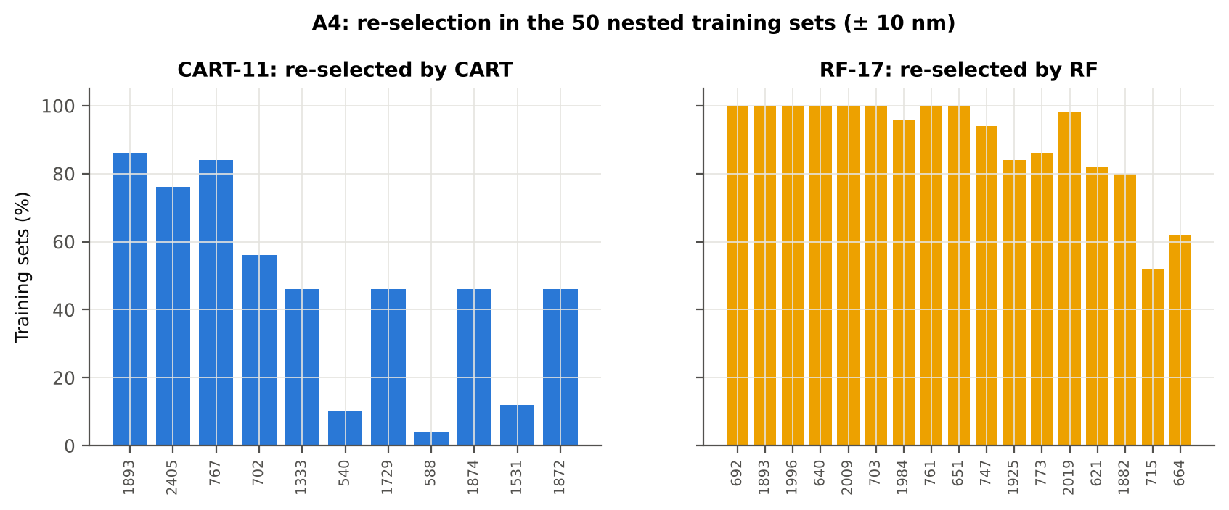
Figure 12. Re-selection of the CART and RF bands in the 50 nested training sets.
Table 19. Stability of band selection.
Method | Mean features | Unique features (union) | Stability index (exact) = all / union | Stability index (±10 nm) | Mean pairwise Jaccard (±10 nm)
CART | 14.4 | 290 | 0.000 | 0.000 | 0.296
RF | 17.0 | 308 | 0.000 | 0.269 | 0.724

RF re-selects its peaks far more consistently (mean pairwise Jaccard 0.72 vs 0.30; 83 bands chosen within ± 10 nm in all 50 training sets vs none for CART).

3.8 Disease-sensitive features (Part K)

K0 — denoising and detector joins
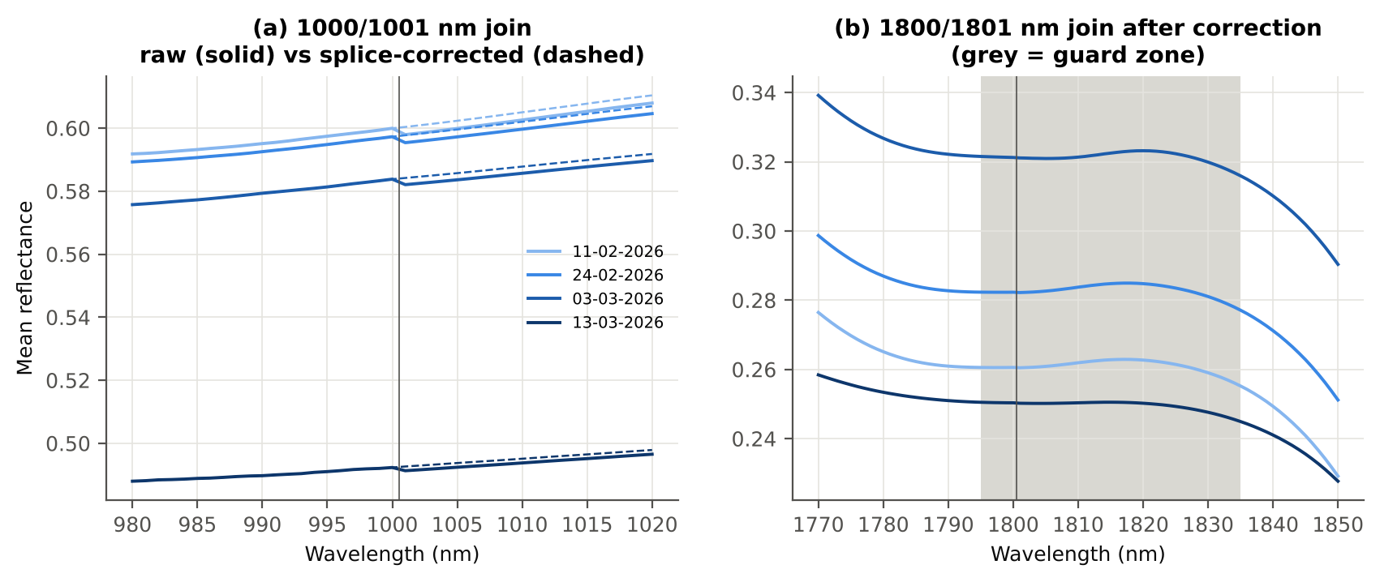
Figure 13. (a) Step at the 1000/1001 nm detector join before and after splice correction; (b) the 1800/1801 nm join by date (grey = guard zone).
Smoothing preserved the signal (r ≥ 0.99999 between raw and smoothed class means; 1653 vs 1652 significant bands). A start-up rise after 1801 nm was present and date-dependent, so the guard zones were applied.

K1 — band reflectance
0 bands reached AUC ≥ 0.70; the most sensitive band was 1890 nm (AUC 0.691).
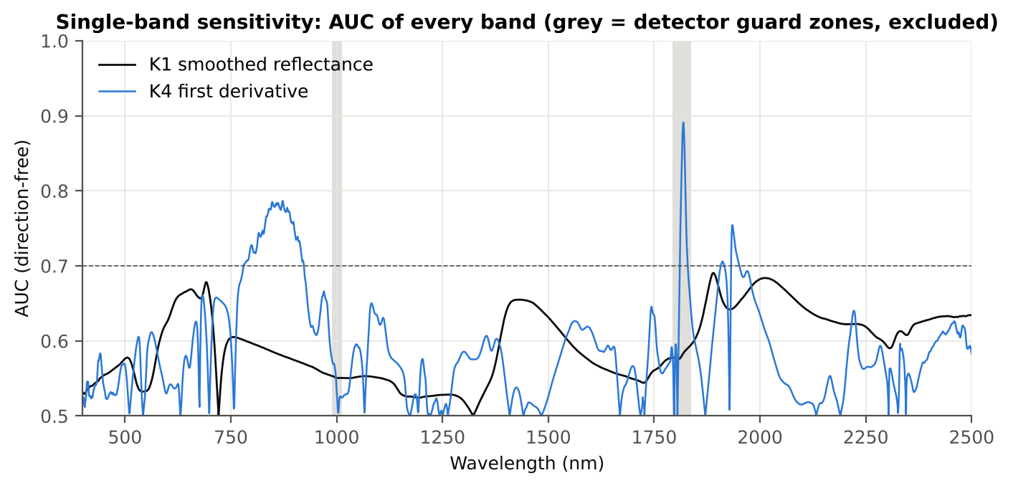
Figure 14. AUC of every band for reflectance (K1) and the first derivative (K4); grey = guard zones.
Table 20. Most sensitive band per region with its threshold-classifier accuracy on new plots.
Region | Wavelength (nm) | AUC | Direction | Hedges g | BA plot-grouped CV | BA hold-out
400–499 | 499 | 0.576 | D > H | 0.28 | 54.3 % | 54.6 %
500–599 | 599 | 0.625 | D > H | 0.44 | 59.1 % | 58.6 %
600–679 | 656 | 0.669 | D > H | 0.54 | 62.8 % | 62.2 %
680–759 | 692 | 0.678 | D > H | 0.56 | 62.5 % | 63.0 %
760–1349 | 760 | 0.605 | D < H | -0.28 | 60.9 % | 59.9 %
1350–1430 | 1430 | 0.655 | D > H | 0.50 | 60.1 % | 60.4 %
1431–1799 | 1431 | 0.655 | D > H | 0.50 | 60.6 % | 60.9 %
1800–1950 | 1890 | 0.691 | D > H | 0.50 | 63.9 % | 63.6 %
1951–2349 | 2010 | 0.684 | D > H | 0.50 | 64.6 % | 64.4 %
2350–2500 | 2496 | 0.634 | D > H | 0.43 | 57.6 % | 58.5 %

K2 — continuum-removed absorption features
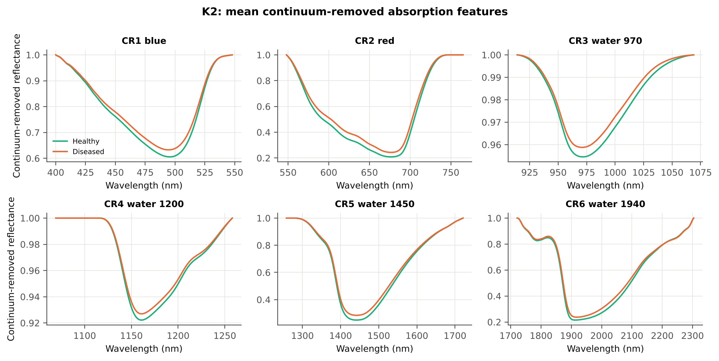
Figure 15. Mean continuum-removed curves of healthy and diseased leaves in the six absorption windows.
Table 21. Continuum-removed parameters ranked by AUC (top 8).
name | Mean healthy | Mean diseased | AUC | Direction | BA plot-grouped CV | BA hold-out
CR3 water 970 width | 64.159 | 60.944 | 0.765 | D < H | 70.1 % | 70.5 %
CR6 water 1940 position | 1912.193 | 1916.592 | 0.686 | D > H | 64.3 % | 64.6 %
CR6 water 1940 symmetry | 0.238 | 0.250 | 0.669 | D > H | 67.0 % | 67.3 %
CR2 red area | 95.305 | 88.115 | 0.666 | D < H | 62.5 % | 61.8 %
CR2 red width | 129.997 | 124.995 | 0.655 | D < H | 61.4 % | 61.0 %
CR2 red depth | 0.791 | 0.757 | 0.652 | D < H | 58.8 % | 59.6 %
CR3 water 970 area | 3.069 | 2.674 | 0.645 | D < H | 61.1 % | 62.1 %
CR5 water 1450 depth | 0.751 | 0.716 | 0.636 | D < H | 59.0 % | 59.8 %

K3 — spectral indices and the optimised index
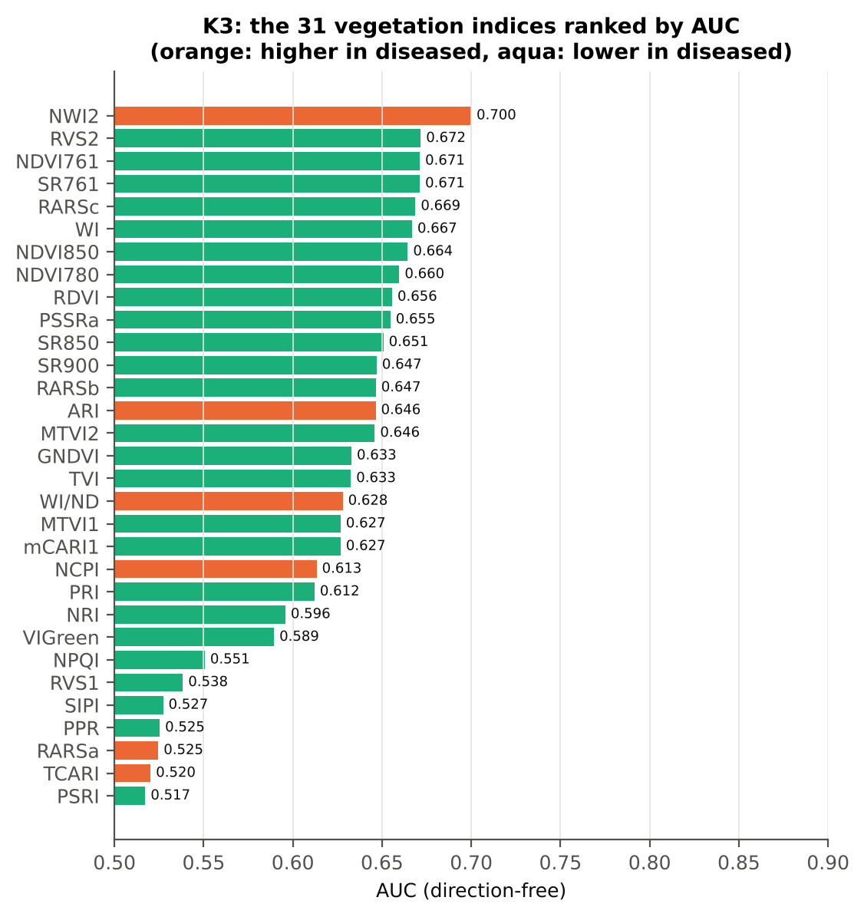
Figure 16. The 31 vegetation indices ranked by AUC.
Table 22. The ten most sensitive indices.
name | Mean healthy | Mean diseased | AUC | Direction | BA plot-grouped CV | BA hold-out
NWI2 | -0.027 | -0.020 | 0.700 | D > H | 65.4 % | 65.8 %
RVS2 | -1.467 | -1.604 | 0.672 | D < H | 61.9 % | 60.7 %
NDVI761 | 0.689 | 0.642 | 0.671 | D < H | 61.7 % | 60.7 %
SR761 | 5.609 | 4.874 | 0.671 | D < H | 61.7 % | 60.7 %
RARSc | 3.068 | 2.711 | 0.669 | D < H | 62.6 % | 61.8 %
WI | 1.052 | 1.043 | 0.667 | D < H | 63.1 % | 63.1 %
NDVI850 | 0.687 | 0.644 | 0.664 | D < H | 61.8 % | 60.9 %
NDVI780 | 0.722 | 0.681 | 0.660 | D < H | 62.6 % | 62.4 %
RDVI | 0.578 | 0.538 | 0.656 | D < H | 59.5 % | 59.6 %
PSSRa | 6.241 | 5.495 | 0.655 | D < H | 60.4 % | 60.9 %

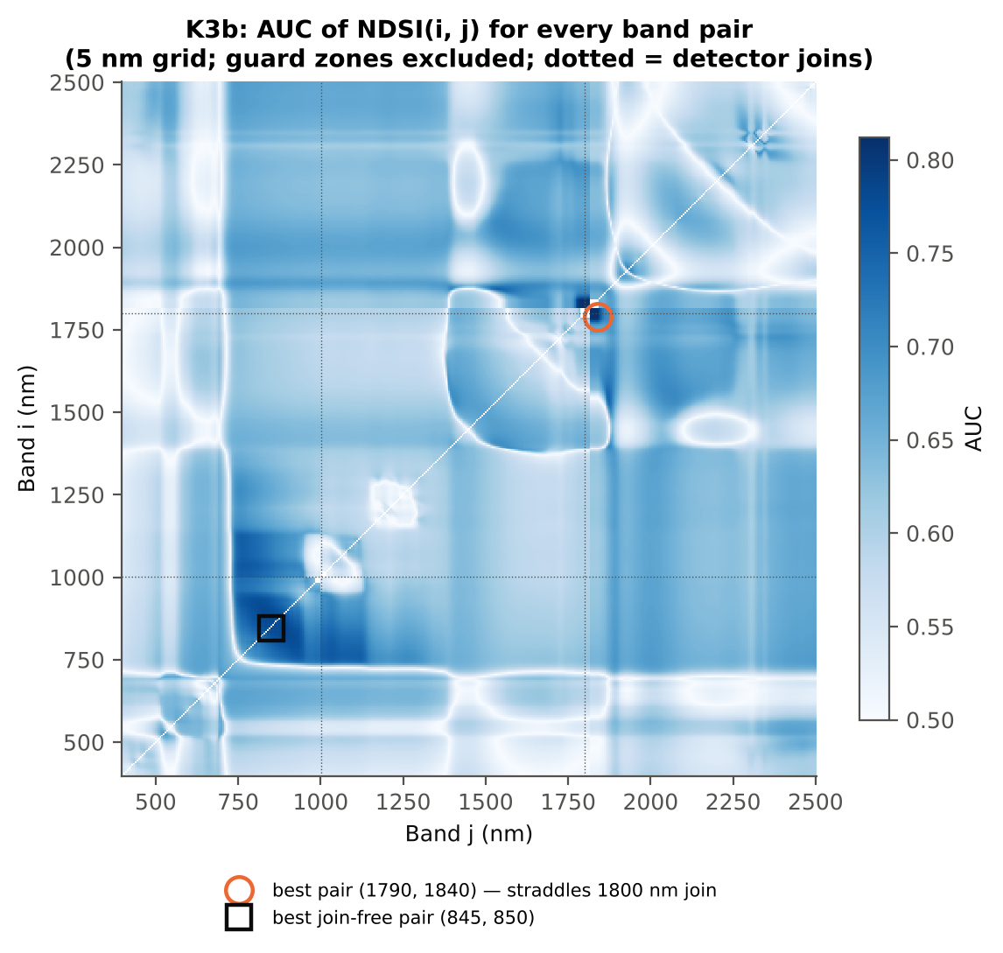
Figure 17. AUC of the normalised difference of every band pair (5 nm grid).
Table 23. Refined best two-band indices (pair found on all leaves).
name | Mean healthy | Mean diseased | AUC | Direction | BA plot-grouped CV | BA hold-out
NDSI(1794,1837) | 0.019 | 0.013 | 0.821 | D < H | 76.0 % | 76.2 %
DI(872,874) | 1.0e-04 | -6.2e-06 | 0.792 | D < H | 70.6 % | 71.2 %

When the pair search was repeated inside the training sets, the honest balanced accuracy was 73.0 % (CV) and 72.8 % (hold-out) for NDSI and 68.9 % / 70.8 % for DI.
The best pair on all band pairs, NDSI(1794, 1837), brackets the 1800/1801 nm detector join just outside the guard zone; part of its separation can come from the date-dependent start-up rise of the SWIR-2 detector, so it is not recommended. Excluding pairs that straddle a join, the best index is NDSI(849, 850) — a NIR slope index at the same wavelengths as the most important first-derivative bands — with AUC 0.80 and an honest balanced accuracy of 70–71 %.
Table 24. Refined best join-free two-band indices (pairs straddling a detector join excluded).
name | Mean healthy | Mean diseased | AUC | Direction | BA plot-grouped CV | BA hold-out
NDSI(849,850) | 3.1e-05 | -2.7e-05 | 0.798 | D < H | 71.5 % | 72.1 %
DI(872,874) | 1.0e-04 | -6.2e-06 | 0.792 | D < H | 70.6 % | 71.2 %

Join-free search repeated inside the training sets: NDSI 70.2 % (CV) / 70.7 % (hold-out); DI 70.7 % / 71.3 %.

K4 — first-derivative spectra, edge parameters and REIP
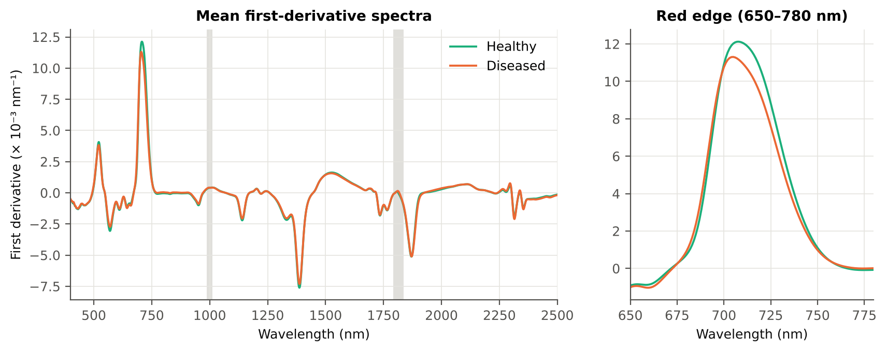
Figure 18. Mean first-derivative spectra of healthy and diseased leaves; right: the red edge.
Table 25. Band-wise derivative sensitivity.
Derivative | Significant (FDR) | Best AUC outside guard | at (nm) | Best AUC inside guard (excluded)
First derivative (SG 15, 2) | 1488 | 0.786 | 872 | 0.891 at 1819 nm
Second derivative (SG 21, 2) | 1558 | 0.740 | 801 | 0.893 at 1809 nm

Table 26. Edge parameters ranked by AUC (top 8).
name | Mean healthy | Mean diseased | AUC | Direction | BA plot-grouped CV | BA hold-out
Ro (red well reflectance) | 0.095 | 0.108 | 0.659 | D > H | 58.9 % | 59.8 %
λr = REP (red-edge position, nm) | 708.143 | 705.703 | 0.638 | D < H | 59.0 % | 58.9 %
REP, linear 4-point (nm) | 715.599 | 714.061 | 0.634 | D < H | 61.3 % | 59.7 %
SDr (red-edge area) | 0.497 | 0.464 | 0.630 | D < H | 60.8 % | 60.5 %
λb (blue-edge position, nm) | 521.500 | 520.931 | 0.622 | D < H | 57.6 % | 57.6 %
Dr = REV (red-edge amplitude) | 0.013 | 0.012 | 0.606 | D < H | 58.1 % | 57.6 %
(Rg − Ro)/(Rg + Ro) | 0.440 | 0.398 | 0.604 | D < H | 53.5 % | 54.4 %
Rg/Ro | 2.650 | 2.431 | 0.604 | D < H | 53.5 % | 54.4 %

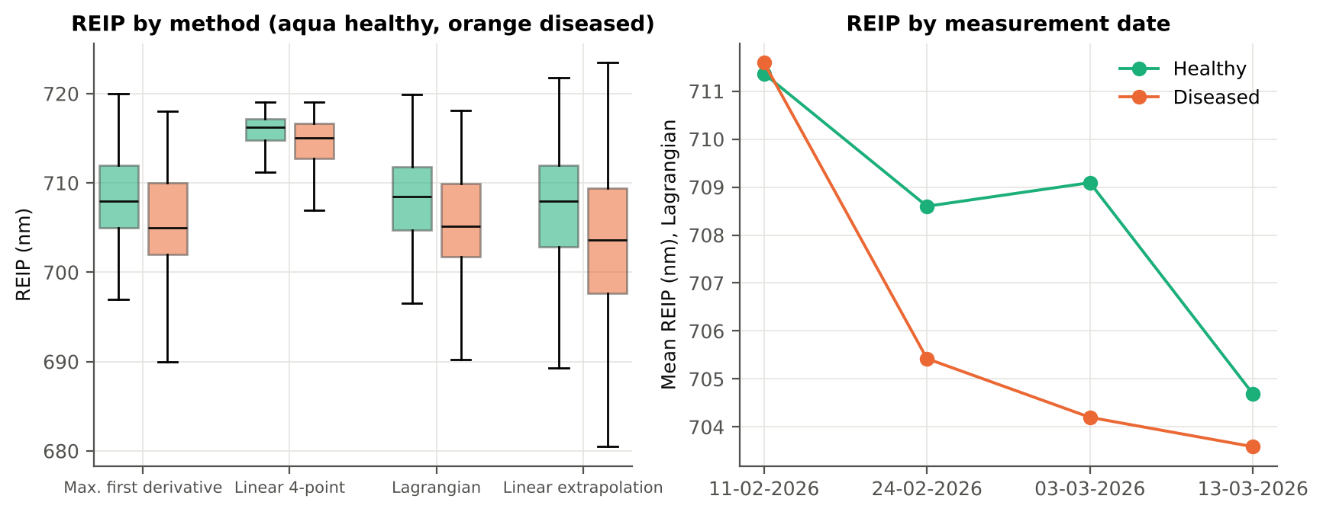
Figure 19. Red-edge inflection point by four methods (left) and by date (right).
Table 27. REIP of healthy and diseased leaves by four methods.
name | Mean healthy | Mean diseased | AUC | Direction | BA plot-grouped CV | BA hold-out
REIP – linear extrapolation | 707.241 | 703.383 | 0.644 | D < H | 60.5 % | 59.2 %
REIP – Lagrangian interpolation | 708.150 | 705.712 | 0.638 | D < H | 59.6 % | 59.1 %
REIP – maximum first derivative | 708.143 | 705.703 | 0.638 | D < H | 59.0 % | 58.9 %
REIP – linear 4-point interpolation | 715.599 | 714.061 | 0.634 | D < H | 61.3 % | 59.7 %

All four REIP estimators shift to shorter wavelengths in diseased leaves (1.5 nm for the linear four-point method, 2.4–3.9 nm for the derivative-based methods; AUC 0.63–0.64), the classical red-edge 'blue shift' of chlorophyll loss. The four methods agree closely (r 0.85–1.00).
The shift is clear at flowering (−3.9 nm, AUC 0.72) and on 03-03-2026 (−4.9 nm), small at pod formation (−1.1 nm) and absent at the vegetative stage and on 11-02-2026 (+0.2 nm), when symptoms were still developing.

K6 — correlation spectra
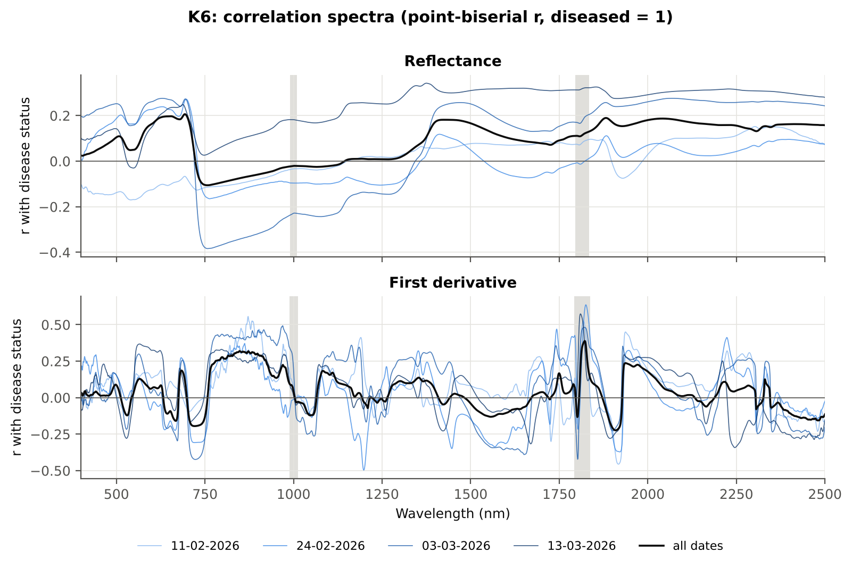
Figure 20. Point-biserial correlation between band value and disease status for reflectance and first derivative; thin lines: single dates.
Table 28. Band of maximum |r| per region.
Spectrum | Region (nm) | Band of max |r| | r | Same sign on all 4 dates
Reflectance | 400–499 | 499 | +0.104 | no
Reflectance | 500–599 | 599 | +0.162 | no
Reflectance | 600–679 | 653 | +0.197 | no
Reflectance | 680–759 | 693 | +0.206 | no
Reflectance | 760–1349 | 760 | -0.105 | no
Reflectance | 1350–1430 | 1426 | +0.182 | yes
Reflectance | 1431–1799 | 1431 | +0.182 | yes
Reflectance | 1800–1950 | 1882 | +0.190 | yes
Reflectance | 1951–2349 | 2041 | +0.187 | yes
Reflectance | 2350–2500 | 2418 | +0.163 | yes
First derivative | 400–499 | 498 | +0.089 | yes
First derivative | 500–599 | 565 | +0.129 | yes
First derivative | 600–679 | 667 | -0.159 | no
First derivative | 680–759 | 721 | -0.195 | yes
First derivative | 760–1349 | 848 | +0.319 | yes
First derivative | 1350–1430 | 1353 | +0.137 | yes
First derivative | 1431–1799 | 1750 | +0.167 | yes
First derivative | 1800–1950 | 1937 | +0.237 | yes
First derivative | 1951–2349 | 1971 | +0.226 | yes
First derivative | 2350–2500 | 2483 | -0.156 | yes

K5 — CART versus Random Forest on each feature group
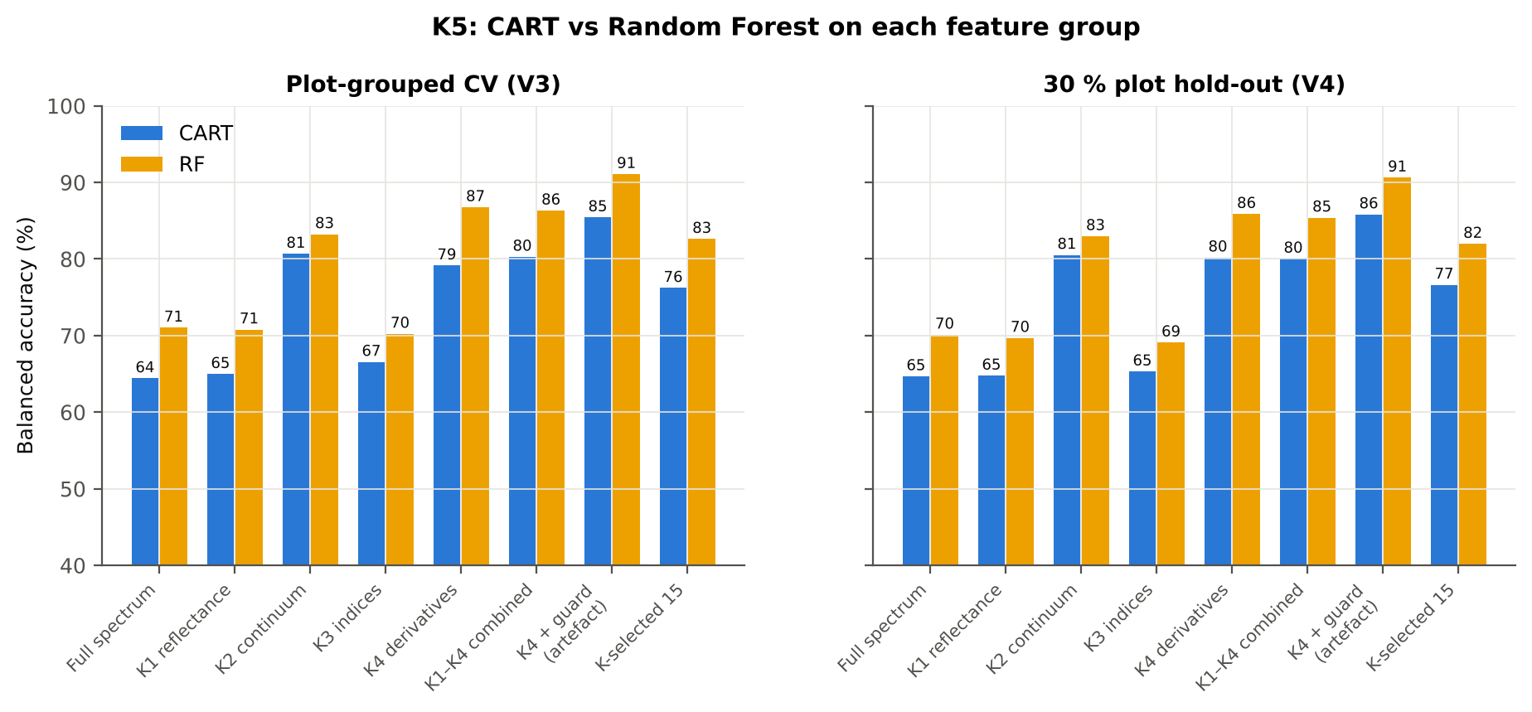
Figure 21. Balanced accuracy of CART and RF on each feature group (V3 and V4).
Table 29. CART and RF on each feature group (balanced accuracy, mean over repeats).
Feature group | Features | CART CV | RF CV | CART hold-out | RF hold-out
Full spectrum (raw reflectance) | 2101 | 64.4 % | 71.0 % | 64.7 % | 70.1 %
K1 band reflectance | 2039 | 65.0 % | 70.8 % | 64.8 % | 69.7 %
K2 continuum-removed parameters | 30 | 80.7 % | 83.2 % | 80.5 % | 83.0 %
K3 vegetation indices | 31 | 66.6 % | 70.2 % | 65.3 % | 69.1 %
K4 derivatives + edge parameters | 2051 | 79.2 % | 86.8 % | 80.2 % | 85.9 %
K1–K4 combined pool | 4151 | 80.3 % | 86.3 % | 80.0 % | 85.4 %
K4 incl. guard-zone bands (artefact test) | 2121 | 85.4 % | 91.1 % | 85.8 % | 90.6 %
K-selected (top 15 non-redundant, chosen inside each training set) | 15 | 76.2 % | 82.6 % | 76.6 % | 82.0 %

Table 30. Paired comparison RF − CART on identical folds.
Feature group | Units | RF − CART (BA) | RF better | CART better | Wilcoxon p
Full spectrum (raw reflectance) | CV (50 folds) | +6.6 pts | 50 | 0 | 7.6e-10
Full spectrum (raw reflectance) | Hold-out (10 splits) | +5.4 pts | 10 | 0 | 0.002
K1 band reflectance | CV (50 folds) | +6.1 pts | 49 | 1 | 3.4e-14
K1 band reflectance | Hold-out (10 splits) | +4.9 pts | 10 | 0 | 0.002
K2 continuum-removed parameters | CV (50 folds) | +2.2 pts | 35 | 15 | 0.003
K2 continuum-removed parameters | Hold-out (10 splits) | +2.5 pts | 8 | 2 | 0.010
K3 vegetation indices | CV (50 folds) | +3.9 pts | 33 | 17 | 6.3e-05
K3 vegetation indices | Hold-out (10 splits) | +3.8 pts | 10 | 0 | 0.002
K4 derivatives + edge parameters | CV (50 folds) | +7.8 pts | 48 | 2 | 1.1e-09
K4 derivatives + edge parameters | Hold-out (10 splits) | +5.7 pts | 10 | 0 | 0.002
K1–K4 combined pool | CV (50 folds) | +5.8 pts | 47 | 3 | 2.8e-09
K1–K4 combined pool | Hold-out (10 splits) | +5.4 pts | 10 | 0 | 0.002
K4 incl. guard-zone bands (artefact test) | CV (50 folds) | +5.5 pts | 47 | 3 | 1.4e-12
K4 incl. guard-zone bands (artefact test) | Hold-out (10 splits) | +4.8 pts | 10 | 0 | 0.002
K-selected (top 15 non-redundant) | CV (50 folds) | +6.2 pts | 45 | 5 | 3.5e-08
K-selected (top 15 non-redundant) | Hold-out (10 splits) | +5.3 pts | 10 | 0 | 0.002

Table 31. Share of RF importance by feature type (combined pool, all leaves).
Feature type | Features | Share of RF importance | Importance per feature (K1 band = 1)
K1 reflectance | 2039 | 19.4 % | 1.00
K2 continuum | 30 | 1.5 % | 5.32
K3 index | 31 | 0.6 % | 2.20
K4 derivative | 2031 | 78.0 % | 4.03
K4 edge | 20 | 0.5 % | 2.46

RF beats CART on every feature group (2–8 points, all p < 0.01).
Derivatives (K4) and continuum-removed parameters (K2) carry far more information than reflectance (K1) or the 31 indices (K3): RF 86.8 % and 83.2 % vs 70.8 % and 70.2 % (V3).
Keeping the guard-zone derivative bands raises RF to 91.1 % — an instrument artefact, not disease, so they are excluded.

3.9 Four-tier analysis of the combined feature pool (Part C)
Table 32. Combined pool: features by type, Tier-1 significant and selected by CART and RF.
Feature type | Features | Tier-1 significant | CART-13 | CART-8 (1-SE) | RF-17 | RF-10 | RF-13 (size-matched)
K1 band reflectance | 2039 | 1610 | 2 | 1 | 0 | 0 | 0
K2 continuum removal | 30 | 25 | 2 | 2 | 2 | 2 | 2
K3 vegetation index | 30 | 23 | 0 | 0 | 0 | 0 | 0
K4 edge parameter | 20 | 17 | 0 | 0 | 0 | 0 | 0
K4 first-derivative band | 2031 | 1440 | 9 | 5 | 15 | 8 | 11

Of 4150 features, 3115 passed Tier 1. CART selected 13 features (D1861, CR6 water 1940 symmetry, CR3 water 970 width, D11163, D11164, D1900, D12224, D11945, R639, D11739, D11931, D1630, R743); RF-17 comprised CR3 water 970 width, D1861, D1871, CR6 water 1940 symmetry, D1848, D11915, D1888, D12223, D12209, D11944, D1899, D11934, D1911, D11740, D1837, D11792, D11163.
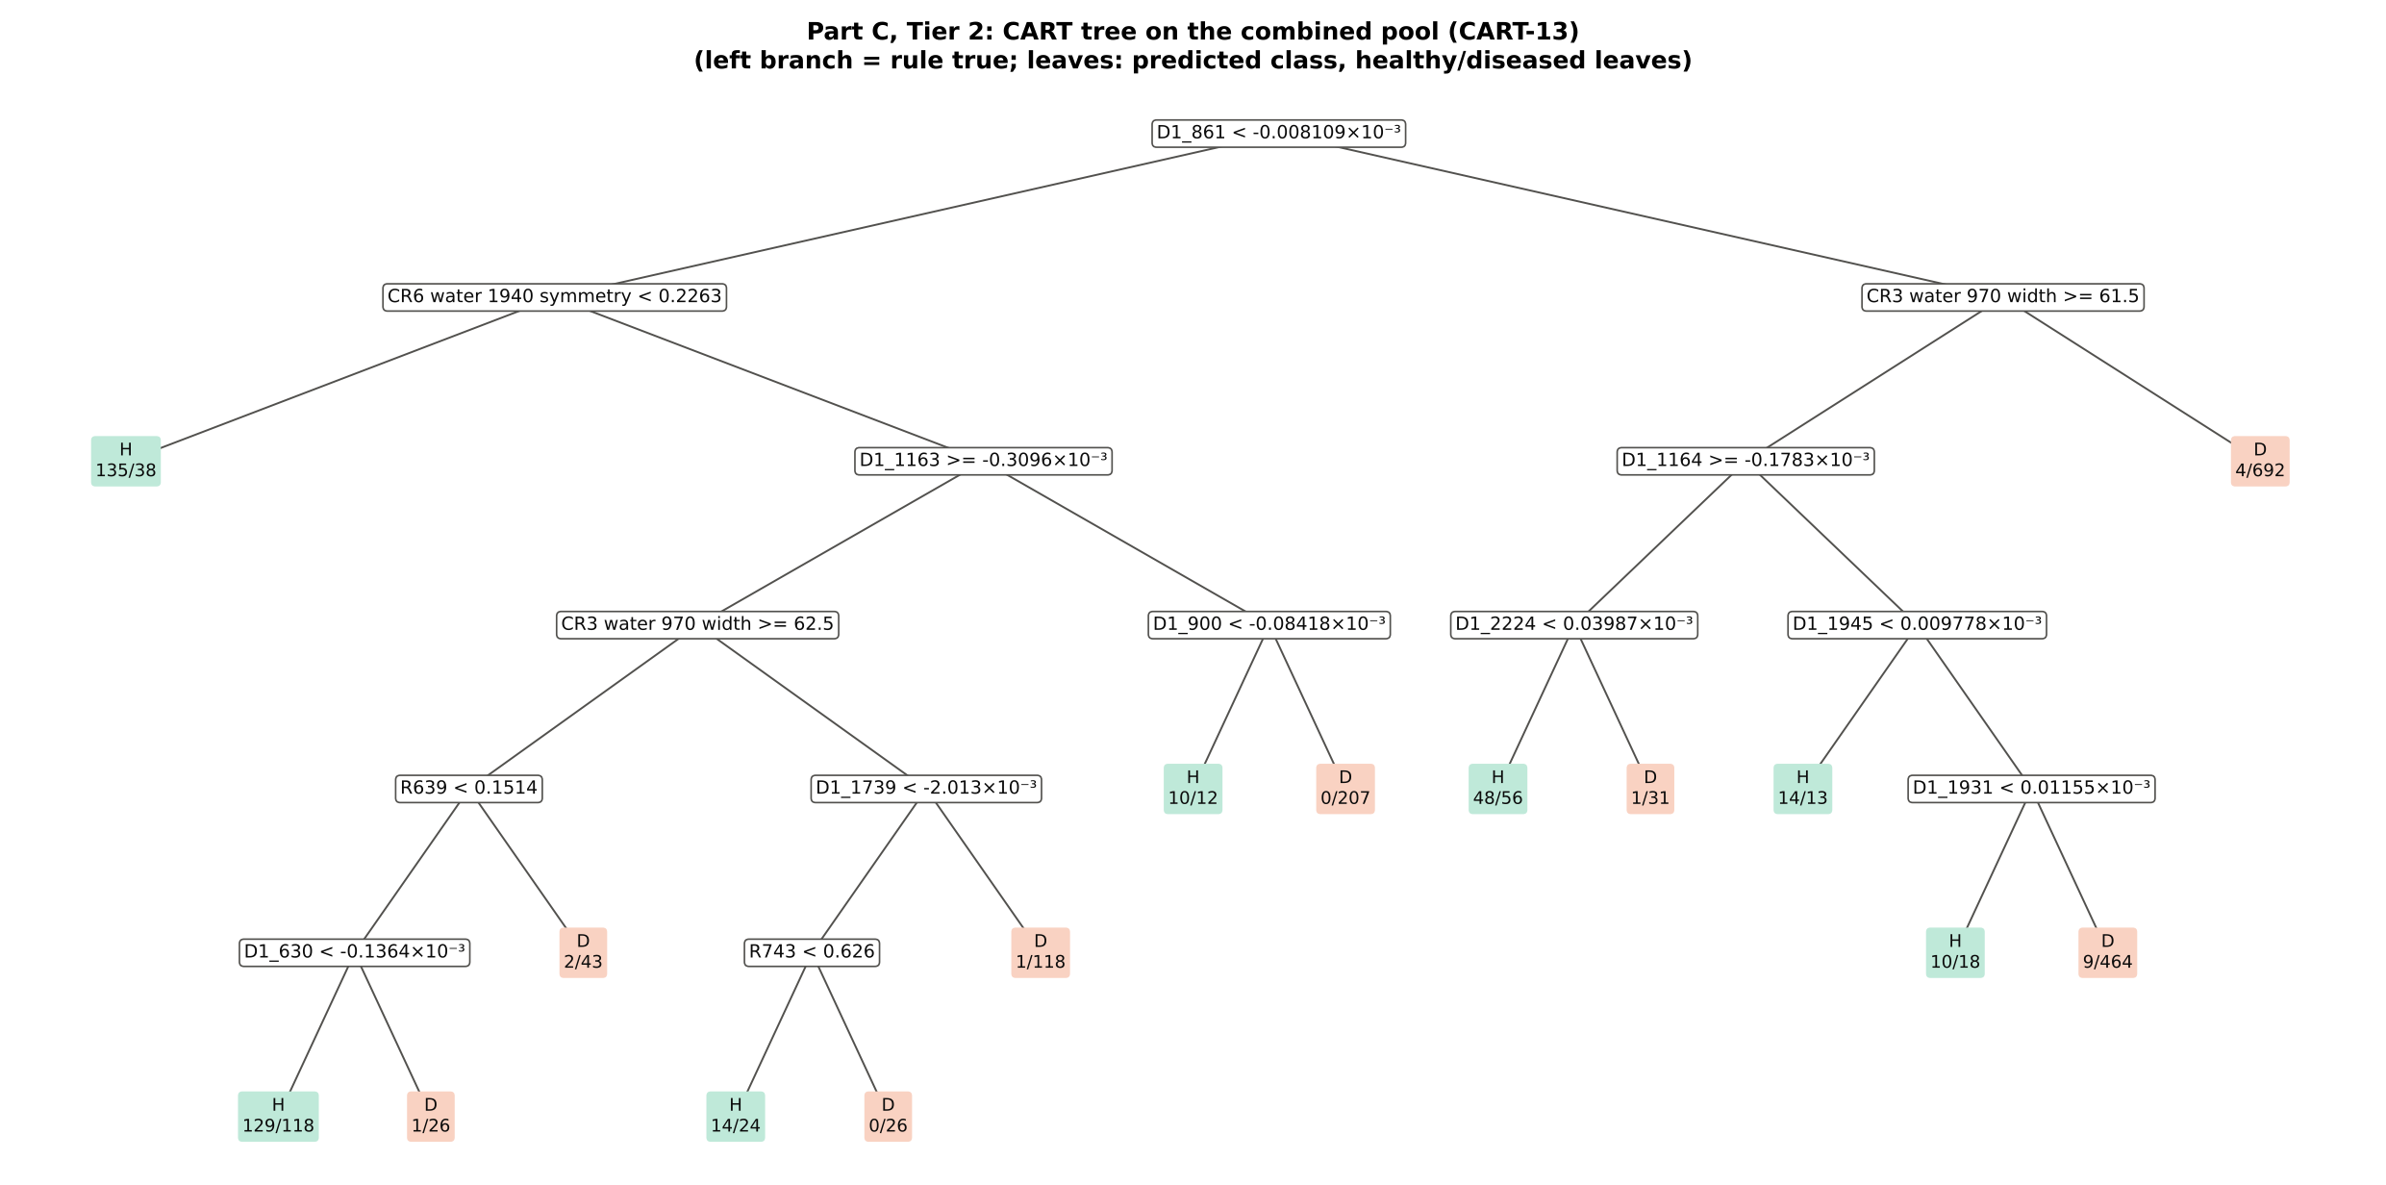
Figure 22. CART tree on the combined feature pool.
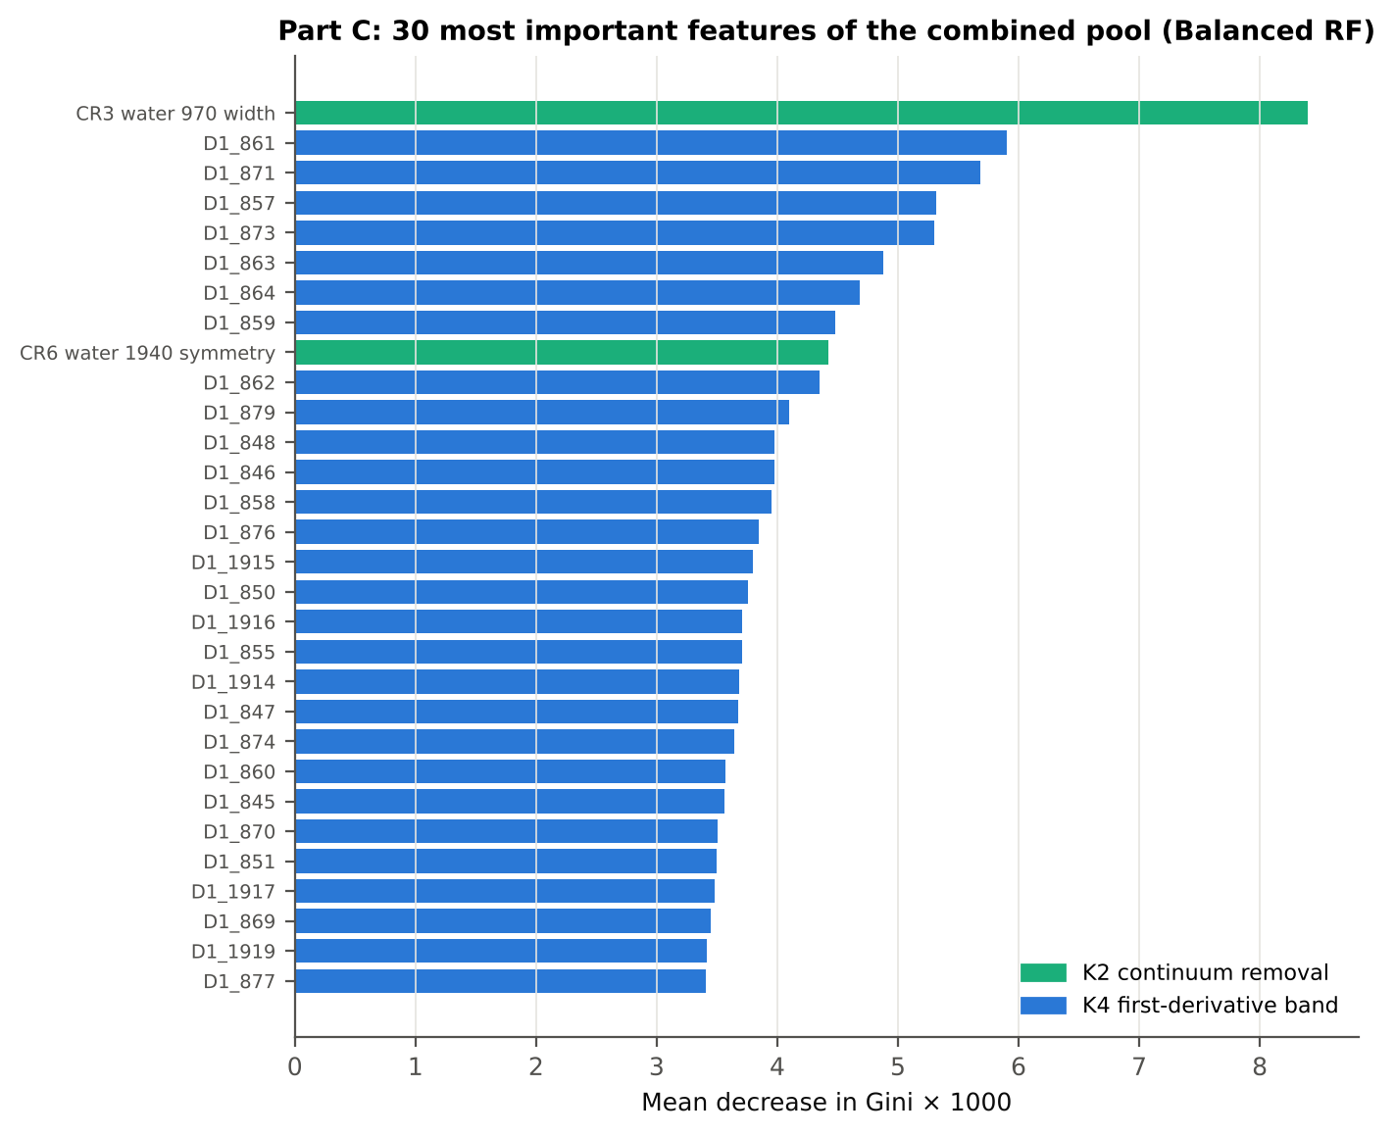
Figure 23. The 30 most important features of the combined pool (Balanced RF), coloured by type.
Table 33. J–M distance for the feature sets selected from the combined pool.
Set | Features | JM
CART-13 | 13 | 1.626
CART-8 (1-SE) | 8 | 1.197
RF-17 | 17 | 1.684
RF-10 | 10 | 1.437
RF-13 (size-matched) | 13 | 1.554

Table 34. Error matrix of QDA (equal priors, 10-fold CV) on RF-17 of the combined pool.
Classified \ Reference | Healthy | Diseased | Row total | User's accuracy
Healthy | 353 | 455 | 808 | 43.7 %
Diseased | 25 | 1431 | 1456 | 98.3 %
Column total | 378 | 1886 | 2264
Producer's accuracy | 93.4 % | 75.9 %
Overall accuracy | 78.8 % | Balanced accuracy | 84.6 % | κ = 0.476

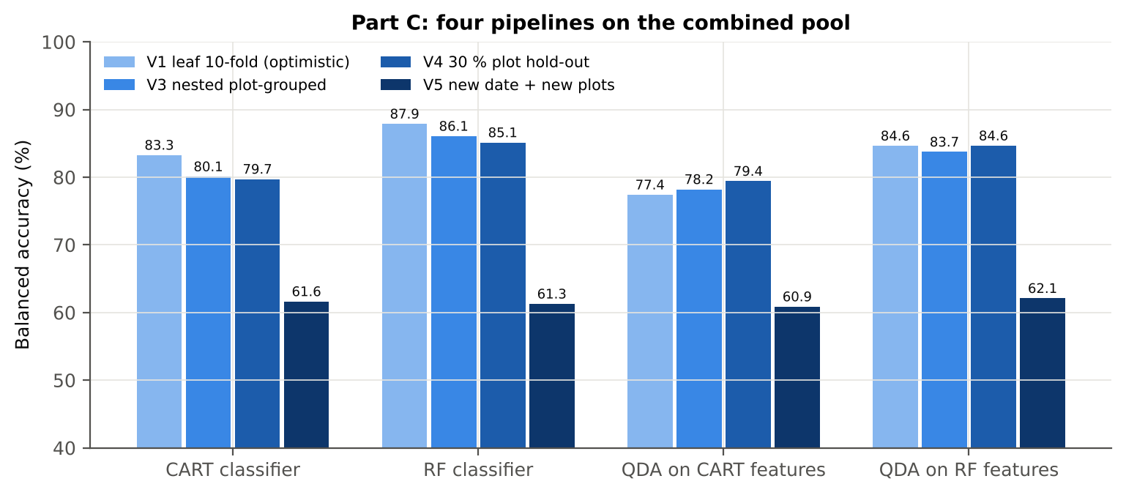
Figure 24. Four pipelines on the combined pool under V1, V3, V4 and V5.
Table 35. Validation of the combined-pool pipelines.
Pipeline | Scheme | BA | BA_SD | AUC | kappa
CART classifier | V1 | 83.3 % | – | 0.860 | 0.538
CART classifier | V3 | 80.1 % | 0.7 % | 0.842 | 0.482
CART classifier | V4 | 79.7 % | 2.8 % | 0.829 | 0.525
CART classifier | V5 | 61.6 % | 3.0 % | 0.599 | 0.210
RF classifier | V1 | 87.9 % | – | 0.948 | 0.679
RF classifier | V3 | 86.1 % | 0.2 % | 0.934 | 0.644
RF classifier | V4 | 85.1 % | 3.2 % | 0.928 | 0.638
RF classifier | V5 | 61.3 % | 1.5 % | 0.701 | 0.202
QDA on CART features | V1 | 77.4 % | – | 0.912 | 0.325
QDA on CART features | V3 | 78.2 % | 0.9 % | 0.902 | 0.330
QDA on CART features | V4 | 79.4 % | 4.4 % | 0.891 | 0.407
QDA on CART features | V5 | 60.9 % | 4.0 % | 0.631 | 0.173
QDA on RF features | V1 | 84.6 % | – | 0.937 | 0.476
QDA on RF features | V3 | 83.7 % | 0.6 % | 0.926 | 0.468
QDA on RF features | V4 | 84.6 % | 2.8 % | 0.929 | 0.527
QDA on RF features | V5 | 62.1 % | 3.1 % | 0.636 | 0.214

Table 36. Combined pool vs reflectance only vs K5: paired Wilcoxon tests on identical folds.
First | Second | Units | Mean difference (BA) | First better | Second better | Wilcoxon p
Combined pool: QDA on CART features | Reflectance: QDA on CART bands | V3 nested (50 folds) | +6.1 pts | 41 | 9 | 1.1e-06
Combined pool: QDA on CART features | Reflectance: QDA on CART bands | V4 hold-out (10 splits) | +6.6 pts | 9 | 1 | 0.014
Combined pool: QDA on RF features | Reflectance: QDA on RF bands | V3 nested (50 folds) | +15.0 pts | 50 | 0 | 7.6e-10
Combined pool: QDA on RF features | Reflectance: QDA on RF bands | V4 hold-out (10 splits) | +15.0 pts | 10 | 0 | 0.002
Combined pool: RF classifier (Tier-1 features) | Reflectance: RF classifier (Tier-1 bands) | V3 nested (50 folds) | +15.3 pts | 50 | 0 | 7.6e-10
Combined pool: RF classifier (Tier-1 features) | Reflectance: RF classifier (Tier-1 bands) | V4 hold-out (10 splits) | +15.7 pts | 10 | 0 | 0.002
Combined pool: CART classifier (Tier-1 features) | Reflectance: CART classifier (Tier-1 bands) | V3 nested (50 folds) | +15.7 pts | 50 | 0 | 1.8e-15
Combined pool: CART classifier (Tier-1 features) | Reflectance: CART classifier (Tier-1 bands) | V4 hold-out (10 splits) | +15.6 pts | 10 | 0 | 0.002
Combined pool: QDA on RF features | Combined pool: QDA on CART features | V3 nested (50 folds) | +5.8 pts | 44 | 6 | 1.4e-10
Combined pool: QDA on RF features | Combined pool: QDA on CART features | V4 hold-out (10 splits) | +5.2 pts | 10 | 0 | 0.002
Combined pool: QDA on RF features | K5: RF classifier on all 4151 features | V3 nested (50 folds) | -2.1 pts | 13 | 36 | 0.004
Combined pool: QDA on RF features | K5: RF classifier on all 4151 features | V4 hold-out (10 splits) | -0.8 pts | 5 | 5 | 0.492
Combined pool: QDA on RF features | K5: QDA on 15 features chosen by AUC | V3 nested (50 folds) | +5.7 pts | 43 | 7 | 1.1e-07
Combined pool: QDA on RF features | K5: QDA on 15 features chosen by AUC | V4 hold-out (10 splits) | +5.8 pts | 9 | 1 | 0.014
Combined pool: RF classifier (Tier-1 features) | K5: RF classifier on all 4151 features | V3 nested (50 folds) | -0.3 pts | 16 | 23 | 0.115
Combined pool: RF classifier (Tier-1 features) | K5: RF classifier on all 4151 features | V4 hold-out (10 splits) | -0.3 pts | 4 | 6 | 0.625

In the combined pool the RF-selected features beat the CART-selected features for QDA by 5.8 points (44 of 50 folds), and QDA on 17 RF features (83.7 %) is close to a Balanced RF on all 4150 features (86.3 %).
Selection is stable: the width of the 970 nm water feature is chosen in all 50 training sets by both selectors, the symmetry of the 1940 nm feature in 50 (RF) and 45 (CART); RF Jaccard 0.82, CART 0.37.
The combined pool beats reflectance alone in every pipeline (+6 to +16 points, 41–50 of 50 folds, all p < 10⁻⁵). QDA on 17 RF-selected features is 2.1 points below an RF on all features in V3 and equal in V4 — a compact, interpretable 17-feature model loses little.

3.10 Additional checks
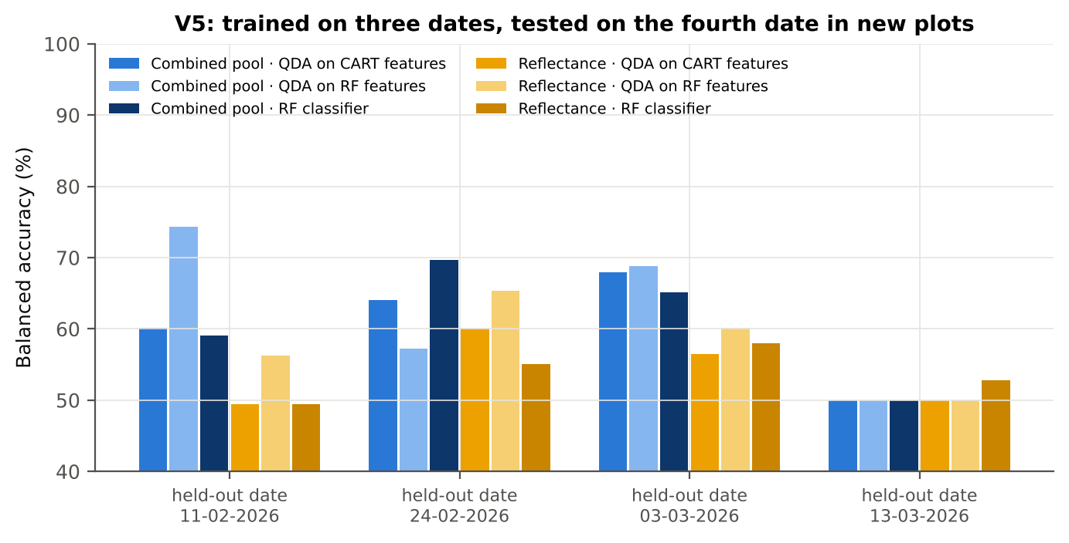
Figure 25. V5: balanced accuracy on each held-out date in held-out plots.
Table 37. Balanced accuracy by held-out date (V5).
Feature set · pipeline | 11-02-2026 | 24-02-2026 | 03-03-2026 | 13-03-2026
Reflectance · CART classifier | 48.5 % | 50.9 % | 57.2 % | 53.3 %
Reflectance · RF classifier | 49.4 % | 55.1 % | 57.9 % | 52.8 %
Reflectance · QDA on CART features | 49.4 % | 60.0 % | 56.5 % | 50.0 %
Reflectance · QDA on RF features | 56.3 % | 65.4 % | 60.1 % | 50.0 %
Combined pool · CART classifier | 65.4 % | 72.2 % | 59.5 % | 51.6 %
Combined pool · RF classifier | 59.1 % | 69.7 % | 65.1 % | 50.0 %
Combined pool · QDA on CART features | 60.2 % | 64.1 % | 68.0 % | 50.0 %
Combined pool · QDA on RF features | 74.4 % | 57.2 % | 68.8 % | 50.0 %

Trained on three dates and tested on the fourth date in new plots, accuracy falls to 53–58 % (reflectance) and 61–62 % (combined pool). When 13-03-2026 (mostly pod formation) is held out, every leaf — healthy or diseased — is called diseased: senescing pod-stage leaves resemble diseased leaves spectrally, and the training dates contained few pod-stage leaves.
The disease signal is real but stage-dependent; models must be trained on the growth stages and dates to which they will be applied.
Table 38. AUC of the key features on all leaves and its range within dates, growth stages and varieties.
Feature | AUC all leaves | AUC range over dates | over growth stages | over varieties
K1 reflectance R1890 | 0.691 | 0.54–0.83 | 0.53–0.75 | 0.67–0.72
K4 first derivative D1_872 | 0.786 | 0.69–0.90 | 0.70–0.85 | 0.74–0.82
K2 CR3 water 970 width | 0.765 | 0.57–0.87 | 0.65–0.85 | 0.75–0.78
K3 NWI2 | 0.700 | 0.61–0.87 | 0.59–0.77 | 0.66–0.76
K4 edge Ro (red well reflectance) | 0.659 | 0.56–0.74 | 0.54–0.72 | 0.64–0.67
REIP (Lagrangian) | 0.638 | 0.52–0.77 | 0.54–0.72 | 0.60–0.67

The key features work inside every date, growth stage and variety (same direction in nearly all strata), but their AUC varies widely between dates (e.g. D1 at 872 nm 0.69–0.90; CR3 width 0.57–0.87).
Classifier accuracy (V3 out-of-fold) of QDA on the combined-pool RF features is 82–86 % in each variety, 73–88 % in each growth stage (lowest at pod formation) and 68–94 % in each date.

3.11 Synthesis
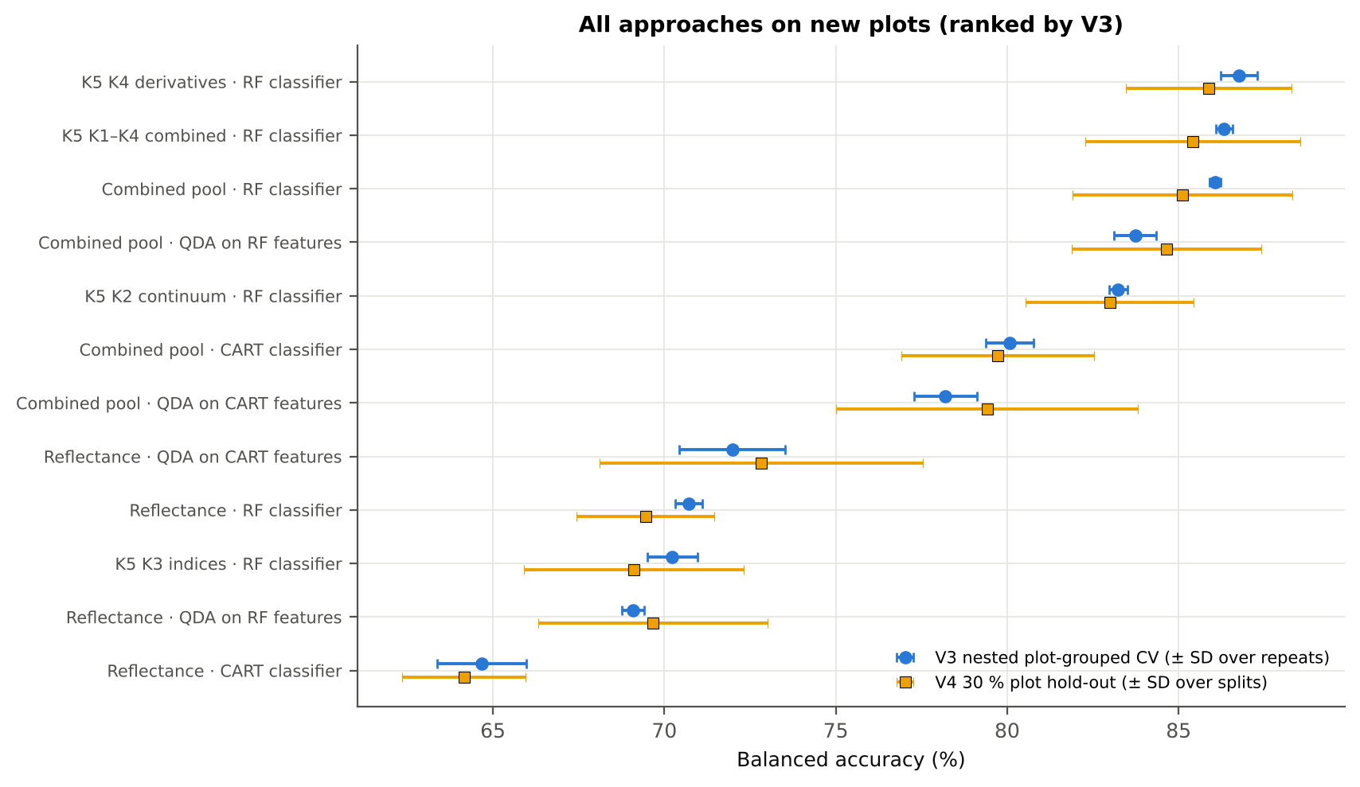
Figure 26. All approaches ranked by balanced accuracy on new plots (V3 and V4).
Table 39. All approaches side by side.
Approach | BA V3 (nested CV) | BA V4 (hold-out plots) | BA V5 (new date + plots)
K5 · K4 incl. guard bands (artefact): RF | 91.1 % | 90.6 % | –
K5 · K4 derivatives + edge: RF | 86.8 % | 85.9 % | –
K5 · K1–K4 combined: RF | 86.3 % | 85.4 % | –
Part C · combined-pool four-tier: RF classifier (Balanced RF) | 86.1 % | 85.1 % | 61.3 %
K5 · K4 incl. guard bands (artefact): CART | 85.4 % | 85.8 % | –
Part C · combined-pool four-tier: QDA on RF-17 (RF-selected) | 83.7 % | 84.6 % | 62.1 %
K5 · K2 continuum removal: RF | 83.2 % | 83.0 % | –
K5 · K-selected 15: RF | 82.6 % | 82.0 % | –
K5 · K2 continuum removal: CART | 80.7 % | 80.5 % | –
K5 · K1–K4 combined: CART | 80.3 % | 80.0 % | –
Part C · combined-pool four-tier: CART classifier (rpart) | 80.1 % | 79.7 % | 61.6 %
K5 · K4 derivatives + edge: CART | 79.2 % | 80.2 % | –
K5 · K-selected 15: QDA | 78.5 % | 78.8 % | –
Part C · combined-pool four-tier: QDA on CART-13 (CART-selected) | 78.2 % | 79.4 % | 60.9 %
K5 · K-selected 15: CART | 76.2 % | 76.6 % | –
Single feature · K3b optimised NDSI, all pairs — brackets the 1800 nm join (search nested) | 73.0 % | 72.8 % | –

4. Discussion

4.1 What the spectra say about white rust
White rust lowers chlorophyll (higher visible reflectance and a 1.5–4 nm blue shift of the red edge), damages the mesophyll (lower NIR plateau at 750–930 nm) and reduces leaf water (higher SWIR reflectance, shallower and narrower water absorption features at 970 and 1940 nm). These are the same regions in which Das et al. (2020) found genotype differences in rice (chlorophyll absorption, red edge, water bands), but here the effect is small relative to the variation between growth stages and dates.
Derivative and continuum-removed features remove most of the brightness variation between leaves and dates and isolate band shape, which explains why they discriminate far better (AUC up to 0.79 for single first-derivative bands vs 0.69 for reflectance). The most informative derivative bands (845–875 nm) describe the slope of the NIR plateau, which is sensitive to cell structure and leaf water.

4.2 The four-tier method on a two-class, imbalanced, pooled problem
Das et al. obtained J–M ≥ 1.94 and 98 % QDA accuracy for 14 genotypes from canopy spectra of one stage. For healthy vs diseased leaves pooled over stages the classes overlap: J–M 1.27–1.68 and balanced accuracy 71–85 %. The method still works as intended — it reduces 2101 bands (or 4150 features) to 11–17 interpretable features and quantifies how separable the classes are — but separability below 1.90 should be reported honestly rather than read as failure of the method.
Without correction for the 1 : 5 imbalance overall accuracy would be misleading (sample-prior QDA OA 72 % with healthy recall 82 %; an ordinary class-weighted RF recognises only 49 % of healthy leaves). Equal priors, balanced bootstraps and balanced accuracy make the minority class count. For QDA, equal priors produced high healthy recall and lower diseased recall; sample priors gave a higher balanced accuracy, so the choice of prior (or a decision threshold tuned on training data) should be stated with the results.

4.3 CART versus Random Forest
A single CART tree is an unstable band selector: in 50 nested training sets only three of its bands were re-selected in most sets (Jaccard 0.30). RF importance peaks were reproducible (Jaccard 0.72, 0.82 in the combined pool), agreed with an independent R implementation (16 of 17 peaks within ± 10 nm) and gave the more accurate classifier in every feature group. As a band selector for QDA, CART was slightly better on reflectance (it picks complementary regions), RF clearly better on the combined pool.

4.4 Validation and generalisation
Because leaves of one plot share conditions, and because bands were selected on the same data, leaf-level cross-validation can be optimistic. Here the nested plot-grouped and hold-out estimates were close to the leaf-level estimate, so selection bias and plot leakage were small with 2264 leaves and 48 plots. The transfer to a new date was the real limitation: growth stage dominates the spectra, and a model trained mostly on vegetative and flowering leaves classified pod-stage healthy leaves as diseased. Stage-specific models, or training data that cover all stages, are required for application.

4.5 Instrument artefacts
The ASD detector join at 1800/1801 nm produced a date-dependent rise in the first 20–30 nm of the SWIR-2 detector. Derivative bands inside this zone reached AUC 0.89 and raised RF accuracy to 91 %, and the best two-band index without restriction bracketed the join. Guard zones, a join-free index search and an explicit artefact test kept these effects out of the conclusions; 2–5 % of fold selections still fall within 5 nm of a guard zone and are flagged.

4.6 Limitations
Disease severity and leaf position were not used; healthy vs diseased is a plot-level label, so mildly infected leaves of inoculated plots are labelled diseased. The four dates are not independent of growth stage. J–M and QDA assume multivariate normal classes. All results refer to leaf-level contact-probe spectra; canopy or airborne data would require masking of the atmospheric water bands.

5. Conclusions
1. White rust changes mustard leaf reflectance significantly at 1653 of 2101 bands (1604 with a plot random effect), mainly in the red / red edge, the NIR plateau and the water absorption bands, irrespective of date, growth stage and variety.
2. The four-tier method of Das et al. (2020), corrected for imbalance, selects 11 CART bands (root 1893 nm) that give QDA balanced accuracies of 71–73 % on new plots; the classes are not separable by the J–M criterion (1.27 < 1.90).
3. Random Forest is a better classifier than CART (+6 points) and a far more stable band selector; RF and CART agree on the red edge (≈ 690–705 nm) and the 1890 nm water band.
4. First-derivative spectra and continuum-removed water features are the most disease-sensitive features; the red-edge inflection point shows a blue shift of 1.5–3.9 nm in diseased leaves, strongest at flowering.
5. Applying the four tiers to the combined feature pool (4150 features) raises accuracy to 83.7–84.6 % with QDA on 17 RF-selected features and to 86 % with an RF on all features — 15 points above reflectance alone.
6. Models transfer poorly to an unseen date (53–62 %) because growth stage changes the spectra more than the disease; practical detection needs stage-specific calibration or training data covering all stages.

Recommendations
- Use first-derivative bands (845–875 and 1915–1945 nm) together with the width of the 970 nm and the symmetry of the 1940 nm continuum-removed water features; select them with Random Forest importance and classify with QDA or RF.
- Report balanced accuracy and both class recalls; state the priors used (equal priors favour the healthy class here).
- Validate with plots grouped across dates and test transfer to new dates; calibrate per growth stage or include all stages in training.
- Apply splice correction and guard zones at the ASD detector joins and avoid indices whose bands bracket a join.
- Record a disease-severity score per leaf in future campaigns, so that severity-related spectral changes can be modelled directly.

6. Quality control: cross-checks
51 cross-checks were run: 45 PASS, 6 FLAG (limitations that are reported and handled) and 0 FAIL. The full register with methods is in workbook sheet 33_CrossChecks.
Table 40. Cross-check register.
# | Step | What was checked | Result | Status
1 | Step 0 | Missing values in spectra | 0 | PASS
2 | Step 0 | Reflectance range (350–2500 nm) | 0.026 – 0.935 | PASS
3 | Step 0 | Wavelength grid identical in all files | 350–2500 nm, 1 nm, 2151 bands | PASS
4 | Step 0 | Plot-average formula columns ignored | 197 | PASS
5 | Step 0 | Second data block 13-03-2026: exact copies of block 1 (same plot) | 75 of 75 identical → removed | PASS
6 | Step 0 | Exact duplicates among the remaining spectra | 4 (the unnamed plot-27 spectra of 11-02-2026) → removed | FLAG
7 | Step 0 | Each plot has one class on every date | 48 of 48 plots | PASS
8 | Step 0 | Each plot has one variety on every date | 48 of 48 plots | PASS
9 | Step 0 | Healthy = plots 1–12, diseased = plots 13–48 | consistent | PASS
10 | Step 0 | Repeated ASD file names within a date (counter restarted on 13-03-2026) | 75 names repeated; spectra differ (max |Δ| ≥ 0.025) → distinct leaves, kept | PASS
11 | Tier 3 | J–M implementation (Part A (raw reflectance)) | |Δα| = 3.0e-13 | PASS
12 | Tier 4 | QDA implementation (Part A (raw reflectance)) | 99.91 % identical predictions — the 2 differing leaves have P(diseased) = 0.5002 and 0.5020 (ties at the bound | PASS
13 | Tier 1 | Welch t-statistic | max |Δt| = 3.6e-15 | PASS
14 | Tier 1 | Benjamini–Hochberg q-values | max |Δq| = 1.1e-16 | PASS
15 | Tier 1 | ANOVA equivalence | max relative |F − t²| = 3.8e-14 | PASS
16 | Tier 1 | Class imbalance | median 1568 significant bands per subset vs 1653 on all leaves | PASS
17 | Tier 2 | CART implementation | root variable rpart 'WV1893< 0.08056' vs sklearn 'WV1893 < 0.08056' | PASS
18 | Tier 2 | Stability of the selected bands | 1893 nm 86 %; 767 nm 84 %; 2405 nm 76 % | PASS
19 | Tier 3 | J–M formula | 0.0e+00 | PASS
20 | Tier 4 | QDA in R | CART-11 equal: 99.91 % identical; CART-11 sample: 99.96 % identical; CART-4 (1-SE) equal: 100.00 % identical; | PASS
21 | A1 | Reproducibility: importance of seed 42 vs seed 7 (Spearman ρ) | 0.891; 17 of 17 peaks within ±10 nm | PASS
22 | A1 | R randomForest (stratified sampsize 378 + 378), mean decrease in Gini | ρ = 0.893; 16 of 17 peaks within ±10 nm; R out-of-bag BA 0.733 | PASS
23 | A1 | Permutation importance (drop in AUC, 5 plot-grouped folds) vs Gini, top-50 bands | ρ = -0.06; shuffling one band hardly changes the forest because its neighbours carry the same information | FLAG
24 | A1 | Ordinary RF with class weights only (no balanced bootstrap), out-of-bag | BA 0.703; healthy recall 0.49: class weights alone leave the forest biased | PASS
25 | Tier 1 | Pseudo-replication | 1604 of 2101 bands significant (Welch: 1653); plot ICC median 0.043 | PASS
26 | Tier 1 | Mixed model implementation | Spearman ρ of p-values 1.000; max |ΔICC| 0.000 (statsmodels uses a Wald z-test, nlme a t-test with 46 df, so n | PASS
27 | Tier 3 | Invertibility of the class covariances | max 3.3e+07 (well below the ~1e12 limit of double precision) | PASS
28 | Tier 3 | J–M is scale-invariant | max |ΔJ–M| = 4.9e-11 | PASS
29 | K0 | Smoothing preserves the signal | r ≥ 0.999988; 1653 (raw) vs 1652 (smoothed) significant bands | PASS
30 | K0 | Detector artefact at the 1800/1801 nm join | start-up bump detected → guard zones applied | FLAG
31 | K2 | Convex hull | max |Δ continuum| = 0.0e+00 | PASS
32 | K3 | Duplicated indices | max |mCARI1 − MTVI1| = 4.4e-16 (algebraically identical); AUC SR761 0.6712 = NDVI761 0.6712 (monotone transfor | PASS
33 | K4 | REIP by four methods | r between methods 0.849 – 0.999 | PASS
34 | K4 | REP by two methods (Excel) | see 'largest difference' on sheet K4 | PASS
35 | K4 | Derivative filter | r = 0.9995 | PASS
36 | K6 | Correlation vs t-test | ρ = 0.9829 (r_pb is a monotone function of Student's t) | PASS
37 | K3b | NDSI vs simple ratio | max |ΔAUC| = 0.0e+00 | PASS
38 | K3b | Selection optimism | honest BA 73.0 % (CV) / 72.8 % (hold-out) vs 76.5 % on all leaves | FLAG
39 | K3b | Best pair straddles a detector join? | all-pair best NDSI(1794,1837) brackets the 1800/1801 nm join → treated as artefact-prone; join-free best NDSI( | FLAG
40 | Part C · Tier 3 | J–M implementation (Part C (combined pool)) | |Δα| = 3.3e-15 | PASS
41 | Part C · Tier 4 | QDA implementation (Part C (combined pool)) | 99.91 % identical predictions | PASS
42 | Part C · Tier 3 | Invertibility of the class covariances | max 7.8e+03 (well below the ~1e12 limit of double precision) | PASS
43 | Part C · Tier 3 | J–M is scale-invariant | max |ΔJ–M| = 2.4e-14 | PASS
44 | Validation | No plot in both training and test | passed for all folds | PASS
45 | Validation | No date in both training and test (V5) | passed | PASS
46 | Validation | Identical folds in every step | same objects | PASS
47 | K5 / Part A | K5 full spectrum reproduces Part A | RF 71.0 % vs 70.7 %; CART 64.4 % vs 64.7 % | PASS
48 | Error matrices | Matrix sums equal the class totals | V1 totals 378 healthy / 1886 diseased | PASS
49 | K5 artefact test | Guard-zone bands inflate accuracy? | 91.1 % with vs 86.8 % without | FLAG
50 | Part C | Selected features next to the guard zones | CART: 2.4 %; RF: 4.6 % | PASS
51 | Numerics | QDA fits failing on singular covariances | 0 (Part A), 0 (Part C) | PASS

References
Ambroise C, McLachlan GJ. 2002. Selection bias in gene extraction on the basis of microarray gene-expression data. Proceedings of the National Academy of Sciences 99:6562–6566.
Babar MA, Reynolds MP, van Ginkel M, Klatt AR, Raun WR, Stone ML. 2006. Spectral reflectance indices as a potential indirect selection criteria for wheat yield under irrigation. Crop Science 46:578–588.
Benjamini Y, Hochberg Y. 1995. Controlling the false discovery rate: a practical and powerful approach to multiple testing. Journal of the Royal Statistical Society B 57:289–300.
Bhattacharyya A. 1943. On a measure of divergence between two statistical populations defined by their probability distributions. Bulletin of the Calcutta Mathematical Society 35:99–109.
Breiman L. 2001. Random forests. Machine Learning 45:5–32.
Breiman L, Friedman JH, Olshen RA, Stone CJ. 1984. Classification and regression trees. Belmont (CA): Wadsworth.
Brodersen KH, Ong CS, Stephan KE, Buhmann JM. 2010. The balanced accuracy and its posterior distribution. Proceedings of the 20th International Conference on Pattern Recognition, 3121–3124.
Chen C, Liaw A, Breiman L. 2004. Using random forest to learn imbalanced data. Technical Report 666, Department of Statistics, University of California, Berkeley.
Cho MA, Skidmore AK. 2006. A new technique for extracting the red edge position from hyperspectral data: the linear extrapolation method. Remote Sensing of Environment 101:181–193.
Clark RN, Roush TL. 1984. Reflectance spectroscopy: quantitative analysis techniques for remote sensing applications. Journal of Geophysical Research 89(B7):6329–6340.
Cohen J. 1960. A coefficient of agreement for nominal scales. Educational and Psychological Measurement 20:37–46.
Congalton RG. 1991. A review of assessing the accuracy of classifications of remotely sensed data. Remote Sensing of Environment 37:35–46.
Das B, Sahoo RN, Biswas A, Pargal S, Krishna G, Verma R, Chinnusamy V, Sehgal VK, Gupta VK. 2020. Discrimination of rice genotypes using field spectroradiometry. Geocarto International 35(1):64–77. doi:10.1080/10106049.2018.1506507
Dawson TP, Curran PJ. 1998. A new technique for interpolating the reflectance red edge position. International Journal of Remote Sensing 19:2133–2139.
Gong P, Pu R, Heald RC. 2002. Analysis of in situ hyperspectral data for nutrient estimation of giant sequoia. International Journal of Remote Sensing 23:1827–1850.
Guyot G, Baret F. 1988. Utilisation de la haute résolution spectrale pour suivre l'état des couverts végétaux. Proceedings of the 4th International Colloquium on Spectral Signatures of Objects in Remote Sensing, ESA SP-287, 279–286.
Haboudane D, Miller JR, Pattey E, Zarco-Tejada PJ, Strachan IB. 2004. Hyperspectral vegetation indices and novel algorithms for predicting green LAI of crop canopies. Remote Sensing of Environment 90:337–352.
Hanley JA, McNeil BJ. 1982. The meaning and use of the area under a receiver operating characteristic (ROC) curve. Radiology 143:29–36.
Hastie T, Tibshirani R, Friedman J. 2009. The elements of statistical learning. 2nd ed. New York: Springer.
Hedges LV. 1981. Distribution theory for Glass's estimator of effect size and related estimators. Journal of Educational Statistics 6:107–128.
Horler DNH, Dockray M, Barber J. 1983. The red edge of plant leaf reflectance. International Journal of Remote Sensing 4:273–288.
Hurlbert SH. 1984. Pseudoreplication and the design of ecological field experiments. Ecological Monographs 54:187–211.
Kokaly RF, Clark RN. 1999. Spectroscopic determination of leaf biochemistry using band-depth analysis of absorption features and stepwise multiple linear regression. Remote Sensing of Environment 67:267–287.
Kuncheva LI. 2007. A stability index for feature selection. Proceedings of the 25th IASTED International Multi-Conference: Artificial Intelligence and Applications, 390–395.
Lemaître G, Nogueira F, Aridas CK. 2017. Imbalanced-learn: a Python toolbox to tackle the curse of imbalanced datasets in machine learning. Journal of Machine Learning Research 18(17):1–5.
Levene H. 1960. Robust tests for equality of variances. In: Olkin I, editor. Contributions to probability and statistics. Stanford: Stanford University Press; p. 278–292.
Liaw A, Wiener M. 2002. Classification and regression by randomForest. R News 2(3):18–22.
Mahlein A-K. 2016. Plant disease detection by imaging sensors — parallels and specific demands for precision agriculture and plant phenotyping. Plant Disease 100:241–251.
Mahlein A-K, Rumpf T, Welke P, Dehne H-W, Plümer L, Steiner U, Oerke E-C. 2013. Development of spectral indices for detecting and identifying plant diseases. Remote Sensing of Environment 128:21–30.
Pedregosa F, Varoquaux G, Gramfort A, et al. 2011. Scikit-learn: machine learning in Python. Journal of Machine Learning Research 12:2825–2830.
Pinheiro J, Bates D, R Core Team. 2023. nlme: linear and nonlinear mixed effects models. R package.
R Core Team. 2024. R: a language and environment for statistical computing. Vienna: R Foundation for Statistical Computing.
Richards JA. 2013. Remote sensing digital image analysis. 5th ed. Berlin: Springer.
Roberts DR, Bahn V, Ciuti S, et al. 2017. Cross-validation strategies for data with temporal, spatial, hierarchical, or phylogenetic structure. Ecography 40:913–929.
Saharan GS, Verma PR, Meena PD, Kumar A. 2014. White rust of crucifers: biology, ecology and management. New Delhi: Springer India.
Savitzky A, Golay MJE. 1964. Smoothing and differentiation of data by simplified least squares procedures. Analytical Chemistry 36:1627–1639.
Seabold S, Perktold J. 2010. Statsmodels: econometric and statistical modeling with Python. Proceedings of the 9th Python in Science Conference, 92–96.
Strobl C, Boulesteix A-L, Zeileis A, Hothorn T. 2007. Bias in random forest variable importance measures: illustrations, sources and a solution. BMC Bioinformatics 8:25.
Swain PH, Davis SM. 1978. Remote sensing: the quantitative approach. New York: McGraw-Hill.
Therneau T, Atkinson B. 2023. rpart: recursive partitioning and regression trees. R package version 4.1.23.
Varma S, Simon R. 2006. Bias in error estimation when using cross-validation for model selection. BMC Bioinformatics 7:91.
Venables WN, Ripley BD. 2002. Modern applied statistics with S. 4th ed. New York: Springer.
Welch BL. 1947. The generalization of 'Student's' problem when several different population variances are involved. Biometrika 34:28–35.
Wilcoxon F. 1945. Individual comparisons by ranking methods. Biometrics Bulletin 1:80–83.
Youden WJ. 1950. Index for rating diagnostic tests. Cancer 3:32–35.
Vegetation-index sources (formulas in workbook sheet 17): Jordan 1969; Gitelson & Merzlyak 1996; Gamon et al. 1992; Chappelle et al. 1992; Blackburn 1998; Raun et al. 2001; Peñuelas et al. 1994, 1995, 1997; Barnes et al. 1992; Merzlyak et al. 1999; Haboudane et al. 2002; Gitelson et al. 2001, 2002; Merton 1998; Broge & Leblanc 2001; Roujean & Bréon 1995; Metternicht 2003; Bausch & Duke 1996.

