UNIT-I

Meaning of Communication:
Communication can broadly be defined as exchange of ideas, messages and information between two or more persons, through a medium, in a manner that the sender and the receiver understand the message in the common sense that is, they develop common understanding of the message.
The word communication is derived from the Latin word ‘communicare’, which means to share, impart, participate, exchange, transmit or to make common. It emphasizes on sharing common information, ideas and messages. It is not merely issuing orders and instructions.
Definition:-

Shorter Oxford English Dictionary:
“Imparting, conveying or exchange of ideas, knowledge etc by speech, writing or signs.”

Webster Dictionary:
“The art of expressing ideas” or “the science of transmitting information”
’The transfer of information &understanding from one person to another person.
It is a way of reaching other with facts, ideas, thoughts and values.
It is a bridge of meaning among people so that they can share what the feel and know.
By using this bridge, a person can cross safely the river of misunderstanding that sometimes separates people.”---Kith Davis

“Communication is the transfer of information from a sender to a receiver, with the information being understood by the receiver”. — Koontz and Weihrich

“Communication is the art of developing and attaining understanding between people. It is the process of exchanging information and feelings between two or more people and it are essential to effective management.” — Terry and Franklin
“Communication is the sum of all things one person does when he wants to create understanding in the mind of another. It is a bridge of meaning. It involves a systematic and continuous process of telling, listening and understanding.” — Allen Louis
“Communication is the process by which people attempt to share meaning via the transmission of symbolic messages.” — Stoner and Wankel.

Characteristics of Communication:
Communication has the following features:
1. Involves at least 2 persons i.e. a sender & a receiver- A minimum of two persons — sender and receiver — must be present for communication to take place. It may be between superiors, subordinates and peer group, intra or inter se.
2. Involves transmission of ideas or views- Communication cannot be thought of in the absence of exchange of ideas. In order to complete the process of communication there must be an exchange of ideas, orders, feelings, etc., among two or more than two persons.
3. Understanding: an essential component- Mutual understanding means that the receiver should receive the information in the same spirit with which it is being given. In the process of communication, it is more important to understand the information rather than carry it out.
6. Purpose- Communication is goal-oriented. Unless the receiver and sender know the purpose they intend to achieve through communication, it has little practical utility.
7. A Two-way Process- Communication is a two-way process of understanding between two or more persons – sender and receiver. A person cannot communicate with himself.
8. Dynamic process- Communication between sender and receiver takes different forms and medium depending upon their moods and behavior. It is, thus, a dynamic process that keeps changing in different situations.
9. Continuous process:
Exchange of ideas and opinion amongst people is an ongoing process in business and non-business organizations. Continuous interaction promotes understanding and exchange of information relevant for decision-making.
10. Dynamic process: it is constantly evolving, influenced by various factors such as context, feedback, and the participants involved.
11. Pervasive:
Communication is a pervasive activity. It takes place at all levels (top, middle, low) in all functional areas (production, finance, personnel, sales) of a business organisation.
12. Mutual understanding:
Communication is effective when sender and receiver develop mutual understanding of the subject. Messages conveyed should be understood by the receiver in the desired sense.
13. A means, not an end:
Communication is not an end. Effective communication is a means towards achieving the end, that is, goal accomplishment. It smoothens managerial operations by facilitating planning, organising, staffing, directing and controlling functions.
14. Human activity:
Since communication makes accomplishment of organisational goals possible, it is essential that people understand and like each other. If people do not understand each others’ viewpoint, there cannot be effective communication.
Objectives of Communication
- Information
- Education
- Advice
- Warning
- Order
- Raising morale
- Suggestion
- Motivation
- Persuasion
- Integration
- Training
- Entertaining
- Decision making

Role of Communication:
Right from the time a child is born, communication plays an important role in his life. Speaking, listening and writing are the common forms of communication. A large part of our time is devoted to communication as we share our thoughts and feelings with individuals and groups of people. Communication helps to develop an organised society with defined roles for each individual.
In the business world, managers perform their tasks and responsibilities through communication. Communication provides the basis for effective implementation of plans, assigning jobs to people, carrying out directions and activities and facilitates control.
Management functions can be performed successfully when managers communicate face-to-face, telephonically or electronically with their superiors, peers, subordinates, customers, suppliers, competitors etc. Even when they are not talking, they are busy reading or writing reports, memos and letters which are different forms of communication. Communication has reduced geographical distances into storable and confidential forms and has facilitated a large number of people to interact with each other.
It is important that communication should be effective. Effective communication is transfer of information along with transfer of understanding. It means transfer of messages, ideas and information in a manner that the sender and receiver understand the subject in the same sense.
“It is the process of sending a message in such a way that the message received is as close in meaning as possible to the message intended.” Effective communication, thus, takes place when receiver understands the message in the same sense as the sender wants to convey.
Communication is the foundation for human interaction that develops common understanding amongst two or more persons. This promotes common objectives through coordinated efforts amongst people belonging to different functional departments.

Importance of Communication:
The desire to socialize and get formed into organised groups necessitates the need for communication. In the fast changing world, managers communicate changes in technology, structure or people to the subordinates. If the communication system is well organised, it becomes easier for subordinates to understand and act upon the message. Communication plays important role in the lives of individuals and organisations.
The following points highlight the importance of communication:
1. Basis for planning:
Planning is the basic function of management. If plans are well designed and communicated for their implementation, it leads to organisational success. Planning requires extensive environmental scanning and information about internal and external organisation elements. An effective system of communication helps in obtaining this information. Implementing the plans requires communicating them to everybody in the organisation. Communication is, thus, the basis of planning.
2. Motivation to work:
Employees are motivated to work if their needs are satisfied. Communication helps managers know needs of their employees so that they can adopt suitable motivators and inspire them to develop positive attitude towards the work environment.
3. Job satisfaction:
Exchange of information develops trust, confidence and faith amongst managers and subordinates. They understand their job positions better and, thus, perform better. People are committed to organisational objectives which promotes job satisfaction,
4. Commitment to organisational objectives:
Managers who follow an effective system of communication understand employees’ needs, adopt suitable motivators to satisfy them, appraise their performance and provide them regular feedback. The employees also work with commitment towards organisational objectives.
5. Coordination:
Communication coordinates organisational resources (human and non- human), individual goals with organisational goals and internal environment with external environment. Coordination is the key to organisational success and communication is an active contributor to coordination.
6. Adaptability to external environment:
In order to survive in the changing, dynamic environment, managers continuously interact with external parties like government, suppliers, customers, etc. This requires effective communication system in the organisation.
7. Internal functioning of an enterprise:
Managers interact with parties internal to business enterprises. They constantly obtain and provide information to them. More effective the communication system, more accurate will be the information.
8. Healthy industrial relations:
Satisfied workers contribute to healthy organisations. Communication brings managers and trade unions closer, develops mutual understanding and promotes industrial peace and harmony. This increases industrial production.
9. Helps in performing managerial roles:
Managers perform three major roles – interpersonal, informational and decisional. Communication helps managers in performing these roles effectively.
In interpersonal roles, managers interact with superiors, peers and subordinates;
in informational roles they receive and give information to people inside and outside the organization and
in decisional roles, they take important decisions and communicate them to organisational members for their effective implementation.
10. Facilitates leadership:
Effective leaders interact with followers, guide and inspire them to perform the individual and organisational goals. Effective communication process facilitates leaders to carry out the leadership functions.
11. Facilitates control:
Planning is effective if accompanied by an effective control system. Control is possible when managers assess subordinates’ performance, correct and prevent deviations and provide them regular feedback of performance. Control function largely depends upon communication system of the organisation. How effectively managers control organisational activities depends upon how effective is the communication system.
12. Training and development:
Imparting training and development facilities to employees depends upon how well their superiors communicate with them. Trainers with good communication skills are better than those who have poor communication skills.
13. Substance to organisational existence:
Obtaining information to make plans, making members aware of authority-responsibility structure, position in the organisational hierarchy, coordinating their activities is the essence of organisational survival and growth. This is possible through effective communication.

Types of communication based on the communication channels used are:

- Verbal Communication

- Nonverbal Communication

Verbal Communication

Verbal communication refers to the form of communication in which message is transmitted verbally; communication is done by word of mouth and a piece of writing. Objective of every communication is to have people understand what we are trying to convey. In verbal communication remember the acronym KISS (keep it short and simple).

When we talk to others, we assume that others understand what we are saying because we know what we are saying. But this is not the case, usually people bring their own attitude, perception, emotions and thoughts about the topic and hence creates barrier in delivering the right meaning.

So in order to deliver the right message, you must put yourself on the other side of the table and think from your receiver’s point of view. Would he understand the message? how it would sound on the other side of the table?

Verbal Communication is further divided into:

- Oral Communication
ii. Written Communication
Oral Communication
In oral communication, Spoken words are used. It includes face-to-face conversations, speech, telephonic conversation, video, radio, television, voice over internet. In oral communication, communication is influence by pitch, volume, speed and clarity of speaking.
Benefits of Oral Communication
- Fast: More immediate than written communication. Pass along information and get response quickly.
- Meaningful: Use voice to add feelings to your words.
- Useful in the future: All jobs required good communication skills
Advantages of Oral communication are:
- Time saving
- Cost savings
- Immediate feedback
- A relationship develops
- Flexibility
- Easiness
- Correction of errors
- Informal communication
- Maintaining secrecy
Disadvantage of oral communication
- No record
- Inaccuracy
- Limited use
- Probability of omitting main subject
- Confused speech
- No legal validity
- Less important
- Creates misunderstanding
Written Communication
In written communication, written signs or symbols are used to communicate. A written message may be printed or hand written. In written communication message can be transmitted via email, letter, report, memo etc. Message, in written communication, is influenced by the vocabulary & grammar used, writing style, precision and clarity of the language used.

Written Communication is most common form of communication being used in business. So, it is considered core among business skills.

Memos, reports, bulletins, job descriptions, employee manuals, and electronic mail are the types of written communication used for internal communication. For communicating with external environment in writing, electronic mail, Internet Web sites, letters, proposals, telegrams, faxes, postcards, contracts, advertisements, brochures, and news releases are used.

Definitions of Written Communication:

“Written communication is the expression of ideas through words that are meant to be read.” - Bovee
“A written communication process is always put into writing and generally used when the audience is at a distance or when a permanency of record is required.” - C.B. Mamoria
“Written communicationis the message that is encoded and transmitted in written form.” - Ricky W. Griffin
“Everything that has to be written and transmitted in the w
falls in the area of written communication.” - R. Pal and J.S. Korlahlli

Advantages of written communication includes:
- It creates permanent record of evidence. It can be used for future reference.
- It gives the receiver sufficient time to think, act and react.
- It can be used as legal document.
- It can be sent to many persons at a time.
- It is suitable for sending statistical data, chart, diagram, pictures, etc.
- Order, allocation of work, job distribution, etc. in written form reduce ambiguity and help in fixation of responsibility.
- Uniformity in work procedure can be maintained through written communication.
- A good written communication can create goodwill and promote business.
Disadvantages of written communication includes:
- It is time-consuming.

It cannot maintain strict secrecy which would have been possible in oral communication.

Written communication has no scope for immediate

Clarification if not understood properly.

Being written in nature it is less flexible and cannot be changed easily.

It is not effective in the case of emergency.

Written communication does not save upon the costs. It costs huge in terms of stationery and the man-power employed in writing/typing and delivering letters.

NON-VERBAL COMMUNICATION

Nonverbal Communication = Communication without words
Nonverbal communication is the process of sending and receiving messages without using words, either spoken or written. Also called manual language.
Definitions:
“ The most important thing in communication is to hear what isn't being said.” Peter F. Drucker.
“Non- Verbal Communication is any message you give other than the literal interpretation of your words- the way you move, speak appear” Mary Munter
“Communication by means of elements and behaviours that are not coded into words” Bartol and Martin

Power of nonverbal communication
Nonverbal communication is the most powerful form of communication. More than voice or even words, nonverbal communication helps to create your image in others mind and even you can express your emotions and feelings in front of others, which you are unable to express in words.
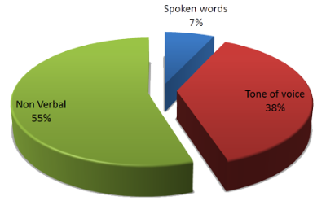
Types of Nonverbal Communication
- Kinesis – Facial Expression, Posture, & Gesture
- Oculesics – Eye Contact
- Haptics – Communication of Touch
- Proxemics – Comm. of space and proximity
- Chronemics – Effects on time on comm.
- Paralinguistic – Variation in speed, volume, & Pause that convey meaning.
- Appearance & Accessories – Physical characteristic such as Perfume, makeup, etc.
- Audio Visual sound – VIP Alarm, Ambulance etc.

Kinesics
The word kinesics comes from the root word kinesis, which means “movement,” and refers to the study of hand, arm, body, and face movements. Specifically, this section will outline the use of gestures, head movements and posture, eye contact, and facial expressions as nonverbal communication.

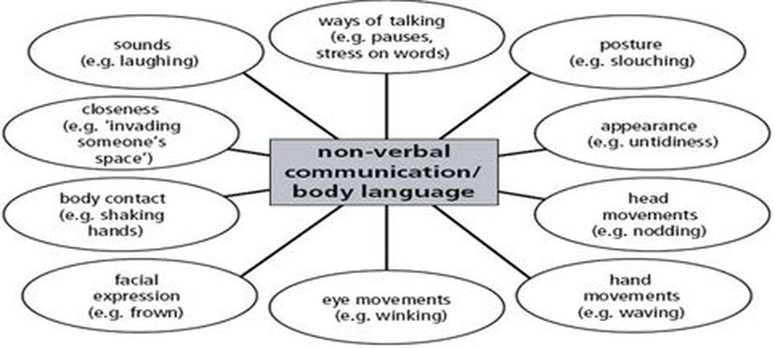
Gesture


Posture
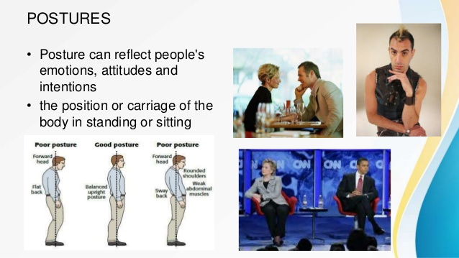

Advantages of body language

1. Body language is the most easily visible aspect of
communication. It, therefore, helps the receiver of the
message in decoding the message.

- Body language complements verbal communication.

3. Body language adds intensity to the process of communication. In the absence of any gestures, change of
posture, proper eye contact any face-to-face communication will look blank.

4. Because people care for body language it goes a long way to improve the overall atmosphere and looks of the
organization. A resourceful manager can make very effective use of it.

Limitations of body language

1. Being a non-verbal communication, relying on facial
expressions, gestures etc., it cannot be wholly relied on.
Words written or spoken can be taken seriously, but body
language cannot always be taken seriously.

2. People belonging to different cultural backgrounds sent out different body signals. They are, therefore, liable to be
misinterpreted.

- Facial expressions, gestures, postures etc. become ineffective if the listener is inattentive. It, therefore, requires extra care in getting the right message.

4. Use of body language is not very effective in large gatherings. It is effective in face-to-face situation that means there are just two or a small number of participants in the communication situation.

Proper word stress: By putting stress or emphasis on a word here or a word there in the same sentence or utterance we can change the whole meaning.
What are you Doing?
What are you Doing?
What are you Doing?

Advantages of Para language
1. No oral message is complete without paralanguage as it is very closely allied to language.
2. Paralanguage speaks a lot about the speaker’s national/regional background. This information is of immense use to the receiver/organization in dealing with him.
3. Paralanguage gives us useful clues regarding the speaker’s mental state.
4. Paralanguage enables us to understand the speaker’s place in the organization.
5. Paralanguage tells us quite clearly about the speaker’s educational background.

Limitation of paralanguage

1. Paralanguage is non-verbal part of communication, therefore, cannot be fully relied upon.
2. The voice quality and pitch of the speaker may unnecessarily prejudice the receiver of the message. The listener/receiver of the message has, therefore, to be very open-minded.
3. Because of the reasons given above paralanguage may sometimes misguide or mislead.
4. As speakers belong to different speech communities it is difficult to achieve uniformity in oral communication.

LECTURE CONTENTS WITH A BLEND OF NPTEL CONTENTS

• https://nptel.ac.in/courses/109/104/109104031/

• https://www.youtube.com/watch?v=QSLIttMmaLk

• https://www.youtube.com/watch?v=CQ6D_bxZyxg
.

